Lab 9 — Profiling in Python
Profiling, memory analysis, test coverage, and optimization comparison
Student: Mohannad Al Ghourayeb | Course: EECE 435L | Academic year: 2026–2027

1. Objective and methodology
The purpose of this lab is to identify Python runtime bottlenecks, examine line-by-line execution cost and process memory usage, assess test coverage, and compare the initial implementation against an optimized fast_function. The screenshots below are taken directly from the submitted VS Code terminal captures.
Tools used: Python 3.13, cProfile, line_profiler, memory_profiler, coverage.py, and unittest. The original versions were preserved in the original/ folder before the optimized files were edited.

2. Executive summary
Measure | Before optimization | After optimization
cProfile total runtime | 2.436 s | 2.442 s
cProfile function calls | 8 | 110
Line profiler: fast function | 0.000087 s | 0.000067 s
Overall test coverage | 90% | 90%
Unit tests | 3 passed | 3 passed

Interpretation: the optimized small function had a slightly lower line-profile runtime in these two runs, but the program-wide runtime remained essentially unchanged. The two-second sleep and the 10-million-iteration calculation still dominate. This is not evidence of a reliable 23% speed improvement without repeated measurements.

3. cProfile — function-level performance
The pre-optimization run took 2.436 seconds; time.sleep used 2.005 seconds and memory_intensive_function used 0.428 seconds of self time. The post-optimization run took 2.442 seconds, with 2.005 seconds in sleep and 0.435 seconds in the large loop. The difference of 0.006 seconds is negligible in this context.
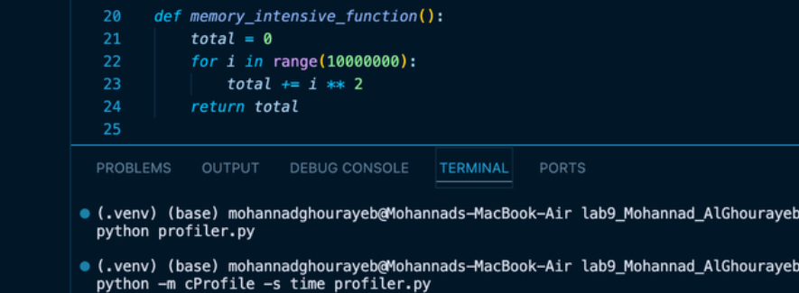
Figure 1. cProfile before optimization — terminal evidence

3. cProfile — continued
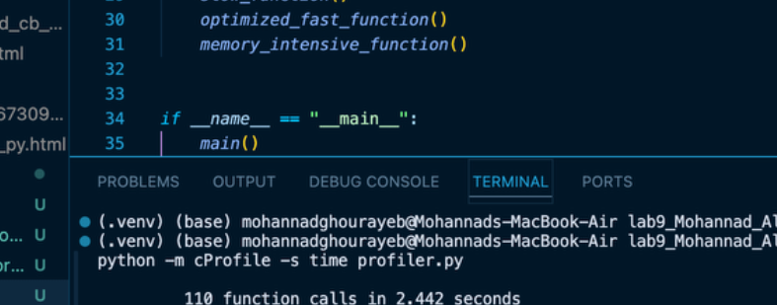
Figure 2. cProfile after optimization — terminal evidence
The optimized implementation changes the small function to sum(i ** 2 for i in range(100)), introducing generator-related calls. The higher total call count is not itself a problem, and the unchanged dominant workloads explain why the full script does not become faster in this run.

4. Line profiler — line-by-line performance
Before optimization, slow_function was dominated by time.sleep(2), which accounted for approximately 99.4% of its measured line time. The 10-million-iteration function spent approximately 44.5% on the loop operation and 55.5% on the accumulation line. The fast function completed in approximately 0.000087 seconds.
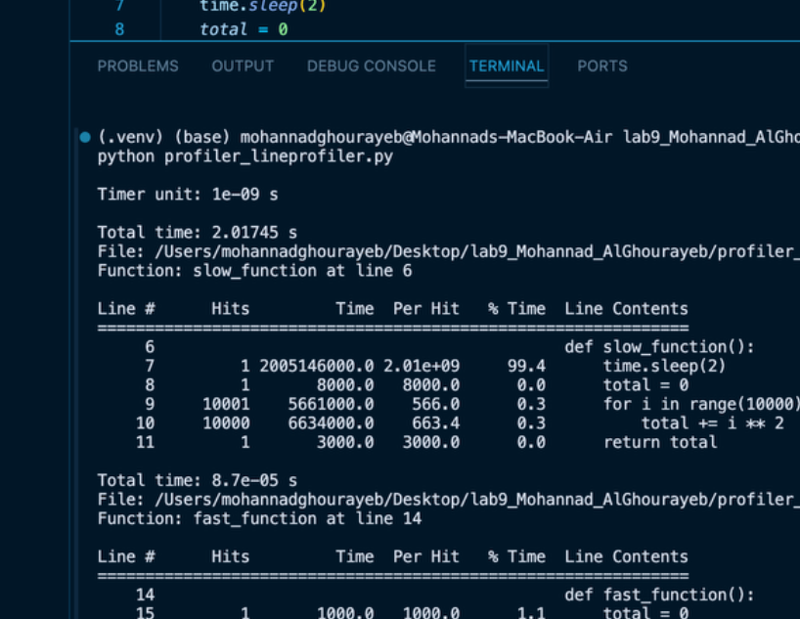
Figure 3. line_profiler before optimization — three functions

4. Line profiler — continued
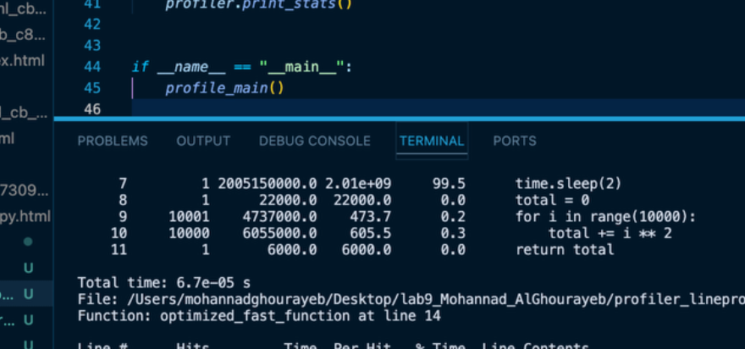
Figure 4. line_profiler after optimization — three functions
Measured function | Before | After
fast / optimized_fast | 0.000087 s | 0.000067 s
memory_intensive | 3.25954 s | 3.00250 s

The optimized fast-function sample is about 23% lower than the original sample, but these are very short single measurements. The large-loop difference also varies even though its code was not changed. Accordingly, these observed differences should not be interpreted as proven, repeatable optimization gains.

5. Memory profiling
The line-based memory_profiler captures before optimization show approximately 27.9–28.0 MiB for slow_function and 28.0 MiB for fast_function. The same two functions show approximately 28.1 MiB after optimization. These are process memory measurements, not per-function allocations.
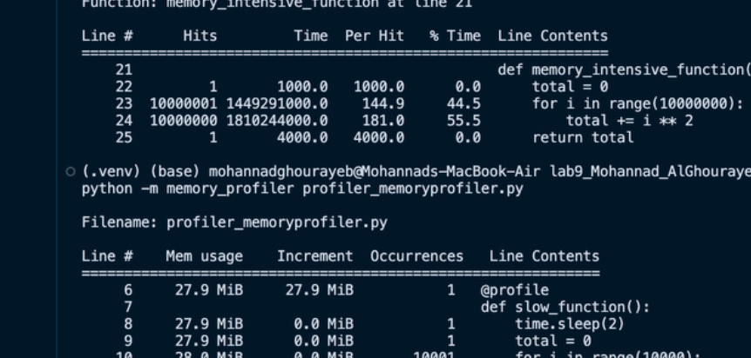
Figure 5. memory_profiler before optimization — completed sections

5. Memory profiling — continued
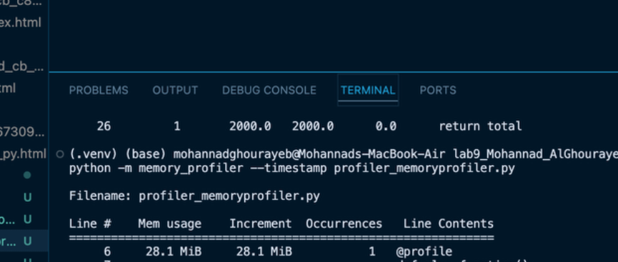
Figure 6. memory_profiler after optimization — completed sections
The line-based runs did not finish reporting the 10-million-iteration memory_intensive_function in the screenshots provided. Its unusually high instrumentation overhead led to an interrupted earlier run. This is an evidence limitation rather than a demonstrated memory improvement.
A separate sampling-based measurement of the unchanged memory-intensive function reported a peak process usage of 28.265625 MiB (approximately 28.27 MiB). The sample does not replace the missing line-by-line memory report or provide a directly comparable before/after peak pair.
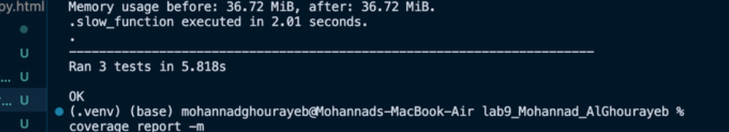
Figure 7. Sampled peak process memory for memory_intensive_function

6. Code coverage and unit tests
Three unittest cases passed in both runs. The tests validate execution and numerical results of slow_function, fast_function, and memory_intensive_function. Total measured coverage remained at 90%.

6. Code coverage and unit tests — continued
File / metric | Before | After
profiler.py | 83% (4 missing of 23) | 82% (4 missing of 22)
test_profiler.py | 97% (1 missing of 29) | 97% (1 missing of 29)
Combined coverage | 90% | 90%
Tests passed | 3 of 3 | 3 of 3

Before optimization, profiler.py missing lines were 28–30 and 34. After optimization, they were 29–31 and 35: the test suite imports and calls the functions, but does not enter the script-level main() path. In the test file, line 64 is the direct-run test entry point and is not exercised when unittest discover imports the module.
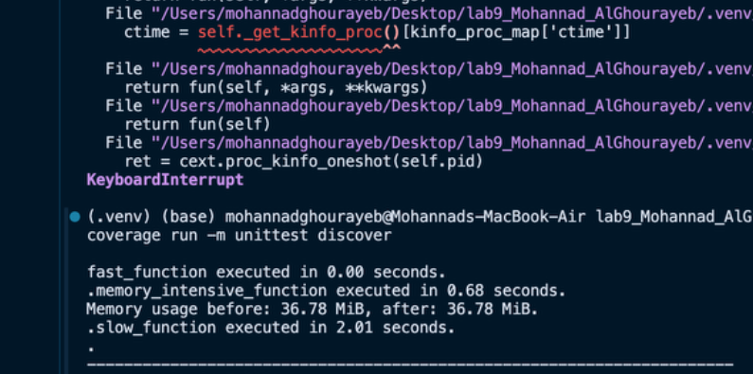
Figure 8. unittest and coverage report before optimization; HTML output generated

6. Code coverage and unit tests — continued
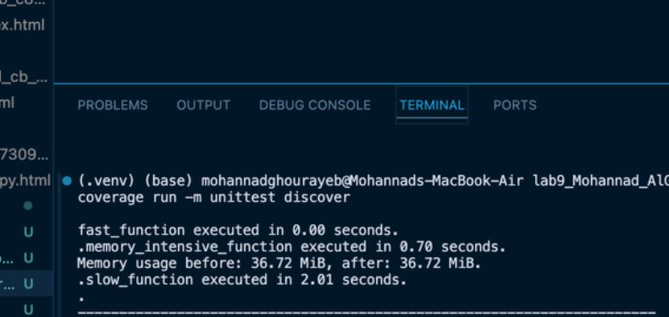
Figure 9. unittest and coverage report after optimization; HTML output regenerated

7. Optimization details and conclusion
Optimization made: replace the original explicit for-loop accumulation in fast_function with return sum(i ** 2 for i in range(100)). The optimized implementation preserves the computed result; a compatibility fast_function wrapper remains in profiler.py for existing tests. The slow and memory-intensive functions were not changed.
The profiling exercise illustrates why optimization should focus on measured bottlenecks. The small fast-function computation shows a minor local timing difference, but does not materially change the overall runtime, while the unchanged sleep and large loop account for most measured time. Test results remain correct and overall coverage remains at 90%.

Evidence and submission notes
The terminal screenshots supplied in this report document cProfile, line_profiler, the completed sections of memory_profiler, unittest, code coverage, and sampled peak memory. The complete line-by-line memory_intensive_function report is not available in the supplied evidence. Submit the original and optimized Python files, the generated htmlcov/index.html report (preferably with its associated assets), and this report in the GitHub repository, with the repository URL in a .txt file on Moodle.

