**Personal website:**

To visit the website: <http://mohannadaltawaijri.eb2a.com/>

Home:

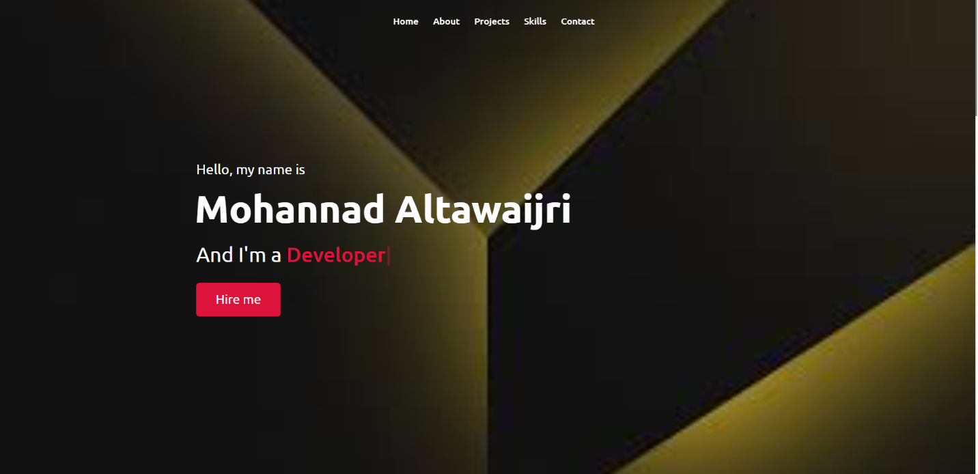

This is the home section. Which contains a simple introduction about myself (my name and profession).

About me:

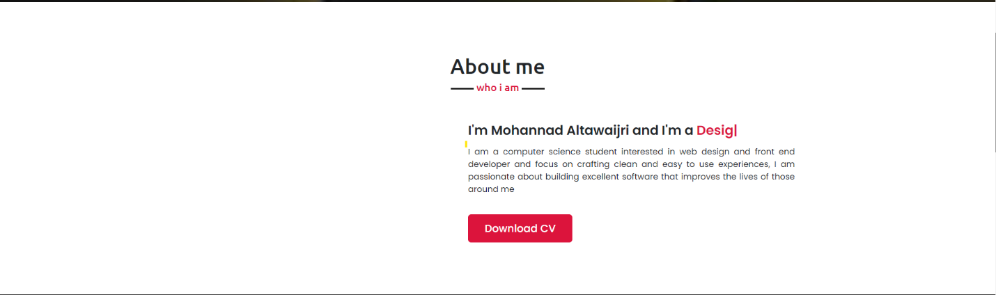

In this section I give a complete information about myself.And a link to download my CV.

My projects:

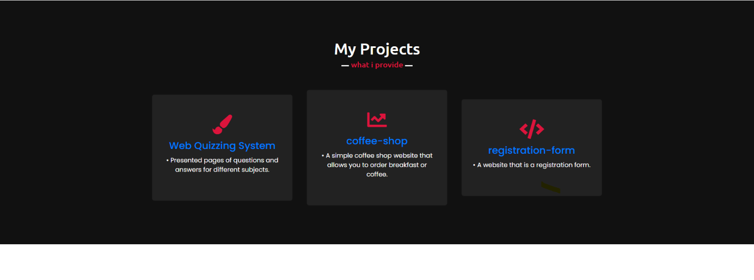

Here I have shown my projects that I have done with a simplified explanation of each project.

My skills:

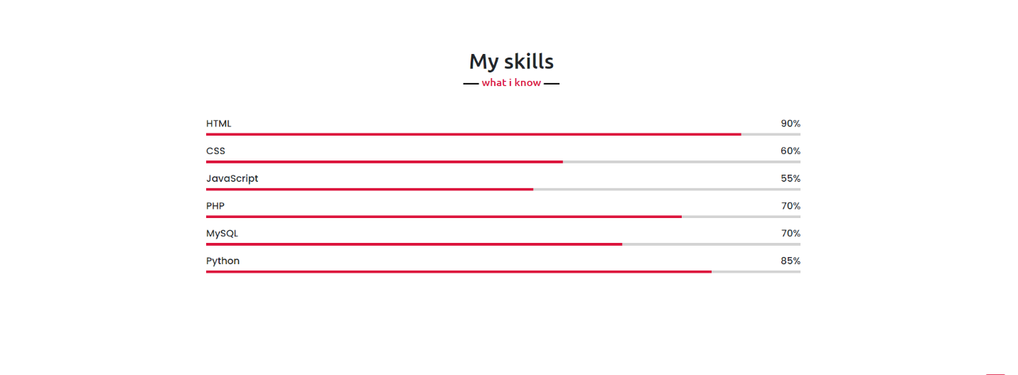

Here I show the skills I have and the percentage of my mastery for each skill.

Contact me:

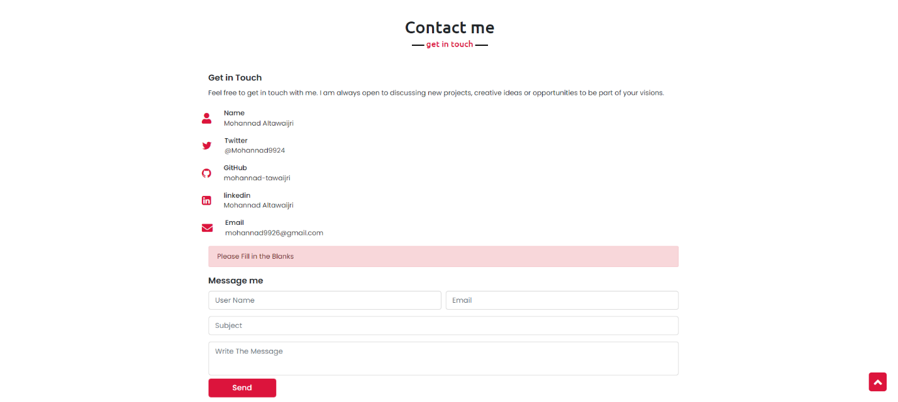

In this section, I have shown my social communication accounts to communicate with me through them, or you can contact me in a faster way through (massage me).