Project Report Template

1. **INTRODUCTION**

TITLE : RETAIL MANAGEMENT APPLICATION USING SALESFORCE

* 1.1 OVERVIEW: Retailing encompasses the business activities involved in selling goods and services to consumers for their personal, family, or household etc. A CRM product owner has requested to create two applications, one is a sales app for sales reps to use this application and store customers data, and the second application is a service app for service reps/agents to provide support to customers in dealing cases. To generate business on top of the customers.
* 1.2 PURPOSE : It is used for managing sales customer service , marketing and employee relation

**2 Problem Definition & Design Thinking**

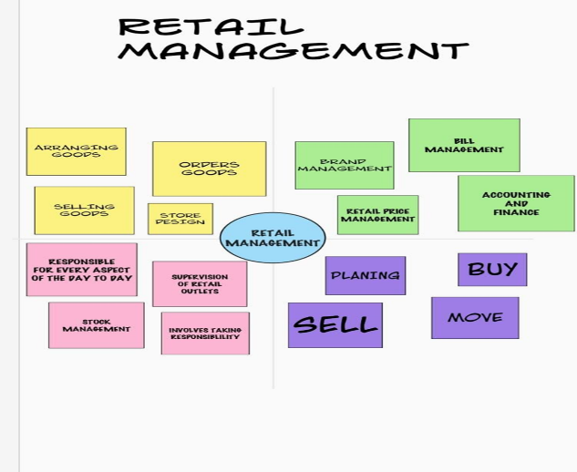**2.1.Empathy_map: . 2.2 Brainstorming map:**

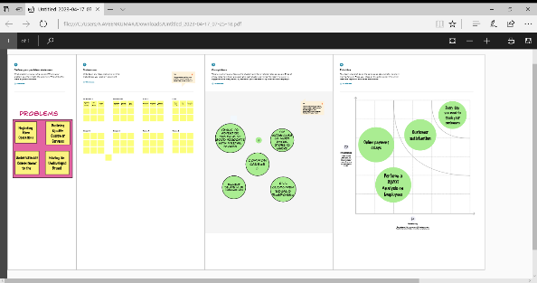

**RESULT**

3.1 **Data Model:**

|  |  |  |  |
| --- | --- | --- | --- |
| **OBJECT:** | **Account** | **Contact** | **Case** |
| **FIELD 1** | **Account name** | **Contact name** | **Holder name** |
| **FIELD 2** | **Created by** | **Account website** | **Cases ID** |
| **FIELD 3** | **Last modified by** | **Last modified by** | **Last modified by** |
| **FIELD 4** | **owner** | **owner** | **Created by** |
| **FIELD 5** | **phone** | **Created by** | **Owner** |

3.2 Activity screenshot

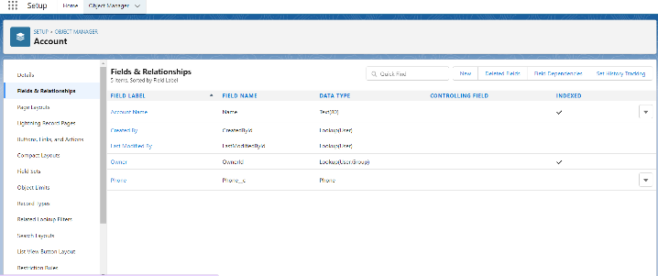Attach the screenshots of your project activity along with the description.

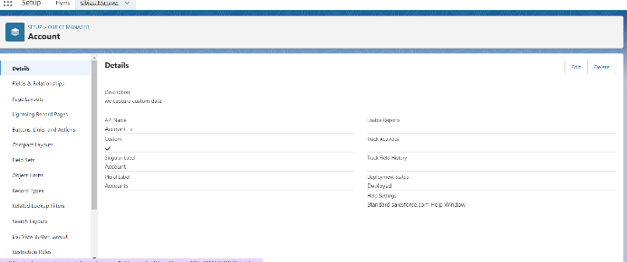

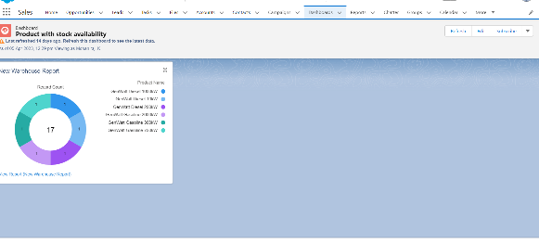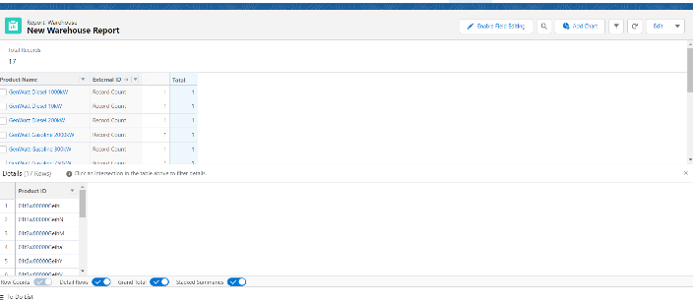

1. **Trailhead Profile Public URL**

**Team lead :** [**https://trailblazer.me/id/vikram07**](https://trailblazer.me/id/vikram07)

**Team m1:** [**https://trailblazer.me/id/solo47**](https://trailblazer.me/id/solo47)

**Team m2 :** [**https://trailblazer.me/id/dwayne2711**](https://trailblazer.me/id/dwayne2711)

**Team 3 :** [**https://trailblazer.me/id/madhavan05**](https://trailblazer.me/id/madhavan05)

1. **ADVANTAGES & DISADVANTAGE**

**ADVANTAGE**

* It increase the efficiency of standard of employee with high quality and profit for the company(better customer relationship ,more profit).

**DISADVANTAGE**

*High marketing cost and selling skill required

1. **APPLICATIONS**

* Used to study buying pattern of the customers
* Used to analyse and keep track of product ,sales and manage.

1. **CONCLUSION**

* It helps to design marketing strategy and analyse the customer need status . this helps on improving the profit of the company .

1. **FUTURE SCOPE**

* We can predict the product buying nature of the customer. This helps in sales improvement in marketing
* Retail management has become one of the fastest growing career in the industry with the tremendous growth in the economy. Retail Market of India is the most attractive and emerging market in the world and has demanded more number of trained professionals in this field