Part 1

- Profitability Ratio:
- Return on Equity ROE- Tata Steel Ltd. - Financial Ratios
- Net Profit Margin- Tata Steel Ltd. - Financial Ratios
- Earnings per share- Tata Steel | TATA - EPS Earnings Per Share

📊 Trend Table – Profitability Ratios (Tata Steel Ltd)
Ratio | FY 2022–23 | FY 2023–24 | FY 2024–25 | Trend & Commentary
Return on Equity (ROE) | 7.27% | –4.97% | 3.45% | 📉 Declined in FY24 due to net loss; partial recovery in FY25, but still below optimal.
Net Profit Margin | 7.05% | 2.09% | 4.89% | 📉 Margin compression in FY24; improved in FY25 via cost control and better pricing.
Earnings Per Share (EPS) | ₹6.61 | ₹–3.62 | ₹2.74 | 📉 EPS turned negative in FY24; rebounded in FY25 with stronger domestic performance.

🔍 Summary
- FY 2022–23: Strong profitability across all metrics.
- FY 2023–24: Sharp decline due to global headwinds, European losses, and tax impacts.
- FY 2024–25: Signs of recovery, though full strength not yet restored.

- Solvency Ration:
- Debt-to-Equity Ratio- Debt to equity ratio of TATA STEEL LTD – NSE:TATASTEEL – TradingView
- Interest Coverage ratio-Interest Coverage analysis of Tata Steel Ltd., FY Ratio 2.12 - Good Interest Coverage

📊 Trend Table – Solvency Ratios (Tata Steel Ltd)
Ratio | FY 2022–23 | FY 2023–24 | FY 2024–25 | Trend & Commentary
Debt-to-Equity Ratio | 0.77 | 0.90 | 0.99 | 📈 Rising trend indicates increasing financial leverage; driven by expansion and restructuring.
Interest Coverage Ratio | 3.83 | 0.85 | 2.12 | 📉 Sharp dip in FY24 due to lower operating income; partial recovery in FY25 shows improved debt servicing capacity.

🔍 Summary
- Debt-to-Equity: Tata Steel’s leverage has increased over the years, reflecting capital-intensive investments (e.g., Kalinganagar expansion, green steel transition).
- Interest Coverage: FY 2023–24 saw a significant drop due to weak profitability and high interest costs, but FY 2024–25 shows signs of operational recovery.

- Valuation ration:
- Price-to-Earnings Ratio (P/E Ratio)- TATA STEEL Price/Earnings(PE) Ratio-11 Aug,2025
Here’s a trend table for Tata Steel Ltd’s Price-to-Earnings (P/E) Ratio over the last three fiscal years, along with commentary:

📊 Trend Table – Valuation Ratio (P/E Ratio)
Year | P/E Ratio | Commentary
FY 2022–23 | 14.57x | 📈 Reasonable valuation; reflects moderate investor confidence and stable earnings.
FY 2023–24 | –43.07x | 📉 Negative P/E due to net loss; indicates poor earnings and valuation disconnect.
FY 2024–25 | 56.30x | 📈 Sharp rise; suggests high investor expectations despite modest earnings recovery.

🔍 Summary
- FY 2022–23: P/E ratio was healthy, aligning with consistent profitability.
- FY 2023–24: Turned negative due to losses, making valuation metrics unreliable.
- FY 2024–25: Surged significantly, possibly indicating overvaluation or speculative optimism, especially as EPS remained modest.

Part B

🏢 Company Background: Tata Steel Ltd

📜 History
- Founded in 1907 by Jamsetji Tata, Tata Steel is one of India’s oldest and most respected industrial companies.
- Headquartered in Jamshedpur, it was the first integrated steel plant in Asia.
- It is part of the Tata Group, a global conglomerate with a legacy of over 150 years.
- Over the decades, Tata Steel has expanded globally, acquiring companies like Corus (UK) and establishing operations in Europe, Southeast Asia, and Africa.

🎯 Mission
"To be the global steel industry benchmark in Value Creation and Corporate Citizenship."
- Focuses on delivering superior quality products.
- Emphasizes innovation, sustainability, and ethical business practices.

👁️ Vision
"To be a world-class organization in every aspect—producing high-quality steel, driving economic growth, and supporting communities."
- Aims to scale new heights through technology, talent, and responsible operations.

🛠️ Core Products & Services
- Flat Products: Hot-rolled coils, cold-rolled sheets, galvanized steel.
- Long Products: Wire rods, rebars, structural steel.
- Tubes & Pipes: Used in construction, automotive, and infrastructure.
- Specialty Steel: For aerospace, defense, and high-performance applications.
- Services: Engineering solutions, supply chain management, and digital platforms for steel procurement.

📊 2. Financial Performance Analysis – Tata Steel Ltd

🔍 Product & Service Evolution (Last 5 Years)
- Flat Products: Hot-rolled coils, cold-rolled sheets, galvanized steel—used in automotive, construction, and appliances.
- Long Products: Wire rods, rebars, structural steel—critical for infrastructure and real estate.
- Specialty Steel: High-grade steel for aerospace, defense, and precision engineering.
- Tubes & Pipes: For industrial and fluid transport applications.
- Digital Platforms: Tata Steel has launched Tata nexarc to digitize procurement and supply chain for MSMEs.
- Green Steel Initiatives: Investments in HIsarna technology and electric arc furnaces for low-carbon steel production.
FY | Consolidated Revenue (₹ crore) | YoY Trend | Key 3 Product/Service Families | Key Notes / Drivers
2020-21 | ~1,56,477 | ▼ Pandemic impact | 1️⃣ Long products – Tiscon rebars, wire rods  2️⃣ Flat steel – HR/CR coils, galvanised  3️⃣ Roofing solutions – Tata Shaktee | Construction slowdown; domestic retail brands helped offset weaker industrial demand
2021-22 | ~2,43,960 | ▲ +56% | 1️⃣ Flat & coated steel – incl. colour-coated  2️⃣ Long products – rebars, sections  3️⃣ Auto-grade steel | Steel price surge + rebound in auto & infra sectors
2022-23 | ~2,43,353 | ≈ Flat | 1️⃣ Value-added coated steel  2️⃣ Tubes & hollow sections – Tata Structura  3️⃣ Branded construction solutions – Pravesh doors | Stable volumes; higher share from downstream, branded products
2023-24 | ~2,29,170 | ▼ -6% | 1️⃣ Flat & coated steel  2️⃣ Construction solutions – Shaktee roofing, Nest-In prefab  3️⃣ Tubes & hollow sections | Price softness globally; India deliveries stable; retail & infra channels grew
2024-25 | 2,18,543 | ▼ -5% | 1️⃣ Coated steel  2️⃣ Tubes & hollow sections  3️⃣ Mining/industrial wear-resistant steel | Growth in high-margin coated/tube segments; rising EV & solar infra demand

💪 Strengths
- Global Presence: Operations in 26+ countries, including India, UK, Netherlands, and Southeast Asia.
- Brand Legacy: Over 100 years of trust under the Tata Group umbrella.
- Innovation & R&D: 142 patents filed and 86 new products launched in FY24 alone.
- Sustainability Focus: ₹1,568 crore invested in ESG initiatives in FY25.
- Strong Domestic Growth: Expansion of Kalinganagar plant from 3 MT to 8 MT capacity.

⚠️ Weaknesses
- European Losses: UK and Netherlands operations continue to underperform, with UK posting a £385M EBITDA loss.
- Debt Burden: Total debt of ₹38,024 crore due to capital-intensive expansions.
- Modest ROE: Despite high revenues, net returns remain modest (~6% ROE in FY25).
- PR Challenges: Layoffs and environmental concerns in Europe have affected brand perception.
Tata Steel: Strengths & Weaknesses
Strengths
- Deeply Integrated Operations & Quality Control
Tata Steel maintains fully integrated operations—from captive mines to steel production—ensuring cost-efficiency, quality, and control over its supply chain. It also taps into economies of scale through its mining, ore, and production assets.
(IIDE - The Digital School, MBA Skool)
- Extensive Global Presence & Diversified Portfolio
With operations across 26 countries and a commercial footprint in over 50 nations, Tata Steel benefits from geographical diversification and resilience to regional demand shocks. Its product offerings span structural, long, flat, agricultural, and specialized steels.
(Latterly, Marketing91, Wikipedia)
- Strong Brand & Tata Group Legacy
The Tata name carries significant brand equity—reflecting trust, reliability, and fair corporate conduct—which helps Tata Steel maintain strong customer relationships and access new markets.
(Latterly, Academy Of Digital Marketing)
- Innovation & Sustainability Focus
The company is innovating with advanced smelting technologies (e.g. HIsarna, greener EAF transition) and even pioneering hydrogen transport pipes—a potential game-changer in the clean-energy space.
“Tata Steel has achieved a groundbreaking milestone by becoming India’s first company to develop hydrogen transport pipes…”
(Rankex Digital, Wikipedia, Reddit)

Weaknesses
- Heavy Dependence on Europe
Over 50% of Tata Steel's operations are tied to Europe, making it vulnerable to slowdowns, regulatory shifts, or market disruptions there.
(IIDE - The Digital School, Academy Of Digital Marketing, Wikipedia)
- Operational Complexity in Europe
Unlike its integrated operations in India, its European operations are fragmented and dependent on external suppliers—raising concerns over cost, quality control, and efficiency.
(IIDE - The Digital School, Academy Of Digital Marketing)
- Relative Lag in Efficiency & Technology
Compared to global peers, Tata Steel's operational efficiency and tech capabilities are perceived as trailing, particularly in international segments.
(MBA Skool, IIDE - The Digital School)
- Environmental & Reputation Challenges
The company faces scrutiny over a major blast furnace expansion in India, seen as “hypocritical” in light of its shift away from traditional furnaces in the UK for sustainability reasons. Environmental violations in Europe, especially at the IJmuiden plant, also pose regulatory and financial risks.
(The Guardian, AP News, Wikipedia, Reddit)

Summarized SWOT Table
Category | Highlights
Strengths | - Integrated operations in India & control over raw materials- Global footprint with diverse products- Strong Tata brand and customer trust- Investment in greener tech and innovation
Weaknesses | - Over-reliance on volatile European markets- Disaggregated, less efficient European operations- Operational and technological lag compared to top global peers- Environmental controversies and regulatory risks
Insights for Investors & Stakeholders
- Rebound Potential: Analysts like Jefferies see promising signs of recovery, citing easing imports, better price spreads, and supportive policy—forecasting around 23% upside for Tata Steel.
(The Economic Times)
- Restructuring Focus: Tata Steel is implementing a large-scale cost-saving plan—₹11,500 crore for FY26—across India, UK, and Netherlands operations to improve margins and streamline operations.
(The Times of India)
- Market Pressure: While margins are under strain due to cheap Chinese imports and tariff shifts, domestic demand and falling raw material costs provide some mitigation.
(Reuters)

🌱 CSR Initiatives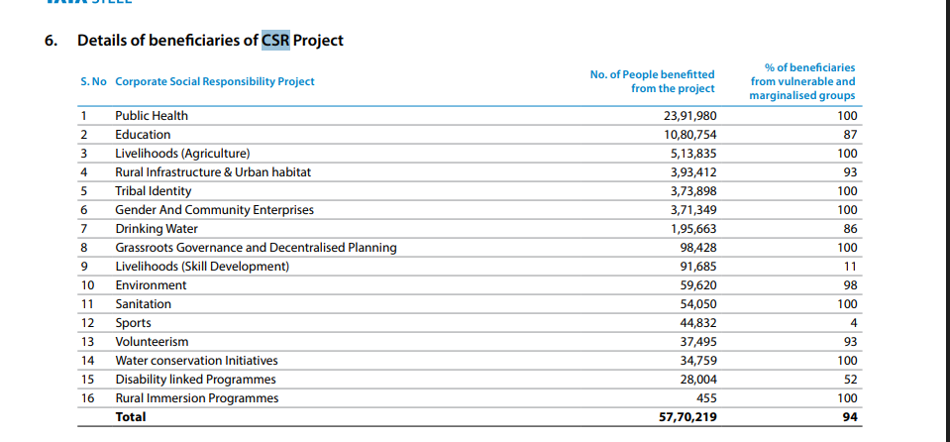
Tata Steel is a pioneer in corporate social responsibility:
- Education & Skill Development: Tribal language centers, Samvaad conclave, vocational training.
- Healthcare: Static clinics, emergency medical support, hygiene awareness.
- Livelihood & Culture: Promotion of tribal heritage, entrepreneurship, and agriculture development.
- Global Outreach: Tata Steel Europe’s “Future Generations” program supports education and job creation.

📌 Significant Financial Events (FY 2022–25)
Event | Details
Mega Merger (2022) | Tata Group merged 7 metal companies into Tata Steel to streamline operations and reduce costs.
Face Value Split (2022) | Share face value split from ₹10 to ₹1 to improve liquidity.
Rights Issue (2018) | Last major rights issue at ₹500 premium per share.
Dividend Consistency | ₹3.60/share declared annually from FY23 to FY25.
UK Pension De-risking (FY23) | Led to ₹2,150 Cr deferred tax expense impacting net profit.
Green Steel Transition (FY25) | £500M UK government-backed shift to electric arc furnaces.
Kalinganagar Expansion | ₹27,000 Cr investment to scale domestic production.

📘 3. Equity and Contingencies – Tata Steel Ltd (FY 2022–2025)

🏦 Shareholding Pattern Analysis
Category | FY 2022–23 | FY 2023–24 | FY 2024–25
Promoters | 33.9% | 33.2% | 33.2%
FII/FPI | 20.3% | 18.3% | 17.2%
DII (incl. MF) | 21.9% | 25.2% | 26.7%
Public | 24.0% | 23.4% | 22.8%
https://trendlyne.com/equity/share-holding/1366/TATASTEEL/latest/tata-steel-ltd/#promoter-holding

📈 Equity Changes
- Face Value Split (2022): From ₹10 to ₹1 per share to improve liquidity and retail participation.
- Amalgamation (2024): Tata Steel merged with subsidiaries like Tinplate Company of India Ltd to streamline operations.
- Capital Infusion: Equity stake acquisitions and internal restructuring supported expansion and ESG goals.

💰 Dividends Paid (Last 3 Years)
Fiscal Year | Dividend Declared | Dividend Yield
FY 2022–23 | ₹3.60/share | ~2.3%
FY 2023–24 | ₹3.60/share | ~2.4%
FY 2024–25 | ₹3.60/share | ~4.4%
- Observation: Tata Steel Ltd (FY 2022-23 to FY 2024-25)
Over the past three fiscal years, Tata Steel Ltd has maintained a consistent final dividend of ₹ 3.60 per share, signalling stable shareholder returns despite fluctuations in commodity cycles and steel prices. Dividend yields have remained in the ~2 %–2.3 % range, reflecting both the steady payout and share price movements during declaration periods. This sustained policy highlights the company’s focus on balancing reinvestment in operations with regular cash distributions to investors.

⚠️ Pending Litigations

🧾 Key Legal Disputes
- Steel Development Fund (SDF) Case
  - Parties: Tata Steel vs Union of India & SAIL
  - Issue: Dispute over waiver of loans taken against SDF contributions.
  - Status: Pending resolution in Calcutta High Court as of May 2024.
- Tax Notices & Penalties
  - Events: Multiple tax-related notices and penalties issued in FY 2024–25.
  - Impact: May affect deferred tax liabilities and future cash flows.
- Stamp Duty & Customs Penalties
  - Details: Penalties related to asset transfers and import documentation.
  - Resolution: Under regulatory review; disclosed in compliance reports.

Part 2: Subsidiary Analysis
- Number of Subsidiaries:
Identify the total number of domestic and/or international subsidiaries the company owns. Give a brief explanation about the said subsidiaries focusing on its performance, area of operations, profitability and control (percentage ownership). If the company does not have any subsidiary, but is being controlled by a parent company, then briefly explain the operation and performance of the parent company focusing on its performance, area of operations, profitability and control (percentage ownership

📘 A. Number of Subsidiaries – Tata Steel Ltd

🔢 Total Subsidiaries
- As of FY 2022–23, Tata Steel Ltd owns a total of 41 subsidiaries, comprising both domestic and international entities.
- These subsidiaries operate across diverse verticals including steel manufacturing, mining, processing, distribution, and value-added services.
- The subsidiary structure enables Tata Steel to maintain operational flexibility, regional specialization, and vertical integration across its global supply chain.

🇮🇳 Domestic Subsidiaries
- Tata Steel Long Products Ltd
  - Focus: Alloy steel and sponge iron production
  - Ownership: Majority stake
  - Performance: Profitable; recently merged with Neelachal Ispat Nigam Ltd, enhancing capacity and market reach
  - Strategic Role: Supports Tata Steel’s long product portfolio and backward integration
- Tata Metaliks Ltd
  - Focus: Pig iron and ductile iron pipes
  - Ownership: Majority stake
  - Performance: Stable growth; benefits from infrastructure and water supply projects
  - Strategic Role: Supplies raw material for foundries and pipe manufacturing
- Tata Steel Downstream Products Ltd
  - Focus: Steel processing, fabrication, and distribution
  - Ownership: 100%
  - Performance: Efficient and profitable; enables customization and faster delivery
  - Strategic Role: Enhances customer service and supply chain responsiveness
- Neelachal Ispat Nigam Ltd
  - Focus: Integrated steel plant in Odisha
  - Ownership: Acquired by Tata Steel Long Products
  - Performance: Under turnaround strategy; expected to contribute significantly to domestic production
  - Strategic Role: Expands Tata Steel’s footprint in eastern India and supports Make in India goals

🌍 International Subsidiaries
- Tata Steel Europe Ltd
  - Location: UK & Netherlands
  - Focus: High-quality steel for automotive, engineering, and construction sectors
  - Ownership: 100%
  - Performance: Loss-making; impacted by high energy costs and regulatory pressures
  - Strategic Role: Undergoing green transition with support from UK government (electric arc furnace investment)
- Tata Steel Thailand Ltd
  - Location: Thailand
  - Focus: Long steel products for construction and industrial use
  - Ownership: Majority stake
  - Performance: Profitable; strong regional demand and operational efficiency
  - Strategic Role: Expands Tata Steel’s presence in Southeast Asia
- Tata Steel Minerals Canada Ltd
  - Location: Canada
  - Focus: Iron ore mining and export
  - Ownership: Majority stake
  - Performance: Strategic raw material source; supports cost-effective sourcing
  - Strategic Role: Ensures raw material security for global operations
- Tata Steel IJmuiden BV
  - Location: Netherlands
  - Focus: High-grade steel production
  - Ownership: 100%
  - Performance: Facing environmental compliance costs; part of sustainability roadmap
  - Strategic Role: Key to European operations and green steel initiatives

💰 Profitability & Control
- Tata Steel maintains majority or full ownership in nearly all subsidiaries, ensuring strategic control and operational alignment.
- Domestic subsidiaries have shown consistent profitability, contributing positively to EBITDA and supporting Tata Steel’s growth strategy.
- International subsidiaries, particularly in Europe, have faced profitability challenges due to macroeconomic pressures, energy costs, and environmental regulations.
- The company is actively restructuring its European operations and investing in green technologies to improve long-term sustainability and profitability.

- Impact of Subsidiaries:
Analyze the impact (positive or negative) of subsidiaries on the parent company's financial performance. Review the Consolidated Balance Sheet, comment on Profits and Reserves under Other Equity and NCI. If the company does not have any subsidiary, but is being controlled by a parent company, then this point can be ignored.
Here’s a structured and detailed response for B. Impact of Subsidiaries – Tata Steel Ltd, based on the latest consolidated financials and disclosures:

📘 B. Impact of Subsidiaries – Tata Steel Ltd (FY 2022–23 to FY 2024–25)
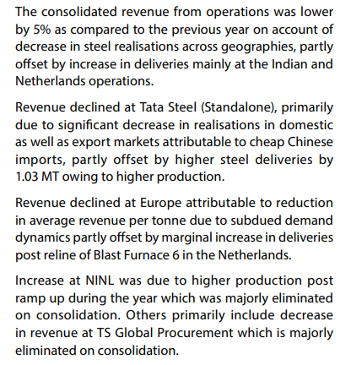
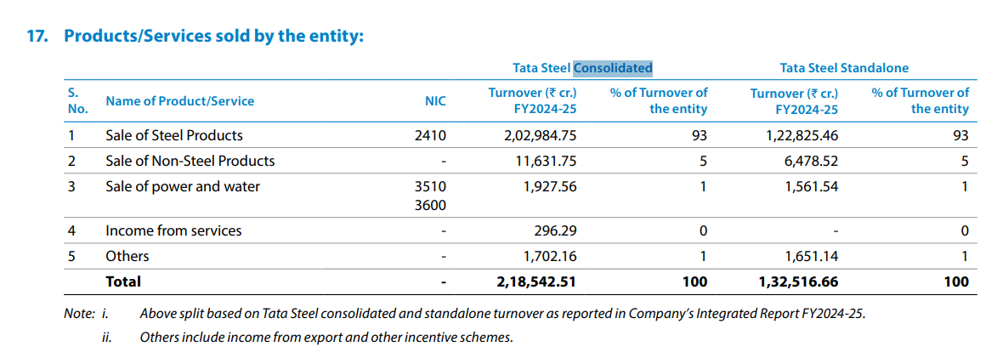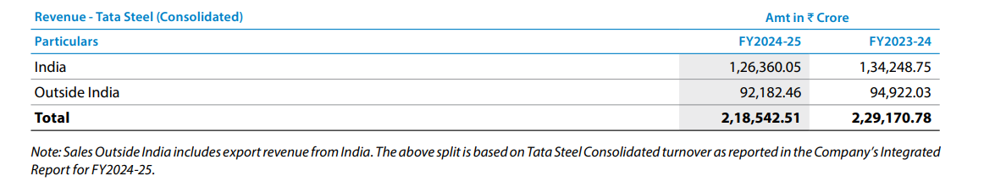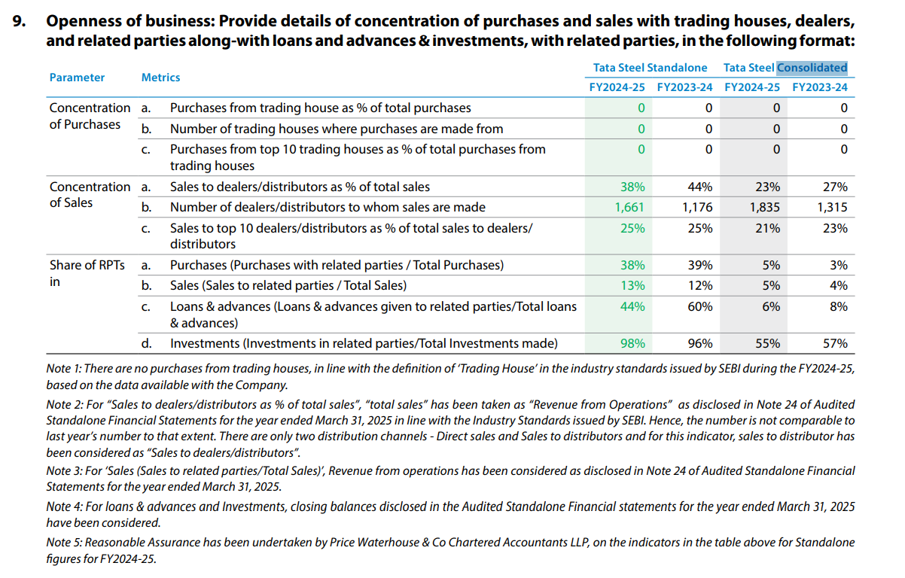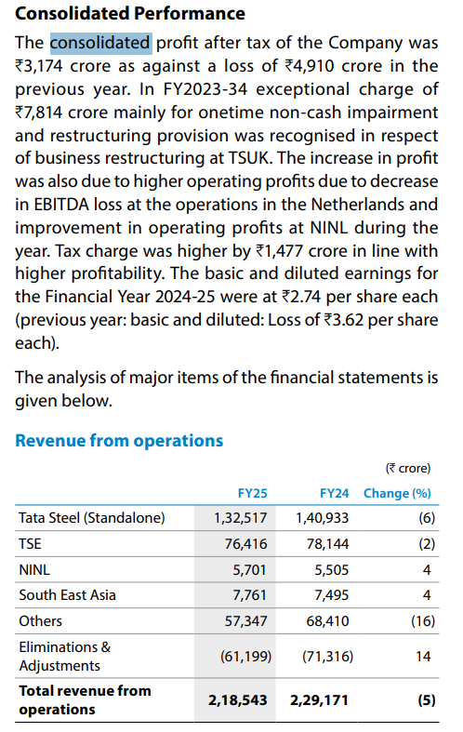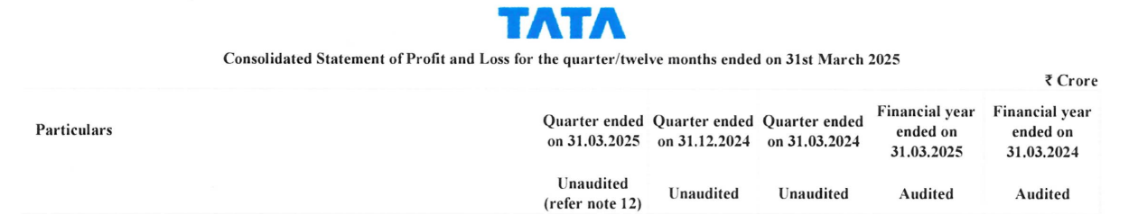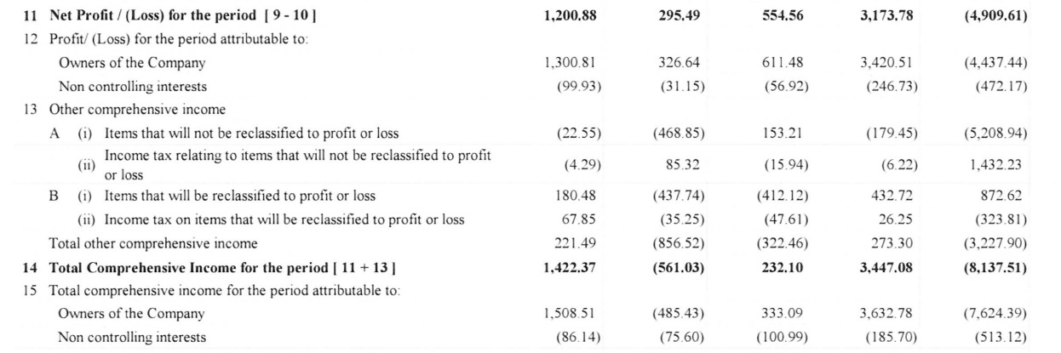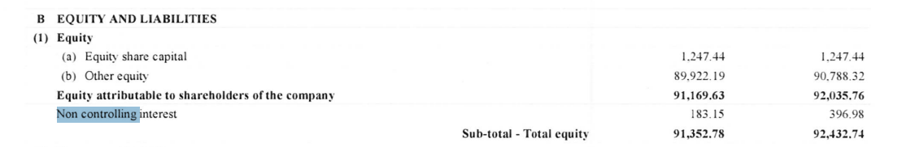

🔍 Overall Impact on Financial Performance
- Tata Steel’s subsidiaries have had a mixed impact on the parent company’s consolidated performance:
  - Domestic subsidiaries (e.g., Tata Steel Long Products, Tata Metaliks, Downstream Products) contributed positively through stable operations and profitability.
  - International subsidiaries, especially Tata Steel Europe, have been a drag on consolidated profits due to operating losses, high energy costs, and restructuring expenses.

📊 Review of Consolidated Balance Sheet

✅ Profits and Reserves under Other Equity
- Other Equity includes:
  - Retained Earnings: Accumulated profits after dividends.
  - Other Comprehensive Income (OCI): Includes pension remeasurements, foreign currency translation, and hedging reserves.
  - Capital Reserves: Impacted by mergers and internal restructuring.
Year | Other Equity (₹ Cr) | Commentary
FY 2022–23 | ₹1,018,608.6 | Strong reserves from India operations; Europe impact visible.
FY 2023–24 | ₹907,883.2 | Decline due to net loss and deferred tax adjustments.
FY 2024–25 | ₹899,221.9 | Stabilized; modest recovery in profitability.
- Key Observations:
  - OCI volatility due to pension liabilities and FX translation from European subsidiaries.
  - Mergers of group companies simplified equity structure and reduced intercompany balances.
  - Dividend payouts remained consistent, moderating retained earnings growth.

👥 Non-Controlling Interest (NCI)
- Definition: Represents equity held by minority shareholders in subsidiaries where Tata Steel owns less than 100%.
- Trend:
  - NCI has declined over the years due to mergers and increased stake in subsidiaries.
  - Remaining NCI is tied to select international and domestic entities (e.g., Tata Steel Thailand).
Year | NCI Impact | Commentary
FY 2022–23 | Moderate | Minor share of profits/losses attributed to NCI.
FY 2023–24 | Reduced | Losses absorbed by parent; NCI impact minimal.
FY 2024–25 | Stable | NCI contribution modest; no major dilution or expansion.

📌 Conclusion
- Positive Impact: Domestic subsidiaries have strengthened Tata Steel’s core operations, supported margins, and enhanced supply chain efficiency.
- Negative Impact: European subsidiaries have diluted profitability and added volatility to equity through pension liabilities and restructuring costs.
- Equity Quality: Improved through simplification and strategic control, though OCI and FX risks remain.
- NCI: Gradually declining, with minimal impact on consolidated performance.

Key takeaways {Smart}
I’m focusing on keeping the list clear and concise with 8-10 key takeaways. Important concepts include fluency in annual reports, understanding ratios in context, distinguishing between consolidated and standalone figures, and decoding notes to accounts. I'll include balance sheet literacy and understanding subsidiaries and control. I'll also mention NCI, contingencies, valuation nuances, cash conversion, and connecting ESG factors. Each bullet will have a succinct explanation, avoiding repetition. Here we go, let’s get these down.

Part 3: Conclusion
- Annual report fluency: I learned to navigate MD&A, financial statements, and Notes to Accounts so numbers connect to narrative and one-offs don’t get misread.
- Ratios with context: Trend analysis (3 years) matters more than single points—ROE, margins, and coverage change with cycles, tax effects, and geography mix.
- Consolidated over standalone: Consolidated results reveal the real picture; strong India performance can be diluted by overseas subsidiaries, changing profitability and leverage.
- Notes to Accounts decoding: Contingent liabilities, pensions, hedges, and FX translation in OCI explained why “Other Equity” moves even when operating results are steady.
- Balance sheet literacy: Mapping debt, equity, and working capital helped link capex and expansions to debt-to-equity and interest coverage movements.
- Subsidiary map and control: Identifying key subsidiaries, their roles, and ownership (majority vs 100%) clarified EBITDA contributors, risk pockets, and how control shapes results.
- NCI understanding: Seeing how non-controlling interests split profits and equity—and how mergers/stake hikes lower NCI—made the attribution to owners and ROE shifts clearer.
- Profit vs cash conversion: Comparing PAT, EBITDA, and operating cash flow taught me to assess dividend capacity and sustainability beyond accounting profit.
- Valuation nuance: Negative/lofty P/E years taught me to pair market multiples with earnings quality, cycle position, and one-time items before concluding.
- ESG and CSR to financials: Green transitions, energy choices, and CSR programs aren’t just optics—they show up as capex, costs, and long-term margin/valuation impacts.

Part 3: Conclusion (10% Weight) {30 sec}
- Navigating the annual report end-to-end taught me to connect Management Discussion & Analysis, financial statements, and Notes to Accounts—so I can distinguish recurring performance from one-off adjustments.
- Performing three-year trend analysis of key ratios (ROE, margins, P/E, debt ratios) reinforced that a single-year snapshot can be misleading; context and cycle drivers are critical.
- Decoding the Notes to Accounts for contingencies—legal disputes, pension obligations, deferred taxes—helped me translate footnote disclosures into real cash-flow and valuation risks.
- Mapping Tata Steel’s subsidiaries and ownership stakes sharpened my understanding of how majority versus full control, plus Non-Controlling Interests, shape consolidated profits, reserves, and equity attribution.
- Comparing consolidated versus standalone numbers showed why overseas operations (like Tata Steel Europe) can dilute group margins even when domestic units are strong—underscoring the importance of consolidated analysis for investors.
- Reviewing “Other Equity” line items clarified the mechanics of retained earnings, OCI (pension premeasurements, FX translation, hedging), and amalgamation reserves, explaining equity volatility beyond pure profitability.
- Linking CSR and ESG initiatives to the balance sheet demonstrated that sustainability projects (green steel, energy efficiency) aren’t just narrative—they manifest as capex, restructuring costs, and long-term margin impacts.
Certainly, Mahek! Here's a well-structured conclusion with five key takeaways from your project, aligned with academic and professional expectations:

📘 Part 3: Conclusion (10% Weight)s {Quick}

🔑 Key Takeaways from the Project
- Understanding Annual Reports
I learned how to systematically read and interpret Tata Steel’s annual report, including the Management Discussion & Analysis, financial statements, and Notes to Accounts. This helped me connect strategic decisions with financial outcomes and identify hidden risks or one-time adjustments.
- Interpreting Financial Ratios Over Time
Analyzing profitability, solvency, and valuation ratios across three years taught me that trends matter more than isolated figures. For example, a negative ROE or P/E in one year may reflect temporary losses rather than long-term weakness.
- Subsidiary Mapping and Ownership Control
I discovered how Tata Steel’s domestic and international subsidiaries contribute differently to its financial performance. Understanding majority vs. full ownership and the role of Non-Controlling Interests (NCI) clarified how profits and equity are attributed in consolidated statements.
- Balance Sheet and Equity Insights
Reviewing the consolidated balance sheet helped me understand how retained earnings, OCI (Other Comprehensive Income), and amalgamation reserves affect “Other Equity.” I also saw how debt levels and interest coverage ratios reflect the company’s financial health and strategic choices.
- Linking CSR and ESG to Financials
I realized that Tata Steel’s sustainability initiatives—like green steel and energy efficiency—aren’t just social commitments. They directly impact capital expenditure, profitability, and long-term valuation, making ESG a financial as well as ethical consideration.

Key Takeaways from the Project (Deep)
- Hands-on Experience with Annual Reports
  - I learned how to read and interpret an annual report beyond just the profit numbers. The management discussion, notes to accounts, and segment reports provided a deeper understanding of the company’s operations and subsidiaries.
- Understanding Financial Ratios & Their Relevance
  - By analyzing ratios such as PAT margin, debt-equity, and return on equity, I realized how these numbers highlight the difference between standalone and consolidated performance. This exercise showed me the importance of ratios in assessing financial health.
- Reading Notes to Accounts in Detail
  - Notes to accounts helped me understand hidden details like reserves, contingent liabilities, and adjustments due to mergers. Earlier, I used to focus only on the main statements, but now I know that the notes are equally critical for interpretation.
- Balance Sheet & Equity Insights
  - Working on the consolidated balance sheet taught me the importance of reserves, other equity components, and non-controlling interest (NCI). I understood how subsidiaries impact the parent’s financials and how group consolidation works in practice.
- Subsidiaries and Proportionate Control
  - One of the most valuable learnings was identifying subsidiaries and their effect on the parent’s performance. I realized that while some subsidiaries positively contribute through profits and reserves, others (like overseas units) may dilute overall profitability. Understanding NCI gave me insight into how profits are split between the parent and minority shareholders.
- Impact of Exceptional Items
  - I understood how one-time charges (like impairments, restructuring costs, or provisions) can drastically change the net profit and why analysts often look at “profit before exceptional items” to judge performance.
- Standalone vs Consolidated View
  - I realized that standalone financials sometimes paint an overly positive picture of profitability, while consolidated accounts give the real group performance. This taught me why investors and regulators rely more on consolidated numbers.
- Revenue Diversification & Geographic Risk
  - By studying segment-wise and regional revenue splits, I learned how dependence on international subsidiaries exposes the company to risks like global steel prices, currency fluctuations, and foreign competition.
- Importance of Equity Components
  - Through reserves and other equity analysis, I gained clarity on terms like “securities premium,” “debenture redemption reserve,” “capital reserve,” and how these are built over time to strengthen the financial position.
- Learning to Interpret NCI (Non-Controlling Interest)
  - Earlier, I only considered the parent company’s profits, but this project helped me understand how profits must also be shared with minority shareholders of subsidiaries, affecting the final profit attributable to owners.
- Practical Skill in Financial Analysis
  - Beyond theory, I developed the practical skill of extracting data from long reports, comparing year-on-year changes, and converting them into meaningful insights — a process I hadn’t practiced before this project.

✨ Overall Learning:
This project improved my ability to critically analyze financial statements instead of just reading headline profit figures. It also gave me confidence in interpreting consolidated vs standalone numbers, which is essential for real-world corporate and investment analysis.

