1)Creating Empl table in MYSQL

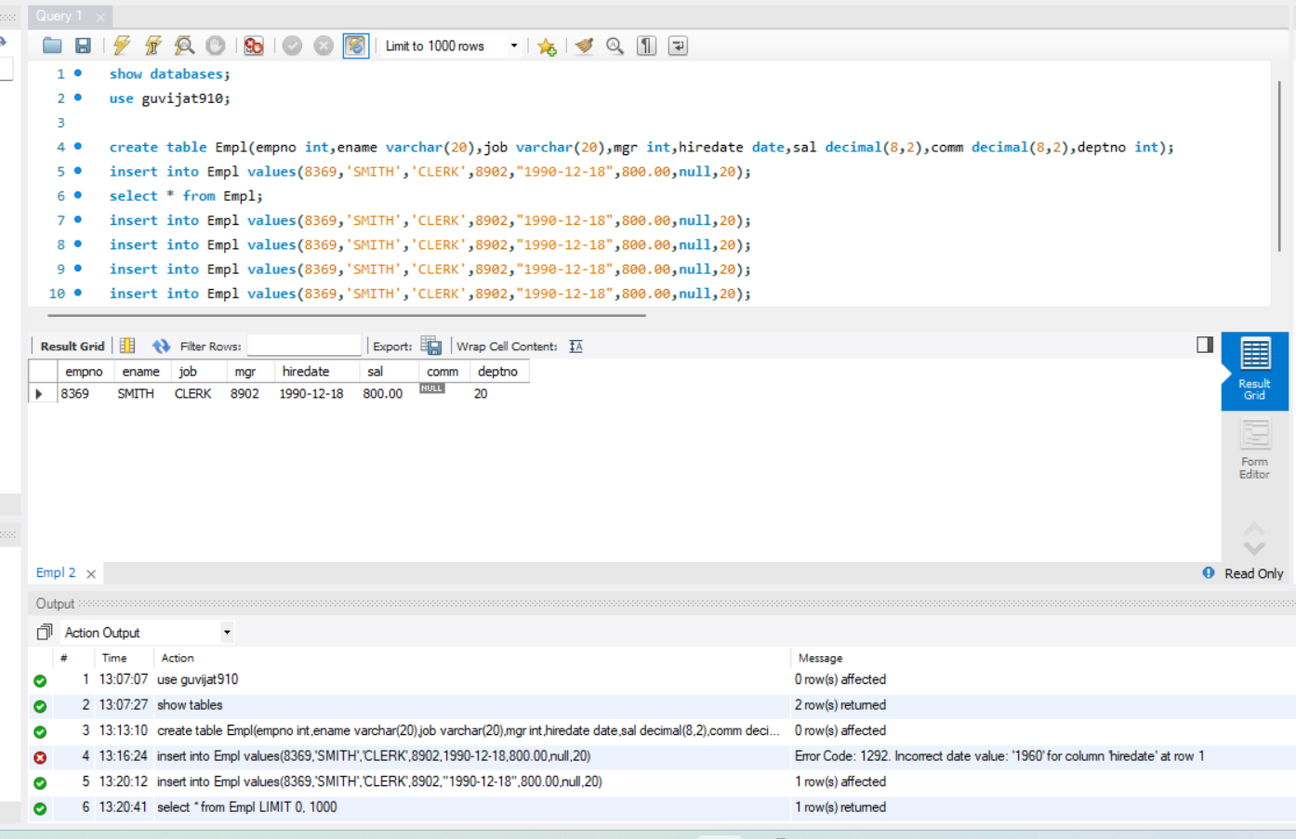

Inserting values:

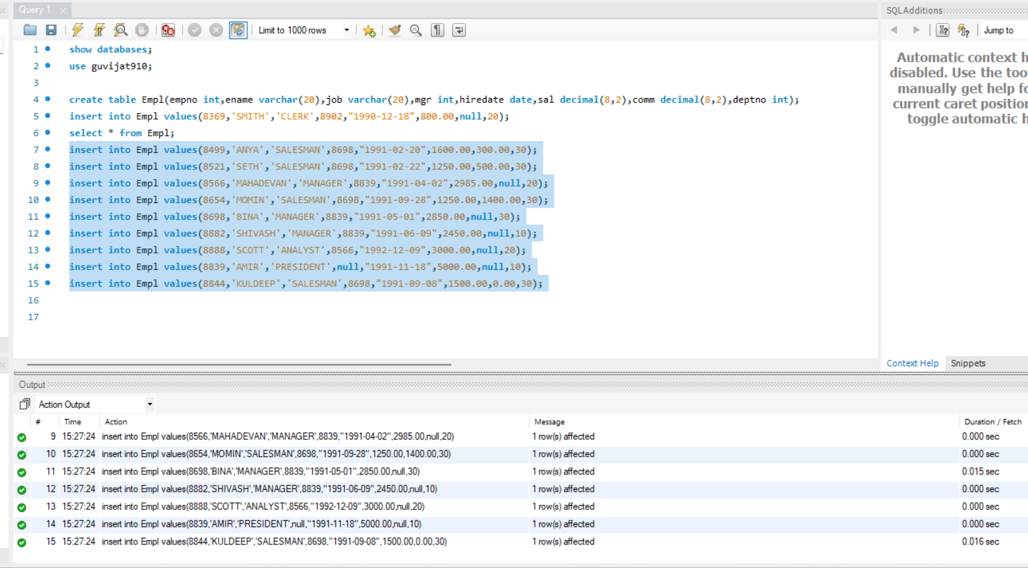

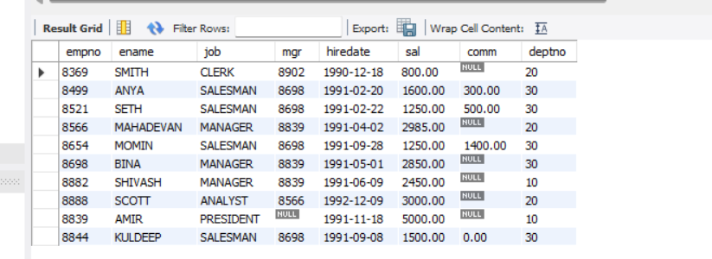

A)ENAME&SAL >=2200

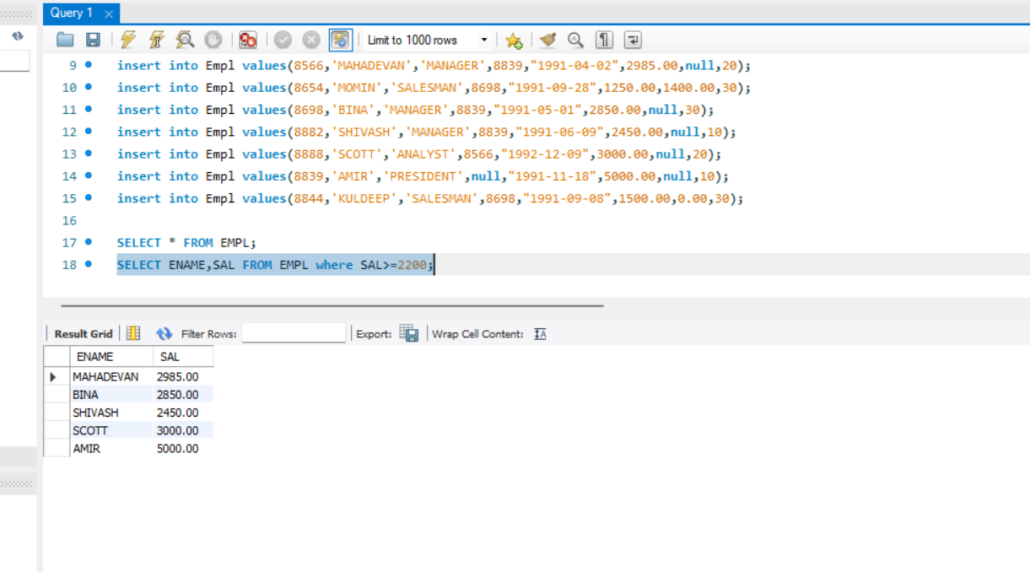

B) NO COMMISION EMPLOYEE LIST

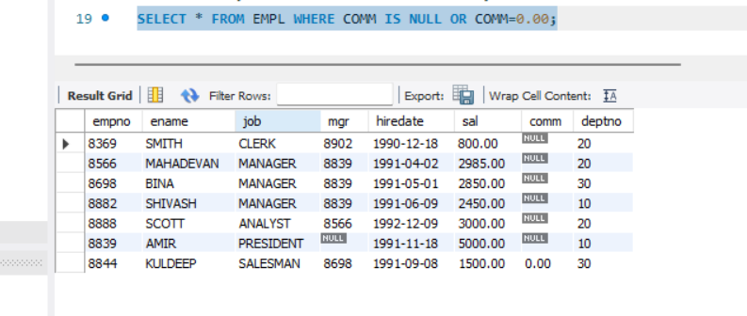

C)ENAME & SALARY NOT B/W SALARY RANGE 2500 TO 4000.

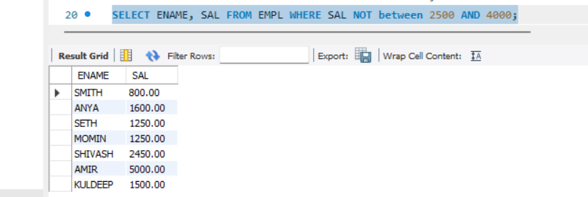

D)NAME,JOB AND SALARY WHERE NOT IN MANAGER ROLE

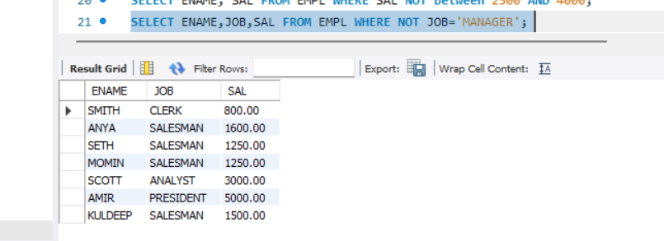

E)EMPLOYEE NAME WITH 3 LETTER as ‘A’

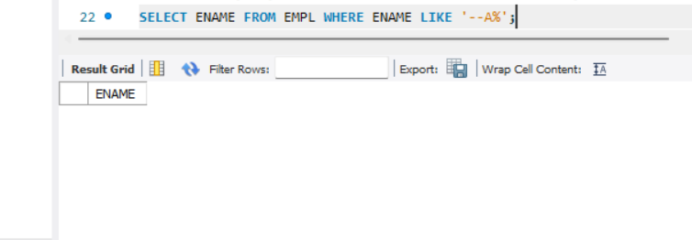

F)EMPLOYEE NAME ENDS WITH ‘T’

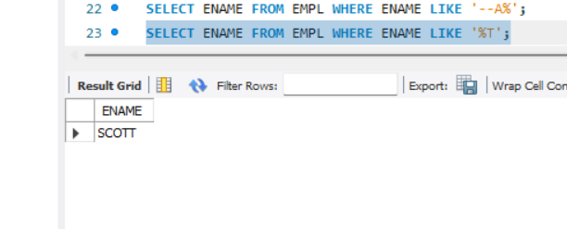

2)Table creation in MySQL using JDBC

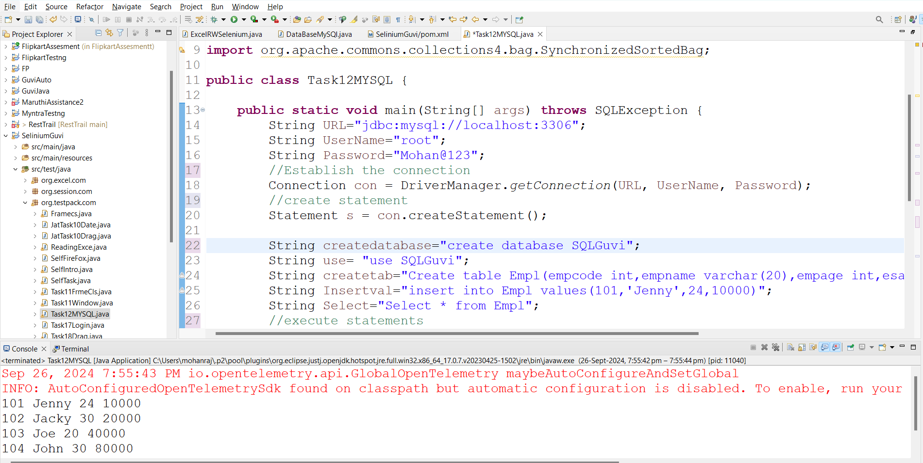

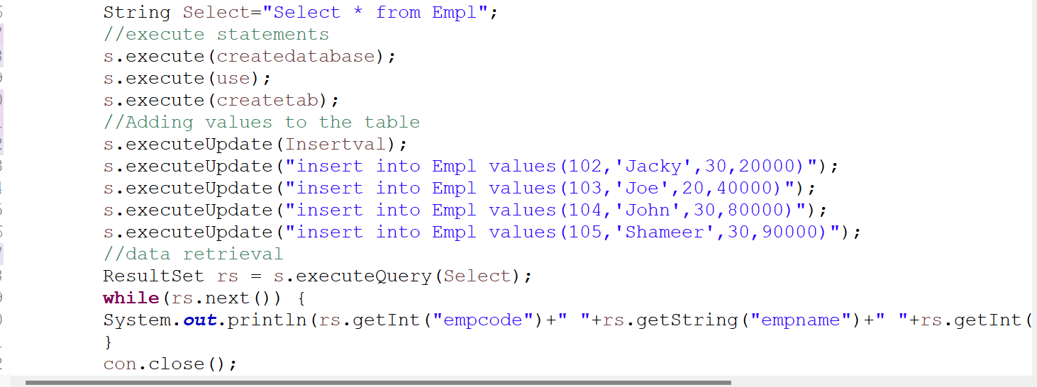

Output:

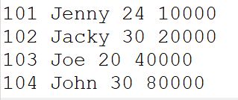

MYSQL:

