1. Write a Java program to implement the following UML class diagram and create a Main class to invoke all the methods.

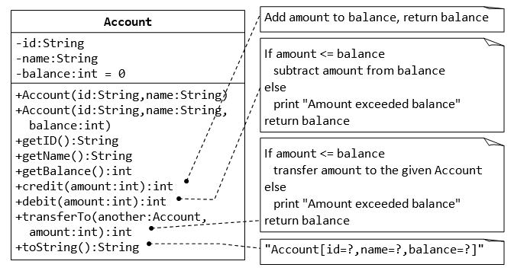

1. Write a Java program to implement the following UML class diagram and create a Main class to invoke all the methods.

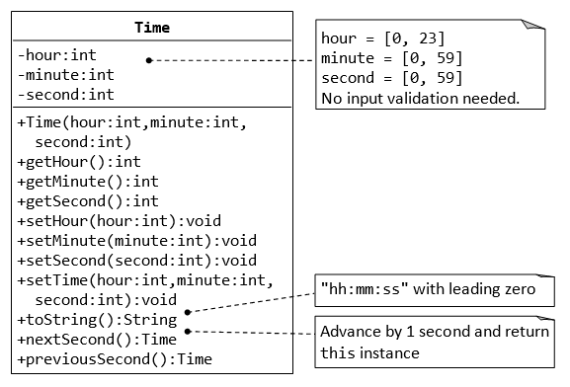

1. Write a Java program to implement the following UML class diagram and create a Main class to invoke all the methods.

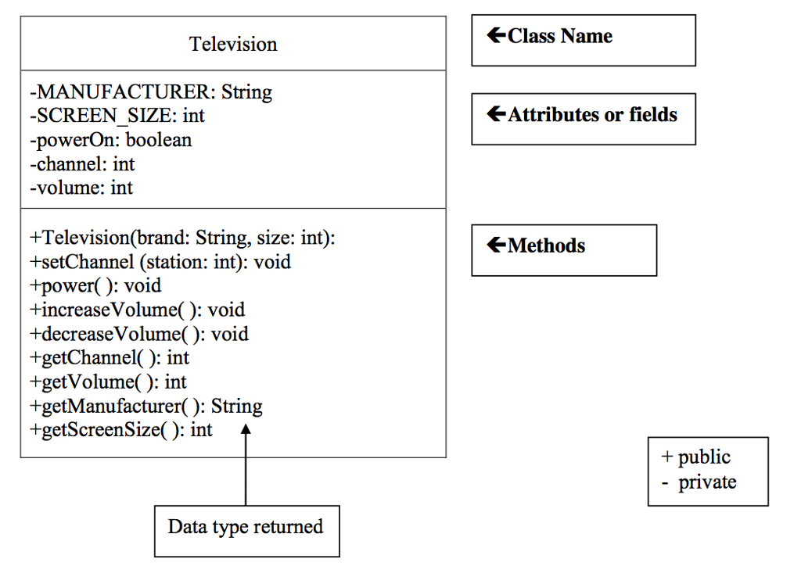

1. Write a Java program to implement the following UML class diagram and create a Main class to invoke all the methods.

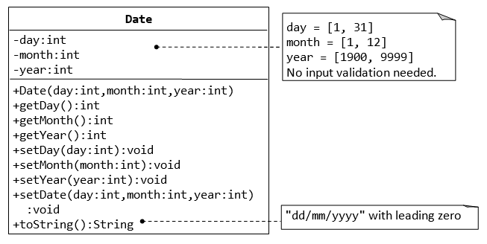

1. Write a Java program to implement the following UML class diagram and create a Main class to invoke all the methods.

|  |
| --- |
| Book |
| - bookId : int  - title : String  - author: String  - price: double |
| + Book()  + getBookId(): int  + setBookId(bookId: int): void  + getTitle(): String  + setTitle(title: String): void  + getAuthor(): String  + setAuthor(author: String): void  + getPrice(): double  + setPrice(price: double): void |

1. Write a Java program to implement the following UML class diagram and create a Main class to invoke all the methods.

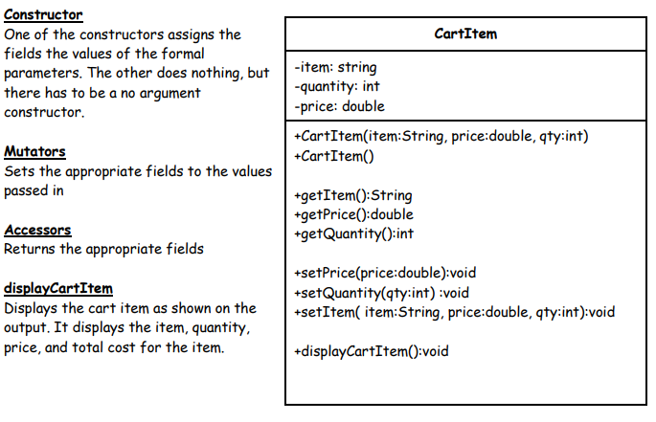

1. Write a Java program to implement the following relationship and create a Main class to invoke all the methods.

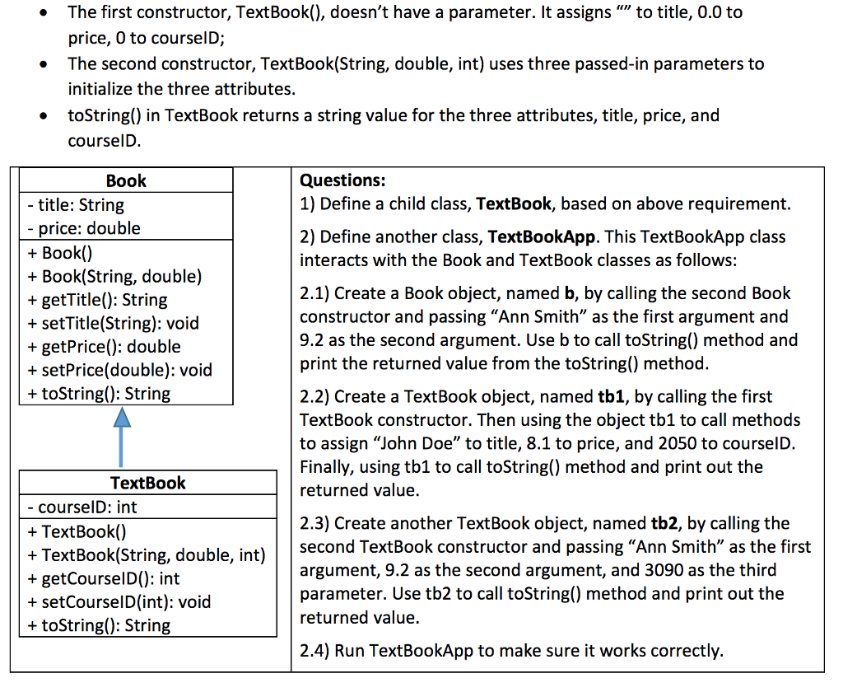

1. Write a Java program to implement the following relationship and create a Main class to invoke all the methods.

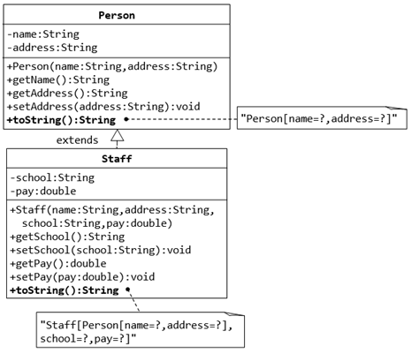

1. Write a Java program to implement the following relationship and create a Main class to invoke all the methods.

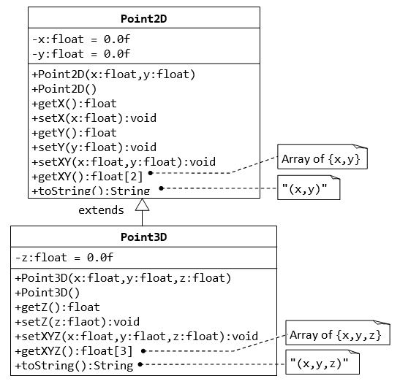

1. Write a Java program to implement the following relationship and create a Main class to invoke all the methods.

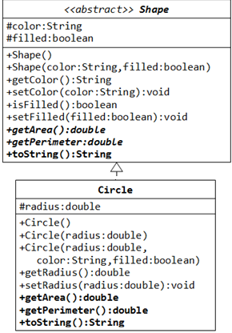

1. Write a Java program to implement the following relationship and create a Main class to invoke all the methods.

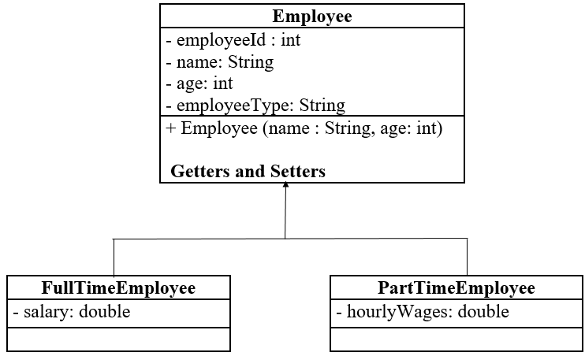

1. Write a Java program to implement the following relationship and create a Main class to invoke all the methods.

