MCXE247 Clock Configuration
Technical Reference: Initialization, Safety Diagnostics & Debugging
IEC 60730 Clock Safety Validation

1 System Overview

1.1 Purpose
This document describes the manual clock bring-up, register configuration, clock tree analysis, IEC 60730 safety diagnostics, and debugging procedure for the NXP MCXE247 microcontroller.
The target application domain is railway CBTC (Communications-Based Train Control) systems, which impose the following constraints on the clock subsystem:
- Deterministic — clock source and frequency must be fixed at startup.
- Stable — no runtime clock switching or dynamic frequency scaling.
- Monitored — clock output is measured against reference.
- Fault-detectable — any clock deviation must be caught.

1.2 Clock Philosophy
The implementation avoids SDK drivers and configures registers directly. This ensures:
- Explicit register-level traceability for functional safety analysis.
- Fail-stop behaviour — clock faults produce a deterministic system halt, not a fallback.
- No hidden runtime reconfiguration by middleware.

Feature | NXP SDK | Custom (This Impl.) | Notes
Uses SDK drivers | Yes | No | Direct register access
Deterministic | No | Yes | Fixed sequence
Fail-stop | No | Yes | No silent fallback
Runtime reconfiguration | Yes | No | Not permitted
Suitable for SIL-4 | ❌ No | ⚠ Possible (with improvements) | Needs diagnostic coverage analysis
Clock fallback allowed | Yes | No | Fail-stop required
Explicit register access | No | Yes | Full traceability
Timing traceability | Hard | Clear | Each step documented
Safety philosophy | General-purpose | Deterministic
Table 1 — NXP SDK vs. Custom Implementation Comparison

2 Hardware Architecture

2.1 System Clock Generator (SCG)
The SCG is the central clock management block on the MCXE247. It integrates:
- FIRC — Fast Internal RC oscillator (~48 MHz). Used as safe startup clock.
- SIRC — Slow Internal RC oscillator (~8 MHz).
- SOSC — System Oscillator. Accepts external crystal or TCXO input.
- SPLL — System Phase-Locked Loop. Multiplies SOSC output to generate high-speed core clock.

2.2 SOSC (System Oscillator)
The SOSC block accepts an external clock source. Two modes are supported:
- Crystal mode — MCXE247 drives the crystal directly.
- Bypass mode — external TCXO signal drives EXTAL pin directly. Used in this implementation for deterministic frequency accuracy.

2.3 SPLL (System PLL)
The SPLL multiplies the SOSC output to produce the high-speed system clock:
- Input: SOSC output (post-PREDIV divider).
- VCO: Input × MULT → internal high-frequency signal.
- Output: VCO ÷ 2 (fixed post-divider).

2.4 Clock Tree
The peripheral clocks (SPLLDIV1, SPLLDIV2) are derived from SPLL output via independent dividers. Peripheral modules are gated separately through PCC (Peripheral Clock Controller) and SIM.

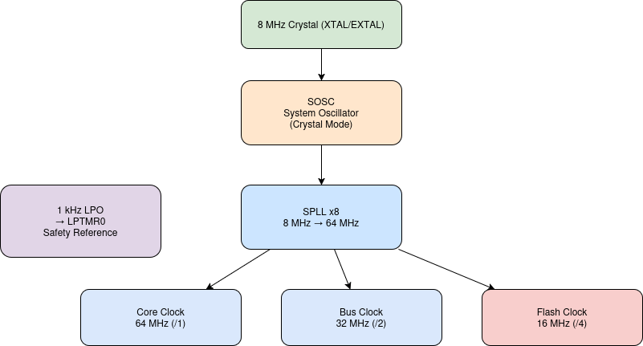
Figure 1 — MCXE247 Clock Tree (Top Level)

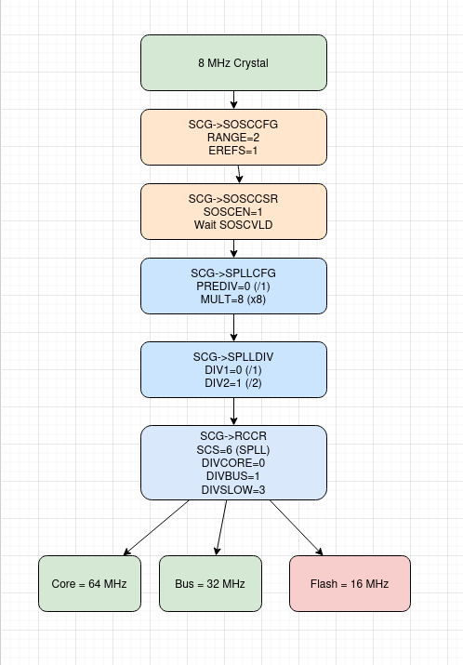
Figure 2 — MCXE247 Clock Tree (Detailed)

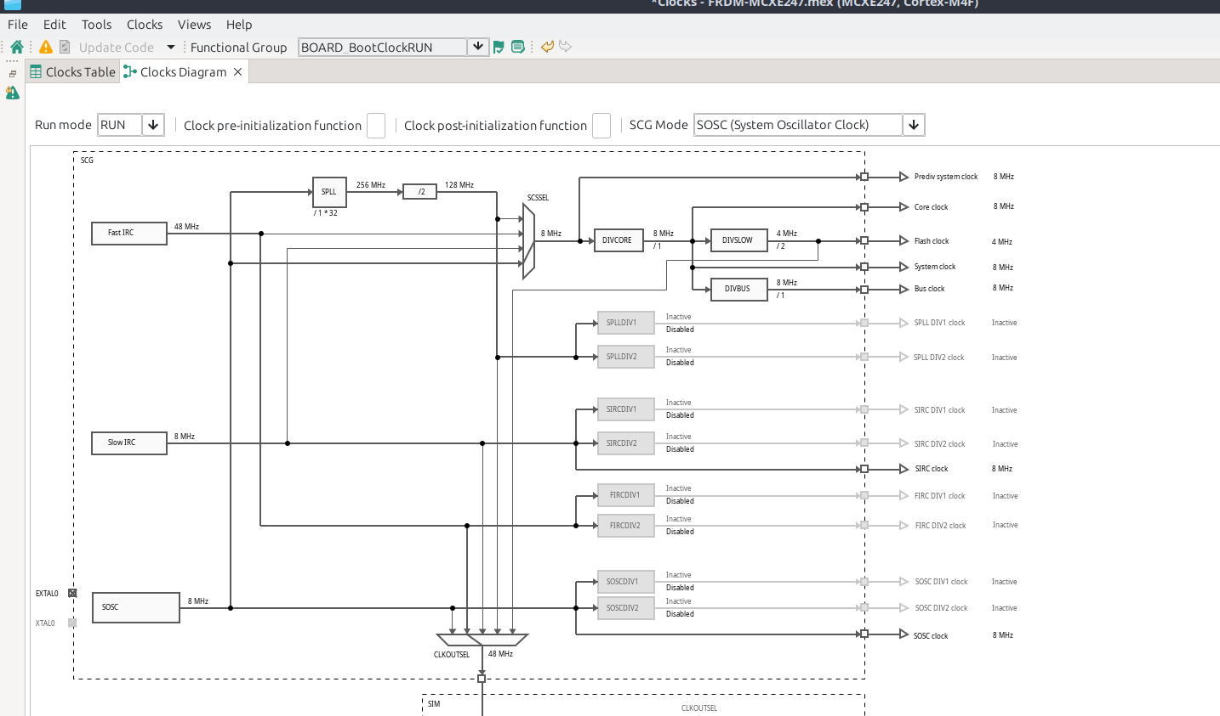
Figure 3 — MCXE247 System Overview Diagram

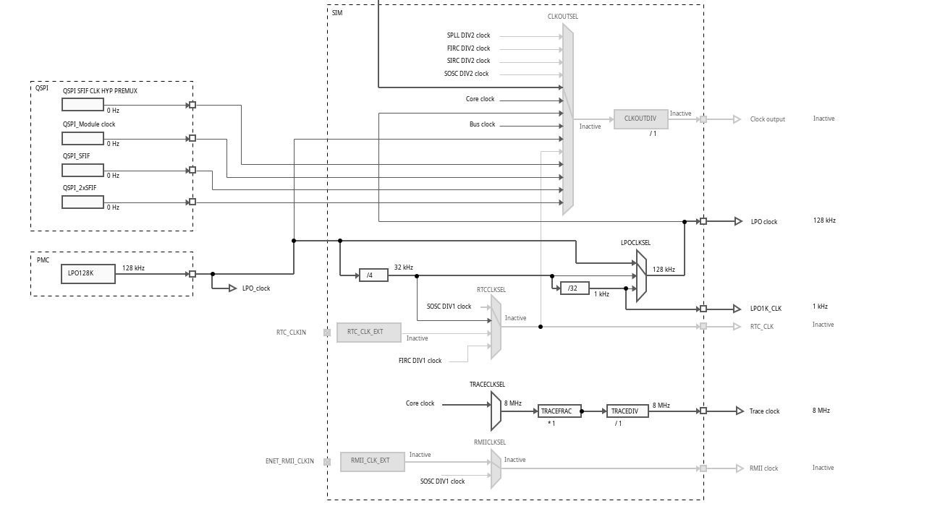
Figure 4 — SCG Block Diagram

Concept | Meaning
SIM | Enables some system-level clocks
PCC | Enables peripheral clocks
CGC bit | Turns ON peripheral clock gate
PR bit | Peripheral ready indicator
CLOCK_EnableClock() | Generic SDK call to enable any peripheral clock
Table 2 — Clock Control Concept Reference

3 Clock Initialization Sequence

The Clock_Init() function follows a strict bring-up order to avoid operating any peripheral at an unsafe frequency during reconfiguration.

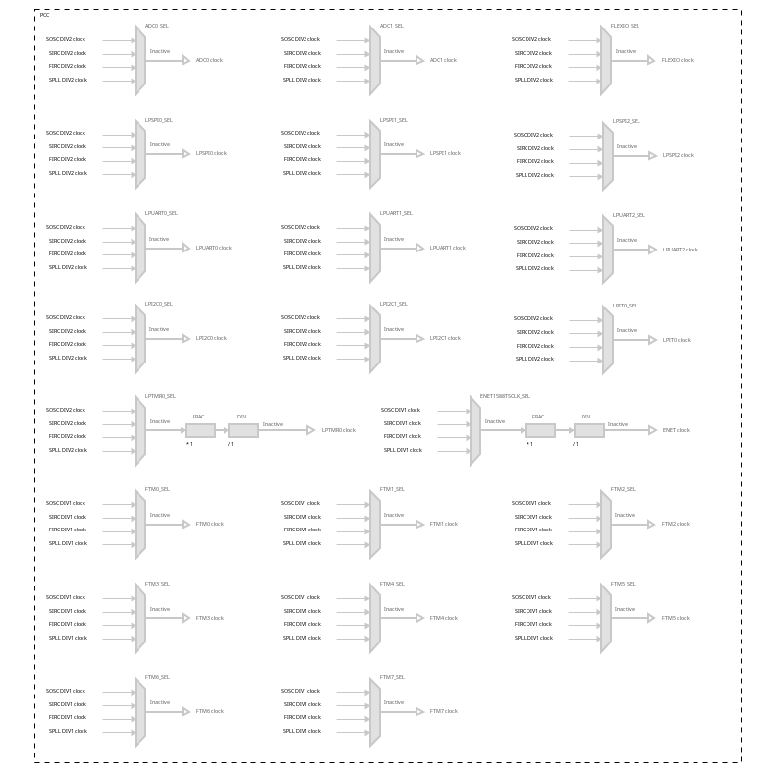
Figure 5 — Clock_Init() Flowchart

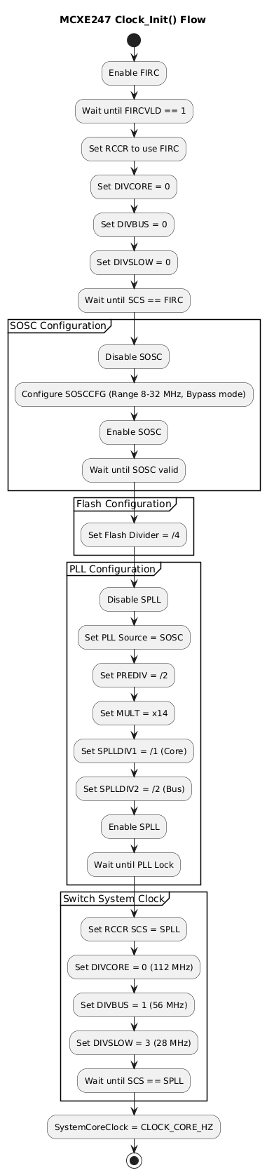
Figure 6 — Clock Initialization Step Detail

3.1 Step-by-Step Sequence

- Start from safe internal clock (FIRC)
SCG->FIRCCSR |= ... FIRCEN
Wait FIRCVLD = 1
Ensures MCU has a stable internal clock before touching any other source.

- Switch system clock to FIRC
SCG->RCCR = SCS(3) ...
Wait CSR[SCS] == 3
Forces system clock to FIRC so that subsequent oscillator and PLL changes do not affect the running core.

- Configure and enable SOSC
Disable SOSC
Set SOSCCFG (bypass mode, range, etc.)
Enable SOSC
Wait SOSCVLD = 1
Configures external TCXO path in bypass mode and waits until hardware reports stable oscillator output.

- Set flash clock divider
FTFC->FCLKDIVR = ...
Sets flash clock divider early so flash does not exceed its maximum operating frequency after PLL switch.

- Configure, enable, and lock SPLL
Disable SPLL
Set SPLLCFG (PREDIV, MULT)
Set SPLLDIV (peripheral clock dividers)
Enable SPLL
Wait SPLLVLD = 1
Programs PLL from SOSC input and waits for lock confirmation.

- Switch system clock to SPLL
SCG->RCCR = SCS(6) with core/bus/slow dividers
Wait CSR[SCS] == 6
Switches system clock source to SPLL and configures final core, bus, and flash dividers atomically.

- Update SystemCoreClock
SystemCoreClock = CLOCK_CORE_HZ
Updates the software variable to reflect actual CPU frequency.

4 Register Configuration

4.1 SOSCCFG
Configures SOSC oscillator mode and frequency range. Key fields:
- EREFS — External reference select: 1 = bypass (external TCXO on EXTAL).
- RANGE — Frequency range select: must match crystal/TCXO frequency band.

4.2 SOSCCSR
SOSC Control and Status Register. Key fields:
- SOSCEN (bit 0) — Enable SOSC.
- SOSCVLD (bit 24) — SOSC output valid (set by hardware when stable).
- SOSCSEL (bit 16) — SOSC selected as clock source.
Verified value: 0x01000001 (enabled + valid).

4.3 SPLLCFG
PLL multiplication and pre-division configuration. Key fields:
- PREDIV[2:0] — Pre-divider. Divides SOSC input before VCO.
- MULT[4:0] — VCO multiplication factor.
For EXTAL = 8 MHz: PREDIV = 0 (÷1), MULT = 31 (×32) → VCO = 256 MHz → output = 128 MHz.
For EXTAL = 16 MHz: PREDIV = 1 (÷2), MULT = 31 (×32) → VCO = 256 MHz → output = 128 MHz.
Verified value: 0x00100000

4.4 SPLLCSR
PLL Control and Status Register. Key fields:
- SPLLEN (bit 0) — Enable SPLL.
- SPLLVLD (bit 24) — PLL locked and output valid.
- SPLLSEL (bit 16) — SPLL selected as system clock.
Verified value: 0x03000001 (enabled + locked + selected).

4.5 RCCR
Run Clock Control Register. Selects system clock source and sets core/bus/flash dividers. Key fields:
- SCS[3:0] — System Clock Source: 3 = FIRC, 6 = SPLL.
- DIVCORE[3:0] — Core clock divider (value = divider − 1).
- DIVBUS[3:0] — Bus clock divider.
- DIVSLOW[3:0] — Slow/flash clock divider.
Verified value: 0x06010013

4.6 SPLLDIV
SPLL Output Clock Dividers for peripheral clock buses. Fields:
- SPLLDIV1[2:0] — Divider for SPLLDIV1 peripheral clock output.
- SPLLDIV2[2:0] — Divider for SPLLDIV2 peripheral clock output.
Verified value: 0x00000000 (dividers set to ÷1 by default).

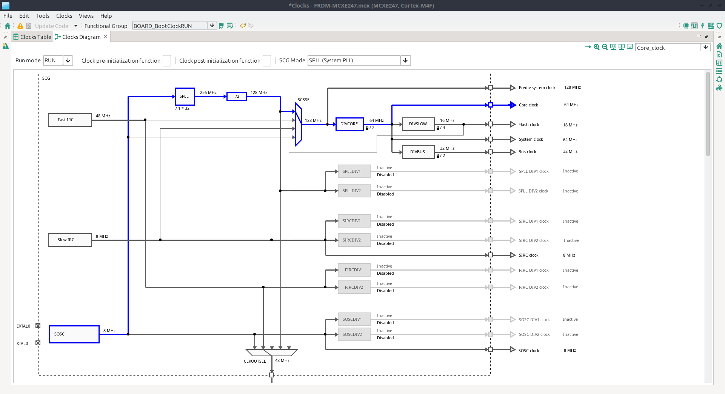
Figure 7 — Register Configuration Screenshot

5 Clock Tree Analysis

5.1 EXTAL = 8 MHz
Clock Domain | Calculation | Result
SOSC | Crystal input | 8 MHz
PLL input | 8 MHz (PREDIV ÷1) | 8 MHz
PLL VCO | 8 × 32 (MULT = 31+1) | 256 MHz
PLL output | VCO ÷ 2 (fixed) | 128 MHz
Core clock | 128 ÷ 2 (DIVCORE) | 64 MHz
Bus clock | 128 ÷ 4 (DIVBUS) | 32 MHz
Flash clock | 128 ÷ 6 (DIVSLOW) | 21.33 MHz
SPLLDIV1 | 128 ÷ 4 | 32 MHz
SPLLDIV2 | 128 ÷ 4 | 32 MHz
Table 3 — Clock Frequencies for EXTAL = 8 MHz

5.2 EXTAL = 16 MHz (TCXO with PREDIV ÷2)
Clock Domain | Calculation | Result
SOSC | TCXO input | 16 MHz
PLL input | 16 ÷ 2 (PREDIV) | 8 MHz
PLL VCO | 8 × 32 (MULT = 31+1) | 256 MHz
PLL output | VCO ÷ 2 (fixed) | 128 MHz
Core clock | 128 ÷ 2 (DIVCORE) | 64 MHz
Bus clock | 128 ÷ 4 (DIVBUS) | 32 MHz
Flash clock | 128 ÷ 6 (DIVSLOW) | 21.33 MHz
SPLLDIV1 | 128 ÷ 4 | 32 MHz
SPLLDIV2 | 128 ÷ 4 | 32 MHz
Table 4 — Clock Frequencies for EXTAL = 16 MHz

Both configurations produce identical final frequencies. The PREDIV field compensates for a higher-frequency TCXO.

6 Safety Diagnostics

6.1 IEC 60730 Clock Test
The IEC 60730 clock test is a runtime diagnostic that verifies the system clock frequency is within a defined tolerance band. It does not reconfigure clocks — it verifies the result of the initialization sequence.

6.2 What the Test Detects

6.2.1 PLL Runaway
If the PLL MULT register is corrupted or misbehaves, the measured frequency will fall outside the MIN/MAX window.

6.2.2 Crystal Drift
If the external 8 MHz crystal deviates beyond its tolerance band, the test detects the deviation.

6.2.3 Divider Corruption
If RCCR divider fields are modified unexpectedly after initialization, the core clock will shift and the test will fail.

6.2.4 Clock Switching Faults
If SCS field was not correctly switched (e.g., system remained on FIRC instead of SPLL), frequency will not match expected.

6.2.5 Periodic Runtime Supervision
The test can be re-run at periodic intervals (e.g., during background task) to increase diagnostic coverage over mission time.

6.3 Frequency Window Validation Mechanism
The test counts system clock ticks against an independent reference clock window, then checks:
MIN_FREQ < measured_freq < MAX_FREQ
If the measured frequency is outside this range, the test reports FAIL. The reference clock is typically FIRC, LPO, or an independent hardware timer — a source independent of SOSC/SPLL.

6.4 What the Test Does NOT Detect
- Incorrect initialization sequence (e.g., wrong wait order).
- Missing VALID bit waits during initialization.
- Incorrect flash clock divider (DIVSLOW).
- Register access order violations.
The test validates frequency output behaviour only, not register structural correctness.

6.5 Open Safety Questions (Unresolved)
- Is reference clock truly independent of SOSC/SPLL?
- What is the tolerance justification for MIN/MAX window?
- What action is taken on failure — safe state or interrupt?
- Is the measurement timeout bounded?
- Has diagnostic coverage been formally analyzed?

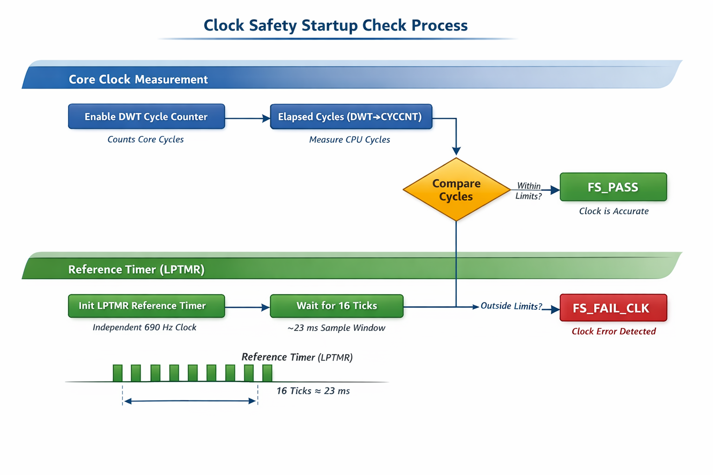
Figure 8 — IEC 60730 Clock Test Block Diagram

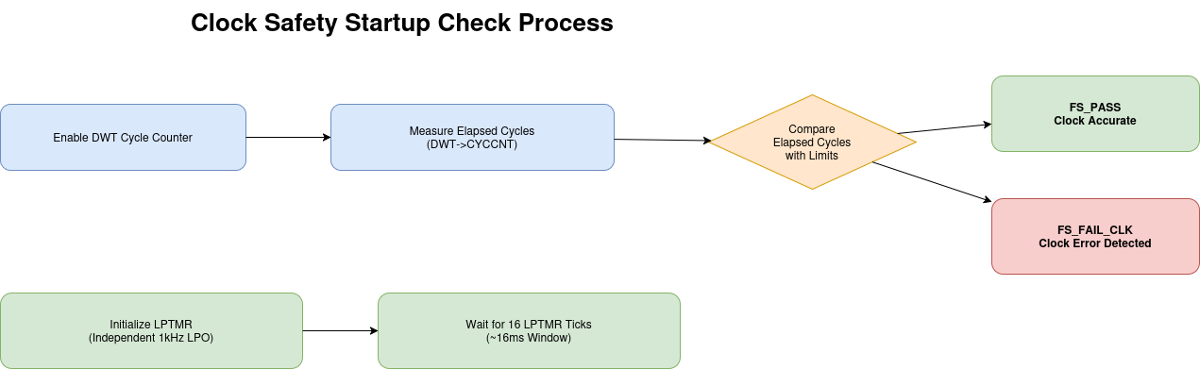
Figure 9 — IEC 60730 Frequency Window Validation

7 Debugging Procedure

7.1 Register Debugging Flow
When a clock problem occurs (system stuck, wrong frequency, PLL not locking), check these six registers in the following order. If all six are correct, the clock system is functioning correctly.

Step | Register | Check | Failure Meaning
1 | SCG->CSR | SCS == expected value | Clock switch failed — system on wrong source
2 | SCG->SOSCCSR | SOSCVLD == 1 | Crystal/TCXO not starting or unstable
3 | SCG->SPLLCSR | SPLLVLD == 1 | PLL not locking — check SOSCCFG/SPLLCFG
4 | SCG->SPLLCFG | PREDIV, MULT match expected | Wrong multiplication or pre-division factor
5 | SCG->RCCR | SCS, DIVCORE, DIVBUS, DIVSLOW correct | Wrong divider — frequency mismatch on core/bus
6 | SCG->SPLLDIV | SPLLDIV1, SPLLDIV2 correct | Peripheral clock frequency wrong
Table 5 — 6-Step Clock Debugging Register Sequence

7.2 Clock Failure Diagnosis Steps

Step 1 — Check System Clock Source
Read: SCG->CSR
Extract SCS field. If SCS ≠ 6 (SPLL not selected), the clock switch in RCCR did not complete. Check that the RCCR write occurred after SPLLVLD = 1.

Step 2 — Check Oscillator Valid
Read: SCG->SOSCCSR
If SOSCVLD = 0, the external oscillator has not started. Check hardware: crystal connections, EREFS mode, RANGE setting, TCXO drive level.

Step 3 — Check PLL Lock
Read: SCG->SPLLCSR
If SPLLVLD = 0, PLL has not locked. Verify SOSC is valid first. Then check SPLLCFG PREDIV and MULT values for correctness.

Step 4 — Check PLL Configuration
Read: SCG->SPLLCFG
Verify PREDIV and MULT fields match the expected frequency calculation. Incorrect MULT causes PLL VCO to target wrong frequency.

Step 5 — Check System Dividers
Read: SCG->RCCR
Verify DIVCORE, DIVBUS, DIVSLOW match the intended divider values. Wrong dividers cause core or peripheral frequency errors without changing the clock source.

Step 6 — Check Peripheral Clock Dividers
Read: SCG->SPLLDIV
Verify SPLLDIV1 and SPLLDIV2 match expected peripheral clock dividers.

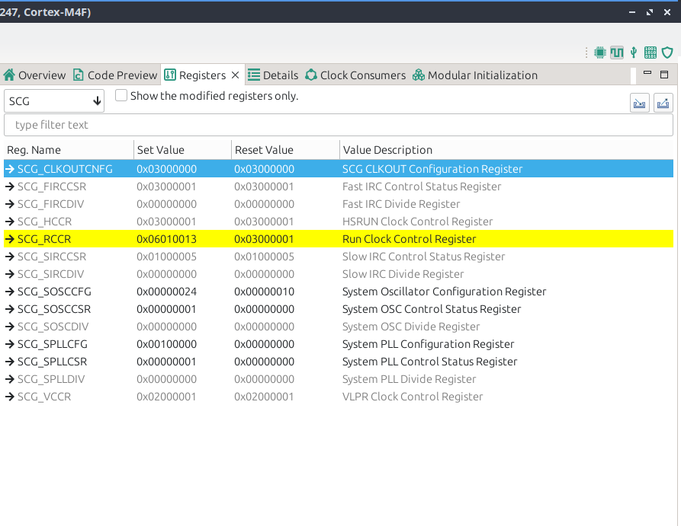
Figure 10 — GDB Register Read — SOSCCSR / SPLLCSR

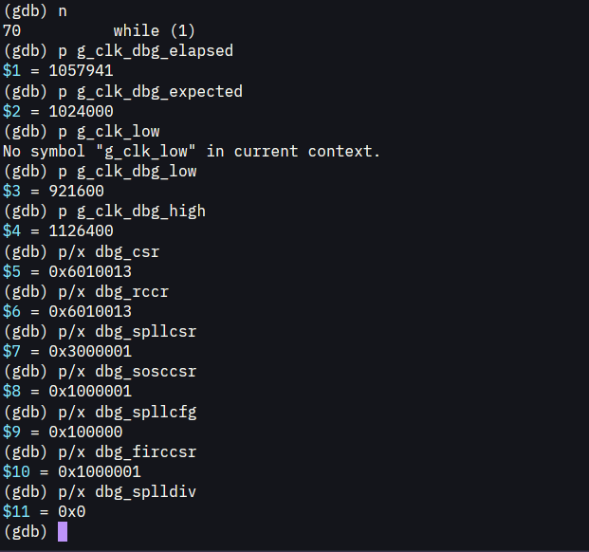
Figure 11 — GDB Register Read — SPLLCFG / SPLLDIV

8 Verification Results

8.1 Register Comparison Table
The following table compares register values as expected by the clock configuration tool against values read back via GDB at runtime.

Register | Config Tool Value | GDB (Actual) | Match?
SPLLCFG | 0x00100000 | 0x00100000 | ✅
SPLLDIV | 0x00000000 | 0x00000000 | ✅
RCCR | 0x06010013 | 0x06010013 | ✅
CSR | 0x06010013 | 0x06010013 | ✅
SPLLCSR | Locked | 0x03000001 | ✅
SOSCCSR | Valid | 0x01000001 | ✅
Table 6 — Register Verification: Config Tool vs. GDB Readback

8.2 Debug Output Validation
Serial debug output captured after Clock_Init() completion:

===== MCX Clock Tree =====
SystemCoreClock: 64000000 Hz
System Clock Source: 6
SOSC CSR: 0x1030001
SPLL CSR: 0x3030001
SPLL CFG: 0x100000
SPLL DIV: 0x202
Core Divider: 1
Bus Divider: 1
Flash Divider: 2
==========================

All values match the clock tree analysis in Section 5. The configuration is confirmed correct for EXTAL = 8 MHz.

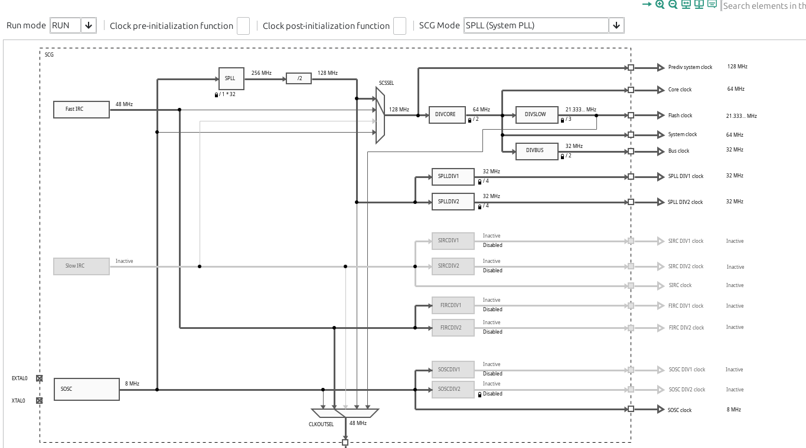
Figure 12 — Clock Register Verification Debug Output

8.3 Confirmation of Diagram Match
The register values and frequency calculations in Sections 4 and 5 exactly match the clock tree diagram (Figure 1 / Figure 2). The initialization sequence produces the expected clock topology without deviation.

