RuInvest.AI
AI DRIVEN INVESTMENT PORTFOLIO MANAGEMENT

Charu Hastir  Consultant, Keev Capital &  Product Manager, OIF Tech  charu.hastir@gmail.com | Kamal Agarwal  Director, Product Success BI  Salesforce  agarwal.kamal@gmail.com | Mohanraj Shanmugam  Director, Technology Solutions  EPAM Systems, India  mohanraz@gmail.com
Mehul Negandhi  Director, Financial Analysis  J P Morgan  mjnegandhi@yahoo.com | Sahil Sanjay Shah  Head of Agile  Hilti Technology Solutions India  sahilshah59@gmail.com | Sandeep Mishra  Director,  J P Morgan  sandeepmishra25@gmail.com

- PROBLEM STATEMENT
Individuals face challenges in effectively building and managing investment portfolios aligned with their financial goals and risk preferences. Without a centralized and intelligent solution, investors often struggle to make informed decisions, leading to suboptimal portfolio performance and increased market risks. Existing portfolio management tools lack the integration of personalized client input, fundamental stock analysis, technical analysis, and sentiment analysis, limiting their ability to provide tailored investment recommendations.

- SOLUTION OVERVIEW
RuInvest.AI is an AI-driven platform designed to assist individuals in building effective investment portfolios. The platform addresses the challenge of crafting and maintaining portfolios that align with users' financial goals and risk preferences. Without a centralized and intelligent solution, investors often struggle to make optimal decisions, leading to increased market risks. RuInvest.AI aims to solve this issue by providing a user-friendly platform that integrates personalized client input, fundamental stock analysis, technical analysis, and sentiment analysis to recommend the Portfolio for the customer. The goal is to empower users with the tools necessary to make informed investment decisions and optimize their portfolios for long-term success.

- ORGANIZATION DESCRIPTION
Vision Statement
To be the leading AI-driven platform empowering individuals worldwide to build and optimize investment portfolios, enabling them to achieve their financial goals with confidence and ease.
Mission Statement
Our mission is to revolutionize the way individuals approach investment portfolio building by providing a comprehensive, AI-driven platform that combines personalized client input, advanced analytics, and intelligent insights. We strive to empower users to make informed investment decisions, manage risks effectively, and achieve long-term financial success.
Goals
- Develop a user-friendly interface that simplifies the portfolio building process for users of all levels of experience.
- Implement advanced AI algorithms to analyze market trends, stock performance, and user preferences to provide personalized investment recommendations.
- Build a robust database of stocks, funds, and other investment opportunities to offer a wide range of options to users.
- Establish partnerships with financial institutions and advisors to enhance the platform's credibility and reach.
- Provide educational resources and tools to help users understand investment principles and make informed decisions.
- Continuously improve the platform based on user feedback and market trends to ensure its effectiveness and relevance.
- Expand the platform's reach globally to empower investors worldwide to achieve their financial goals.

- WHY AI BASED PORTFOLIO MANAGEMENT TOOL?
Portfolio Managers: Currently in the industry Investment Portfolio Management is performed by a Portfolio Manager whose role in investment are:
- Investment Strategy: Develop and implement strategies based on clients' goals, risk tolerance, and market conditions, considering asset allocation and diversification.
- Stock Selection: Research and analyze stocks, bonds, and other assets to identify suitable investments, evaluating company financials and market trends.
- Risk Management: Diversify portfolios, use hedging strategies, and employ risk models to minimize losses and protect capital.
- Performance Monitoring: Continuously monitor portfolio performance using metrics like returns, volatility, and correlation with benchmarks, making adjustments as needed.
- Client Communication: Regularly update clients on portfolio performance, discuss strategies, and educate them on investment principles and trends.
- Regulatory Compliance: Ensure adherence to laws and regulations, following standards set by regulatory bodies to protect investors' interests.
Overall, portfolio managers play a crucial role in helping investors achieve their financial goals by managing their investment portfolios effectively and efficiently.
Asset Under Management:
- AUM stands for "Assets Under Management," which is the total market value of assets managed by a portfolio manager or financial institution on behalf of clients. AUM is a key metric used to measure the size and growth of a portfolio management business.
- Portfolio managers use AUM to gauge their business's scale, track performance, and assess revenue potential. AUM includes a variety of assets, such as stocks, bonds, mutual funds, ETFs, and other investment vehicles. As a portfolio manager's AUM grows, so does their potential revenue, as fees are often based on a percentage of AUM.
- AUM can fluctuate based on market performance, client inflows and outflows, and investment decisions made by the portfolio manager. Overall, AUM is a critical metric for portfolio managers, as it provides insights into the size and health of their business.
Here are some reasons why higher AUM might lead to lower performance:
- Capacity Constraints: Managing larger amounts of capital can limit a portfolio manager's ability to invest in smaller, less liquid securities that may offer higher returns. This can result in a more conservative investment approach and potentially lower returns.
- Market Impact: Trading large positions in the market can impact prices, especially in less liquid markets. This can result in higher transaction costs and lower overall returns for the portfolio.
- Dilution of Skill: As AUM grows, portfolio managers may have to delegate more responsibilities to junior staff, which could lead to a dilution of skill and potentially lower performance.
- Style Drift: Managing larger portfolios may tempt portfolio managers to deviate from their investment style or take on more risk in an attempt to generate higher returns, which can lead to lower performance.
- Benchmark Effects: As AUM grows, portfolio managers may find it challenging to beat benchmark returns, especially in efficient markets, leading to lower relative performance.
Industry Study On AUM Size Vs Portfolio Performance:
To illustrate the potential impact of AUM size on portfolio manager performance, we can look at industry studies and research that have examined this relationship. While it's important to note that the relationship can vary based on numerous factors, including the skill of the portfolio manager and the investment strategy employed, some studies suggest that larger AUM can indeed be associated with lower performance.
- Morningstar Study: A study by Morningstar found that mutual funds with higher AUM tend to underperform those with lower AUM over time. The study suggests that larger funds may find it challenging to generate alpha (excess returns above a benchmark) due to liquidity constraints and limited investment opportunities.
- Hedge Fund Research (HFR) Index: The HFR indices track the performance of hedge funds across different strategies and sizes. While the relationship between AUM and performance can vary by strategy, some indices suggest that larger hedge funds may have slightly lower returns compared to smaller funds within the same strategy.
- Academic Research: Several academic studies have examined the impact of AUM on mutual fund performance. Some studies have found evidence of a negative relationship between AUM and performance, suggesting that as AUM increases, the ability to outperform a benchmark decreases.
- Industry Reports: Reports from industry research firms such as Preqin and eVestment provide insights into the performance of different types of investment funds based on their AUM size. These reports can offer a broader perspective on how AUM size may impact performance across various investment strategies and asset classes.
While these studies and reports provide valuable insights, it's essential to interpret the findings with caution. The relationship between AUM and performance can be influenced by various factors, and individual portfolio managers may be able to overcome the challenges associated with managing larger AUM to deliver strong performance.

Why AI Based Personalized Investment Portfolio Management?
AI-based portfolio management tools like RuInvest.AI can solve the problem of creating investment portfolios tailored to individual needs and market conditions in several ways:
- Personalization: AI algorithms can analyze an individual's financial goals, risk tolerance, and investment preferences to create a personalized investment portfolio. This ensures that the portfolio aligns with the individual's specific needs and objectives.
- Market Analysis: AI can analyze market conditions, trends, and economic indicators to make informed investment decisions. This allows the portfolio to be adjusted based on current market conditions, potentially improving performance and minimizing risk.
- Dynamic Portfolio Management: AI can continuously monitor the portfolio and make real-time adjustments based on changing market conditions. This dynamic approach ensures that the portfolio remains optimized and aligned with the individual's investment goals.
- Risk Management: AI can assess and manage risk by diversifying the portfolio across different asset classes and industries. It can also identify potential risks and recommend strategies to mitigate them, helping to protect the individual's investment capital.
- Performance Tracking: AI can track the performance of the portfolio and provide insights into its performance drivers. This allows the individual to monitor the portfolio's performance and make informed decisions about future investments.
Overall, AI-based portfolio management tools like RuInvest.AI offer a powerful solution for creating and managing investment portfolios that are tailored to individual needs and market conditions. By leveraging AI algorithms, these tools can help individuals achieve their investment goals while minimizing risk and maximizing returns.
5. INDUSTRY OVERVIEW
The AI-based portfolio management tools industry is experiencing rapid growth and innovation as financial firms and investors increasingly turn to artificial intelligence to enhance their investment strategies. This industry encompasses a wide range of software and services that leverage AI algorithms to analyze market data, identify investment opportunities, and manage portfolios more effectively. Here's an overview of key aspects of the AI-based portfolio management tools industry:
- Market Size and Growth: The global AI in Fintech market, which includes AI-based portfolio management tools, is expected to reach $22.6 billion by 2025, growing at a CAGR of 40.4% from 2020 to 2025. This growth is driven by increasing demand for advanced analytics, automation, and personalized investment solutions.
- Key Players: The industry is dominated by a few key players, including established financial technology companies and startups. Some of the leading players in the AI-based portfolio management tools industry include BlackRock, IBM, Alpaca, and Wealthfront.
- Technology Trends: AI-based portfolio management tools are leveraging advanced technologies such as machine learning, natural language processing, and predictive analytics to provide more accurate and personalized investment recommendations. These tools can analyze vast amounts of data from various sources, including market data, financial reports, and news articles, to identify trends and opportunities in real-time.
- Benefits: AI-based portfolio management tools offer several benefits, including improved investment decision-making, better risk management, and enhanced portfolio performance. These tools can automate routine tasks, such as portfolio rebalancing and performance tracking, allowing portfolio managers to focus on strategic decisions.
- Challenges: Despite the benefits, AI-based portfolio management tools face several challenges, including data privacy concerns, regulatory compliance, and the risk of algorithmic bias. Ensuring the accuracy and fairness of AI algorithms is crucial to building trust with investors and regulators.
- Overall, the AI-based portfolio management tools industry is poised for continued growth and innovation as firms seek to leverage AI to gain a competitive edge in the rapidly evolving financial markets.
6.INDUSTRY GROWTH AND OUTLOOK
The AI-based portfolio management tools industry is experiencing robust growth and is poised for further expansion in the coming years. Several factors are driving this growth and shaping the industry's outlook:
- Increasing Adoption of AI: Financial firms and investors are increasingly recognizing the benefits of AI in portfolio management, such as improved decision-making, enhanced risk management, and better performance. This is driving the adoption of AI-based tools across the industry.
- Technological Advancements: Advances in AI technologies, such as machine learning and natural language processing, are enabling more sophisticated and accurate portfolio management tools. These advancements are enhancing the capabilities of AI-based tools and driving their adoption.
- Growing Demand for Personalization: Investors are seeking more personalized and tailored investment solutions to meet their specific needs and objectives. AI-based portfolio management tools can provide personalized recommendations and strategies, driving their adoption among investors.
- Regulatory Environment: The regulatory environment is evolving, with regulators increasingly focusing on the use of AI in financial services. While this presents challenges, it also provides opportunities for AI-based portfolio management tools to demonstrate compliance and gain regulatory approval.
- Competitive Landscape: The industry is becoming more competitive, with new entrants and existing players launching innovative AI-based tools. This competition is driving innovation and leading to the development of more advanced and sophisticated portfolio management solutions.
Overall, the AI-based portfolio management tools industry is expected to continue growing at a rapid pace, driven by increasing adoption, technological advancements, and growing demand for personalized investment solutions. As AI technologies continue to evolve and become more sophisticated, the industry is likely to see further innovation and expansion, offering new opportunities for financial firms and investors alike.
- PwC’s 2023 Global Asset and Wealth Management Survey, which includes forecasts through 2027, predicts that assets managed by the algorithm-driven and increasingly AI-enabled digital platforms will surge to almost US$6 trillion by 2027, nearly double the figure for 2022.
- As per the CFA Institute research, AI and big data have the potential to bring about the most significant change to the investment management industry that current professionals will experience in their careers.
SOURCE: PWC; CFA Institute
7. SOLUTION

Application Design
- RuInvest.AI will be accessible to end customers as a mobile app or web application. This section will explore the customer journey within the application.
- Customers will sign up for the application through either the mobile app or web application.
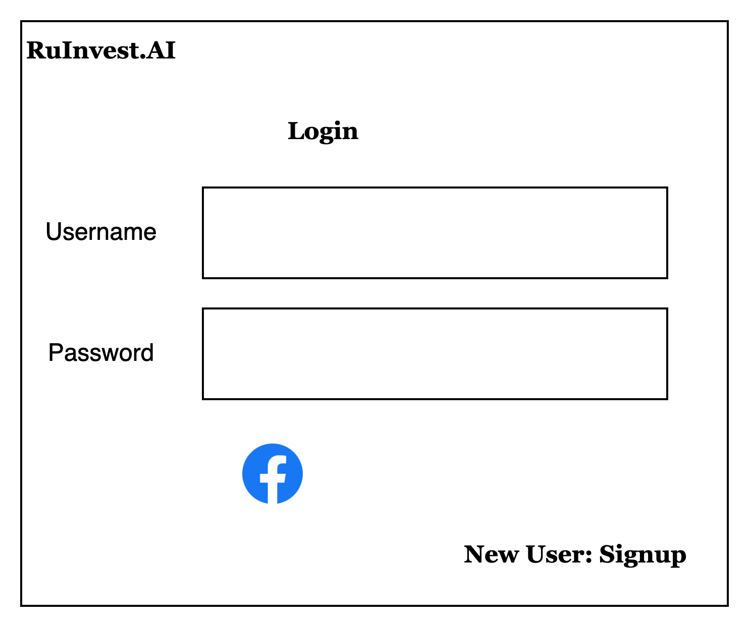
- After signing up, users will be directed to their profile page where they will input their name, age, and the size of the portfolio they wish to build.
- Once these three pieces of information are provided, the Portfolio Recommendation template will be displayed. This template utilizes the recommendation engine.
- Users can choose to either use the recommended template or customize it.
- Customization involves specifying the percentage allocation of the portfolio for high, medium, and low-risk investments.
- The system will also calculate the risk type based on the user's profile.
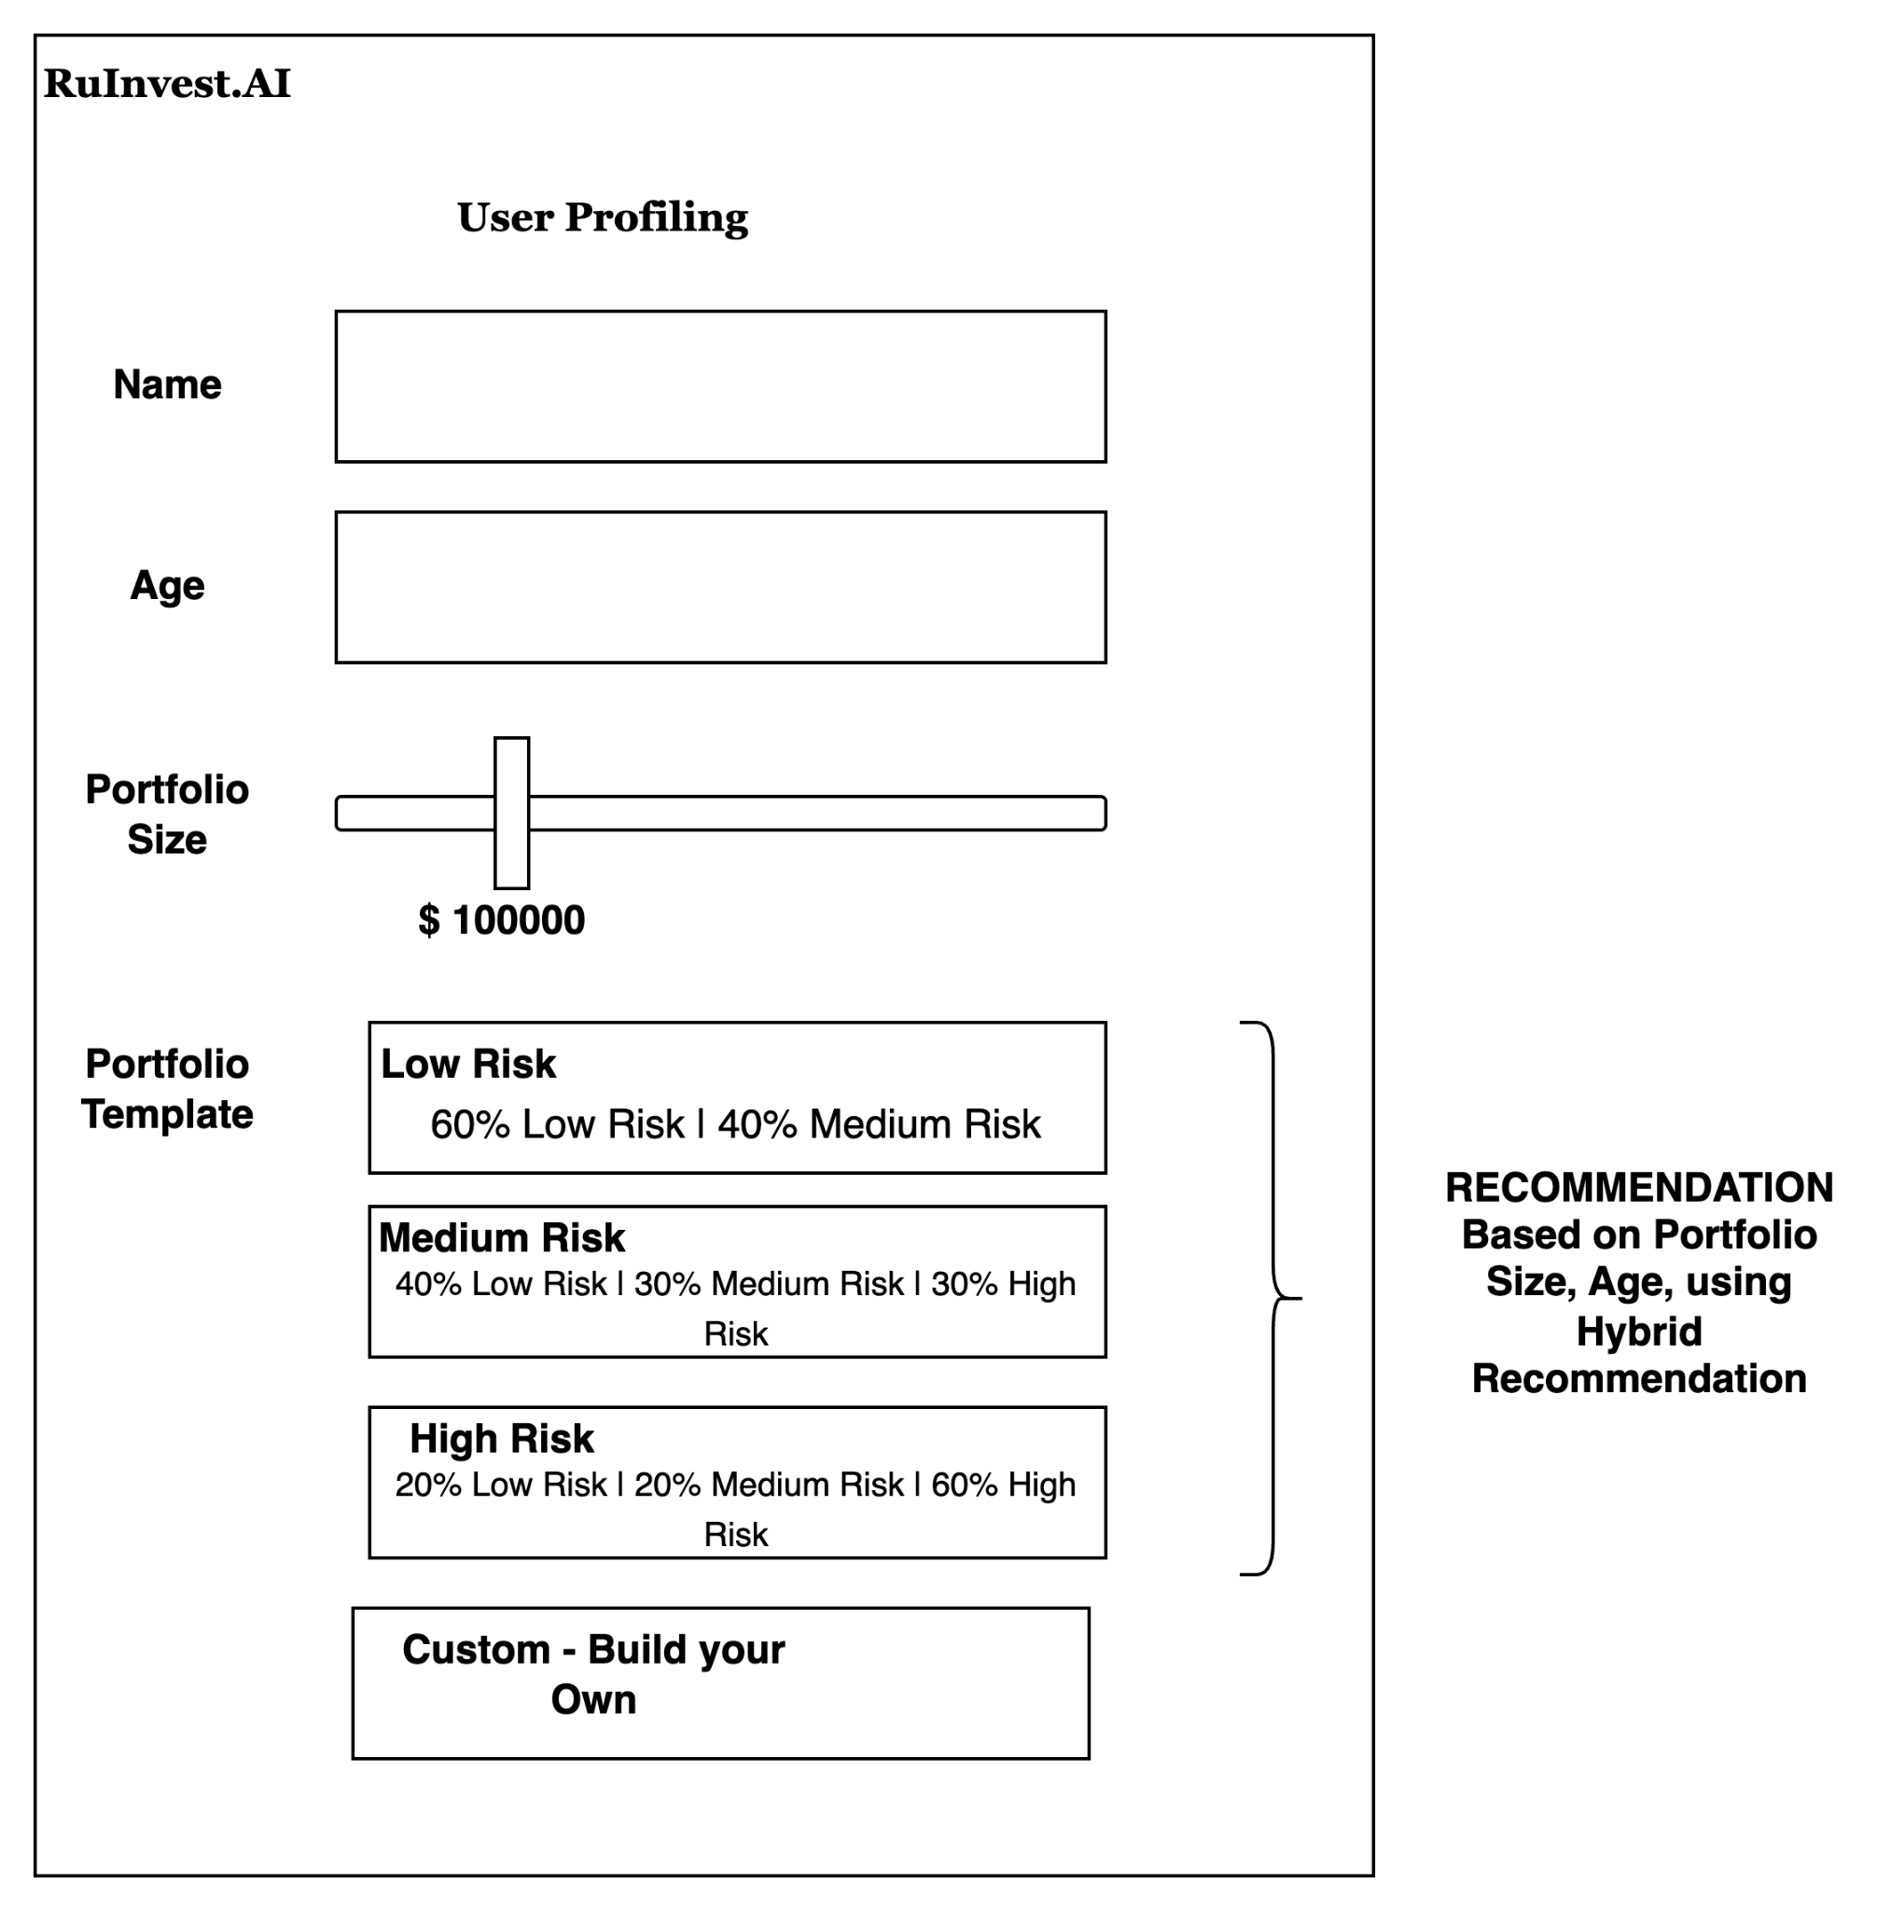
- Once a user completes their profile for the first time, they will land in the portfolio management application. At the top, the user's profile will be displayed, allowing the user to change their template and adjust their risk profile as needed.
- The layout of the application features a Stock Picker window on the right-hand side, where users can select stocks. RuInvest.AI will recommend stocks and indicate their risk profile based on the portfolio, using a recommendation engine.
- After selecting stocks, the application will calculate the number of stocks to pick based on the Ru Score of the stock and its price, inline with the user's portfolio.
- Below this, the application will predict the portfolio's growth for the next four quarters.
- Once the portfolio is applied to an associated broker, buy or sell actions are performed. The software also tracks the stocks in real-time, providing positive or negative indicators and recommending rebalancing of the stocks.

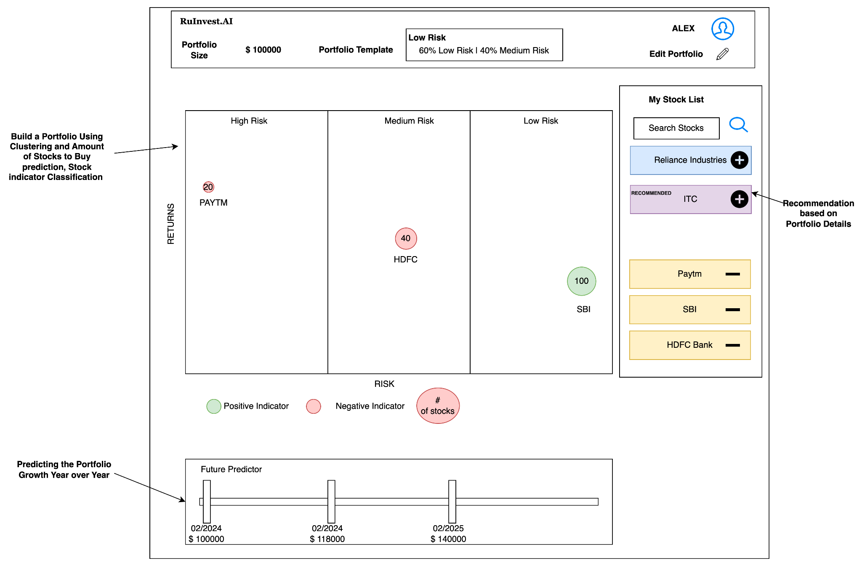

DETAILED DESIGN
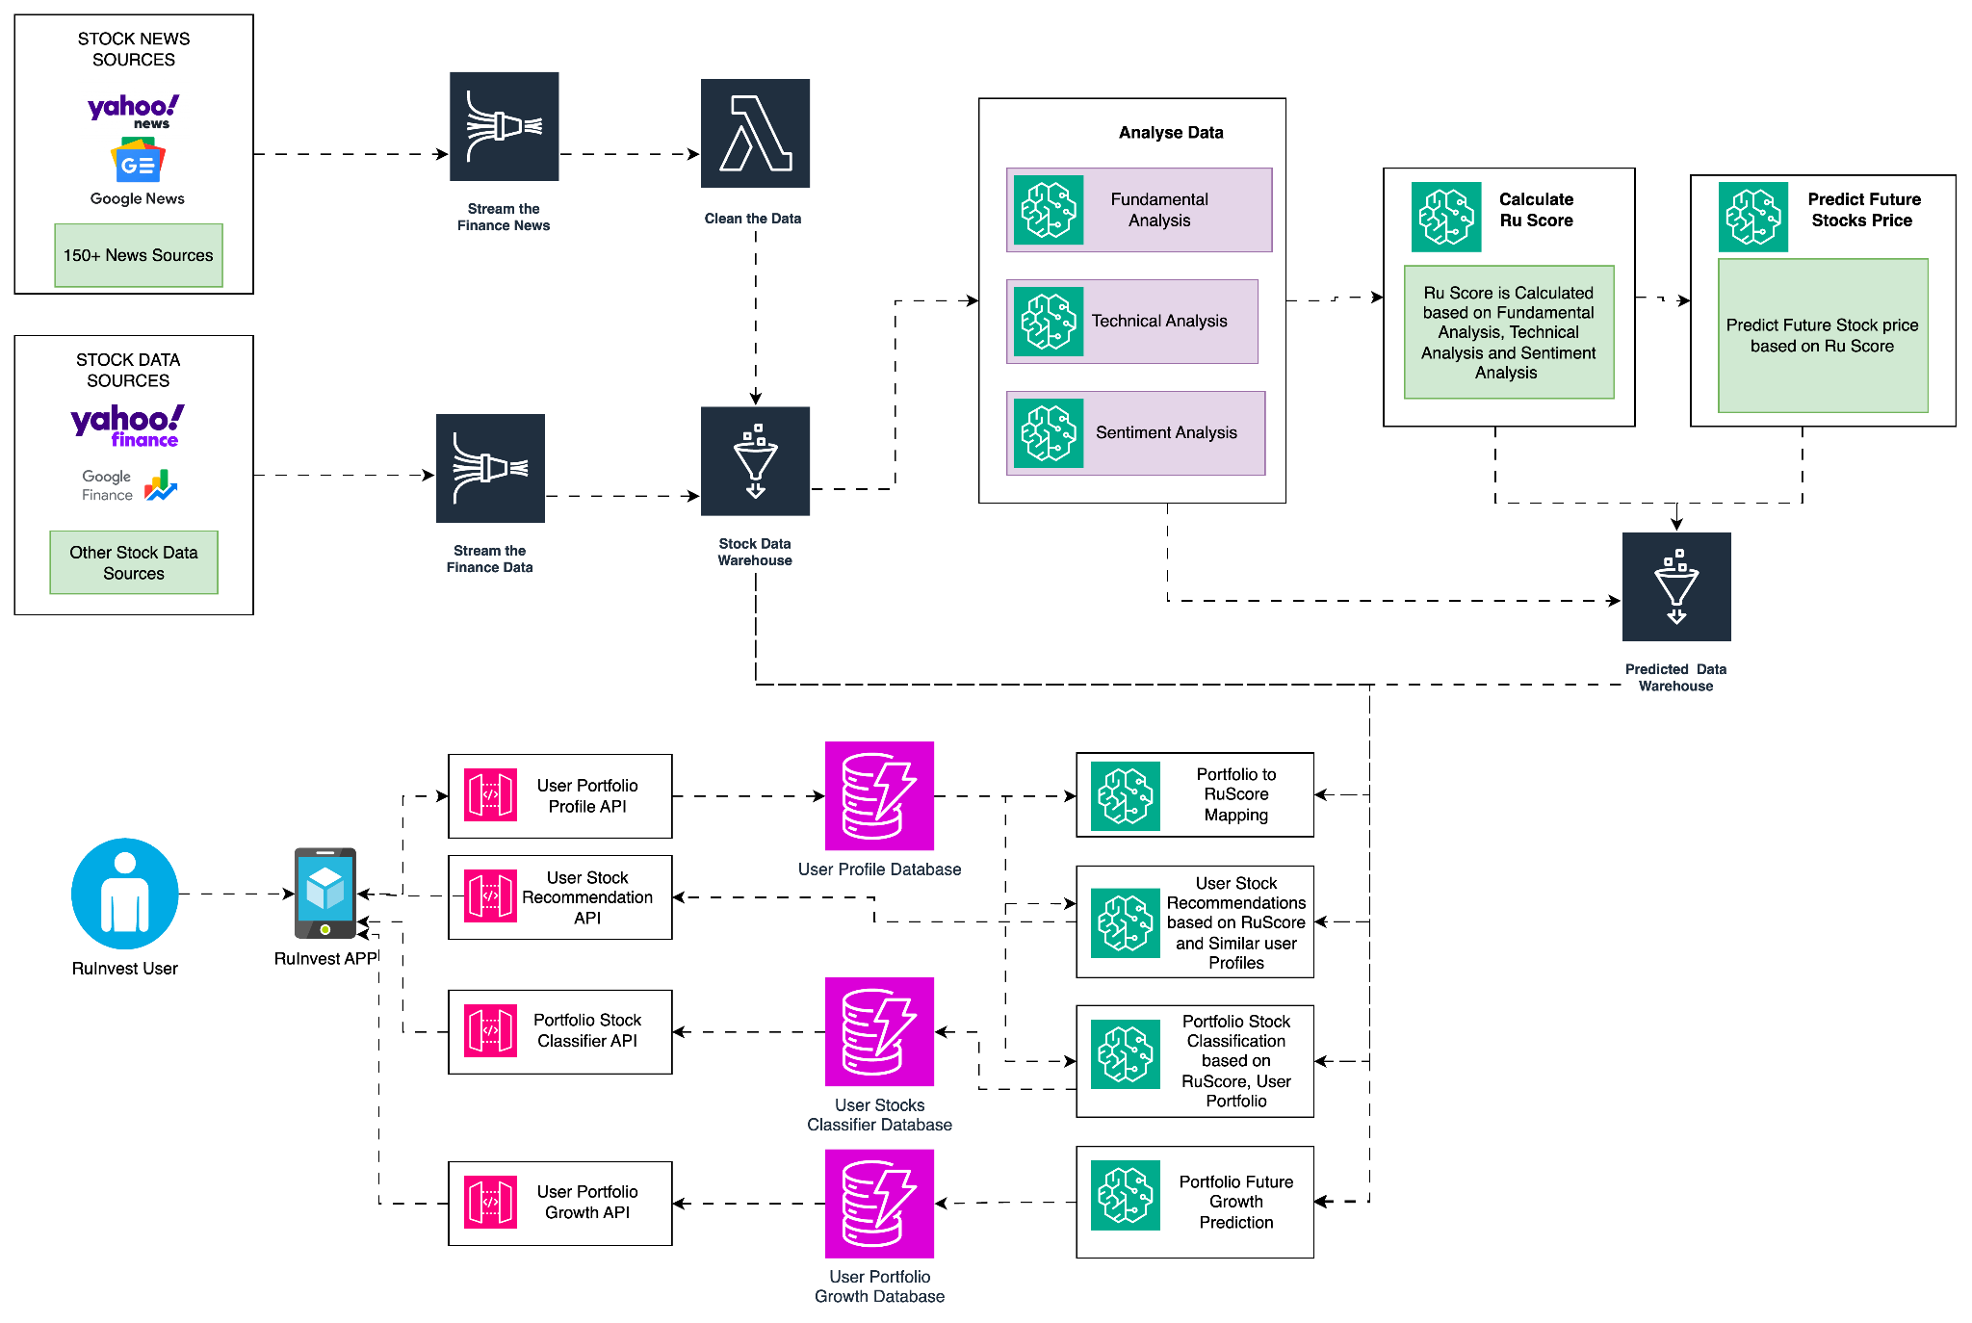
- The system design for RuInvest.AI begins with acquiring stock and market data from established platforms such as Yahoo Finance, Google Finance, and stock exchanges like the National Stock Exchange and Bombay Stock Exchange. This data is streamed and transformed using platforms like Amazon Kinesis, and then stored in the Stock Data Lake.
- To understand sentiment, regulations, and news related to stocks, data is collected from various sources including Yahoo News, Google News, and over 150 curated platforms. This data is also streamed, transformed, and stored in the Stock Data Lake.
- RuInvest.AI conducts three types of analysis for each stock:
- Fundamental Analysis: This measures the performance of the stock's organization and business performance.
- Technical Analysis: This measures the stock price trends and their influence on macro factors.
- Sentiment Analysis: This measures the sentiment of investors, regulators, and other market participants from the 150+ sources.
- All three analyses use machine learning algorithms, as discussed in further sections. The output of these analyses is a composite score called RuScore, which represents the overall health of the stock. RuInvest.AI uses the RuScore for all actions within the application.
- Using the RuScore, the platform predicts the share price for the next four quarters and stores the RuScore and predicted share price in the Ru Prediction Data Lake.
- When a user provides their profile, the platform creates a RuScore range for the user's portfolio, categorized as low, medium, or high risk. Based on this range, a recommendation engine, trained on various portfolio templates, suggests a portfolio. Once the user selects a portfolio, the platform calculates the recommended stocks using the stock recommendation engine.
- After the user adds stocks to their portfolio, the platform calculates the number of stock predictions using regression. Finally, it uses the predicted stock prices to calculate the future growth of the portfolio.
Fundamental Analysis
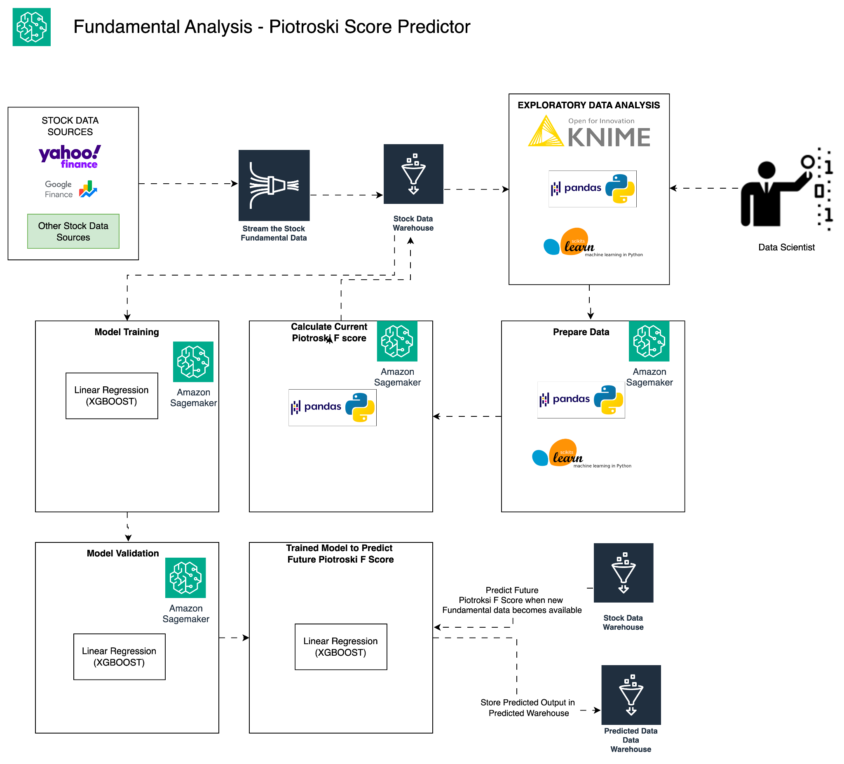
- For Fundamental Analysis, data is extracted from the Stock Data Warehouse. An exploratory data analysis (EDA) is performed, and the data is prepared for transformation and normalization using industry-standard tools such as Knime, Python Pandas, and the Scikit-Learn library. Once the data is prepared, the Piotroski F Score is calculated for all previous quarters for the last 10 years for the organization.
- The Piotroski Score is a discrete score between zero and nine that reflects nine criteria used to determine the strength of a firm's financial position. It is used to identify the best value stocks, with nine being the best and zero being the worst. The score is based on specific aspects of a company's financial statements, focusing on accounting results in recent years.
- The criteria for the Piotroski Score are divided into three categories:
  - Profitability:
    - Positive net income (1 point)
    - Positive return on assets (ROA) in the current year (1 point)
    - Positive operating cash flow in the current year (1 point)
    - Cash flow from operations greater than net income (quality of earnings) (1 point)
  - Leverage, Liquidity, and Source of Funds:
    - Lower amount of long-term debt in the current period compared to the previous year (1 point)
    - Higher current ratio this year compared to the previous year (1 point)
    - No new shares issued in the last year (lack of dilution) (1 point)
  - Operating Efficiency:
    - Higher gross margin compared to the previous year (1 point)
  - Higher asset turnover ratio compared to the previous year (1 point)
- Model proposed to use is XGBoost with LTSM.
- After calculating the Piotroski Score for the previous data, a model is built to predict the Piotroski score for the next four quarters. This model uses regression, specifically XGBoost with LSTM. XGBoost with LSTM has been shown to provide better results than traditional ARIMA models for regression with stock data, as mentioned in the research paper provided.
Reference: https://www.techscience.com/csse/v40n1/44219/html
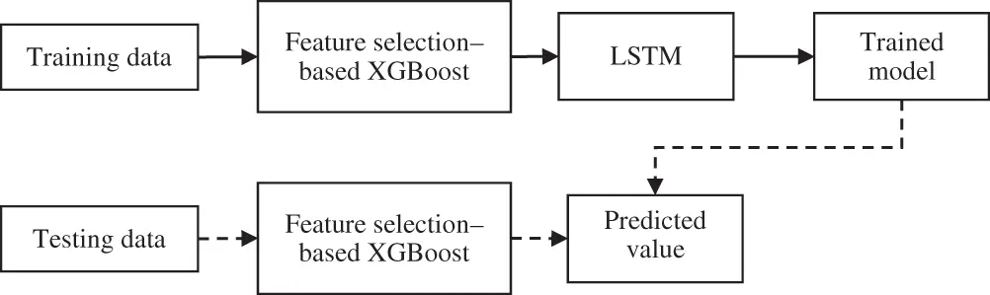
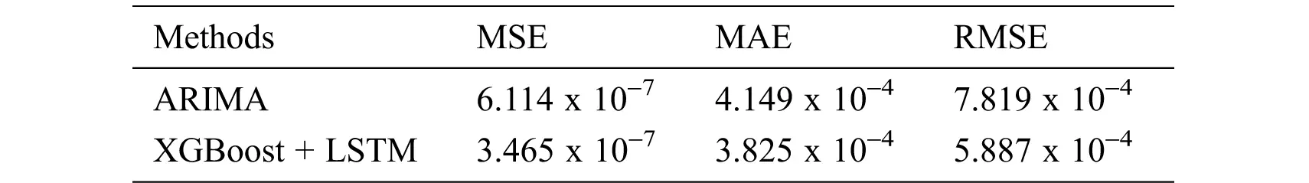
Technical Analysis
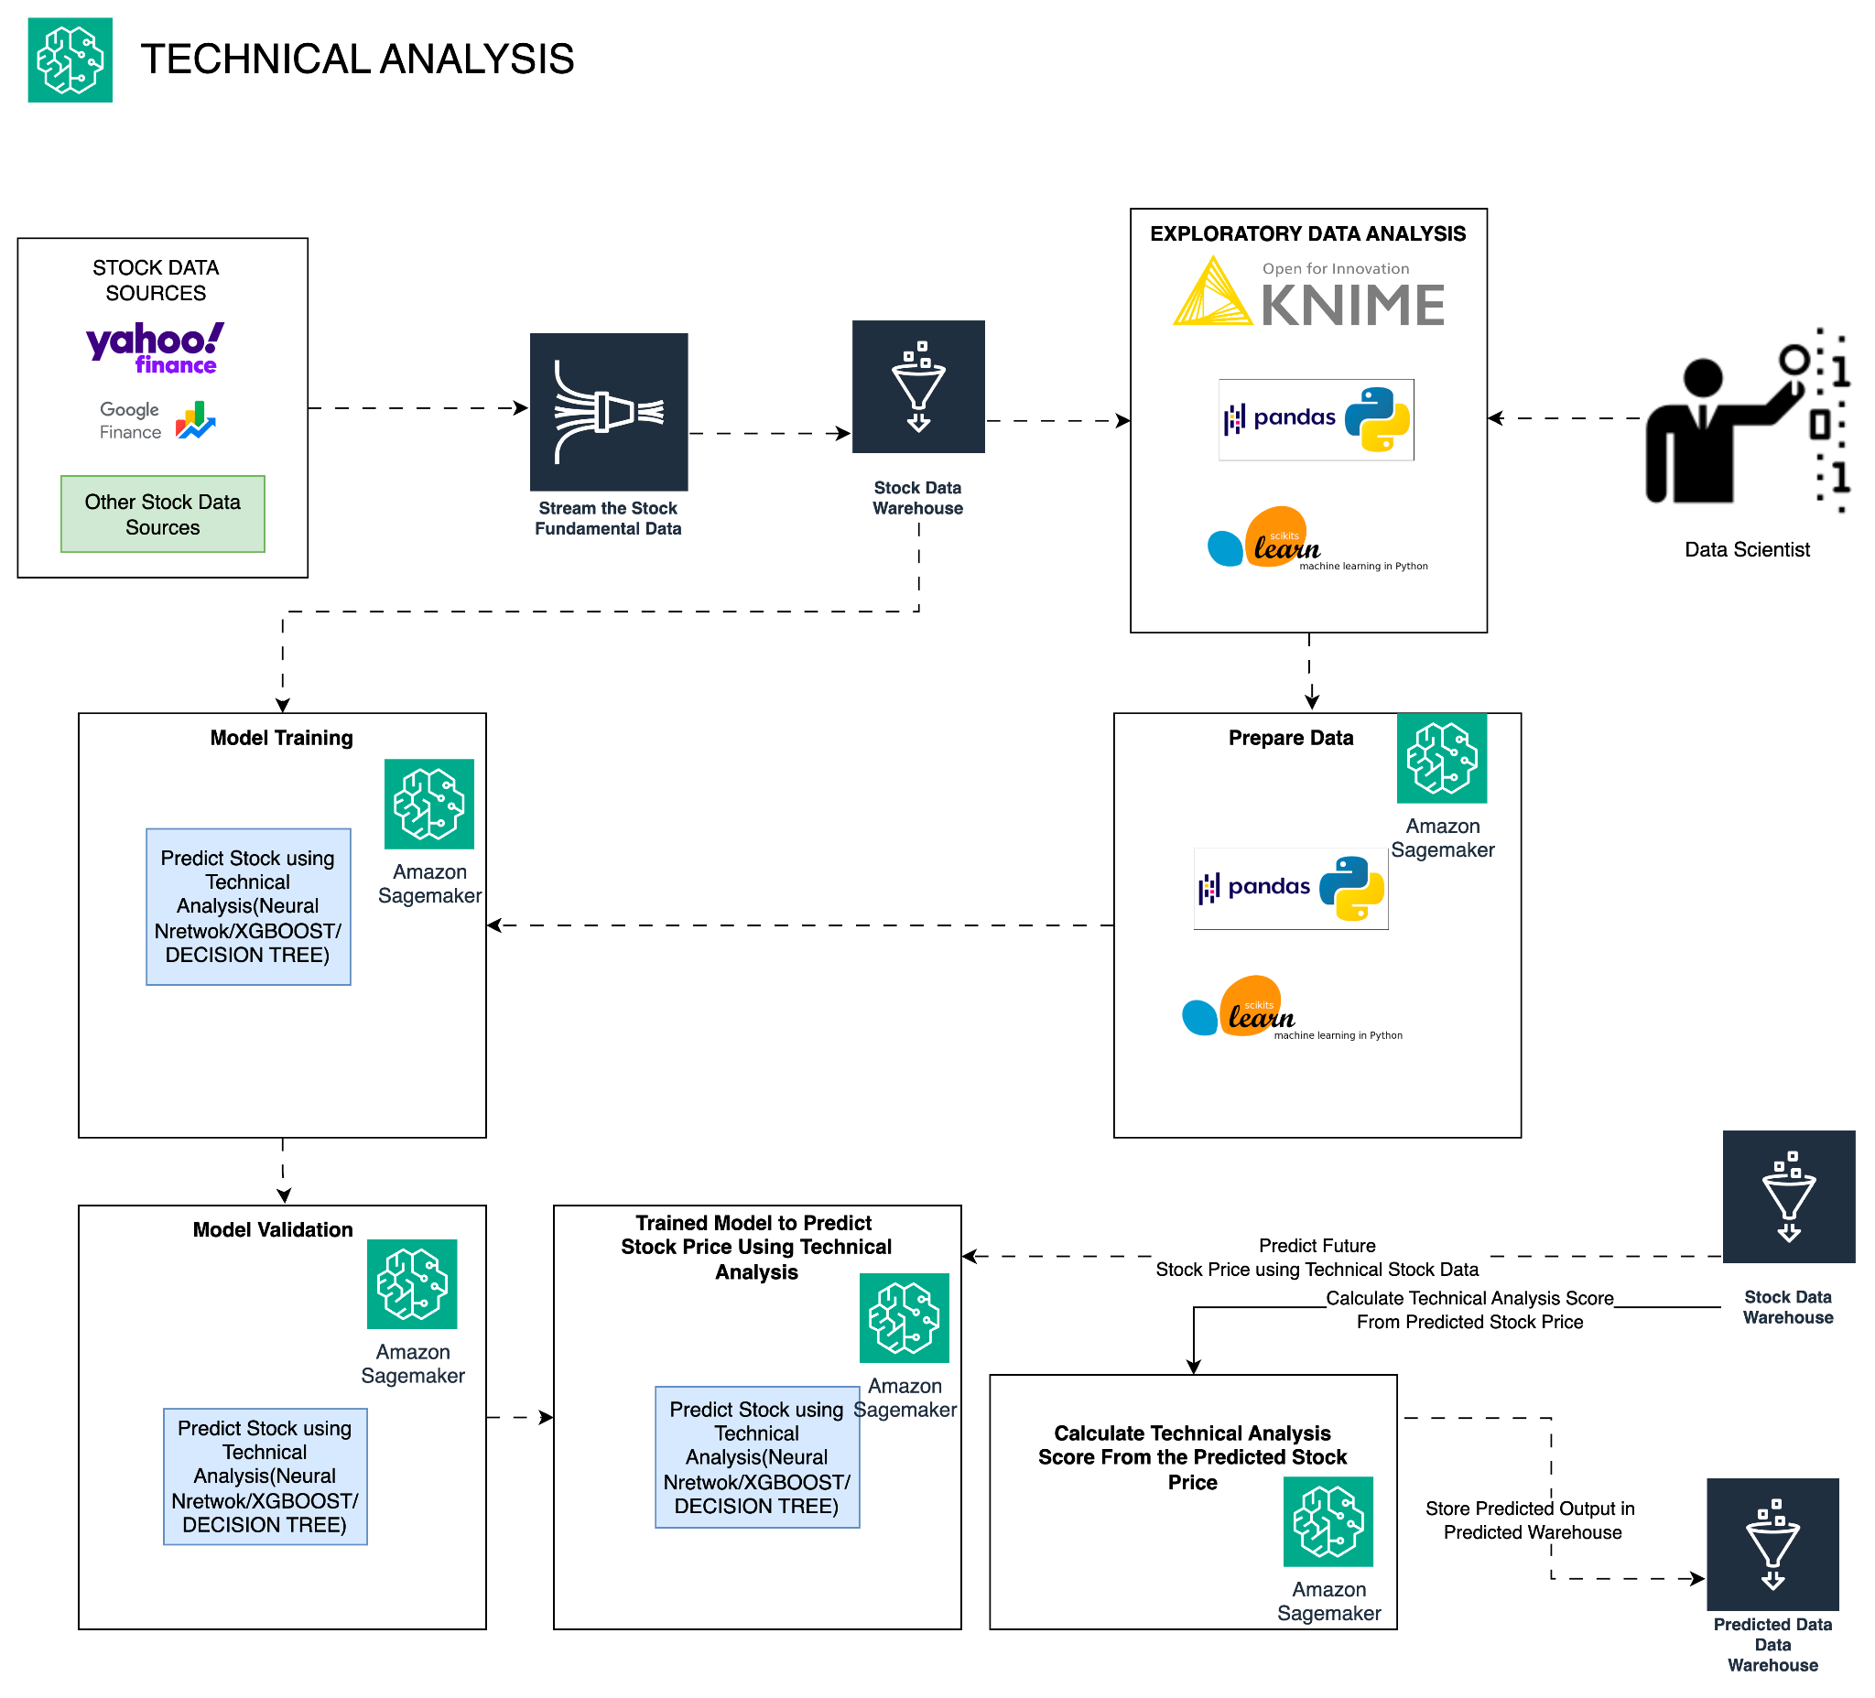
- Technical analysis is a trading discipline employed to evaluate investments and identify trading opportunities by analyzing statistical trends gathered from trading activity, such as price movement and volume. Unlike fundamental analysis, which attempts to evaluate a security's value based on business results such as sales and earnings, technical analysis focuses on the study of price and volume.
- Technical analysis look at the following broad types of indicators:
    - Price trends
    - Chart patterns
    - Volume and momentum indicators
    - Oscillators
    - Moving averages
    - Support and resistance levels
- The Data Acquisition, Data Storage, EDA, Prepare Data will follow the same process as Fundamental analysis but data used will be relevant to the technical analysis which is related to the indicators mentioned above.
- Using the Technical Analysis, will predict the price trend and also predict the share price as well based on the share price come up with a Technical Score.
- The model proposed to use will be Support Vector Machine or Artificial Neural Network.
References:https://irep.ntu.ac.uk/id/eprint/32787/1/PubSub10294_702a_McGinnity.pdf
- Based on the above references we would use SVM/ANN for predicting the stock price movement and XGBOOST to predict the stock price. Here is the performance result of the SVM/ANN for Price movement prediction.
    - Both SVM and ANN outperform the baseline buy-and-hold method in terms of every considered performance measure for all horizons. kNN outperforms the buy-and-hold strategy for short horizons of 1-10 trading days and underperforms for long horizons of 15-30 trading days.
    - The highest prediction accuracy of 75.43% and 61.71% is obtained by SVM when predicting a price change in 15 trading days for two class classification and in 20 trading days for three class classification respectively.
    - Values of the winning rate are equal to those of prediction accuracy for two class classification but differ from them for three class classification, because only predictions of ‘Up’ and ‘Down’ price movements are regarded as a signal for entering into trade when computing winning rate.
    - There is an important observation that winning rates achieved for three class classification are higher than those achieved when classifying into two classes.
    - These results confirm that introducing the ‘No Move’ class enhances the profitability of a trading system utilizing those predictions in trading. When predicting for three classes, the winning rate generally increases with an increase in forecast horizon reaching 82.64% using SVM for a horizon equal to 20 trading days.

Sentiment Analysis
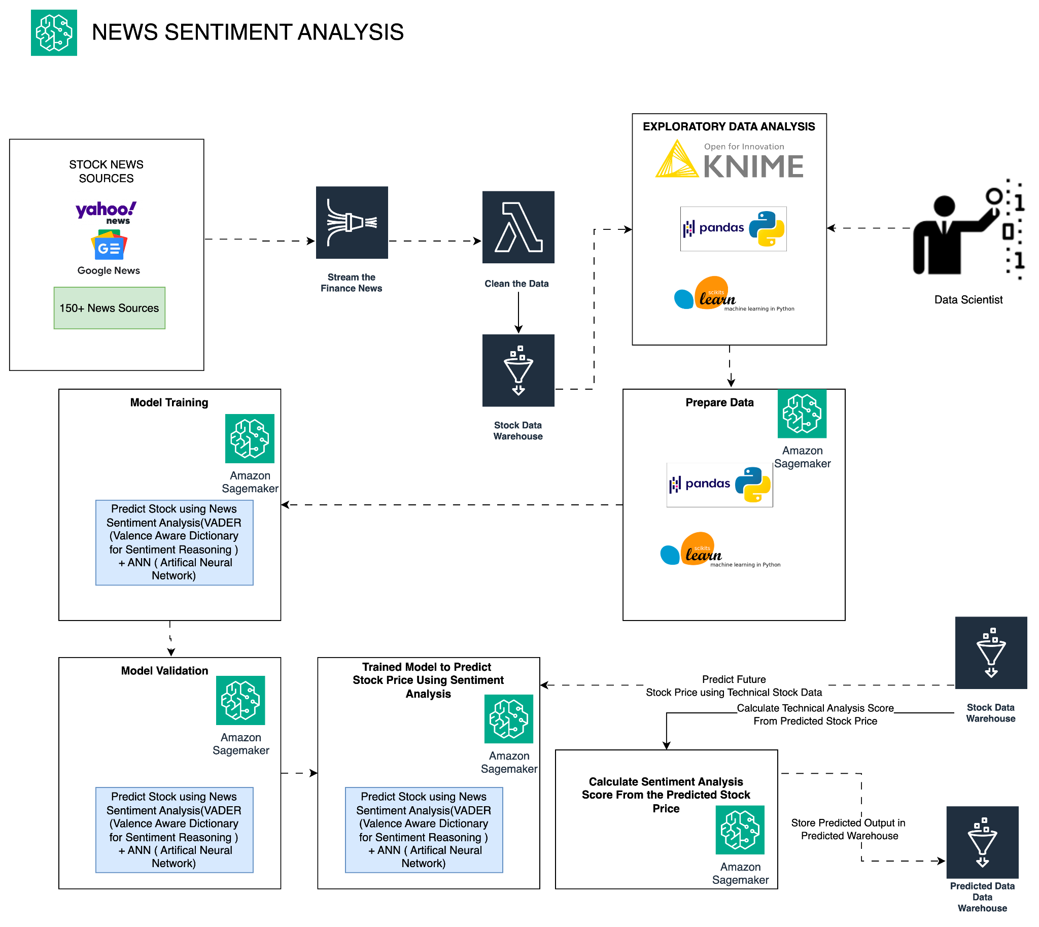
- Stock prices are greatly influenced by market sentiments, making sentiment analysis a crucial factor in stock prediction. Given the high volatility of stocks, which can be affected by various factors including news, our goal is to predict whether a stock's price will increase or decrease based on news sentiment. This binary classification problem focuses primarily on Natural Language Processing (NLP).
- For Sentiment Analysis Data Sources are News feed from reliable sources like Yahoo Finance News, Google Finance New and 150+ News providers. Get the News through RSS Feeds, Once news is received, prepare the news in standard format and store it in Stock Data Lake.
- Perform Exploratory Data Analysis for NLP sentiment analysis and send the data for training.
- We will use LTSM with a VADER Dictionary.
- Using the model we will find the polarity of the news
- Based on the polarity and severity of the news we will predict the share price
- Based on the share price prediction calculate the Sentiment Score.
- Store the Sentiment score in the Predicted Data Lake.

Reference:https://www.researchgate.net/publication/362942387_Stock_Price_Prediction_Using_News_Sentiment_Analysis
- To determine the polarity of news, we explore three techniques: Natural Language Toolkit (NLTK) using a pre-trained model, Long Short-Term Memory (LSTM), and Valence Aware Dictionary for Sentiment Reasoning (VADER). For binary classification, we label the output feature based on whether the closing price is lower or higher than the opening price. We then apply various machine learning techniques for binary classification.

RuScore Prediction
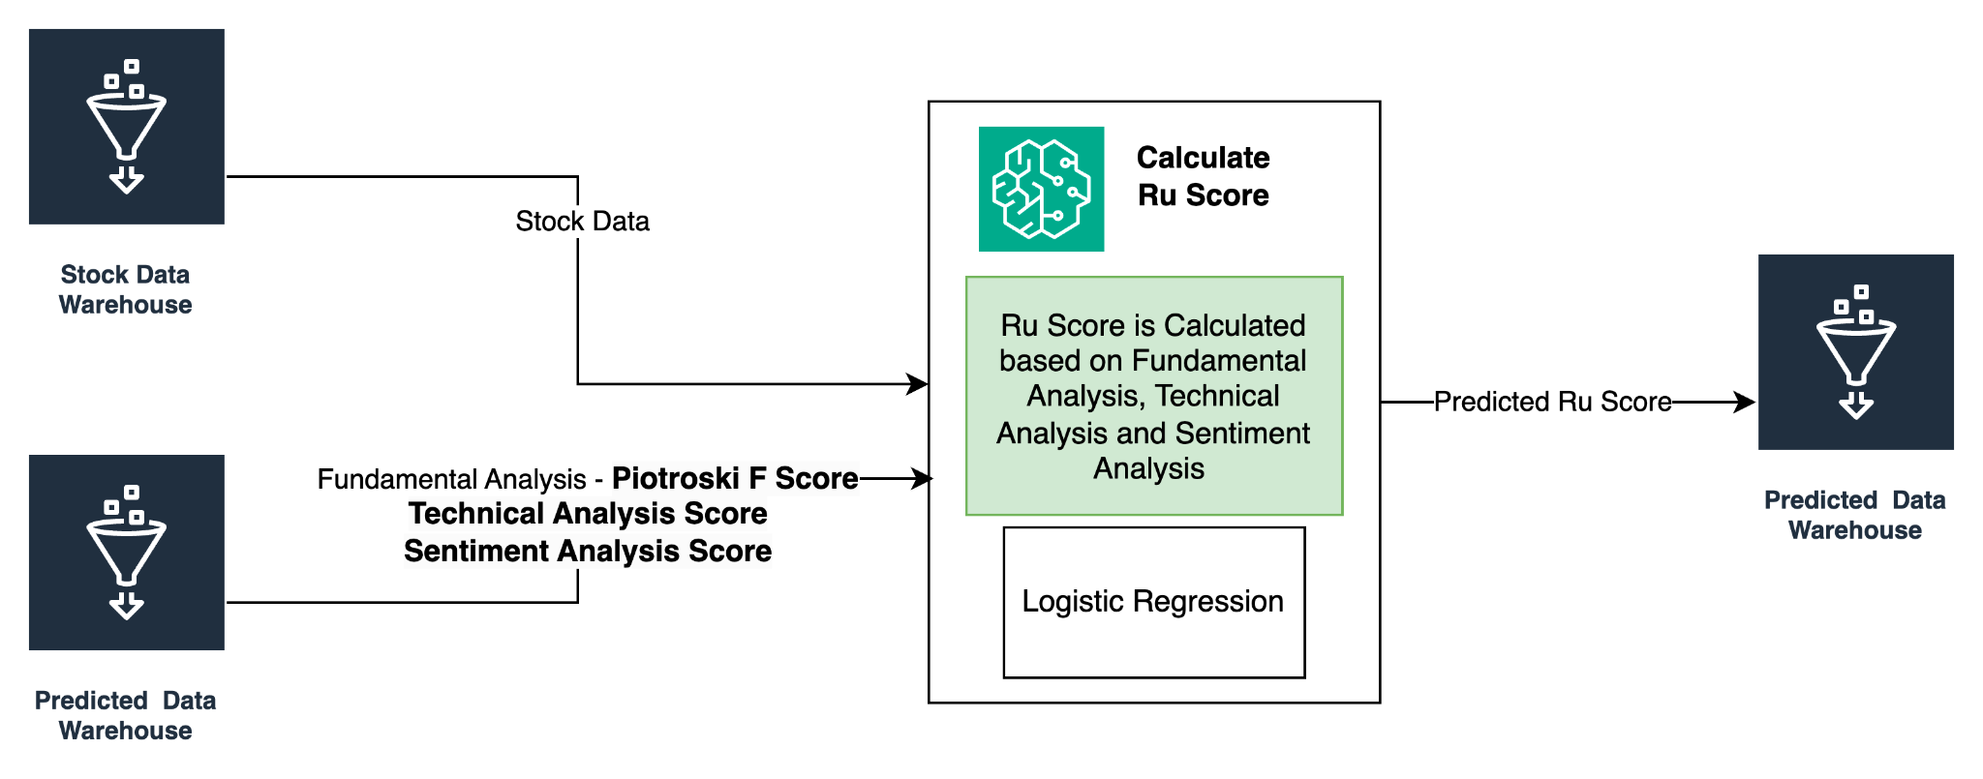
We will use a composite score, Ruscore, to predict stock prices based on Fundamental Analysis, Technical Analysis, and Sentiment Analysis scores. Ruscore combines these three views of the stocks to derive the price. It is calculated as follows:
Ruscore = xF(Fundamental Score) + yF(Technical Score) + z(Sentiment Score).
The weights of x, y, and z will be dynamically calculated based on factors such as market cap (small, mid, large) and other research. We will use the Logistic Regression model for this simple logistic regression.

Future Stock Price Prediction
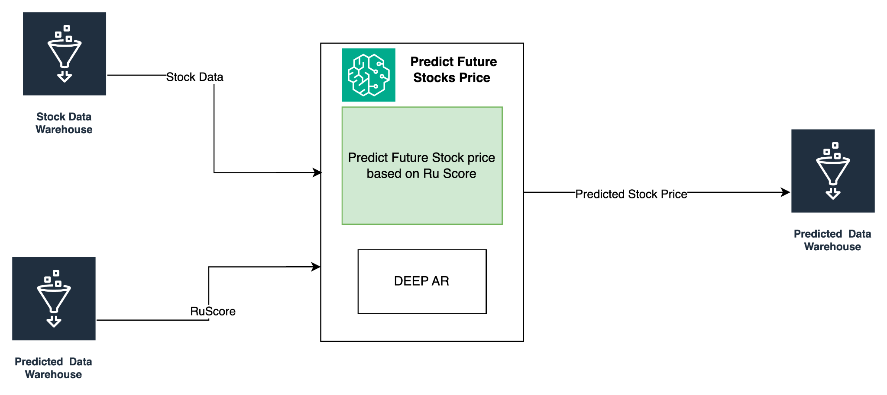

- Based on the RuScore we will calculate the Stock price. We will use DEEP AR to predict the stock price for the next 3 months. We understand this is pretty long term, we recalculate this multiple times in a day and update the portfolio in real time for the users to take action on the portfolio in any alarming situations. Where alarms can be set by the users.
- We would follow EDA and prepare data as per the above models corresponding to time series data.

Reference: https://arxiv.org/pdf/2306.13931.pdf#:~:text=Deep%20AR%2C%20a%20probabilistic%20forecasting,Term%20Memory%20(LSTM)%20architecture.

Based on the above reference the stock prediction for time series is performed by the DEEP AR model and here is the results
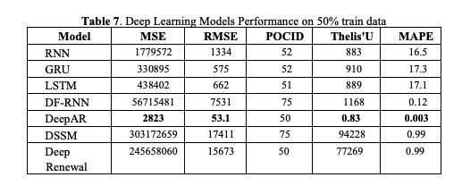

Profile to RuScore Mapping
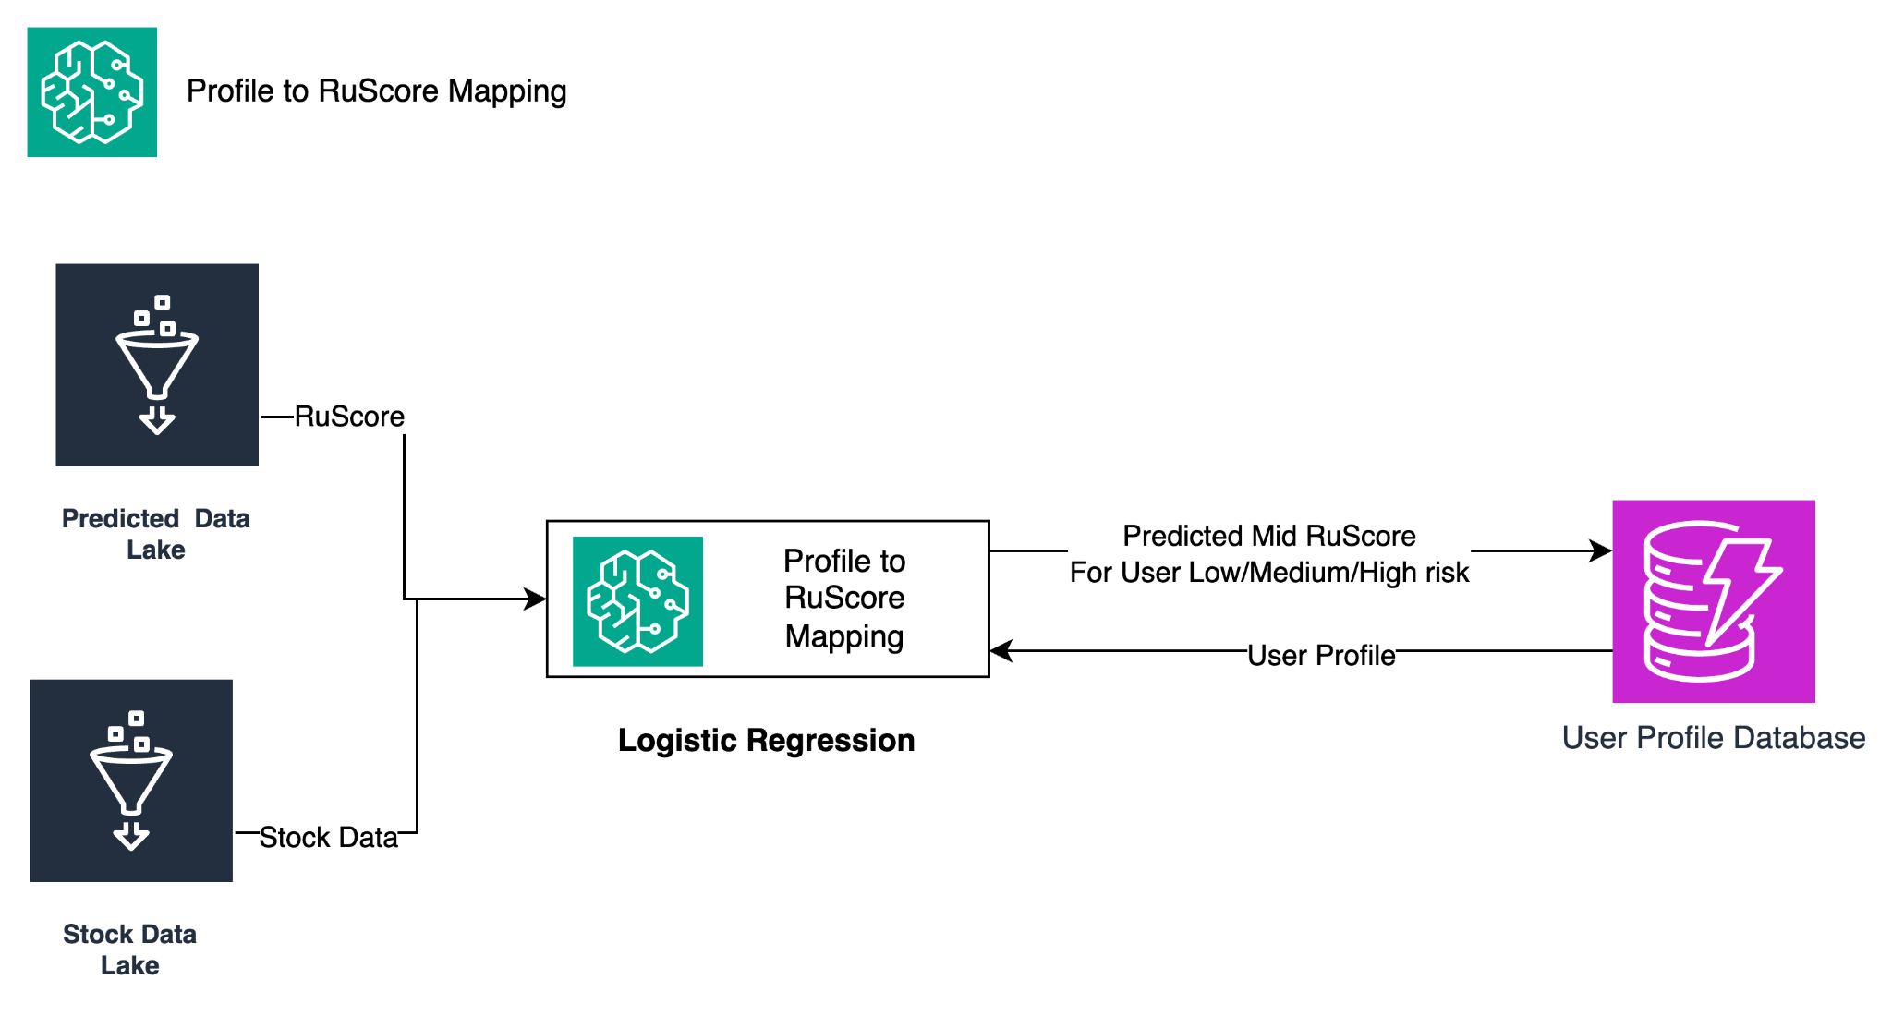
- Based on the User Profile we will predict Midpoint RuScore for Low/Medium/High risk, based on the midpoint we will calculate the range of RuScore of Low/Medium High risk in the portfolio. We would use Linear Regression to train and predict the score.
- This Ruscore is used to recommend the stocks which fit the portfolio.

User Stock Recommendation

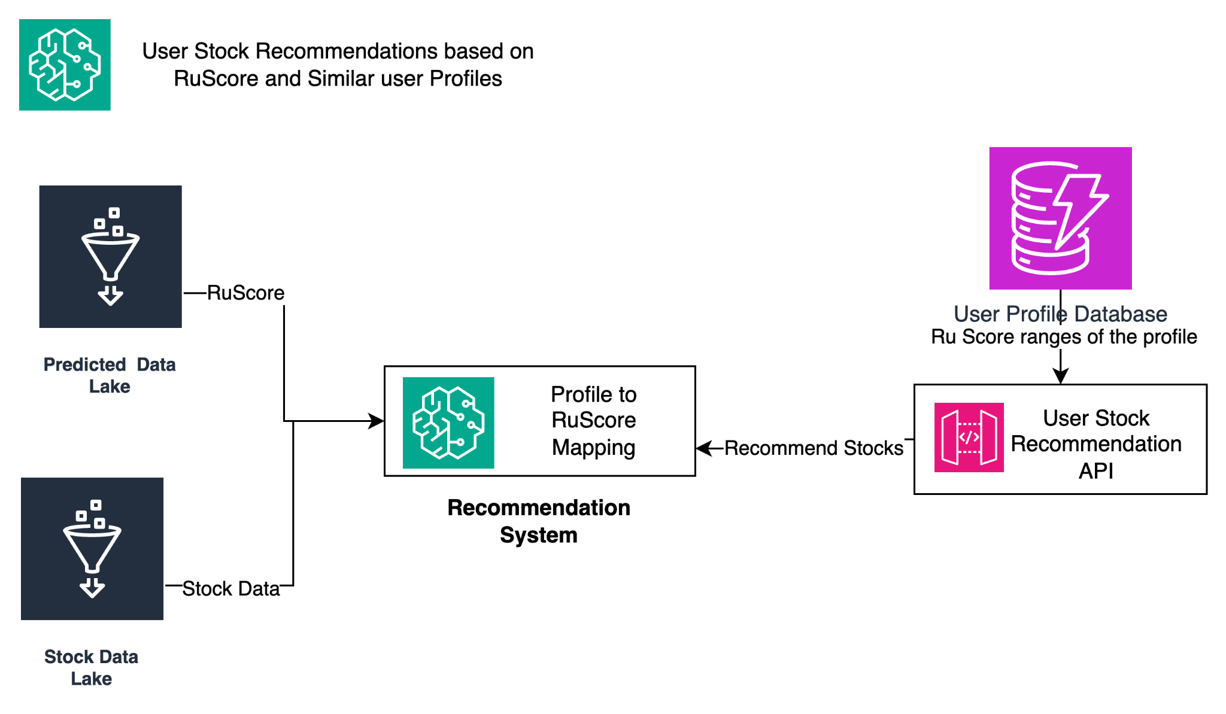
We would train the recommendation model based on the run score ranges it will recommend the best ruscore stocks and also recommend the stocks based on user preference of similar profile once user data are loaded.

Portfolio Stock Classification Based on RuScore and User Profile
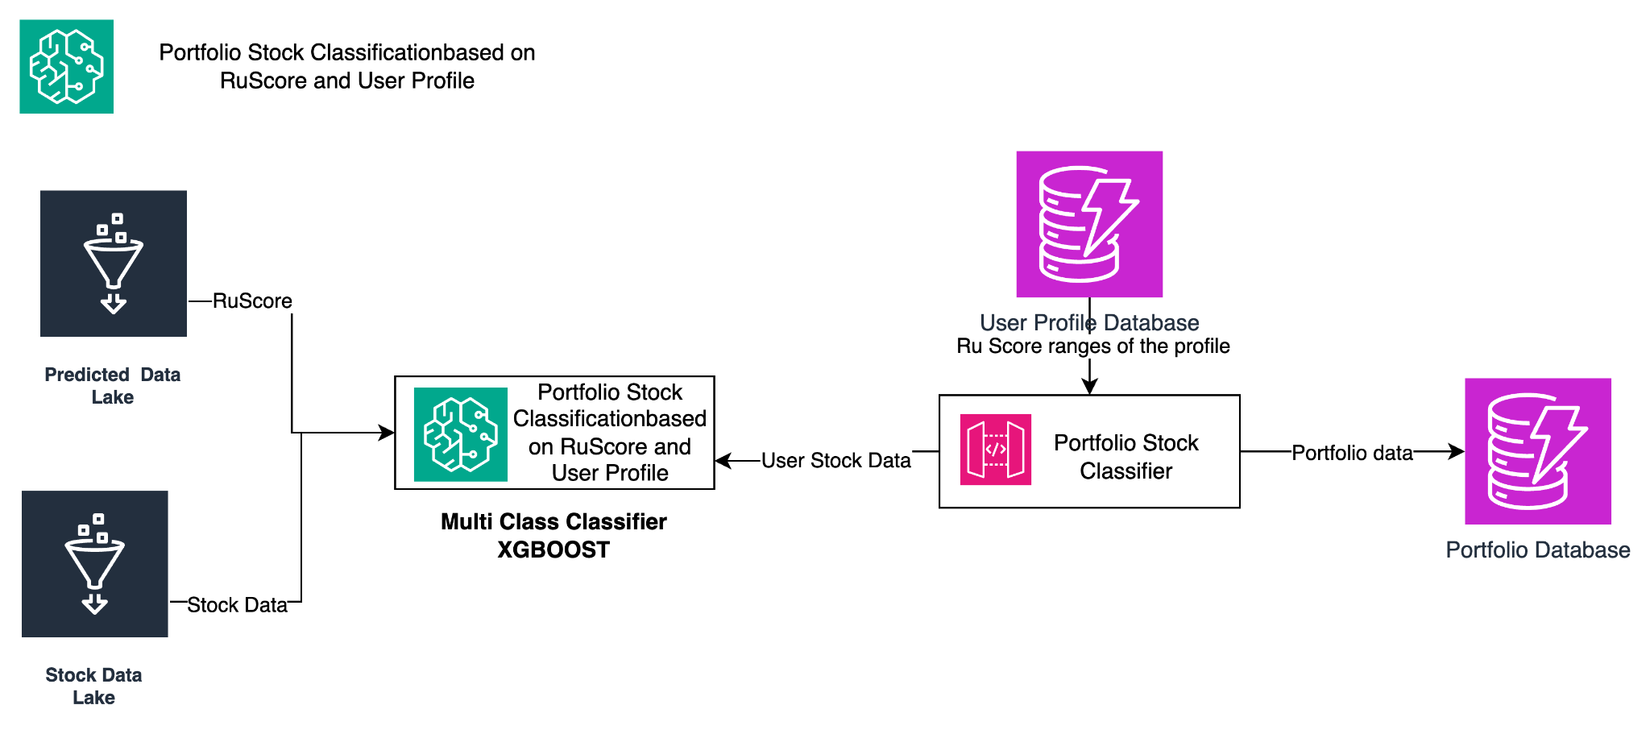
Once Stock is added to the User profile, Classify the stock as High, medium or Low risk based on Risk profile of the stock and user profile. We will use XGBoost with a Multi class classifier for the train and prediction.
Portfolio Future Growth Prediction
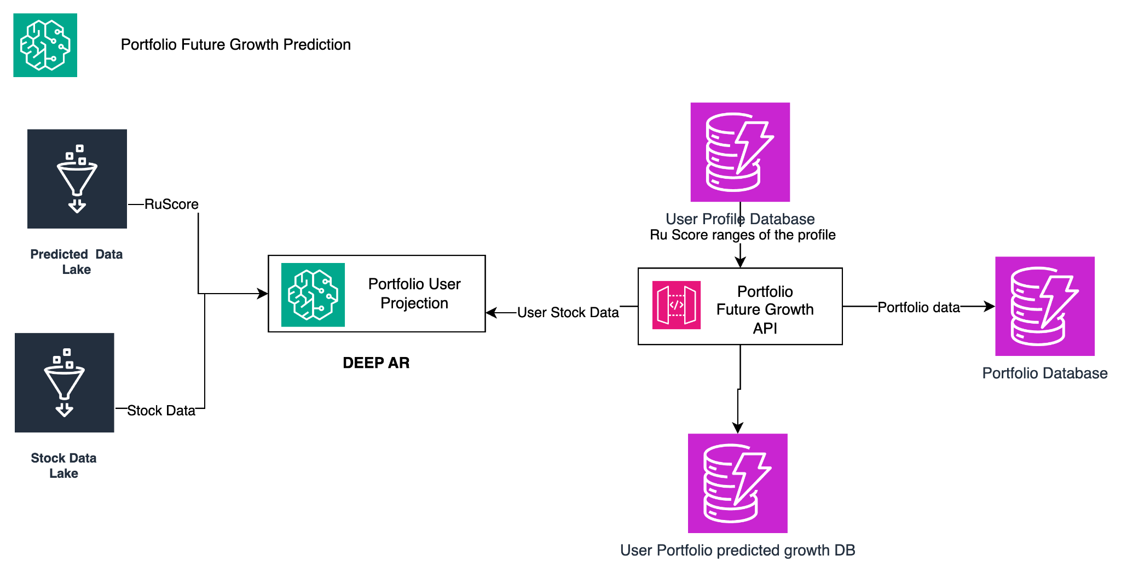
Predict the Future portfolio value by predicting future growth of the stock which will be performed using DEEPAR Model.

8. UNIQUE VALUE PROPOSITION

RuInvest.AI is the product which focuses on all three analyses and comes up with a Dynamic Composite Ruscore of the stock and personalizes the Portfolio Management which Ruscore stocks fit into their portfolio. It integrates advanced AI algorithms for fundamental, technical, and sentiment analysis, providing users with comprehensive insights into their investments. The platform's predictive capabilities enable users to forecast stock prices and optimize their portfolios for maximum returns. Additionally, Ruinvest.AI's user-friendly interface and seamless integration with various data sources make it a valuable tool for both novice and experienced investors.

9. MARKET ANALYSIS

Portfolio Management Market Size
The market size of portfolio management services (PMS) in India is currently experiencing significant growth, and can be understood through 2 key metrics
- PMS Industry (Excluding AIFs):
    - As of June 2023, the PMS industry (excluding Alternative Investment Funds or AIFs) had an Assets Under Management (AUM) of ₹5.29 lakh crore.
    - This represents a 14.81% year-on-year growth compared to June 2022.
    - Experts predict further growth, with the AUM expected to reach ₹43.64 lakh crore by 2028.
- Combined PMS and AIF Industry:
    - When including AIFs, the combined market size expands significantly.
    - As of June 2024, the combined AUM of the PMS and AIF industry stood at ₹13.74 lakh crore.
    - This represents a 26% compounded annual growth rate (CAGR) over the past five years, double the growth of the mutual fund industry.
- Additional Insights:
    - The average ticket size for PMS clients in India is around ₹10 crore, indicating a focus on high-net-worth individuals.
    - The top 10 PMS providers control roughly 60% of the total AUM.
- Number of Clients:
    - As of June 2023: There were 2.8 lakh PMS clients in India, reflecting a 10% growth compared to the previous year.
    - Average Ticket Size: This indicates a growing interest in PMS with an average ticket size of Rs 10 crore, signifying significant trust and capital invested by individuals.
- Future Outlook:
    - Experts predict continued expansion of the PMS industry, with an estimated 25% growth in AUM over the next 3-5 years.
    - Factors like rising wealth, increasing HNWI population, and evolving regulations supporting innovation are expected to fuel this growth.
Sources:
PMS Bazaar: https://pmsbazaar.com/
BusinessToday:https://business.outlookindia.com/invest/sebi-hiking-pms-investment-limit-to-rs-50-lakh-will-attract-clients-with-larger-networth-experts-3914
Times of India:https://www.businesstoday.in/markets/market-commentary/story/the-secret-behind-the-huge-growth-of-the-pms-industry-387896-2023-07-03
Outlook Business: https://business.outlookindia.com/
Times of India:https://business.outlookindia.com/invest/indias-aif-pms-industry-to-grow-to-rs-4364-lakh-crore-by-2028-says-pms-bazaar-study
Business Outlook:https://www.sebi.gov.in/sebi_data/commondocs/mar-2023/LGT_Wealth_India_AL_p.pdf

Barrier to Entry
Entering the investment management services industry in India comes with several barriers, both regulatory and practical. Here are some key points to consider:
Regulatory barriers:
- Licensing: Obtaining the required licenses from SEBI (Securities and Exchange Board of India) is crucial. Different licenses are needed for various services, such as Portfolio Management Services (PMS) or Alternate Investment Funds (AIFs). The licensing process can be lengthy and complex.
- Minimum Investment: SEBI mandates minimum investment requirements for different categories of investors, which can be high for certain services like PMS.
- Compliance: Stringent compliance requirements exist regarding KYC (Know Your Customer) norms, anti-money laundering regulations, and reporting obligations. Maintaining compliance can be resource-intensive.
Practical barriers:
- Competition: The Indian investment management industry is highly competitive, with established players commanding a significant market share. Differentiating yourself and attracting clients can be challenging.
- Distribution: Reaching potential clients and building trust can be difficult, especially for new entrants. Existing distribution channels are often dominated by established players.
- Technology and Infrastructure: Building a robust technology infrastructure to support investment research, portfolio management, and client communication requires significant investment.
- Human Capital: Finding qualified and experienced investment professionals can be challenging, particularly in specialized areas.
Additional considerations:
- Target market: Defining your target audience (retail, high-net-worth individuals, institutions) and tailoring your offerings accordingly is essential.
- Investment strategy: Developing a clear and differentiated investment strategy that resonates with your target market is crucial.
- Performance track record: Building a strong track record of performance is essential for attracting and retaining clients.
Resources:
SEBI website: https://www.sebi.gov.in/
AMFI (Association of Mutual Funds in India): https://www.amfiindia.com/
PWB (Portfolio Management Service Bazaar): https://pmsbazaar.com/

10. SWOT ANALYSIS
Strengths:
- Advanced AI algorithms for personalized portfolio management.
- Comprehensive analysis including fundamental, technical, and sentiment analysis.
- Predictive capabilities for forecasting stock prices.
- User Friendly interface and seamless integration with various data sources.
- Growing demand for investment products and services in India.
- Technological advancements in the financial services industry.
- Diverse product offerings catering to different investment needs.
- Regulatory reforms making the investment environment more transparent.
Weaknesses:
- Dependency on AI algorithms which may not always accurately predict market trends.
- Reliance on external data sources which could be subject to inaccuracies.
- Low financial literacy levels in India.
- High fees associated with portfolio investment services.
- Mistrust of financial institutions due to past scams.
- Limited accessibility of portfolio investment services, especially in rural areas.
- Increasing competition in the industry.
Opportunities:
- Rising disposable income leading to increased investments.
- Technological advancements overcoming challenges in the industry.
- Government initiatives promoting financial inclusion.
- Focus on retail investors with tailored products and services.
- Internationalization by tapping into global markets.
Threats:
- Economic slowdown impacting investment activity.
- Market volatility affecting investor confidence.
- Regulatory changes increase operational costs.
- Competition from fintech startups offering innovative solutions.
- Cybersecurity threats compromising client data security.
11. COMPETITION ANALYSIS
Competitors:
- FundsIndia (www.fundsindia.com): A robo-advisor offering automated investment management services using algorithms.
- Scripbox (scripbox.com): Similar to FundsIndia, Scripbox provides automated investing and financial planning services in mutual funds.
Evaluation of Features and Functionality:
RuInvest.AI:
- User-friendly platform with personalized client input.
- Integrates Fundamental Stock Analysis and real-time stock data.
- Utilizes advanced risk assessment algorithms.
Competitors:
- FundsIndia and Scripbox offer automated portfolio management based on selected stocks and mutual funds
Market Positioning:
RuInvest.AI:
- Targets individuals seeking AI-driven solutions for investment management.
- Positions itself as a centralized and intelligent platform for informed decision-making.
- Emphasizes empowerment of users through AI technology.
Competitors:
- FundsIndia and Scripbox target tech-savvy millennials and novice investors with low fees and easy-to-use interfaces.
Customer Reviews and Feedback:
RuInvest.AI:
- Limited customer feedback due to being a newer entrant in the market.
Competitors:
- Generally positive reviews for user experience and investment performance.
- Some complaints about lack of customization in automated portfolios.

Market Share and Growth:
RuInvest.AI:
Market share is likely lower compared to established competitors.
Potential for growth with increasing demand for AI-driven investment solutions.
Competitors:
FundsIndia and Scripbox hold significant market share in the robo-advisory space.

Future Outlook and Innovation:
RuInvest.AI:
Opportunities for innovation in AI algorithms, user experience enhancements, and expanding product offerings.
Competitors:
Continued focus on technology enhancements, personalized services, and regulatory compliance to stay competitive.
Overall, RuInvest.AI faces competition from the competitors in the AI-driven investment management space. Its success will depend on its ability to differentiate itself through superior technology, user experience, and innovation while navigating regulatory requirements and market dynamics.

12. PRODUCT ROADMAP
A product roadmap outlines the vision and direction of a product over time, highlighting key features and milestones along the way. Here is a high-level overview of the product roadmap for RuInvest.AI:
Phase 1: Initial Launch (Q2-Q3 2024)
- Develop and launch the RuInvest.AI platform as a mobile app and web application.
- Implement user signup and profile creation features.
- Integrate the recommendation engine for portfolio building.
- Enable customization of portfolio templates and risk profiles.
- Provide real time tracking of stock performance and portfolio growth predictions.
Phase 2: Enhanced Features (Q4 2024 Q1 2025)
- Enhance the recommendation engine to provide more accurate and personalized stock recommendations.
- Implement advanced risk management tools, including scenario analysis and stress testing.
- Introduce social features, allowing users to share their portfolios and strategies with others.
- Expand the platform to include additional asset classes, such as bonds, ETFs, and cryptocurrencies.
Phase 3: Integration and Expansion (Q2 2025 and beyond)
- Integrate RuInvest.AI with third party financial platforms and brokers for seamless portfolio management.
- Expand the platform's reach to international markets, offering localized versions for different regions.
- Continuously improve the platform based on user feedback and market trends, adding new features and functionalities to enhance the user experience.
This roadmap is subject to change based on market conditions, technological advancements, and user feedback. It serves as a guide for the development and evolution of RuInvest.AI, ensuring that it remains competitive and meets the needs of its users.

13. PROJECT PLAN FOR PHASE-1
Plan Phase:
- Define project objectives, scope, and timeline.
- Conduct market research and competitor analysis.
- Identify target audience and user personas.
- Create a project plan with key milestones and deliverables.
Outcome:
- Clear project plan outlining objectives, scope, timeline, and resources.
- Market research report, competitor analysis report, user personas.

Design Phase:
- Design UI/UX for mobile and web platforms.
- Develop wireframes and prototypes for user testing.
- Design database schema and system architecture.
- Design Data Acquisition and Model Ops Architecture.
- Create detailed design documents for the development team.
- DevOps Pipeline Architecture.

Outcome:
- Well-designed UI/UX for mobile and web platforms.
- API Design Document, Model Design Document, MLOps Document, DevOps Design Document.
- Reviewed and Approved Designs.

Develop and Test Phase:
- Develop a Data Ops Platform and train the model.
- Validate the model.
- Develop frontend and backend components.
- Integrate third-party APIs.
- Implement user signup, profile creation, portfolio management, and recommendation engine features.
- Conduct testing (unit, integration, and user acceptance testing).

Outcome:
- Fully functional RuInvest.AI platform.
- Frontend and backend components, integrated third-party APIs, testing documentation, bug fixes.

Production Release Phase:
- Prepare for production deployment.
- Deploy RuInvest.AI platform to production environment.
- Monitor platform performance post-launch.
- Address post-launch issues or bugs.

Outcome:
- Successfully deployed RuInvest.AI platform to production environment.
- Production deployment documentation, monitoring setup, post-launch bug fixes.

User Acquisition Phase:
- Develop a marketing strategy.
- Utilize digital marketing channels.
- Launch promotional campaigns and partnerships.
- Analyze user acquisition metrics.

Outcome:
- Increased user base and engagement with the RuInvest.AI platform.
- Marketing strategy document, digital marketing campaigns, user acquisition metrics analysis.

14. PROJECT TEAM
Chief Executive Officer/CFO (1)
Responsibilities: Define the Organization Vision, Mission, goals, Go-To Strategy, Overall Execution
Chief Marketing/Sales Officer (1)
Responsibilities: Define Marketing Strategies, Rollout Campaigns, Develop Sales pipeline and Conversion.
Product Manager/Chief Technology Officer(1)
Responsibilities: Define product vision, strategy, and roadmap. Coordinate with stakeholders. Ensure alignment with business goals.
UI/UX Designer (1)
Responsibilities: Design user interface and user experience. Create wireframes, prototypes, and design assets.
Frontend Developer(2)
Responsibilities: Develop frontend using HTML, CSS, and JavaScript. Implement UI/UX design. Ensure frontend is responsive and user-friendly.
Backend Developer(2)
Responsibilities: Develop backend using Node.js, Python, or Java. Implement business logic, data storage, and APIs.
Data Scientist(1)
Responsibilities: Develop and implement machine learning algorithms for analyzing stock data, predicting prices, and generating insights.
QA Engineer(1)
Responsibilities: Test platform to ensure quality standards. Identify and report issues. Ensure the platform is stable and reliable.
DevOps Engineer(1)
Responsibilities: Manage deployment, scaling, and monitoring on AWS cloud. Ensure the platform is secure, scalable, and performs optimally.
Business Analyst(1)
Responsibilities: Gather and analyze requirements. Define features and user stories. Ensure alignment with business objectives.
Technical Writer(1)
Responsibilities: Create documentation including user guides, API docs, and release notes. Ensure the platform is well-documented and easy to understand.

15. PROJECT COST
Personal Cost:
- Chief Executive Officer: 1 person, INR 60,00,000 per year, INR 30,00,000 for Q2 and Q3
- Chief Marketing Officer: 1 person, INR 60,00,000 per year, INR 30,00,000 for Q2 and Q3
- Product Manager/CTO: 1 person, INR 60,00,000 per year, INR 30,00,000 for Q2 and Q3
- UI/UX Designer: 1 person, INR 36,00,000 per year, INR 18,00,000 for Q2 and Q3
- Frontend Developer: 2 people, INR 80,00,000 per year, INR 40,00,000 for Q2 and Q3
- Backend Developer: 2 people, INR 1,00,00,000 per year, INR 50,00,000 for Q2 and Q3
- Data Scientist: 1 person, INR 70,00,000 per year, INR 35,00,000 for Q2 and Q3
- QA Engineer: 1 person, INR 35,00,000 per year, INR 17,50,000 for Q2 and Q3
- DevOps Engineer: 1 person, INR 40,00,000 per year, INR 20,00,000 for Q2 and Q3
- Business Analyst: 1 person, INR 50,00,000 per year, INR 25,00,000 for Q2 and Q3
- Technical Writer: 1 person, INR 20,00,000 per year, INR 10,00,000 for Q2 and Q3
- Digital Marketing Specialist: 1 person, INR 30,00,000 per year, INR 15,00,000 for Q2 and Q3

Cloud Infrastructure Cost:
- AWS Usage Approximate: INR 49,80,000 per year, INR 24,90,000 for Q2 and Q3

Operational Expenses:
- Laptop and Software: INR 5,50,000 per year, INR 5,50,000 for Q2 and Q3
- Office Space: INR 12,00,000 per year, INR 6,00,000 for Q2 and Q3
- Utilities and Maintenance: INR 6,00,000 per year, INR 2,00,000 for Q2 and Q3

Marketing Expenses:
- Digital Marketing: INR 1,00,00,000 for Q2 and Q3
- Events and Conference: INR 50,00,000 for Q2 and Q3
- Marketing Collaterals: INR 25,00,000 for Q2 and Q3

Total Cost for Phase 1 Initial Launch Development:
INR 5,33,90,000

16. REVENUE PROJECTIONS
Plans proposed to charge for RuInvest Users
Starter | TakeOff | Professional
Up to 10 Lakh AUM | 10 Lakh to 1 Crore AUM | More than one crore AUM
Free | 1000 Per Month | 0.3% of AUM

Revenue Per Year
Year | AUM Growth | Revenue
Year-1 | ₹50,00,00,000.00 | ₹15,00,000.00
Year-2 | ₹2,00,00,00,000.00 | ₹60,00,000.00
Year-3 | ₹8,00,00,00,000.00 | ₹2,40,00,000.00
Year-4 | ₹25,00,00,00,000.00 | ₹7,50,00,000.00
Year-5 | ₹50,00,00,00,000.00 | ₹15,00,00,000.00

18. BREAK EVEN
Out of a $3 Trillion AUM Market across the world in 2022 this is very conservative estimates. Breakeven will be achieved in 5 years and Grow exponentially from there as this a trust based industry new entrants take time to establish in the market.
End of the Paper

