Institute of Systems Science
National University of Singapore

MASTER OF TECHNOLOGY IN
SOFTWARE ENGINEERING/KNOWLEDGE ENGINEERING & ENTERPRISE BUSINESS ANALYTICS

Elective Examinations

Subject: Text Mining

Sample Examination Questions

SECTION A

Question 1 (Total: 16 Marks)

Consider the following paragraph of text:
There are three companies, Alpha Pte Ltd, Beta Co. and Gamma & Sons, involved in the merger. The resulting company will be named GreekAlphabet Pte Ltd (GAPL) and will be privately held. Prof Aleph, the current CEO of Alpha, will become the chairman of GreekAlphabet while Dr Naught, the MD of Beta will be the CEO of the new company. Dr Tom Gamma and his two sons, Dick Gamma and Harry Gamma, have announced that they will be retiring once Gamma & Sons is acquired. They wish the future management of GAPL the very best.
- Write one or more rules that attempts to extract all instances of company names from the paragraph above. You may not use the names themselves as part of your rule(s), ie: “If X = “Alpha Pte Ltd” then X is a company” is not allowed. List the output of each rule.
(4 Marks)
- By inspection, list all instances of company names from the paragraph above. Calculate the precision and recall for your answer in part (a).
(2 Marks)
- Would your rule or set of rules work for other text different from the paragraph above? Justify your answer.
(2 Marks)
- What would you recommend as an alternative approach to extracting company names that will work for any arbitrary paragraph (assuming the same language)? Will there be errors if applied to the paragraph above? Suggest how these problems (if any) might be solved.
(4 Marks)
- You will note that the paragraph above refers to the same company by different text strings. This is the problem of co-reference resolution. Suggest two different methods to unify company names in a general context (not just for the paragraph above). Discuss very briefly what are the advantages and disadvantages of each of your methods.
(4 Marks)
Question 2 (Total: 14 Marks)

Read the HealthCare4All (HC4A) overleaf and then answer the following questions:
- HC4A needs to reduce fraud but must also be careful about spending too much money doing it. Which of the three approaches described overleaf would you recommend? Justify your answer.
(4 Marks)
- It seems that text mining with the doctor’s case notes helps to reduce the false positives, but it is text mining with the patients’ symptoms that works to reduce the false negatives. How would you try to get the best of both worlds? Justify your answer.
(4 Marks)
- The Board of HC4A is happy with your results, and will implement your suggestion. In the meantime, they ask you to go back to try more experiments. Given that you now have more time, suggest two methods you may wish to try with the data overleaf. Explain each answer.
(6 Marks)
HealthCare4All Case Study
HealthCare4All (HC4A) is a non-profit health insurance company. They provide insurance to low-income and unemployed people who would otherwise have little or no access to proper healthcare.
HC4A works with over 400 small clinics and GPs (doctors) all over the country. Most of these clinics are located in the poorer sections of towns and cities so the clinics are often barely making money. As such, HC4A has been paying most claims made by the clinics with only a few claims disputed as possibly being fraud. They know that if they delay payments, the clinics would have cash flow problems.
Unfortunately, HC4A knows that there is actually a fair amount of fraud committed by some clinics, sometimes in collusion with the patients. By their estimates, they lose over $5,000,000 every year due to inflated claims and claims for treatments that were never done. The board of HC4A has decided that they need to take action to reduce the losses, but are wary of spending too much money on the initiative. It’s no use trying to prevent fraud if the cost of the prevention is more than what they can afford – there will be less money for the patients. And HC4A is a non-profit dedicated to patient welfare, not to making profits.
HC4A receives almost 2 million claims every year. This huge volume is one reason why the claims managers have mostly been ignoring possible fraudulent claims. It will take more time and costs to investigate than to pay the claim, since most claims are under $50. However there are about 200,000 claims (10%) that are over $200 including about 2,000 claims (0.1%) that exceed $1000.
HC4A decided to focus on these approximately 200,000 claims in the last year that were over $200. They did a representative sampling from these claims to create a set of 10,000 claims. They asked their claims managers plus expert consultants from other insurance companies to review those claims and identify the claims that seem suspicious. They then proceeded to investigate those claims and this was the resulting information:
- The mean average claim was $400 per claim.
- They investigated 1,200 suspicious claims at a total cost of $1,200,000 and confirmed that 600 of those claims were actually fraudulent.
- HC4A then did a test of their claim managers to see if they could reliably identify which among the 1,200 suspicious claims were the fraudulent ones, and found that the managers could do no better than chance.
- They also did a random sampling of the 8,800 non-suspicious claims and found negligible fraud among those claims.
You have just been hired by HC4A as a data-mining specialist. Your job is to try and create a system to better predict which claims are fraudulent. You are given the 10,000 insurance claims data from above, and the details of the 1,200 suspicious claims as well as the 600 verified fraud cases.
Each of the claims has many structured fields and two open text fields – the patient’s symptoms that are recorded by a nurse before the patient sees the doctor and the doctor’s case notes that are written by the doctor after seeing the patient. You randomly partition your data into 80% training and 20% test sets.
Based only on the structured data, you get the following results when you try to predict fraud:
Structured  Data only | Actual  Fraud | Actual  Non-Fraud
Predicted Fraud | 240 | 1000
Predicted  Non-Fraud | 240 | 6520
This was not acceptable to HC4A management as there were too many false positives as well as too many false negatives.
You discuss with the claim managers who suggest that it is likely that the doctor is behind the fraud, so they suggest adding text mining of the doctor’s case notes to the structured data. These were the results:
Structured + Doctor’s Case Notes | Actual  Fraud | Actual  Non-Fraud
Predicted Fraud | 200 | 400
Predicted  Non-Fraud | 280 | 7120
You then try text mining but with the patient symptoms recorded by the nurse instead of the doctor’s case notes. This were the results:
Structured + Patient Symptoms | Actual  Fraud | Actual  Non-Fraud
Predicted Fraud | 360 | 2000
Predicted  Non-Fraud | 120 | 5520
When you try your models on the test data, you get similar results, suggesting that your models may be able to generalize to new claims data. By this time, you have run out of time, and now need to give recommendations to your management.
SECTION B

Question 3 (Total: 30 Marks)

FinCom Pte Ltd is planning to start a text mining project with the objective of extracting financial events, such as earnings announcements and revenue forecasts, from finance news articles collected from the web. The company would also like to identify the company names involved in the events and assign them to their corresponding industry sectors, such as “car”, “finance”, “energy”, etc.
A screen capture of part of a website with articles containing such information is given in figure 1 overleaf. Figure 2 on page 8 gives snippets of the first few paragraphs in two example articles.
The leader of the project has created an initial project plan (see figure 3 on page 8) and has identified an open source text mining tool to use on the project which provides the following components:
- Gazetteer.
- Sentence splitter.
- Chunker.
- Tokenizer.
- HTML tag remover.
- Part-of-speech tagger.
Answer the following questions:
- Identify the problems in the initial project plan.
(4 Marks)
- Is the bag-of-words model suitable for this project?
(3 Marks)
- State the order in which the components of the open source tool should be applied as text pre-processing steps. Justify your answer.
(3 Marks)
- Is the selected open source tool sufficient for this text mining project? Justify your answer.
(3 Marks)
- Is it necessary to create synonym dictionaries? Justify your answer.
(2 Marks)
- Suggest how the team can assign the extracted company names to their corresponding industry sectors. Briefly describe your method.
(4 Marks)
- The project leader is worried about the performance of the open source tool if it is used to process in real time a very large number of articles crawled from websites. Propose a solution without changing the tool.
(4 Marks)
- Analysts from FinCom would like to have an overview of extracted information periodically, from which they want to see companies with profits increasing, decreasing, or suffering a loss from each sector. Suggest a design of the summarization and visualization layer to enable this.
(3 Marks)
- The company also wants to discover from collected articles the major reasons for profit increase, decrease, or loss. Suggest an approach to achieve this.
(4 Marks)
Figure 1: Screen capture of part of a financial website
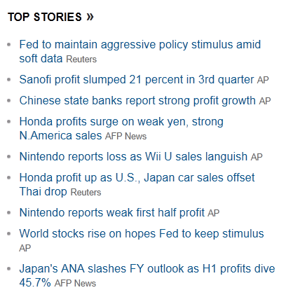
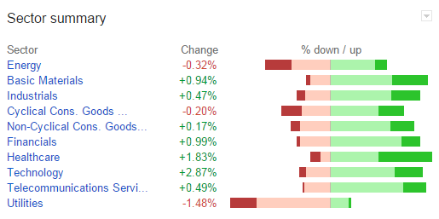
Summary of Stock Market by Sectors
Figure 2: Snippets of financial news
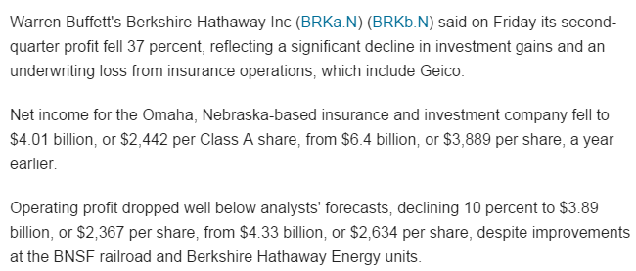
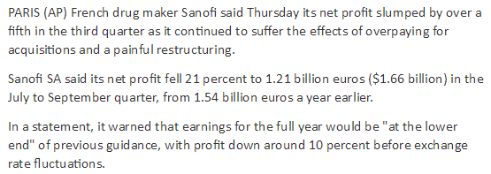
Figure 3: Initial project plan for the text mining project
Phase Name | Months
Phase Name | 1 | 2 | 3 | 4 | 5 | 6 | 7 | 8 | 9 | 10
Business Understanding
Corpus Preparation
Knowledge Extraction
Evaluation
Deployment

