Institute of Systems Science
National University of Singapore

MASTER OF TECHNOLOGY IN
ENTERPRISE BUSINESS ANALYTICS

Unit 3 Examination

Subject: Data Analytics

Sample Examination Questions

SECTION A

Question 1 (Total: 10 Marks)

A Conjoint project was conducted in class where three variables - university, university ranking, and course fees - were considered. Sample data from the project is given in figure 1 overleaf. Answer the following questions:
- Briefly describe the objective, questionnaire design, target respondents and sample, and method of data collection.
(4 Marks)
- 238 records were found. Suppose that using Microsoft Excel the following estimates of the parameters were calculated with NUS as base reference for brand:

Write down the utility function for each of the three universities
(Hint: U_{j} = β_{0j}+β_{1j}+…). State the limitation of this output. Is it possible to comment on the order of importance of all the three variables to run the analyses.

(3 Marks)
- As the market dynamic changes, NTU and NUS are now both Tier 1 universities with SMU still remaining as Tier 2. Both NTU and NUS offer a 1.5 year degree course but SMU offers 1 year course. Fees for NTU, NUS and SMU are S$50K, S$50K and S$40K respectively.
Based on the developed Conjoint model in part (b), determine the market shares of NUS, NTU and SMU. Complete your exercise by doing appropriate research.
(3 Marks)

Figure 1: Sample Data from the Conjoint Project
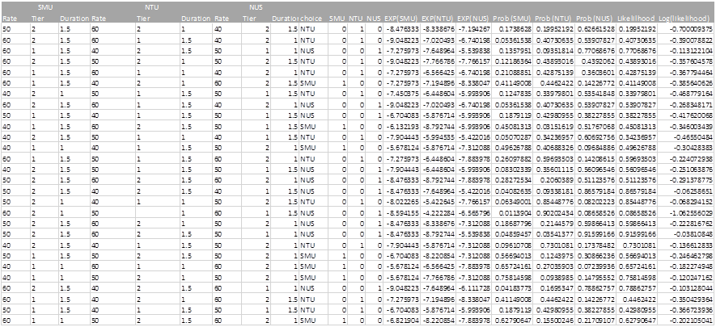

Question 2 (Total: 15 Marks)

720 patients with primary node positive breast cancer have been recruited into a clinical study to assess the effectiveness of hormone therapy. Researchers collected complete data on the 10 covariates for 686 of these patients as shown in figure 2. Survival analysis was performed on these patients with recurrence time as the survival time variable and recurrence status as the censoring variable. A subset of the data is shown in figure 3.
  - Provide two scenarios where censoring would occur in this study.
(2 Marks)
  - What can you deduce from the Kaplan-Meier survival curves shown in figure 4
(2 Marks)
  - A printout from R of the log–rank test is given below. What conclusions can you draw from these results?
Results of the Log-Rank Test

Call:
survdiff(formula = Y ~ bc$hormone, data = bc)

N Observed Expected (O-E)^2/E (O-E)^2/V
bc$hormone=No 440 205 180 3.37 8.56
bc$hormone=Yes 246 94 119 5.12 8.56

Chisq= 8.6 on 1 degrees of freedom, p= 0.00343

(2 Marks)
  - Using age, menopause status, hormone therapy, tumor size, tumor grade, number of nodes, number of progesterone receptors, and number of estrogen receptors as predictor variables, the backward stepwise selection technique was adopted to develop an appropriate Cox Proportional Hazard model. Based on the R outputs given in figure 5, select the best Cox Proportional Hazard model and write down the model equation. Discuss how the final model was chosen using backward stepwise selection from the initial model.
(4 Marks)
  - Interpret each regression coefficient of the model you selected in part (d).
(3 Marks)
  - Explain the critical assumption underlying your model.
(2 Marks)
Figure 2: Variable Description
Variable | Description
age | Age at diagnosis (years)
menopause | Menopausal status (No, Yes)
hormone | Hormone therapy (No, Yes)
size | Tumor size (millimetre)
grade | Tumor grade (1, 2, 3)
nodes | Number of nodes involved
prog_recp | Number of progesterone receptors
estrg_recp | Number of estrogen receptors
rectime | Time to recurrence (days)
censrec | Recurrence censoring (0 = Censored, 1 = Recurrence)
Figure 3: Sample Data
age | menopause | hormone | size | grade | nodes | prog_recp | estrg_recp | rectime | censrec
38 | No | No | 18 | 3 | 5 | 141 | 105 | 1337 | 1
52 | No | No | 20 | 1 | 1 | 78 | 14 | 1420 | 1
47 | No | No | 30 | 2 | 1 | 422 | 89 | 1279 | 1
40 | No | No | 24 | 1 | 3 | 25 | 11 | 148 | 0
64 | Yes | Yes | 19 | 2 | 1 | 19 | 9 | 1863 | 0
49 | Yes | Yes | 56 | 1 | 3 | 356 | 64 | 1933 | 0
53 | Yes | No | 52 | 2 | 9 | 6 | 29 | 358 | 1
61 | Yes | Yes | 22 | 2 | 2 | 6 | 173 | 2372 | 1
43 | No | No | 30 | 2 | 1 | 22 | 0 | 2563 | 0
74 | Yes | Yes | 20 | 2 | 1 | 462 | 240 | 2372 | 0
Figure 4: Kaplan-Meier Survival Curves
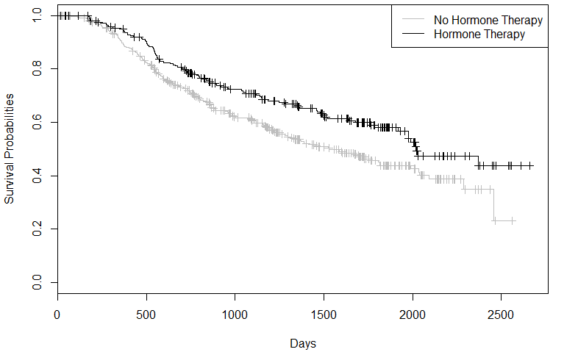
Figure 5: Cox Proportional Hazard Model R Outputs
> Y <- Surv(bc$rectime, bc$censrec == 1)
> coxph.fit1 <- coxph(Y ~ age + menopause + hormone + size + grade +
nodes + prog_recp + estrg_recp, data = bc)
> coxph.fit1
Call:
coxph(formula = Y ~ age + menopause + hormone + size + grade +
nodes + prog_recp + estrg_recp, data = bc)

coef exp(coef) se(coef) z p
age -0.009459 0.991 0.009301 -1.017 3.1e-01
menopauseYes 0.258445 1.295 0.183476 1.409 1.6e-01
hormoneYes -0.346278 0.707 0.129075 -2.683 7.3e-03
size 0.007796 1.008 0.003939 1.979 4.8e-02
grade2 0.636112 1.889 0.249202 2.553 1.1e-02
grade3 0.779654 2.181 0.268480 2.904 3.7e-03
nodes 0.048789 1.050 0.007447 6.551 5.7e-11
prog_recp -0.002217 0.998 0.000574 -3.866 1.1e-04
estrg_recp 0.000197 1.000 0.000450 0.438 6.6e-01

Likelihood ratio test=105 on 9 df, p=0 n= 686, number of events= 299

> coxph.fit2 <- step(coxph.fit1, direction="backward")
Start: AIC=3489.46
Y ~ age + menopause + hormone + size + grade + nodes + prog_recp +
estrg_recp

Df AIC
- estrg_recp 1 3487.7
- age 1 3488.5
- menopause 1 3489.4
<none> 3489.5
- size 1 3491.2
- hormone 1 3494.9
- grade 2 3495.3
- prog_recp 1 3507.5
- nodes 1 3519.5

Step: AIC=3487.65
Y ~ age + menopause + hormone + size + grade + nodes + prog_recp

Df AIC
- age 1 3486.6
- menopause 1 3487.7
<none> 3487.7
- size 1 3489.3
- hormone 1 3493.0
- grade 2 3493.5
- prog_recp 1 3506.8
- nodes 1 3517.6

Step: AIC=3486.56
Y ~ menopause + hormone + size + grade + nodes + prog_recp

Df AIC
- menopause 1 3485.7
<none> 3486.6
- size 1 3488.1
- hormone 1 3492.3
- grade 2 3492.6
- prog_recp 1 3506.6
- nodes 1 3516.4

Step: AIC=3485.68
Y ~ hormone + size + grade + nodes + prog_recp

Df AIC
<none> 3485.7
- size 1 3487.0
- hormone 1 3490.5
- grade 2 3491.8
- prog_recp 1 3506.1
- nodes 1 3515.9

> coxph.fit2
Call:
coxph(formula = Y ~ hormone + size + grade + nodes + prog_recp,
data = bc)

coef exp(coef) se(coef) z p
hormoneYes -0.32352 0.724 0.125824 -2.57 1.0e-02
size 0.00731 1.007 0.003890 1.88 6.0e-02
grade2 0.64403 1.904 0.249018 2.59 9.7e-03
grade3 0.78823 2.199 0.268258 2.94 3.3e-03
nodes 0.04900 1.050 0.007453 6.57 4.9e-11
prog_recp -0.00222 0.998 0.000554 -4.00 6.3e-05

Likelihood ratio test=103 on 6 df, p=0 n= 686, number of events= 299

SECTION B

Question 3 (Total: 6 Marks)

- Describe briefly what is meant by the term “overfitting” when used in the context of building a prediction model.
(1 mark)

- Give one symptom of overfitting when building a Neural Network.
(1 mark)

- Assume that a Neural Network has been built and that overfitting is detected. It is decided to rebuild the Neural Network. For each of the options listed below, state whether it would or would not help prevent overtraining in the new network. Justify (explain) your answers.

- Increase the training time
- Decrease the number of nodes in the hidden layer
- Add an extra hidden layer
- Use fresh random initial weights
- Increase the number of training examples
- Increase the number of input variables (input nodes)

(4 marks)
Question 4 (Total: 7 Marks)

- You have been asked to build an ensemble classifier comprising 10 decision tree models using a set of 1000 training examples. You have also been asked to ensure that each of the 1000 training examples should be used at least once during model building (ie: should be used as a training record for at least one of the trees). Which of the following three model building methods would you recommend? Explain your answer:
  - Build the 10 trees by bootstrap sampling (with replenishment) of 90% of the training data for each tree.
  - Build the 10 trees by bootstrap sampling (without replenishment) of 90% of the training data for each tree.
  - Build the 10 trees using 10-fold cross validation with 9-folds being used for each tree.
(2 Marks)
- When building a random forest classifier, should over-fitting of the training data by the trees within the forest be avoided? Explain you answer.
(2 Marks)
- When building a single decision tree classifier using a decision tree learning algorithm, the first feature (variable) appearing in the tree (ie: the feature that is tested in the tree root node) is generally considered the most important feature in the dataset with respect to the classification task. However, when building a random forest to perform the same classification task, the first feature that appears in each tree in the forest cannot be considered the most important feature. Explain why this is the case.
(3 Marks)
Question 5 (Total: 7 Marks)

Below are confusion matrices showing the performances of three prediction models that have been built to perform a binary classification task (with class values = true, false). The test set used contained 100 examples of which 41 have class value = true (T) and 59 have the class value = false (F). The rows in the confusion matrices show the number of actual values in each class and the columns show the number of predicted values in each class. A fourth confusion matrix is also shown which shows the performance of an ensemble of the three prediction models. The voting method used by the ensemble was that only if all three individual models agreed on the predicted class value, would a prediction be made, otherwise no prediction would be made. Hence the ensemble has three prediction outcomes, T, F and U (unknown).
 |  | predicted
 | actual | T | F
model1 | T | 27 | 14
 | F | 13 | 46
 |  | predicted
 | actual | T | F
model2 | T | 33 | 8
 | F | 8 | 51
 |  | predicted
 | actual | T | F
model3 | T | 32 | 9
 | F | 17 | 42
 |  | predicted
 | actual | T | F
ensemble | T | 16 | 0
 | F | 1 | 26
Answer the following questions:
- Is the precision of the ensemble higher than that of the best individual model? Show your calculations.
(3 Marks)
- Is the recall of the ensemble higher than that of the best individual model? Show your calculations. We define recall here as the percentage of the actual true examples that was predicted as true.
(3 Marks)
- If the ensemble voting rule was changed to only require a majority vote then would you expect the precision of the ensemble model to increase or decrease? Similarly, would you expect the recall to increase or decrease? Explain your answer.
(1 Mark)

SECTION C

Question 6 (Total: 15 Marks)

The monthly passenger numbers of an airline over 11 years (132 months) are shown below in figure 6.
- Using multiplicative decomposition method, 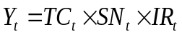, the average seasonal indices for a twelve month period are as follows:
The trend component is found to be TC = 2.5539t + 92.494 where:
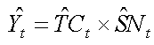
- Give an intuitive explanation of your understanding of the seasonal pattern.
(2 Marks)
- Using the developed model, provide a projection for the first half of year 12.
(3 Marks)
- ARIMA models have been applied to the passenger data shown in figure 1:
- The passenger data is not a stationary series. How can this be overcome?
(2 Marks)
- Two modeled results of the series are shown below in figures 7 and 8:
  - Comment on the validity of the two results and recommend your model of choice.
(4 Marks)
  - Based on your recommendation in part (1), write the full expression of the forecast summary (Y_{t} = … Y_{t-n}.. Y_{t-m..}) using the coefficient estimates given in figures 2 and 3 (Hint: use the backshift B operator to express and expand the equation).
(4 Marks)
Figure 6: Monthly Airline Passenger Numbers
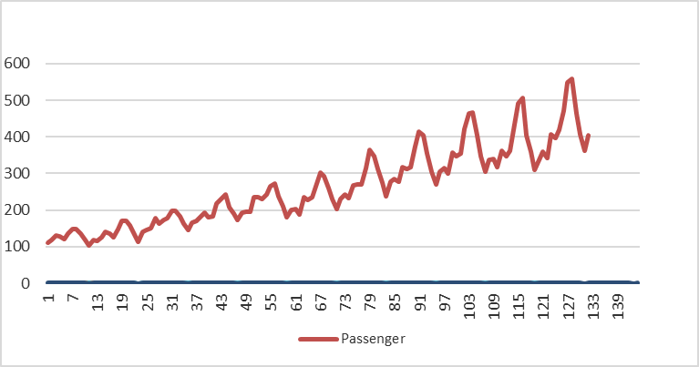
Figure 7: First Model Results
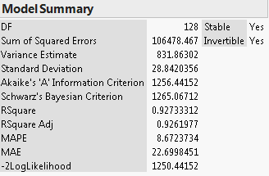
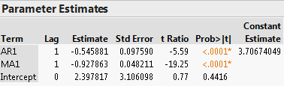
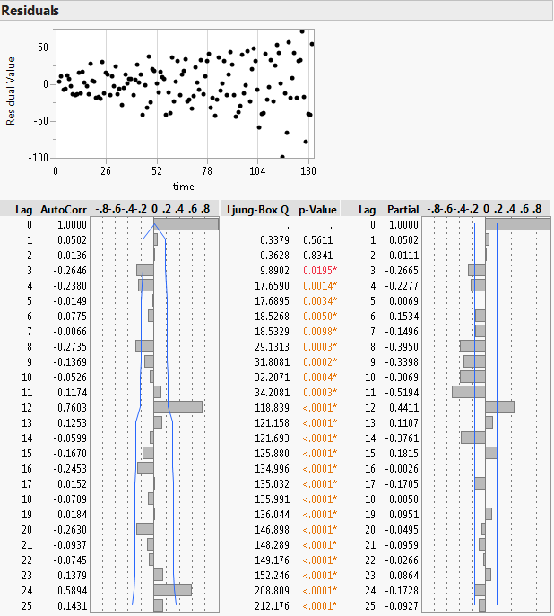
Figure 8: Second Model Results
