DBMS LAB ASSIGNMENT 3
24MAB0A32

Question 1: Manufacturer

Assumptions made:

1)SupplierID was invented . A surrogate key plus basic contact details were added as Supplier name alone is not reliably unique.

2)QuantityUsed was added to PRODUCT_COMPONENT as a relationship attribute: how many units of a component go into one unit of a product. This is a property of the pairing, not of either entity.

3)UnitPrice and LeadTimeDays were added to SUPPLIER_COMPONENT for the same reason , price depends on which supplier sells which component.

4)Components are flat. No component is itself made of sub-components, so there is no recursive bill-of-materials relationship. If that were required, a unary M:N
COMPONENT_ASSEMBLY (ParentComponentID, ChildComponentID, Quantity) would be added.

a)ER Diagram

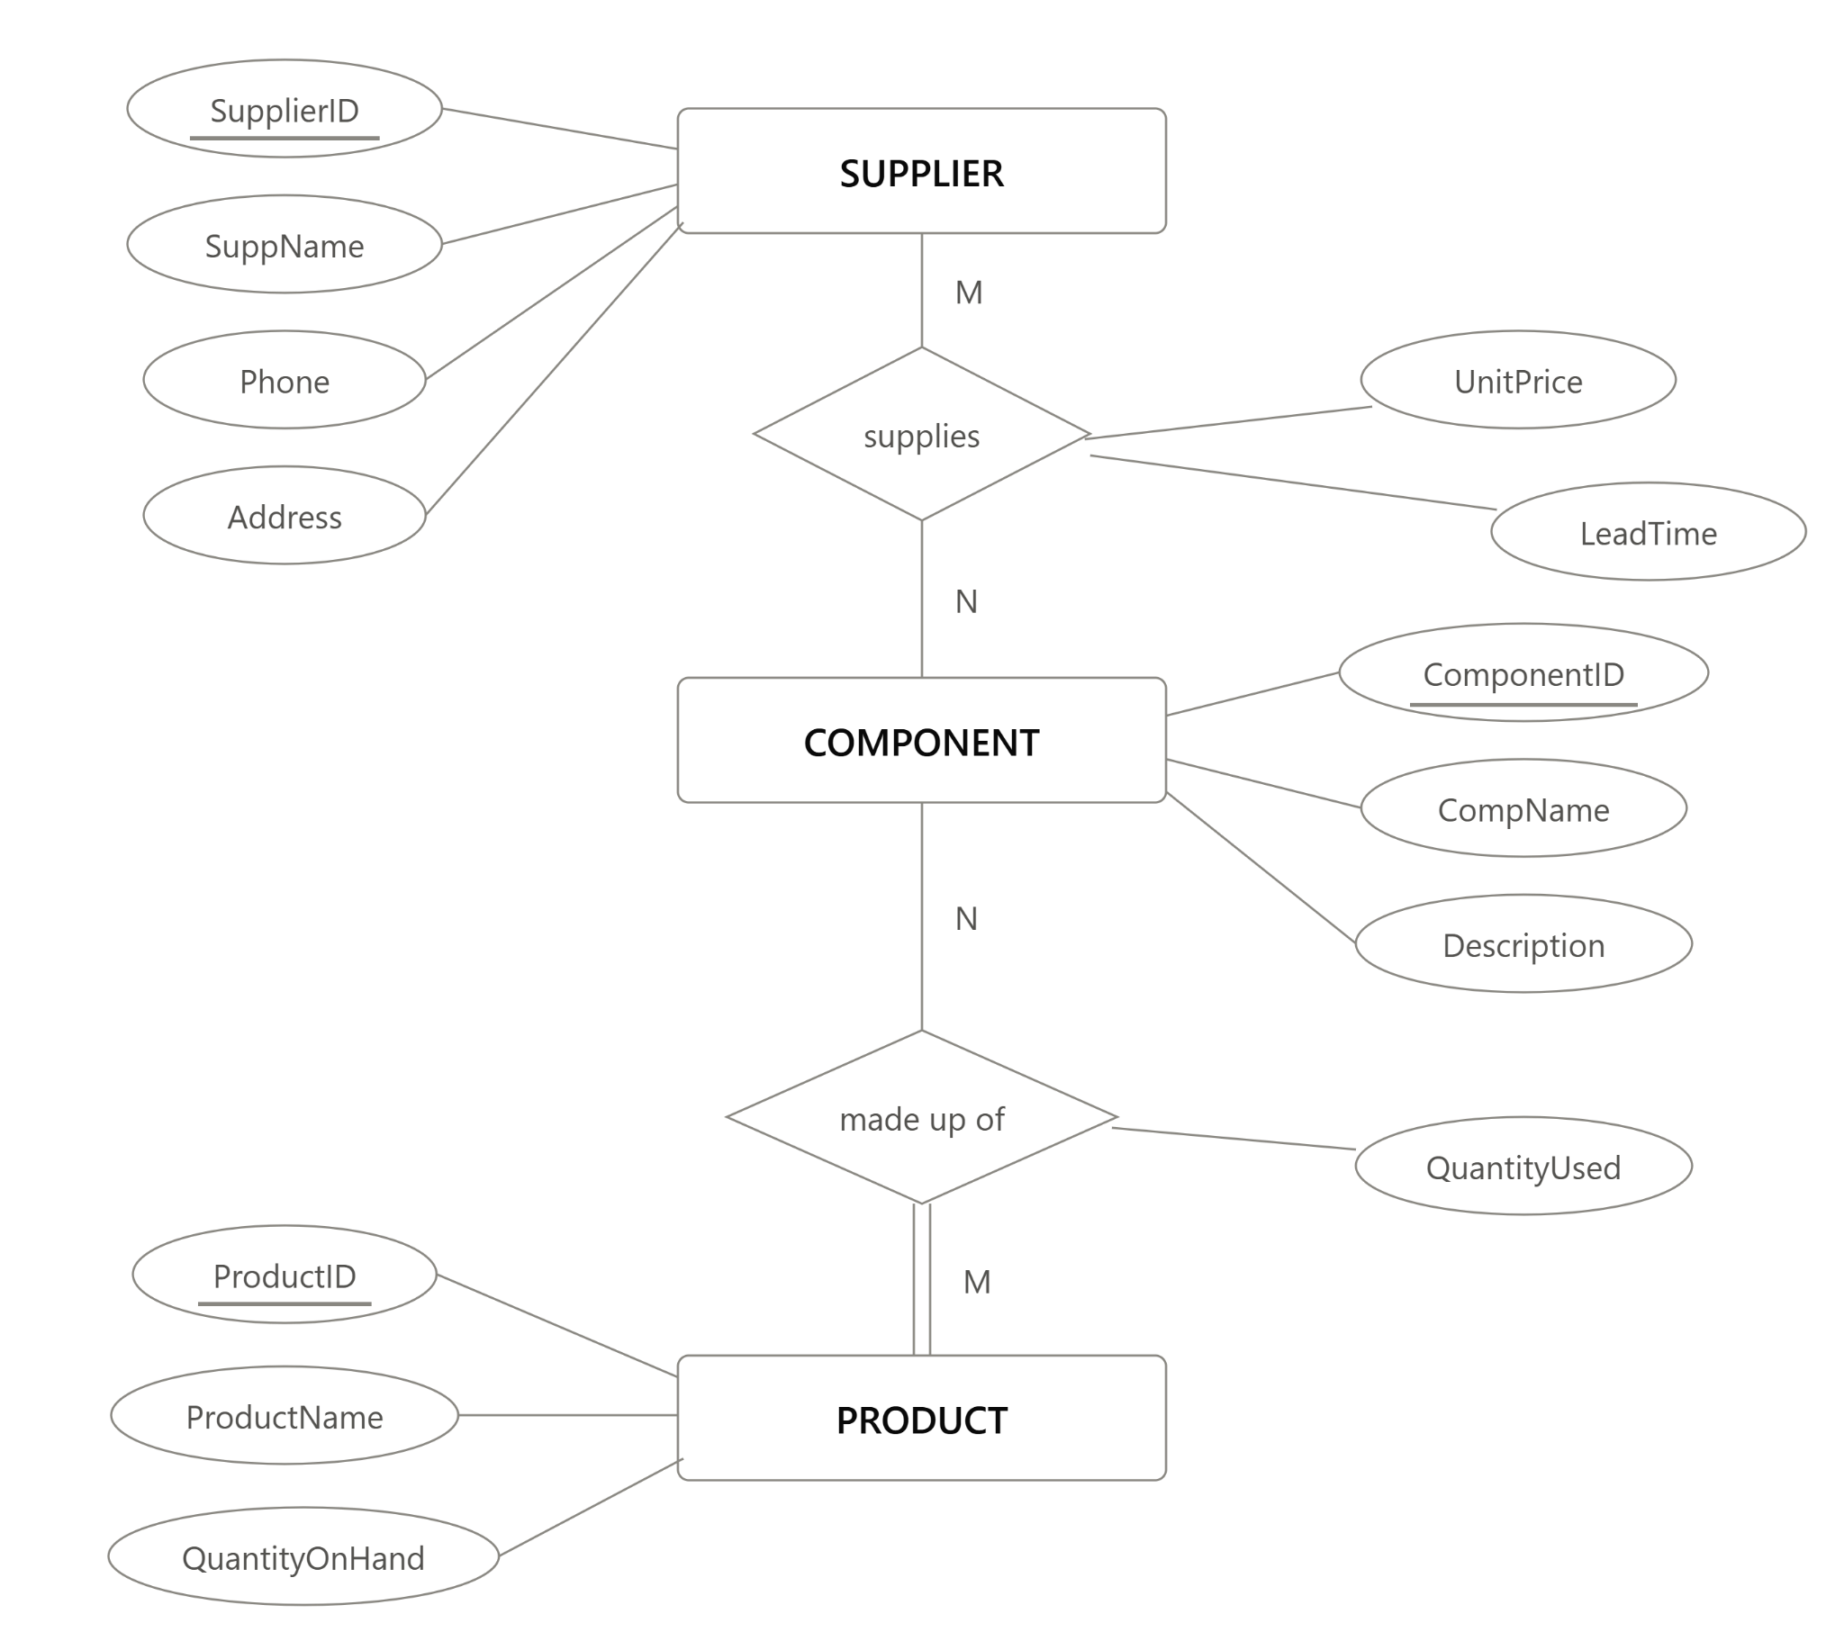

b)Relational schema

PRODUCT (ProductID, ProductName, QuantityOnHand)
PK: ProductID

COMPONENT (ComponentID, ComponentName, Description)
PK: ComponentID

SUPPLIER (SupplierID, SupplierName, ContactPhone, Address) PK: SupplierID

PRODUCT_COMPONENT (ProductID, ComponentID, QuantityUsed)
PK: (ProductID, ComponentID)
FK: ProductID -> PRODUCT (ProductID)
FK: ComponentID -> COMPONENT (ComponentID)
SUPPLIER_COMPONENT (SupplierID, ComponentID, UnitPrice, LeadTimeDays)
PK: (SupplierID, ComponentID)
FK: SupplierID -> SUPPLIER (SupplierID)
FK: ComponentID -> COMPONENT (ComponentID)

Question 2: Car Dealership

Assumptions:

1)CAR entity holds every car the dealership deals with new inventory, used inventory, and cars brought in only for service (which may never have been sold by this dealership). SerialNo is the natural, dealership-wide unique key (VIN-style).

2)A car may sit unsold. SalespersonID and CustomerID on CAR (the "sold to / sold by" links) are optional they're only filled in once the car is actually sold. So CAR has partial participation in Sold_By and Sold_To.

3)Invoice exists only after a sale, and exactly one invoice per sale (1:1). CAR has partial participation in Generates (unsold car → no invoice); INVOICE has total participation (an invoice can't exist without a car sale). So the FK naturally sits on the INVOICE side.

4)A customer can exist purely as a service customer, never having bought a car so CUSTOMER has partial participation in Sold_To, but its link into SERVICE_TICKET (via Requests) is mandatory for any given ticket.

5)Service history is tracked by car serial number, so every SERVICE_TICKET must reference a SerialNo (total participation of SERVICE_TICKET in Serviced_In); one car can have many tickets over its lifetime.

6)Works_On and Uses are both M:N, so each needs its own associative (junction) table to hold the relationship attribute (HoursWorked, QtyUsed) and the composite key.

7)A service ticket may use zero parts handled automatically: if no parts are used, there's simply no row in the USES table for that ticket (no NULL-key issue).

8)Commission is a simple attribute of SALESPERSON, not computed. TicketID, InvoiceNo, CustomerID, SalespersonID, MechanicID, PartID are all surrogate/system-generated keys; SerialNo is the one natural key.

ER Diagram
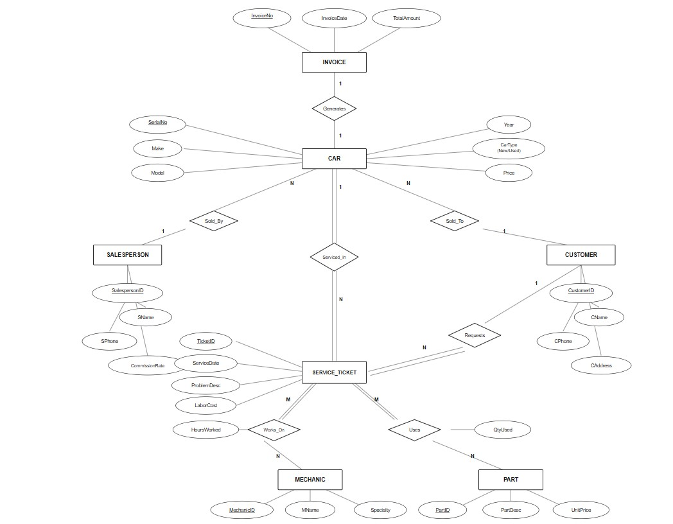

Relation Schema
SALESPERSON (SalespersonID, SName, SPhone, CommissionRate) PK: SalespersonID

CUSTOMER (CustomerID, CName, CPhone, CAddress)
PK: CustomerID

MECHANIC (MechanicID, MName, Specialty)
PK: MechanicID

PART (PartID, PartDesc, UnitPrice)
PK: PartID

CAR (SerialNo, Make, Model, Year, CarType, Price, SalespersonID, CustomerID)
PK: SerialNo
FK: SalespersonID -> SALESPERSON (SalespersonID) [nullable — unsold car]
FK: CustomerID -> CUSTOMER (CustomerID) [nullable — unsold car]

INVOICE (InvoiceNo, InvoiceDate, TotalAmount, SerialNo)
PK: InvoiceNo
FK: SerialNo -> CAR (SerialNo) [not null, unique — one invoice per car sale]

SERVICE_TICKET (TicketID, ServiceDate, ProblemDesc, LaborCost, SerialNo, CustomerID) PK: TicketID
FK: SerialNo -> CAR (SerialNo)
FK: CustomerID -> CUSTOMER (CustomerID)

WORKS_ON (TicketID, MechanicID, HoursWorked)
PK: (TicketID, MechanicID)
FK: TicketID -> SERVICE_TICKET (TicketID)
FK: MechanicID -> MECHANIC (MechanicID)

USES (TicketID, PartID, QtyUsed)
PK: (TicketID, PartID)
FK: TicketID -> SERVICE_TICKET (TicketID)
FK: PartID -> PART (PartID)

