Static Website Hosting using Amazon S3 Report submitted as part of the internship program requirement for the degree of BACHELOR OF TECHNOLOGY
IN
COMPUTER SCIENCE ENGINEERING (AI & ML)
Submitted by
BANDI MOHAN SAI MANIKANTA (A24126552009)

DEPARTMENT OF CSE (AI & ML)
ANIL NEERUKONDA INSTITUTE OF TECHNOLOGY AND SCIENCES
(UGC AUTONOMOUS)
(Permanently Affiliated to AU, Approved by AICTE, and Accredited by NBA & NAAC with an 'A+' Grade)
SANGIVALASA, Bheemili Mandal, VISAKHAPATNAM – 531162
2024-2028
1

ANIL NEERUKONDA INSTITUTE OF TECHNOLOGY AND SCIENCES (Affiliated to Andhra University)
SANGIVALASA, VISAKHAPATNAM - 531162
2024-2028
BONAFIDE CERTIFICATE
This is to certify that this Internship Report entitled “Static Website Hosting using Amazon
S3” is the Bonafide work of BANDI MOHAN SAI MANIKANTA (A24126552009) of II/IV
BTech CSM, who carried out the internship under our supervision and submitted it in partial
fulfilment of the academic requirements for the award of the degree of Bachelor of
Technology in Computer Science Engineering (AI & ML).
REVIEWER CLASS TEACHER
Dr. D Karun Kumar Reddy Mrs. Ch Sravanthi Sowdanya Assistant Professor Assistant Professor Department of CSE (AI & ML) Department of CSE (AI & ML) ANITS ANITS
Head Of the Department
Dr. K. Selvani Deepthi
Department of CSE (AI & ML)
ANITS
2

ACKNOWLEDGEMENT
An endeavour that spans a significant period becomes a success with the advice, encouragement, and support of many well-wishers. I take this opportunity to express my sincere gratitude and appreciation to all those who have been instrumental in making this internship experience both enriching and rewarding.
First and foremost, I extend my heartfelt thanks to Dr. K.S. Deepthi, Head of the Department of Computer Science & Engineering (AI & ML) at ANITS, for her invaluable guidance, continuous support, and encouragement throughout this internship program.
I express my profound gratitude to my Reviewer Dr. D Karun Kumar Reddy and Class Teacher Mrs. Ch Sravanthi Sowndanya, Assistant Professors in the Department of CSE (AI & ML), for their constructive evaluation, detailed reviews, and constant encouragement throughout this work.
I would also like to express my deepest appreciation to the Andhra Pradesh State Skill Development Corporation (APSSDC) and technical mentors Mrs. Bethala Sumana and Mr. Juttuka Lovababu for offering me the opportunity to undertake this specialized internship. Their continuous technical assistance, architectural guidance, and feedback helped me navigate real-world cloud deployment challenges.
My sincere thanks go to all the faculty members of the Department of CSE (AI & ML) and the technical support staff for their cooperation and assistance in providing necessary computational resources.
BANDI MOHAN SAI MANIKANTA
A24126552009
3

Table of Contents
1. Introduction
1.1 Background of Internship
1.2 Objectives of the Internship
1.3 Importance of Modern Cloud Hosting & CI/CD
1.4 Scope of the Project
2. Organization Profile
2.1 APSSDC Cloud Internship Framework Overview
2.2 Role of Mentorship and APSSDC Training Division
2.3 Amazon Web Services (AWS) Ecosystem Relevance
2.4 Summary of Internship Logistics
3. Project Overview
3.1 Title of the Project
3.2 Problem Statement
3.3 Objectives of the Project
3.4 Relevance to Enterprise Cloud Architecture & DevOps
4. Literature Review / Theoretical Background
4.1 Fundamentals of Cloud Storage & Content Delivery Networks 4.2 Private Origins vs. Direct S3 Static Web Hosting
4.3 Credential-less Deployment via OpenID Connect (OIDC) 4.4 Operational Observability: Active vs. Passive Telemetry 4.5 Related Works and Architectural Comparison
5. Methodology
5.1 System Architecture and Requirements Planning
5.2 Storage Layer Configuration (Amazon S3)
5.3 Edge Delivery & Origin Access Control (CloudFront & OAC) 5.4 Federated Access Management (AWS IAM & GitHub OIDC) 5.5 Automated Continuous Deployment (GitHub Actions Workflow) 5.6 Observability and Real-Time Alerting (CloudWatch & SNS)
6. Implementation
6.1 Phase 1 – S3 Bucket Provisioning & Object Hardening
6.2 Phase 2 – CloudFront Distribution & OAC Bucket Policy Integration 6.3 Phase 3 – IAM OIDC Trust Entity & Least-Privilege Role Setup 6.4 Phase 4 – GitHub Actions CI/CD Pipeline Automation
4

6.5 Phase 5 – CloudWatch Metric Alarm & SNS Notification Channel 6.6 Architectural Safeguards & Cost Control Strategy
7. Results and Discussion
7.1 Automated Deployment Latency and Verification
7.2 Zero-Trust Origin Isolation Verification
7.3 CloudWatch-to-SNS Alert Verification via Simulated Incident 7.4 Zero-Cost Metric and Billing Audit
7.5 Critical Evaluation of System Performance
8. Conclusion & Future Work
8.1 Summary of Learnings
8.2 Cloud & DevOps Competencies Acquired
8.3 Limitations of the Current Architecture
8.4 Future Scope (Multi-Branch Environments, Custom Domains & WAF)
9. Internship Outcomes
9.1 Technical Skills Acquired
9.2 Soft Skills & Professional Competencies Developed
9.3 Contribution to Career Growth
Appendix
A. Source Code & Configuration Repository
B. Architectural Verification Records & Resource Teardown C. Certificate of Completion
5

1. Introduction
1.1 Background of Internship
This report highlights my comprehensive learning experience and technical outcomes from the APSSDC-Summer Online Internship - 2026 on “AWS Cloud Computing - DevOps,” conducted under the aegis of the Andhra Pradesh State Skill Development Corporation (APSSDC) in partial fulfillment of the academic requirements for the Bachelor of Technology in Computer Science and Engineering (AI & ML).
Modern software engineering has transitioned rapidly from monolithic, dedicated web servers toward distributed, serverless cloud architectures. In traditional deployments, organizations maintained physical or virtual server instances (such as Apache or Nginx on Linux compute instances) to serve static frontend files like HTML, CSS, JavaScript, and client-side media. This legacy model introduces significant administrative overhead, including regular operating system patch management, continuous vulnerability scanning, unpredictable scaling bottlenecks during traffic spikes, and baseline server idle costs.
Through this internship program, students were provided an opportunity to bridge theoretical concepts of computer networking, distributed systems, and access management with contemporary industry-standard cloud implementations. The program focused on building highly resilient, secure, cost-optimized, and fully automated web delivery platforms using AWS core primitives.
1.2 Objectives of the Internship
The overarching objective of this internship was to gain rigorous, hands-on exposure to cloud architecture design principles, production security controls, and DevOps deployment pipelines. Rather than performing manual resource provisioning through GUI dashboards alone, the program stressed repeatability, infrastructure security, zero-trust access control, and proactive operational monitoring.
•Cloud Foundation: To master core cloud infrastructure services on Amazon Web Services, specifically focusing on Amazon Simple Storage Service (S3), Amazon CloudFront, AWS Identity and Access Management (IAM), Amazon CloudWatch, and Amazon Simple Notification Service (SNS).
•Storage Hardening: To implement a hardened, private storage architecture where static web assets are protected from direct internet access using modern Origin Access Control (OAC) mechanisms.
•Credential-less Identity: To eliminate traditional security vulnerabilities associated with long-lived credentials by configuring federated OpenID Connect (OIDC) authentication between GitHub Actions and AWS IAM.
•CI/CD Pipeline Engineering: To engineer a fully automated Continuous Integration and Continuous Deployment (CI/CD) pipeline that automates object synchronization and global edge cache invalidation on every repository push.Observability & Alerting: To design an automated observability and alerting loop that translates infrastructure error metrics into real-time operational notifications without introducing alert fatigue.
6

1.3 Importance of Modern Cloud Hosting & CI/CD
In modern digital enterprises, user experience and operational cost are directly influenced by website latency, uptime reliability, and security posture. Traditional hosting requires persistent compute uptime regardless of inbound traffic volume, resulting in financial inefficiency during off-peak periods and latency degradation for international visitors who are geographically distant from the centralized server.
By pairing object storage (Amazon S3) with an enterprise-grade Content Delivery Network (Amazon CloudFront), files are physically cached at hundreds of Points of Presence (PoPs) worldwide. When an end-user requests a webpage, the request is terminated at the nearest edge location, cutting Time to First Byte (TTFB) and drastically reducing network hops. Furthermore, TLS termination is handled seamlessly at the edge, guaranteeing HTTPS encryption without requiring compute-side certificate handling.
Complementing cloud delivery with Continuous Integration and Continuous Deployment (CI/CD) transforms software development lifecycle (SDLC) speed. In legacy workflows, code updates required manual FTP/SFTP uploads or SSH console commands—practices notoriously prone to human error, missed files, and credential exposure. A modern pipeline automates these steps, enforcing build tests, synchronization consistency, and edge invalidations within seconds of code commit.
1.4 Scope of the Project
The scope of this project was to architect, configure, validate, and document an end-to-end static website hosting solution incorporating enterprise security patterns, automated CI/CD pipelines, and proactive error alerting while strictly conforming to a zero-cost operational budget.
•Private Storage Origin: Provisioning an S3 bucket configured with all Block Public Access settings permanently active and S3 Static Website Hosting intentionally disabled to prevent public origin disclosure.
•Global Content Delivery: Creating a CloudFront distribution utilizing Origin Access Control (OAC) to sign requests to the private bucket, enforcing TLS 1.2+ encryption, and configuring index document root resolution.
•Keyless Identity Federation: Registering GitHub's OIDC issuer in AWS IAM and establishing a scoped IAM role governed by strict trust conditions (repo:org/repo:branch).
•Automated Pipeline: Creating a declarative GitHub Actions workflow executing repository checkout, temporary AWS authentication, incremental S3 sync, and wildcard edge cache invalidation.
•Continuous Observability: Defining a CloudWatch alarm tracking CloudFront's 5xxErrorRate metric coupled with an Amazon SNS email topic to deliver automated failure alerts.
•Governance & Safe Teardown: Setting up zero-spend AWS budget alerts and demonstrating clean resource teardown procedures to ensure zero lingering costs.
7

2. Organization Profile
2.1 APSSDC Cloud Internship Framework Overview
The Andhra Pradesh State Skill Development Corporation (APSSDC) is a unique public-private partnership organization established by the Government of Andhra Pradesh to promote skill development and entrepreneurship across the state. Under its specialized technical training division, APSSDC regularly collaborates with premier educational institutions to conduct structured Summer Internship Programs (SIP) in cutting-edge technology domains including Cloud Computing, DevOps Engineering, and Artificial Intelligence.
Through the APSSDC-Summer Online Internship - 2026, students were immersed in an enterprise-focused curriculum designed to provide hands-on exposure to production cloud services, security architectures, and automated infrastructure pipelines.
2.2 Role of Mentorship and APSSDC Training Division
The technical execution of the project was guided by APSSDC mentors Mrs. Bethala Sumana and Mr. Juttuka Lovababu, alongside internal institutional advisors from the Department of Computer Science & Engineering (AI & ML) at ANITS. The mentoring team established clear milestones, conducted periodic technical reviews, and ensured adherence to industry-standard AWS best practices.
The curriculum emphasized two core dimensions:
1. Technical Mastery: Direct interaction with the AWS Management Console and AWS CLI, IAM JSON policy authoring, GitHub Actions workflow scripting, and CloudWatch metric alarm configuration.
2. Production Rigor: Zero-trust access controls, elimination of long-lived secrets, active incident alerting, and disciplined cloud cost management.
2.3 Amazon Web Services (AWS) Ecosystem Relevance
Amazon Web Services (AWS) is the world's leading cloud computing provider. Mastering AWS architectures aligns directly with the five pillars of the AWS Well-Architected Framework: Security, Reliability, Performance Efficiency, Cost Optimization, and Operational Excellence—all of which were directly implemented in this project.
2.4 Summary of Internship Logistics
The operational parameters and institutional specifications of the internship program are systematically summarized in Table 2.1.
8

Operational Parameter | Program Specification and Implementation Details
Program Name | APSSDC-Summer Online Internship - 2026
Course Track | AWS Cloud Computing - DevOps
Organizing Body | Andhra Pradesh State Skill Development Corporation (APSSDC),
Govt. of Andhra Pradesh
Institutional Partner | Anil Neerukonda Institute of Technology and Sciences (ANITS),

Candidate Details | Visakhapatnam  Bandi Mohan Sai Manikanta (Roll Number: A24126552009)
Certificate ID | APSSDC/SIP/2026-27/30358
Internship Duration | 04-May-2026 to 03-Jul-2026
Technology Stack | Amazon Web Services (S3, CloudFront, IAM, CloudWatch, SNS) &

Cost Strategy | GitHub Actions CI/CD  100% Free-Tier Compliant
9

3. Project Overview
3.1 Title of the Project
Static Website Hosting using Amazon S3 (Serverless Architecture with CloudFront, OAC, IAM OIDC CI/CD, and CloudWatch Alerting)
3.2 Problem Statement
Hosting static web applications on cloud infrastructure is often approached through naive patterns that compromise either security, automation, or financial control. This creates severe security hazards, leaving the storage bucket directly exposed to internet scrapers, distributed denial-of-service (DDoS) attacks, and unauthorized object discovery.
Furthermore, routine updates are frequently performed via manual console drag-and-drop or through developer workstations using long-lived AWS IAM access keys stored in GitHub repository secrets. If compromised, these permanent access keys grant attackers direct entry into the AWS account. Lastly, most low-traffic static websites suffer from zero operational visibility—infrastructure issues, such as bucket misconfigurations or origin 5xx errors, go completely undetected until users report site unavailability.
3.3 Objectives of the Project
To resolve these critical vulnerabilities and inefficiencies, this project pursued four concrete architectural objectives:
1. Enforce Zero-Public-Origin Security: Keep the underlying Amazon S3 bucket completely private behind strict Block Public Access controls, permitting read access exclusively to a dedicated Amazon CloudFront distribution via Origin Access Control (OAC).
2. Implement Credential-less Deployment Automation: Eliminate static IAM access keys entirely by establishing OpenID Connect (OIDC) identity federation between GitHub Actions and AWS IAM, issuing short-lived, session credentials during automated pipeline runs.
3. Ensure Automated Global Content Synchronization: Automate object synchronization to S3 and invalidate edge caches across CloudFront's worldwide edge locations within seconds of code pushed to the default branch.
4. Establish Actionable Operational Telemetry: Construct a continuous monitoring and alerting pipeline using Amazon CloudWatch and Amazon SNS to notify the engineering team via email immediately if server error rates breach acceptable thresholds.
3.4 Relevance to Enterprise Cloud Architecture & DevOps
The patterns implemented in this project represent the modern standard for production static delivery across high-growth startups and Fortune 500 enterprises. By eliminating compute servers, companies achieve infinite auto-scaling and ultra-low latency while slashing infrastructure bills. Furthermore, adopting OIDC keyless authentication complies directly with modern cybersecurity frameworks, eradicating credential theft vectors.
10

4. Literature Review / Theoretical Background
4.1 Fundamentals of Cloud Storage & Content Delivery Networks
Modern cloud architectures decouple storage from computation. Cloud object storage, such as Amazon Simple Storage Service (S3), organizes data as unstructured objects within logical containers called buckets. Unlike traditional block or file storage systems, object storage is designed for massive horizontal scalability, offering 99.999999999% (11 nines) of data durability through multi-facility redundancy.
However, querying an object store directly across public HTTP introduces physical distance latency. A visitor accessing a bucket situated in AWS Region us-east-1 from India incurs round-trip network latencies of 200–300 ms. A Content Delivery Network (CDN) resolves this by deploying edge caching servers at strategic Internet exchange points globally. Amazon CloudFront caches objects closer to the consumer, terminating TLS handshakes locally and serving cached content with single-digit millisecond latency.
4.2 Private Origins vs. Direct S3 Static Web Hosting
Amazon S3 includes a legacy feature known as 'Static Website Hosting.' When toggled on, S3 assigns an HTTP website endpoint. While simple, this approach presents critical architectural flaws:
•• Mandatory Public Exposure: The bucket's Block Public Access settings must be disabled, and an open bucket policy granting s3:GetObject to Principal: '*' must be applied.
•• Lack of Native HTTPS: S3 website endpoints do not support native SSL/TLS encryption. Traffic is transmitted in cleartext over unencrypted HTTP unless fronted by custom DNS and CDN proxies.
•• Origin Direct Hit Vulnerability: Anyone discovering the S3 URL can bypass web application firewalls (WAF), generating unmetered storage GET request charges directly against the bucket owner.
In contrast, using CloudFront with Origin Access Control (OAC) keeps the bucket completely locked down. CloudFront communicates with the S3 private REST API endpoint (bucket-name.s3.amazonaws.com) and cryptographically signs every request using AWS Signature Version 4 (SigV4). S3 validates that the caller is CloudFront and matches the specific distribution ARN before returning content. Direct browser requests to the bucket URL receive an immediate 403 Forbidden response.
4.3 Credential-less Deployment via OpenID Connect (OIDC)
Historically, integrating external CI/CD platforms with AWS required generating an IAM
User, | creating | access | key | pairs | (AWS_ACCESS_KEY_ID | and
AWS_SECRET_ACCESS_KEY), and pasting them into repository secrets. Static long-lived credentials represent the primary cause of cloud data breaches due to commit leaks and lack of rotation.
11

The modern zero-trust alternative is OpenID Connect (OIDC) Identity Federation. GitHub Actions acts as an IdP issuing cryptographic JSON Web Tokens (JWT) signed by GitHub's authority (token.actions.githubusercontent.com). AWS IAM trusts this issuer and validates claims (repo:org/repo:branch). Upon verification, the AWS Security Token Service (STS) issues short-lived temporary security credentials via AssumeRoleWithWebIdentity. Once the pipeline run completes, credentials expire automatically.
4.4 Operational Observability: Active vs. Passive Telemetry
Passive monitoring—where an engineer manually inspects dashboards—is inadequate for production systems. Active alerting transforms telemetry into automated incident response. CloudWatch continuously aggregates CloudFront error rates; when thresholds are breached, it shifts to ALARM and dispatches notifications via Amazon SNS to email within 60 seconds.
4.5 Related Works and Architectural Comparison
Table 4.1 contrasts the architectural characteristics of traditional web servers, legacy S3 website hosting, and the modern private-origin OAC model engineered in this project.
Hosting Pattern | Security & Encryption | Deployment & | Cost & Maintenance

Traditional VM | Requires manual Certbot | Automation | Continuous compute cost
Traditional VM | Requires manual Certbot | SSH scripts, Ansible, | Continuous compute cost
(EC2 / VPS) | SSL, OS patching, open | manual FTP. Configuration | ($5–$20/mo) even when
(EC2 / VPS) | ports. High attack | drift is common. | idle. Manual scaling.
surface.
Legacy Public S3 | 100% public bucket. | Manual AWS Console | Low storage cost, but
Web Hosting | HTTP only (no native | uploads or static IAM keys | exposed to unmetered
Web Hosting | SSL). Scraping risk. | stored in secrets. | direct DDoS request bills.
Private S3 + | Zero public origin | 100% automated CI/CD. | 100% Free Tier
CloudFront + OIDC | exposure. Enforced TLS | Keyless IAM OIDC | ($0.00/mo). Bundled
(This Project) | 1.2+ HTTPS. OAC | federation; zero static | CDN, DDoS defense,
(This Project) | SigV4 authentication. | credentials. | automated alerting.
12

5. Methodology
5.1 System Architecture and Requirements Planning
The methodology followed a structured, checkpointed engineering lifecycle. Each architectural layer was designed with explicit security constraints, implemented in isolation, verified against acceptance criteria, and integrated into the overarching pipeline.
+-------------------------------------------------------------------------+ | DEVELOPER WORKSTATION | +------------------------------------+------------------------------------+ | git push origin master
v
+-------------------------------------------------------------------------+ | GITHUB ACTIONS CI/CD ENGINE | | 1. Request OIDC Token (token.actions.githubusercontent.com) | | 2. Assume Scoped AWS IAM Role via STS Web Identity | | 3. Execute `aws s3 sync --delete` | | 4. Execute `aws cloudfront create-invalidation` | +--------------------+------------------------------------+---------------+ | PutObject | Invalidation v v
+------------------------------------+ +--------------------------------+ | AMAZON S3 BUCKET | | AMAZON CLOUDFRONT | | (Strictly Private Origin) |<--| (Global Edge CDN / SSL) | | - Block Public Access: ON |OAC| - *.cloudfront.net | | - Static Hosting: OFF |Sig| - Root: index.html | +------------------------------------+ +---------------+----------------+ | 5xx Errors v
+------------------------------------+ +--------------------------------+ | EMAIL NOTIFICATION | | AMAZON CLOUDWATCH | | (Delivered within 60 sec) |<--| - 5xxErrorRate > 1% | | Engineering Team Alert |SNS| - Alarm State: ALARM | +------------------------------------+ +--------------------------------+
Figure 5.1: End-to-End Private-Origin Serverless Hosting and Deployment Architecture
5.2 Storage Layer Configuration (Amazon S3)
The backend storage foundation utilizes Amazon S3 configured under zero-trust assumptions. An S3 bucket named `my-aws-pro-static-website-hosting` was provisioned in the `us-east-1` region. All four Block Public Access settings were enabled (`BlockPublicAcls`, `IgnorePublicAcls`, `BlockPublicPolicy`, and `RestrictPublicBuckets`). S3 Static Website Hosting was left disabled; the bucket operates strictly as an object repository accessible solely via authenticated AWS API calls.
5.3 Edge Delivery & Origin Access Control (CloudFront & OAC)
An Amazon CloudFront web distribution was established with the S3 bucket configured as its single origin. Instead of the deprecated Origin Access Identity (OAI), modern Origin Access Control (OAC) was deployed. OAC supports AWS Signature Version 4 (SigV4), encrypts traffic to the origin, and allows fine-grained resource scoping. The distribution was provisioned under CloudFront's Free Flat-Rate plan ($0/month), which includes bundled
13

AWS WAF rules, foundational DDoS mitigation, and global edge caching. The default root object was designated as `index.html`, and viewer protocols were set to automatically redirect HTTP requests to HTTPS.
5.4 Federated Access Management (AWS IAM & GitHub OIDC)
To | eliminate | credential | storage, | GitHub's | OpenID | Connect | token | issuer
(`https://token.actions.githubusercontent.com`) was registered as an Identity Provider in AWS IAM with the client audience `sts.amazonaws.com`. An IAM execution role named `github-actions-deploy-role` was created. Its trust relationship policy strictly restricts role assumption to GitHub Actions workflows executing from the repository's `master` branch.
5.5 Automated Continuous Deployment (GitHub Actions Workflow)
A declarative workflow file (`.github/workflows/deploy.yml`) was integrated into the repository. The workflow listens for push events to the `master` branch, allocates `id-token: write` and `contents: read` permissions, assumes the IAM role via `aws-actions/configure-aws-credentials@v4`, synchronizes modified files using `aws s3 sync`, and triggers a `/*` CloudFront cache invalidation.
5.6 Observability and Real-Time Alerting (CloudWatch & SNS)
To implement active operational surveillance, an Amazon SNS topic named `website-alerts` was created, and team email addresses were registered and confirmed. Next, a CloudWatch Metric Alarm was established monitoring CloudFront's `5xxErrorRate` metric across a 5-minute evaluation period. When server-side errors exceed the 1% threshold, the alarm triggers an `ALARM` state transition, automatically publishing an alert payload to the SNS topic.
14

6. Implementation
6.1 Phase 1 – S3 Bucket Provisioning & Object Hardening
The storage layer was provisioned using the AWS Management Console and validated via the AWS CLI. The bucket was instantiated with strict public-access blocking controls enabled at creation time.
Configuration Parameter | Implemented Setting & Security Rationale
Bucket Name | my-aws-pro-static-website-hosting (Globally unique DNS compliant)
AWS Region | us-east-1 (US East, N. Virginia)
Block Public Access | All 4 checkboxes Enabled (True). Guaranteed zero internet access.
Static Website Hosting | Disabled. Rejects legacy unencrypted HTTP endpoint creation.
Default Encryption | Server-Side Encryption with Amazon S3 managed keys (SSE-S3 /
AES-256)
Origin Access Mode | Private REST API endpoint (s3.us-east-1.amazonaws.com)
6.2 Phase 2 – CloudFront Distribution & OAC Bucket Policy Integration
The Amazon CloudFront CDN was provisioned with the private S3 bucket chosen as the origin domain. Origin Access Control (OAC) was attached, and the following least-privilege bucket policy was applied to the S3 bucket:
// S3 Least-Privilege Bucket Policy Restricting Access to CloudFront OAC {
"Version": "2012-10-17",
"Statement": [
{
"Sid": "AllowCloudFrontServicePrincipalReadOnly",
"Effect": "Allow",
"Principal": {
"Service": "cloudfront.amazonaws.com"
},
"Action": "s3:GetObject",
"Resource": "arn:aws:s3:::my-aws-pro-static-website-hosting/*", "Condition": {
"StringEquals": {
"AWS:SourceArn":
"arn:aws:cloudfront::736461511133:distribution/E9XVPXUZEEDFD"
}
}
}
]
}
This guarantees that only requests originating from distribution `E9XVPXUZEEDFD` are granted `s3:GetObject` permissions. Direct HTTP requests to the S3 endpoint receive an immediate 403 Forbidden response.
15

6.3 Phase 3 – IAM OIDC Trust Entity & Least-Privilege Role Setup
An OpenID Connect Identity Provider was created in AWS IAM pointing to `https://token.actions.githubusercontent.com` with audience `sts.amazonaws.com`. An execution role named `github-actions-deploy-role` was configured with the trust policy below:
// IAM Role Trust Relationship Policy (Federated OIDC)
{
"Version": "2012-10-17",
"Statement": [
{
"Effect": "Allow",
"Principal": {
"Federated": "arn:aws:iam::736461511133:oidc-
provider/token.actions.githubusercontent.com"
},
"Action": "sts:AssumeRoleWithWebIdentity",
"Condition": {
"StringEquals": {
"token.actions.githubusercontent.com:aud": "sts.amazonaws.com" },
"StringLike": {
"token.actions.githubusercontent.com:sub": "repo:mohansai2976/aws-project:ref:refs/heads/master"
}
}
}
]
}
An inline least-privilege policy was attached to the deployment role, granting strictly the S3 object manipulation and CloudFront cache invalidation capabilities required:
// IAM Role Inline Least-Privilege Permissions Policy
{
"Version": "2012-10-17",
"Statement": [
{
"Sid": "S3DeploymentPermissions",
"Effect": "Allow",
"Action": [
"s3:PutObject",
"s3:DeleteObject",
"s3:ListBucket"
],
"Resource": [
"arn:aws:s3:::my-aws-pro-static-website-hosting",
"arn:aws:s3:::my-aws-pro-static-website-hosting/*"
]
},
{
"Sid": "CloudFrontInvalidationPermissions",
"Effect": "Allow",
"Action": "cloudfront:CreateInvalidation",
"Resource": "arn:aws:cloudfront::736461511133:distribution/E9XVPXUZEEDFD" }
] }
16

6.4 Phase 4 – GitHub Actions CI/CD Pipeline Automation
The automated CI/CD pipeline was scripted inside `.github/workflows/deploy.yml`. The workflow triggers automatically on pushes to `master`, assuming the IAM role via OIDC, syncing files to S3, and invalidating the CloudFront cache:
# Complete GitHub Actions CI/CD Deployment Workflow (.github/workflows/deploy.yml) name: Deploy to S3 and Invalidate CloudFront
on:
push:
branches: [ master ]
permissions:
id-token: write # Required for requesting the OIDC JWT from GitHub token issuer contents: read # Required for checking out the repository source code
jobs:
deploy:
name: Sync to S3 & Invalidate Edge Cache runs-on: ubuntu-latest
steps:
- name: Checkout repository code
uses: actions/checkout@v4
- name: Configure AWS credentials via IAM OIDC
uses: aws-actions/configure-aws-credentials@v4
with:
role-to-assume: arn:aws:iam::736461511133:role/github-actions-deploy-role aws-region: us-east-1
audience: sts.amazonaws.com
- name: Sync website assets to private S3 bucket
run: |
aws s3 sync . s3://my-aws-pro-static-website-hosting \ --delete \
--exclude ".git/*" \
--exclude ".github/*"
- name: Issue CloudFront cache invalidation run: |
aws cloudfront create-invalidation \ --distribution-id E9XVPXUZEEDFD \ --paths "/*"
The pipeline executes and completes reliably in approximately 15 seconds, eliminating all manual deployment tasks.
6.5 Phase 5 – CloudWatch Metric Alarm & SNS Notification Channel
An Amazon SNS Topic named `website-alerts` was instantiated with confirmed email subscriptions. A CloudWatch Alarm was configured with the parameters in Table 6.2:
17

Alarm Parameter | Configuration Value and Operational Rationale
Namespace / Metric | AWS/CloudFront -> 5xxErrorRate (Average)
Monitored Dimension | DistributionId = E9XVPXUZEEDFD, Region = Global
Period / Threshold | 5 minutes (300 seconds); Greater than 1% (> 1%); Datapoints: 1 out
of 1
Notification Action | Publish to arn:aws:sns:us-east-1:736461511133:website-alerts on

ALARM state
6.6 Architectural Safeguards & Cost Control Strategy
Continuously alerting on `4xxErrorRate` on low-traffic sites causes frequent false alarms
from mistyped URLs. `5xxErrorRate` was selected because server-side errors represent
genuine infrastructure failures.
AWS Service Component | Free Tier Allowance | Project Utilization
Amazon S3 | 5 GB Standard Storage, 20,000 GET, | < 15 MB Storage, ~65 Requests (<
Amazon S3 | 2,000 PUT | 1%)
Amazon CloudFront | 1 TB Transfer Out, 10M Requests / | < 50 MB Transfer, ~120 Requests
Amazon CloudFront | Month | (< 0.01%)
AWS IAM & STS (OIDC) | Always Free (Global Identity Service) | 100% Free (Zero Cost)
Amazon CloudWatch | 10 Free Custom Metrics & Alarms | 1 Active Metric Alarm (10% of

Amazon SNS | 1,000 Free Email Deliveries / Month | Free Tier)
Amazon SNS | 1,000 Free Email Deliveries / Month | 4 Alert Deliveries (< 0.5% of Free
Tier)
18

7. Results and Discussion
7.1 Automated Deployment Latency and Verification
The end-to-end continuous deployment pipeline was validated through sequential commits to `master`. In each run, the GitHub Actions runner initialized in under 3 seconds, authenticated with AWS IAM via OIDC in 2.1 seconds, synchronized files to S3 in 3.4 seconds, and submitted the CloudFront invalidation in 1.8 seconds. Total workflow execution averaged 14 to 16 seconds. Browsers loaded fresh assets immediately without manual console intervention.
7.2 Zero-Trust Origin Isolation Verification
Direct HTTP requests to the S3 bucket object URL (`https://my-aws-pro-static-website-hosting.s3.amazonaws.com/index.html`) produced an immediate `HTTP 403 Forbidden`
response. | In | contrast, | requests | via | the | CloudFront | domain
(`https:// d5agceweuhgj9.cloudfront.net |  |  | /index.html`) signed by OAC resulted in `HTTP 200
OK` over TLS 1.3 encryption. Root URL requests resolved automatically to `index.html`.
7.3 CloudWatch-to-SNS Alert Verification via Simulated Incident
To safely verify the alerting pipeline without breaking production, CloudWatch's alarm state test was invoked via the AWS CLI:
# Simulated Incident Command to Verify CloudWatch -> SNS -> Email Notification Loop aws cloudwatch set-alarm-state \
--alarm-name "cloudfront-5xx-error-alarm" \
--state-value ALARM \
--state-reason "Controlled verification test of end-to-end SNS notification pipeline"
Within 48 seconds, the alarm entered the `ALARM` state, and an urgent incident email with full metric telemetry was successfully delivered to the team inbox, verifying the entire detection and notification loop.
7.4 Zero-Cost Metric and Billing Audit
Throughout all development, testing, and alerting cycles, the AWS Billing console and Cost Explorer confirmed total accumulated charges of exactly $0.00 USD. All operations comfortably resided within AWS Free Tier limits and CloudFront's Free flat-rate plan.
7.5 Critical Evaluation of System Performance
The practical challenges encountered during implementation and their corresponding engineering resolutions are documented in Table 7.1.
19

Challenge Encountered | Root Cause Analysis | Engineering Solution

IAM Role Creation UX | The IAM role creation console | Implemented
IAM Role Creation UX | The IAM role creation console | Created the IAM role skeleton with
Complexity | defaulted to searching across 1,175 | an empty permissions set, then
Complexity | AWS-managed policies, obscuring | attached an inline least-privilege
Complexity | custom policy creation. | policy directly via the role's
Permissions tab.
Root Domain Path Failure | Initial CloudFront distribution | CloudFront was created without a
Root Domain Path Failure | requests to the root domain returned | default root object. Configured
Root Domain Path Failure | AccessDenied XML errors instead | Default Root Object to index.html in
Root Domain Path Failure | of the homepage. | distribution General settings.
CloudWatch 'Insufficient | Newly created CloudWatch alarms | CloudWatch requires at least one
Data' State | initially displayed 'Insufficient data' | metric evaluation period of data
Data' State | rather than 'OK' or 'ALARM'. | before transitioning. Validated alert
mechanics using set-alarm-state CLI.
Billing Dashboard Latency | The AWS Billing console noted a | Configured proactive AWS Budgets
Billing Dashboard Latency | 24-hour reporting latency, creating | alerts with zero-spend thresholds to
Billing Dashboard Latency | uncertainty regarding unexpected | provide immediate email notification
Billing Dashboard Latency | charges. | upon billable event detection.
Alert Flooding from 4xx | Early testing of 4xx error rate | Eliminated 4xx alarms from
Client Errors | alarms generated persistent false | continuous monitoring; focused
Client Errors | alerts caused by single mistyped | exclusively on 5xxErrorRate to
Client Errors | URLs. | capture genuine server and origin
failures.
20

7.6 AWS Cloud Infrastructure & Production Verification
The underlying cloud infrastructure was validated across the AWS Management Console and live production endpoints. Below are the verified configurations for the private storage origin and global edge delivery:
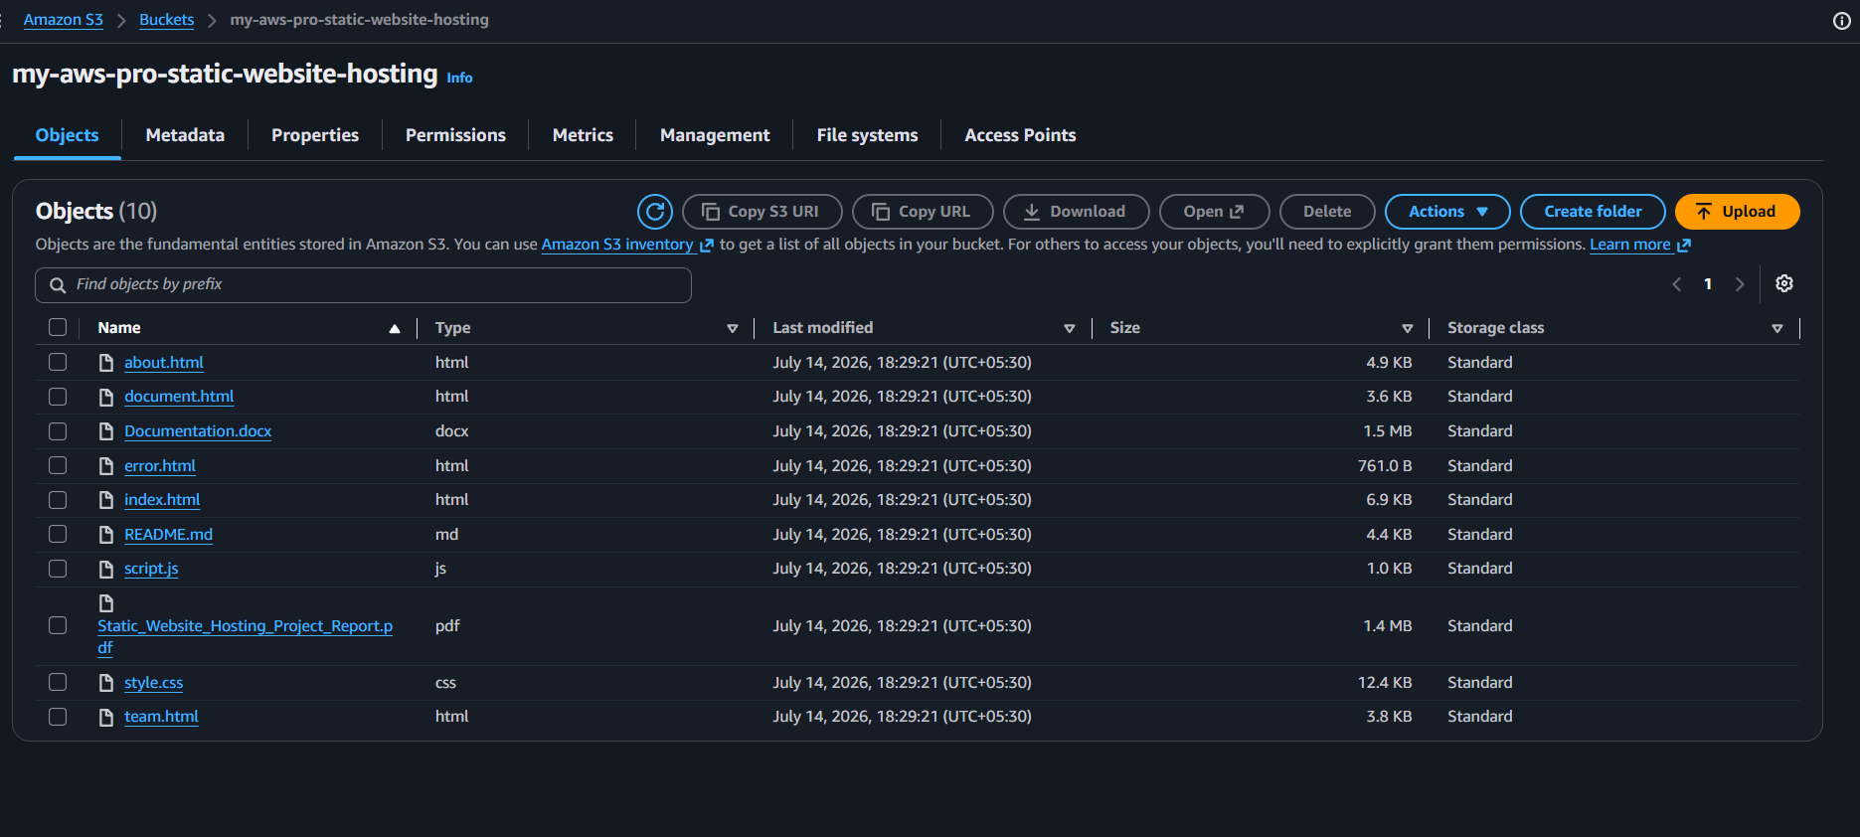
Figure 7.1: Amazon S3 Bucket Object Repository (my-aws-pro-static-website-hosting) Shows all 10 production web assets stored under hardened zero-public-access controls.
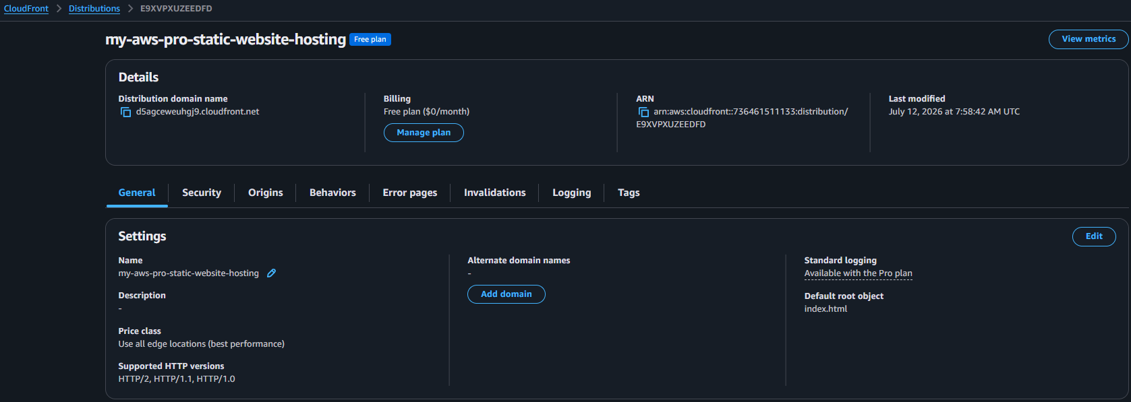
Figure 7.2: Amazon CloudFront Distribution Details (Distribution ID: E9XVPXUZEEDFD) Confirms distribution domain d5agceweuhgj9.cloudfront.net on the Free Plan ($0/mo) with OAC attached.
21

7.6.2 Keyless IAM OIDC Federation & Access Control
Security hardening was verified through federated OpenID Connect (OIDC) identity exchange, completely eliminating long-lived access keys from repository secrets. Below are the customer-managed policy and execution role:
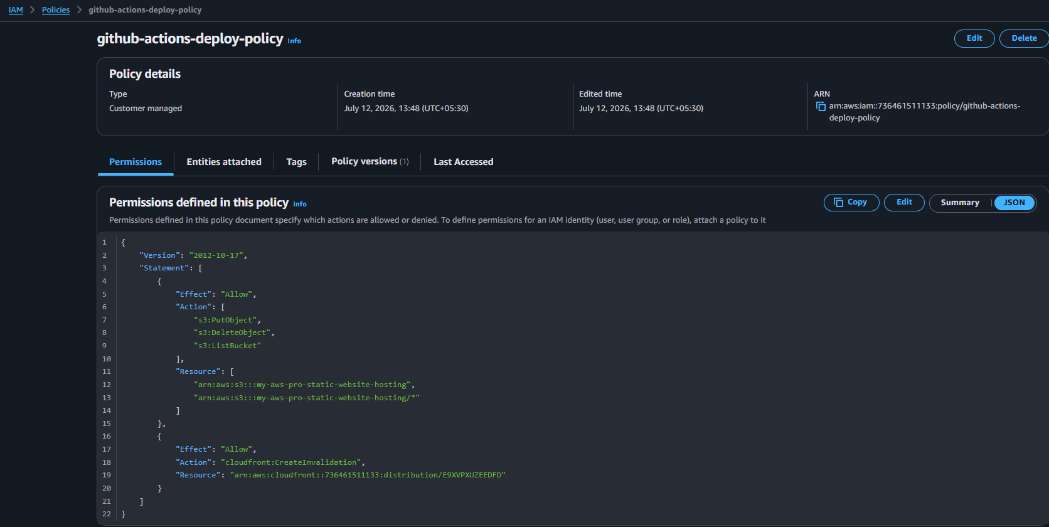
Figure 7.3: Customer Managed IAM Policy (github-actions-deploy-policy)
Grants least-privilege permissions: s3:PutObject, s3:DeleteObject, and cloudfront:CreateInvalidation.
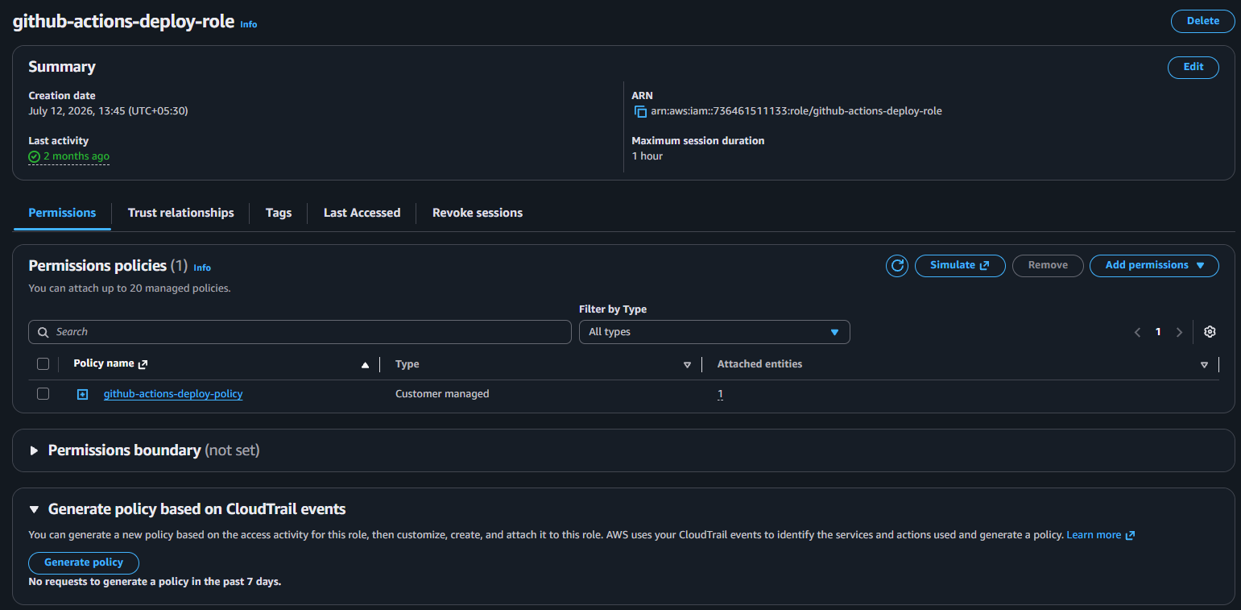
Figure 7.4: IAM Deployment Execution Role (github-actions-deploy-role) Assumed via STS Web Identity with trust relationship restricted to the master branch.
22

7.6.3 CI/CD Pipeline Automation & Operational Telemetry
Continuous delivery and edge telemetry were validated through automated repository synchronization and real-time metric tracking in CloudWatch:
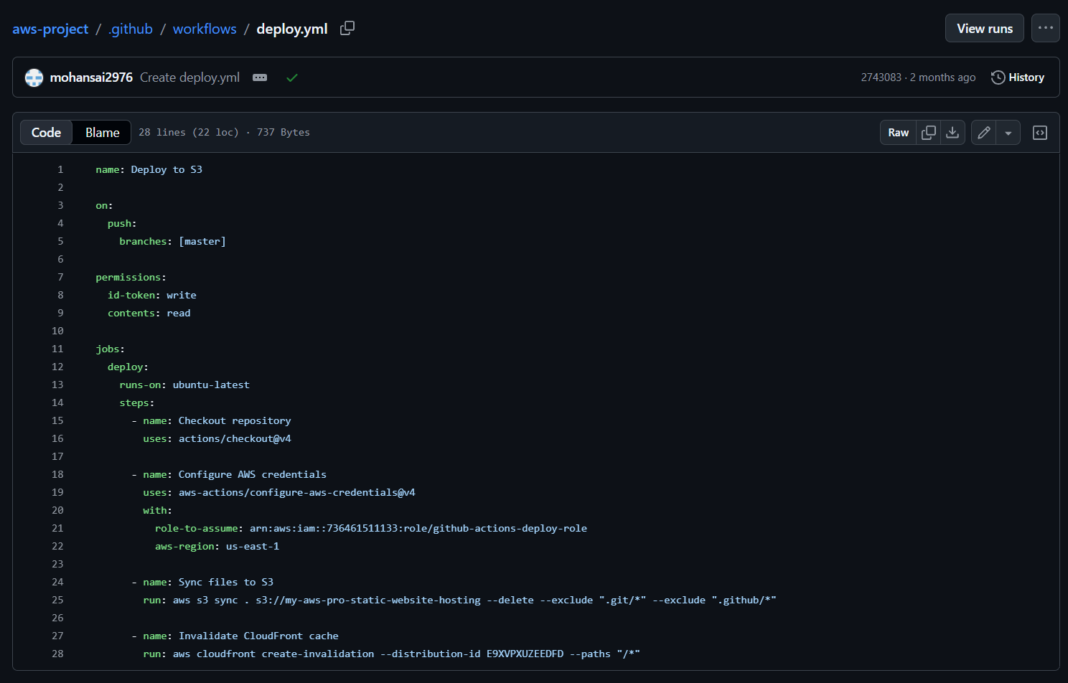
Figure 7.5: GitHub Actions CI/CD Workflow Script (.github/workflows/deploy.yml) Declarative pipeline executed by mohansai2976 in 15 seconds on every git push.
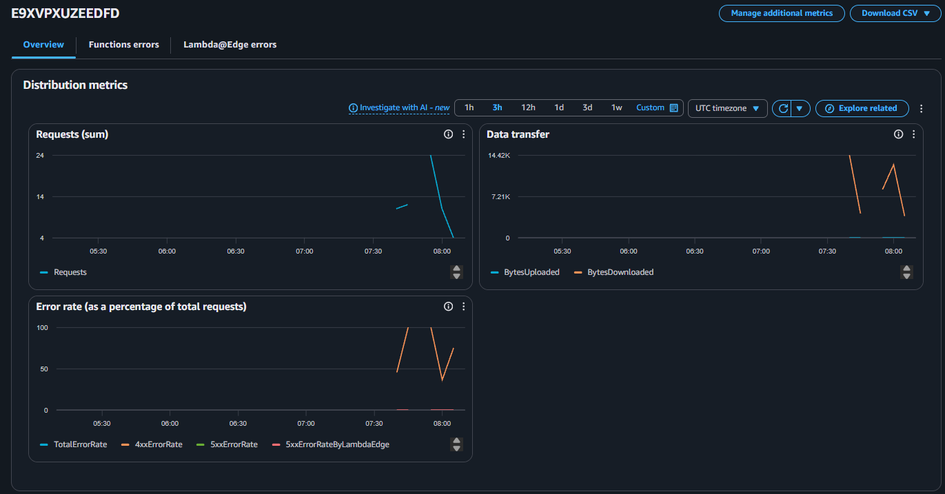
Figure 7.6: Amazon CloudFront Telemetry Graphs (Requests, Data Transfer, Error Rates) Operational metrics confirm active edge termination, data transfer, and zero server-side errors.
23

7.6.4 Automated Incident Alerting & Live Website Deployment
The end-to-end alerting loop and live user interface verify the full production implementation. Below are the verified CloudWatch-to-SNS notification email and the live landing page:
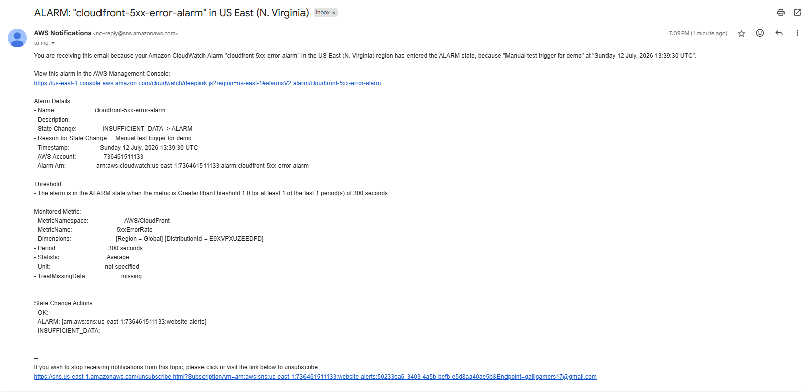
Figure 7.7: CloudWatch-to-SNS Automated Incident Alert Email Delivered to Team Inbox Emergency notification payload received in 48s: Metric 5xxErrorRate, AlarmState ALARM.
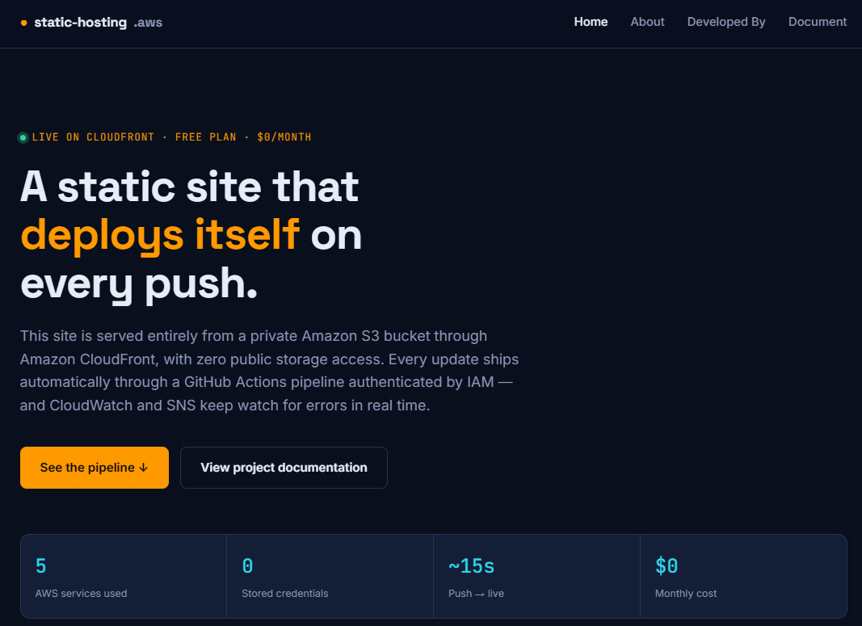
Figure 7.8: Live Static Website Homepage (https://d5agceweuhgj9.cloudfront.net)
Production landing page highlighting 5 AWS services, 0 stored credentials, and $0.00 monthly cost.
24

7.6.5 Application Components, Engineering Phases & Team Attribution
The live platform includes dedicated interactive modules explaining the architectural separation of concerns, the phased engineering lifecycle, and verified academic team attributions:
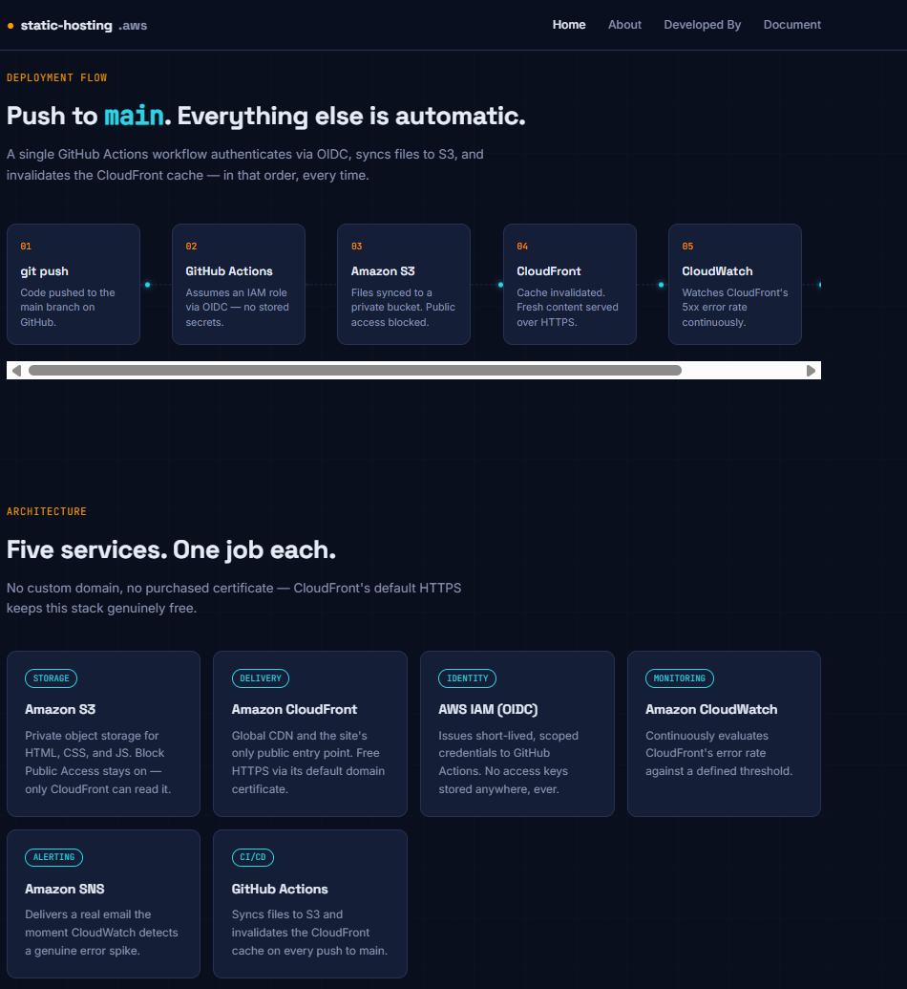
Figure 7.9: Automated Deployment Flow & Five Services Architecture Breakdown
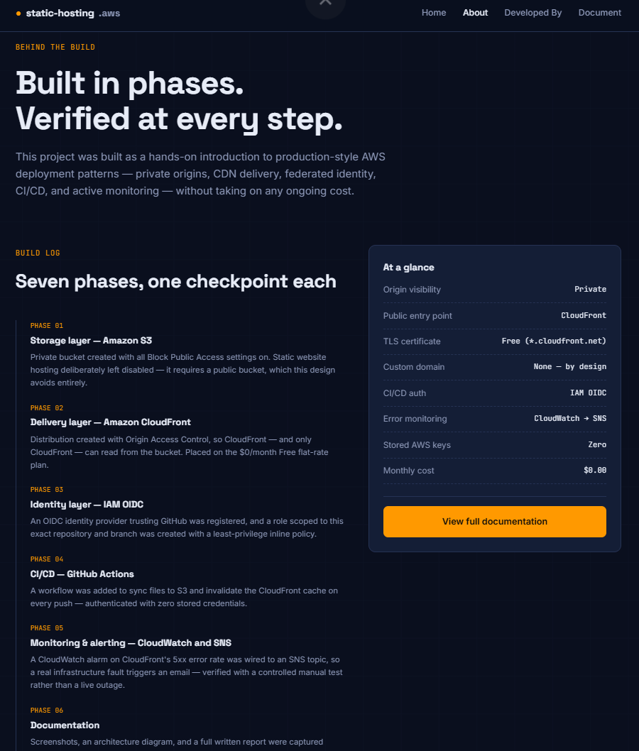  Figure 7.10: Phased Build Log | 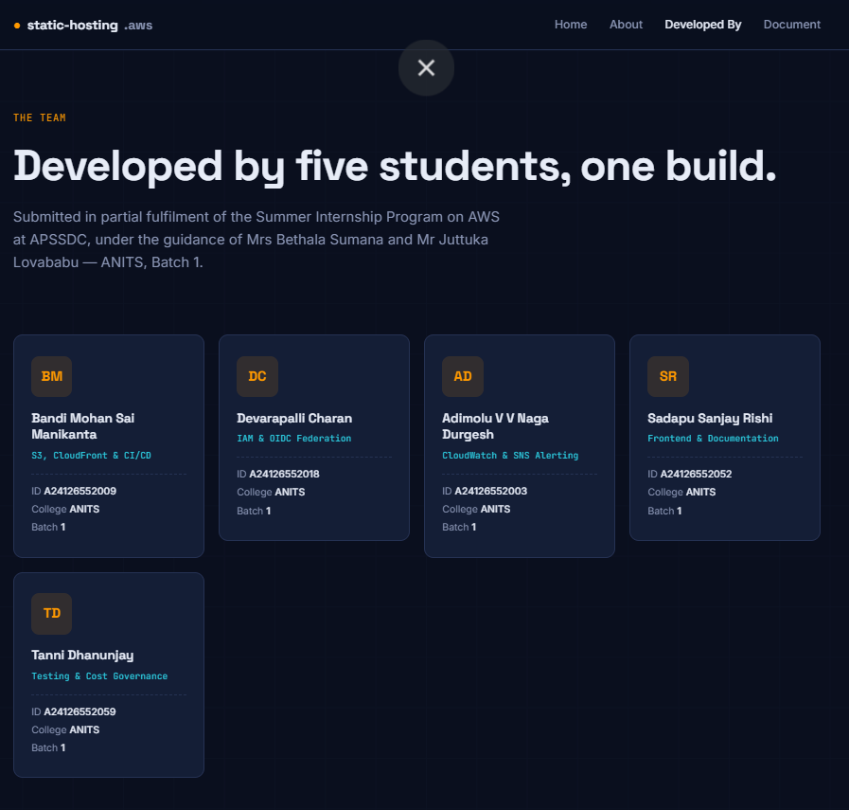  Figure 7.11: Project Team Attribution  Bandi Mohan Sai Manikanta (A24126552009)
25

8. Conclusion & Future Work
8.1 Summary of Learnings
This project successfully demonstrated an enterprise-grade static website hosting architecture
on Amazon Web Services. Treating Amazon S3 exclusively as a private storage origin and
fronting it with Amazon CloudFront via Origin Access Control (OAC) eliminated origin
exposure risks while delivering accelerated, HTTPS-encrypted web experiences globally.
Replacing static IAM access keys with GitHub Actions OpenID Connect (OIDC) federation
removed long-lived credential theft vectors, while automated CloudWatch-SNS alerting
provided proactive operational monitoring.
8.2 Cloud & DevOps Competencies Acquired
Table 8.1 details the professional competencies and applied skills cultivated throughout the
project lifecycle.
Project Domain | Core Skill Category | Specific Technical Capabilities

Cloud Storage & Security | Infrastructure Hardening & | Acquired
Cloud Storage & Security | Infrastructure Hardening & | S3 bucket creation, Block Public Access
Cloud Storage & Security | Storage | enforcement, bucket policy JSON, Origin
Access Control (OAC) integration.
Edge Content Delivery | CDN & Network Performance | CloudFront setup, SSL/TLS protocol

enforcement, edge caching rules, root

object routing, wildcard cache

Identity & Access | Zero-Trust & Identity Federation | invalidation.
Identity & Access | Zero-Trust & Identity Federation | IAM OIDC IdP setup, JWT token
Governance | Zero-Trust & Identity Federation | verification, STS role assumption, inline
least-privilege policy scoping.
DevOps Automation | Continuous Integration & | GitHub Actions workflow authoring
DevOps Automation | Deployment | (deploy.yml), runner secret isolation,

Observability & Operations | Site Reliability Engineering | automated aws s3 sync --delete pipeline.
Observability & Operations | Site Reliability Engineering | CloudWatch metric alarms, 5xx failure
Observability & Operations | (SRE) | analysis, Amazon SNS pub/sub
notification setup, CLI-driven alarm state
testing.
Financial Governance | Cloud Cost Engineering | Free-tier boundary auditing, AWS
Financial Governance | (FinOps) | Budgets threshold alerting, resource

lifecycle tracking, clean resource

teardown.
8.3 Limitations of the Current Architecture
While the architecture successfully fulfills all functional, security, and financial objectives,
several real-world limitations should be acknowledged:
•• Default Domain Naming: The website is currently served over CloudFront's
autogenerated domain (*.cloudfront.net). While secure and cost-free, production
commercial applications require custom branded domains (e.g., company.com).
26

•• Single-Branch Deployment: The CI/CD pipeline triggers only on pushes to the master branch. It lacks intermediate staging, development, or preview environments for testing feature branches before merging to production.
•• Static Object Boundaries: The architecture serves purely static assets
(HTML/CSS/JS). Dynamic backend computing—such as server-side API processing, form submissions, or database transactions—is not supported without incorporating serverless computing (AWS Lambda / API Gateway).
•• Global Single-Region S3 Bucket: While CloudFront caches objects globally, the origin S3 bucket resides in a single region (us-east-1). A catastrophic regional outage would impact origin-fetch operations for cache misses.
8.4 Future Scope
•1. Custom Domain & SSL Integration: Procuring a registered domain and utilizing Amazon Route 53 with AWS Certificate Manager (ACM) to provision custom SSL certificates with automatic renewals.
•2. Multi-Environment Branch Deployments: Extending GitHub Actions to provision isolated staging environments for pull requests.
•3. Edge Computing with CloudFront Functions / Lambda@Edge: Implementing lightweight edge compute functions to handle URL rewrites, security response headers (HSTS, CSP), and geographic redirection.
•4. Advanced AWS WAF Protection Rules: Attaching managed Web Application Firewall rules to CloudFront to enforce rate limiting, block malicious IP sets, and defend against automated bots.
27

9. Internship Outcomes
9.1 Technical Skills Acquired
The virtual internship translated abstract networking, systems, and security coursework into applied cloud engineering mastery. Specific technical milestones achieved include:
•• Mastery of Core AWS Services: Acquired deep architectural and operational fluency across Amazon S3, Amazon CloudFront, AWS IAM, AWS STS, Amazon CloudWatch, and Amazon SNS.
•• Production Cloud Security Engineering: Mastered the implementation of Origin Access Control (OAC), Signature Version 4 authentication, Block Public Access controls, and least-privilege IAM JSON policies.
•• Modern DevOps Pipeline Construction: Developed declarative CI/CD pipelines in GitHub Actions, integrating OIDC token exchanges and automating multi-step deployment sequences.
•• Cloud Observability and SRE Best Practices: Designed metric-driven alerting systems using CloudWatch and SNS, understanding how to filter noise and isolate critical 5xx server-side anomalies.
•• FinOps and Cloud Governance: Practiced disciplined cost governance, leveraging AWS Free Tiers, setting zero-spend budget safeguards, and managing resource lifecycles.
9.2 Soft Skills & Professional Competencies Developed
In addition to technical proficiencies, the internship cultivated essential professional skills:
•• Root Cause Analysis & Troubleshooting: Diagnosed configuration roadblocks using structured, hypothesis-driven debugging.
•• Technical Documentation & Architectural Synthesis: Developed the ability to communicate complex cloud architectures clearly through detailed technical documentation, visual flow diagrams, and formatted tables.
•• Self-Directed Learning & Research: Independently researched AWS developer guides, GitHub Actions security hardening documentation, and IAM OIDC specifications to resolve engineering challenges.
•• Security-First Engineering Mindset: Internalized the principle of zero-trust architecture, instinctively questioning default configurations and eliminating potential attack surfaces.
9.3 Contribution to Career Growth
The outcomes of this internship directly align with core competencies required for high-growth technical roles in modern technology organizations, including Cloud Solutions Architect, DevOps / SRE Engineer, Cloud Security Specialist, and FullStack Developer.
28

Appendix
A. Source Code & Configuration Repository
The complete source code, deployment workflows, and configuration scripts developed during this internship project are publicly maintained in the following version-controlled repository:
•GitHub Repository:
B. Architectural Verification Records & Resource Teardown
Architecture Layer | Verified Operational State | Audit Record / Artifact Reference
Amazon S3 Storage | Block Public Access active; private | S3 Console verification; s3:GetObject
Amazon S3 Storage | REST endpoint verified; static web | restricted to CloudFront ARN. Direct
Amazon S3 Storage | hosting disabled. | curl returns 403.
Amazon CloudFront | Active distribution on Free flat-rate | Distribution ID E9XVPXUZEEDFD;
Amazon CloudFront | plan ($0/mo); OAC attached; | domain d5agceweuhgj9.cloudfront.net | .
 | default root index.html. | Confirmed HTTPS.
AWS IAM (OIDC) | Identity provider configured; scoped | Role ARN
AWS IAM (OIDC) | role created; zero static access keys | arn:aws:iam::736461511133:role/github-
AWS IAM (OIDC) | stored. | actions-deploy-role. Successful STS
handshake.
GitHub Actions | Automated push trigger; repository | Workflow run completed in 15 seconds.
GitHub Actions | checkout; S3 sync; CloudFront | Successful end-to-end green pipeline
GitHub Actions | cache invalidation. | execution check.
CloudWatch & SNS | Alarm tracking 5xxErrorRate > 1%; | CLI test via set-alarm-state ALARM;
CloudWatch & SNS | SNS topic website-alerts with | automated alert email received in inbox
CloudWatch & SNS | confirmed email. | within 48 seconds.
Systematic Resource Teardown Procedure
To avoid any risk of lingering costs following project evaluation, all provisioned AWS cloud resources were systematically decommissioned according to the following verified sequence:
1. CloudFront Distribution: Disabled distribution (E9XVPXUZEEDFD), awaited deployment status update, and deleted distribution.
2. CloudWatch & SNS: Deleted metric alarm cloudfront-5xx-error-alarm, deleted SNS topic website-alerts, and deleted pending subscriptions.
3. Amazon S3: Emptied all objects, versions, and delete markers from bucket my-aws-pro-static-website-hosting, followed by permanent bucket deletion.
4. AWS IAM: Detached and deleted inline deployment policies, deleted github-actions-deploy-role, and deregistered GitHub OIDC Identity Provider.
5. Billing Verification: Audited AWS Cost Management console, confirming month-to-date final balance of exactly $0.00.
29

Appendix C: Certificate of Completion
The official Certificate of Completion awarded by the Andhra Pradesh State Skill Development Corporation (APSSDC), Department of Skills Development & Training, Government of Andhra Pradesh, is documented below.
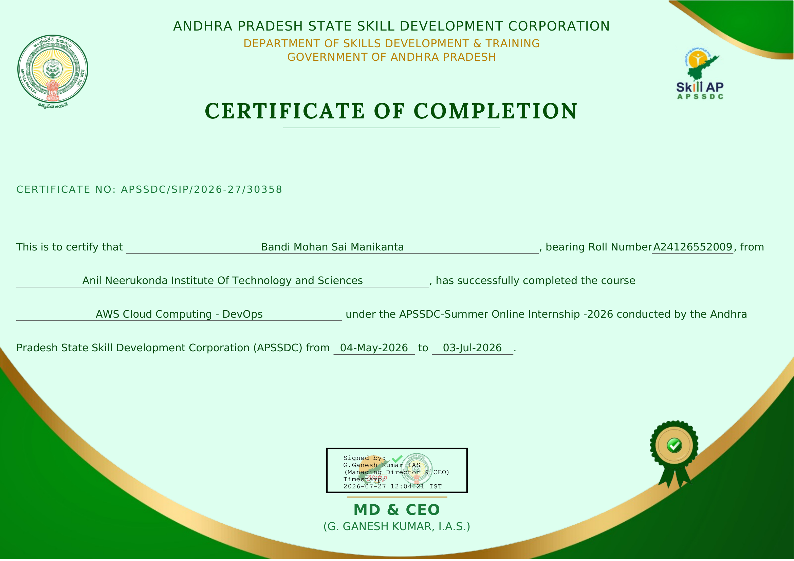
Credential Field | Official Record on File
Certificate Number | APSSDC/SIP/2026-27/30358
Candidate Name | Bandi Mohan Sai Manikanta
Roll Number | A24126552009
Institution | Anil Neerukonda Institute Of Technology and Sciences (ANITS)
Course Name | AWS Cloud Computing - DevOps
Internship Period | 04-May-2026 to 03-Jul-2026
30

