Prediction of Product Ratings Based on Reviews

Saloni Mohan -011546457
Nishchay Madan-011824501
Sahitya Mullapudi-011545404

CMPE 255 - Data Mining

Professor David Anastasiu

December 3 2017
Table of Contents

- Introduction
Motivation
Objective
- System Design & Implementation
Algorithms
Linear Regression
Ridge Regression
KNN
Logistic Regression
- Technologies & Tools
- Components
- Data Preprosessing
- Data Set
- Graph Results
- Difficulties
- Observation
- Conclusion
- References

Introduction

Motivation

Businesses are nowadays using social media to promote their products and services. The online shopping websites like Amazon and Ebay are becoming highly popular amongst companies of different domains. The people also prefer to do shopping online rather than buying products from store. Some studies describe the product in terms of different usage scenarios and assess it from a user's perspective as compared to vendor-generated product. Although analysis of OCR can be beneficial to both consumers and businesses, it is challenging to analyze it due to the show that customers are also more inclined towards user-generated product information on the internet than the information vendors provide. A recent study depicts that Online Customer reviews are one of the most-trusted source of product information. Online Customer Reviews are more user characteristics such as volume, variety, velocity and veracity. As a summary for a review, ratings are highly preferred for quick decision and access. In our project, we have tried to implement a solution which predict the rating of a product on the basis of the review provided.

Objective

We started out this project to perform some data analysis on the customer reviews of the products of healthcare domain. We decided to predict the rating of the product taking the review as input from the user. We used regression techniques to perform the task. One of the major objective of our project was to build two models for the project. In our first model, we used all the reviews individually and in our second model, we aggregated the data based on product id and the ratings provided to the product. We later applied different regression algorithms on the two models and compared and analyzed the result.

System Design & Implementation

Algorithms

Linear Regression
In statistics, linear regression is a linear approach for modeling the relationship between a scalar dependent variable y and one or more explanatory variables (or independent variables) denoted X. The case of one explanatory variable is called simple linear regression. For more than one explanatory variable, the process is called multiple linear regression. (This term is distinct from multivariate linear regression, where multiple correlated dependent variables are predicted, rather than a single scalar variable.)

Ridge Regression
Ridge Regression is a technique for analyzing multiple regression data that suffer from multicollinearity. When multicollinearity occurs, least squares estimates are unbiased, but their variances are large so they may be far from the true value. By adding a degree of bias to the regression estimates, ridge regression reduces the standard errors. It is hoped that the net effect will be to give estimates that are more reliable

KNN Regression
A simple implementation of KNN regression is to calculate the average of the numerical target of the K nearest neighbors. Another approach uses an inverse distance weighted average of the K nearest neighbors. KNN regression uses the same distance functions as KNN classification.

Logistic Regression
Logistic regression is a statistical method for analyzing a dataset in which there are one or more independent variables that determine an outcome. The outcome is measured with a dichotomous variable (in which there are only two possible outcomes).
We have used other algorithms like elastic Net, Lasso Regression, Random Forest which did not give considerable results.

Technologies & Tools

Jupyter Notebooks

Jupyter Notebooks made it easy and simple to share code between the team members and identifying easily the block of code where generates the error

Python 2.7
From Python 2.7, we used the following libraries: ​​Numpy, Scipy, Pandas, Sklearn, Flask

Regression Algorithms

For implementing regression algorithms, we used Sklearn and for plotting of graphs, we used Matplotlib.

Components

Data Preprocessing

Data from the amazon reviews is prepossessed and stored in different .dat files, so as to not to compute or process the data all the times.

Sklearn (Building Models )

We used the sklearn libraries to build our models. Sklearn is built on numpy, scipy, matplotlib. It provided us the necessary tools for data mining and analysis.

Data Preprocessing
Model 1 – Individual reviews
Our dataset is in .gz file format. We first extract the data from the .gz file and import into the pandas dataframe. We drop all the columns which are not used in regression analysis and retain the columns ‘reviewText’ and ‘overall’ which consists of all the reviews and the ratings corresponding to the reviews, respectively.
The CSR Matrix on the ‘reviewText’ is computed and the csr idf and L2 normalization is applied on computed matrix. After this, the matrix is divided into train and test data.
The number of rows in individual reviews model is 300k plus, so we used dimensionality reduction approach Singular Value Decompostion to reduce the size of the data.

Model 2 – Aggregated Reviews

Our dataset is in .gz file format. We first extract the data from the .gz file and import into the pandas dataframe. We drop all the columns which are not used in regression analysis and retain the columns
‘reviewText’, ‘asin’ and ‘overall’ which represent the user reviews, product ID and ratings, respectively.
We now aggregated the data based on product ID and ratings.
The CSR Matrix on the ‘reviewText’ is computed and the csr idf and L2 normalization is applied on computed matrix. After this, the matrix is divided into train and test data. As, we are able to process the computation of the aggregated reviews, we have not done dimensionality reduction on Model2.

MSE for algorithms
Mean Square Error is estimate of error of variance
 | Individual | Aggregate
Ridge | 0.68 | 0.70
Logistic | 0.5 | 0.857
Linear | 0.9 | 1.87
KNN | 0.60 | 1.50

Dataset

Type of data |  | File with JSON Objects
Size of data |  | nrows: 300000, cols: 2  1 column is text data with long reviews
All instances/ statistics |  | used in all the algorithms
Any preprocessing performed: |  | Read the filtered the data for product review and ratings.

Graphs and Results

Real values vs KNN Graph

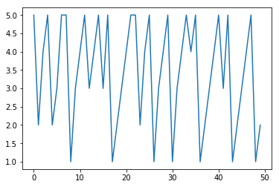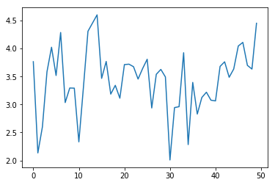

Real values vs linear regression
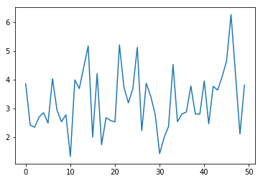

Real values vs ridge regression
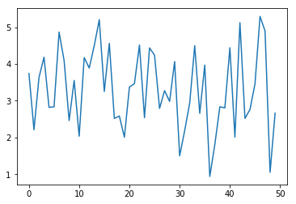

Real values vs logistic regression
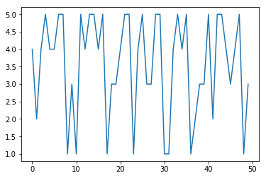

Difficulties

We faced difficulties in finding a data set. Once we decided on the project, computing the huge data proved to be difficult. Once we used dimensionality reduction, the no.of computations decreased exponentially.
We tried to do text summarization of the review using graph building. But we are unable to implement it.

Observations

Expected: We expected aggregated reviews model to do better than individual reviews. But we are proven wrong. Our assumption is KNN works would give better prediction. But that also is proved to be wrong. Expected dimensionality reduction to decrease the accurarcy. But, the result are better.

Actual : The Model 1 with individual reviews is more accurate than the aggregate reviews model.

Conclusion

Ridge Regression and Logistic Regression proved to be giving accurate predicted ratings combined with SVD dimensionality reduction

References/Datasets

https://snap.stanford.edu/data/web-Amazon.html

