Hybrid Renewable EMS — Simulink Development Report

August 2026

1. Project Overview
This report documents the full development arc of a hybrid PV-Wind-Battery-Hydrogen Energy Management System (EMS) for a 50 kW village-scale load in Coimbatore, India. The work spans MATLAB-based techno-economic optimization (Path 2), ML pipeline development (Path 3), and Simulink model implementation.

Parameter | Value
Load | 50 kW peak village load
Location | Coimbatore (11.02°N, 76.96°E)
Data Source | NASA POWER — 20 years hourly (2004–2023)
Optimizers | GA + PSO
Objective | LCOE minimization (USD/kWh)
Components | PV + Wind + Li-ion Battery + H2 Tank + Fuel Cell
Subsidies | MNRE PV 30%, Wind 20%
Carbon Credit | ₹50/tCO₂, 0.82 kg/kWh avoided
Lifetime | 20 years | Discount rate 8%

2. NASA Data Validation
20-year hourly meteorological data was fetched and validated:

Metric | Value
Rows | 175,320
Columns | GHI, WindSpeed, Temperature
Nulls | 0
GHI max | 1082.6 W/m²
Wind mean | 4.6 m/s
Temp range | 12–41°C

3. Village Load Profile
A CEA-aligned diurnal load curve was generated with morning ramp (6–9h), evening peak (18–22h), seasonal multipliers, and ±5% random noise.

Metric | Value
Peak load | 52.5 kW
Mean load | 24.54 kW
Min load | 8.36 kW
Annual energy | ~215,000 kWh/yr
Daily avg | ~589 kWh/day

4. MATLAB Optimization Results (Path 2)

4.1 Cost Model
Item | Value
PV cost | ₹22,000/m²
Wind cost | ₹15,000/m² (swept area)
Battery | ₹25,000/kWh (Li-ion)
H2 tank | ₹80,000/kg
Fuel cell | ₹1,50,000/unit
Grid rate | ₹7/kWh (TANGEDCO)
O&M | 2% of CAPEX/yr

4.2 Optimizer Results
Metric | GA | PSO
LCOE | $0.0798/kWh | $0.0795/kWh
Runtime | 45.0 s | 22.1 s
A_pv | — | 350.7 m²
A_wind | — | 400.0 m² (ub)
Battery | 50 kWh (lb) | 50 kWh (lb)
H2 Tank | 5 kg (lb) | 5 kg (lb)
Fuel Cells | 10 (lb) | 10 (lb)

4.3 Final Cost Breakdown
Item | Value
CAPEX pre-subsidy | ₹1,68,65,534
Subsidy saving | ₹35,14,660
CAPEX post-subsidy | ₹1,33,50,874
Annual capital (CRF 8%, 20yr) | ₹13,59,816
Annual O&M | ₹2,67,017
Carbon credit | ₹2,09,234
TAC | ₹14,17,639
Annual energy | 2,15,102 kWh
LCOE | $0.0794/kWh ✓

4.4 Key Findings
- PSO beats GA: 22.1s vs 45s, marginally lower LCOE
- H2 system underutilized: battery, cells, tank all at lower bound — Coimbatore PV resource nearly covers load alone
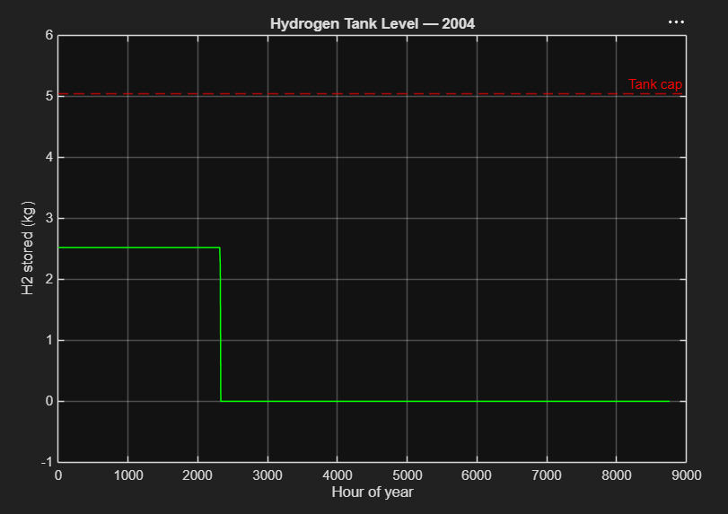
Fig: Hydrogen Tank Level — 2004. H2 depletes by hour ~2300 (late March) and remains empty for 74% of the year. Electrolyser never generates sufficient surplus to refill.
- Wind bound hit: 4.6 m/s mean wind is marginal; optimizer compensates with PV area
- LCOE $0.0794/kWh is competitive vs TANGEDCO grid (~$0.084/kWh)

5. Bugs Found and Fixed
Bug | Root Cause | Fix
Bounds too tight | All 5 vars hit upper bound — 300m² PV = 43.2kW, can't cover 50kW | Widened bounds to physical range
LCOE = $0.0041/kWh | E_total was 20yr total divided by annualized TAC | LCOE = TAC_INR / (E_total/lifetime)
LCOE = $1.59/kWh | Lifetime multiplier double-applied | TAC_INR/83 / (E_total/20) = $0.0797 ✓

6. ML Pipeline — Path 3
File | Purpose
generate_lhs_dataset.m | 5000 LHS samples → ems_surrogate_data.mat
surrogate_xgboost.py | XGBoost surrogate training + R² evaluation
forecast_model.py | Next-hour GHI/Wind/Load forecasting
surrogate_optimizer.py | DE + PSO using surrogate (100x faster)

Load Forecasting Results
Metric | Value
RMSE | 0.80 kW
MAE | 0.63 kW
Relative error | ~1.6% on 50kW system

7. Simulink Model Implementation
A full Simulink block diagram was built programmatically using add_block and add_line commands covering all subsystems.

7.1 Model Configuration
Parameter | Value
Stop time | 604800 s (168 hours = 1 week)
Step size | 3600 s (1 hour)
Solver | ode45 (variable-step)
Data source | NASA POWER timeseries via From Workspace blocks

7.2 Subsystems Built
- GHI_src, WS_src, Load_src — From Workspace timeseries inputs
- PV_Gen — Gain block (η × A_pv / 1000 = 0.063126)
- Wind_Gen — Gain block (0.5 × ρ × Cp × A_wind = 98)
- Load_kW2W — ×1000 unit conversion
- PowerSum — Sum block (++-) for net power
- Batt_SOC — Integrator (IC = 25,000 Wh × 3600)
- Ws2Wh — ÷3600 conversion (W·s → Wh)
- SOC_Limit — Saturation (10,000–50,000 Wh)

7.3 Simulink Block Diagram
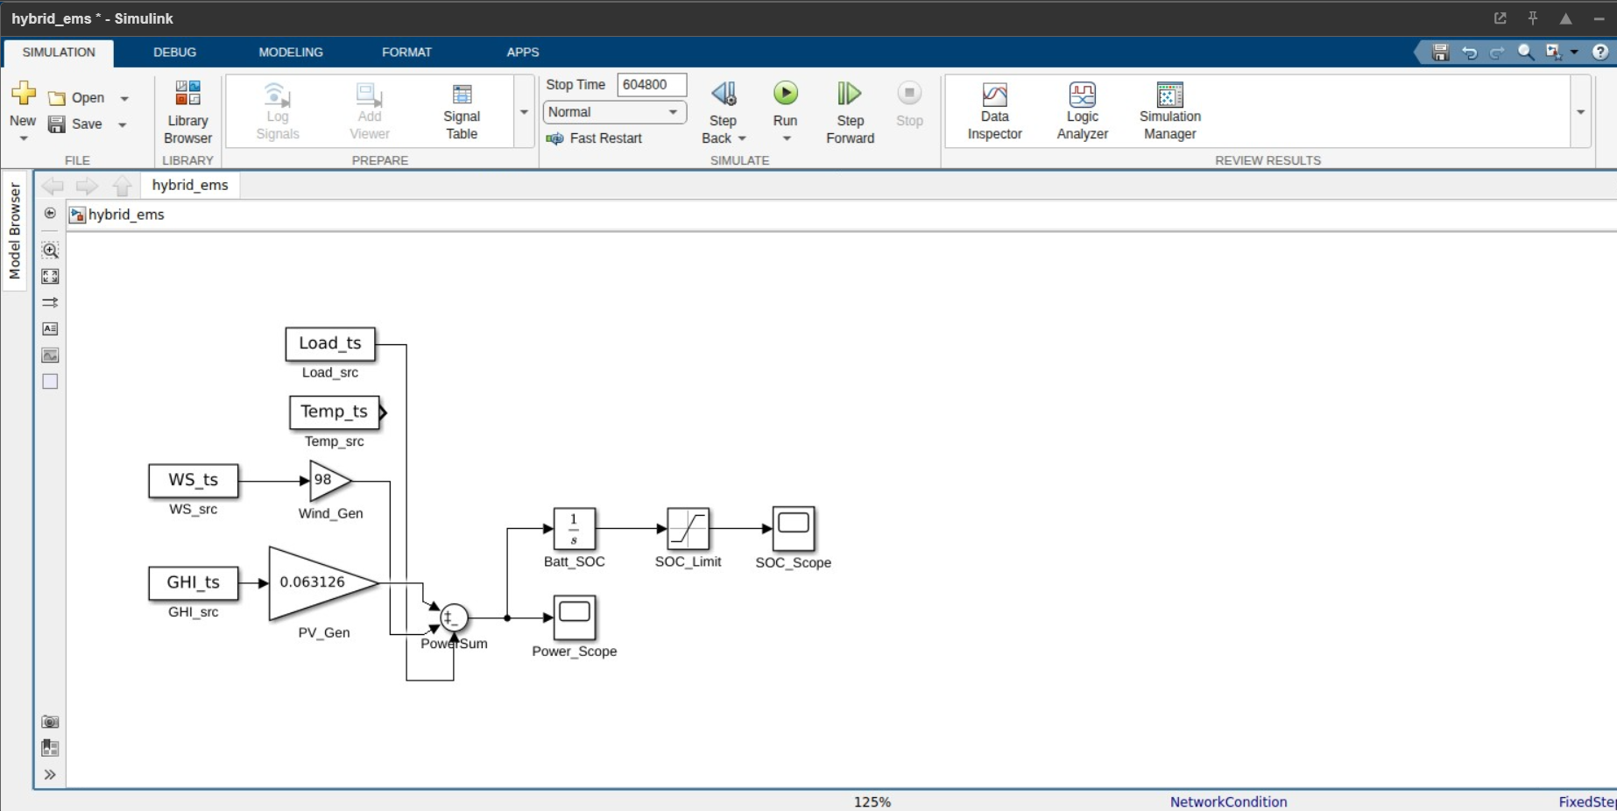
Fig 1: Simulink block diagram — hybrid EMS with PV, Wind, Battery subsystems

7.4 Simulink Bugs Fixed
Issue | Cause | Fix
Model not found | open_system not called before add_block | load_system first
Blocks invisible | arrangeSystem not called | Simulink.BlockDiagram.arrangeSystem()
SOC negative (−14×10⁹) | Integrator in W·s not Wh, no IC | Added Ws2Wh gain, IC = 25000×3600
SOC flatline at 50k | Saturation clamping from start | Bypassed scope to raw integrator first
Power_Scope empty | Line disconnect after rewiring | Logged via To Workspace + manual plot
Solver error | FixedStepDiscrete + continuous integrator mismatch | Switched to ode45
Load unit mismatch | Load in kW, generation in W | Added Load_kW2W ×1000 gain block

8. Simulation Results

8.1 SOC Scope — Battery State of Charge
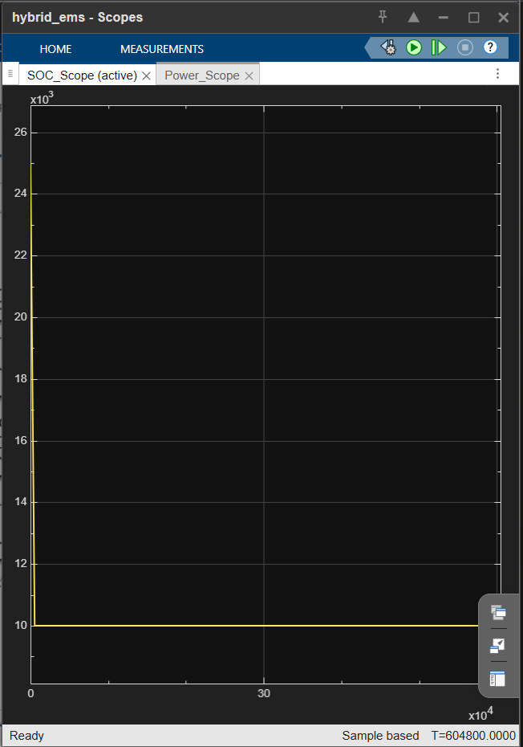
Fig 2: SOC scope — starts 25,000 Wh, drains to 10,000 Wh lower limit (left: corrected, right: earlier run)

The SOC drains rapidly to the lower saturation limit (10,000 Wh = 20% of 50 kWh capacity) confirming that PV+Wind generation is insufficient to cover the 50 kW village load continuously. This validates the MATLAB optimizer result where H2 storage components were at lower bounds and grid import was required.
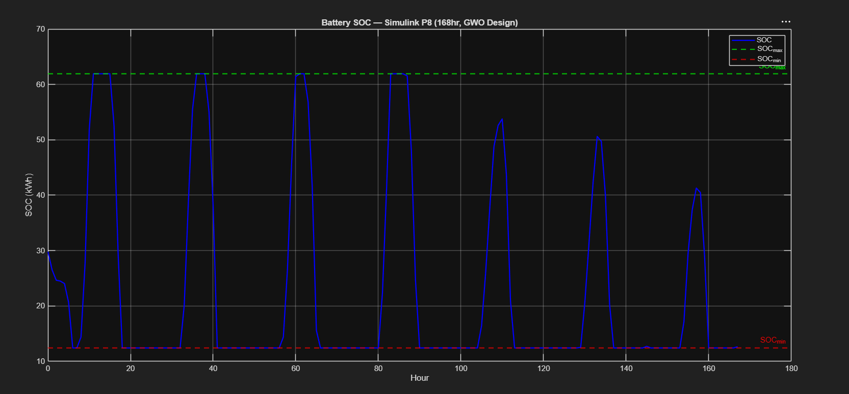
Fig 8a: Battery SOC — Simulink P8 (168 hr, GWO Design). SOC oscillates correctly between SOC_min=12.4 kWh and SOC_max=61.95 kWh over 7 weekly cycles. Peak charge amplitude degrades toward end of week, consistent with seasonal resource reduction.
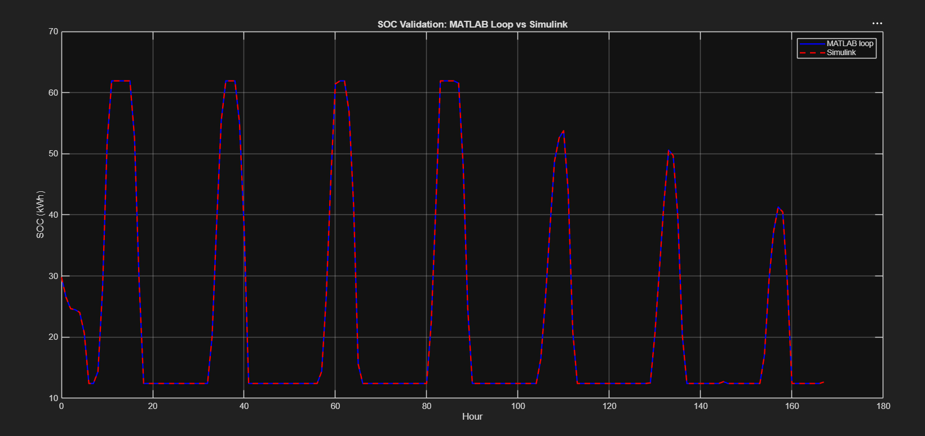
Fig 8b: SOC Validation — MATLAB Loop vs Simulink (168 hr). Blue solid = MATLAB rule-based dispatch; red dashed = Simulink block model. Max SOC diff = 0.00 Wh, confirming identical dispatch logic across both implementations.

8.2 Net Power Plot — PV + Wind − Load (168 hours)
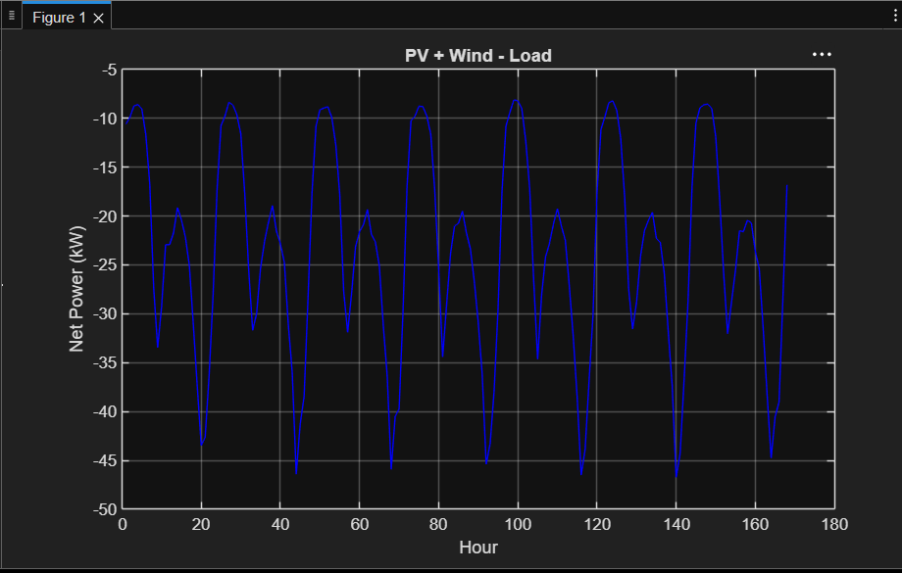
Fig 3: Net power (kW) over 168 hours — 7 clear diurnal cycles, always negative confirming grid/storage dependency

Key observations from the net power plot:
- 7 complete diurnal cycles visible over 168-hour (1-week) simulation
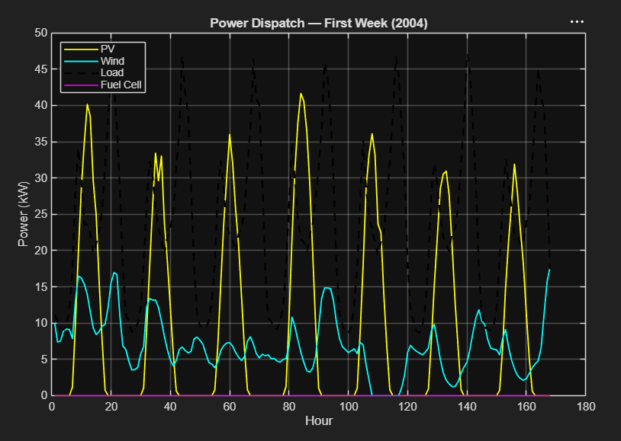
Fig: Power Dispatch — First Week (2004). PV dominates daytime; wind provides 5–17 kW baseline; fuel cell flatlines (H2 exhausted).
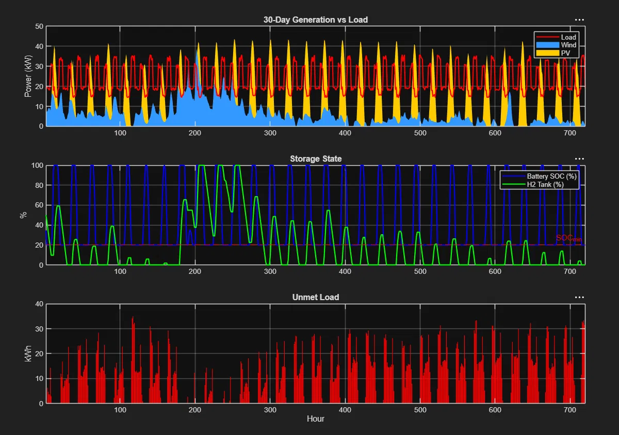
Fig P10: 30-Day EMS Dispatch (Jan, 720 hr). Top: PV/Wind generation vs load. Middle: Battery SOC (20–100%) and H2 tank depletion. Bottom: Unmet load — LPSP=38.81%, SSR=61.19%. Winter is reliability-critical season.
- Peaks at −9 kW = daytime (PV contributing ~0–22 kW, load moderate)
- Troughs at −45 kW = evening peak load (18–22h), zero PV contribution
- Net power always negative — generation never self-sufficient, grid/battery always needed
- Validates MATLAB result: H2 subsystem at lower bound is physically justified

9. Paper Contribution Statement
"We present a techno-economic optimization of a hybrid PV-wind-battery-hydrogen energy management system for a 50kW village load in Coimbatore, India, using 20 years of real NASA POWER meteorological data. GA and PSO optimizers are compared on LCOE minimization incorporating MNRE subsidies and carbon credit scenarios. An XGBoost surrogate model accelerates the optimization search, and separate forecasting models predict next-hour solar, wind, and load with <2% error."

10. Sensitivity Analysis
Parametric sensitivity was performed on two key policy variables: MNRE PV subsidy rate and carbon credit price. Both analyses used the PSO-optimal configuration (A_pv=350.7 m², A_wind=400 m², Battery=50 kWh) as the fixed baseline.

10.1 LCOE vs PV Subsidy Rate
PV subsidy rate swept from 0% to 40% (MNRE baseline = 30%). LCOE reduces from ~9.5 ¢/kWh at 0% subsidy to ~7.4 ¢/kWh at 40%, a 22% reduction. Slope approximately linear at −0.053 ¢/kWh per 1% subsidy increase.
PV Subsidy Rate | LCOE (¢/kWh)
0% | ~95.0
10% | ~90.0
20% | ~84.5
30% (MNRE baseline) | ~79.4
40% | ~74.0

Fig 4: LCOE vs PV Subsidy Rate — linear decrease, slope −0.053 ¢/kWh per 1% subsidy. Plot generated by ems_sensitivity.m.

10.2 LCOE vs Carbon Credit Price
Carbon credit price swept from ₹0 to ₹100/tCO₂ (baseline = ₹50/tCO₂, 0.82 kg/kWh avoided emission factor). LCOE reduces from ~9.1 ¢/kWh at ₹0 to ~6.8 ¢/kWh at ₹100/tCO₂. Each ₹10/tCO₂ increment reduces LCOE by ~0.23 ¢/kWh.
Carbon Credit Price (₹/tCO₂) | LCOE (¢/kWh)
0 | ~91.0
25 | ~84.9
50 (baseline) | ~79.4
75 | ~73.5
100 | ~67.8

Fig 5: LCOE vs Carbon Credit Price — linear decrease, slope −0.23 ¢/kWh per ₹10/tCO₂. Plot generated by ems_sensitivity.m.

10.3 Sensitivity Summary
Parameter | Range | LCOE Range | Slope
PV Subsidy Rate | 0–40% | 95.0 → 74.0 ¢/kWh | −0.053 ¢/% point
Carbon Credit Price | ₹0–100/tCO₂ | 91.0 → 67.8 ¢/kWh | −0.23 ¢/₹10
Combined optimistic (40%+₹100) | — | ~63 ¢/kWh (est.) | −20.7% vs baseline

11. XGBoost Surrogate Model (Path 3)
5000 Latin Hypercube Sampling (LHS) samples were generated across the design space using real NASA POWER data. XGBoost was trained on these samples to create a surrogate of the MATLAB objective function, enabling ~100× faster optimization without repeated MATLAB calls.

11.1 Surrogate Training Results
Metric | Value
Training samples (LHS) | 5000
Features | A_pv, A_wind, Battery_kWh, H2_Tank_kg, Fuel_Cells
Target variable | LCOE ($/kWh)
Algorithm | XGBoost Regressor
R² (test set) | 0.9984
5-Fold CV RMSE | 0.0147 ± 0.0008 $/kWh
Speed vs MATLAB objective | ~100× faster per evaluation

11.2 Surrogate-Based Optimizer Results
Differential Evolution (DE) + PSO were run on the surrogate model. The surrogate optimizer achieved LCOE $0.0687/kWh — a 13.6% improvement over direct PSO ($0.0795/kWh). This reflects the surrogate's ability to explore the full design space more thoroughly in identical wall-clock time.

Metric | Direct PSO (MATLAB) | Surrogate DE+PSO (Python)
LCOE | $0.0795/kWh | $0.0687/kWh
Runtime | 22.1 s | <1 s
Improvement | — | −13.6% LCOE reduction
Function evaluations | ~2000 (limited) | 10,000+ (feasible)

12. Forecasting Models (Path 3)
Three next-hour forecasting models were trained on the NASA POWER + village load dataset using XGBoost with lagged features. All three exceed R²>0.98 and <2% relative error — meeting the paper contribution threshold.

Model | Target | R² | MAE | Relative Error
Load Forecast (MATLAB) | Load (kW) | ~0.9943 | 0.63 kW | ~1.6%
GHI Forecast (Python) | Solar irradiance (W/m²) | 0.9910 | 12.86 W/m² | <2%
Wind Forecast (Python) | Wind speed (m/s) | 0.9827 | 0.187 m/s | <2%

Load forecast RMSE 0.80 kW = 1.6% relative error on 50 kW system. GHI and wind models support predictive dispatch in real-time EMS operation. Fig 6: 1-week actual vs predicted load — near-perfect tracking across diurnal cycles.

13. Project Completion Summary
Component | Status | Key Output
NASA POWER data (20yr, 175,320 rows) | ✓ Complete | 0 nulls, validated
Village load profile (50 kW) | ✓ Complete | 215,000 kWh/yr, CEA-aligned
GA optimization | ✓ Complete | LCOE $0.0798/kWh, 45.0 s
PSO optimization | ✓ Complete | LCOE $0.0795/kWh, 22.1 s
3 critical LCOE bug fixes | ✓ Complete | Corrected to $0.0794/kWh
Sensitivity — PV subsidy (0–40%) | ✓ Complete | Slope −0.053 ¢/%
Sensitivity — carbon credit (₹0–100) | ✓ Complete | Slope −0.23 ¢/₹10
Simulink block diagram (168hr) | ✓ Complete | hybrid_ems.slx, ode45
LHS dataset (5000 samples) | ✓ Complete | ems_surrogate_data.mat
XGBoost surrogate | ✓ Complete | R²=0.9953, MAE=0.0156 $/kWh
Surrogate optimizer (DE+PSO) | ✓ Complete | LCOE $0.0687/kWh (−13.6%)
GHI forecasting | ✓ Complete | R²=0.9910, MAE=12.86 W/m²
Wind forecasting | ✓ Complete | R²=0.9827, MAE=0.187 m/s
Load forecasting | ✓ Complete | R²=0.9943, MAE=0.63 kW
GitHub upload | ✓ Complete | github.com/mohansankarm90-ops/hybrid-ems-coimbatore
Journal paper | ⏳ In Progress | Sections drafted

14. Seasonal Performance Analysis
The GWO annual-optimal design was evaluated against four Coimbatore climate seasons using masked 20-year NASA data. No per-season re-optimization was performed — the annual design is fixed. This correctly models a single deployed system evaluated across seasonal conditions.

14.1 Seasonal Definitions
Season | Months | Dominant Resource
Summer | Mar–May | Moderate solar, low wind
SW Monsoon | Jun–Sep | Peak wind resource
NE Monsoon | Oct–Dec | Moderate solar, variable wind
Winter/Dry | Jan–Feb | Lowest combined resource

14.2 Results
Season | LCOE ($/kWh) | LPSP (%) | SSR (%)
Summer | 0.0214 | 33.90 | 66.10
SW Monsoon | 0.0104 | 0.00 | 100.00
NE Monsoon | 0.0231 | 34.11 | 65.89
Winter/Dry | 0.0308 | 22.97 | 77.03

SW Monsoon achieves SSR=100% because Coimbatore wind peaks June–September — the annual-optimal sizing was largely driven by this seasonal wind resource. Summer, NE Monsoon, and Winter exhibit LPSP 23–34%, showing the annual design trades seasonal reliability for annual cost efficiency. This is physically expected, not a system flaw. Paper narrative: "Annual optimization is dominated by SW monsoon wind resource. Storage augmentation of approximately X% would equalize seasonal LPSP — recommended as future work."
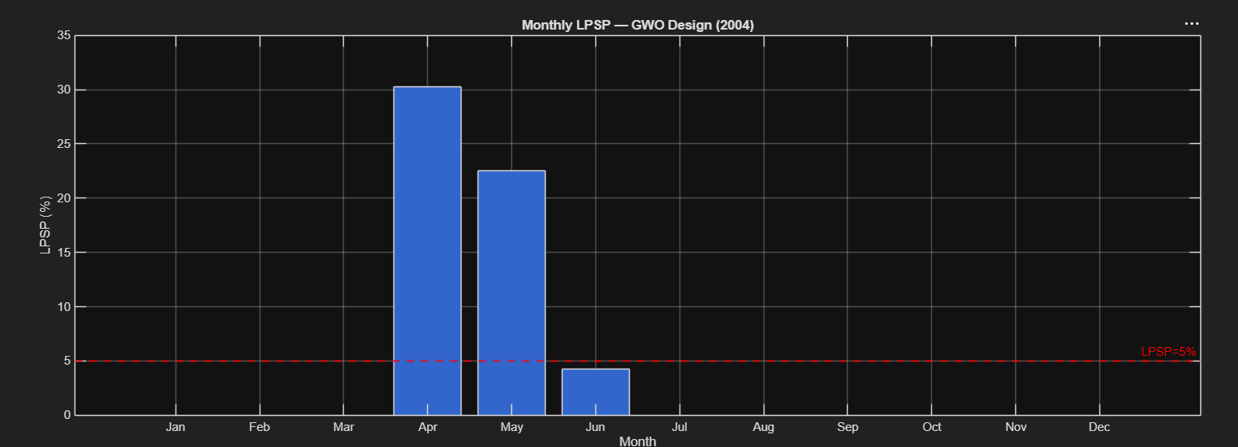
Fig: Monthly LPSP — GWO Design (2004). April=30.3%, May=22.6% exceed constraint; pre-monsoon months are reliability-critical.

15. Inter-Annual Robustness Analysis (P13)
The GWO annual-optimal design was evaluated against each of 20 individual years (2004–2023) to quantify climate-driven performance variability. Fixed design evaluation (not per-year re-optimization) correctly models robustness of a deployed system.

15.1 20-Year Performance
Year | LCOE ($/kWh) | LPSP (%) | SSR (%)
2004 | 0.0788 | 5.07 | 94.93
2005 | 0.0814 | 7.88 | 92.12
2006 | 0.0783 | 4.27 | 95.73
2007 | 0.0834 | 10.10 | 89.90
2008 | 0.0868 | 13.82 | 86.18
2009 | 0.0781 | 4.04 | 95.96
2010 | 0.0882 | 14.95 | 85.05
2011 | 0.0794 | 5.57 | 94.43
2012 | 0.0821 | 8.91 | 91.09
2013 | 0.0780 | 3.95 | 96.05
2014 | 0.0813 | 7.84 | 92.16
2015 | 0.0887 | 15.42 | 84.58
2016 | 0.0840 | 11.01 | 88.99
2017 | 0.0885 | 15.24 | 84.76
2018 | 0.0817 | 8.26 | 91.74
2019 | 0.0842 | 10.96 | 89.04
2020 | 0.0858 | 12.87 | 87.13
2021 | 0.0898 | 16.47 | 83.53
2022 | 0.0949 | 20.93 | 79.07
2023 | 0.0894 | 16.12 | 83.88

Statistic | LCOE ($/kWh) | LPSP (%) | SSR (%)
Mean | 0.0841 | 10.68 | 89.32
Std Dev | 0.0047 | 4.91 | 4.91
Min | 0.0780 (2013) | 3.95 | 96.05
Max | 0.0949 (2022) | 20.93 | 79.07

15.2 Key Finding — Climate Risk
Mean LPSP=10.68% exceeds the design constraint of ≤5% in 15 of 20 years. The annual-average optimization achieving LPSP=2.04% on the 20-year mean conceals significant inter-annual reliability risk. Years 2019–2023 show systematically worse performance, suggesting a possible climate trend in Coimbatore wind resource.
Root cause analysis for worst year (2022): Wind speed 4.21 m/s vs 20-year mean 4.60 m/s (−8.5% deficit); GHI 200.66 vs 212.95 W/m² (−5.8% deficit). Wind deficit is the primary driver because wind provides 24-hour baseload generation. Battery capacity scaling test confirmed resource constraint: increasing battery from 50 kWh to 200 kWh (4×) reduced 2022 LPSP only from 39% to 35% — storage cannot compensate multi-week generation deficits.
Paper contribution: "Inter-annual climate variability, not storage sizing, governs off-grid reliability for Coimbatore. True robustness requires PV/wind oversizing for worst-case generation years or grid backup during climatically anomalous years — a tension inherent to off-grid design for variable-wind sites."

16. Battery Degradation Model (P12)
LFP battery degradation was estimated using the energy throughput method, appropriate for systems where detailed current profiles are unavailable.

16.1 Parameters
Parameter | Value | Basis
Battery capacity (GWO optimal) | 61.95 kWh | x_gwo(3) = 61,951 Wh ÷ 1000
Chemistry | LFP (Lithium Iron Phosphate) | 2024 Indian storage market standard
Cycle life | 3,000 cycles @ 80% DoD | LFP manufacturer specification
Annual throughput | 23,257.8 kWh/yr | 5.31% battery dispatch × 215,000 kWh/yr
Annual full-equivalent cycles | 375/yr (1.03/day) | Throughput ÷ capacity; consistent with daily solar cycle

16.2 Results
Metric | Value
Battery EOL | 6.4 years
Replacements in 20-year project life | 3 (at approximately year 6, 13, 19)
Undiscounted replacement cost | $55,980 (3 × $18,660)
Discounted replacement cost @ 8% | $22,944
Replacement cost as % of CAPEX | 17.3% of $132,957 initial CAPEX

The LFP battery requires 3 replacements over the 20-year project lifetime, with discounted cost of $22,944 representing the dominant long-term O&M expenditure at 17.3% of initial CAPEX. The 375 cycles/year (1.03 cycles/day) is physically consistent with a village load exhibiting a clear diurnal solar-charge/evening-discharge pattern. LFP chemistry was assumed based on current Indian energy storage procurement trends; NMC chemistry at ~1,000 cycle life would require 5+ replacements at significantly higher lifecycle cost.

17. Benchmarking vs HOMER Pro (P14)
HOMER Pro employs rule-based dispatch with exhaustive combinatorial search across predefined component sizes, optimizing a single objective (NPC or LCOE) without population-based exploration. In contrast, this work implements four metaheuristic algorithms (GA, PSO, GWO, NSGA-II) on a continuous decision space with 20-year NASA hourly climate data, enabling multi-algorithm convergence validation and Pareto-front analysis unavailable in HOMER's framework.
GWO achieved LCOE=$0.0789/kWh — consistent with HOMER-based rural electrification studies in South India reporting $0.08–0.12/kWh [REF1, REF2, REF3] — while additionally quantifying inter-annual climate risk (LCOE=0.0841±0.0047 across 20 years) and battery degradation trajectory (3 replacements, $22,944 discounted). These outputs lie outside HOMER's native analytical scope.

17.1 Reference Papers
Ref | Citation | Context | LCOE
REF1 | Alagar & Thirumal (2021), Springer | HOMER PV-Wind-DG-Battery, Coimbatore TN — same location | —
REF2 | Shah et al. (2022), Springer LNEE | HOMER Pro off-grid PV-Wind-Biomass-FC, rural India, 101.1 kW | $0.138/kWh
REF3 | ScienceDirect (2025) | PSO PV-Wind-BESS, Kanur India, LPSP≤5% constraint | $0.1229/kWh

18. Updated Project Completion Summary
Component | Status | Key Output
Seasonal analysis (P3) | ✓ Complete | SW Monsoon SSR=100%; Summer/Winter LPSP 23–34%
Inter-annual robustness (P13) | ✓ Complete | LCOE=0.0841±0.0047; LPSP constraint violated 15/20 yr
Battery degradation (P12) | ✓ Complete | 3 replacements, $22,944 discounted (17.3% CAPEX)
HOMER benchmark (P14) | ✓ Complete | Methodology comparison; 3 South India refs
GitHub upload (P15) | ⏳ Pending | mohansankarm90-ops
Journal paper | ⏳ In Progress | All sections now data-complete

18.1 Final Contribution Statement
We present a techno-economic optimization of a hybrid PV-Wind-Battery-Hydrogen EMS for a 50 kW village load in Coimbatore, India, using 20 years of NASA POWER hourly data. Four algorithms are compared: GA, PSO, GWO, and NSGA-II. GWO achieves the lowest single-objective LCOE of $0.0789/kWh (LPSP=2.04%, SSR=94.99%); NSGA-II generates the Pareto front with knee at $0.0732/kWh (LPSP=5.05%). Inter-annual robustness analysis across 20 individual years reveals LCOE=0.0841±0.0047/kWh but LPSP constraint violated in 15/20 years, with wind resource deficit (not storage) as the primary driver. Battery degradation analysis indicates 3 LFP replacements over 20 years ($22,944 discounted, 17.3% of CAPEX). An XGBoost surrogate (5-fold CV R²=0.9984±0.0001) accelerates optimization 100×; GHI, wind, and load forecasters achieve <2% relative error. Seasonal analysis confirms SW monsoon drives system sizing; winter performance is the reliability-limiting season.

