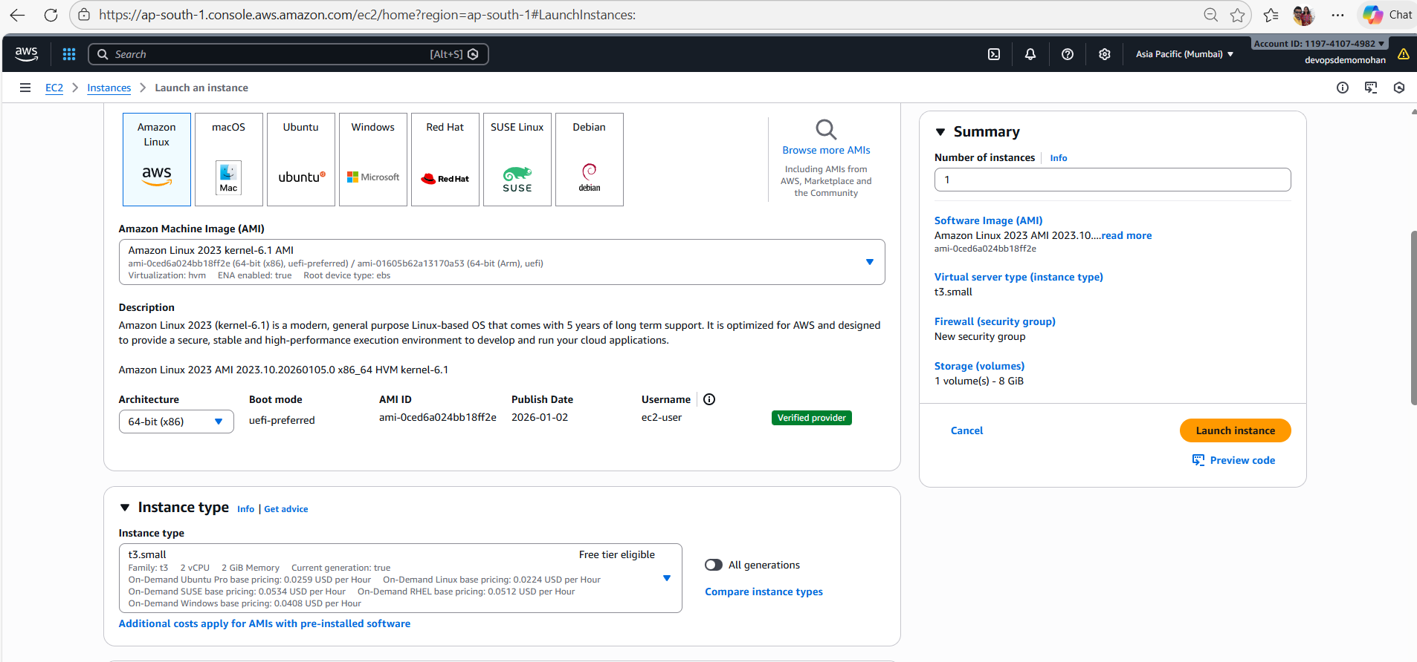
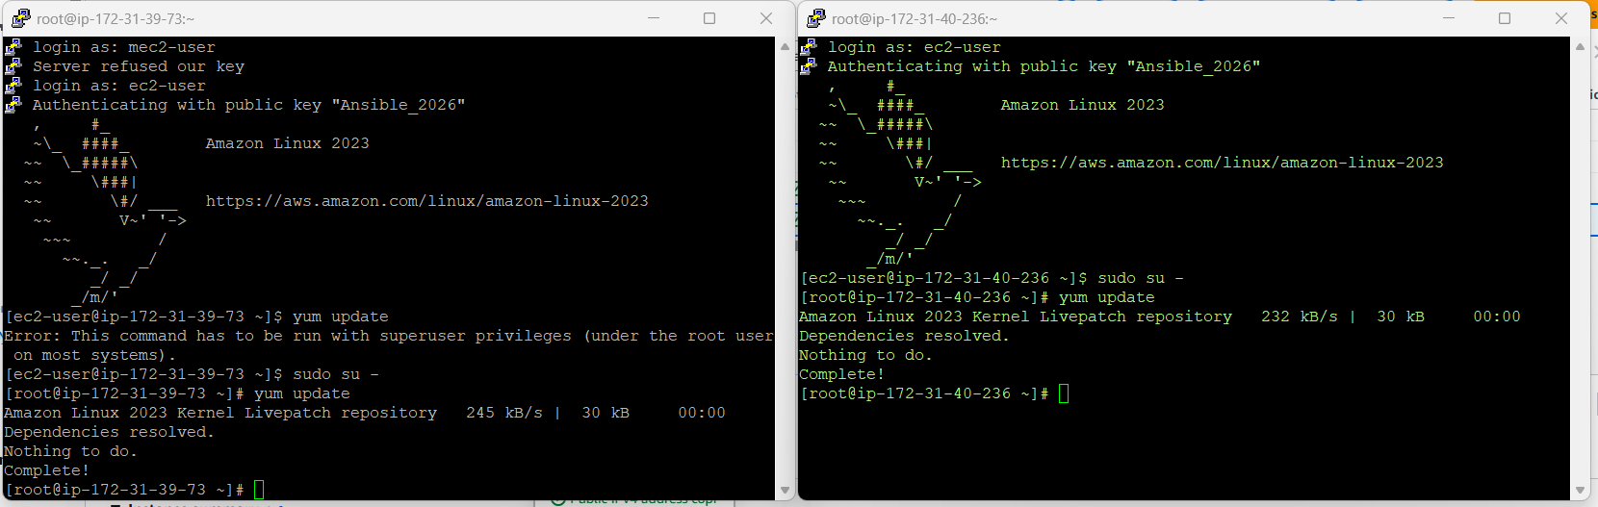
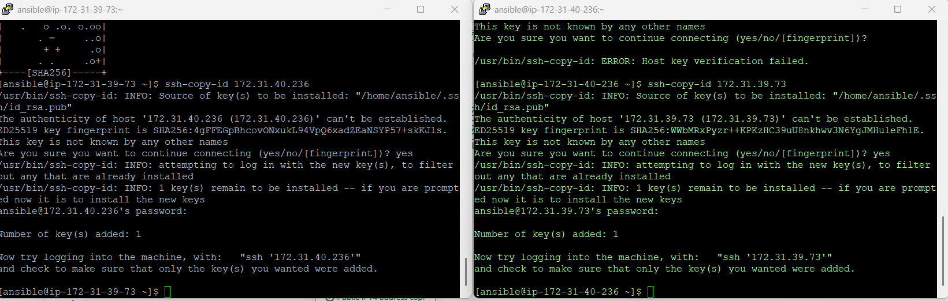
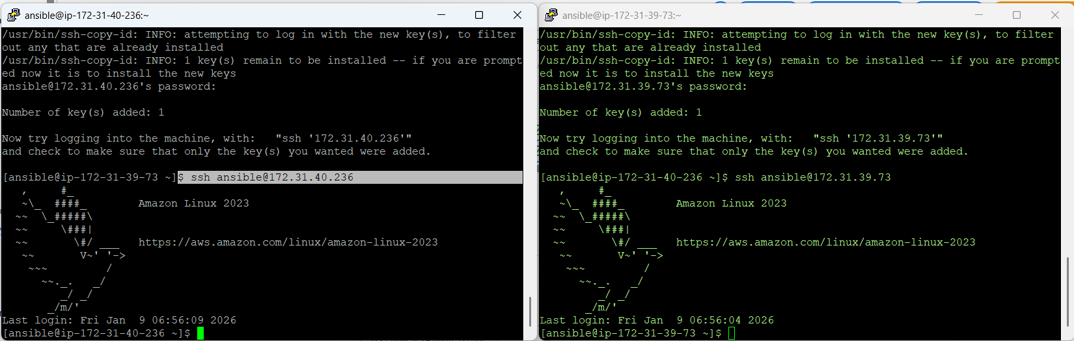

✅ Correct Way to Install Ansible on Amazon Linux 2023

❌ Why the error happens
No match for argument: epel-release
Because:
- AL2023 removed amazon-linux-extras
- EPEL is not supported
- Ansible is provided directly via Amazon repos

✅ Method 1 (RECOMMENDED): Install Ansible from Amazon Repo

🔹 Step 1: Update system
sudo dnf update -y

🔹 Step 2: Install Ansible Core
sudo dnf install -y ansible-core
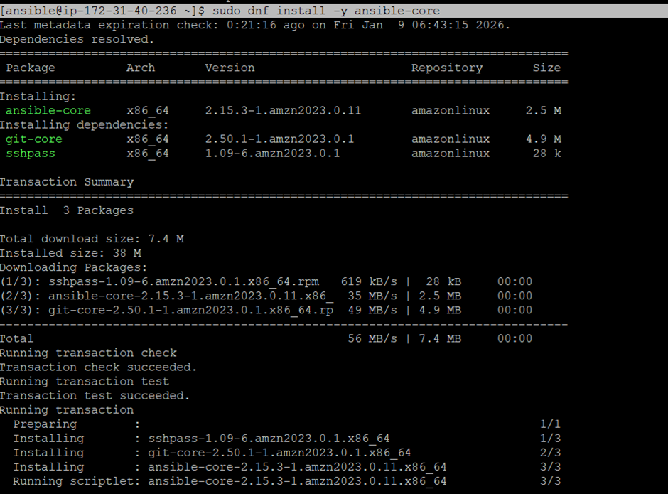
✅ This is the official & supported way on AL2023.

🔹 Step 3: Verify installation
ansible --version
Expected output:
ansible [core 2.15.x]
python version = 3.x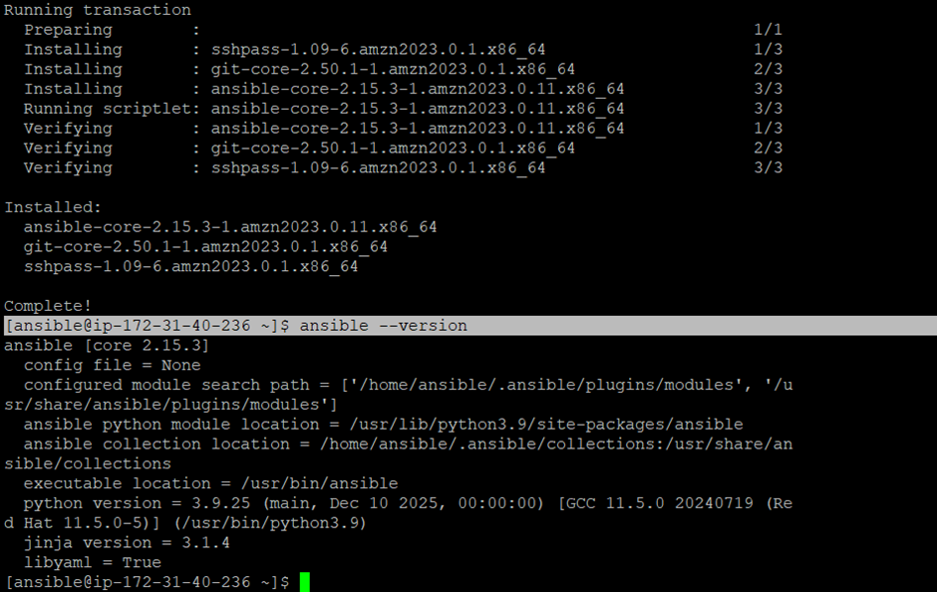

Normal behavior in Ansible Core, especially on Amazon Linux 2023 👍
ansible-core does NOT ship with a default ansible.cfg file.
Ansible looks for ansible.cfg in specific locations, but you must create it yourself.

✅ Where Ansible Looks for ansible.cfg (Order Matters)
1️⃣ Project directory
2️⃣ User home directory → ~/.ansible.cfg
3️⃣ System-wide → /etc/ansible/ansible.cfg
Check active config:
ansible --version
Example output:
config file = None
This confirms no config file exists yet.

✅ Recommended: Create System-wide ansible.cfg

🔹 Step 1: Create config file and host file
sudo vi /etc/ansible/ansible.cfg and sudo vi /etc/ansible/hosts

🔹 Step 2: Minimal Production-Ready ansible.cfg
[defaults]
inventory = /etc/ansible/hosts
remote_user = ansible
host_key_checking = False
retry_files_enabled = False
timeout = 30
interpreter_python = /usr/bin/python3

[privilege_escalation]
become = True
become_method = sudo
become_user = root
Save & exit.

✅ Create Inventory File
sudo vi /etc/ansible/hosts
[ec2-user@ip-172-31-40-236 ~]$ cat /etc/ansible/hosts
[dev]
172.31.39.73
[ec2-user@ip-172-31-40-236 ~]$

✅ Verify Config Is Picked Up
ansible --version
Expected:
config file = /etc/ansible/ansible.cfg

[ec2-user@ip-172-31-40-236 ~]$ cat /etc/ansible/hosts
## [local]
## localhost ansible_connection=local
[dev]
172.31.39.73
[ec2-user@ip-172-31-40-236 ~]$
🔹 Test Ansible
ansible all -m ping
✅ Output:
localhost | SUCCESS => {"ping": "pong"}

