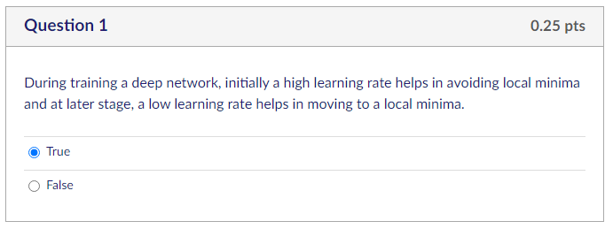
During training a deep network, initially a high learning rate helps in avoiding local minima and at later stage, a low learning rate helps in moving to a local minima.
Group of answer choices
True
False

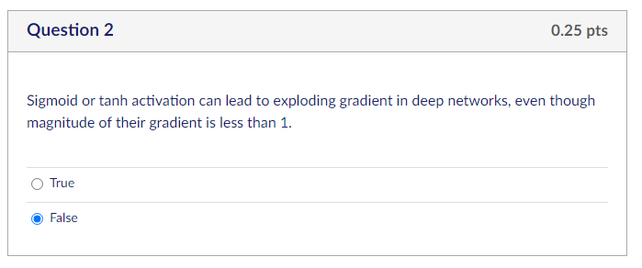
Sigmoid or tanh activation can lead to exploding gradient in deep networks, even though magnitude of their gradient is less than 1.
Group of answer choices
True
False

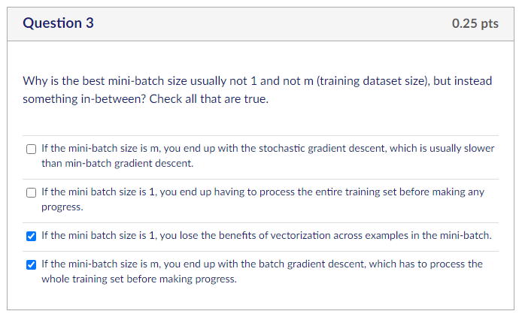
Why is the best mini-batch size usually not 1 and not m (training dataset size), but instead something in-between? Check all that are true.
Group of answer choices
If the mini-batch size is m, you end up with the stochastic gradient descent, which is usually slower than min-batch gradient descent.
If the mini batch size is 1, you end up having to process the entire training set before making any progress.
If the mini batch size is 1, you lose the benefits of vectorization across examples in the mini-batch.
If the mini-batch size is m, you end up with the batch gradient descent, which has to process the whole training set before making progress.

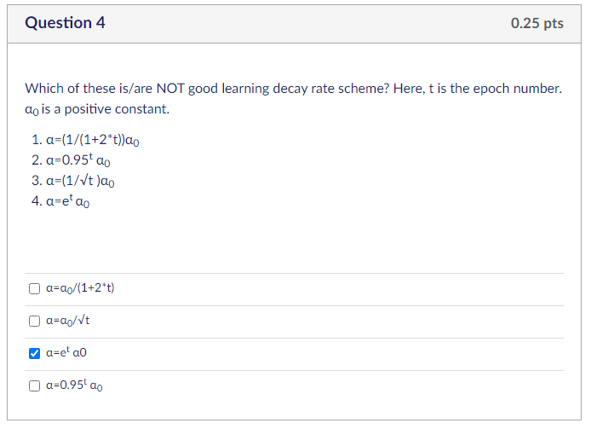
Which of these is/are NOT good learning decay rate scheme? Here, t is the epoch number. α₀ is a positive constant.
- α=(1/(1+2*t))α₀
- α=0.95^{t} α₀
- α=(1/√t )α₀
- α=e^{t} α₀

Group of answer choices
α=α₀/(1+2*t)
α=α₀/√t
α=e^{t} α0
α=0.95^{t} α₀

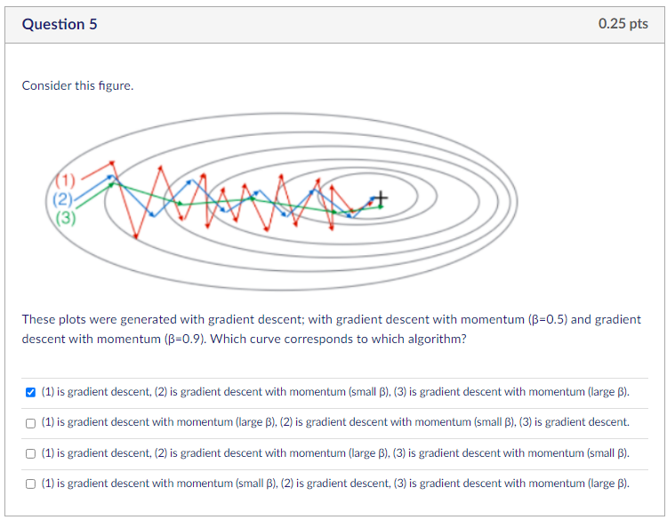
These plots were generated with gradient descent; with gradient descent with momentum (β=0.5) and gradient descent with momentum (β=0.9). Which curve corresponds to which algorithm?
Group of answer choices
(1) is gradient descent, (2) is gradient descent with momentum (small β), (3) is gradient descent with momentum (large β).
(1) is gradient descent with momentum (large β), (2) is gradient descent with momentum (small β), (3) is gradient descent.
(1) is gradient descent, (2) is gradient descent with momentum (large β), (3) is gradient descent with momentum (small β).
(1) is gradient descent with momentum (small β), (2) is gradient descent, (3) is gradient descent with momentum (large β).

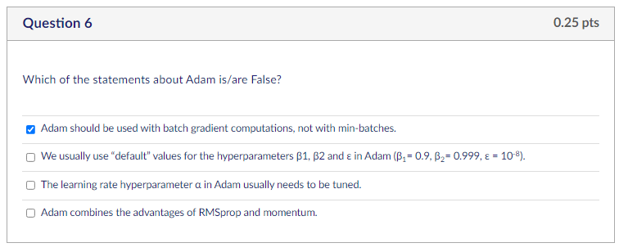
Which of the statements about Adam is/are False?
Group of answer choices
Adam should be used with batch gradient computations, not with min-batches.
We usually use “default” values for the hyperparameters β1, β2 and ε in Adam (β₁= 0.9, β₂= 0.999, ε = 10⁻⁸).
The learning rate hyperparameter α in Adam usually needs to be tuned.
Adam combines the advantages of RMSprop and momentum.

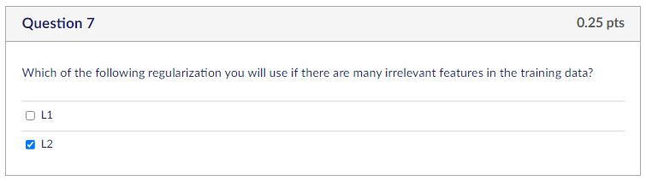
Which of the following regularization you will use if there are many irrelevant features in the training data?
Group of answer choices
L1
L2

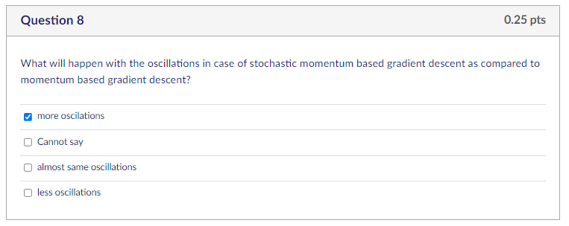
What will happen with the oscillations in case of stochastic momentum based gradient descent as compared to momentum based gradient descent?
Group of answer choices
more oscilations
Cannot say
almost same oscillations
less oscillations

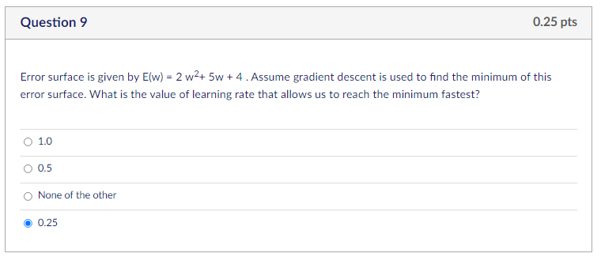
Error surface is given by E(w) = 2 w²+ 5w + 4 . Assume gradient descent is used to find the minimum of this error surface. What is the value of learning rate that allows us to reach the minimum fastest?
Group of answer choices
1.0
0.5
None of the other
0.25

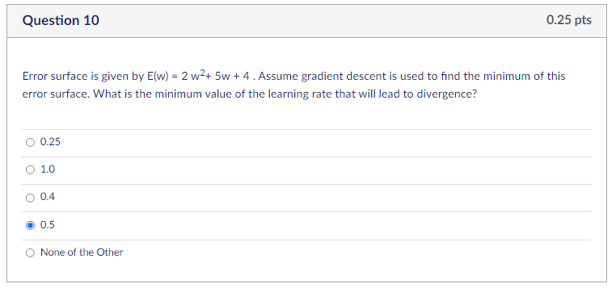
Error surface is given by E(w) = 2 w²+ 5w + 4 . Assume gradient descent is used to find the minimum of this error surface. What is the minimum value of the learning rate that will lead to divergence?
Group of answer choices
0.25
1.0
0.4
0.5
None of the Other

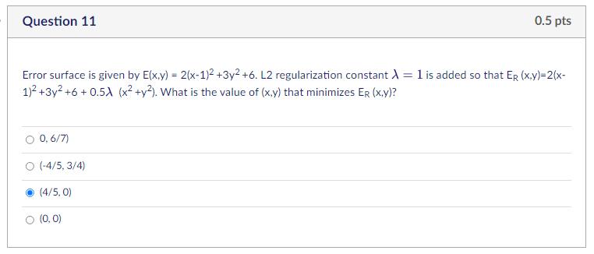
Error surface is given by E(x,y) = 2(x-1)² +3y² +6. L2 regularization constant λ=1 is added so that E_{R} (x,y)=2(x-1)² +3y² +6 + 0.5λ (x² +y²). What is the value of (x,y) that minimizes E_{R} (x,y)?
Group of answer choices
0, 6/7)
(-4/5, 3/4)
(4/5, 0)
(0, 0)

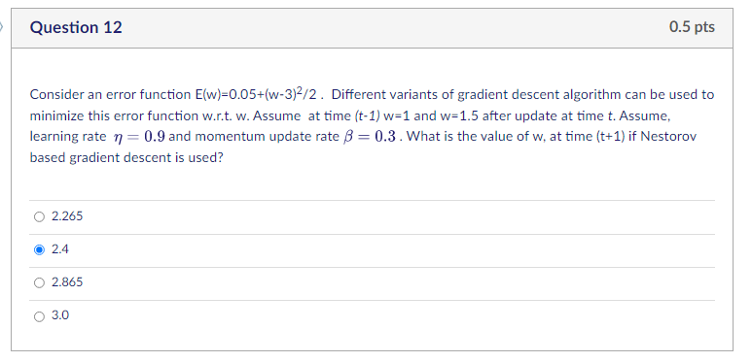
Consider an error function E(w)=0.05+(w-3)²/2 . Different variants of gradient descent algorithm can be used to minimize this error function w.r.t. w. Assume at time (t-1) w=1 and w=1.5 after update at time t. Assume, learning rate η=0.9 and momentum update rate β=0.3 . What is the value of w, at time (t+1) if Nestorov based gradient descent is used?
Group of answer choices
2.265
2.4
2.865
3.0

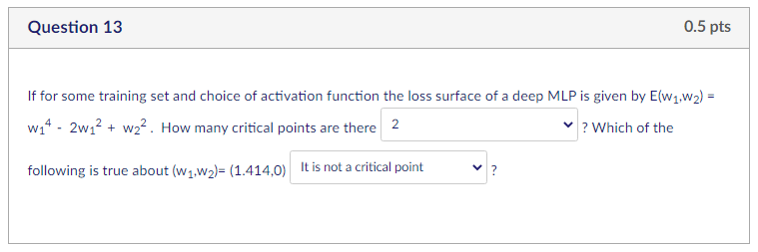
If for some training set and choice of activation function the loss surface of a deep MLP is given by E(w₁,w₂) = w₁⁴ - 2w₁² + w₂² . How many critical points are there ["", "", "", ""] ? Which of the following is true about (w₁,w₂)= (1.414,0) ["", "", "", ""] ?

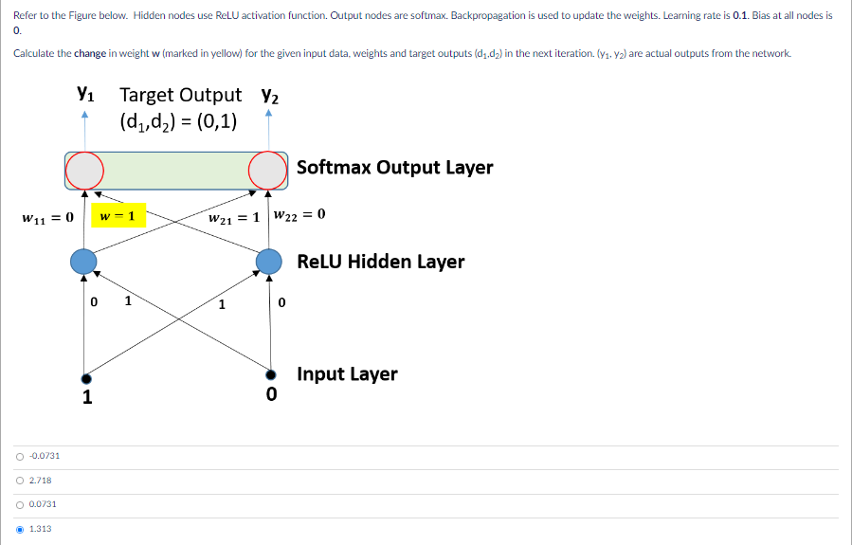

Refer to the Figure below. Hidden nodes use ReLU activation function. Output nodes are softmax. Backpropagation is used to update the weights. Learning rate is 0.1. Bias at all nodes is 0.
Calculate the change in weight w (marked in yellow) for the given input data, weights and target outputs (d₁,d₂) in the next iteration. (y₁, y₂) are actual outputs from the network.

Group of answer choices
-0.0731
2.718
0.0731
1.313

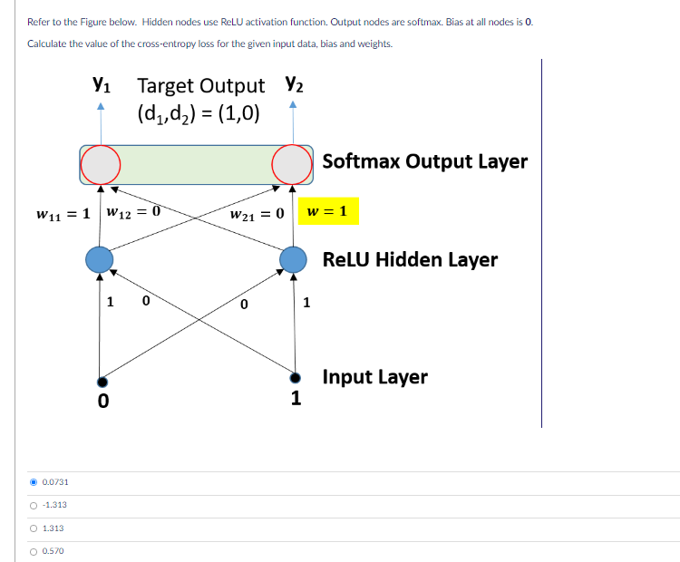

Refer to the Figure below. Hidden nodes use ReLU activation function. Output nodes are softmax. Bias at all nodes is 0.
Calculate the value of the cross-entropy loss for the given input data, bias and weights.

Group of answer choices
0.0731
-1.313
1.313
0.570

