SOFTWARE ENGINEERING DEVELOPMENT REPORT
TalentAI — AI-Powered Semantic Recruitment System
Complete Deliverables Package (Phases 1 — 8)
Deployment URL:
https://6a45e6b52c5f7dcfdf5ab2d7--endearing-zabaione-e08728.netlify.app/
Prepared for Software Engineering Course
Date: July 2026

PHASE 1 — IDEA FINALIZATION
1.1 Problem Statement
Traditional recruitment is heavily throttled by manual screening processes. Recruiters spend hours scanning resumes, often relying on simple keyword-matching algorithms that miss highly qualified candidates who use different terminology (e.g., 'Machine Learning' vs 'ML', 'Node.js' vs 'Express'). Additionally, candidates receive little to no transparency regarding their application status or specific skill gaps, leading to a poor applicant experience.
1.2 Project Objectives
- Automate Resume Parsing: Instantly extract personal, educational, and professional data from raw PDF/DOCX resumes.
- Implement Semantic Matching: Rank candidates fairly by assessing work relevance, skill proximity, and educational fit using Google Gemini AI.
- Provide Role-Based Portals: Deliver tailored dashboards for Recruiters (to manage jobs and view match comparisons) and Candidates (to monitor progress and view skill gaps).
- Ensure Cost Efficiency: Run on a serverless, database-only architecture bypassing premium storage plans.
1.3 Scope Document
In-Scope Features:
- Secure email/password authentication: Enforced role-based signup via Firebase Auth.
- Client-side PDF/DOCX text parsing: Direct file reading using pdfjs-dist and mammoth.
- AI-driven JSON extraction: Gemini 2.5 Flash for structuring resume profiles.
- Semantic match matching engine: Real-time AI matching score computations and feedback on apply.
- Delete/Withdraw portal option: Allows candidates to instantly withdraw an application from their dashboard.
Out-of-Scope Features:
- Video interviews: Video analysis or facial mood tracking.
- Automatic outbound emailing: Job notification and alerts are handled fully inside the live in-app notification center.
1.4 Initial Use Cases & Diagram
The system manages two key roles: the Recruiter (who creates job posts, configures required skills, and views candidate lists sorted by AI matching score) and the Candidate (who registers, builds profile, uploads resumes, tracks status, and applies/withdraws).
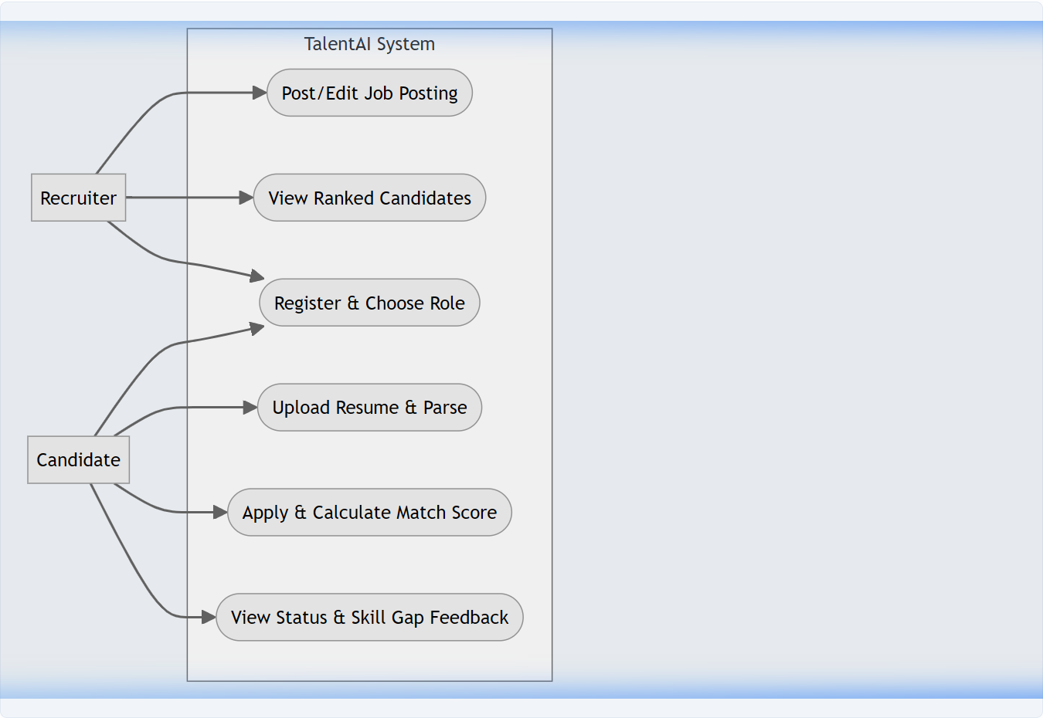
[Figure 1: Use Case Diagram]

PHASE 2 — REQUIREMENT ENGINEERING (SRS)
2.1 Functional Requirements
- FR-1 (Authentication): Users register and log in via email and password using Firebase Auth.
- FR-2 (Role Assignment): User role (Recruiter/Candidate) is saved in Firestore user record and enforces dashboard access routing.
- FR-3 (Job Posting CRUD): Recruiters can create, read, update, and close job posts (specifying required skills).
- FR-4 (Resume Uploader): Candidates upload PDF/DOCX resumes which get parsed client-side to bypass Storage billing restrictions.
- FR-5 (AI Parsing): Gemini model extracts details (name, email, skills, work history) as structured JSON profiles.
- FR-6 (AI Matching): AI evaluates candidate profiles against job required skills, creating a match score out of 100.
- FR-7 (Application Status): Recruiter changes application statuses (applied, reviewing, shortlisted, rejected).
- FR-8 (Real-time Alerts): Changes trigger real-time updates and alerts on the candidate's navigation notification bell.
- FR-9 (Application Withdrawal): Candidates can delete their job application, reducing the application count on the job.
2.2 Non-Functional Requirements
- Performance: Vite build must launch in under 1.5 seconds, and AI resume parsing must return results in under 7 seconds.
- Security: Restricted read/write privileges inside Firestore rules. Only the application candidate or job recruiter has write access.
- Reliability: Serverless Firestore provides a 99.99% database uptime SLA.
- Usability: Responsive dashboard design featuring CSS glassmorphism, responsive navigation bars, and color-coded match bars.

PHASE 3 — SYSTEM DESIGN
3.1 Activity Diagram
This diagram details the flow from candidate resume upload through local text extraction to Gemini JSON parsing and job application submission.
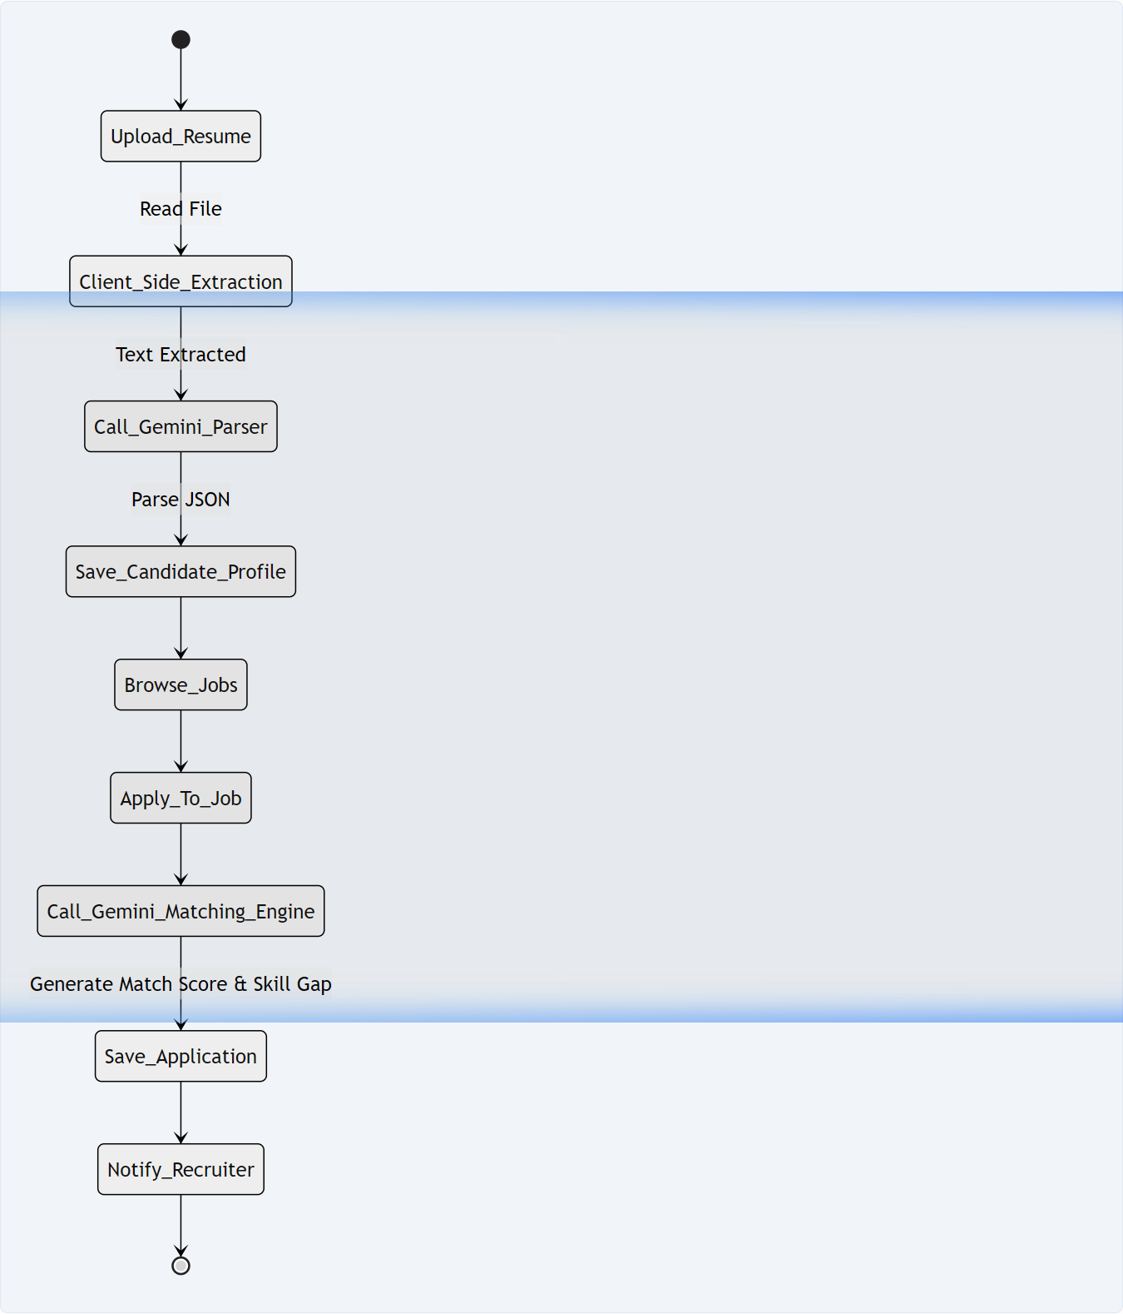
[Figure 2: System Activity Flow Diagram]
3.2 Sequence Diagram
This sequence details the synchronous API interaction between the candidate UI, the backend Firestore collections, and the Gemini 2.5 Flash matching engine.
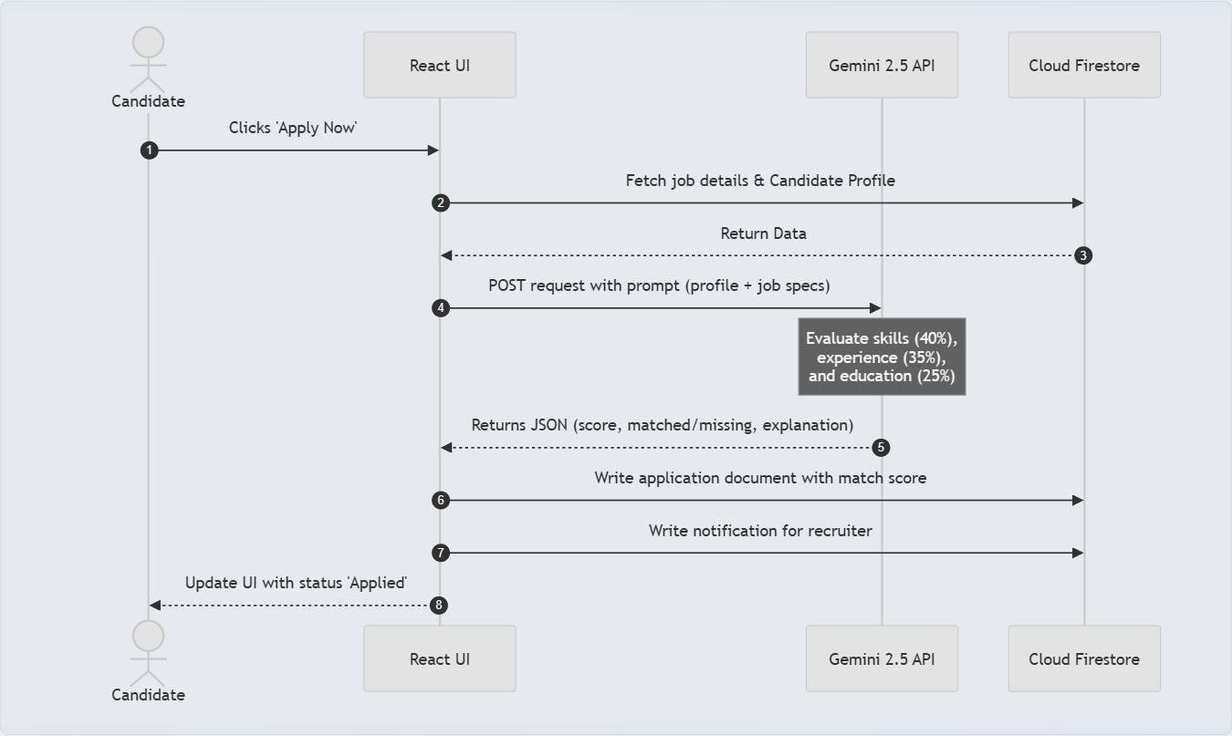
[Figure 3: Sequence Flow of AI Matching Pipeline]
3.3 Entity-Relationship Diagram (ERD)
Details the Firestore NoSQL schema mappings (Users, Candidates, Jobs, Applications, and Notifications collections).
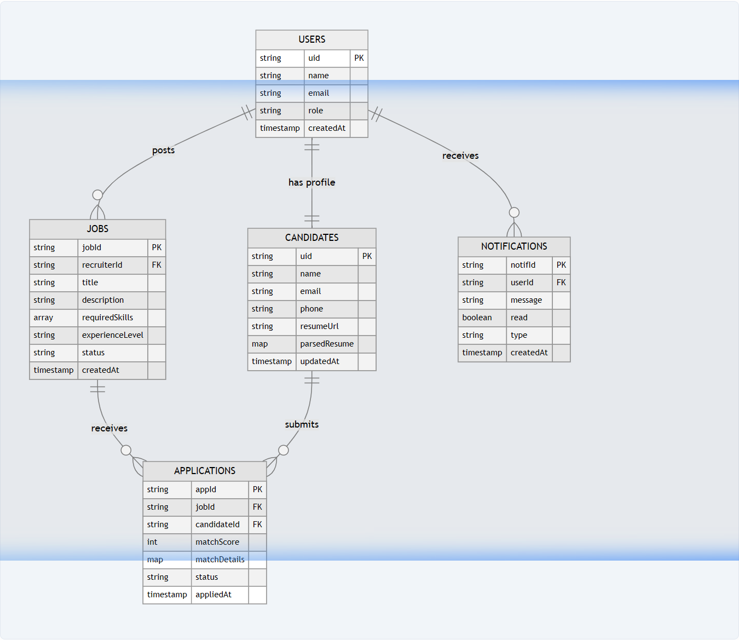
[Figure 4: Entity-Relationship Mapping]
3.4 Data Flow Diagram (DFD Level 1)
Describes information processing paths between users, database stores, and AI matching routines.
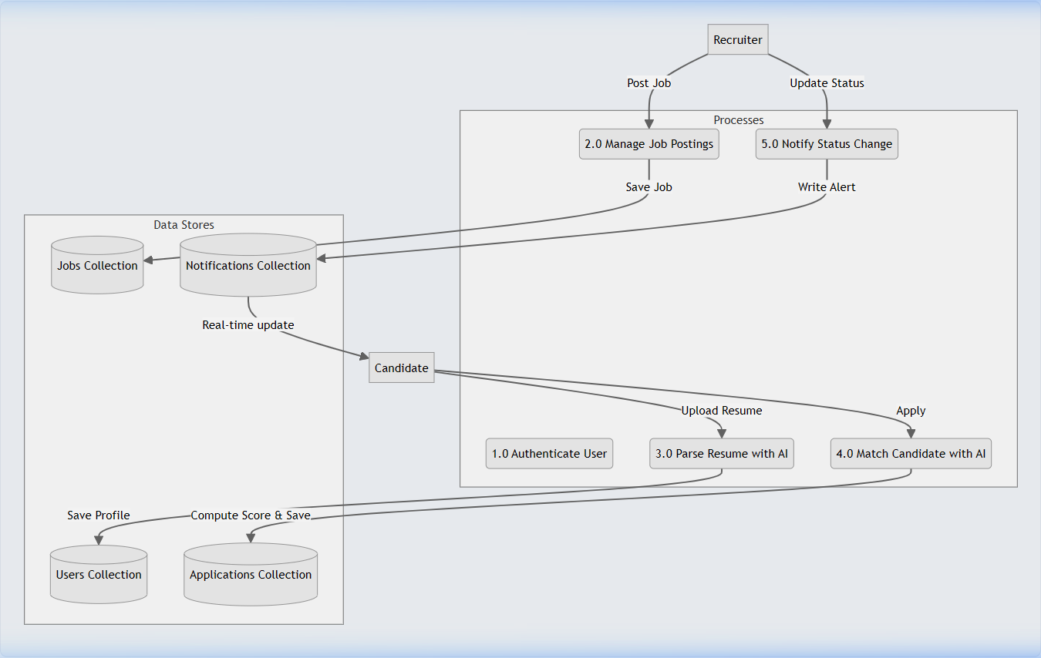
[Figure 5: DFD Level 1]

PHASE 4 — AI-ASSISTED DEVELOPMENT
AI was used to accelerate the development workflow, specifically for designing prompt guidelines and parsing output schemas.
4.1 Prompt Engineering Guidelines
1. Resume JSON Extraction Prompt:
You are an expert resume parser. Extract structured information from the resume text.
Return ONLY valid JSON (no markdown explanation or formatting fences):
{
"name": "Full Name",
"email": "email@example.com",
"phone": "+1234567890",
"skills": ["skill1", "skill2"],
"education": [{"degree": "B.Sc CS", "institution": "College", "year": "2020"}],
"workExperience": [{"title": "Job Title", "company": "Company", "duration": "2021-2023", "description": "Details"}]
}
2. Match Scoring Prompt (configured with responseMimeType):
SCORING RUBRIC (total = 100 points):
1. Skills Match (40 pts) - Use semantic match: "ReactJS" = "React.js"
2. Experience (35 pts) - Work history relevance
3. Education (25 pts) - Degree match
Return JSON:
{
"score": <0-100>,
"matchedSkills": [],
"missingSkills": [], // Cap at TOP 8 most critical missing skills
"explanation": "Brief reasoning under 60 words"
}

PHASE 5 — DEVELOPMENT METHODOLOGIES
The application was developed in two Sprints using a Scrum Framework:
- Sprint 1: Set up Vite React project structure, Firebase client instance, AuthContext provider, and local Base64 uploader components.
- Sprint 2: Integrated Gemini 2.5 Flash API, designed structured parsing scripts, and built Candidate/Recruiter dashboards, adding withdrawal features.

PHASE 6 — TESTING & QUALITY ASSURANCE
Unit, integration, and security rules testing were performed locally. Test cases are summarized below:
Test ID | Module | Inputs & Expected Output | Result
TC-01 | Auth | Sign up Recruiter & Candidate -> saved with role field and routed correctly. | Passed
TC-02 | AI Parse | Upload resume -> extracts client-side, Gemini returns structured JSON. | Passed
TC-03 | AI Match | Apply candidate -> semantic match score computed and stored in Firestore. | Passed
TC-04 | Withdraw | Delete application -> successfully deletes doc and decrements applicationCount. | Passed

PHASE 7 — DEPLOYMENT
The application frontend is compiled using Vite and deployed to Netlify via GitHub integration. The backend database and user roles are served from Google Firebase.
- Live Deployment URL: https://6a45e6b52c5f7dcfdf5ab2d7--endearing-zabaione-e08728.netlify.app/
- Firestore Configuration: Initialized rules file (firestore.rules) and indexes file (firestore.indexes.json) deployed via Firebase CLI.

PHASE 8 — USER GUIDE
Recruiter Guide
1. Sign up/log in as a Recruiter. You'll be routed to the Recruiter Dashboard.
2. Click '+ Post Job'. Enter details and list key skills (press Enter to commit tags).
3. Candidates list is automatically sorted by the AI Match Score. Click 'View Full Profile & Comparison' to open the details side-drawer.
4. Use the status dropdown (Shortlisted, Reviewing, Rejected) to notify candidates in real-time.
Candidate Guide
1. Sign up/log in as a Candidate. Go to 'My Profile' and upload a resume (PDF/DOCX).
2. Go to 'Browse Jobs' and click 'Apply Now'. The system calculates a match score and saves the application.
3. View and track applications, status updates, notifications, and AI skill gap analysis on your dashboard.
4. Click 'Withdraw' to retract an application if necessary.

