QLoRA Fine-Tuning with PEFT
A beginner-friendly guide to understanding the Fine_Tuning_PEFT_Colab_Updated notebook
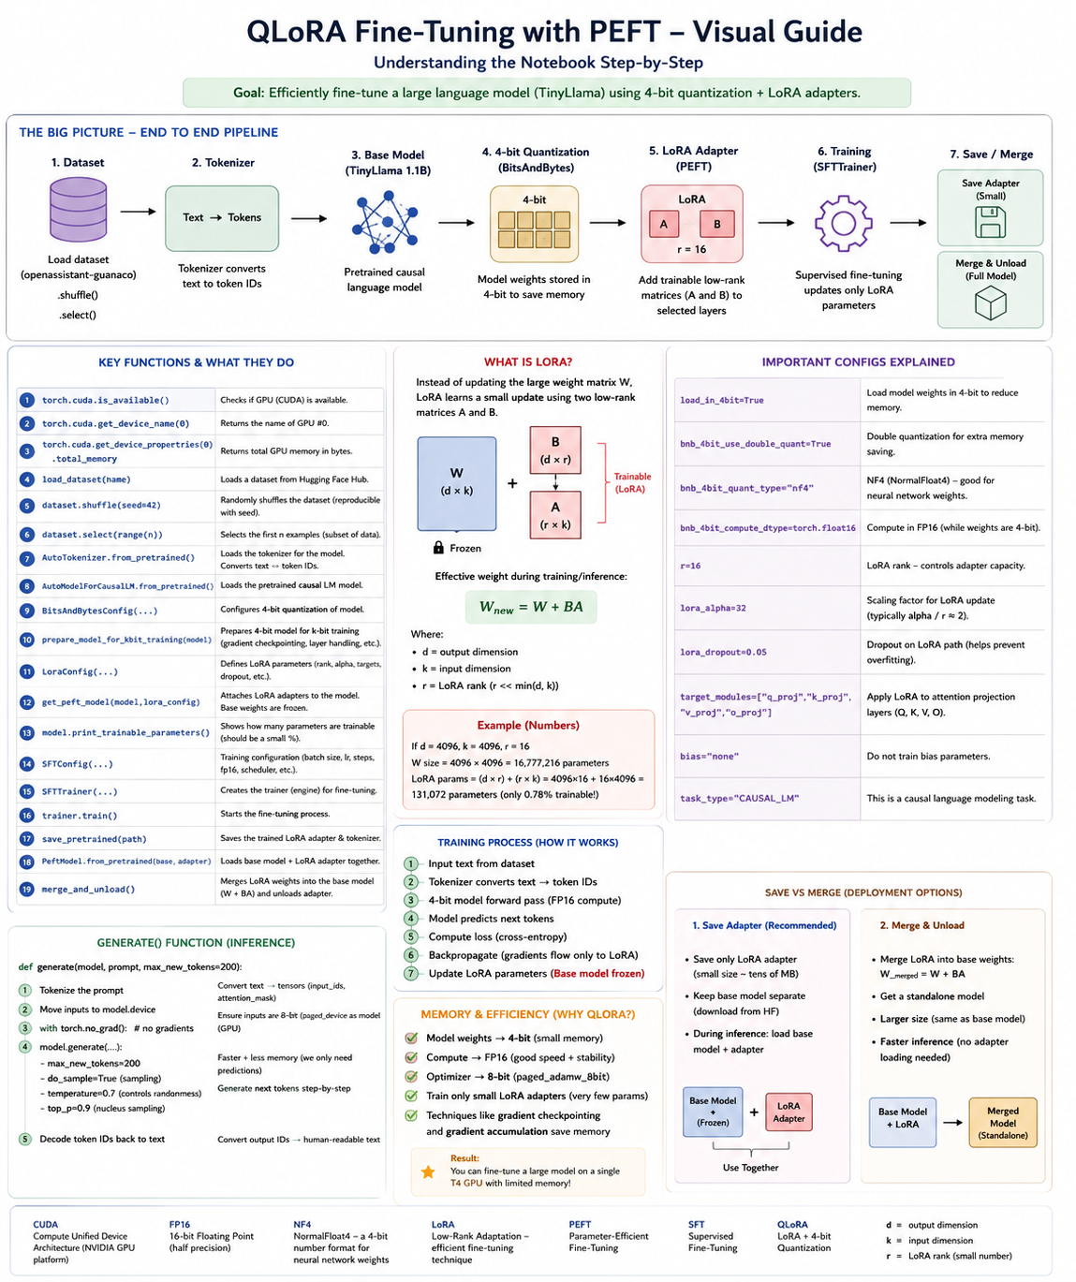

1. The Big Picture
The notebook demonstrates Parameter-Efficient Fine-Tuning (PEFT) using LoRA on a 4-bit quantized model (QLoRA). The base model is TinyLlama-1.1B-Chat and the training dataset is OpenAssistant Guanaco. The important idea is that the original model weights are kept frozen while small LoRA adapter parameters are trained.
Dataset → Tokenizer → Base LLM → 4-bit Quantization → LoRA → SFT Training → Save Adapter / Merge

2. What Each Library Does
Library | Purpose
torch | GPU access, tensors, inference/training utilities
transformers | Load the tokenizer and causal language model
datasets | Load and manipulate Hugging Face datasets
bitsandbytes | 4-bit/8-bit quantization and memory-efficient optimization
peft | LoRA and other parameter-efficient fine-tuning methods
trl | Supervised fine-tuning with SFTTrainer
accelerate | Device/GPU and distributed-training support
huggingface_hub | Authentication and uploading models/adapters

3. Function-by-Function Explanation
torch.cuda.is_available() — Checks whether PyTorch can access a CUDA-capable NVIDIA GPU. True means CUDA is available; False means the notebook is effectively running without CUDA.
torch.cuda.get_device_name(0) — Returns the name of GPU number 0, such as Tesla T4.
torch.cuda.get_device_properties(0).total_memory — Returns the total VRAM of GPU 0 in bytes. The notebook divides by 1e9 and rounds the result to display approximate GB.
load_dataset(DATASET_NAME) — Loads the selected dataset from the Hugging Face Datasets ecosystem. The notebook then uses dataset['train'] to access the training split.
.shuffle(seed=42) — Randomizes the order of training examples. The seed makes the shuffle reproducible.
.select(range(n)) — Selects a subset of examples. The notebook uses this to limit the demo to at most 1,000 examples.
BitsAndBytesConfig(...) — Defines how the model is quantized. load_in_4bit=True stores model weights in 4-bit form; double quantization saves additional memory; NF4 is the 4-bit quantization type; FP16 is used for computation.
AutoTokenizer.from_pretrained(MODEL_NAME) — Loads the tokenizer associated with the selected model. It converts text into token IDs that the model can process.
AutoModelForCausalLM.from_pretrained(...) — Loads a pretrained causal language model. Causal language models predict the next token from previous tokens.
prepare_model_for_kbit_training(model) — Prepares the quantized model for parameter-efficient training. It performs the model preparation required for k-bit training.
LoraConfig(...) — Defines the LoRA adapter: rank r, scaling alpha, dropout, target modules, bias handling, and task type.
get_peft_model(model, lora_config) — Wraps the base model with the LoRA adapter and makes the selected LoRA parameters trainable while the base parameters remain frozen.
model.print_trainable_parameters() — Displays how many parameters are trainable compared with the total model parameters. This demonstrates the parameter-efficiency of LoRA.
SFTConfig(...) — Stores supervised fine-tuning settings such as sequence length, batch size, gradient accumulation, learning rate, optimizer, epochs, and checkpoint strategy.
SFTTrainer(...) — Creates the training engine that connects the model, dataset, tokenizer/processing class, LoRA configuration, and training settings.
trainer.train() — Starts the actual fine-tuning process: forward pass, loss calculation, backpropagation, and LoRA parameter updates.
save_pretrained(path) — Saves the trained model/adapter files to a directory. In this notebook, the small LoRA adapter is saved rather than a full copy of the base model.
tokenizer.save_pretrained(path) — Saves the tokenizer files needed to reproduce the same tokenization later.
PeftModel.from_pretrained(base_model, adapter) — Loads a trained LoRA adapter on top of a compatible base model.
merge_and_unload() — Merges the LoRA update into the base model weights and removes the separate adapter wrapper, producing a standalone merged model.
model.generate(...) — Generates new tokens from a prompt during inference. Parameters such as max_new_tokens, temperature, top_p, and do_sample control the generation behavior.
tokenizer.decode(...) — Converts generated token IDs back into human-readable text.

4. Understanding Tokenization
An LLM does not directly receive ordinary text. The tokenizer converts text into token IDs. During fine-tuning, the training text is tokenized, passed through the model, and compared with the expected next tokens.
Text → tokenizer() → input_ids + attention_mask → LLM → predicted token probabilities

5. Understanding LoRA
Full fine-tuning changes the model's original weight matrices. LoRA instead learns a small low-rank update. A simplified view is:
W_new = W + BA
W is the original frozen weight matrix. A and B are the small trainable LoRA matrices. The rank r controls the adapter's capacity. Higher r generally means more trainable parameters and potentially more capacity.

6. Important LoRA Settings in This Notebook
Setting | Notebook value | Meaning
LORA_R | 16 | LoRA rank; controls adapter size/capacity
LORA_ALPHA | 32 | Scaling factor for the LoRA update
LORA_DROPOUT | 0.05 | Dropout applied to the LoRA path during training
TARGET_MODULES | q_proj, k_proj, v_proj, o_proj | Attention projection layers receiving LoRA adapters
bias | none | No bias parameters are trained by LoRA
task_type | CAUSAL_LM | The task is causal language modeling

7. Understanding QLoRA
QLoRA combines LoRA with a 4-bit quantized base model. The model weights are stored in a much smaller representation, while the trainable LoRA adapters are kept separate. In this notebook, NF4 is used for 4-bit storage and FP16 is used for computation.
QLoRA = 4-bit Quantized Base Model + LoRA Adapters

8. Training Settings
Setting | Value | Why it matters
NUM_TRAIN_EPOCHS | 1 | One pass through the training data, subject to max_steps
MAX_STEPS | 250 | Quick demo limit; -1 would allow epoch-based training
PER_DEVICE_BATCH_SIZE | 4 | Examples processed on the GPU per batch
GRAD_ACCUM_STEPS | 4 | Accumulates gradients; effective batch size is 4 × 4 = 16
LEARNING_RATE | 2e-4 | Controls the size of parameter updates
MAX_SEQ_LENGTH | 512 | Maximum training sequence length in tokens
gradient_checkpointing | True | Saves memory by recomputing selected activations
optim | paged_adamw_8bit | Memory-efficient 8-bit optimizer
fp16 | True | Uses FP16 training on the T4

9. What Happens During trainer.train()?
- Training examples are taken from the dataset.
- The tokenizer converts text into token IDs.
- The quantized model performs a forward pass.
- The model predicts the next tokens.
- A loss value measures the difference between predictions and targets.
- Backpropagation calculates gradients.
- Only the trainable LoRA parameters are updated; the base model remains frozen.
- The process repeats for the configured training steps.

10. Save Adapter vs. Merge Model
Option | What you get | When useful
Save LoRA adapter | Base model + small adapter kept separate | Usually convenient for storage, sharing, and maintaining one base model with multiple adapters
Merge and unload | Standalone model containing W + LoRA update | Convenient when a deployment environment prefers a single model

11. One-Minute Mental Model
If you remember only one diagram, remember this:
BASE LLM
↓
4-bit Quantize
↓
Freeze Base Parameters
↓
Attach LoRA
↓
Train Only LoRA Params
↓
Save Adapter / Merge

12. Key Takeaways
- Fine-tuning teaches a pretrained model to perform better on a target dataset or style.
- PEFT reduces the number of parameters that must be trained.
- LoRA learns small low-rank updates instead of changing all base weights.
- QLoRA combines LoRA with 4-bit quantization to reduce memory usage.
- The tokenizer converts text into token IDs before the model processes it.
- SFTTrainer provides the supervised fine-tuning training loop.
- Saving the adapter is different from saving a merged standalone model.

Based on the supplied Fine_Tuning_PEFT_Colab_Updated.ipynb

