**Model for High Dynamic Range Imaging System Using Hybrid Feature Based Tone Mapping Algorithm**

Bagadi Ravi Kiran1, Vatsavayi Valli Kumari2, and KVSVN Raju3

1 Faculty of Andhra University College of Engineering,  
Visakhapatnam, Andhrapradesh, India-531162

ravik.phd018@gmail.com

2 Faculty of Andhra University College of Engineering,  
Visakhapatnam, Andhrapradesh, India-531162

vallikumari@gmail.com

3 Faculty of Gayatri Vidya Parishad College for Degree and PG Courses,  
Rushikonda, Visakhapatnam, Andhrapradesh, India, 530 045

kvsvn.raju@gvptc.edu.in

### Abstract

The luminous value is high for the many natural scenes, it causes loss of information and it may occurin dark images. The High Dynamic Range (HDR) technique captures the same objects or scene for multiple times in different exposure and produce the images with proper illumination. This technique used in the various applications such as medical imaging and observing the skylight, etc. HDR imaging techniques usually has the issue of lower efficiency due to capturing multiple photos. In this paper, efficient method was used to HDR imaging technique for better performance and lower noise. The multiple images with different luminous images used as an input for the Luminance-Chrominance-Gradient High Dynamic Range (LCGHDR) technique. Based on these feature values extracted from the different images and tone map was buildthat helps for the proper imaging. This experiment evaluated and analyzed with other methods. The experimental result showed the performance of the proposed method was high whilecompared it with other methods. The proposed system needs only 124.594 seconds for the computation, while existing method need 139.869 seconds for the same number of images.

**Keywords**: Exposure, High Dynamic Range, Luminance-Chrominance-Gradient HDR, Tone map.

### Introduction

The real world scene has the dynamic range of the eight orders of magnitude much larger than the conventional digital imaging system, which has the two ordersin common [1].The details of the image lost due to the underexposure and overexposure.The single image does not provide the information of the objects due to some loss of data in the images [2]. The multiple image of the same object with the different exposure can provide the needed information about the image, because different exposure of the image gives the different data [3]. The advancement in the image acquisition technique helps to overcome the issues presented in current imaging system and make it possible to capture the scene with the higher value of dynamic range in the imagefrom theexposure between the bright and dark area [4], [5].The photometric and colorimetric information calculated from captured images has been highly used in scientific and engineering applications like an environment evaluation for example Unified Glare Rating (UGR) measurement for office or road monitor,medical imaging and graphics rendering consists of image-based lighting.

Many approaches proposed to capture the image with the proper dynamic range and some methods provide the ability to capture the HDR image [6].The basic method is to capture simultaneously with the different exposure and then irradiance spatial dimensions of the same scene [7].The captured images mapped to an HDR based efficient image reconstruction algorithm [8]. The exposure time of the camera depends on the lens aperture, shutter speed, and ISO levels; the exposure time controls the intensity of the light incident on the image sensor [9]. The long exposure time capture the dim details, whereas the bright area details captured using the short exposure time [10].In this research, aLuminance-Chrominance-Gradient High Dynamic Range (LCGHDR)used for the effective HDR imaging techniqueand to reduce noise in the image.It extracts the Luminance, chrominance and gradient value from the images from the different exposure image and give the image a proper exposure. The proposed method compared with other existing methods for the evaluation purpose in the manner of efficiency and SNR. The proposed method showed higher performancecompared to the other method.

### Literature review

The latest research papers on the HDR imaging techniques taken for the literature review. This gives the current techniques in the HDR imaging and also their advantages and limitations for the respective research.

Xiaomin Wu, *et al.* [11] created a colorimetric method for the reconstruction in CIEXYZ with the camera device implementation to attain the accurate colorimetric and luminance information of the HDR scene.The colorimetric characterization transformed the individual RGB values of the picture into the corresponding CIEXYZ values with unlimited capture.The weighing function calculated according to the value of characterization accuracy fused with XYZ values.The performance was verified by the two phases of experiments and it outperformed the traditional onesunder the constant relative spectral power distribution (SPD) of lighting, it has 2 CIELAB units less than the traditional one and in the illuminations of different Correlated Color Temperatures (CCTs) is 3.5 CIELAB.The HDR reconstruction under mixed lighting conditions using a standard color checker can be used for efficiency.

Qingsen Yan, *et al*. [12] utilized the sparse representation framework for the HDR image synthesis algorithm with ghost free. The ghost artifacts created due to the adjacent Low Dynamic range (LDR) image and the moving object sparsity. The problem formulated into the two process: detection of moving object and ghost free HDR generation.The proposed method has the higher performance than the existing methods based on the textures and colors.The overall performance of this technique was better and in the few databases, the value of the PSNR was less than those other methods.

Yuije Wu, *et al*. [13] established the calibrated embedded system for quasi real-time lighting for HDR sky monitoring.The direction of the device was set in direct of a test module with unilateral-facades to calculatethe distribution of the luminance in sky and the ground dome. The measurement of the luminance distribution made for the sun, landscape and ground dome, and on-board illuminance processed in the device. This proposed method and the Perez all-weather sky model was comparedand this method attained the more reliable, which had the 10%-25% more accuracy due to HDR imaging and luminance mapping in transient lighting computation of horizontal illuminance.This can possibly help to improve the system that rejection of sun’s component in the luminance map.

Yang Song, *et al*. [14] proposed exposure condition analysis method based on the quality evaluation method for the tone-mapped HDR images. First, local exposure property analyzed for the purpose-designed HDR exposure segmentation modelthat used to separate image. The two new quality features such as abnormal exposure ration and exposure residual energy extracted and it is low complex. The color-based feature was also extracted and these features in the different exposure region. The quality evaluation model implemented by regression training. The ability of the model to predict the quality of tone-mapped HDR images showed in their experiment. The Pearson linear correlation coefficients are higher than 0.88; this technique have the high consistent with human visual perception.

Hyuk-Ju Kwon, *et al.* [15] proposed the new method in the HDR bleeding algorithm, which used only the dual-exposure image. The least squares method used in the proposed algorithm and it also included the spatial and intensity weighting functions.The error point was reduced and improved the Camera Response Function using the weighting function. In addition, a constraint was added to correct the white balance in the brightness level.The result showed that the proposed algorithm outperformed the existing method. This method was not evaluated in the real time function and this gives the efficiency of the system.

To overcome the above limitation, LCGHDR proposed for better performance of the HDR imaging also to reduce noise.

### Proposed system

The images from the database used as an input and the features such as luminance, chrominance and gradient were extracted from those images. Tone mapping developed based on the features and provide the image with the proper luminance. The higher luminance image and lower luminance images used as input. This technique requires only two input images of higher and lower exposure image and result obtained with exposure with more clarity of the image. The performance measured and compared with the other existing systems, which discussed in the experimental result section.The illustration of the dataset and algorithm of this method is given below.

**Algorithm**

1. Start
2. Capture the image with high exposure
3. Calculate the mean value of the highlyexposed image
4. Capture the image with low exposure
5. Calculate the mean value of the lowerexposed image
6. Check whether the scene is under exposure, over exposure or proper exposure using the mean value of the image. The mean value of the image is 0 to 100 is under exposed, 100 to 150 is properlyexposed and 150 above is over exposed.
   1. If the scene is under or over exposed,apply LCGHDR method to achieve the proper illuminated value and go to step 6.
   2. If the image is properly exposed and go to step 7
7. Stop

#### Database collection

The HDR Photographic Survey is the exclusive HDR database and consists of detailed colorimetric/luminance measurements [16]. The images have the contents and challenges with the data for the HDR imaging algorithm. This is a publicly available database and this can be used for the non-commercial research purpose. The attempt was made to collect the datasets up to 40 images and having 106 images in total by now. Twenty-eight images in the database have been accompanying colorimetric, appearance data and the various data associated with the remaining data. The thumbnail is available in the database to view the image and the images can be downloaded in the OpenEXR file.The database size is more than 13GB and this database inspired from the nineteenth century photographic survey of the American west. This database and stimulated database used to understand the performance of this method. The sample images of the database are shown in figure 1.

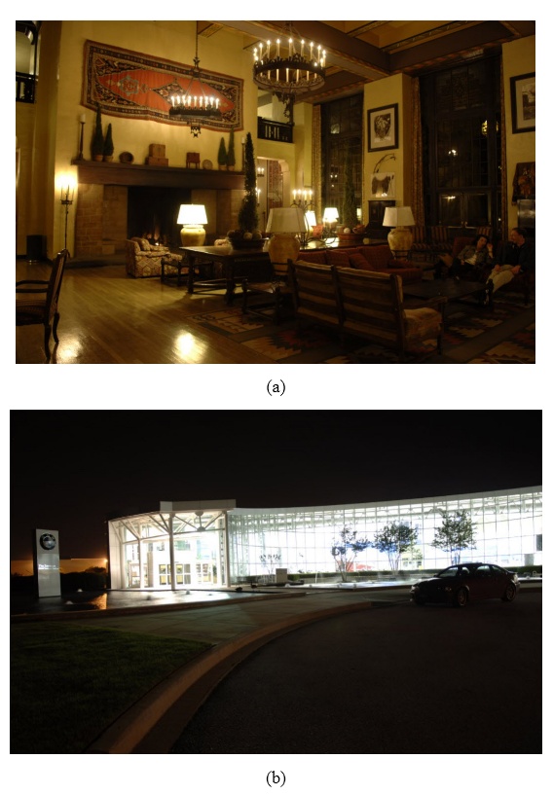

Figure 1 HDR Photographic Survey (a) Ahwahnee Great Lounge image with low luminance (b) Zentrum image with low luminance

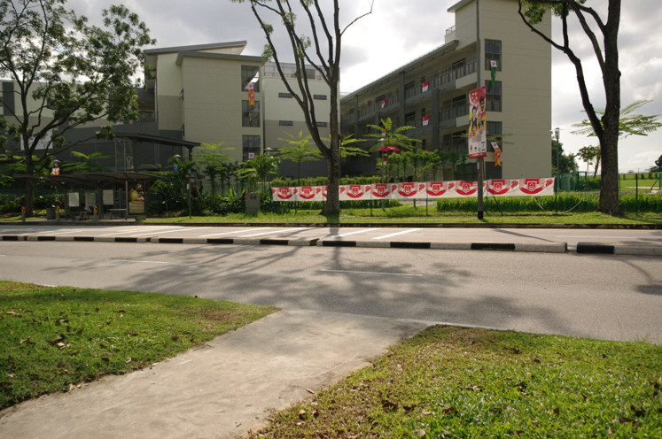

Figure 2 Sample image of building from Stimulated database

#### HDR Image Composition

The luminance, the two chrominance components and gradient are denoted as , respectively. Let be an image in the RGB space and is the same images in the luminance, chrominance and gradient space. The Roman letters to images in RGB and corresponding Greek letters to denote images in the luminance, chrominance and gradient manner).The transformation of the image from the RGB to the manner of luminance, chrominance and gradient is defined in the matrix form as , where A is the matrix normalized in such a way that if , then . The hue and saturation can be defined as and , respectively.

Consider a set of images , in the luminance-chrominance-gradient space, captured with different exposure time and with LDR, assuming , where is a pixel coordinate. The aim is to obtain the single HDR image in the same color space. In our setting, the luminance, chrominance and gradient channels measured and processed separately.

#### Luminance component composition

The multiple images captured from the same scene with the different exposure times used to calculate the luminance channel.The sufficient amount of pixels are taken with increasing monotonically values between under and over-exposure images.Using these pixels, the camera response function is fitted and applied an SVD solver.In this research, 100 pixelsconsideredas sufficient for most cases.The camera response measured only once and used for the input values as linearization in all HDR compositions of the same device.

The HDR luminance component calculated by a pixel wise weighted average of input luminance and as a weighting function, Gaussian function with a mean of 0.5 and a standard deviation of 0.2 thus ensuring a smaller impact of the under or over-exposed pixels. The calculation of the logarithmic HDR luminance obtained as:

(1)

From the Eq. (1), is the camera response function and the value of the HDR luminance is measured in the logarithmic scale. After applying the natural exponential, the resulting values are positive, normally spanning thus being truly HDR.

#### Chromium component composition

There is no camera response required for the chrominance components and the color saturation is taken for the weight the chrominance. If the value of the color saturation is high in the image, then the more pixel contains valuable chromatic information and the weight is also higher. The chromium feature is chosen for the reason of its values is saturated when a pixel is over- or under-exposed than value of pixel is correctly exposed. More specifically, , where . In this method, we found that is a good choice.To guarantee the color preservation, the same weight is used for the both chromatic components and compose any chromatic component as

(2)

Where denotes the saturation of . Bearing a convex combination of the input chrominances, the range of is again in . The distinct pixel value possible number is higher than in the original source sequence.

#### Gradient value of the image

The weighted map of the gradient information is generated for static and dynamic scenes and similarly to Canny detection, the first derivatives of 2-D Gaussian filter in the x- and y- directions to extract the gradient information is given in the Eq. (3)& (4)

(3)

(4)

Where and are the partial derivatives of image along the x- and y- directions, respectively. Standard deviation is set to two pixels in the experiments and the gradient magnitude reflects the maximum change in pixel values, whereas the angle points out the direction corresponding to the maximum change. These two components calculated in the following equations:

(5)

The illuminance, chrominance and the gradient values used to develop the tone mapping and this provide the image with proper illumination. The brief description of the tone mapping using the feature values are given below.

#### Tone Mapping for HDR images

Tone mapping is an HDR imaging technique used to approximate the visibility of the tones of an HDR image on an LDR media, such as LCD and CRT displays or print-outs.Essentially, tone mapping compresses the contrast of animage to set into the range for the display in a media, while details and color are preserved.

There are several tone mapping methods in RGBand these techniques are easily being adapted for the luminance range reduction, the term ‘tone mapping’ would be questionable in this context, as tone is usually used in connection with color. A luminance range reduction operator as and define its output, the reduced-range luminance image, as . This is the most effective approach in term of the chromatic channels.

The sRGB gamut does not allow the rendering of the very dark or very bright and saturated colors, which is present in the real scenes and captured in the HDR images. Therefore, there is a need for a chromatic tone mapping and hue intact while sacrificing saturation in order to fit into the sRGB gamut. Introducing a scaling factor for the two chrominance will scale down the saturation and not change the hue.The scheme uses to guarantee legal sRGB values embedded in the color space transformation itself and described as follows.

Let be the luminance, chrominance and gradient to RGB transformation matrix and define the gray (achromatic) image and its chromatic complement image in RGB space by

Remark that is truly a gray image because in RGB to luminance, chrominance and gradient transforms Look for a map such that

(6)

This is define it by

(7)

Where are defined analogously. Thus, is the largest one, which allows the condition (1) to hold. It is easy to realize that the hue of is not influenced by , whereas the saturation is measured proportionally to it. The low dynamic range image has colors which consists of same hue as those in the HDR image and which are desaturated a little, as it needed to fit within the sRGB gamut.

The tone mapped LDR image can be defined in luminance, chrominance, and gradient space as

(8)

The tone mapped luminance, chrominance and gradient image can be compressed and stored directly with an arbitrary method and for display transformed into RGB using the matrix B. This method evaluated and its performance presented in the experimental result section.

### Experimental Result

The experiment conducted in the software of MATLAB (R2017b) with the system specification of 4GB of RAM and 3.0 GHz processor.The value of iteration was set at 50 and the various images with different exposure considered as input and process the image. The output obtained as aproperly illuminated image and that image took for the evaluation. Thismethod was evaluated in terms of efficiency and Signal to Noise ratio (SNR). The other existing methods were also processed in the same dataset and compared it with the proposed method. The database has the same images with different illumination and it consists of the few sets of images. Each set of images have the fifteen similar image capture in the different exposure. The HDR techniques used for the 10 set of images and obtain the image with proper illumination.

The input images obtained from the dataset and there are 106 images used as an input image for evaluation.The feature values such as illuminance, chrominance and gradient values extracted from the images. The tone map was constructed based on the feature value and it provided the proper illumination measure. The two input images of the HDR Photographic Survey databaseare shown in the figure 3 (a) & (b) with the high illumination in 3 (a) and low illumination in 3 (b). The output image with the proper illumination is given in the figure 3 (c). The two input images of stimulated dataset are shown in the Fig (4) (a) & (b) and the output images of stimulated dataset is shown in the Fig (4) (c).

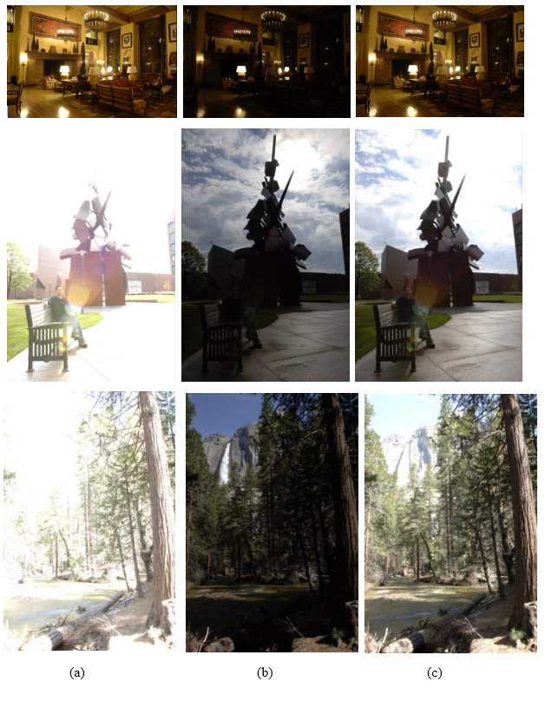

Figure 3 (a) Input image with high luminance (b) Input image with low luminance (c) output image

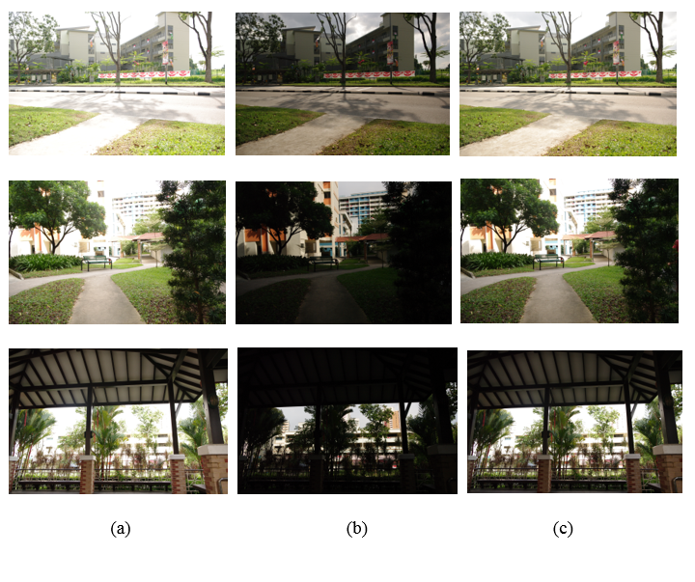

Figure 4 Stimulated dataset (a) High exposure Input image (b) Low exposure Input image (c) Output image with proper exposure

#### Performance evaluation in HDR Photographic Survey database

The BAR and AEE [17] were compared with the LCGHDR to show the performance in a number of shots, percentage of lost and Time efficiency (Table 1). The proposed method showed higher performance in terms of the time compared tothe other two methods (BAR and AEE). The BAR method requires three shots of the picture and, AEE, LCGHDR consider the two numbers of shots. Some of the capture have the lost values that are equal to zero. The LCGHDR method requires only a two capture of images and less time for the HDR imaging. The ten scenes were captured in total and there are 15 images with different illumination used for HDR imaging. The BAR method need 218.734 seconds for the 96 images and AEE method took total 81 images in 139.869 seconds. The proposed method requires 124.594 seconds for the 81 images.

Table 1. Comparison of BAR, AEE and LCGHDR

|  |  |  |  |  |
| --- | --- | --- | --- | --- |
| Number of scene | Methods | Number of shots | % Lost |  |
| 1 | BAR | 3 | 1.61 | 0.301 |
| AEE | 2 | 1.61 | 0.025 |
| LCGHDR | 2 | 1.61 | 0.014 |
| 2 | BAR | 3 | 0 | 0.301 |
|  | AEE | 2 | 0 | 0.101 |
|  | LCGHDR | 2 | 0 | 0.85 |
| 3 | BAR | 3 | 0 | 0.301 |
|  | AEE | 2 | 0 | 0.04 |
|  | LCGHDR | 2 | 0 | 0.021 |
| 4 | BAR | 3 | 0 | 0.301 |
|  | AEE | 2 | 0 | 0.05 |
|  | LCGHDR | 2 | 0 | 0.032 |
| 5 | BAR | 3 | 0 | 0.301 |
|  | AEE | 2 | 0 | 0.034 |
|  | LCGHDR | 2 | 0 | 0.015 |
| 6 | BAR | 3 | 0 | 0.301 |
|  | AEE | 2 | 0 | 0.025 |
|  | LCGHDR | 2 | 0 | 0.012 |
| 7 | BAR | 3 | 0 | 30.282 |
|  | AEE | 2 | 0 | 13.067 |
|  | Proposed LCGHDR | 2 | 0 | 11.042 |

Table 2 Mean value for the input and output images

|  |  |  |  |
| --- | --- | --- | --- |
| Model | Mean luminous value | | |
| High exposed input image | Low exposed input image | Output image |
| Model 1 | 162 | 95 | 124 |
| Model 2 | 168 | 92 | 112 |
| Model 3 | 184 | 72 | 134 |
| Model 4 | 173 | 93 | 132 |
| Model 5 | 167 | 82 | 121 |

The Mean luminous value of the two inputs and one-output images for the five imagespresented in the table 2. The mean value of the highly exposed input images having the highest value and for the low exposed value has the low value. These images used to measure the feature values and tone map helps to produce the image with a proper illuminant value.

Table 3 PSNR value for the images

|  |  |  |
| --- | --- | --- |
| Images | Average PSNR value of input image | Output image PSNR value |
| Model 1 | 24.24 | 28.51 |
| Model 2 | 25.74 | 30.54 |
| Model 3 | 22.15 | 27.94 |
| Model 4 | 24.78 | 28.78 |

Table 3 gives the PSNR value for the input images and output images. The four models of images used to measure the PSNR value. The two input images used for each caseand average PSNR measure compared with the output images. This shows that the PSNR value for the output image is higher than the input images.

#### Signal to Noise Ratio

The SNR is measured for these methods and compared it with other methods. In the AEE method, the four different conditionsmade for comparative purpose namely A (LO = 3 and HI =253), B (LO = 16 and HI =240), C (LO = 56 and HI =200), and D (LO = 106 and HI = 150). The proposed LCGHDR has been compared with the AEE method with four different conditions, BAR method and Ground Truth (GT) images.The SNR values measured using the Eq. (8) and shown in the table 4.

(8)

Table 4 SNR value for the different method

|  |  |  |  |
| --- | --- | --- | --- |
| **Methods** | **Number of shots** |  | **SNR (dB)** |
| AEE A [17] | 3 | 14.79 | 27.19 |
| AEE B [17] | 4 | 15.02 | 30.47 |
| AEE C [17] | 5 | 31.32 | 32.58 |
| AEE D [17] | 16 | 61.22 | 33.57 |
| GT [17] | 55 | 151.43 | 35.32 |
| BAR [17] | 4 | 30.3 | 29.97 |
| **Proposed LCGHDR** | **4** | **12.58** | **24.42** |

The proposed LCGHDR method has been compared with the other methods and AEE method with four different conditions, shown in table 4. The number of shots is given in the table with the time efficiency. The proposed method has the low SNR value compared to the other method. The number of shots of the proposed system is 4 and compared it with other methods. This provides high performance compared to the other methods.

Figure 5 SNR comparison

The graphical representation of the SNR values for the different method presented in the figure 5. The AEE method evaluated in the four different conditions and compared it with the proposed system. The proposed system utilizes the four shots for itsfunction and has less SNR value compared to the other methods.

#### Evaluation in Stimulated dataset

There are six methods compared with the LCGHDR in terms of control time of HDR imaging in seconds is shown in table 5. The four cases evaluated for the processing these six existing methods and the mean value is calculated. The control time stopped if the process takes more than 20 seconds for the processing. The false prediction method requires more time for processing the four cases as well as the Secant, Bisection and Kuno. The false prediction having the large time for the HDR imaging of exceeding 20 seconds, Kuno has lower time of 0.08 seconds. The secant also has the exceeding 20 seconds and Bisection requires 0.48 seconds. The proposed system needs only less time for the computation except Kuno. But Kuno and Liang method often fails in processing the images. The Liang method has higher efficiency in time compared to all other method and it causes a tumbling effect in its functions.

Table 5 Control time in seconds for several methods

|  |  |  |  |  |  |
| --- | --- | --- | --- | --- | --- |
| Control time in seconds | | | | | |
|  | Mean | Case 1 | Case 2 | Case 3 | Case 4 |
| False position [18] | 20 | 20 | 20 | 20 | 20 |
| Secant [18] | 20 | 20 | 20 | 20 | 20 |
| Bisection [18] | 0.48 | 0.48 | 0.48 | 0.48 | 0.4 |
| Kuno [18] | 0.08 | 0.08 | 0.08 | 0.08 | 0.08 |
| Liang [18] | 0.35 | 0.24 | 0.16 | 0.56 | 0.44 |
| Yuanhang [18] | 1.23 | 0.72 | 0.48 | 2.6 | 1.12 |
| Proposed LCGHDR | 0.795 | 0.63 | 0.32 | 1.4 | 0.83 |

Figure 6 Control time

The graphical representation of the control time of the six methods showed in the Fig. (6). The false prediction method and Secant methods require more than 20 seconds. If any method performs more than 20 seconds, then it stops immediately. The remaining method has the least time for the HDR imaging and Kuno have the very less time for its function. There are four cases used to evaluate the performance of the methods in the manner of the time (seconds). The proposed system showed the efficient time for the processing of HDR imaging except Kuno and Liang. But, Kuno often fails in the processing and Liang has the higher tumbling effects in their process.

This experimental result clearly showed that the proposed LCGHDR method has higher efficiency and lower SNR values. The less number of capture is also enough for the performance of the LCGHDR values. The LCGHDR values extract the luminance, chrominance and gradient values from the images and perform the function of the HDR imaging.

### Conclusion

The HDR imaging captures multiple images and give the proper illumination of the image for better understanding of information. The loss of information may occur in the high and low exposure; this makes the HDR imaging as amore important method. The same images with different exposure are captured and analyzed for the proper illumination. Now a days HDR techniques are highly used and in the smartphone camera. The HDR imaging generally has the problem of low efficiency due to the process of capturing multiple images and analyze for better illumination. The aim of this method is to propose the technique for the HDR imaging with more efficiency. LCGHDR techniques require less captures for the function of HDR, which helps in reduction of the performance time. The proposed method outperformed the existing methods in the terms of efficiency and SNR.The PSNR values attained higher than the input images and this method executed in 124.594 seconds.In the future work, more features extracted to improve the efficiency of the HDR imaging.

### References

[1] Schulz, S., Grimm, M. and Grigat, R.R., 2007. Using brightness histogram to perform optimum auto exposure. *WSEAS Transactions on Systems and Control*, *2*(2), p.93.

[2] Grosch, T., 2006. Fast and robust high dynamic range image generation with camera and object movement. *Vision, Modeling and Visualization, RWTH Aachen*, pp.277-284.

[3] Hsia, S.C. and Kuo, T.T., 2015. High-performance high dynamic range image generation by inverted local patterns. *IET Image Processing*, *9*(12), pp.1083-1091.

[4] Uda, S., Sakaue, F. and Sato, J., 2016. Variable exposure time imaging for obtaining unblurred HDR images. *IPSJ Transactions on Computer Vision and Applications*, *8*(1), p.3.

[5] Lapray, P.J., Heyrman, B. and Ginhac, D., 2016. HDR-ARtiSt: an adaptive real-time smart camera for high dynamic range imaging. *Journal of Real-Time Image Processing*, *12*(4), pp.747-762.

[6] Popadić, I., Todorović, B.M. and Reljin, I., 2017. Method for HDR-like imaging using industrial digital cameras. *Multimedia Tools and Applications*, *76*(10), pp.12801-12817.

[7] Lee, G.Y., Lee, S.H., Kwon, H.J. and Sohng, K.I., 2015. Visual acuity-adaptive detail enhancement and shadow noise reduction for iCAM06-based HDR imaging. *Optical Review*, *22*(2), pp.232-245.

[8] Sun, W., Han, C., Xue, X., Lv, H., Shi, J., Hu, C., Li, X., Fu, Y., Jiang, X., Huang, L. and Han, H., 2018. An HDR imaging method with DTDI technology for push-broom cameras. *Photonic Sensors*, *8*(1), pp.34-42.

[9] Várkonyi-Kóczy, A.R., Hancsicska, S. and Bukor, J., 2016. Fuzzy information measure for improving HDR imaging. In *Recent Developments and New Direction in Soft-Computing Foundations and Applications* (pp. 113-126). Springer, Cham.

[10] Patil, A.G. and Raman, S., 2017. Tone Mapping HDR Images Using Local Texture and Brightness Measures. In *Proceedings of International Conference on Computer Vision and Image Processing* (pp. 443-452). Springer, Singapore.

[11] Wu, X., Fang, J., Xu, H. and Wang, Z., 2017. High dynamic range image reconstruction in device-independent color space based on camera colorimetric characterization. *Optik-International Journal for Light and Electron Optics*, *140*, pp.776-785.

[12] Yan, Q., Sun, J., Li, H., Zhu, Y. and Zhang, Y., 2017. High dynamic range imaging by sparse representation. *Neurocomputing*, *269*, pp.160-169.

[13] Wu, Y., Këmpf, J.H. and Scartezzini, J.L., 2017. Characterization of a quasi-real-time lighting computing system based on HDR imaging. *Energy Procedia*, *122*, pp.649-654.

[14] Song, Y., Jiang, G., Yu, M., Peng, Z. and Chen, F., 2017. Quality assessment method based on exposure condition analysis for tone-mapped high-dynamic-range images. *Signal Processing*.

[15] Kwon, H.J., Lee, S.H., Lee, G.Y. and Sohng, K.I., 2016. Radiance map construction based on spatial and intensity correlations between LE and SE images for HDR imaging. *Journal of Visual Communication and Image Representation*, *38*, pp.695-703.

[16] Fairchild, M.D., 2007, January. The HDR photographic survey. In *Color and Imaging Conference* (Vol. 2007, No. 1, pp. 233-238). Society for Imaging Science and Technology.

[17] Martínez, M.A., Valero, E.M. and Hernández-Andrés, J., 2015. Adaptive exposure estimation for high dynamic range imaging applied to natural scenes and daylight skies. *Applied optics*, *54*(4), pp.B241-B250.

[18] Su, Y., Lin, J.Y. and Kuo, C.C.J., 2016. A model-based approach to camera’s auto exposure control. *Journal of Visual Communication and Image Representation*, *36*, pp.122-129.