Graded Assignment on Serverless Architecture

Automated S3 Bucket Clean up Using AWS Lambda and Boto3

Task: Automate the deletion of les older than 30 days in a specific S3 bucket.

1. S3 Setup: -

Navigate to the S3 dashboard and create a new bucket.

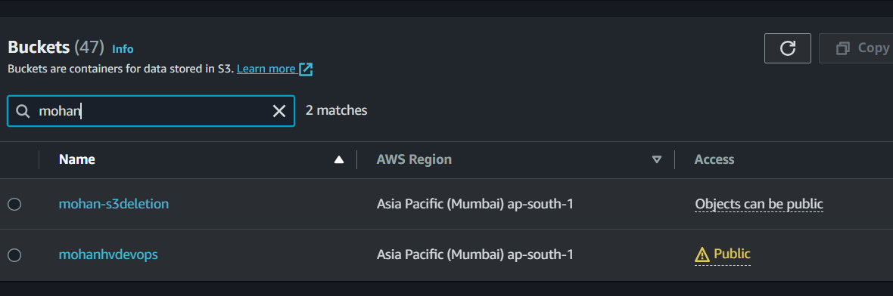

Upload multiple objects to this bucket, ensuring that some les are older than 30 days (you may need to adjust your system's date temporarily for this or use old less).

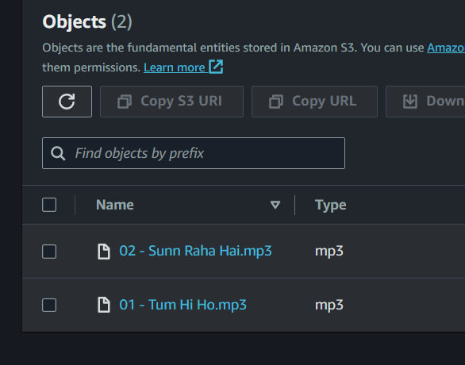

1. Lambda IAM Role: -

In the IAM dashboard, create a new role for Lambda.

Attach the `AmazonS3FullAccess ` policy to this role.

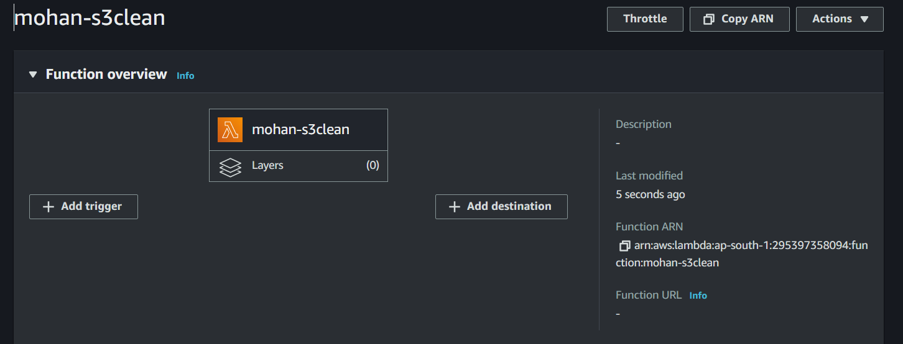

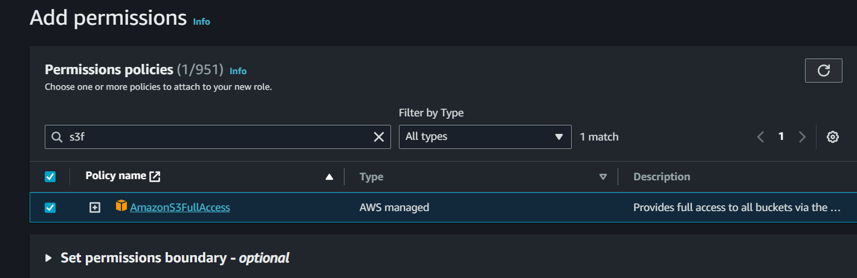

1. Lambda Function: -

Navigate to the Lambda dashboard and create a new function. –

Choose Python 3.x as the runtime. –

Assign the IAM role created in the previous step. –

Write the Boto3 Python script to:

1. Initialize a boto3 S3 client.

2. List objects in the specied bucket.

3.Delete objects older than 30 days.

1. Print the names of deleted objects for logging purposes.

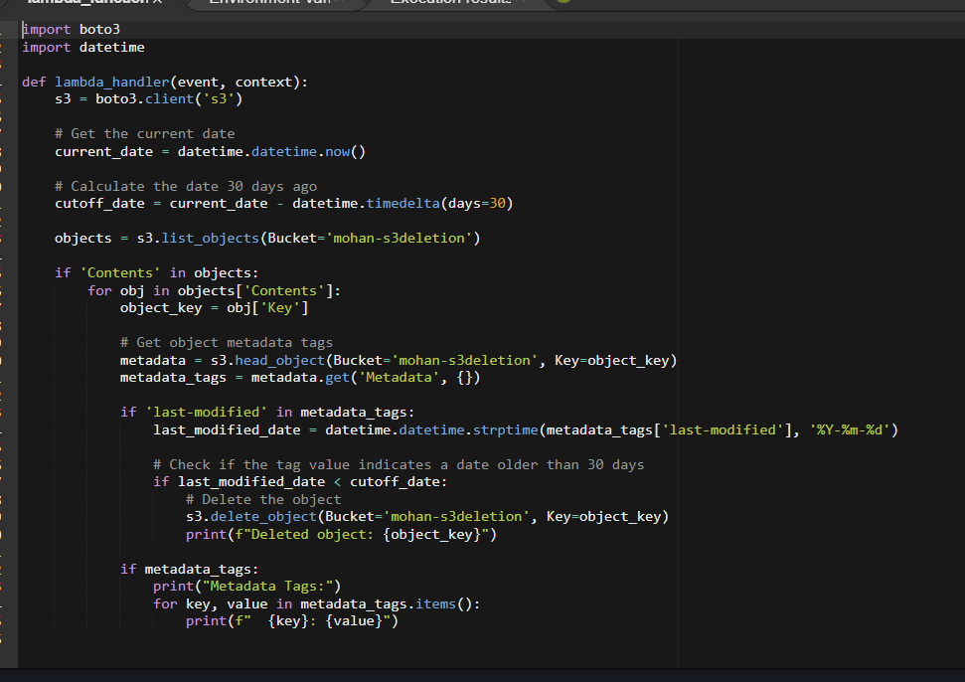



4.Manual Invocation: -

After saving your function, manually trigger it. - Go to the S3 dashboard and confirm that only less newer than 30 days remain.

