Traffic Simulating System

Vision

Version 2.0

Revision History
Date | Version | Description | Author
16/Sep/2008 | 1.0 | Draft of vision. | Mohan Yang, etc.
05/Oct/2008 | 1.1 | Refine system context diagram. | Mohan Yang
04/Jan/2009 | 2.0 | Final vision. | Sangxia Huang

Table of Contents

Introduction 4
Purpose 4
References 4
Positioning 4
Problem Statement 4
Product Position Statement 4
Stakeholder and User Descriptions 4
Stakeholder Summary 4
User Summary 4
User Environment 5
Summary of Key Stakeholder or User Needs 5
Product Overview 5
Product Perspective 5
Assumptions and Dependencies 6
Product Features 6
Traffic simulation 6
Road design 6
Vehicle customization 6
Traffic light customization 6
Traffic jam and accident handling 6
Cross platform 6
Other Product Requirements 6
System Requirements 6
Performance Requirements 7

Vision (Traffic Simulation System)

Introduction

Purpose
Our target system provides a simulation tool for the city planner to simulate the traffic condition after some road designs have been implemented.

References
Applying UML and Patterns: An Introduction to Object-Oriented Analysis and Design and Iterative Development, Third Edition.

Positioning

Problem Statement
The problem of | The seriousness of crowded traffic and the unpredictability of the effectiveness of road design.
the impact of which is | Serious traffic jam remains after lots of roads being built.
a successful solution would | Help city planners understand their design thoroughly, and help them make the most effective decision which will lead to less traffic jam and traffic accident.

Product Position Statement
For | City planner
Who | Design the city traffic system
Traffic simulating system | is a tool
That | Enable road design simulating and help city planner make decision
Our product | Provides a simulation tool for the city planner to simulate the traffic condition after some road designs have been implemented.

Stakeholder and User Descriptions

Stakeholder Summary
Name | Description | Responsibilities
Ruonan Rao | Instructor | Give design suggestions
City Planner | System users | Describe system requirements.  Use the system.

User Summary
Name | Description | Responsibilities | Stakeholder
City Planner | Use the system to help simulate the traffic conditions and make road-design decisions. | Describe system requirements.  Use the system. | self-represented

User Environment
The user should have a computer with Java Virtual Machine installed. The computer should have a monitor and a mouse. At least 256MB memory and 30MB hard disk space should be available for the running of the system.

Summary of Key Stakeholder or User Needs
Need | Priority | Concerns | Current Solution | Proposed Solutions
A simulating system | High | The seriousness of crowded traffic and the unpredictability of the effectiveness of road design. | N/A |  | Our system
Cross platform support | Medium | N/A | N/A |  | Java implementation
Extensibility | Medium | Future schedule algorithm | N/A |  | A common interface
User-friendly interface | Low | Easy to handle | N/A |  | Graphic engine

Product Overview

Product Perspective
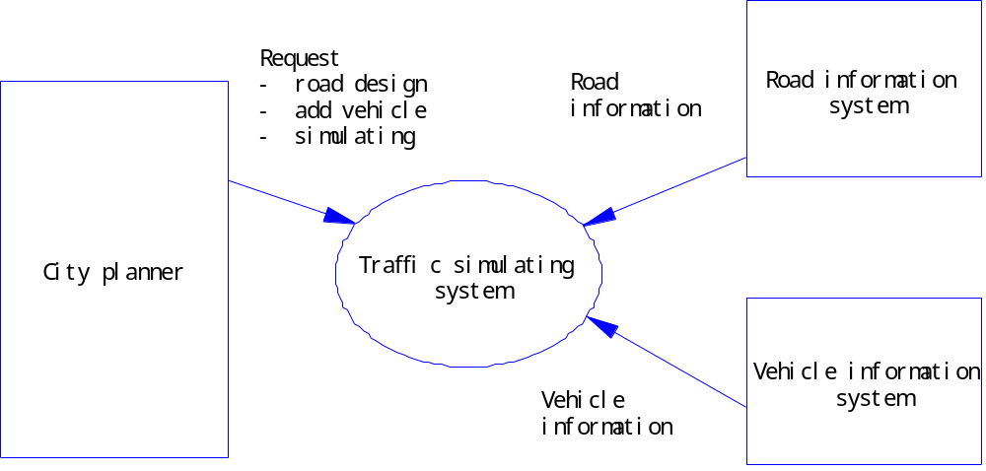
Figure 4.1.1 Traffic Simulating System Context Diagram
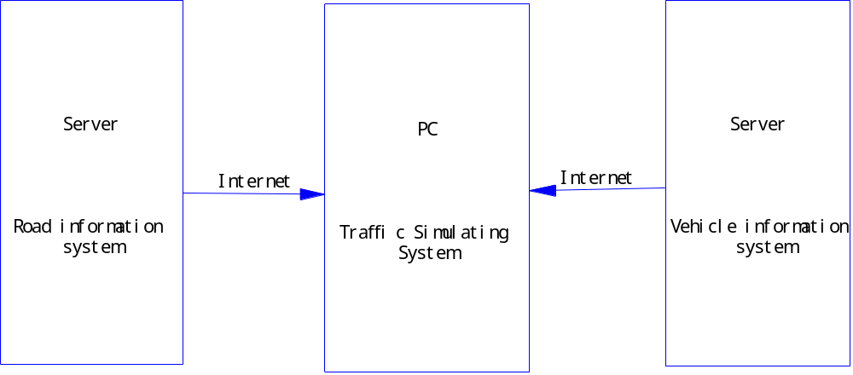
Figure 4.1.2 Traffic Simulating System Overview

Assumptions and Dependencies
The following assumptions and dependencies relate to the capabilities of the Traffic Simulating System as outlined in this Vision Document:
- The existing road information system which will provide road map information.
- The existing vehicle information system which will provide vehicle information.

Product Features

Traffic simulation
Simulate real-time traffic conditions under a given circumstances, and visualize the traffic situations.

Traffic Statistics
The system would be able to calculate the traffic statistics, such as the load of the roads, through the simulation result. User would be able to plug in their own statistics, according to some common interfaces of the system.

Road Information Loading
User can load the road information, e.g., the map of local zone, into our system. The system would be able to handle different data types by providing a common interface for road information description.

Vehicle customization
User can add different kind of vehicles and can customize the behavior of vehicles by choosing different algorithms.

Traffic light customization
User can modify the time slot of light shifting and system will ensure the consistency of light signals.

Traffic jam and accident handling
System will automatically handle traffic jam and accident by some specified mechanism.

System Performance Logging
System would automatically log running and debugging informations via the logger user provided. User could choose to log the information in some external file, via net, etc.

Cross platform
The system can run on different systems.

Other Product Requirements

System Requirements
- A monitor
- A mouse
- 256MB available memory or more
- 30MB free hard disk or more
- Java Virtual Machine 1.6 compatible

Performance Requirements
The system shall support up to 200 simultaneous vehicles on the map.

