

Experiential Learning Assignment
Phase - 2

for the subject

Applied Machine Learning & Deep Learning

on the topic

Predicting Crime Against Women in Indian States Using Machine Learning

by

Name | ID
Sambit Mohapatra | 2024bc26253

Introduction

Crime against women continues to be a major concern in India and has a significant impact on the society. Every year, the National Crime Records Bureau (NCRB) publishes crime statistics that help understand how crime patterns are changing across different States and Union Territories. While these reports provide valuable information about past incidents, it would be even more useful if the available data could be used to anticipate future trends.

The objective of this project is to predict future crime counts against women for Indian States and Union Territories using historical NCRB crime data. The project is a continuation of Phase – 1 assignment which covered the Initial Data Assessment, Methodologies, and Business KPIs around the topic. The problem is treated as a regression task because the target variable is a numerical crime count. The previous three years of crime counts are used as input features to predict the following year's crime count.
Dataset and Data Preparation

The project uses cleaned State/UT-wise NCRB datasets covering consecutive three-year periods. The notebook currently loads seven cleaned CSV files covering the periods 2015–2017 through 2021–2023. Each file contains 36 State/UT records. Overlapping years were checked before constructing one consolidated historical dataset.
A rolling-window approach was then used. For each State/UT, three consecutive annual crime counts form Input_1, Input_2 and Input_3, while the following year's count becomes the Target. This produces 216 historical examples: 36 examples for each target year from 2018 to 2023.
The data was split chronologically rather than randomly. Target years 2018–2021 provide 144 training examples, while target years 2022–2023 provide 72 testing examples. This keeps the later years as unseen test observations and is appropriate for the forecasting objective.
Models and Model-Selection Rationale

Linear Regression was used as the baseline because it is simple and interpretable and provides a reference for judging whether more complex models improve prediction.
Polynomial Regression was evaluated because crime trends may not follow a purely linear relationship. A degree-2 polynomial model was initially tested to capture possible curvature without introducing excessive complexity.
Random Forest Regression was included as an ensemble alternative capable of modelling non-linear relationships. Gradient Boosting was also evaluated as a sequential boosting approach that attempts to improve predictions by learning from previous errors.
Model Evaluation Results

The following values are taken from the executed notebook's test-set outputs. Lower MAE, MSE and RMSE indicate lower prediction error, while higher R² indicates better explanatory performance.
Model | MAE | MSE | RMSE | R²
Linear Regression | 1585.99 | 9,360,031.26 | 3059.42 | 0.96
Polynomial Regression (Degree 2) | 1389.36 | 8,909,636.12 | 2984.90 | 0.96
Tuned Polynomial Regression | 1585.99 | 9,360,031.26 | 3059.42 | 0.96
Random Forest Regression | 1844.21 | 14,421,371.22 | 3797.55 | 0.94
Gradient Boosting | 1769.51 | 14,446,547.81 | 3800.86 | 0.94

On the reported test-set results, the degree-2 Polynomial Regression has the lowest RMSE (2984.90) and the highest R² (0.9645), and it also has the lowest MAE (1389.36). Random Forest and Gradient Boosting perform worse than the linear and polynomial models on this test set.
Hyperparameter Tuning

Grid Search was used to tune Polynomial Regression degree over degrees 1 to 4. The cross-validation results were:
Polynomial Degree | Mean CV RMSE | Std. Dev.
1 | 2321.91 | 1143.39
2 | 3534.93 | 2597.80
3 | 19605.05 | 28934.92
4 | 93155.43 | 113626.44

The Grid Search selected degree 1 with a cross-validation RMSE of 2321.91. The notebook therefore shows an important distinction between cross-validation selection and the single held-out test result: degree 2 performs better on the reported test set, while degree 1 is selected by the tuning procedure.
Random Forest Grid Search selected max_depth=5, min_samples_split=5 and n_estimators=100, with a best cross-validation RMSE of 3094.19.

K-Fold Cross-Validation

A separate 5-Fold Cross-Validation evaluation was performed for the degree-2 polynomial pipeline. The fold RMSE values were:
Fold | RMSE
1 | 1596.03
2 | 8983.87
3 | 2629.36
4 | 8430.30
5 | 4348.17
Mean | 5197.54

The mean RMSE is 5197.54 with a standard deviation of 3002.49. The large variation between folds indicates that model performance is not equally stable across all folds. This is an important limitation when interpreting the model's generalisation performance.
Feature Analysis

The F-test based feature analysis ranks the three historical inputs as follows: Input_3 has the highest F-score (4589.66), followed by Input_2 (3939.70) and Input_1 (2497.38). All three reported p-values are extremely small, indicating a strong statistical association with the target within the analysed training data.
Figure 1. Actual versus predicted values for the degree-2 Polynomial Regression.
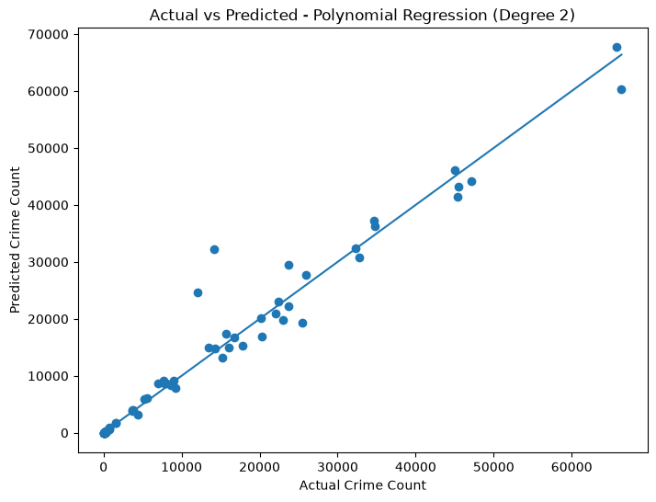
Figure 2. Test-set RMSE comparison across the evaluated models.
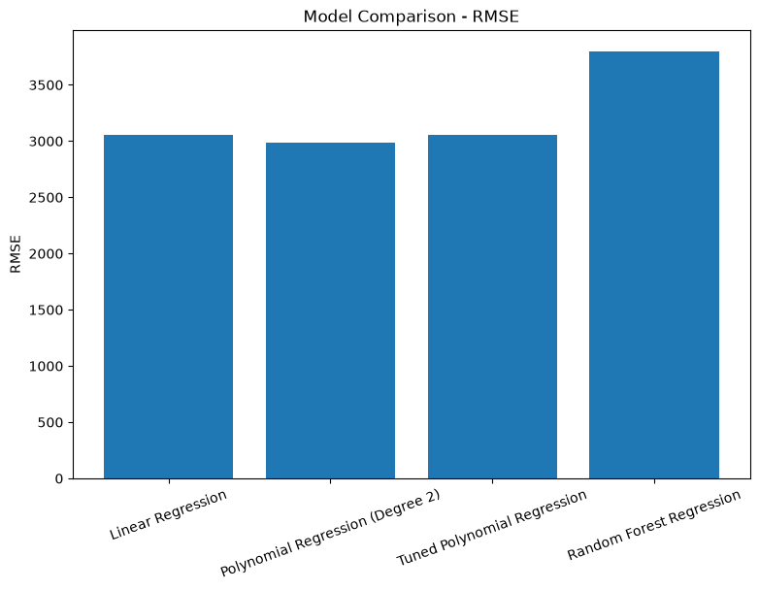
Figure 3. RMSE across the five cross-validation folds.
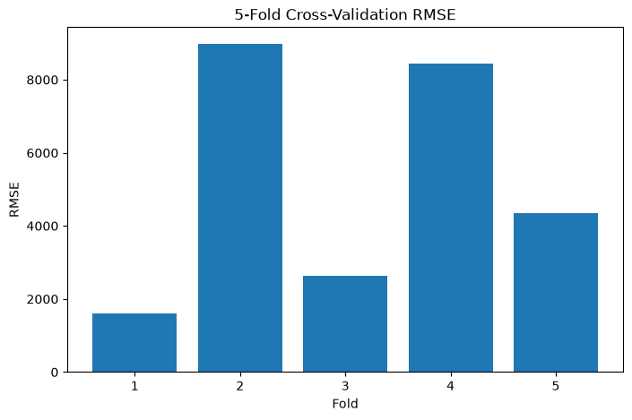
Prediction - 2024

The notebook prepares 2024 inputs using the 2021, 2022 and 2023 crime counts for each State/UT. The current final prediction code trains a degree-2 polynomial model on all 216 historical examples and generates predictions for 2024. The predictions are saved to the specified output CSV file.
State/UT | Predicted 2024
Andhra Pradesh | 24,624.27
Arunachal Pradesh | 350.55
Assam | 35,823.49
Bihar | 22,519.85
Chhattisgarh | 8,744.65
Goa | 261.70
Gujarat | 8,343.51
Haryana | 17,514.46
Himachal Pradesh | 1,728.94
Jammu & Kashmir | 4,136.22

The notebook contains predictions for all 36 State/UT records; the table above shows the first ten displayed prediction results.

Business Interpretation

The model outputs can be used as decision-support information for identifying regions with comparatively high predicted crime counts and for supporting resource allocation. They may also help policy makers focus attention on regions showing changing historical patterns. The predictions should not be interpreted as certainty about future crime or as a measure of how safe or unsafe a State/UT is.

Sl. No. | KPI | Important Points
1 | Improved Resource Allocation | - The model can provide an estimate of the expected crime count for each State/UT based on its recent historical pattern.  - The test results show that the degree-2 Polynomial Regression achieved an RMSE of 2,984.90 and an R² of 0.9645, indicating that the model was able to capture a substantial part of the variation in the target values.  - Such predictions can be used as an additional input while planning the allocation of personnel, funding and other resources across regions.

2 | Better Policy Planning | - The analysis shows that recent crime counts have a strong relationship with the following year's count.  - In the feature analysis, Year_3 had the highest F-score (4,589.66), followed by Year_2 (3,939.70) and Year_1 (2,497.38), with very small p-values for all three features.  - This indicates that recent historical crime levels provide useful information for estimating the next year's count.  - Such information can support policy makers in identifying changing patterns and planning targeted interventions.
3 | Early Identification of High-Risk Regions | - The final model was used to generate 2024 crime-count predictions for all 36 States/UTs using their 2021–2023 counts.  - For example, the predicted 2024 counts include 24,624.27 for Andhra Pradesh, 35,823.49 for Assam, 22,519.85 for Bihar and 17,514.46 for Haryana.  - These predictions can help authorities identify regions with comparatively higher expected crime counts and give them greater attention while planning preventive measures.

Because the dataset contains reported crime counts, differences in reporting practices and under-reporting can affect the observed values. Therefore, model predictions should be considered alongside other administrative and social indicators.

Conclusion

The Phase 2 implementation developed a complete regression workflow using historical NCRB crime data. A rolling three-year feature structure produced 216 examples, which were split chronologically into 144 training and 72 testing examples. Linear Regression, Polynomial Regression, Random Forest and Gradient Boosting were evaluated using regression metrics, followed by hyperparameter tuning and 5-Fold Cross-Validation.

The reported test-set comparison favors degree-2 Polynomial Regression, with RMSE 2984.90 and R² 0.9645. However, the tuning procedure selected degree 1, and the separate 5-Fold evaluation of the degree-2 model produced a mean RMSE of 5197.54 with substantial variation between folds. Therefore, the model-selection evidence should be interpreted carefully rather than relying on the single best test-set score.

Github Link

