Which claim lines should a reviewer check first?
Predicting Medicare claim denial risk and turning it into a review worklist
Mo Hassanpour | October 2026 | github.com/mohassan99/claims-denial-risk-prediction
Where to look. Readers want different things, so here is a shortcut to each.
If you are | Start here
A health plan or claims manager | In brief | 4. The review rule | Table 3, what a short list earns | 7. Using this at a plan
A data scientist or ML interviewer | 2. How well it ranks | 3. SHAP | 5. The agent | Appendix B, measures defined
An IT or engineering manager | 6. Azure and Databricks | Monitoring, in section 7 | Appendix C, where the code is
Checking assumptions or sources | Appendix C, assumptions and sources

In brief
A health plan pays millions of claim lines a year and has a small team to review them. (A claim line is one billed service on a claim.) This project answers a practical question: which lines should that team look at first, and is looking worth their time?
What I built
- A risk score. A machine learning model gives every claim line a chance, from 0 to 100%, that it should be denied.
- A review rule. The score is combined with the line's dollars to decide whether a review would pay for itself, and to sort lines into a worklist.
- A running service. The model runs in the cloud on Azure and the data pipeline runs on Databricks. Both were checked against the original and gave the same answers.
- An agent. An agent (an AI assistant that chooses which tools to use) tells a reviewer why a line scored high. It was tested to state only facts it can trace to the system's own outputs.
What I found, on 15 months of claims the model had never seen:
- A short list holds most of the money. Sorted by expected dollars, the top 1% of lines covers 80% of the money at stake. Reviewing those 3,600 lines earns 84% of the savings that reviewing all 85,665 worthwhile lines would earn, for 4% of the reviewer hours.
- Dollars should set the order, not the score alone. Judging each line by its own dollars beat every “review anything above X%” rule, by $1.4 to $2.9 million.
- The scores can be believed. When the model says 20%, about 20 in 100 such lines are denied; the term is calibrated. For the 94% of lines scored below 30%, the predicted chance and the share actually denied differ by one percentage point or less.
The limit to keep in mind. Public Medicare data does not say which claims were denied, so I built the denial outcome from six documented payment rules, and the dollar amounts come from synthetic claims. The results show that the method works and how carefully it was tested. They are not a forecast of what a real plan would save.
How to read this report. Each section starts in plain language. Blue boxes add the technical method, and green boxes say what the result means for a health plan. Either kind of box can be skipped without losing the thread. Terms are defined in the table below and in Appendix B.

1. The problem and the data
When a plan pays a claim line it should have denied, it has to chase the money afterward and usually gets only part of it back. Catching the problem takes a trained examiner's time, and there are far more claim lines than examiner hours. The team needs to know where its hours do the most good.
The data is the CMS Synthetic Medicare Claims file. It has the structure of real Medicare claims (procedure codes, diagnosis codes, providers and payment amounts) and no real patients. It holds 1.8 million claim lines from 2015 to 2023, of three kinds:
- Carrier claims come from doctors and other clinicians, plus labs and ambulance services.
- Outpatient claims come from facilities, such as hospital outpatient departments, dialysis centers and clinics, for patients who were not admitted.
- DME claims are for durable medical equipment, such as wheelchairs and CPAP machines.
One thing is missing from public data: which lines were denied. Payers do not publish that. So I built the outcome from six documented reasons a line gets denied: the procedure code is missing; the line uses a consultation code (a billing code for a specialist's opinion given at another doctor's request) that Medicare stopped paying for in 2010, though the data still contains such lines; it duplicates a line already billed; a required prior authorization is absent; the diagnosis does not support the procedure; or the provider bills far above its peers. Each reason raises a line's chance of denial, some by a little and one by a lot, and chance decides the rest, as it does in real claim decisions. About 15% of lines end up denied.
Term | What it means in this report
Claim line | One billed service on a claim. The model scores lines, not whole claims.
Denial | A line that the six documented rules say should not be paid.
Consultation code | A billing code for a specialist's opinion given at another doctor's request, such as 99241. Medicare stopped paying for these in 2010.
Score | The model's predicted chance, 0 to 100%, that a line is a denial.
Calibrated | A model is calibrated when its percentages are accurate: of the lines it scores at 30%, about 30 in 100 are denied.
Review | An examiner checking one line. Assumed to take 20 minutes and cost $16.25.
Miss | A denial that is not reviewed (a false negative). The wrong payment goes out and only part is recovered.
False alarm | A review of a line that turns out not to be a denial (a false positive). The review time is wasted.
Recovery rate | The share of a wrongly paid amount the plan later gets back.
Agent | An AI assistant that decides for itself which of its tools to use.
Test set | The newest 15 months of claims, held back and scored once at the end.

Technical detail. The label is a noisy-OR of six risk factors with assumed probabilities, followed by a random draw per line with a fixed seed, so it can be rebuilt exactly. An earlier version denied every line that matched a rule; the model then simply re-learned the rules and scored almost perfectly, a sign of leakage, so the label was made probabilistic. The overall denial rate is 14.9%.
Lines are split by service date so the model is always judged on the future: training January 2015 to October 2020 (1,151,951 lines), validation to November 2021 (287,988), test to March 2023 (359,985). Every choice, including the review rule, was made on validation and written to a file before the test set was touched. The test set was then scored exactly once. The scoring script is built to stop if its results file already exists, so the test score cannot be re-run and adjusted after the fact.
For a health plan. These six reasons are ones a claims team will recognize, and most map to a standard claim adjustment reason code, such as CARC 18 for a duplicate or CARC 197 for a missing prior authorization. A plan would replace my built outcome with its own denial or audit history; the rest of the pipeline stays the same.

2. How well does the model find denials?
The model reads the fields on each line (procedure code, diagnosis, place of service, provider and amounts) and returns a chance of denial. Two questions decide whether it is useful: does it put the right lines at the top, and can its percentages be believed?
It puts the right lines at the top. Pick test lines at random and 14 in 100 are denials. Take the 1% of lines the model scores highest and 95 in 100 are. Table 1 shows how much better than random the ranking is for each claim type.
Claim type | Lines in test | Share denied | Times better than random | PR-AUC | ROC-AUC
All claim types | 359,985 | 14.2% | 4.0 | 0.570 | 0.813
Carrier | 219,887 | 9.9% | 1.9 | 0.189 | 0.713
Outpatient | 120,547 | 21.5% | 3.8 | 0.807 | 0.898
DME | 19,551 | 16.2% | 1.6 | 0.259 | 0.710
Table 1. Ranking quality on the test set, scored once. “Times better than random” is PR-AUC divided by the share denied. PR-AUC and ROC-AUC are defined in Appendix B.
Its percentages can be believed. When the model says 20%, about 20 in 100 such lines are denied. The left panel of Figure 1 plots what the model predicted against what happened; a perfect model follows the dashed line. The right panel shows where the lines sit: 94% are scored below 30%, and there the two differ by one point or less.
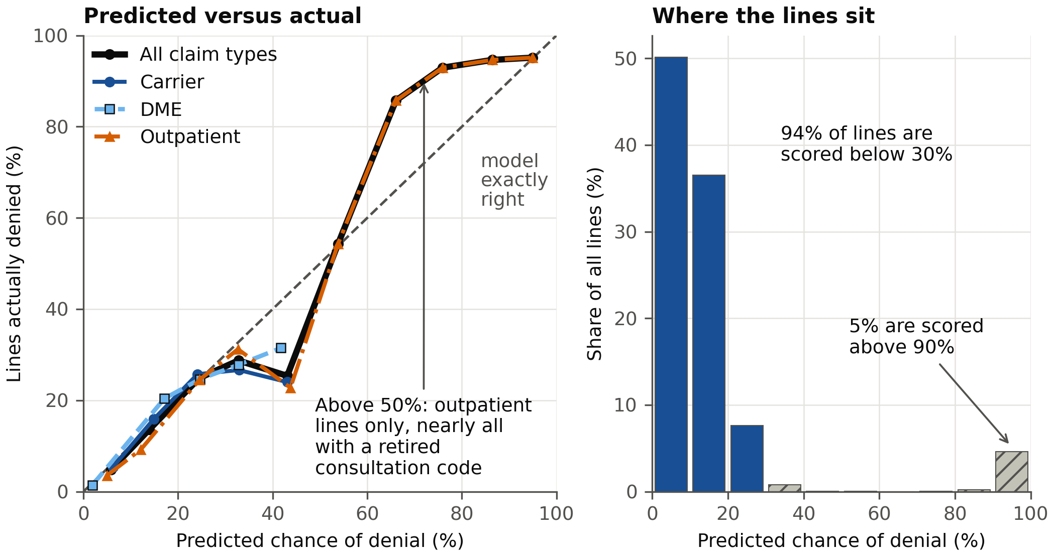
Figure 1. Predicted chance of denial compared with the share actually denied, test set (359,985 lines). Left: each marker is a group of lines with similar scores; the claim types are told apart by line style and marker shape as well as color. Right: how many lines fall in each score range; hatched bars are the ranges above 30%.
One easy pattern carries much of the result, and I report that plainly. Every line scored above 50% is an outpatient line, and nearly all of them carry the retired consultation code. Those lines are denied about 95% of the time, and the model learned that. Away from that one pattern the model is 1.6 to 2.3 times better than random: useful for ordering a worklist, and modest. It also explains why outpatient results dipped between validation and test: lines with that code became rarer, falling from 24.9% to 14.5% of outpatient lines, while results on every other outpatient line held steady.
Technical detail. The model is XGBoost (gradient-boosted decision trees: many small decision trees added one at a time, each correcting the errors of those before it; 73 trees chosen by early stopping on validation, 159 features, categorical fields handled natively). The baseline is a logistic regression whose claim-type interactions were chosen with a Chow test, a test of whether one set of coefficients can serve all three claim types; it said no. On validation XGBoost scored PR-AUC 0.691 against the baseline's 0.671, with the largest gain on carrier claims (0.191 against 0.141).
Calibration error (ECE) is 0.007 overall and at most 0.018 for any claim type; ECE, the Brier score and PR-AUC are defined in Appendix B. Before scoring test I fixed a rule in advance: recalibrate a claim type with isotonic regression only if it cut the Brier score on held-out validation data by more than 1%. The gains were 0.37% (carrier), 0.23% (outpatient) and -0.11% (DME), so the raw scores are used. On outpatient lines without the consultation code, PR-AUC was 0.200 in validation and 0.206 in test.
For a health plan. A score that behaves like a true percentage can be multiplied by dollars, which is what section 4 does. One caution: the model leans heavily on the procedure code, so it would need retraining when codes or payment policies change.

3. SHAP: What drives the score?
A score is easier to trust when you can see what is behind it. For each line, a method called SHAP splits that line's score into pieces, one per field, showing how far each field pushed the score up or down. Averaging those pushes over 20,000 lines shows which fields matter most overall.
One field dominates: the procedure code. Its average influence is 0.87, more than five times that of the next field, place of service (0.15). That matches how the outcome was built, because most of the six reasons depend on the procedure code. Provider identifiers follow with small contributions. The numbers are in log-odds, the scale the model works in internally; a longer bar means a bigger push, and the comparison between bars is what matters.
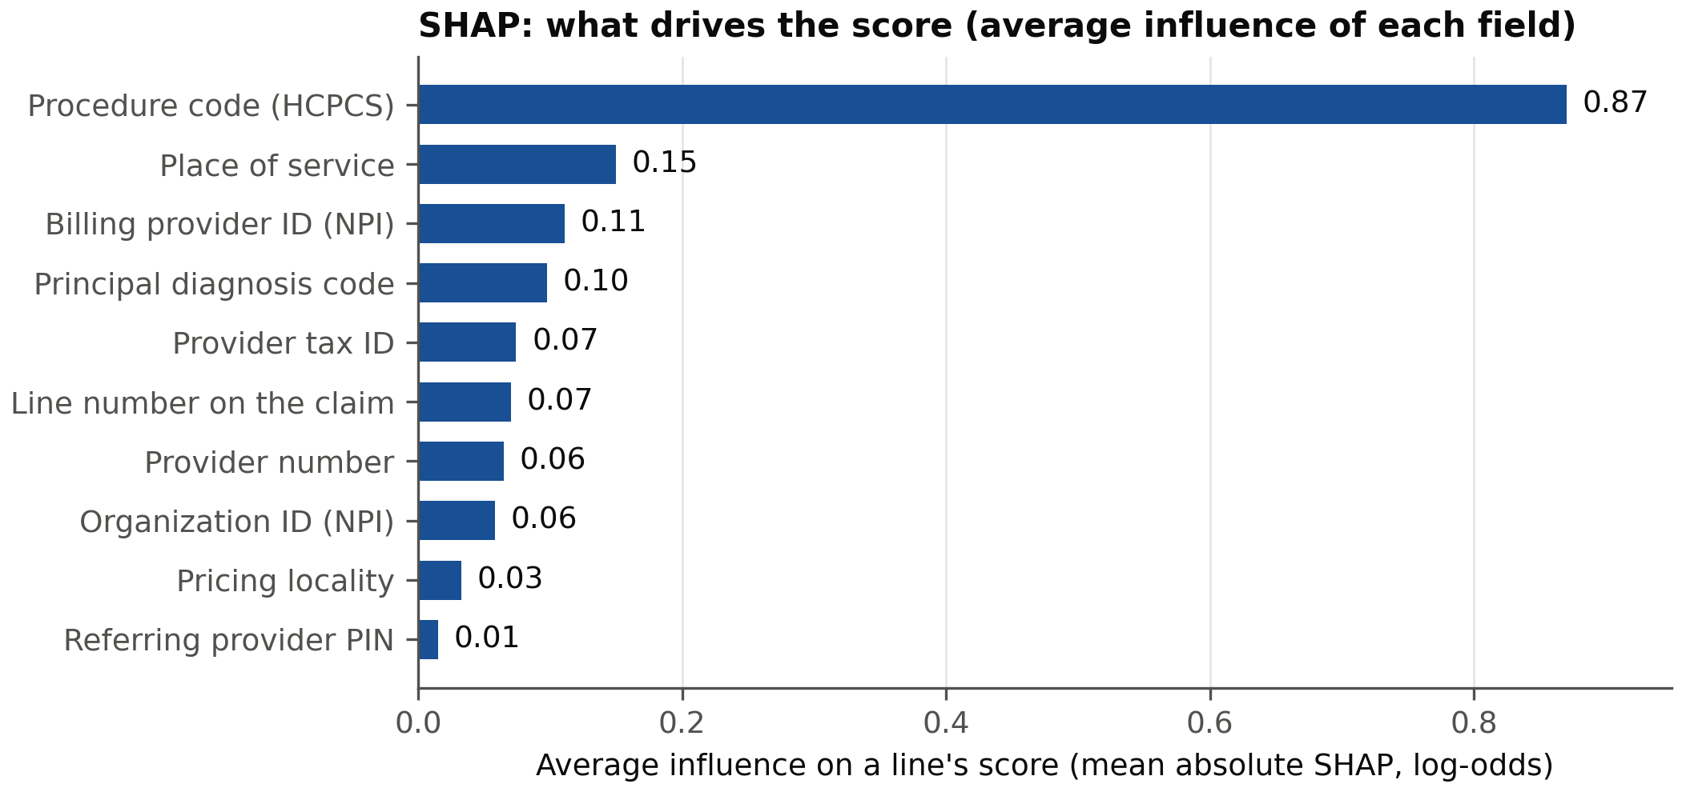
Figure 2. SHAP: what drives the score. The ten fields with the largest average influence on a line's score, from a 20,000-line sample of the validation data. Field names are plain-language versions of the Medicare data fields.
Technical detail. SHAP values come from the tree explainer on the saved model. They add up to the model's score exactly (reconstruction error about 5 millionths). I report SHAP and not the model's own gain-based importance, because they can disagree: one dollar field ranks second by gain but falls outside the SHAP top 20, since it wins a few very effective splits without moving most predictions.
Provider identifiers can let a model memorize small providers instead of learning a general pattern. To check, I compared how much influence each category carries against how many training claims it has; rare providers carrying more weight is the sign of memorizing. Only the provider tax ID shows it (correlation -0.15), and its influence is small (0.07).
For a health plan. This chart is a quick audit. The model responds mostly to procedure codes, which a plan's coders already know drive denials. If a model ever leaned heavily on something like a provider identifier, this is where it would show.

4. From a score to a decision
A high score alone does not justify a review. What matters is the score times the money. Table 2 shows two lines. The first is unlikely to be a denial and is still worth reviewing, because it is large. The second is far more likely to be a denial and is not worth reviewing, because the most a review could save is less than the review costs.
Line payment | Chance of denial | Lost if it is missed | Expected loss | Cost of a review | Decision
$2,000 | 3% | $1,580 | $47.40 | $16.25 | Review
$20 | 40% | $15.80 | $6.32 | $16.25 | Don't review
Table 2. The rule on two example lines. Expected loss is the chance of denial times the amount lost if the line is missed. “Don't review” means the line is paid as billed.
The rule: review a line when its chance of denial, times the dollars lost if it is missed, is more than the cost of one review. “Lost if it is missed” is less than the full payment because the plan recovers part of a wrong payment later. For the $2,000 line, recovering 24% brings back $480 at a collection cost of $60, so the plan is out $1,580. For the $20 line the answer is don't review: the line is paid as billed, and if it is a denial the plan accepts a small loss.
Any rule makes two kinds of mistake. A miss (a false negative) is a denial that is not reviewed, so the wrong payment goes out and only part comes back. A false alarm (a false positive) is a review of a line that turns out to be fine, and the examiner's time is wasted. The rule weighs one against the other, line by line: a large line justifies many false alarms, because a miss on it is expensive.
The rule needs three numbers. All three are assumptions, taken from public sources and stated here so they can be challenged (Appendix C lists each source):
- A review costs $16.25: 20 minutes of a claims examiner's time at the national median wage of $37.51 an hour (Bureau of Labor Statistics), plus 30% for benefits. The 20 minutes is my own assumption.
- The plan recovers 24% or 55% of a wrong payment. A federal audit found that Medicare reported recovering 55% of identified overpayments and that 24% could be verified. Every result is reported both ways.
- Recovering money costs 12.5% of what is recovered, the top of the fee range paid to Medicare's recovery contractors.
With no limit on reviewers, the rule flags 85,665 test lines, about one in four, and nets $29.6 million compared with reviewing nothing (at 24% recovery; $19.0 million at 55%). That is 95% of what a reviewer who knew every outcome in advance would net. The dollars are synthetic.
What precision and recall say about it. Of the 85,665 lines the rule flags, 26% are denials (its precision), and they include 44% of all denials (its recall). Many flags are false alarms, and more than half of denials are not flagged. That is by design: 44% of denials sit on lines too small to repay a review, so even the reviewer who knew every outcome would skip them. Reviewing every line would catch every denial (recall 100%) with a precision of 14%. Both measures are defined in Appendix B.
It beats the usual approach. The common alternative is one cutoff for every line, such as “review anything scored above 30%”. Figure 3 tries every cutoff. The solid curves are the savings from a single cutoff, and each dot marks the best one, which could only be found with hindsight. The dotted lines are the savings from the rule. The rule is higher in every case, by $1.4 to $2.9 million, because a single cutoff sends reviewers to small lines that cannot repay the review and skips large lines with modest scores.
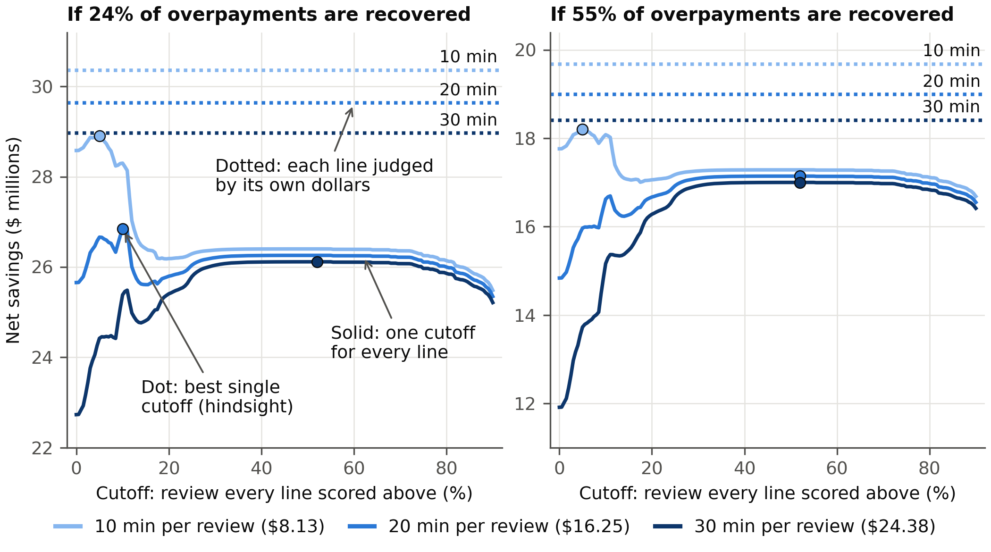
Figure 3. Net savings compared with reviewing nothing, test set. Line shade is the assumed review time (lighter is faster, darker is slower), and each dotted line is labelled. The vertical axis does not start at zero.
With a limit on reviewers, which is the real situation, the team works down a sorted list until its hours run out. The order matters. Figure 4 compares two. Sorting by score finds the most denials. Sorting by expected dollars (chance times loss, minus the review cost) finds the most money: its top 1% of lines covers 80% of the money at stake, where the top 1% by score covers 22%.
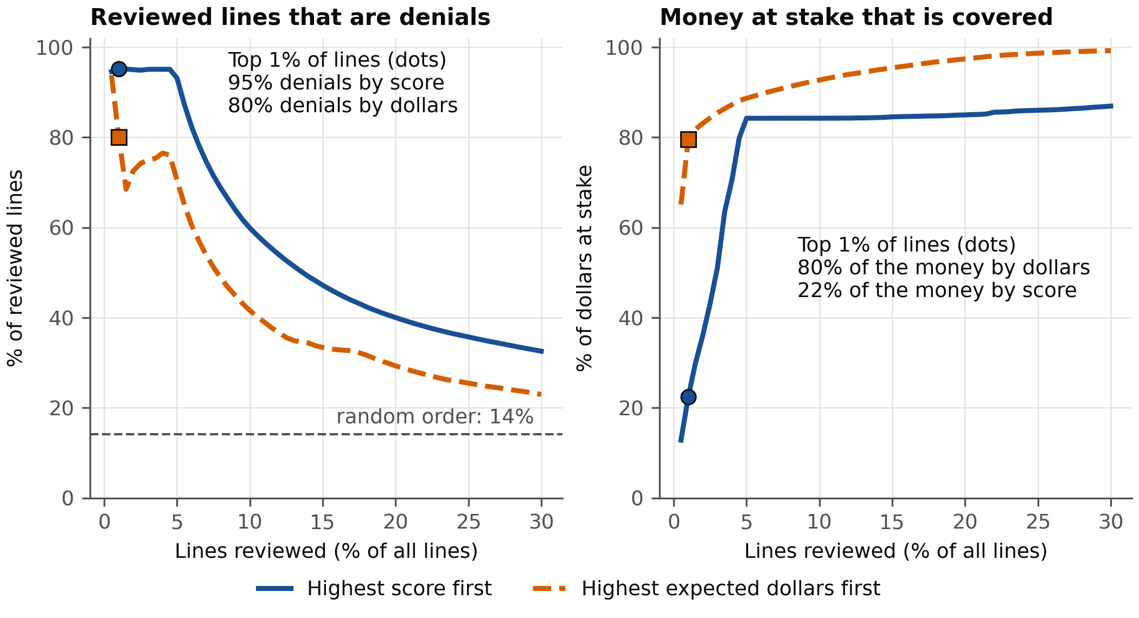
Figure 4. Two ways to order the worklist, test set, at 24% recovery. Solid line with circles: highest score first. Dashed line with squares: highest expected dollars first. Left: of the lines reviewed, the share that are denials. Right: the share of all money at stake that the reviewed lines cover.
Lines reviewed, in dollar order | Lines | Reviewer hours | Net savings | Share of the full rule's savings
Top 1% | 3,600 | 1,200 | $25.0M | 84%
Top 2% | 7,200 | 2,400 | $26.1M | 88%
Top 5% | 17,999 | 6,000 | $27.7M | 93%
Every line the rule flags | 85,665 | 28,555 | $29.6M | 100%
Table 3. Most of the value comes from a short list (24% recovery; at 55% the top 1% earns 86%). Hours assume 20 minutes per line.
Technical detail. Let p be the model's chance of denial for a line, A the line's payment, ρ the share of a wrong payment the plan recovers, and c = 0.125 the cost of recovering, as a share of what is recovered. The cost of one review, r, is the examiner's hourly wage w ($37.51) times a benefits factor b (1.3) times the minutes m (20), divided by 60:
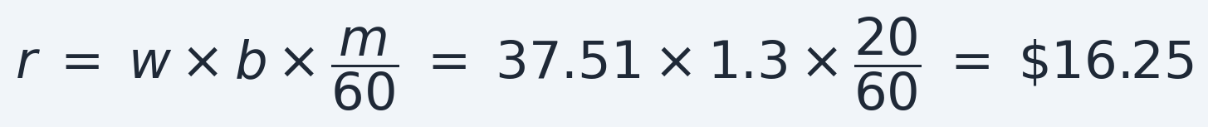
The dollars lost if a line is a denial and is missed, L, are the part never recovered plus the cost of recovering the rest:
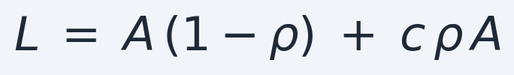
A review gains p × L on average and costs r, so the rule flags a line when its expected loss is larger than the cost, which is the same as using a different cutoff for each line:
This is the standard cost-optimal threshold, with a false alarm costing r and a miss costing L. It is valid only if the scores are calibrated, so that p really is the chance of denial. Under a staffing limit, rank lines by p × L − r and take the top k.
A sweep over 36 settings (review time 10, 20 or 30 minutes; benefits load 1.3 or 1.43; recovery cost 9%, 12.5% or 20%; recovery rate 24% or 55%) keeps net savings between $28.4M and $31.1M at 24% recovery and between $17.5M and $21.3M at 55%, always 92% to 97% of the perfect-knowledge figure. By claim type: reviewing every outpatient line would net $28.2M against the rule's $28.9M, so on outpatient the model's value is the order of the list; reviewing every carrier line would lose $2.2M, while the rule reviews 5.8% of them and nets $0.7M; synthetic DME payments are too small (median $0) to justify reviews.
For a health plan. The full list would take about 28,555 reviewer hours, roughly 11 full-time examiners over the 15 months (at 2,080 hours a year). The top 1% takes 1,200 hours, less than half of one examiner, and keeps 84% of the savings. The practical output is a ranked worklist a team can cut off wherever its staffing ends, with the expected dollars shown for each line.

5. Agent: explaining a score to a reviewer (project Phase 4)
A reviewer handed a flagged line will ask why it was flagged. I built an agent (an AI assistant that decides for itself which tools to use), based on the Claude AI model, that answers that question for one claim at a time. It cannot look anything up on its own. It can only call four tools: one returns the claim's score, one lists which fields pushed the score up or down, one looks up denial reason codes, and one searches Medicare policy documents. Its instruction is to state only what a tool returned. Asked which denial reason code best fits one claim, and how the score relates to it, the agent answered in part:
“CMS Transmittal 1875 says Medicare stopped recognizing consultation codes 99241-99245 and 99251-99255 for Part B payment from January 1, 2010. The claim bills 99241, so 181 fits best ... The model gives a denial probability of 0.9518. The validation average is 0.1805, so this is 5.27 times the average ... Nearly all of that comes from one feature ... The denial label is also synthetic, so the CARC here is illustrative and not a real payer decision.”
AI assistants are known to state things that sound right and are not. So I measured it. I wrote an automatic checker, the grader, that takes every number and code in an answer and looks for it in what the tools returned. I ran the agent on 30 claims at a time (10 of each claim type, half denied and half not) and recorded the share the grader could trace. The first version scored 97.5%: 9 of 364 could not be traced. The misses were the agent doing its own arithmetic and describing codes from memory; in an early trial it called a depression screening code a consultation. Two fixes brought it to 100%:
- Fix 1: the tools return every number ready-made, such as “5.27 times the average”, so the agent no longer calculates anything. This took it from 97.5% to 99.3%.
- Fix 2: new instructions forbid arithmetic, forbid describing a code unless a tool supplied the description, and forbid stating a policy fact unless a search returned it. This took it to 100%.
It stayed at 100% on 30 new claims. That is the fair test, because I adjusted the instructions after seeing the first 30.
An agent can also stay accurate by saying very little, so I measured how much it could explain. After I added definitions taken from CMS and other official sources, 99% of the data fields it showed came with a meaning, up from 38%, and 91% of code values did, up from none. The final check on the 30 new claims was still 100% traceable (516 of 516). Explaining one claim costs about two cents, paid to Anthropic, the company that makes Claude.
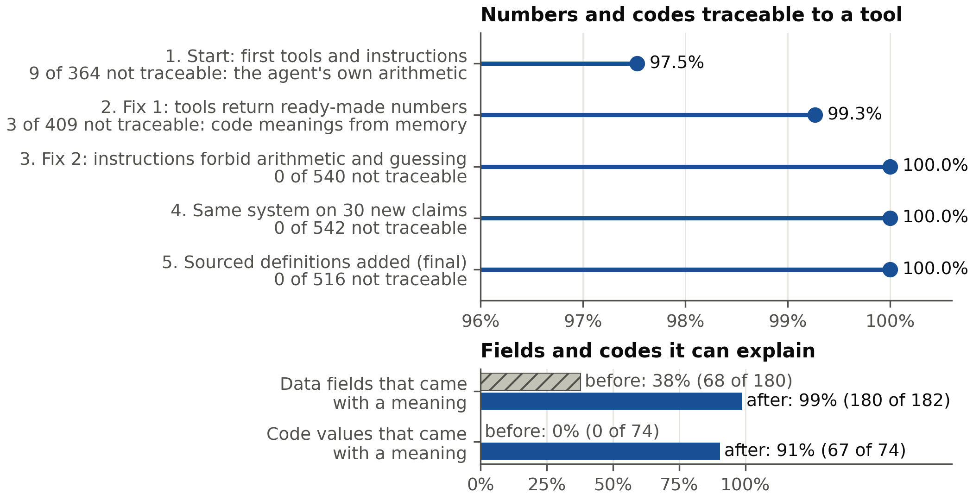
Figure 5. Top: share of the numbers and codes in the agent's answers that trace to a tool's output, at five stages (30 claims each; the axis starts at 96%). Stages 1 to 3 use one set of 30 claims; stages 4 and 5 use a second set of 30. Bottom: share of fields and codes that came with a sourced meaning, before (hatched) and after (solid) definitions were added.
Technical detail. The agent uses tool calling on the Anthropic API; the model decides which tools to call. The grader extracts every checkable item from an answer (numbers, procedure and diagnosis codes, reason codes, and descriptions given for a code) and looks for each in the tool outputs of that conversation. Claims were sampled 10 per claim type, half denied and half not, and the agent is never told the outcome. The instructions were revised after seeing the first 30 claims, so the 30 held-out claims are the fair test. Traceable does not mean correct or useful: one overstated policy claim was caught only by reading answers, and each claim was run once. The tools and grader have 17 automated tests; the design and every failure found are in docs/PHASE4.md.
For a health plan. An agent that states only what the system returned can be audited: every number in its answer can be checked against the record. It is honest about what it does not know, which matters more in a compliance setting than fluency.

6. Azure deployment: running it as a service (project Phases 3 and 3b)
A model that only runs on its builder's laptop is not much use, so I deployed it, and rebuilt the data pipeline on a platform built for large data.
- The model runs as a web service on Microsoft Azure (Azure Machine Learning, Microsoft's service for running models). A program sends a claim line and gets a score back; access needs a secret key. I sent 3,000 lines to the service and to the original model, and the scores agreed to within 0.0000005.
- The data pipeline runs on Databricks, a platform for processing large data. I rebuilt every step there, from the raw files to the model's input tables, and checked each table against the original. All matched.
- Every step of the Azure setup is scripted, so it can be repeated. One script, deploy/deploy.sh, does the following in order and skips any step already done:
- Log in to Azure with a limited account that can only touch this project's resources.
- Make sure the resource group exists (the folder that holds all the project's Azure items).
- Make sure the workspace exists (the Azure Machine Learning home for the project).
- Register the model: save a named, versioned copy of it in the workspace, unless that exact model is already saved.
- Create the endpoint if it is missing (the web address that receives requests).
- Create or update the deployment (the computer and software that actually run the model; building it takes 10 to 20 minutes) and send all requests to it.
- Test it with a sample request.
The same script can also stop the service, restore it in about 15 minutes, download the saved model, or remove the endpoint. The service costs about 15 cents an hour while it runs, so it is stopped when not in use. Passwords and keys are kept out of the code.
Term | What it means
Registered model, registry | A registry is a catalog of saved models. Registering the model stores its exact files under a name and version number, so the service and anyone later can fetch precisely that model.
Content hash | A short fingerprint computed from the model's files (here the first 16 characters of a SHA-256 hash: 11f409f72fc4c45e). Change one byte of a file and the fingerprint changes. It proves the model running in the cloud is exactly the one that was tested, and lets the script skip re-registering a model that is already saved.
Bronze, silver, gold | Three stages of the data pipeline. Bronze: the raw files loaded unchanged. Silver: cleaned and combined, with the denial outcome added. Gold: the final training, validation and test tables the model reads.
Delta table | The table format Databricks uses. It stores data as files plus a log of every change, so a write either completes in full or not at all, and earlier versions can be read back.
Unity Catalog | Databricks' catalog. It gives every table, file folder and model a three-part name (catalog.schema.name) and controls who can use each.
Databricks Job | A saved, repeatable run of the pipeline. Mine has five tasks that run in order: bronze and silver tables, the denial label, the gold tables, and a parity check.
Parity check | A comparison of every table the pipeline produces against the original version, value by value.
MLflow tracking and model registry | Tracking records each training run: its settings, scores and files. The model registry keeps trained models under version numbers (the Databricks model here is version 3).
Table 4. Terms used in this section.
Technical detail. Azure Machine Learning managed online endpoint (key authentication, one Standard_DS2_v2 instance, Canada Central region) with a deployment named blue; the model's content hash is stored as a tag on the registered model. The Databricks version uses PySpark (the Python interface to Spark, which spreads data work across many computers). The label's random draws are reproduced exactly on Spark, matched row by row to the original, so the model trained there is identical to the original. Databricks Free Edition was used because the Azure for Students subscription refused Azure Databricks. The Databricks guide is docs/DATABRICKS.md.

7. What it would take to use this at a real plan
The approach carries over as it stands: score every line, multiply by its dollars, subtract the cost of a review, and work down the list until the reviewers' time runs out. Every input is something a plan already has or can measure. Four things would change:
- Real outcomes. The model would be trained on the plan's own denials or audit findings, not on my built outcome.
- The plan's own costs, and calibrated scores. Its measured review cost and recovery rate would replace my assumptions. The scores would also be checked for calibration on its own claims before anyone multiplied them by dollars. Calibrated means that when the model says 30%, about 30 in 100 such lines really are denied. If the plan's claims differ from mine, the model could say 30% while 45 in 100 are denied, and every dollar figure built on those scores would be too low.
- Claims, not lines. Examiners usually review a whole claim, so the expected losses of a claim's lines would be added up and compared with the cost of one review.
- Timing. I treated a miss (a denial that is not reviewed, so the wrong payment goes out) as a wrong payment partly recovered later. If the review happens before payment, the cost of a miss is delay and rework, and the same rule applies with different dollar values.
How a plan would monitor it. This project does not include monitoring. If a plan ran the approach, the steps would be as follows. A denial is known only after the claim is adjudicated, which takes days to weeks, so monitoring would work in layers:
- Early warning, before outcomes are known (weekly). Compare the lines being scored with the training data: the share of each claim type, the share of lines with a retired consultation code, and the spread of scores. If any moves past a limit agreed in advance, the team is alerted. This study shows why. Between validation and test, the share of retired-code lines among outpatient lines fell from 24.9% to 14.5%, and the outpatient results moved with it, although the model was unchanged on all other lines. A mix alarm would have fired. The follow-up check, by group, would have shown that the model itself had not got worse.
- Confirmation, once outcomes arrive (monthly). Recompute the measures used here, PR-AUC and calibration, separately for each claim type and for lines with and without the retired code. This also catches what early warning cannot see: inputs that look the same while the plan's denial behavior has changed.
- Action, only with a person's approval. If calibration or ranking slips past preset limits, retrain on recent data, compare the new model with the current one on data held back from training, and switch only after a reviewer signs off. The current model stays available so the switch can be reversed.
Technical detail. On Azure this could use the endpoint's request logs sent to Azure Monitor and Application Insights; a scheduled job that computes a drift statistic on the scores and the key fields (for example the population stability index, where values under about 0.1 are commonly read as little change and over about 0.25 as a large one); an alert rule; and a second deployment beside the current one (for example green beside blue) on the same endpoint, so requests can be moved gradually and moved back. Limits and alert levels must be fixed before looking at the data, and the data used to compare an old and a new model must not be used to tune either. A label-free alarm can fire when the claim mix changes even though the model is fine, as in this study, so the alert should lead to the by-group check and not to automatic retraining.
Limits of this study.
- The outcome and the dollars are synthetic, so the savings show that the method works, not what a plan would save.
- The built outcome treats the six reasons as independent.
- Appeals, audit time limits and the effect of audits on provider relations are not modeled.
- The cost of a review (20 minutes) is my assumption, and the recovery figures come from public audits. Results held across 36 settings, but they remain assumptions.
- One provider field, the provider tax ID, shows a small sign that the model memorized individual providers. It is too small to change the results and would need watching.
- There is one test period, and the mix of claims shifted during it, which is a reminder that a deployed model has to be monitored.

Appendix A. Is acting on the model better than reviewing everything or nothing?
This chart asks a simpler question than the dollar rule, and it counts denials, not dollars. Suppose you would review a line if it had at least a 10% chance of being a denial. That choice says how you weigh mistakes: a wasted review costs you one ninth of what a caught denial gains (10 divided by 90). “Net denials” is denials caught, minus wasted reviews weighted by that fraction, per 100 lines:
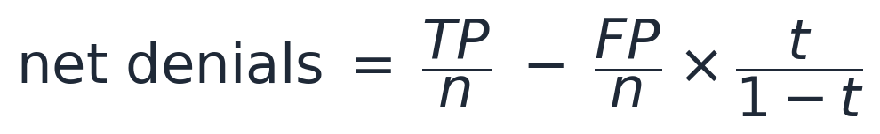
Here TP is the number of flagged lines that are denials, FP the number that are not, n the number of lines, and t the cutoff. At a 10% cutoff the model flags 49.9 of every 100 lines: 11.7 are denials and 38.1 are wasted reviews, so the net is 11.7 - 38.1/9 = 7.5. Reviewing every line catches all 14.2 denials and wastes 85.8 reviews: 14.2 - 85.8/9 = 4.6. Reviewing nothing scores zero. Across all claim types the model beats both at every cutoff. For carrier and DME claims its advantage disappears above a cutoff of about 30%, where net denials fall to about zero.
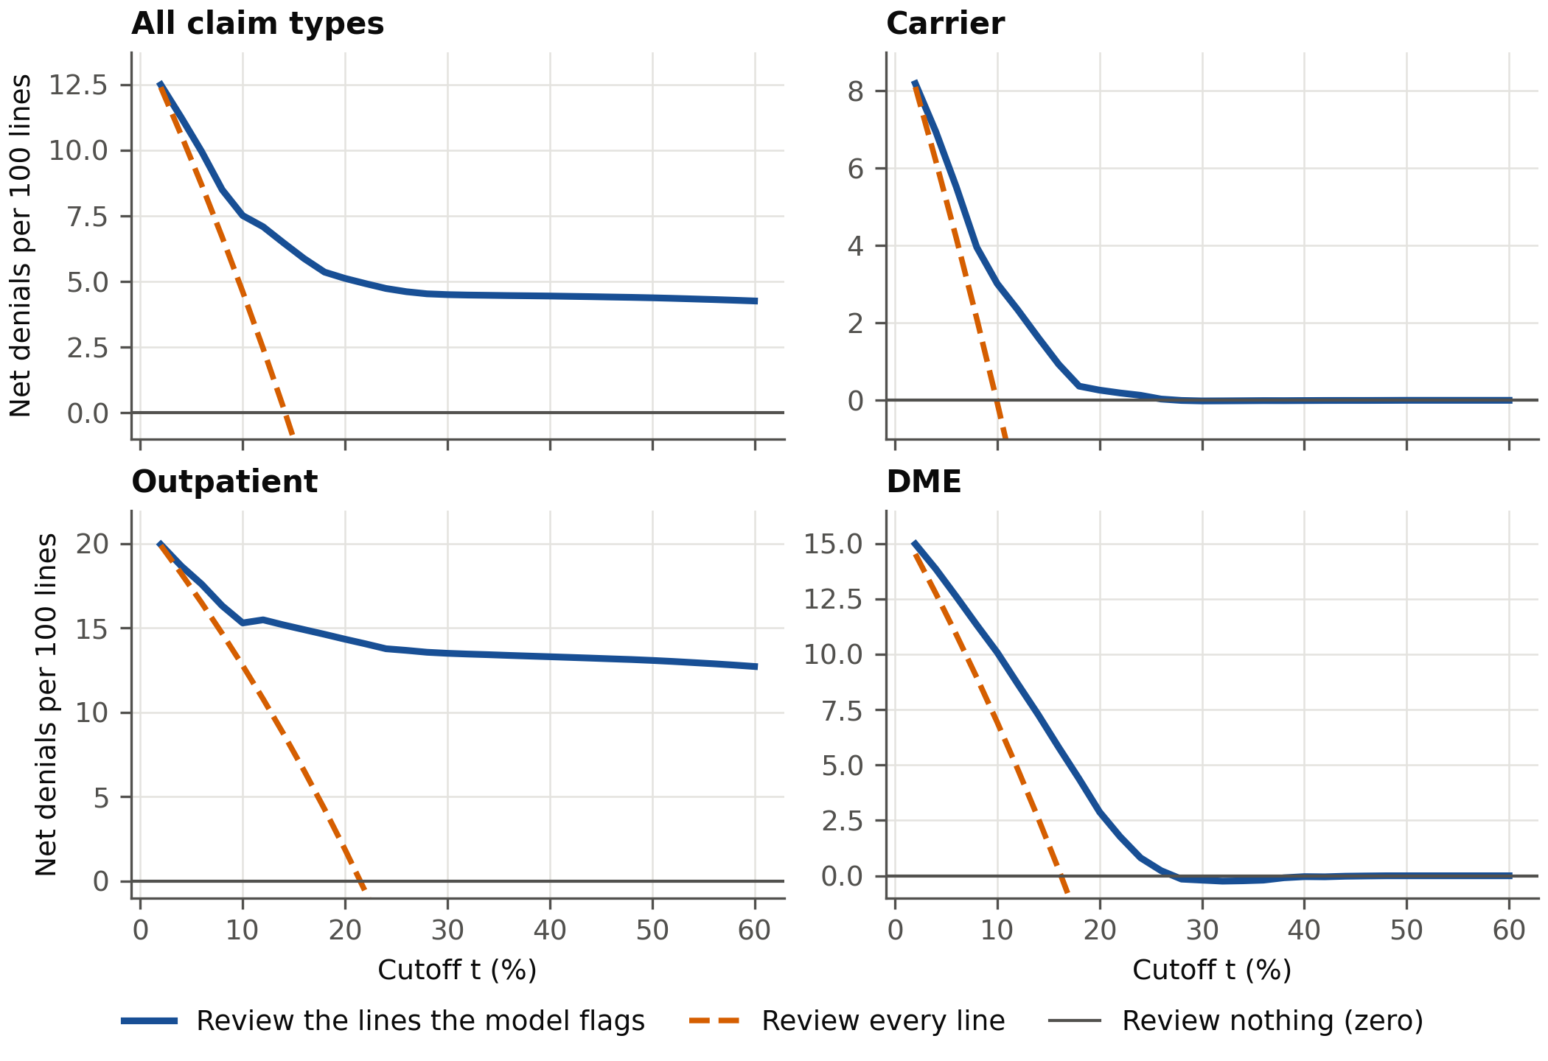
Figure A1. Decision curve by claim type, test set. The cutoff t is the lowest chance of denial at which you would review a line. Solid line: review the lines the model flags. Dashed line: review every line. Thin line at zero: review nothing.

Appendix B. Measures used in this report, defined
Each measure is defined in words, then with a formula, then with the number from this project. The test set has 359,985 lines, of which 50,945 (14.2%) are denials.
Precision and recall (recall is also called sensitivity). A flagged line is a true positive (TP) if it is a denial and a false positive (FP, a false alarm) if it is not. A denial that is not flagged is a false negative (FN, a miss). Precision asks: of the lines I flagged, what share were really denials? Recall asks: of all the denials, what share did I flag?
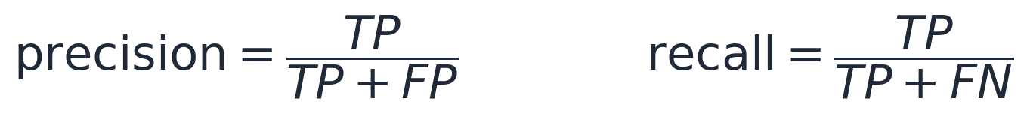
The two pull against each other. Flag more lines and recall rises, because more denials are caught, while precision usually falls, because more of what is flagged is fine. Flag fewer and the reverse happens. Neither is the right target alone; it depends on what a false alarm costs against what a miss costs, which is what the rule in section 4 weighs. On the test set: flagging only the top 1% of lines by score gives precision 95% and recall 7%; the review rule at 24% recovery gives precision 26% and recall 44%; flagging every line gives recall 100% and precision 14.2%, the denial rate. Accuracy is not used here, because a model that called every line “not denied” would be right 85.8% of the time and find nothing.
PR-AUC and ROC-AUC. Both summarize how well the scores rank denials above other lines, across every possible cutoff. PR-AUC is the area under the curve of precision against recall; a random ranking scores the denial rate (0.142) and a perfect one scores 1. ROC-AUC is the chance that a randomly chosen denied line scores higher than a randomly chosen paid line; a coin flip scores 0.5 and a perfect ranking 1. Test results: PR-AUC 0.570, ROC-AUC 0.813.
Calibration and calibration error (ECE). A model is calibrated when its percentages are accurate: of the lines it scores at 30%, about 30 in 100 are denied. This matters here because the review rule multiplies the score by dollars. ECE (expected calibration error) measures how far off the percentages are. Split the lines into 10 equal-width groups by score (0 to 10%, 10 to 20%, and so on). In each group, compare the average score with the share actually denied, and take the gap. Average the gaps, weighting each group by its share of the lines:
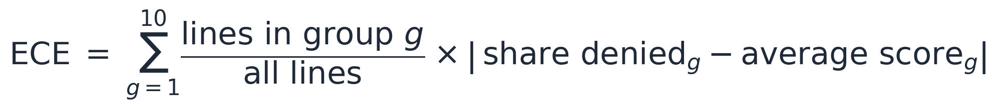
An ECE of 0.007 means the predicted chance and the share actually denied differ by 0.7 percentage points on average. Test results: 0.007 overall; carrier 0.010, DME 0.012 and outpatient 0.018. Figure 1 shows the groups themselves, because an average can hide a gap inside one group.
Brier score. The average squared difference between each line's predicted chance and what happened (1 for a denial, 0 for not). Lower is better, and 0 would be perfect. It rewards both good ranking and honest percentages.
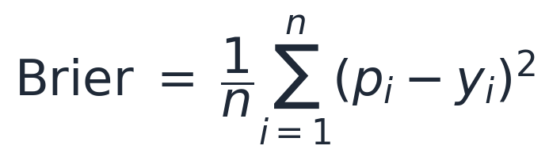
Here the sum runs over all n lines; p is a line's score and y is 1 if that line was denied and 0 if not. Test result: 0.083. A model that gave every line the average 14.2% would score 0.121, so 0.083 is a clear improvement.
Isotonic regression. A way to repair a model's percentages after it is trained. Using held-out data, it fits a staircase curve that only goes up, and replaces each raw score with the share actually denied among lines with similar scores. Because the curve never goes down, the order of the lines is preserved, except that lines on the same step become tied; only the percentages change. I decided in advance to use it only if it helped clearly: fitted on the first half of the validation data, it had to cut the Brier score on the second half by more than 1%. The gains were 0.37% for carrier, 0.23% for outpatient and -0.11% for DME, so I kept the raw scores.

Appendix C. Sources and where to find the work
Everything in this report can be traced to files in the project's GitHub repository, mohassan99/claims-denial-risk-prediction. The first table says where to find each piece of the work, and the second lists every assumption with its source. The figures are drawn by scripts that recompute each plotted number from the saved predictions and stop if any differs from the saved results.
What | File (opens on GitHub)
Test evaluation, scored once | src/evaluate_test.py
Rules fixed in advance, before the test set was touched | reports/phase5/protocol.json
Saved test results | reports/phase5/test_results.json
Terms, sources and reasoning for the review rule | docs/PHASE5.md
Why a different cutoff for each line | docs/COST_SENSITIVE_THRESHOLDS.md
The agent: design and every failure found | docs/PHASE4.md
Azure deployment script | deploy/deploy.sh
Databricks pipeline guide | docs/DATABRICKS.md
How the denial outcome was built | data/TARGET_DEFINITION.md
Every feature decision, including the Chow test | data/FEATURE_ENGINEERING.md
Demo runbook (start and stop the service) | docs/DEMO.md
Table C1. Where to find the work.
Assumption | Value used | Source
Claims data | CMS Synthetic Medicare Claims, 2015 to 2023 | CMS Data: Synthetic Medicare claims
Meaning of claim fields | Field descriptions | ResDAC, the CMS data documentation center
Consultation codes retired | Medicare stopped paying on January 1, 2010 | CMS Transmittal 1875
Examiner's hourly wage | $37.51 (May 2025 median) | BLS Occupational Outlook Handbook: claims adjusters, appraisers, examiners and investigators
Benefits on top of wages | 30% (also tested at 43%) | BLS Employer Costs for Employee Compensation, June 2026
Minutes per review | 20 (also tested at 10 and 30) | My assumption; no published figure
Share of a wrong payment recovered | 24% verified, 55% reported | HHS Office of Inspector General, report A-04-18-03085
Cost of recovering money | 12.5% of what is recovered (also tested at 9% and 20%) | CRS report R40592, Medicare's Recovery Audit Contractor program for the 9% to 12.5% fee range; 20% is my assumption
Table C2. Assumptions and where each comes from.

