**Calculator Project**

**Milestone 2**

**Mahmoud Abdalla Mohasseb**

**20P2787**

**Java Code**

package com.example.calculator;  
  
// azbot divide by zero  
// azbot length ally zahr fe text  
  
import android.os.Bundle;  
  
import androidx.annotation.NonNull;  
import androidx.annotation.Nullable;  
import androidx.fragment.app.Fragment;  
  
import android.service.quickaccesswallet.SelectWalletCardRequest;  
import android.support.v4.os.IResultReceiver;  
import android.view.LayoutInflater;  
import android.view.View;  
import android.view.ViewGroup;  
import android.widget.Button;  
import android.widget.ImageButton;  
import android.widget.TextView;  
import android.widget.Toast;  
  
public class Calculator extends Fragment {  
 Button[] btns = new Button[35];  
 TextView tv;  
  
 double operandOne = 0, result = 0;  
 String operation = "";  
 String viewText = "", pressed = "0";  
 boolean first = true, isFloat = false, isNeg = false, firstOp = true, firstRun = true;  
 int base = 10;  
  
  
 View.OnClickListener numberListener = new View.OnClickListener() {  
 @Override  
 public void onClick(View view) {  
 //Toast.makeText(getActivity(),"numbers",Toast.LENGTH_SHORT).show();  
 firstOp = true;  
  
 switch (view.getId()) {  
 case R.id.*btn_num0*:  
 if (!first) pressed += "0";  
 break;  
 case R.id.*btn_num1*:  
 pressed += "1";  
 if(first) pressed = (isNeg) ? "-":"";  
 first = false;  
 break;  
 case R.id.*btn_num2*:  
 if (base != 2) {  
 if(first) pressed = (isNeg) ? "-":"";  
 pressed += "2";  
 first = false;  
 }  
 break;  
 case R.id.*btn_num3*:  
 if (base != 2) {  
 if(first) pressed = (isNeg) ? "-":"";  
 pressed += "3";  
 first = false;  
 }  
 break;  
 case R.id.*btn_num4*:  
 if (base != 4) {  
 if(first) pressed = (isNeg) ? "-":"";  
 pressed += "4";  
 first = false;  
 }  
 break;  
 case R.id.*btn_num5*:  
 if (base != 2) {  
 if(first) pressed = (isNeg) ? "-":"";  
 pressed += "5";  
 first = false;  
 }  
 break;  
 case R.id.*btn_num6*:  
 if (base != 2) {  
 if(first) pressed = (isNeg) ? "-":"";  
 pressed += "6";  
 first = false;  
 }  
 break;  
 case R.id.*btn_num7*:  
 if (base != 2) {  
 if(first) pressed = (isNeg) ? "-":"";  
 pressed += "7";  
 first = false;  
 }  
 break;  
 case R.id.*btn_num8*:  
 if (base == 10 || base == 16) {  
 if(first) pressed = (isNeg) ? "-":"";  
 pressed += "8";  
 first = false;  
 }  
 break;  
 case R.id.*btn_num9*:  
 if (base == 10 || base == 16) {  
 if(first) pressed = (isNeg) ? "-":"";  
 pressed += "9";  
 first = false;  
 }  
 break;  
 case R.id.*btn_A*:  
 if (base == 16) {  
 if(first) pressed = "";  
 pressed += "A";  
 first = false;  
 }  
 break;  
 case R.id.*btn_B*:  
 if (base == 16) {  
 if(first) pressed = "";  
 pressed += "B";  
 first = false;  
 }  
 break;  
 case R.id.*btn_C*:  
 if (base == 16) {  
 if(first) pressed = "";  
 pressed += "C";  
 first = false;  
 }  
 break;  
 case R.id.*btn_D*:  
 if (base == 16) {  
 if(first) pressed = "";  
 pressed += "D";  
 first = false;  
 }  
 break;  
 case R.id.*btn_E*:  
 if (base == 16) {  
 if(first) pressed = "";  
 pressed += "E";  
 first = false;  
 }  
 break;  
 case R.id.*btn_F*:  
 if (base == 16) {  
 if(first) pressed = "";  
 pressed += "F";  
 first = false;  
 }  
 break;  
 case R.id.*btn_float*:  
 if (!isFloat && base == 10) {  
 pressed += ".";  
 isFloat = true;  
 first = false;  
 }  
 break;  
 case R.id.*btn_plusNeg*:  
 if (first && base == 10) {  
 if (isNeg) pressed = "0";  
 else pressed = "-0";  
 isNeg = !isNeg;  
 }  
 break;  
 }  
  
 /*if(pressed.length() <= 9)*/tv.setText(viewText + operation + "\n" + pressed);  
 }  
 };  
  
 View.OnClickListener baseListener = new View.OnClickListener() {  
 @Override  
 public void onClick(View view) {  
 Toast.*makeText*(getActivity(),"base",Toast.*LENGTH_SHORT*).show();  
 switch (view.getId()){  
 case R.id.*btn_decimal*:  
 base = 10;  
 break;  
 case R.id.*btn_hexa*:  
 base = 16;  
 break;  
 case R.id.*btn_binary*:  
 base = 2;  
 break;  
 case R.id.*btn_octal*:  
 base = 8;  
 break;  
 }  
 }  
 };  
  
 View.OnClickListener memoryListener = new View.OnClickListener() {  
 @Override  
 public void onClick(View view) {  
 Toast.*makeText*(getActivity(),"memory",Toast.*LENGTH_SHORT*).show();  
 }  
 };  
  
  
 View.OnClickListener opsListener = new View.OnClickListener() {  
 @Override  
 public void onClick(View view) {  
 if(firstOp){  
 operandOne = Double.*parseDouble*(pressed);  
 if(firstRun) {  
 result = operandOne;  
 firstRun = false;  
 viewText += pressed;  
 }  
 else {  
 switch (operation) {  
 case "+":  
 viewText += " + ";  
 result += operandOne;  
 break;  
 case "-":  
 viewText += " - ";  
 result -= operandOne;  
 break;  
 case "*":  
 viewText += " * ";  
 result *= operandOne;  
 break;  
 case "÷":  
 viewText += " ÷ ";  
 result /= operandOne;  
 break;  
 }  
 viewText += pressed;  
 }  
 tv.setText(viewText + "\n");  
 first = true;  
 isNeg = isFloat = false;  
 pressed = "0";  
 firstOp = false;  
 }  
  
  
 switch (view.getId()){  
 case R.id.*btn_sum*:  
 tv.setText(viewText + " +" + "\n" + result);  
 operation = "+";  
 break;  
 case R.id.*btn_subtract*:  
 tv.setText(viewText + " -" + "\n" + result);  
 operation = "-";  
 break;  
 case R.id.*btn_multiply*:  
 tv.setText(viewText + " *" + "\n" + result);  
 operation = "*";  
 break;  
 case R.id.*btn_divide*:  
 if(operandOne != 0) {  
 tv.setText(viewText + " ÷" + "\n" + result);  
 operation = "÷";  
 }  
 else{  
 Toast.*makeText*(getActivity(),"Can not divide by Zero",Toast.*LENGTH_SHORT*).show();  
 }  
 break;  
 case R.id.*btn_equal*:  
 tv.setText(viewText + "=" + "\n" + result);  
 result = 0;  
 operandOne = 0;  
 operation = "";  
 viewText = "";  
 pressed = "0";  
 first = true;  
 isFloat = false;  
 isNeg = false;  
 firstOp = true;  
 firstRun = true;  
 break;  
  
 }  
  
  
 }  
 };  
  
  
  
  
  
  
  
 public Calculator() {  
 // Required empty public constructor  
 }  
  
 @Override  
 public View onCreateView(LayoutInflater inflater, ViewGroup container,  
 Bundle savedInstanceState) {  
 // Inflate the layout for this fragment  
 return inflater.inflate(R.layout.*fragment_calculator*, container, false);  
 }  
  
  
 @Override  
 public void onViewCreated(@NonNull View view, @Nullable Bundle savedInstanceState) {  
 super.onViewCreated(view, savedInstanceState);  
  
 tv = (TextView)view.findViewById(R.id.*TV_numbers*);  
  
 /* numbers buttons */  
 btns[0] = (Button)view.findViewById(R.id.*btn_num0*);  
 btns[1] = (Button)view.findViewById(R.id.*btn_num1*);  
 btns[2] = (Button)view.findViewById(R.id.*btn_num2*);  
 btns[3] = (Button)view.findViewById(R.id.*btn_num3*);  
 btns[4] = (Button)view.findViewById(R.id.*btn_num4*);  
 btns[5] = (Button)view.findViewById(R.id.*btn_num5*);  
 btns[6] = (Button)view.findViewById(R.id.*btn_num6*);  
 btns[7] = (Button)view.findViewById(R.id.*btn_num7*);  
 btns[8] = (Button)view.findViewById(R.id.*btn_num8*);  
 btns[9] = (Button)view.findViewById(R.id.*btn_num9*);  
 btns[10] = (Button)view.findViewById(R.id.*btn_A*);  
 btns[11] = (Button)view.findViewById(R.id.*btn_B*);  
 btns[12] = (Button)view.findViewById(R.id.*btn_C*);  
 btns[13] = (Button)view.findViewById(R.id.*btn_D*);  
 btns[14] = (Button)view.findViewById(R.id.*btn_E*);  
 btns[15] = (Button)view.findViewById(R.id.*btn_F*);  
 btns[16] = (Button)view.findViewById(R.id.*btn_float*);  
 btns[17] = (Button)view.findViewById(R.id.*btn_plusNeg*);  
  
  
 for(int i = 0; i <= 17; i++){  
 btns[i].setOnClickListener(numberListener);  
 }  
  
 /* base buttons */  
 btns[18] = (Button)view.findViewById(R.id.*btn_decimal*);  
 btns[19] = (Button)view.findViewById(R.id.*btn_binary*);  
 btns[20] = (Button)view.findViewById(R.id.*btn_hexa*);  
 btns[21] = (Button)view.findViewById(R.id.*btn_octal*);  
  
 for(int i = 18; i <= 21; i++){  
 btns[i].setOnClickListener(baseListener);  
 }  
  
 /* operations buttons */  
 btns[22] = (Button)view.findViewById(R.id.*btn_sum*);  
 btns[23] = (Button)view.findViewById(R.id.*btn_subtract*);  
 btns[24] = (Button)view.findViewById(R.id.*btn_multiply*);  
 btns[25] = (Button)view.findViewById(R.id.*btn_divide*);  
 btns[26] = (Button)view.findViewById(R.id.*btn_mod*);  
 btns[27] = (Button)view.findViewById(R.id.*btn_equal*);  
 btns[28] = (Button)view.findViewById(R.id.*btn_removeAll*);  
 btns[29] = (Button) view.findViewById(R.id.*btn_backSpace*);  
  
 for(int i = 22; i <= 29; i++){  
 btns[i].setOnClickListener(opsListener);  
 }  
  
 /* memory buttons */  
 btns[30] = (Button)view.findViewById(R.id.*btn_memPlus*);  
 btns[31] = (Button)view.findViewById(R.id.*btn_memSubtract*);  
 btns[32] = (Button)view.findViewById(R.id.*btn_memRecall*);  
 btns[33] = (Button)view.findViewById(R.id.*btn_memRemove*);  
 btns[34] = (Button)view.findViewById(R.id.*btn_memStore*);  
  
 for(int i = 30; i <= 34; i++){  
 btns[i].setOnClickListener(memoryListener);  
 }  
 }  
}

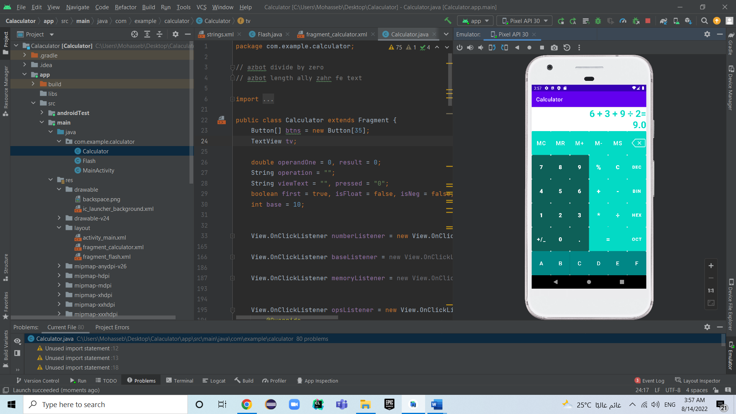**Screenshot of layout**

**Test case scenarios:**

000000000000000 o/p: 0

0…………… o/p: 0.

053 + - * + 9 o/p: 53 + 9