Mohammed Ahmed Atiya

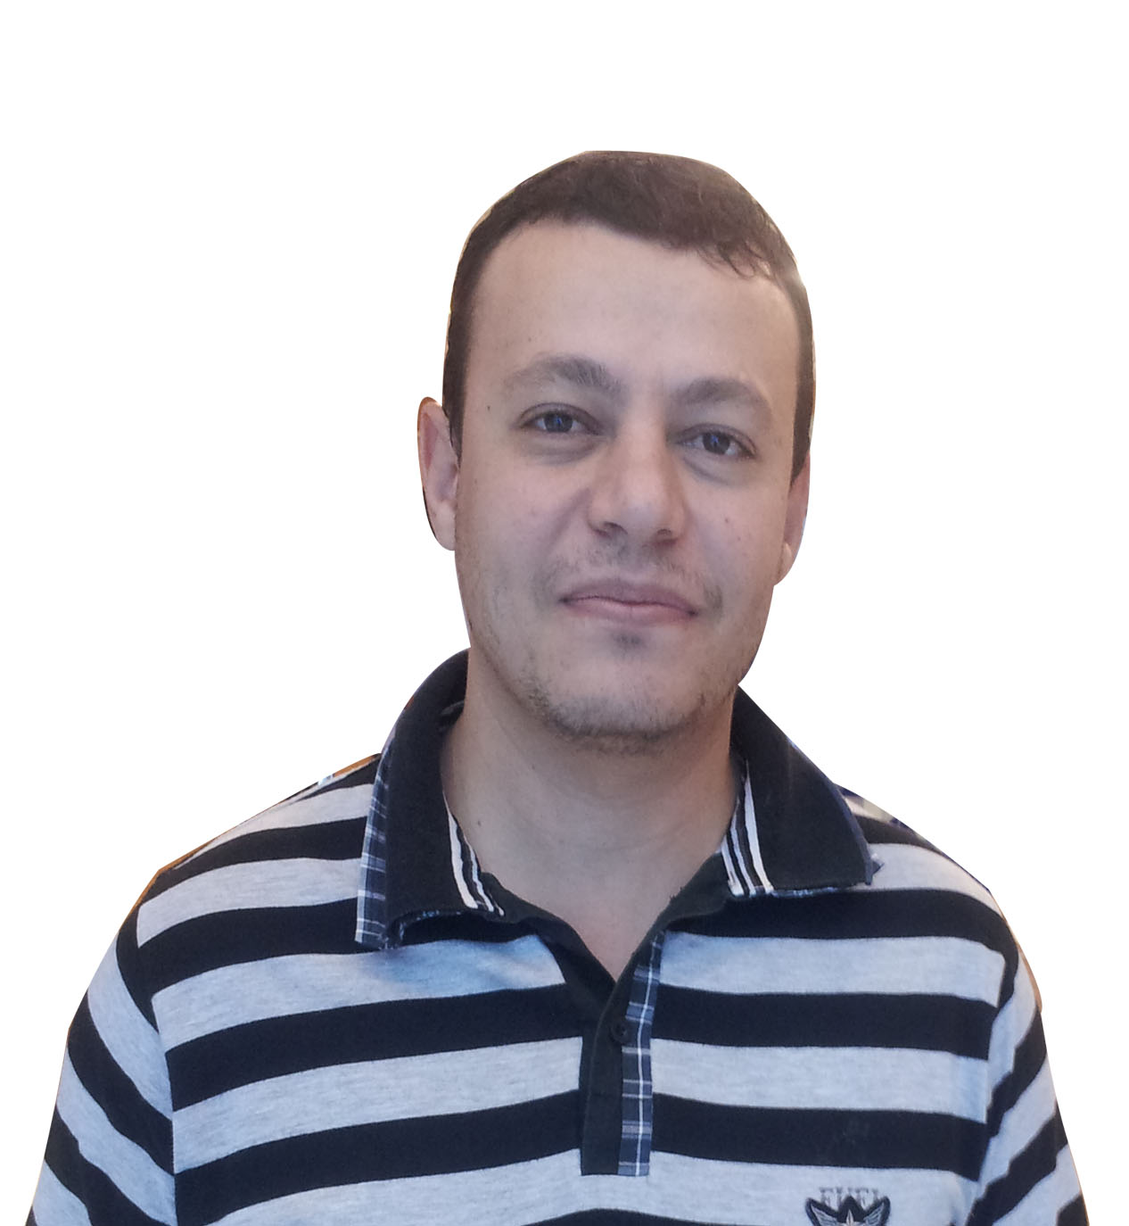
604, Al Shamsi New Building,
Buttina, Sharjah ,
United Arab Emirates
Mobile: +971561281945
+201118008887
Email: moh.atiya@gmail.com
OBJECTIVE
Seeking a challenging position in a big company that meets my skills and let me fulfills all my aspirations and ideas and updates my academic and Work background.

Education

Bachelor of Information Technology June 2005
Faculty of Computers & Information [Menoufia University].
Grade: good (73 %).
Graduation Project: P2P File Sharing Application
It allows you to search a file and open multiple channels for
download parts of file from multiple sources.
Graduation Project Grade: Excellent (96%).

Certifications

2017 MCP [HTML5 , CSS and Javascript]
2015 MTA [Microsoft Technology Associate]
2011 OCPJP [Oracle Certified Professional Java Programmer]
2006 MCP [SQL Server Database Design and Implementation]

Work Experience ( https://ae.linkedin.com/in/mohamed-atiya-a6a12421)

Mwasala/Accela --------------------(Senior Software Consultant from 3/2014)
Providing Customization and Handling required
Integration for Government Solution.

IST Networks (UAE-DUBAI)--------( Senior Software Engineer from 3/2012 till 2/2014)
Contact Center Applications, Integration and Support.

IST Networks (Egypt)--------------( Senior Software Engineer from 9/2009 to 3/2012)
Text To Speech and Automatic Speech Recognition
Servers , Voice Recording and IVR Call flows.
IDX -------------------------------- --(Senior Software Engineer from 3/2008 up to 9/2009).

IVR, Recording, VoIP Servers and Gateways. IVR
Applications using PSTN Modems.
etisalat[Egypt]----------------------(VAS Engineer 6/2007 up to 3/2008).
Troubleshooting issues reported by Call Center for SMS,
MMS, USSD and ADC Services.
HI-Q Academy----------------------.NET(MCSD) instructor from 1/2006
to 2/2007).

Clients and Projects

Name | Dubai Tourism and Commerce Marketing
Description | - Accela Government Solution  Using ACCELA Platform for Development of Permitting Process including Workflows, Fees, Online/Offline Payment, and Creating Central Service for collecting all hotel transactions across Dubai.
Name |  | KAHRAMAA Contact Center Dashboards
Description |  | - Contact center Dash Board Development.  Providing Different Dashboard Screens for all contact center operations for Agent and Call Queues, Email Queue and Chat Queues.
Name | DUNIA Contact Center Upgrade
Description | - Call Flow Upgrade  This project is part of upgrade whole call center from IPCC version 4.0 to 8.5. Which required more modification on scripting and all back-end integration used to be compatible with new version.
Name | PDO [Petroleum Development Of Oman] Contact Center
Description | - Contact Center Upgrade  Development for Call Flow on Cisco CVP and Back-end integration with HPMS through Web service and Customize Agent CTIOS Client to integrate with HPMS.

Tools And Technologies
Programming Languages: | - C#.  - Java  - C/C++ (Windows, Linux).  - VB6
Web and Enterprise Technologies | - ASP.NET and MVC  - Ado.Net , Entity Framework  - LINQ  - WCF and Web Services  - HTML and CSS  - Java Script, JQuery  - Bootstrap.  - Servlets, JSP, Struts and GWT.  - EJB, JPA, Hibernate.  - Crystal Reports /Jasper Reporting Tools.  - XML, XSLT, XSD.  - ASP Classic.
DBMS | - SQL Server and SSRS.  - Oracle 10g [PL-SQL/SQL].  - MS-Access.  - MySql.
Others | - Maven  - Subversion  - Data Networks [CCNA].  - VoIP[SIP,SDP,RTP]  - IVR ,VXML,CVP  - MRCP protocol, SSML ,SRGS, SISR  - Mobile Networks Fundamentals.  - MS Project  - MS Visio

Interpersonal Skills
Description | - Team player  - Work under time pressure.  - Hard worker.  - Fast Learner.  - Excellent research abilities.  - High communications skills.  - Self Motivated.  - Self-Dependent.

Language Skills
Arabic  English | - Mother tongue.  - Very Good.

Personal details
Date of Birth:  Nationality:  Gender:  Marital status:  Military service: | 1-May-1984.  Egyptian.  Male.  Married.  Exempt.

References furnished upon request.

