
COMSATS UNIVERSITY ISLAMABAD ABBOTTABAD CAMPUS, PAKISTAN

CYBERSENTINEL AI – INTELLIGENT CYBERSECURITY TOOLKIT FOR PHISHING, MALWARE, AND THREAT DETECTION

BY

MOHAVIA ARIF
CIIT/FA22-BCS-084/ATD
ANAS BASHIR
CIIT/FA22-BCS-081/ATD
ABDUL SAMAD PARACHA
CIIT/FA22-BCS-056/ATD

SUPERVISOR
DR. MAZHAR ALI

BACHELOR OF SCIENCE IN COMPUTER SCIENCE (2022–2026)


COMSATS UNIVERSITY ISLAMABAD ABBOTTABAD CAMPUS, PAKISTAN

CYBERSENTINEL AI – INTELLIGENT CYBERSECURITY TOOLKIT FOR PHISHING, MALWARE, AND THREAT DETECTION

A PROJECT PRESENTED TO
COMSATS UNIVERSITY ISLAMABAD, ABBOTTABAD CAMPUS
IN PARTIAL FULFILLMENT
OF THE REQUIREMENTS FOR THE DEGREE OF
BACHELOR OF SCIENCE IN COMPUTER SCIENCE (2022–2026)

BY

MOHAVIA ARIF
CIIT/FA22-BCS-084/ATD
ANAS BASHIR
CIIT/FA22-BCS-081/ATD
ABDUL SAMAD PARACHA
CIIT/FA22-BCS-056/ATD

DECLARATION
We hereby declare that this project titled “CyberSentinel AI – Intelligent Cybersecurity Toolkit for Phishing, Malware, and Threat Detection” is the result of our own efforts and has not been copied from any external source. All sources of information used in this project have been properly acknowledged and referenced.
We further declare that this project report has not been submitted, either in whole or in part, for any other degree or qualification at this or any other institution.
If any part of this work is found to be plagiarized or reproduced from another source without proper citation, we accept full responsibility and the consequences as determined by the university.

MOHAVIA ARIF ANAS BASHIR ABDUL SAMAD PARACHA

------------------------ -------------------- --------------------------------------

CERTIFICATE OF APPROVAL
It is to certify that the Final Year Project titled “CyberSentinel AI – Intelligent Cybersecurity Toolkit for Phishing, Malware, and Threat Detection” has been developed by Mohavia Arif (CIIT/FA22-BCS-084/ATD), Anas Bashir (CIIT/FA22-BCS-081/ATD), and Abdul Samad Paracha (CIIT/FA22-BCS-056/ATD) under the supervision of Dr. Mazhar Ali.
In our opinion, this project is fully adequate in scope and quality for the award of the degree of Bachelor of Science in Computer Science (2022–2026).

----------------------------------

Supervisor

----------------------------------
External Examiner

-----------------------------------
Head of Department
(Department of Computer Science)

EXECUTIVE SUMMARY
In today’s rapidly evolving digital landscape, cybersecurity threats such as phishing attacks, malicious URLs, and malware infections have become increasingly common, particularly affecting individuals and small businesses with limited access to advanced security tools. In Pakistan, the lack of affordable, user-friendly, and localized cybersecurity solutions further increases the vulnerability of users to online scams, data breaches, and financial fraud.
To address these challenges, CyberSentinel AI – Intelligent Cybersecurity Toolkit for Phishing, Malware, and Threat Detection is developed as a web-based platform that provides real-time threat detection using Artificial Intelligence (AI) and Machine Learning (ML). The system integrates multiple detection modules into a unified interface, enabling users to analyze suspicious emails, URLs, and files through a simple and intuitive dashboard.
The phishing detection module utilizes Natural Language Processing (NLP) techniques, including TF-IDF vectorization and a trained Logistic Regression model, to classify email content as safe, suspicious, or phishing based on linguistic patterns and contextual features. The malicious URL analyzer employs machine learning algorithms and external threat intelligence sources such as PhishTank and AbuseIPDB to evaluate domain credibility and detect harmful links. Additionally, the malware detection module integrates with the VirusTotal API to analyze uploaded files and identify known malware signatures using hash-based scanning.
The system is built using a modern technology stack consisting of a React-based frontend for user interaction, a Flask backend for API handling, and machine learning libraries such as scikit-learn for model implementation. The modular architecture ensures scalability, allowing future integration of advanced features such as threat intelligence dashboards, browser extensions, and mobile applications.
CyberSentinel AI provides results in a clear and user-friendly manner using color-coded risk indicators (green for safe, yellow for suspicious, and red for malicious), along with confidence scores and actionable recommendations. The platform also supports report generation and logging mechanisms to enhance usability and auditability.
Overall, CyberSentinel AI offers an accessible, efficient, and intelligent cybersecurity solution tailored to the needs of non-technical users. By combining AI-driven analysis with a simplified interface, the system contributes to improving cybersecurity awareness and reducing the risk of digital threats in Pakistan’s growing online environment.

ACKNOWLEDGEMENT
All praise is to Almighty Allah, whose countless blessings, guidance, and wisdom enabled us to successfully complete this project.
We would like to express our sincere gratitude to our respected supervisor, Dr. Mazhar Ali, for his continuous support, valuable guidance, and constructive feedback throughout the development of this project. His encouragement and insightful suggestions played a vital role in shaping the direction and quality of our work.
We are also thankful to the faculty members of the Department of Computer Science, COMSATS University Islamabad, Abbottabad Campus, for providing us with the knowledge, resources, and academic environment necessary for completing this project successfully.
Furthermore, we extend our heartfelt appreciation to our parents and families for their unwavering support, motivation, and prayers, which have been a constant source of strength during our academic journey.
Finally, we would like to acknowledge everyone who directly or indirectly contributed to the completion of this project.

MOHAVIA ARIF ANAS BASHIR ABDUL SAMAD PARACHA

----------------------- --------------------- ---------------------------------------

ABBREVIATIONS

Abbreviation | Full Form
AI | Artificial Intelligence
API | Application Programming Interface
CSV | Comma Separated Values
DB | Database
FR | Functional Requirement
ML | Machine Learning
NLP | Natural Language Processing
SVM | Support Vector Machine
TF-IDF | Term Frequency – Inverse Document Frequency
UI | User Interface
URL | Uniform Resource Locator
VT | VirusTotal

Table of contents

1. INTRODUCTION 10
1.1 Brief 10
1.2 Relevance to Course Modules 11
1.3 Project Background 11
1.4 Literature Review 12
1.5 Analysis from Literature Review 13
1.6 Methodology and Software Process Model 13
1.6.1 Rationale for Selected Methodology 14
2. Problem Definition 14
2.1 Problem Statement 14
2.2 Deliverables and Development Requirements 15
2.3 Current System 15
3. Requirement Analysis 16
3.1 Use Case Diagram 16
3.2 Detailed Use Cases 17
3.3 Functional Requirements 20
3.4 Non-Functional Requirements 22
3.5 UML Diagrams 22
4. Design and Architecture 23
4.1 System Architecture 23
4.2 Entity Relationship Diagram 24
4.3 Process Flow Diagram 25
4.4 Class Diagram 27
4.5 Sequence Diagram 28
5. Implementation 30
5.1 Algorithm 30
5.1.1 Phishing Email Detection Algorithm 30
5.1.2 Embedded Link Scanning Algorithm 31
5.1.3 Hidden Link Detection in .eml Files 32
5.1.4 URL Threat Analysis Algorithm 32
5.1.5 Malware File Scanning Algorithm 33
5.1.6 VirusTotal Live Upload for Unknown Files 34
5.1.7 Scan History and Database Storage Algorithm 34
5.1.8 Report Generation Algorithm 35
5.1.9 Admin Panel Workflow 35
5.1.10 Email Notification Workflow 35
5.1.11 Gmail/Chrome Extension Workflow 36
5.1.12 Live Deployment Workflow 36
5.2 External APIs 38
5.3 User Interface 38
5.3.1 Login and Registration Interface 39
5.3.2 User Dashboard 39
5.3.3 Email Phishing Scan Interface 40
5.3.4 Embedded and Hidden Link Result Interface 40
5.3.5 URL Threat Analysis Interface 41
5.3.6 Malware File Scan Interface 41
5.3.7 Scan History Interface 42
5.3.8 Report Interface 42
5.3.9 Admin Panel Interface 43
5.3.10 Email Notification Output 43
5.3.11 Gmail/Chrome Extension Interface 44
5.4 Summary 44
6. Testing and Evaluation 46
6.1 Manual Testing 46
6.1.1 System Testing 47
6.1.2 Unit Testing 48
6.1.3 Functional Testing 51
6.1.4 Integration Testing 51
6.2 Automated Testing 52
6.2.1 Tools Used 52
6.2.2 Automated API Test Results 53
6.2.3 Performance Testing 53
6.2.4 Security Testing 54
6.3 Summary 54
7. Conclusion and Future Work 56
7.1 Conclusion 56
7.2 Future Work 57
7.2.1 Larger Pakistani Cyber Threat Dataset 57
7.2.2 Deep Learning-Based Phishing Detection 57
7.2.3 Full Browser-Wide Extension 58
7.2.4 Mobile Application 58
7.2.5 Behavioral Malware Analysis 58
7.2.6 Enterprise Dashboard and SIEM Integration 58
7.2.7 Multi-Language Support 58
7.2.8 Two-Factor Authentication and Advanced Security 58
7.2.9 Continuous Model Retraining 58
7.2.10 Cloud Scalability and Load Balancing 59
7.3 Summary 59
8. References 60

Table of Figures

Figure 3. 1: Use Case Diagram 20

Figure 4. 1: System Architecture Diagram 28
Figure 4. 2: Entity Relationship Diagram 29
Figure 4. 3: Process Flow Diagram 30
Figure 4. 4: Class Diagram 31
Figure 4. 5: Sequence Diagram 32

Figure 5. 1: Login and Registration Interface 42
Figure 5. 2: User Dashboard 43
Figure 5. 3:Email Phishing Scan Interface 44
Figure 5. 4: Embedded and Hidden Link Detection Result 45
Figure 5. 5:URL Threat Analysis Interface 46
Figure 5. 6: Malware File Scan Interface 47
Figure 5. 7: Scan History Interface 48
Figure 5. 8: PDF Report Interface 49
Figure 5. 9: Admin Panel Interface 50
Figure 5. 10: Email Notification Output 51
Figure 5. 11: Gmail Extension Interface 52

Table of Tables

Table 3. 1: USE CASE 20
Table 3. 2: Use Case Description – Scan URL for Threats 21
Table 3. 3: Use Case Description – Malware File Detection 22
Table 3. 4: Functional Requirements 24
Table 3. 5: Non-Functional Requirements 25

Table 5. 1: Details of APIs Used in the Project 40

Table 6. 1: System Testing 51
Table 6. 2: Phishing Email Detection Unit Test Case 53
Table 6. 3: Embedded Link Scanning Unit Test Case 53
Table 6. 4: Hidden EML Link Detection Unit Test Case 54
Table 6. 5: URL Analyzer Unit Test Case 54
Table 6. 6: Malware File Scanner Unit Test Case 55
Table 6. 7: Authentication and Database Unit Test Case 55
Table 6. 8: Admin Panel and Email Notification Unit Test Case 56
Table 6. 9: Functional Testing 56
Table 6. 10: Integration Testing 57
Table 6. 11:Tools Used for Automated Testing 58
Table 6. 12: Automated API Test Results 59
Table 6. 13: Performance Test Results 59
Table 6. 14: Security Test Results 60

INTRODUCTION
This chapter presents an overview of the project titled “CyberSentinel AI – Intelligent Cybersecurity Toolkit for Phishing, Malware, and Threat Detection.” It introduces the purpose, significance, and background of the system, along with its relevance to academic coursework. The chapter also includes a review of existing systems, analysis of their limitations, and the methodology adopted for developing the proposed solution.

1.1 Brief
CyberSentinel AI is a web-based cybersecurity platform designed to detect and analyze digital threats in real time using Artificial Intelligence (AI) and Machine Learning (ML) techniques. The system focuses on three primary threat categories: phishing emails, malicious URLs, and malware-infected files.
The platform enables users to submit suspicious content—such as email text, web links, or files—and receive instant classification results indicating whether the input is safe, suspicious, or malicious. The system presents results using color-coded indicators along with confidence scores, making it easy for non-technical users to understand potential risks.
The core functionality of the system is based on an NLP-driven phishing detection module, which utilizes TF-IDF vectorization and a Logistic Regression model to analyze textual patterns in emails. Additional modules for URL analysis and malware detection are integrated using machine learning techniques and external threat intelligence APIs such as PhishTank and VirusTotal.
The primary objective of CyberSentinel AI is to provide an accessible, affordable, and user-friendly cybersecurity solution tailored for individuals and small organizations, particularly in regions where advanced security tools are not readily available.

1.2 Relevance to Course Modules
The development of CyberSentinel AI integrates knowledge and concepts from multiple courses studied during the Bachelor of Science in Computer Science program. It demonstrates the practical application of theoretical concepts in a real-world cybersecurity solution.
Key course contributions include:
• Machine Learning: Implementation of classification models such as Logistic Regression for phishing detection and feature-based models for URL analysis.
• Natural Language Processing (NLP): Text preprocessing, tokenization, and TF-IDF vectorization for analyzing email content.
• Software Engineering: Application of Software Development Life Cycle (SDLC), modular system design, and Agile development methodology.
• Web Development: Development of a responsive frontend using React.js and backend API integration using Flask.
• Database Systems: Management of user data, scan history, and logs using structured storage systems.
• Computer Networks & Security: Understanding of cyber threats such as phishing, malware, and malicious URLs, and techniques for detecting and mitigating them.
This project effectively bridges academic learning with practical implementation, providing hands-on experience in designing and deploying an intelligent cybersecurity system.

1.3 Project Background
With the rapid growth of internet usage and digital services, cybersecurity threats have become increasingly prevalent. Users frequently encounter phishing emails, fraudulent websites, and malicious software designed to steal sensitive information or compromise systems.
In Pakistan, many individuals and small businesses lack access to reliable cybersecurity tools due to high costs, technical complexity, and limited awareness. As a result, users often rely on guesswork when dealing with suspicious content, leading to increased vulnerability to cyberattacks.
Existing solutions such as antivirus software and online scanning tools are often either too complex for non-technical users or require paid subscriptions. Additionally, many systems focus on a single type of threat and do not provide a unified platform for analyzing multiple types of cybersecurity risks.
CyberSentinel AI is developed to address these challenges by offering a simple, web-based platform that combines phishing detection, URL analysis, and malware scanning into a single system. By leveraging AI and ML techniques, the system provides real-time threat detection and enhances user awareness, making cybersecurity more accessible and effective for a broader audience.

1.4 Literature Review
Several existing systems and platforms have been developed to address cybersecurity threats such as phishing, malicious URLs, and malware detection. These systems provide valuable insights into threat detection techniques but also exhibit certain limitations.
One of the widely used platforms is VirusTotal, which allows users to scan files and URLs using multiple antivirus engines. While it is effective in identifying known threats, it is primarily designed for technical users and lacks Natural Language Processing (NLP) capabilities for detecting phishing emails. Additionally, the interpretation of its results often requires technical expertise.
Another notable system is the Kaspersky Threat Intelligence Portal, which provides advanced threat analysis and malware detection services. However, it is mainly targeted toward enterprise environments and requires paid subscriptions, making it less accessible for individual users and small businesses.
Cisco Talos Intelligence is another cybersecurity platform that offers comprehensive threat intelligence and network security insights. Despite its effectiveness, it is complex and not designed for non-technical users, limiting its usability for the general public.
In the academic domain, several AI-based phishing detection systems have been proposed using Machine Learning and Deep Learning techniques such as Support Vector Machines (SVM), Logistic Regression, and BERT-based models. These systems demonstrate high accuracy in controlled environments but often lack real-world deployment, integration with external APIs, and user-friendly interfaces.
Overall, while existing systems provide effective threat detection, they often lack accessibility, integration of multiple threat detection methods, and simplicity required for non-technical users.

1.5 Analysis from Literature Review
The analysis of existing systems reveals several key limitations that highlight the need for an improved cybersecurity solution. Most platforms focus on a single type of threat, such as file scanning or URL analysis, and do not provide a unified system for detecting multiple threats simultaneously.
Additionally, many existing tools are either too complex for non-technical users or require paid subscriptions, limiting their accessibility. The lack of user-friendly interfaces and clear result interpretation further reduces their effectiveness for everyday users.
Another major limitation is the reliance on static databases and rule-based detection methods, which are not effective against evolving cyber threats. Many systems also fail to provide real-time analysis or do not integrate multiple data sources for improved accuracy.
CyberSentinel AI addresses these limitations by integrating phishing detection, URL analysis, and malware scanning into a single platform. It utilizes AI and ML techniques for adaptive threat detection and combines them with external threat intelligence APIs to provide up-to-date and accurate results.
Furthermore, the system emphasizes simplicity and accessibility by offering a user-friendly web interface with clear visual indicators and actionable insights. This makes it suitable for non-technical users while maintaining effectiveness in threat detection.

1.6 Methodology and Software Process Model
The development of CyberSentinel AI follows an Object-Oriented Methodology (OOM) combined with an Agile Software Development Life Cycle (SDLC). This approach enables modular development, flexibility, and continuous improvement throughout the project lifecycle.
The Object-Oriented Methodology is used to structure the system into independent modules such as phishing detection, URL analysis, malware scanning, and user management. Each module is designed as a separate component, ensuring scalability, maintainability, and ease of integration.
The Agile methodology is adopted to manage the development process through iterative and incremental cycles. The project is divided into multiple phases, including dataset preparation, model development, backend implementation, frontend integration, and testing. Each phase is developed and refined through continuous feedback and evaluation.

1.6.1 Rationale for Selected Methodology
The Object-Oriented approach is selected because it supports modular system design, allowing different components of the system to be developed and tested independently. It also enhances code reusability and simplifies system maintenance.
The Agile development model is chosen due to its flexibility and suitability for AI-based systems, where continuous refinement and testing are required. It allows the team to adapt to changes, improve model performance, and integrate new features efficiently.
Together, these methodologies ensure that CyberSentinel AI is developed as a scalable, efficient, and well-structured cybersecurity platform capable of evolving with future requirements.

2. Problem Definition
This chapter defines the core problem addressed by CyberSentinel AI and explains the limitations of current cybersecurity practices. It also outlines the deliverables of the proposed system and provides an overview of existing solutions.

2.1 Problem Statement
The increasing reliance on digital communication and online platforms has led to a significant rise in cybersecurity threats such as phishing attacks, malicious URLs, and malware infections. Users are frequently exposed to deceptive emails, fraudulent websites, and harmful files that are designed to steal sensitive information, including login credentials, financial data, and personal details.
In Pakistan, individuals and small businesses are particularly vulnerable due to limited cybersecurity awareness and lack of access to affordable and easy-to-use security tools. Many users are unable to distinguish between legitimate and malicious content, which results in increased risks of data breaches, financial losses, and system compromise.
Traditional cybersecurity solutions, including antivirus software and online scanning tools, are often complex, expensive, or designed for technically skilled users. These systems typically require installation, subscription fees, and prior knowledge, making them inaccessible to a large portion of the population. Moreover, most existing platforms focus on a single type of threat and fail to provide a unified solution for detecting phishing, malicious URLs, and malware in one system.
Therefore, there is a need for an intelligent, accessible, and user-friendly cybersecurity platform that can detect multiple types of threats in real time and present results in a clear and understandable manner for non-technical users.

2.2 Deliverables and Development Requirements
The key deliverables of CyberSentinel AI include:
- A fully functional web-based cybersecurity application
- Phishing email detection module using NLP and machine learning
- Malicious URL analysis module with risk scoring
- File malware detection module integrated with VirusTotal API
- User-friendly dashboard with visual threat indicators
- Report generation and download functionality
- Scan history and logging system
- Integration with external threat intelligence APIs (VirusTotal, PhishTank, AbuseIPDB)
The development requirements of the system include:
- Frontend development using React.js
- Backend API development using Flask
- Machine learning implementation using scikit-learn
- Natural Language Processing using TF-IDF techniques
- Integration of external APIs for enhanced threat detection
- Standard computing environment with internet connectivity
- Compatibility with modern web browsers (Chrome, Firefox, Edge)
- Secure communication using HTTPS protocols

2.3 Current System
Existing cybersecurity solutions primarily rely on traditional antivirus software and online scanning platforms. While these systems provide basic protection, they have several limitations in terms of usability, accessibility, and scope.
Limitations of Current Systems:
- Most tools focus only on malware detection and do not effectively handle phishing or malicious URLs
- Lack of a unified platform, requiring users to use multiple tools for different threats
- Complex interfaces that are difficult for non-technical users to understand
- Dependence on paid subscriptions, making them less accessible to general users
- Requirement of installation and system resources for antivirus software
- Limited real-time detection capabilities in some tools
- Difficulty in interpreting detailed technical reports provided by platforms like VirusTotal
- Lack of user-friendly visualization and simplified results
- Dependence on user judgment due to fragmented analysis
These limitations highlight the need for a unified, AI-driven cybersecurity solution like CyberSentinel AI, which provides real-time threat detection through a simple and accessible web interface.

3. Requirement Analysis
This chapter defines the functional and non-functional requirements of the CyberSentinel AI system. It explains how users interact with the system through use case modeling and describes the expected behavior of each module. The purpose of this chapter is to provide a clear and structured specification of system requirements for design and implementation.

3.1 Use Case Diagram
The use case diagram provides a high-level representation of the interactions between system actors and CyberSentinel AI. The primary actors include the User and Admin.
The User interacts with the system to perform threat analysis tasks such as scanning emails, analyzing URLs, uploading files, viewing results, and downloading reports. The Admin manages system operations including user management, system monitoring, and log analysis.
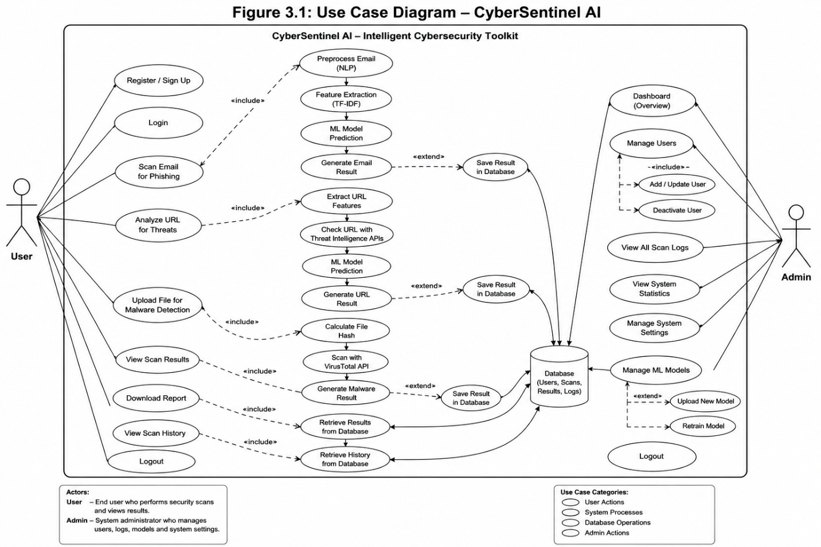
Figure 3. 1: Use Case Diagram

3.2 Detailed Use Cases

Table 3. 1: USE CASE
Field: | Description
Use Case ID: | UC-01
Use Case Name: | Scan Email for Phishing
Primary Actor: | User
Secondary Actors: | Backend API, NLP Module, ML Model
Description: | User submits email text for phishing detection
Trigger: | User clicks "Analyze"
Preconditions: | Internet available, system running, model loaded
Postconditions: | Prediction displayed, result stored in logs
Description – Scan Email for Phishing
Normal Flow:
- User enters email text
- User clicks analyze
- System validates input
- NLP preprocessing applied
- ML model generates prediction
- Result displayed with confidence score
Alternative Flow:
- Empty input → error message
- Server unavailable → failure notification

Table 3. 2: Use Case Description – Scan URL for Threats
Field | Description
Use Case ID | UC-02
Use Case Name | Analyze URL
Primary Actor | User
Secondary Actors | Backend API, ML Model, Threat APIs
Description | User submits URL for threat analysis
Trigger | User clicks "Analyze URL"
Preconditions | Internet connection, API keys active
Postconditions | Risk level displayed, result stored
Normal Flow:
- User inputs URL
- System validates format
- ML model analyzes URL
- APIs provide threat intelligence
- Risk score generated
- Result displayed

Table 3. 3: Use Case Description – Malware File Detection
Field | Description
Use Case ID | UC-03
Use Case Name | File Malware Detection
Primary Actor | User
Secondary Actors | Backend API, VirusTotal API
Description | User uploads file for malware scanning
Trigger | User uploads file
Preconditions | Valid file, API access available
Postconditions | Malware result displayed

Normal Flow:
- User uploads file
- System validates file
- File hash generated
- API request sent
- Results retrieved
- Output displayed

3.3 Functional Requirements
The functional requirements define the expected behavior of the system.

Table 3. 4: Functional Requirements
ID | Requirement
FR-01 | System shall allow users to submit email text
FR-02 | System shall classify email using NLP and ML
FR-03 | System shall allow URL submission
FR-04 | System shall analyze URLs using ML and APIs
FR-05 | System shall allow file uploads
FR-06 | System shall integrate VirusTotal API
FR-07 | System shall display results with color indicators
FR-08 | System shall store scan history
FR-09 | System shall generate downloadable reports
FR-10 | System shall support admin functionalities

3.4 Non-Functional Requirements

Table 3. 5: Non-Functional Requirements
Category | Requirement
Usability | System shall provide simple UI for non-technical users
Performance | Response time should be within a few seconds
Security | Data must be transmitted via HTTPS
Reliability | System should handle failures gracefully
Maintainability | System should support modular updates

3.5 UML Diagrams
The system design is supported by UML diagrams to visually represent structure and behavior.
The following diagrams will be included:
- Use Case Diagram
- Class Diagram
- Sequence Diagram
- Activity Diagram
- Entity Relationship Diagram
- CyberSentinel AI – Intelligent Cybersecurity Toolkit

4. Design and Architecture
This chapter presents the overall system design and architecture of CyberSentinel AI. It explains the structural organization of the system and illustrates how different components interact to perform cybersecurity threat detection. The chapter also includes UML diagrams and database design used for system implementation.

4.1 System Architecture
CyberSentinel AI follows a modular three-tier architecture consisting of the frontend layer, backend layer, and AI/ML processing layer. This architecture ensures scalability, maintainability, and efficient communication between system components.
The frontend layer is developed using React.js and provides a responsive user interface through which users can interact with the system. Users can submit suspicious emails, URLs, or files and view threat analysis results in real time.
The backend layer is implemented using the Flask framework. It handles API requests, validates user inputs, communicates with machine learning modules, and manages interactions with external threat intelligence APIs such as VirusTotal, PhishTank, and AbuseIPDB.
The AI/ML layer contains the phishing detection models, NLP preprocessing pipelines, and URL analysis mechanisms. TF-IDF vectorization and Logistic Regression are used for phishing email classification, while external APIs and machine learning techniques are used for URL and malware analysis.
The database layer stores user accounts, scan history, logs, and generated reports. This layer ensures persistent storage and supports system monitoring and audit functionality.
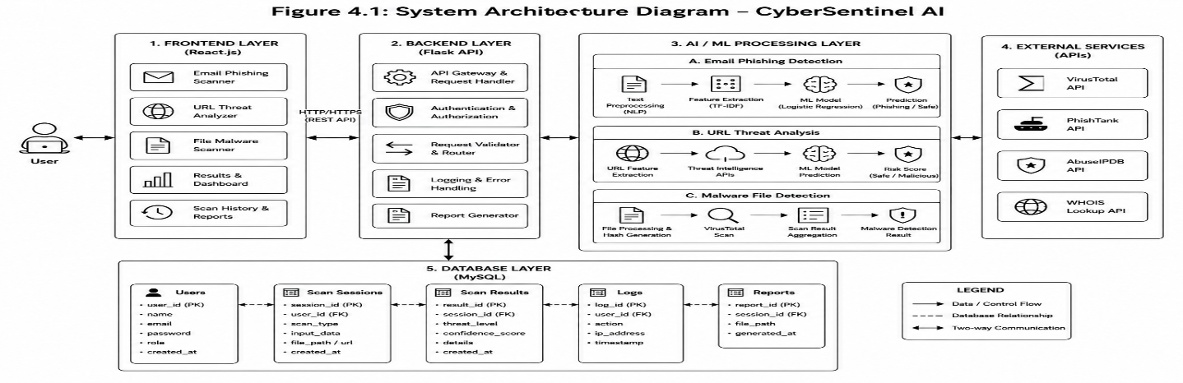
Figure 4. 1: System Architecture Diagram

4.2 Entity Relationship Diagram
The Entity Relationship (ER) diagram represents the database structure of CyberSentinel AI. It illustrates the entities used in the system along with their attributes and relationships.
The primary entities include User, Scan Session, Scan Result, Logs, and Reports. A user can perform multiple scan sessions, while each session generates a corresponding scan result. Logs are maintained for monitoring system activities and reports are generated for storing downloadable scan summaries.
The ER diagram helps define the logical database design and ensures proper organization and retrieval of system data.
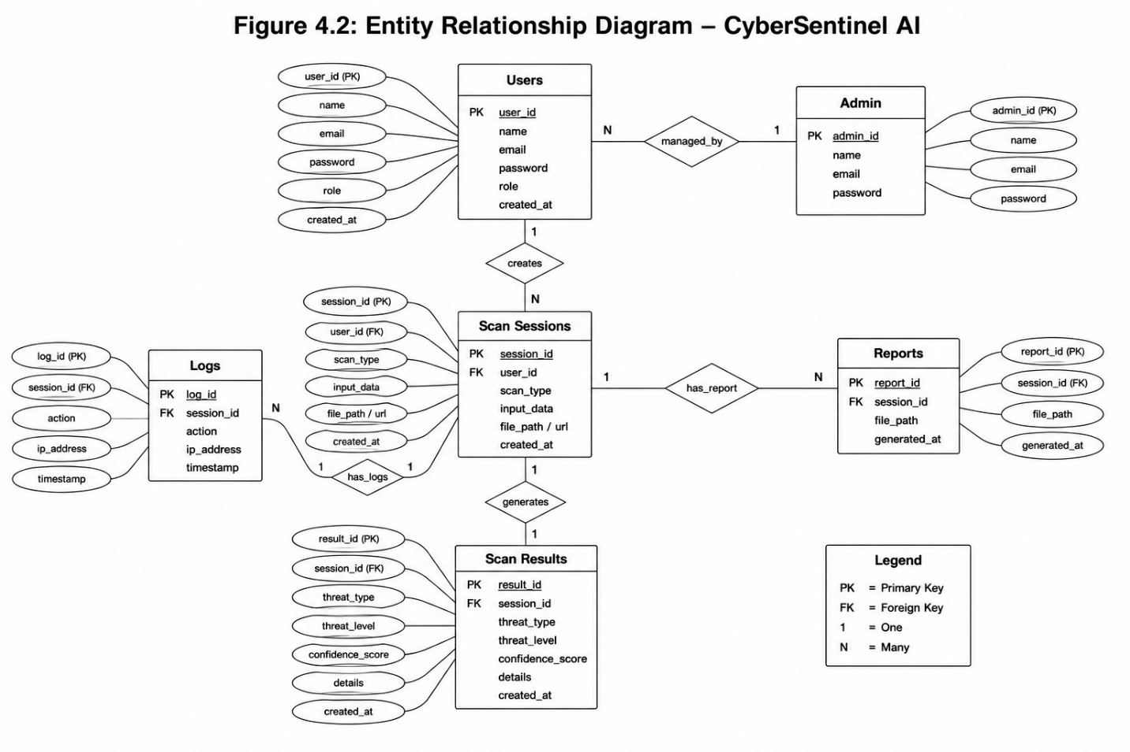
Figure 4. 2: Entity Relationship Diagram

4.3 Process Flow Diagram
The process flow diagram illustrates the workflow of the CyberSentinel AI system. It describes how the system processes user input and generates threat analysis results.
The process begins when the user submits an email, URL, or file to the system. Based on the input type, the request is forwarded to the corresponding analysis module. Email content is processed using NLP preprocessing and machine learning classification, URLs are analyzed using feature extraction and threat intelligence APIs, and uploaded files are scanned through VirusTotal API integration.
After analysis is completed, the generated results are stored in the database and displayed to the user with confidence scores, risk indicators, and recommendations. Users can also view scan history and download reports.
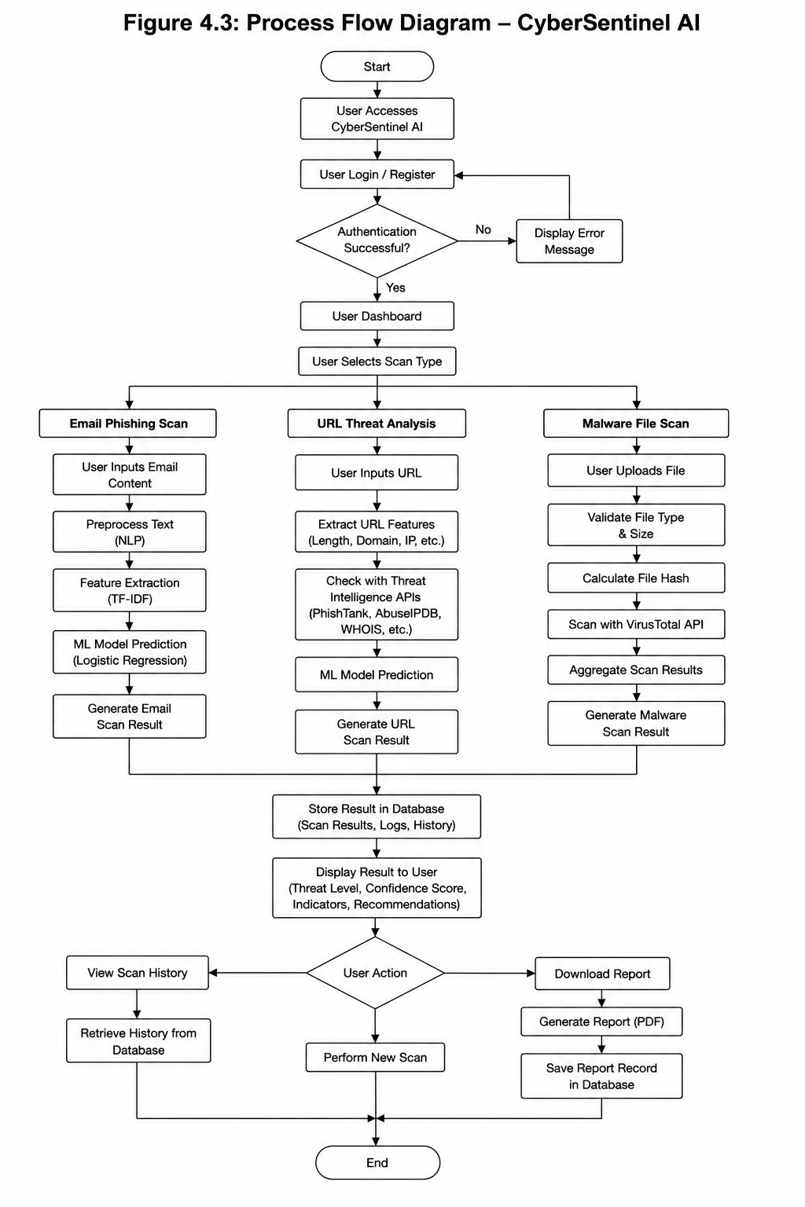
Figure 4. 3: Process Flow Diagram

4.4 Class Diagram
The class diagram represents the structural design of the system and shows the relationships between system classes. It identifies the main classes, their attributes, methods, and associations used within CyberSentinel AI.
The primary classes include User, Admin, ScanSession, ScanResult, and ThreatDetection modules. The User class manages user operations and authentication, while the Admin class handles system monitoring and management functionalities.
The ScanSession class stores information related to user scans, whereas the ScanResult class maintains prediction outputs, confidence scores, and threat levels. Additional classes are responsible for machine learning processing and API communication.
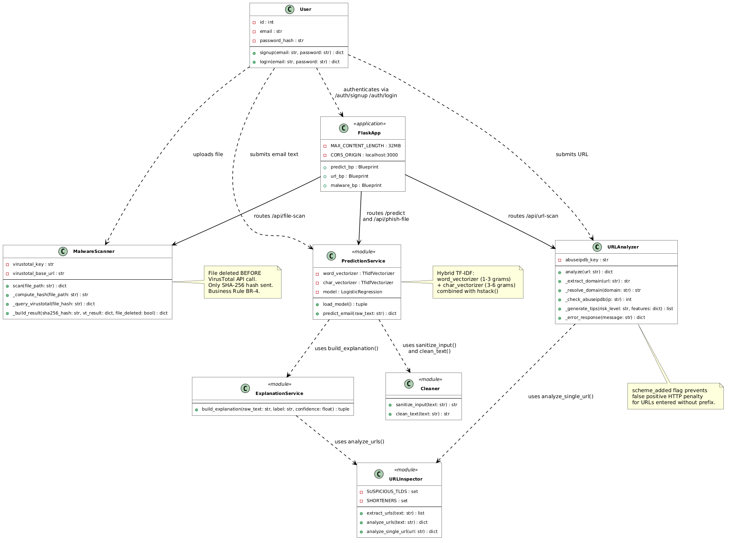
Figure 4. 4: Class Diagram

4.5 Sequence Diagram
The sequence diagram illustrates the interaction flow between the user, frontend interface, backend server, machine learning modules, and database during the threat analysis process.
When a user submits data for scanning, the frontend sends a request to the backend API. The backend validates the request and forwards it to the appropriate processing module. After analysis is completed, the result is returned to the backend, stored in the database, and displayed to the user through the frontend interface.
The sequence diagram highlights the communication and synchronization between different system components involved in the threat detection workflow.
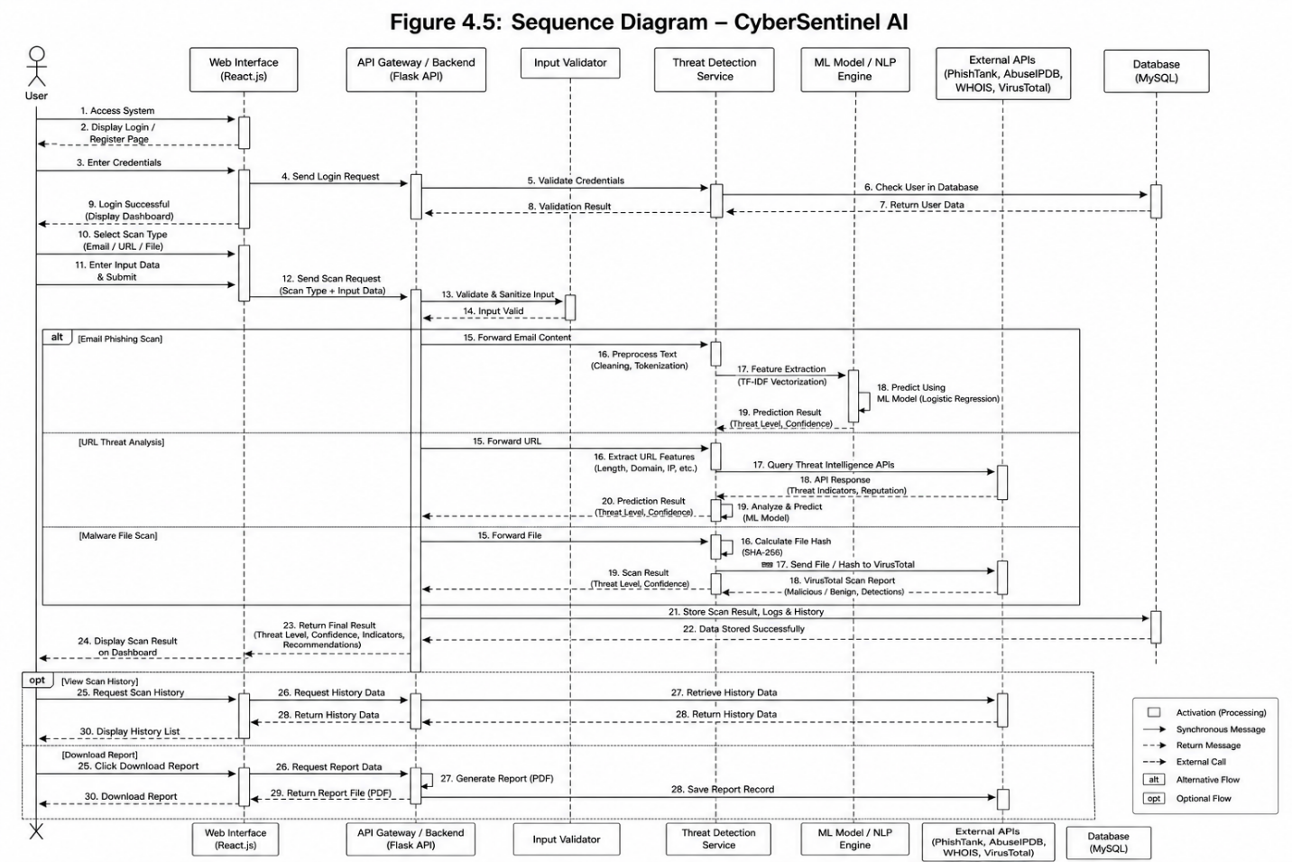
Figure 4. 5: Sequence Diagram

5. Implementation
This chapter explains the implementation details of CyberSentinel AI – Intelligent Cybersecurity Toolkit for Phishing, Malware, and Threat Detection. It describes the main algorithms used in the project, the external APIs integrated into the system, and the user interface screens developed for different users. The implementation of CyberSentinel AI is based on a modular approach in which each major functionality is developed as a separate component and then integrated into a unified web-based cybersecurity platform.
The final implementation includes phishing email detection, embedded link scanning, hidden .eml link analysis, malicious URL analysis, malware file scanning, VirusTotal live upload for unknown files, scan history, report generation, user authentication, admin panel, email notifications, Gmail/Chrome extension, and live deployment. The system uses a React.js frontend, Flask backend, machine learning models, SQLite database, and external threat intelligence APIs to provide real-time cybersecurity analysis.
The implementation follows the system architecture discussed in Chapter 4. The frontend layer handles user interaction, the backend layer processes requests and controls system logic, the AI/ML layer performs threat classification, the external API layer provides live threat intelligence, and the database layer stores user records, scan history, logs, and reports.

5.1 Algorithm
This section explains the major algorithms and workflows implemented in CyberSentinel AI. The purpose of this section is to describe how the main system modules operate without including source code. Each algorithm is explained using step-by-step natural language so that the working of the system can be clearly understood.

5.1.1 Phishing Email Detection Algorithm
The phishing email detection module is one of the core modules of CyberSentinel AI. It analyzes email text using Natural Language Processing and Machine Learning techniques. The module classifies email content as Safe, Suspicious, or Phishing and provides a confidence score with explanation. The phishing detection system uses a hybrid TF-IDF approach with Logistic Regression. Word-level TF-IDF captures complete words and phrases commonly found in phishing messages, while character-level TF-IDF helps detect obfuscated words and suspicious character patterns.
Algorithm Steps:
1. User enters email text or uploads an email file through the frontend.
2. The frontend sends the email content to the Flask backend.
3. The backend validates the input to ensure that the email text is not empty.
4. The input is sanitized to remove harmful HTML tags, scripts, and unnecessary characters.
5. Text preprocessing is applied, including lowercasing, punctuation removal, URL tokenization, and spacing normalization.
6. Word-level TF-IDF vectorization is applied to capture important phishing words and phrases.
7. Character-level TF-IDF vectorization is applied to capture obfuscated patterns.
8. Both feature matrices are combined into a single feature vector.
9. The trained Logistic Regression model predicts the class of the email.
10. The system calculates the confidence score and prepares threat indicators.
11. The final result is returned to the frontend and stored in scan history.
12. If the result is suspicious or phishing, the notification module may generate an alert.
Output of the module includes:
• Email classification result
• Confidence score
• Threat indicators
• Safety recommendations
• Timestamp
• Scan history record

5.1.2 Embedded Link Scanning Algorithm
The embedded link scanning module extracts visible URLs from email text and analyzes each URL individually using the URL analyzer. This improves phishing detection because many phishing emails contain malicious links even when the surrounding message appears normal.
Algorithm Steps:
1. User submits email text for phishing analysis.
2. The backend scans the email text using a URL extraction pattern.
3. All visible URLs found in the email are collected in a list.
4. Duplicate URLs are removed to avoid repeated scanning.
5. Each extracted URL is passed to the URL analyzer module.
6. The URL analyzer checks structural URL features and reputation information.
7. Each link receives an individual verdict as Safe, Suspicious, or Malicious.
8. The embedded link results are combined with the main phishing email result.
9. The frontend displays a separate embedded links section.
10. The scan record is stored in the database.

5.1.3 Hidden Link Detection in .eml Files
The final version implements hidden link detection for .eml email files. This is an advanced feature because hidden links cannot always be detected from copied plain text. In HTML emails, the visible text may show a trusted phrase while the actual hyperlink points to a malicious domain.
Algorithm Steps:
1. User uploads a .eml email file.
2. The backend reads the email file using an email parsing module.
3. The system separates plain text and HTML content from the email body.
4. HTML content is parsed to identify anchor tags.
5. For each anchor tag, the system extracts visible link text and hidden href destination.
6. The destination URL is passed to the URL analyzer.
7. The system checks whether the visible text and destination domain are mismatched.
8. If the visible text appears safe but the actual link points to a suspicious or unrelated domain, the system flags it as a hidden-link risk.
9. The result is added to the email scan output.
10. The frontend displays hidden link warnings separately and stores the scan result in history.

5.1.4 URL Threat Analysis Algorithm
The URL threat analyzer checks suspicious URLs using structural features and threat intelligence. It classifies URLs as Safe, Suspicious, or Malicious. The analyzer evaluates URL length, IP-based domains, @ symbols, HTTP usage, suspicious keywords, hyphens, shorteners, excessive subdomains, suspicious top-level domains, and long paths.
Algorithm Steps:
1. User submits a URL through the URL scan page or through an embedded email link.
2. The backend validates the URL format and normalizes it if necessary.
3. The system extracts structural URL features such as length, domain format, suspicious keywords, subdomain count, scheme, and path length.
4. Each suspicious feature contributes to a risk score.
5. The system resolves the domain to an IP address where possible.
6. The resolved IP is checked using AbuseIPDB.
7. If PhishTank lookup is available, the URL reputation is checked against known phishing records.
8. The local risk score and threat intelligence score are combined.
9. The system assigns a final verdict as Safe, Suspicious, or Malicious.
10. The result is displayed with risk indicators, explanation, and recommendation.
11. The URL scan result is saved in the database.
Output of the module includes:
• Final URL verdict
• Risk score
• Matched suspicious features
• Threat intelligence result
• Recommendation for the user

5.1.5 Malware File Scanning Algorithm
The malware file scanning module allows users to upload suspicious files for scanning. The system validates the file, computes its SHA-256 hash, and checks it through VirusTotal. File scanning is designed with privacy in mind because files are handled temporarily and are not permanently stored.
Algorithm Steps:
1. User uploads a file through the file scan page.
2. The frontend sends the file to the Flask backend using multipart form data.
3. The backend validates file type, file size, and file name safety.
4. The file is temporarily saved in a secure temporary location.
5. The system calculates the SHA-256 hash of the file.
6. The file is checked against VirusTotal using hash lookup.
7. If VirusTotal returns a known result, the system parses malicious, suspicious, harmless, undetected, and flagged-engine counts.
8. The system generates a verdict as Clean, Suspicious, or Malicious.
9. The file is deleted after processing according to the privacy policy.
10. The result is returned to the frontend and stored as scan metadata.
11. If the file is suspicious or malicious, an email notification may be sent.

5.1.6 VirusTotal Live Upload for Unknown Files
A limitation of hash-based scanning is that a new file may not exist in the VirusTotal database. The final system improves this by uploading unknown files to VirusTotal for live analysis and polling until the result becomes available.
Algorithm Steps:
1. File hash lookup is performed through VirusTotal.
2. If the file is found, the system uses the returned report.
3. If the file is not found, the system marks it as unknown temporarily.
4. The backend uploads the file to VirusTotal’s file analysis endpoint.
5. VirusTotal returns an analysis ID.
6. The backend waits for a short interval and checks the analysis status using the analysis ID.
7. If the analysis is completed, the result is fetched and parsed.
8. If the maximum polling limit is reached, the system returns a pending or delayed result.
9. The final verdict is displayed to the user and saved in scan history.
10. The user may receive an email notification if the verdict is suspicious or malicious.

5.1.7 Scan History and Database Storage Algorithm
The scan history module stores previous scans so that users can review earlier results. This improves system usability and provides evidence for later reference.
Algorithm Steps:
1. User performs an email, URL, or file scan.
2. The backend receives the result from the related detection module.
3. The system creates a scan session record.
4. The scan result is saved with user ID, scan type, threat type, threat level, confidence score, timestamp, and result details.
5. If a report is generated, the report path is linked with the scan session.
6. The history page requests previous scans for the logged-in user.
7. The backend retrieves records from the database.
8. The frontend displays the scan history in tabular or card format.
9. Users can view details or download available reports.

5.1.8 Report Generation Algorithm
The report generation module allows users to download a summary of scan results. Reports are useful for record keeping, awareness, and sharing suspicious content analysis with other people.
Algorithm Steps:
1. User completes a scan.
2. User clicks the Download Report button.
3. The frontend collects the current scan result.
4. The report generator prepares report content including scan type, verdict, confidence score, threat indicators, recommendations, date, and time.
5. The report is generated in PDF format.
6. The file is downloaded by the user.
7. A report record is saved in the database.

5.1.9 Admin Panel Workflow
The admin panel allows administrative monitoring and management of the system. The admin can view users, scan records, logs, system statistics, and threat activity.
Algorithm Steps:
1. Admin logs into the system using admin credentials.
2. The backend verifies the admin role.
3. After successful login, the admin dashboard is displayed.
4. The admin can view total users, total scans, email scans, URL scans, file scans, threat statistics, and recent logs.
5. The admin can manage users where required.
6. The admin can review scan history and audit logs.
7. System statistics are updated from database records.
8. Admin actions are logged for traceability.

5.1.10 Email Notification Workflow
The email notification module sends alerts or scan summaries to users when important events occur. It is especially useful when a scan result is suspicious or malicious.
Algorithm Steps:
1. A scan is completed.
2. The system checks the final threat level.
3. If the result is suspicious or malicious, the notification module is triggered.
4. The system prepares an email message containing scan type, threat verdict, confidence score, short explanation, and safety recommendation.
5. The email is sent to the registered user using SMTP or configured email service.
6. Notification status is recorded in logs.
7. If email sending fails, the system records the error and continues without interrupting the scan result display.

5.1.11 Gmail/Chrome Extension Workflow
The Gmail/Chrome extension allows users to scan email content directly from Gmail. This makes the system more practical because users do not always need to copy and paste email text manually.
Algorithm Steps:
1. User opens Gmail in the Chrome browser.
2. User opens a suspicious email.
3. User clicks the CyberSentinel AI extension icon.
4. The extension content script reads the visible email text and available links.
5. The extension sends the extracted email data to the live CyberSentinel backend.
6. The backend runs phishing detection and embedded link analysis.
7. The backend returns the verdict and confidence score.
8. The extension popup displays the result to the user.
9. If the email is risky, the user receives a warning.
10. The scan may be saved in scan history if the user is authenticated.

5.1.12 Live Deployment Workflow
The final version of CyberSentinel AI is deployed so that it can be accessed beyond the local development environment.
Algorithm Steps:
1. Flask backend is deployed on a cloud hosting platform.
2. Environment variables are configured securely on the hosting platform.
3. API keys are stored on the server side only.
4. React frontend is deployed on a static hosting platform.
5. Frontend API base URL is changed from localhost to the live backend URL.
6. CORS settings are updated to allow the deployed frontend domain.
7. Database and logs are configured for the deployed environment.
8. All modules are tested from a different device and network.
9. The Gmail extension is connected to the live backend.

5.2 External APIs
CyberSentinel AI integrates external APIs to improve real-time threat intelligence and detection accuracy. These APIs allow the system to check URLs, IP addresses, and files against large external cybersecurity databases. API keys are stored on the backend side and are not exposed to the frontend or browser extension.

Table 5. 1: Details of APIs Used in the Project
Name of API | Description of API | Purpose of Usage | Function/Class Name in Which It Is Used
VirusTotal API v3 | VirusTotal is a threat intelligence platform that analyzes files and URLs using multiple antivirus engines and security vendors. | Used for malware file scanning, SHA-256 hash lookup, live upload of unknown files, and retrieval of file analysis results. | MalwareScanner, malware_service.py, file_scan_route
AbuseIPDB API | AbuseIPDB provides reputation information about IP addresses reported for malicious or abusive activity. | Used to check the reputation of IP addresses resolved from submitted URLs. | URLAnalyzer, url_service.py, abuseipdb_lookup
PhishTank API | PhishTank provides a community-based database of reported phishing URLs. | Used to verify whether a submitted URL is already reported as a phishing website. | URLAnalyzer, phishtank_lookup
SMTP / Email Service | SMTP or configured email service is used to send system generated email messages to users. | Used for sending threat alerts, suspicious scan notifications, and scan summary messages. | NotificationService, email_service.py
CyberSentinel Backend API | Internal REST API developed using Flask for communication between the frontend, extension, and backend modules. | Used by React frontend and Gmail extension to submit scans and receive results. | app.py, predict_routes.py, url_routes.py, malware_routes.py
Gmail / Chrome Extension API | Browser extension interface used to interact with Gmail page content and browser popup components. | Used to extract email text and links from Gmail and send them to the CyberSentinel live backend. | manifest.json,content.js, popup.js

The external API integration makes CyberSentinel AI more reliable because the system does not depend only on local rules or machine learning predictions. Instead, it combines local AI-based analysis with live global threat intelligence.

5.3 User Interface
The user interface of CyberSentinel AI is designed to be simple, clear, and understandable for non-technical users. Since the target users include students, freelancers, small business owners, and general internet users, the interface avoids unnecessary technical complexity and presents results in plain language.
The system uses a dashboard-based interface developed in React.js. Users can navigate to different modules from the sidebar or navigation menu. Each module follows a simple workflow: submit input, click scan, view result, and download report if required.

5.3.1 Login and Registration Interface
The login and registration interface allows users to create an account and access the system securely. Registered users can scan content, view scan history, download reports, and receive email notifications.
Main features include:
• User registration
• User login
• Role-based access
• Session handling
• Logout functionality

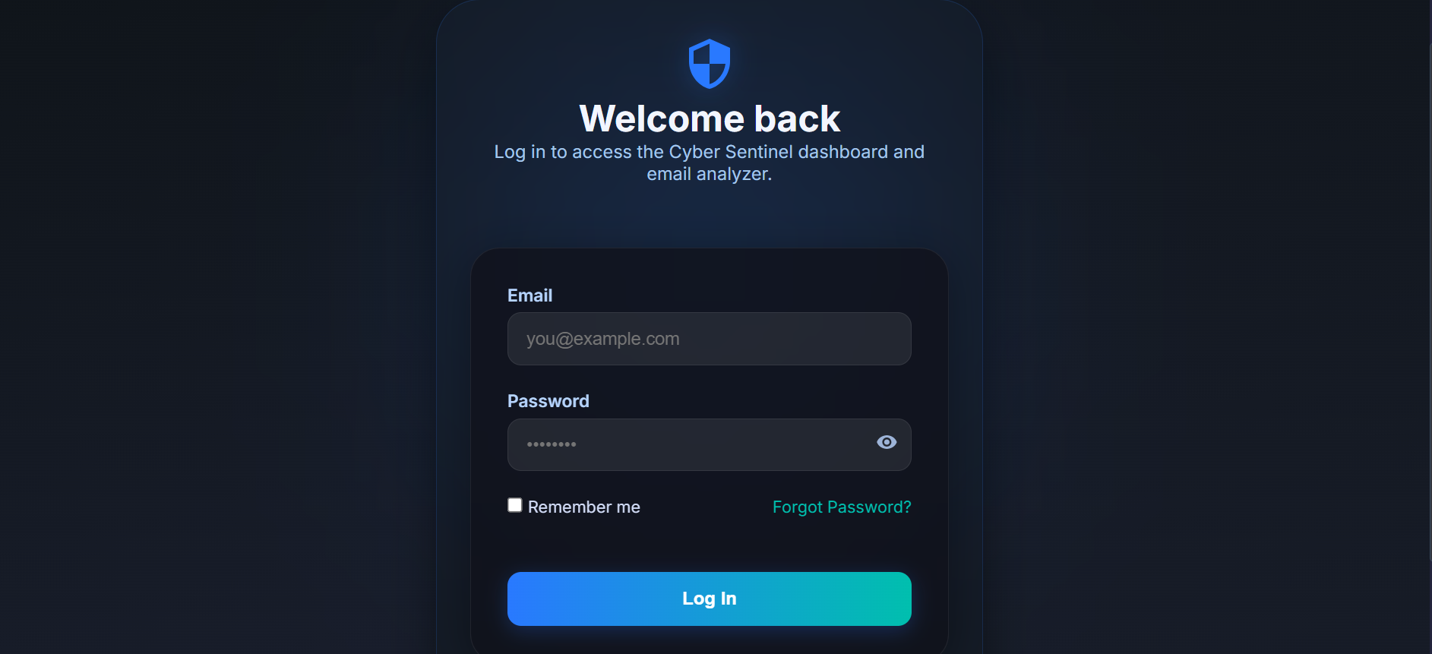
Figure 5. 1: Login and Registration Interface

5.3.2 User Dashboard
The dashboard provides an overview of the system and gives users access to all major scanning modules. It may also show scan statistics such as total scans, recent scans, and detected threats.
This section shows:
• Email phishing scan
• URL threat analysis
• Malware file scan
• Scan history
• Download reports
• User profile
• Logout


Figure 5. 2: User Dashboard

5.3.3 Email Phishing Scan Interface
The email scan page allows users to paste suspicious email text or upload email files. After scanning, the system displays whether the email is safe, suspicious, or phishing.
Main features include:
• Threat verdict
• Confidence score
• Explanation
• Embedded link analysis
• Hidden .eml link warning
• Recommended action

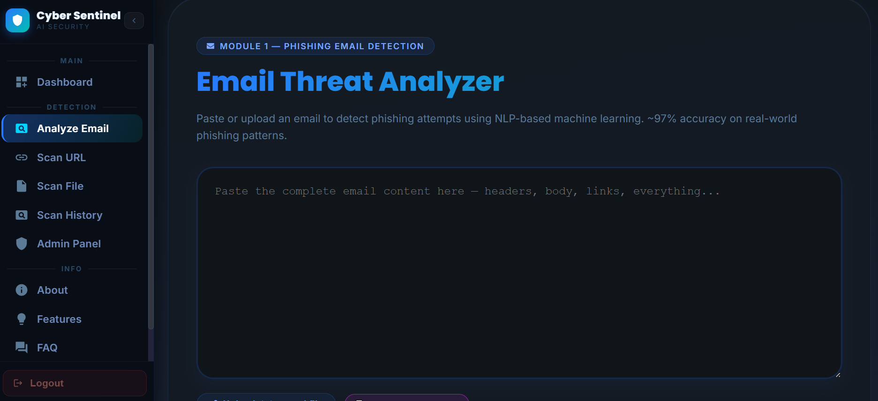
Figure 5. 3:Email Phishing Scan Interface

5.3.4 Embedded and Hidden Link Result Interface
The embedded link result section displays all extracted URLs found inside the email. Each URL is analyzed separately and shown with its own risk level. For .eml files, hidden HTML links are also displayed if the visible text and actual destination are mismatched.
This section shows:
• Extracted visible URL
• Hidden destination URL
• URL verdict
• Mismatch warning
• Risk score

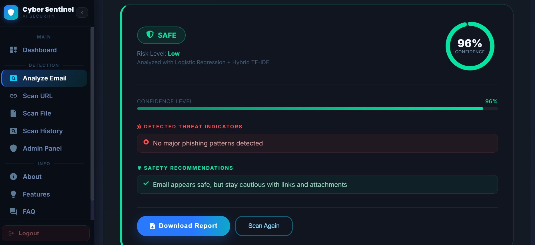
Figure 5. 4: Embedded and Hidden Link Detection Result

5.3.5 URL Threat Analysis Interface
The URL scan page allows users to enter suspicious links. The system checks URL structure and threat intelligence results.
Main features include:
• URL verdict
• Risk score
• Suspicious features
• AbuseIPDB result
• PhishTank result
• Final recommendation
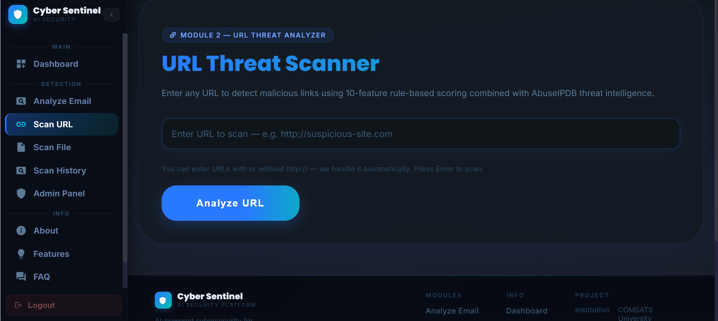
Figure 5. 5:URL Threat Analysis Interface

5.3.6 Malware File Scan Interface
The file scan page allows users to upload files for malware scanning. The system validates the file and scans it using VirusTotal.
Main features include:
• File name
• File hash
• VirusTotal result
• Malicious engine count
• Suspicious engine count
• Final verdict
• File privacy status
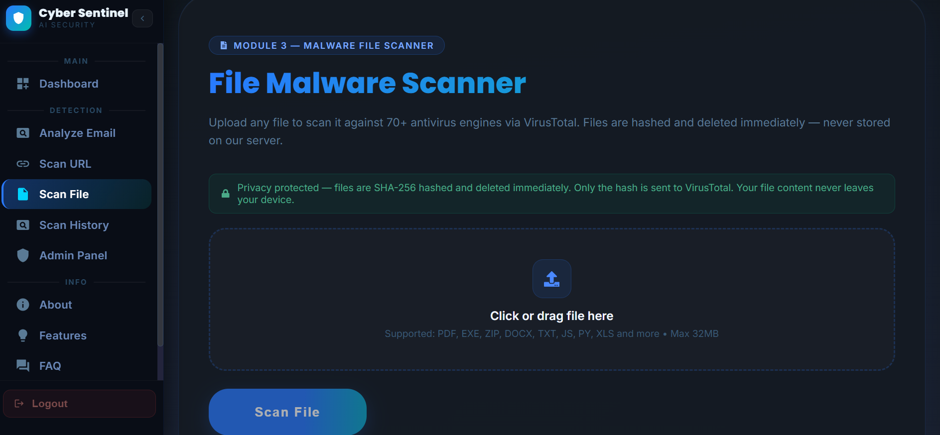
Figure 5. 6: Malware File Scan Interface

5.3.7 Scan History Interface
The scan history page displays previous scans performed by the user. This allows users to review older results and download reports if available.
Main features include:
• Scan type
• Date and time
• Threat verdict
• Confidence score
• Report option
• Detailed view
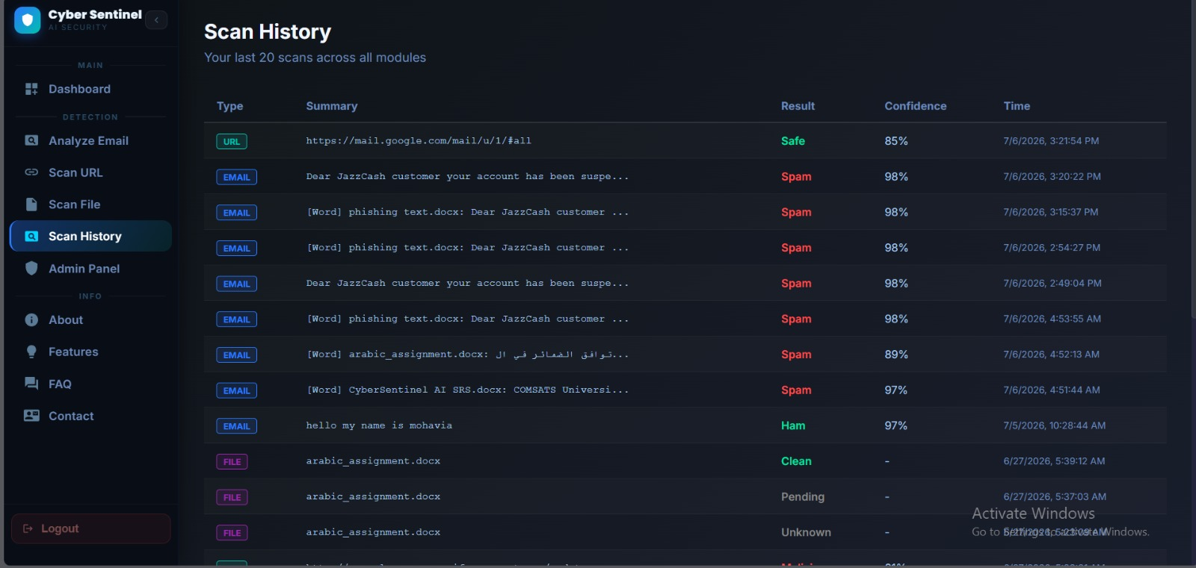
Figure 5. 7: Scan History Interface

5.3.8 Report Interface
The report interface allows users to generate and download scan reports. Reports summarize the scan result in a structured format.
Main features include:
• Project name
• Scan type
• Verdict
• Confidence score
• Threat details
• Safety tips
• Timestamp
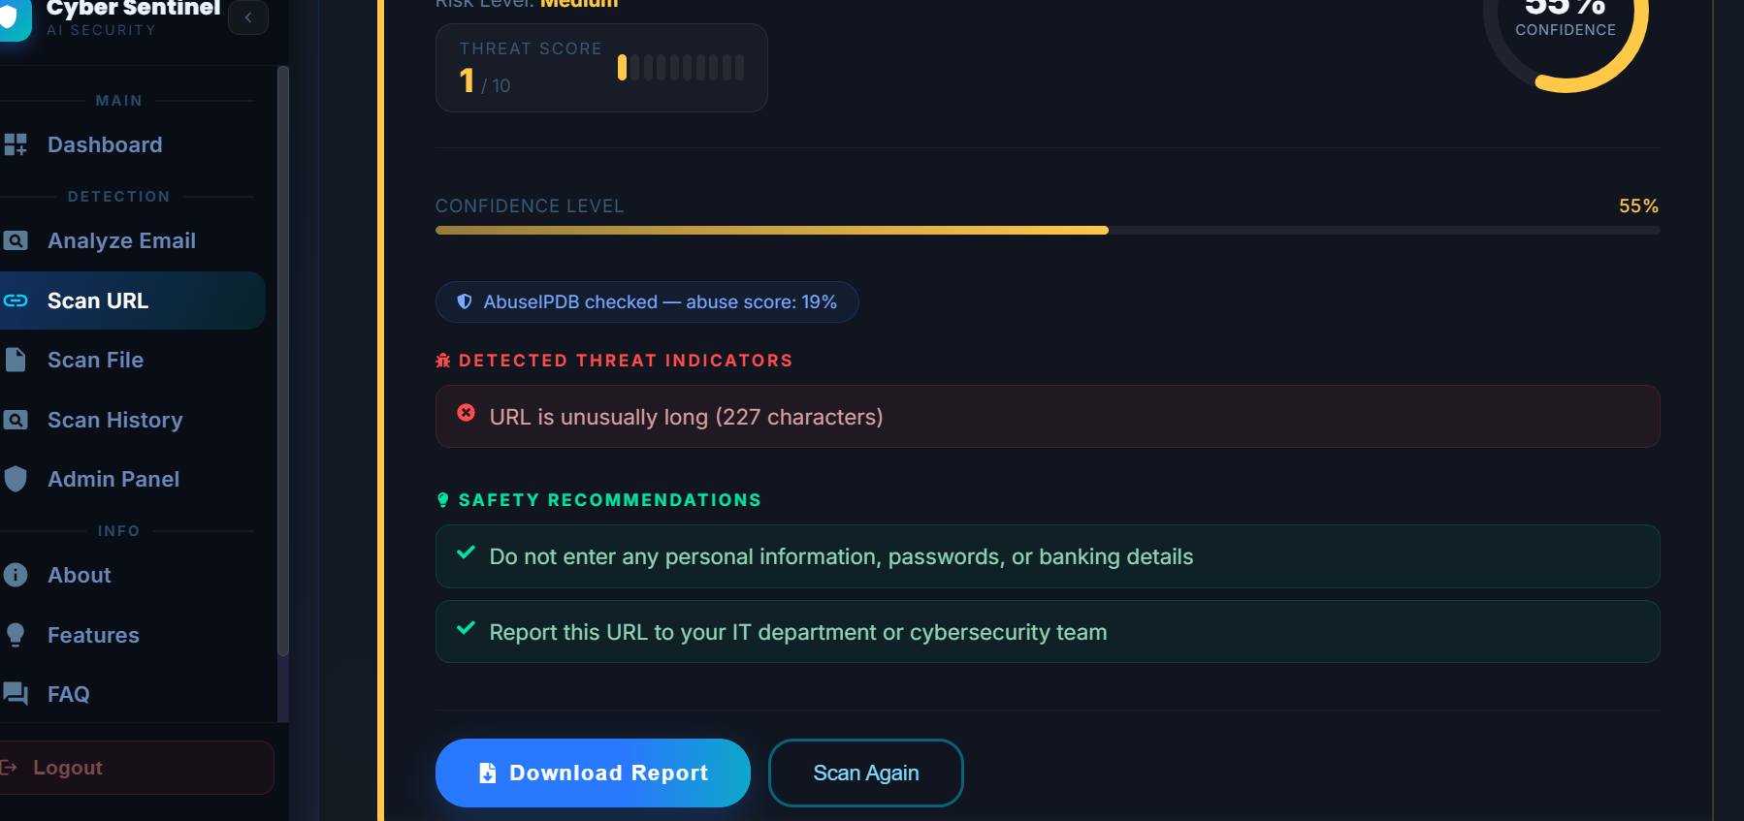
Figure 5. 8: PDF Report Interface

5.3.9 Admin Panel Interface
The admin panel is designed for system monitoring and management. Admin users can view scan statistics, user records, threat logs, and system activity.
Main features include:
• View total users
• View total scans
• View detected threats
• Manage users
• View logs
• View scan records
• Monitor system activity
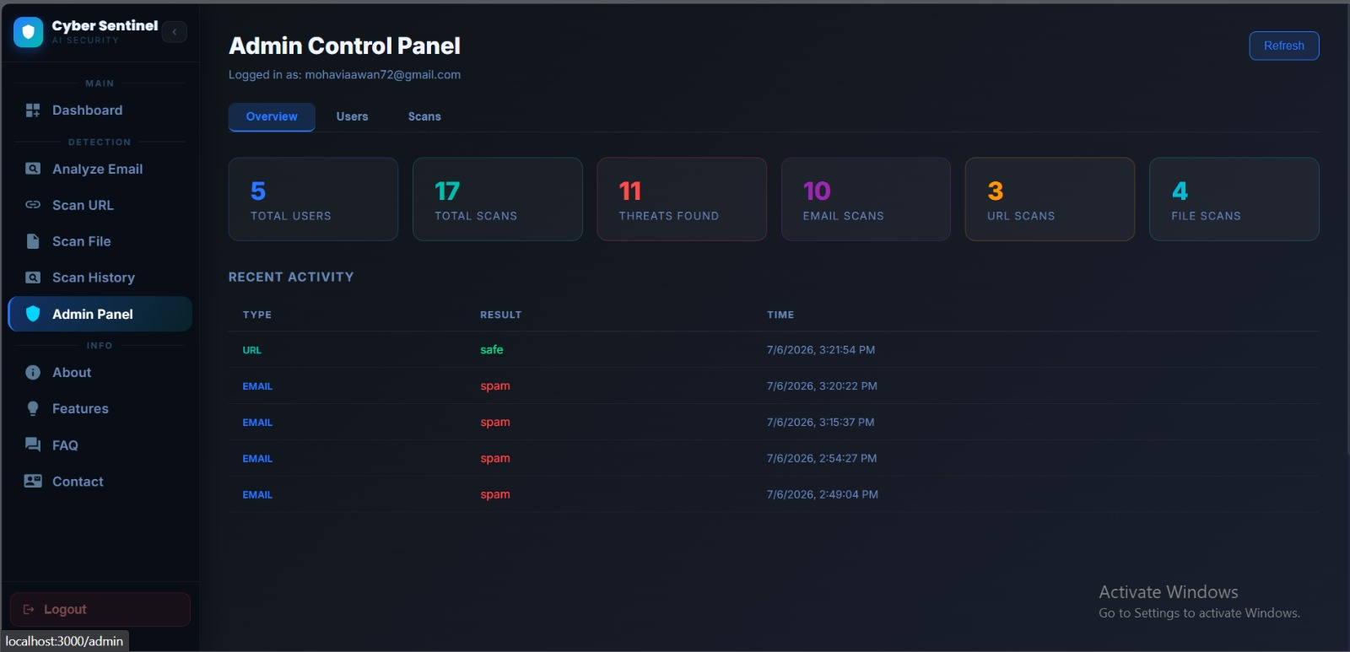
Figure 5. 9: Admin Panel Interface

5.3.10 Email Notification Output
The email notification system sends alerts to users when suspicious or malicious activity is detected. The notification contains the scan result and a short safety recommendation.
This section shows:
• Scan type
• Threat level
• Confidence score
• Short explanation
• Recommended user action
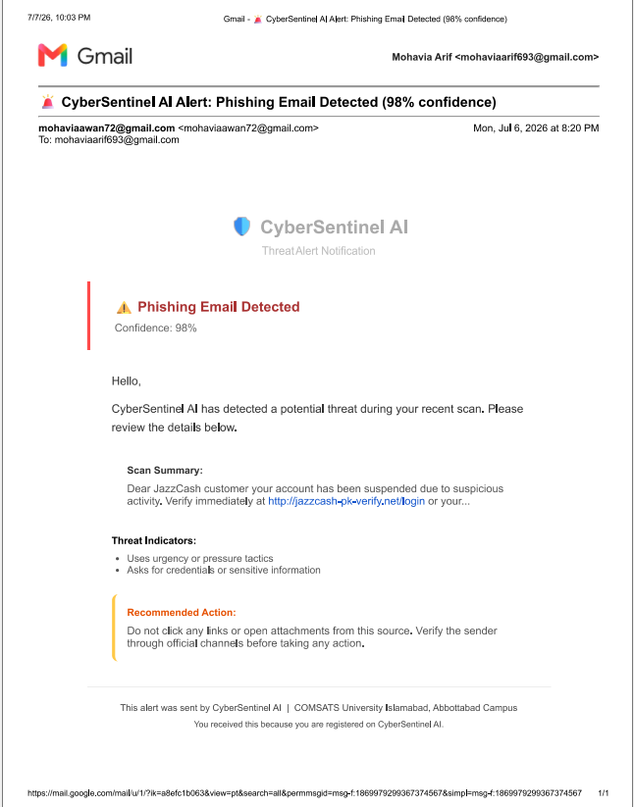
Figure 5. 10: Email Notification Output

5.3.11 Gmail/Chrome Extension Interface
The Gmail extension interface allows the user to scan an opened Gmail message directly from the browser. The extension popup displays the verdict without requiring the user to manually copy the email into the web dashboard.
Main features include:
• Scan current email button
• Result badge
• Confidence score
• Risk explanation
• Link warning
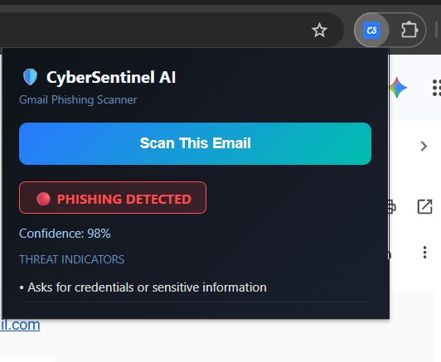
Figure 5. 11: Gmail Extension Interface

5.4 Summary
This chapter explained the implementation of CyberSentinel AI through its major algorithms, external APIs, and user interface modules. The implementation demonstrates how multiple cybersecurity features are integrated into one complete platform. The system combines machine learning, natural language processing, URL feature analysis, malware scanning, live threat intelligence, database storage, reporting, admin monitoring, email notifications, Gmail extension support, and live deployment.
The next chapter discusses the testing and evaluation of the implemented system, including manual testing, unit testing, functional testing, integration testing, and automated testing.

6. Testing and Evaluation
This chapter presents the testing and evaluation process performed on CyberSentinel AI - Intelligent Cybersecurity Toolkit for Phishing, Malware, and Threat Detection. Testing was conducted to verify that all implemented modules work according to the defined requirements and that the system performs reliably in real usage conditions. The testing process included manual testing, system testing, unit testing, functional testing, integration testing, automated API testing, deployment testing, and extension testing.
The final version of CyberSentinel AI includes several modules such as phishing email detection, embedded link scanning, hidden .eml link detection, malicious URL analysis, malware file scanning, VirusTotal live upload for unknown files, scan history, report generation, admin panel, email notifications, Gmail/Chrome extension, and live deployment. Each module was tested individually and then evaluated as part of the complete integrated system.
Testing was performed to ensure that the system correctly accepts user input, validates data, processes requests through the backend, performs AI/ML or API-based analysis, stores results in the database, generates reports, sends notifications, and displays results clearly to the user. The main goal of testing was to confirm that CyberSentinel AI is accurate, usable, secure, and reliable for non-technical users.

6.1 Manual Testing
Manual testing was performed by interacting with the system through the user interface and verifying whether each feature behaved as expected. The system was tested from the perspective of both normal users and administrators. Manual testing helped identify interface issues, incorrect messages, missing validations, and integration problems that may not be detected through automated tests.
The following modules were manually tested:
• User registration and login
• Email phishing scan
• Embedded link scanning
• Hidden .eml link detection
• URL threat analysis
• Malware file scanning
• VirusTotal unknown file upload
• Scan history
• PDF report generation
• Email notifications
• Admin dashboard
• Gmail/Chrome extension
• Live deployment access

6.1.1 System Testing
System testing was performed after all modules were integrated into one complete platform. The purpose of system testing was to verify that CyberSentinel AI works as a complete cybersecurity toolkit rather than separate individual modules. The testing checked complete user journeys from login to scan submission, result display, report generation, scan history storage, and notification delivery.

Table 6. 1: System Testing
No. | Test Case / Test Script | Input / Attribute | Expected Result | Result
1 | Open the deployed CyberSentinel AI web application | Live frontend URL | Homepage or login page loads successfully | Pass
2 | Register a new user account | Name, email, password | User account is created successfully | Pass
3 | Login with valid user credentials | Registered email and password | User dashboard is displayed | Pass
4 | Login with invalid credentials | Wrong email or password | Error message is displayed | Pass
5 | Submit phishing email text for scanning | JazzCash-style phishing message | System classifies email as suspicious or phishing | Pass
6 | Submit safe email text for scanning | Normal meeting email | System classifies email as safe | Pass
7 | Submit email containing visible URL | Email with suspicious URL | Email result and embedded URL result are displayed | Pass
8 | Upload .eml file containing hidden link | HTML email with mismatched link text and href | Hidden link warning is displayed | Pass
9 | Submit suspicious URL | URL containing suspicious keywords and long path | URL is classified as suspicious or malicious | Pass
10 | Submit safe URL | Trusted website URL | URL is classified as safe | Pass
11 | Upload known malware test file/hash sample | Supported file type | VirusTotal result is displayed | Pass
12 | Upload unknown clean Word file | New .docx file | File is uploaded to VirusTotal for live analysis and result is returned | Pass
13 | Generate scan report | Completed scan result | PDF report is generated and downloaded | Pass
14 | View scan history | Logged-in user with previous scans | Previous scans are displayed | Pass
15 | Admin login | Admin credentials | Admin dashboard is displayed | Pass
16 | View admin statistics | Admin dashboard | Total scans, users, and threats are displayed | Pass
17 | Send email notification after risky scan | Suspicious or malicious scan result | User receives notification email | Pass
18 | Scan Gmail message using extension | Open Gmail email and click extension | Extension displays scan verdict | Pass
19 | Test system from another device/network | Live deployed link | System opens and scans successfully | Pass
20 | Logout from system | Logout button | User session ends successfully | Pass

System testing confirmed that the complete platform works according to the expected workflow and that all major modules are connected properly.

6.1.2 Unit Testing
Unit testing was performed on individual modules to verify that each component works correctly before integration. Each unit was tested separately using controlled input and expected output. Unit testing helped ensure that errors inside one module did not affect the rest of the system.
Unit Testing 1: Phishing Email Detection
Testing Objective: To ensure that the phishing detection model correctly classifies email text.

Table 6. 2: Phishing Email Detection Unit Test Case
No. | Test Case / Test Script | Attribute and Value | Expected Result | Result
1 | Test phishing email classification | Your JazzCash account is suspended. Verify now. | Email classified as phishing or suspicious | Pass
2 | Test safe email classification | Project meeting is scheduled for Monday. | Email classified as safe | Pass
3 | Test empty email input | Empty text field | Error message displayed | Pass
4 | Test long email input | Large email text | System processes or rejects safely according to limit | Pass
5 | Test obfuscated phishing words | verif1cation required for acc0unt | Suspicious pattern detected | Pass

Unit Testing 2: Embedded Link Scanning
Testing Objective: To ensure that visible URLs inside email text are extracted and analyzed separately.

Table 6. 3: Embedded Link Scanning Unit Test Case
No. | Test Case / Test Script | Attribute and Value | Expected Result | Result
1 | Extract one URL from email | Email contains one suspicious link | URL is extracted successfully | Pass
2 | Extract multiple URLs from email | Email contains more than one URL | All URLs are extracted | Pass
3 | Remove duplicate URLs | Same URL repeated twice | Duplicate URL is ignored | Pass
4 | Scan extracted suspicious URL | Extracted phishing-style URL | URL verdict shown separately | Pass
5 | Submit email without URLs | Email contains no URL | System displays email result without embedded link section | Pass

Unit Testing 3: Hidden .eml Link Detection
Testing Objective: To ensure that hidden links inside .eml files are parsed and checked.

Table 6. 4: Hidden EML Link Detection Unit Test Case
No. | Test Case / Test Script | Attribute and Value | Expected Result | Result
1 | Upload valid .eml file | Email file with HTML content | Email is parsed successfully | Pass
2 | Detect anchor tag link | HTML email with href link | Actual destination URL is extracted | Pass
3 | Compare visible text with hidden URL | Visible text says JazzCash but href points to unknown domain | Mismatch warning displayed | Pass
4 | Scan hidden URL | Extracted hidden link | URL analyzer returns risk result | Pass
5 | Upload .eml without links | Plain email file | No hidden link warning displayed | Pass

Unit Testing 4: URL Threat Analyzer
Testing Objective: To ensure that URL analysis correctly checks structural features and API reputation.

Table 6. 5: URL Analyzer Unit Test Case
No. | Test Case / Test Script | Attribute and Value | Expected Result | Result
1 | Test safe HTTPS URL | https://www.comsats.edu.pk | URL classified as safe | Pass
2 | Test HTTP URL | http://example.com/login | HTTP risk feature detected | Pass
3 | Test IP-based URL | http://192.168.1.1/login | IP-domain risk detected | Pass
4 | Test suspicious keyword URL | URL containing verify-account-login | Suspicious keyword risk detected | Pass
5 | Test shortened URL | Shortener-based URL | URL shortener warning displayed | Pass
6 | Test AbuseIPDB lookup | URL domain resolved to IP | IP reputation checked successfully | Pass

Unit Testing 5: Malware File Scanner
Testing Objective: To ensure that file validation, hash generation, VirusTotal lookup, and live upload work correctly.

Table 6. 6: Malware File Scanner Unit Test Case
No. | Test Case / Test Script | Attribute and Value | Expected Result | Result
1 | Upload supported file type | .pdf, .docx, .txt, or .zip | File accepted for scanning | Pass
2 | Upload unsupported file type | Unsupported extension | Error message displayed | Pass
3 | Upload large file | File exceeding size limit | File rejected safely | Pass
4 | Generate SHA-256 hash | Valid uploaded file | Correct hash generated | Pass
5 | VirusTotal hash lookup | Known file hash | VirusTotal report returned | Pass
6 | Unknown file live upload | New file not found by hash lookup | File uploaded for live analysis | Pass
7 | Poll VirusTotal analysis | Analysis ID returned | Final analysis result retrieved | Pass
8 | Delete temporary file | File after scan | Temporary file removed | Pass

Unit Testing 6: Authentication, Database, and Scan History
Testing Objective: To ensure user accounts, sessions, and scan records work correctly.

Table 6. 7: Authentication and Database Unit Test Case
No. | Test Case / Test Script | Attribute and Value | Expected Result | Result
1 | Register new user | Valid email and password | User record stored | Pass
2 | Prevent duplicate registration | Existing email | Duplicate account error displayed | Pass
3 | Login valid user | Correct credentials | User session starts | Pass
4 | Login invalid user | Wrong credentials | Login rejected | Pass
5 | Store email scan result | Completed email scan | Record saved in database | Pass
6 | Store URL scan result | Completed URL scan | Record saved in database | Pass
7 | Store file scan result | Completed file scan | Record saved in database | Pass
8 | Retrieve scan history | Logged-in user | Previous scan records displayed | Pass

Unit Testing 7: Admin Panel and Email Notifications
Testing Objective: To ensure admin monitoring and notification delivery work correctly.

Table 6. 8: Admin Panel and Email Notification Unit Test Case
No. | Test Case / Test Script | Attribute and Value | Expected Result | Result
1 | Login as admin | Admin credentials | Admin dashboard opens | Pass
2 | View user list | Admin panel | Registered users displayed | Pass
3 | View scan logs | Admin panel logs page | Logs displayed correctly | Pass
4 | View threat statistics | Admin dashboard | Scan and threat statistics shown | Pass
5 | Trigger email notification | Suspicious scan result | Email alert sent to user | Pass
6 | Handle email failure | Invalid SMTP setting or unreachable service | Error logged without crashing system | Pass

6.1.3 Functional Testing
Functional testing was performed to verify that each functional requirement defined in Chapter 3 is implemented correctly. The purpose of functional testing is to ensure that every module performs its required operation from the user perspective.

Table 6. 9: Functional Testing
No. | Functional Requirement | Test Case / Test Script | Expected Result | Result
1 | User registration | User creates new account | Account is created successfully | Pass
2 | User login | User enters valid credentials | Dashboard opens | Pass
3 | Email scan | User submits email text | Email verdict is displayed | Pass
4 | Phishing classification | Submit phishing-style email | System identifies risk | Pass
5 | Embedded link scanning | Submit email containing URL | Extracted link is scanned separately | Pass
6 | Hidden .eml link detection | Upload .eml file with hidden href | Hidden link mismatch detected | Pass
7 | URL analysis | User submits suspicious URL | URL risk result displayed | Pass
8 | AbuseIPDB integration | Submit URL with resolvable domain | IP reputation is checked | Pass
9 | File scanning | User uploads file | Malware scan result displayed | Pass
10 | VirusTotal live upload | Upload unknown file | File is uploaded and analyzed | Pass
11 | Result visualization | Complete any scan | Green/yellow/red result indicator shown | Pass
12 | Scan history | User opens history page | Previous scans displayed | Pass
13 | PDF report | User downloads report | Report downloaded successfully | Pass
14 | Admin dashboard | Admin logs in | Admin statistics displayed | Pass
15 | Email notification | Risky scan completed | Alert email sent | Pass
16 | Gmail extension | Scan opened Gmail email | Extension shows verdict | Pass
17 | Logout | User logs out | Session is cleared | Pass

Functional testing confirmed that all major user-facing features of CyberSentinel AI are working as expected.

6.1.4 Integration Testing
Integration testing was performed to verify communication between different modules. Since CyberSentinel AI includes frontend, backend, machine learning model, database, external APIs, email service, and browser extension, integration testing was important to ensure that all components work together correctly.

Table 6. 10: Integration Testing
No. | Integrated Modules | Test Case / Test Script | Expected Result | Result
1 | React frontend + Flask backend | Submit email scan request | Backend receives request and returns result | Pass
2 | Backend + phishing ML model | Send preprocessed email text to model | Model returns prediction and confidence | Pass
3 | Email scan + URL analyzer | Submit email containing URL | Email and embedded link results are returned together | Pass
4 | .eml parser + URL analyzer | Upload .eml with hidden link | Hidden link is extracted and scanned | Pass
5 | URL analyzer + AbuseIPDB | Submit URL for scanning | IP reputation result included | Pass
6 | File scanner + VirusTotal | Upload known file | VirusTotal report returned | Pass
7 | File scanner + VirusTotal live upload | Upload unknown file | Live analysis result returned after polling | Pass
8 | Backend + database | Complete any scan | Result stored in database | Pass
9 | Frontend + scan history API | Open history page | Stored results displayed | Pass
10 | Report generator + scan result | Generate PDF report | Report includes correct scan details | Pass
11 | Scan module + email service | Suspicious result generated | Notification email sent | Pass
12 | Admin panel + database | Admin opens logs/statistics | Data loaded from database | Pass
13 | Gmail extension + live backend | Scan Gmail email from extension | Backend returns result to extension popup | Pass
14 | Live frontend + live backend | Access from different network | Complete scan works successfully | Pass

Integration testing confirmed that the system modules communicate correctly and that the final deployed system works as a complete platform.

6.2 Automated Testing
Automated testing was performed to verify backend APIs, model predictions, input validation, and integration points more efficiently. Automated testing helped reduce repeated manual work and ensured that core endpoints responded correctly after changes.
Automated tests were mainly applied to backend endpoints, scanning modules, API responses, and selected frontend workflows. Tools such as Postman, browser developer tools, Python test scripts, SQLite Browser, Chrome extension developer mode, and deployment logs were used during testing.

6.2.1 Tools Used

Table 6. 11:Tools Used for Automated Testing
Tool Name | Tool Description | Applied On | Results
Postman | API testing tool used to send HTTP requests and inspect responses. | Login API, email scan API, URL scan API, file scan API, scan history API | APIs returned expected JSON responses
Python Test Scripts | Custom scripts used to test backend endpoints and prediction responses. | Phishing prediction, URL analyzer, malware scanner | Core backend functions tested successfully
Pytest / unittest | Python testing frameworks used for unit-level testing. | Input validation, text preprocessing, URL feature extraction, hash generation | Unit tests passed
Browser Developer Tools | Used to inspect frontend requests, console errors, and network responses. | React frontend and API integration | Frontend-backend communication verified
SQLite Browser | Tool used to inspect local database records. | Users, scan history, reports, logs | Records stored and retrieved correctly
Chrome Extension Developer Mode | Used to load and test the Gmail/Chrome extension. | manifest.json, content script, popup interface | Extension installed and scanned Gmail content
Render / Railway Logs | Deployment logs used to verify backend hosting behavior. | Live backend API | Backend deployed and reachable
Vercel / Netlify Logs | Deployment logs used to verify frontend hosting. | Live React frontend | Frontend deployed and connected to backend
Email Test Inbox | Used to verify delivery of system notifications. | Email notification module | Notification emails received successfully

6.2.2 Automated API Test Results

Table 6. 12: Automated API Test Results
No. | API / Module Tested | Test Input | Expected Response | Result
1 | Login API | Valid email and password | Success response with session/token | Pass
2 | Login API | Invalid password | Error response | Pass
3 | Email Scan API | Phishing email text | Prediction, confidence, explanation | Pass
4 | Email Scan API | Empty text | Validation error | Pass
5 | Embedded Link API Logic | Email containing URL | Embedded link result list | Pass
6 | .eml Upload API | Valid .eml file | Parsed email and hidden link results | Pass
7 | URL Scan API | Suspicious URL | URL verdict and risk score | Pass
8 | URL Scan API | Invalid URL | Validation error | Pass
9 | File Scan API | Valid uploaded file | File scan result | Pass
10 | File Scan API | Unsupported file | File type error | Pass
11 | VirusTotal Upload Logic | Unknown file | Live analysis request created | Pass
12 | Scan History API | Logged-in user request | User scan records returned | Pass
13 | Admin API | Admin request | System statistics returned | Pass
14 | Notification Service | Risky scan result | Email sent or logged | Pass
15 | Extension Backend Request | Gmail email content | Prediction returned to extension | Pass

6.2.3 Performance Testing
Performance testing was conducted to check whether the system provides results within acceptable time. Since CyberSentinel AI depends on external APIs such as VirusTotal and AbuseIPDB, response time may vary depending on API availability and network conditions.

Table 6. 13: Performance Test Results
No. | Test Area | Expected Performance | Observed Result | Result
1 | Email phishing prediction | Result within a few seconds | Result returned quickly | Pass
2 | Embedded link extraction | Links extracted immediately | Links extracted successfully | Pass
3 | URL analysis without API delay | Result within a few seconds | Result returned successfully | Pass
4 | AbuseIPDB lookup | Result depends on API response | Result returned or graceful fallback applied | Pass
5 | File hash generation | Hash generated quickly for allowed file size | Hash generated successfully | Pass
6 | VirusTotal known file lookup | Result depends on API response | Result returned successfully | Pass
7 | VirusTotal unknown file upload | Longer due to upload and polling | Result returned after polling | Pass
8 | Scan history retrieval | Records load within acceptable time | History displayed successfully | Pass
9 | Gmail extension scan | Result displayed in extension popup | Result displayed successfully | Pass

6.2.4 Security Testing
Security testing was performed to verify that the system includes basic protections against common web application issues. The system was tested for input validation, rate limiting, payload size control, API key protection, file handling safety, and role-based access.

Table 6. 14: Security Test Results
No. | Security Feature | Test Case / Test Script | Expected Result | Result
1 | Input sanitization | Submit script tags in email input | Script removed or neutralized | Pass
2 | Empty input validation | Submit blank scan request | Request rejected with error | Pass
3 | File size limit | Upload file above allowed size | File rejected | Pass
4 | File type validation | Upload unsupported file type | File rejected | Pass
5 | API key protection | Inspect frontend code | API keys not visible in frontend | Pass
6 | CORS configuration | Request from unauthorized origin | Request blocked or restricted | Pass
7 | Password hashing | Inspect stored password | Plain password not stored | Pass
8 | Role-based admin access | Normal user opens admin route | Access denied | Pass
9 | Temporary file deletion | Scan uploaded file | Temporary file removed after processing | Pass
10 | Rate limiting | Send repeated scan requests | Excessive requests limited | Pass

6.3 Summary
Testing and evaluation confirmed that CyberSentinel AI satisfies its major functional and non-functional requirements. Manual testing verified that the user interface, scanning modules, reports, notifications, admin panel, and extension work correctly. Unit testing confirmed that individual modules such as phishing detection, URL analysis, .eml parsing, malware scanning, authentication, and notifications function properly. Functional testing verified that all user-facing requirements are implemented, while integration testing confirmed successful communication between frontend, backend, ML models, database, external APIs, email service, and Gmail extension.
Automated testing further validated API responses, input handling, backend logic, and deployment behavior. The final system was tested as a deployed platform and confirmed to work from different devices and networks. Overall, the testing process shows that CyberSentinel AI is a reliable and functional cybersecurity toolkit suitable for final demonstration and evaluation.

7. Conclusion and Future Work
This chapter concludes the development and implementation of CyberSentinel AI - Intelligent Cybersecurity Toolkit for Phishing, Malware, and Threat Detection. It summarizes the achievements of the project, highlights the effectiveness of the implemented modules, and discusses possible future enhancements that can further improve the system. The project successfully demonstrates how Artificial Intelligence, Machine Learning, Natural Language Processing, external threat intelligence APIs, secure web technologies, and user-centered design can be combined to build a practical cybersecurity solution for non-technical users.
CyberSentinel AI was developed to address the increasing threat of phishing emails, malicious URLs, and malware-infected files. The system provides an integrated platform where users can scan suspicious emails, links, and files in real time. It also includes scan history, report generation, admin monitoring, email notifications, Gmail extension support, hidden link detection in .eml files, and live deployment. These features make the system more complete, practical, and suitable for final-year project demonstration as well as real-world educational use.

7.1 Conclusion
CyberSentinel AI successfully achieves the main objective of providing a unified, intelligent, and user-friendly cybersecurity toolkit for detecting common digital threats. The system combines multiple detection techniques in a single platform instead of depending on only one method. This hybrid approach improves the system ability to analyze phishing emails, suspicious URLs, and potentially harmful files.
The phishing detection module uses Natural Language Processing and Machine Learning to classify email content as safe, suspicious, or phishing. Hybrid TF-IDF vectorization and Logistic Regression allow the system to identify phishing language, urgency-based wording, suspicious account-related messages, and obfuscated phishing patterns. The inclusion of Pakistani-specific phishing patterns improves the relevance of the system for local users who may receive scams related to JazzCash, Easypaisa, banks, NADRA, PTA, FBR, BISP, and similar services.
The URL threat analysis module strengthens the system by checking suspicious links using structural URL features and external reputation services. It analyzes indicators such as long URLs, suspicious keywords, IP-based domains, unsafe protocols, shorteners, unusual top-level domains, excessive subdomains, and long paths. Integration with AbuseIPDB and PhishTank further improves the reliability of URL analysis by adding live threat intelligence.
The malware file scanning module provides file-based threat detection using SHA-256 hashing and VirusTotal API integration. In the final implementation, the system was improved beyond simple hash lookup by adding live upload and polling for unknown files. This makes the scanner more practical because a new file that is not already present in VirusTotal can still be submitted for live analysis.
The system also implements embedded link scanning inside emails and hidden link detection in .eml files. These features are important because phishing emails often hide malicious links behind safe-looking text. By extracting visible URLs and analyzing hidden HTML links, CyberSentinel AI provides deeper email inspection than a simple text classifier.
The final version further includes user authentication, persistent scan history, downloadable reports, admin panel, audit logging, email notifications, Gmail/Chrome extension, and live deployment. These modules improve usability, monitoring, accountability, and accessibility. The admin panel helps manage and monitor system activity, while email notifications alert users about suspicious or malicious scan results. The Gmail extension allows users to scan email content directly from Gmail, reducing the need for manual copy-paste.
Testing and evaluation confirmed that the system performs its required functions successfully. Manual testing, unit testing, functional testing, integration testing, automated API testing, security testing, deployment testing, and extension testing were performed to verify system behavior. The results show that CyberSentinel AI meets its functional and non-functional requirements and works as a complete cybersecurity toolkit.
Overall, CyberSentinel AI provides an accessible and practical cybersecurity solution for students, freelancers, small businesses, and general internet users. It simplifies threat detection by presenting results through clear verdicts, confidence scores, color-coded indicators, reports, and recommendations. The project demonstrates the successful application of AI, ML, NLP, web development, database systems, cybersecurity principles, and software engineering practices in solving a real-world problem.

7.2 Future Work
Although CyberSentinel AI has been completed as a functional and deployed cybersecurity toolkit, several future improvements can further enhance its accuracy, scalability, and real-world usability.

7.2.1 Larger Pakistani Cyber Threat Dataset
In future, the phishing dataset can be expanded with more real-world Pakistani phishing emails, scam messages, fake banking alerts, mobile wallet fraud examples, and malicious URLs. A larger local dataset would improve detection accuracy against threats targeting Pakistani users. The dataset can also include Urdu and Roman Urdu phishing messages to make the system more effective for local communication patterns.

7.2.2 Deep Learning-Based Phishing Detection
The current phishing detection model uses hybrid TF-IDF and Logistic Regression because it is fast, interpretable, and suitable for real-time classification. In future, advanced deep learning models such as BERT, DistilBERT, LSTM, or transformer-based classifiers can be explored. These models may improve contextual understanding, especially for complex phishing emails that use indirect language or advanced social engineering.

7.2.3 Full Browser-Wide Extension
The current Gmail/Chrome extension focuses on scanning Gmail messages. In future, the extension can be expanded into a browser-wide security assistant that scans suspicious links, web pages, forms, and downloads across different websites. This would allow CyberSentinel AI to provide real-time protection beyond Gmail.

7.2.4 Mobile Application
A mobile application can be developed for Android and iOS users. Since many Pakistani users access digital banking, emails, and social media through mobile phones, a mobile version would make the system more accessible. The mobile app can include email scanning, URL scanning, file scanning, notifications, and report viewing.

7.2.5 Behavioral Malware Analysis
The current malware scanner uses VirusTotal and file analysis results. In future, behavioral malware analysis can be added using sandbox execution. This would allow the system to observe how a suspicious file behaves when executed in a controlled environment. Behavioral analysis can detect threats that may not be identified by static scanning alone.

7.2.6 Enterprise Dashboard and SIEM Integration
For organizational use, CyberSentinel AI can be extended with enterprise-level dashboards and integration with Security Information and Event Management systems. This would allow companies, universities, and small businesses to monitor threats, export logs, generate analytics, and integrate CyberSentinel AI with existing cybersecurity workflows.

7.2.7 Multi-Language Support
Future versions can support multiple languages, especially Urdu and Roman Urdu. This is important because many phishing messages in Pakistan use mixed English, Urdu, and Roman Urdu. Multi-language support would improve detection for local users and make the system more inclusive.

7.2.8 Two-Factor Authentication and Advanced Security
The authentication system can be improved by adding two-factor authentication, stronger password policies, session expiration controls, and advanced role-based permissions. These improvements would make the platform more secure for larger deployments.

7.2.9 Continuous Model Retraining
A feedback-based retraining pipeline can be added in future. If users or admins mark a scan result as correct or incorrect, the feedback can be stored and later used to improve the model. This would allow the system to adapt to new phishing patterns over time.

7.2.10 Cloud Scalability and Load Balancing
The deployed system can be improved through cloud scaling, load balancing, containerization, and monitoring tools. These improvements would help CyberSentinel AI handle more users and maintain stable performance under higher traffic.

7.3 Summary
CyberSentinel AI has been successfully developed as a complete, deployed, AI-assisted cybersecurity toolkit. It fulfills the project objectives by providing phishing detection, embedded and hidden link analysis, malicious URL scanning, malware file scanning, scan history, reports, admin panel, notifications, Gmail extension, and live deployment. Future improvements can make the system more advanced by adding larger datasets, deep learning models, mobile applications, behavioral malware analysis, browser-wide protection, enterprise integrations, and multi-language support.

8. References
The development of CyberSentinel AI - Intelligent Cybersecurity Toolkit for Phishing, Malware, and Threat Detection was supported by standard software engineering concepts, machine learning techniques, cybersecurity practices, official documentation, and external API references. The following sources were consulted during the design, development, implementation, testing, and documentation of the system.
1. R. S. Pressman and B. R. Maxim, Software Engineering: A Practitioner’s Approach, McGraw-Hill Education.
2. I. Sommerville, Software Engineering, Pearson Education.
3. C. D. Manning, P. Raghavan, and H. Schütze, Introduction to Information Retrieval, Cambridge University Press.
4. S. Bird, E. Klein, and E. Loper, Natural Language Processing with Python, O’Reilly Media.
5. T. M. Mitchell, Machine Learning, McGraw-Hill Education.
6. C. M. Bishop, Pattern Recognition and Machine Learning, Springer.
7. D. Jurafsky and J. H. Martin, Speech and Language Processing, draft edition.
8. F. Pedregosa et al., “Scikit-learn: Machine Learning in Python,” Journal of Machine Learning Research, vol. 12, pp. 2825-2830, 2011.
9. Scikit-learn Developers, “Scikit-learn Documentation,” https://scikit-learn.org/, Last accessed: July 2026.
10. Python Software Foundation, “Python Documentation,” https://docs.python.org/, Last accessed: July 2026.
11. Pallets Projects, “Flask Documentation,” https://flask.palletsprojects.com/, Last accessed: July 2026.
12. React Developers, “React Documentation,” https://react.dev/, Last accessed: July 2026.
13. SQLite, “SQLite Documentation,” https://www.sqlite.org/docs.html, Last accessed: July 2026.
14. VirusTotal, “VirusTotal API v3 Documentation,” https://developers.virustotal.com/, Last accessed: July 2026.
15. AbuseIPDB, “AbuseIPDB API Documentation,” https://www.abuseipdb.com/api.html, Last accessed: July 2026.
16. PhishTank, “PhishTank Developer Information,” https://phishtank.org/developer_info.php, Last accessed: July 2026.
17. OWASP Foundation, “OWASP Web Security Testing Guide,” https://owasp.org/www-project-web-security-testing-guide/, Last accessed: July 2026.
18. OWASP Foundation, “OWASP Top Ten Web Application Security Risks,” https://owasp.org/www-project-top-ten/, Last accessed: July 2026.
19. NIST, “Cybersecurity Framework,” National Institute of Standards and Technology, https://www.nist.gov/cyberframework, Last accessed: July 2026.
20. IEEE, ISO/IEC/IEEE 29148: Systems and Software Engineering - Life Cycle Processes - Requirements Engineering, IEEE Standards Association.
21. Object Management Group, “Unified Modeling Language Specification,” https://www.uml.org/, Last accessed: July 2026.
22. GitHub Docs, “GitHub Documentation,” https://docs.github.com/, Last accessed: July 2026.
23. Postman, “Postman API Platform Documentation,” https://learning.postman.com/docs/, Last accessed: July 2026.
24. Google Chrome Developers, “Chrome Extensions Documentation,” https://developer.chrome.com/docs/extensions/, Last accessed: July 2026.
25. Mozilla Developer Network, “Web APIs and JavaScript Documentation,” https://developer.mozilla.org/, Last accessed: July 2026.
26. Flask-Limiter Documentation, “Rate Limiting for Flask Applications,” https://flask-limiter.readthedocs.io/, Last accessed: July 2026.
27. Python-dotenv Documentation, “Python-dotenv,” https://pypi.org/project/python-dotenv/, Last accessed: July 2026.
28. joblib Developers, “Joblib Documentation,” https://joblib.readthedocs.io/, Last accessed: July 2026.
29. SciPy Developers, “SciPy Documentation,” https://docs.scipy.org/doc/scipy/, Last accessed: July 2026.
30. jsPDF Developers, “jsPDF Documentation,” https://github.com/parallax/jsPDF, Last accessed: July 2026.
31. html2canvas Developers, “html2canvas Documentation,” https://html2canvas.hertzen.com/, Last accessed: July 2026.
32. Google, “Gmail Help and Gmail Security Information,” https://support.google.com/mail/, Last accessed: July 2026.
33. Render, “Render Documentation,” https://render.com/docs, Last accessed: July 2026.
34. Vercel, “Vercel Documentation,” https://vercel.com/docs, Last accessed: July 2026.
35. Netlify, “Netlify Documentation,” https://docs.netlify.com/, Last accessed: July 2026.
36. Kaggle, “Phishing Email Dataset Resources,” https://www.kaggle.com/, Last accessed: July 2026.
37. Cisco Talos Intelligence Group, “Talos Intelligence,” https://talosintelligence.com/, Last accessed: July 2026.
38. Kaspersky, “Threat Intelligence Portal,” https://opentip.kaspersky.com/, Last accessed: July 2026.
39. Google, “Google Safe Browsing,” https://safebrowsing.google.com/, Last accessed: July 2026.
40. Microsoft, “Microsoft Security Documentation,” https://learn.microsoft.com/en-us/security/, Last accessed: July 2026.

