
COMSATS UNIVERSITY ISLAMABAD ABBOTTABAD CAMPUS, PAKISTAN

CYBERSENTINEL AI – INTELLIGENT CYBERSECURITY TOOLKIT FOR PHISHING, MALWARE, AND THREAT DETECTION

BY

MOHAVIA ARIF
CIIT/FA22-BCS-084/ATD
ANAS BASHIR
CIIT/FA22-BCS-081/ATD
ABDUL SAMAD PARACHA
CIIT/FA22-BCS-056/ATD

SUPERVISOR
DR. MAZHAR ALI

BACHELOR OF SCIENCE IN COMPUTER SCIENCE (2022–2026)


COMSATS UNIVERSITY ISLAMABAD ABBOTTABAD CAMPUS, PAKISTAN

CYBERSENTINEL AI – INTELLIGENT CYBERSECURITY TOOLKIT FOR PHISHING, MALWARE, AND THREAT DETECTION

A PROJECT PRESENTED TO
COMSATS UNIVERSITY ISLAMABAD, ABBOTTABAD CAMPUS
IN PARTIAL FULFILLMENT
OF THE REQUIREMENTS FOR THE DEGREE OF
BACHELOR OF SCIENCE IN COMPUTER SCIENCE (2022–2026)

BY

MOHAVIA ARIF
CIIT/FA22-BCS-084/ATD
ANAS BASHIR
CIIT/FA22-BCS-081/ATD
ABDUL SAMAD PARACHA
CIIT/FA22-BCS-056/ATD

DECLARATION
We hereby declare that this project titled “CyberSentinel AI – Intelligent Cybersecurity Toolkit for Phishing, Malware, and Threat Detection” is the result of our own efforts and has not been copied from any external source. All sources of information used in this project have been properly acknowledged and referenced.
We further declare that this project report has not been submitted, either in whole or in part, for any other degree or qualification at this or any other institution.
If any part of this work is found to be plagiarized or reproduced from another source without proper citation, we accept full responsibility and the consequences as determined by the university.

MOHAVIA ARIF ANAS BASHIR ABDUL SAMAD PARACHA

------------------------ -------------------- --------------------------------------

CERTIFICATE OF APPROVAL
It is to certify that the Final Year Project titled “CyberSentinel AI – Intelligent Cybersecurity Toolkit for Phishing, Malware, and Threat Detection” has been developed by Mohavia Arif (CIIT/FA22-BCS-084/ATD), Anas Bashir (CIIT/FA22-BCS-081/ATD), and Abdul Samad Paracha (CIIT/FA22-BCS-056/ATD) under the supervision of Dr. Mazhar Ali.
In our opinion, this project is fully adequate in scope and quality for the award of the degree of Bachelor of Science in Computer Science (2022–2026).

----------------------------------

Supervisor

----------------------------------
External Examiner

-----------------------------------
Head of Department
(Department of Computer Science)

EXECUTIVE SUMMARY
Cybersecurity threats such as phishing emails, malicious URLs, and malware-infected files continue to affect individuals and small organizations. The risk is especially serious for non-technical users who may not have access to affordable security tools or the expertise needed to interpret conventional threat-intelligence reports.
CyberSentinel AI - Intelligent Cybersecurity Toolkit for Phishing, Malware, and Threat Detection addresses this problem through a unified web application. It allows users to analyze email text and supported documents, inspect URLs, and submit files for malware reputation analysis through a simple dashboard.
The email module applies Natural Language Processing with word-level and character-level TF-IDF features and a binary Logistic Regression classifier that predicts ham or spam. The interface maps ham to Safe and spam to Phishing. Visible HTTP/HTTPS links found in email text are analyzed separately. The URL module uses ten rule-based structural checks together with AbuseIPDB reputation data, while the malware module uses SHA-256 lookup and live analysis through VirusTotal [8], [14], [15].
The implementation uses a React frontend, a Flask backend, and scikit-learn for the phishing model. PostgreSQL provides persistent storage in the deployed environment, while SQLite remains the local-development fallback. The backend is deployed on Render and the frontend on Vercel; the Gmail Chrome extension connects to the same backend [9], [11], [12], [24], [33], [34].
Results are presented through color-coded verdicts, confidence values, threat indicators, and safety recommendations. Scan summaries are stored in the database, and PDF reports are generated in the browser from the current result. Email alerts are attempted only for configured high-risk outcomes and do not interrupt scanning when SMTP delivery fails.
CyberSentinel AI therefore demonstrates a practical AI-assisted cybersecurity prototype. It combines a trained phishing classifier with deterministic URL rules and external file-reputation services while clearly separating implemented capabilities from future security hardening and advanced threat-analysis work.

ACKNOWLEDGEMENT
All praise is to Almighty Allah, whose countless blessings, guidance, and wisdom enabled us to successfully complete this project.
We would like to express our sincere gratitude to our respected supervisor, Dr. Mazhar Ali, for his continuous support, valuable guidance, and constructive feedback throughout the development of this project. His encouragement and insightful suggestions played a vital role in shaping the direction and quality of our work.
We are also thankful to the faculty members of the Department of Computer Science, COMSATS University Islamabad, Abbottabad Campus, for providing us with the knowledge, resources, and academic environment necessary for completing this project successfully.
Furthermore, we extend our heartfelt appreciation to our parents and families for their unwavering support, motivation, and prayers, which have been a constant source of strength during our academic journey.
Finally, we would like to acknowledge everyone who directly or indirectly contributed to the completion of this project.

MOHAVIA ARIF ANAS BASHIR ABDUL SAMAD PARACHA

----------------------- --------------------- ---------------------------------------

ABBREVIATIONS

Abbreviation | Full Form
AI | Artificial Intelligence
API | Application Programming Interface
CSV | Comma-Separated Values
DB | Database
FR | Functional Requirement
ML | Machine Learning
NLP | Natural Language Processing
SVM | Support Vector Machine
TF-IDF | Term Frequency-Inverse Document Frequency
UI | User Interface
URL | Uniform Resource Locator
VT | VirusTotal

Table of contents

1. Introduction 1
1.1 Brief 1
1.2 Relevance to Course Modules 1
1.3 Project Background 2
1.4 Literature Review 3
1.5 Analysis from Literature Review 3
1.6 Methodology and Software Process Model 4
1.6.1 Rationale for Selected Methodology 4
2. Problem Definition 5
2.1 Problem Statement 5
2.2 Deliverables and Development Requirements 5
2.3 Current System 6
3. Requirement Analysis 7
3.1 Use Case Diagram 7
3.2 Detailed Use Cases 8
3.3 Functional Requirements 12
3.4 Non-Functional Requirements 13
3.5 UML Diagrams 14
4. Design and Architecture 14
4.1 System Architecture 15
4.2 Entity Relationship Diagram 16
4.3 Process Flow Diagram 17
4.4 Class and Module Diagram 19
4.5 Sequence Diagram 20
5. Implementation 21
5.1 Algorithm 21
5.1.1 Phishing Email Detection Algorithm 21
5.1.2 Embedded Link Scanning Algorithm 22
5.1.3 Email and Document File Upload 23
5.1.4 URL Threat Analysis Algorithm 23
5.1.5 Malware File Scanning Algorithm 24
5.1.6 VirusTotal Live Upload for Unknown Files 25
5.1.7 Scan History and Database Storage Algorithm 25
5.1.8 Report Generation Algorithm 26
5.1.9 Admin Panel Workflow 26
5.1.10 Email Notification Workflow 27
5.1.11 Gmail/Chrome Extension Workflow 27
5.1.12 Live Deployment Workflow 28
5.2 External APIs 29
5.3 User Interface 30
5.3.1 Login and Registration Interface 30
5.3.2 User Dashboard 31
5.3.3 Email Phishing Scan Interface 32
5.3.4 Email Result and Embedded URL Interface 32
5.3.5 URL Threat Analysis Interface 33
5.3.6 Malware File Scan Interface 34
5.3.7 Scan History Interface 35
5.3.8 Report Interface 36
5.3.9 Admin Panel Interface 37
5.3.10 Email Notification Output 38
5.3.11 Gmail/Chrome Extension Interface 39
5.4 Summary 40
6. Testing and Evaluation 41
6.1 Manual Testing 41
6.1.1 System Testing 42
6.1.2 Unit Testing 43
6.1.3 Functional Testing 47
6.1.4 Integration Testing 48
6.2 Automated Testing 49
6.2.1 Tools Used 50
6.2.2 Automated API Test Results 50
6.2.3 Model and Performance Evaluation 51
6.2.4 Security Testing 52
6.3 Summary 53
7. Conclusion and Future Work 54
7.1 Conclusion 54
7.2 Future Work 55
7.2.1 Larger Pakistani Cyber Threat Dataset 55
7.2.2 Deep Learning-Based Phishing Detection 55
7.2.3 Full Browser-Wide Extension 55
7.2.4 Mobile Application 55
7.2.5 Behavioral Malware Analysis 56
7.2.6 Enterprise Dashboard and SIEM Integration 56
7.2.7 Multi-Language Support 56
7.2.8 Two-Factor Authentication and Advanced Security 56
7.2.9 Continuous Model Retraining 56
7.2.10 Cloud Scalability and Load Balancing 56
7.3 Summary 56
8. References 58

Table of Figures

Figure 3. 1: Use Case Diagram 8
Figure 4. 1: System Architecture Diagram 16
Figure 4. 2: Entity Relationship Diagram 17
Figure 4. 3: Process Flow Diagram 18
Figure 4. 4: Class and Module Diagram 19
Figure 4. 5: Sequence Diagram 20
Figure 5. 1: Login and Registration Interface 30
Figure 5. 2: User Dashboard 31
Figure 5. 3: Email Phishing Scan Interface 32
Figure 5. 4: Email Phishing Scan Result 33
Figure 5. 5: URL Threat Analysis Interface 34
Figure 5. 6: Malware File Scan Interface 35
Figure 5. 7: Scan History Interface 36
Figure 5. 8: PDF Report Generation Option 37
Figure 5. 9: Admin Panel Interface 38
Figure 5. 10: Email Notification Output 39
Figure 5. 11: Gmail Extension Interface 40

Table of Tables

Table 3. 1: Use Case Description - Scan Email for Phishing 8
Table 3. 2: Use Case Description - Scan URL for Threats 10
Table 3. 3: Use Case Description - Scan File for Malware 11
Table 3. 4: Functional Requirements 12
Table 3. 5: Non-Functional Requirements 13

Table 5. 1: Details of APIs Used in the Project 29

Table 6. 1: System Testing 42
Table 6. 2: Phishing Email Detection Unit Test Case 44
Table 6. 3: Embedded Link Scanning Unit Test Case 44
Table 6. 4: Email and Document File Upload Unit Test Case 45
Table 6. 5: URL Analyzer Unit Test Case 45
Table 6. 6: Malware File Scanner Unit Test Case 46
Table 6. 7: Authentication and Database Unit Test Case 46
Table 6. 8: Admin Panel and Email Notification Unit Test Case 47
Table 6. 9: Functional Testing 47
Table 6. 10: Integration Testing 49
Table 6. 11: Tools Used for Automated Testing 50
Table 6. 12: Automated API Test Results 50
Table 6. 13: Model and Performance Results 51
Table 6. 14: Security Test Results 52

1. Introduction
This chapter presents an overview of the project titled “CyberSentinel AI – Intelligent Cybersecurity Toolkit for Phishing, Malware, and Threat Detection.” It introduces the purpose, significance, and background of the system, along with its relevance to academic coursework. The chapter also includes a review of existing systems, analysis of their limitations, and the methodology adopted for developing the proposed solution.

1.1 Brief
CyberSentinel AI is a web-based cybersecurity platform that combines three implemented detection approaches: machine-learning classification for phishing email text, rule-based analysis for suspicious URLs, and VirusTotal-assisted reputation analysis for uploaded files.
Users can submit email text, supported email or document files, URLs, and malware-scan files. Email results are presented as Safe or Phishing, URL results as Safe, Suspicious, or Malicious, and file results using VirusTotal-derived verdicts such as Clean, Suspicious, Malicious, Unknown, or Pending.
The phishing module uses hybrid TF-IDF features and Logistic Regression. The URL module is deterministic rather than machine-learning based and combines ten structural rules with AbuseIPDB IP reputation. The file module computes SHA-256 hashes and uses VirusTotal for known-file lookup and, when necessary, live upload analysis [14], [15].
The primary objective of CyberSentinel AI is to provide an accessible, affordable, and user-friendly cybersecurity solution tailored for individuals and small organizations, particularly in regions where advanced security tools are not readily available.

1.2 Relevance to Course Modules
The development of CyberSentinel AI integrates knowledge and concepts from multiple courses studied during the Bachelor of Science in Computer Science program. It demonstrates the practical application of theoretical concepts in a real-world cybersecurity solution.
Key course contributions include:
• Machine Learning: Implementation and evaluation of a Logistic Regression classifier for binary phishing-email detection.
• Natural Language Processing (NLP): Text preprocessing, tokenization, and TF-IDF vectorization for analyzing email content.
• Software Engineering: Application of Software Development Life Cycle (SDLC), modular system design, and Agile development methodology.
• Web Development: Development of a responsive frontend using React.js and backend API integration using Flask.
• Database Systems: Storage of users and email, URL, and file scan summaries in PostgreSQL, with SQLite used as a local fallback.
• Computer Networks & Security: Understanding of cyber threats such as phishing, malware, and malicious URLs, and techniques for detecting and mitigating them.
This project effectively bridges academic learning with practical implementation, providing hands-on experience in designing and deploying an intelligent cybersecurity system.

1.3 Project Background
With the rapid growth of internet usage and digital services, cybersecurity threats have become increasingly prevalent. Users frequently encounter phishing emails, fraudulent websites, and malicious software designed to steal sensitive information or compromise systems.
In Pakistan, many individuals and small businesses lack access to reliable cybersecurity tools due to high costs, technical complexity, and limited awareness. As a result, users often rely on guesswork when dealing with suspicious content, leading to increased vulnerability to cyberattacks.
Existing solutions such as antivirus software and online scanning tools are often either too complex for non-technical users or require paid subscriptions. Additionally, many systems focus on a single type of threat and do not provide a unified platform for analyzing multiple types of cybersecurity risks.
CyberSentinel AI addresses these challenges through one web interface that combines an ML-based phishing classifier, rule-based URL scoring, and VirusTotal-assisted file analysis. This hybrid approach keeps each module aligned with the technique actually suited to its input.

1.4 Literature Review
Several existing systems and platforms have been developed to address cybersecurity threats such as phishing, malicious URLs, and malware detection. These systems provide valuable insights into threat detection techniques but also exhibit certain limitations.
VirusTotal is widely used to inspect files and URLs using results contributed by multiple security engines. It is effective for known-file reputation but its detailed results can be difficult for non-technical users to interpret [14].
PhishTank, Kaspersky Threat Intelligence Portal, and similar services provide useful phishing or malware intelligence, but they are separate platforms rather than a unified end-user workflow. PhishTank was reviewed during the project but is not integrated into the final implementation [16], [38].
Cisco Talos Intelligence provides broad threat-intelligence and network-security information, but its professional focus can be difficult for general users who only need a clear decision and recommended action [37].
Research and standard machine-learning libraries support classifiers such as Logistic Regression, Support Vector Machines, and transformer-based models for text classification. CyberSentinel AI selects Logistic Regression because it is fast, interpretable, and suitable for sparse TF-IDF features [4], [5], [6], [8].
Overall, while existing systems provide effective threat detection, they often lack accessibility, integration of multiple threat detection methods, and simplicity required for non-technical users.

1.5 Analysis from Literature Review
The analysis of existing systems reveals several key limitations that highlight the need for an improved cybersecurity solution. Most platforms focus on a single type of threat, such as file scanning or URL analysis, and do not provide a unified system for detecting multiple threats simultaneously.
Additionally, many existing tools are either too complex for non-technical users or require paid subscriptions, limiting their accessibility. The lack of user-friendly interfaces and clear result interpretation further reduces their effectiveness for everyday users.
A single detection technique is not sufficient for every threat type. CyberSentinel AI therefore uses a trained text classifier for email content, deterministic structural rules for URLs, and continuously updated external reputation data for files and resolved IP addresses.
The final system combines these techniques without claiming that every module uses machine learning. VirusTotal and AbuseIPDB provide live external intelligence, while the locally loaded phishing model provides low-latency text classification [14], [15].
Furthermore, the system emphasizes simplicity and accessibility by offering a user-friendly web interface with clear visual indicators and actionable insights. This makes it suitable for non-technical users while maintaining effectiveness in threat detection.

1.6 Methodology and Software Process Model
The development of CyberSentinel AI follows an Object-Oriented Methodology (OOM) combined with an Agile Software Development Life Cycle (SDLC). This approach enables modular development, flexibility, and continuous improvement throughout the project lifecycle.
The Object-Oriented Methodology is used to structure the system into independent modules such as phishing detection, URL analysis, malware scanning, and user management. Each module is designed as a separate component, ensuring scalability, maintainability, and ease of integration.
The Agile methodology is adopted to manage the development process through iterative and incremental cycles. The project is divided into multiple phases, including dataset preparation, model development, backend implementation, frontend integration, and testing. Each phase is developed and refined through continuous feedback and evaluation.

1.6.1 Rationale for Selected Methodology
The Object-Oriented approach is selected because it supports modular system design, allowing different components of the system to be developed and tested independently. It also enhances code reusability and simplifies system maintenance.
The Agile development model is chosen due to its flexibility and suitability for AI-based systems, where continuous refinement and testing are required. It allows the team to adapt to changes, improve model performance, and integrate new features efficiently.
Together, these methodologies ensure that CyberSentinel AI is developed as a scalable, efficient, and well-structured cybersecurity platform capable of evolving with future requirements.

2. Problem Definition
This chapter defines the core problem addressed by CyberSentinel AI and explains the limitations of current cybersecurity practices. It also outlines the deliverables of the proposed system and provides an overview of existing solutions.

2.1 Problem Statement
The increasing reliance on digital communication and online platforms has led to a significant rise in cybersecurity threats such as phishing attacks, malicious URLs, and malware infections. Users are frequently exposed to deceptive emails, fraudulent websites, and harmful files that are designed to steal sensitive information, including login credentials, financial data, and personal details.
In Pakistan, individuals and small businesses are particularly vulnerable due to limited cybersecurity awareness and lack of access to affordable and easy-to-use security tools. Many users are unable to distinguish between legitimate and malicious content, which results in increased risks of data breaches, financial losses, and system compromise.
Traditional cybersecurity solutions, including antivirus software and online scanning tools, are often complex, expensive, or designed for technically skilled users. These systems typically require installation, subscription fees, and prior knowledge, making them inaccessible to a large portion of the population. Moreover, most existing platforms focus on a single type of threat and fail to provide a unified solution for detecting phishing, malicious URLs, and malware in one system.
Therefore, there is a need for an intelligent, accessible, and user-friendly cybersecurity platform that can detect multiple types of threats in real time and present results in a clear and understandable manner for non-technical users.

2.2 Deliverables and Development Requirements
The key deliverables of CyberSentinel AI include:
- A fully functional web-based cybersecurity application
- Phishing email detection module using NLP and machine learning
- Malicious URL analysis module with risk scoring
- File malware detection module integrated with VirusTotal API
- User-friendly dashboard with visual threat indicators
- Report generation and download functionality
- Scan history and logging system
- Integration with implemented external services: VirusTotal, AbuseIPDB, and SMTP email delivery
The development requirements of the system include:
- Frontend development using React.js
- Backend API development using Flask
- Machine learning implementation using scikit-learn
- Natural Language Processing using TF-IDF techniques
- Integration of external APIs for enhanced threat detection
- Standard computing environment with internet connectivity
- Compatibility with modern web browsers (Chrome, Firefox, Edge)
- Secure communication using HTTPS protocols

2.3 Current System
Existing cybersecurity solutions primarily rely on traditional antivirus software and online scanning platforms. While these systems provide basic protection, they have several limitations in terms of usability, accessibility, and scope.
Limitations of Current Systems:
- Most tools focus only on malware detection and do not effectively handle phishing or malicious URLs
- Lack of a unified platform, requiring users to use multiple tools for different threats
- Complex interfaces that are difficult for non-technical users to understand
- Dependence on paid subscriptions, making them less accessible to general users
- Requirement of installation and system resources for antivirus software
- Limited real-time detection capabilities in some tools
- Difficulty in interpreting detailed technical reports provided by platforms like VirusTotal
- Lack of user-friendly visualization and simplified results
- Dependence on user judgment due to fragmented analysis
These limitations highlight the need for a unified, AI-driven cybersecurity solution like CyberSentinel AI, which provides real-time threat detection through a simple and accessible web interface.

3. Requirement Analysis
This chapter defines the functional and non-functional requirements of the CyberSentinel AI system. It explains how users interact with the system through use case modeling and describes the expected behavior of each module. The purpose of this chapter is to provide a clear and structured specification of system requirements for design and implementation.

3.1 Use Case Diagram
The use case diagram provides a high-level representation of the interactions between system actors and CyberSentinel AI. The primary actors include the User and Admin.
The User registers or logs in, performs email, URL, and file scans, reviews the latest scan records, downloads result reports, and may scan an open Gmail message through the extension. The Administrator can view system statistics, registered users, and recent scan records; user editing, settings management, and model management are outside the current prototype.
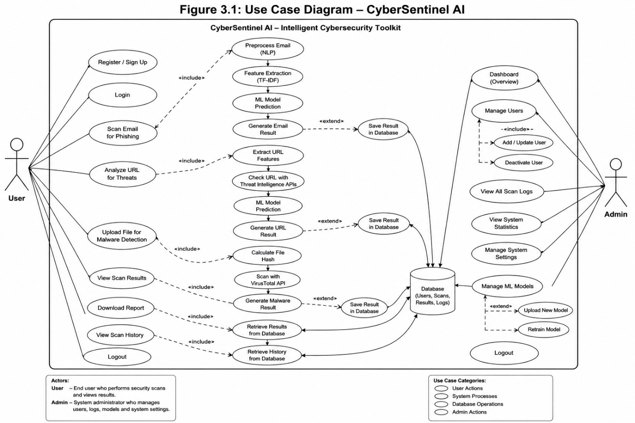
Figure 3. 1: Use Case Diagram

3.2 Detailed Use Cases

Table 3. 1: Use Case Description - Scan Email for Phishing
Field | Description
Use Case ID | UC-01
Use Case Name | Scan Email for Phishing
Primary Actor | User
Secondary Actors | Backend API, NLP module, and ML model
Description | The user submits email text for phishing detection
Trigger | The user clicks "Analyze Email"
Preconditions | Internet connection, running backend, and loaded model
Postconditions | The prediction is displayed and the scan is stored
Description – Scan Email for Phishing
Normal Flow:
- User enters email text
- User clicks analyze
- System validates input
- NLP preprocessing applied
- ML model generates prediction
- Result displayed with confidence score
Alternative Flow:
- Empty input → error message
- Server unavailable → failure notification

Table 3. 2: Use Case Description - Scan URL for Threats
Field | Description
Use Case ID | UC-02
Use Case Name | Analyze URL for Threats
Primary Actor | User
Secondary Actors | Backend API, rule-based URL analyzer, and AbuseIPDB
Description | The user submits a URL for threat analysis
Trigger | The user clicks "Analyze URL"
Preconditions | Internet connection and running backend
Postconditions | The risk result is displayed and the scan is stored
Normal Flow:
- User inputs URL
- System validates format
- Rule-based analyzer evaluates URL features
- AbuseIPDB provides IP reputation when available
- Risk score generated
- Result displayed

Table 3. 3: Use Case Description - Scan File for Malware
Field | Description
Use Case ID | UC-03
Use Case Name | Scan File for Malware
Primary Actor | User
Secondary Actors | Backend API and VirusTotal API
Description | The user uploads a file for malware scanning
Trigger | The user selects and uploads a file
Preconditions | Supported file, internet connection, and VirusTotal API access
Postconditions | The malware verdict is displayed and the scan is stored

Normal Flow:
- User uploads file
- System validates file
- File hash generated
- API request sent
- Results retrieved
- Output displayed

3.3 Functional Requirements
The functional requirements define the expected behavior of the system.

Table 3. 4: Functional Requirements
ID | Requirement
FR-01 | The system shall allow users to submit email text.
FR-02 | The system shall classify email using NLP and machine learning.
FR-03 | The system shall allow users to submit URLs.
FR-04 | The system shall analyze URLs using rule-based scoring and optional AbuseIPDB reputation.
FR-05 | The system shall allow users to upload files.
FR-06 | The system shall integrate with the VirusTotal API.
FR-07 | The system shall display results using clear color indicators.
FR-08 | The system shall store scan-history records.
FR-09 | The system shall generate downloadable reports.
FR-10 | The system shall provide read-only administrator monitoring.

3.4 Non-Functional Requirements

Table 3. 5: Non-Functional Requirements
Category | Requirement
Usability | The system shall provide a simple interface for non-technical users.
Performance | The system shall return results within a few seconds when external services respond normally.
Security | The system shall transmit production traffic over HTTPS.
Reliability | The system shall handle external-service failures gracefully.
Maintainability | The system shall support modular updates.

3.5 UML Diagrams
The system design is supported by UML diagrams to visually represent structure and behavior.
The following diagrams will be included:
- Use Case Diagram
- Class Diagram
- Sequence Diagram
- Activity Diagram
- Entity Relationship Diagram
- CyberSentinel AI – Intelligent Cybersecurity Toolkit

4. Design and Architecture
This chapter presents the overall system design and architecture of CyberSentinel AI. It explains the structural organization of the system and illustrates how different components interact to perform cybersecurity threat detection. The chapter also includes UML diagrams and database design used for system implementation.

4.1 System Architecture
CyberSentinel AI follows a modular client-server architecture comprising React and Chrome-extension clients, Flask API routes, detection services, persistent storage, and external intelligence services. The modules communicate through JSON or multipart HTTP requests.
The client layer contains the React web application and the Gmail Chrome extension. The web interface provides email, URL, file, history, report, and administrative views, while the extension submits the visible text of an opened Gmail message.
The Flask backend validates requests, applies rate limits and payload controls, invokes the appropriate detection service, returns JSON responses, stores scan summaries, and attempts configured email notifications. External integrations are limited to VirusTotal, AbuseIPDB, and SMTP [11], [14], [15], [26].
The service layer contains the phishing NLP/ML pipeline, the deterministic URLAnalyzer, the MalwareScanner, database utilities, and notification functions. Only the phishing email classifier uses machine learning; URL decisions are rule-based and malware verdicts are derived from VirusTotal responses.
The data layer uses PostgreSQL when DATABASE_URL is configured and SQLite otherwise. It stores users plus email_scans, url_scans, and file_scans records. Application log files and browser-generated PDF reports are not database entities.
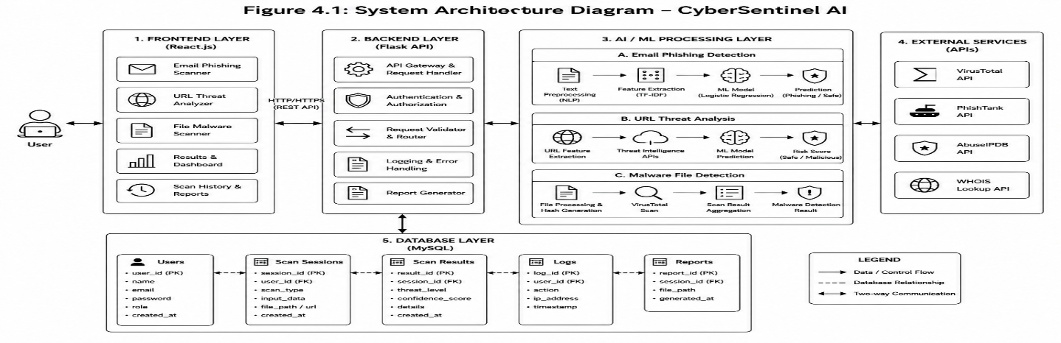
Figure 4. 1: System Architecture Diagram

4.2 Entity Relationship Diagram
The Entity Relationship diagram represents the four tables created by the current database initialization code: users, email_scans, url_scans, and file_scans.
Each scan table stores a user_email value together with module-specific result fields and a timestamp. These values provide a logical relationship to users.email, although the current schema does not enforce foreign-key constraints.
PostgreSQL is used for persistent live deployment and SQLite is retained for local development. Both database paths expose the same logical table structure.
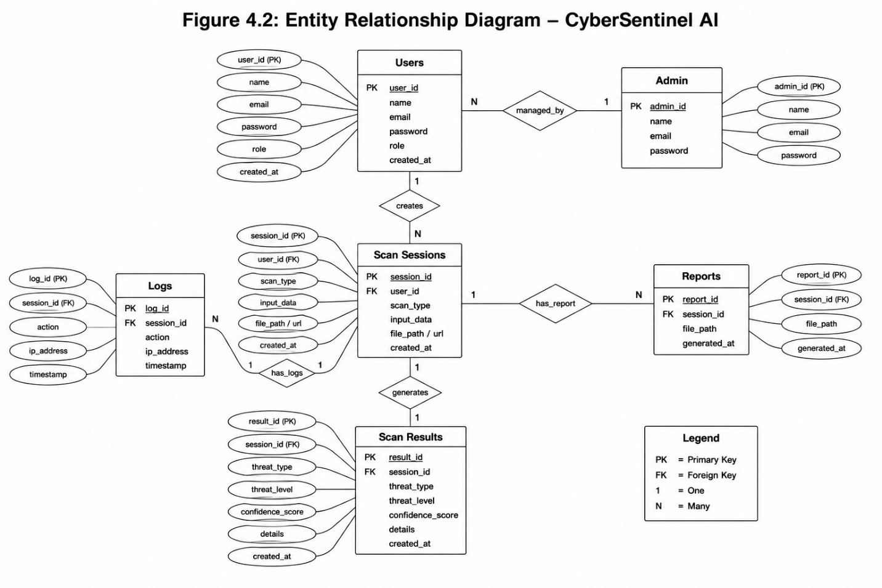
Figure 4. 2: Entity Relationship Diagram

4.3 Process Flow Diagram
The process flow diagram describes the implemented path from user input through validation, module-specific analysis, database storage, result presentation, and optional client-side PDF generation.
Email text and extracted document text pass through sanitization, hybrid TF-IDF transformation, and Logistic Regression; up to five unique visible URLs may also be analyzed. Submitted URLs use structural scoring and AbuseIPDB. Uploaded files use SHA-256 lookup and optional VirusTotal live upload.
After a scan, a summary record is stored in the appropriate scan table and the JSON result is displayed with verdicts, confidence values, indicators, and recommendations. The user can then download the current result as a PDF or open the latest-history view.
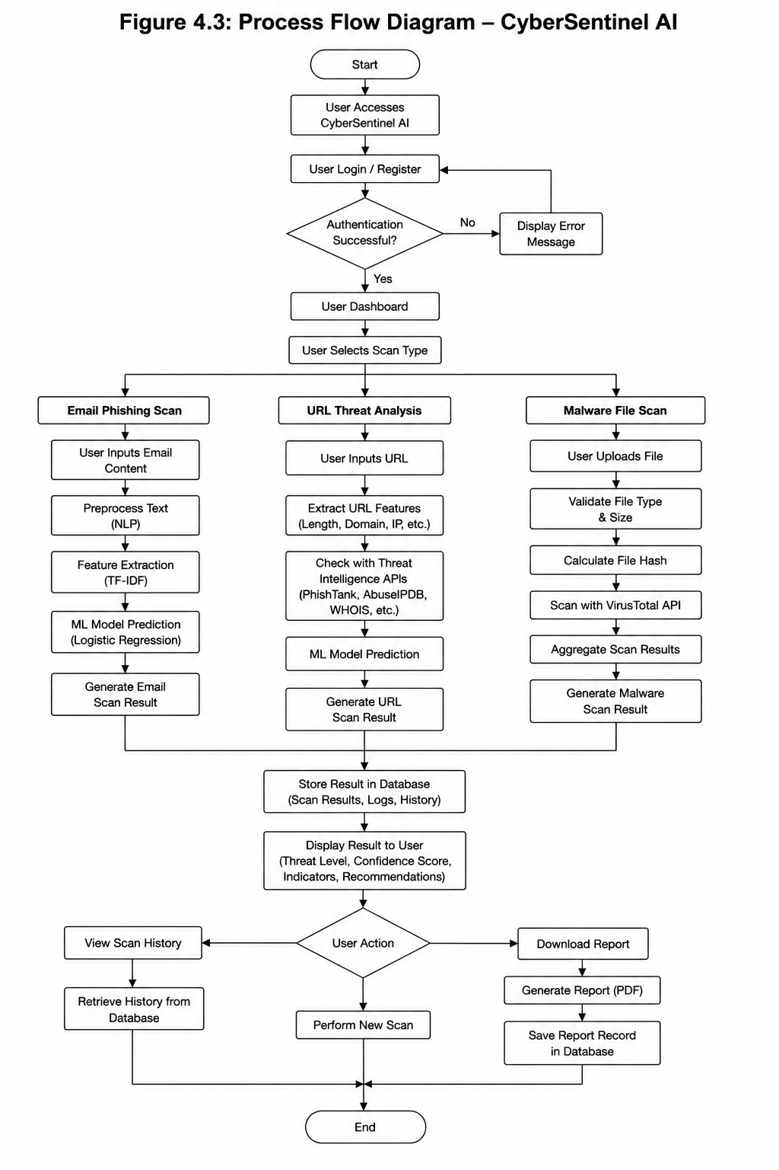
Figure 4. 3: Process Flow Diagram

4.4 Class and Module Diagram
The implementation is organized around Flask blueprints, two service classes, and supporting modules rather than separate domain classes for User, Admin, ScanSession, or Report.
URLAnalyzer and MalwareScanner are the principal service classes. Prediction, notification, database, cleaning, and URL-inspection behavior is provided by modules and functions.
The diagram shows how Flask routes invoke these services and how shared database and notification utilities support the request workflow.
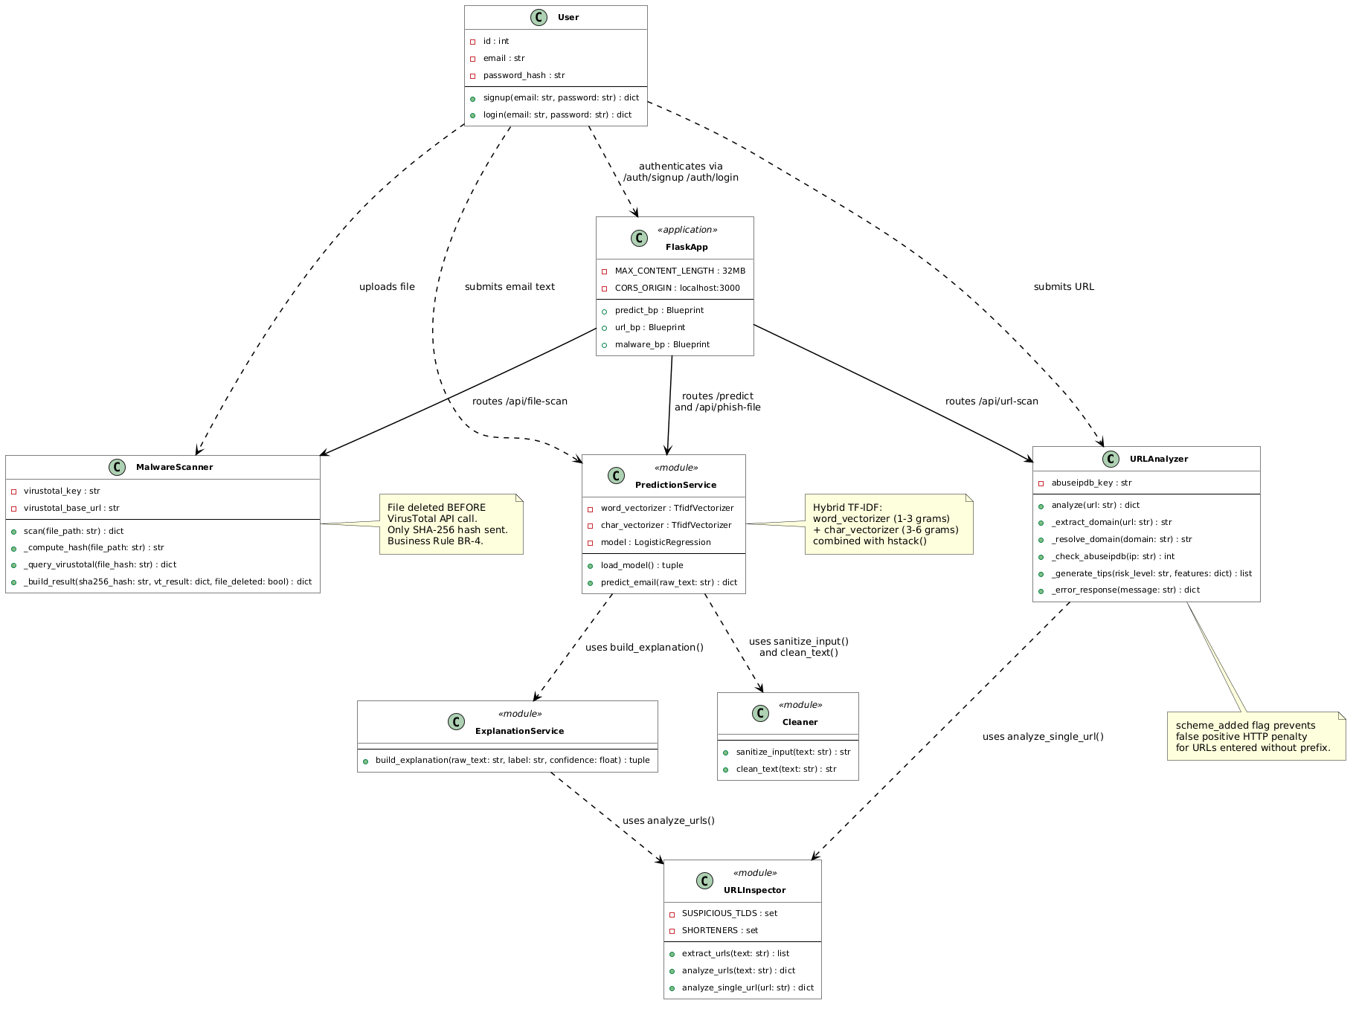
Figure 4. 4: Class and Module Diagram

4.5 Sequence Diagram
The sequence diagram illustrates communication among the user, React application or extension, Flask API, detection service, external intelligence provider, and database during a scan.
The frontend sends JSON or multipart data to Flask. Flask validates the request and invokes the phishing, URL, or file service. Optional AbuseIPDB or VirusTotal calls are made only by the relevant module. The result is stored as a scan summary and returned as JSON.
Threat-email delivery is attempted after selected high-risk results. Notification failure is logged and does not change the successful scan response.
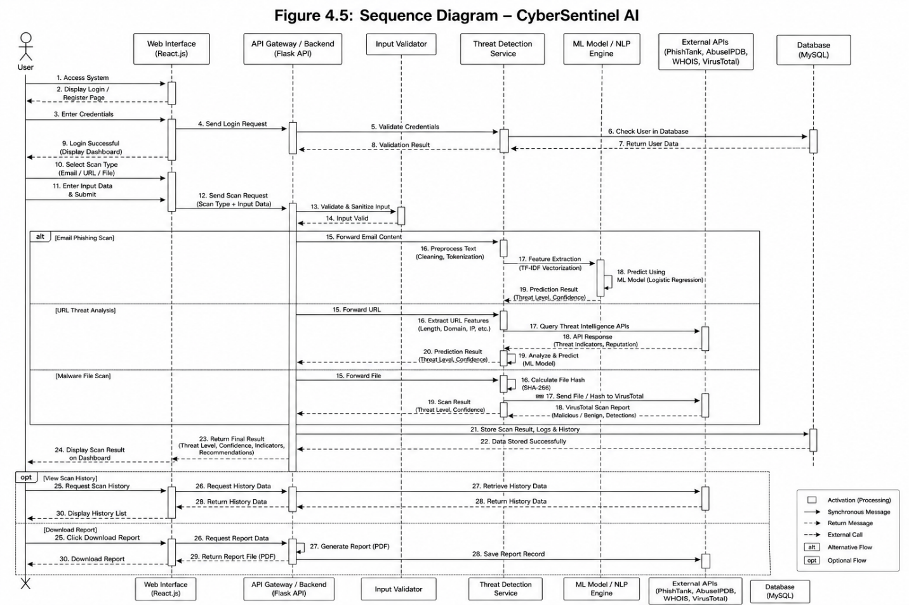
Figure 4. 5: Sequence Diagram

5. Implementation
This chapter explains the implementation details of CyberSentinel AI – Intelligent Cybersecurity Toolkit for Phishing, Malware, and Threat Detection. It describes the main algorithms used in the project, the external APIs integrated into the system, and the user interface screens developed for different users. The implementation of CyberSentinel AI is based on a modular approach in which each major functionality is developed as a separate component and then integrated into a unified web-based cybersecurity platform.
The final implementation includes binary phishing email detection, visible embedded-link analysis, TXT/EML/PDF/DOCX text input, rule-based URL analysis, VirusTotal file lookup and live upload, scan-summary storage, browser-generated PDF reports, prototype authentication and administration, SMTP notifications, a Gmail Chrome extension, public dashboard statistics, and live deployment. PostgreSQL is used live and SQLite is the local fallback.
The frontend handles interaction and report generation, Flask routes coordinate validation and services, the phishing pipeline performs ML classification, URLAnalyzer performs deterministic scoring, MalwareScanner communicates with VirusTotal, and four relational tables store users and scan summaries.

5.1 Algorithm
This section explains the major algorithms and workflows implemented in CyberSentinel AI. The purpose of this section is to describe how the main system modules operate without including source code. Each algorithm is explained using step-by-step natural language so that the working of the system can be clearly understood.

5.1.1 Phishing Email Detection Algorithm
The phishing email module analyzes text using Natural Language Processing and Machine Learning. Its Logistic Regression model is binary and predicts ham or spam; the interface maps these labels to Safe or Phishing. Word-level TF-IDF captures phrases, while character-level TF-IDF captures obfuscation and character patterns.
Algorithm Steps:
1. User enters email text or uploads an email file through the frontend.
2. The frontend sends the email content to the Flask backend.
3. The backend validates the input to ensure that the email text is not empty.
4. The input is sanitized to remove harmful HTML tags, scripts, and unnecessary characters.
5. Text preprocessing is applied, including lowercasing, punctuation removal, URL tokenization, and spacing normalization.
6. Word-level TF-IDF vectorization is applied to capture important phishing words and phrases.
7. Character-level TF-IDF vectorization is applied to capture obfuscated patterns.
8. Both feature matrices are combined into a single feature vector.
9. The trained Logistic Regression model predicts the class of the email.
10. The system calculates the confidence score and prepares threat indicators.
11. The final result is returned to the frontend and stored in scan history.
12. If the prediction is spam with confidence above 0.70, the notification module may attempt a phishing alert.
Output of the module includes:
• Binary classification result (ham/spam, displayed as Safe/Phishing)
• Confidence score
• Threat indicators
• Safety recommendations
• Prediction processing time in backend logs
• Scan history record

5.1.2 Embedded Link Scanning Algorithm
The embedded link scanning module extracts visible URLs from email text and analyzes each URL individually using the URL analyzer. This improves phishing detection because many phishing emails contain malicious links even when the surrounding message appears normal.
Algorithm Steps:
1. User submits email text for phishing analysis.
2. The backend scans the email text using a URL extraction pattern.
3. Up to five unique visible HTTP/HTTPS URLs are collected for analysis.
4. Duplicate URLs are removed to avoid repeated scanning.
5. Each extracted URL is passed to the URL analyzer module.
6. The URL analyzer checks structural URL features and reputation information.
7. Each link receives an individual verdict as Safe, Suspicious, or Malicious.
8. The embedded link results are combined with the main phishing email result.
9. The frontend displays a separate embedded links section.
10. The scan record is stored in the database.

5.1.3 Email and Document File Upload
The email page accepts TXT and EML files as decoded text input and also accepts PDF and DOCX documents for text extraction. The extracted text is sent through the same phishing pipeline. The current version does not parse MIME parts, inspect HTML anchor tags, or compare visible link text with hidden href destinations.
Algorithm Steps:
1. User uploads a TXT, EML, PDF, or DOCX file.
2. The backend validates the filename, extension, size, and non-empty content.
3. TXT and EML content is decoded using UTF-8 with a Latin-1 fallback.
4. PDF text is extracted page by page; DOCX text is collected from non-empty paragraphs.
5. Extracted text must contain at least ten readable characters.
6. At most the first 5,000 characters of document text are passed to the phishing classifier.
7. Visible HTTP/HTTPS URLs present in the extracted text may be analyzed separately.
8. The response includes the filename, extraction method, extracted character count, prediction, confidence, threats, tips, and embedded-link results.
9. A summary is stored in email_scans using the supplied user-email header or anonymous as fallback.
10. Image-only or unreadable documents return a clear extraction error rather than a fabricated prediction.

5.1.4 URL Threat Analysis Algorithm
The URL threat analyzer checks suspicious URLs using structural features and threat intelligence. It classifies URLs as Safe, Suspicious, or Malicious. The analyzer evaluates URL length, IP-based domains, @ symbols, HTTP usage, suspicious keywords, hyphens, shorteners, excessive subdomains, suspicious top-level domains, and long paths.
Algorithm Steps:
1. User submits a URL through the URL scan page or through an embedded email link.
2. The backend validates the URL format and normalizes it if necessary.
3. The system extracts structural URL features such as length, domain format, suspicious keywords, subdomain count, scheme, and path length.
4. Each suspicious feature contributes to a risk score.
5. The system resolves the domain to an IP address where possible.
6. The resolved IP is checked using AbuseIPDB.
7. The structural score and AbuseIPDB reputation value are combined when reputation data is available.
8. Thresholds convert the final score into Safe, Suspicious, or Malicious.
9. The response includes the score, confidence, threat indicators, AbuseIPDB status, and safety tips.
10. The result is displayed and may trigger an alert only when it is malicious with confidence above 0.60.
11. The URL scan summary is saved in url_scans.
Output of the module includes:
• Final URL verdict
• Risk score
• Matched suspicious features
• Threat intelligence result
• Recommendation for the user

5.1.5 Malware File Scanning Algorithm
The malware file scanning module allows users to upload suspicious files for scanning. The system validates the file, computes its SHA-256 hash, and checks it through VirusTotal. File scanning is designed with privacy in mind because files are handled temporarily and are not permanently stored.
Algorithm Steps:
1. User uploads a file through the file scan page.
2. The frontend sends the file to the Flask backend using multipart form data.
3. The backend validates the extension, non-empty content, and maximum size of 32 MB.
4. The file is temporarily saved in a secure temporary location.
5. The system calculates the SHA-256 hash of the file.
6. The file is checked against VirusTotal using hash lookup.
7. If VirusTotal returns a known result, the system parses malicious, suspicious, harmless, undetected, and flagged-engine counts.
8. The system generates a verdict as Clean, Suspicious, or Malicious.
9. The temporary file is deleted after the lookup or live-analysis workflow; the application does not retain the uploaded file.
10. The result is returned to the frontend and stored as scan metadata.
11. An email notification is attempted only when the final verdict is Malicious and at least one engine detected the file.

5.1.6 VirusTotal Live Upload for Unknown Files
A limitation of hash-based scanning is that a new file may not exist in the VirusTotal database. The final system improves this by uploading unknown files to VirusTotal for live analysis and polling until the result becomes available.
Algorithm Steps:
1. File hash lookup is performed through VirusTotal.
2. If the file is found, the system uses the returned report.
3. If the file is not found, the system marks it as unknown temporarily.
4. The backend uploads the file to VirusTotal’s file analysis endpoint.
5. VirusTotal returns an analysis ID.
6. The backend waits for a short interval and checks the analysis status using the analysis ID.
7. If the analysis is completed, the result is fetched and parsed.
8. If the maximum polling limit is reached, the system returns a pending or delayed result.
9. The final verdict is displayed and its metadata is saved in file_scans.
10. Only a Malicious final verdict triggers an attempted malware email alert.

5.1.7 Scan History and Database Storage Algorithm
The history module presents the latest scan summaries across email, URL, and file modules. In the current prototype, the backend returns the most recent twenty system-wide scans rather than filtering by the logged-in user.
Algorithm Steps:
1. User performs an email, URL, or file scan.
2. The backend receives the result from the related detection module.
3. The related module inserts a record into email_scans, url_scans, or file_scans.
4. Each record stores user_email, module-specific summary and result fields, and scanned_at.
5. PDF report files and report paths are not stored in the database.
6. The history page requests the latest scan records.
7. The backend retrieves records from the database.
8. The frontend displays the scan history in tabular or card format.
9. The current history table does not provide record-detail or report-download actions.

5.1.8 Report Generation Algorithm
The report feature generates a PDF from the currently displayed result in the user browser using html2canvas and jsPDF. The generated file is downloaded locally and is not saved by the backend [30], [31].
Algorithm Steps:
1. User completes a scan.
2. User clicks the Download Report button.
3. The frontend collects the current scan result.
4. The captured result contains the scan type, verdict, confidence, indicators, and recommendations visible on screen.
5. The report is generated in PDF format.
6. The file is downloaded by the user.
7. No report record or report path is inserted into the database.

5.1.9 Admin Panel Workflow
The current admin panel is a read-only monitoring interface. It displays system statistics, registered users, recent activity, and the latest fifty scans; it does not edit users, settings, logs, or model files.
Algorithm Steps:
1. A user logs in with an email configured in the ADMIN_EMAILS environment variable.
2. The prototype backend compares the X-User-Email request header with that configured list.
3. After successful login, the admin dashboard is displayed.
4. The Overview tab shows users, scan counts, detected threats, and recent activity.
5. The Users tab shows registration dates and scan counts but provides no modification controls.
6. The Scans tab shows recent email, URL, and file scan summaries.
7. Statistics are calculated from current database records.
8. Signed tokens and server-enforced role records are future security work.

5.1.10 Email Notification Workflow
The notification module sends welcome messages after registration and attempts alerts for configured high-risk scan outcomes. Missing SMTP configuration, anonymous requests, or delivery failures do not interrupt the scan.
Algorithm Steps:
1. A scan is completed.
2. The system checks the final threat level.
3. Alerts are attempted for spam predictions above 0.70, malicious URLs above 0.60 confidence, and Malicious file verdicts with at least one detection.
4. The system prepares an email message containing scan type, threat verdict, confidence score, short explanation, and safety recommendation.
5. The email is sent to the registered user using SMTP or configured email service.
6. Delivery success or failure is written to application logs; there is no notification database table.
7. If email sending fails, the system records the error and continues without interrupting the scan result display.

5.1.11 Gmail/Chrome Extension Workflow
The Gmail/Chrome extension allows users to scan email content directly from Gmail. This makes the system more practical because users do not always need to copy and paste email text manually.
Algorithm Steps:
1. User opens Gmail in the Chrome browser.
2. User opens a suspicious email.
3. User clicks the CyberSentinel AI extension icon.
4. The content script reads the largest visible Gmail message-text block.
5. The extension submits up to 5,000 characters to the live /predict endpoint.
6. The backend runs phishing detection and embedded link analysis.
7. The backend returns the verdict and confidence score.
8. The extension popup displays the result to the user.
9. If the email is risky, the user receives a warning.
10. Extension requests do not currently include an authenticated user header and are stored as anonymous if database saving succeeds.

5.1.12 Live Deployment Workflow
The final version of CyberSentinel AI is deployed so that it can be accessed beyond the local development environment.
Algorithm Steps:
1. The Flask backend is deployed on Render.
2. Environment variables are configured securely on the hosting platform.
3. API keys are stored on the server side only.
4. The React frontend is deployed on Vercel.
5. Frontend API base URL is changed from localhost to the live backend URL.
6. CORS settings are updated to allow the deployed frontend domain.
7. PostgreSQL is configured for persistent deployed storage, while SQLite remains available locally.
8. All modules are tested from a different device and network.
9. The Gmail extension is connected to the live backend.

5.2 External APIs
CyberSentinel AI integrates VirusTotal for file reputation and live analysis, AbuseIPDB for resolved-IP reputation, and SMTP for welcome and high-risk alert email. API credentials remain in backend environment variables and are not embedded in frontend or extension code [14], [15].

Table 5. 1: Details of APIs Used in the Project
API / Service | Description | Purpose | Implementation
VirusTotal API v3 | VirusTotal is a threat intelligence platform that analyzes files and URLs using multiple antivirus engines and security vendors. | Used for malware file scanning, SHA-256 hash lookup, live upload of unknown files, and retrieval of file analysis results. | MalwareScanner, malware_service.py, file_scan_route
AbuseIPDB API | AbuseIPDB provides reputation information about IP addresses reported for malicious or abusive activity. | Used to check the reputation of IP addresses resolved from submitted URLs. | URLAnalyzer, url_service.py, abuseipdb_lookup
SMTP / Email Service | Configured SMTP service for welcome messages and selected high-risk alerts. | Used after signup and after configured phishing, URL, or malware outcomes. | notification_service.py, send_welcome_email(), send_threat_alert()
CyberSentinel Backend API | Internal REST API developed using Flask for communication between the frontend, extension, and backend modules. | Used by React frontend and Gmail extension to submit scans and receive results. | app.py, predict_routes.py, url_routes.py, malware_routes.py
Gmail / Chrome Extension API | Browser extension interface used to interact with Gmail page content and browser popup components. | Used to extract email text and links from Gmail and send them to the CyberSentinel live backend. | manifest.json, content.js, and popup.js

These integrations complement the local phishing model and deterministic URL rules. External failures are handled with error, unavailable, pending, or fallback responses instead of being presented as successful threat-intelligence checks.

5.3 User Interface
The user interface of CyberSentinel AI is designed to be simple, clear, and understandable for non-technical users. Since the target users include students, freelancers, small business owners, and general internet users, the interface avoids unnecessary technical complexity and presents results in plain language.
The system uses a dashboard-based interface developed in React.js. Users can navigate to different modules from the sidebar or navigation menu. Each module follows a simple workflow: submit input, click scan, view result, and download report if required.

5.3.1 Login and Registration Interface
The login and registration interface supports account creation and prototype login state. The current frontend stores a dummy token, email address, and login flag in localStorage; production-grade signed sessions and role records are future work.
Main features include:
• User registration
• User login
• Configured admin-email check for the prototype admin view
• Client-side login-state handling
• Logout functionality

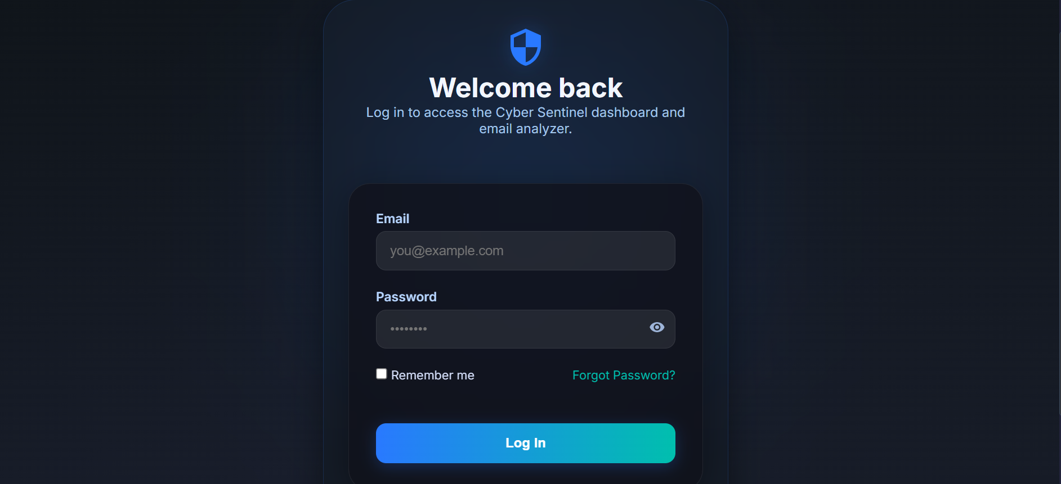
Figure 5. 1: Login and Registration Interface

5.3.2 User Dashboard
The dashboard links to the three scanning modules and displays database-backed email-scan and threat counts from the public /api/stats endpoint, refreshed every thirty seconds.
This section shows:
• Email phishing scan
• URL threat analysis
• Malware file scan
• Scan history
• Database-backed system statistics
• Access to scan-history and admin-monitoring views
• Logout

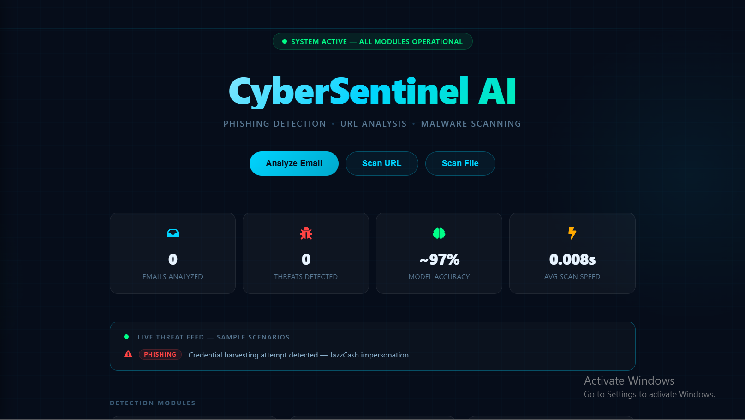
Figure 5. 2: User Dashboard

5.3.3 Email Phishing Scan Interface
The email scan page accepts pasted text, TXT/EML email files, and PDF/DOCX documents. The binary model result is displayed as Safe or Phishing with confidence, indicators, recommendations, and any visible embedded-link results.
Main features include:
• Threat verdict
• Confidence score
• Explanation
• Embedded link analysis
• TXT/EML upload and PDF/DOCX text extraction
• Recommended action

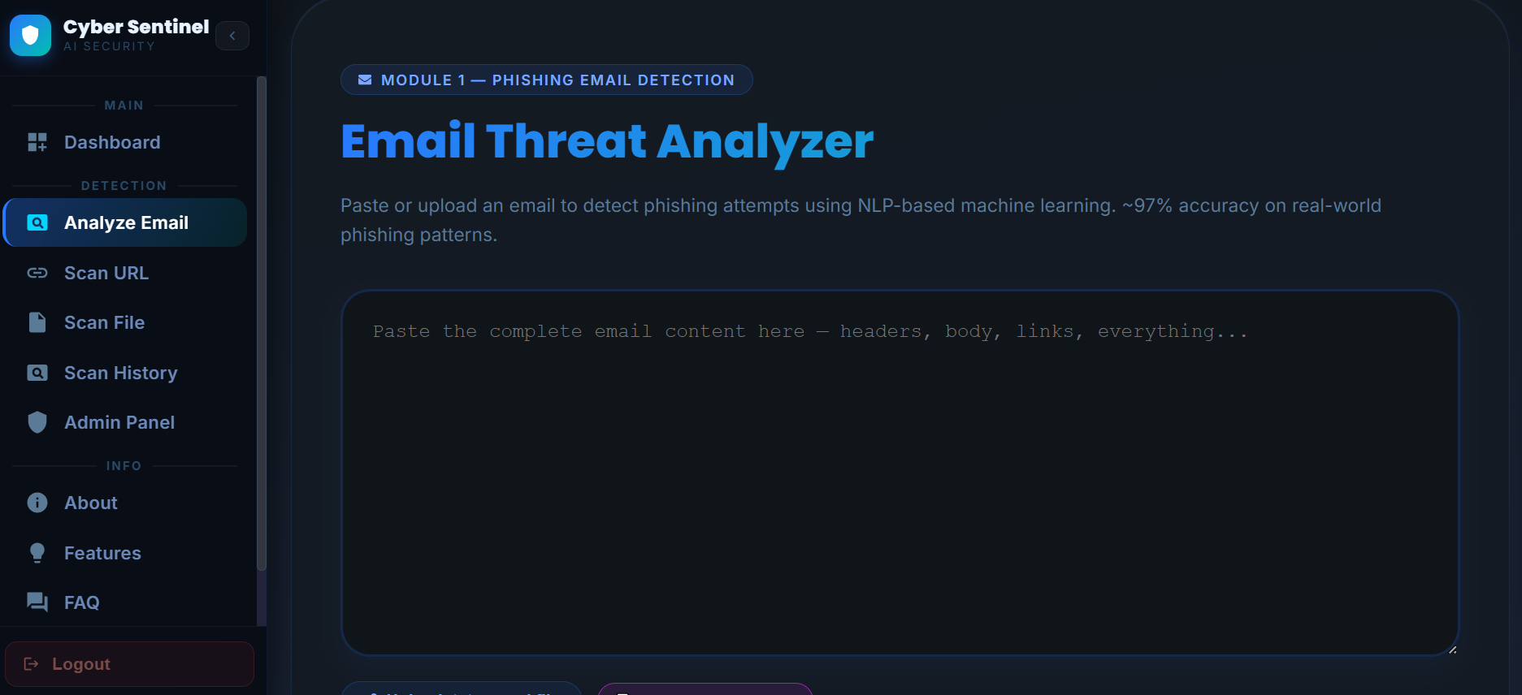
Figure 5. 3: Email Phishing Scan Interface

5.3.4 Email Result and Embedded URL Interface
The result section displays the Safe or Phishing verdict, confidence, threat indicators, safety recommendations, and separately analyzed visible HTTP/HTTPS URLs when any are found. Hidden HTML href mismatch detection is not implemented in the current version.
This section shows:
• Email verdict and confidence
• Visible extracted URL, when present
• Individual URL verdict and risk score
• Threat indicators and safety recommendations
• Scan-again and PDF-download actions

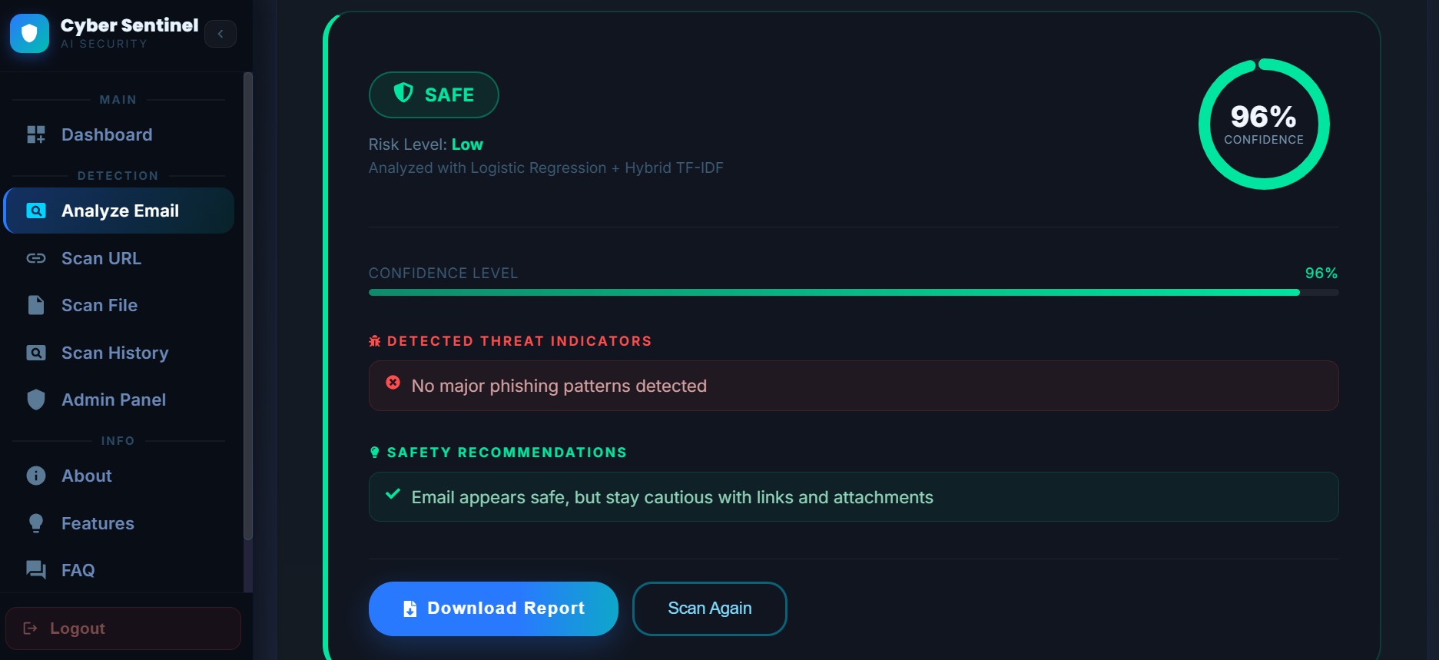
Figure 5. 4: Email Phishing Scan Result

5.3.5 URL Threat Analysis Interface
The URL scan page applies ten deterministic structural checks and, when available, AbuseIPDB reputation for the resolved IP address.
Main features include:
• URL verdict
• Risk score
• Suspicious features
• AbuseIPDB result
• AbuseIPDB availability and abuse score
• Final recommendation
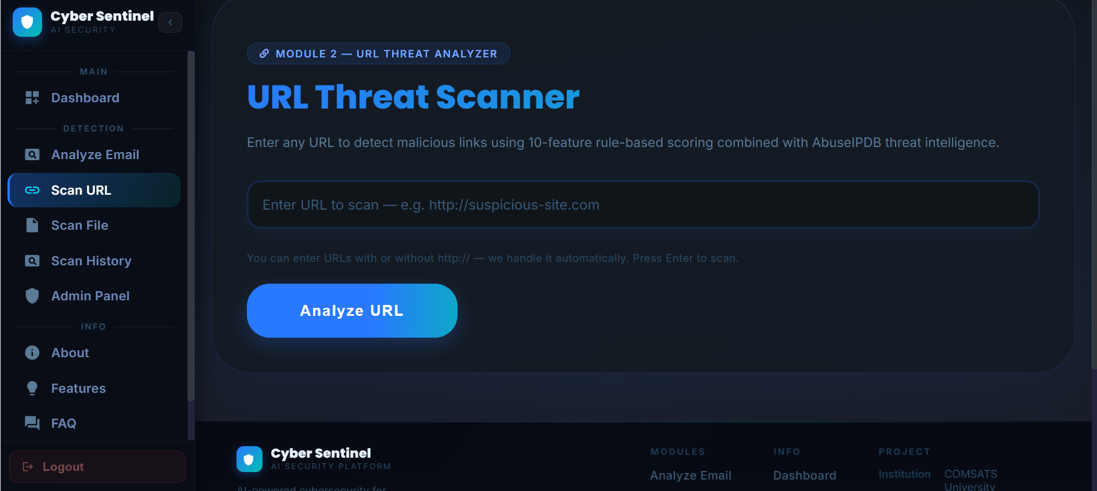
Figure 5. 5: URL Threat Analysis Interface

5.3.6 Malware File Scan Interface
The file scan page validates supported extensions and a 32 MB limit, creates a temporary backend file, and uses VirusTotal hash lookup or live upload. The temporary file is deleted, but unknown files may be transmitted to VirusTotal for analysis.
Main features include:
• File name
• File hash
• VirusTotal result
• Malicious engine count
• Suspicious engine count
• Final verdict
• Temporary-file deletion status and clear external-upload disclosure
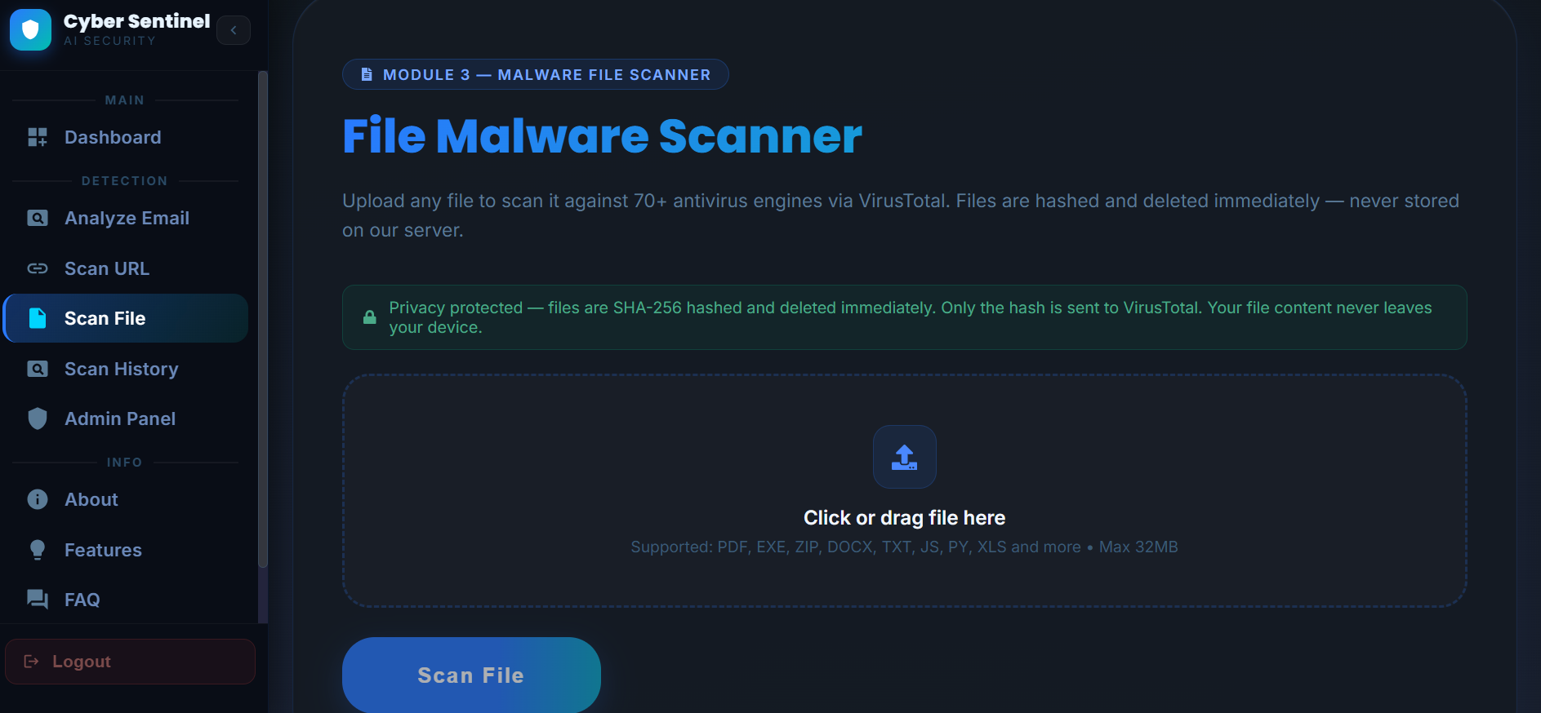
Figure 5. 6: Malware File Scan Interface

5.3.7 Scan History Interface
The history page displays the latest twenty scan summaries across all modules. The current backend response is system-wide and the table does not provide record-detail or report-download actions.
Main features include:
• Scan type
• Date and time
• Threat verdict
• Confidence score
• Module-specific confidence where available
• System-wide latest-record limitation
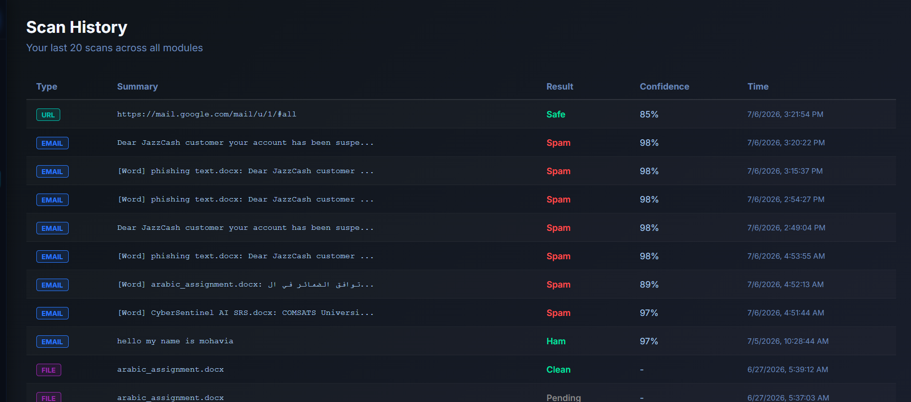
Figure 5. 7: Scan History Interface

5.3.8 Report Interface
Each result page can capture the displayed result and download it as a PDF through client-side libraries. Reports are not persisted by the backend.
Main features include:
• Project name
• Scan type
• Verdict
• Confidence score
• Threat details
• Safety tips
• Local browser download
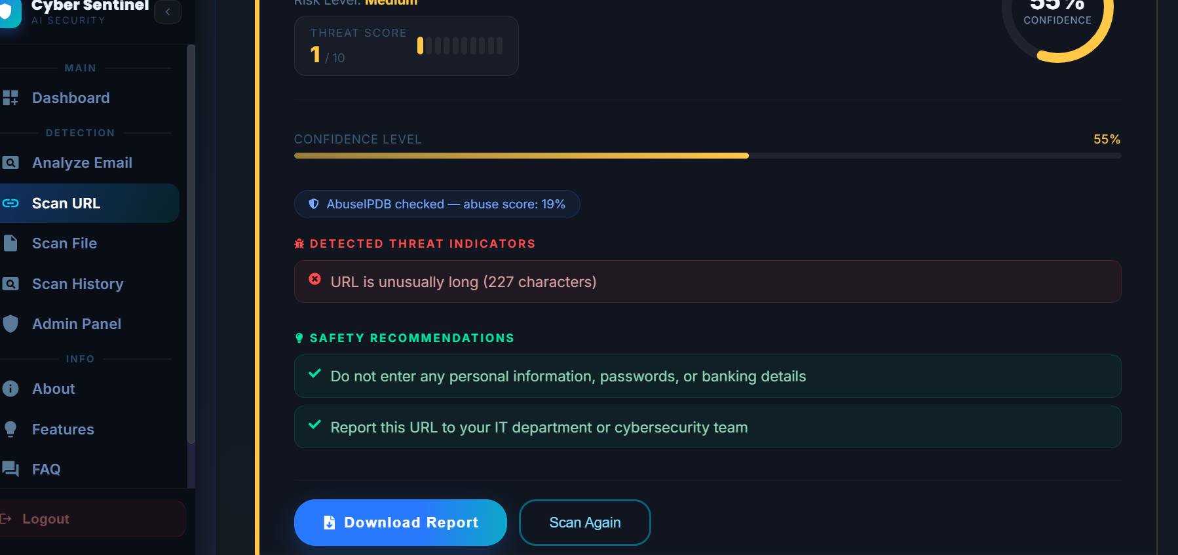
Figure 5. 8: PDF Report Generation Option

5.3.9 Admin Panel Interface
The admin panel provides read-only monitoring for configured administrator emails. It exposes Overview, Users, and Scans tabs backed by database queries.
Main features include:
• View total users
• View total scans
• View detected threats
• View registered users and per-module scan counts
• View recent scan summaries
• Refresh current database statistics
• No user-editing, log-management, settings, or model controls
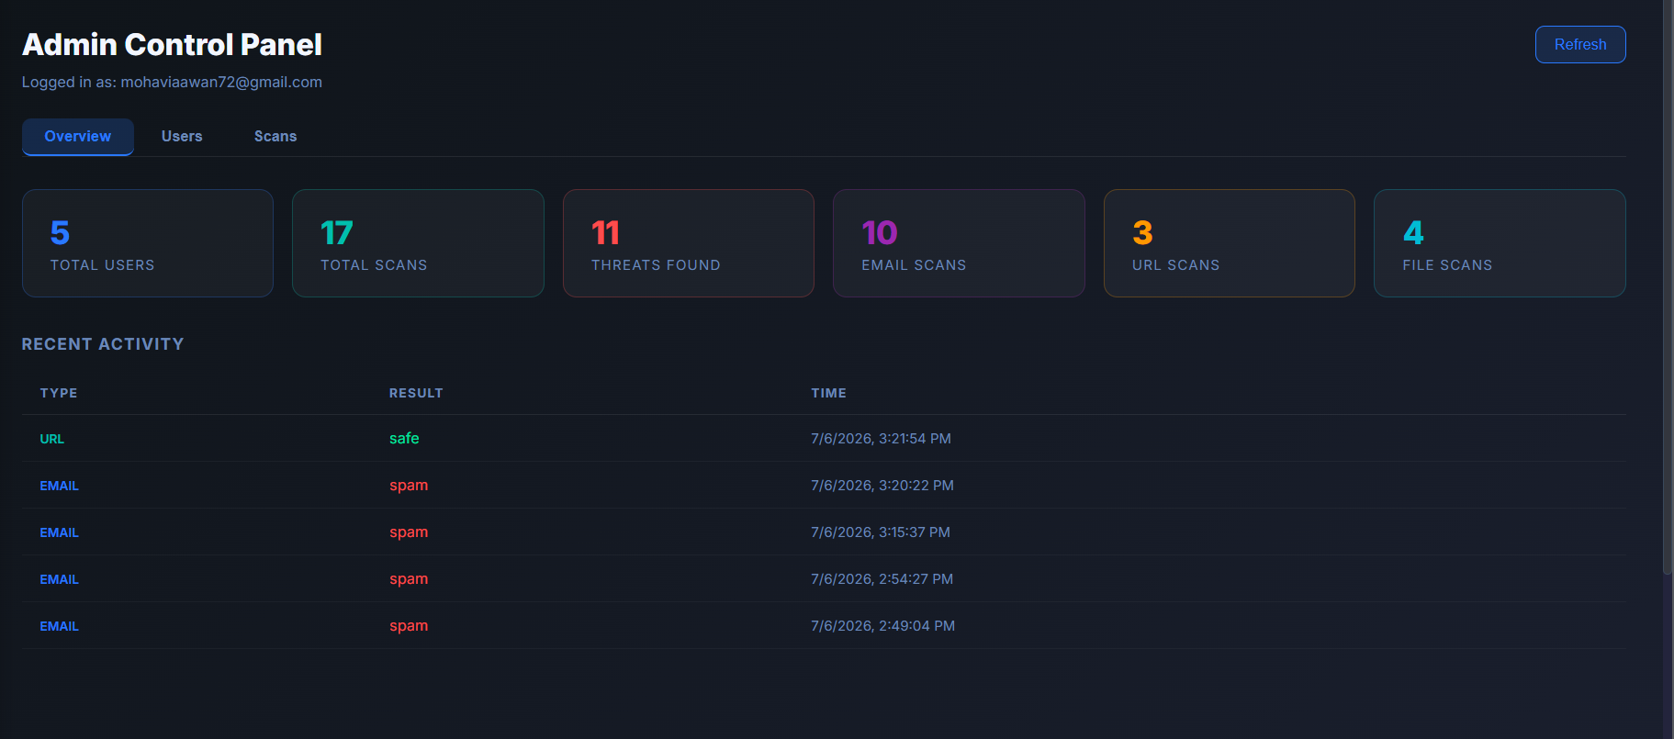
Figure 5. 9: Admin Panel Interface

5.3.10 Email Notification Output
Email output is generated for welcome messages and selected high-risk results when SMTP credentials are configured. The example shown is a high-confidence phishing alert.
This section shows:
• Scan type
• Threat level
• Confidence score
• Short explanation
• Recommended user action
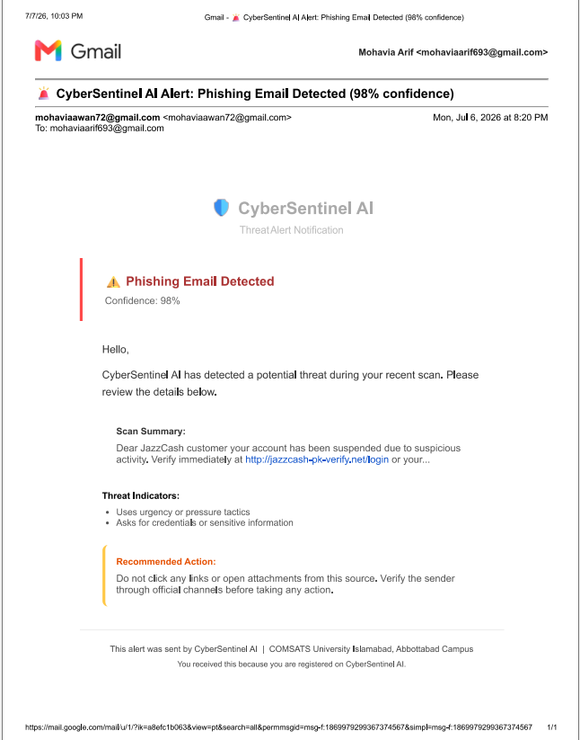
Figure 5. 10: Email Notification Output

5.3.11 Gmail/Chrome Extension Interface
The Gmail extension reads the visible text of an opened Gmail message and sends it to the live phishing endpoint. The popup displays a binary verdict, confidence, threat indicators, and any visible URLs returned by the backend.
Main features include:
• Scan current email button
• Result badge
• Confidence score
• Risk explanation
• Link warning
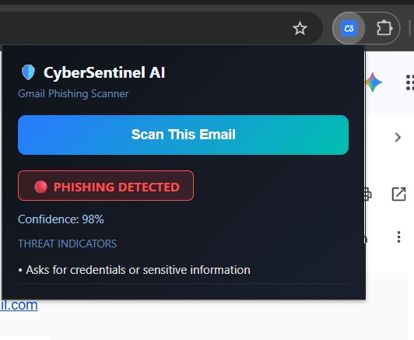
Figure 5. 11: Gmail Extension Interface

5.4 Summary
This chapter described the implemented ML email classifier, document-text extraction, visible embedded-link analysis, deterministic URL scoring, VirusTotal workflow, PostgreSQL/SQLite storage, client-side reports, prototype administration, notifications, Gmail extension, and deployed architecture without attributing unimplemented features to the system.
The next chapter discusses the testing and evaluation of the implemented system, including manual testing, unit testing, functional testing, integration testing, and automated testing.

6. Testing and Evaluation
This chapter presents the testing and evaluation process performed on CyberSentinel AI - Intelligent Cybersecurity Toolkit for Phishing, Malware, and Threat Detection. Testing was conducted to verify that all implemented modules work according to the defined requirements and that the system performs reliably in real usage conditions. The testing process included manual testing, system testing, unit testing, functional testing, integration testing, automated API testing, deployment testing, and extension testing.
The final version includes binary phishing detection, visible embedded-link scanning, TXT/EML/PDF/DOCX input, rule-based URL analysis, VirusTotal file lookup and live upload, latest scan history, client-side PDF reports, read-only admin monitoring, configured email notifications, a Gmail extension, and live deployment.
Testing was performed to ensure that the system correctly accepts user input, validates data, processes requests through the backend, performs AI/ML or API-based analysis, stores results in the database, generates reports, sends notifications, and displays results clearly to the user. The main goal of testing was to confirm that CyberSentinel AI is accurate, usable, secure, and reliable for non-technical users.

6.1 Manual Testing
Manual testing was performed by interacting with the system through the user interface and verifying whether each feature behaved as expected. The system was tested from the perspective of both normal users and administrators. Manual testing helped identify interface issues, incorrect messages, missing validations, and integration problems that may not be detected through automated tests.
The following modules were manually tested:
• User registration and login
• Email phishing scan
• Embedded link scanning
• Email and document file upload
• URL threat analysis
• Malware file scanning
• VirusTotal unknown file upload
• Scan history
• PDF report generation
• Email notifications
• Admin dashboard
• Gmail/Chrome extension
• Live deployment access

6.1.1 System Testing
System testing was performed after all modules were integrated into one complete platform. The purpose of system testing was to verify that CyberSentinel AI works as a complete cybersecurity toolkit rather than separate individual modules. The testing checked complete user journeys from login to scan submission, result display, report generation, scan history storage, and notification delivery.

Table 6. 1: System Testing
No. | Test Case / Test Script | Input / Attribute | Expected Result | Result
1 | Open the deployed CyberSentinel AI web application | Live frontend URL | Homepage or login page loads successfully | Pass
2 | Register a new user account | Email and password | User account is created successfully | Pass
3 | Login with valid user credentials | Registered email and password | User dashboard is displayed | Pass
4 | Login with invalid credentials | Wrong email or password | Error message is displayed | Pass
5 | Submit phishing email text | JazzCash-style phishing message | System returns spam and the interface displays Phishing | Pass
6 | Submit safe email text for scanning | Normal meeting email | System classifies email as safe | Pass
7 | Submit email containing visible URL | Email with suspicious URL | Email result and embedded URL result are displayed | Pass
8 | Upload a PDF or DOCX containing email text | Readable document | Text is extracted and classified | Pass
9 | Submit suspicious URL | URL containing suspicious keywords and long path | URL is classified as suspicious or malicious | Pass
10 | Submit safe URL | Trusted website URL | URL is classified as safe | Pass
11 | Upload known malware test file/hash sample | Supported file type | VirusTotal result is displayed | Pass
12 | Upload unknown clean Word file | New .docx file | File is uploaded to VirusTotal for live analysis and result is returned | Pass
13 | Generate scan report | Completed scan result | PDF report is generated and downloaded | Pass
14 | View scan history | Existing scan records | Latest system-wide scan summaries are displayed | Pass
15 | Open the admin panel as a configured administrator | Configured administrator email | Admin panel is displayed | Pass
16 | View admin statistics | Admin dashboard | Total scans, users, and threats are displayed | Pass
17 | Trigger configured risk notification | High-confidence phishing, malicious URL, or malicious file | SMTP alert is attempted without blocking the scan | Pass
18 | Scan Gmail message using extension | Open Gmail email and click extension | Extension displays scan verdict | Pass
19 | Test system from another device/network | Live deployed link | System opens and scans successfully | Pass
20 | Logout from system | Logout button | User session ends successfully | Pass

System testing confirmed that the complete platform works according to the expected workflow and that all major modules are connected properly.

6.1.2 Unit Testing
Unit testing was performed on individual modules to verify that each component works correctly before integration. Each unit was tested separately using controlled input and expected output. Unit testing helped ensure that errors inside one module did not affect the rest of the system.
Unit Testing 1: Phishing Email Detection
Testing Objective: To ensure that the phishing detection model correctly classifies email text.

Table 6. 2: Phishing Email Detection Unit Test Case
No. | Test Case / Test Script | Input / Attribute | Expected Result | Result
1 | Test phishing email classification | Your JazzCash account is suspended. Verify now. | Email classified as spam / displayed as Phishing | Pass
2 | Test safe email classification | Project meeting is scheduled for Monday. | Email classified as safe | Pass
3 | Test empty email input | Empty text field | Error message displayed | Pass
4 | Test long email input | Large email text | System processes or rejects safely according to limit | Pass
5 | Test obfuscated phishing words | verif1cation required for acc0unt | Suspicious pattern detected | Pass

Unit Testing 2: Embedded Link Scanning
Testing Objective: To ensure that visible URLs inside email text are extracted and analyzed separately.

Table 6. 3: Embedded Link Scanning Unit Test Case
No. | Test Case / Test Script | Input / Attribute | Expected Result | Result
1 | Extract one URL from email | Email contains one suspicious link | URL is extracted successfully | Pass
2 | Extract multiple URLs | Email contains several URLs | Up to five unique URLs are analyzed | Pass
3 | Remove duplicate URLs | Same URL repeated twice | Duplicate URL is ignored | Pass
4 | Scan extracted suspicious URL | Extracted phishing-style URL | URL verdict shown separately | Pass
5 | Submit email without URLs | Email contains no URL | System displays email result without embedded link section | Pass

Unit Testing 3: Email and Document File Upload
Testing Objective: To verify TXT/EML decoding, PDF/DOCX text extraction, and unsupported or unreadable-file handling.

Table 6. 4: Email and Document File Upload Unit Test Case
No. | Test Case / Test Script | Input / Attribute | Expected Result | Result
1 | Upload TXT email file | Readable UTF-8 text | Content decoded and classified | Pass
2 | Upload EML file | Readable email source | File treated as decoded text and classified | Pass
3 | Upload text-based PDF | PDF containing email text | Page text extracted and classified | Pass
4 | Upload DOCX document | DOCX containing email text | Paragraph text extracted and classified | Pass
5 | Upload unreadable or unsupported file | Image-only/empty/unsupported input | Clear validation or extraction error | Pass

Unit Testing 4: URL Threat Analyzer
Testing Objective: To ensure that URL analysis correctly checks structural features and API reputation.

Table 6. 5: URL Analyzer Unit Test Case
No. | Test Case / Test Script | Input / Attribute | Expected Result | Result
1 | Test safe HTTPS URL | https://www.comsats.edu.pk | URL classified as safe | Pass
2 | Test HTTP URL | http://example.com/login | HTTP risk feature detected | Pass
3 | Test IP-based URL | http://192.168.1.1/login | IP-domain risk detected | Pass
4 | Test suspicious keyword URL | URL containing verify-account-login | Suspicious keyword risk detected | Pass
5 | Test shortened URL | Shortener-based URL | URL shortener warning displayed | Pass
6 | Test AbuseIPDB lookup | URL domain resolved to IP | IP reputation checked successfully | Pass

Unit Testing 5: Malware File Scanner
Testing Objective: To ensure that file validation, hash generation, VirusTotal lookup, and live upload work correctly.

Table 6. 6: Malware File Scanner Unit Test Case
No. | Test Case / Test Script | Input / Attribute | Expected Result | Result
1 | Upload supported file type | .pdf, .docx, .txt, or .zip | File accepted for scanning | Pass
2 | Upload unsupported file type | Unsupported extension | Error message displayed | Pass
3 | Upload large file | File exceeding size limit | File rejected safely | Pass
4 | Generate SHA-256 hash | Valid uploaded file | Correct hash generated | Pass
5 | VirusTotal hash lookup | Known file hash | VirusTotal report returned | Pass
6 | Unknown file live upload | New file not found by hash lookup | File uploaded for live analysis | Pass
7 | Poll VirusTotal analysis | Analysis ID returned | Final analysis result retrieved | Pass
8 | Delete temporary file | File after scan | Temporary file removed | Pass

Unit Testing 6: Authentication, Database, and Scan History
Testing Objective: To verify account lookup, prototype login responses, database inserts, and latest-history retrieval.

Table 6. 7: Authentication and Database Unit Test Case
No. | Test Case / Test Script | Input / Attribute | Expected Result | Result
1 | Register new user | Valid email and password | User record stored | Pass
2 | Prevent duplicate registration | Existing email | Duplicate account error displayed | Pass
3 | Login valid user | Correct credentials | Success response and prototype token returned | Pass
4 | Login invalid user | Wrong credentials | Login rejected | Pass
5 | Store email scan result | Completed email scan | Record saved in database | Pass
6 | Store URL scan result | Completed URL scan | Record saved in database | Pass
7 | Store file scan result | Completed file scan | Record saved in database | Pass
8 | Retrieve scan history | History request | Latest system-wide records returned | Pass

Unit Testing 7: Admin Panel and Email Notifications
Testing Objective: To verify read-only admin monitoring and configured notification behavior.

Table 6. 8: Admin Panel and Email Notification Unit Test Case
No. | Test Case / Test Script | Input / Attribute | Expected Result | Result
1 | Login as admin | Admin credentials | Admin dashboard opens | Pass
2 | View user list | Admin panel | Registered users displayed | Pass
3 | View recent scans | Admin Scans tab | Latest scan summaries displayed | Pass
4 | View threat statistics | Admin dashboard | Scan and threat statistics shown | Pass
5 | Trigger threat notification | Configured high-risk result | Email is attempted when SMTP is configured | Pass
6 | Handle email failure | Invalid SMTP setting or unreachable service | Error logged without crashing system | Pass

6.1.3 Functional Testing
Functional testing was performed to verify that each functional requirement defined in Chapter 3 is implemented correctly. The purpose of functional testing is to ensure that every module performs its required operation from the user perspective.

Table 6. 9: Functional Testing
No. | Functional Requirement | Test Case / Test Script | Expected Result | Result
1 | User registration | User creates new account | Account is created successfully | Pass
2 | User login | User enters valid credentials | Dashboard opens | Pass
3 | Email scan | User submits email text | Email verdict is displayed | Pass
4 | Phishing classification | Submit phishing-style email | System identifies risk | Pass
5 | Embedded link scanning | Submit email containing URL | Extracted link is scanned separately | Pass
6 | Email/document file upload | Upload TXT, EML, PDF, or DOCX | Readable text is classified | Pass
7 | URL analysis | User submits suspicious URL | URL risk result displayed | Pass
8 | AbuseIPDB integration | Submit URL with resolvable domain | IP reputation is checked | Pass
9 | File scanning | User uploads file | Malware scan result displayed | Pass
10 | VirusTotal live upload | Upload unknown file | File is uploaded and analyzed | Pass
11 | Result visualization | Complete any scan | Green/yellow/red result indicator shown | Pass
12 | Scan history | Open history page | Latest system-wide scans are displayed | Pass
13 | PDF report | User downloads report | Report downloaded successfully | Pass
14 | Admin monitoring | Configured admin opens panel | Statistics, users, and scans load | Pass
15 | Email notification | Configured high-risk result | Alert is attempted without blocking scan | Pass
16 | Gmail extension | Scan opened Gmail email | Extension shows verdict | Pass
17 | Logout | User logs out | Session is cleared | Pass

Functional testing confirmed that all major user-facing features of CyberSentinel AI are working as expected.

6.1.4 Integration Testing
Integration testing was performed to verify communication between different modules. Since CyberSentinel AI includes frontend, backend, machine learning model, database, external APIs, email service, and browser extension, integration testing was important to ensure that all components work together correctly.

Table 6. 10: Integration Testing
No. | Integrated Modules | Test Case / Test Script | Expected Result | Result
1 | React frontend + Flask backend | Submit email scan request | Backend receives request and returns result | Pass
2 | Backend + phishing ML model | Send preprocessed email text to model | Model returns prediction and confidence | Pass
3 | Email scan + URL analyzer | Submit email containing URL | Email and embedded link results are returned together | Pass
4 | Document extractor + phishing model | Upload PDF or DOCX | Readable text is extracted and classified | Pass
5 | URL analyzer + AbuseIPDB | Submit URL for scanning | IP reputation result included | Pass
6 | File scanner + VirusTotal | Upload known file | VirusTotal report returned | Pass
7 | File scanner + VirusTotal live upload | Upload unknown file | Live analysis result returned after polling | Pass
8 | Backend + database | Complete any scan | Result stored in database | Pass
9 | Frontend + scan history API | Open history page | Latest records across modules are displayed | Pass
10 | Client report generator + scan result | Download PDF | Current result is captured and downloaded locally | Pass
11 | Scan module + email service | Suspicious result generated | Notification email sent | Pass
12 | Admin panel + database | Open admin tabs | Statistics, users, and scans load | Pass
13 | Gmail extension + live backend | Scan visible Gmail text | Binary prediction returned to popup | Pass
14 | Live frontend + live backend | Access from different network | Complete scan works successfully | Pass

Integration testing confirmed that the system modules communicate correctly and that the final deployed system works as a complete platform.

6.2 Automated Testing
Python integration scripts and Postman requests were used to exercise core backend endpoints, validation, and response structures. These scripts are useful regression checks but are not a comprehensive pytest or unittest suite.
Additional verification used browser developer tools, database inspection, Chrome extension developer mode, and deployment logs. The React repository still contains the default Create React App test and does not provide substantive automated frontend coverage.

6.2.1 Tools Used

Table 6. 11: Tools Used for Automated Testing
Tool Name | Tool Description | Applied On | Results
Postman | API testing tool used to send HTTP requests and inspect responses. | Login API, email scan API, URL scan API, file scan API, scan history API | APIs returned expected JSON responses
Python Integration Scripts | Custom scripts used to test backend endpoints and prediction responses. | Phishing prediction, URL analyzer, malware scanner | Core backend functions tested successfully
Python integration scripts | Custom request scripts for endpoint and validation checks. | Core backend endpoints | Useful regression checks; not a formal pytest suite
Database Inspection | Used to inspect frontend requests, console errors, and network responses. | Users table and the three scan tables | Frontend-backend communication verified
Database inspection | SQLite Browser locally and deployment database queries. | users and three scan tables | Records stored and retrieved
Render Logs | Used to load and test the Gmail/Chrome extension. | manifest.json, content script, popup interface | Extension installed and scanned Gmail content
Vercel Logs | Deployment logs used to inspect backend behavior. | Live Flask backend | Backend reachable and errors inspectable
Vercel logs | Frontend deployment logs and network inspection. | Live React frontend | Frontend connected to backend
Email Test Inbox | Used to verify delivery of system notifications. | Email notification module | Notification emails received successfully

6.2.2 Automated API Test Results

Table 6. 12: Automated API Test Results
No. | API / Module Tested | Test Input | Expected Response | Result
1 | Login API | Valid email and password | Success response with prototype token | Pass
2 | Login API | Invalid password | Error response | Pass
3 | Email Scan API | Phishing email text | Prediction, confidence, explanation | Pass
4 | Email Scan API | Empty text | Validation error | Pass
5 | Embedded Link API Logic | Email containing URL | Embedded link result list | Pass
6 | Email File Upload API | Valid TXT/EML file | Decoded text and prediction returned | Pass
7 | URL Scan API | Suspicious URL | URL verdict and risk score | Pass
8 | URL Scan API | Invalid URL | Validation error | Pass
9 | File Scan API | Valid uploaded file | File scan result | Pass
10 | File Scan API | Unsupported file | File type error | Pass
11 | VirusTotal Upload Logic | Unknown file | Live analysis request created | Pass
12 | Scan History API | GET request | Latest system-wide scan records returned | Pass
13 | Admin API | Admin request | System statistics returned | Pass
14 | Notification Service | Risky scan result | Email sent or logged | Pass
15 | Extension Backend Request | Gmail email content | Prediction returned to extension | Pass

6.2.3 Model and Performance Evaluation
The saved binary Logistic Regression model was evaluated by recreating the stratified 80/20 split of phishing_clean_balanced.csv with random_state=42. On 1,333 held-out records it achieved 98.05% accuracy. Spam precision was 99.02%, recall 94.82%, and F1-score 96.88%; the confusion matrix contained 904 true ham, 4 ham classified as spam, 403 true spam, and 22 spam classified as ham. API response times remain dependent on network and external-service availability.

Table 6. 13: Model and Performance Results
No. | Test Area | Expected Performance | Observed Result | Result
1 | Email phishing prediction | Result within a few seconds | Result returned quickly | Pass
2 | Embedded link extraction | Links extracted immediately | Links extracted successfully | Pass
3 | URL analysis without API delay | Result within a few seconds | Result returned successfully | Pass
4 | AbuseIPDB lookup | Result depends on API response | Result returned or graceful fallback applied | Pass
5 | File hash generation | Hash generated quickly for allowed file size | Hash generated successfully | Pass
6 | VirusTotal known file lookup | Result depends on API response | Result returned successfully | Pass
7 | VirusTotal unknown file upload | Longer due to upload and polling | Result returned after polling | Pass
8 | Scan history retrieval | Records load within acceptable time | History displayed successfully | Pass
9 | Gmail extension scan | Result displayed in extension popup | Result displayed successfully | Pass
10 | Final phishing model evaluation | Held-out 20% split | 98.05% accuracy; spam F1 96.88% | Pass

6.2.4 Security Testing
Security testing covered sanitization, validation, rate limiting, payload controls, environment-based API secrets, CORS, and temporary-file deletion. Authentication and administrator authorization remain prototype controls and are identified as partial rather than production-grade protections [17], [18].

Table 6. 14: Security Test Results
No. | Security Feature | Test Case / Test Script | Expected Result | Result
1 | Input sanitization | Submit script tags in email input | Script removed or neutralized | Pass
2 | Empty input validation | Submit blank scan request | Request rejected with error | Pass
3 | File size limit | Upload file above allowed size | File rejected | Pass
4 | File type validation | Upload unsupported file type | File rejected | Pass
5 | API key protection | Inspect frontend code | API keys not visible in frontend | Pass
6 | CORS configuration | Request from unauthorized origin | Request blocked or restricted | Pass
7 | Password storage | Inspect stored value | Plain password is not stored | Partial - SHA-256 is unsalted
8 | Prototype admin access | Normal and configured-admin headers | Configured list is checked | Partial - header is client supplied
9 | Temporary file deletion | Scan uploaded file | Temporary file removed after processing | Pass
10 | Rate limiting | Send repeated scan requests | Excessive requests limited | Pass

6.3 Summary
Testing supports the implemented scanning, storage, reporting, notification, extension, and deployment workflows. False hidden-link, PhishTank, user-management, audit-log, and report-storage claims have been removed. Prototype authentication, global history visibility, and limited automated test coverage remain documented limitations.
The final system is suitable for an academic demonstration of a hybrid cybersecurity toolkit. Production use would require stronger identity controls, per-user data isolation, formal automated tests, operational monitoring, and additional privacy review.

7. Conclusion and Future Work
This chapter concludes the development and implementation of CyberSentinel AI - Intelligent Cybersecurity Toolkit for Phishing, Malware, and Threat Detection. It summarizes the achievements of the project, highlights the effectiveness of the implemented modules, and discusses possible future enhancements that can further improve the system. The project successfully demonstrates how Artificial Intelligence, Machine Learning, Natural Language Processing, external threat intelligence APIs, secure web technologies, and user-centered design can be combined to build a practical cybersecurity solution for non-technical users.
CyberSentinel AI provides one deployed interface for phishing-email classification, visible URL inspection, and VirusTotal-assisted file analysis. Supporting features include document-text extraction, latest scan history, browser-generated reports, read-only admin monitoring, configured notifications, and a Gmail extension.

7.1 Conclusion
CyberSentinel AI achieves its main objective as a unified and understandable cybersecurity prototype. It combines different techniques according to the threat type instead of inaccurately describing every module as machine learning.
The phishing module uses hybrid word and character TF-IDF with binary Logistic Regression. The model labels are ham and spam and are displayed as Safe and Phishing. On the recreated held-out split of the final balanced dataset, the saved model achieved 98.05% accuracy, with 99.02% spam precision and 94.82% spam recall.
The URL module analyzes length, keywords, IP-based hosts, scheme, shorteners, top-level domains, subdomains, path length, and related structural indicators. AbuseIPDB adds optional resolved-IP reputation; PhishTank is not integrated in the final system.
The malware file scanning module provides file-based threat detection using SHA-256 hashing and VirusTotal API integration. In the final implementation, the system was improved beyond simple hash lookup by adding live upload and polling for unknown files. This makes the scanner more practical because a new file that is not already present in VirusTotal can still be submitted for live analysis.
The email workflow extracts and analyzes visible HTTP/HTTPS URLs. TXT and EML files are treated as decoded text, while PDF and DOCX files use text extraction. Structured MIME parsing, HTML anchor extraction, and visible-text versus href mismatch detection remain future work.
The final version also includes prototype authentication, PostgreSQL-backed scan summaries, browser-generated reports, read-only admin monitoring, application logging, configured email alerts, a Gmail extension, and Render/Vercel deployment. Reports and application logs are not stored as database entities.
Manual and script-based verification covered the implemented workflows. The current limitations include prototype token handling, header-based admin checks, global rather than per-user history, and limited formal automated test coverage.
Overall, CyberSentinel AI provides an accessible and practical cybersecurity solution for students, freelancers, small businesses, and general internet users. It simplifies threat detection by presenting results through clear verdicts, confidence scores, color-coded indicators, reports, and recommendations. The project demonstrates the successful application of AI, ML, NLP, web development, database systems, cybersecurity principles, and software engineering practices in solving a real-world problem.

7.2 Future Work
The deployed prototype is functional, but the following improvements are required for stronger accuracy, privacy, authorization, scalability, and production readiness.

7.2.1 Larger Pakistani Cyber Threat Dataset
In future, the phishing dataset can be expanded with more real-world Pakistani phishing emails, scam messages, fake banking alerts, mobile wallet fraud examples, and malicious URLs. A larger local dataset would improve detection accuracy against threats targeting Pakistani users. The dataset can also include Urdu and Roman Urdu phishing messages to make the system more effective for local communication patterns.

7.2.2 Deep Learning-Based Phishing Detection
The current phishing detection model uses hybrid TF-IDF and Logistic Regression because it is fast, interpretable, and suitable for real-time classification. In future, advanced deep learning models such as BERT, DistilBERT, LSTM, or transformer-based classifiers can be explored. These models may improve contextual understanding, especially for complex phishing emails that use indirect language or advanced social engineering.

7.2.3 Full Browser-Wide Extension
The Gmail extension can be expanded into a browser-wide security assistant. Future email work should also add standards-based MIME parsing, HTML anchor extraction, and visible-text versus destination-domain mismatch detection.

7.2.4 Mobile Application
A mobile application can be developed for Android and iOS users. Since many Pakistani users access digital banking, emails, and social media through mobile phones, a mobile version would make the system more accessible. The mobile app can include email scanning, URL scanning, file scanning, notifications, and report viewing.

7.2.5 Behavioral Malware Analysis
The current malware scanner uses VirusTotal and file analysis results. In future, behavioral malware analysis can be added using sandbox execution. This would allow the system to observe how a suspicious file behaves when executed in a controlled environment. Behavioral analysis can detect threats that may not be identified by static scanning alone.

7.2.6 Enterprise Dashboard and SIEM Integration
For organizational use, CyberSentinel AI can be extended with enterprise-level dashboards and integration with Security Information and Event Management systems. This would allow companies, universities, and small businesses to monitor threats, export logs, generate analytics, and integrate CyberSentinel AI with existing cybersecurity workflows.

7.2.7 Multi-Language Support
Future versions can support multiple languages, especially Urdu and Roman Urdu. This is important because many phishing messages in Pakistan use mixed English, Urdu, and Roman Urdu. Multi-language support would improve detection for local users and make the system more inclusive.

7.2.8 Two-Factor Authentication and Advanced Security
Authentication should replace the dummy client token and unsalted SHA-256 password hashing with signed server sessions or JWTs and a slow salted password hash such as Argon2 or bcrypt. Administrator roles must be verified server-side, and scan-history queries should be restricted to the authenticated user. Two-factor authentication, session expiry, and stronger password policies can then be added.

7.2.9 Continuous Model Retraining
A feedback-based retraining pipeline can be added in future. If users or admins mark a scan result as correct or incorrect, the feedback can be stored and later used to improve the model. This would allow the system to adapt to new phishing patterns over time.

7.2.10 Cloud Scalability and Load Balancing
The deployed system can be improved through cloud scaling, load balancing, containerization, and monitoring tools. These improvements would help CyberSentinel AI handle more users and maintain stable performance under higher traffic.

7.3 Summary
CyberSentinel AI has been developed as a deployed AI-assisted prototype with binary phishing detection, visible embedded-link analysis, rule-based URL scoring, VirusTotal-assisted file analysis, scan summaries, browser reports, read-only admin monitoring, notifications, and a Gmail extension. Future work includes structured EML analysis, stronger authentication and privacy, formal automated testing, larger multilingual datasets, mobile access, behavioral malware analysis, and scalable monitoring.

8. References
The development of CyberSentinel AI - Intelligent Cybersecurity Toolkit for Phishing, Malware, and Threat Detection was supported by standard software engineering concepts, machine learning techniques, cybersecurity practices, official documentation, and external API references. The following sources were consulted during the design, development, implementation, testing, and documentation of the system.
1. R. S. Pressman and B. R. Maxim, Software Engineering: A Practitioner’s Approach, McGraw-Hill Education.
2. I. Sommerville, Software Engineering, Pearson Education.
3. C. D. Manning, P. Raghavan, and H. Schütze, Introduction to Information Retrieval, Cambridge University Press.
4. S. Bird, E. Klein, and E. Loper, Natural Language Processing with Python, O’Reilly Media.
5. T. M. Mitchell, Machine Learning, McGraw-Hill Education.
6. C. M. Bishop, Pattern Recognition and Machine Learning, Springer.
7. D. Jurafsky and J. H. Martin, Speech and Language Processing, draft edition.
8. F. Pedregosa et al., “Scikit-learn: Machine Learning in Python,” Journal of Machine Learning Research, vol. 12, pp. 2825-2830, 2011.
9. Scikit-learn Developers, “Scikit-learn Documentation,” https://scikit-learn.org/, Last accessed: July 2026.
10. Python Software Foundation, “Python Documentation,” https://docs.python.org/, Last accessed: July 2026.
11. Pallets Projects, “Flask Documentation,” https://flask.palletsprojects.com/, Last accessed: July 2026.
12. React Developers, “React Documentation,” https://react.dev/, Last accessed: July 2026.
13. SQLite, “SQLite Documentation,” https://www.sqlite.org/docs.html, Last accessed: July 2026.
14. VirusTotal, “VirusTotal API v3 Documentation,” https://developers.virustotal.com/, Last accessed: July 2026.
15. AbuseIPDB, “AbuseIPDB API Documentation,” https://www.abuseipdb.com/api.html, Last accessed: July 2026.
16. PhishTank, “PhishTank Developer Information,” https://phishtank.org/developer_info.php, Last accessed: July 2026.
17. OWASP Foundation, “OWASP Web Security Testing Guide,” https://owasp.org/www-project-web-security-testing-guide/, Last accessed: July 2026.
18. OWASP Foundation, “OWASP Top Ten Web Application Security Risks,” https://owasp.org/www-project-top-ten/, Last accessed: July 2026.
19. NIST, “Cybersecurity Framework,” National Institute of Standards and Technology, https://www.nist.gov/cyberframework, Last accessed: July 2026.
20. IEEE, ISO/IEC/IEEE 29148: Systems and Software Engineering - Life Cycle Processes - Requirements Engineering, IEEE Standards Association.
21. Object Management Group, “Unified Modeling Language Specification,” https://www.uml.org/, Last accessed: July 2026.
22. GitHub Docs, “GitHub Documentation,” https://docs.github.com/, Last accessed: July 2026.
23. Postman, “Postman API Platform Documentation,” https://learning.postman.com/docs/, Last accessed: July 2026.
24. Google Chrome Developers, “Chrome Extensions Documentation,” https://developer.chrome.com/docs/extensions/, Last accessed: July 2026.
25. Mozilla Developer Network, “Web APIs and JavaScript Documentation,” https://developer.mozilla.org/, Last accessed: July 2026.
26. Flask-Limiter Documentation, “Rate Limiting for Flask Applications,” https://flask-limiter.readthedocs.io/, Last accessed: July 2026.
27. Python-dotenv Documentation, “Python-dotenv,” https://pypi.org/project/python-dotenv/, Last accessed: July 2026.
28. joblib Developers, “Joblib Documentation,” https://joblib.readthedocs.io/, Last accessed: July 2026.
29. SciPy Developers, “SciPy Documentation,” https://docs.scipy.org/doc/scipy/, Last accessed: July 2026.
30. jsPDF Developers, “jsPDF Documentation,” https://github.com/parallax/jsPDF, Last accessed: July 2026.
31. html2canvas Developers, “html2canvas Documentation,” https://html2canvas.hertzen.com/, Last accessed: July 2026.
32. Google, “Gmail Help and Gmail Security Information,” https://support.google.com/mail/, Last accessed: July 2026.
33. Render, “Render Documentation,” https://render.com/docs, Last accessed: July 2026.
34. Vercel, “Vercel Documentation,” https://vercel.com/docs, Last accessed: July 2026.
35. Netlify, “Netlify Documentation,” https://docs.netlify.com/, Last accessed: July 2026.
36. Kaggle, “Phishing Email Dataset Resources,” https://www.kaggle.com/, Last accessed: July 2026.
37. Cisco Talos Intelligence Group, “Talos Intelligence,” https://talosintelligence.com/, Last accessed: July 2026.
38. Kaspersky, “Threat Intelligence Portal,” https://opentip.kaspersky.com/, Last accessed: July 2026.
39. Google, “Google Safe Browsing,” https://safebrowsing.google.com/, Last accessed: July 2026.
40. Microsoft, “Microsoft Security Documentation,” https://learn.microsoft.com/en-us/security/, Last accessed: July 2026.

