# Introduction:

**Proctor system** mainly provides supportive care and advice to the students and to help them in their academic problems and personnel problems, if any, and to council them appropriately. This project includes keeping record of each student furnishing the details of attendance, class marks, and examination results. This is a web based system that will automate the manual system used for management and maintenance of the critical information which reduces a lot of paper work. This system provides teachers an easy access to the student’s academic performance. This system has special access to the proctor to update the student’s details and also includes the counselling about his/her performance. The administrator has the complete access to database so that the users do not modify the details updated by proctor. The application runs on windows platform that uses java, java server pages html.

# Statement about the problem and why is this topic chosen:

The existing system for proctors and students which involves maintenance of files for each student is very tedious and ineffective. It involves maintaining a file for each student, holding a meeting to let students interact with teachers which is restrictive, wastage of paper, preserving all record etc. Thus, a database management system which maintains all the records and let student and teachers login and access data any time makes this entire system more convenient and easy.

# Objective:

It aims at standardizing data, consolidating data ensuring data integrity and reducing inconsistencies. It will reduce the redundancy and the inconsistencies in the data. As the database is centralized redundancy and data inconsistency will be removed. This Project will automate the manual system used for management and maintenance of the critical information. It will reduce the numerous paper forms.

# Scope of the project:

1. Any college can use this system as it is not client centric.
2. All admission and examination related work for the student can be done using this system.
3. Deliver Electronic Workplace
4. Application Support & Maintenance after deployment to production.
5. The Admin Module can be reused for projects as well which have many users with different rights. Hence it is reusable.

# Methodology:

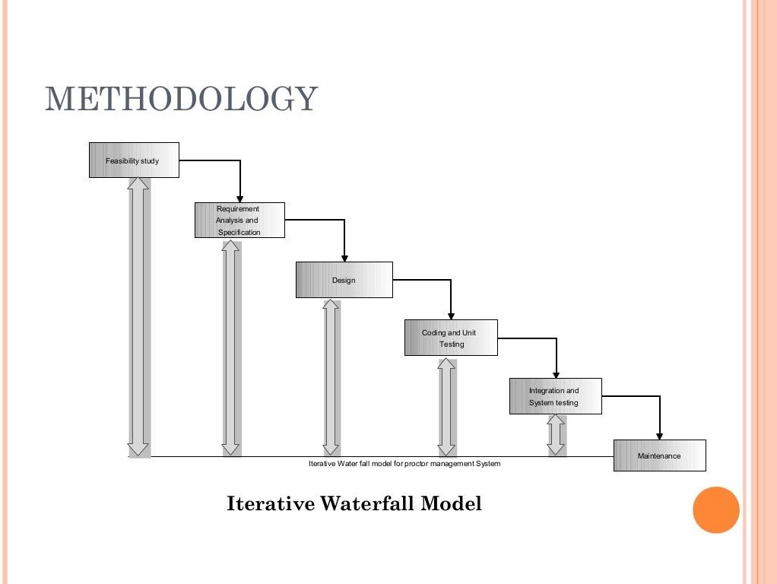

* **Detailed Methodology:**

|  |  |  |
| --- | --- | --- |
| **ID** | **Category** | **Story** |

|  |  |  |
| --- | --- | --- |
| 1 | Database | Creating the schema for the database |
| 2 | Creating the tables |
| 3 | Linking the tables using foreign keys |
| 4 | Hosting the database on Wamp server |
| 5 | User Authentication | New user registration page |
| 6 | Login screen for admin |
| 7 | Dashboard | Creating the dashboard with menu included |
| 9 | Different menu options |
| 10 | New student registration |
| 11 | Searching for a student |
| 12 | Work done checkboxes to check if work done |
| 13 | Creating admin dashboard |
| 14 | Creating student dashboard |
| 15 | Logout |
| 16 | Frontend | Making all HTML and CSS pages |
| 17 | Presenting all data retrieved |
| 18 | Beautifying all the user interface |
| 19 | Backend | Linking all files with relevant PHP files |
| 20 | Linking the PHP files with the database |
| 21 | Code to insert and retrieve data from the database |

|  |  |  |
| --- | --- | --- |
| 22 |  | Combining all files and performing data abstraction |
| 23 | Server | Installing and setting up the Wamp server |
| 24 | Hosting all the required files on the server |

* **Hardware and Software used:**
* **Frontend** - HTML, CSS and JavaScript
* **Backend** – PHP
* **Database engine** - MySQL
* **Server used** –WAMP Server

PHP MyAdmin(to manage the database manually)

# Testing Technologies:

* **Selenium:**

It is a portable [framework](https://en.wikipedia.org/wiki/Software_framework) for [testing](https://en.wikipedia.org/wiki/Software_testing) [web applications](https://en.wikipedia.org/wiki/Web_application). Selenium provides a playback tool for authoring [functional tests](https://en.wikipedia.org/wiki/Functional_testing) without the need to learn a test [scripting language](https://en.wikipedia.org/wiki/Scripting_language) (Selenium IDE). It also provides a test [domain-specific](https://en.wikipedia.org/wiki/Domain-specific_language) [language](https://en.wikipedia.org/wiki/Domain-specific_language) (Selenese) to write tests in a number of popular programming languages, including [C#](https://en.wikipedia.org/wiki/C_Sharp_(programming_language)), [Groovy](https://en.wikipedia.org/wiki/Groovy_(programming_language)), [Java](https://en.wikipedia.org/wiki/Java_(software_platform)), [Perl](https://en.wikipedia.org/wiki/Perl), [PHP](https://en.wikipedia.org/wiki/PHP), [Python](https://en.wikipedia.org/wiki/Python_(programming_language)), [Ruby](https://en.wikipedia.org/wiki/Ruby_(programming_language)) and [Scala](https://en.wikipedia.org/wiki/Scala_(programming_language)). The tests can then run against most modern [web browsers](https://en.wikipedia.org/wiki/Web_browser).

* **Test complete:**

It is used for testing many different application types including [Web](https://en.wikipedia.org/wiki/World_Wide_Web), [Windows](https://en.wikipedia.org/wiki/Microsoft_Windows), [Android](https://en.wikipedia.org/wiki/Android_(operating_system)), [iOS](https://en.wikipedia.org/wiki/IOS), [WPF](https://en.wikipedia.org/wiki/Windows_Presentation_Foundation), [HTML5](https://en.wikipedia.org/wiki/HTML5), [Flash](https://en.wikipedia.org/wiki/Adobe_Flash), [Fle](https://en.wikipedia.org/wiki/Adobe_Flex)x, [Si](https://en.wikipedia.org/wiki/Microsoft_Silverlight) [lverlight](https://en.wikipedia.org/wiki/Microsoft_Silverlight), [.NET](https://en.wikipedia.org/wiki/.NET_Framework), [VCL](https://en.wikipedia.org/wiki/Visual_Component_Library) and [Java](https://en.wikipedia.org/wiki/Java_(programming_language)). It

automates [functional testing](https://en.wikipedia.org/wiki/Functional_testing) and back-end testing like [database](https://en.wikipedia.org/wiki/Database) testing.

# Contribution:

* The system stores the details of the student related to their academics as well as their extra co-curricular activities. A proctor is assigned to each group of students to keep a check on student’s academics and his/her overall performance as a student.
* It will reduce the redundancy and the inconsistencies in the data.
* It will reduce the numerous paper forms.

# Guide Resume:

Mr Suhail Javid

Lecturer Department of Computer Science IITM Srinagar