**UML Diagram**

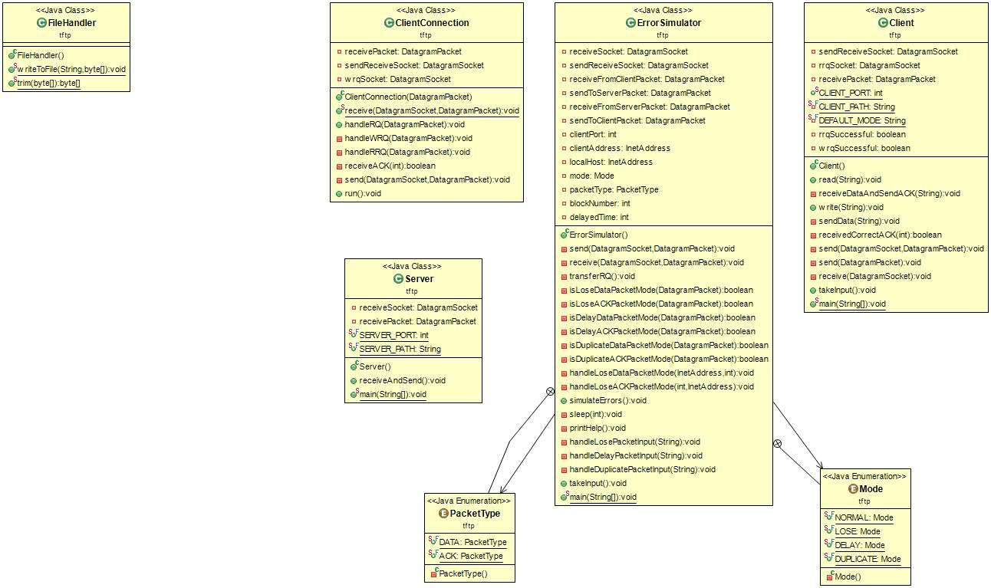

UML Class Diagram for Package **“packet”**

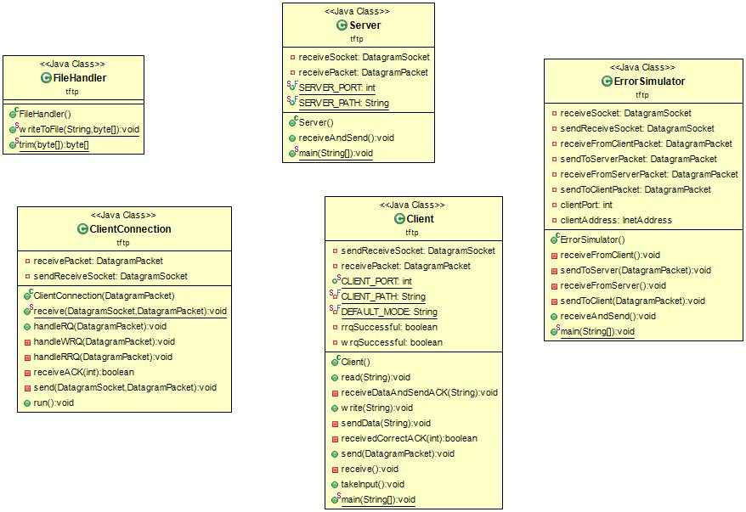

UML Diagram for package “**tftp**”

**UCM Diagrams**:

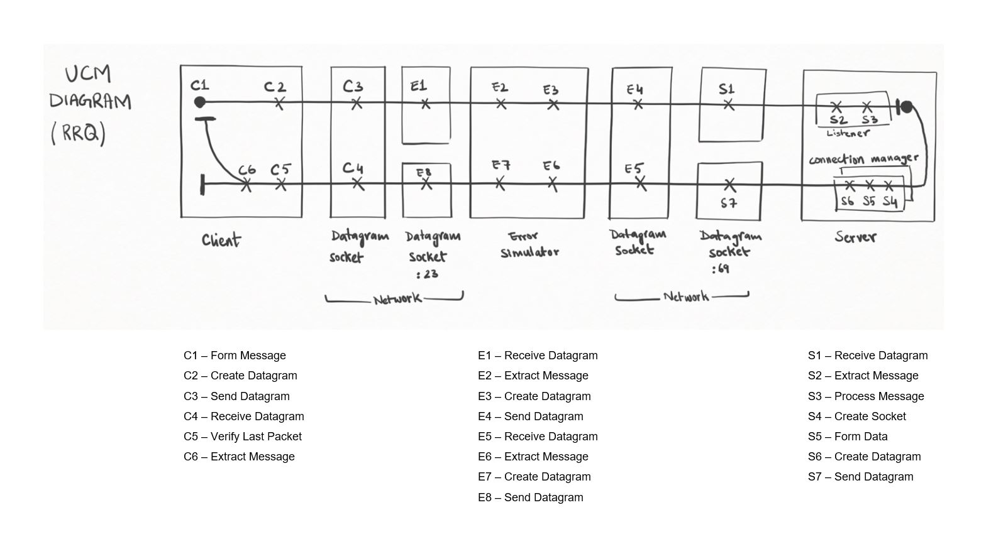

UCM Diagram for RRQ

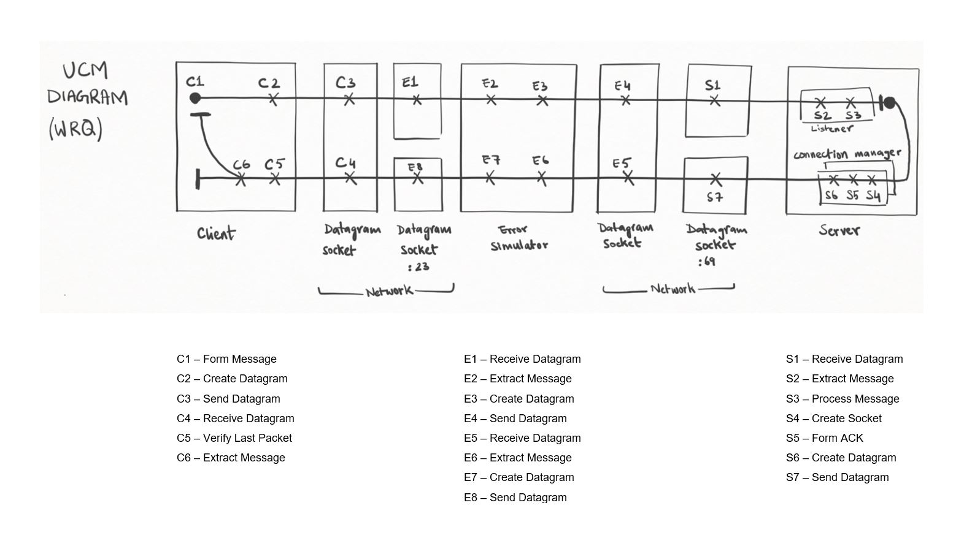

UCM Diagram for WRQ

**Timing Diagrams:**

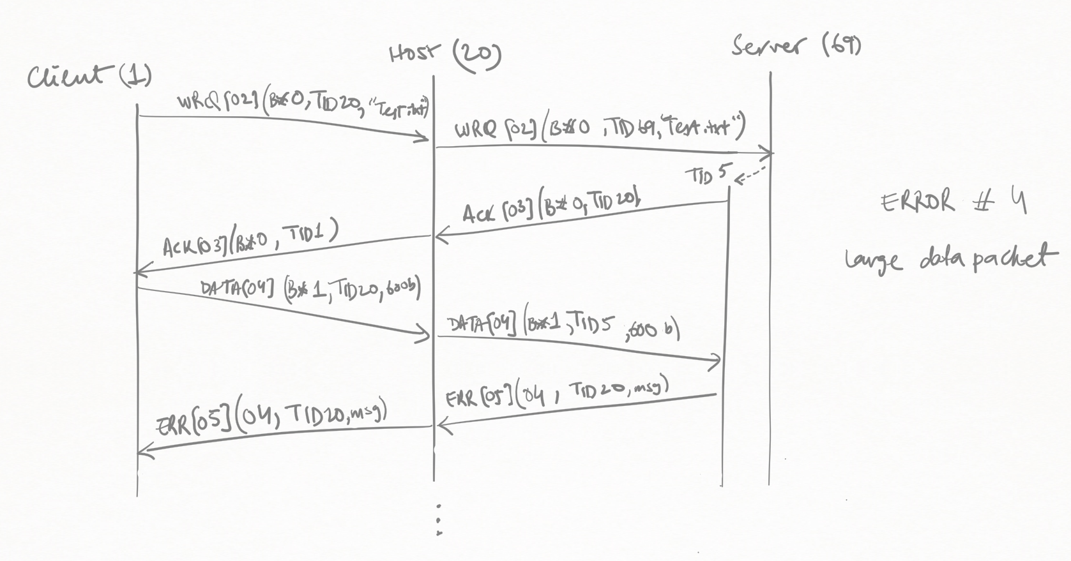

Error 04 (Large Data packet)

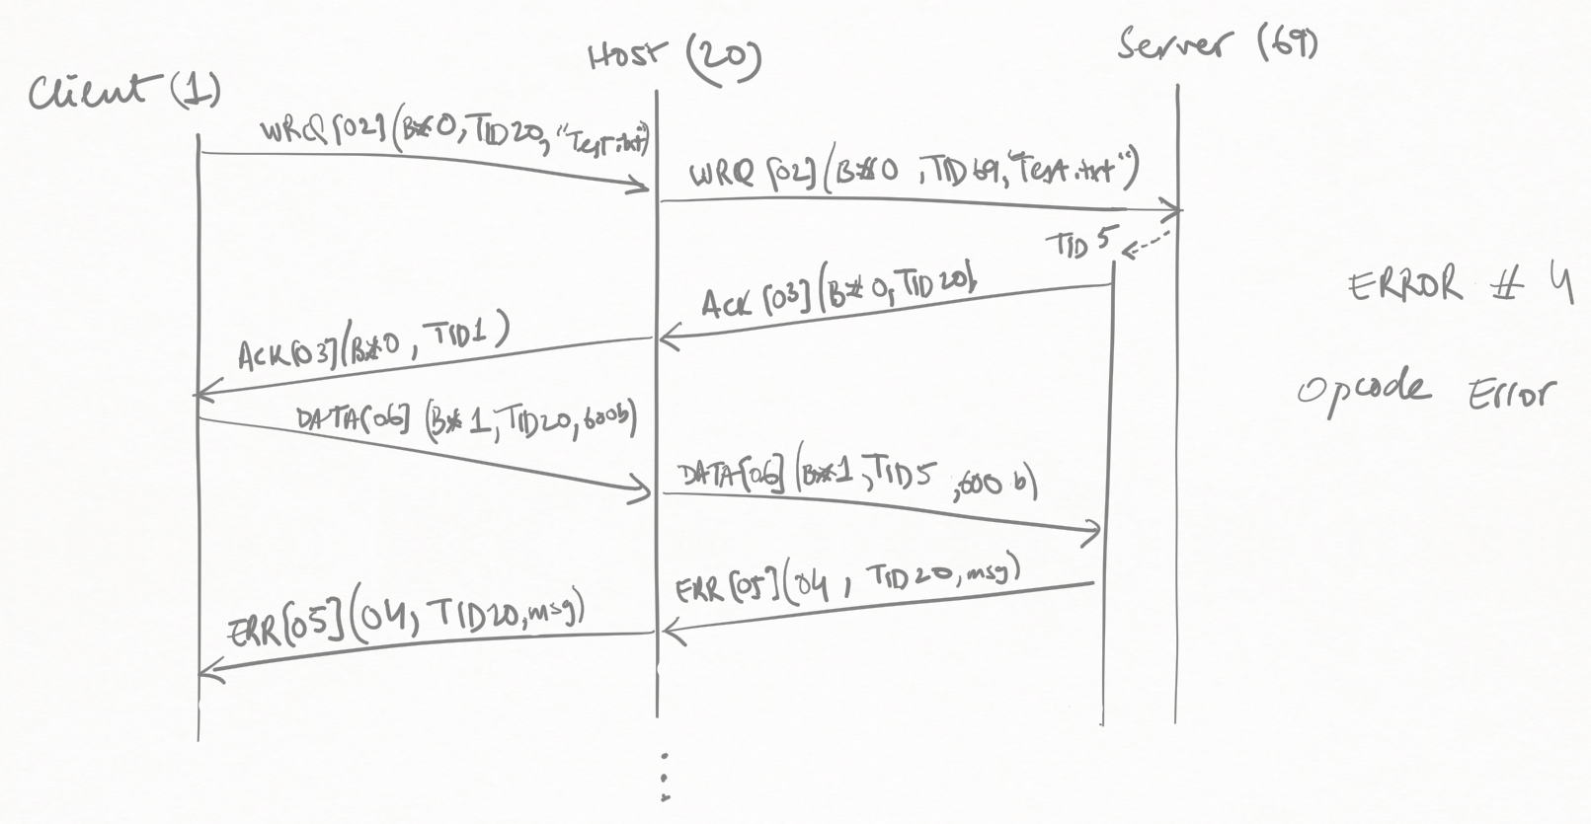

Error 04 (Wrong Opcode)

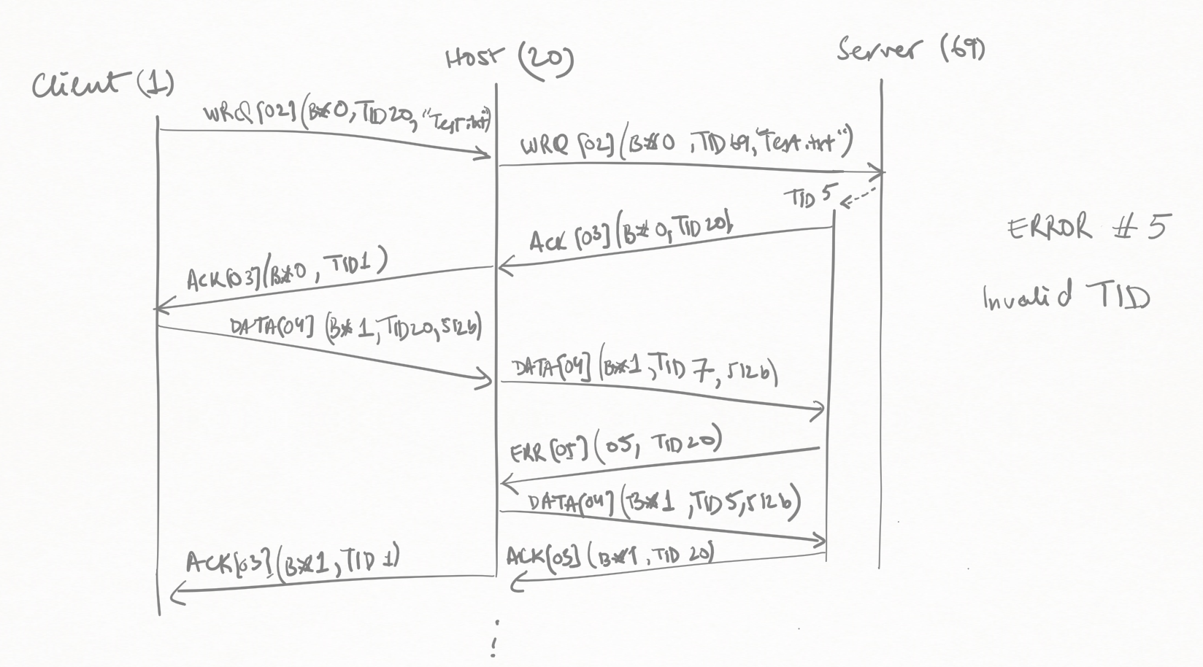

Error 05 (Invalid TID)