Computer Vision Competition — Task 1 (Challenge B) Report
Name: Parrot Cyber
Models: YOLOv8n / YOLOv8s / YOLOv8m (trained best checkpoints)

1. Introduction
In Task 1 (Challenge B), we train and compare multiple YOLOv8 model scales on the provided dataset. The goal is to evaluate accuracy and efficiency trade-offs and recommend the best model for deployment.

2. Methodology
We trained YOLOv8n, YOLOv8s, and YOLOv8m and evaluated them using the same validation protocol. All final results are summarized in comparison.csv.

3. Results Table
model | map50 | map50_95 | inference_ms | fps
yolov8n | 0.62 | 0.435 | 3.2 | 312.5
yolov8s | 0.683 | 0.485 | 7.2 | 138.9
yolov8m | 0.788 | 0.617 | 20.1 | 49.8

4. Charts
Figure: fps
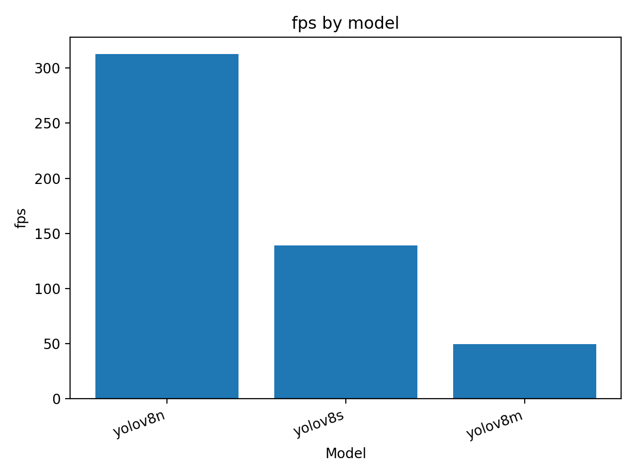
Figure: inference_ms
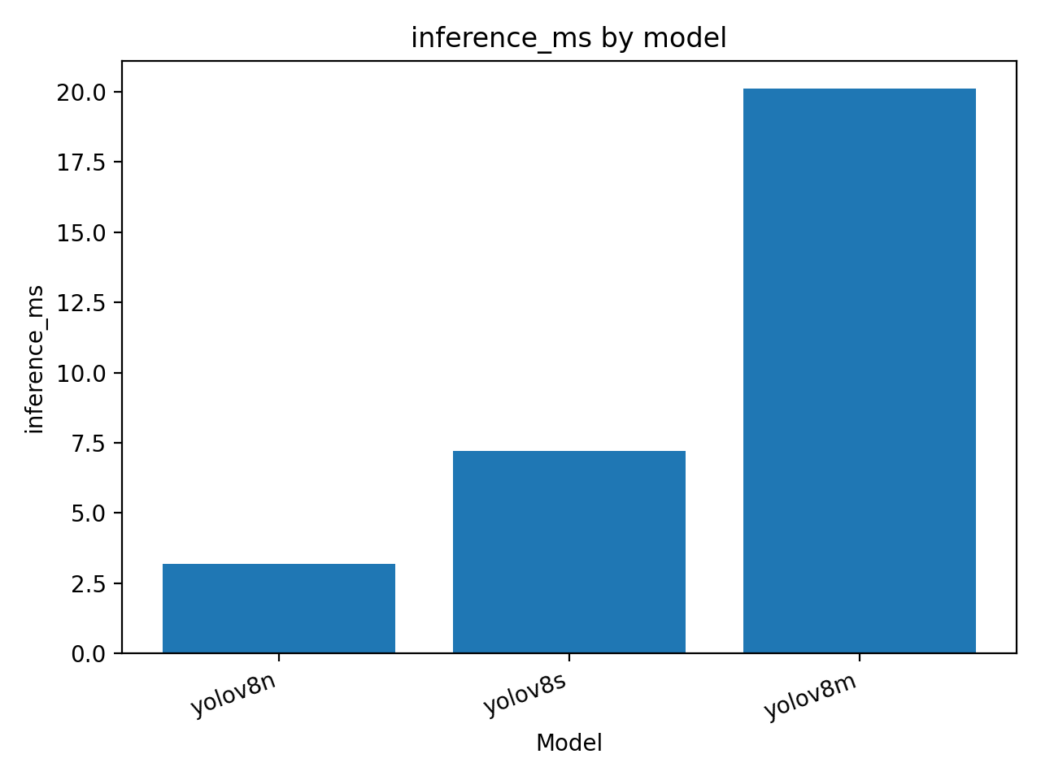
Figure: map50
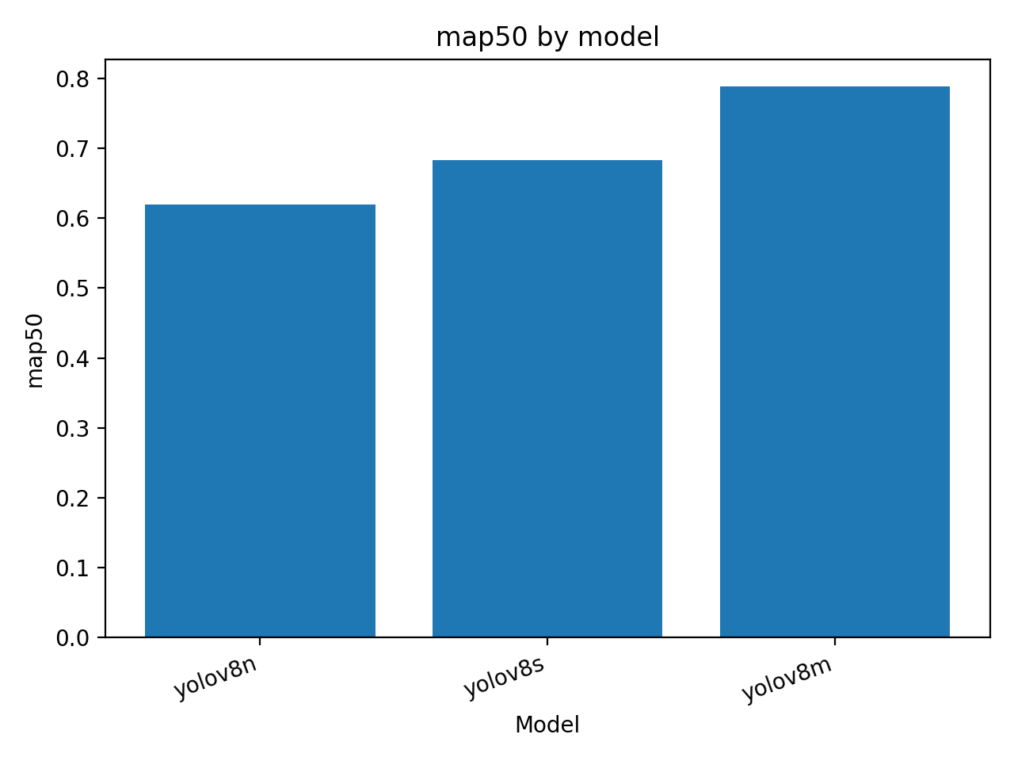
Figure: map50_95
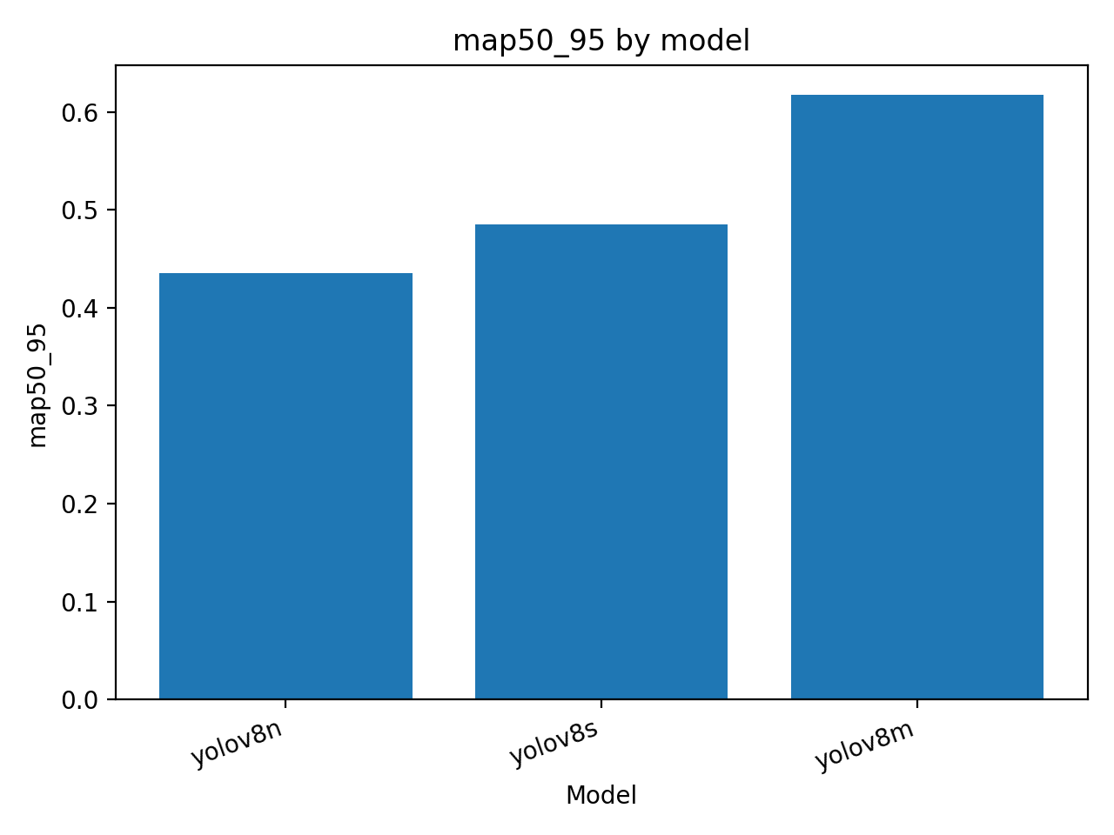

5. Analysis & Recommendation
Typically, larger models (m) achieve higher accuracy but run slower and require more memory, while smaller models (n) are faster but less accurate. We recommend the model that best matches the competition priority metric (often mAP50-95 or mAP50). If real-time constraints exist, a slightly lower mAP may be acceptable for higher FPS.

6. Conclusion
This report compared YOLOv8n/s/m and documented quantitative results and sample predictions. The chosen model is the best trade-off according to the primary evaluation metric in comparison.csv.

