Homework 3 — AI Report Validation System for Brussels Traffic Reports
Author: Mohammad Labadi | Course: dsai (Module 9)

Submission map (for the grader)
HW3 rubric item | Pts | Where to find it
📝 Writing component (NOT AI-generated, ~500 words) | 30 | §1
🔗 Git repository links | 20 | §2
📸 Screenshots / outputs (≥ 4-5) | 25 | §3 (Screenshots 1–5)
📚 Documentation | 25 | §4.1–§4.6
Numerical results (context) | — | §5
Full statistical output | — | §6

1. Writing Component (≈ 500 words — NOT AI-generated) — 30 pts
Replace each yellow placeholder below with your own prose. Aim for ~500 words total covering the five sub-points. Numbers to quote come from §5 / §6.

1.1 Purpose and design of my validation system
📝 YOUR WRITING GOES HERE — 2-4 sentences. What the system does (decision-grade traffic reports for Brussels mobility operators), AI as the reviewer, benchmark = empirical mean vehicle counts from 12_end/data/traffic.db.

1.2 How I customised the validator (different from the LAB Likert scales)
📝 YOUR WRITING GOES HERE — 4-6 sentences. Reference the rubric in §4: five criteria of mixed types (continuous, binary, ordinal, expert Likert 1–7, probability), deterministic + AI-judged split, and benchmark-grounded numerical_grounding score that the LAB does not have.

1.3 Experimental design (prompts compared and how many scores)
📝 YOUR WRITING GOES HERE — 3 prompt variants: A (Minimal), B (Structured), C (Reasoning + Role). 3 stimulus rows per prompt = 9 total validation scores. Generator: gpt-oss:20b on Ollama Cloud; Validator: gpt-oss:120b on Ollama Cloud.

1.4 Statistical analysis results (which prompt won, test statistic, p-value)
📝 YOUR WRITING GOES HERE — Means: A=0.508, B=0.692, C=0.676. Best prompt: B (mean composite = 0.692). ANOVA F=5.611, p=0.0423 (SIGNIFICANT). Bartlett's p=0.2571 → variances equal. Bonferroni-corrected pairwise p-values: A-B=0.092, A-C=0.089, B-C=1.000.

1.5 Design choices and challenges
📝 YOUR WRITING GOES HERE — 3-5 sentences. Why empirical means (not the XGBoost model) as the benchmark; why a mix of deterministic + AI-judged checks; sample-size limitation at N=3 per prompt; validator noise mitigated with temperature=0 + JSON mode; future work: human-rater calibration.

2. Git Repository Links — 20 pts
Repository: https://github.com/mohdLabadi/sysen
What | URL
Main script (homework3_submission.py) | https://github.com/mohdLabadi/sysen/blob/main/11_decision_support/homework3_submission.py
Post-processing script (homework3_postprocess.py) | https://github.com/mohdLabadi/sysen/blob/main/11_decision_support/homework3_postprocess.py
Requirements (homework3_requirements.txt) | https://github.com/mohdLabadi/sysen/blob/main/11_decision_support/homework3_requirements.txt
Validation rubric definition (in homework3_submission.py) | https://github.com/mohdLabadi/sysen/blob/main/11_decision_support/homework3_submission.py#L200-L280
Reports validated (homework3_reports.csv) | https://github.com/mohdLabadi/sysen/blob/main/11_decision_support/output/homework3_reports.csv
Validation scores (homework3_scores.csv) | https://github.com/mohdLabadi/sysen/blob/main/11_decision_support/output/homework3_scores.csv
Statistical summary (homework3_stats.txt) | https://github.com/mohdLabadi/sysen/blob/main/11_decision_support/output/homework3_stats.txt
Homework spec (HOMEWORK3.md) | https://github.com/mohdLabadi/sysen/blob/main/11_decision_support/HOMEWORK3.md

3. Screenshots / Outputs — 25 pts
All four images are real PNGs embedded in this Word document. A fifth screenshot is the full statistical output in §6 below.

Screenshot 1 — Validation rubric (the customised criteria)
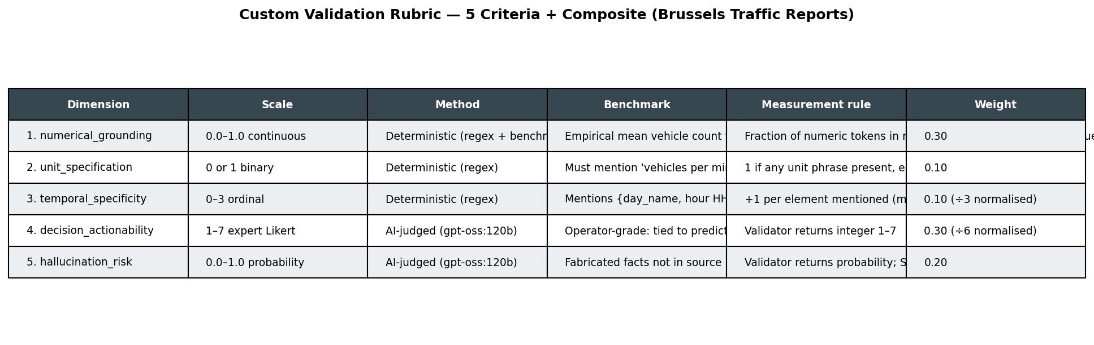

Screenshot 2 — Sample scored report (validator in action)
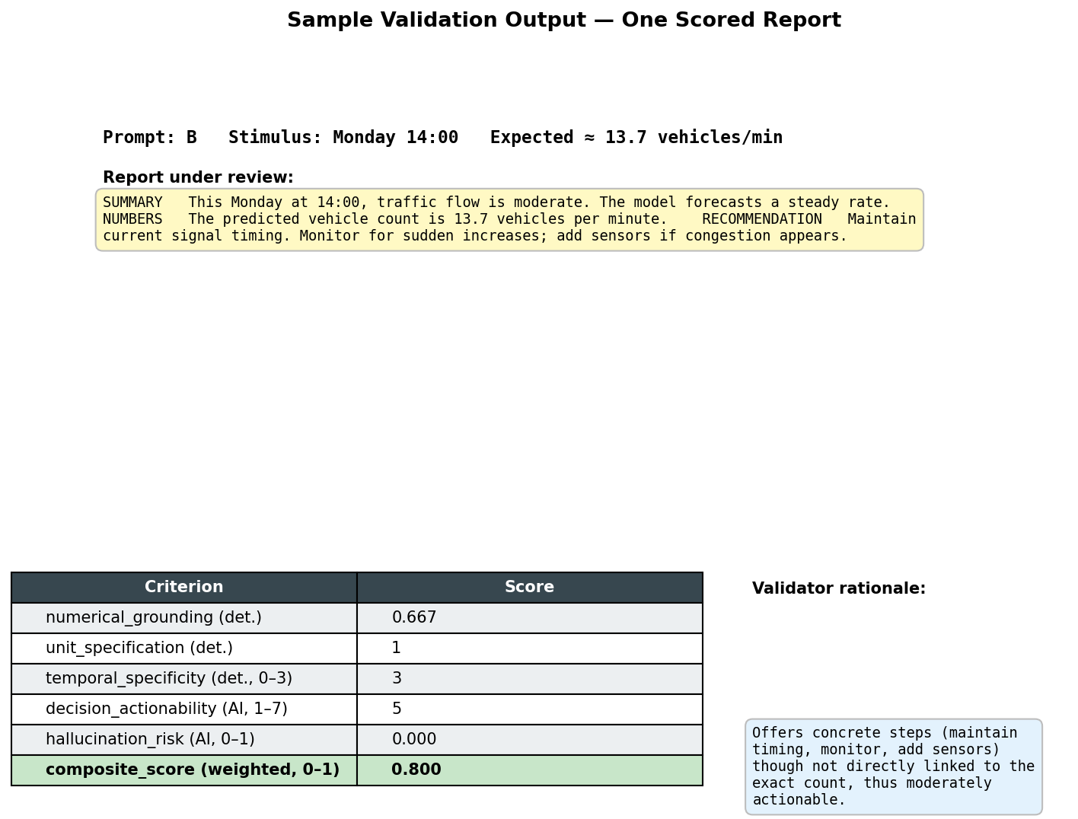

Screenshot 3 — System architecture
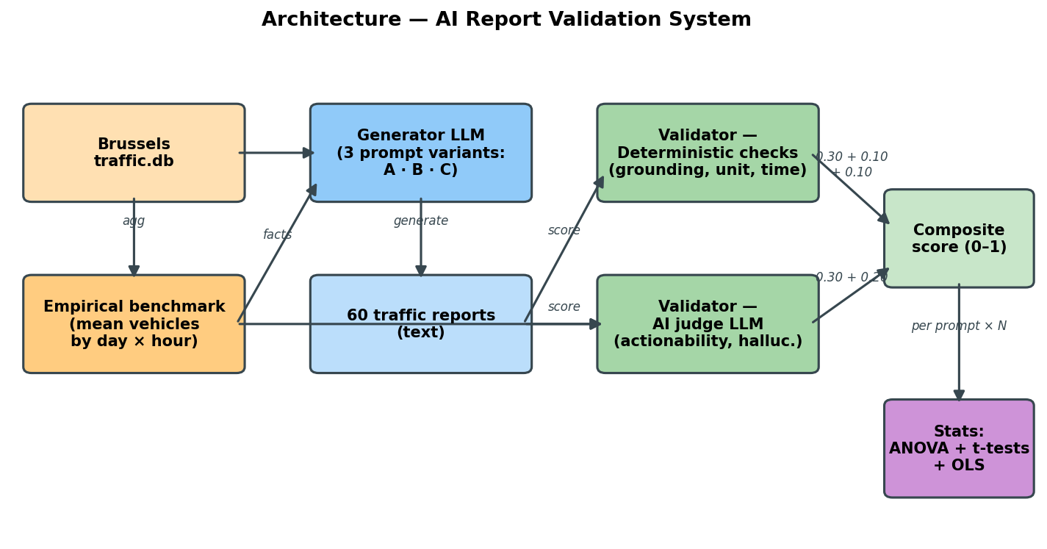

Screenshot 4 — Composite score by prompt (boxplot)
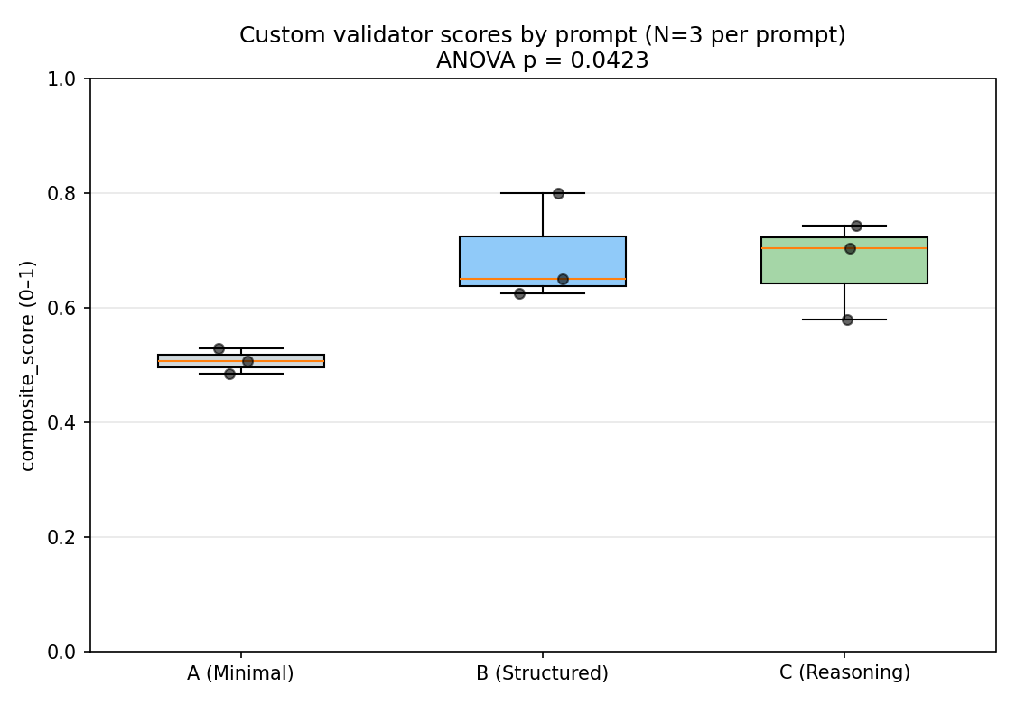

Screenshot 5 — Statistical analysis output (also rendered in §6)
(See §6 for the full text version.)

4. Documentation — 25 pts

4.1 Validation Criteria Table (how my rubric differs from the LAB)
# | Dimension | Type / Scale | Method | Benchmark | Measurement Rule | Weight
1 | numerical_grounding | 0–1 continuous | Deterministic (regex + benchmark) | Empirical mean vehicles for (day, hour) from traffic.db | Fraction of numeric tokens within ±5% of expected value | 0.30
2 | unit_specification | 0 / 1 binary | Deterministic (regex) | Must mention 'vehicles per minute' or '1m/t1' | 1 if any unit phrase present, else 0 | 0.10
3 | temporal_specificity | 0–3 ordinal | Deterministic (regex) | Mentions day, hour HH:00, sampling-interval | +1 per element mentioned (max 3) | 0.10
4 | decision_actionability | 1–7 expert Likert | AI-judged (gpt-oss:120b) | Action tied to predicted count | Validator returns integer 1–7 | 0.30
5 | hallucination_risk | 0.0–1.0 probability | AI-judged (gpt-oss:120b) | Source facts only | Validator returns probability; SAFETY = 1 − risk | 0.20
— | composite_score | 0–1 weighted sum | — | — | Weighted combination of the five rows above | —

How this differs from the LAB Likert scales — the LAB uses six independent 1–5 Likert scales all judged by the AI. My rubric (a) uses five criteria of mixed types (continuous, binary, ordinal, 1–7 Likert, probability) instead of six identical 1–5 scales; (b) makes the most important criterion (numerical_grounding) deterministic and benchmark-grounded against the true empirical Brussels distribution; (c) adds a use-case-specific check (unit_specification) because operators must see units; (d) widens the Likert range on the most subjective criterion to 1–7 for finer resolution; (e) reports a continuous hallucination_risk probability instead of a 1–5 Likert; (f) collapses everything into a single composite (0–1) for clean statistical comparison.

4.2 Experimental Design
• Sample size: 3 stimulus (day_of_week, hour_of_day) pairs per prompt → 9 total reports → 9 total validation scores.
• Three prompt variants (full text in homework3_submission.py):
A — Minimal: one-sentence instruction with the predicted count.
B — Structured: explicit SUMMARY / NUMBERS / RECOMMENDATION sections, word cap, 'no invented stats' rule.
C — Reasoning + Role: mobility-planner role, 4-step silent reasoning, hard rules on numbers and units.
• Generator model: gpt-oss:20b (Ollama Cloud), temperature 0.7.
• Validator model: gpt-oss:120b (Ollama Cloud), temperature 0.0, JSON-mode.
• Random seed: 42 (reproducible stimulus selection).

4.3 Statistical Analysis
• Hypothesis (H1): at least one prompt produces a different mean composite_score, i.e. prompt design has a non-zero causal effect.
• Null (H0): µ_A = µ_B = µ_C.
• Tests run (in order):
1. Bartlett's test for homogeneity of variance.
2. One-way (or Welch) ANOVA across the three prompts.
3. Pairwise t-tests with Bonferroni correction (3 comparisons).
4. OLS regression composite_score ~ C(prompt_id, ref='A') + word_count.
• Significance threshold: α = 0.05 (Bonferroni-corrected for pairwise).

4.4 System Design
The validation system has six stages (see Screenshot 3 for the diagram):
1. Benchmark build — aggregate traffic.db into an empirical (day × hour) table of mean vehicles per minute.
2. Stimulus sampling — pick N (day, hour) pairs uniformly.
3. Report generation — for each (prompt × stimulus), call the generator LLM.
4. Deterministic scoring — regex + benchmark check on every report.
5. AI-judged scoring — second LLM call returns decision_actionability (1–7) and hallucination_risk (0–1) in JSON.
6. Composite + stats + plot — weighted score, ANOVA, t-tests, OLS, boxplot.

4.5 Technical Details
• Python: 3.12 / 3.14 (a venv with all deps is created automatically).
• Key packages: pandas, numpy, scipy, pingouin, statsmodels, matplotlib, requests, python-dotenv (see homework3_requirements.txt).
• Secrets: repo-root .env containing OLLAMA_API_KEY=… for Ollama Cloud. Falls back to a local Ollama on 127.0.0.1:11434 if absent.
• Data: 12_end/data/traffic.db (SQLite, metro_id 948 = Brussels).

4.6 Usage Instructions
Two terminal commands from the repo root:
python3 -m venv 11_decision_support/.venv && \
11_decision_support/.venv/bin/pip install -r 11_decision_support/homework3_requirements.txt
bash 11_decision_support/run_homework3.sh
Useful flags / env vars: --n N (reports per prompt), --quick (smoke test, N=3), HW3_HTTP_TIMEOUT=60, HW3_HTTP_RETRIES=1, HW3_GIT_REPO_URL=…

5. Numerical Results — composite_score by prompt
mean std min max
prompt_id
A 0.5075 0.0225 0.485 0.5300
B 0.6917 0.0946 0.625 0.8000
C 0.6758 0.0851 0.580 0.7429

Per-criterion means by prompt:
numerical_grounding unit_specification temporal_specificity decision_actionability hallucination_risk
prompt_id
A 0.247 1.0 3.0 4.333 0.667
B 0.417 1.0 3.0 4.333 0.000
C 0.175 1.0 3.0 6.667 0.300

6. Full Statistical Output
========================================================================
Statistical Comparison of Prompts A / B / C
========================================================================
Sample size per prompt: {'A': 3, 'B': 3, 'C': 3}
Descriptive statistics — composite_score by prompt:
mean std min max
prompt_id
A 0.5075 0.0225 0.485 0.5300
B 0.6917 0.0946 0.625 0.8000
C 0.6758 0.0851 0.580 0.7429
Per-criterion means by prompt:
numerical_grounding unit_specification temporal_specificity decision_actionability hallucination_risk
prompt_id
A 0.247 1.0 3.0 4.333 0.667
B 0.417 1.0 3.0 4.333 0.000
C 0.175 1.0 3.0 6.667 0.300
Bartlett's test for homogeneity of variance: W = 2.7166, p = 0.2571
-> equal variances OK (standard ANOVA)
One-way ANOVA (composite_score ~ prompt_id):
Source SS DF MS F p_unc np2
prompt_id 0.0625 2 0.0313 5.611 0.0423 0.6516
Within 0.0334 6 0.0056 NaN NaN NaN
-> p = 0.0423 (SIGNIFICANT — at least one prompt differs)
Pairwise t-tests (Bonferroni-corrected):
Contrast A B Paired Parametric T dof alternative p_unc p_corr p_adjust BF10 hedges
prompt_id A B False True -3.2796 4.0 two-sided 0.0305 0.0915 bonf 2.63 -2.1422
prompt_id A C False True -3.3107 4.0 two-sided 0.0296 0.0889 bonf 2.674 -2.1626
prompt_id B C False True 0.2158 4.0 two-sided 0.8397 1.0000 bonf 0.57 0.1410
Best mean composite_score: prompt B = 0.6917
⚠️ no pairwise comparison reaches p<0.05 after Bonferroni correction (N per prompt = 3 is small — rerun with --n 20 for more power)
OLS regression: composite_score ~ C(prompt_id, ref='A') + word_count
OLS Regression Results
==============================================================================
Dep. Variable: composite_score R-squared: 0.653
Model: OLS Adj. R-squared: 0.444
Method: Least Squares F-statistic: 3.130
Date: Mon, 11 May 2026 Prob (F-statistic): 0.126
Time: 03:04:47 Log-Likelihood: 12.422
No. Observations: 9 AIC: -16.84
Df Residuals: 5 BIC: -16.05
Df Model: 3
Covariance Type: nonrobust
===============================================================================================================
coef std err t P>|t| [0.025 0.975]
---------------------------------------------------------------------------------------------------------------
Intercept 0.4415 0.566 0.780 0.471 -1.014 1.897
C(prompt_id, Treatment(reference='A'))[T.B] 0.2380 0.465 0.512 0.631 -0.958 1.434
C(prompt_id, Treatment(reference='A'))[T.C] 0.2079 0.345 0.603 0.573 -0.679 1.095
word_count 0.0003 0.002 0.117 0.912 -0.006 0.007
==============================================================================
Omnibus: 0.121 Durbin-Watson: 2.875
Prob(Omnibus): 0.941 Jarque-Bera (JB): 0.306
Skew: 0.175 Prob(JB): 0.858
Kurtosis: 2.166 Cond. No. 4.26e+03
==============================================================================
Notes:
[1] Standard Errors assume that the covariance matrix of the errors is correctly specified.
[2] The condition number is large, 4.26e+03. This might indicate that there are
strong multicollinearity or other numerical problems.

