**Course 2 – Sprint 1 : Manage_Unstructured_Data_Using_NoSQL_DB​(MongoDB)​**

Installing MongoDB for Windows

1. To download the free, community edition of MongoDB for Windows, start by going to this link: <https://www.mongodb.com/download-center/community>

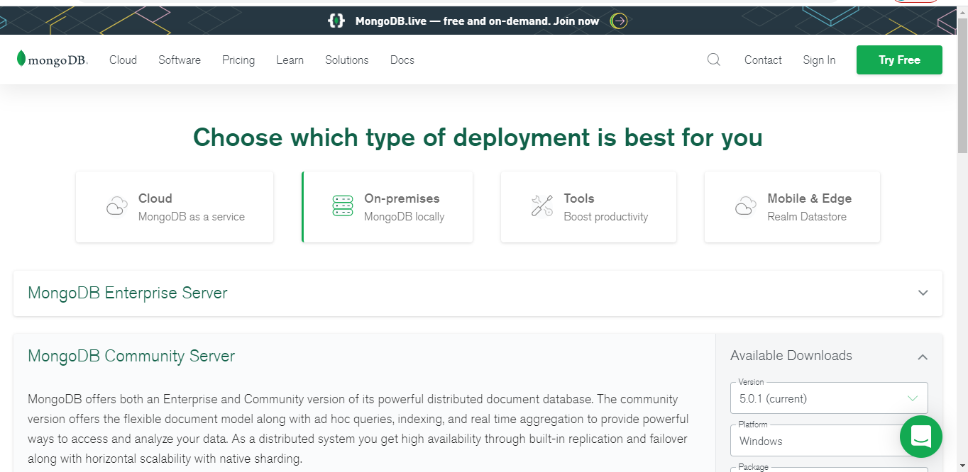

1. Under the “OS” dropdown, choose the Windows 64 bit option
2. By default, the “Package” should be set to “MSI” and the version should be set to the current release. Leave these unchanged
3. Click download. Once the MSI file finishes downloading, double click it to open it

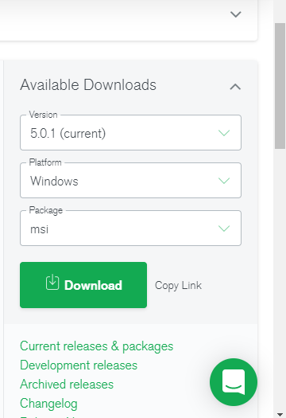

1. Follow along with the installation wizard, with these specifications:
2. When asked whether to use the “Complete” or “Custom” setup type, choose “Complete”

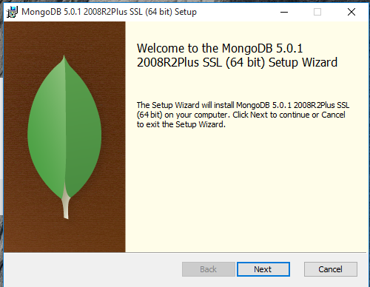

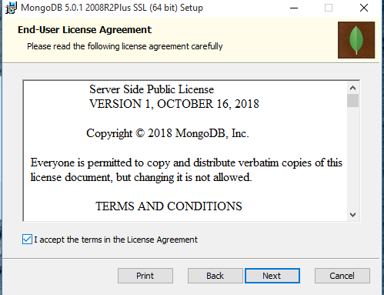

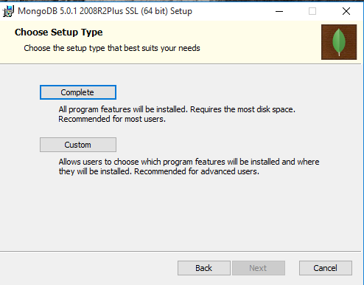

1. When asked whether to install MongoDB as a service, do not install as a service (make sure that “install MongoDB as a service” is unchecked)

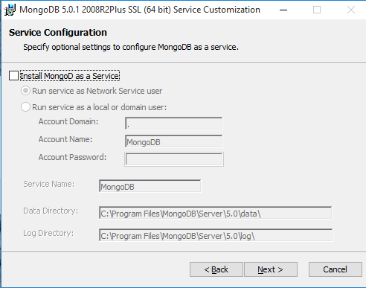

1. When asked to install MongoDB Compass, leave it checked if you have Windows 8 or higher (we will be using MongoDB compass later in the course). If you have Windows 7, uncheck “Install MongoDB compass”. You can install Compass directly later in the course

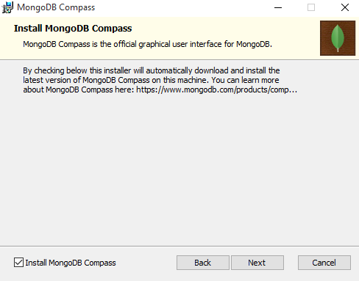

1. After the installation finishes, you can verify that it worked by going to your local disk folder (the C drive), go into your “Program Files” folder, and you should see a “MongoDB” folder there. Verify that this folder is present, and in the “Program Files” folder in your C drive before continuing.

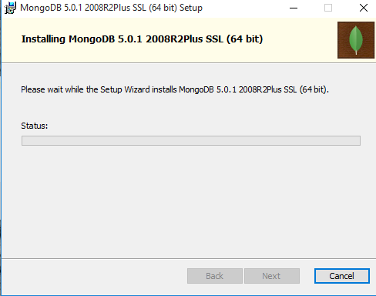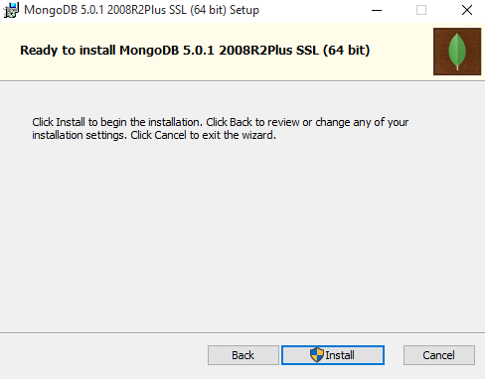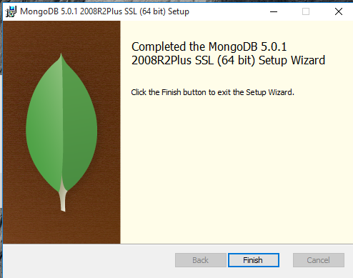

1. MongoDB needs specific folders to be created in order to store data. Go back to your local disk folder (the C drive) and in this folder, create a new folder with the name “data”. Then, go inside the “data” folder you just made and create another folder called “db”.
2. Note - the names and locations of these folders are important.
3. After creating the folders in the previous step, we need to open the command prompt. You can do this by going into the start menu and searching for “cmd”. Click on the “Command Prompt” application that comes up from this search to open it.
4. Next, we’ll start up a MongoDB server. In the command prompt, copy and paste the following command, and hit enter:

(Here, check the version for installation)

"C:\Program Files\MongoDB\Server\4.0\bin\mongod.exe" --dbpath="c:\data\db"

1. After starting our server, next we’ll start up the mongo shell. This is what we’ll use to start working with data directly in MongoDB. Open up a new command prompt window, copy and paste the following command, and hit enter:

"C:\Program Files\MongoDB\Server\4.0\bin\mongo.exe"