Task : 1

Created DataBase named “Library”

Created a collection in it named “Books_Details” and inported the json file of the “Books_details” data.

Task : 2

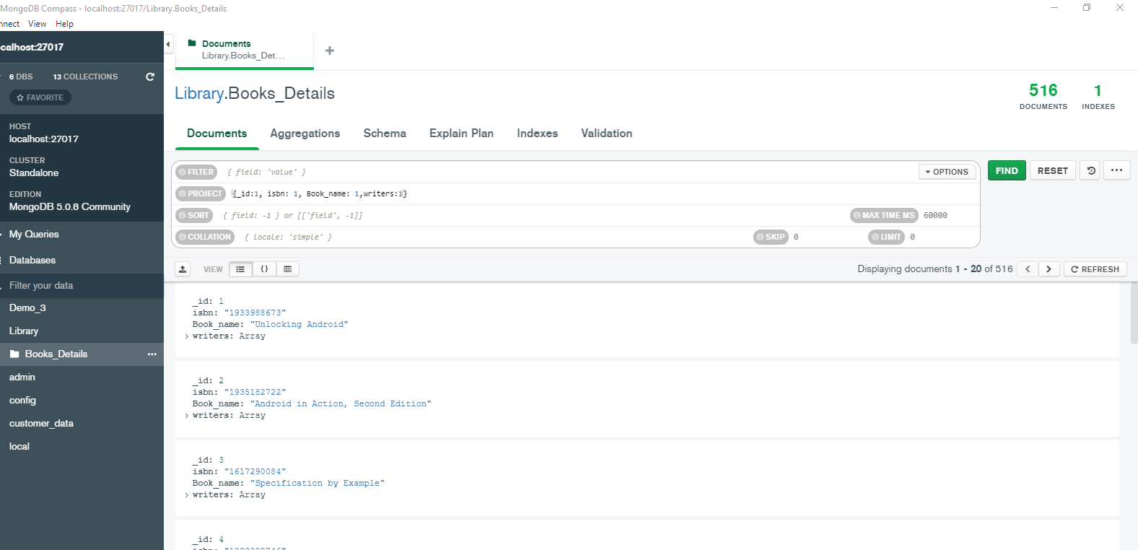

Task : 3

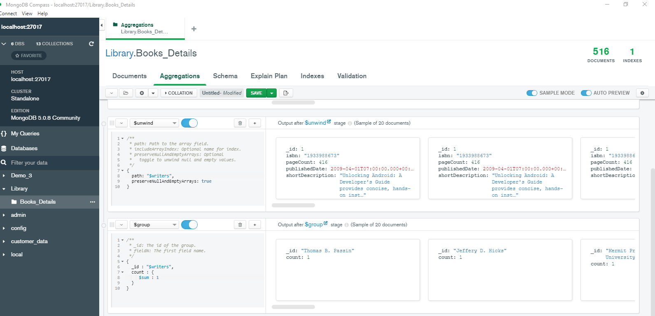

To remove the null values we can set ” preservenulltoemptyarrays “ to “false” instead of “true”.

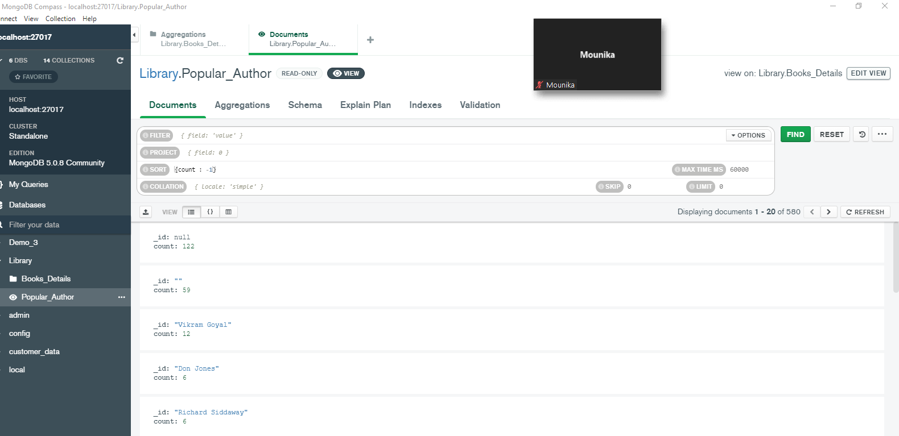

Task : 4

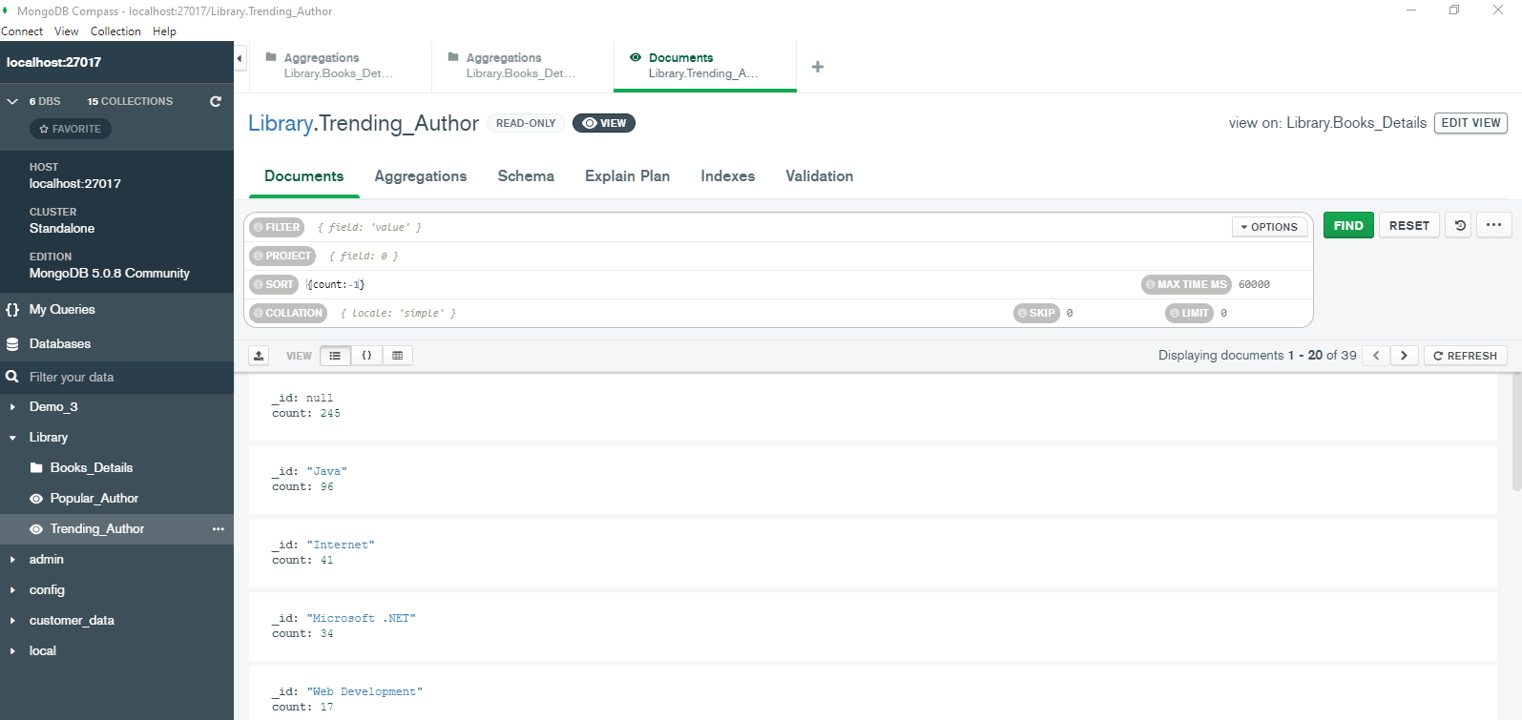

To remove the null values we can set ” preservenulltoemptyarrays “ to “false” instead of “true”.

Task : 5

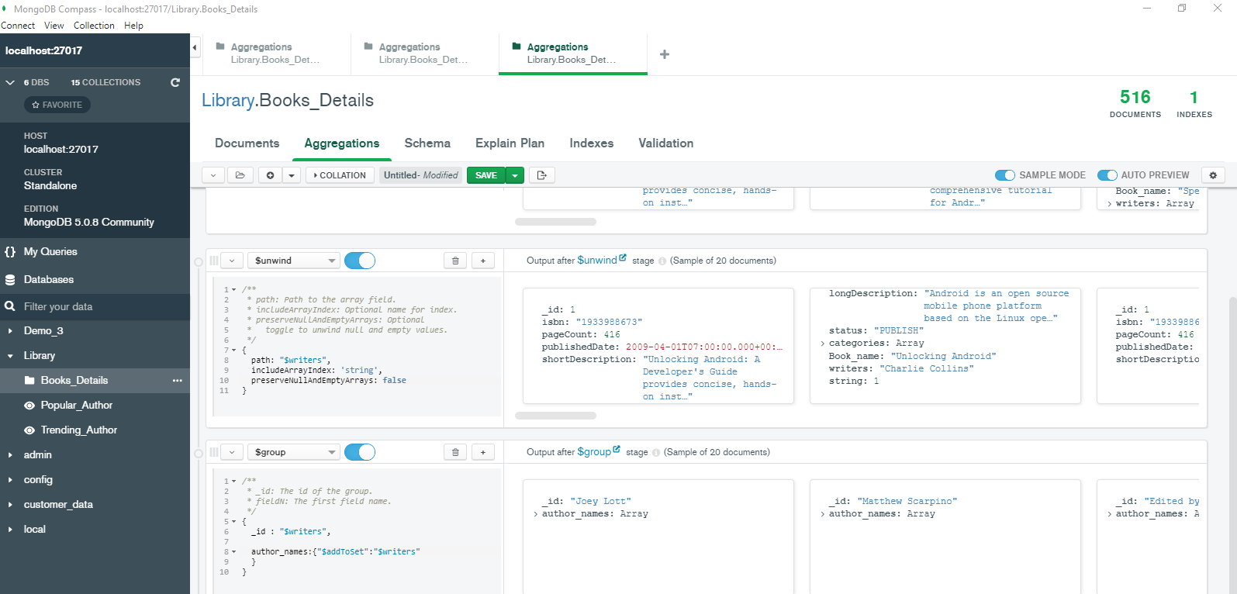

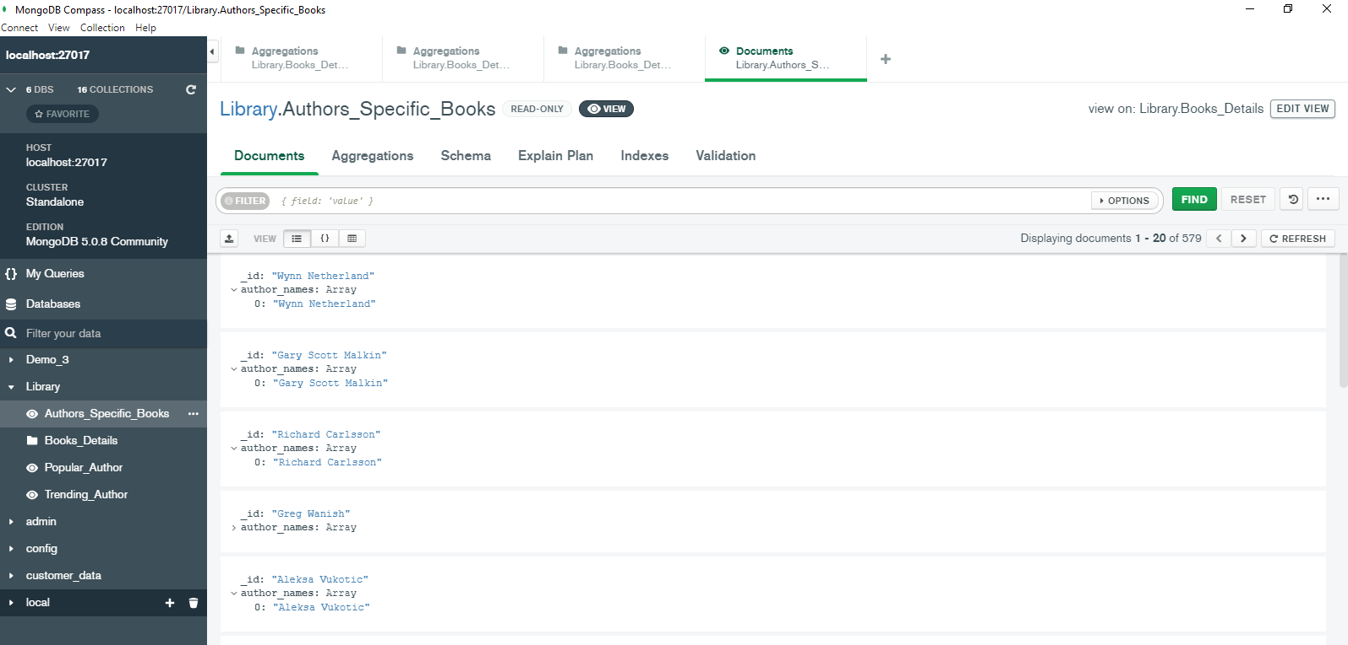

Task : 6



Same as Task : 4!

Task : 7

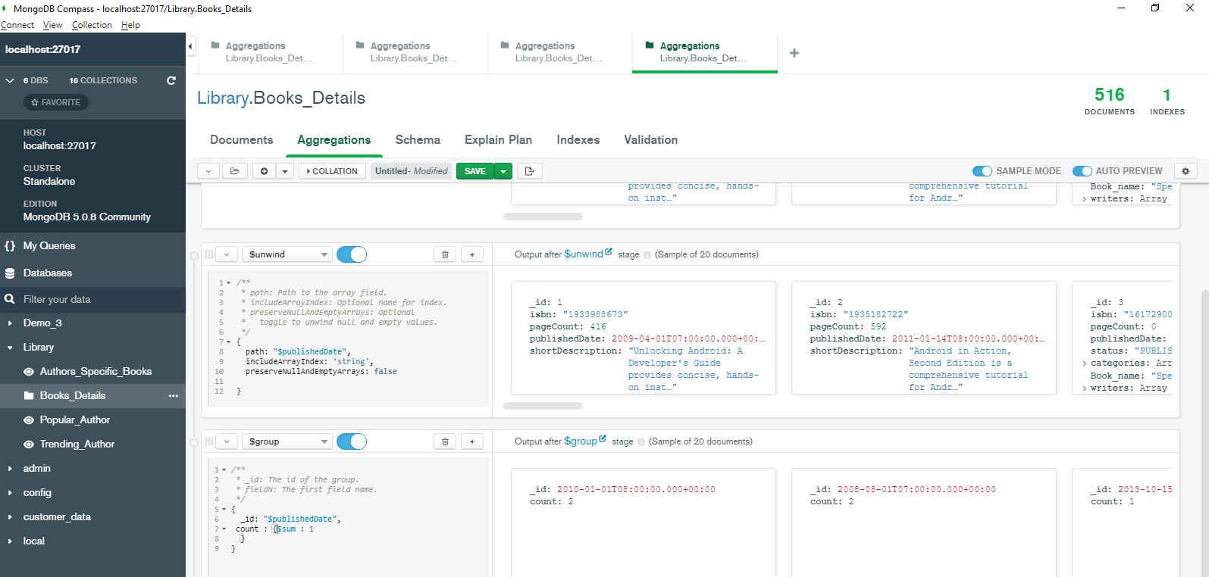

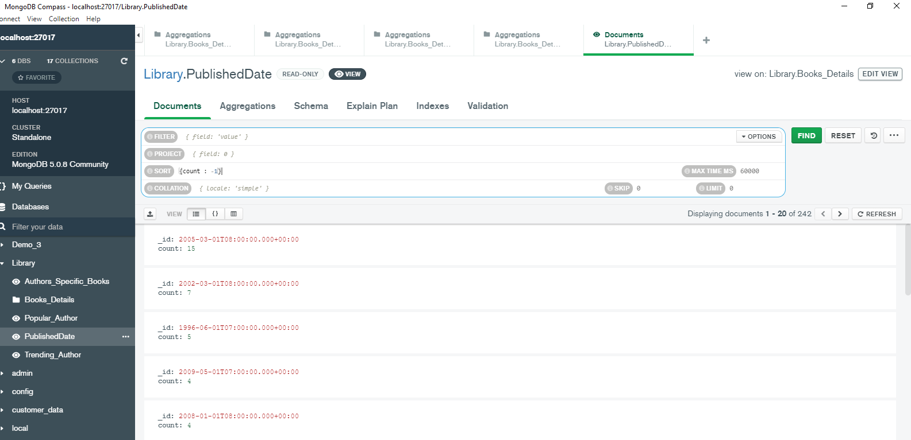

Task : 8

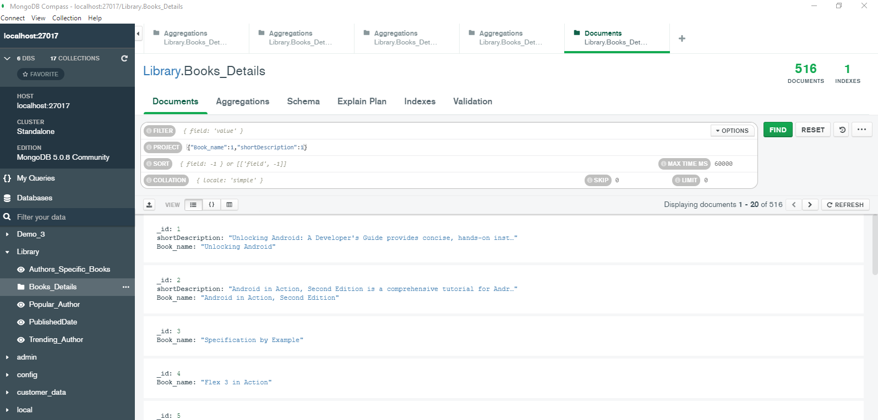

Task : 9

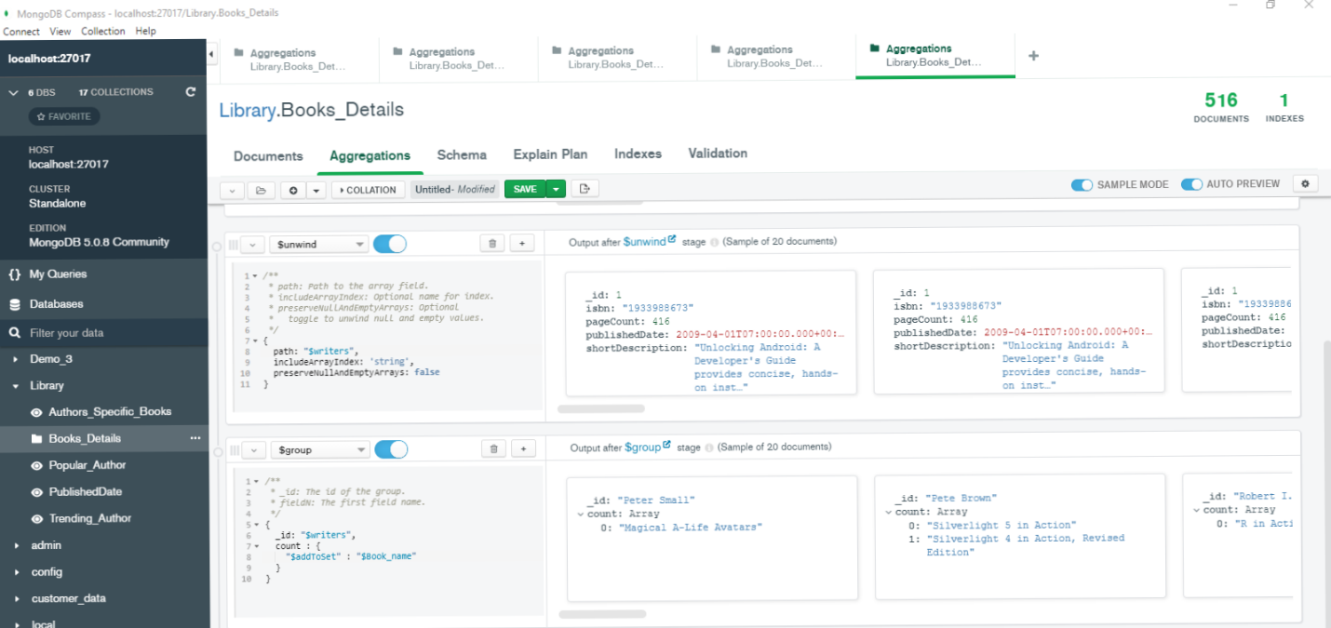

Task : 10

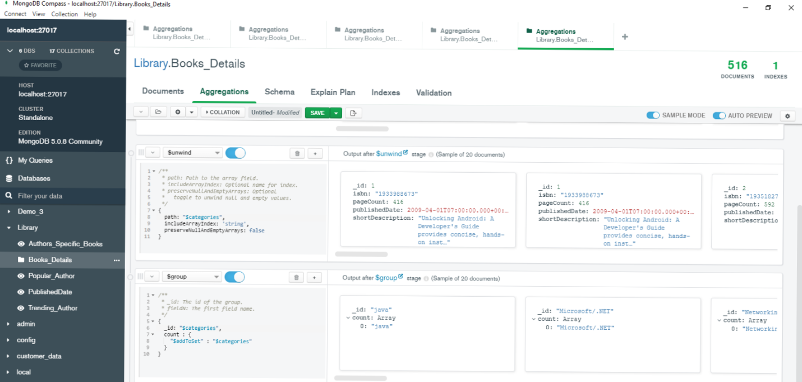

Task : 11



