--Terraform--
Challenge-10

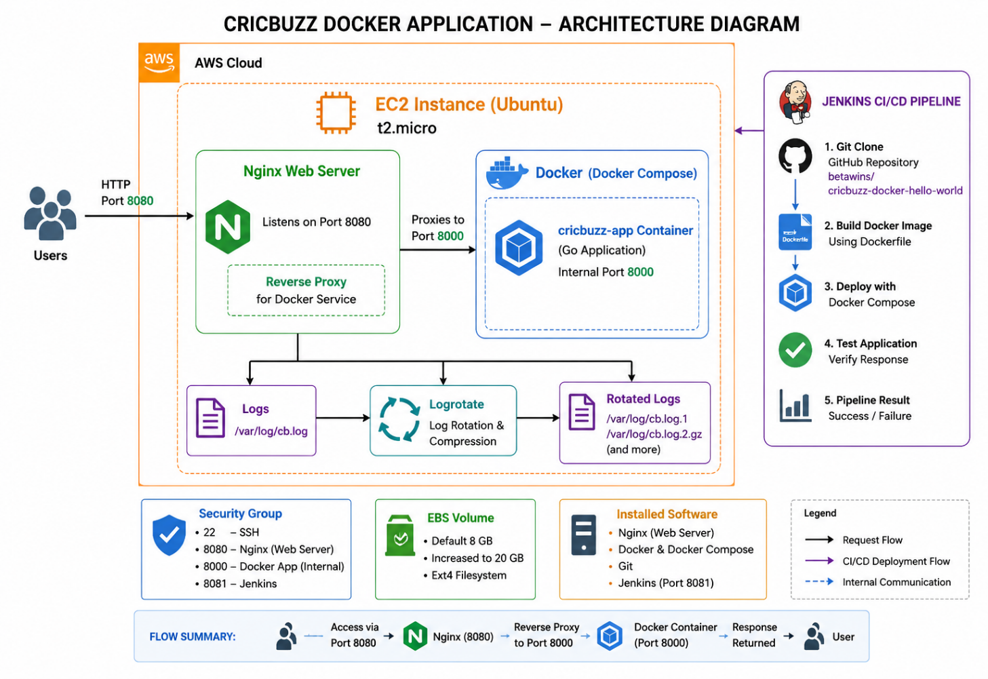

Challenge 1: Provision Ubuntu EC2 Using Terraform
We will first create the EC2 instance and security group. After this works, the next challenge will install Docker, Docker Compose, Nginx, logging, and log rotation.
Overall project flow
Browser :8080
↓
Nginx Web Server
↓ Reverse Proxy
Docker Application :8000
↓
Application Response

Logs → /var/log/cb.log
Objective
Provision an Ubuntu EC2 instance using Terraform with:
- Ubuntu AMI
- t2.micro instance type
- SSH access on port 22
- Nginx access on port 8080
- Docker application access on port 8000
- A public IPv4 address
Terraform uses the aws_instance resource to create and manage an EC2 instance.
Real-life example
Think of this project as a restaurant:
EC2 Instance = Restaurant building
Docker container = Kitchen
Application :8000 = Chef preparing food
Nginx :8080 = Waiter receiving customer requests
Security Group = Security guard at the entrance
The customer speaks to the waiter on port 8080. The waiter sends the request to the kitchen running on port 8000.

Prerequisites
Make sure you have:
- AWS account
- Terraform installed
- AWS CLI installed
- AWS credentials configured
- VS Code
- Existing EC2 key pair in us-east-1
- Default VPC in us-east-1
Verify:
terraform version
aws --version
aws sts get-caller-identity
Check your key-pair name:
aws ec2 describe-key-pairs `
--region us-east-1 `
--query "KeyPairs[*].KeyName" `
--output table
Check the default VPC:
aws ec2 describe-vpcs `
--filters "Name=is-default,Values=true" `
--region us-east-1 `
--output table

Step 1: Create the project folder
mkdir terraform-cricbuzz-project
cd terraform-cricbuzz-project
code .
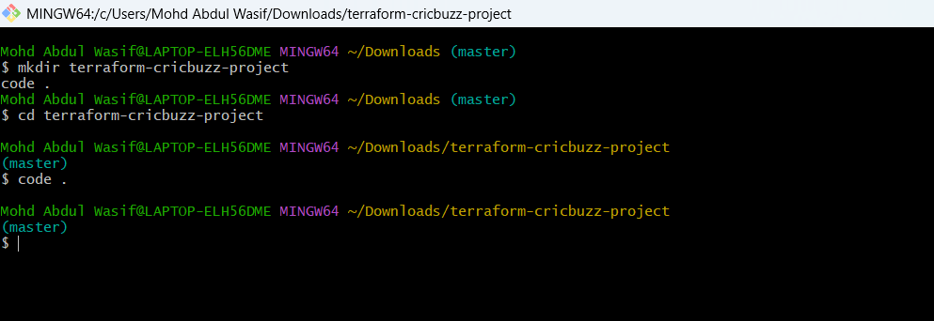
Create these files:
terraform-cricbuzz-project/
├── provider.tf
├── variables.tf
├── main.tf
├── outputs.tf
└── terraform.tfvars
(With directory=mkdir terraform-workspaces-task; cd terraform-workspaces-task; New-Item provider.tf,variables.tf,main.tf,outputs.tf -ItemType File)
(Only files multiple=New-Item provider.tf,variables.tf,main.tf,outputs.tf -ItemType File)
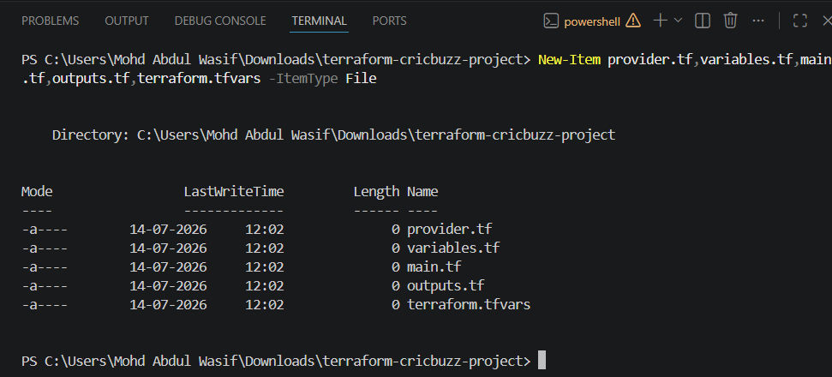

Step 2: Create provider.tf
terraform {
required_providers {
aws = {
source = "hashicorp/aws"
version = "~> 6.0"
}
}
}

provider "aws" {
region = var.aws_region
}
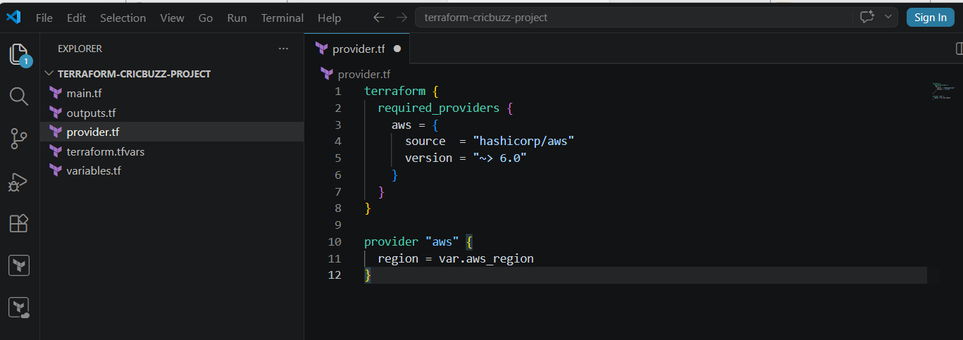
Explanation
terraform block = Defines Terraform requirements
required_providers = Downloads the AWS provider
provider "aws" = Connects Terraform to AWS
region = AWS region where resources will be created

Step 3: Create variables.tf
variable "aws_region" {
description = "AWS region for the resources"
type = string
default = "us-east-1"
}

variable "ami_id" {
description = "Ubuntu AMI ID"
type = string
default = "ami-0461b1436c9b3c1a3"
}

variable "instance_type" {
description = "EC2 instance type"
type = string
default = "t3.micro"
}

variable "key_name" {
description = "Existing AWS EC2 key-pair name"
type = string
}

variable "ssh_cidr" {
description = "IP address allowed to connect through SSH"
type = string
}
The supplied AMI must exist in us-east-1. AMI IDs are region-specific.
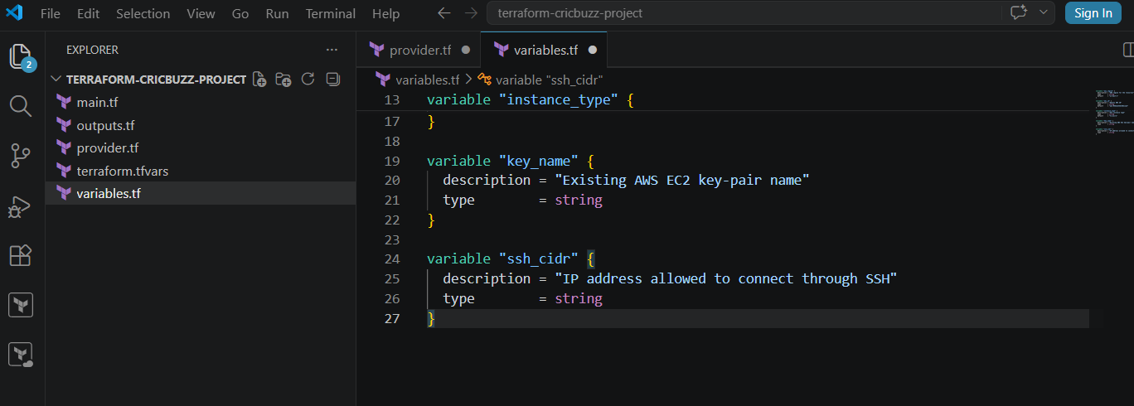

Step 4: Create main.tf
data "aws_vpc" "default" {
default = true
}

data "aws_subnets" "default" {
filter {
name = "vpc-id"
values = [data.aws_vpc.default.id]
}
}

resource "aws_security_group" "cricbuzz_sg" {
name = "cricbuzz-web-sg"
description = "Allow SSH, Nginx and Docker application traffic"
vpc_id = data.aws_vpc.default.id

ingress {
description = "SSH from my computer"
from_port = 22
to_port = 22
protocol = "tcp"
cidr_blocks = [var.ssh_cidr]
}

ingress {
description = "Nginx reverse proxy"
from_port = 8080
to_port = 8080
protocol = "tcp"
cidr_blocks = ["0.0.0.0/0"]
}

ingress {
description = "Docker application testing"
from_port = 8000
to_port = 8000
protocol = "tcp"
cidr_blocks = ["0.0.0.0/0"]
}

egress {
description = "Allow all outbound traffic"
from_port = 0
to_port = 0
protocol = "-1"
cidr_blocks = ["0.0.0.0/0"]
}

tags = {
Name = "cricbuzz-web-sg"
Project = "Cricbuzz Docker"
}
}
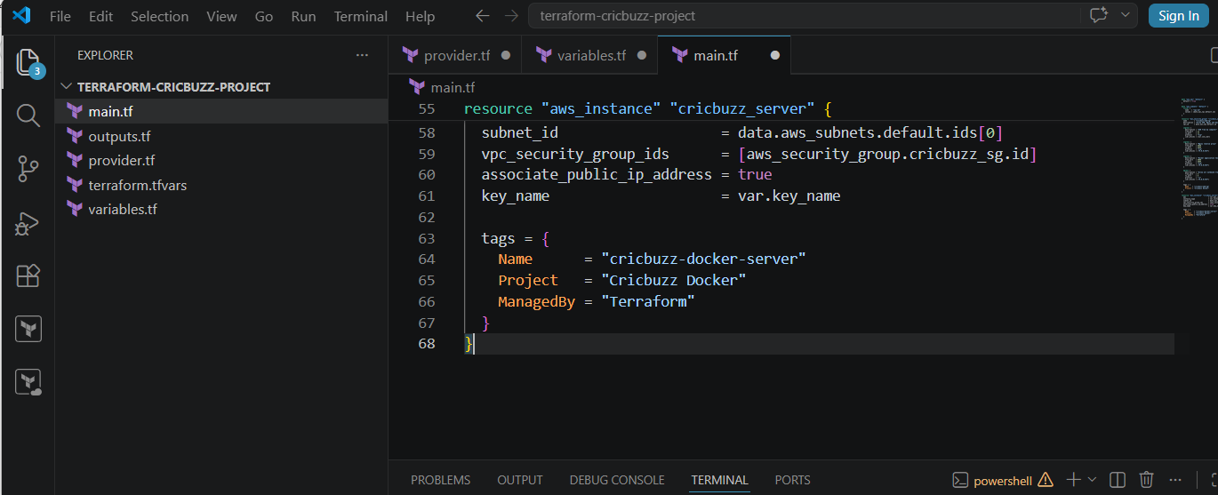
resource "aws_instance" "cricbuzz_server" {
ami = var.ami_id
instance_type = var.instance_type
subnet_id = data.aws_subnets.default.ids[0]
vpc_security_group_ids = [aws_security_group.cricbuzz_sg.id]
associate_public_ip_address = true
key_name = var.key_name

tags = {
Name = "cricbuzz-docker-server"
Project = "Cricbuzz Docker"
ManagedBy = "Terraform"
}
}
Security groups control allowed inbound traffic by protocol, port, and source. AWS recommends restricting SSH access to your own IP rather than allowing port 22 from everywhere.
Important explanation
EC2 resource
resource "aws_instance" "cricbuzz_server"
- aws_instance is the AWS resource type.
- cricbuzz_server is Terraform’s local name for the resource.
AMI
ami = var.ami_id
The AMI is the operating-system image used to launch the server.
Instance type
instance_type = var.instance_type
This controls the EC2 CPU and memory capacity.
Security group connection
vpc_security_group_ids = [aws_security_group.cricbuzz_sg.id]
This attaches the security group to the EC2 instance.
Public IP
associate_public_ip_address = true
This gives the instance a public address so you can connect to it.

Step 5: Find your public IP
In PowerShell:
curl.exe https://checkip.amazonaws.com
Suppose the result is:
49.204.100.25
Your CIDR value becomes:
49.204.100.25/32
/32 means only your current public IP can use SSH.
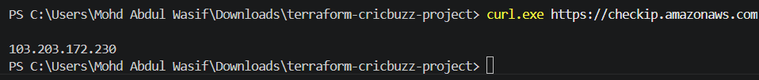

Step 6: Create terraform.tfvars
Replace the values with your actual details:
aws_region = "us-east-1"
ami_id = "ami-0461b1436c9b3c1a3"
instance_type = "t3.micro"
key_name = "Virginia"
ssh_cidr = "YOUR-PUBLIC-IP/32"
Example:
ssh_cidr = "49.204.100.25/32"
Do not write:
ssh_cidr = "192.168.1.9/32"
192.168.1.9 is your private Wi-Fi address, not your internet-facing public IP.
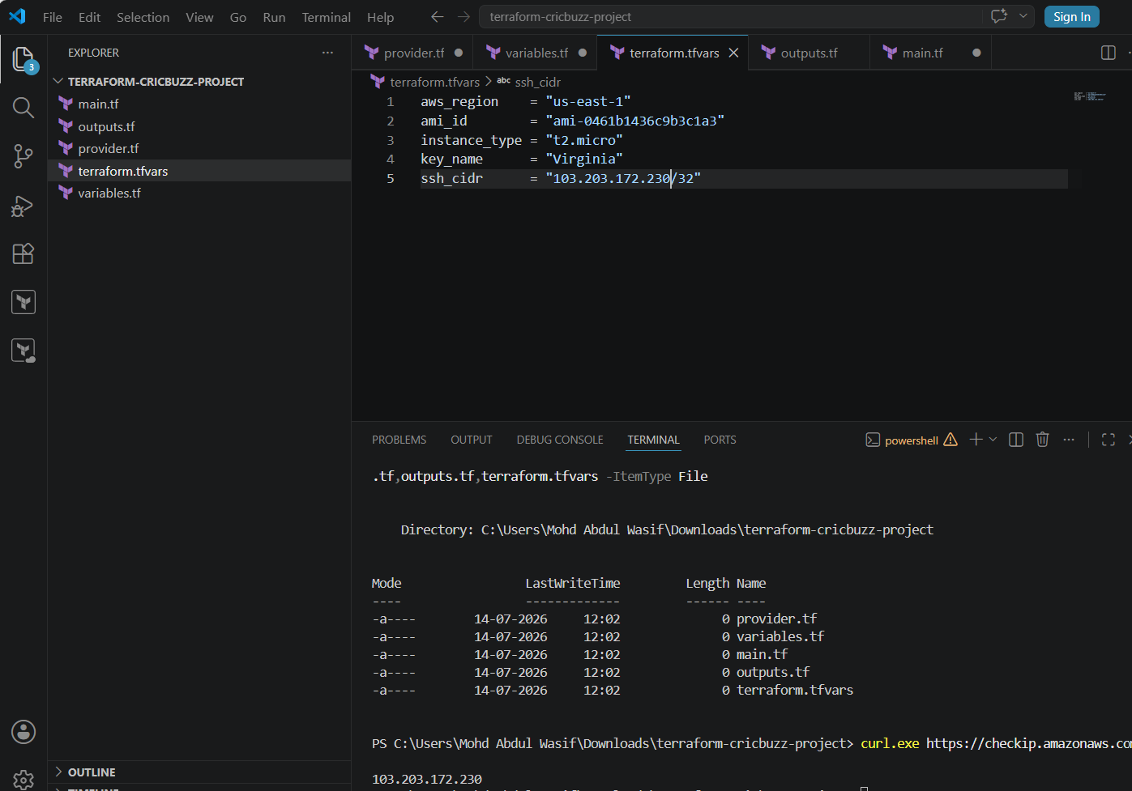

Step 7: Create outputs.tf
output "instance_id" {
description = "EC2 instance ID"
value = aws_instance.cricbuzz_server.id
}

output "public_ip" {
description = "EC2 public IP address"
value = aws_instance.cricbuzz_server.public_ip
}

output "ssh_command" {
description = "Command used to connect to EC2"
value = "ssh -i <key-file.pem> ubuntu@${aws_instance.cricbuzz_server.public_ip}"
}

output "nginx_url" {
description = "Nginx URL for the next challenge"
value = "http://${aws_instance.cricbuzz_server.public_ip}:8080"
}

output "docker_app_url" {
description = "Docker application URL for testing"
value = "http://${aws_instance.cricbuzz_server.public_ip}:8000"
}
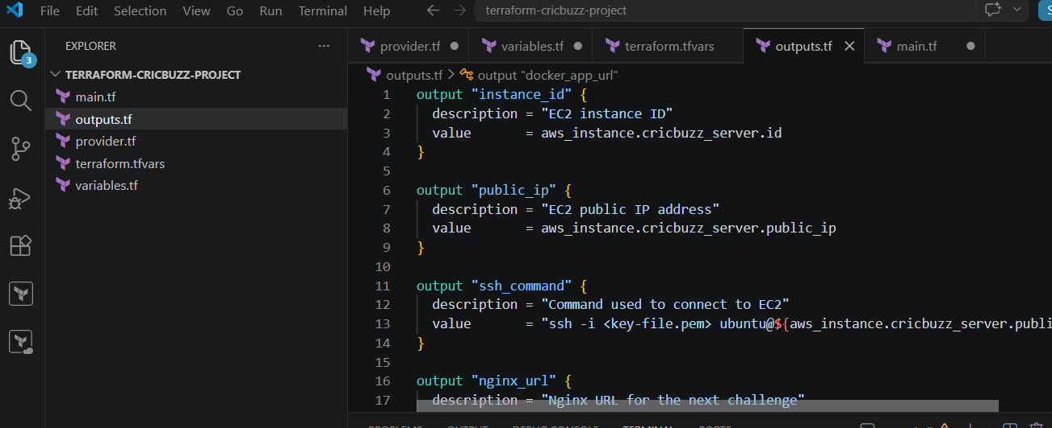

Step 8: Run Terraform
terraform init
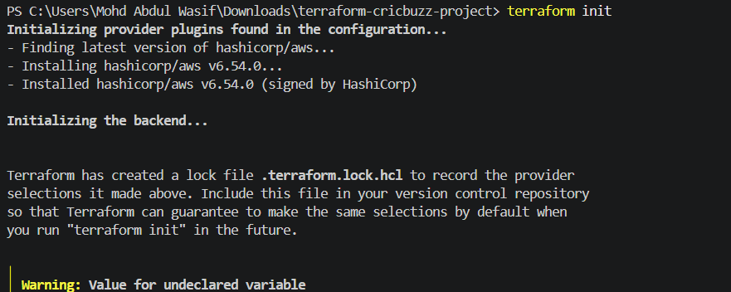
terraform fmt -recursive
terraform validate
Expected result:
Success! The configuration is valid.
Create the execution plan:
terraform plan
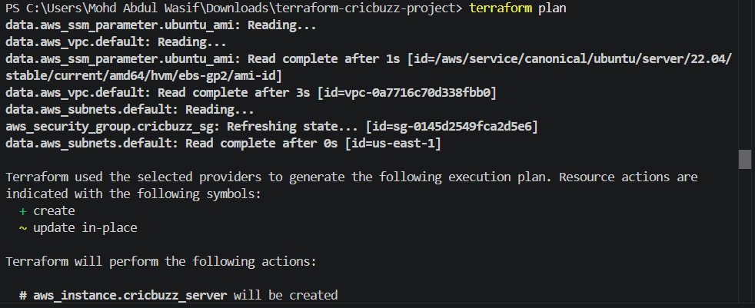
Provision the infrastructure:
terraform apply
Enter:
yes
Or:
terraform apply -auto-approve
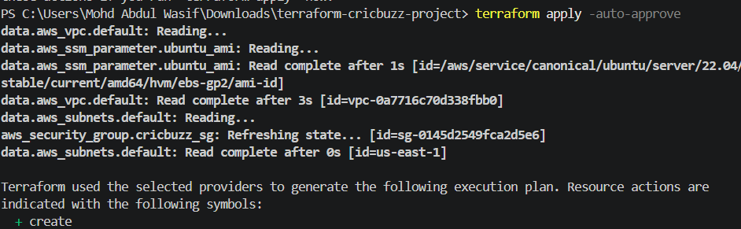

Step 9: View the result
terraform output
Expected structure:
instance_id = "i-xxxxxxxxxxxxxxxxx"
public_ip = "xx.xx.xx.xx"
nginx_url = "http://xx.xx.xx.xx:8080"
docker_app_url = "http://xx.xx.xx.xx:8000"

Step 10: Verify EC2
aws ec2 describe-instances `
--filters "Name=tag:Name,Values=cricbuzz-docker-server" `
--query "Reservations[*].Instances[*].[InstanceId,State.Name,PublicIpAddress,InstanceType]" `
--output table `
--region us-east-1
Expected:
---------------------------------------------------------------
| i-xxxxxxxx | running | PUBLIC-IP | t2.micro |
---------------------------------------------------------------
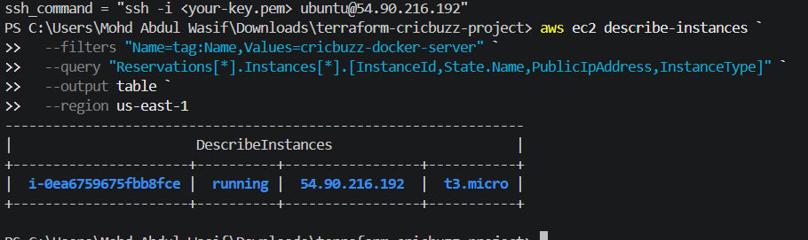

Step 11: Connect through SSH
For Ubuntu, the default username is normally ubuntu:
ssh -i "C:\Users\Mohd Abdul Wasif\Downloads\Virginia.pem" ubuntu@PUBLIC-IP
Example:
ssh -i "C:\Users\Mohd Abdul Wasif\Downloads\Virginia.pem" ubuntu@52.87.236.246
When asked:
Are you sure you want to continue connecting?
Enter:
yes
Verify the operating system:
cat /etc/os-release
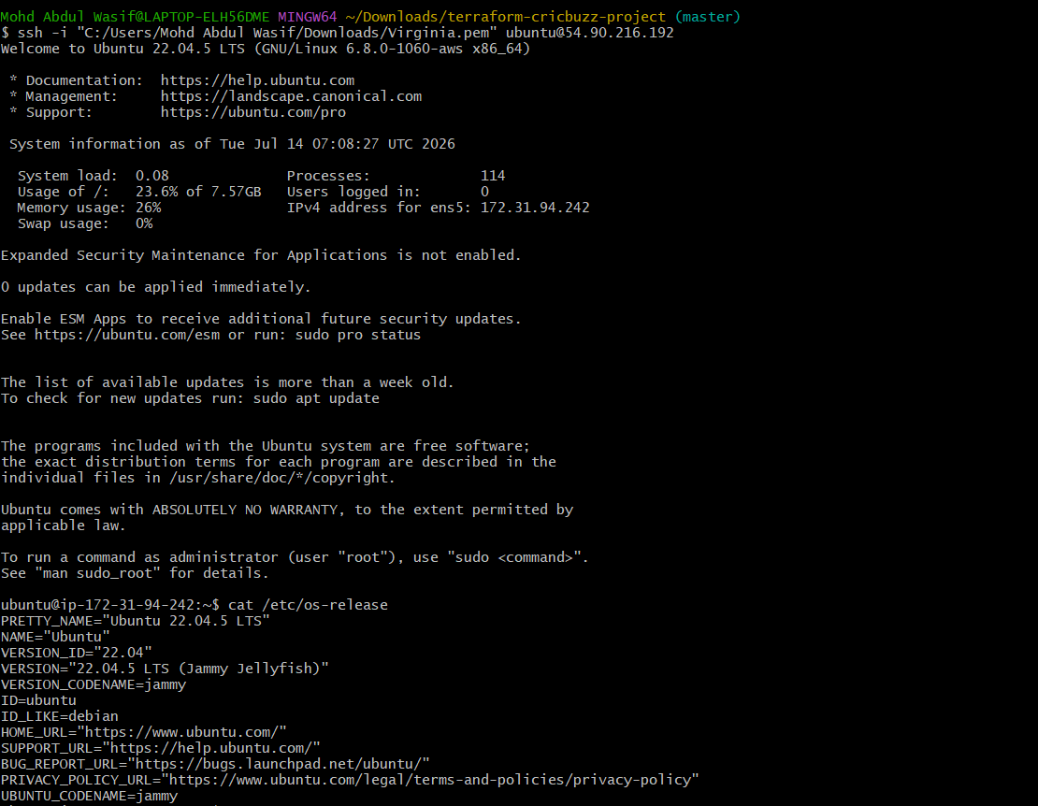

Challenge 1 Expected Result
At this stage:
✅ Ubuntu EC2 instance is running
✅ Public IPv4 address is assigned
✅ Port 22 is available from your IP
✅ Port 8080 is open for the Nginx reverse proxy
✅ Port 8000 is open for temporary Docker testing
✅ Terraform outputs display connection details
Nothing will load yet on ports 8080 or 8000 because the services will be installed in the next challenge.
Interview explanation
Question: Why are ports 8080 and 8000 required?
Answer:
Port 8080 is used by Nginx as the public web-server port. Port 8000 is used internally by the Docker application. Nginx receives requests on port 8080 and forwards them to the Docker service on port 8000.
Question: What is the purpose of a security group?
Answer:
A security group acts as a virtual firewall for an EC2 instance. It controls allowed inbound and outbound traffic based on protocol, port, and source.
Question: Why use Terraform?
Answer:
Terraform allows us to define AWS infrastructure as code, preview changes using terraform plan, create infrastructure using terraform apply, and remove it using terraform destroy.
What we learned
- How Terraform connects to AWS through the provider.
- How to create an EC2 instance using aws_instance.
- How to reference an existing default VPC and subnet.
- How to attach a security group to EC2.
- How to open application ports.
- How variables and outputs make the code reusable.
- Why SSH should be limited to a trusted IP.
Challenge 1 conclusion
We successfully wrote Terraform code to provision an Ubuntu EC2 instance with a public IP and security-group rules for SSH, Nginx, and the Docker application. The server is now ready for Challenge 2: installing Docker, Docker Compose, Nginx, and deploying the Cricbuzz application.
Challenge 2: Install Docker, Docker Compose & Deploy Cricbuzz Application
Objective
After creating the Ubuntu EC2 instance:
- Install Docker
- Install Docker Compose
- Clone the Cricbuzz project
- Create a docker-compose.yml
- Run the application on port 8000
- Verify the application

Architecture
Browser
│
http://Public-IP:8000
│
Docker Container
│
Cricbuzz Hello World App

Prerequisites
- ✅ Ubuntu EC2 running
- ✅ SSH access working
- ✅ Port 8000 open in Security Group
- ✅ Internet connectivity

Step 1: Connect to EC2
ssh -i "/c/Users/Mohd Abdul Wasif/Downloads/Virginia.pem" ubuntu@YOUR_PUBLIC_IP
Example:
ssh -i "/c/Users/Mohd Abdul Wasif/Downloads/Virginia.pem" ubuntu@54.90.216.192
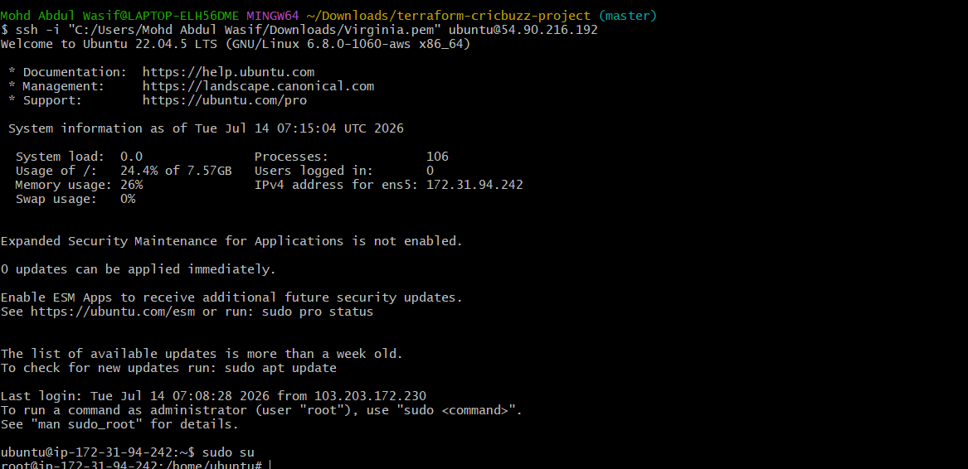

Step 2: Update Ubuntu
sudo apt update
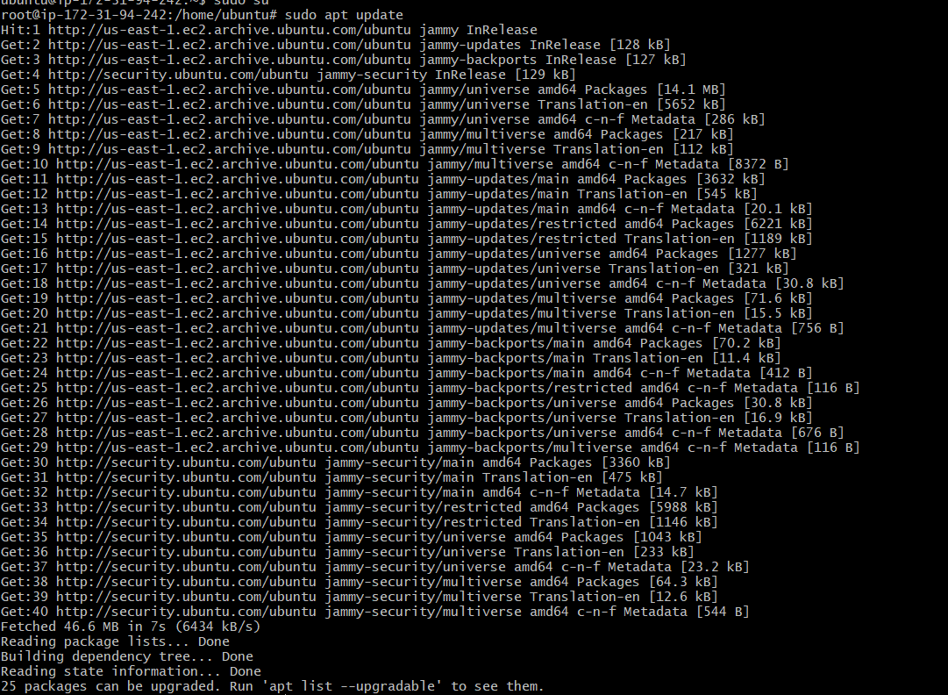
sudo apt upgrade -y
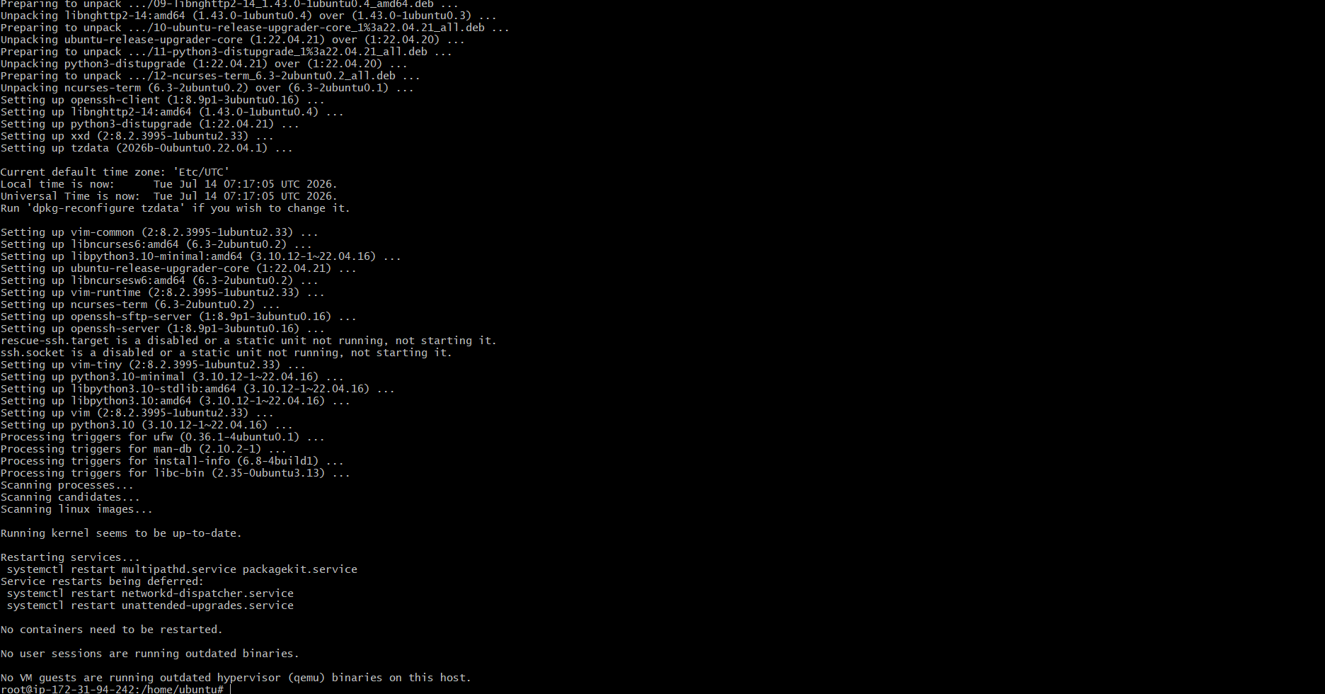

Step 3: Install Docker
sudo apt install docker.io -y
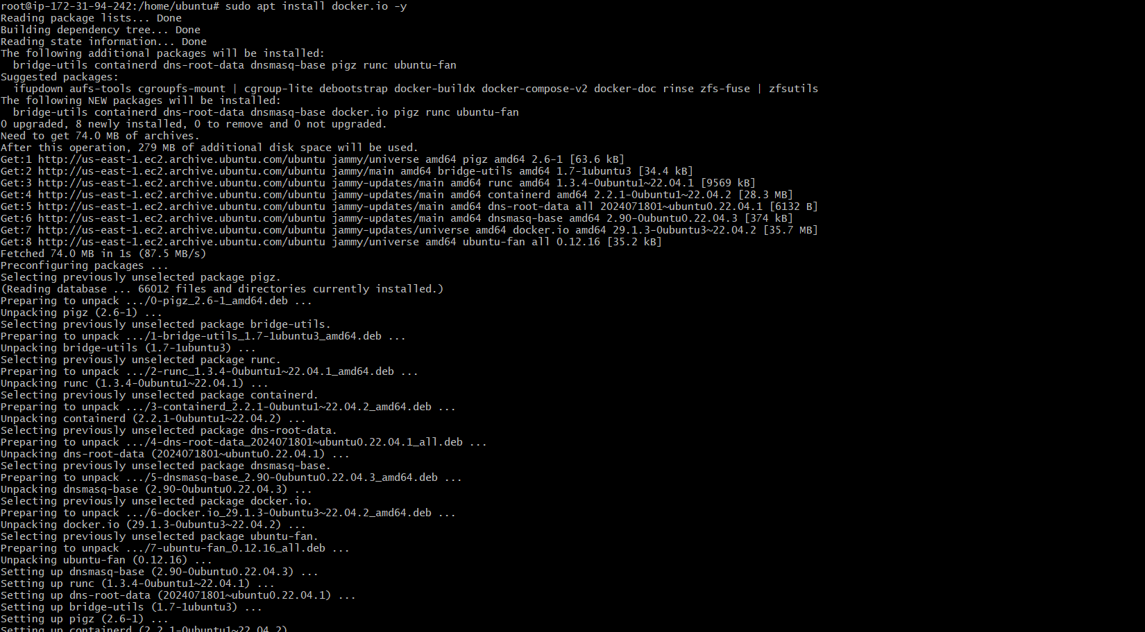
Enable Docker:
sudo systemctl enable docker
Start Docker:
sudo systemctl start docker
Check Docker:
docker –version
Expected:
Docker version 28.x.x

Step 4: Give Docker permission
sudo usermod -aG docker ubuntu
Apply without logout:
newgrp docker
Verify:
docker ps

Step 5: Install Git
sudo apt install git -y
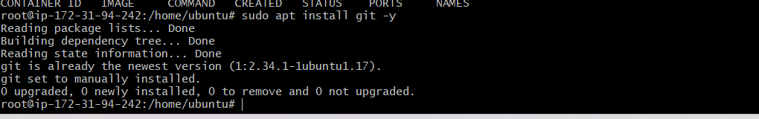
Check:
git --version

Step 6: Install Docker Compose
sudo apt install docker-compose-v2 -y
Verify:
docker compose version
Expected:
Docker Compose version v2.x.x
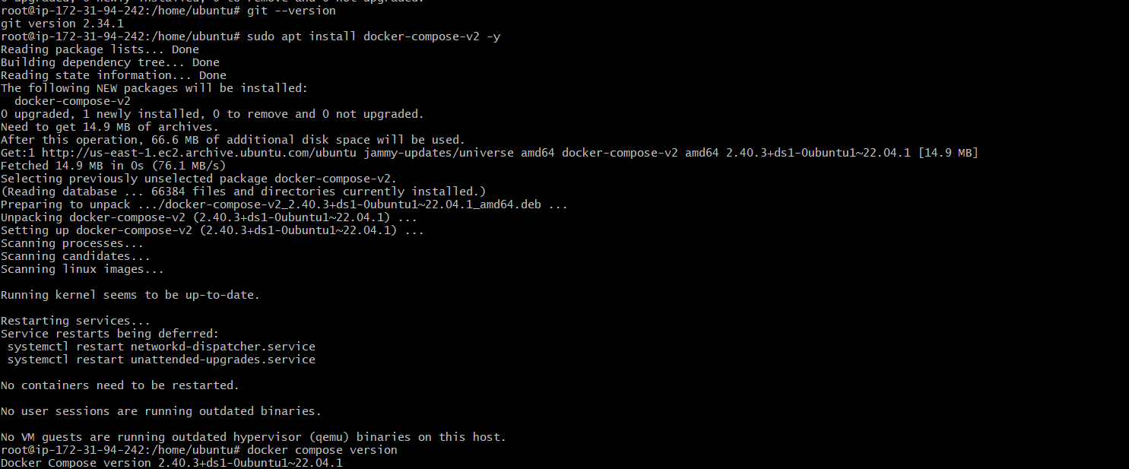

Step 7: Clone the Project
git clone https://github.com/betawins/cricbuzz-docker-hello-world.git
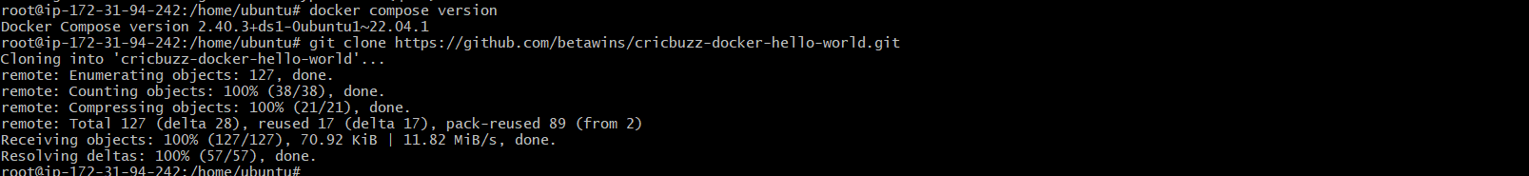
Go inside:
cd cricbuzz-docker-hello-world
Check:
Ls

Step 8: Create docker-compose.yml
nano docker-compose.yml
Paste:
# Stage 1: Build the Go application
FROM golang:1.22-alpine AS builder

WORKDIR /app

COPY go.mod go.sum ./
RUN go mod download

COPY . .

RUN CGO_ENABLED=0 GOOS=linux go build -o hello_world hello_world.go

# Stage 2: Create a small runtime image
FROM alpine:3.20

WORKDIR /app

COPY --from=builder /app/hello_world .

EXPOSE 8000

CMD ["./hello_world"]
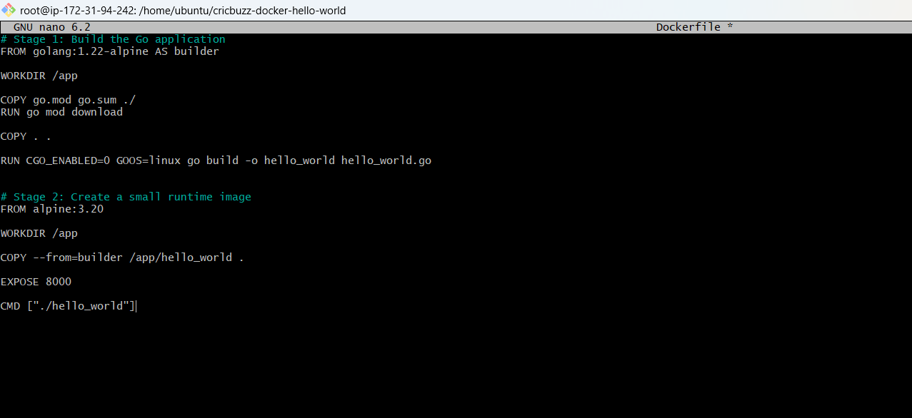

Step 9: Build Docker Image
docker compose build
Expected:
Successfully built
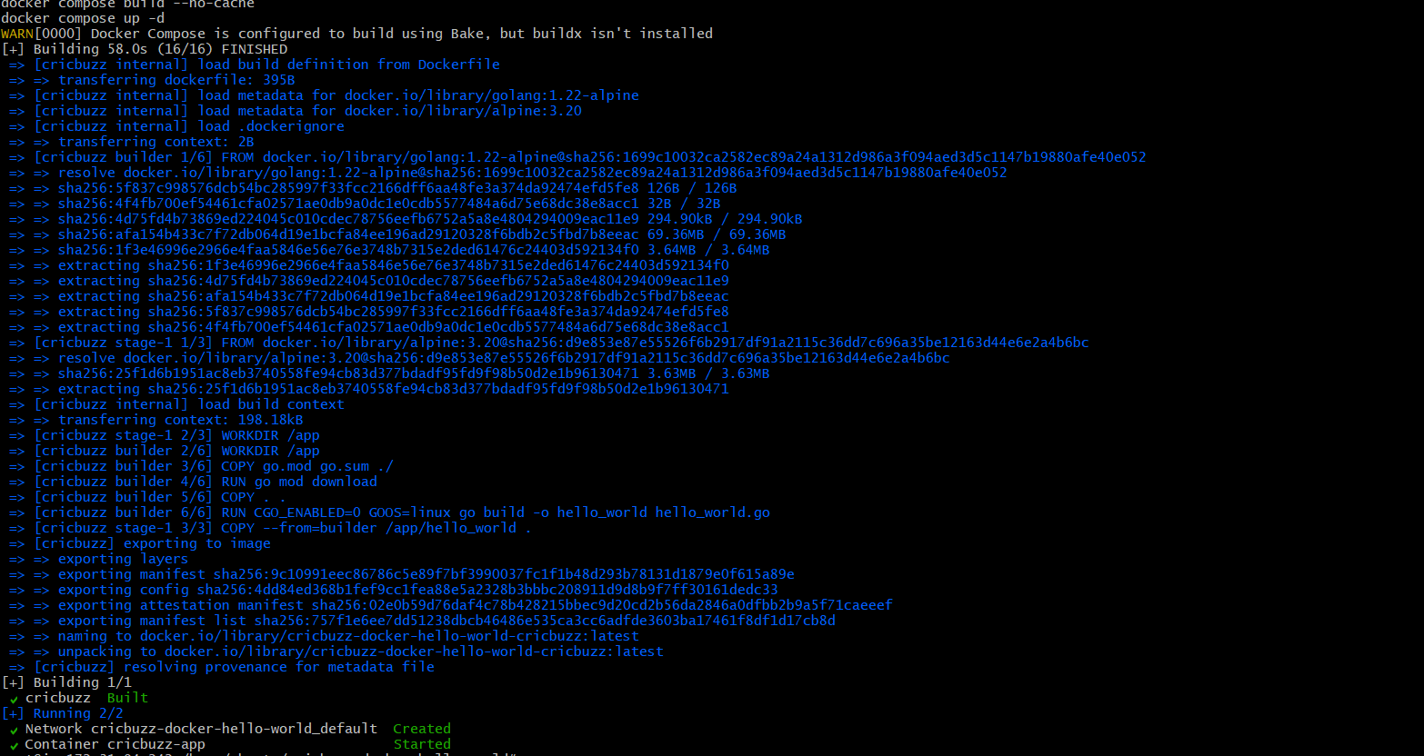

Step 10: Run Container
docker compose up -d
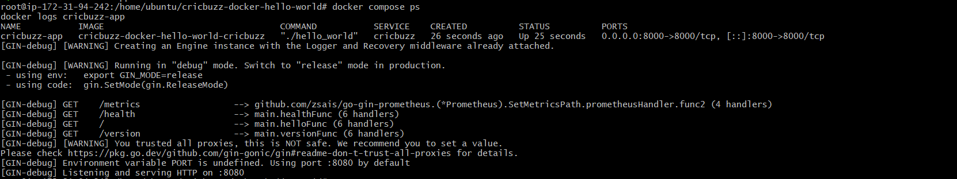

Step 11: Check Running Containers
docker ps
Expected:
CONTAINER ID
cricbuzz-app
Up
0.0.0.0:8000->8000
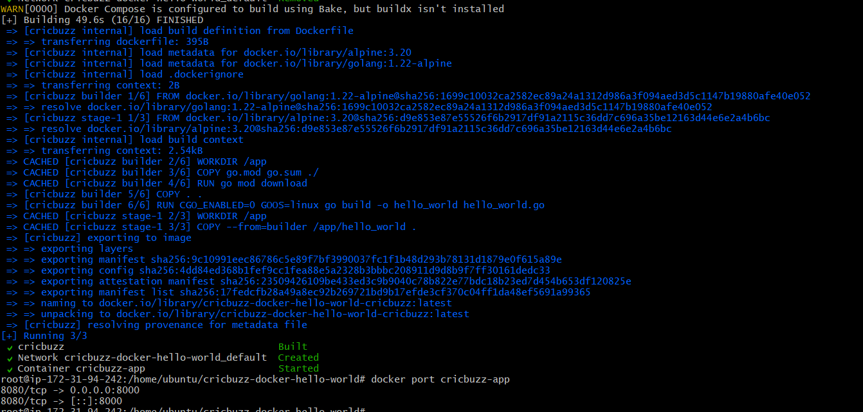
Step 12: Test Inside EC2
curl http://localhost:8000
You should receive the application's response.
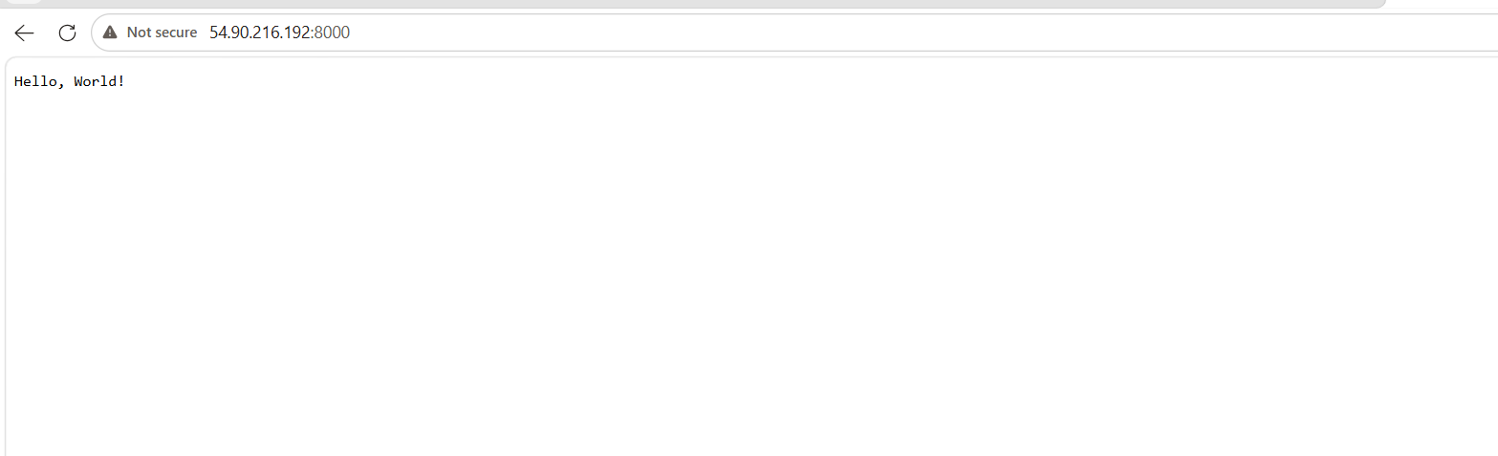

Step 13: Test From Browser
Open:
http://YOUR_PUBLIC_IP:8000
Example:
http://54.90.216.192:8000
The Cricbuzz Hello World application should load.

Folder Structure
cricbuzz-docker-hello-world
│
├── Dockerfile
├── docker-compose.yml
├── package.json
├── src
└── ...

Interview Questions
Q1. Why Docker Compose?
Answer:
Docker Compose allows us to define and run multi-container Docker applications using a single YAML file.

Q2. Difference between Dockerfile and Docker Compose?
Dockerfile | Docker Compose
Builds an image | Runs one or more containers
Defines image layers | Defines services, ports, volumes, networks
One application | Multiple containers

Q3. Why map 8000:8000?
Container port 8000 is exposed to the EC2 host on 8000, allowing external users to access the application.

What We Learned
- Installed Docker on Ubuntu.
- Installed Docker Compose.
- Cloned a GitHub project.
- Built a Docker image.
- Ran the application using Docker Compose.
- Published the application on port 8000.

Challenge 2 Conclusion
We successfully prepared the Ubuntu EC2 server for containerized applications by installing Docker and Docker Compose. We cloned the Cricbuzz Hello World project, created a docker-compose.yml, built the image, and started the application on port 8000. The server is now ready for the next challenge.
Challenge 3: Configure Nginx Reverse Proxy, Logging, and Log Rotation
Objective
Configure the EC2 instance so that:
- Nginx listens on port 8080
- Nginx forwards requests to the Docker app on port 8000
- Access and error logs are saved in /var/log/cb.log
- Log rotation is configured for /var/log/cb.log
Architecture:
Browser
|
v
EC2 Port 8080
|
v
Nginx Reverse Proxy
|
v
Docker App Port 8000
|
v
Hello, World!
Prerequisites
Before starting, confirm:
docker ps
curl http://localhost:8000
Expected:
Hello, World!
Also confirm port 8080 is open in the EC2 security group.
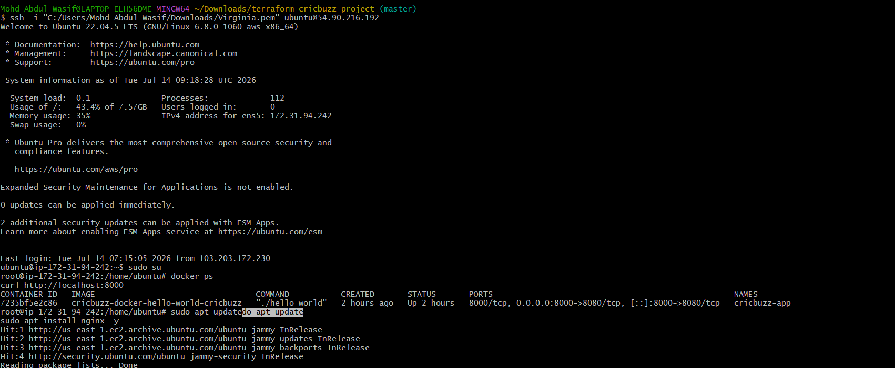

Step 1: Install Nginx
sudo apt update
sudo apt install nginx -y
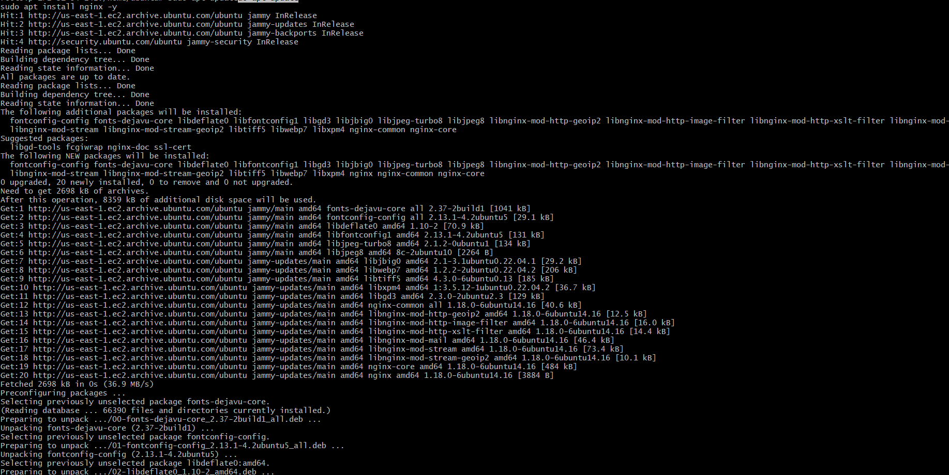
Enable and start it:
sudo systemctl enable nginx
sudo systemctl start nginx
Check:
sudo systemctl status nginx
Expected:
active (running)
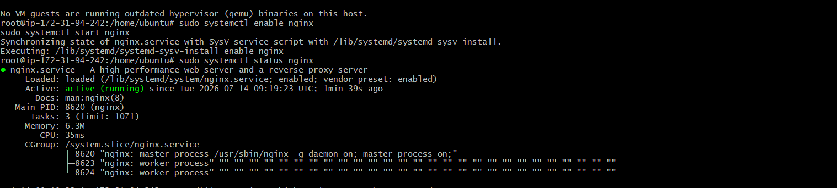

Step 2: Create Nginx configuration
Remove the default site:
sudo rm -f /etc/nginx/sites-enabled/default
Create a new configuration:
sudo nano /etc/nginx/sites-available/cricbuzz
Paste this:
server {
listen 8080;
listen [::]:8080;

server_name _;

access_log /var/log/cb.log;
error_log /var/log/cb.log;

location / {
proxy_pass http://127.0.0.1:8000;

proxy_http_version 1.1;

proxy_set_header Host $host;
proxy_set_header X-Real-IP $remote_addr;
proxy_set_header X-Forwarded-For $proxy_add_x_forwarded_for;
proxy_set_header X-Forwarded-Proto $scheme;

proxy_connect_timeout 10s;
proxy_read_timeout 60s;
}
}
Save:
Ctrl + O
Enter
Ctrl + X
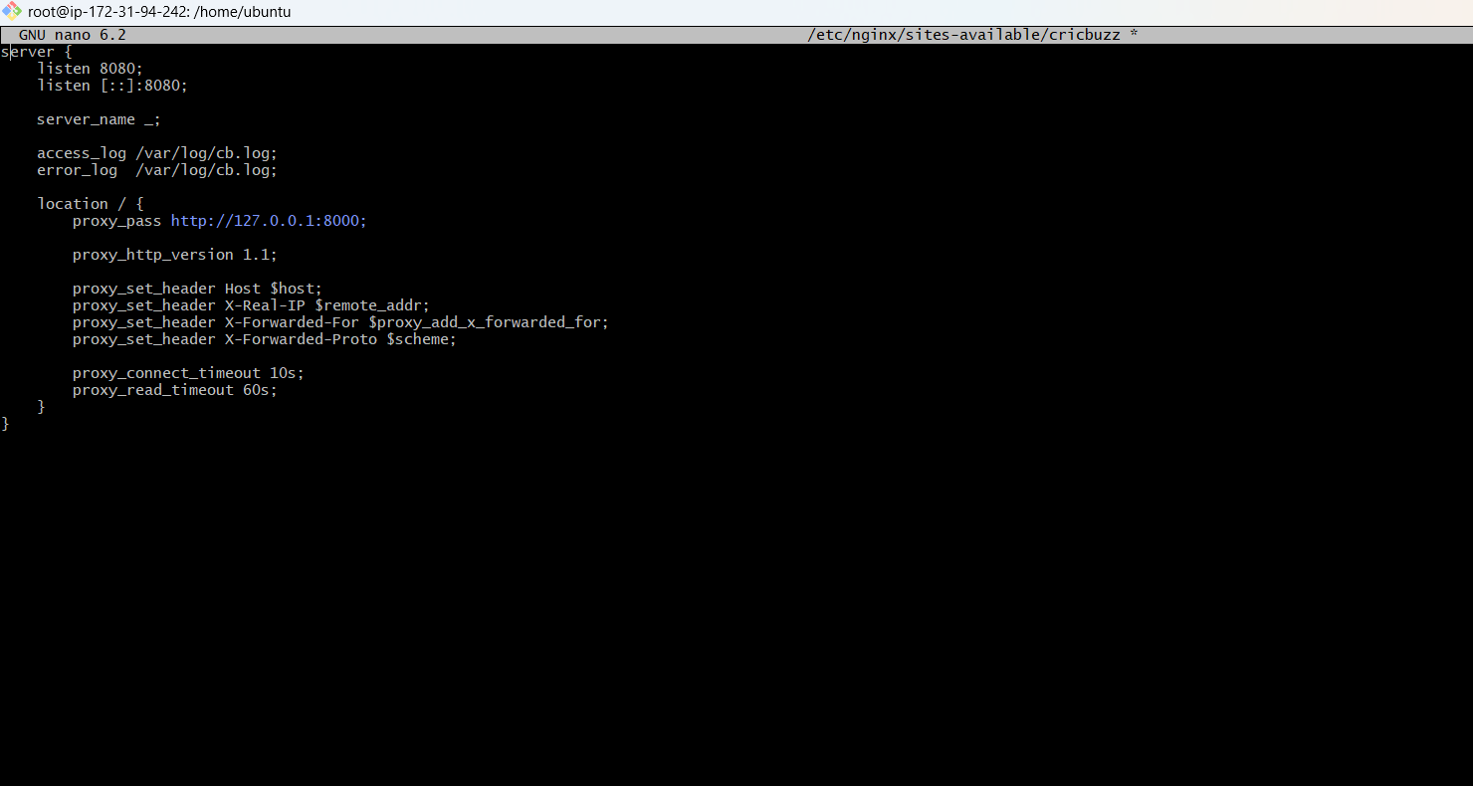
What this configuration means
listen 8080
Nginx accepts browser requests on port 8080.
proxy_pass http://127.0.0.1:8000
Nginx forwards those requests to the Docker service.
access_log /var/log/cb.log
error_log /var/log/cb.log
Both access and error logs are saved in the required file.

Step 3: Enable the Nginx site
sudo ln -s /etc/nginx/sites-available/cricbuzz /etc/nginx/sites-enabled/cricbuzz
Test the syntax:
sudo nginx -t
Expected:
syntax is ok
test is successful
Restart Nginx:
sudo systemctl restart nginx

Step 4: Verify port 8080
sudo ss -tulpn | grep :8080
Expected:
LISTEN ... 0.0.0.0:8080
Test inside EC2:
curl http://localhost:8080
Expected:
Hello, World!
Test directly against Docker:
curl http://localhost:8000
Expected:
Hello, World!
This proves:
8080 → Nginx → 8000 → Docker application

Step 5: Test from browser
Open:
http://54.90.216.192:8080
Expected page:
Hello, World!
Do not use:
https://54.90.216.192:8080
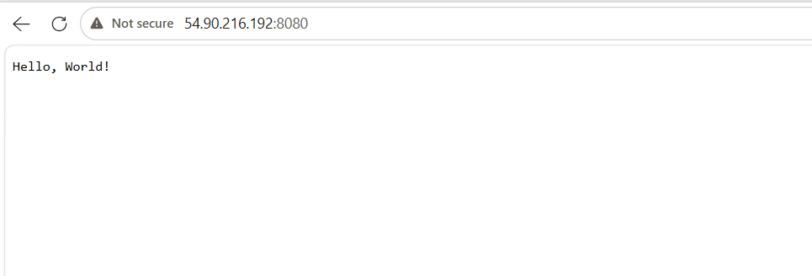

Step 6: Verify the log file
Generate a few requests:
curl http://localhost:8080
curl http://localhost:8080/version
curl http://localhost:8080/health
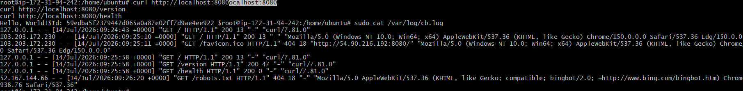
Check the log:
sudo cat /var/log/cb.log
Or watch it live:
sudo tail -f /var/log/cb.log
Press Ctrl + C to stop watching.
You should see entries similar to:
127.0.0.1 - - [date] "GET / HTTP/1.1" 200
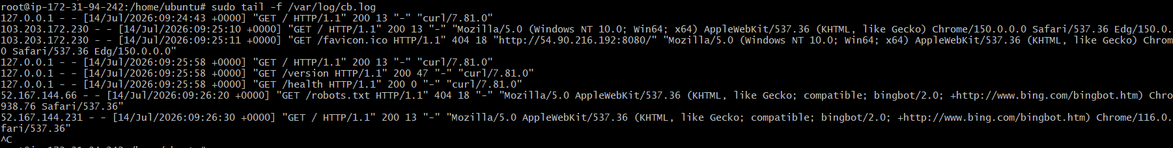

Configure Log Rotation
Step 7: Create logrotate configuration
sudo nano /etc/logrotate.d/cricbuzz
Paste:
/var/log/cb.log {
daily
rotate 7
size 10M
missingok
notifempty
compress
delaycompress
create 0640 www-data adm
sharedscripts

postrotate
if [ -f /run/nginx.pid ]; then
kill -USR1 $(cat /run/nginx.pid)
fi
endscript
}
Save and exit.
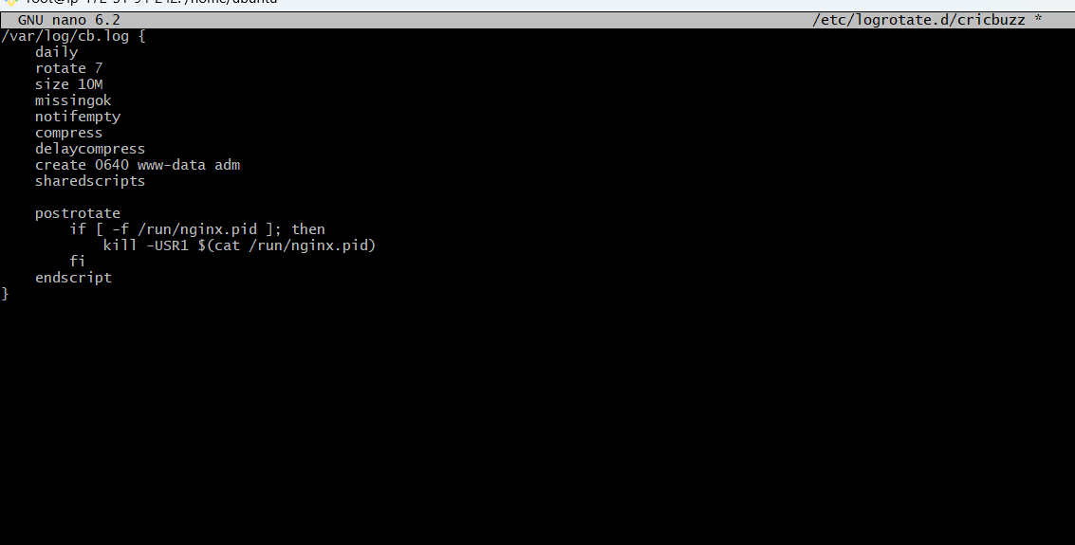
Explanation
daily
Check and rotate the log daily.
rotate 7
Keep seven old log files.
size 10M
Rotate when the file reaches 10 MB.
compress
Compress older files.
create 0640 www-data adm
Create a new log file with proper ownership and permissions.
postrotate
Tell Nginx to reopen the log file after rotation.
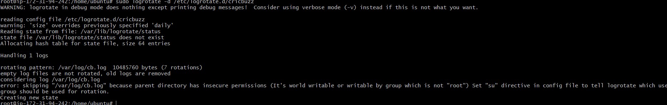

Step 8: Test logrotate configuration
Debug test:
sudo logrotate -d /etc/logrotate.d/cricbuzz
The -d option only checks; it does not rotate.
Force a rotation:
sudo logrotate -f /etc/logrotate.d/cricbuzz
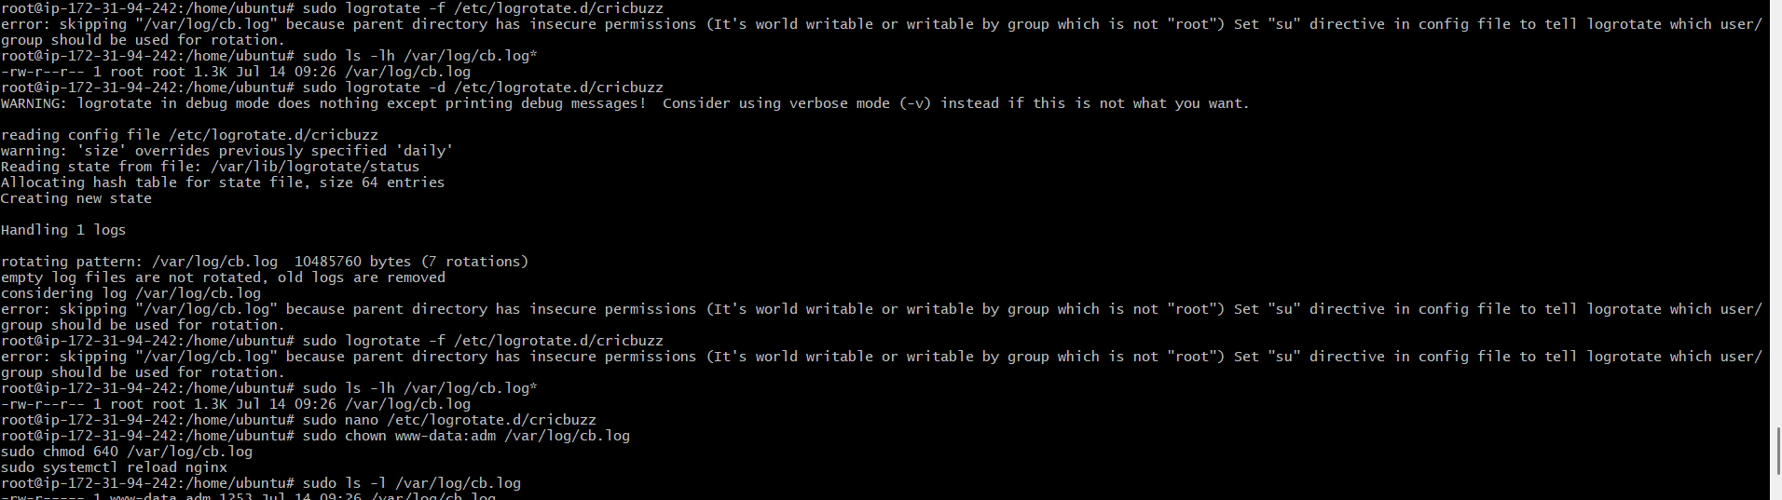
Check:
sudo ls -lh /var/log/cb.log*
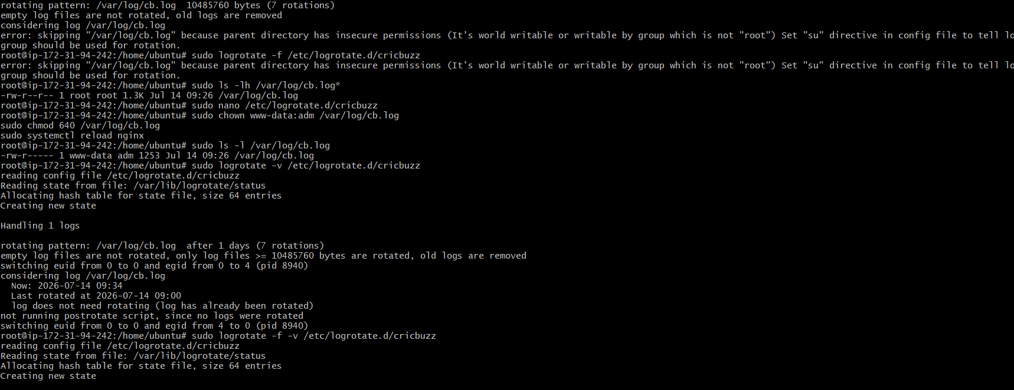
Expected files may look like:
/var/log/cb.log
/var/log/cb.log.1
Generate another request:
curl http://localhost:8080
Then check the new log:
sudo tail /var/log/cb.log

Final verification commands
Run:
docker ps
sudo systemctl status nginx --no-pager
curl http://localhost:8000
curl http://localhost:8080
sudo tail -10 /var/log/cb.log
sudo logrotate -d /etc/logrotate.d/cricbuzz
Expected result:
Docker container: running
Docker app: responds on 8000
Nginx: active
Nginx proxy: responds on 8080
Log file: /var/log/cb.log
Logrotate: configuration valid
Common errors
502 Bad Gateway
Reason:
Nginx cannot reach the Docker application.
Check:
docker ps
curl http://localhost:8000
docker logs cricbuzz-app
Connection refused on port 8080
Check:
sudo systemctl status nginx
sudo nginx -t
sudo ss -tulpn | grep :8080
Browser timeout
Confirm the Terraform security group contains:
ingress {
from_port = 8080
to_port = 8080
protocol = "tcp"
cidr_blocks = ["0.0.0.0/0"]
}
Then run Terraform from your Windows project folder:
terraform plan
terraform apply -auto-approve
Interview explanation
Why use Nginx as a reverse proxy?
Nginx receives client traffic on a public port and forwards it to the backend Docker application. It can also handle logging, SSL, load balancing, caching, and request headers.
What is the difference between port 8080 and 8000 here?
Port 8080 is the public Nginx port. Port 8000 is the backend Docker service port.
Why is log rotation required?
Without log rotation, a log file may continue growing until it consumes the server disk. Logrotate archives, compresses, and removes older logs automatically.
Final architecture:
Browser :8080
↓
Nginx Reverse Proxy
↓
Docker Service :8000
↓
Gin Application :8080 inside container
↓
Hello, World!
Final verification commands
docker ps
curl http://localhost:8000
curl http://localhost:8080
sudo ls -lh /var/log/cb.log*
sudo tail -5 /var/log/cb.log
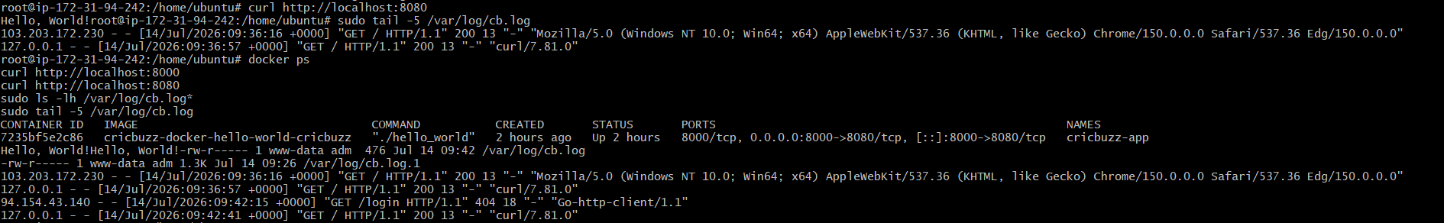
What We Learned
- Installed and configured Nginx.
- Used Nginx as a reverse proxy.
- Forwarded traffic from 8080 to Docker port 8000.
- Saved Nginx logs to /var/log/cb.log.
- Configured daily log rotation.
- Tested Nginx, Docker, logging, and logrotate.
Challenge 3 Conclusion
We configured Nginx to listen on port 8080 and forward requests to the Cricbuzz Docker service running on port 8000. We stored web-server logs in /var/log/cb.log and configured logrotate to rotate, compress, and retain old logs safely. This completes the main technical requirements of the project.

Task-4: Jenkins CI/CD for Cricbuzz Docker Application
Objective
Create a Jenkins Declarative Pipeline that automatically:
GitHub repository
↓
Jenkins clones code
↓
Builds Docker image
↓
Deploys with Docker Compose
↓
Checks port 8000
↓
Nginx serves it on port 8080
Jenkins Pipeline stores the delivery process as code in a Jenkinsfile. Declarative Pipeline uses a structured pipeline {} syntax.
Prerequisites
You need:
- Existing Ubuntu EC2
- Docker and Docker Compose working
- Nginx working on port 8080
- Cricbuzz application working on port 8000
- Git installed
- Jenkins installed
- EC2 security group allowing port 8080
- Port 8080 should be used by Nginx, not Jenkins
Because Nginx already uses port 8080, run Jenkins on port 8081.

Part 1: Install Jenkins
Step 1: Check Java
Jenkins requires Java. Run:
java -version
If Java is missing:
sudo apt update
sudo apt install fontconfig openjdk-21-jre -y
Verify:
java -version
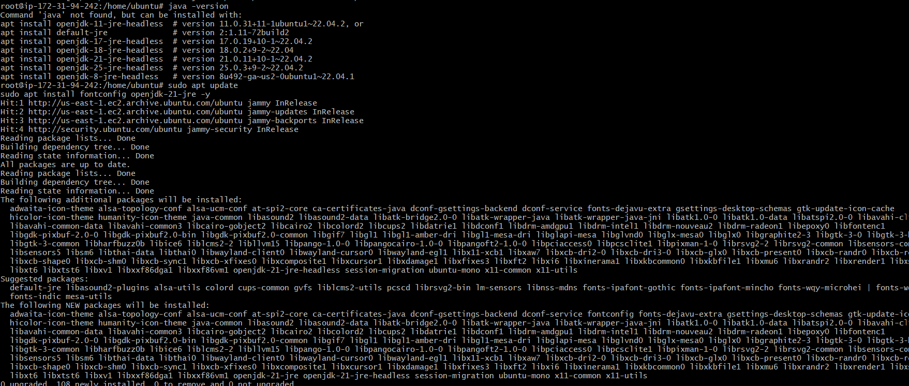
Step 2: Add the Jenkins repository
sudo mkdir -p /etc/apt/keyrings
sudo wget -O /etc/apt/keyrings/jenkins-keyring.asc \
https://pkg.jenkins.io/debian-stable/jenkins.io-2026.key
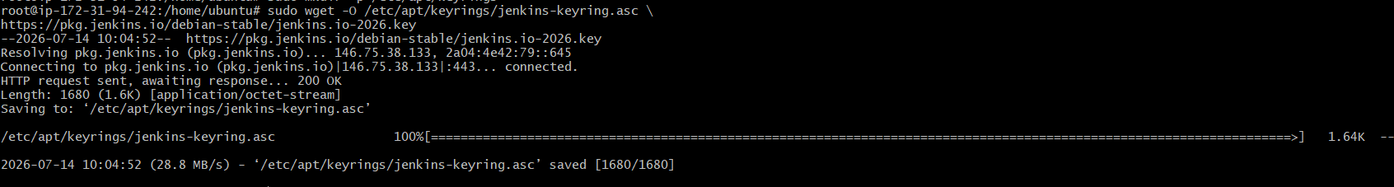
echo "deb [signed-by=/etc/apt/keyrings/jenkins-keyring.asc] https://pkg.jenkins.io/debian-stable binary/" |
sudo tee /etc/apt/sources.list.d/jenkins.list > /dev/null
Install Jenkins:
sudo apt update
sudo apt install jenkins -y
Jenkins officially supports installation on Ubuntu through its Debian apt repository.
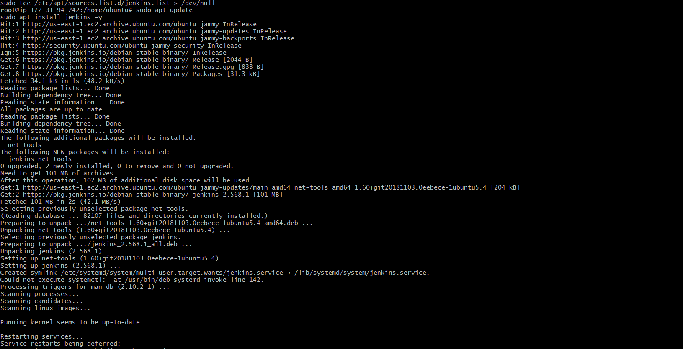

Part 2: Change Jenkins Port to 8081
Step 3: Change the Jenkins service port
Open:
sudo systemctl edit jenkins
Add:
[Service]
Environment="JENKINS_PORT=8081"
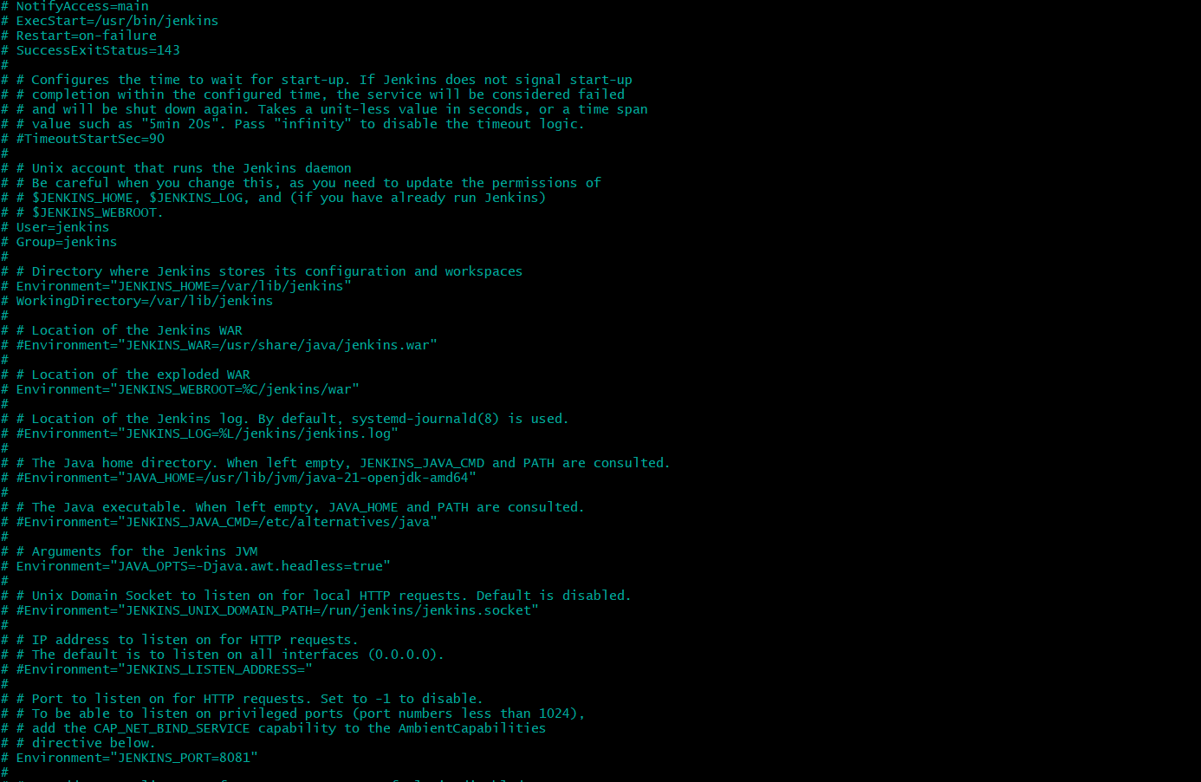
Save and exit.
Reload the service configuration:
sudo systemctl daemon-reload
sudo systemctl restart jenkins
Check:
sudo systemctl status jenkins --no-pager
Check the port:
sudo ss -tulpn | grep 8081
Expected:
LISTEN ... :8081
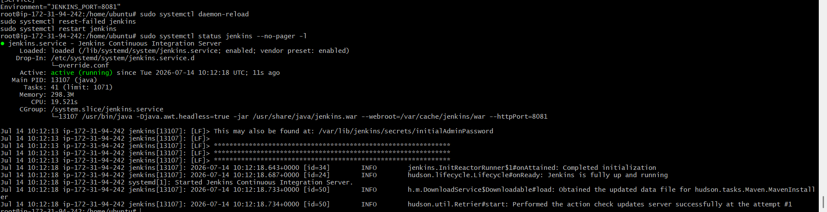
Step 4: Open port 8081 temporarily
Add this Terraform rule to your security group:
ingress {
description = "Jenkins access"
from_port = 8081
to_port = 8081
protocol = "tcp"
cidr_blocks = [var.ssh_cidr]
}
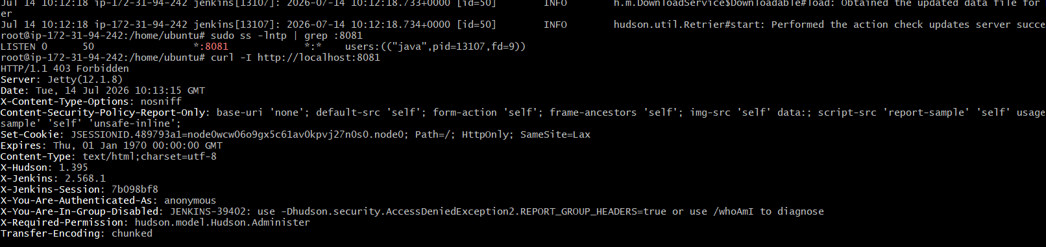
Using your own IP is safer than opening Jenkins to everyone.
From your Windows Terraform directory:
terraform fmt
terraform plan
terraform apply -auto-approve
Open:
http://54.90.216.192:8081
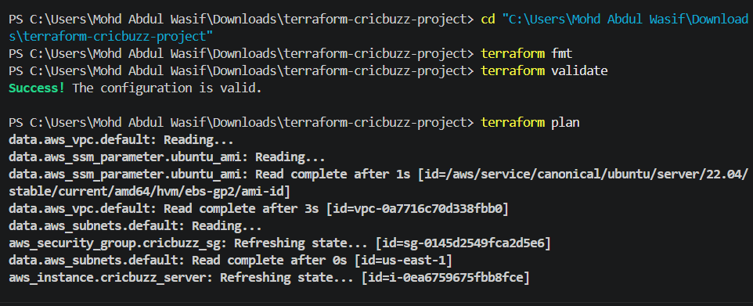
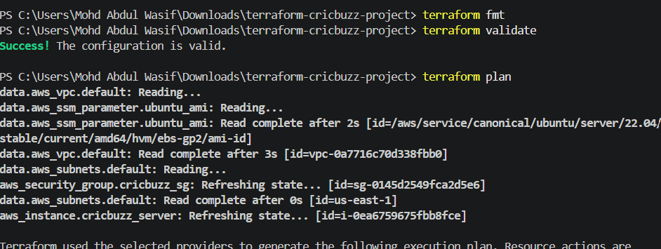
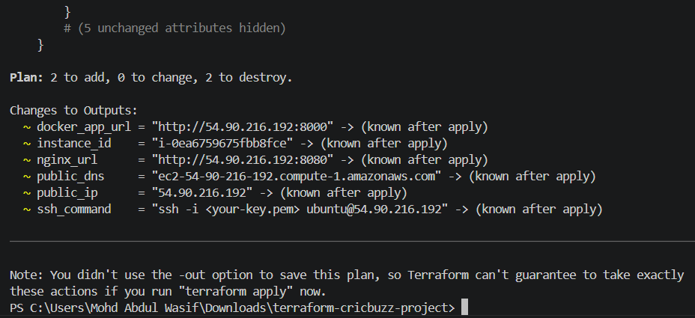
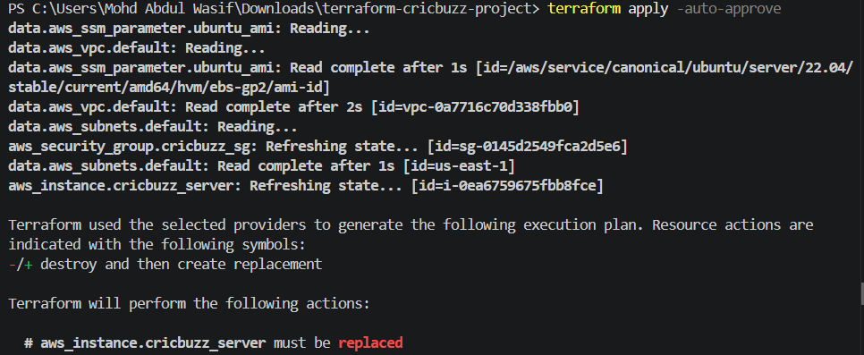
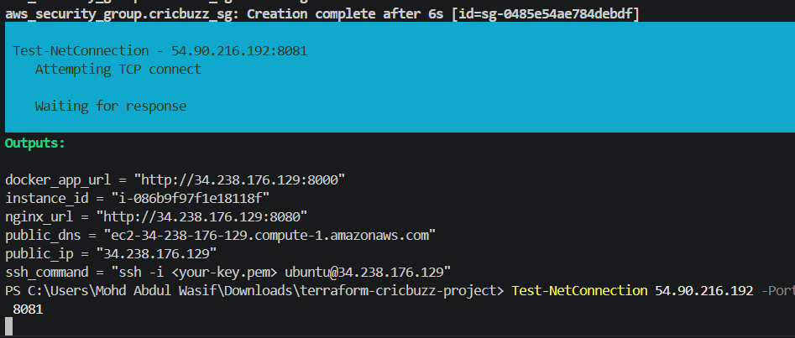

Part 3: Unlock Jenkins
Step 5: Get the initial password
On EC2:
sudo cat /var/lib/jenkins/secrets/initialAdminPassword
Copy the password.
In the browser:
- Open Jenkins on port 8081.
- Paste the password.
- Select Install suggested plugins.
- Create the admin user.
- Complete the setup.

Part 4: Allow Jenkins to Use Docker
Step 6: Add Jenkins to the Docker group
sudo usermod -aG docker jenkins
Restart Jenkins:
sudo systemctl restart jenkins
Confirm group membership:
id jenkins
Expected to include:
docker
Test Docker as the Jenkins user:
sudo -u jenkins docker ps
Test Docker Compose:
sudo -u jenkins docker compose version
Docker Compose v2 uses the command docker compose, while the older standalone version uses docker-compose.

Part 5: Prepare a Jenkins Deployment Directory
Your current project belongs to ubuntu, but Jenkins should deploy from its own controlled directory.
Step 7: Create the deployment directory
sudo mkdir -p /opt/cricbuzz
sudo chown -R jenkins:jenkins /opt/cricbuzz
Verify:
ls -ld /opt/cricbuzz
Expected:
jenkins jenkins /opt/cricbuzz

Part 6: Add the Required Files to GitHub
The GitHub repository needs these two files:
Dockerfile
docker-compose.yml
Step 8: Use this Dockerfile
FROM golang:1.22-alpine AS builder

WORKDIR /app

COPY go.mod go.sum ./
RUN go mod download

COPY . .

RUN CGO_ENABLED=0 GOOS=linux GOARCH=amd64 \
go build -o hello_world .

FROM alpine:3.20

WORKDIR /app

RUN apk add --no-cache ca-certificates

COPY --from=builder /app/hello_world /app/hello_world

EXPOSE 8080

CMD ["/app/hello_world"]
Step 9: Use this docker-compose.yml
services:
cricbuzz:
build:
context: .
dockerfile: Dockerfile

container_name: cricbuzz-app

ports:
- "8000:8080"

environment:
GIN_MODE: release

restart: unless-stopped
Important mapping:
EC2 port 8000 → Container port 8080

Part 7: Create the Jenkins Pipeline Job
Step 10: Create the job
In Jenkins:
- Click New Item
- Enter:
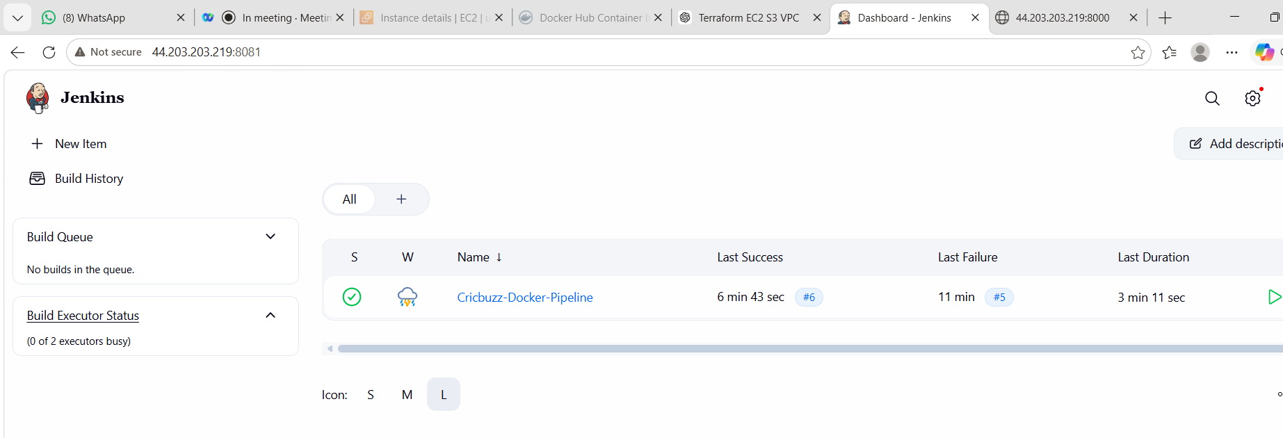
Cricbuzz-Docker-Pipeline
- Select Pipeline
- Click OK
- Scroll to Pipeline
- Select:
Pipeline script
- Paste the pipeline below.

Part 8: Complete Jenkins Pipeline
Replace the repository URL if required.
pipeline {
agent any

environment {
REPO_URL = 'https://github.com/betawins/cricbuzz-docker-hello-world.git'
DEPLOY_DIR = '/opt/cricbuzz'
APP_URL = 'http://localhost:8000'
}

stages {

stage('Check Tools') {
steps {
sh '''
set -e

echo "Checking required tools..."
git --version
docker --version
docker compose version
curl --version
'''
}
}

stage('Git Clone') {
steps {
deleteDir()

git branch: 'master',
url: "${REPO_URL}"

sh '''
echo "Repository cloned successfully"
pwd
ls -la
'''
}
}

stage('Create Dockerfile') {
steps {
sh '''
cat > Dockerfile <<'EOF'
FROM golang:1.22-alpine AS builder

WORKDIR /app

COPY go.mod go.sum ./
RUN go mod download

COPY . .

RUN CGO_ENABLED=0 GOOS=linux GOARCH=amd64 go build -o hello_world .

FROM alpine:3.20

WORKDIR /app

RUN apk add --no-cache ca-certificates

COPY --from=builder /app/hello_world /app/hello_world

EXPOSE 8080

CMD ["/app/hello_world"]
EOF

echo "Dockerfile created successfully"
cat Dockerfile
'''
}
}

stage('Create Docker Compose File') {
steps {
sh '''
cat > docker-compose.yml <<'EOF'
services:
cricbuzz:
build:
context: .
dockerfile: Dockerfile

container_name: cricbuzz-app

ports:
- "8000:8080"

environment:
GIN_MODE: release

restart: unless-stopped
EOF

echo "docker-compose.yml created successfully"
cat docker-compose.yml
'''
}
}

stage('Prepare Deployment Directory') {
steps {
sh '''
set -e

echo "Preparing deployment directory..."

mkdir -p "${DEPLOY_DIR}"

find "${DEPLOY_DIR}" \
-mindepth 1 \
-maxdepth 1 \
-exec rm -rf {} +

cp -a . "${DEPLOY_DIR}/"

echo "Deployment files copied successfully"
ls -la "${DEPLOY_DIR}"
'''
}
}

stage('Remove Old Container') {
steps {
sh '''
docker rm -f cricbuzz-app 2>/dev/null || true
'''
}
}

stage('Build Docker Image') {
steps {
sh '''
set -e

cd "${DEPLOY_DIR}"

echo "Building Docker image..."

DOCKER_BUILDKIT=0 \
COMPOSE_DOCKER_CLI_BUILD=0 \
docker compose build --no-cache
'''
}
}

stage('Deploy Container') {
steps {
sh '''
set -e

cd "${DEPLOY_DIR}"

docker compose down --remove-orphans || true
docker compose up -d --force-recreate

echo "Container deployment completed"
'''
}
}

stage('Verify Container') {
steps {
sh '''
set -e

echo "Waiting for container startup..."
sleep 10

docker ps

STATUS=$(docker inspect cricbuzz-app \
--format='{{.State.Status}}')

echo "Container status: ${STATUS}"

test "${STATUS}" = "running"

docker logs cricbuzz-app --tail 30
'''
}
}

stage('Test Application') {
steps {
sh '''
set -e

RESPONSE=$(curl \
--fail \
--silent \
--retry 5 \
--retry-delay 3 \
"${APP_URL}")

echo "Application response: ${RESPONSE}"

echo "${RESPONSE}" | grep -F "Hello, World!"
'''
}
}

stage('Cleanup Docker Images') {
steps {
sh '''
docker image prune -f || true
'''
}
}
}

post {

success {
echo 'SUCCESS: Cricbuzz application deployed successfully.'
}

failure {
echo 'FAILED: Check the first failed stage in Console Output.'

sh '''
echo "Docker containers:"
docker ps -a || true

echo "Application logs:"
docker logs cricbuzz-app --tail 100 || true
'''
}

always {
echo 'Pipeline execution completed.'
}
}
}
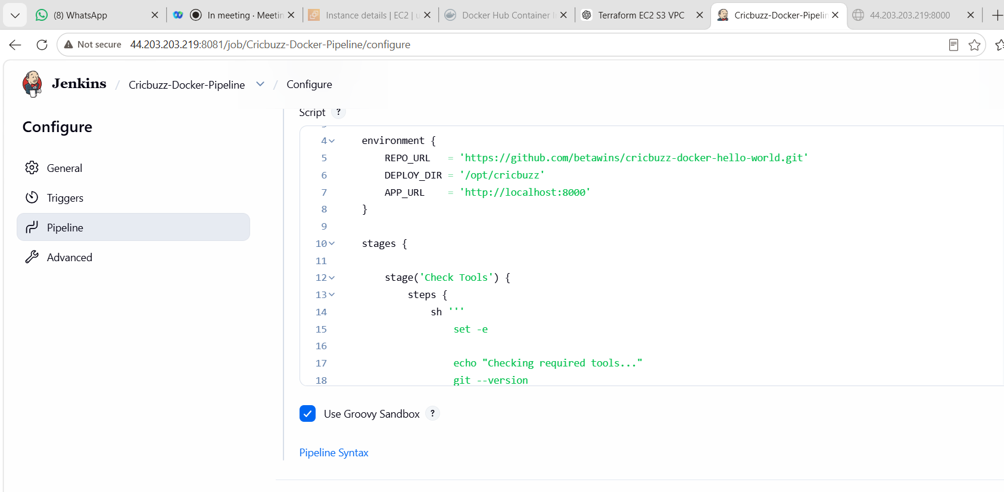

Part 9: Important Permission Fix
Because the pipeline copies files to /opt/cricbuzz, verify Jenkins ownership:
sudo chown -R jenkins:jenkins /opt/cricbuzz
Also verify Jenkins can write there:
sudo -u jenkins touch /opt/cricbuzz/test-file
sudo rm /opt/cricbuzz/test-file

Part 10: Run the Pipeline
Step 11: Build the job
In Jenkins:
- Open Cricbuzz-Docker-Pipeline
- Click Build Now
- Open Build History
- Click the build number
- Open Console Output
Expected stages:
Check Tools
Git Clone
Validate Files
Copy Deployment Files
Build Docker Image
Deploy Application
Verify Container
Test Docker Service
Test Nginx Proxy
Cleanup Images
Expected final result:
SUCCESS
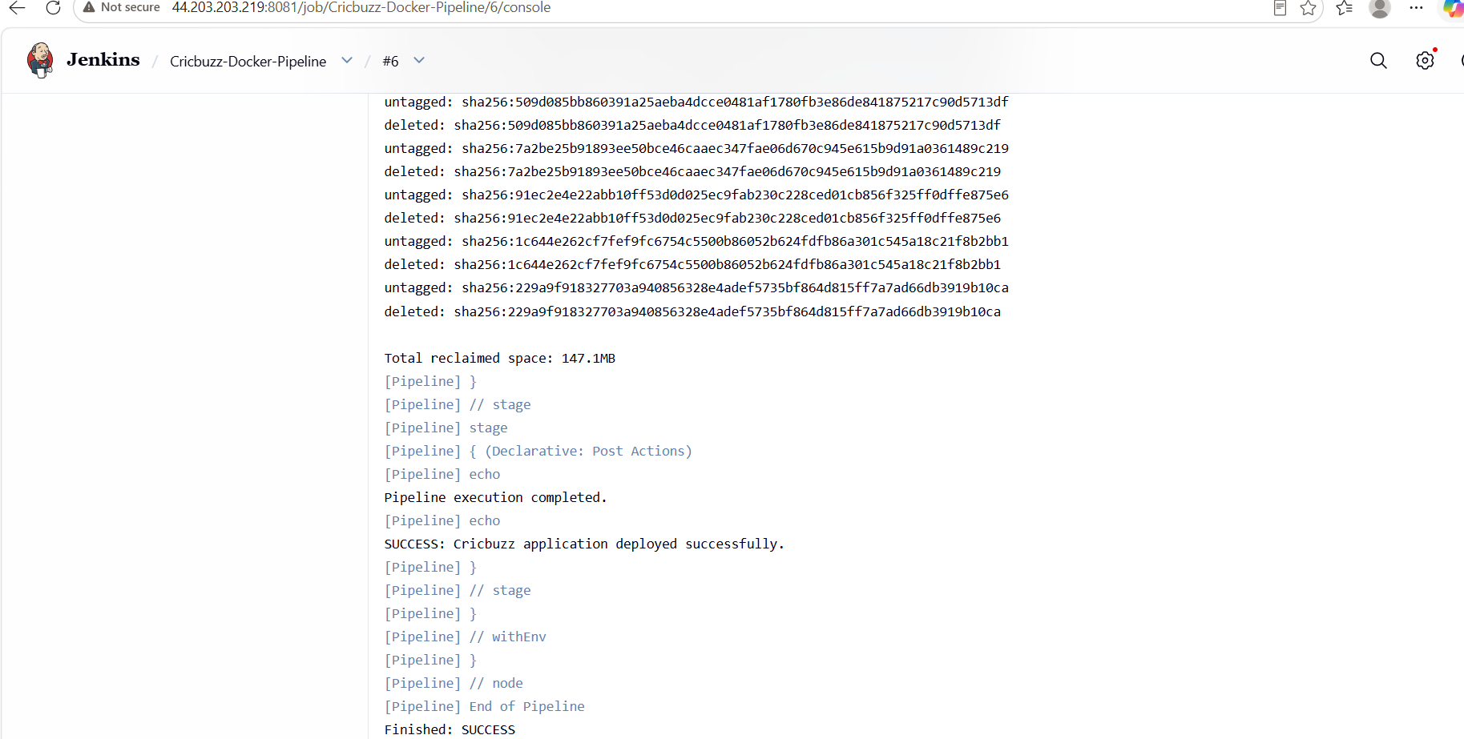

Part 11: Verify Manually
On EC2:
docker ps
Expected mapping:
0.0.0.0:8000->8080/tcp
Test Docker:
curl http://localhost:8000
Test Nginx:
curl http://localhost:8080
Expected for both:
Hello, World!
Check the Nginx logs:
sudo tail -10 /var/log/cb.log
Open in your browser:
http://54.90.216.192:8080

Common Errors
Error 1: Docker permission denied
permission denied while trying to connect to Docker daemon
Fix:
sudo usermod -aG docker jenkins
sudo systemctl restart jenkins
Test:
sudo -u jenkins docker ps
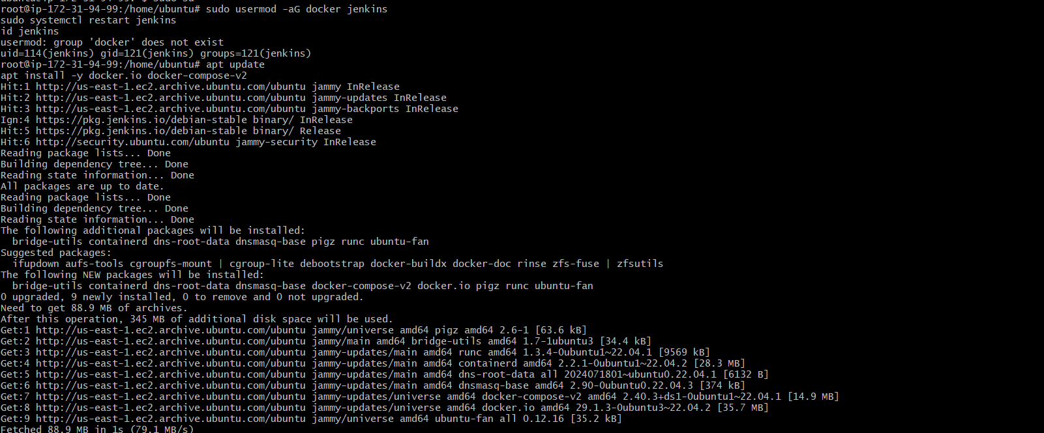
Error 2: docker-compose.yml missing
The original GitHub repository may not contain your locally created Compose file.
Confirm:
ls -la
You must commit and push the file to the repository or configure the pipeline to create it.
Error 3: Port 8000 is already allocated
Bind for 0.0.0.0:8000 failed: port is already allocated
Check:
docker ps
Remove the old manually created container:
docker rm -f cricbuzz-app
Run the pipeline again.
Error 4: Nginx returns 502 Bad Gateway
Check:
docker ps
curl http://localhost:8000
docker logs cricbuzz-app
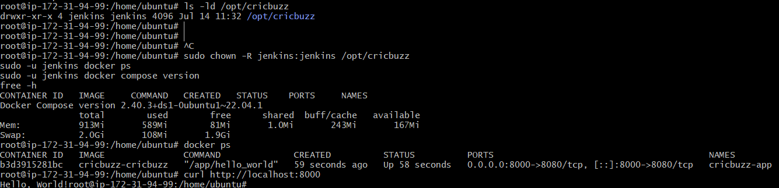
Error 5: Cannot write to /opt/cricbuzz
Fix:
sudo mkdir -p /opt/cricbuzz
sudo chown -R jenkins:jenkins /opt/cricbuzz

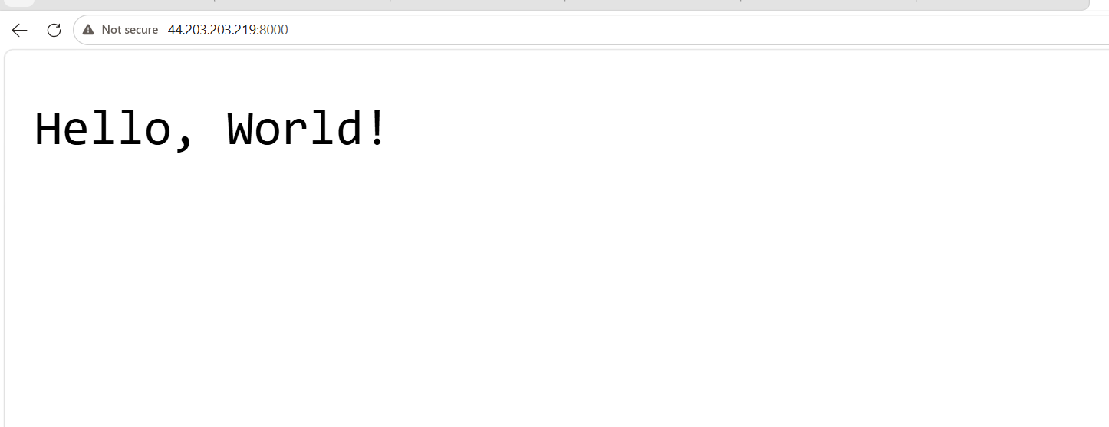
Final pipeline flow
GitHub
↓
Jenkins clones code
↓
Creates Dockerfile and Compose file
↓
Builds Docker image
↓
Deploys container
↓
Tests port 8000
↓
SUCCESS

What We Learned
- Installed Jenkins on Ubuntu.
- Configured Jenkins on a separate port.
- Allowed Jenkins to run Docker commands.
- Created a Declarative Pipeline.
- Cloned application code from GitHub.
- Built and deployed a Docker Compose service.
- Verified both Docker and Nginx endpoints.
- Automated repeated deployments.
Conclusion
We created a Jenkins CI/CD pipeline for the Cricbuzz application. Jenkins downloads the source code, validates the Docker files, builds the image, deploys the container on port 8000, and confirms that Nginx serves the application on port 8080. This converts the earlier manual deployment into an automated and repeatable CI/CD workflow.
