Docker- Tasks - 02

Task 1: Create Tomcat Container on Port 8080 and Deploy Sample Application
Objective
Deploy a sample .war application inside a Tomcat Docker container running on port 8080.
Prerequisites
Docker installed
Tomcat image available
Sample .war file
Steps
Pull Tomcat Image
docker pull tomcat:9
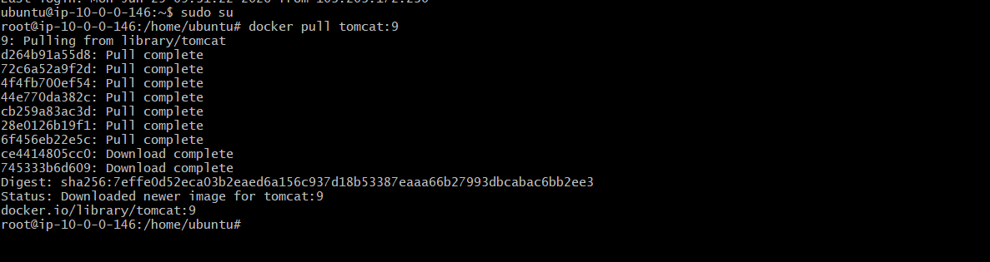
Run Tomcat Container
docker run -d --name tomcat-app -p 8080:8080 tomcat:9
Check Container
docker ps
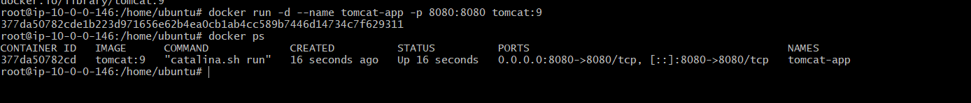
Download Sample WAR File
wget https://tomcat.apache.org/tomcat-7.0-doc/appdev/sample/sample.war
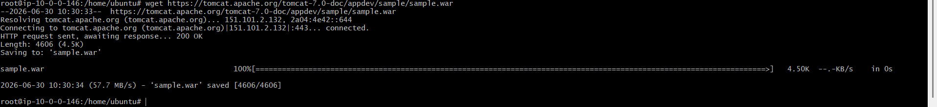
Copy WAR File to Tomcat Container
docker cp sample.war tomcat-app:/usr/local/tomcat/webapps/
Restart Tomcat Container
docker restart tomcat-app
Access Application
http://<EC2-PUBLIC-IP>:8080/sample
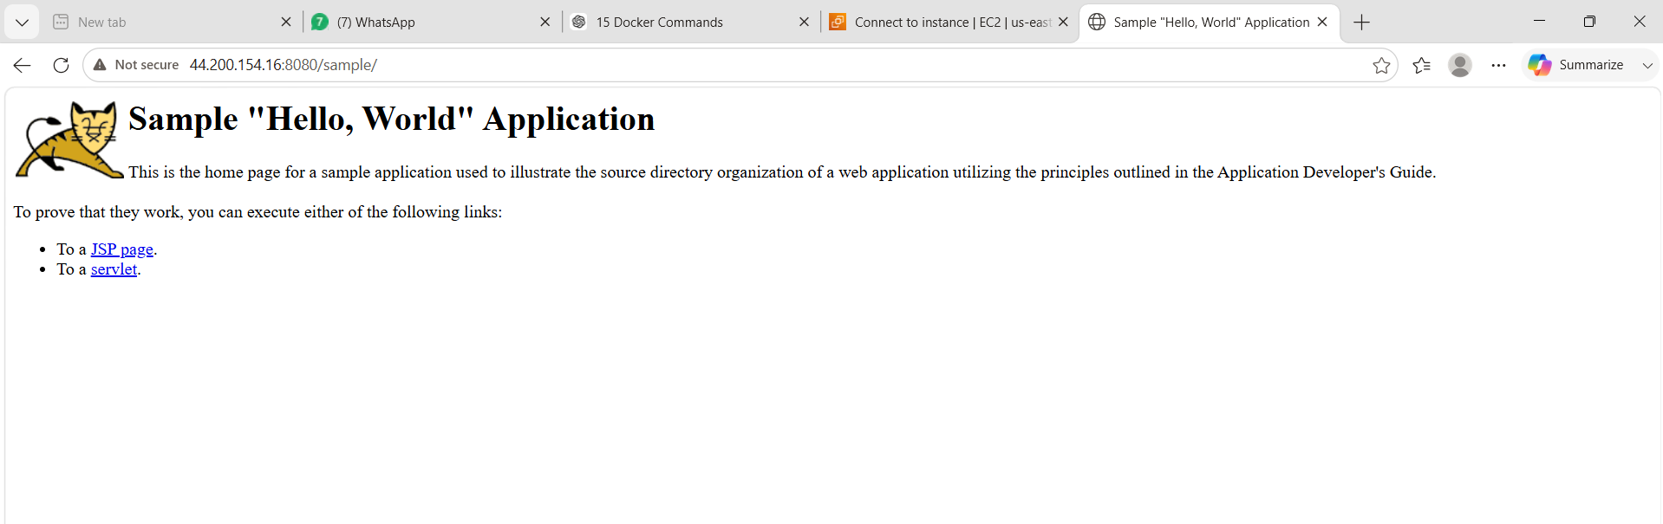
What We Learned
We learned how to run Tomcat container and deploy a WAR file inside it.
Conclusion
Successfully created Tomcat container on port 8080 and deployed sample application.

Task 2: Create Volume and Deploy Tomcat Container on Port 8081
Objective
Create Docker volume and deploy Tomcat container using persistent storage.
Prerequisites
Docker installed
Tomcat image available
Steps
Create Docker Volume
docker volume create tomcat-volume
Check Volume
docker volume ls
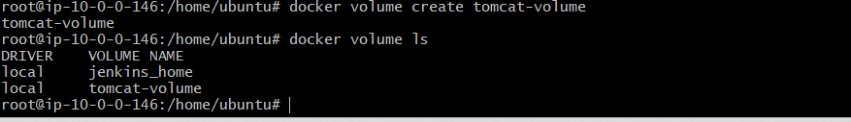
Run Tomcat with Volume on Port 8081
docker run -d \
--name tomcat-volume-app \
-p 8081:8080 \
-v tomcat-volume:/usr/local/tomcat/webapps \
tomcat:9
Copy Sample WAR File
docker cp sample. War tomcat-volume-app:/usr/local/tomcat/webapps/
Restart Container
docker restart tomcat-volume-app
Access Application
http://<EC2-PUBLIC-IP>:8081/sample
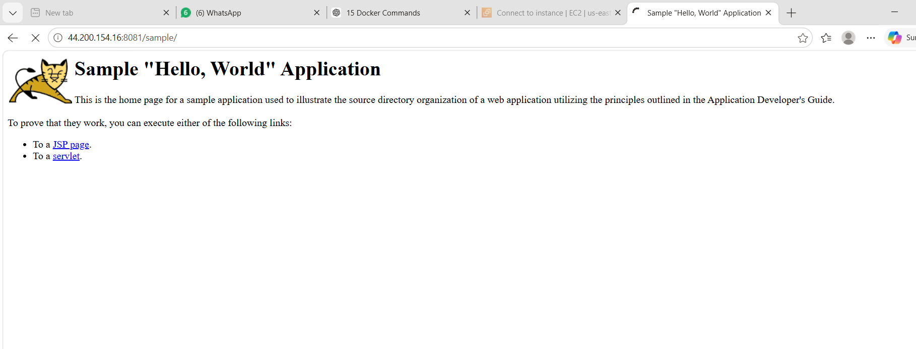
What We Learned
We learned how Docker volumes help store application data permanently.
Conclusion
Successfully deployed Tomcat container with Docker volume on port 8081.

Task 3: Limit Nginx Container to 500 MB
Objective
Run Nginx container with memory limit of 500 MB.
Prerequisites
Docker installed
Nginx image available
Steps
Pull Nginx Image
docker pull nginx
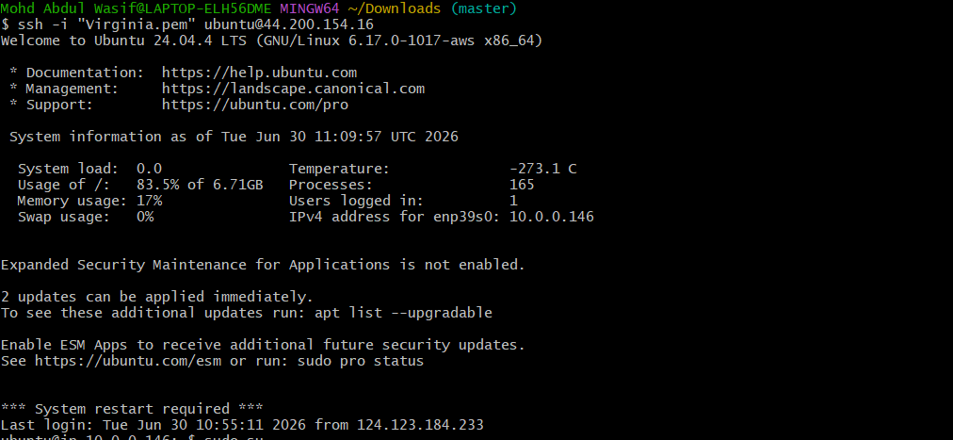
Run Nginx with 500 MB Memory Limit
docker run -d \
--name nginx-limited \
-p 82:80 \
--memory=500m \
nginx
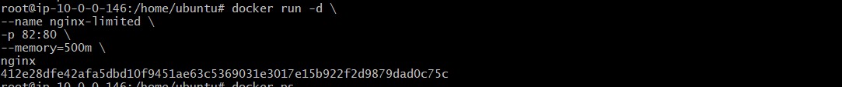
Check Running Container
docker ps
Check Memory Limit
docker inspect nginx-limited | grep -i memory
Check Container Resource Usage
docker stats nginx-limited
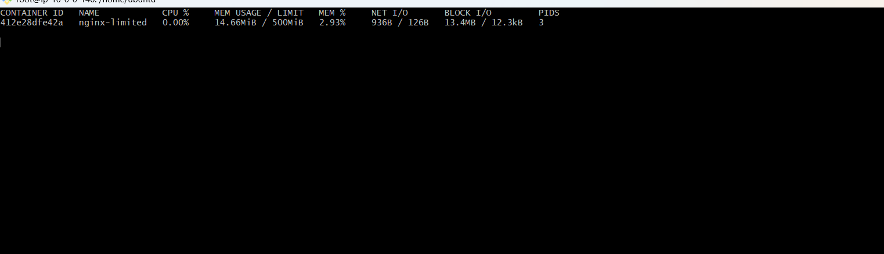
Access Nginx
http://<EC2-PUBLIC-IP>:82
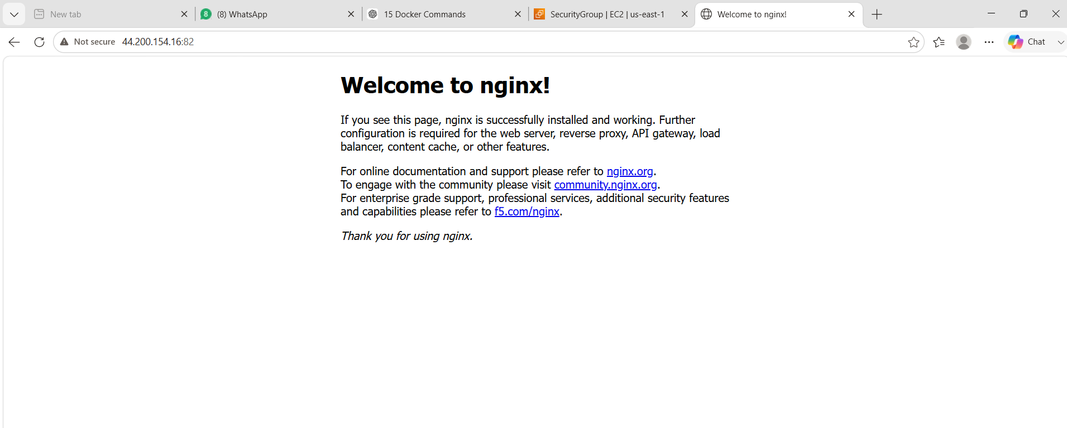
Expected Output
Nginx should run with memory limit of 500 MB.
What We Learned
We learned how to restrict Docker container memory usage.
Conclusion
Successfully limited Nginx container memory to 500 MB.

Task 4: Create Dockerfile Using Amazon Linux and Nginx
Objective
Create a custom Docker image using amazonlinux:latest, install Nginx, copy index.html, expose port 80, and run Nginx.
Prerequisites
Docker installed
Basic Dockerfile knowledge
Steps
Create Project Directory
mkdir docker-nginx-app
cd docker-nginx-app
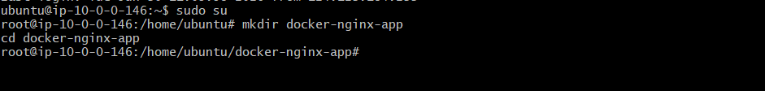
Create index.html File
vi index.html
Paste:
<html>
<head>
<title>Docker Nginx App</title>
</head>
<body>
<h1>Welcome to My Docker Nginx Application</h1>
<h2>This image is created using Amazon Linux</h2>
</body>
</html>
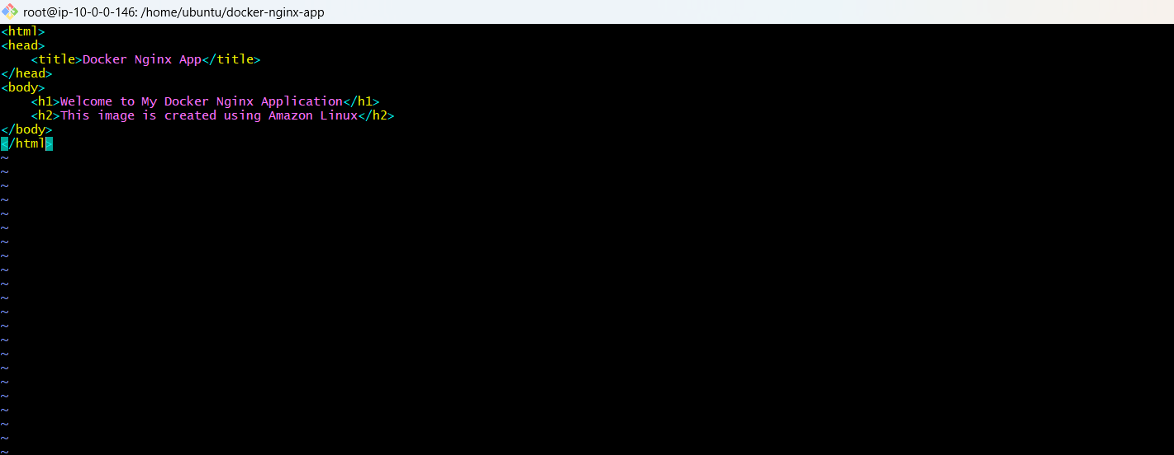
Create Dockerfile
vi Dockerfile
Paste:
FROM amazonlinux:latest
MAINTAINER Mohd Abdul Wasif
RUN yum update -y && \
yum install nginx -y
COPY index.html /usr/share/nginx/html/index.html
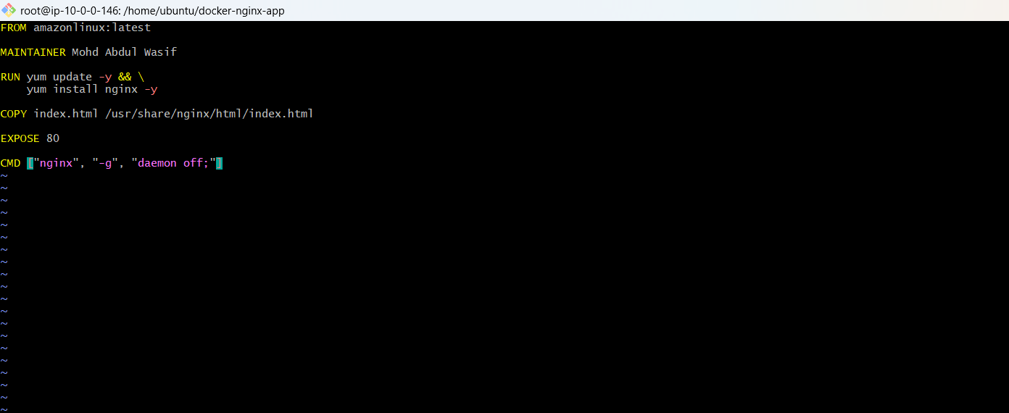
EXPOSE 80
CMD ["nginx", "-g", "daemon off;"]
Build Docker Image
docker build -t amazonlinux-nginx:v1 .
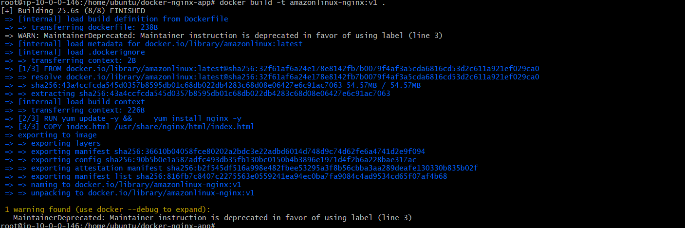
Check Image
docker images
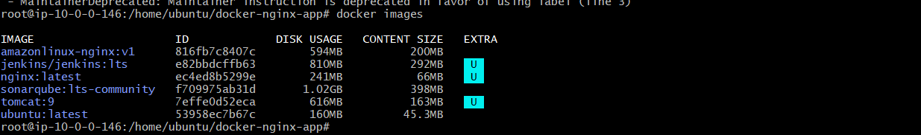
Run Container
docker run -d --name amazon-nginx -p 83:80 amazonlinux-nginx:v1
Access Application
http://<EC2-PUBLIC-IP>:83
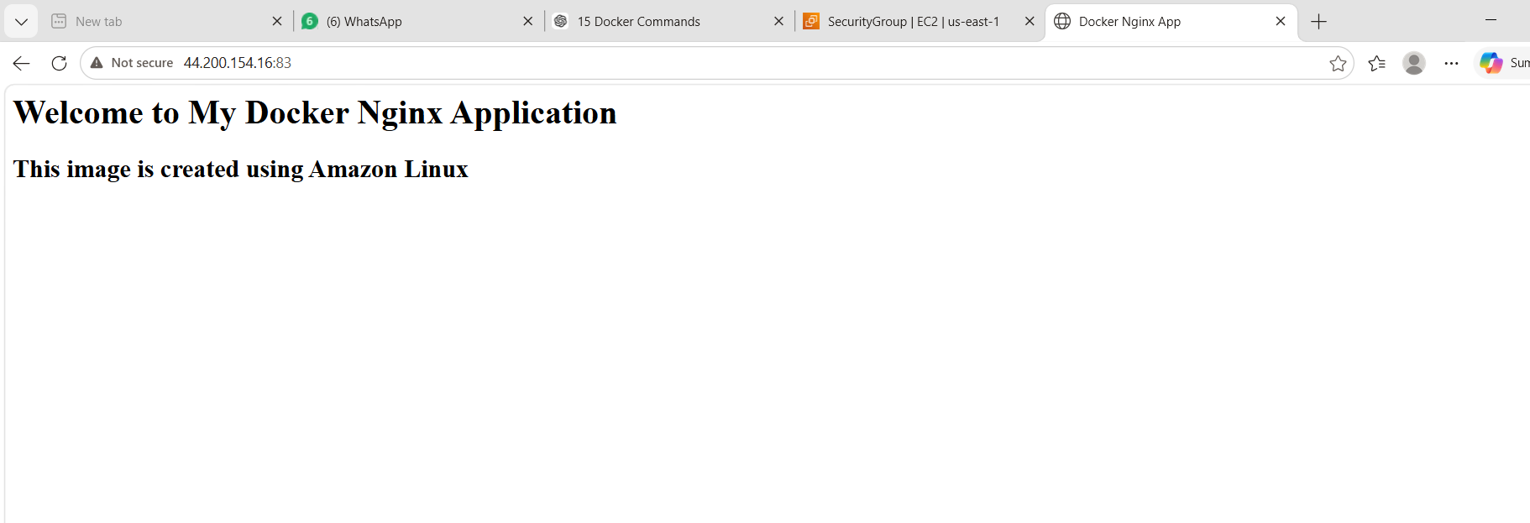

What We Learned
We learned how to create a Dockerfile and build a custom Docker image.
Conclusion
Successfully created a custom Docker image using Amazon Linux and Nginx.

Task 5: Push Image to Docker Hub
Objective
Push custom Docker image to Docker Hub repository.
Prerequisites
Docker Hub account
Docker installed
Custom image created
Steps
Login to Docker Hub
docker login
Enter Docker Hub username and password/token.
docker login -u mohdabdulwasif
dckr_pat_5Id6989x5NcdYCUCU_xtK09KHLo
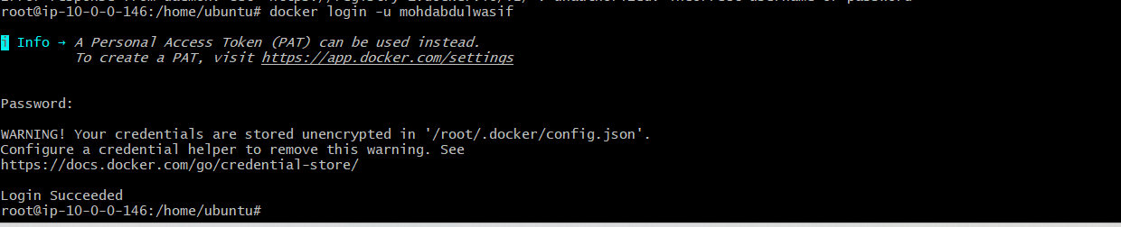
Tag Docker Image
docker tag amazonlinux-nginx:v1 <dockerhub-username>/amazonlinux-nginx:v1
Example:
docker tag amazonlinux-nginx:v1 mohdabdulwasif66/amazonlinux-nginx:v1
Push Image
docker push <dockerhub-username>/amazonlinux-nginx:v1
Example:
docker push mohdabdulwasif66/amazonlinux-nginx:v1
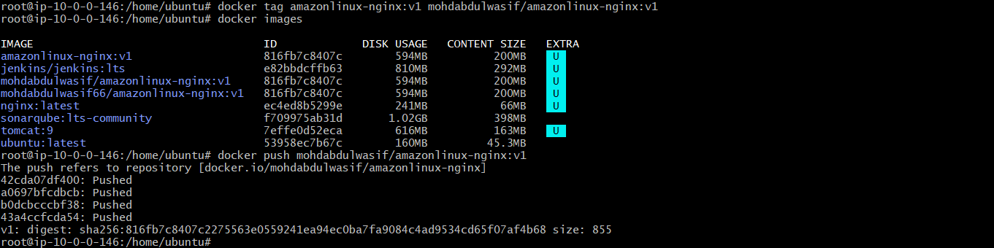
Verify
Go to Docker Hub and check repository.
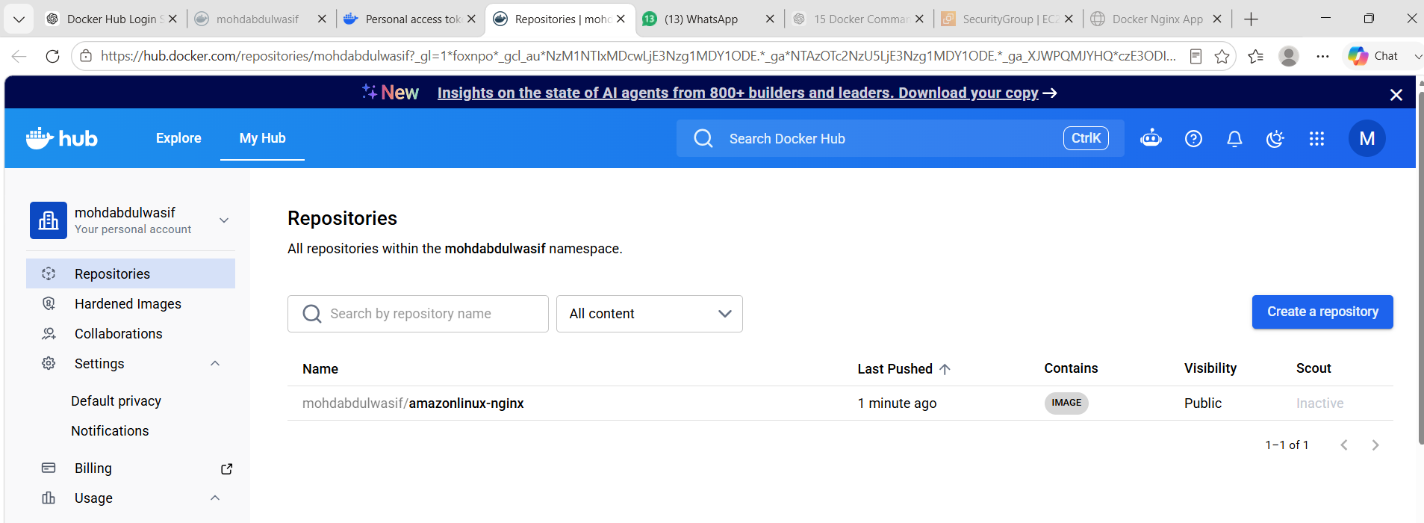
Expected Output
Image should be uploaded to Docker Hub.
What We Learned
We learned how to tag and push Docker images to Docker Hub.
Conclusion
Successfully pushed custom Docker image to Docker Hub.

Task 6: Push Image to AWS ECR
Objective
Push custom Docker image to AWS Elastic Container Registry.
Prerequisites
AWS account
AWS CLI installed and configured
IAM user/role with ECR permissions
Docker image created
Steps
Configure AWS CLI
aws configure
Enter:
AWS Access Key
AWS Secret Key
Region
Output format
Example region:
us-east-1
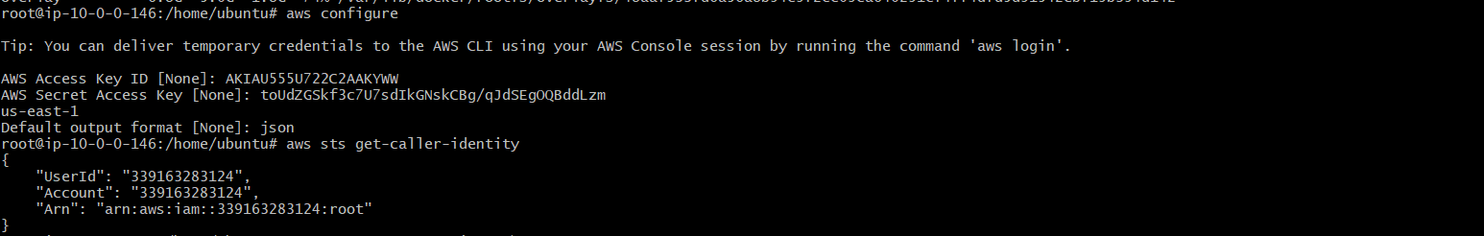
Create ECR Repository
aws ecr create-repository \
--repository-name amazonlinux-nginx \
--region us-east-1
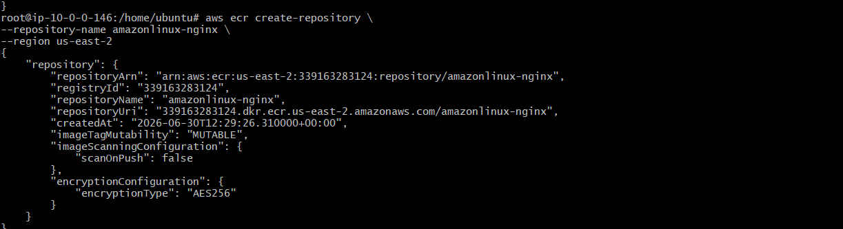
Login to ECR
Replace account ID and region:
aws ecr get-login-password --region us-east-1 | \
docker login --username AWS --password-stdin <AWS-ACCOUNT-ID>.dkr.ecr.us-east-1.amazonaws.com
Tag Image for ECR
docker tag amazonlinux-nginx:v1 <AWS-ACCOUNT-ID>.dkr.ecr.us-east-1.amazonaws.com/amazonlinux-nginx:v1
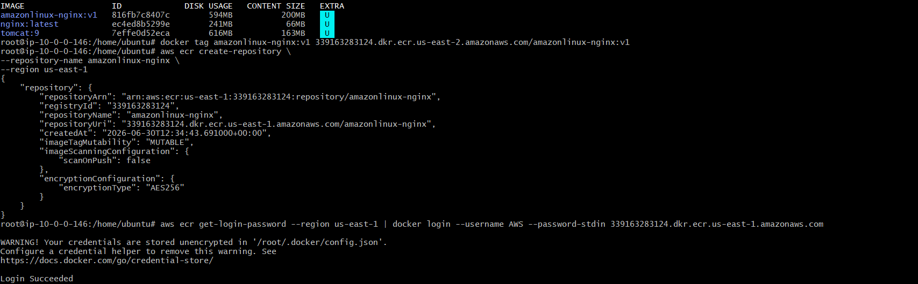
Push Image to ECR
docker push <AWS-ACCOUNT-ID>.dkr.ecr.us-east-1.amazonaws.com/amazonlinux-nginx:v1
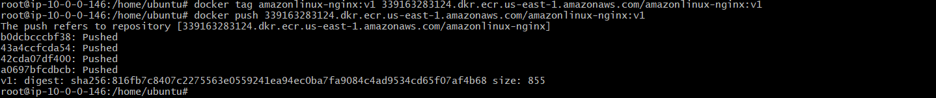
Verify
AWS Console → ECR → Repositories → amazonlinux-nginx
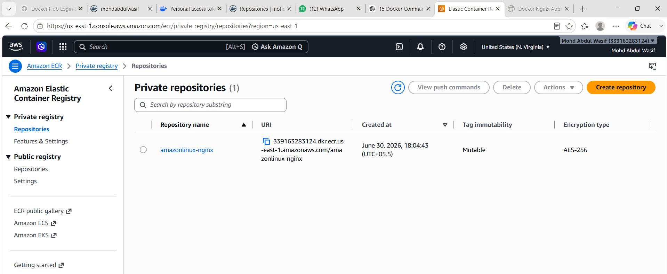
Expected Output
Image should be pushed successfully to AWS ECR.
What We Learned
We learned how to create ECR repository and push Docker image to AWS cloud registry.
Conclusion
Successfully pushed custom Docker image to AWS ECR.

Common Ports Used
Service | Host Port | Container Port
Tomcat App | 8080 | 8080
Tomcat Volume App | 8081 | 8080
Nginx Limited | 82 | 80
Custom Nginx App | 83 | 80
Overall Conclusion
In Docker-02, we deployed Tomcat containers, deployed a sample application, used Docker volumes, limited container memory, created a custom Dockerfile using Amazon Linux, built a Docker image, and pushed the image to both Docker Hub and AWS ECR.

