Docker_task_03
Task -1: Create an Image from a Running Container
Objective
To create a new Docker image from an existing running container so that all current changes inside the container are saved as a reusable image.
Prerequisites
- Docker installed and running
- A running Docker container
- Basic knowledge of Docker commands
Steps
Step 1: Check running containers
docker ps
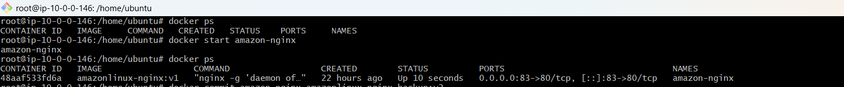
Step 2: Create image from container
docker commit <container_name> myimage:v1
Example:
docker commit nginx-container nginx-backup:v1
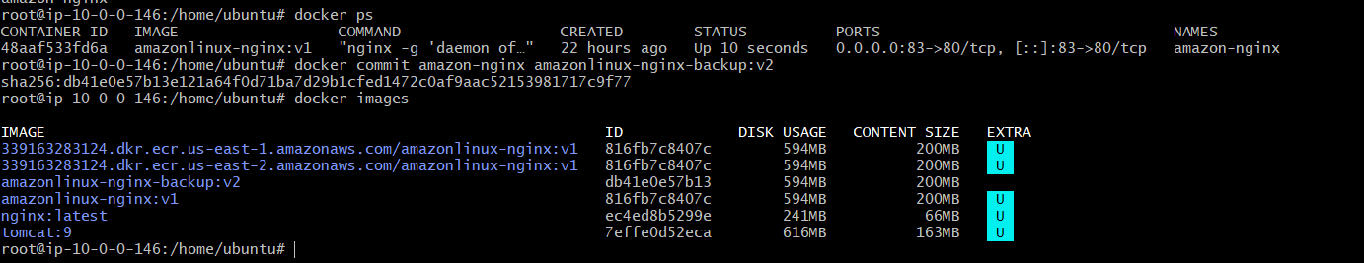
Step 3: Verify image
docker images
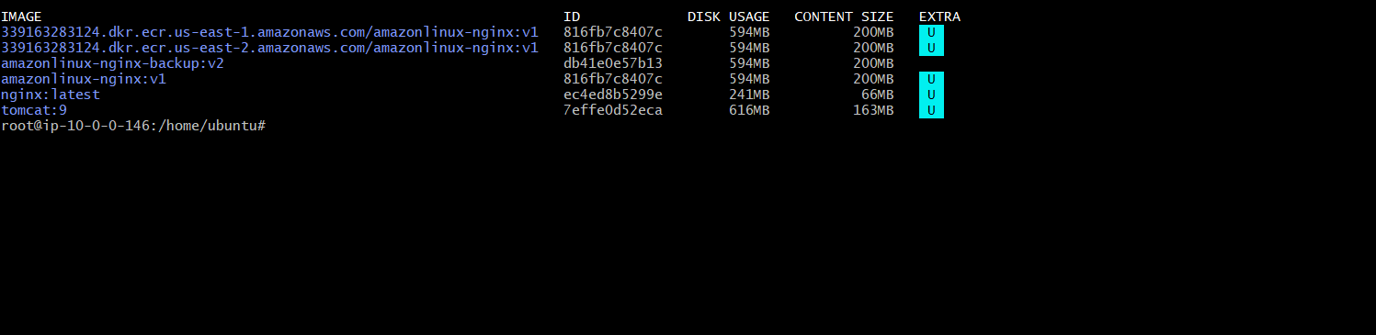
Create an image from a running Nginx container."
Then do these commands from scratch:
docker run -d --name nginx-container -p 81:80 nginx
Check:
docker ps

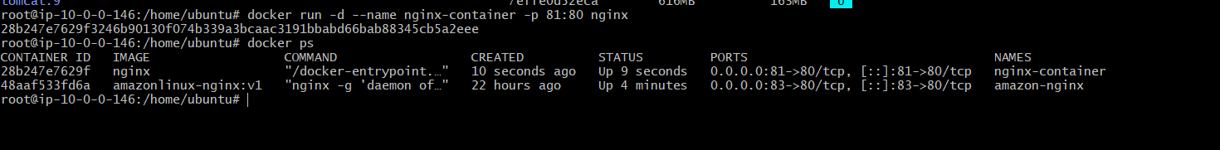
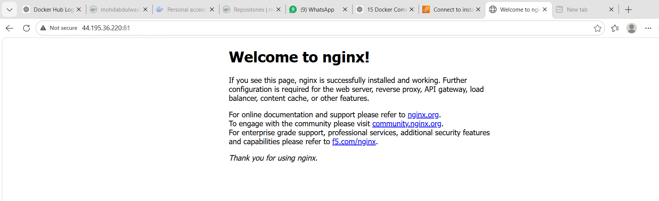
Then:
docker commit nginx-container nginx-backup:v1
Verify:
docker images

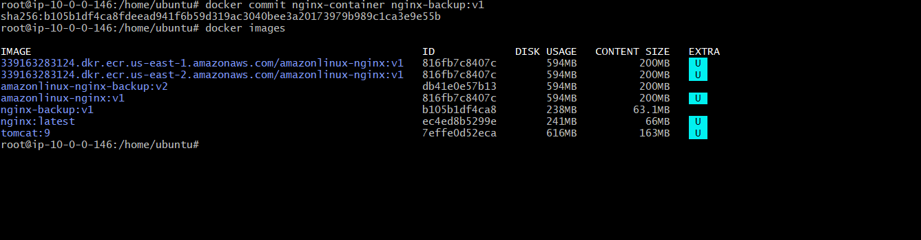
What We Learned
- How Docker creates an image from a running container.
- Difference between a container and an image.
- How to save container changes for future use.
Conclusion
Successfully created a reusable Docker image from a running container using the docker commit command.
Task 2: Copy Image from Local Machine to Docker Server and Load Image
Objective
Save a Docker image as a .tar file, copy it to another server, and load it there.
Steps
On Local Machine
docker images
docker save -o nginx-backup.tar nginx-backup:v1
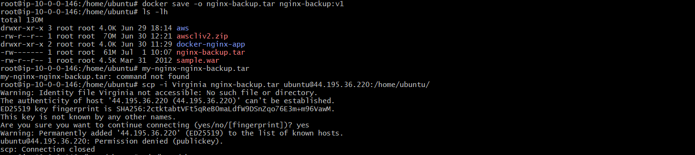
Copy to Docker server:
scp -i key.pem nginx-backup.tar ubuntu@<DOCKER-SERVER-IP>:/home/ubuntu/
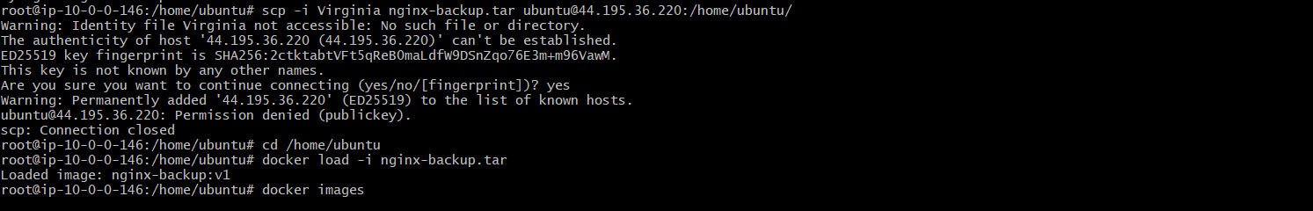
On Docker Server
cd /home/ubuntu
docker load -i nginx-backup.tar
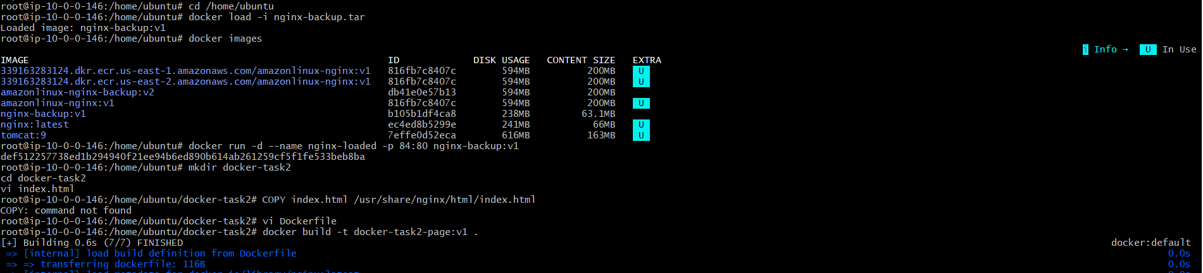
Verify:
docker images
Run container:
docker run -d --name nginx-loaded -p 84:80 nginx-backup:v1
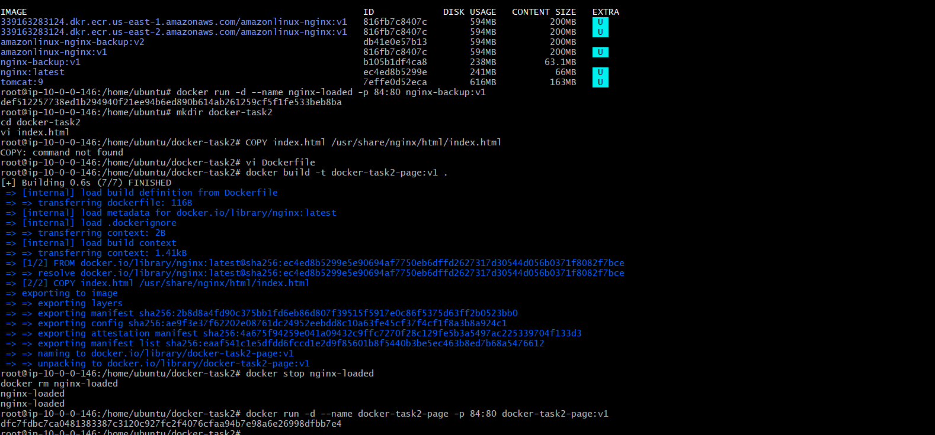
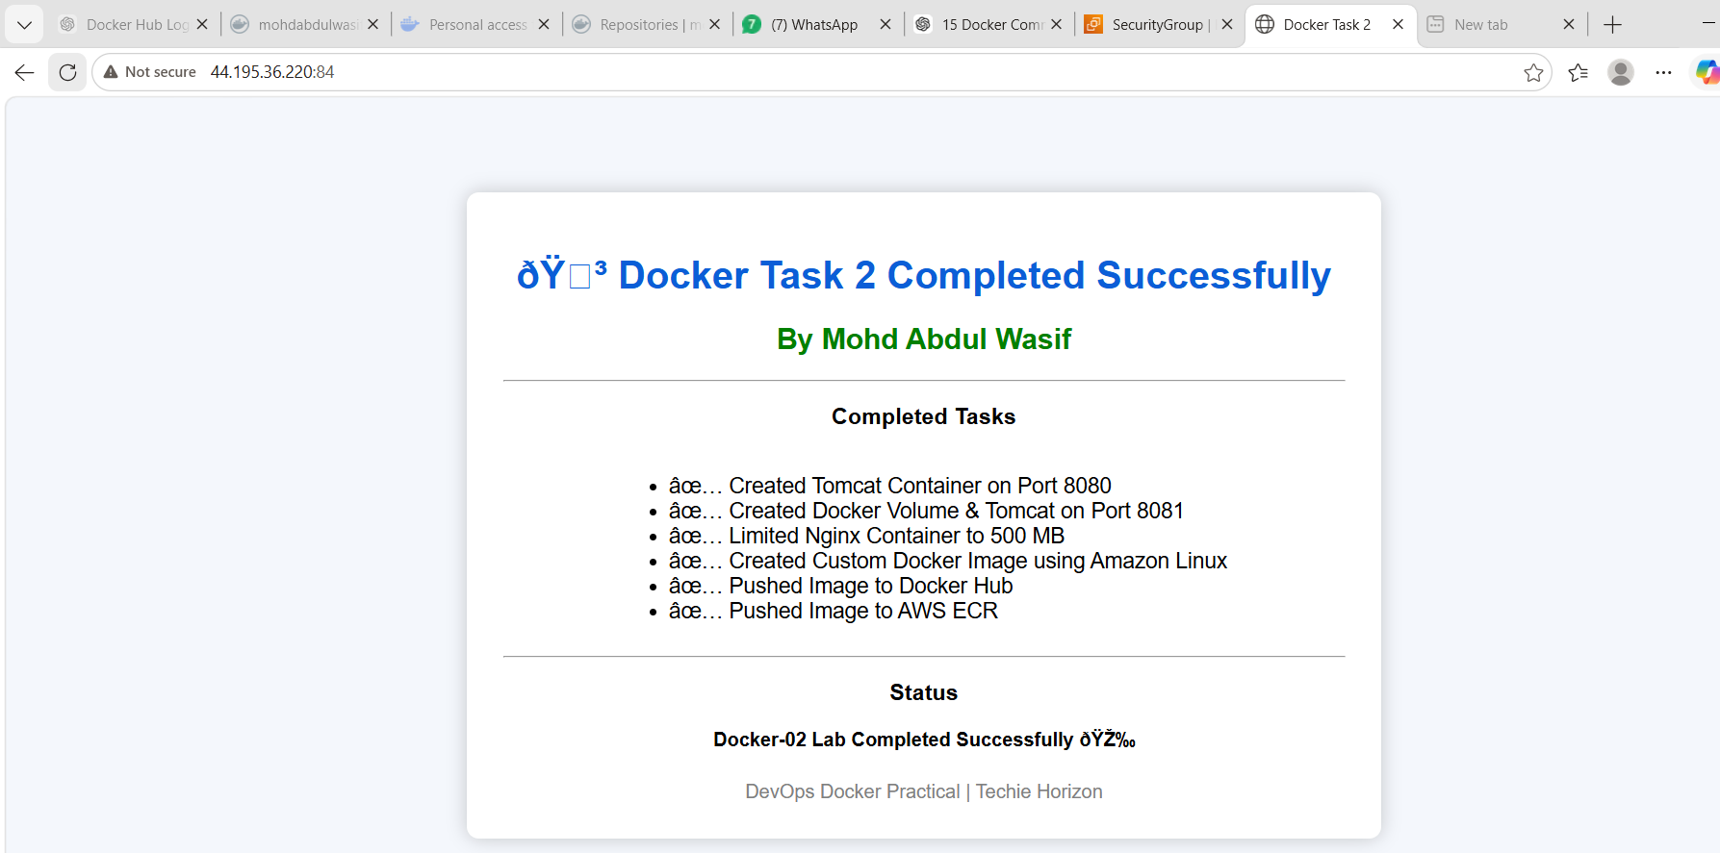
What We Learned
We learned how to export Docker images, transfer them to another server, and import them using docker load.
Conclusion
Successfully copied a Docker image from one machine to another and loaded it on the Docker server.

Task 3: Create Docker Image Using Alpine and Customize with Tomcat
Objective
Create a lightweight custom Tomcat Docker image using Alpine Linux.
Steps
Create folder:
mkdir alpine-tomcat
cd alpine-tomcat
Create Dockerfile:
vi Dockerfile
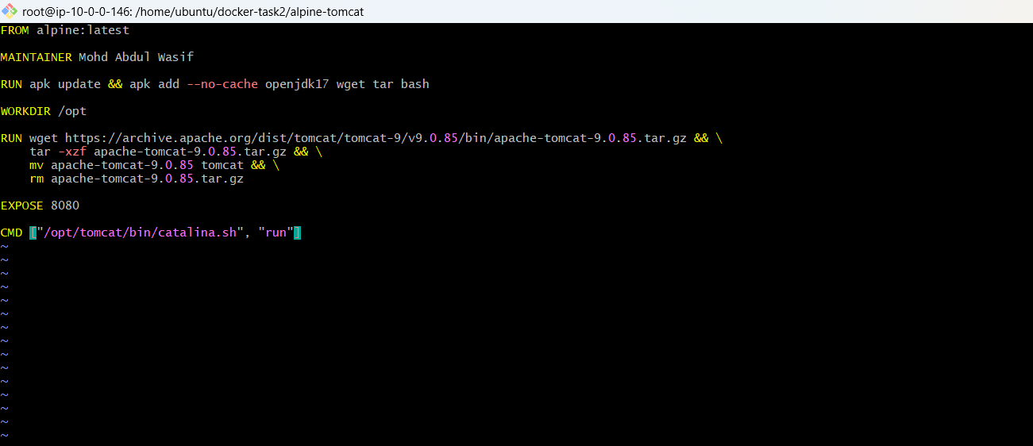
Paste:
FROM alpine:latest
MAINTAINER Mohd Abdul Wasif
RUN apk update && apk add --no-cache openjdk17 wget tar bash
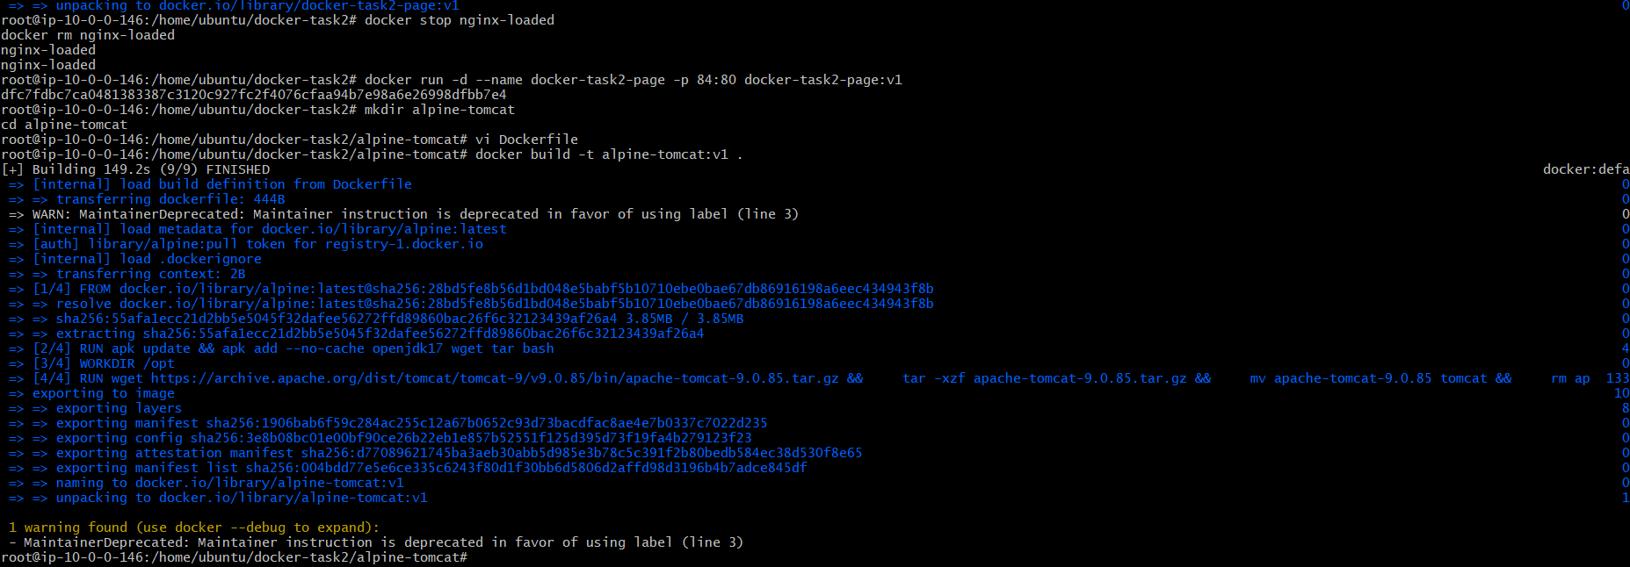
WORKDIR /opt
RUN wget https://archive.apache.org/dist/tomcat/tomcat-9/v9.0.85/bin/apache-tomcat-9.0.85.tar.gz && \
tar -xzf apache-tomcat-9.0.85.tar.gz && \
mv apache-tomcat-9.0.85 tomcat && \
rm apache-tomcat-9.0.85.tar.gz
EXPOSE 8080
CMD ["/opt/tomcat/bin/catalina.sh", "run"]
Build image:
docker build -t alpine-tomcat:v1 .
Run container:
docker run -d --name alpine-tomcat-container -p 8085:8080 alpine-tomcat:v1
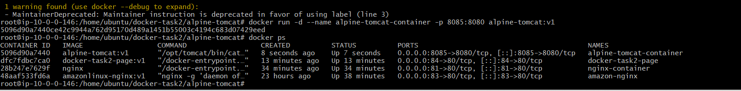
Verify:
docker ps
Open browser:
http://<EC2-PUBLIC-IP>:8085
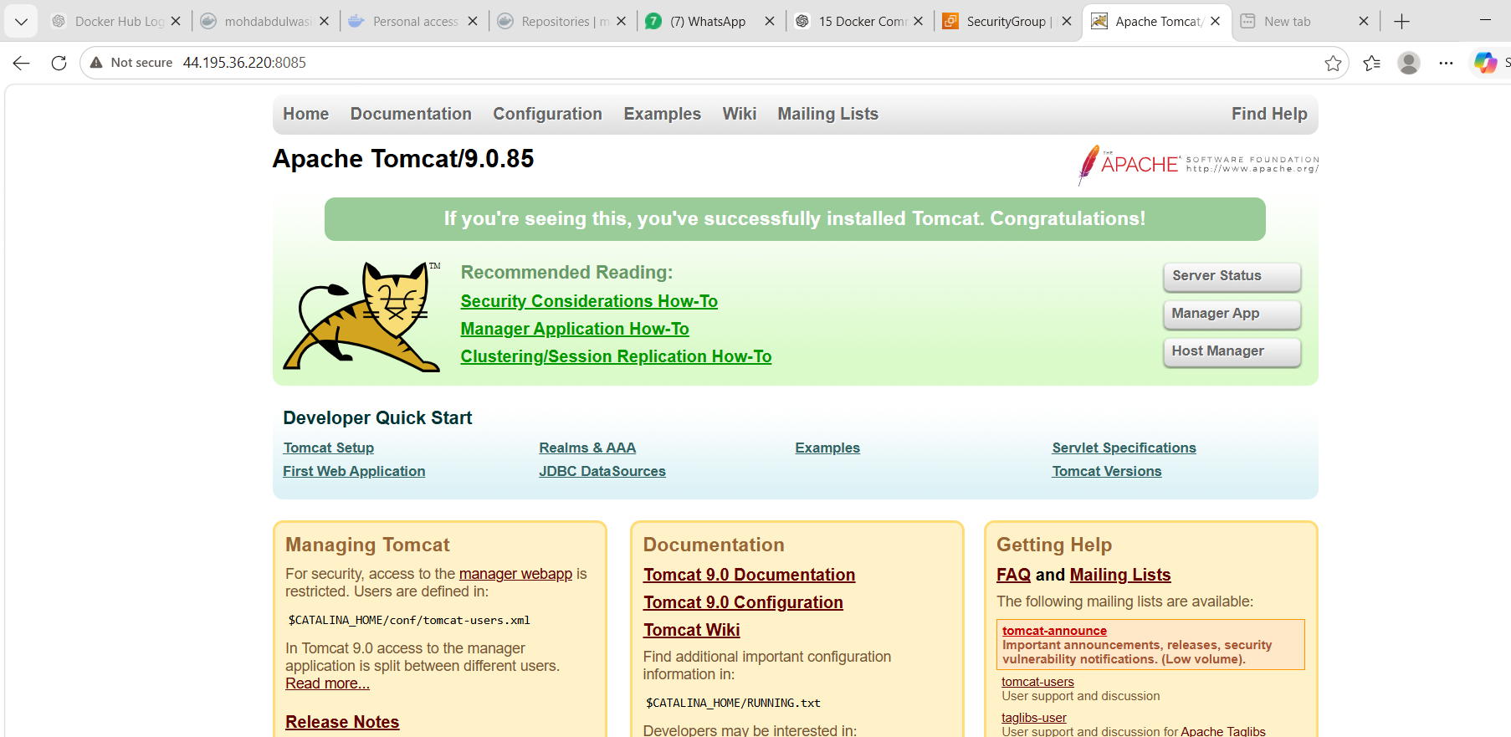
What We Learned
We learned how to create a lightweight Docker image using Alpine and manually install Tomcat.
Conclusion
Successfully created a custom Tomcat image using Alpine Linux.

Task 4: Create Single Stage and Multi Stage Docker file
Source Code:
https://github.com/betawins/multi-stage-example.git
Objective
Create both single-stage and multi-stage Docker builds for the same application.
Steps
Clone source code:
git clone https://github.com/betawins/multi-stage-example.git
cd multi-stage-example
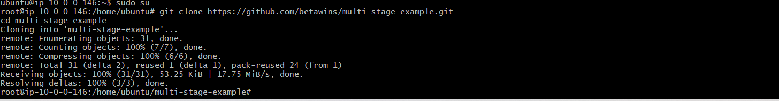

Single Stage Dockerfile
Create:
vi Dockerfile.single
Paste:
FROM maven:3.9.6-eclipse-temurin-17
WORKDIR /app
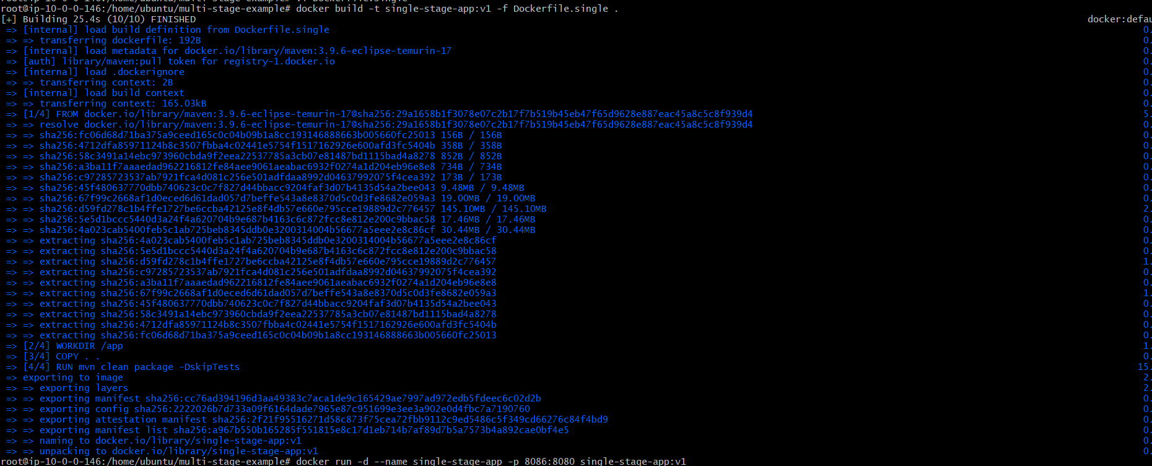
COPY . .
RUN mvn clean package -DskipTests
EXPOSE 8080
CMD ["java", "-jar", "target/*.jar"]
Build:
docker build -t single-stage-app:v1 -f Dockerfile.single .
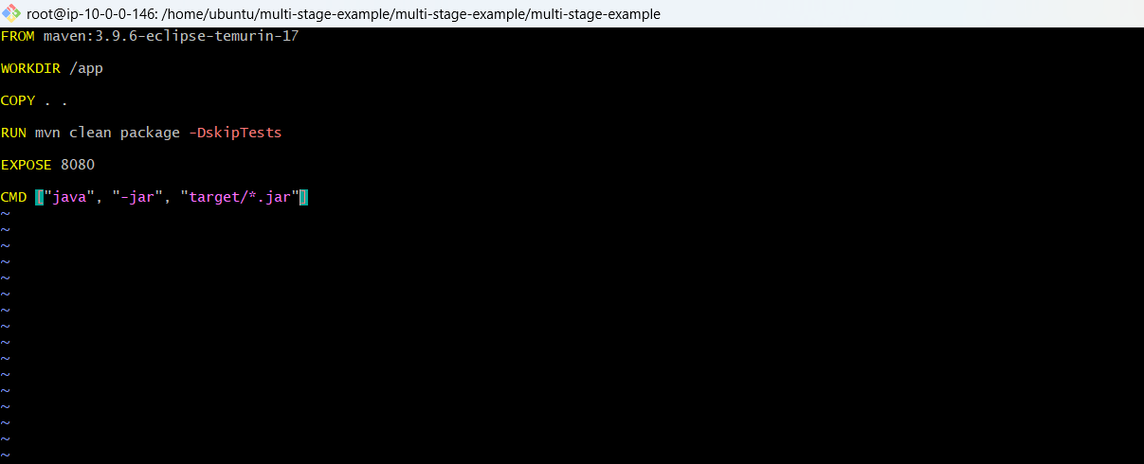
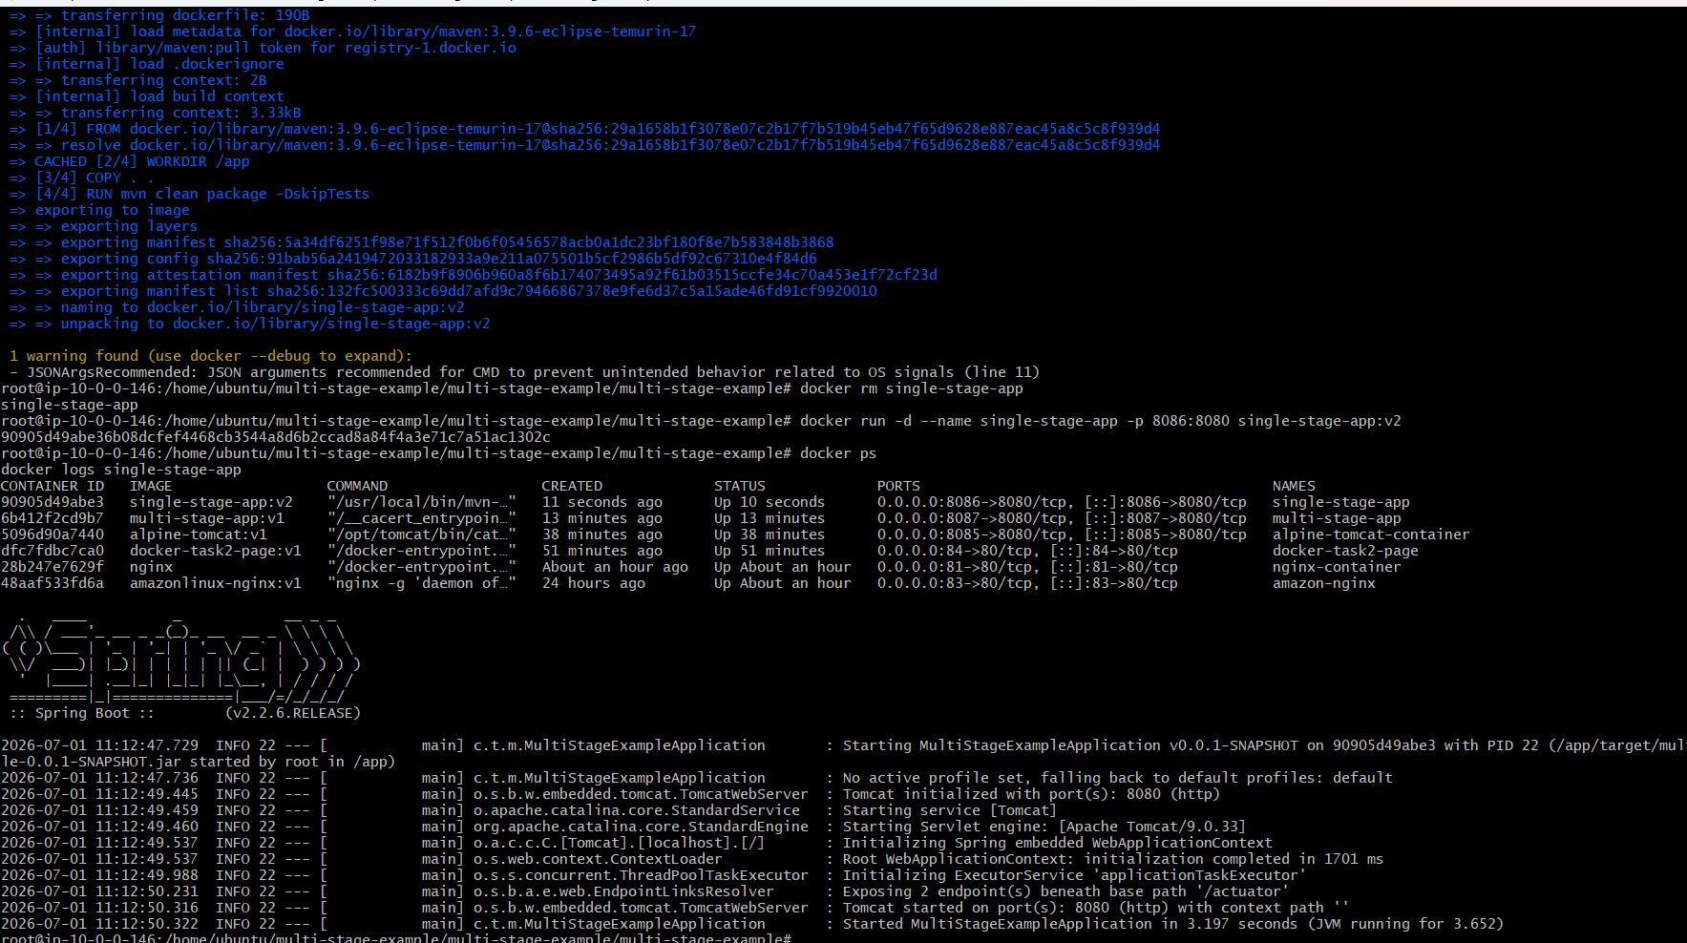
Run:
docker run -d --name single-stage-app -p 8086:8080 single-stage-app:v1
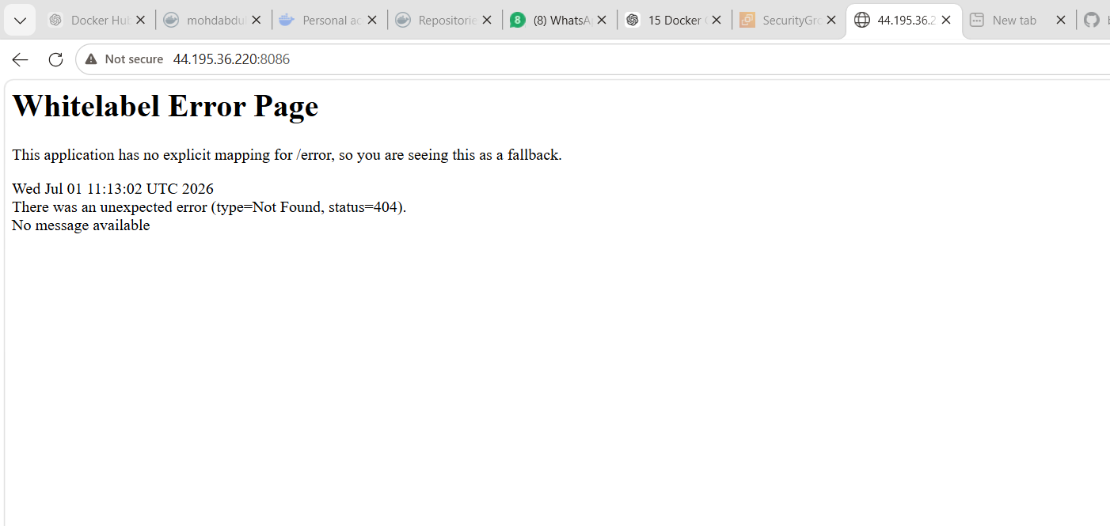

Multi Stage Dockerfile
Create:
vi Dockerfile.multi
Paste:
FROM maven:3.9.6-eclipse-temurin-17 AS build
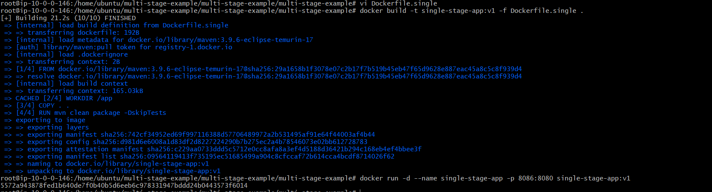
WORKDIR /app
COPY . .
RUN mvn clean package -DskipTests
FROM eclipse-temurin:17-jre
WORKDIR /app
COPY --from=build /app/target/*.jar app.jar
EXPOSE 8080
CMD ["java", "-jar", "app.jar"]
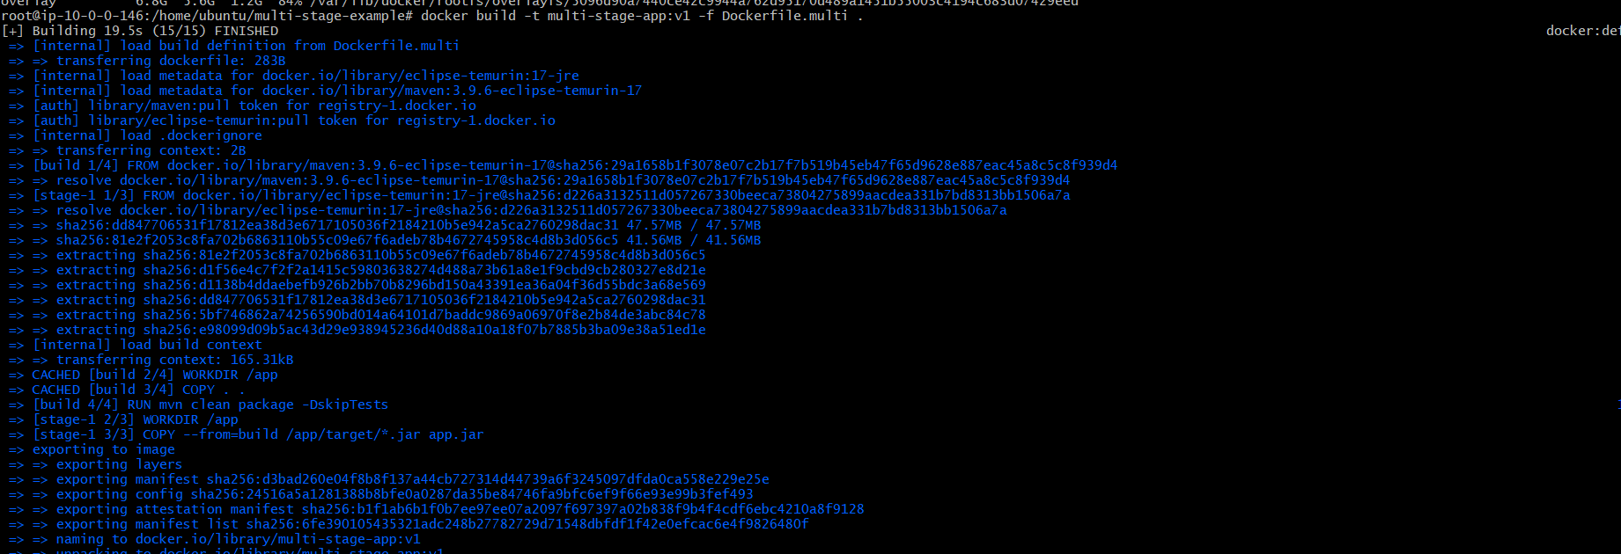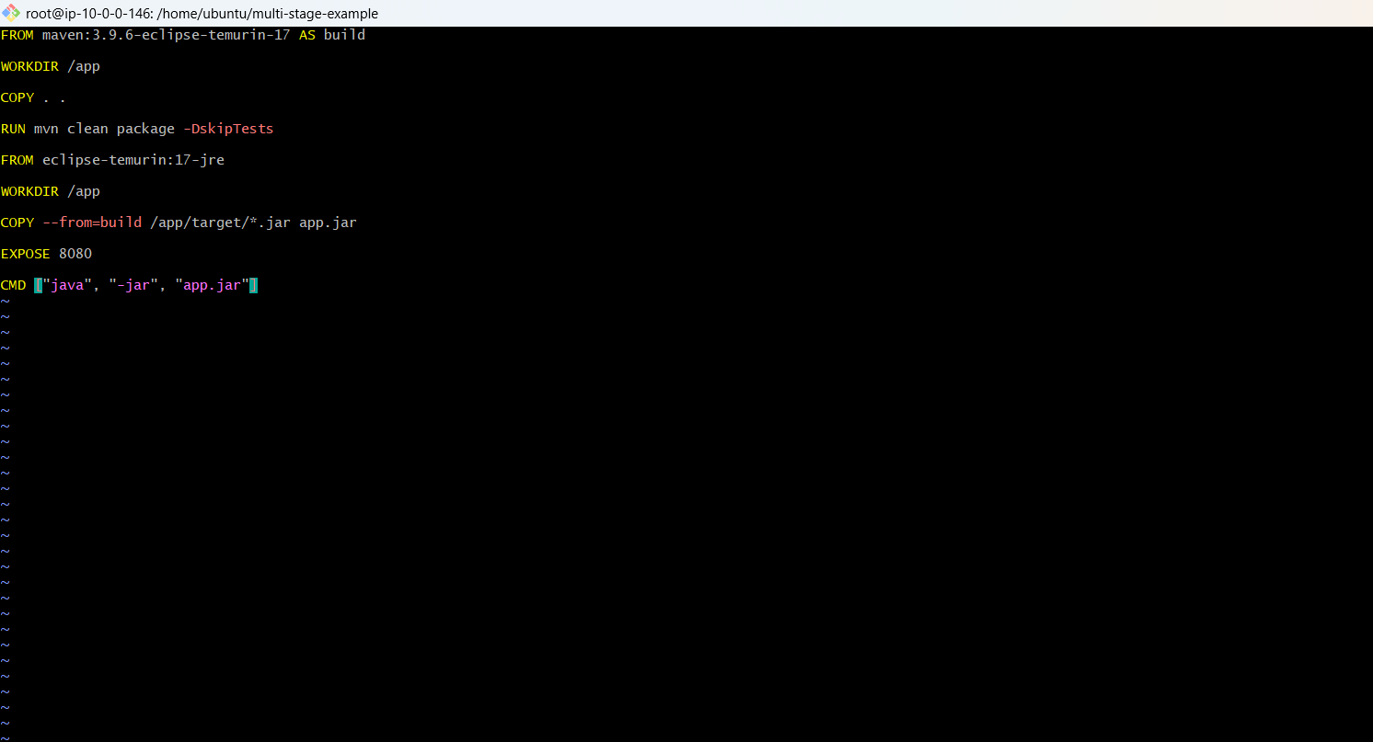
Build:
docker build -t multi-stage-app:v1 -f Dockerfile.multi .
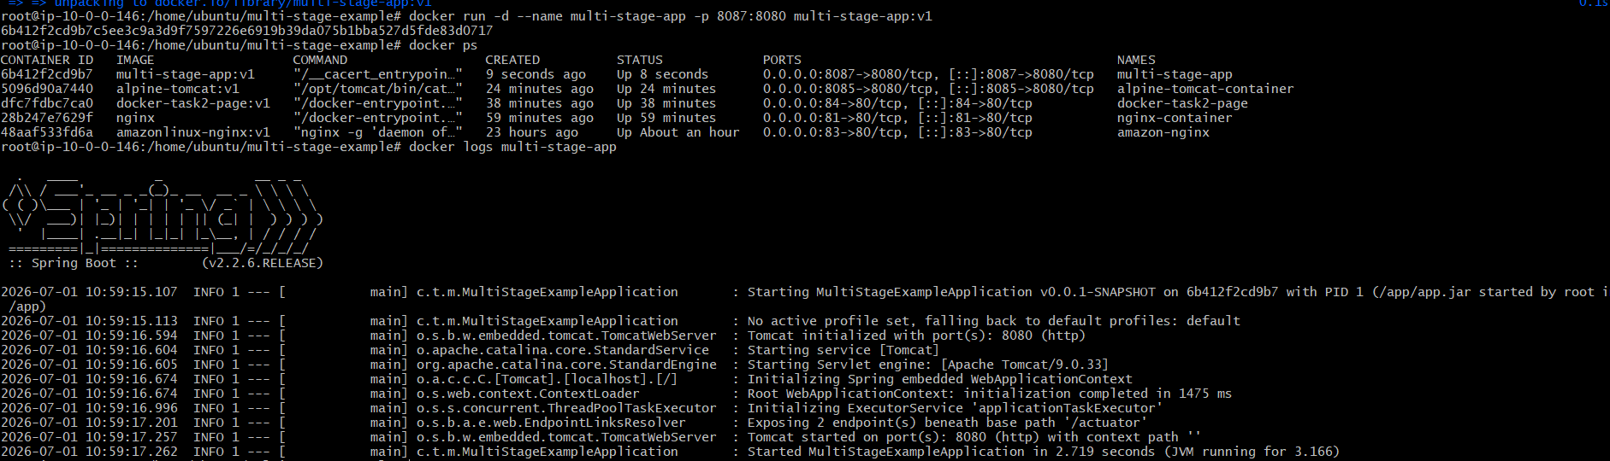
Run:
docker run -d --name multi-stage-app -p 8087:8080 multi-stage-app:v1
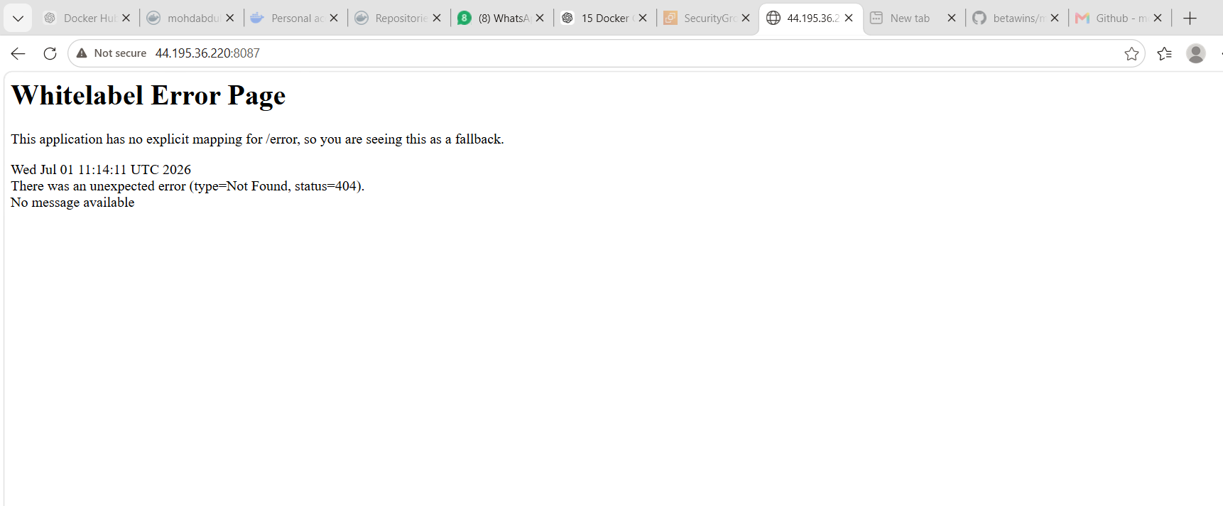
Compare image size:
docker images
What We Learned
We learned the difference between single-stage and multi-stage Docker builds. Multi-stage builds reduce image size because build tools are not included in the final image.
Conclusion
Successfully created single-stage and multi-stage Docker images using the given GitHub source code.

Task 5: Install Docker Compose and Execute Sample Application
Objective
Install Docker Compose and run a sample multi-container application.
Steps
Check Docker Compose:
docker compose version
If not installed:
sudo apt update -y
sudo apt install docker-compose-plugin -y
Create folder:
mkdir compose-demo
cd compose-demo
Create docker-compose.yml:
vi docker-compose.yml
Paste:
services:
web:
image: nginx
container_name: compose-nginx
ports:
- "8088:80"
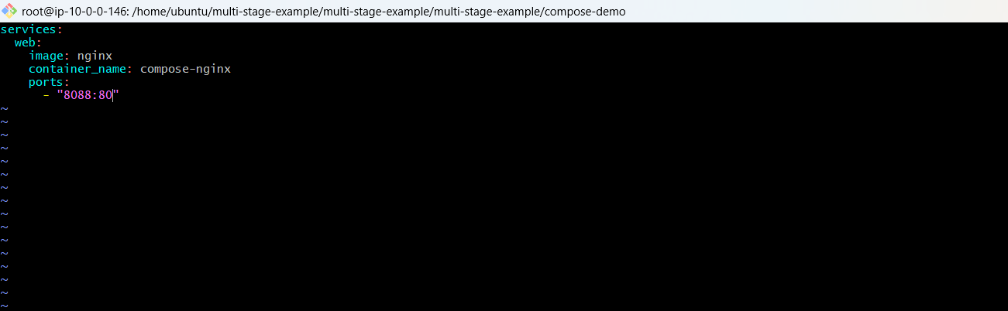
Start application:
docker compose up -d
Check containers:
docker ps
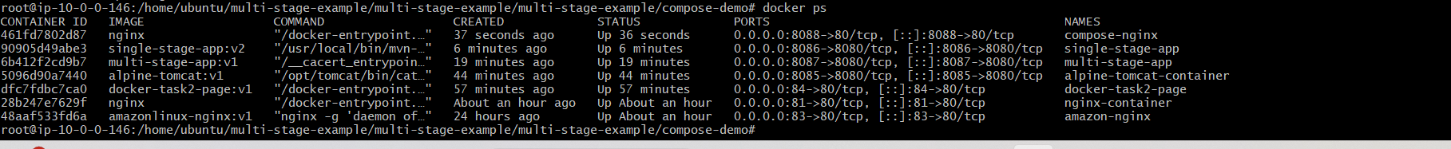
Open browser:
http://<EC2-PUBLIC-IP>:8088
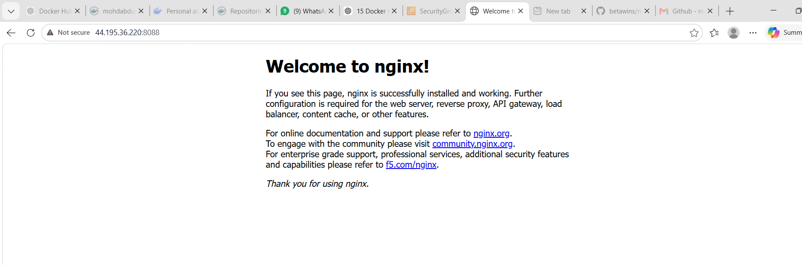
Stop application:
docker compose down
What We Learned
We learned how Docker Compose helps manage containers using a YAML file.
Conclusion
Successfully installed Docker Compose and executed a sample Nginx application.

Task 6: Implement Image Scan When Pushed to Docker Registry
Objective
Enable image scanning for Docker images pushed to a registry.
Option 1: Docker Hub Scanning
Steps
- Login to Docker Hub.
- Go to your repository.
- Open repository settings.
- Enable vulnerability/security scanning if available.
- Push image:
docker login
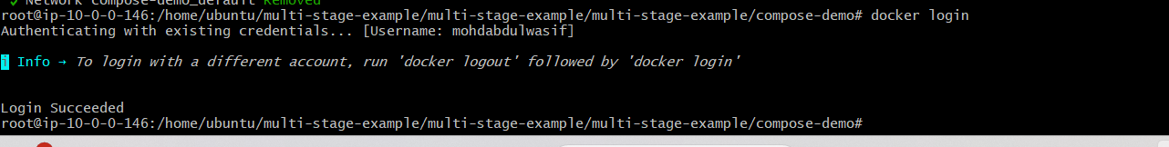
docker tag amazonlinux-nginx:v1 <dockerhub-username>/amazonlinux-nginx:v1
docker push <dockerhub-username>/amazonlinux-nginx:v1
- Open Docker Hub repository and check scan result.
Login to docker
docker login -u mohdabdulwasif
dckr_pat_ftMzbicfYD67XBSbRgjGO9gv1k0
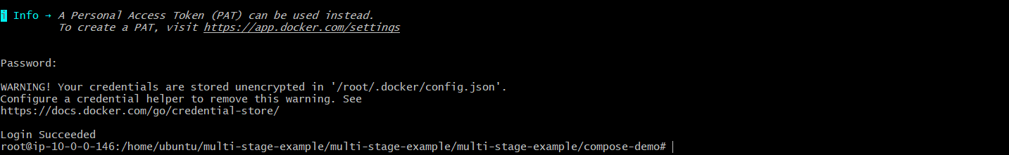
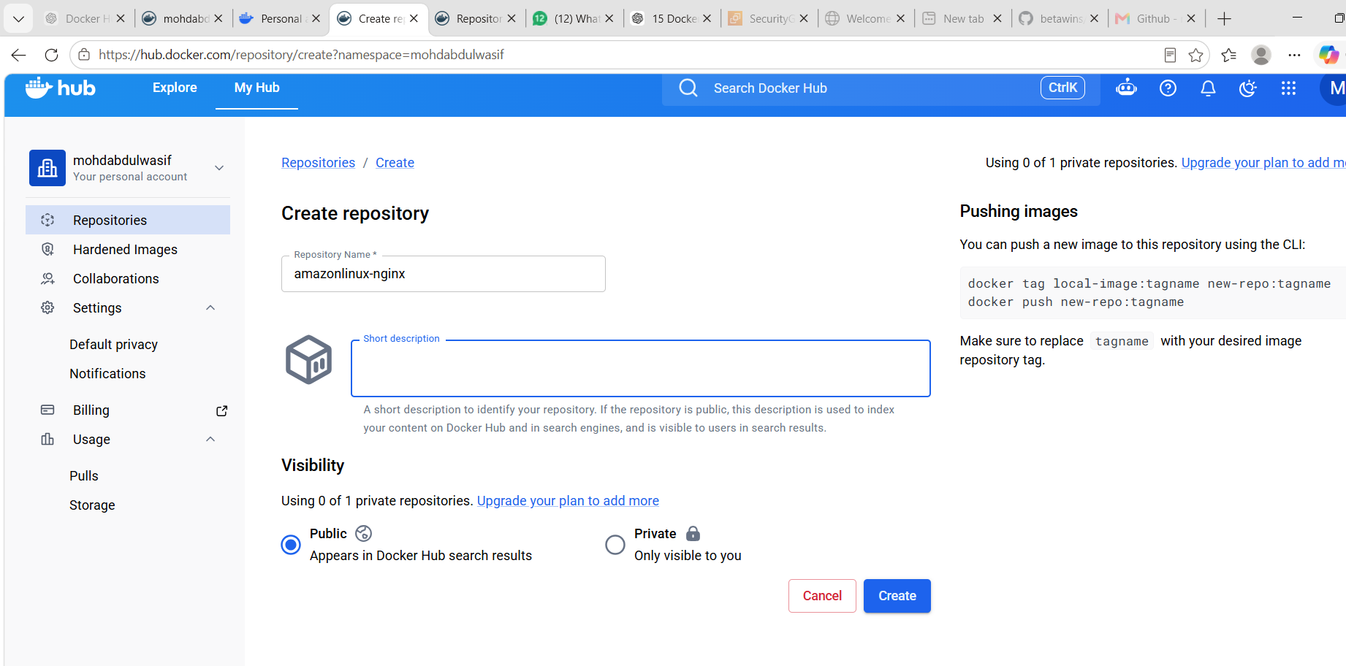
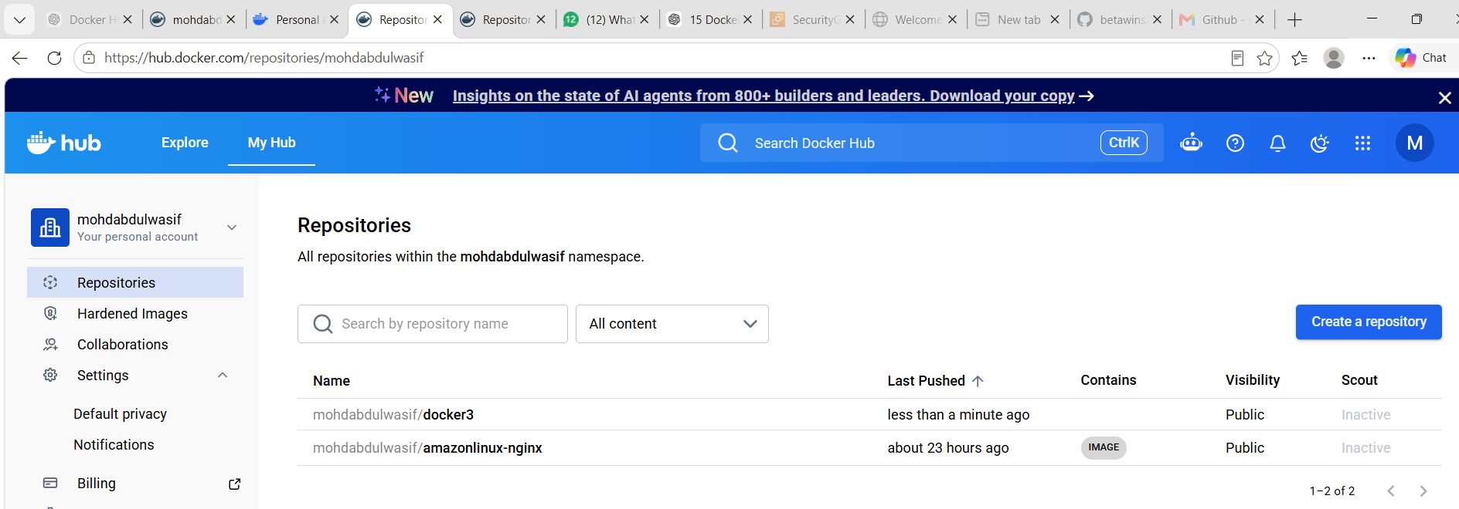
Option 2: Local Scan Using Docker Scout
docker scout quickview amazonlinux-nginx:v1
docker scout cves amazonlinux-nginx:v1
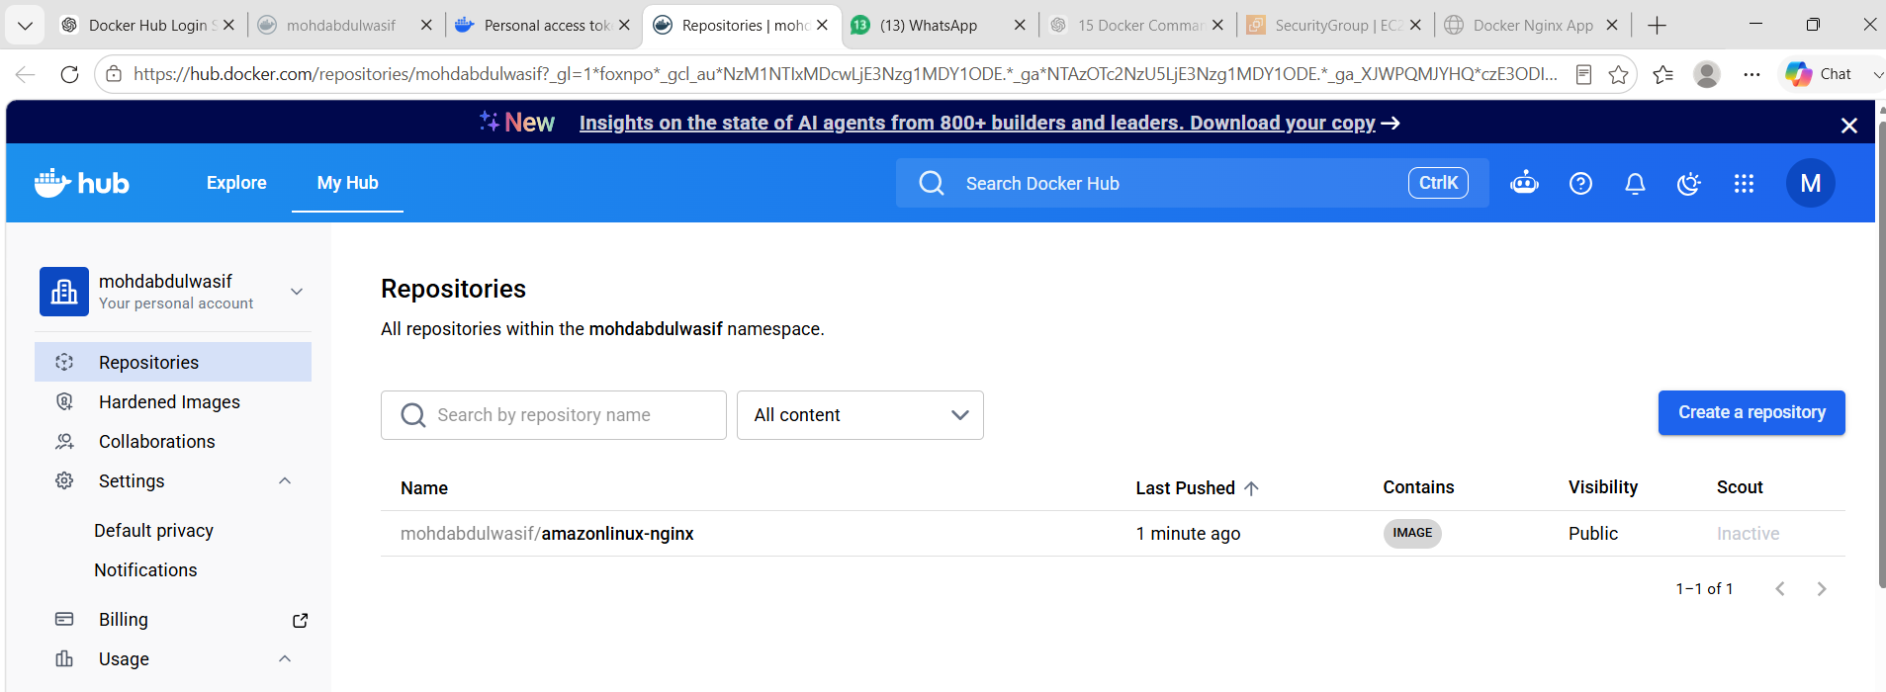
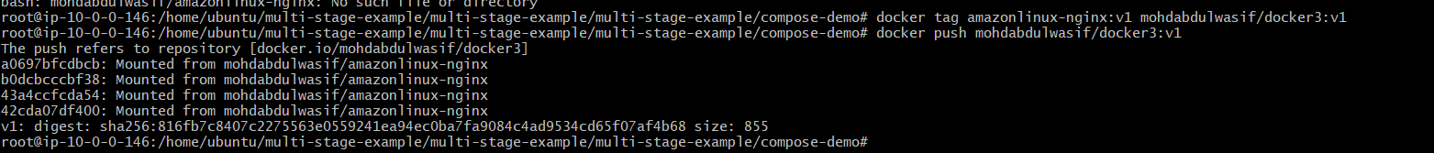
Expected Output
Image should be uploaded to Docker Hub.
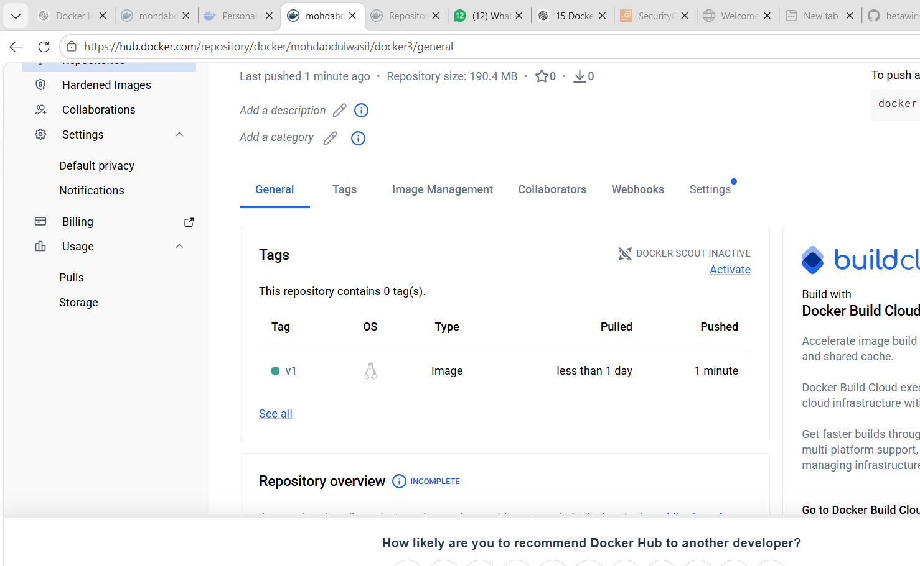
What We Learned
We learned how Docker image scanning helps find vulnerabilities before using images in production.
Conclusion
Successfully implemented image scanning for Docker registry images.

Task 7: Implement Solution to Scan Images When Pushed to AWS ECR
Objective
Enable automatic image vulnerability scanning in Amazon ECR and verify the scan results after pushing a Docker image.

Prerequisites
- AWS Account
- AWS CLI installed and configured
- Docker installed
- Docker image available (amazonlinux-nginx:v1)
- IAM user/role with Amazon ECR permissions
- Docker authenticated with Amazon ECR

Step 1: Configure AWS CLI
aws configure
Enter:
AWS Access Key ID
AWS Secret Access Key
Default Region: us-east-1
Output Format: json
Verify:
aws sts get-caller-identity
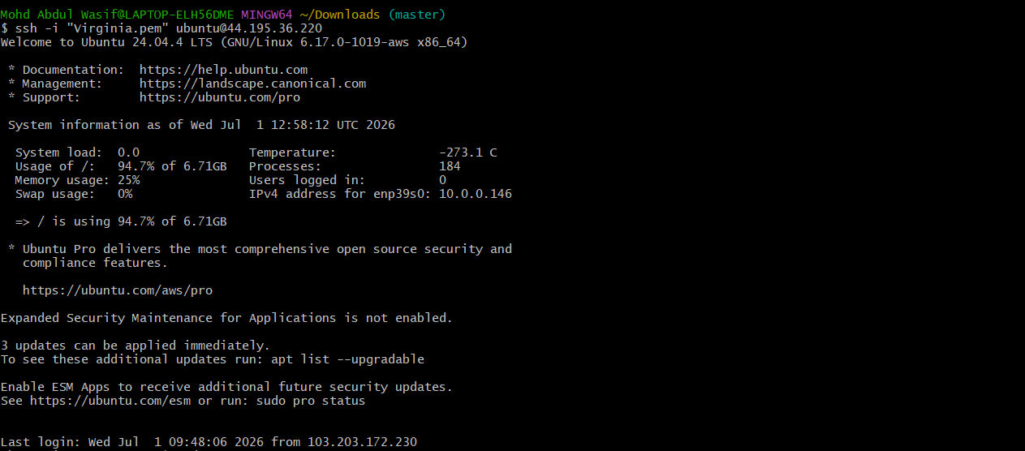

Step 2: Create ECR Repository with Scan-on-Push Enabled
aws ecr create-repository \
--repository-name secure-nginx \
--image-scanning-configuration scanOnPush=true \
--region us-east-1
Expected Output
Repository created successfully
scanOnPush : true

Step 3: Login to Amazon ECR
aws ecr get-login-password --region us-east-1 | docker login \
--username AWS \
--password-stdin 339163283124.dkr.ecr.us-east-1.amazonaws.com
Expected Output
Login Succeeded
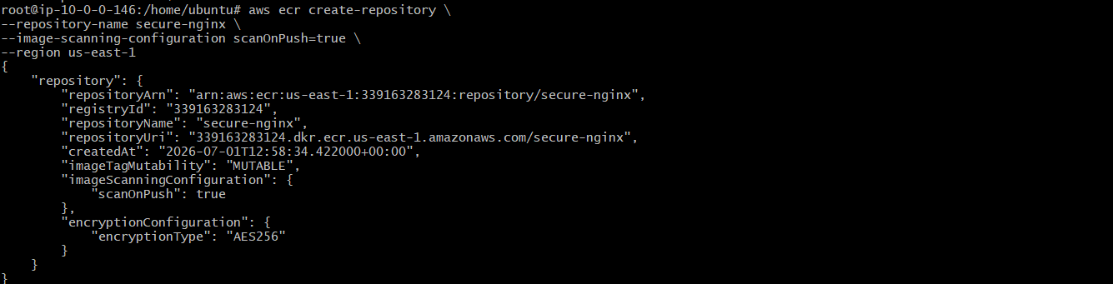

Step 4: Build Docker Image
Since the previous image was created as an OCI image index, rebuild it using Docker image format.
docker build --no-cache \
--provenance=false \
-t 339163283124.dkr.ecr.us-east-1.amazonaws.com/secure-nginx:v2 \
/home/ubuntu/docker-task2
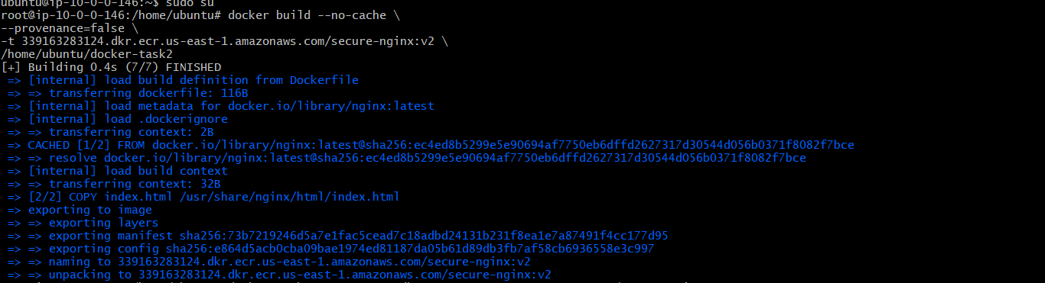

Step 5: Push Image to Amazon ECR
docker push 339163283124.dkr.ecr.us-east-1.amazonaws.com/secure-nginx:v2
Expected Output
v2: digest: sha256:xxxxxxxxxxxxxxxxxxxx
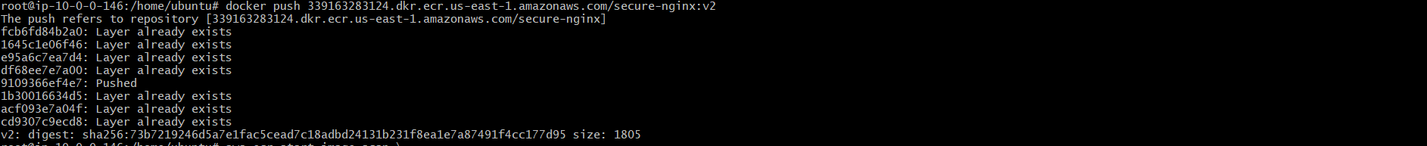

Step 6: Verify Image in Repository
aws ecr list-images \
--repository-name secure-nginx \
--region us-east-1
Expected Output
imageTag : v2
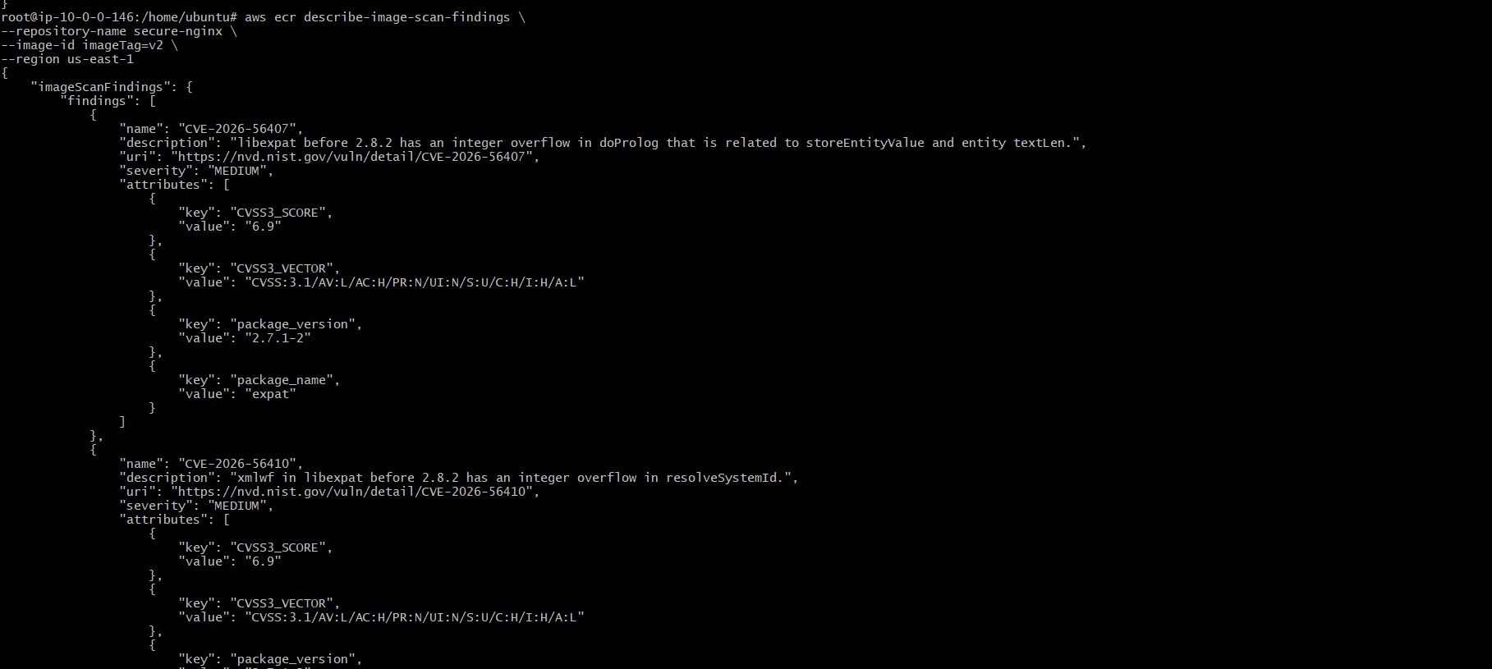
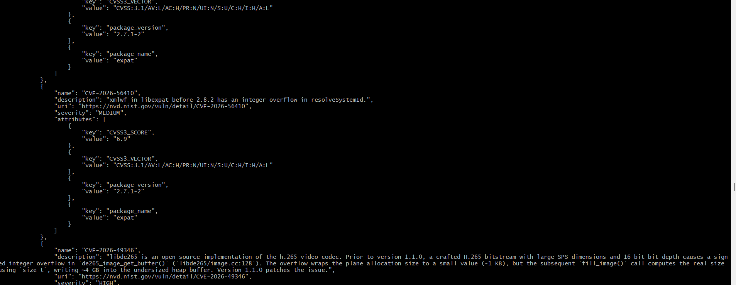

Step 7: View Scan Findings
aws ecr describe-image-scan-findings \
--repository-name secure-nginx \
--image-id imageTag=v2 \
--region us-east-1 \
--no-cli-pager
Expected Output
Image Scan Findings
HIGH
MEDIUM
LOW
CVE Details
Package Name
Severity
Description
You successfully received CVE results such as:
- CVE-2026-56410
- CVE-2026-49346
which confirms the scan completed successfully.
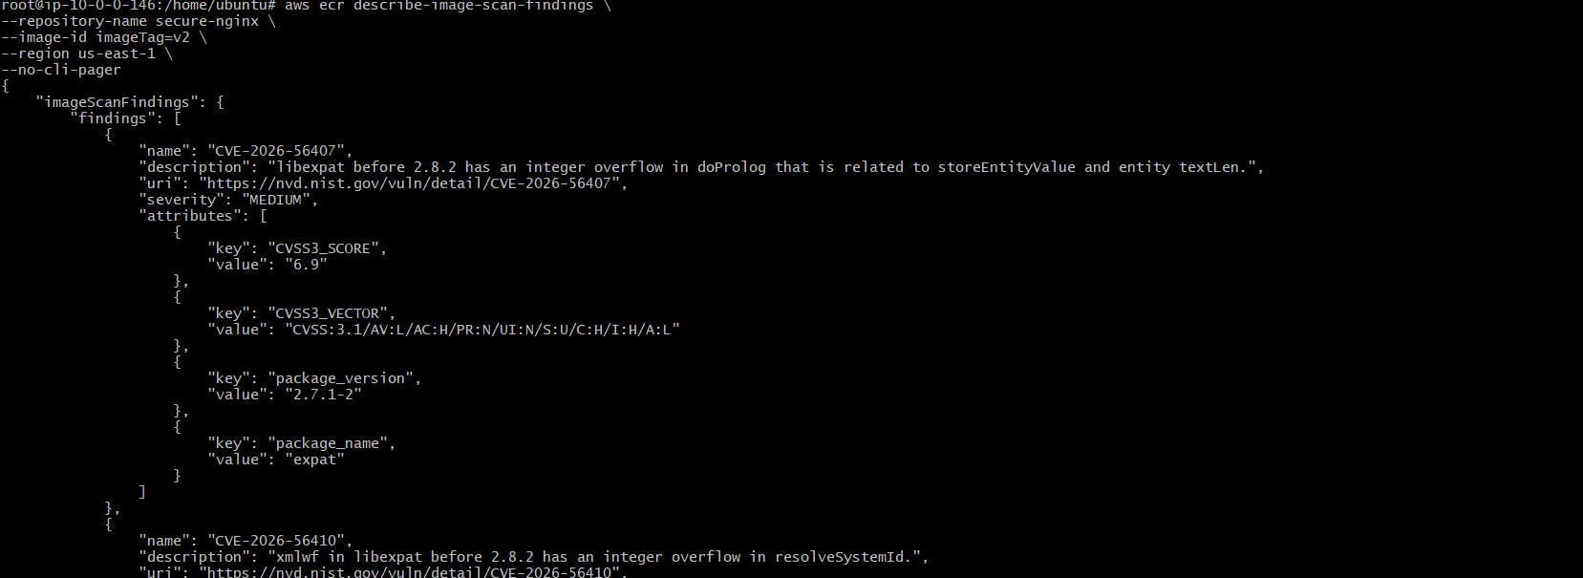
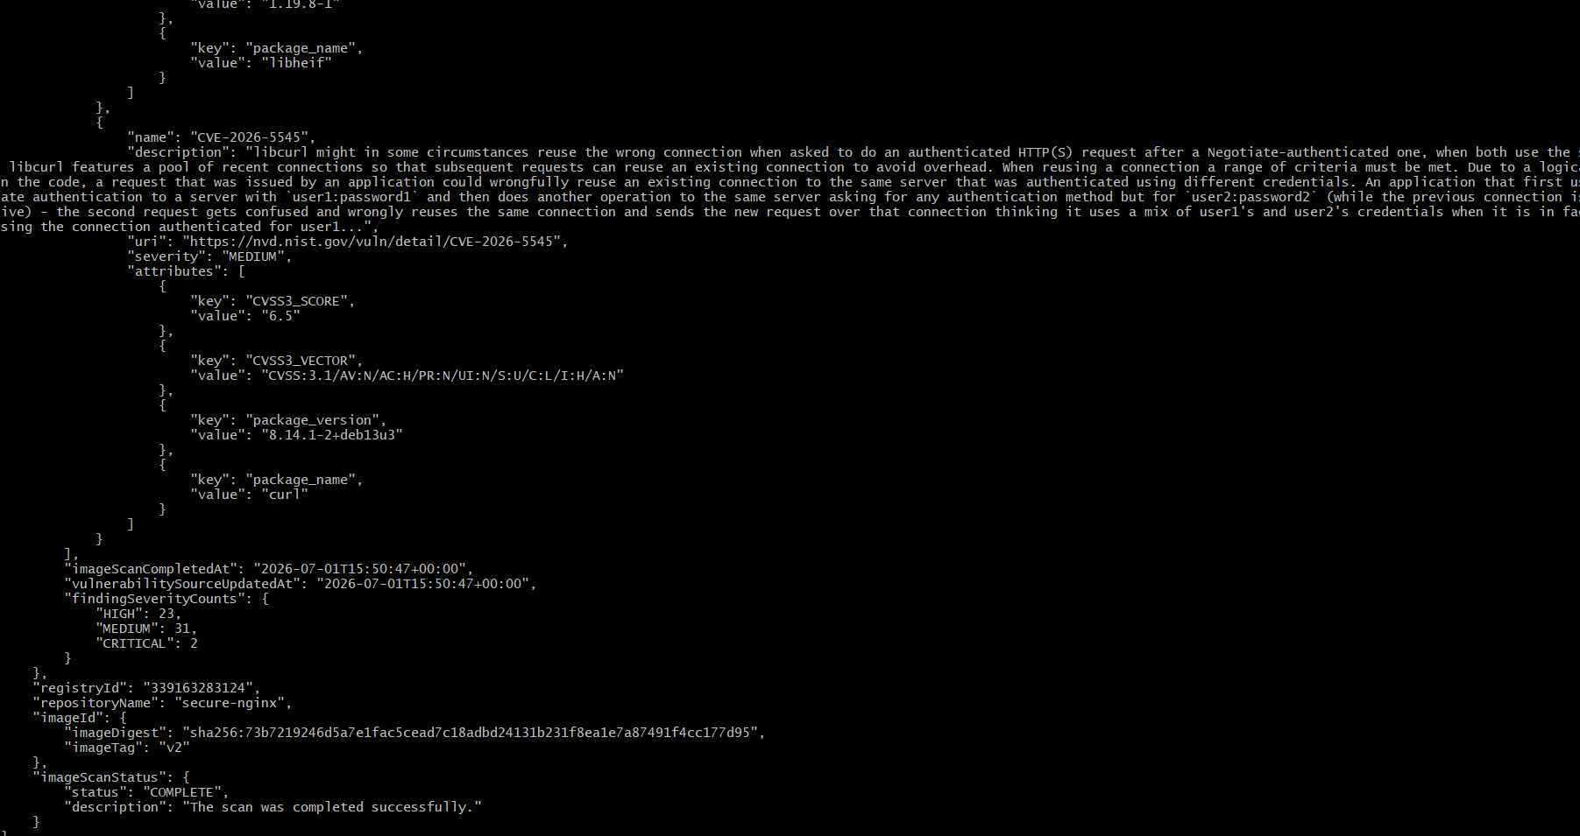
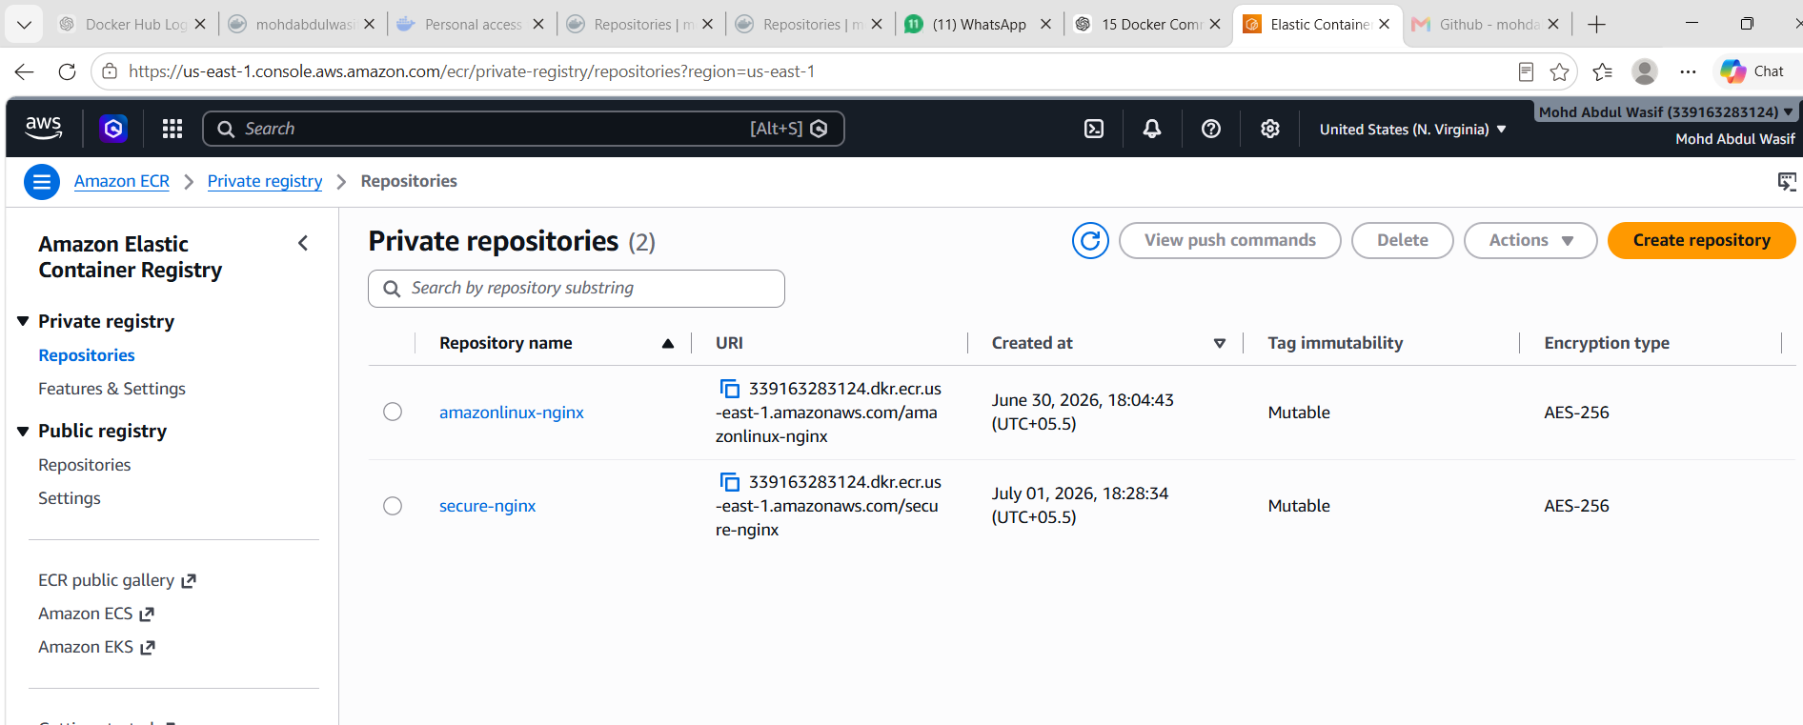

What We Learned
- Created an Amazon ECR repository with scan-on-push enabled.
- Logged in to Amazon ECR using AWS CLI.
- Built a Docker image in Docker image format using --provenance=false.
- Tagged and pushed the image to Amazon ECR.
- Verified the image in the ECR repository.
- Retrieved vulnerability scan results using AWS CLI.
- Understood CVE findings and image security scanning.

Conclusion
Successfully implemented Amazon ECR image scanning by creating a repository with scan-on-push, pushing a Docker image, and retrieving vulnerability findings. The scan identified CVEs with severity levels such as HIGH and MEDIUM, demonstrating how Amazon ECR helps detect security vulnerabilities before deploying container images to production.

Task 8: Jenkins Pipeline to Build Docker Image and Push to Docker Hub
Objective
Create a Jenkins pipeline to build a Docker image and push it to Docker Hub.
Prerequisites
Jenkins installed
Docker installed on Jenkins server
Docker Hub account
Docker Hub credentials added in Jenkins
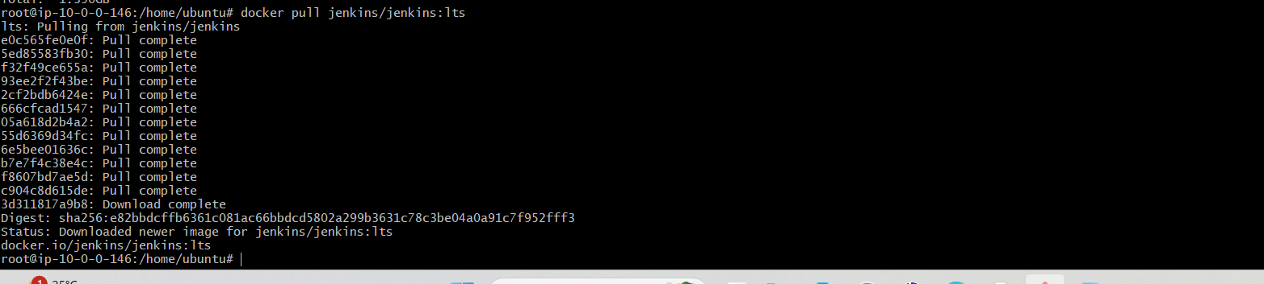
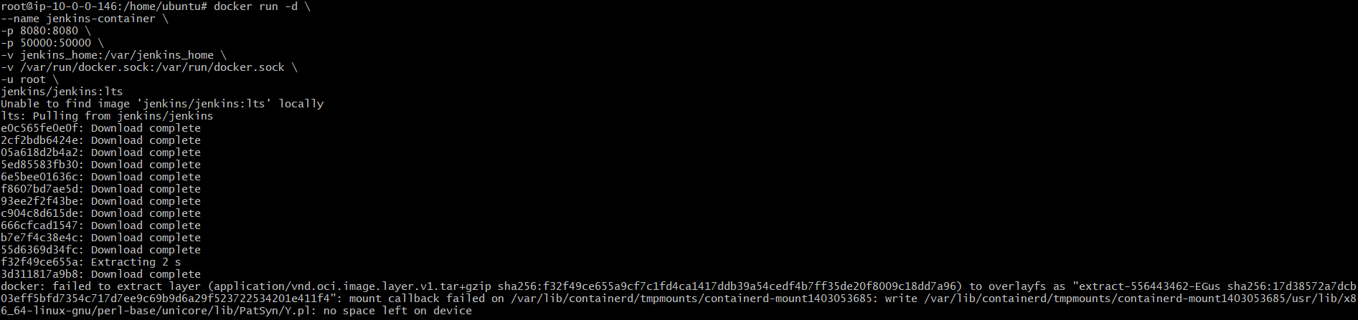
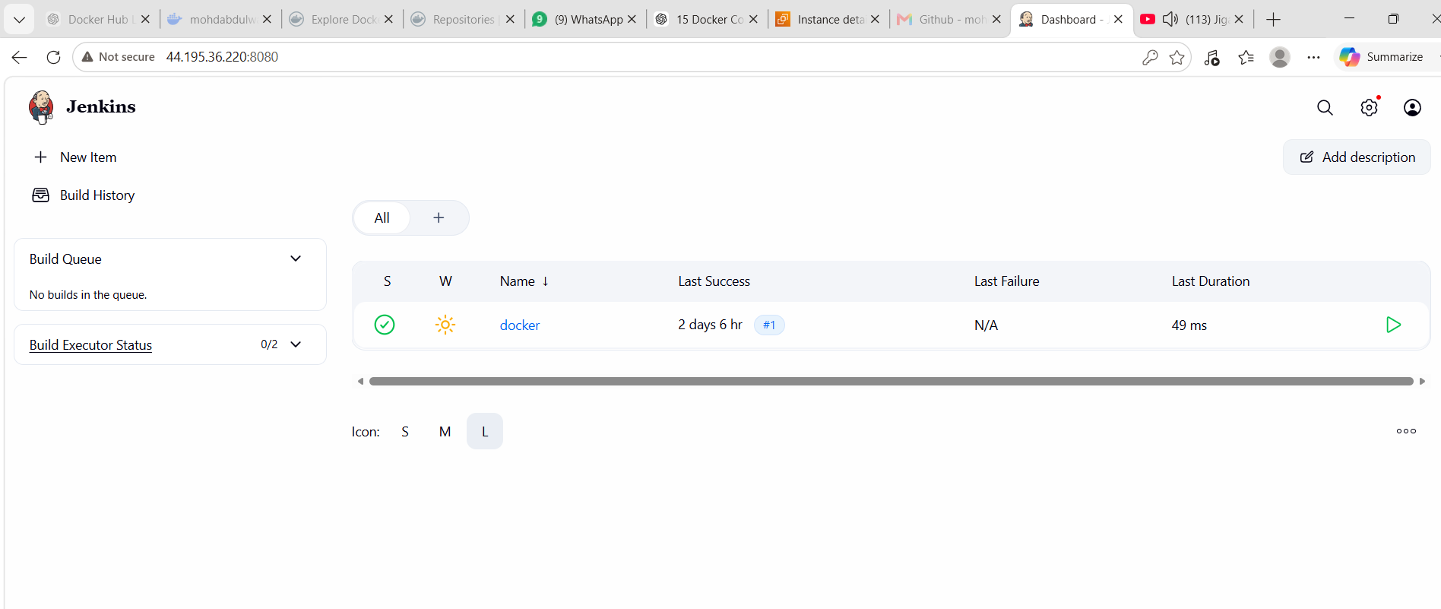
Jenkins Credentials
Go to:
Jenkins → Manage Jenkins → Credentials → Global → Add Credentials
Add:
Kind: Username with password
Username: Docker Hub username
Password: Docker Hub token/password
ID: dockerhub-creds
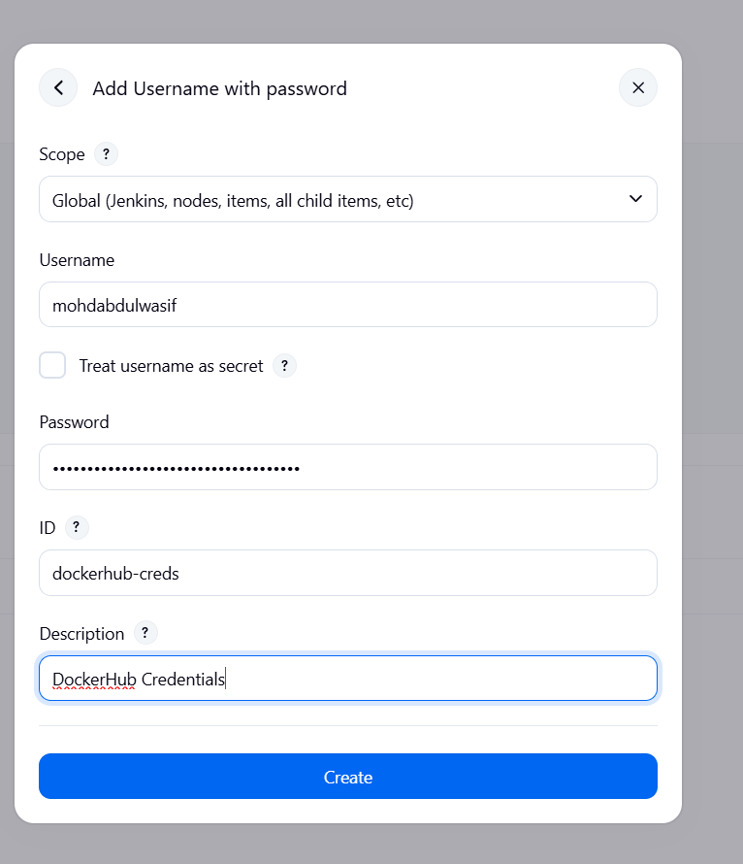
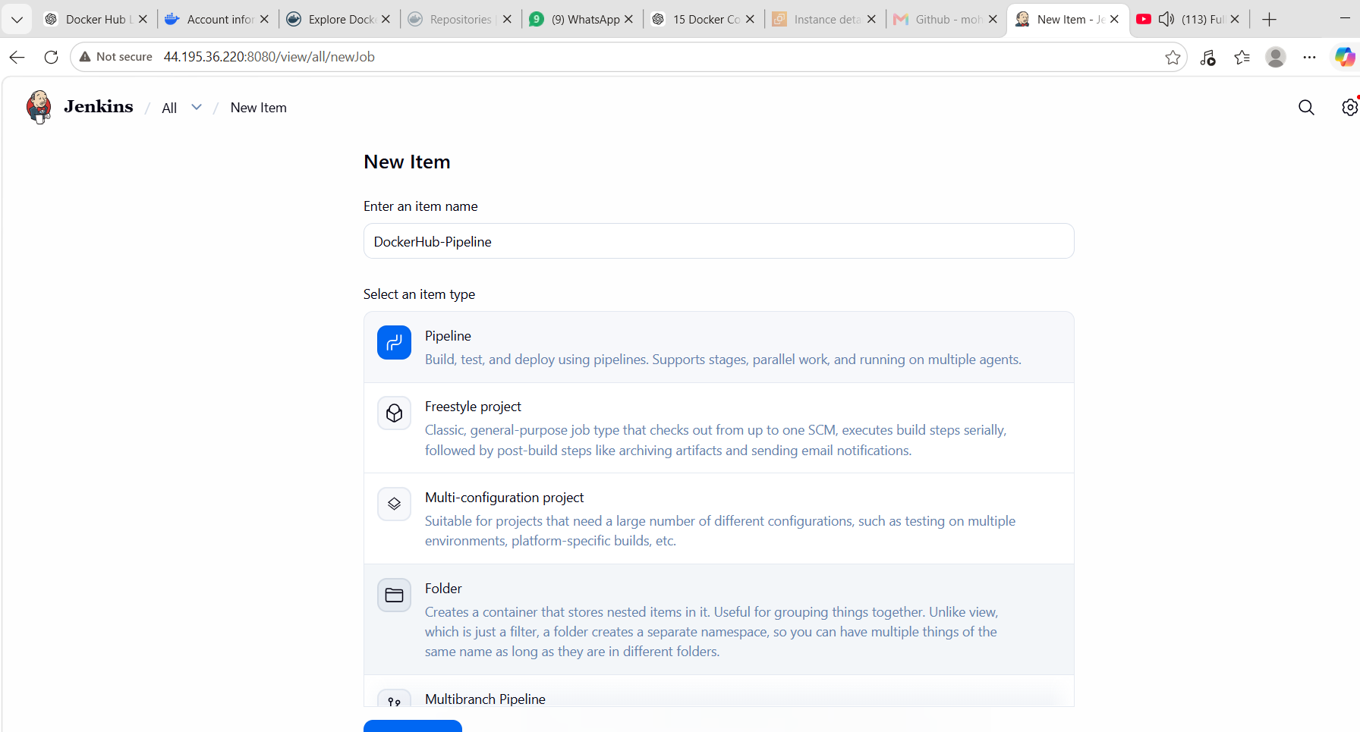
Jenkinsfile / Pipeline Script
pipeline {
agent any

environment {
IMAGE_NAME = "mohdabdulwasif/docker3:v3"
}

stages {
stage('Git Clone') {
steps {
git branch: 'master',
url: 'https://github.com/betawins/multi-stage-example.git'
}
}

stage('Create Dockerfile') {
steps {
sh '''
cat > Dockerfile <<EOF
FROM maven:3.9.6-eclipse-temurin-17 AS build
WORKDIR /app
COPY . .
RUN mvn clean package -DskipTests

FROM eclipse-temurin:17-jre
WORKDIR /app
COPY --from=build /app/target/*.jar app.jar
EXPOSE 8080
CMD ["java", "-jar", "app.jar"]
EOF
cat Dockerfile
'''
}
}

stage('Build Docker Image') {
steps {
sh 'docker build --no-cache --provenance=false -t $IMAGE_NAME .'
}
}

stage('Docker Login') {
steps {
withCredentials([usernamePassword(
credentialsId: 'dockerhub-creds',
usernameVariable: 'DOCKER_USER',
passwordVariable: 'DOCKER_PASS'
)]) {
sh 'echo "$DOCKER_PASS" | docker login -u "$DOCKER_USER" --password-stdin'
}
}
}

stage('Push Image') {
steps {
sh 'docker push $IMAGE_NAME'
}
}
}
}
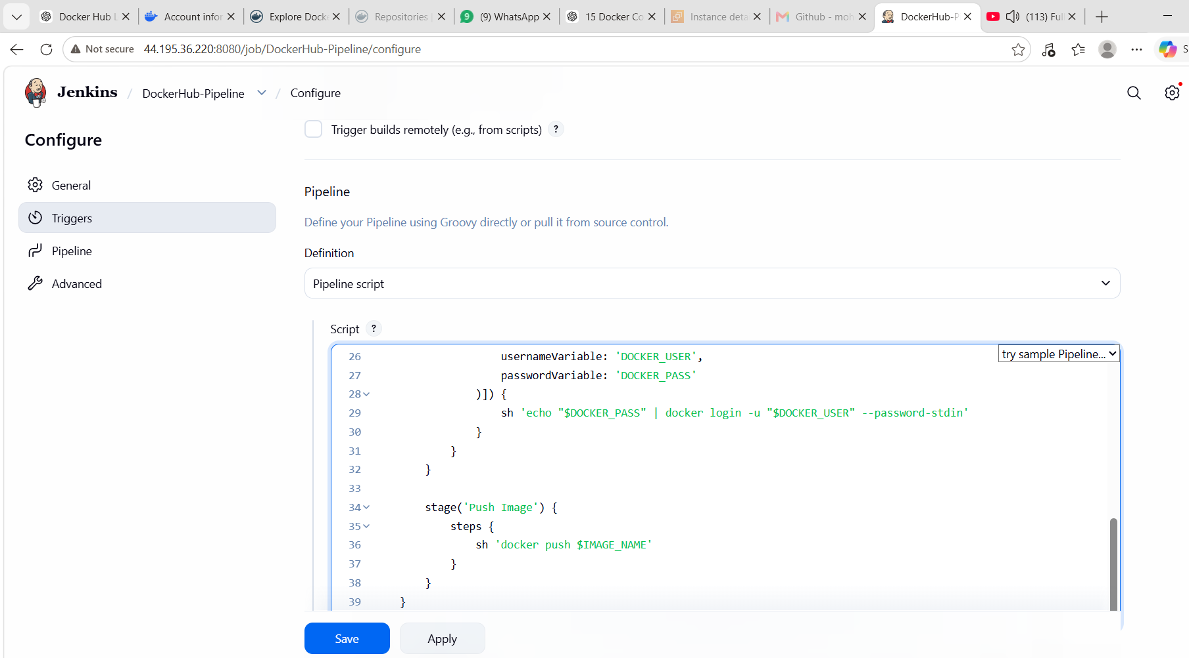
Important Permission Fix
If Jenkins cannot run Docker:
sudo usermod -aG docker jenkins
sudo systemctl restart Jenkins
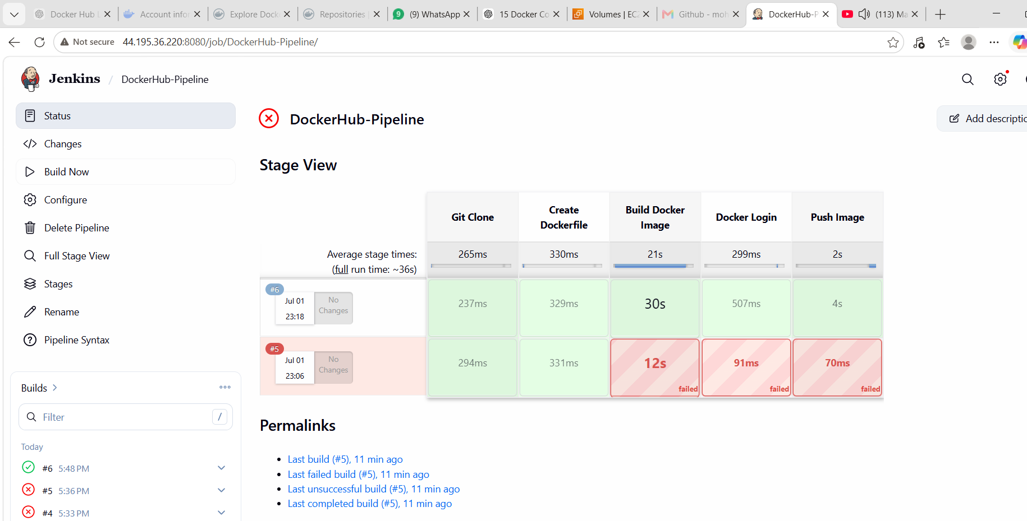
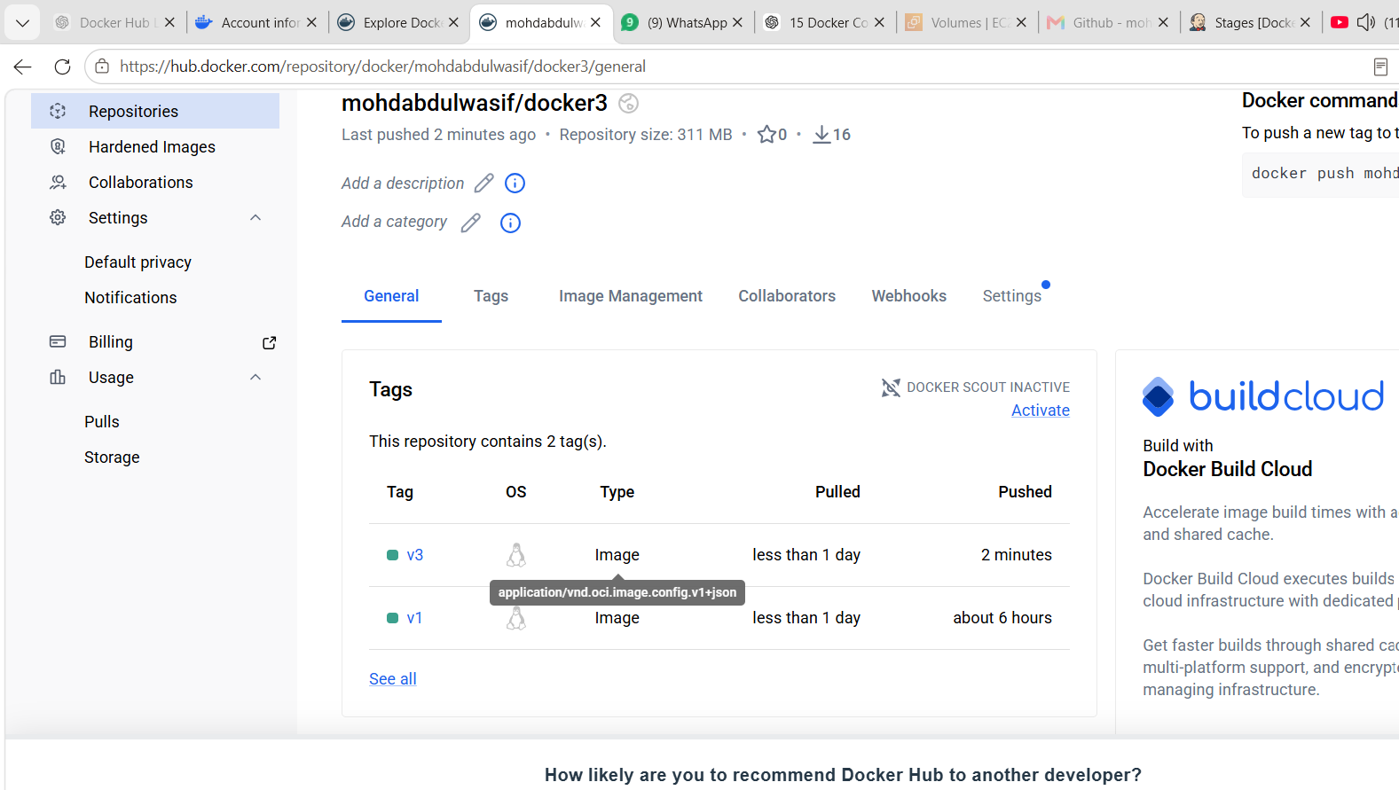
What We Learned
We learned how Jenkins can automate Docker image build and push process.
Conclusion
Successfully created a Jenkins pipeline to build a Docker image and push it to Docker Hub.

Overall What We Learned
We learned Docker image backup and transfer.
We created custom images using Alpine and Amazon Linux.
We understood single-stage and multi-stage Docker builds.
We installed and used Docker Compose.
We implemented image scanning in Docker Registry and AWS ECR.
We automated Docker image build and push using Jenkins pipeline.
Overall Conclusion
These tasks helped us understand real-time Docker workflows used in DevOps projects. We worked with image creation, image transfer, custom Dockerfiles, Docker Compose, image security scanning, AWS ECR, Docker Hub, and Jenkins automation.

