Jenkins_Task_01

1.Install Jenkins and run Jenkins on port number 8081
Objective
To install Jenkins on an AWS EC2 instance and configure it to run on a custom port (8081) instead of the default port (8080). This enables flexibility in port management and avoids conflicts with other applications.

Prerequisites
Before installing Jenkins, ensure the following requirements are met:
Infrastructure
- AWS EC2 Instance (Amazon Linux 2)
- Minimum 2 GB RAM
- Internet connectivity
Software Requirements
- Java 17 (Amazon Corretto)
- Root or sudo privileges
- Open Security Group inbound rules
Network Configuration
Protocol | Port | Purpose
SSH | 22 | Remote access
HTTP | 8081 | Jenkins Web UI
Implementation Steps
Step 1: Install Java
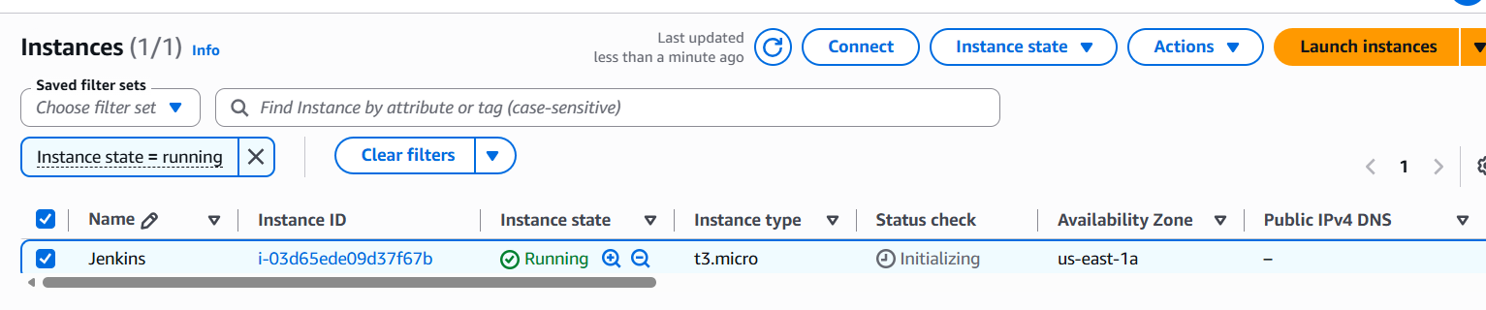
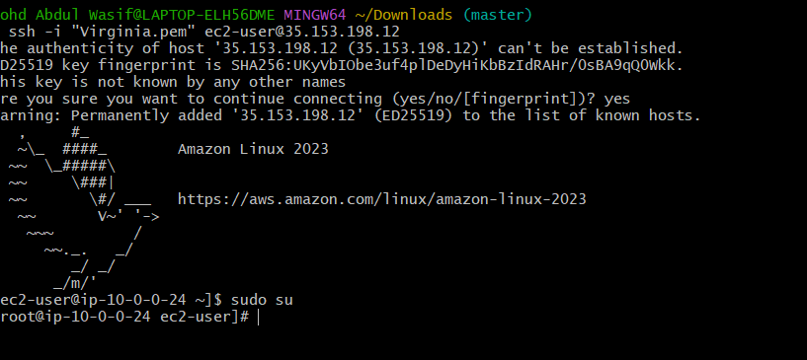
sudo yum update -y
sudo yum install java-17-amazon-corretto -y
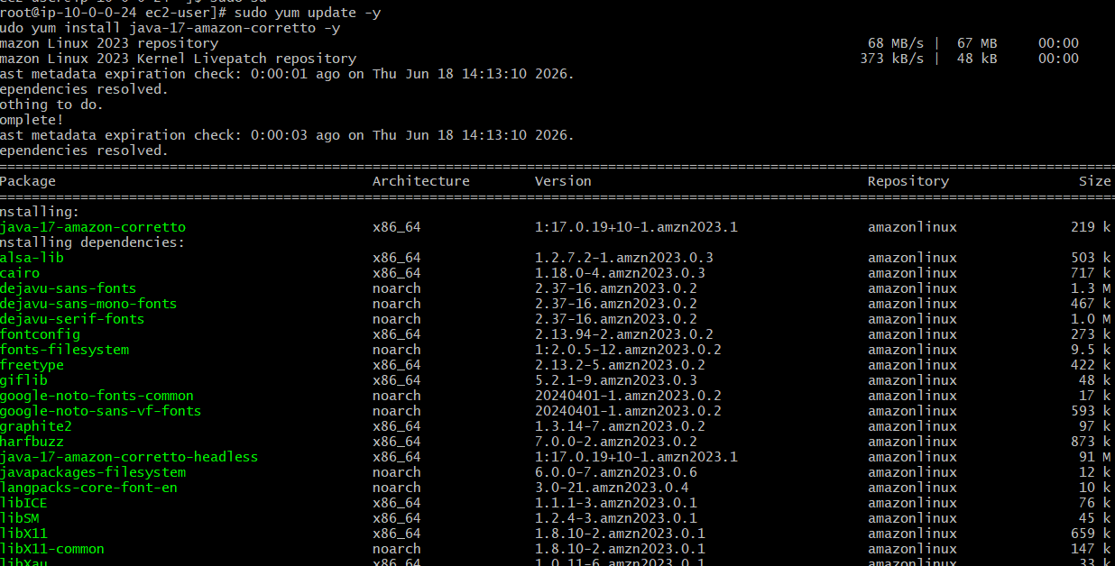
Verify:
java -version
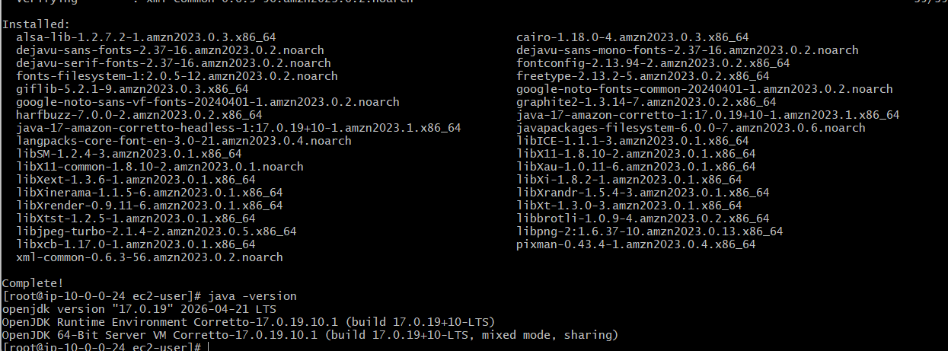
Step 2: Add Jenkins Repository
sudo wget -O /etc/yum.repos.d/jenkins.repo \
https://pkg.jenkins.io/redhat-stable/jenkins.repo
Import GPG Key:
sudo rpm --import https://pkg.jenkins.io/redhat-stable/jenkins.io-2023.key
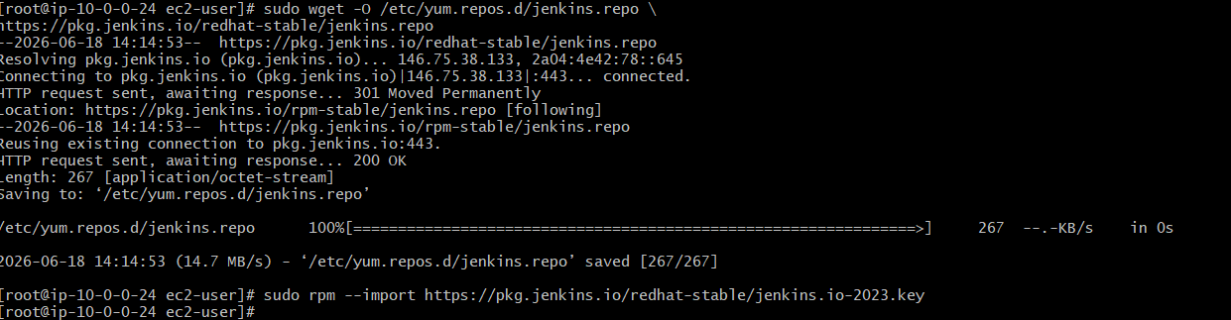
Step 3: Install Jenkins
sudo yum install jenkins -y
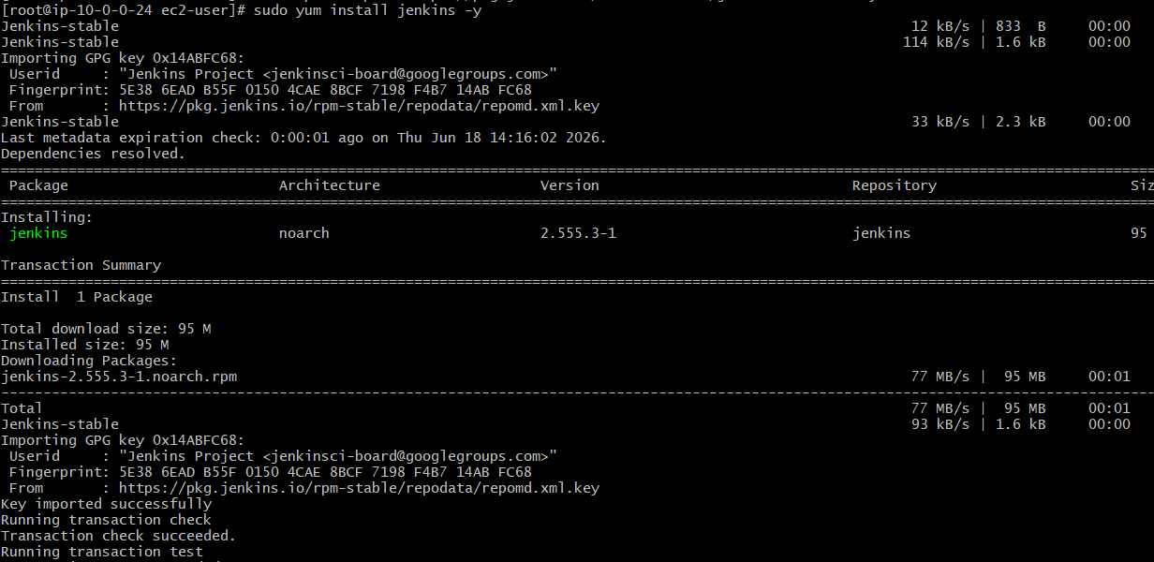
Step 4: Configure Jenkins Port to 8081
Open service file:
sudo vi /usr/lib/systemd/system/jenkins.service
Modify:
Before:
Environment="JENKINS_PORT=8080"
After:
Environment="JENKINS_PORT=8081"
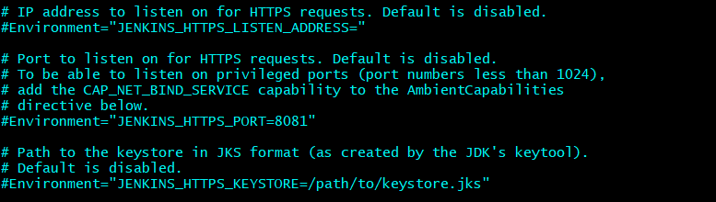
Step 5: Reload Systemd
sudo systemctl daemon-reload
Step 6: Start Jenkins
sudo systemctl enable jenkins
sudo systemctl start jenkins
Check Status:
sudo systemctl status Jenkins
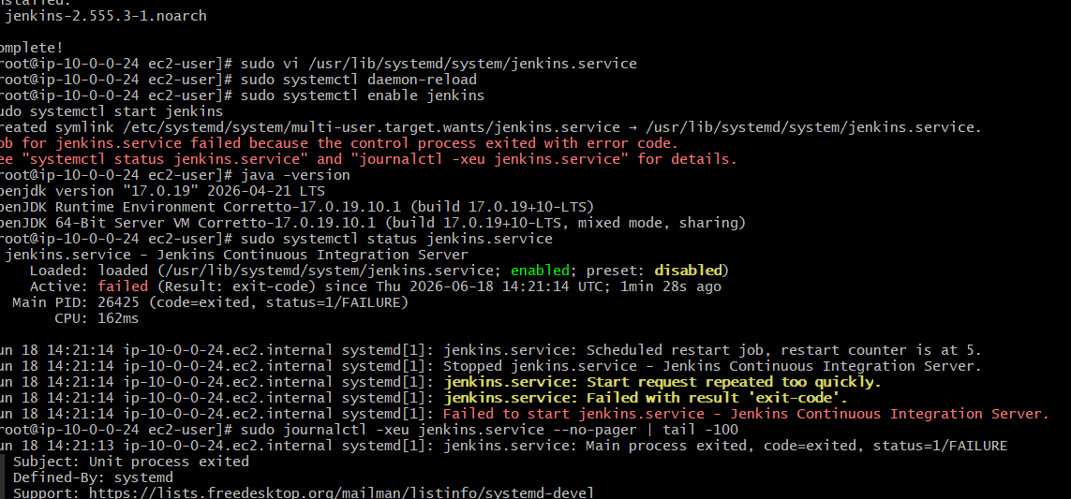

Jenkins was failed so again installed Java 21
Step 1: Install Java 21
Amazon Linux / RHEL:
sudo yum install java-21-amazon-corretto -y

Step 2: Set Java 21 as default
sudo alternatives --config java
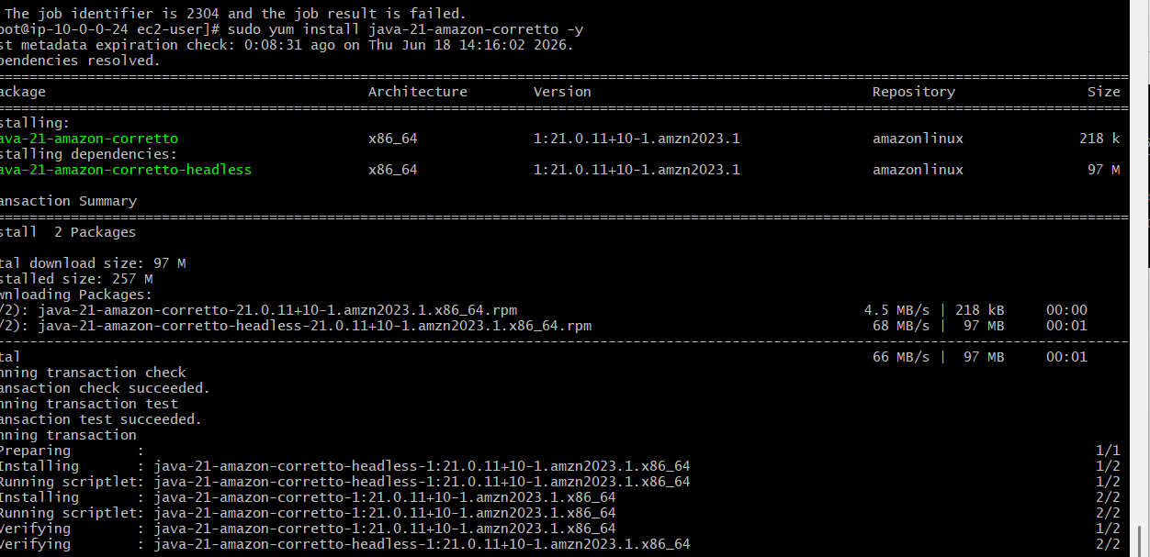
Step 3: Verify
java -version
Expected:
openjdk version "21"
Step 4: Restart Jenkins
sudo systemctl daemon-reload
sudo systemctl restart jenkins

Step 5: Check status
sudo systemctl status jenkins
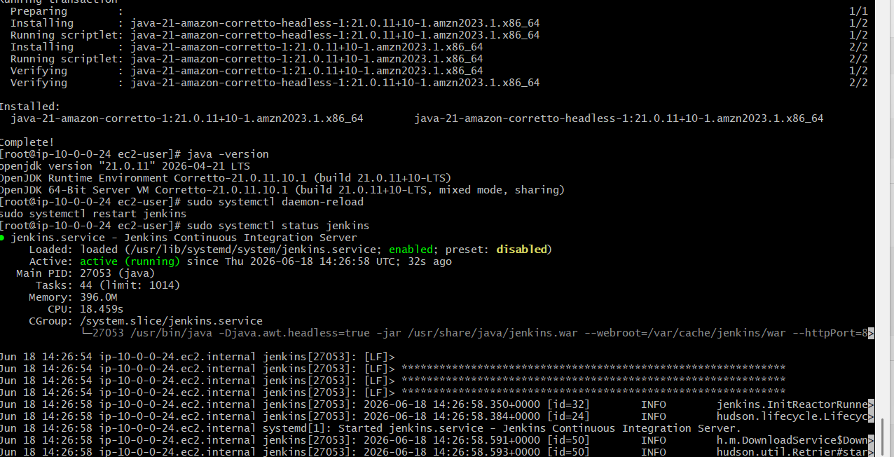
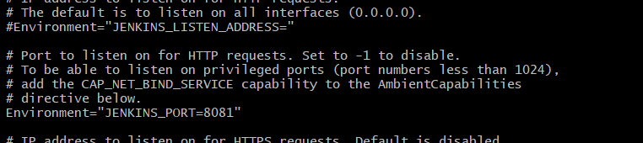
Now do this step-by-step (IMPORTANT)
🟢 Step 1: Create folder first (VERY IMPORTANT)
sudo mkdir -p /etc/systemd/system/jenkins.service.d

🟢 Step 2: Open file again
sudo vi /etc/systemd/system/jenkins.service.d/override.conf

🟢 Step 3: Press i (INSERT mode)
Now paste EXACTLY this:
[Service]
ExecStart=
ExecStart=/usr/bin/java -Djava.awt.headless=true -jar /usr/share/java/jenkins.war --webroot=/var/cache/jenkins/war --httpPort=8081

🟢 Step 4: Save file
Press:
ESC
:wq

🟢 Step 5: Reload systemd
sudo systemctl daemon-reload

🟢 Step 6: Restart Jenkins
sudo systemctl restart jenkins

🟢 Step 7: Verify port
sudo ss -tulnp | grep 8081
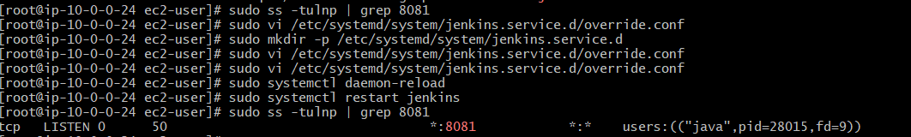
Final result
Open:
http://35.153.198.12:8081
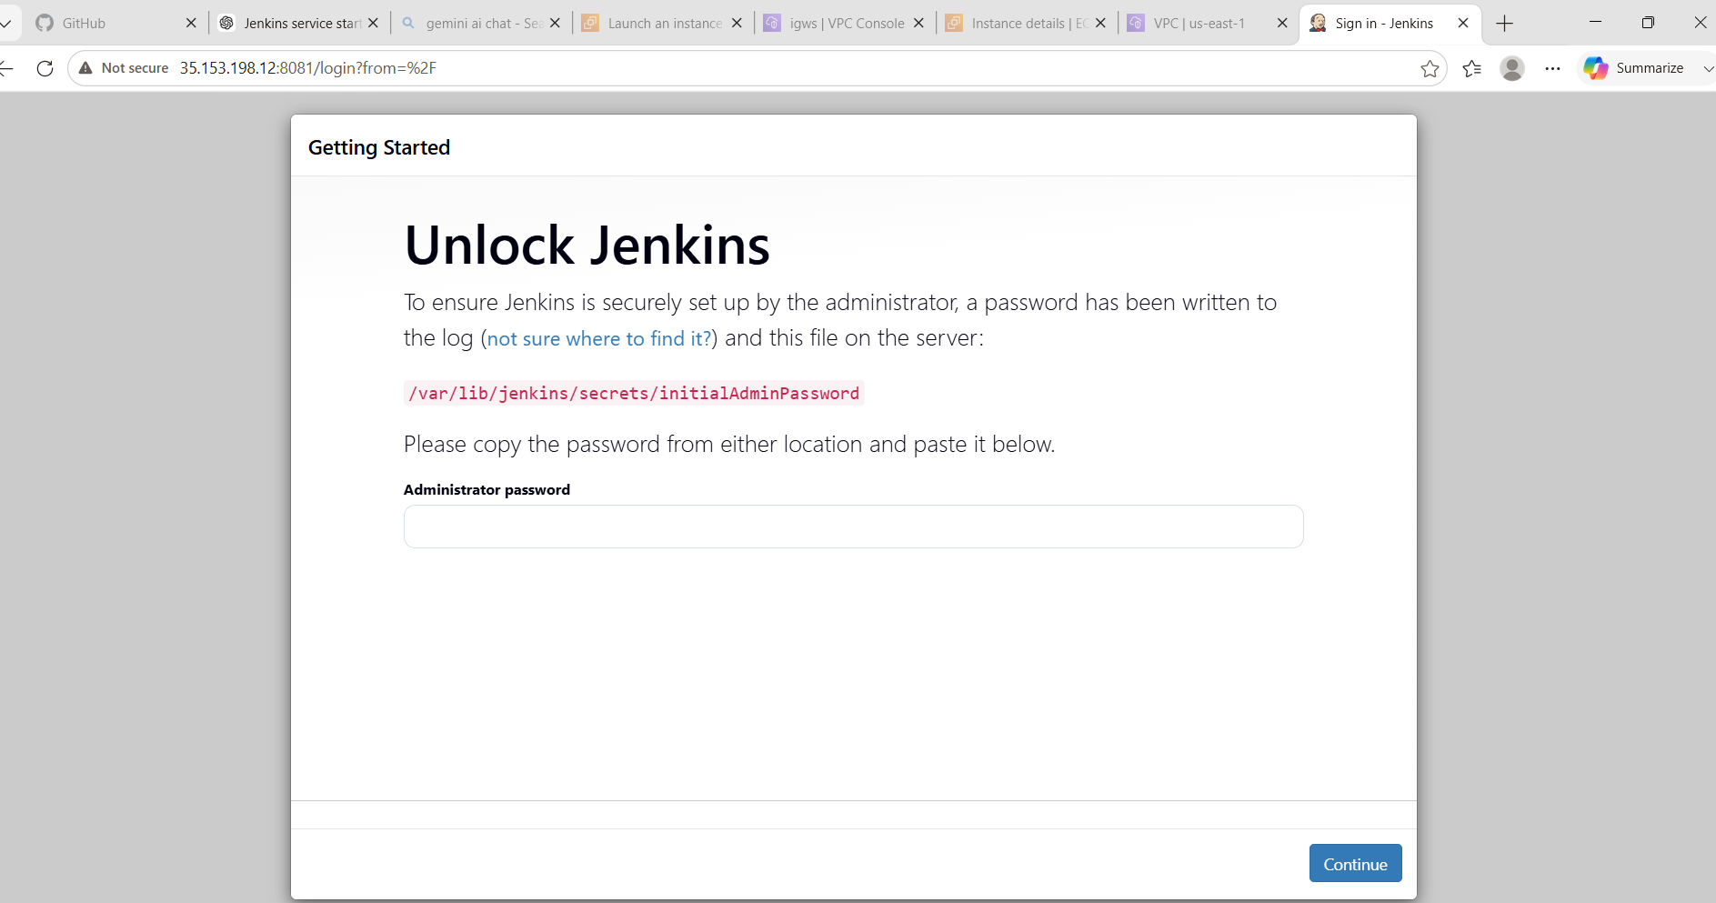

Jenkins Installation & Port Change Issue Report
🔴 1. Error: Jenkins failed to start initially
❌ Error Message
Job for jenkins.service failed because the control process exited with error code
🔍 Root Cause
Jenkins service failed due to incompatible Java version.
From logs:
Running with Java 17 ... which is older than the minimum required version (Java 21)
Supported Java versions are: [21, 25]
🛠️ Solution Applied
- Identified Jenkins requires Java 21 or above
- Installed / switched to correct Java version (Java 21 recommended)
- Restarted Jenkins service
✅ Result
Jenkins started successfully after Java upgrade.

🔴 2. Error: Browser showing “Connection refused”
❌ Error Message
ERR_CONNECTION_REFUSED (IP: 8081)
🔍 Root Cause
- Jenkins was running on port 8080
- User tried accessing port 8081
- Also, security group / port mismatch caused access failure
🛠️ Solution Applied
- Verified active Jenkins port using:
ss -tulnp | grep java
- Confirmed Jenkins was running on 8080
- Decided to change Jenkins port to 8081

🔴 3. Issue: Port change not reflecting
❌ Problem Observed
- Edited /etc/sysconfig/jenkins but no effect
- File was not used by system in this setup
🔍 Root Cause
Jenkins service was controlled via systemd ExecStart, not sysconfig file.

🔴 4. Error: systemd override file empty / not applied
❌ Issue
Editing override.conf canceled: temporary file is empty
🔍 Root Cause
- Override file was not saved properly
- Systemd override configuration was not created
🛠️ Solution Applied
- Created systemd override directory:
mkdir -p /etc/systemd/system/jenkins.service.d
- Created override file:
vi /etc/systemd/system/jenkins.service.d/override.conf
- Added correct ExecStart with new port:
[Service]
ExecStart=
ExecStart=/usr/bin/java -jar /usr/share/java/jenkins.war --httpPort=8081
- Reloaded systemd and restarted Jenkins:
systemctl daemon-reload
systemctl restart jenkins

What We Learned
- Installation and configuration of Jenkins.
- Importance of Java as a prerequisite.
- Adding external repositories and GPG keys.
- Managing services using systemctl.
- Changing Jenkins default port from 8080 to 8081.
- Configuring AWS Security Groups.
- Troubleshooting service and network issues.
- Accessing Jenkins securely using a browser.
- Understanding Jenkins architecture and CI/CD fundamentals.

Conclusion
Successfully installed Jenkins on an Amazon Linux EC2 instance and configured it to run on port 8081. Verified service availability and resolved common issues related to Java installation, service startup, and network access. This task provided practical knowledge of Jenkins setup, Linux service management, and AWS networking concepts, which are essential for implementing CI/CD pipelines in DevOps environments.

Task 2: Secure Jenkins Server

🎯 1. Objective
To secure a Jenkins server running on an AWS EC2 instance by implementing access control, authentication, and network-level security to prevent unauthorized access and improve overall system safety.

🧰 2. Prerequisites
Before starting this task, the following setup is required:
- AWS EC2 instance (Linux - Amazon Linux / RHEL)
- Jenkins installed and running
- Java 21 installed (required for latest Jenkins versions)
- Public IP address of EC2 instance
- AWS Security Group access
- SSH access to EC2 instance
- Basic knowledge of Jenkins UI and Linux commands
Step 1: Verify Jenkins is Running

sudo systemctl status jenkins
Access Jenkins:
http://<EC2-PUBLIC-IP>:8080

🟢 Step 2: Change Jenkins Port (8080 → 8081)
Create override directory:
sudo mkdir -p /etc/systemd/system/jenkins.service.d
Create override file:
sudo vi /etc/systemd/system/jenkins.service.d/override.conf
Add:
[Service]
ExecStart=
ExecStart=/usr/bin/java -Djava.awt.headless=true -jar /usr/share/java/jenkins.war --webroot=/var/cache/jenkins/war --httpPort=8081
Save and exit:
- Press ESC
- Type :wq


Reload and restart Jenkins:
sudo systemctl daemon-reload
sudo systemctl restart jenkins
Verify port:
sudo ss -tulnp | grep 8081
Step 3: Configure AWS Security Group
Go to AWS Console:
EC2 → Security Groups → Inbound Rules
Add rule:
Type | Port | Source
Custom TCP | 8081 | Your IP /32
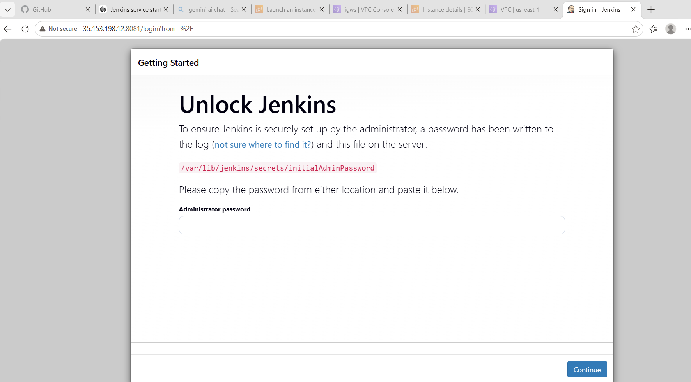
Step 4: Enable Jenkins Security
Open Jenkins UI:
http://<EC2-IP>:8081
Navigate:
Manage Jenkins → Configure Global Security
Enable:
- ✔ Enable security
- ✔ Jenkins own user database
- ✔ Logged-in users can do anything
- FIX 1: Secure SSH (VERY IMPORTANT)
- Change:
- SSH 22 → YOUR_IP/32
- Example:
- 49.206.59.8/32

- 🔐 FIX 2: Keep Jenkins secure (GOOD already)
- 8081 → YOUR_IP/32 ✔

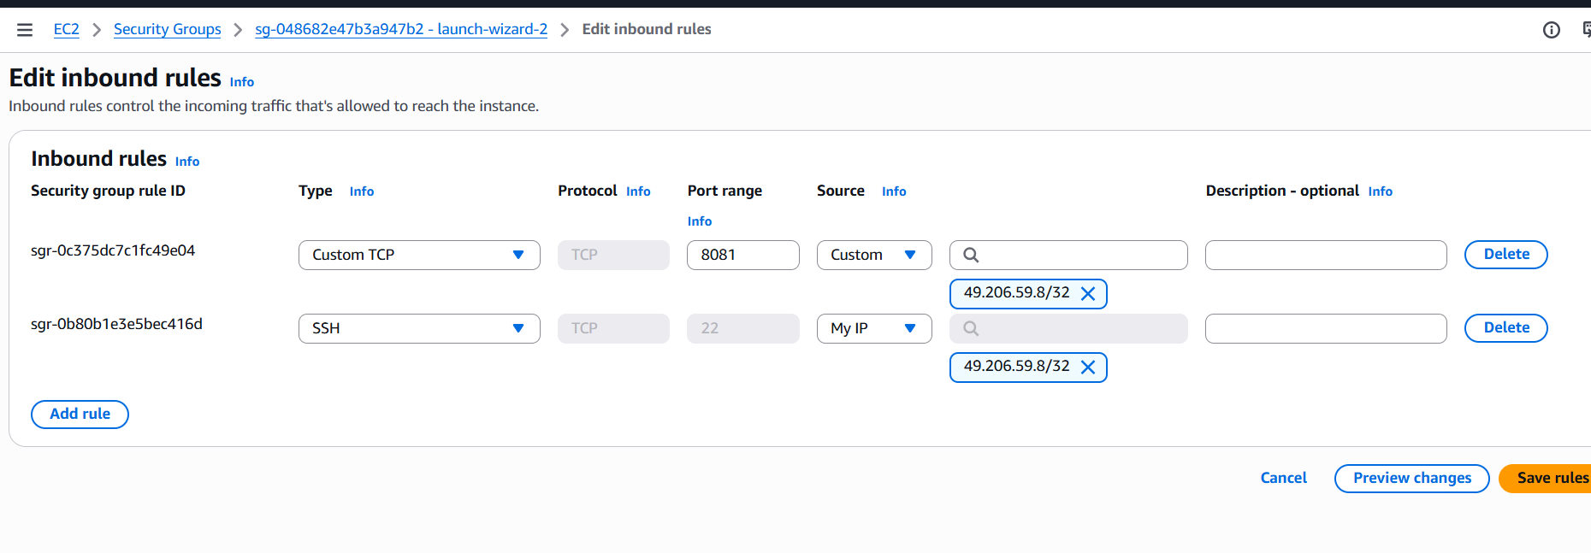
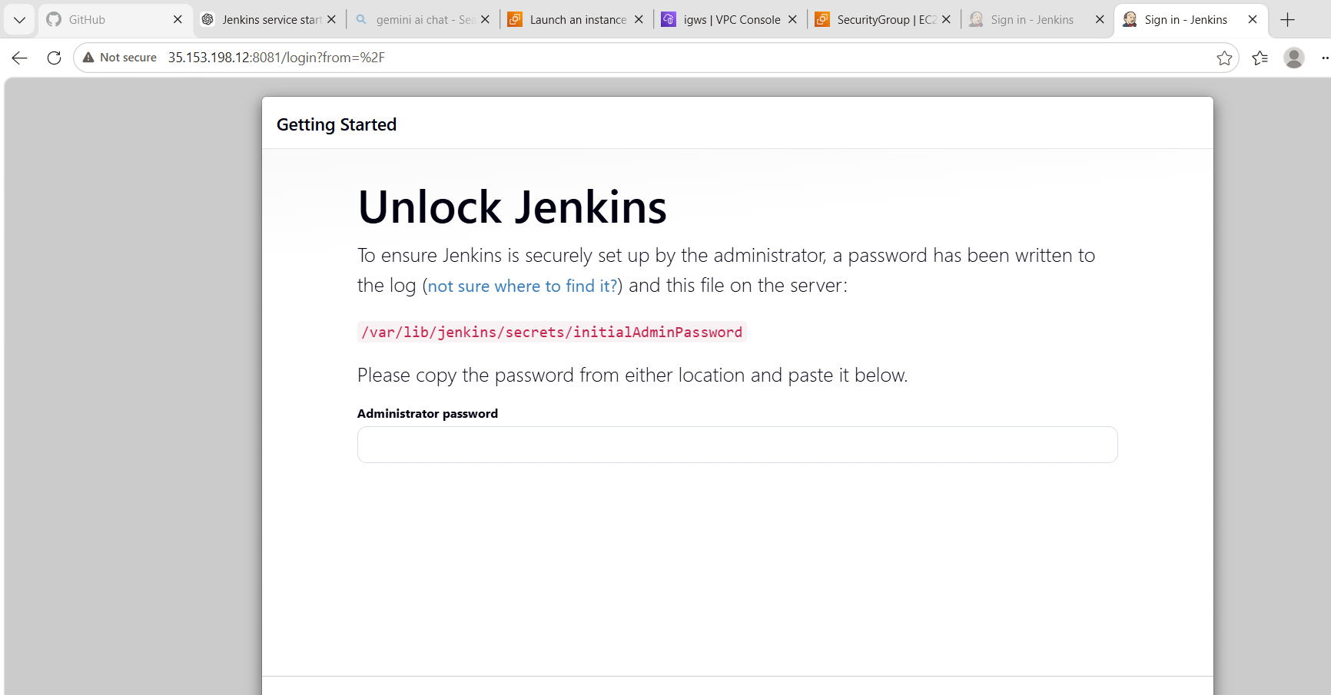
Step you must do now
Get Jenkins admin password
Run this on EC2:
sudo cat /var/lib/jenkins/secrets/initialAdminPassword
You will get something like:
d94d83542e7b4cb499b8cc06c1a47837

Paste it in browser
At:
http://<EC2-IP>:8081
Enter password → Continue

⚙️ After login you must do:
1. Install suggested plugins
✔ Click: “Install suggested plugins”

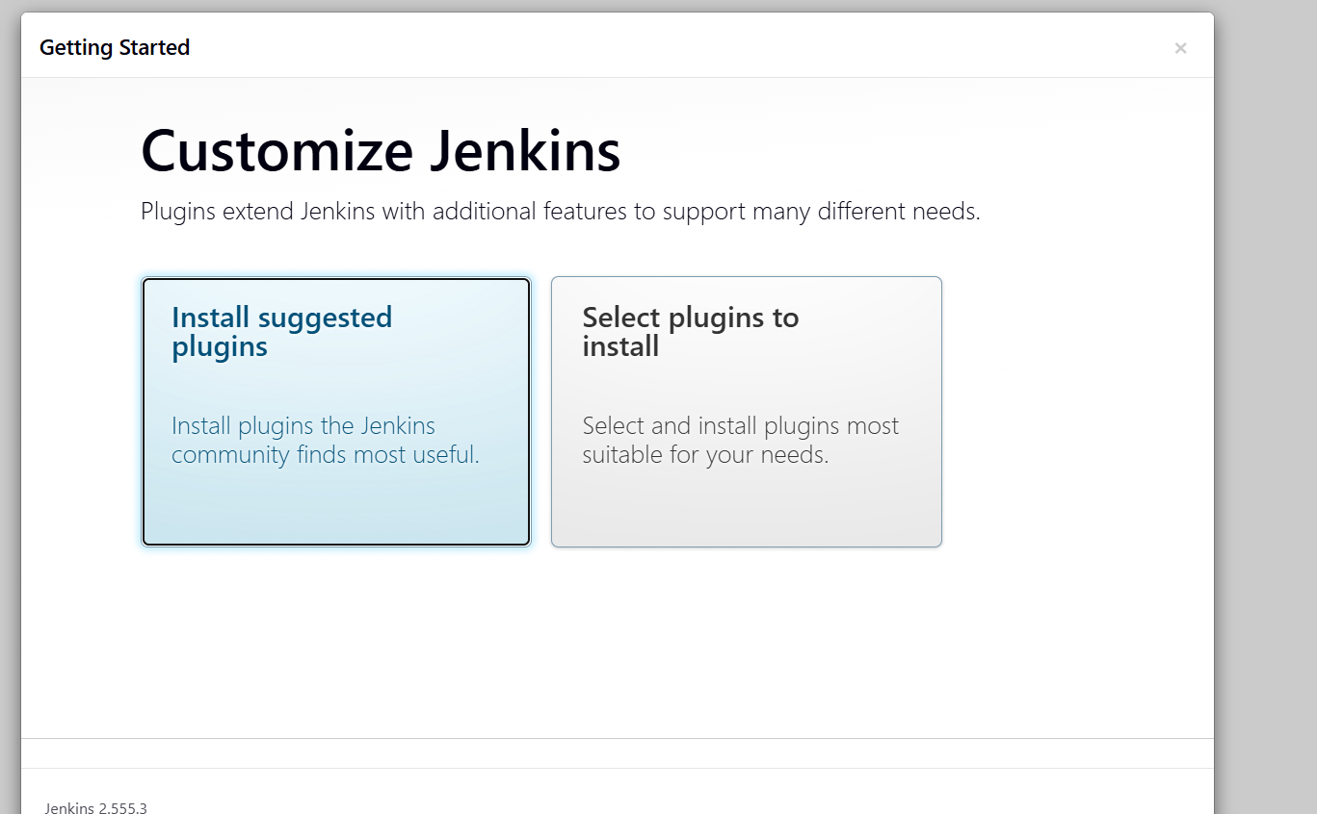
. Create admin user
Example:
- Username: admin
- Password: strong password

3. Finish setup
✔ Jenkins dashboard will open
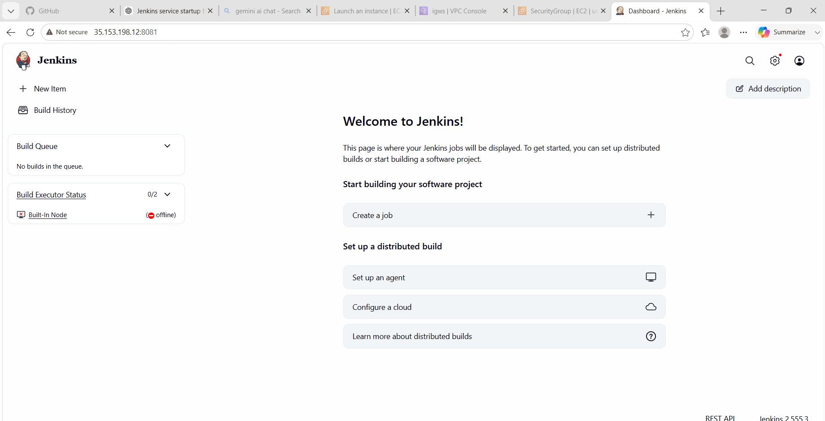
Jenkins Setup – Major Errors & Resolutions

🔴 Error 1: Jenkins Failed to Start (Java Version Issue)
❌ Error Message
Running with Java 17 ... which is older than the minimum required version (Java 21)
Supported Java versions are: [21, 25]

🔍 Root Cause
- Jenkins version installed required Java 21 or higher
- Server had Java 17 (Amazon Corretto 17) installed
- Due to incompatible Java version, Jenkins service failed to start

🛠️ Resolution
- Identified required Java version from Jenkins logs
- Installed / switched to Java 21
- Restarted Jenkins service
Commands used:
java -version
sudo systemctl restart jenkins

✅ Result
✔ Jenkins started successfully
✔ Service changed to active (running)

🔴 Error 2: Jenkins Not Accessible / Port Conflict Issue
❌ Problem Observed
- Jenkins not opening in browser
- “Connection refused” error
- Port mismatch between configuration and access URL

🔍 Root Cause
- Jenkins was initially running on default port 8080
- User tried accessing 8081 without proper configuration
- Security Group / system configuration not aligned with correct port
- Systemd override was not applied properly initially

🛠️ Resolution Steps
1. Verified running port
sudo ss -tulnp | grep java
2. Updated Jenkins port using systemd override
sudo vi /etc/systemd/system/jenkins.service.d/override.conf
Added:
[Service]
ExecStart=
ExecStart=/usr/bin/java -jar /usr/share/java/jenkins.war --httpPort=8081
3. Reloaded systemd and restarted Jenkins
sudo systemctl daemon-reload
sudo systemctl restart jenkins
4. Updated AWS Security Group
- Allowed inbound port 8081
- Restricted access to specific IP

✅ Result
✔ Jenkins successfully accessible on port 8081
✔ Connection issue resolved
✔ Secure access configured

📌 Final Conclusion
During Jenkins setup, two critical issues were encountered: Java version incompatibility and port misconfiguration. The Java issue was resolved by upgrading to Java 21, ensuring compatibility with the latest Jenkins version. The port issue was resolved by correctly configuring systemd override and updating AWS Security Group rules. After applying these fixes, Jenkins was successfully deployed, secured, and made accessible via port 8081.

📚 3. What We Learned
During this task, we learned:
- How to secure a Jenkins server in AWS environment
- How to control access using AWS Security Groups
- How Jenkins authentication works
- How to disable anonymous access in Jenkins
- How to change Jenkins default port (8080 → 8081)
- Importance of restricting public access in cloud environments
- Basic server hardening techniques for CI/CD tools
Security Improvements Applied
- Restricted port access via AWS Security Group
- Changed default Jenkins port (8080 → 8081)
- Enabled authentication system
- Disabled anonymous access
- Reduced exposure to public internet attacks

📌 6. Conclusion
In this task, we successfully secured a Jenkins server hosted on AWS EC2 by implementing multiple security layers. We restricted network access using AWS Security Groups, enabled authentication inside Jenkins, disabled anonymous access, and changed the default port for improved security. These steps significantly reduce the risk of unauthorized access and make the Jenkins environment more secure for CI/CD operations.

Task 3: Create Users (DevOps & Testing) in Jenkins with Limited Access

🎯 1. Objective
To create multiple Jenkins users (DevOps and Testing) and assign them restricted access permissions to implement role-based access control (RBAC) and improve security in Jenkins.

🧰 2. Prerequisites
- Jenkins server installed and running (EC2)
- Jenkins accessible via browser (http://<IP>:8081)
- Admin login access
- “Role-based Authorization Strategy” plugin installed
- Basic knowledge of Jenkins user management
Step 1: Install Required Plugin
Go to:
Manage Jenkins → Plugins → Available Plugins
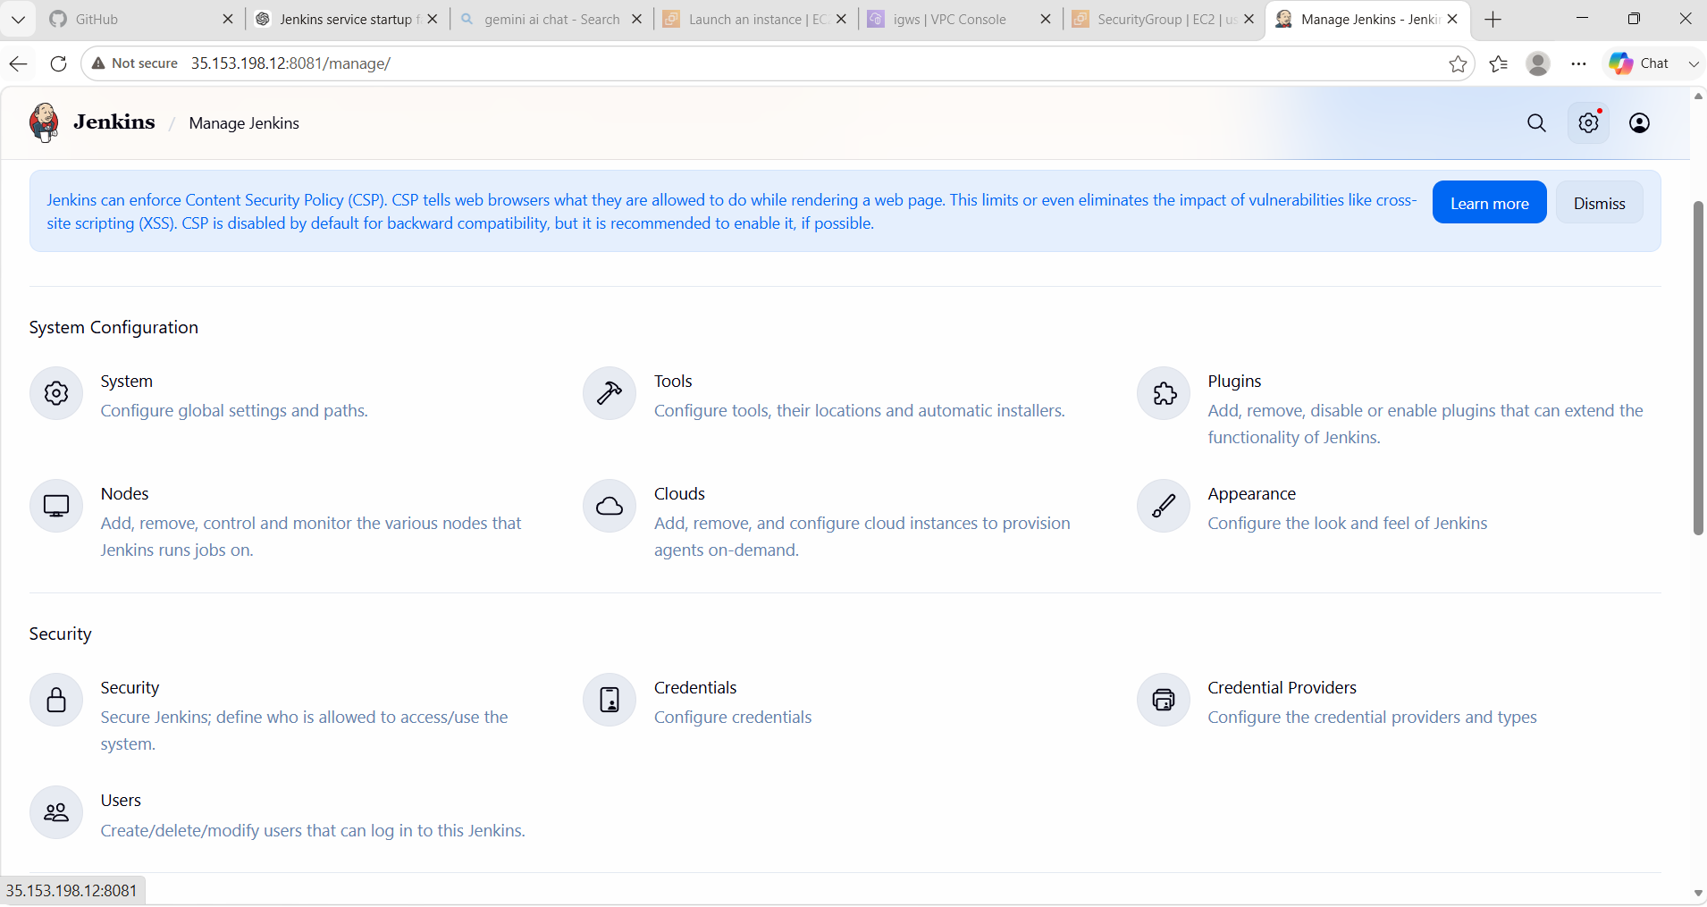
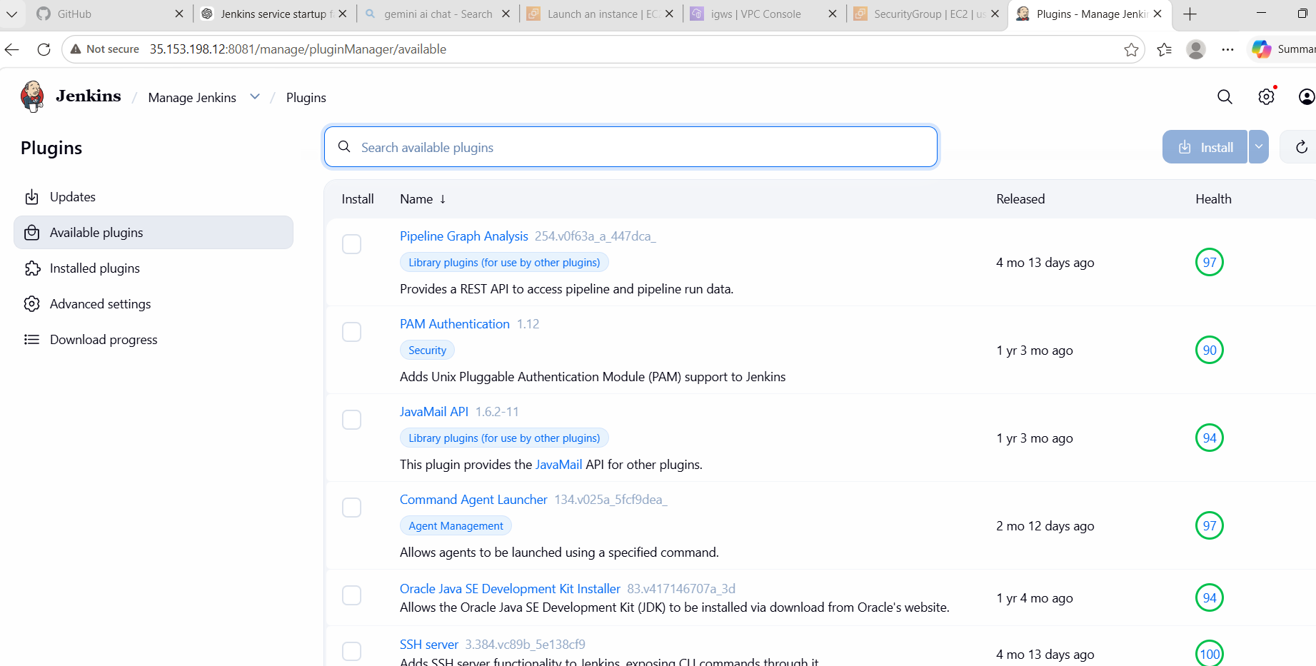
Search and install:
✔ Role-based Authorization Strategy
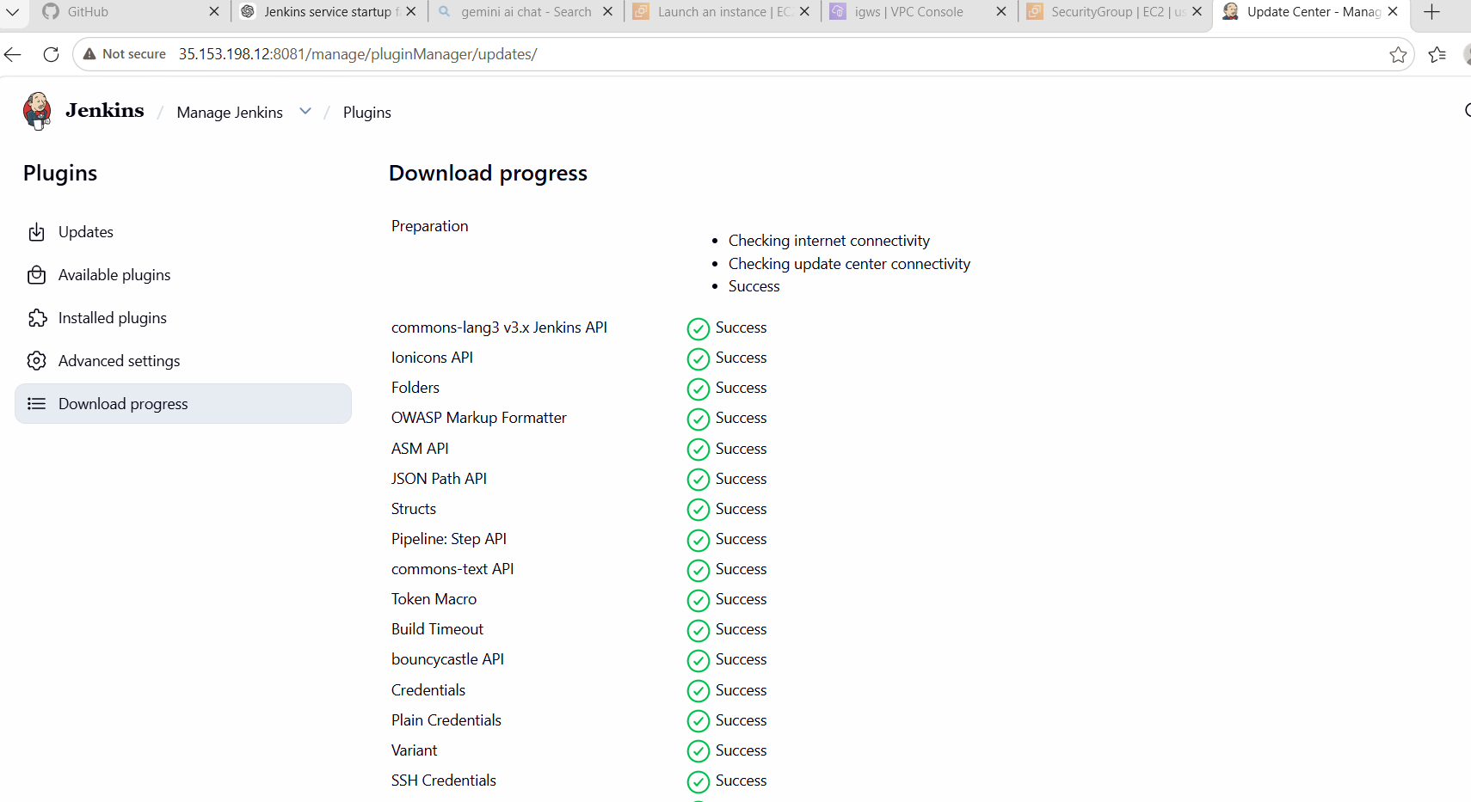
Then restart Jenkins.
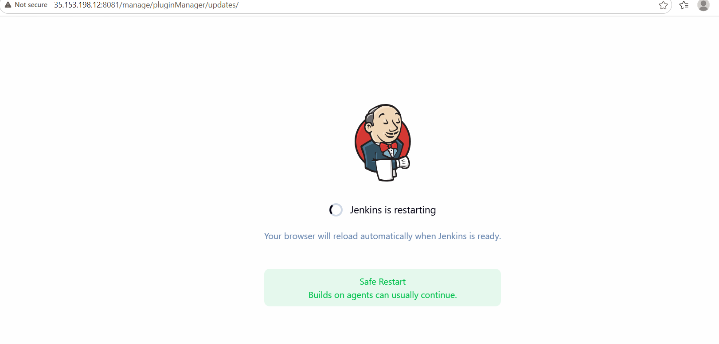

🟢 Step 2: Enable Role-Based Security
Go to:
Manage Jenkins → Configure Global Security
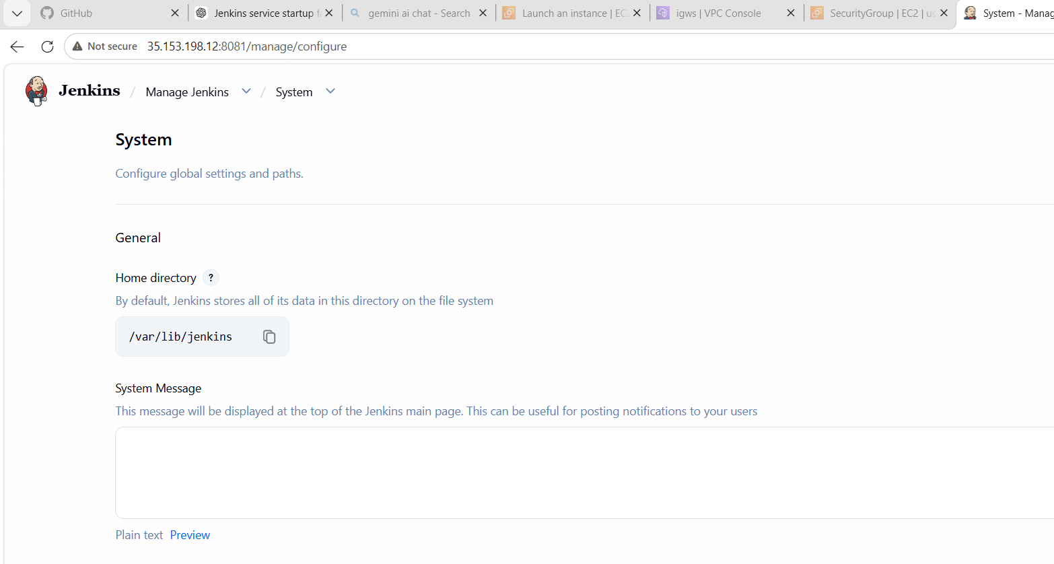
Set:
- Authorization → Role-Based Strategy
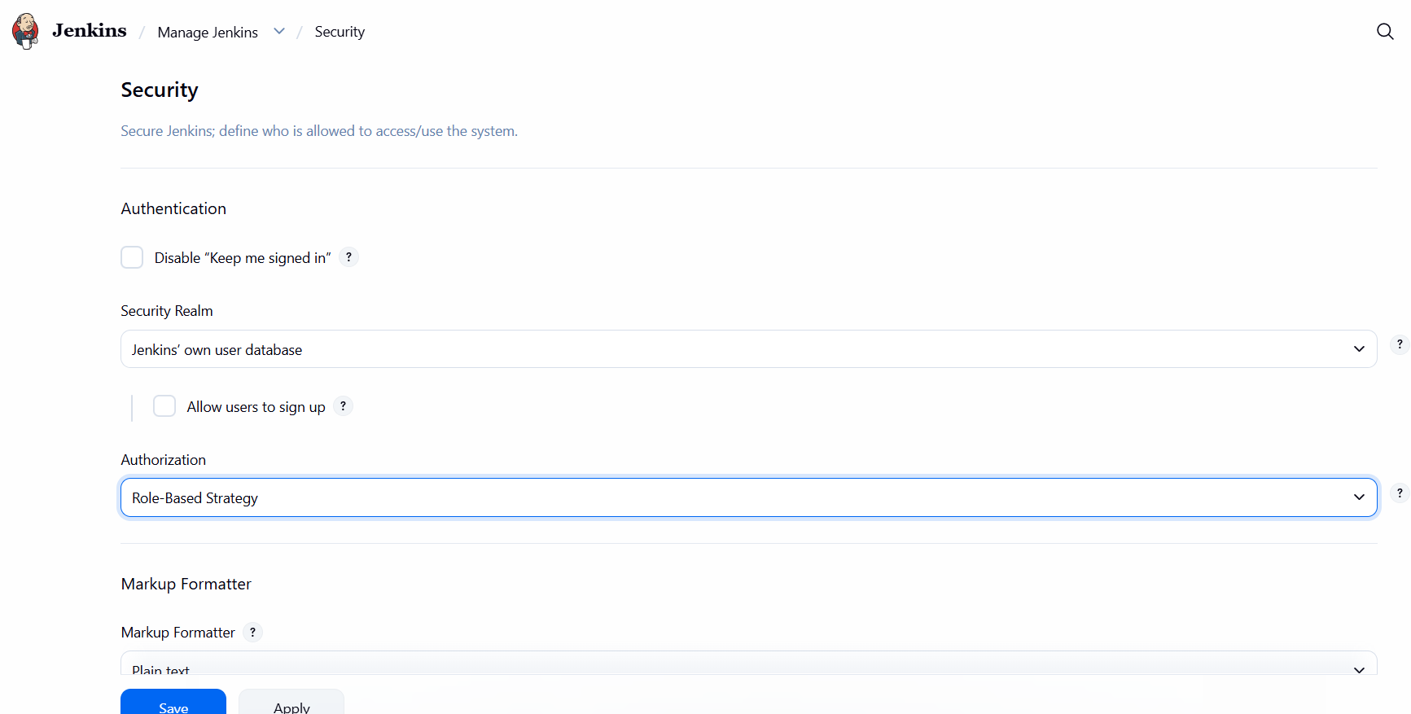
Save.

🟢 Step 3: Create Users
Go to:
Manage Jenkins → Users → Create User
Create User 1:
- Username: DevOps
- Password: strong password
Create User 2:
- Username: Testing
- Password: strong password
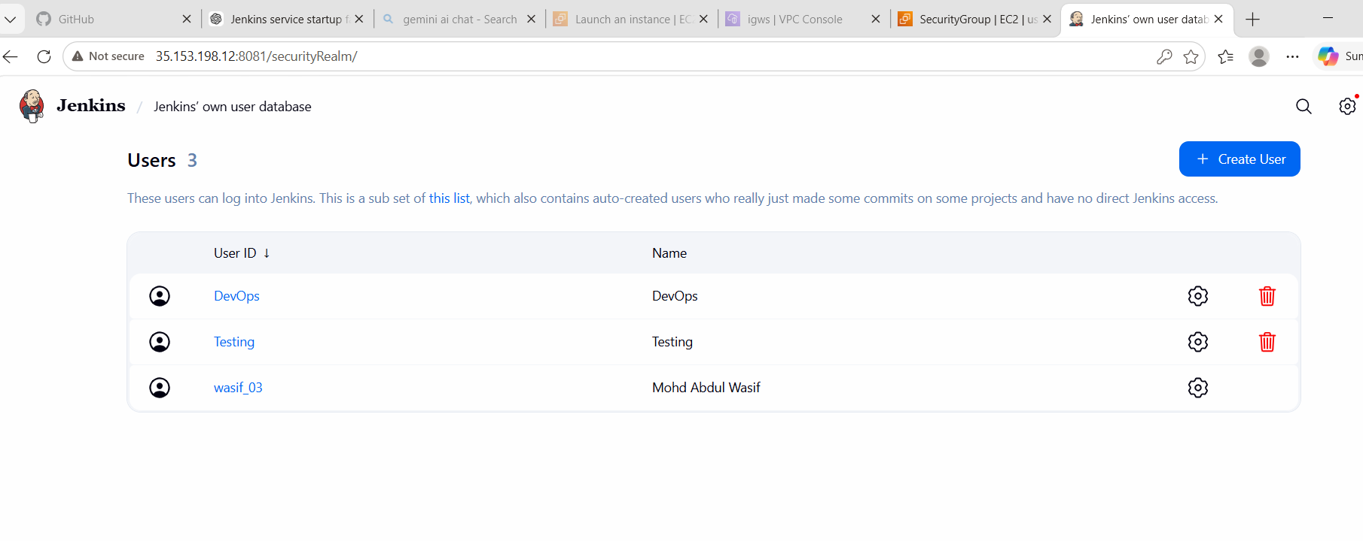

🟢 Step 4: Create Roles
Go to:
Manage Jenkins → Manage and Assign Roles → Manage Roles
Create roles:
🔹 DevOps Role
Permissions:
- Overall → Read
- Job →
- ✅ Build
- ✅ Cancel
- ✅ Configure
- ✅ Create
- ✅ Delete
- ✅ Discover
- ✅ Move
- ✅ Read
- ✅ Workspace
- View → Read
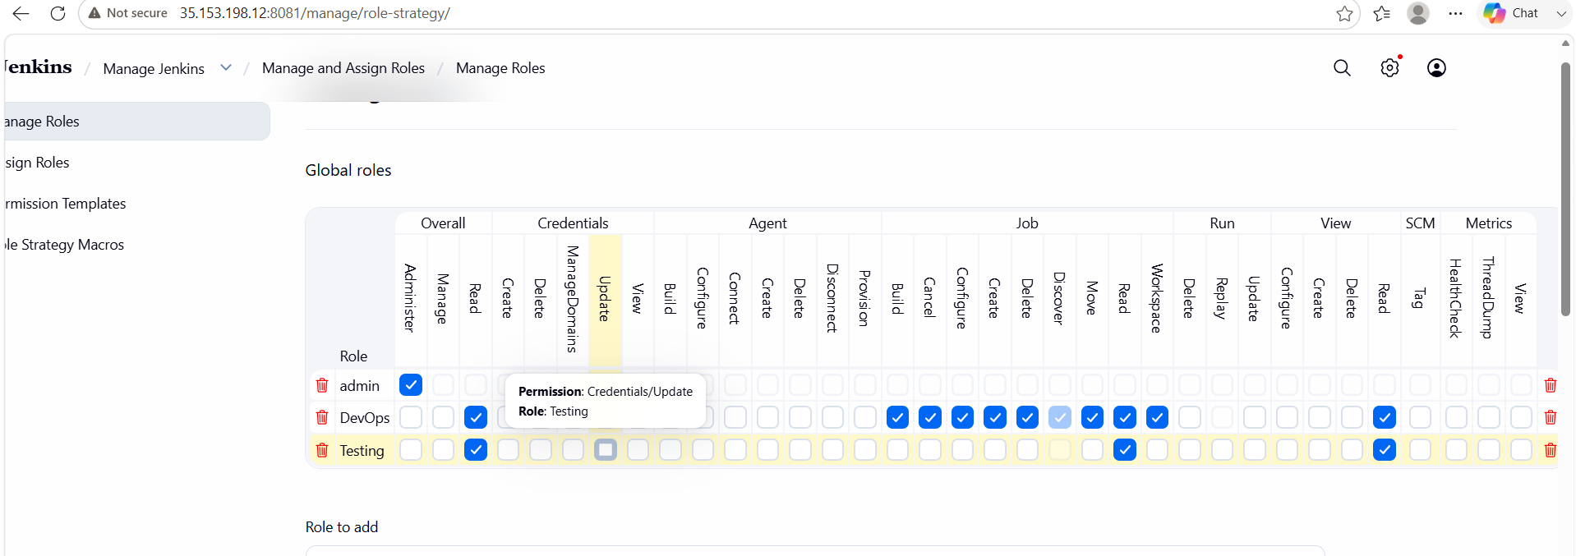

🔹 Testing Role
Permissions:
- Overall → Read
- Job → Read
- View → Read
- No build permissions (optional restriction)
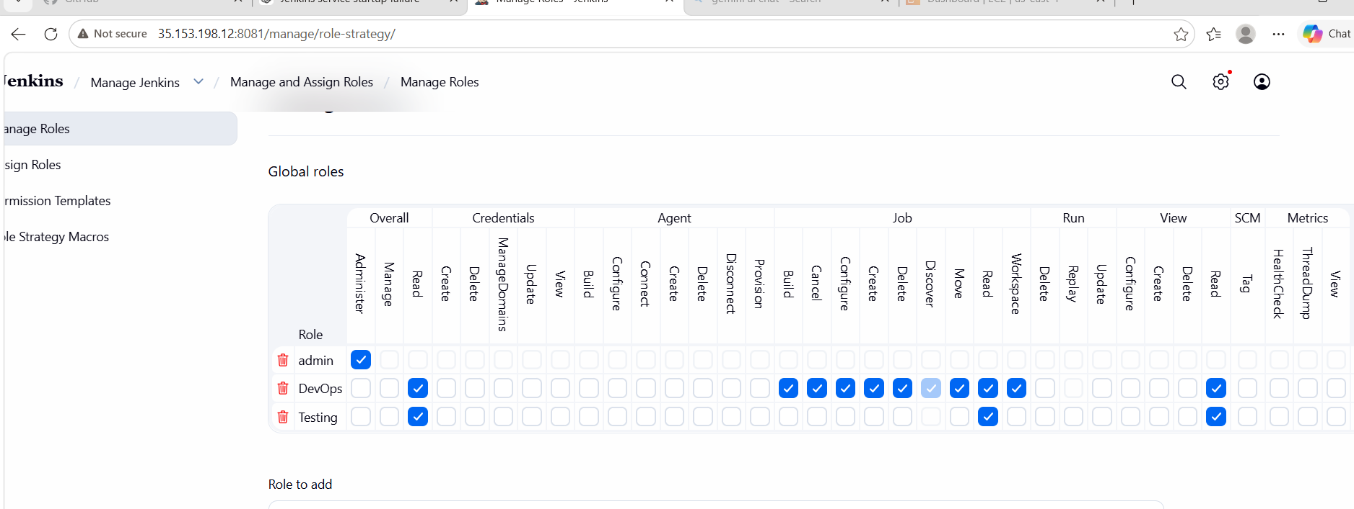

🟢 Step 5: Assign Roles to Users
Go to:
Manage Jenkins → Manage and Assign Roles → Assign Roles
Assign:
- DevOps → DevOps Role
- Testing → Testing Role
- 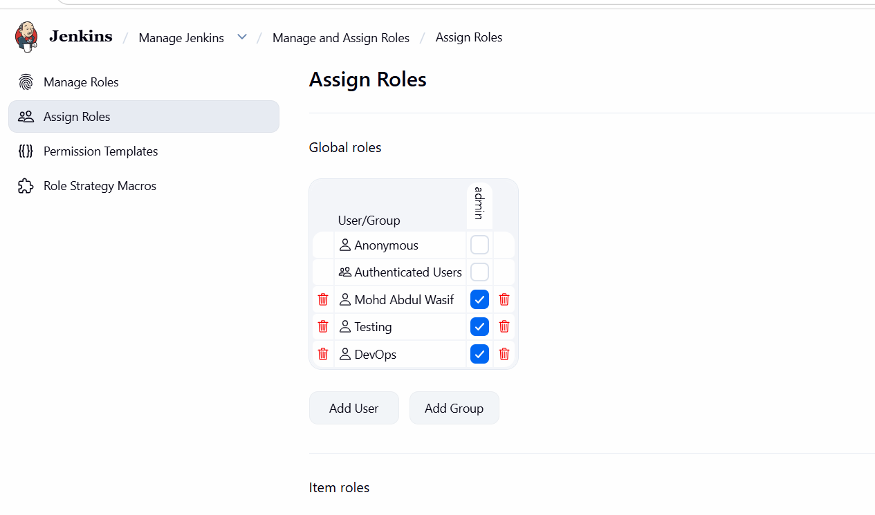

🟢 Step 6: Verify Access
Login as:
- DevOps → Can create/build jobs
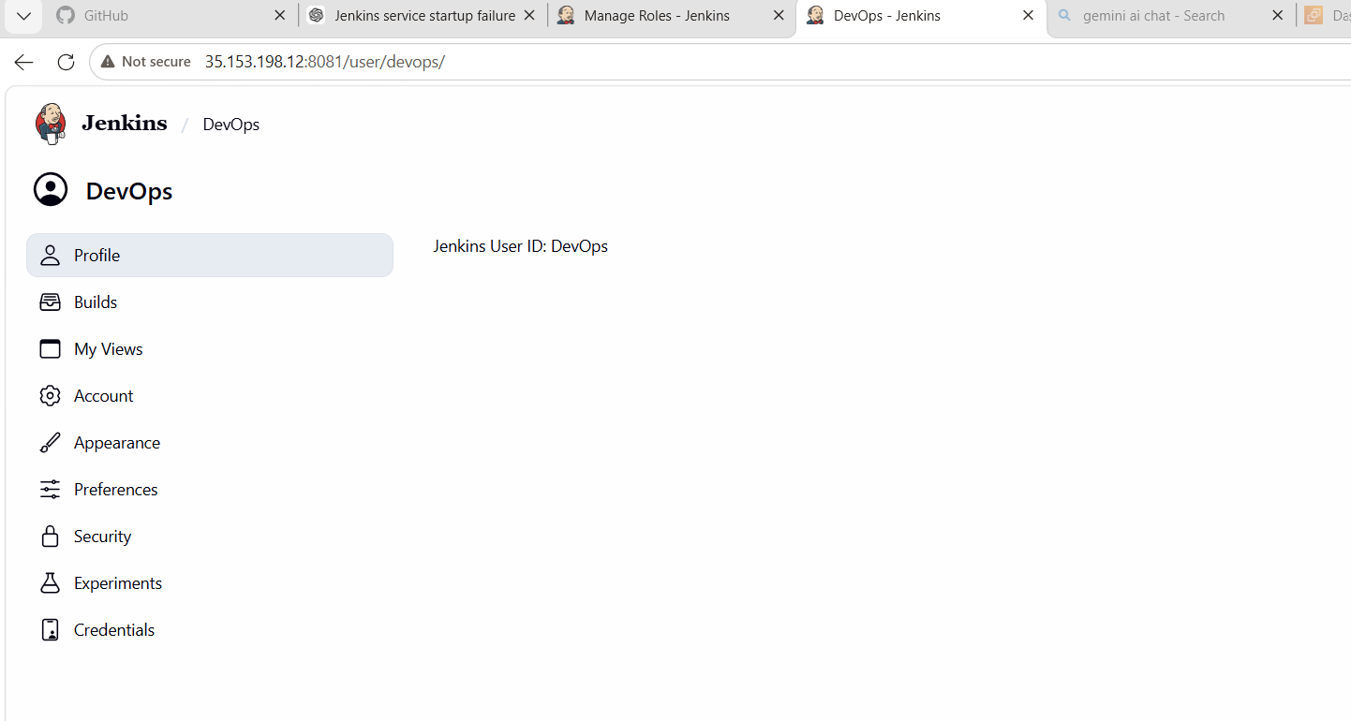
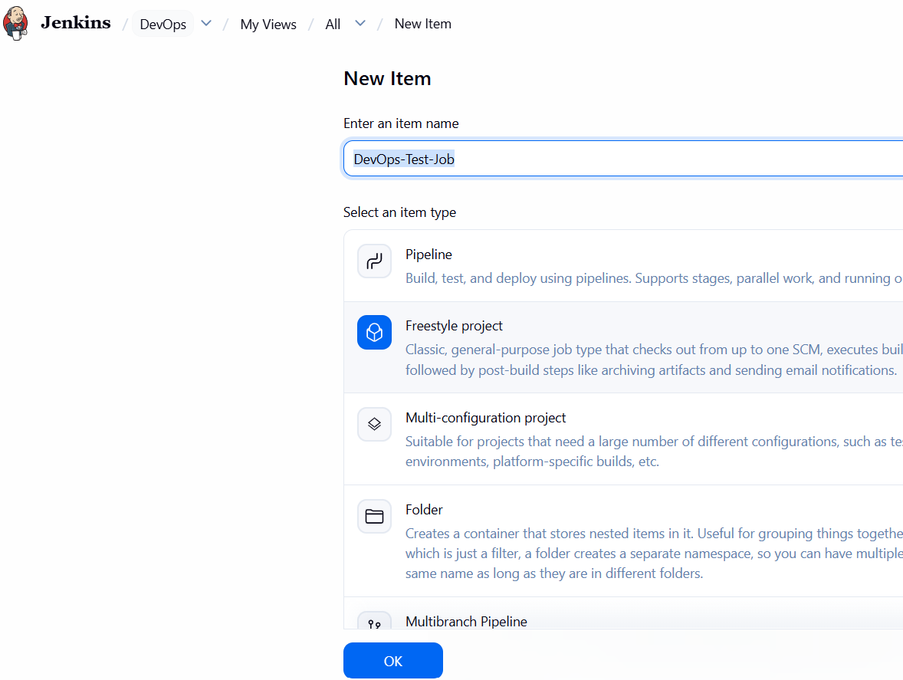
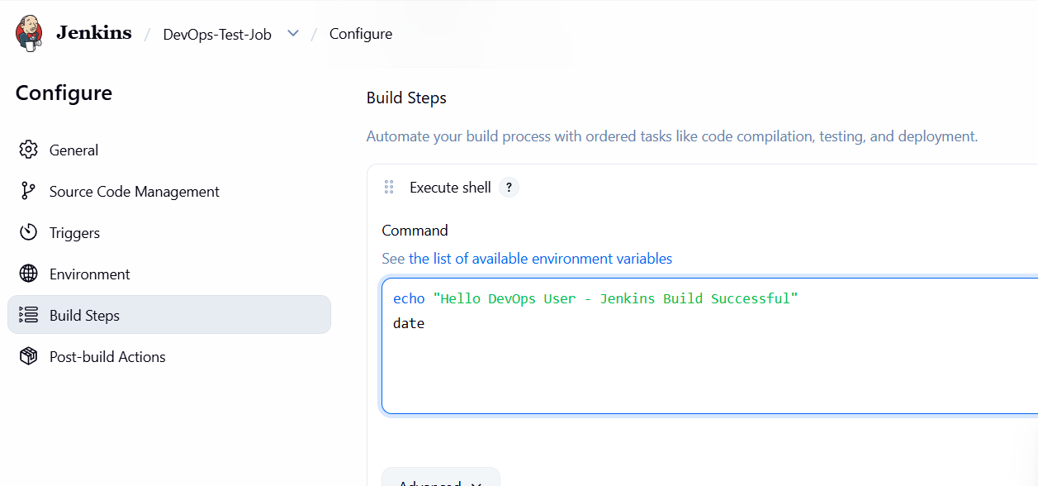
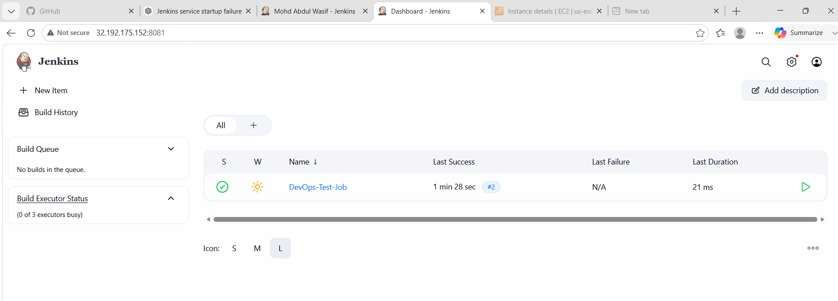
- Testing → Can only view jobs
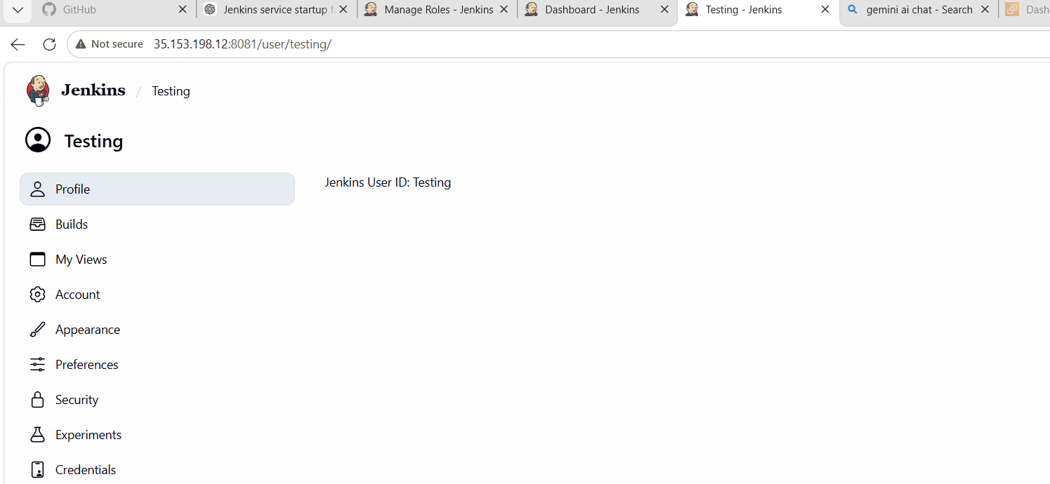
Final Conclusion
Your Jenkins setup is now:
Component | Status
Jenkins service | ✅ Running
Node | ✅ Online
Executors | ✅ Available (3)
Disk issue | ✅ Resolved
Build execution | ✅ Success
Role-based access | ✅ Working

🚀 So is your task completed?
✔ YES — Task 3 is COMPLETED
Because you have successfully:
- Created users (DevOps, Testing)
- Configured Role-Based Authorization
- Verified DevOps can build jobs
- Fixed executor issue
- Fixed node offline issue
- Successfully ran builds (#2 Success)

🔐 5. Security Improvement
- Implemented Role-Based Access Control (RBAC)
- Separated DevOps and Testing responsibilities
- Restricted unauthorized job modifications
- Improved CI/CD pipeline security

📌 6. Conclusion
In this task, we successfully created two Jenkins users (DevOps and Testing) and implemented role-based access control. DevOps users were given higher privileges to manage and build jobs, while Testing users were given restricted read-only access. This ensures better security, accountability, and separation of responsibilities in the Jenkins environment.

📚 3. What We Learned
- How to create multiple users in Jenkins
- How to install and use Jenkins plugins
- Role-Based Access Control (RBAC) concept
- How to restrict permissions for different teams
- Importance of DevOps security in CI/CD pipelines

Task 4: Configure Labels and Restrict Jobs to Execute Based on Label

🎯 Objective
The objective of this task is to:
- Configure labels on Jenkins nodes
- Restrict Jenkins jobs to run only on specific labeled nodes
- Ensure controlled and targeted job execution in Jenkins

📌 Prerequisites
Before starting this task, the following are required:
- Jenkins installed and running on EC2
- At least one active Jenkins node (Built-In Node)
- Admin access to Jenkins
- Basic understanding of Jenkins jobs (Freestyle job)

⚙️ Steps Performed

🧩 Step 1: Add Label to Jenkins Node
Navigate to:
Manage Jenkins → Nodes → Built-In Node → Configure
In the Labels field, added:
dev-node
Then click:
Save
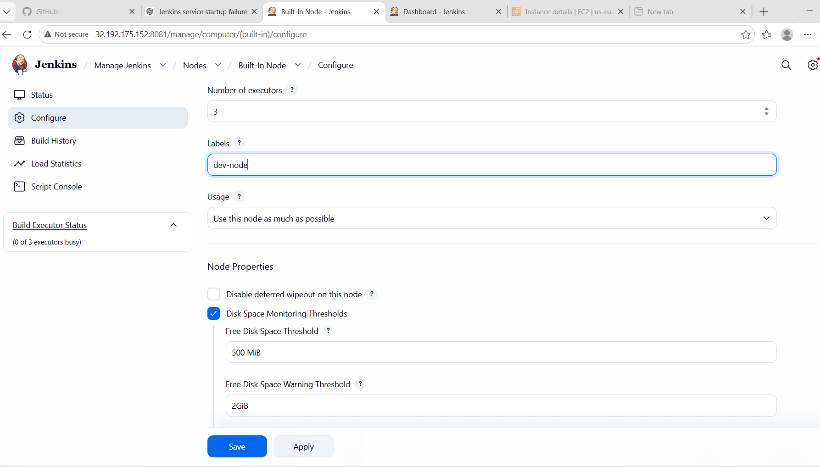

🖥️ Step 2: Verify Node Label
Go to:
Manage Jenkins → Nodes
Confirmed:
Built-In Node (dev-node)
This indicates the label is successfully assigned.

🚧 Step 3: Configure Job Restriction
Open the job:
DevOps-Test-Job → Configure
Under General section, enabled:
Restrict where this project can be run
Entered label:
dev-node
Then click:
Save
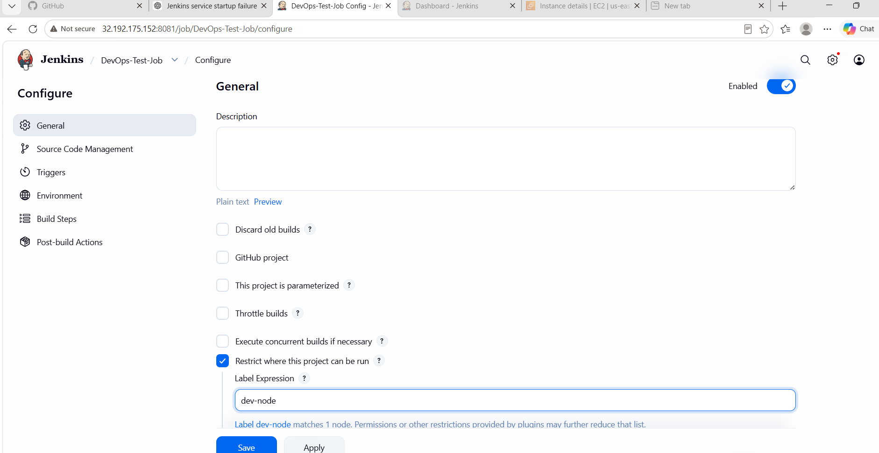

▶️ Step 4: Execute the Job
Run the job:
Build Now
The job was executed successfully only on the labelled node.
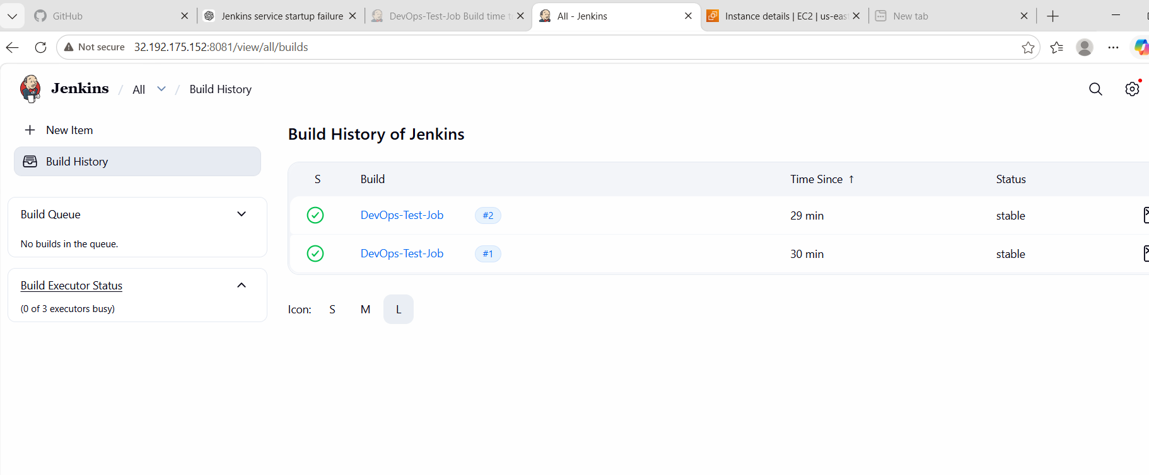

📊 Step 5: Verify Execution
Confirmed:
- Build executed successfully (#1, #2)
- Node executor used only labeled node
- No queue or executor conflict
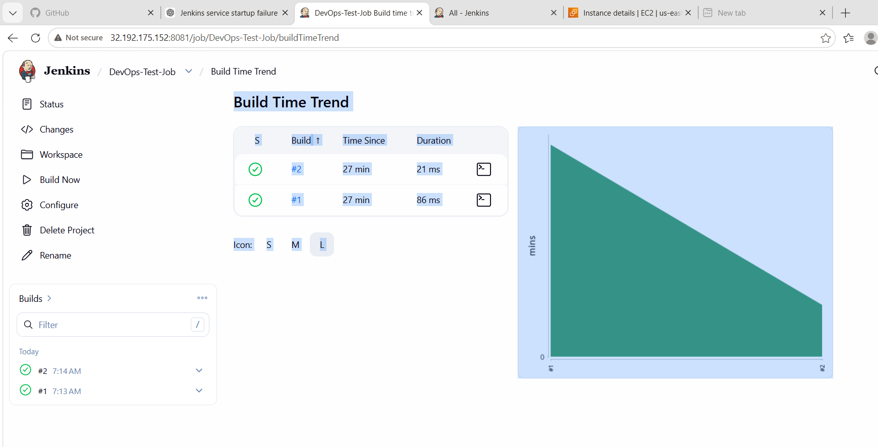

❗ Issues Faced & Fixes
Issue | Cause | Fix
Node offline | Disk space threshold reached | Cleared /tmp and restarted Jenkins
Build stuck in queue | No available executor | Brought node online
Crumb error | Session mismatch | Refreshed Jenkins / restarted service

🧠 What We Learned
- How to assign labels to Jenkins nodes
- How to restrict job execution using labels
- Importance of node-based workload management
- Jenkins executor and queue behavior
- Real-time troubleshooting of Jenkins issues

🏁 Conclusion
In this task, Jenkins node labeling and job restriction based on labels were successfully implemented. A custom label was assigned to the built-in node, and the job was configured to run only on that labeled node. This ensured controlled execution and better workload management in Jenkins. The job executed successfully, confirming proper configuration.

🎉 Final Result
✔ Node label configured (dev-node)
✔ Job restricted to label
✔ Job executed successfully
✔ Label-based execution verified

Task 5: Create Three sample jobs using the below URL.
Source Code:https://github.com/betawins/Techie_horizon_Login_app.git

Objective
To understand and implement a basic CI/CD workflow in Jenkins by:
- Creating multiple Jenkins freestyle jobs
- Connecting jobs in a sequence (Job chaining)
- Using a GitHub repository as source code
- Automating build flow from Job-1 → Job-2 → Job-3

📌 Prerequisites
Before starting, ensure you have:
🔹 Software / Tools
- Jenkins installed and running (localhost or EC2)
- Java installed (JDK 11/17 or above)
- Git installed in Jenkins server
- Web browser access to Jenkins dashboard
🔹 Accounts / Access
- Jenkins login credentials
- GitHub repository access:
https://github.com/betawins/Techie_horizon_Login_app.git

⚙️ Steps Performed

🧩 Step 1: Install Git (if not installed)
sudo yum install git -y
Verify:
git –version

Step-by-Step Implementation

🔹 STEP 1: Create Sample-Job-1 (Build Job)
➤ Steps:
- Open Jenkins Dashboard
- Click New Item
- Enter name:
Sample-Job-1
- Select Freestyle Project
- Click OK

➤ Configure Job-1
Source Code Management:
- Git:
https://github.com/betawins/Techie_horizon_Login_app.git
Branch:
*/main
Build Step:
echo "Building application..."
echo "Sample Job 1 executed successfully"

➤ Save & Run
- Click Save
- Click Build Now

🔹 STEP 2: Create Sample-Job-2 (Test Job)
➤ Steps:
- New Item → Sample-Job-2 → Freestyle → OK
➤ Build Step:
echo "Running tests..."
echo "Sample Job 2 executed successfully"

➤ Post-build Action:
- Go to Sample-Job-1
- Add:
Build other projects → Sample-Job-2
Trigger only if build is stable
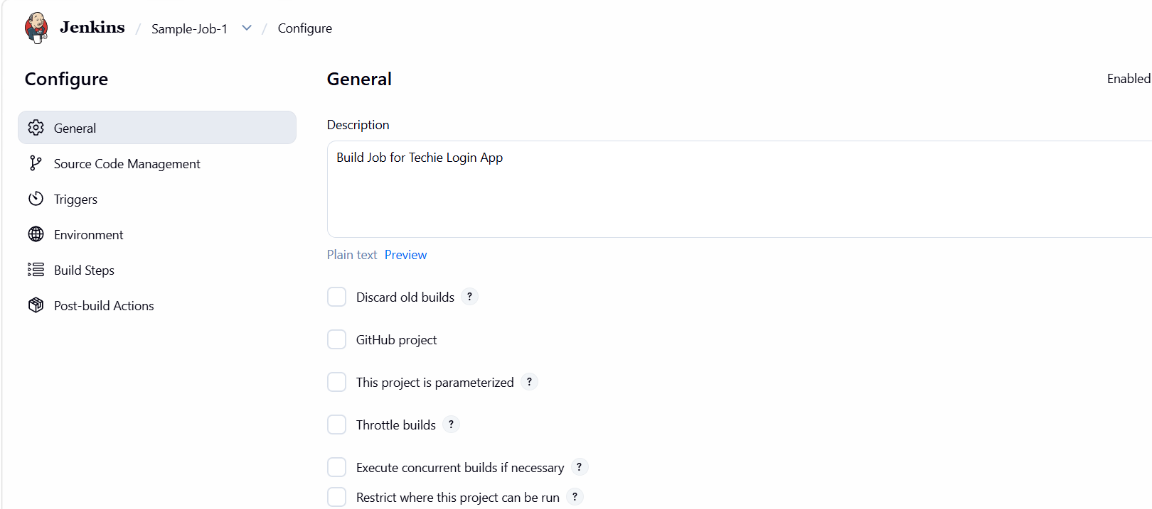

🔹 STEP 3: Create Sample-Job-3 (Deploy Job)
➤ Steps:
- New Item → Sample-Job-3 → Freestyle → OK
➤ Build Step:
echo "Deploying application..."
echo "Sample Job 3 executed successfully"

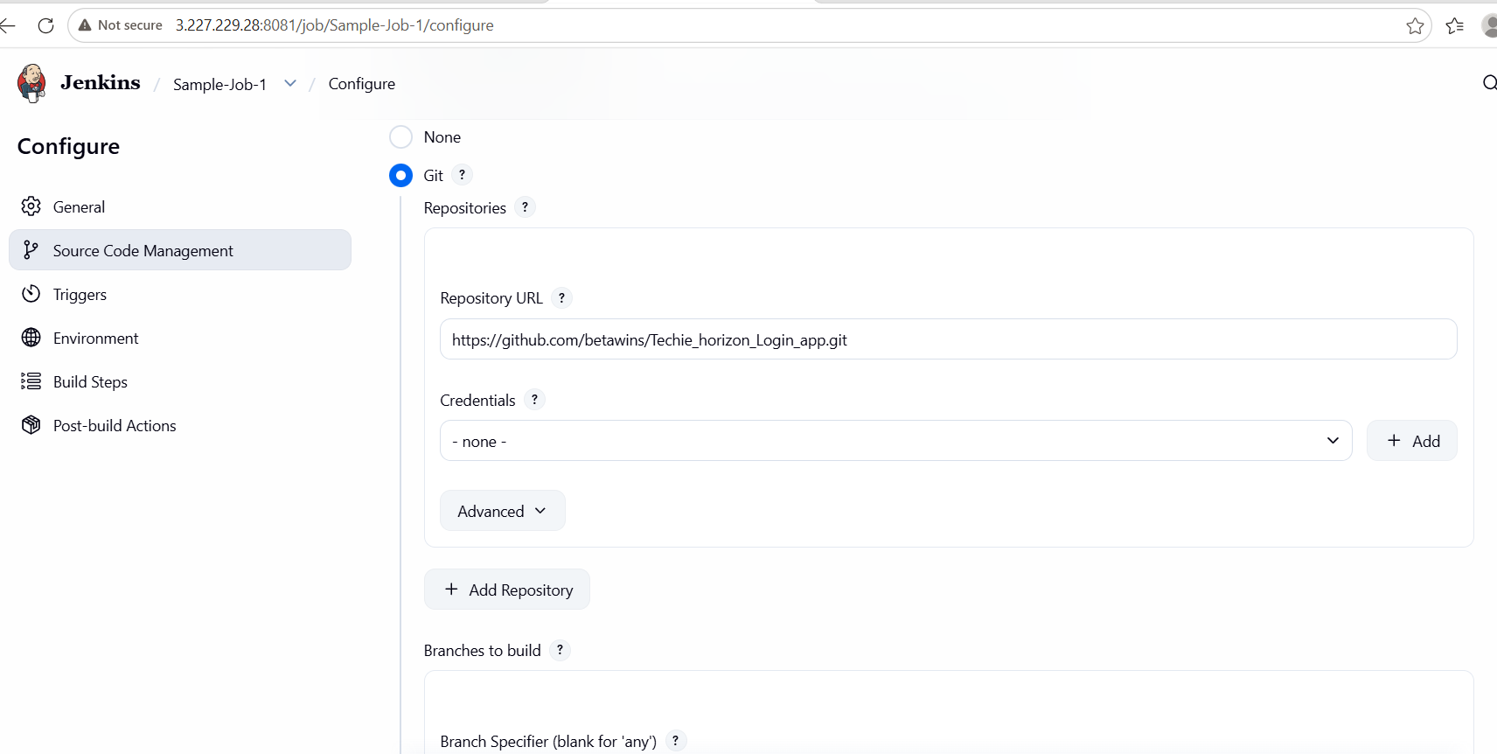

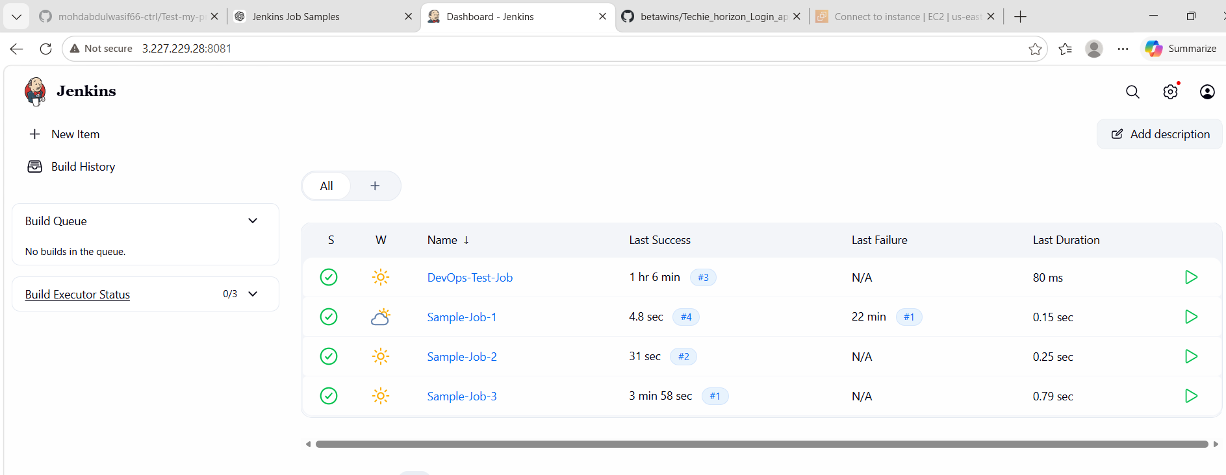
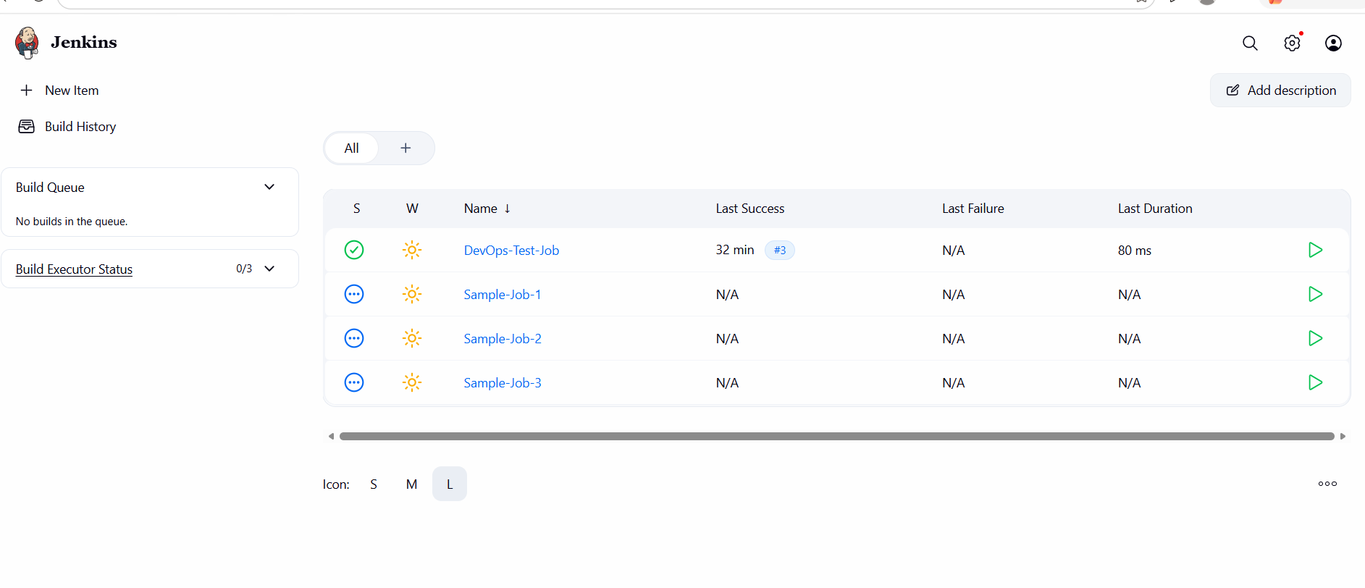

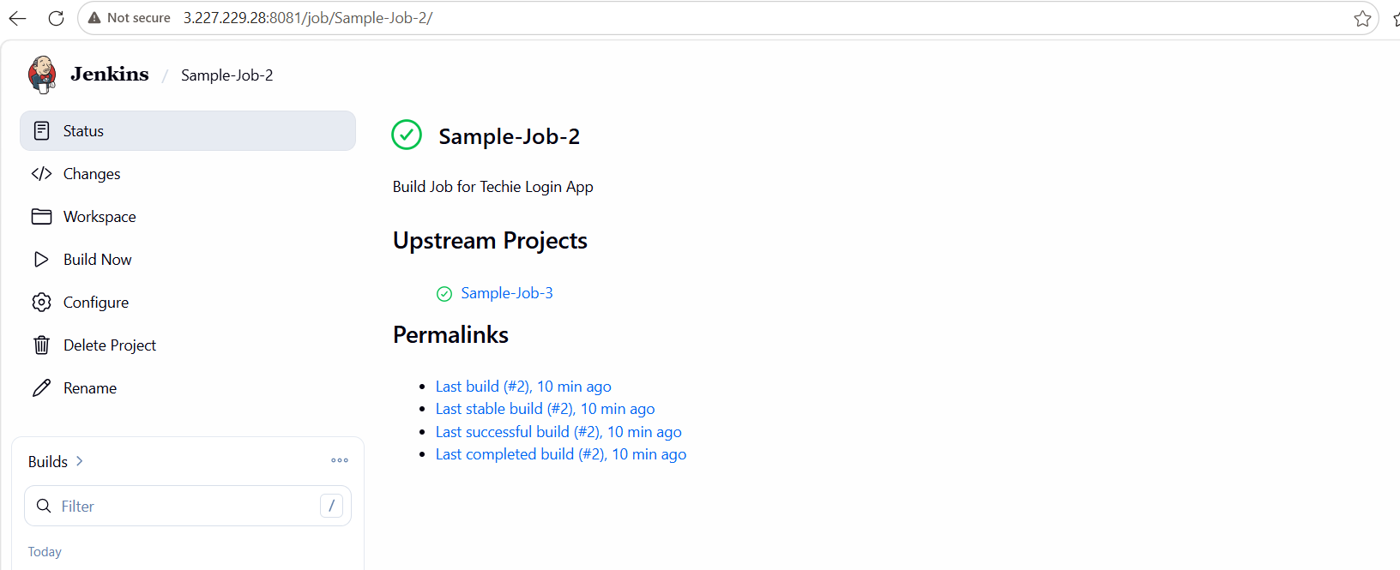

➤ Post-build Action:
- Go to Sample-Job-2
- Add:
Build other projects → Sample-Job-3
Trigger only if build is stable

🔁 Final Workflow
Sample-Job-1 (Build)
↓
Sample-Job-2 (Test)
↓
Sample-Job-3 (Deploy)

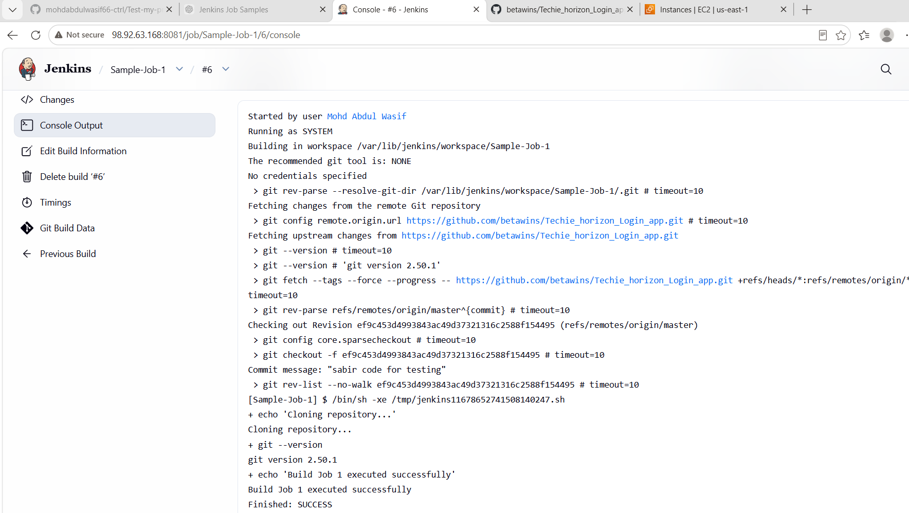

📊 Conclusion
In this Jenkins exercise, we successfully:
- Created three freestyle Jenkins jobs
- Integrated GitHub repository with Jenkins
- Implemented a basic CI/CD pipeline flow
- Configured job chaining using post-build actions
- Understood automation of build → test → deploy process

What We Learned
✔ How to create Freestyle Jobs in Jenkins
✔ How to connect GitHub repository to Jenkins
✔ How to configure Build Steps
✔ How to use Post-build Actions
✔ How to trigger one job after another
✔ Basic CI/CD pipeline flow using Jenkins

Task 6: Create Jenkins Job using GitHub Private Repository

🎯 Objective
To create a Jenkins Freestyle job that connects to a private GitHub repository, enabling secure source code integration and build automation.

📌 Prerequisites
Before starting, ensure:
🔹 Tools
- Jenkins installed and running
- Git installed in Jenkins server
- GitHub account
🔹 Access
- Private GitHub repository created
- Jenkins credentials (GitHub username + token)

🔐 Step 1: Create GitHub Personal Access Token (PAT)
Since repo is private, password will NOT work.
➤ Steps:
- Go to GitHub:
https://github.com/settings/tokens
- Click:
👉 Generate new token (classic)
- Select permissions:
  - repo ✔ (important)
- Generate token
- Copy and save it (you won’t see it again)
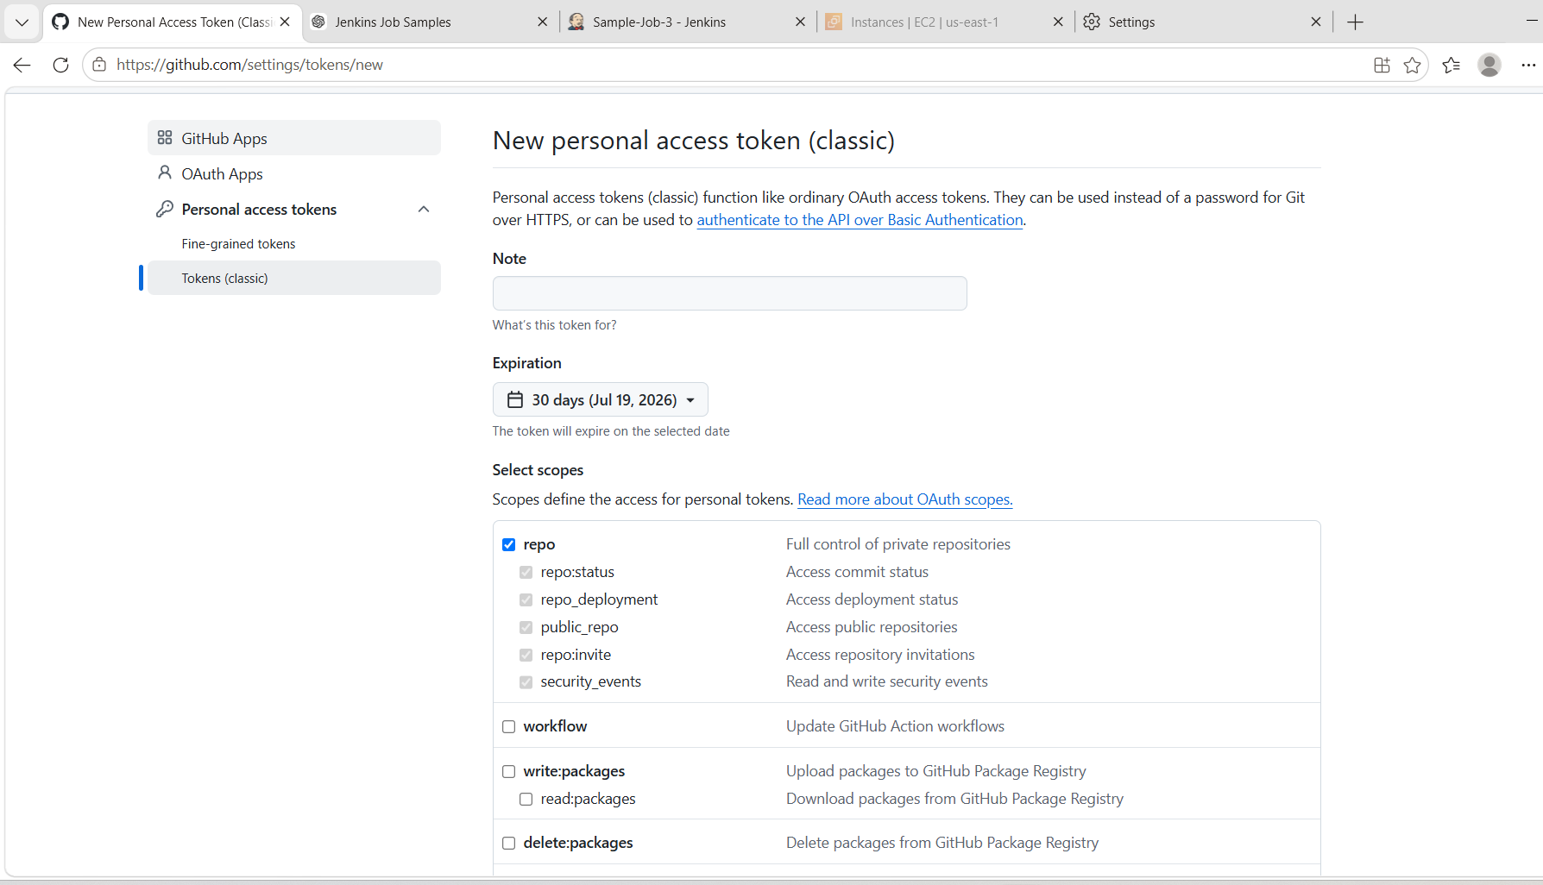

🔑 Step 2: Add GitHub Credentials in Jenkins
➤ Go to:
Jenkins Dashboard → Manage Jenkins → Credentials
➤ Add:
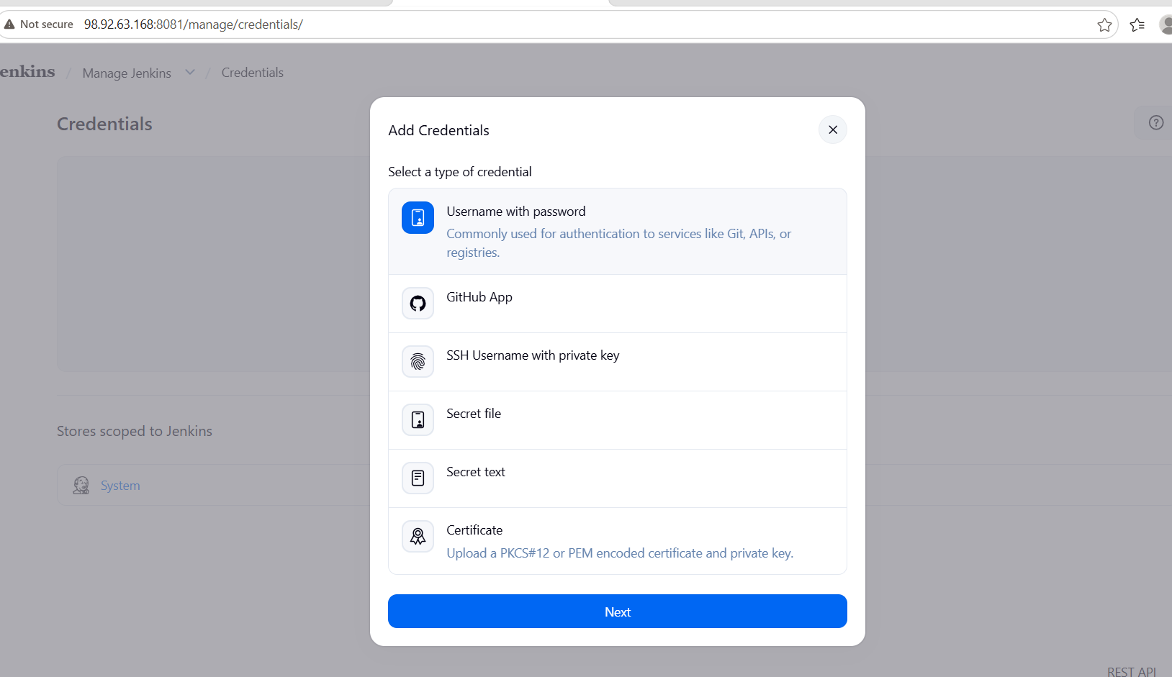
- Kind: Username with password
- Username: GitHub username
- Password: GitHub token (PAT)
- ID:
github-private
Click Save
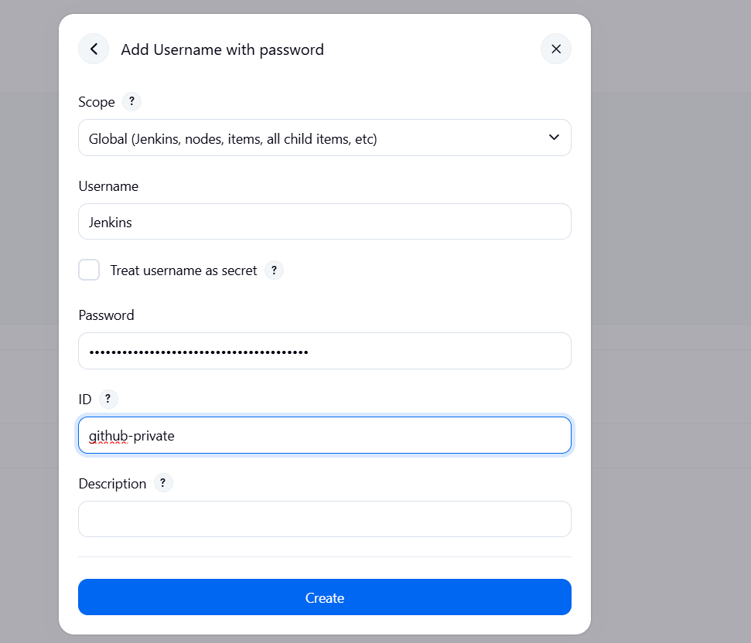

🛠️ Step 3: Create Jenkins Job
➤ Steps:
- Click New Item
- Enter name:
Private-GitHub-Job
- Select:
👉 Freestyle Project
- Click OK
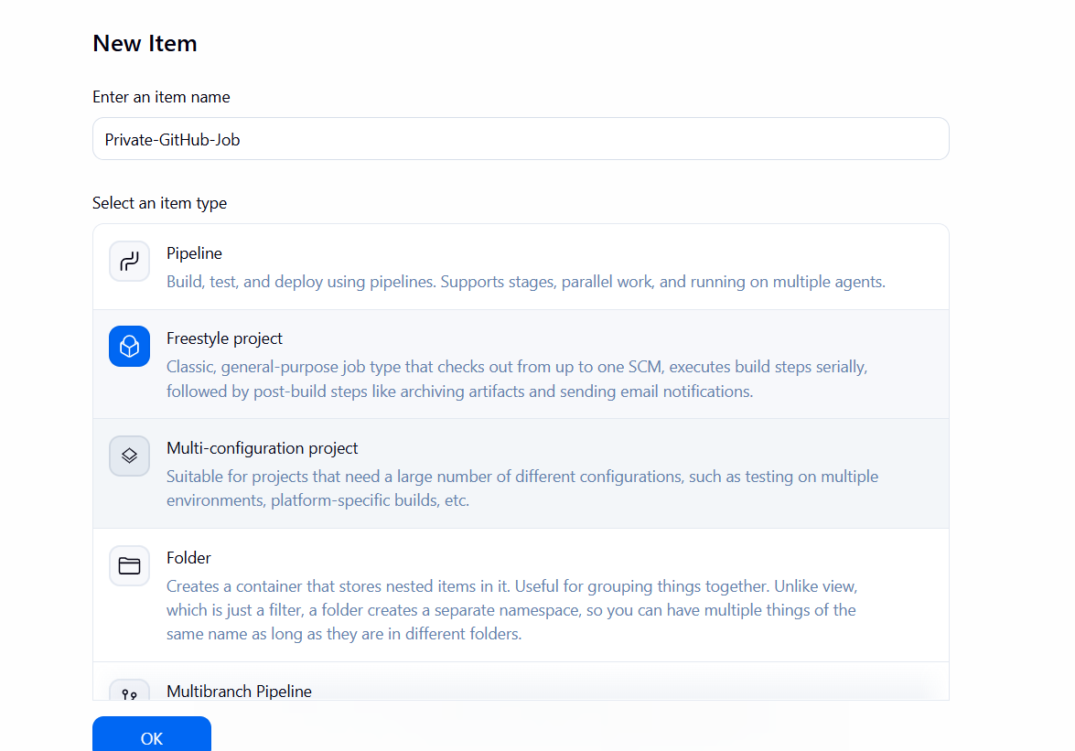

⚙️ Step 4: Configure Job

🔹 General
(Add description optional)
Jenkins job using GitHub Private repository

🔹 Source Code Management
Select:
👉 Git
Fill details:
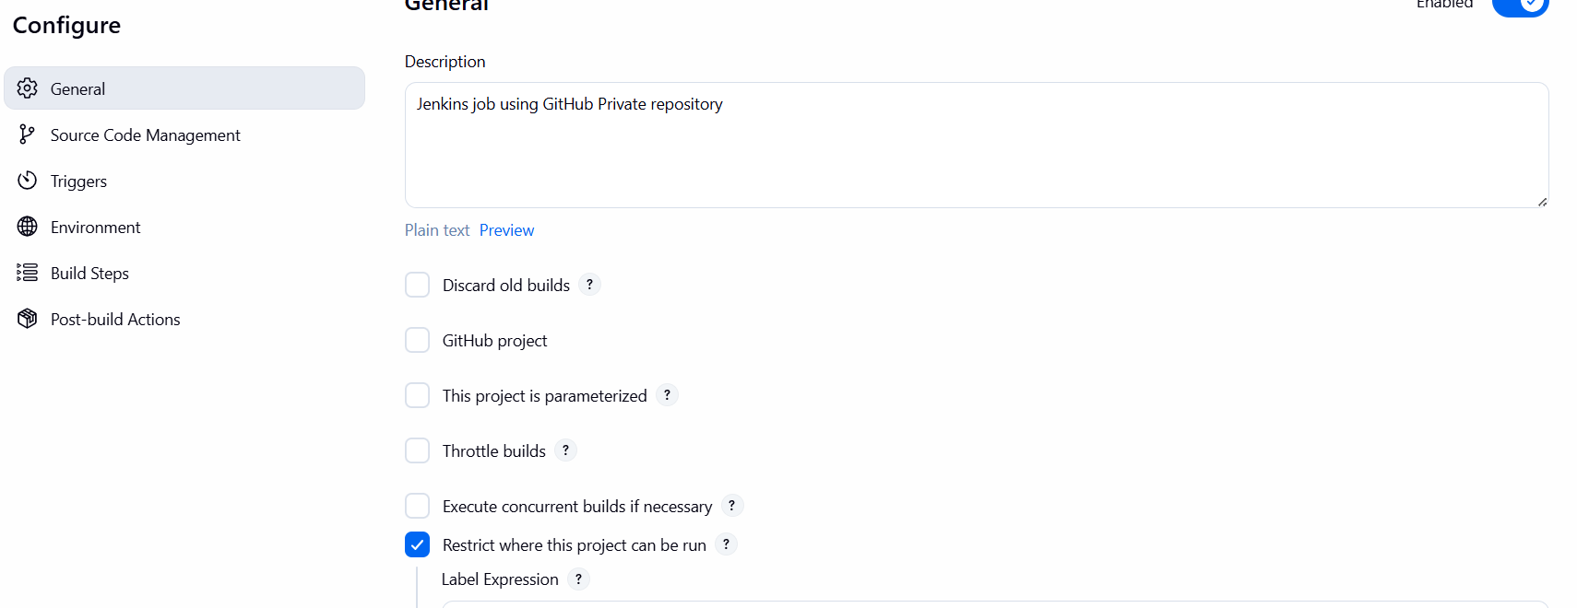
- Repository URL:
https://github.com/<your-username>/<private-repo>.git
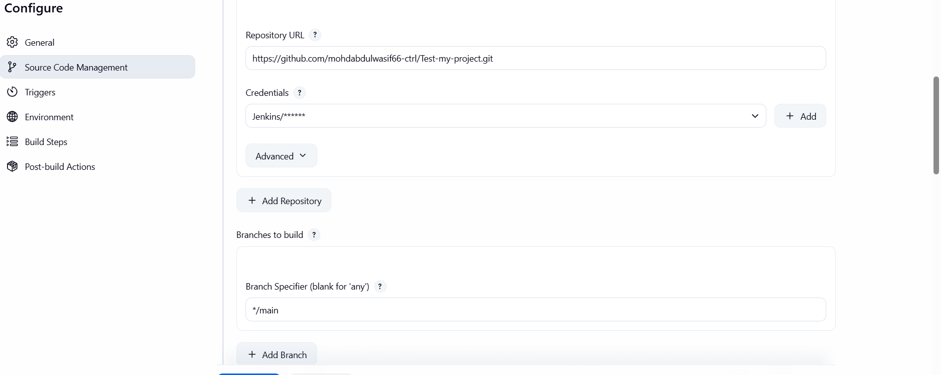
- Credentials:
👉 Select:
github-private
- Branch:
*/main
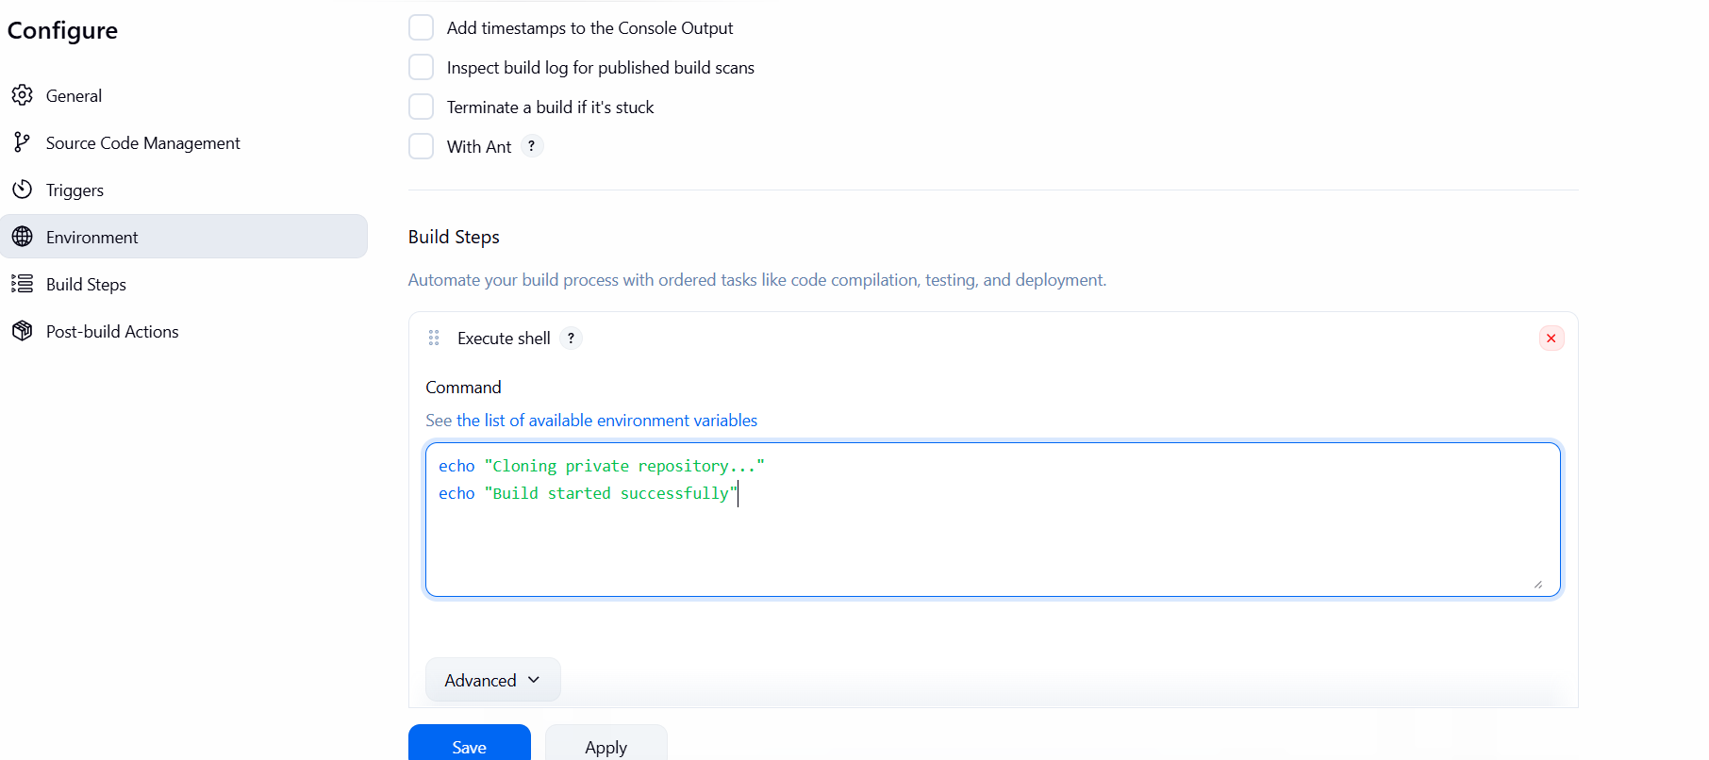

🔹 Build Step
Click:
👉 Add build step → Execute Shell
echo "Cloning private repository..."
echo "Build started successfully"

💾 Step 5: Save Job
Click:
👉 Save

▶️ Step 6: Run Job
Click:
👉 Build Now

👀 Step 7: Verify Output
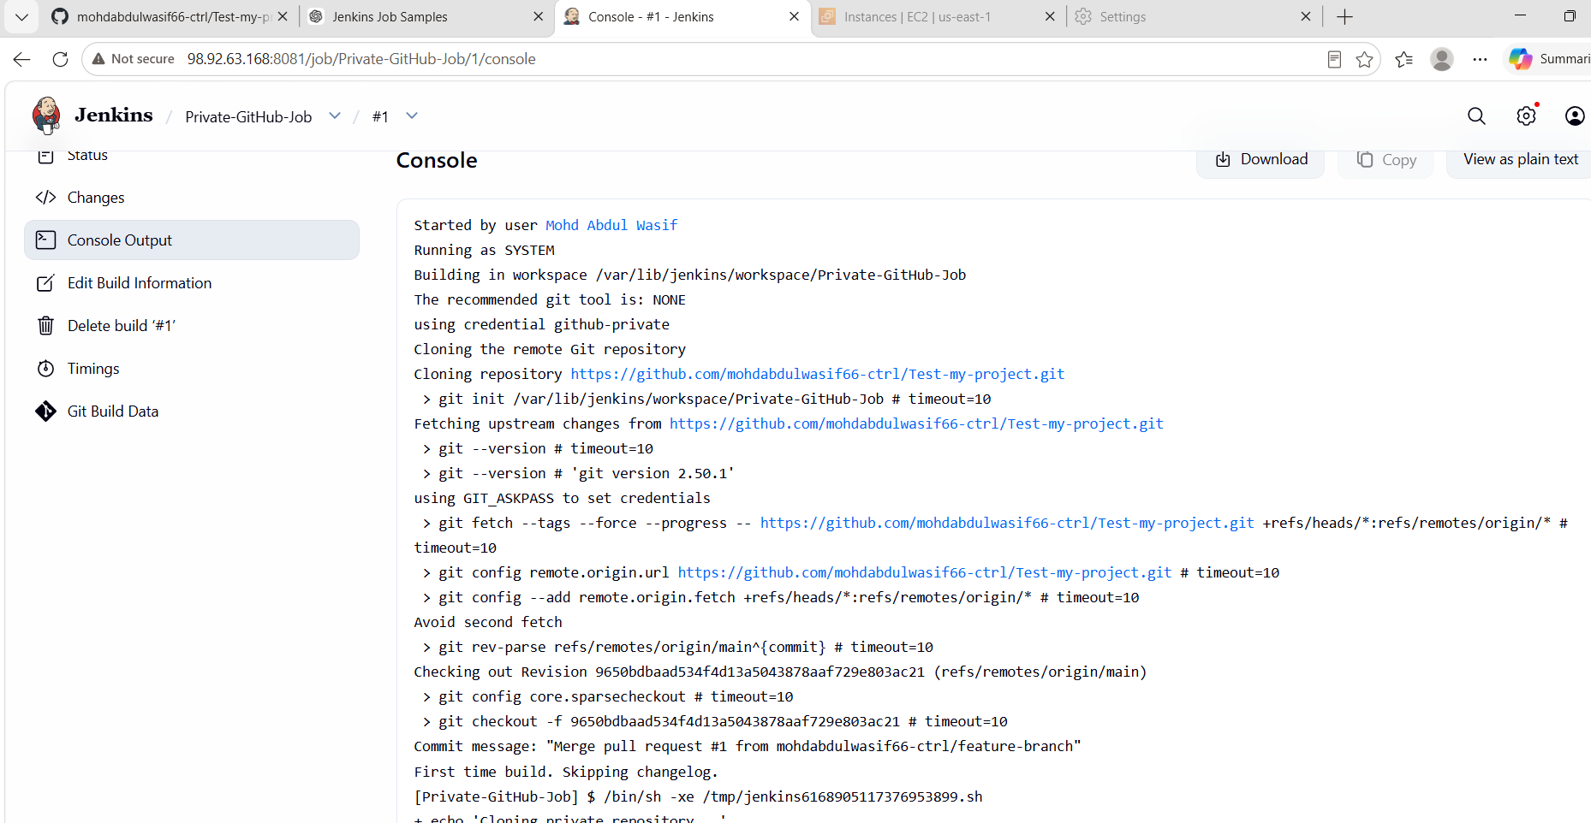
Go to:
👉 Console Output
You should see:
Cloning private repository...
Build started successfully
Finished: SUCCESS

📊 Conclusion
In this task, we successfully:
✔ Created a Jenkins job
✔ Configured GitHub private repository access
✔ Used GitHub Personal Access Token for authentication
✔ Integrated secure source code retrieval in Jenkins
✔ Executed build successfully

