Kubernetes-Task-04
Kubernetes Deployment Lab – 8 Tasks
Run all YAML and kubectl commands on the master/control-plane node. Kubernetes automatically schedules Pods on suitable worker nodes.

Objective
The objective of this lab is to understand:
- Deployments and replica management
- Rolling Update and Recreate strategies
- Application updates and rollbacks
- CPU and memory requests and limits
- maxSurge and maxUnavailable
- Deployment revision history
- Pausing and resuming updates
- Resource-based Pod scheduling

Prerequisites
Make sure you have:
- A working Kubernetes cluster
- One master/control-plane node
- One or more worker nodes
- kubectl configured on the master
- Worker nodes in Ready status
- Internet access to pull Nginx images
- A working CNI plugin such as Calico
Check the cluster:
kubectl get nodes
Create a separate namespace:
kubectl create namespace deployment-lab
kubectl config set-context --current --namespace=deployment-lab
Verify:
kubectl config view --minify | grep namespace

Task 1: Deployment with 3 Replicas and Rolling Update
Step 1: Create the YAML file
vi rolling-deployment.yaml
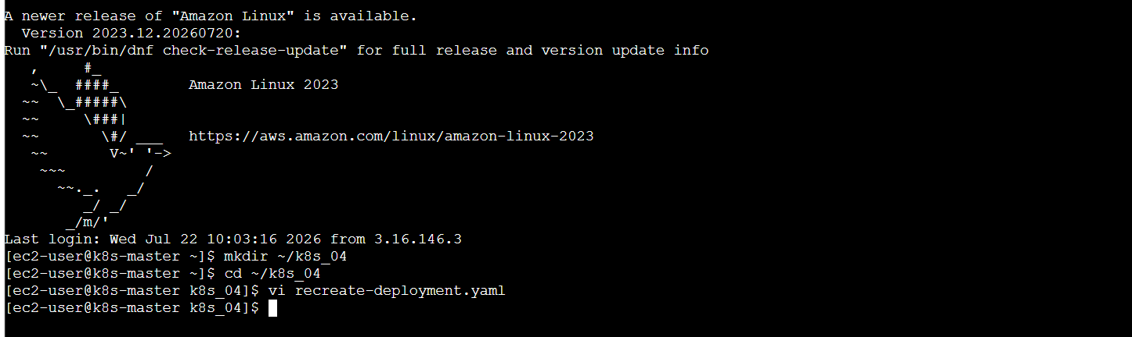
Add:
apiVersion: apps/v1
kind: Deployment
metadata:
name: rolling-deployment
spec:
replicas: 3
minReadySeconds: 10

strategy:
type: RollingUpdate
rollingUpdate:
maxSurge: 1
maxUnavailable: 1

selector:
matchLabels:
app: rolling-nginx

template:
metadata:
labels:
app: rolling-nginx
spec:
containers:
- name: nginx
image: nginx:1.26
ports:
- containerPort: 80
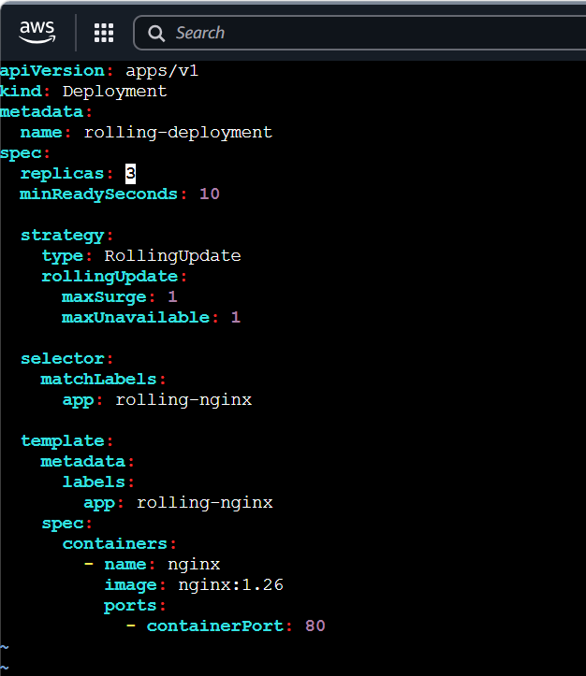
Step 2: Deploy
kubectl apply -f rolling-deployment.yaml
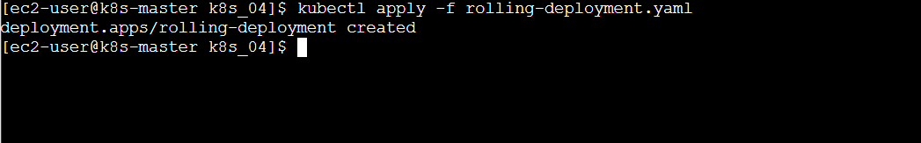
Step 3: Verify
kubectl get deployments
kubectl get replicasets
kubectl get pods -l app=rolling-nginx -o wide
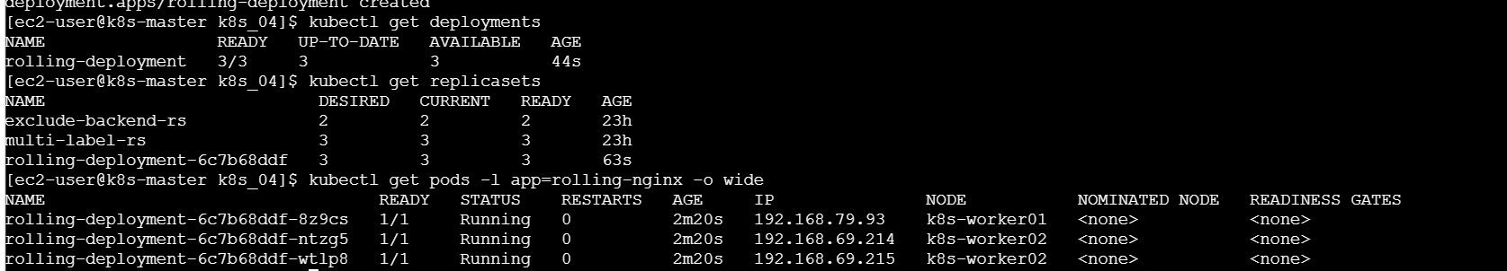
Check rollout status:
kubectl rollout status deployment/rolling-deployment
Expected:
deployment "rolling-deployment" successfully rolled out
Step 4: Perform a rolling update
Update Nginx from version 1.26 to 1.27:
kubectl set image deployment/rolling-deployment \
nginx=nginx:1.27
Watch the Pods:
kubectl get pods -l app=rolling-nginx -w
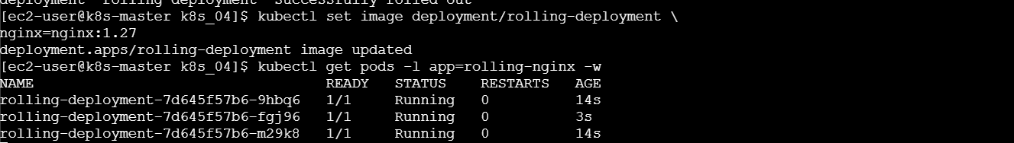
Press Ctrl+C after the update completes.
Verify:
kubectl rollout status deployment/rolling-deployment
kubectl get pods -l app=rolling-nginx
Check the current image:
kubectl get deployment rolling-deployment \
-o jsonpath='{.spec.template.spec.containers[0].image}{"\n"}'
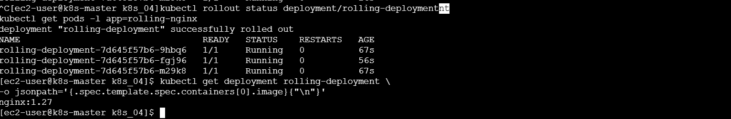
Expected:
nginx:1.27
Observation
Kubernetes gradually created new Pods and removed old Pods. The application remained available during the update.
Task 2: Recreate Strategy and Observe Downtime
The Recreate strategy removes all old Pods before creating the new Pods. Therefore, temporary downtime occurs.
Step 1: Create the YAML file
vi recreate-deployment.yaml
Add:
apiVersion: apps/v1
kind: Deployment
metadata:
name: recreate-deployment
spec:
replicas: 3
minReadySeconds: 10

strategy:
type: Recreate

selector:
matchLabels:
app: recreate-nginx

template:
metadata:
labels:
app: recreate-nginx
spec:
containers:
- name: nginx
image: nginx:1.26
ports:
- containerPort: 80
readinessProbe:
httpGet:
path: /
port: 80
initialDelaySeconds: 5
periodSeconds: 3
---
apiVersion: v1
kind: Service
metadata:
name: recreate-service
spec:
type: NodePort
selector:
app: recreate-nginx
ports:
- port: 80
targetPort: 80
nodePort: 30082
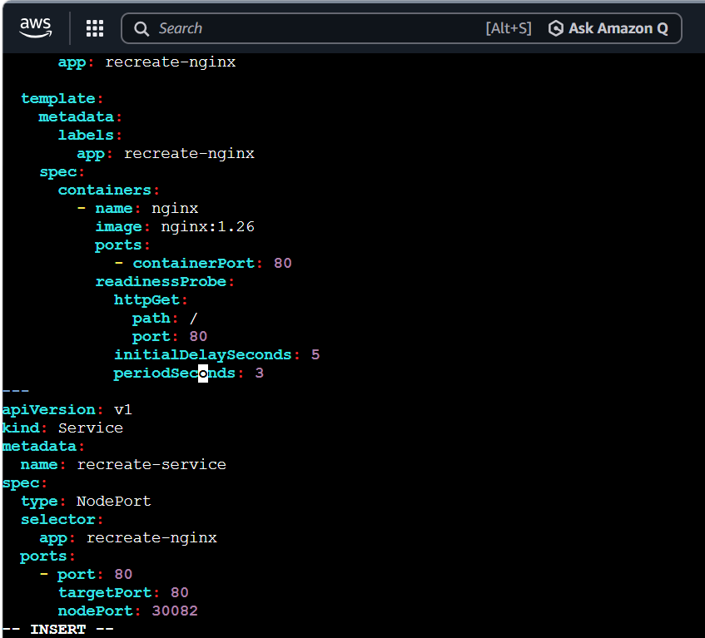
Step 2: Deploy
kubectl apply -f recreate-deployment.yaml
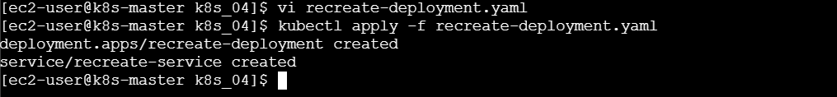
Verify:
kubectl get deployment recreate-deployment
kubectl get pods -l app=recreate-nginx
kubectl get service recreate-service
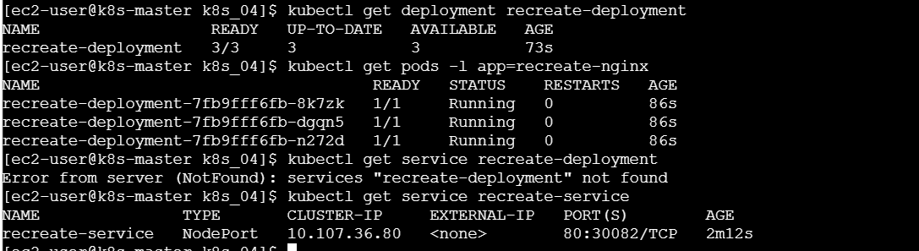
Wait for completion:
kubectl rollout status deployment/recreate-deployment
Step 3: Test the application
Get the node IP:
kubectl get nodes -o wide
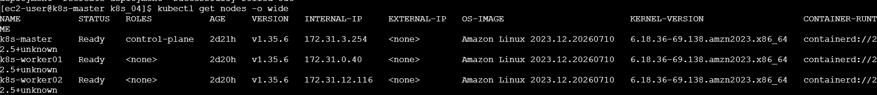
Test:
curl http://<WORKER-NODE-IP>:30082
Example:
curl http://172.31.10.20:30082
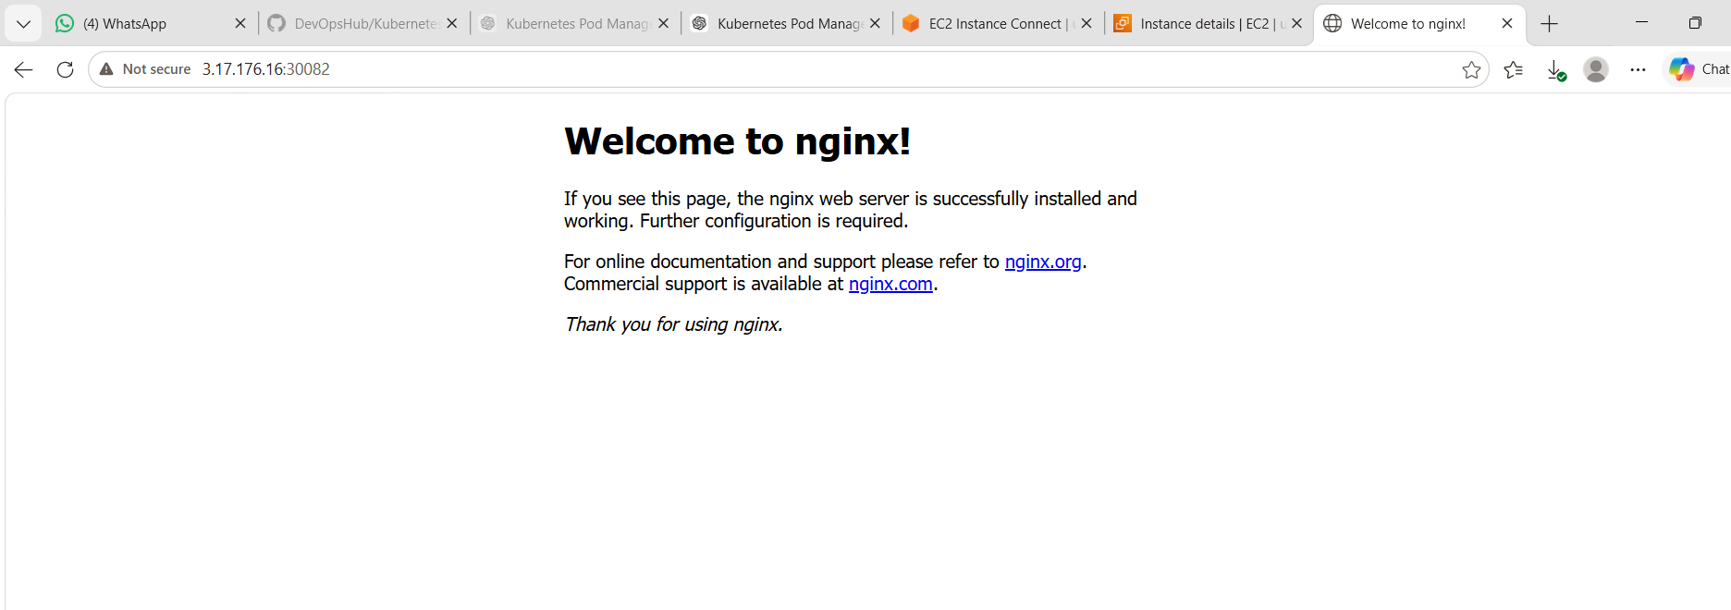
Step 4: Continuously test the application
Open another master-node terminal and run:
while true; do
curl -s --connect-timeout 1 http://<WORKER-NODE-IP>:30082 \
>/dev/null && echo "Application available" || echo "Application unavailable"
sleep 1
done
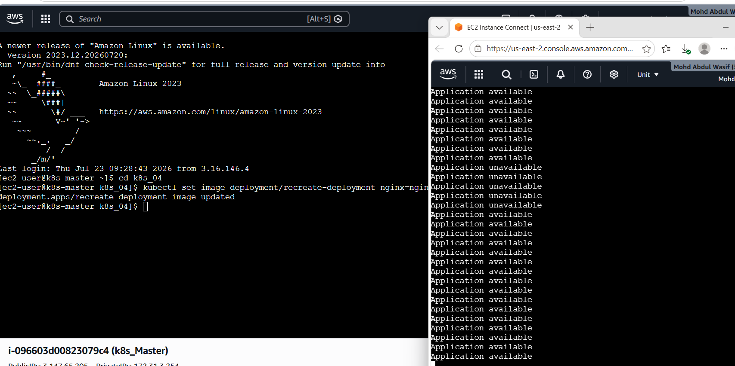
Step 5: Update the application
In the first terminal:
kubectl set image deployment/recreate-deployment \
nginx=nginx:1.27
Watch the Pods:
kubectl get pods -l app=recreate-nginx -w
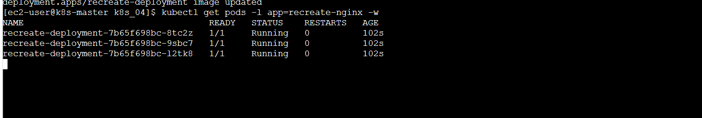
During the replacement, the testing terminal may show:
Application available
Application unavailable
Application unavailable
Application available
Stop both watch commands with Ctrl+C.
Step 6: Verify the strategy
kubectl describe deployment recreate-deployment
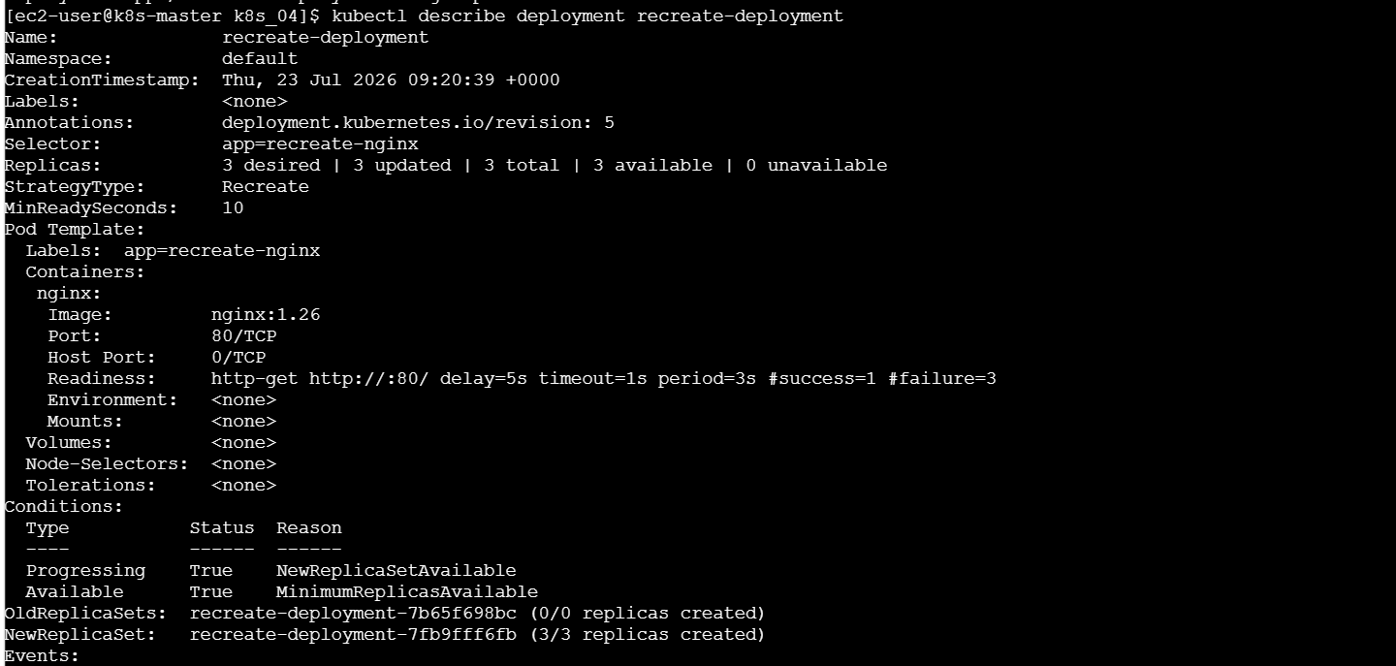
Look for:
StrategyType: Recreate
Observation
All old Pods were deleted before new Pods became Ready. During this time, the Service had no available backend Pods, causing temporary downtime.
Task 3: Update and Roll Back a Deployment
Step 1: Create the initial Deployment
vi rollback-deployment.yaml
Add:
apiVersion: apps/v1
kind: Deployment
metadata:
name: rollback-deployment
annotations:
kubernetes.io/change-cause: "Initial deployment with nginx 1.26"
spec:
replicas: 3

strategy:
type: RollingUpdate

selector:
matchLabels:
app: rollback-nginx

template:
metadata:
labels:
app: rollback-nginx
spec:
containers:
- name: nginx
image: nginx:1.26
ports:
- containerPort: 80
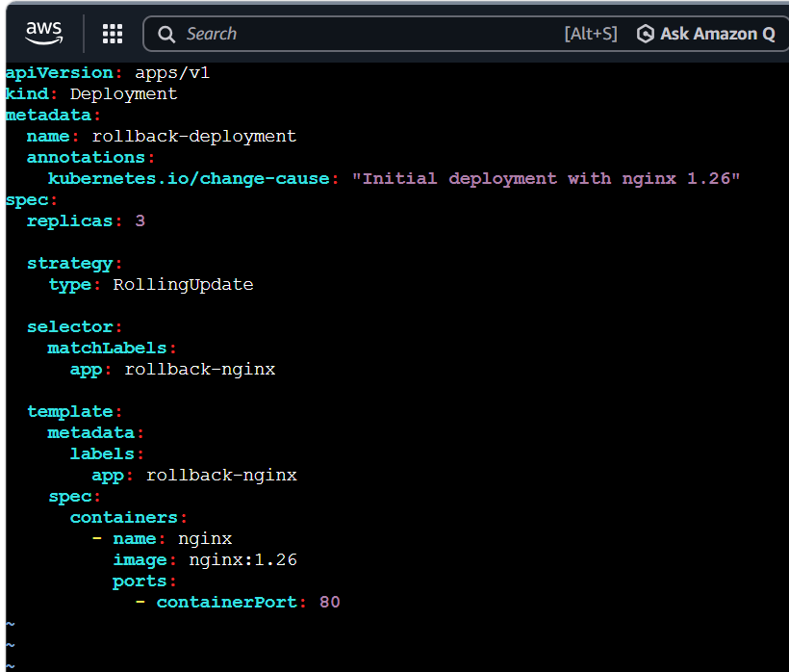
Deploy:
kubectl apply -f rollback-deployment.yaml
Check:
kubectl rollout status deployment/rollback-deployment
Step 2: Update the image
kubectl set image deployment/rollback-deployment \
nginx=nginx:1.27
Add a change description:
kubectl annotate deployment rollback-deployment \
kubernetes.io/change-cause="Updated nginx from 1.26 to 1.27" \
--overwrite
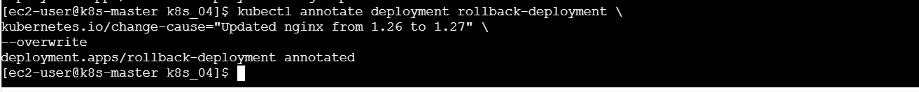
Check the rollout:
kubectl rollout status deployment/rollback-deployment
Check the image:
kubectl get deployment rollback-deployment \
-o jsonpath='{.spec.template.spec.containers[0].image}{"\n"}'
Expected:
nginx:1.27
Step 3: Check revision history
kubectl rollout history deployment/rollback-deployment
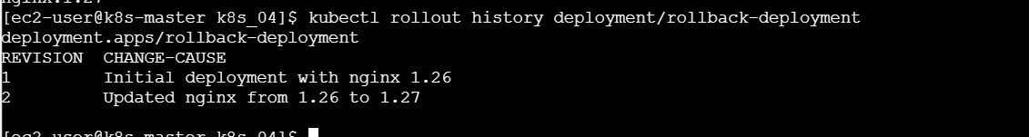
Expected example:
REVISION CHANGE-CAUSE
1 Initial deployment with nginx 1.26
2 Updated nginx from 1.26 to 1.27
Step 4: Perform rollback
kubectl rollout undo deployment/rollback-deployment
Check status:
kubectl rollout status deployment/rollback-deployment
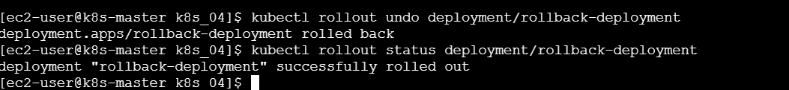
Check the image again:
kubectl get deployment rollback-deployment \
-o jsonpath='{.spec.template.spec.containers[0].image}{"\n"}'
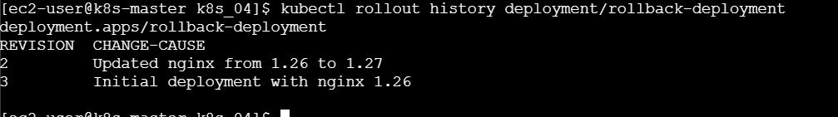
Expected:
nginx:1.26

Task 4: Add CPU and Memory Requests and Limits
Understanding resources
- Request: Minimum resources reserved for the container.
- Limit: Maximum resources the container is allowed to use.
Step 1: Create the Deployment
vi resource-deployment.yaml
Add:
apiVersion: apps/v1
kind: Deployment
metadata:
name: resource-deployment
spec:
replicas: 2

selector:
matchLabels:
app: resource-nginx

template:
metadata:
labels:
app: resource-nginx
spec:
containers:
- name: nginx
image: nginx:1.27
ports:
- containerPort: 80

resources:
requests:
cpu: "100m"
memory: "128Mi"
limits:
cpu: "500m"
memory: "256Mi"
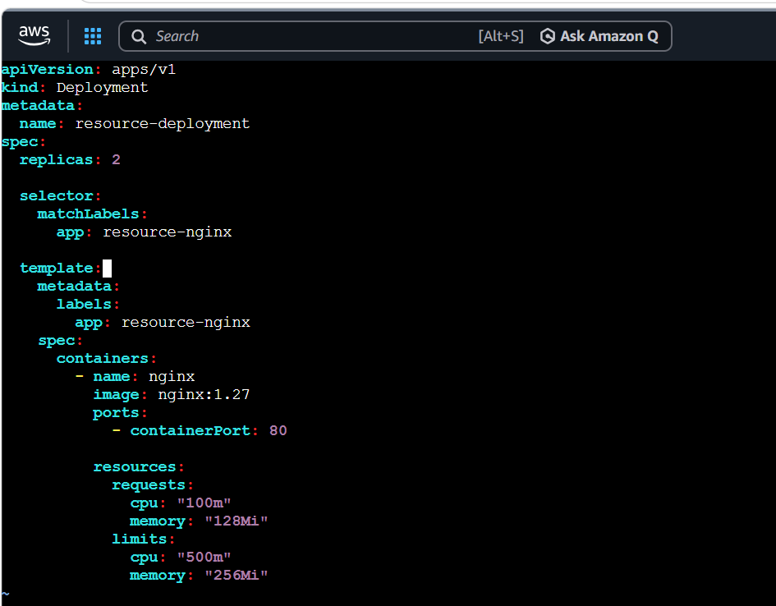
Step 2: Deploy
kubectl apply -f resource-deployment.yaml
Step 3: Verify
kubectl get deployment resource-deployment
kubectl get pods -l app=resource-nginx -o wide
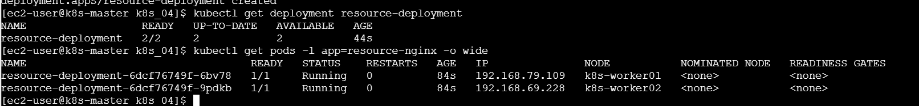
Describe one Pod:
kubectl describe pod <RESOURCE-POD-NAME>
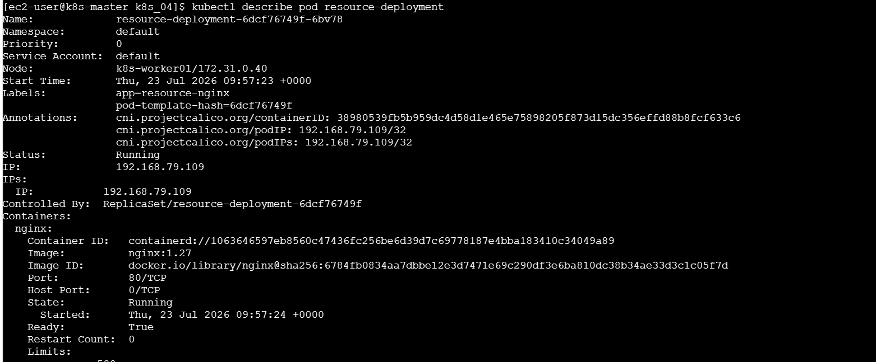
Look for:
Limits:
cpu: 500m
memory: 256Mi
Requests:
cpu: 100m
memory: 128Mi
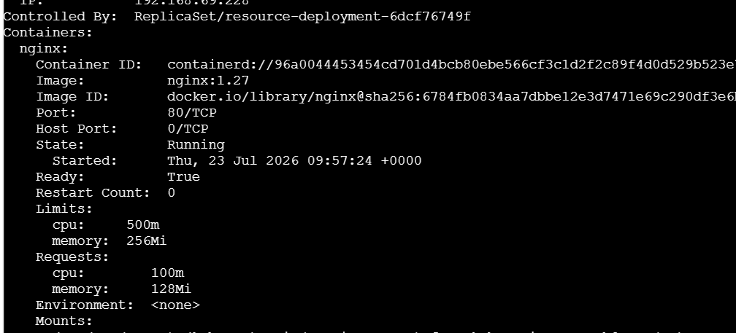
You can also check using:
kubectl get deployment resource-deployment \
-o jsonpath='{.spec.template.spec.containers[0].resources}{"\n"}'
Meaning
- 100m means 0.1 CPU core.
- 500m means 0.5 CPU core.
- 128Mi is the requested memory.
- 256Mi is the maximum memory.

Task 5: Configure MaxSurge and MaxUnavailable
Step 1: Create the YAML file
vi surge-deployment.yaml
Add:
apiVersion: apps/v1
kind: Deployment
metadata:
name: surge-deployment
spec:
replicas: 4
minReadySeconds: 10

strategy:
type: RollingUpdate
rollingUpdate:
maxSurge: 2
maxUnavailable: 1

selector:
matchLabels:
app: surge-nginx

template:
metadata:
labels:
app: surge-nginx
spec:
containers:
- name: nginx
image: nginx:1.26
ports:
- containerPort: 80
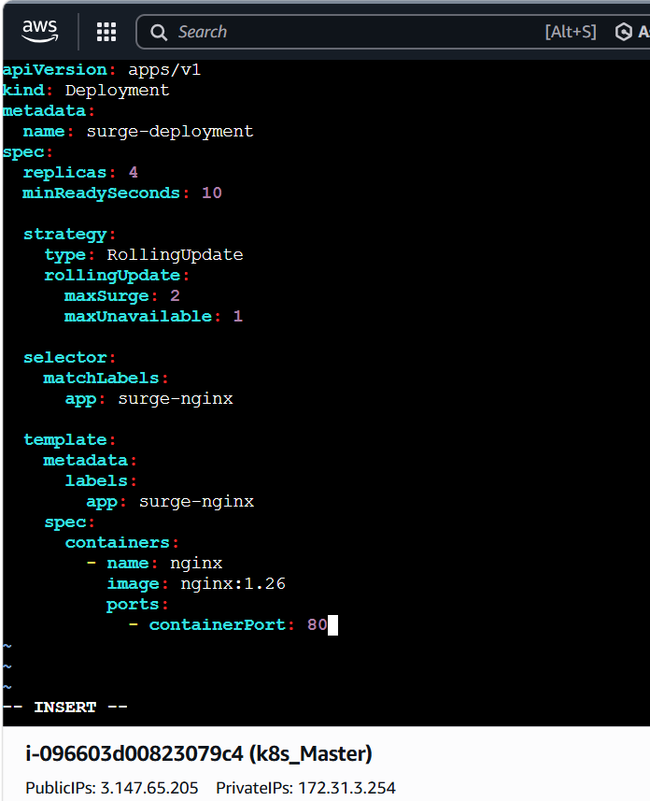
Step 2: Deploy
kubectl apply -f surge-deployment.yaml
Verify:
kubectl rollout status deployment/surge-deployment
kubectl get pods -l app=surge-nginx
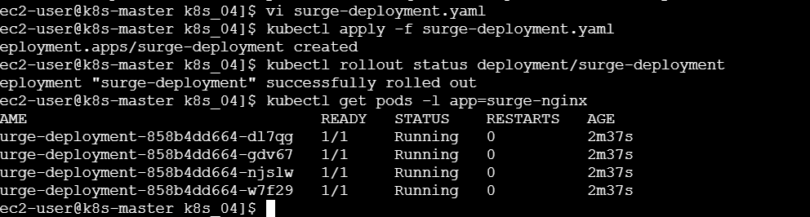
Step 3: Update the image
Run the watch command in one terminal:
kubectl get pods -l app=surge-nginx -w
In another terminal, update the image:
kubectl set image deployment/surge-deployment \
nginx=nginx:1.27
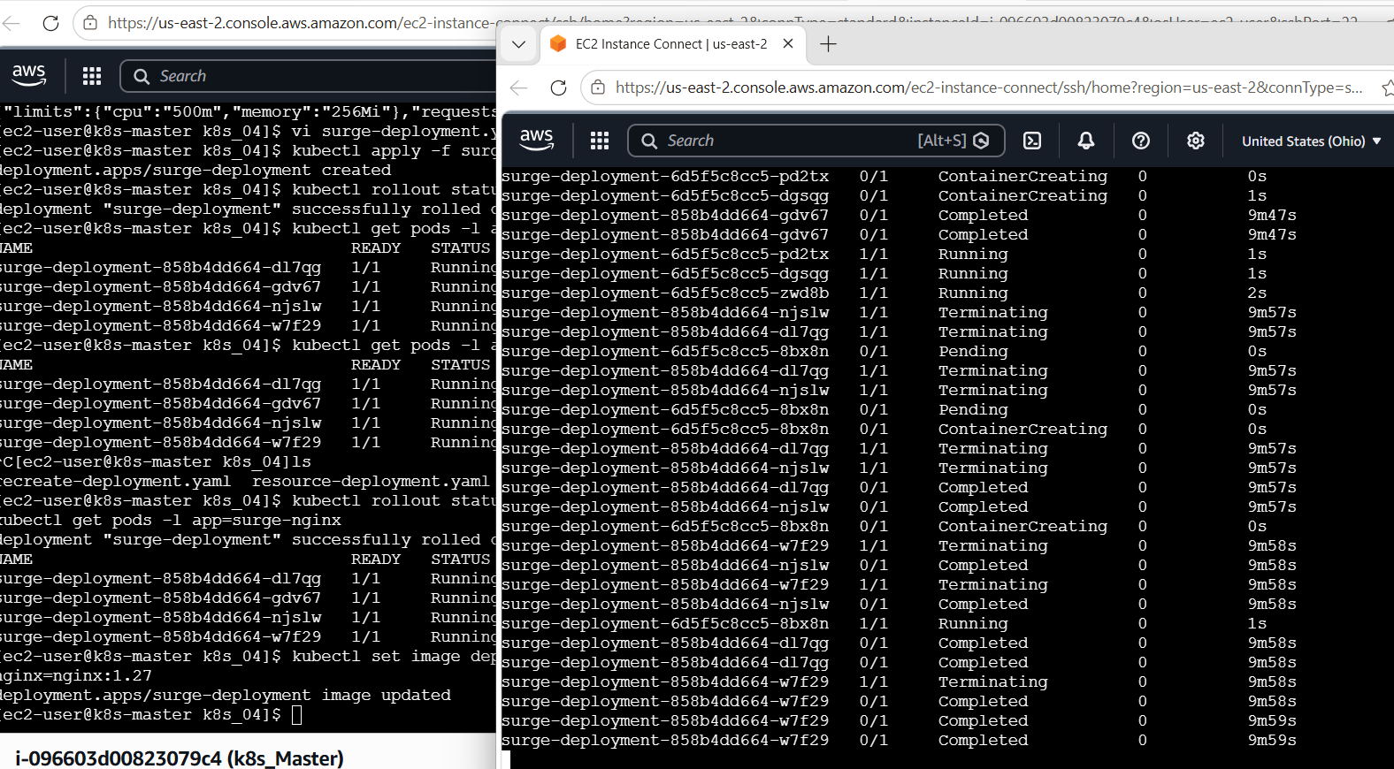
Explanation
The Deployment has:
Desired Pods: 4
MaxSurge: 2
MaxUnavailable: 1
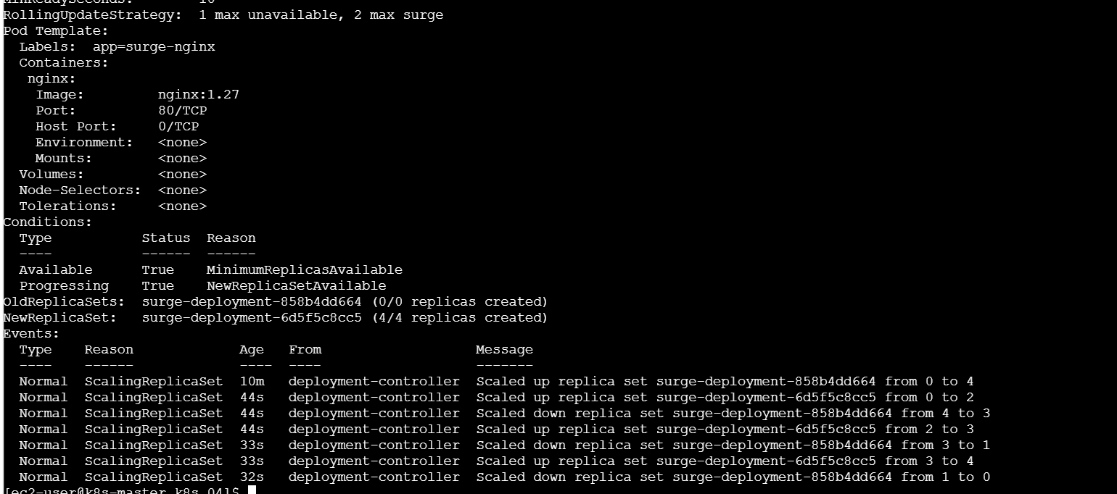
Therefore:
Maximum temporary Pods = 4 + 2 = 6
Minimum available Pods = 4 - 1 = 3
Verify the strategy:
kubectl describe deployment surge-deployment
Look for:
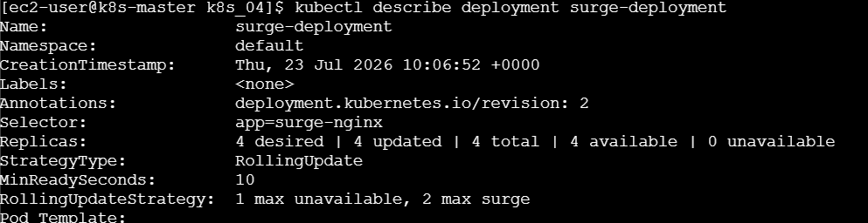
RollingUpdateStrategy: 1 max unavailable, 2 max surge
Task 6: Custom Revision History Limit
revisionHistoryLimit controls how many old ReplicaSets Kubernetes keeps for rollback.
Step 1: Create the YAML file
vi history-deployment.yaml
Add:
apiVersion: apps/v1
kind: Deployment
metadata:
name: history-deployment
annotations:
kubernetes.io/change-cause: "Revision 1 - nginx 1.25"
spec:
replicas: 2
revisionHistoryLimit: 3

selector:
matchLabels:
app: history-nginx

template:
metadata:
labels:
app: history-nginx
spec:
containers:
- name: nginx
image: nginx:1.25
ports:
- containerPort: 80
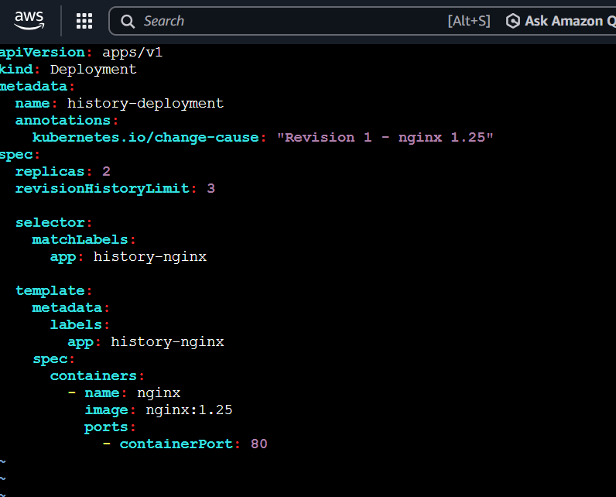
Step 2: Deploy
kubectl apply -f history-deployment.yaml
Check:
kubectl rollout status deployment/history-deployment
Step 3: Create more revisions
Create revision 2:
kubectl set image deployment/history-deployment nginx=nginx:1.26
kubectl annotate deployment history-deployment \
kubernetes.io/change-cause="Revision 2 - nginx 1.26" \
--overwrite
kubectl rollout status deployment/history-deployment
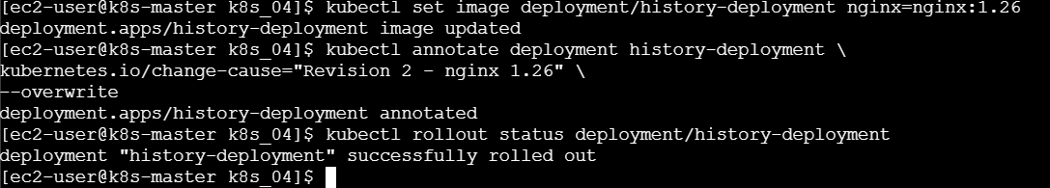
Create revision 3:
kubectl set image deployment/history-deployment nginx=nginx:1.27
kubectl annotate deployment history-deployment \
kubernetes.io/change-cause="Revision 3 - nginx 1.27" \
--overwrite
kubectl rollout status deployment/history-deployment
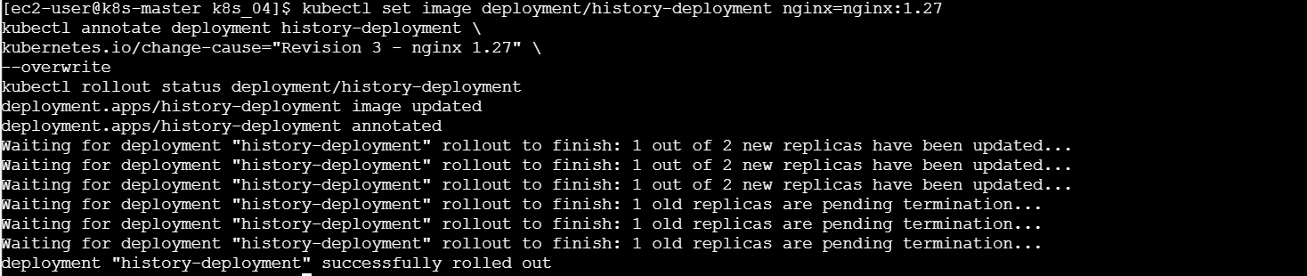
Create revision 4 by changing an environment variable:
kubectl set env deployment/history-deployment RELEASE=revision-4
kubectl annotate deployment history-deployment \
kubernetes.io/change-cause="Revision 4 - added environment variable" \
--overwrite
kubectl rollout status deployment/history-deployment
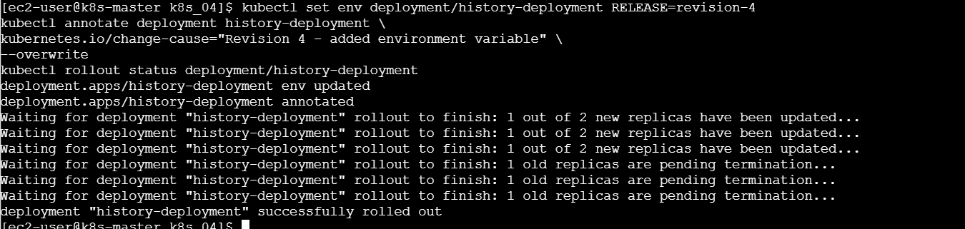
Step 4: Check history
kubectl rollout history deployment/history-deployment
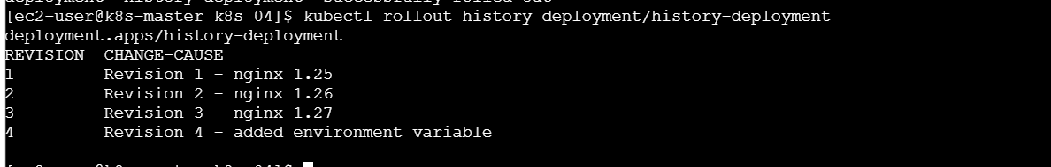
Check old ReplicaSets:
kubectl get replicasets -l app=history-nginx
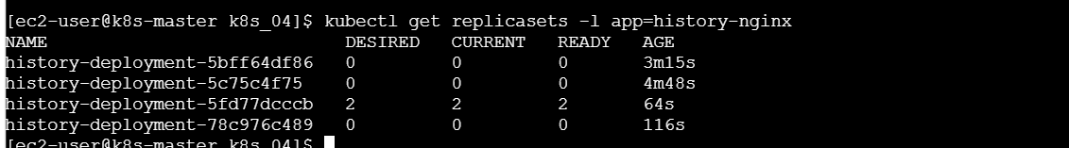
Observation
The Deployment keeps a limited number of old ReplicaSets according to:
revisionHistoryLimit: 3
The currently active ReplicaSet is separate from the retained old ReplicaSets. Very old ReplicaSets are cleaned up after a successful rollout.

Task 7: Pause and Resume a Deployment
Pausing lets you make changes without immediately rolling out new Pods.
Step 1: Create the Deployment
vi pause-deployment.yaml
Add:
apiVersion: apps/v1
kind: Deployment
metadata:
name: pause-deployment
spec:
replicas: 4
minReadySeconds: 10

strategy:
type: RollingUpdate
rollingUpdate:
maxSurge: 1
maxUnavailable: 1

selector:
matchLabels:
app: pause-nginx

template:
metadata:
labels:
app: pause-nginx
spec:
containers:
- name: nginx
image: nginx:1.26
ports:
- containerPort: 80
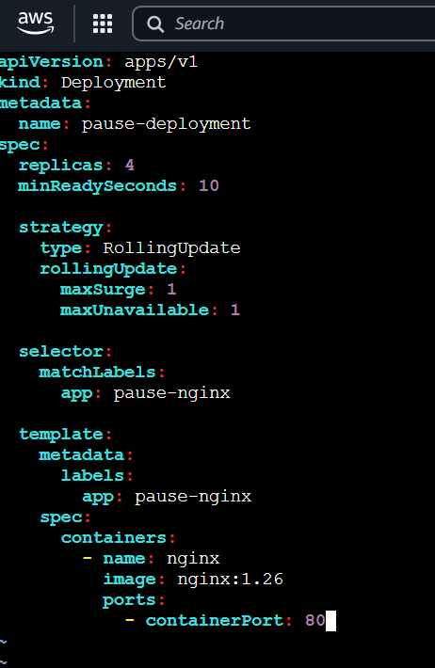
Deploy:
kubectl apply -f pause-deployment.yaml
kubectl rollout status deployment/pause-deployment
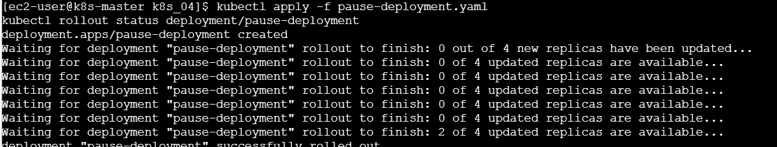
Step 2: Pause the Deployment
kubectl rollout pause deployment/pause-deployment
Expected:
deployment.apps/pause-deployment paused
Step 3: Make changes while paused
Change the image:
kubectl set image deployment/pause-deployment \
nginx=nginx:1.27
Add an environment variable:
kubectl set env deployment/pause-deployment \
ENVIRONMENT=production
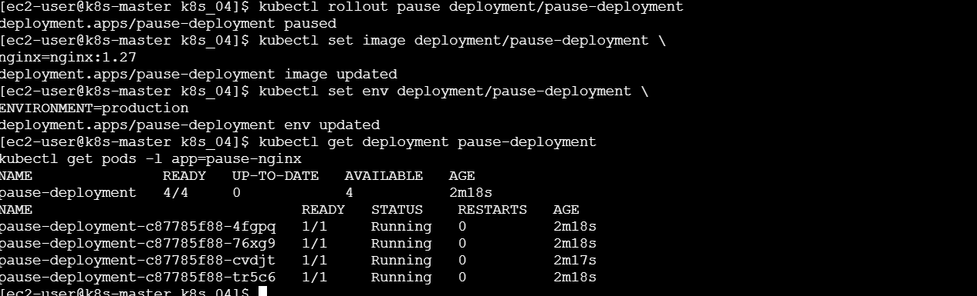
Check the status:
kubectl get deployment pause-deployment
kubectl get pods -l app=pause-nginx

Because the Deployment is paused, Kubernetes saves the changes but does not complete the rollout.
Verify paused status:
kubectl get deployment pause-deployment \
-o jsonpath='{.spec.paused}{"\n"}'
Expected:
true
Step 4: Resume the Deployment
kubectl rollout resume deployment/pause-deployment
Expected:
deployment.apps/pause-deployment resumed
Watch the rollout:
kubectl rollout status deployment/pause-deployment
Verify the new image:
kubectl get deployment pause-deployment \
-o jsonpath='{.spec.template.spec.containers[0].image}{"\n"}'
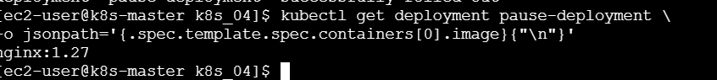
Expected:
nginx:1.27
Check Pods:
kubectl get pods -l app=pause-nginx
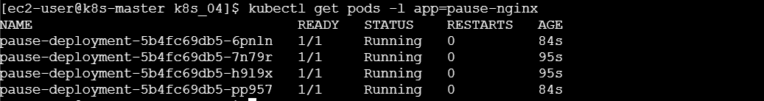
The standard kubectl rollout commands include pause, resume, status, restart, history and undo.
Task 8: Pod with CPU and Memory Requests
Kubernetes Scheduler checks the Pod’s resource requests and assigns it to a worker node with enough available CPU and memory.
Step 1: Check worker-node resources
kubectl describe nodes
Under each node, check:
Capacity
Allocatable
Allocated resources
You can get a shorter output using:
kubectl get nodes \
-o custom-columns=NAME:.metadata.name,CPU:.status.allocatable.cpu,MEMORY:.status.allocatable.memory
Step 2: Create the Pod YAML
vi scheduler-pod.yaml
Add:
apiVersion: v1
kind: Pod
metadata:
name: scheduler-resource-pod
labels:
app: scheduler-demo
spec:
containers:
- name: nginx
image: nginx:1.27
ports:
- containerPort: 80
resources:
requests:
cpu: "200m"
memory: "128Mi"
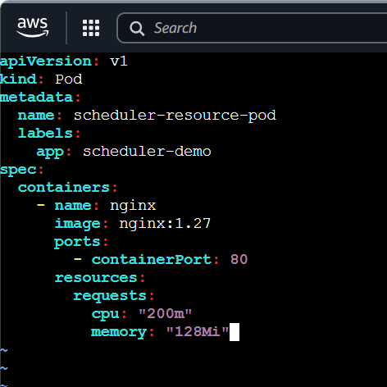
Step 3: Create the Pod
kubectl apply -f scheduler-pod.yaml
Step 4: Check which node was selected
kubectl get pod scheduler-resource-pod -o wide
Example:
NAME READY STATUS NODE
scheduler-resource-pod 1/1 Running k8s-worker01
Step 5: Check the scheduling event
kubectl describe pod scheduler-resource-pod
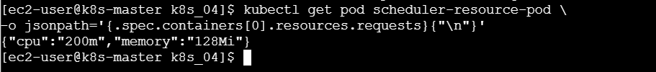
At the bottom, look for an event similar to:
Successfully assigned deployment-lab/scheduler-resource-pod to k8s-worker02
Check the requested resources:
kubectl get pod scheduler-resource-pod \
-o jsonpath='{.spec.containers[0].resources.requests}{"\n"}'
Expected:
{"cpu":"200m","memory":"128Mi"}
Observation
The scheduler selected a worker node that had enough available CPU and memory for the Pod’s resource requests.
Requests influence scheduling. A request does not guarantee that Kubernetes will choose a particular worker when multiple workers have enough capacity.

Important Verification Commands
kubectl get deployments
kubectl get replicasets
kubectl get pods -o wide
kubectl get all
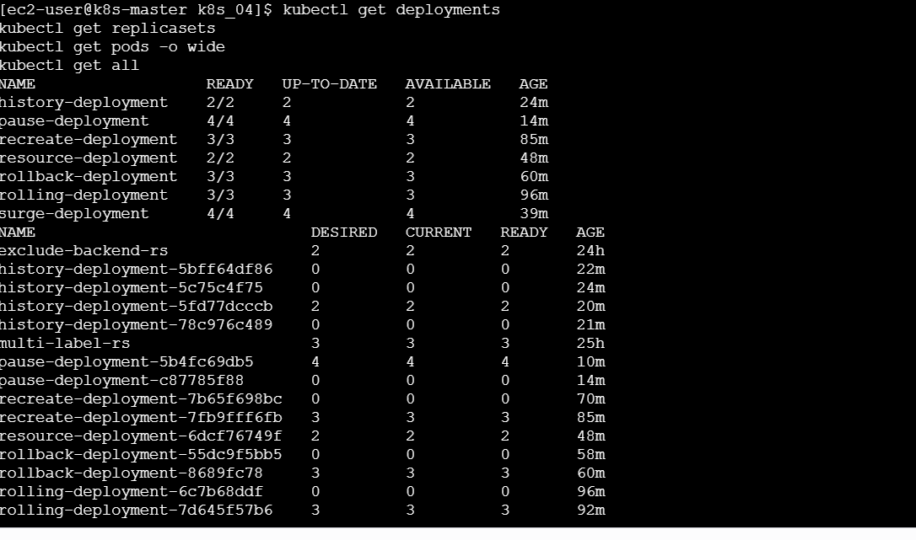
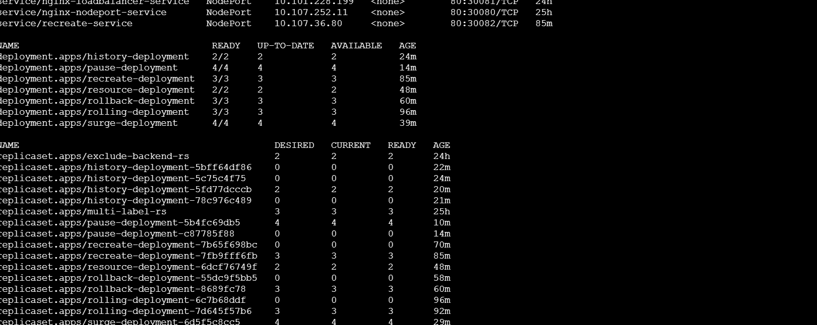
Check rollout status:
kubectl rollout status deployment/<DEPLOYMENT-NAME>
Check rollout history:
kubectl rollout history deployment/<DEPLOYMENT-NAME>
Check a Deployment:
kubectl describe deployment <DEPLOYMENT-NAME>
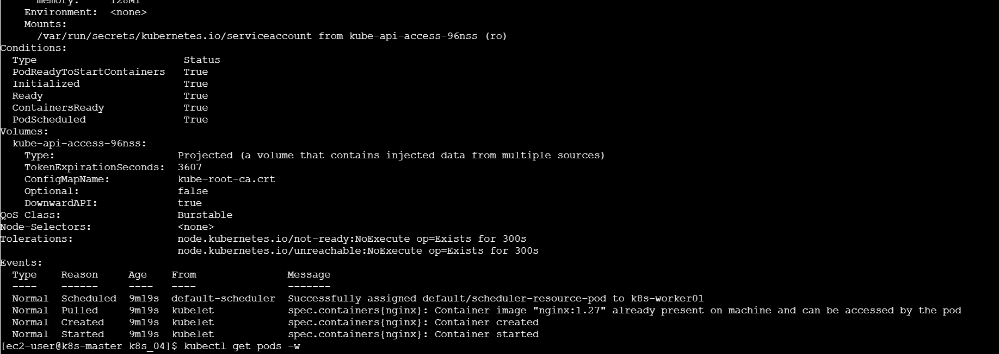
Check Pod events and scheduling:
kubectl describe pod <POD-NAME>
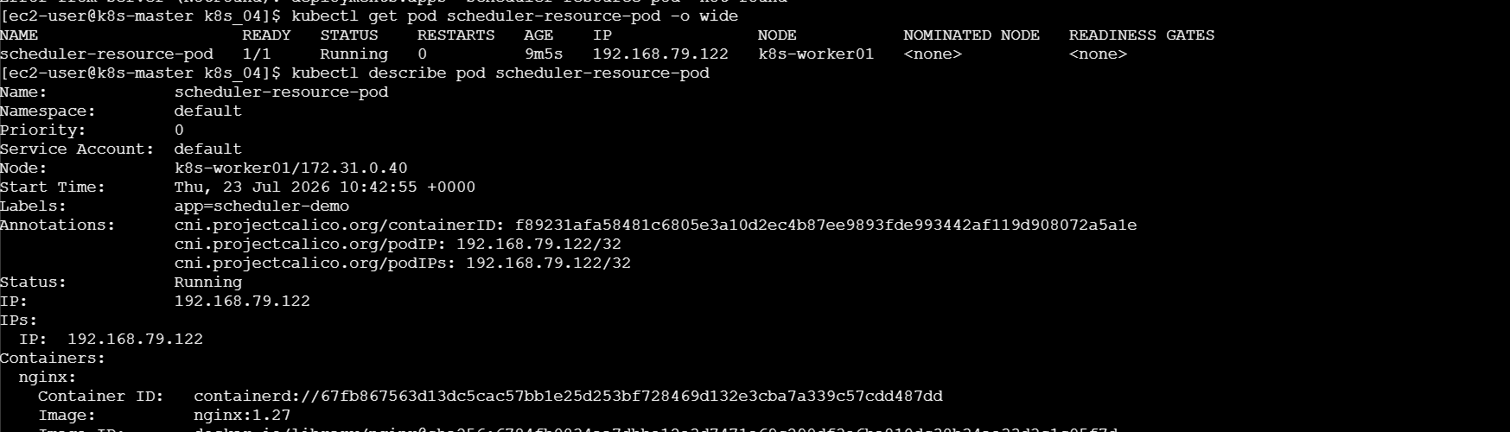
Watch Pods:
kubectl get pods -w
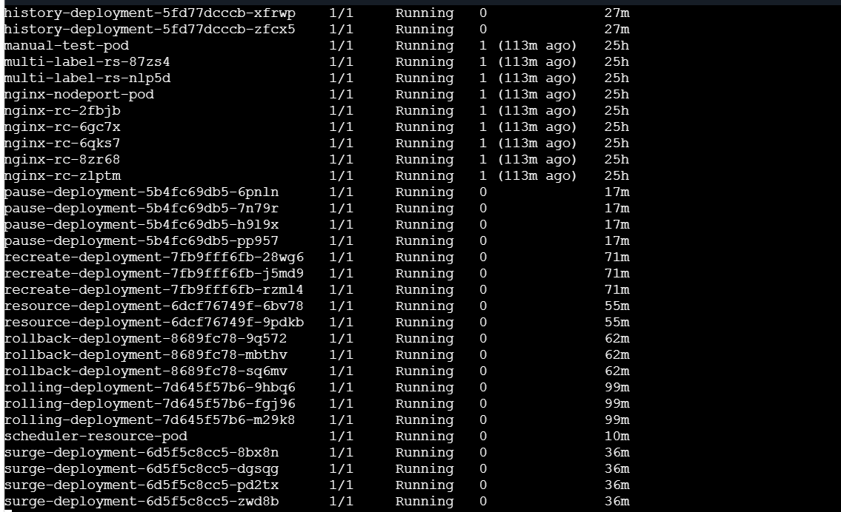
Press Ctrl+C to stop watching.

Cleanup
After completing your screenshots and documentation:
kubectl delete -f rolling-deployment.yaml
kubectl delete -f recreate-deployment.yaml
kubectl delete -f rollback-deployment.yaml
kubectl delete -f resource-deployment.yaml
kubectl delete -f surge-deployment.yaml
kubectl delete -f history-deployment.yaml
kubectl delete -f pause-deployment.yaml
kubectl delete -f scheduler-pod.yaml
Or delete the entire lab namespace:
kubectl delete namespace deployment-lab
Return to the default namespace:
kubectl config set-context --current --namespace=default
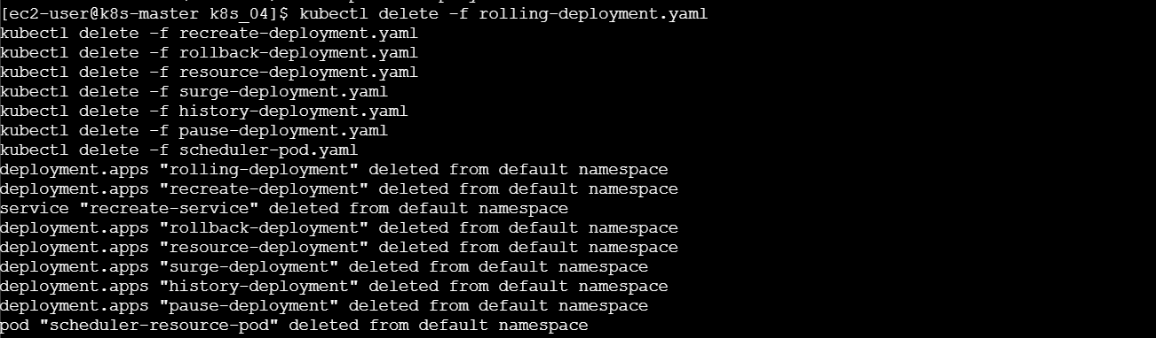

What We Learned
- A Deployment manages ReplicaSets and application Pods.
- Rolling Update gradually replaces Pods and normally avoids downtime.
- Recreate deletes all old Pods before starting new Pods, causing downtime.
- Deployment revisions allow applications to be rolled back.
- Resource requests help the scheduler select an appropriate node.
- Resource limits control maximum CPU and memory usage.
- maxSurge controls extra Pods during an update.
- maxUnavailable controls how many Pods may be unavailable.
- revisionHistoryLimit controls how many old ReplicaSets are retained.
- A Deployment update can be paused, modified and resumed.
- The scheduler assigns Pods according to available node resources and other scheduling rules.
Conclusion
In this lab, we deployed and updated applications using Rolling Update and Recreate strategies. We performed a rollback, configured CPU and memory resources, controlled update availability using maxSurge and maxUnavailable, managed revision history, paused and resumed a rollout, and observed how Kubernetes schedules a Pod according to its resource requests.

