Kubernetes-Task-06
Task 1: ConfigMap from Directory and Inject as Environment Variables
Objective
Create a ConfigMap from a directory containing multiple files. Inject each file’s value into a Pod as an environment variable.
Prerequisites
- Kubernetes cluster is running
- kubectl is working
- BusyBox image is available
Step 1: Create a directory
mkdir app-config
Step 2: Create configuration files
Create one file for each variable:
echo -n "production" > app-config/APP_ENV
echo -n "8080" > app-config/APP_PORT
echo -n "my-application" > app-config/APP_NAME
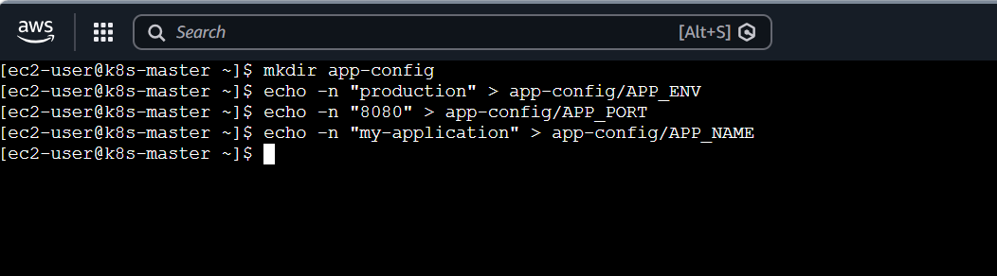
Check the files:
ls -l app-config
cat app-config/APP_ENV
cat app-config/APP_PORT
cat app-config/APP_NAME
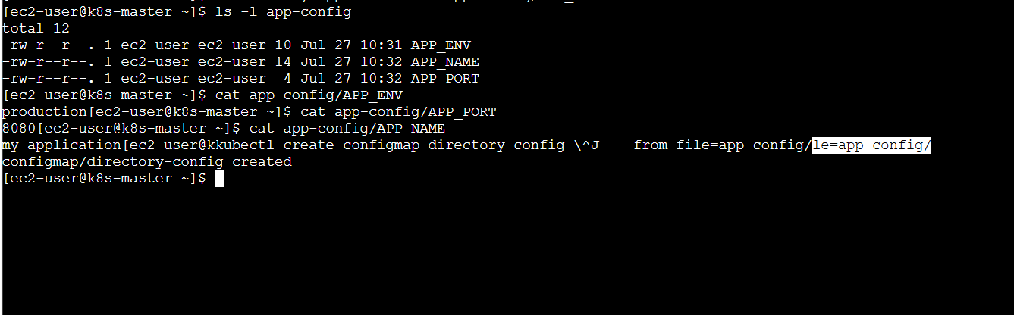
Directory structure:
app-config/
├── APP_ENV
├── APP_NAME
└── APP_PORT
The filenames become ConfigMap keys, and their contents become values.
Step 3: Create ConfigMap from directory
kubectl create configmap directory-config \
--from-file=app-config/

Expected output:
configmap/directory-config created
Step 4: Verify the ConfigMap
kubectl get configmap
kubectl describe configmap directory-config
You can also check the YAML:
kubectl get configmap directory-config -o yaml
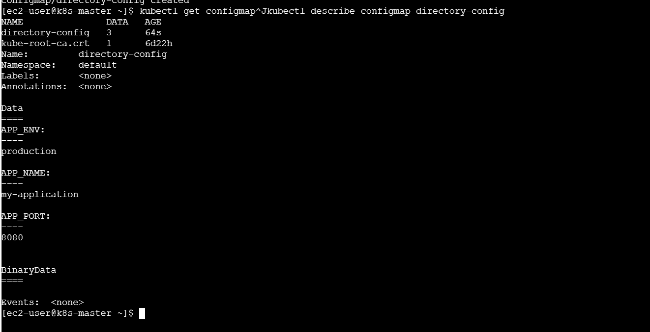
Step 5: Create the Pod YAML
Create the file:
vi directory-config-pod.yaml
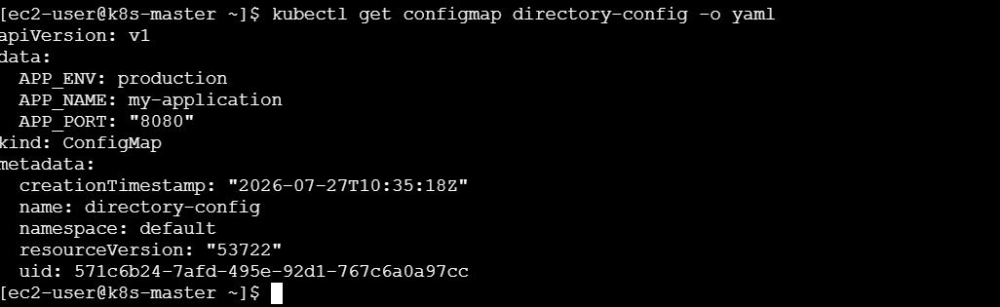
Add:
apiVersion: v1
kind: Pod
metadata:
name: directory-config-pod
spec:
containers:
- name: busybox
image: busybox:1.36
command: ["sh", "-c", "sleep 3600"]
envFrom:
- configMapRef:
name: directory-config
restartPolicy: Never
Save the file.
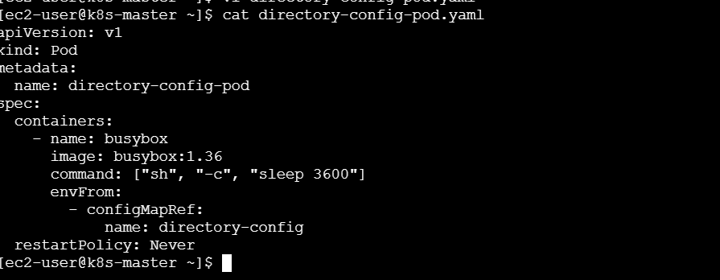
Step 6: Create the Pod
kubectl apply -f directory-config-pod.yaml
Check its status:
kubectl get pods
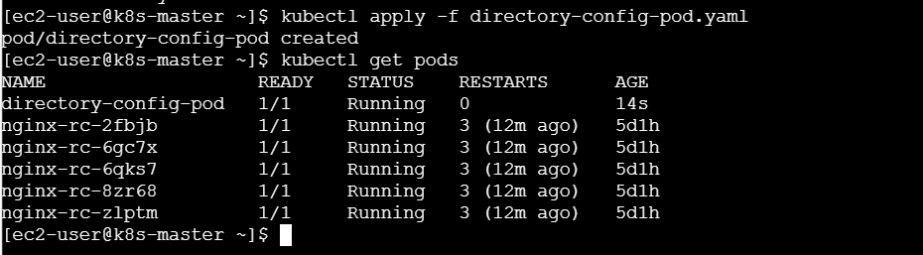
Wait until it shows:
directory-config-pod 1/1 Running
Step 7: Verify environment variables
kubectl exec directory-config-pod – env
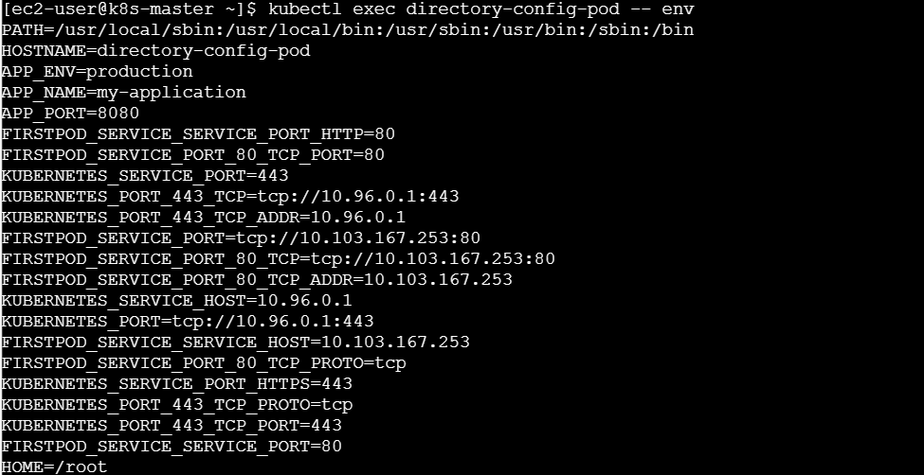
Check individual variables:
kubectl exec directory-config-pod -- printenv APP_NAME
kubectl exec directory-config-pod -- printenv APP_ENV
kubectl exec directory-config-pod -- printenv APP_PORT
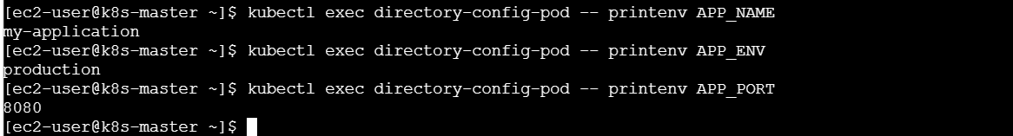
Expected output:
my-application
production
8080
Troubleshooting
kubectl describe pod directory-config-pod
kubectl logs directory-config-pod
If you receive configmap not found, confirm the ConfigMap and Pod are in the same namespace:
kubectl get configmap
kubectl get pod
What we learned
- Created a directory containing multiple configuration files.
- Created one ConfigMap using the complete directory.
- Understood that filenames become ConfigMap keys.
- Injected all ConfigMap values using envFrom.
- Verified the values with printenv.
Conclusion
A directory-based ConfigMap is useful when configuration is separated into multiple files. Using envFrom, all valid keys can be injected into a container as environment variables.

Task 2: ConfigMap from File and Mount as Volume
Objective
Create a ConfigMap from one configuration file and mount it inside a Pod as a file.
Prerequisites
- Kubernetes cluster is running
- kubectl is configured
- Basic understanding of volumes
Step 1: Create a configuration file
vi application.properties
Add:
app.name=shopping-app
app.environment=production
server.port=8080
database.host=mysql-service
Save the file.
Check it:
cat application.properties
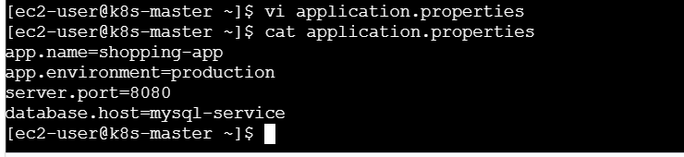
Step 2: Create ConfigMap from the file
kubectl create configmap file-config \
--from-file=application.properties
Step 3: Verify the ConfigMap
kubectl get configmap file-config
kubectl describe configmap file-config
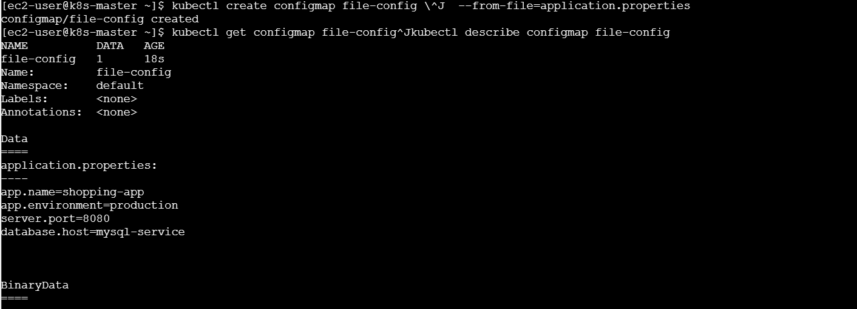
The key will be:
application.properties
The value will be the complete content of the file.
Step 4: Create the Pod YAML
vi file-config-pod.yaml
Add:
apiVersion: v1
kind: Pod
metadata:
name: file-config-pod
spec:
containers:
- name: busybox
image: busybox:1.36
command: ["sh", "-c", "sleep 3600"]
volumeMounts:
- name: config-volume
mountPath: /config
readOnly: true
volumes:
- name: config-volume
configMap:
name: file-config
restartPolicy: Never
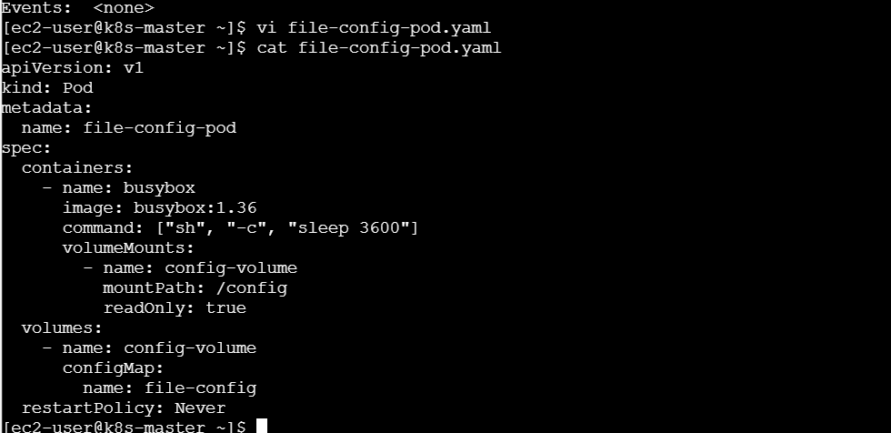
Step 5: Create the Pod
kubectl apply -f file-config-pod.yaml
Check:
kubectl get pods
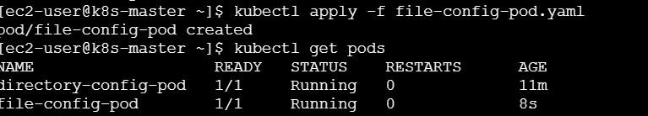
Step 6: Verify the mounted file
List the /config directory:
kubectl exec file-config-pod -- ls -l /config
Read the configuration:
kubectl exec file-config-pod -- cat /config/application.properties
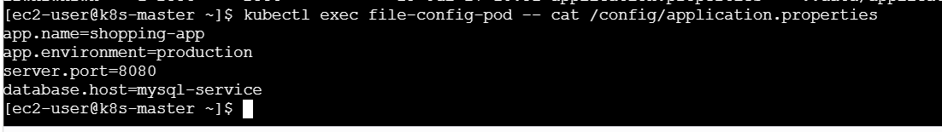
Expected output:
app.name=shopping-app
app.environment=production
server.port=8080
database.host=mysql-service
Important explanation
This time, the configuration is not injected as environment variables. Kubernetes creates the following file inside the container:
/config/application.properties
Troubleshooting
kubectl describe pod file-config-pod
kubectl get configmap file-config -o yaml
What we learned
- Created a ConfigMap from one file.
- Mounted the ConfigMap using a volume.
- Used volumeMounts inside the container section.
- Used volumes inside the Pod specification.
- Verified the configuration file inside the container.
Conclusion
A file-based ConfigMap volume is useful when an application expects configuration in files such as application.properties, nginx.conf or httpd.conf.

Task 3: Secret with Username and Password as Environment Variables
Objective
Create a Kubernetes Secret containing a username and password and inject both values into a Pod as environment variables.
Prerequisites
- Running Kubernetes cluster
- kubectl access
- Use only test credentials
Step 1: Create a generic Secret
kubectl create secret generic database-secret \
--from-literal=DB_USERNAME=admin \
--from-literal=DB_PASSWORD=Test@123
Expected output:
secret/database-secret created
Step 2: Verify the Secret
kubectl get secrets
kubectl describe secret database-secret
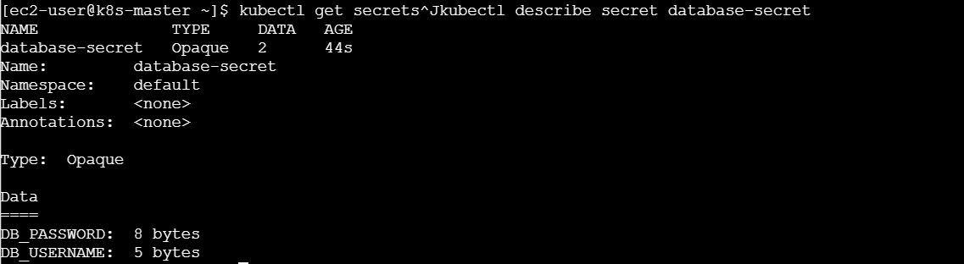
describe shows the keys and sizes but does not display the values.
Check the YAML:
kubectl get secret database-secret -o yaml
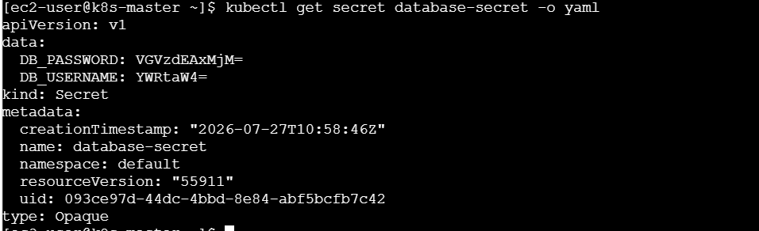
The values under data are Base64-encoded.
Base64 is encoding, not strong encryption.
Step 3: Create the Pod YAML
vi secret-env-pod.yaml
Add:
apiVersion: v1
kind: Pod
metadata:
name: secret-env-pod
spec:
containers:
- name: busybox
image: busybox:1.36
command: ["sh", "-c", "sleep 3600"]
env:
- name: DATABASE_USER
valueFrom:
secretKeyRef:
name: database-secret
key: DB_USERNAME

- name: DATABASE_PASSWORD
valueFrom:
secretKeyRef:
name: database-secret
key: DB_PASSWORD
restartPolicy: Never
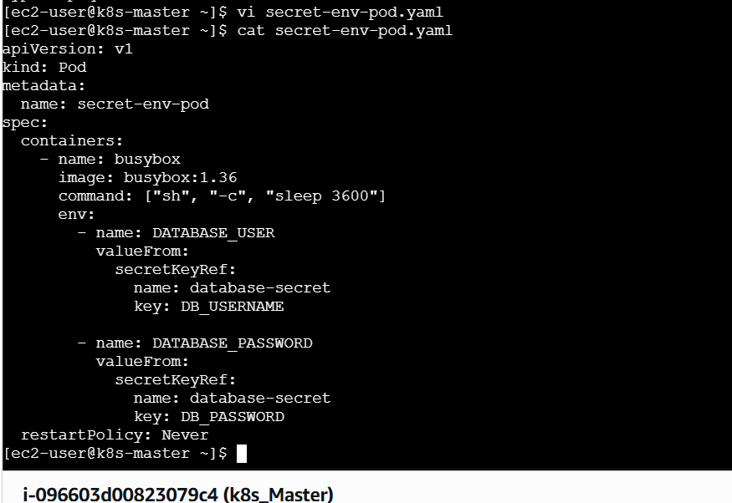
Step 4: Create the Pod
kubectl apply -f secret-env-pod.yaml
kubectl get pods
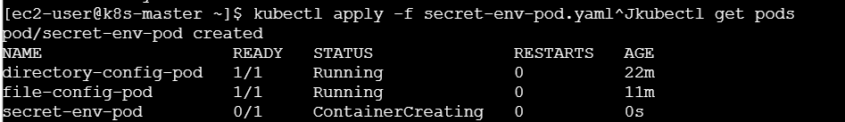
Step 5: Verify the username
kubectl exec secret-env-pod -- printenv DATABASE_USER
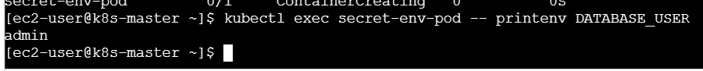
Expected output:
admin
For practice, verify that the password variable exists without printing it:
kubectl exec secret-env-pod -- sh -c \
'test -n "$DATABASE_PASSWORD" && echo "Password variable is available"'
Expected output:
Password variable is available
Alternative: Inject all Secret values
Instead of selecting individual keys, use:
envFrom:
- secretRef:
name: database-secret
This injects:
DB_USERNAME
DB_PASSWORD
Troubleshooting
kubectl describe pod secret-env-pod
kubectl get secret database-secret
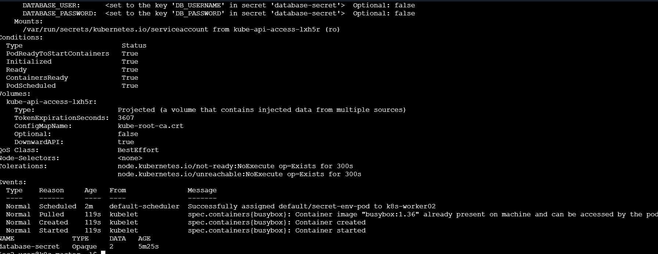
Common errors:
- Secret not found
- Incorrect Secret key
- Pod and Secret created in different namespaces
What we learned
- Created a generic Secret.
- Stored a test username and password.
- Used secretKeyRef to select specific values.
- Injected Secret values as environment variables.
- Verified that the variables were available inside the container.
Conclusion
Kubernetes Secrets are used for sensitive information. They can be injected into containers using secretKeyRef or envFrom.

Task 4: Create Secret Using YAML and Mount Specific Values as Files
Objective
Create a Secret using YAML, mount selected Secret values as files and verify them inside the Pod.
Prerequisites
- Kubernetes cluster is running
- kubectl configured
- YAML knowledge
- Use test credentials only
Step 1: Create the Secret YAML
vi application-secret.yaml
Add:
apiVersion: v1
kind: Secret
metadata:
name: application-secret
type: Opaque
stringData:
username: app-user
password: Demo@123
api-key: sample-api-key
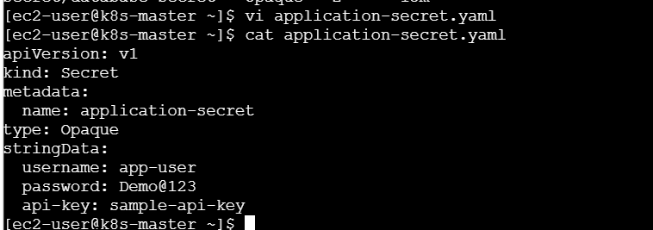
Why use stringData?
stringData allows us to provide plain values in YAML. Kubernetes converts them to Base64 before storing them.
Do not commit real passwords to Git.
Step 2: Create the Secret
kubectl apply -f application-secret.yaml
Verify:
kubectl get secret application-secret
kubectl describe secret application-secret
Step 3: Create the Pod YAML
vi secret-volume-pod.yaml
Add:
apiVersion: v1
kind: Pod
metadata:
name: secret-volume-pod
spec:
containers:
- name: busybox
image: busybox:1.36
command: ["sh", "-c", "sleep 3600"]
volumeMounts:
- name: secret-volume
mountPath: /secrets
readOnly: true
volumes:
- name: secret-volume
secret:
secretName: application-secret
items:
- key: username
path: application-username
- key: api-key
path: application-api-key
restartPolicy: Never
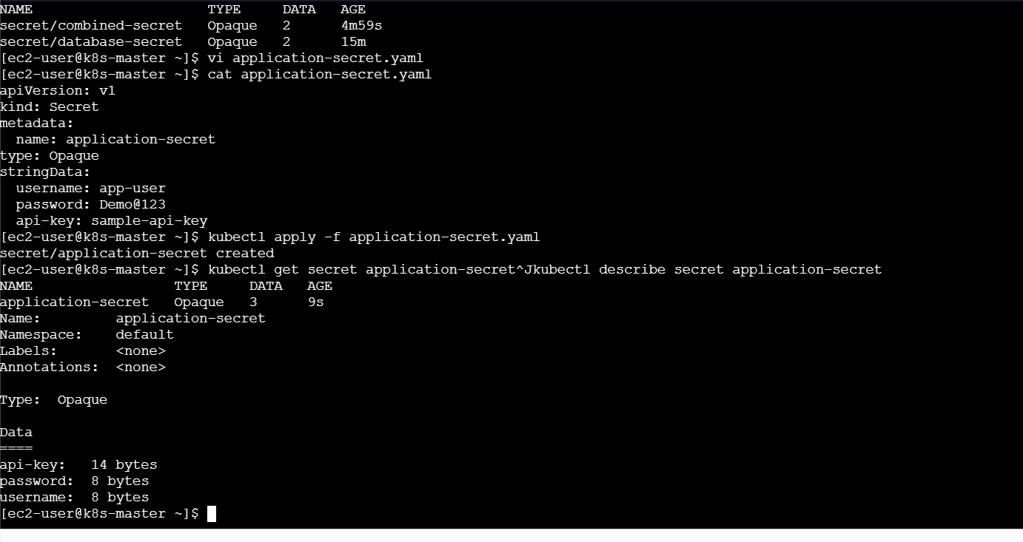
Important explanation
The items section mounts only:
username
api-key
The password is not mounted because it was not included under items.
The keys are renamed inside the Pod:
username → application-username
api-key → application-api-key
Step 4: Create the Pod
kubectl apply -f secret-volume-pod.yaml
kubectl get pods
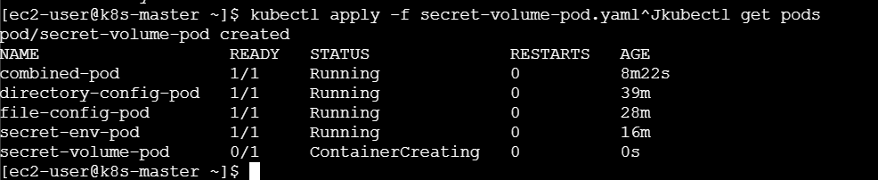
Step 5: Verify the mounted files
kubectl exec secret-volume-pod -- ls -l /secrets
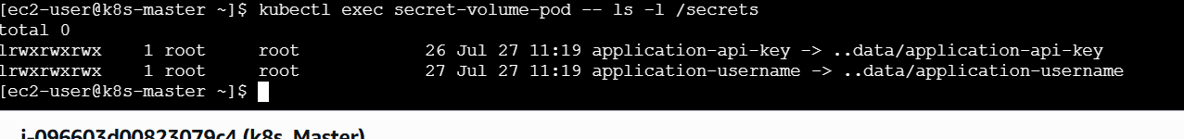
Expected files:
application-username
application-api-key
Read the sample username:
kubectl exec secret-volume-pod -- cat /secrets/application-username
Verify the API-key file exists without printing its value:
kubectl exec secret-volume-pod -- \
test -s /secrets/application-api-key
Check that the password file was not mounted:
kubectl exec secret-volume-pod -- ls /secrets
Troubleshooting
kubectl describe pod secret-volume-pod
kubectl get secret application-secret -o yaml
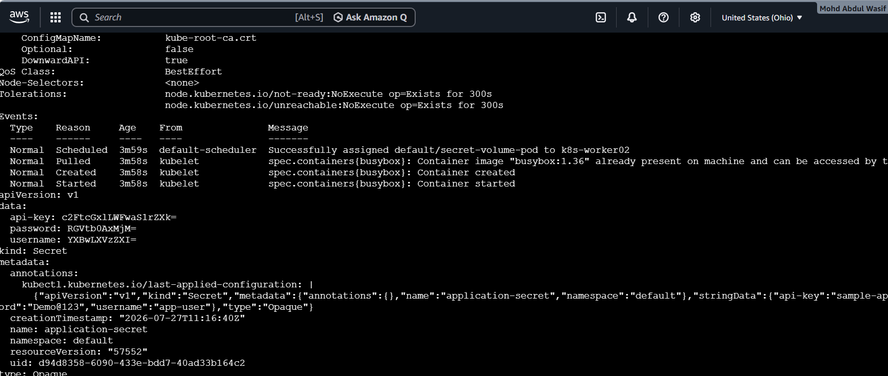
If a key under items does not exist, the volume will fail to mount.
What we learned
- Created a Secret using YAML.
- Used stringData for simple Secret creation.
- Mounted the Secret using a volume.
- Selected specific Secret keys using items.
- Renamed mounted files using path.
- Verified the files inside the container.
Conclusion
Mounting Secrets as files is useful when applications read credentials from specific file paths. The items option allows us to mount only the required Secret values.

Task 5: ConfigMap as Environment Variables and Secret as Files
Objective
Inject non-sensitive ConfigMap values as environment variables and mount sensitive Secret values as files inside the same Pod.
Prerequisites
- Running Kubernetes cluster
- Existing ConfigMap and Secret knowledge
- kubectl configured
- Use sample Secret values only
Step 1: Create the ConfigMap
kubectl create configmap combined-config \
--from-literal=APP_NAME=payment-service \
--from-literal=APP_ENV=production \
--from-literal=APP_PORT=8080
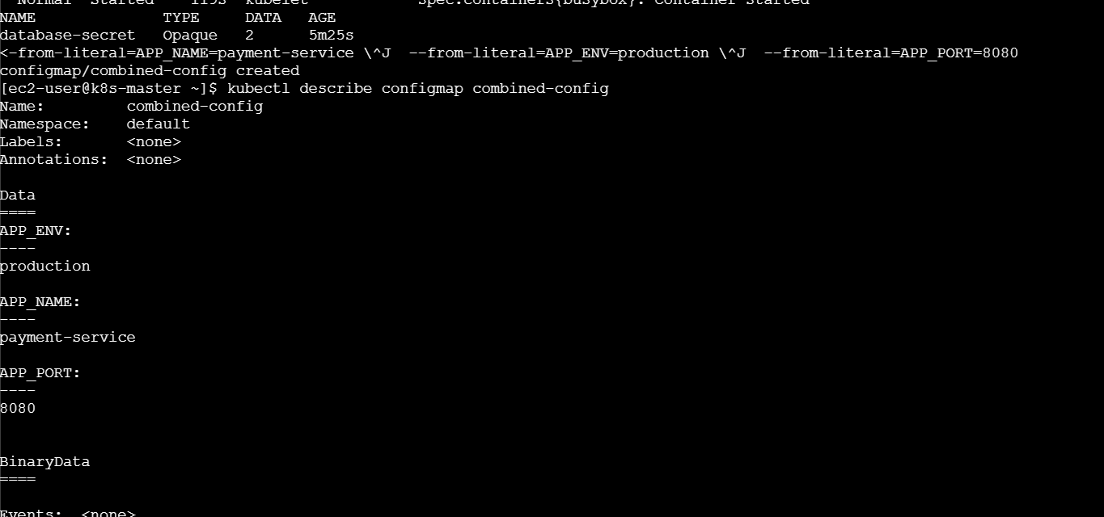
Verify:
kubectl describe configmap combined-config
Step 2: Create the Secret
kubectl create secret generic combined-secret \
--from-literal=username=payment-user \
--from-literal=password=Demo@456
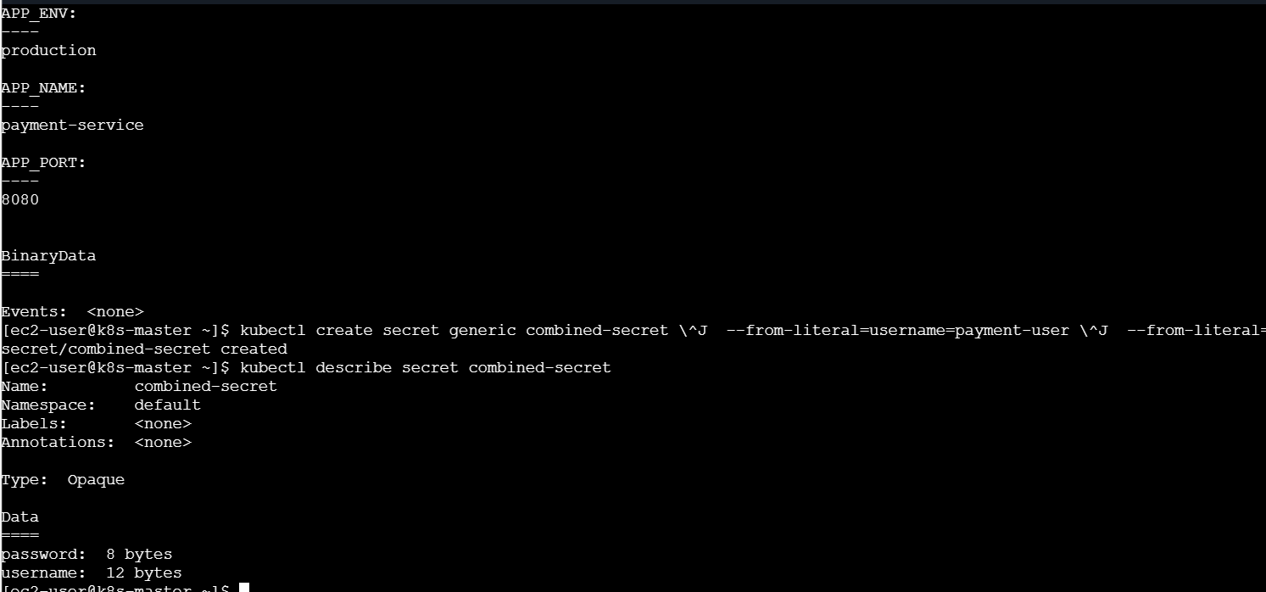
Verify:
kubectl describe secret combined-secret
Step 3: Create the Pod YAML
vi combined-pod.yaml
Add:
apiVersion: v1
kind: Pod
metadata:
name: combined-pod
spec:
containers:
- name: busybox
image: busybox:1.36
command: ["sh", "-c", "sleep 3600"]

envFrom:
- configMapRef:
name: combined-config

volumeMounts:
- name: secret-volume
mountPath: /credentials
readOnly: true

volumes:
- name: secret-volume
secret:
secretName: combined-secret

restartPolicy: Never
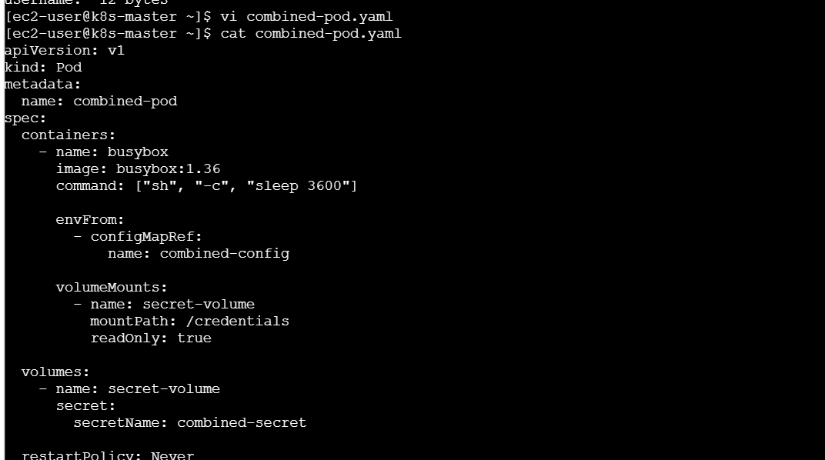
Step 4: Create the Pod
kubectl apply -f combined-pod.yaml
kubectl get pods
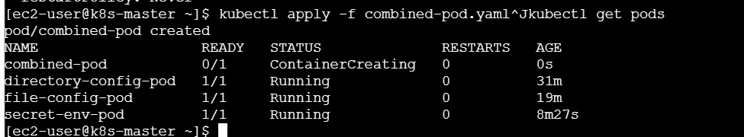
Step 5: Verify ConfigMap environment variables
kubectl exec combined-pod -- printenv APP_NAME
kubectl exec combined-pod -- printenv APP_ENV
kubectl exec combined-pod -- printenv APP_PORT
Expected output:
payment-service
production
8080
Step 6: Verify Secret files
kubectl exec combined-pod -- ls -l /credentials
Expected files:
username
password
Read the sample username:
kubectl exec combined-pod -- cat /credentials/username
Verify the password file is available without displaying it:
kubectl exec combined-pod -- sh -c \
'test -s /credentials/password && echo "Password file is available"'
Expected output:
Password file is available
Step 7: Verify both together
kubectl exec combined-pod -- sh -c \
'echo "Application: $APP_NAME"; echo "Environment: $APP_ENV"; ls /credentials'
This confirms:
- ConfigMap values are available as environment variables.
- Secret values are available as files.
Troubleshooting
kubectl describe pod combined-pod
kubectl get events --sort-by=.metadata.creationTimestamp
Check whether all resources are in the same namespace:
kubectl get pod,configmap,secret
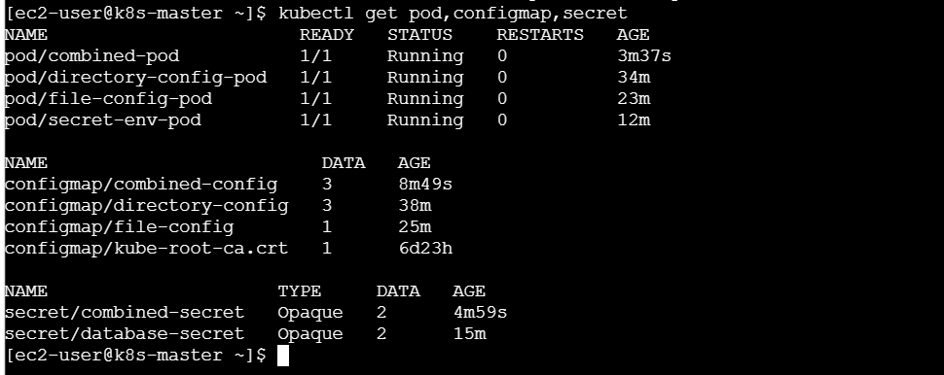
What we learned
- Used a ConfigMap and Secret in the same Pod.
- Injected non-sensitive values through envFrom.
- Mounted sensitive values as read-only files.
- Verified environment variables and mounted files.
- Separated application settings from credentials.
Conclusion
Using ConfigMaps for application configuration and Secrets for credentials provides clear separation between non-sensitive and sensitive data. Both resources can be consumed by the same container in different ways.

Final learning summary
After completing all five tasks, we learned:
- ConfigMaps store non-sensitive configuration.
- Secrets store sensitive information.
- ConfigMaps can be created from directories and files.
- Secrets can be created through commands or YAML.
- ConfigMaps and Secrets can be injected as environment variables.
- They can also be mounted as files through volumes.
- A Pod and its ConfigMap or Secret must be in the same namespace.
- Incorrect names or keys can cause CreateContainerConfigError.
- Secret values should not be printed unnecessarily.
- Base64 encoding is not encryption.
Final memory trick
Creation methods: L-F-D-E
- L – Literal
- F – File
- D – Directory
- E – Environment file
Injection methods: E-V
- E – Environment variables
- V – Volume files
Data selection: C-S
- C – ConfigMap for configuration
- S – Secret for sensitive data
Optional cleanup
After taking screenshots and completing your documentation:
kubectl delete pod \
directory-config-pod \
file-config-pod \
secret-env-pod \
secret-volume-pod \
combined-pod
Delete ConfigMaps:
kubectl delete configmap \
directory-config \
file-config \
combined-config
Delete Secrets:
kubectl delete secret \
database-secret \
application-secret \
combined-secret
Verify cleanup:
kubectl get pods
kubectl get configmaps
kubectl get secrets
