Kubernetes-Task-05

Kubernetes Namespaces, ResourceQuota and LimitRange – 5 Tasks
Objective
Learn how to:
- Create and manage Kubernetes namespaces.
- Restrict Pods and Services using ResourceQuota.
- Assign CPU and memory requests and limits.
- Automatically control container resources using LimitRange.
- Communicate across namespaces using Service DNS.
- Restrict the limit-to-request ratio.

Task 1: ResourceQuota in dev-environment
Requirement
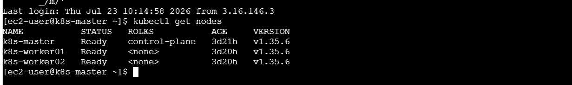
Create the dev-environment namespace and allow a maximum of:
- 3 Pods
- 2 Services
Step 1: Create the namespace
kubectl create namespace dev-environment
Verify:
kubectl get namespaces
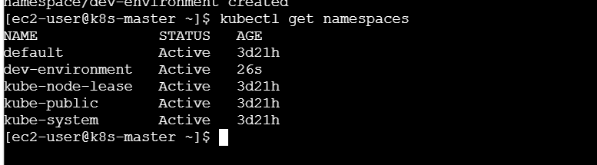
Step 2: Create the quota YAML file
vi dev-resource-quota.yaml
Add:
apiVersion: v1
kind: ResourceQuota
metadata:
name: dev-resource-quota
namespace: dev-environment
spec:
hard:
pods: "3"
services: "2"
Save the file:
Esc
:wq
Enter
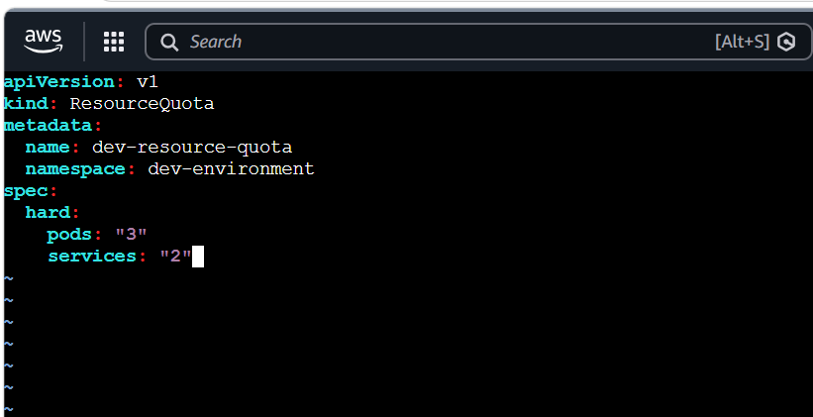
Step 3: Apply the quota
kubectl apply -f dev-resource-quota.yaml
Step 4: Verify
kubectl get resourcequota -n dev-environment
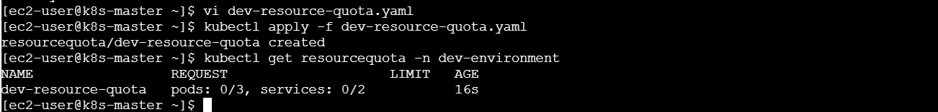
kubectl describe resourcequota dev-resource-quota -n dev-environment
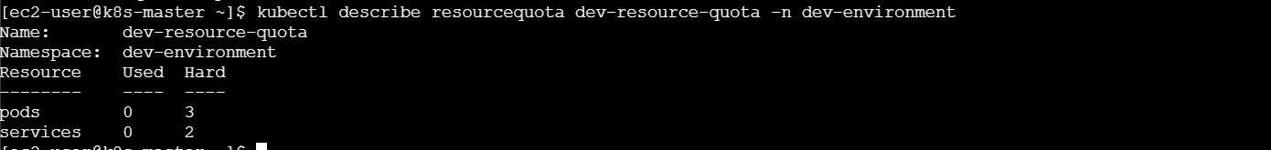
Expected output:
Resource Used Hard
-------- ---- ----
pods 0 3
services 0 2
Step 5: Test the Pod quota
Create three Pods:
kubectl run dev-pod1 --image=nginx -n dev-environment
kubectl run dev-pod2 --image=nginx -n dev-environment
kubectl run dev-pod3 --image=nginx -n dev-environment
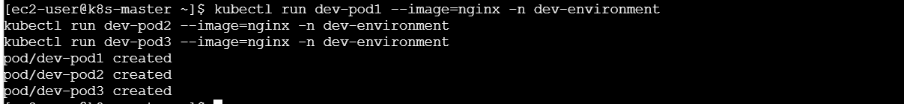
Try creating the fourth Pod:
kubectl run dev-pod4 --image=nginx -n dev-environment
Expected error:
exceeded quota: dev-resource-quota
requested: pods=1
used: pods=3
limited: pods=3
Check:
kubectl get pods -n dev-environment
kubectl describe resourcequota dev-resource-quota -n dev-environment
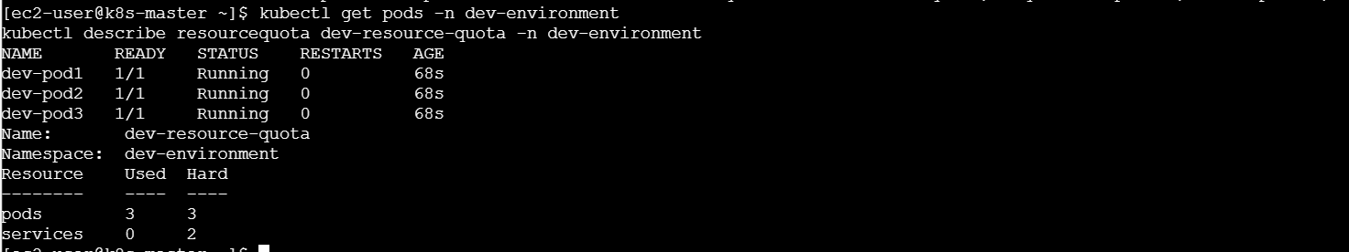
Result: The namespace allows only 3 Pods and 2 Services.

Task 2: Pod resources in prod-environment
Requirement
Create a Pod with:
Resource | Request | Limit
CPU | 0.2 CPU or 200m | 0.5 CPU or 500m
Memory | 200Mi | 500Mi
Step 1: Create the namespace
kubectl create namespace prod-environment
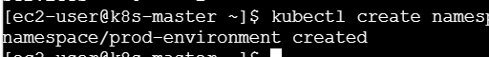
Step 2: Create the Pod YAML file
vi prod-resource-pod.yaml
Add:
apiVersion: v1
kind: Pod
metadata:
name: prod-resource-pod
namespace: prod-environment
labels:
app: prod-app
spec:
containers:
- name: nginx-container
image: nginx:latest
resources:
requests:
cpu: "200m"
memory: "200Mi"
limits:
cpu: "500m"
memory: "500Mi"
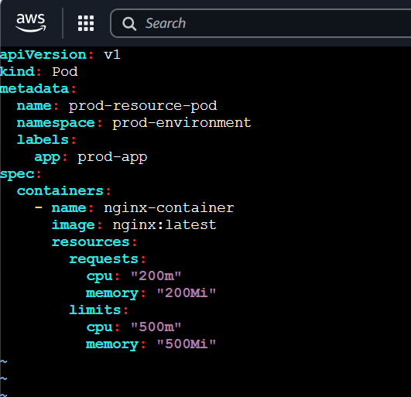
Step 3: Apply the file
kubectl apply -f prod-resource-pod.yaml
Step 4: Verify
kubectl get pods -n prod-environment
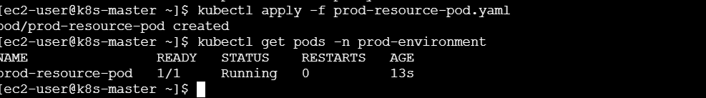
kubectl describe pod prod-resource-pod -n prod-environment
Look for:
Limits:
cpu: 500m
memory: 500Mi
Requests:
cpu: 200m
memory: 200Mi
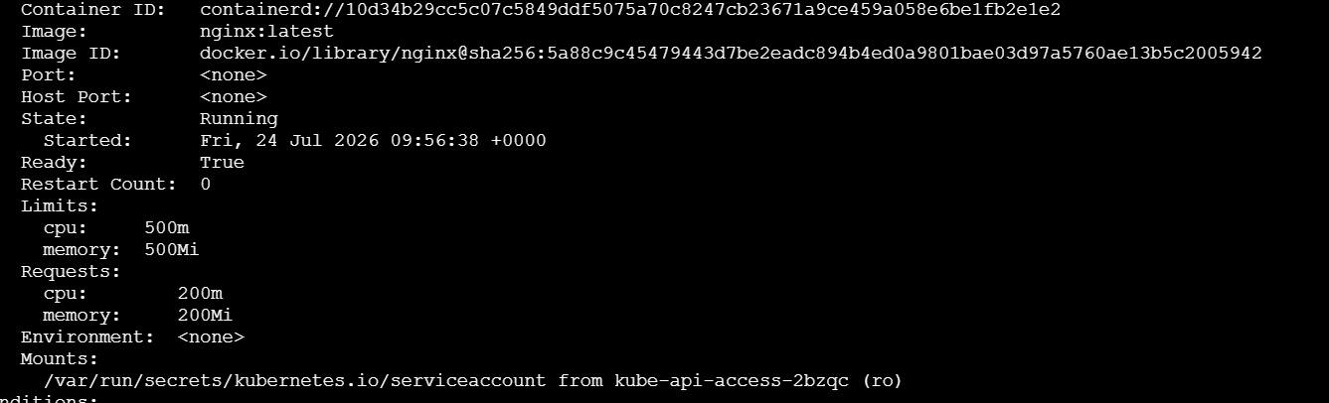
You can also verify using:
kubectl get pod prod-resource-pod -n prod-environment \
-o jsonpath='{.spec.containers[0].resources}'
Result: The Pod reserves 200m CPU and 200Mi memory, but it cannot use more than 500m CPU and 500Mi memory.
1000m CPU = 1 CPU, so 200m = 0.2 CPU and 500m = 0.5 CPU.
Task 3: LimitRange in staging-environment
Requirement
Configure:
- Default CPU limit: 300m
- Default memory limit: 600Mi
- Minimum CPU: 100m
- Maximum CPU: 1
The task does not specify the minimum and maximum CPU values, so we are using 100m and 1 CPU.
Step 1: Create the namespace
kubectl create namespace staging-environment
Step 2: Create the LimitRange YAML
vi staging-limitrange.yaml
Add:
apiVersion: v1
kind: LimitRange
metadata:
name: staging-limitrange
namespace: staging-environment
spec:
limits:
- type: Container
default:
cpu: "300m"
memory: "600Mi"
min:
cpu: "100m"
max:
cpu: "1"
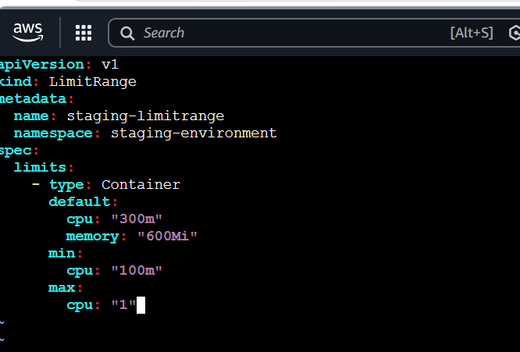
Step 3: Apply the LimitRange
kubectl apply -f staging-limitrange.yaml
Step 4: Verify
kubectl get limitrange -n staging-environment
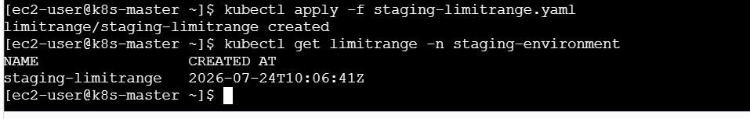
kubectl describe limitrange staging-limitrange -n staging-environment
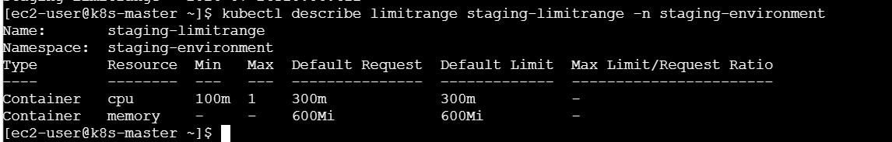
Step 5: Create a Pod without resources
vi staging-pod.yaml
Add:
apiVersion: v1
kind: Pod
metadata:
name: staging-pod
namespace: staging-environment
spec:
containers:
- name: nginx-container
image: nginx:latest
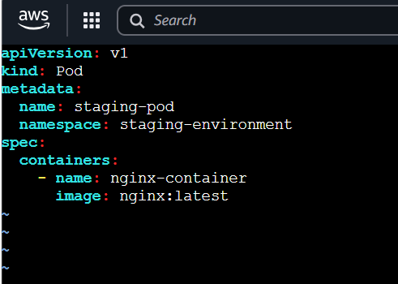
Apply:
kubectl apply -f staging-pod.yaml
Step 6: Check the automatically assigned resources
kubectl describe pod staging-pod -n staging-environment
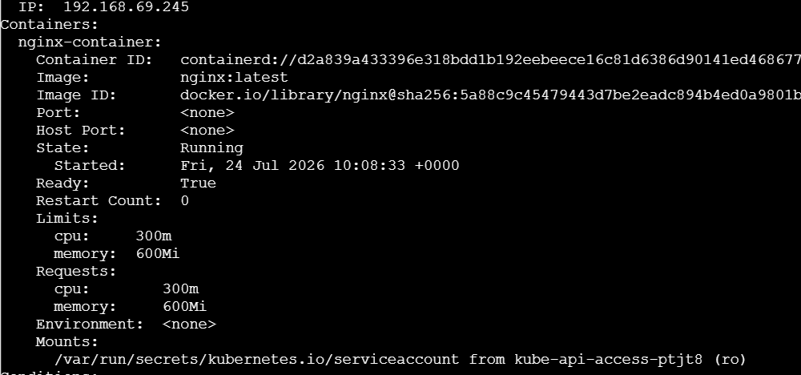
Look for:
Limits:
cpu: 300m
memory: 600Mi
Check the complete resources section:
kubectl get pod staging-pod -n staging-environment \
-o jsonpath='{.spec.containers[0].resources}'
Optional failure test
Try creating a container with more than the maximum CPU:
kubectl run high-cpu-pod \
--image=nginx \
--namespace=staging-environment \
--requests=cpu=1500m
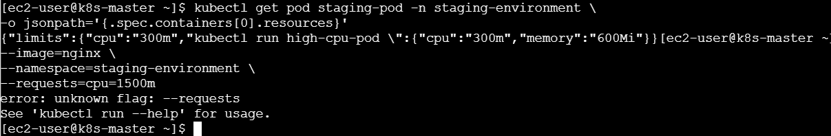
Expected result: Kubernetes rejects it because 1500m is greater than the allowed maximum of 1 CPU.
Result: Containers without limits receive default limits, and containers cannot request CPU outside the configured minimum and maximum.

Task 4: Communication using Service DNS
Requirement
- Create an Nginx Pod in the default namespace.
- Expose it using a NodePort Service.
- Create another Pod in the test namespace.
- Access the Service using its DNS name.
Step 1: Create the test namespace
kubectl create namespace test
Step 2: Create the application Pod
vi dns-nginx-pod.yaml
Add:
apiVersion: v1
kind: Pod
metadata:
name: dns-nginx-pod
namespace: default
labels:
app: dns-nginx
spec:
containers:
- name: nginx-container
image: nginx:latest
ports:
- containerPort: 80
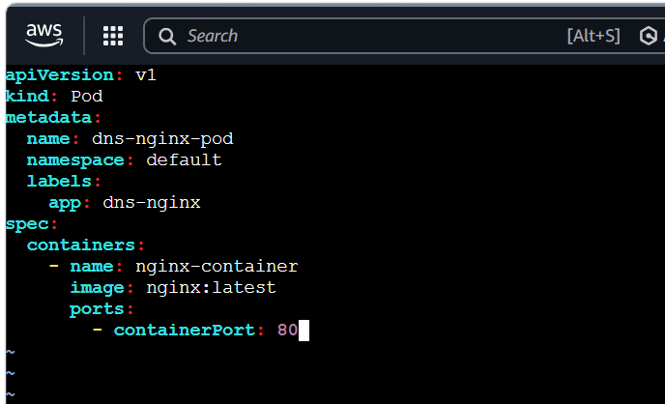
Apply:
kubectl apply -f dns-nginx-pod.yaml
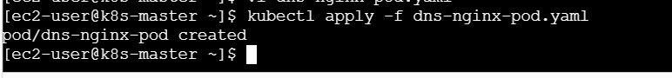
Verify:
kubectl get pod dns-nginx-pod
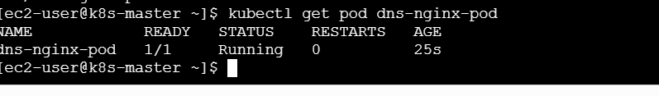
Step 3: Create the NodePort Service
vi dns-nginx-service.yaml
Add:
apiVersion: v1
kind: Service
metadata:
name: dns-nginx-service
namespace: default
spec:
type: NodePort
selector:
app: dns-nginx
ports:
- name: http
protocol: TCP
port: 80
targetPort: 80
nodePort: 30080
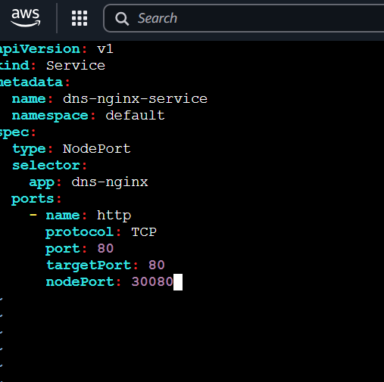
Apply:
kubectl apply -f dns-nginx-service.yaml
Verify:
kubectl get service dns-nginx-service
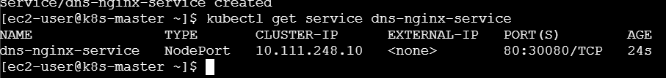
kubectl get endpoints dns-nginx-service
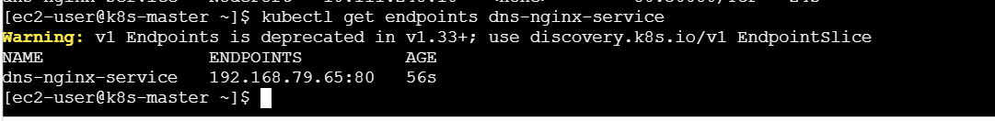
Expected Service output:
NAME TYPE CLUSTER-IP PORT(S)
dns-nginx-service NodePort 10.96.x.x 80:30080/TCP
Step 4: Create the test Pod
vi dns-test-pod.yaml
Add:
apiVersion: v1
kind: Pod
metadata:
name: dns-test-pod
namespace: test
spec:
containers:
- name: busybox-container
image: busybox:1.36
command:
- sleep
- "3600"
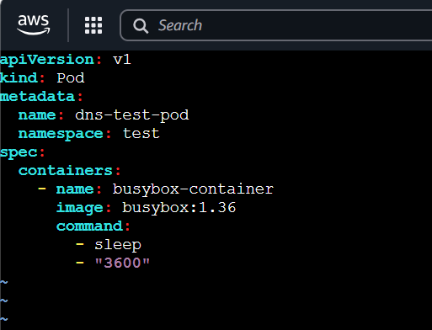
Apply:
kubectl apply -f dns-test-pod.yaml
Verify:
kubectl get pods -n test
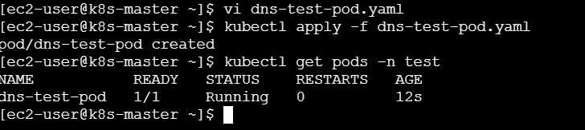
Step 5: Check Service DNS
The complete Service DNS name is:
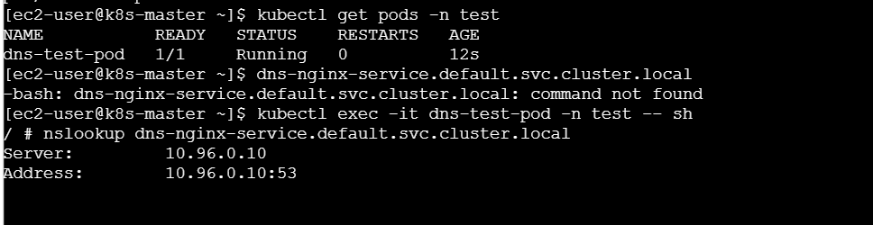
dns-nginx-service.default.svc.cluster.local
Run nslookup:
kubectl exec -it dns-test-pod -n test -- \
nslookup dns-nginx-service.default.svc.cluster.local/’
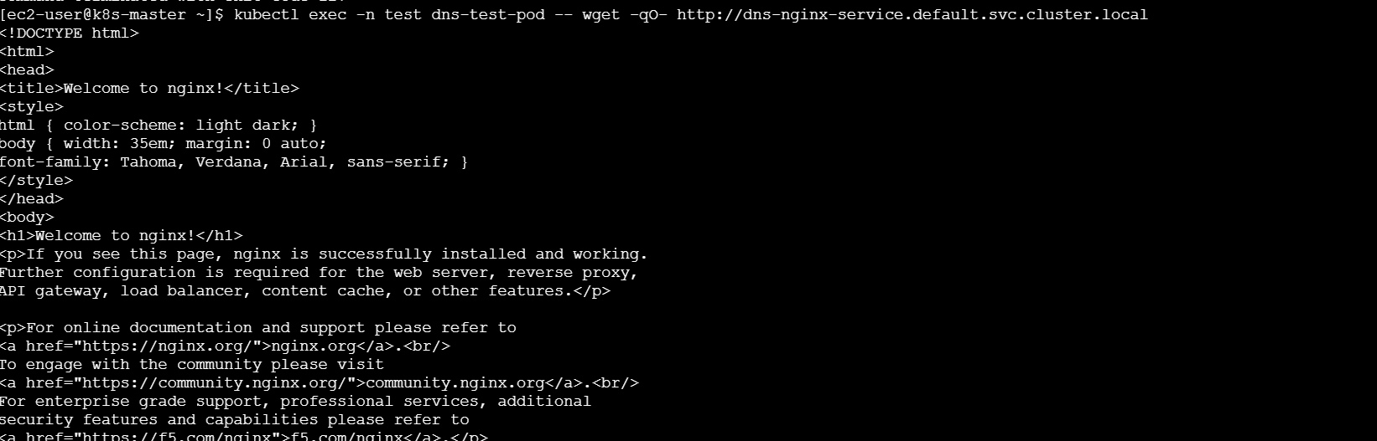
Expected result: It should return the ClusterIP of dns-nginx-service.
Step 6: Access Nginx using Service DNS
kubectl exec -it dns-test-pod -n test -- \
wget -qO- http://dns-nginx-service.default.svc.cluster.local
Expected output:
<h1>Welcome to nginx!</h1>
You can also use the shorter cross-namespace name:
kubectl exec -it dns-test-pod -n test -- \/
wget -qO- http://dns-nginx-service.default
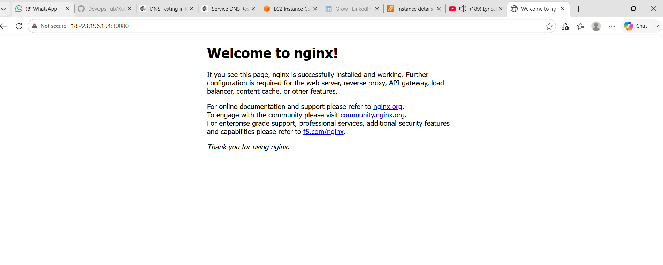
Result: The Pod in the test namespace successfully accesses the Service in the default namespace using Service DNS.
NodePort provides external access, but internal Pod-to-Service communication uses the Service DNS and port 80.

Task 5: Memory limit/request ratio in performance-environment
Requirement
Create a LimitRange where:
Memory limit ÷ memory request ≤ 2
Example:
- Request: 100Mi
- Maximum allowed limit: 200Mi
- A limit of 500Mi must be rejected.
Step 1: Create the namespace
kubectl create namespace performance-environment
Step 2: Create the LimitRange
vi performance-limitrange.yaml
Add:
apiVersion: v1
kind: LimitRange
metadata:
name: memory-ratio-limit
namespace: performance-environment
spec:
limits:
- type: Container
maxLimitRequestRatio:
memory: "2"
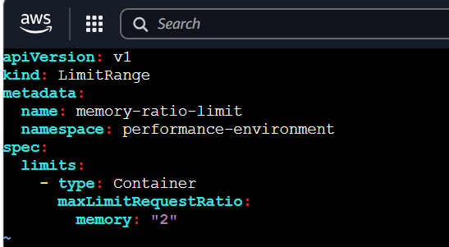
Step 3: Apply and verify
kubectl apply -f performance-limitrange.yaml
kubectl get limitrange -n performance-environment
kubectl describe limitrange memory-ratio-limit \
-n performance-environment
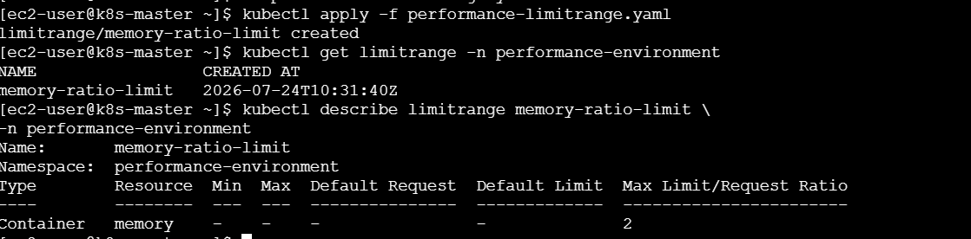
Step 4: Create a mismatched Pod
Here, the memory request is 100Mi and the limit is 500Mi.
500Mi ÷ 100Mi = 5
The ratio 5 is greater than the maximum allowed ratio of 2.
Create:
vi invalid-ratio-pod.yaml
Add:
apiVersion: v1
kind: Pod
metadata:
name: invalid-ratio-pod
namespace: performance-environment
spec:
containers:
- name: nginx-container
image: nginx:latest
resources:
requests:
memory: "100Mi"
limits:
memory: "500Mi"
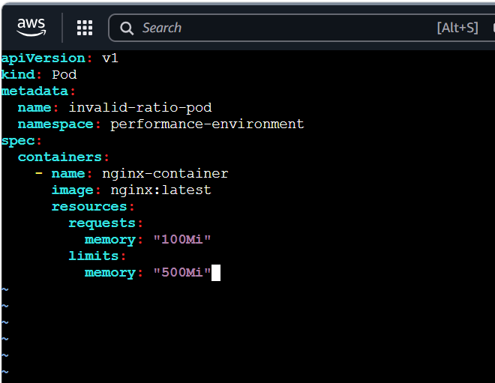
Apply:
kubectl apply -f invalid-ratio-pod.yaml
Expected error:
Pod "invalid-ratio-pod" is invalid:
maximum memory usage per Container is 2,
but limit is 500Mi and request is 100Mi
Step 5: Create a valid Pod
vi valid-ratio-pod.yaml
Add:
apiVersion: v1
kind: Pod
metadata:
name: valid-ratio-pod
namespace: performance-environment
spec:
containers:
- name: nginx-container
image: nginx:latest
resources:
requests:
memory: "100Mi"
limits:
memory: "200Mi"
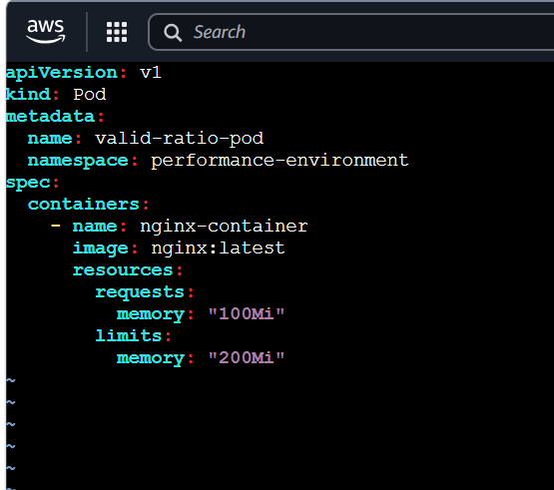
Apply:
kubectl apply -f valid-ratio-pod.yaml
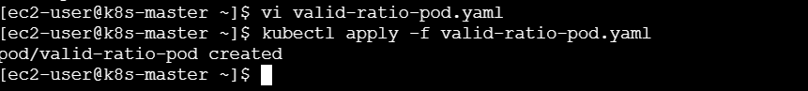
Verify:
kubectl get pods -n performance-environment
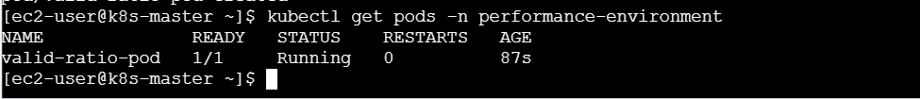
kubectl describe pod valid-ratio-pod \
-n performance-environment
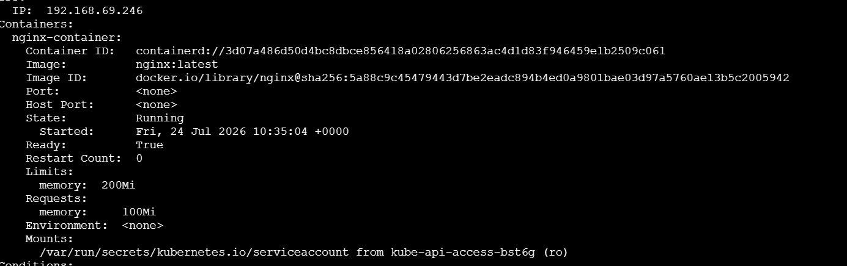
Result: The Pod with a ratio of 5 is rejected, while the Pod with a ratio of 2 is accepted.

Final Verification Commands
kubectl get namespaces
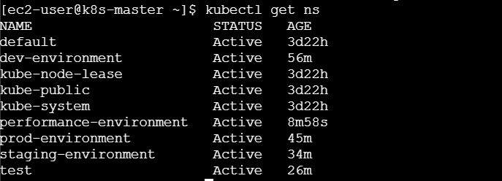
kubectl get resourcequota -A
kubectl get limitrange -A
kubectl get pods -A
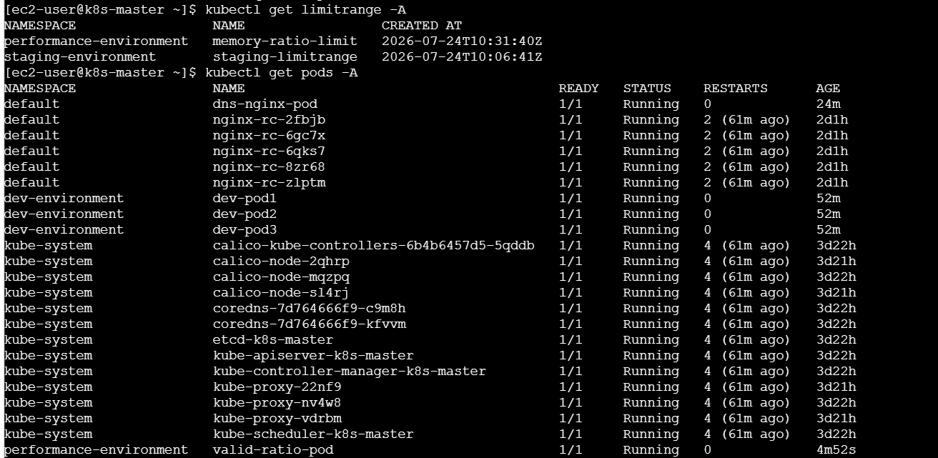
kubectl get services -A
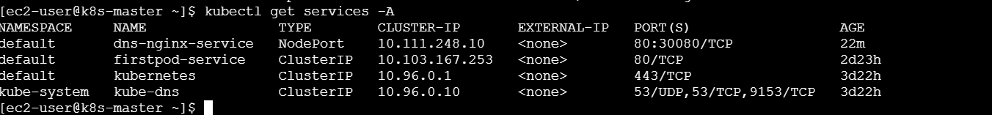

What We Learned
- A namespace separates Kubernetes resources.
- ResourceQuota controls the total number or amount of resources in a namespace.
- Requests reserve resources, while limits control maximum resource usage.
- LimitRange applies resource rules to individual Pods or containers.
- Service DNS allows communication without remembering Service IP addresses.
- maxLimitRequestRatio prevents a container’s limit from being much higher than its request.
Conclusion
We created four environment namespaces and one test namespace. We restricted Pods and Services with ResourceQuota, configured CPU and memory for Pods, assigned automatic resource limits with LimitRange, tested communication across namespaces using Service DNS, and verified memory request-to-limit ratio enforcement.

