Kubernetes-Task-07

Task - Taint a Node and Schedule a Tolerant Pod
Objective
The objective of this task is to understand Kubernetes Node Taints and Pod Tolerations. We will apply a taint to a worker node so that normal pods cannot be scheduled on it. Then, we will create a pod with a matching toleration, allowing it to run on the tainted node.

Prerequisites
Before performing this task, ensure:
- Kubernetes cluster is running (Master + Worker nodes).
- kubectl is configured and connected to the cluster.
- Worker nodes are available.
- Basic knowledge of:
  - Pods
  - Nodes
  - YAML files
  - kubectl commands
Check cluster status:
kubectl get nodes
Example output:
NAME STATUS ROLES
k8s-master Ready control-plane
worker-01 Ready <none>
worker-02 Ready <none>

Step 1: Check Available Nodes
First, check all nodes in the cluster.
kubectl get nodes
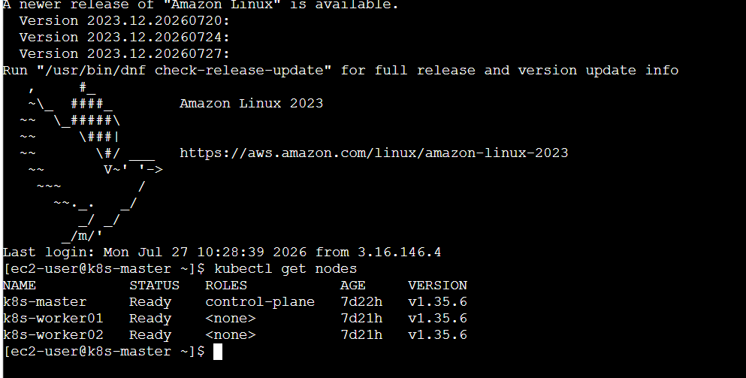
We will apply the taint on worker-01.

Step 2: Add Taint to Worker Node
Apply a taint to the worker node:
kubectl taint nodes worker01 special=true:NoSchedule
Explanation:
- special=true → Key-value pair of taint
- NoSchedule → Kubernetes will not schedule normal pods on this node
- Only pods with matching toleration can run on this node

Step 3: Verify Node Taint
Check node details:
kubectl describe node k8s-worker01
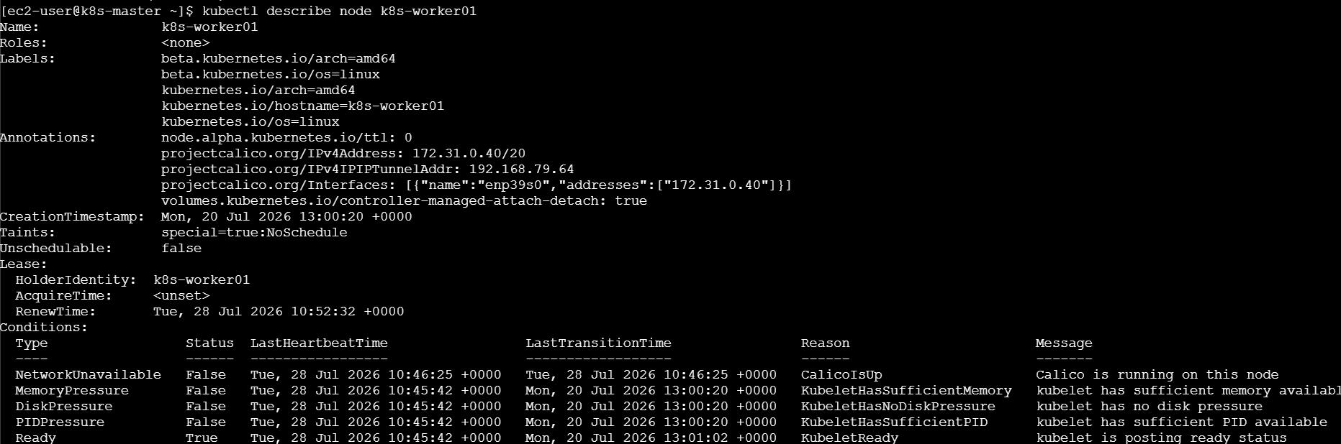
Search for:
Taints:
special=true:NoSchedule
The node is now protected.

Step 4: Create Pod Without Toleration (Testing)
Create a simple pod:
vi normal-pod.yaml
Add:
apiVersion: v1
kind: Pod
metadata:
name: normal-pod
spec:
containers:
- name: nginx
image: nginx
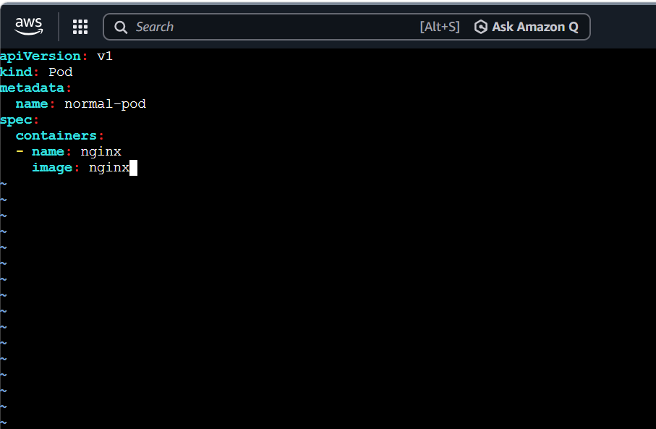
Apply:
kubectl apply -f normal-pod.yaml
Check pod:
kubectl get pods -o wide
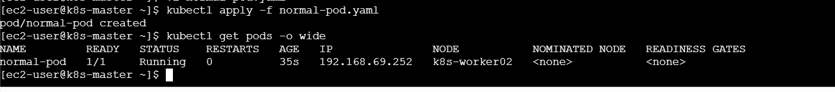
Output:
NAME STATUS
normal-pod Pending
Reason:
The pod does not have permission to run on the tainted node.

Step 5: Create Pod with Toleration
Create a pod YAML file:
vi tolerant-pod.yaml
Add:
apiVersion: v1
kind: Pod
metadata:
name: tolerant-pod
spec:

tolerations:
- key: "special"
operator: "Equal"
value: "true"
effect: "NoSchedule"

containers:
- name: nginx
image: nginx

Step 6: Deploy Tolerant Pod
Create the pod:
kubectl apply -f tolerant-pod.yaml

Step 7: Verify Pod Status
Check pod status:
kubectl get pods -o wide
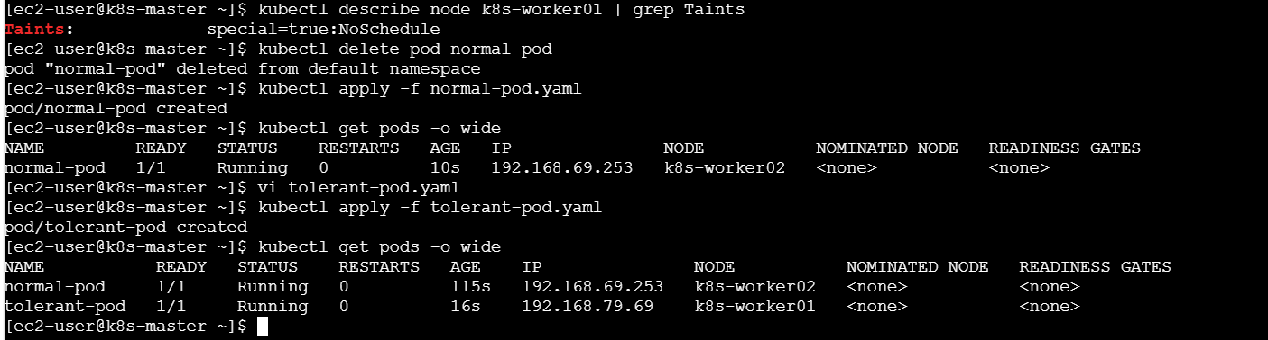
Example output:
NAME STATUS NODE
tolerant-pod Running worker-01
The pod is successfully scheduled on the tainted node.

Step 8: Verify Pod Details
Check pod information:
kubectl describe pod tolerant-pod
You can verify:
Node: worker-01
Tolerations:
special=true:NoSchedule

Step 9: Remove Taint (Cleanup)
Remove the taint from the node:
kubectl taint nodes worker-01 special=true:NoSchedule-
The - at the end removes the taint.

Verify:
kubectl describe node worker-01
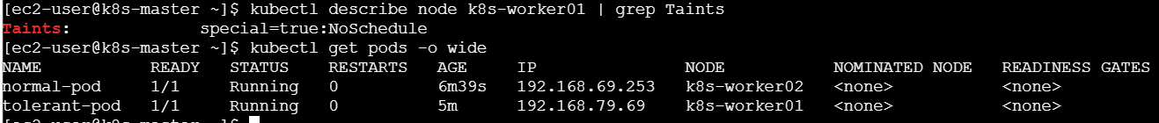

Step 10: Delete Created Resources
Delete pods:
kubectl delete pod normal-pod tolerant-pod
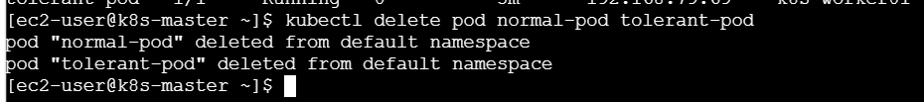

What We Learned
- Taint is a restriction applied to a node that prevents normal pods from being scheduled.
- Toleration allows a pod to run on a node that has a matching taint.
- NoSchedule prevents new pods from being placed on a tainted node.
- Taints are useful for reserving nodes for specific workloads.
- Pods require matching tolerations to use reserved nodes.

Real-Time Example
In a company:
- A high-performance GPU node is reserved for Machine Learning applications.
- The administrator applies a taint:
gpu=true:NoSchedule
- Normal applications cannot run on that node.
- Only ML pods with GPU toleration can use that node.
This ensures important workloads get dedicated resources.

Conclusion
In this task, we successfully created a node taint using special=true:NoSchedule and deployed a pod with a matching toleration. The tolerant pod was able to run on the restricted node, demonstrating how Kubernetes controls workload placement using Taints and Tolerations.

Task : Use NodeSelector to Schedule a Pod on a Specific Node
Objective
The objective of this task is to understand Kubernetes Node Labels and NodeSelector. We will label a node with env=dev and create a pod with a nodeSelector so that Kubernetes schedules the pod only on the node having that specific label.

Prerequisites
Before performing this task, ensure:
- Kubernetes cluster is running.
- kubectl is configured properly.
- Worker nodes are available.
- Basic knowledge of:
  - Nodes
  - Pods
  - YAML files
  - Labels and selectors
Check nodes:
kubectl get nodes
Example:
NAME STATUS
k8s-master Ready
k8s-worker01 Ready
k8s-worker02 Ready

Step 1: Check Existing Node Labels
View labels of all nodes:
kubectl get nodes --show-labels
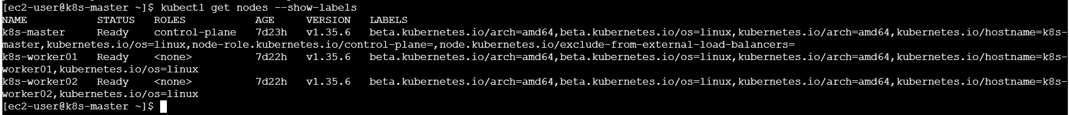
Example:
NAME LABELS
k8s-worker01 kubernetes.io/hostname=k8s-worker01
k8s-worker02 kubernetes.io/hostname=k8s-worker02

Step 2: Add Label to Node
We will add the label:
env=dev
to k8s-worker01.
Command:
kubectl label node k8s-worker01 env=dev
Expected output:
node/k8s-worker01 labeled

Step 3: Verify Node Label
Run:
kubectl get nodes --show-labels
You should see:
k8s-worker01 env=dev
or check directly:
kubectl describe node k8s-worker01
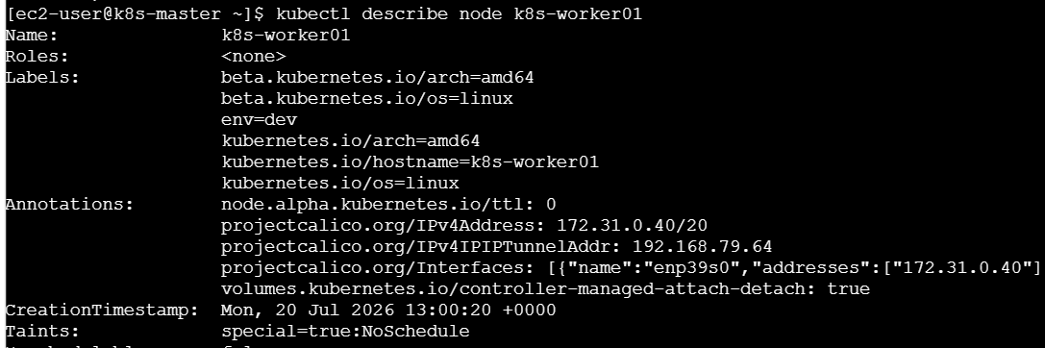
Output:
Labels:
env=dev

Step 4: Create Pod YAML with NodeSelector
Create a YAML file:
vi node-selector-pod.yaml
Add:
apiVersion: v1
kind: Pod
metadata:
name: node-selector-pod

spec:
nodeSelector:
env: dev

tolerations:
- key: "special"
operator: "Equal"
value: "true"
effect: "NoSchedule"

containers:
- name: nginx
image: nginx
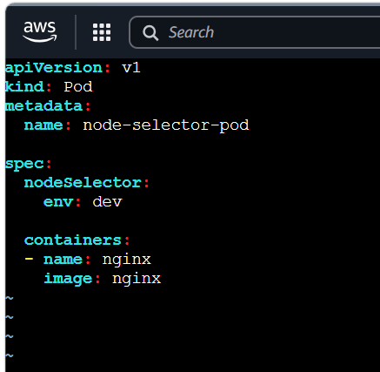

Step 5: Deploy the Pod
Apply the YAML:
kubectl apply -f node-selector-pod.yaml
Expected:
pod/node-selector-pod created

Step 6: Verify Pod Scheduling
Check pod status:
kubectl get pods -o wide
Expected output:
NAME READY STATUS NODE
node-selector-pod 1/1 Running k8s-worker01
The pod is running only on the node with:
env=dev
label.

Step 7: Verify Pod Details
Run:
kubectl describe pod node-selector-pod
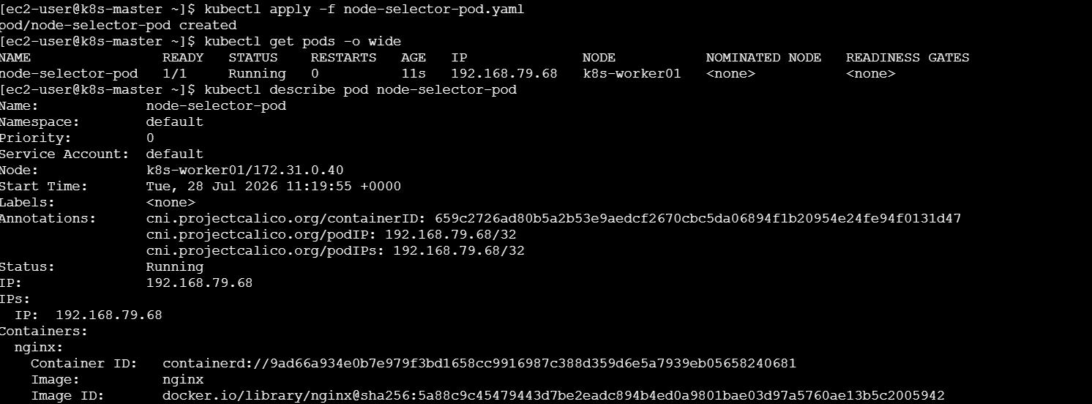
Check:
Node: k8s-worker01
Node-Selectors:
env=dev

Step 8: Test NodeSelector Behavior
If you remove the label:
kubectl label node k8s-worker01 env-
and recreate the pod:
kubectl delete pod node-selector-pod

kubectl apply -f node-selector-pod.yaml
The pod will remain:
Pending
because no node has:
env=dev

Cleanup
Remove pod:
kubectl delete pod node-selector-pod
Remove node label:
kubectl label node k8s-worker01 env-
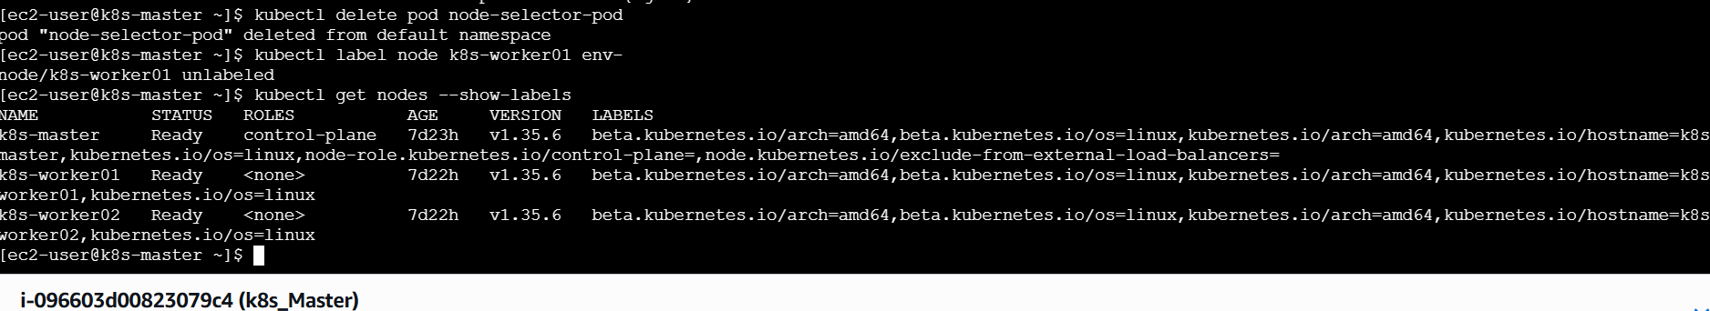

What We Learned
- Node Labels are key-value pairs attached to Kubernetes nodes.
- NodeSelector helps schedule pods only on nodes with matching labels.
- Kubernetes scheduler checks node labels before placing a pod.
- NodeSelector is useful for running workloads on specific nodes.

Real-Time Example
In a company:
- Development applications should run only on development servers.
- Administrator labels a node:
env=dev
- Developer pods use:
nodeSelector:
env: dev
Now those applications automatically run only on development nodes.

Conclusion
In this task, we successfully labeled a Kubernetes node with env=dev and created a pod using nodeSelector. The pod was scheduled only on the node matching the required label. This demonstrates how Kubernetes controls workload placement using Node Labels and NodeSelector.

Task : Use Node Affinity with Soft Scheduling
Objective
The objective of this task is to understand Kubernetes Node Affinity with soft scheduling. We will label a node with env=test and create a pod using PreferredDuringSchedulingIgnoredDuringExecution affinity. Kubernetes will prefer scheduling the pod on the labeled node, but it can run on another node if the preferred node is not available. After removing the label, we will verify that the running pod continues without interruption.

Prerequisites
Before performing this task, ensure:
- Kubernetes cluster is running.
- Master and worker nodes are in Ready state.
- kubectl is configured correctly.
- Basic understanding of:
  - Nodes
  - Pods
  - Labels
  - YAML files
  - NodeSelector
Check nodes:
kubectl get nodes
Example:
NAME STATUS
k8s-master Ready
k8s-worker01 Ready
k8s-worker02 Ready

Step 1: Check Available Nodes
List all nodes:
kubectl get nodes
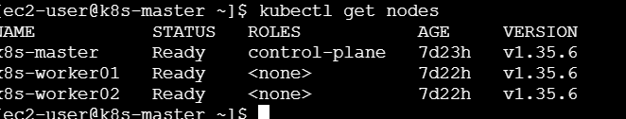
We will use:
k8s-worker01
for adding the label.

Step 2: Add Label to Node
Add the label:
env=test
to k8s-worker01.
Command:
kubectl label node k8s-worker01 env=test
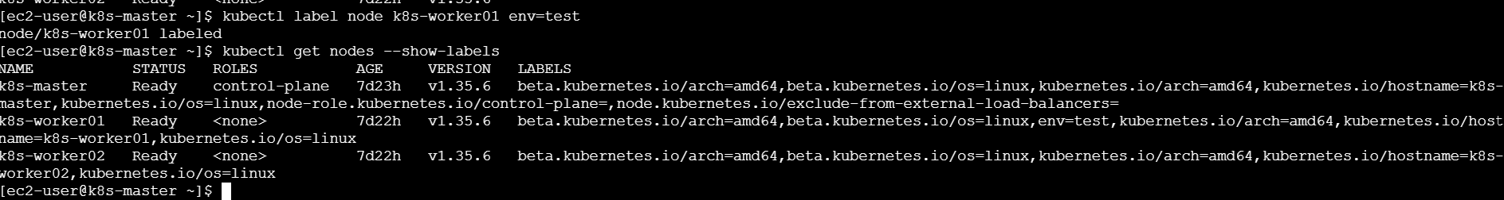
Expected output:
node/k8s-worker01 labeled

Step 3: Verify Node Label
Check labels:
kubectl get nodes --show-labels

Expected:
k8s-worker01 ... env=test
The node is now marked as a test environment node.

Step 4: Create Pod YAML with Node Affinity
Create YAML file:
vi node-affinity-pod.yaml
Add:
apiVersion: v1
kind: Pod

metadata:
name: node-affinity-pod

spec:

affinity:
nodeAffinity:
preferredDuringSchedulingIgnoredDuringExecution:
- weight: 1
preference:
matchExpressions:
- key: env
operator: In
values:
- test

containers:
- name: nginx
image: nginx
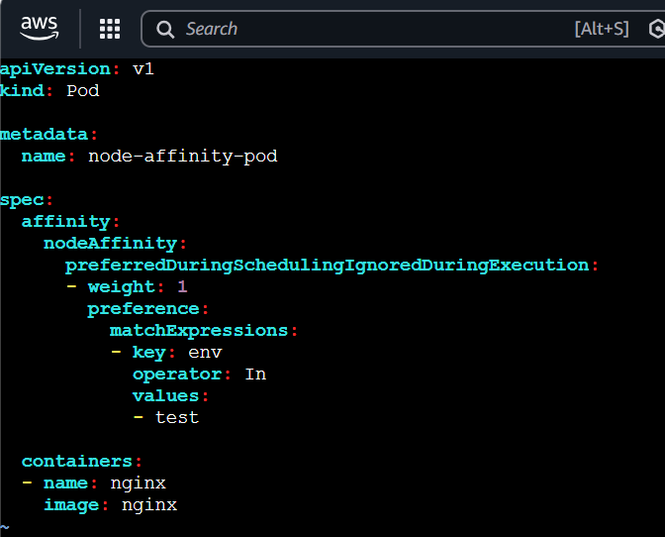

YAML Explanation
Node Affinity Type:
preferredDuringSchedulingIgnoredDuringExecution
Means:
- Kubernetes will try first to schedule the pod on matching nodes.
- If the node is not available, Kubernetes can schedule it elsewhere.
- After scheduling, removing the label will not move the pod.

Match Expression:
key: env
values:
- test
Means:
"Prefer nodes having the label env=test."

Step 5: Create the Pod
Deploy:
kubectl apply -f node-affinity-pod.yaml
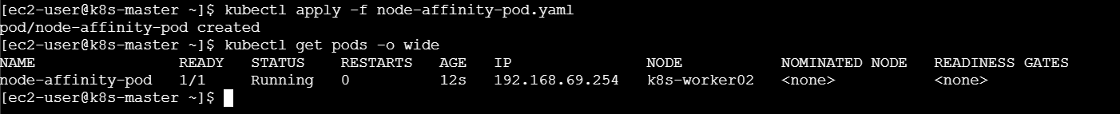
Output:
pod/node-affinity-pod created

Step 6: Verify Pod Scheduling
Check pod location:
kubectl get pods -o wide

Expected:
NAME STATUS NODE
node-affinity-pod Running k8s-worker01
Because:
k8s-worker01 → env=test

Step 7: Remove Node Label
Remove the label:
kubectl label node k8s-worker01 env-
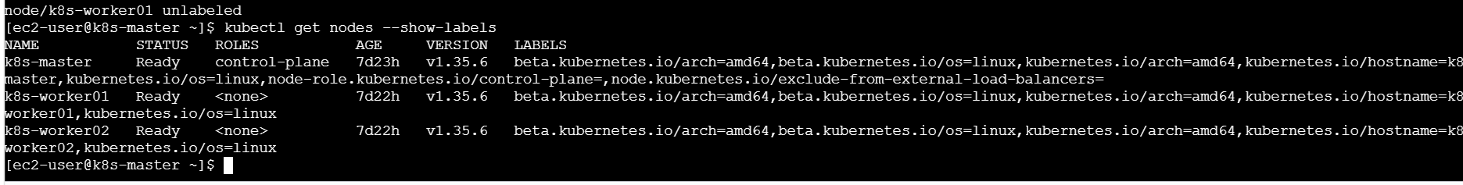
Output:
node/k8s-worker01 unlabeled

Step 8: Verify Pod Continues Running
Check pod status:
kubectl get pods -o wide
Expected:
NAME STATUS NODE
node-affinity-pod Running k8s-worker01
The pod continues running even though the label is removed.
Why is it still running?
Because:
preferredDuringSchedulingIgnoredDuringExecution
means:
- During scheduling → Kubernetes prefers the matching node.
- After scheduling → Kubernetes ignores label changes.
- The pod will not be moved or deleted when the label is removed

Step 9: Verify Node Affinity Details
Check pod details:
kubectl describe pod node-affinity-pod
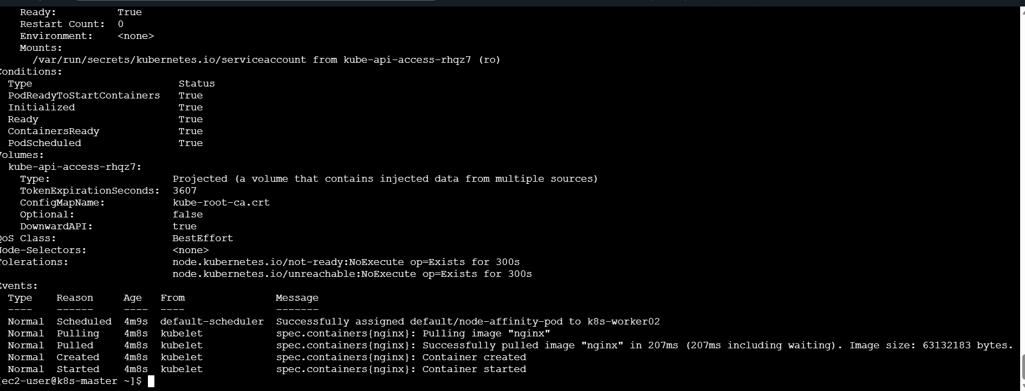
You can verify:
Node Affinity:
Preferred Terms:
Weight: 1
Match Expressions:
Key: env
Values: test

Step 10: Cleanup
Delete the pod:
kubectl delete pod node-affinity-pod
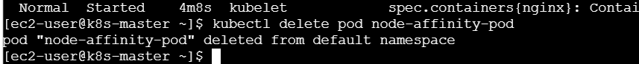
Verify:
kubectl get pods

What We Learned
- Node Affinity is an advanced method for controlling pod scheduling.
- PreferredDuringSchedulingIgnoredDuringExecution provides soft scheduling.
- Kubernetes tries to place pods on preferred nodes but does not force it.
- Removing labels does not evict already running pods.
- Node affinity is useful when workloads have preferred infrastructure requirements.

Real-Time Example
In a company:
- Testing applications should preferably run on test servers.
- Admin labels a node:
env=test
- Application pod uses preferred node affinity.
Kubernetes tries to place the application on the test server, but if the server is unavailable, it can use another available node.

Conclusion
In this task, we successfully created a node label env=test and deployed a pod using PreferredDuringSchedulingIgnoredDuringExecution node affinity. The pod was scheduled on the preferred node, and after removing the label, the pod continued running. This demonstrates how Kubernetes provides flexible workload placement using soft node affinity scheduling.

Task : Implement Node Affinity with Hard Scheduling
Objective
The objective of this task is to understand Kubernetes Node Affinity with hard scheduling. We will create a pod using RequiredDuringSchedulingIgnoredDuringExecution node affinity, which ensures that the pod will be scheduled only on a node having the label env=prod. We will verify that the pod remains Pending when no node has the required label.

Prerequisites
Before performing this task, ensure:
- Kubernetes cluster is running.
- Master and worker nodes are in Ready state.
- kubectl is configured properly.
- Basic knowledge of:
  - Nodes
  - Pods
  - Labels
  - Node Affinity
Check nodes:
kubectl get nodes
Example:
NAME STATUS
k8s-master Ready
k8s-worker01 Ready
k8s-worker02 Ready

Step 1: Check Existing Node Labels
Check current labels:
kubectl get nodes --show-labels
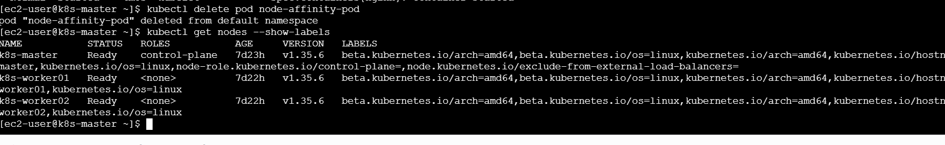
Verify that no node has:
env=prod
Example:
k8s-worker01 env=test
k8s-worker02

Step 2: Create Pod YAML with Required Node Affinity
Create YAML file:
vi required-affinity-pod.yaml
Add:
apiVersion: v1
kind: Pod

metadata:
name: required-affinity-pod

spec:
affinity:
nodeAffinity:
requiredDuringSchedulingIgnoredDuringExecution:
nodeSelectorTerms:
- matchExpressions:
- key: env
operator: In
values:
- prod

containers:
- name: nginx
image: nginx
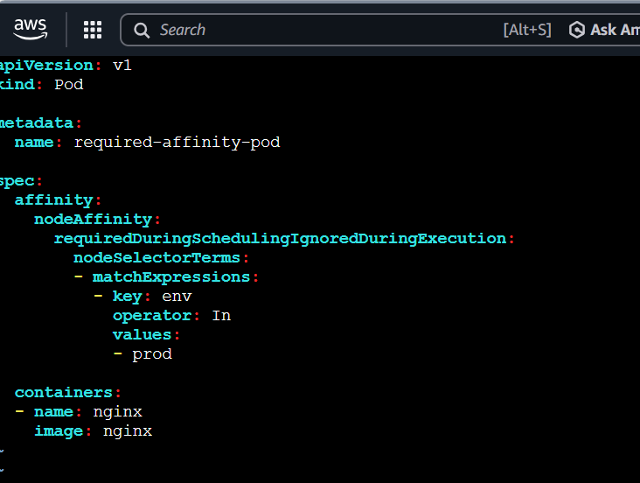

YAML Explanation
Required Node Affinity
requiredDuringSchedulingIgnoredDuringExecution
Means:
- Pod must run on a node matching the condition.
- If no matching node exists, pod will remain in Pending state.
- After scheduling, removing the label will not move the pod.

Step 3: Create the Pod
Apply YAML:
kubectl apply -f required-affinity-pod.yaml
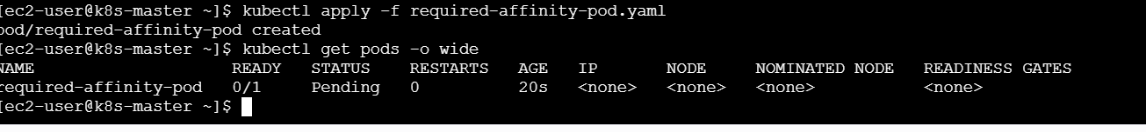
Expected:
pod/required-affinity-pod created

Step 4: Check Pod Status
Run:
kubectl get pods -o wide

Expected output:
NAME READY STATUS
required-affinity-pod 0/1 Pending
Reason:
No node currently has:
env=prod

Step 5: Check Scheduling Failure Reason
Run:
kubectl describe pod required-affinity-pod
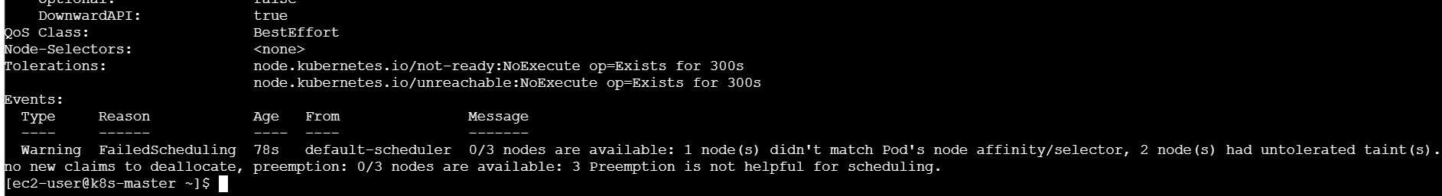
At the bottom, check Events:
Example:
Events:
Warning FailedScheduling
0/3 nodes are available:
node(s) didn't match Pod's node affinity/selector
This confirms hard scheduling is working.
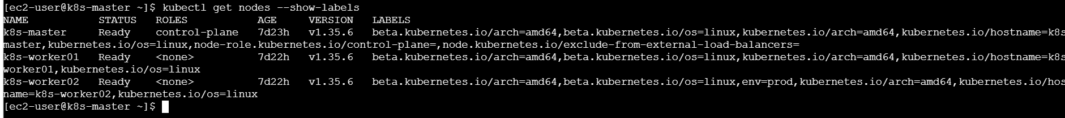

Step 6: Add env=prod Label to a Node
Now label k8s-worker02:
kubectl label node k8s-worker02 env=prod
Expected:
node/k8s-worker02 labeled

Step 7: Verify Node Label
Run:
kubectl get nodes --show-labels

Output:
k8s-worker02 ... env=prod

Step 8: Verify Pod Scheduling
Check pods:
kubectl get pods -o wide
Expected:
NAME READY STATUS NODE
required-affinity-pod 1/1 Running k8s-worker02
Now Kubernetes scheduled the pod because the required condition is satisfied.

Step 9: Remove Label and Verify Behavior
Remove the label:
kubectl label node k8s-worker02 env-
Verify:
kubectl get nodes --show-labels
The env=prod label will be removed.
The pod will continue running:
kubectl get pods -o wide
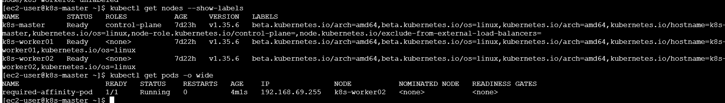
Output:
required-affinity-pod Running k8s-worker02
Reason:
IgnoredDuringExecution means:
- Label is checked only during scheduling.
- Existing running pods are not removed when labels change.

Step 10: Cleanup
Delete pod:
kubectl delete pod required-affinity-pod

What We Learned
- Node Affinity controls pod placement based on node labels.
- RequiredDuringSchedulingIgnoredDuringExecution is a hard rule.
- Pod cannot run unless a matching node exists.
- If no matching node exists, the pod remains in Pending state.
- Removing labels after scheduling does not affect running pods.

Difference Between Soft and Hard Node Affinity
Type | Behavior
PreferredDuringSchedulingIgnoredDuringExecution | Preference only; pod can run elsewhere
RequiredDuringSchedulingIgnoredDuringExecution | Mandatory; pod runs only on matching nodes

Real-Time Example
A company has production servers:
env=prod
Database pods should run only on production nodes.
Using:
requiredDuringSchedulingIgnoredDuringExecution
ensures the database pod will never run on development or testing servers.

Conclusion
In this task, we implemented hard node affinity using RequiredDuringSchedulingIgnoredDuringExecution. The pod remained Pending when no node had the required env=prod label and successfully scheduled after adding the label. This demonstrates how Kubernetes enforces strict workload placement using node affinity.

Task : Taint a Node and Use NoExecute with Toleration Seconds
Objective
The objective of this task is to understand Kubernetes NoExecute Taints and Toleration Seconds. We will apply a NoExecute taint to a node and create a pod with tolerationSeconds. The pod will temporarily tolerate the taint and will be automatically evicted after the specified time (60 seconds).

Prerequisites
Before performing this task, ensure:
- Kubernetes cluster is running.
- Master and worker nodes are in Ready state.
- kubectl is configured correctly.
- Basic knowledge of:
  - Nodes
  - Pods
  - Taints
  - Tolerations
Check nodes:
kubectl get nodes
Example:
NAME STATUS
k8s-master Ready
k8s-worker01 Ready
k8s-worker02 Ready

Step 1: Check Worker Node
List nodes:
kubectl get nodes
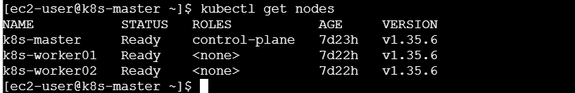
We will apply the taint on:
k8s-worker01

Step 2: Apply NoExecute Taint
Add the taint:
kubectl taint nodes k8s-worker01 special=true:NoExecute
Expected output:
node/k8s-worker01 tainted

Explanation
special=true:NoExecute
Means:
- Pods without matching toleration will be evicted immediately.
- New pods without toleration cannot be scheduled on this node.
- Existing pods will also be removed from this node.

Step 3: Verify Node Taint
Run:
kubectl describe node k8s-worker01 | grep Taints
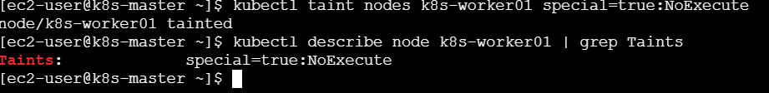
Expected:
Taints:
special=true:NoExecute

Step 4: Create Pod with Toleration Seconds
Create YAML file:
vi noexecute-pod.yaml
Add:
apiVersion: v1
kind: Pod

metadata:
name: noexecute-pod

spec:

nodeSelector:
kubernetes.io/hostname: k8s-worker01

tolerations:
- key: "special"
operator: "Equal"
value: "true"
effect: "NoExecute"
tolerationSeconds: 60

containers:
- name: nginx
image: nginx
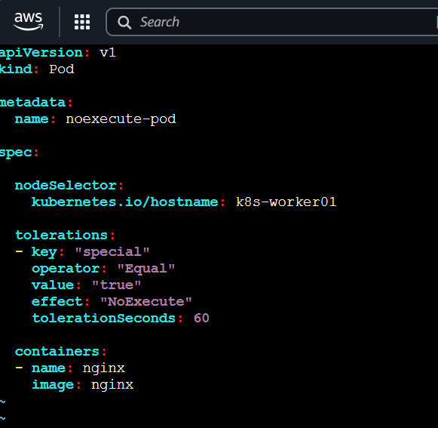

YAML Explanation
Toleration
tolerationSeconds: 60
Means:
- Pod can stay on the tainted node for 60 seconds.
- After 60 seconds Kubernetes evicts the pod.

Step 5: Create Pod
Deploy:
kubectl apply -f noexecute-pod.yaml
Expected:
pod/noexecute-pod created

Step 6: Verify Pod Running
Check:
kubectl get pods -o wide
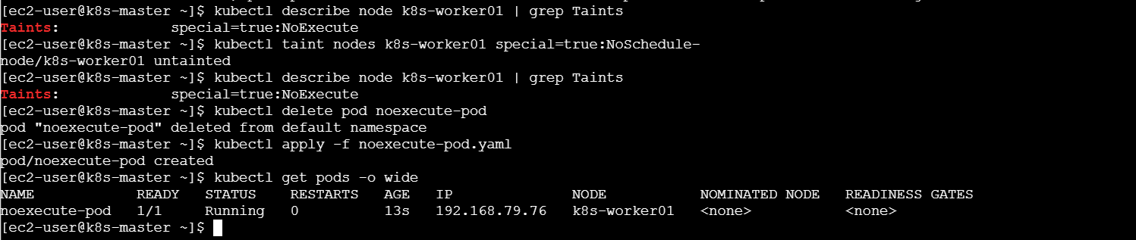
Expected:
NAME READY STATUS NODE
noexecute-pod 1/1 Running k8s-worker01

Step 7: Observe Eviction After 60 Seconds
Wait for approximately 60 seconds.
Check:
kubectl get pods -o wide
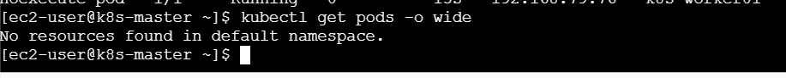
Expected:
NAME READY STATUS
noexecute-pod 0/1 Terminating
or:
NAME STATUS
noexecute-pod Evicted
The pod is removed because the toleration time expired.

Step 8: Verify Pod Events
Run:
kubectl describe pod noexecute-pod
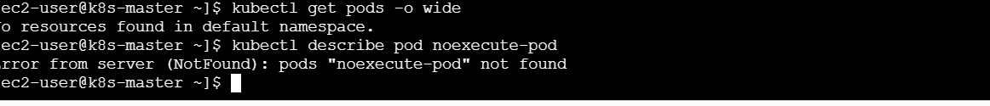
Check Events:
Example:
Events:
Warning Evicted
The node had condition: NoExecute

Step 9: Remove Taint (Cleanup)
Remove the taint:
kubectl taint nodes k8s-worker01 special=true:NoExecute-
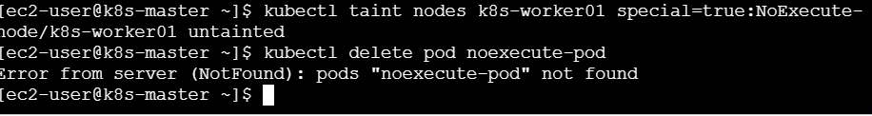
Expected:
node/k8s-worker01 untainted

Step 10: Delete Pod
Delete the pod:
kubectl delete pod noexecute-pod


What We Learned
- NoExecute taint affects both existing and new pods.
- Pods without tolerations are immediately evicted.
- tolerationSeconds defines how long a pod can tolerate a taint.
- After the specified time, Kubernetes automatically removes the pod.
- NoExecute is useful for handling node problems and workload migration.

Real-Time Example
In production:
- A node has a hardware issue or maintenance activity.
- Administrator applies:
maintenance=true:NoExecute
- Critical pods may have:
tolerationSeconds: 300
They get 5 minutes to gracefully handle the situation before eviction.

Difference Between Taint Effects
Effect | Behavior
NoSchedule | New pods cannot schedule on the node
PreferNoSchedule | Kubernetes avoids the node if possible
NoExecute | Existing pods are evicted and new pods are blocked

Conclusion
In this task, we successfully applied a NoExecute taint to a node and created a pod with tolerationSeconds: 60. The pod was allowed to run temporarily on the tainted node and was automatically evicted after 60 seconds. This demonstrates how Kubernetes manages workloads during node maintenance or failure scenarios using NoExecute Taints and Tolerations.

