Jenkins _02
- Configure 2 slave machines in the Jenkins master.
Architecture
Jenkins Master
|
--------------------------------
| |
| SSH | SSH
▼ ▼
Slave1 Slave2
(Agent-1) (Agent-2)
Java 21 Java 21

Step 1: Create Two EC2 Instances (Slave Machines)
Launch two Linux instances:
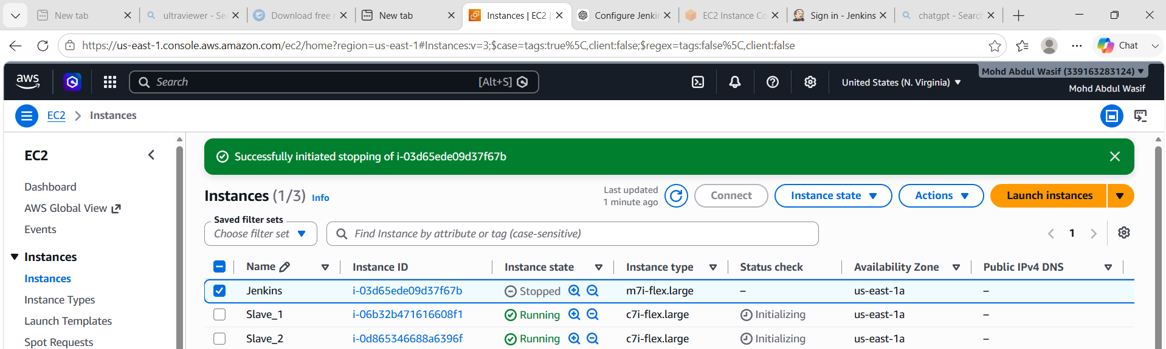
Allow:
- SSH (22) from Jenkins Master
- All ICMP (optional)
Step 2: Connect to Slave1
- ssh -i mykey.pem ec2-user@172.31.10.101
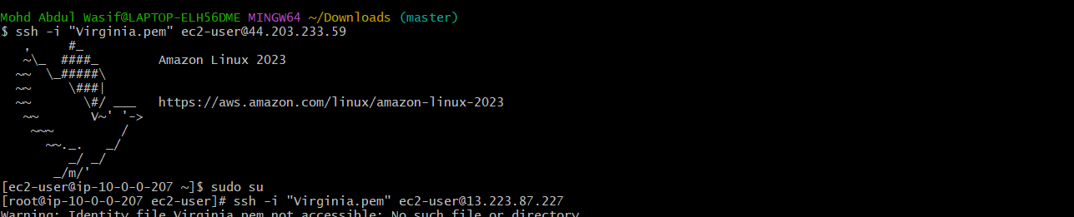

- Step 3: Install Java 21 on Slave1
- Check Java:
- java -version
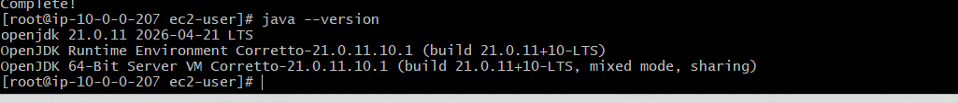
- If Java is not installed or older version exists:
- Amazon Linux 2023
- sudo yum update -y
sudo yum install java-21-amazon-corretto-devel -y
- Verify:
- java -version

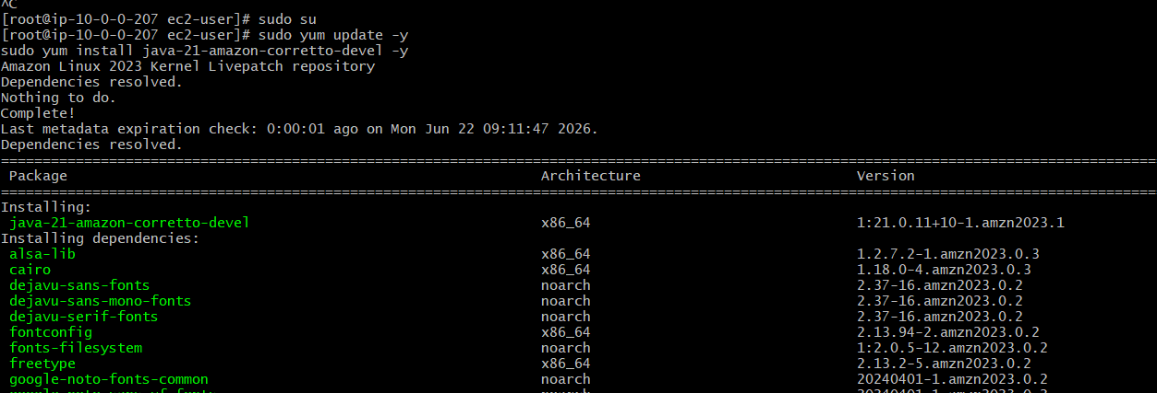
Step 4: Create Jenkins User on Slave1
Create user:
sudo useradd jenkins
sudo passwd jenkins
Example password:
Jenkins@123
Switch user:
su - jenkins
Verify:
whoami
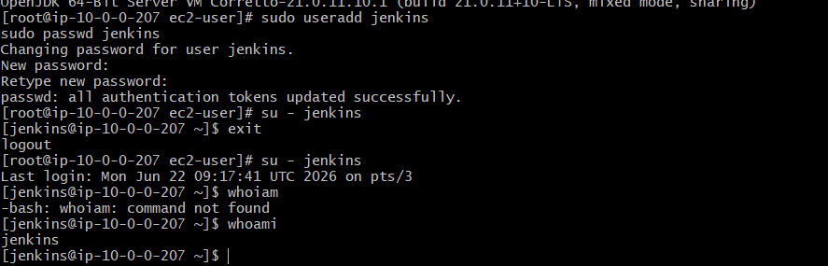
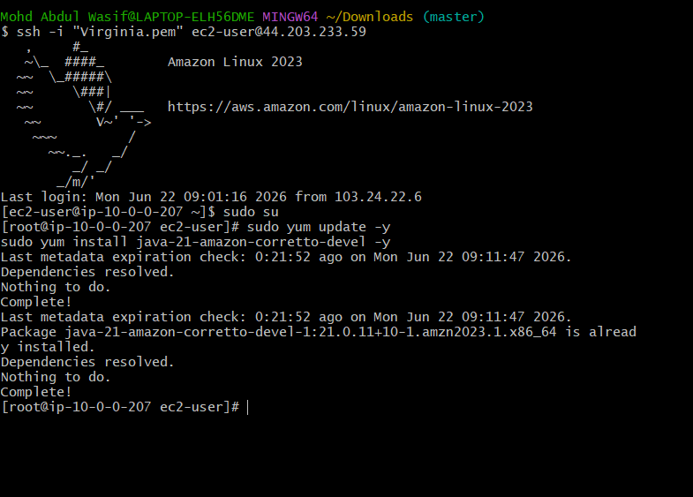
Step 6: Repeat Steps 2–5 on Slave2
Login:
ssh -i mykey.pem ec2-user@172.31.10.102
Install Java 21:
sudo yum update -y
sudo yum install java-21-amazon-corretto-devel -y
Create Jenkins user:
sudo useradd jenkins
sudo passwd jenkins
Give sudo access:
sudo visudo
Add:
jenkins ALL=(ALL) NOPASSWD:ALL
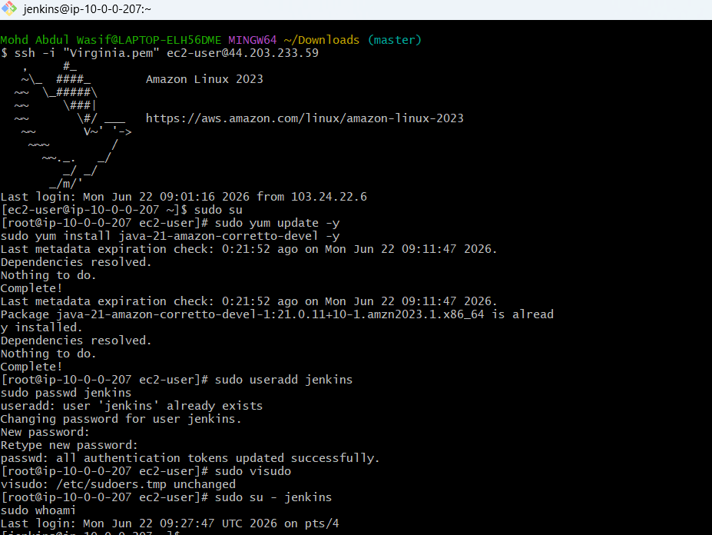

Step 7: Login to Jenkins Master Server
ssh -i mykey.pem ec2-user@<Master-IP>
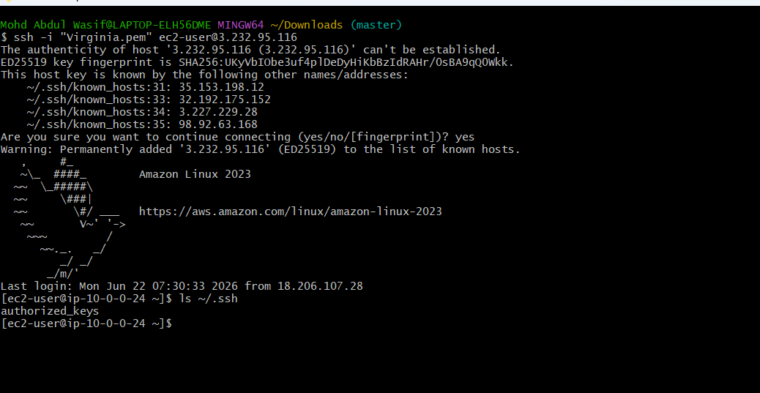
Step 6: Test SSH From Master to Slave1
On the Master:
ssh jenkins@10.0.0.25
If asked:
Are you sure you want to continue connecting (yes/no)?
Type:
yes
You should log in without a password.
Verify:
whoami
Output:
jenkins
Exit:
exit

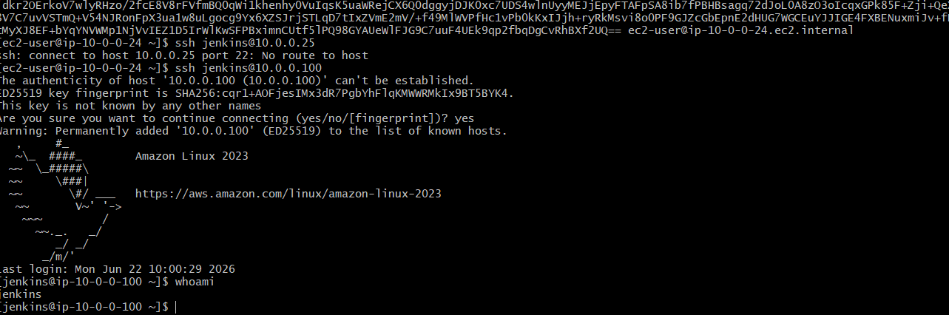
Step 7: Test Slave2
ssh jenkins@10.0.0.26
Again, verify:
whoami
Output:
jenkins
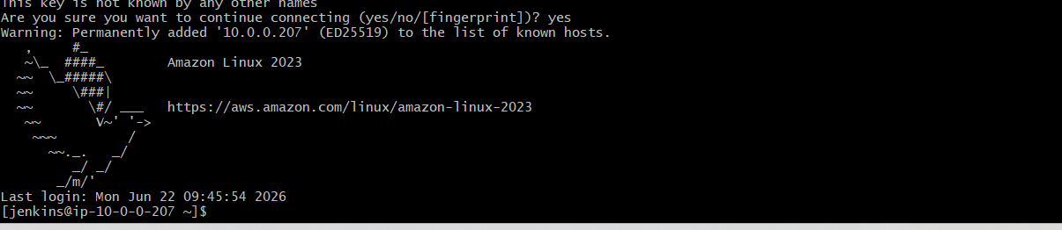
Step 8: Add Both Nodes in Jenkins UI
Go to:
Manage Jenkins
→ Nodes
→ New Node
Create:
Slave1
- Name: slave1
- Remote root directory: /home/jenkins
- Labels: slave1
- Launch method: Launch agents via SSH
- Host: 10.0.0.25
- Credentials: Add SSH credentials

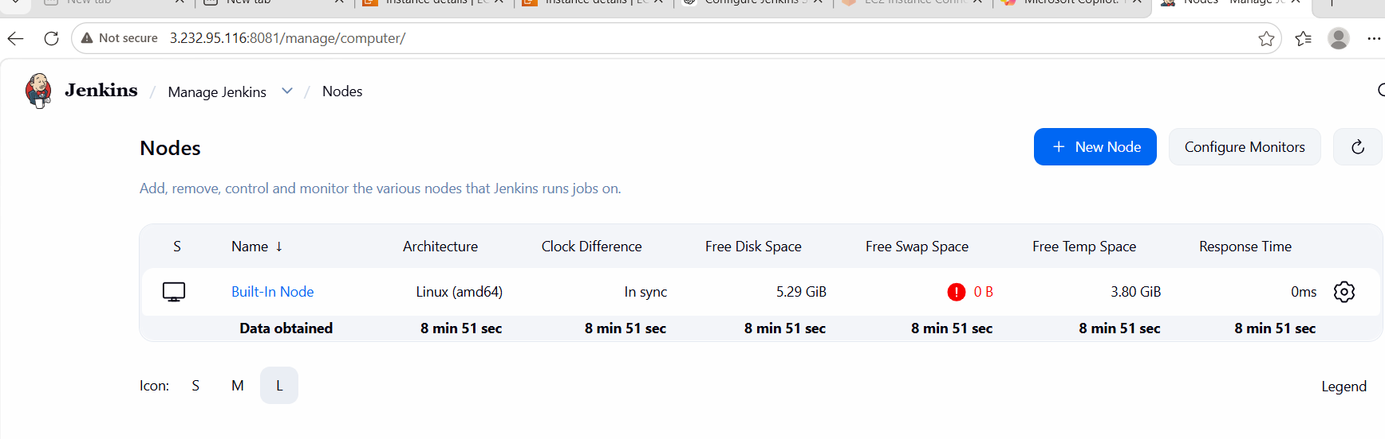
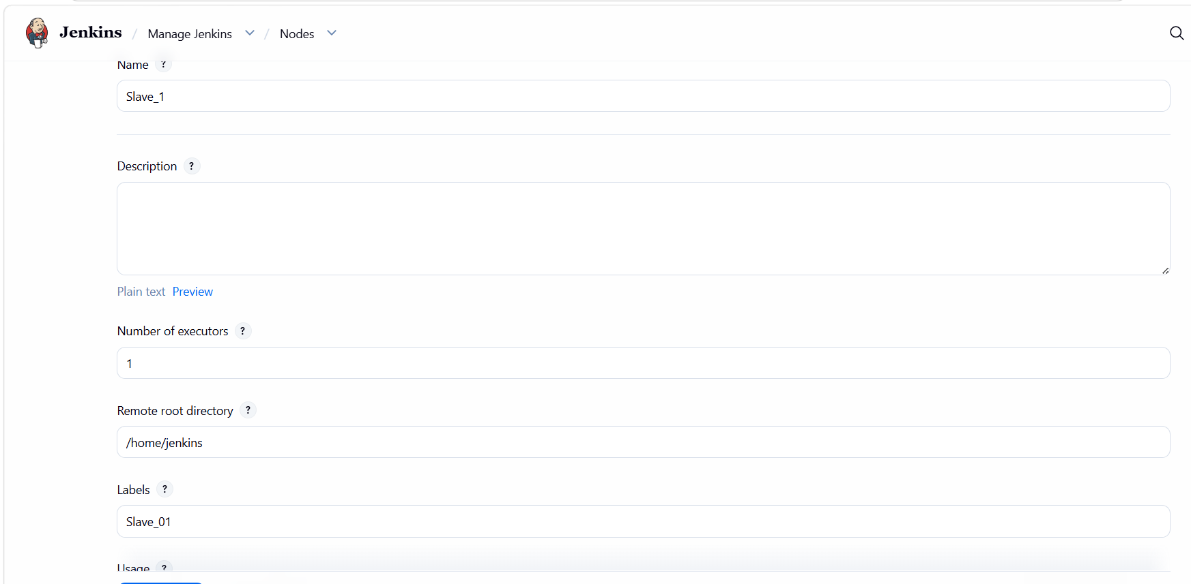
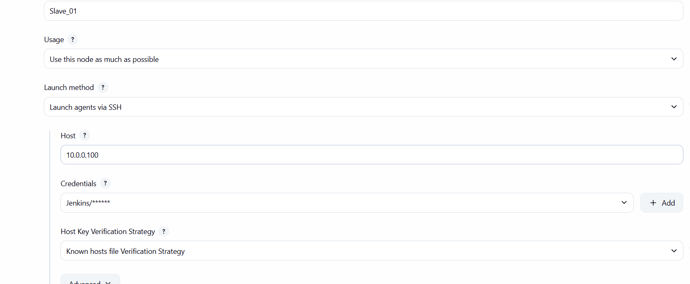
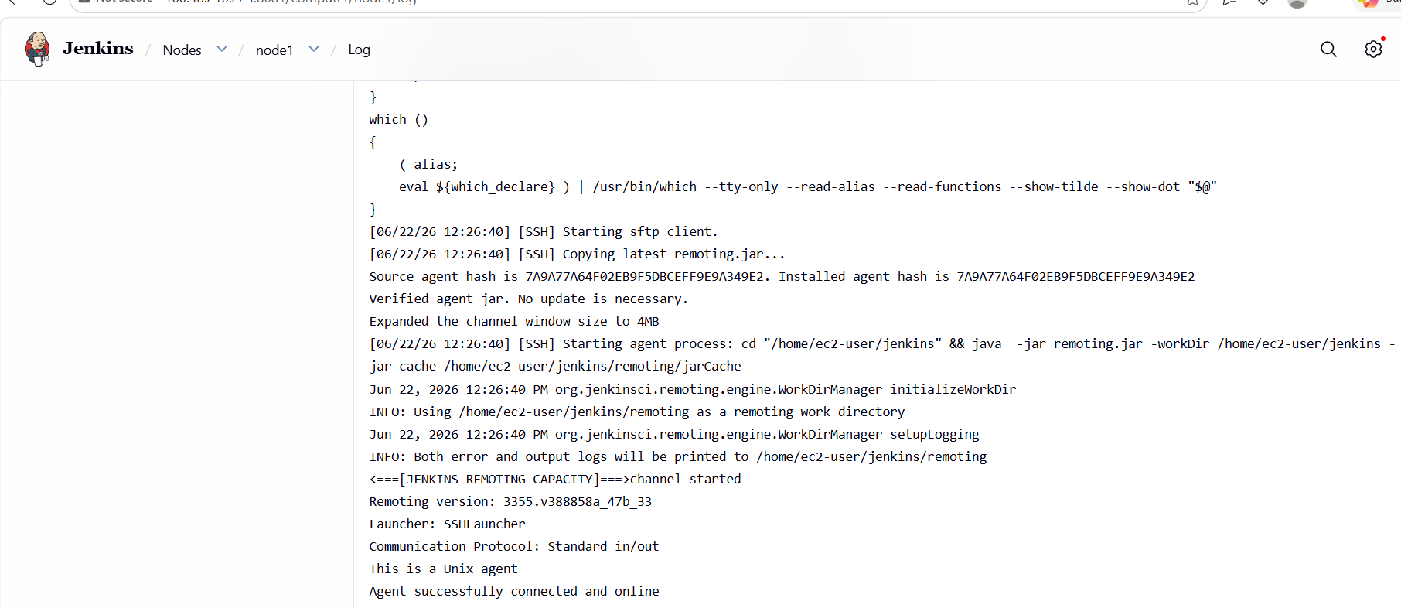
Slave2
- Name: slave2
- Host: 10.0.0.26
- Labels: slave2
STEP 5: Launch agent
- Click:
- Launch agent

- 🎯 EXPECTED RESULT
- If everything is correct:
- Slave_1 → ONLINE ✔
- And you will see:
- Agent successfully connected

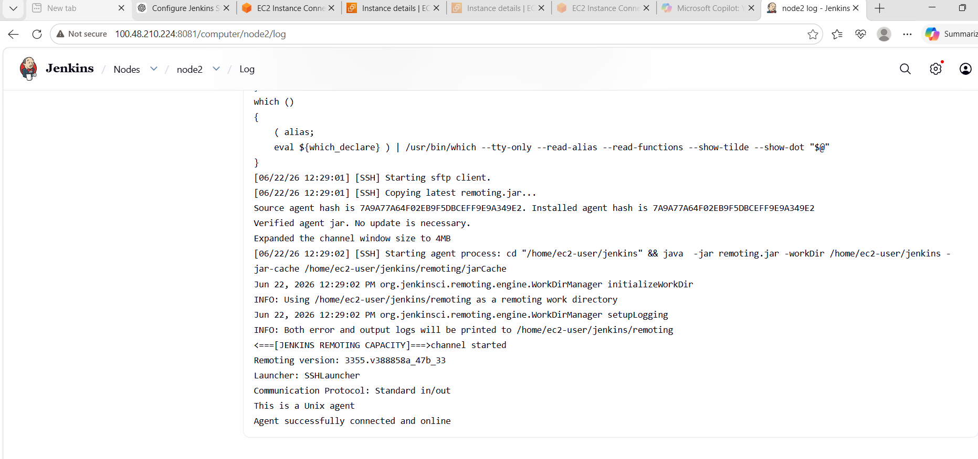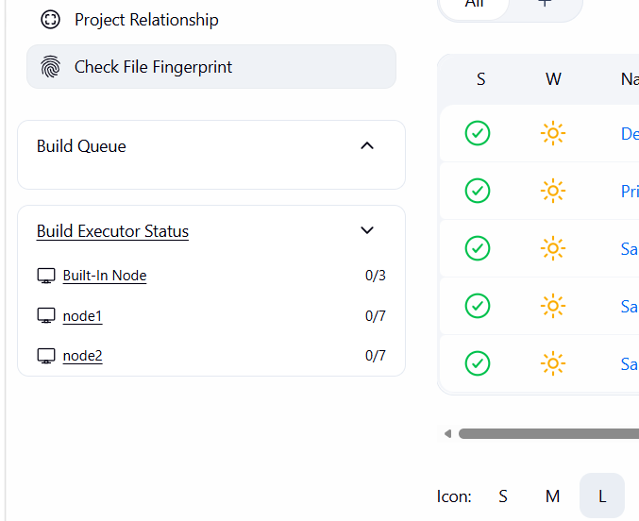

FINAL OUTCOME
✔ Jenkins Master installed
✔ 2 EC2 Slave machines configured
✔ Java 21 installed on slaves
✔ SSH passwordless authentication working
✔ Jenkins nodes ONLINE
✔ Distributed build setup completed

🧠 KEY LEARNINGS
- Security Groups control all EC2 connectivity
- SSH key authentication is mandatory for Jenkins agents
- Jenkins Master NEVER installs on slaves
- Java must be installed on agents
- OFFLINE nodes usually = SSH issue, not Jenkins issue

- Configure webhooks to the Jenkins job.
Goal
Whenever you push code to GitHub:
👉 Jenkins job should automatically trigger build

✅ STEP 1: Prerequisite Check
Make sure:
✔ Jenkins is running
✔ GitHub repo is ready
✔ Jenkins job already created (Freestyle or Pipeline)
✔ Jenkins is accessible via public URL
Example:
http://<jenkins-public-ip>:8081

⚠️ IMPORTANT (VERY IMPORTANT)
GitHub cannot send webhook to private IP.
So Jenkins must be:
- Public EC2 OR
- Accessible via internet (Security Group open on 8081)

✅ STEP 2: Install GitHub Plugin in Jenkins
Go:
Manage Jenkins → Plugins → Available
Install:
✔ GitHub Integration Plugin
✔ Git Plugin
Restart Jenkins after install.

STEP 3: Configure Jenkins Job
Go to:
Job → Configure

🔹 Source Code Management
Select:
Git
Add repo:
https://github.com/your-repo.git

🔹 Build Trigger Section
Enable:
☑ GitHub hook trigger for GITScm polling

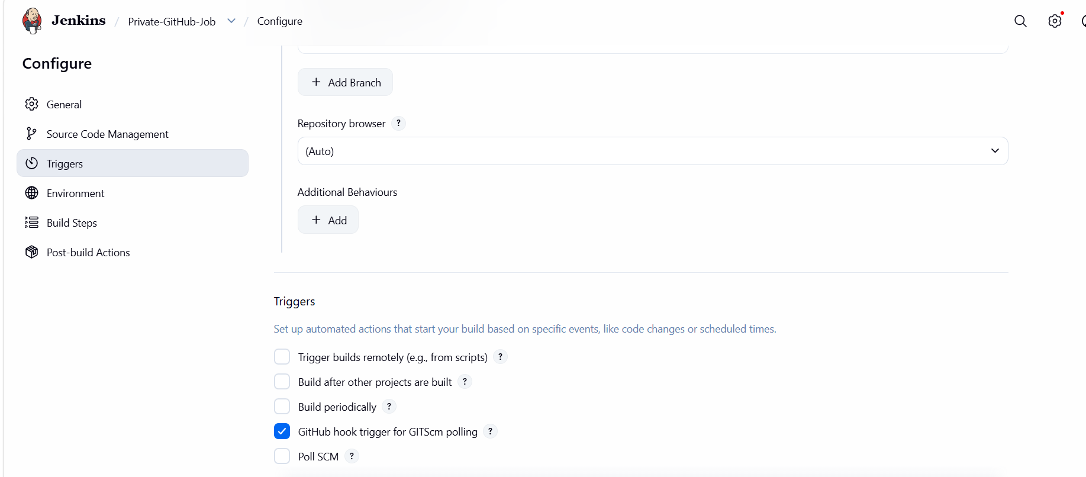
STEP 5: Configure GitHub Webhook
Go to:
GitHub Repo → Settings → Webhooks → Add webhook
Fill:
Payload URL:
http://<jenkins-public-ip>:8081/github-webhook/
Content type:
application/json
Events:
Select:
Just push event
Click:
Add webhook

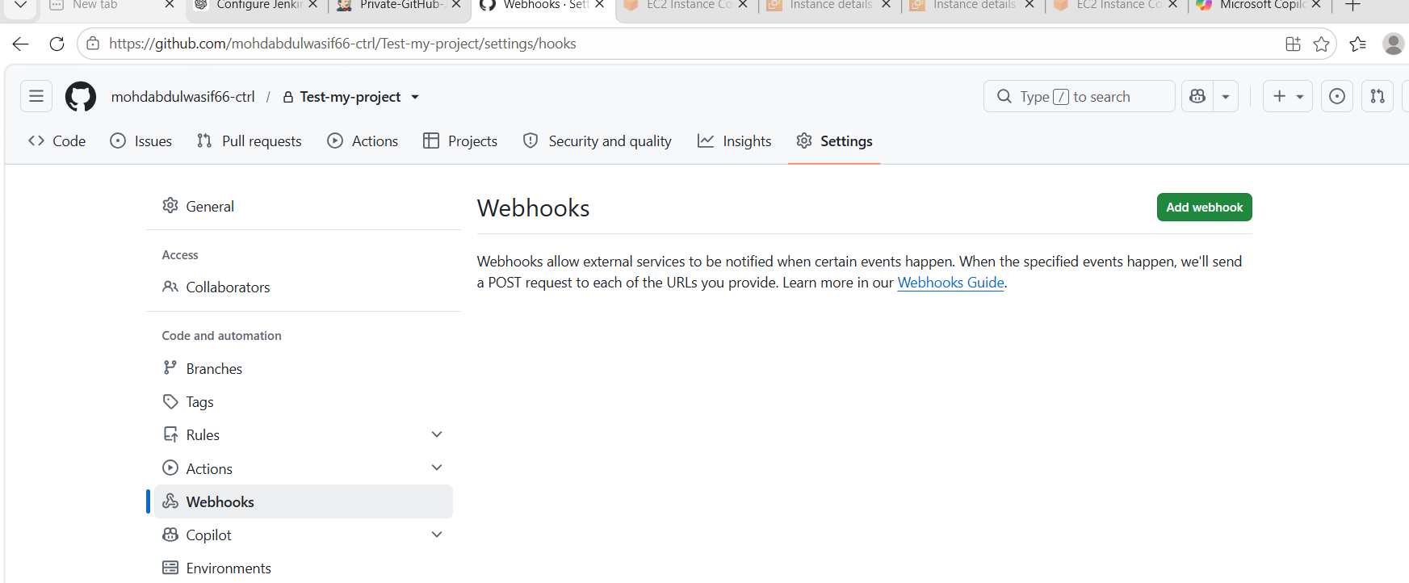

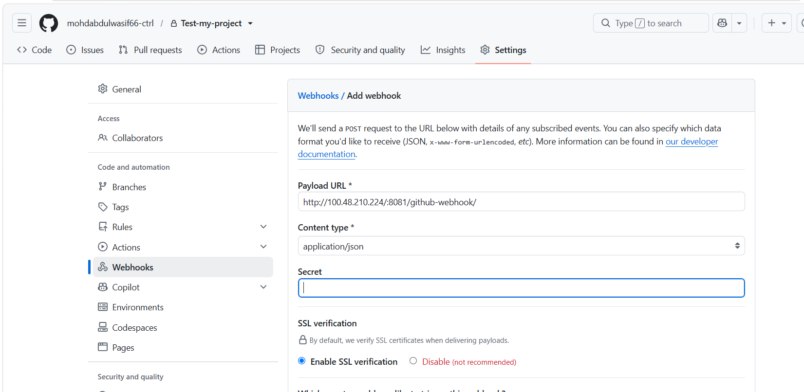

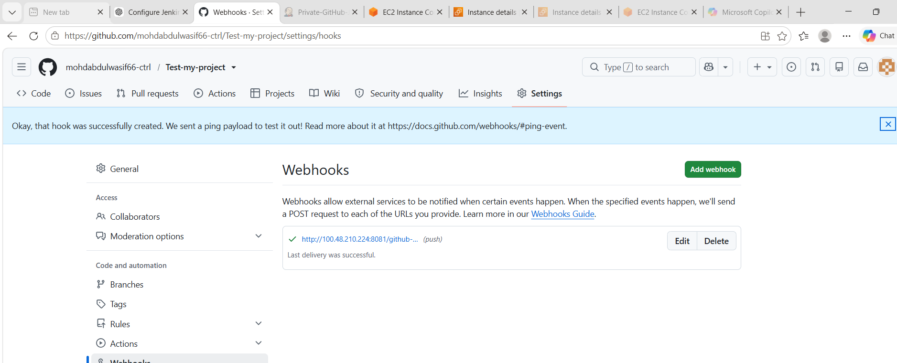
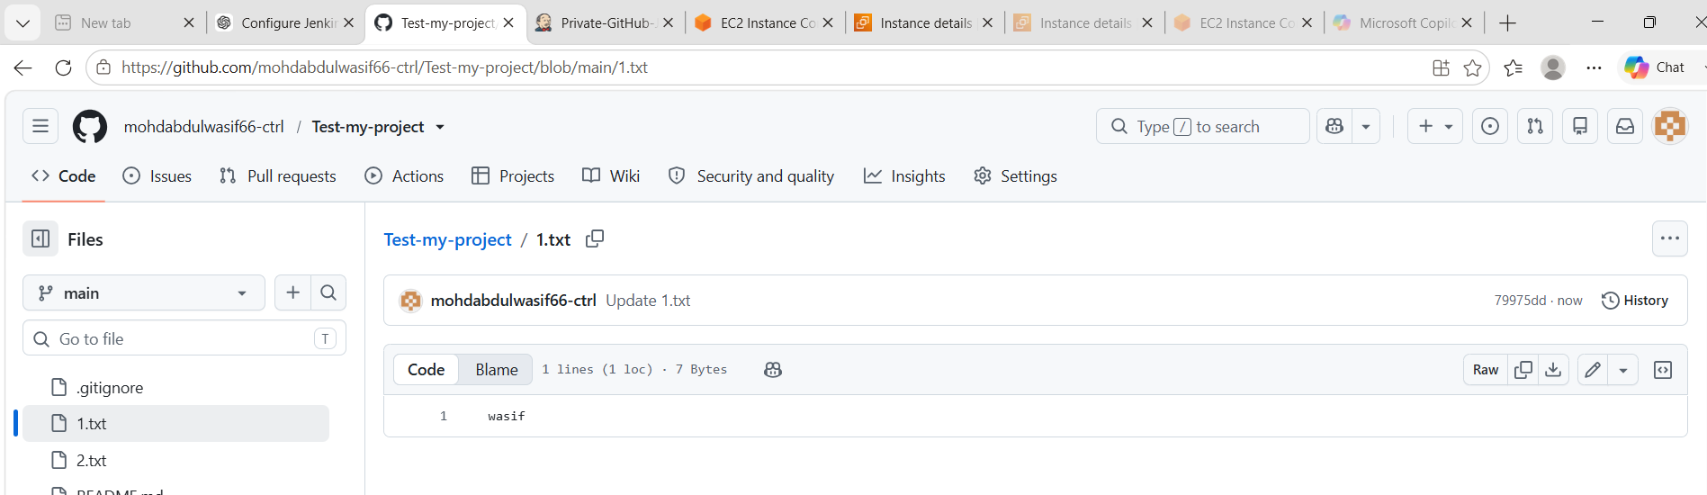
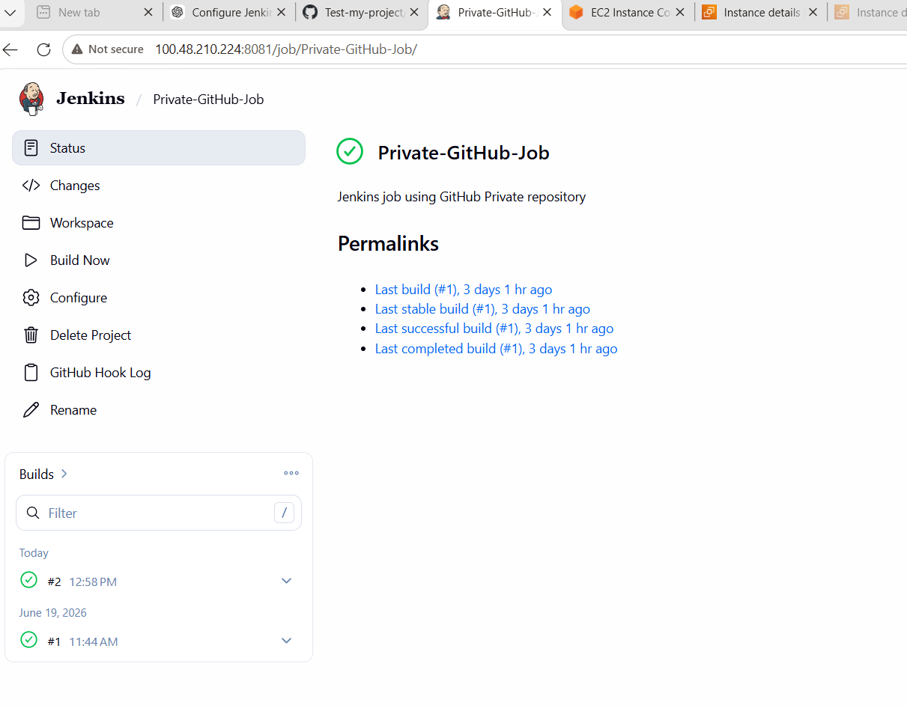
Conclusion – GitHub Webhook Integration with Jenkins
In this task, we successfully configured GitHub Webhooks with Jenkins to enable automatic build triggering whenever code is pushed to the repository. The setup was part of implementing a basic CI/CD automation workflow using Jenkins.
Initially, webhook delivery failed due to incorrect configuration of Jenkins URL using a private/internal IP address. After correcting it to a publicly accessible Jenkins URL and ensuring proper security group rules, the webhook started functioning correctly and Jenkins was able to receive GitHub events.

📚 What We Learned
🔹 1. GitHub Webhook Concept
- Webhooks are used to notify Jenkins about code changes in real-time
- GitHub sends HTTP POST requests to Jenkins on every push event

🔹 2. Jenkins Integration with GitHub
- Jenkins job can be configured to listen for GitHub events
- “GitHub hook trigger for GITScm polling” enables automatic builds

🔹 3. Webhook URL Configuration
- Correct endpoint required:
http://<public-jenkins-ip>:8081/github-webhook/
- Private IPs (like 10.x.x.x or 100.x.x.x) cannot be used externally

🔹 4. Networking Understanding
- Difference between private IP and public IP
- GitHub is an external service and requires public accessibility
- Importance of opening port 8081 in security groups

🔹 5. Troubleshooting Skills
- Identified webhook failure due to invalid/internal IP
- Resolved “failed to connect to host” error
- Verified Jenkins accessibility through browser and security settings

3. Configure Poll SC Mand Build Periodically options in the Jenkins
job.
STEP 1: Open Jenkins Job
Go to:
http://<jenkins-ip>:8081
Then:
Job → Configure

🔹 PART 1: Poll SCM

✅ STEP 2: Enable Poll SCM
Go to:
Build Triggers
Select:
☑ Poll SCM

🧠 STEP 3: Add Schedule (CRON)
Example:
H/1 * * * *
📌 Meaning:
- Check GitHub every 1 minutes
- If changes found → trigger build

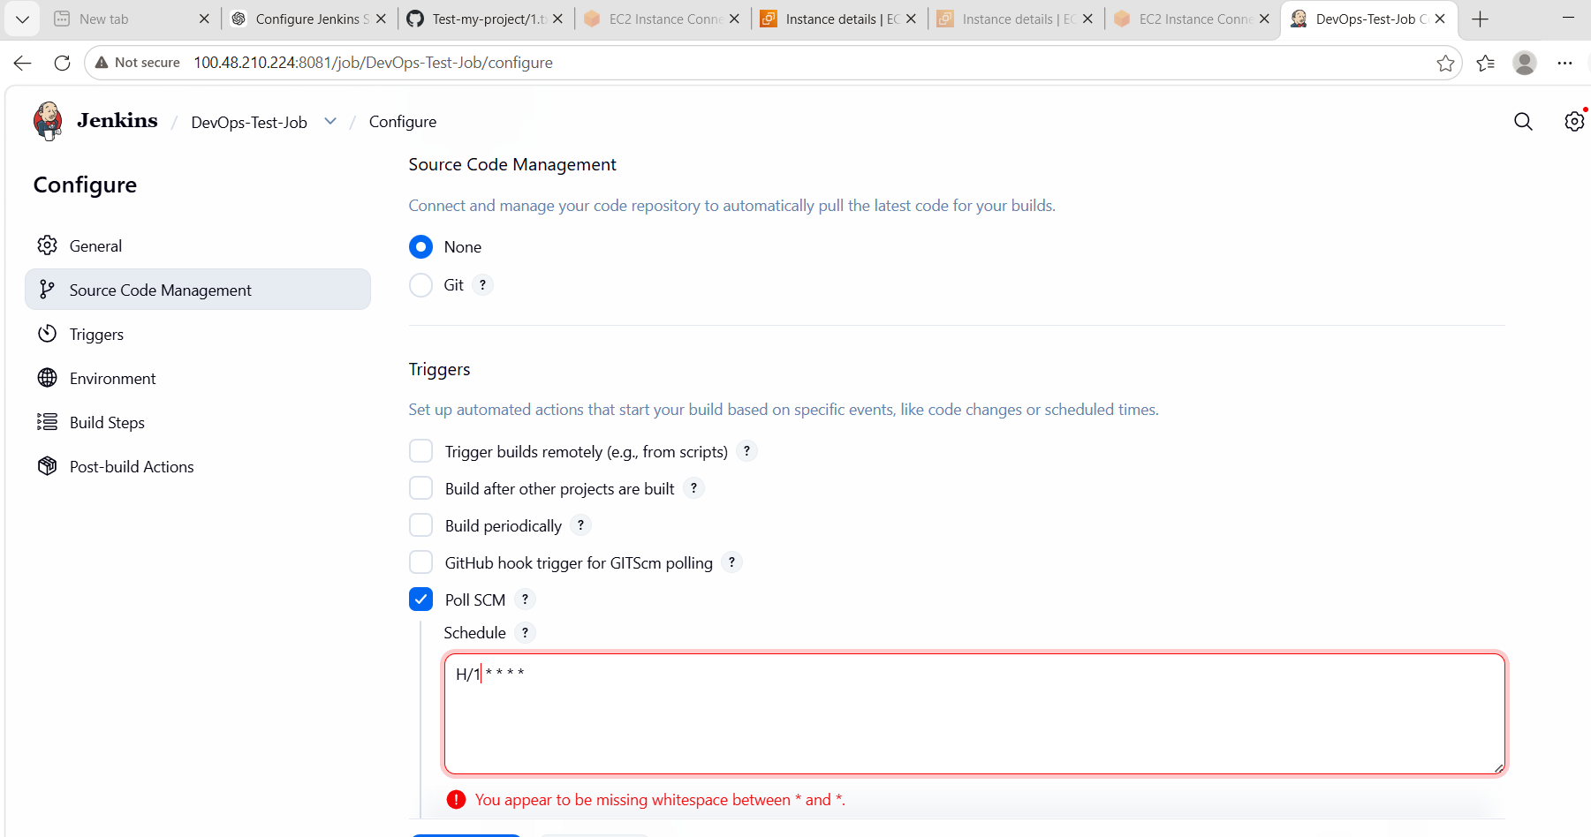
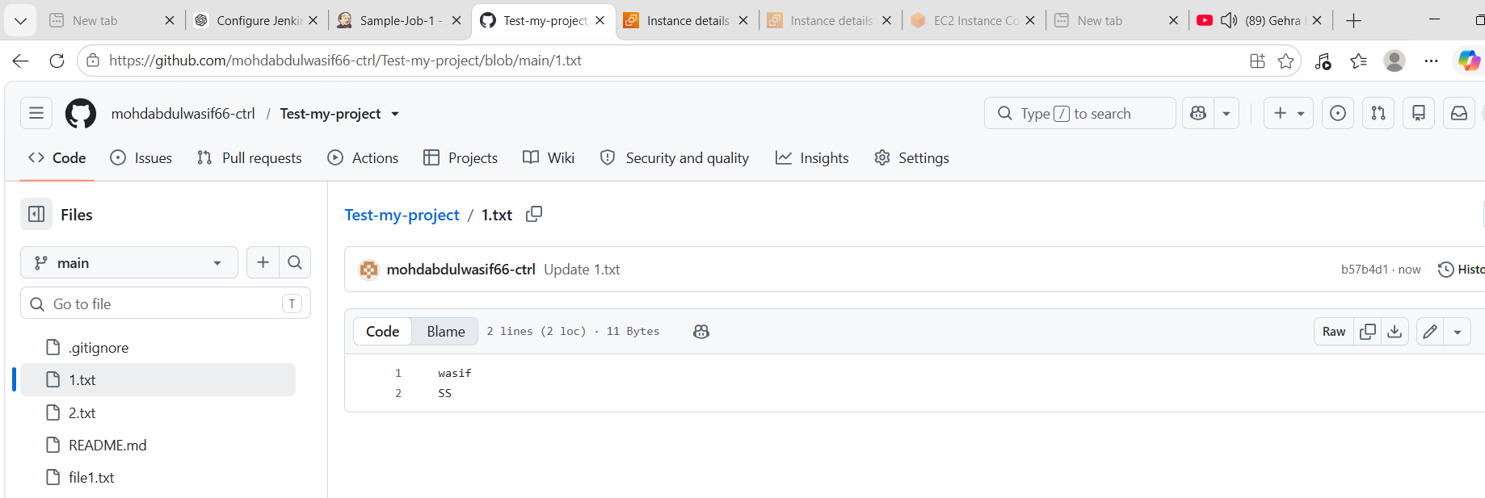
Build Periodically Configuration
Steps Performed
- Opened Jenkins Job → Configure
- Enabled Build periodically
- Added schedule:
H/5 * * * *
Meaning
- Jenkins executes the job every 5 minutes.
- Build runs even if there are no code changes.

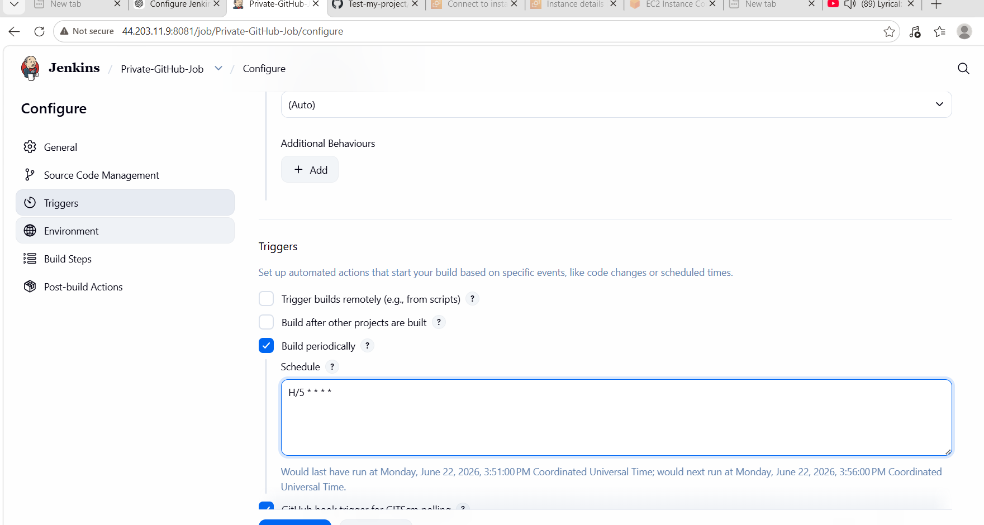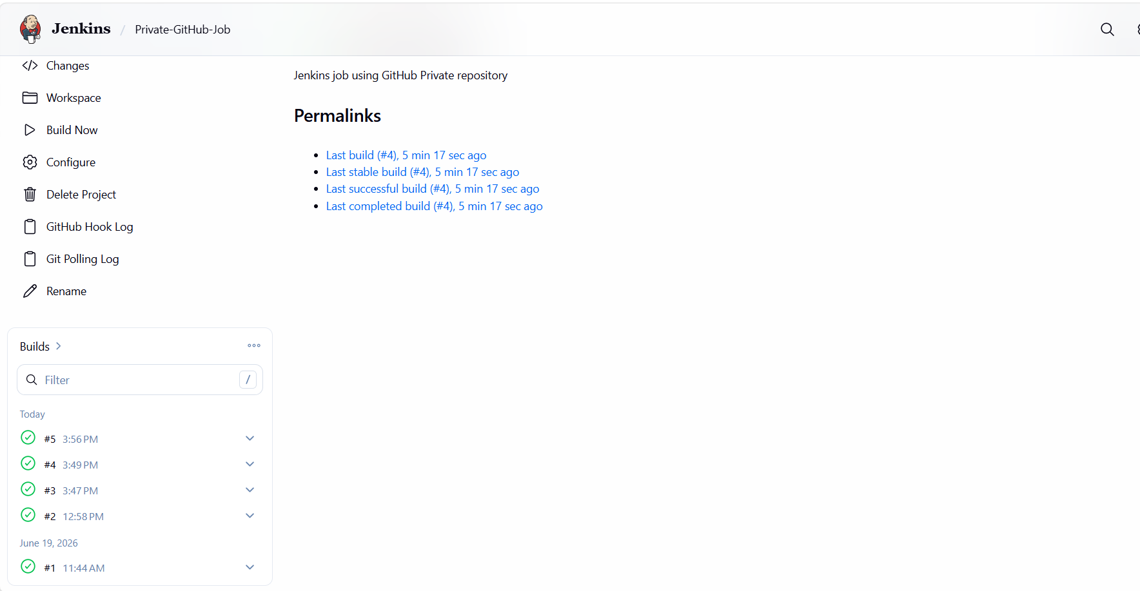

Conclusion
Successfully configured Poll SCM and Build Periodically options in Jenkins. Poll SCM enabled automatic builds when changes were detected in the GitHub repository, while Build Periodically allowed scheduled execution of jobs at predefined intervals. This enhanced the Continuous Integration process and reduced manual intervention.

What We Learned
- How Poll SCM works in Jenkins.
- Difference between Poll SCM and Build Periodically.
- Jenkins Cron syntax.
- Repository polling mechanism.
- Troubleshooting Poll SCM schedules.
- Importance of repository credentials and branch configuration.
- Automating builds based on code changes and time schedules.

- Take a backup of the Jenkins server using a bash-script.
Objective
Take manual backup of Jenkins server using a Bash script.

1. Go inside Jenkins directory
cd /var/lib/jenkins
Then check:
ls -l

🔹 2. Confirm Jenkins Home
Run as root:
echo $JENKINS_HOME
If empty, manually check:
ls -ld /var/lib/jenkins
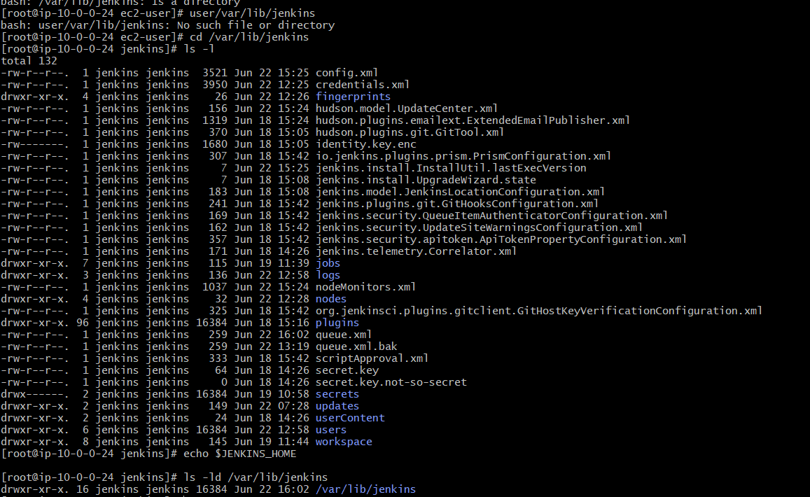
STEP 2: Create Backup Folder
sudo mkdir -p /backup/jenkins

✅ STEP 3: Create Backup Script
sudo vi /backup/jenkins/jenkins_backup.sh
Paste this:
#!/bin/bash
DATE=$(date +%F-%H-%M-%S)
JENKINS_HOME="/var/lib/jenkins"
BACKUP_DIR="/backup/jenkins"
echo "Starting Jenkins backup..."
tar -czvf $BACKUP_DIR/jenkins_backup_$DATE.tar.gz $JENKINS_HOME
echo "Backup completed at $DATE"
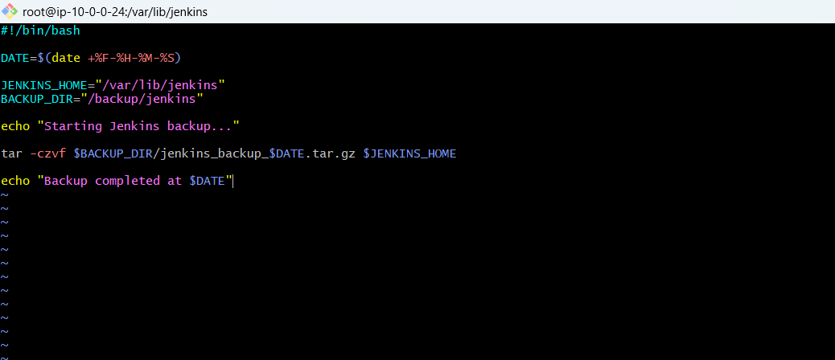
STEP 4: Give Execute Permission
sudo chmod +x /backup/jenkins/jenkins_backup.sh

✅ STEP 5: Run Backup Manually
sudo /backup/jenkins/jenkins_backup.sh
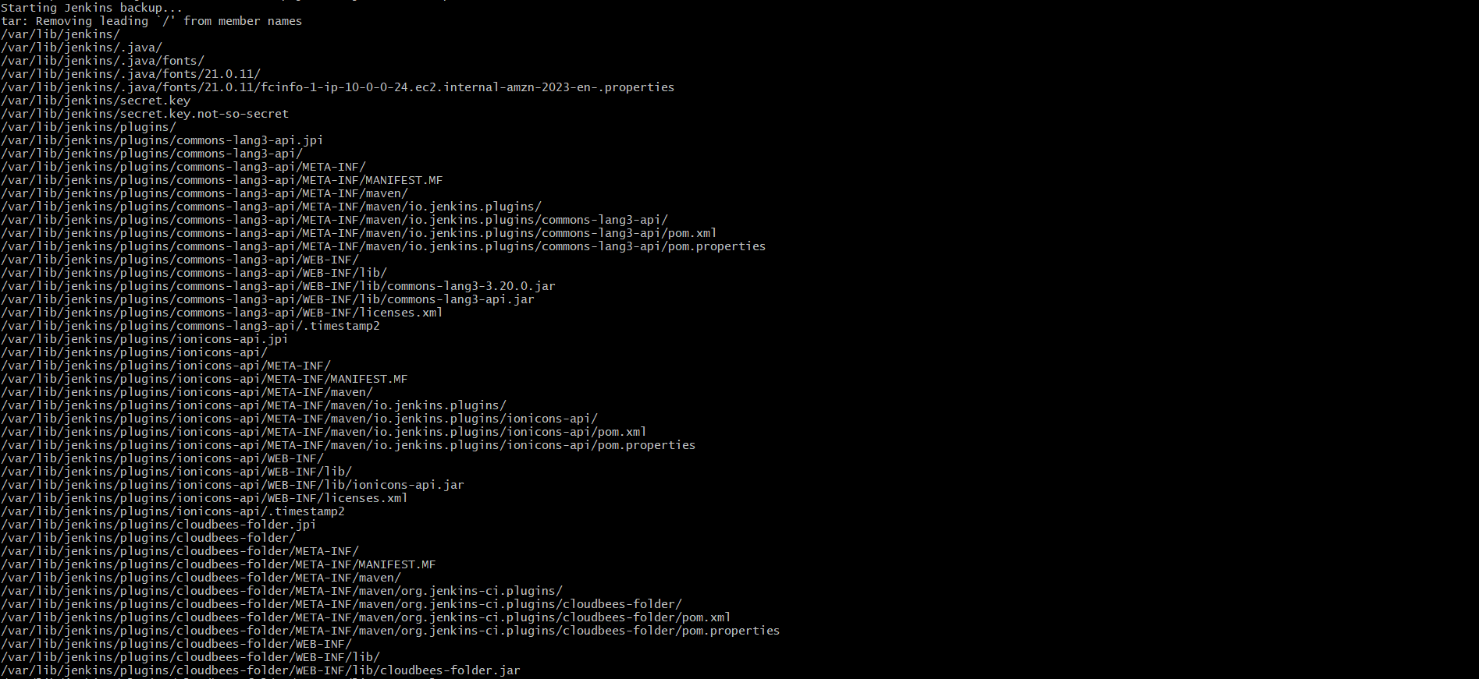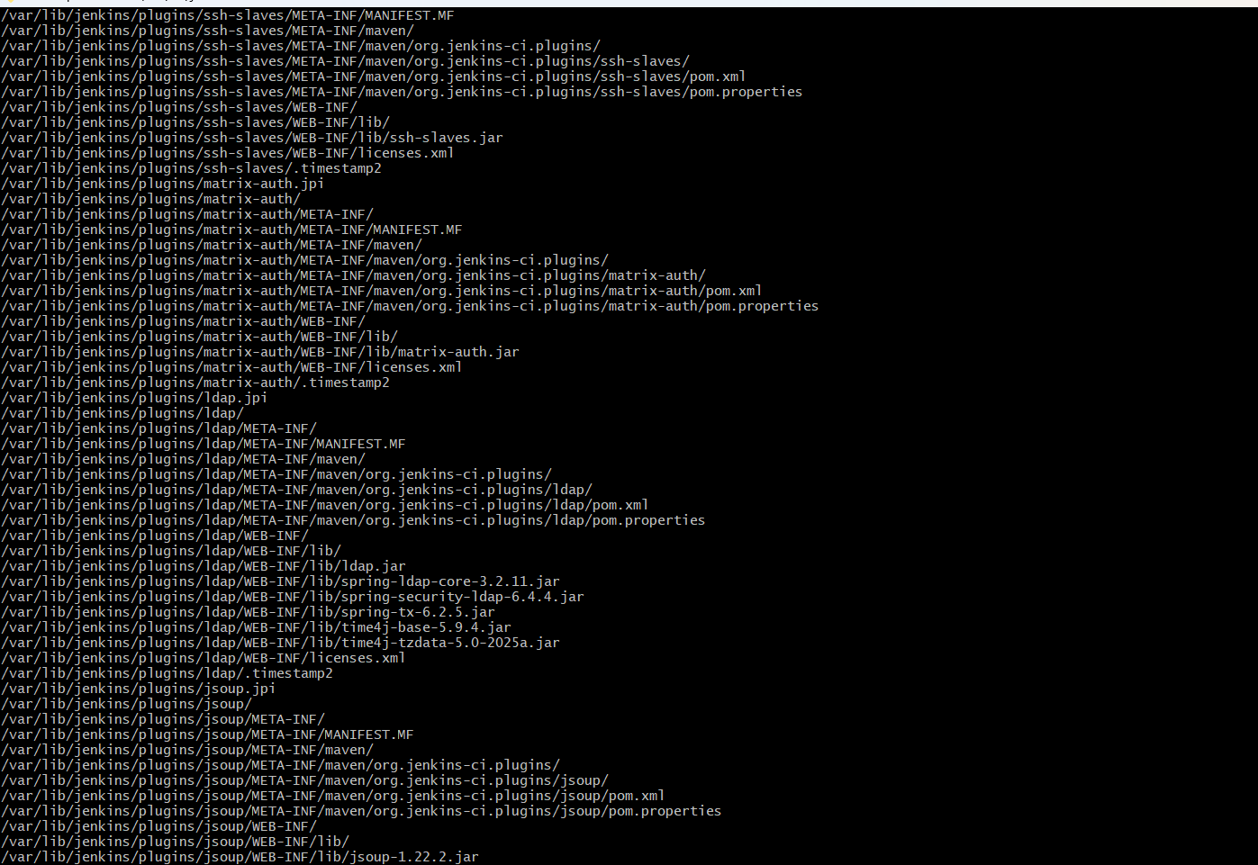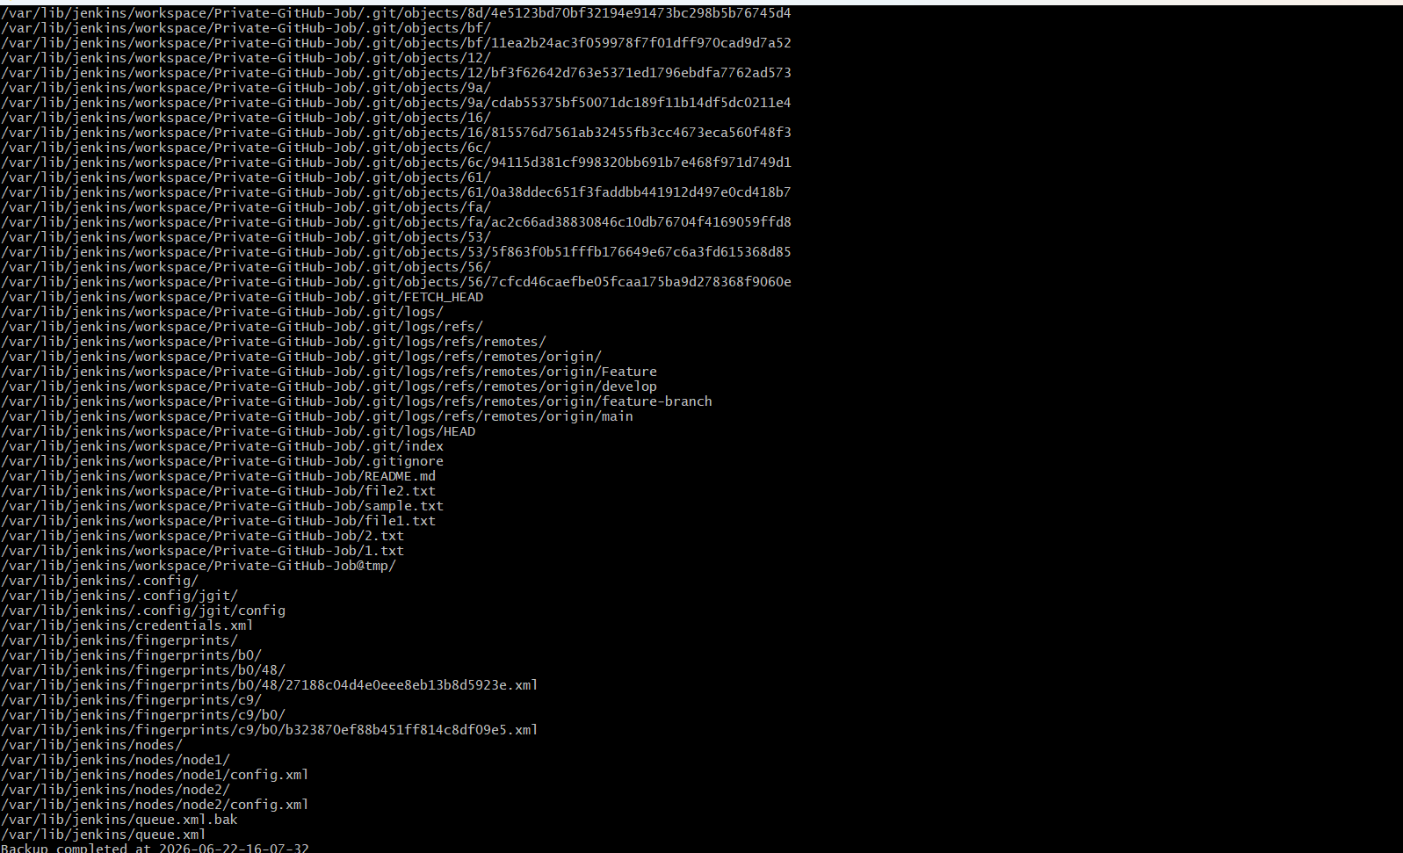
STEP 6: Verify Backup File
ls -lh /backup/jenkins
You should see:
jenkins_backup_2026-06-22-xx-xx-xx.tar.gz
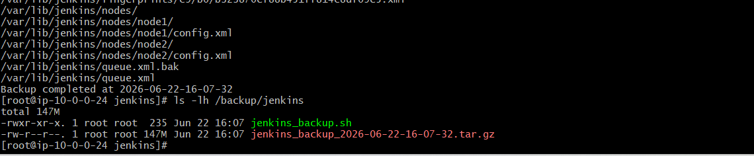
Restore Jenkins Server from Backup (Bash Method)
🎯 Objective
Restore Jenkins configuration, jobs, plugins, and data from a backup .tar.gz file.

⚠️ IMPORTANT (Before restore)
✔ Stop Jenkins service before restoring
✔ Take fresh backup before overwrite (safety)

✅ STEP 1: Stop Jenkins Service
sudo systemctl stop jenkins
Check status:
sudo systemctl status Jenkins
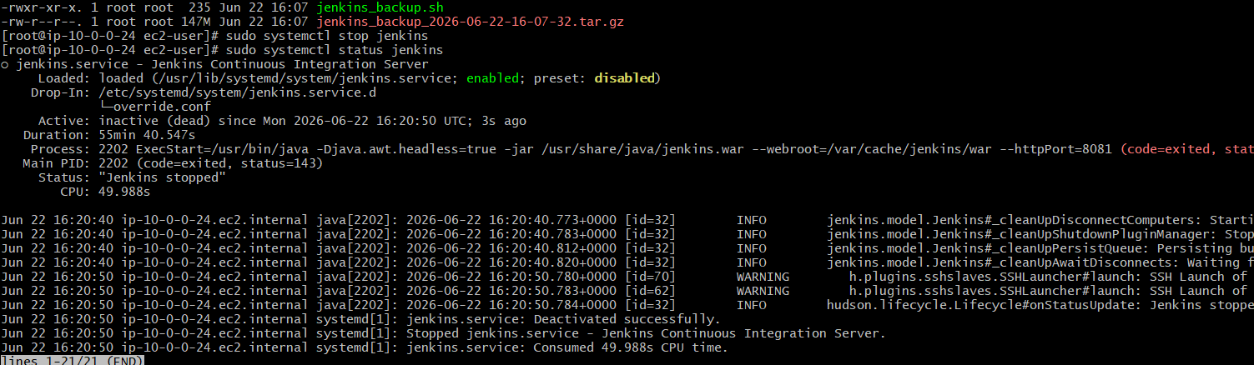

FINAL OUTPUT
✔ Jenkins data backed up
✔ Backup stored locally
✔ Script executed manually (NO cron required)

📌 What this backup contains
- Jobs
- Builds history
- Plugins
- Credentials
- Configurations
- User data
From:
/var/lib/jenkins

❌ Why cron is NOT needed here
Your task says:
“Take a backup using bash script”
So:
- Manual execution ✔
- Scheduled automation ❌ (not required)

📄 Conclusion (for your document)
In this task, a Bash script was created to manually back up the Jenkins server. The script compresses the Jenkins home directory (/var/lib/jenkins) into a timestamped archive and stores it in a backup directory. This ensures Jenkins configurations, jobs, and build history are safely preserved and can be restored when needed.

🧠 What you learned
- Jenkins data location (/var/lib/jenkins)
- Creating backup scripts in Linux
- Using tar for compression
- Manual backup execution
- Importance of Jenkins disaster recovery

5.Take a backup of Jenkins using the ThinBackup plugin.
Objective
Use the ThinBackup plugin in Jenkins to create lightweight, efficient backups of Jenkins configurations, jobs, plugins, and system settings.

✅ STEP 1: Install ThinBackup Plugin
Go to Jenkins:
Manage Jenkins → Plugins → Available Plugins
Search:
ThinBackup
Install:
✔ ThinBackup plugin
✔ Restart Jenkins after installation

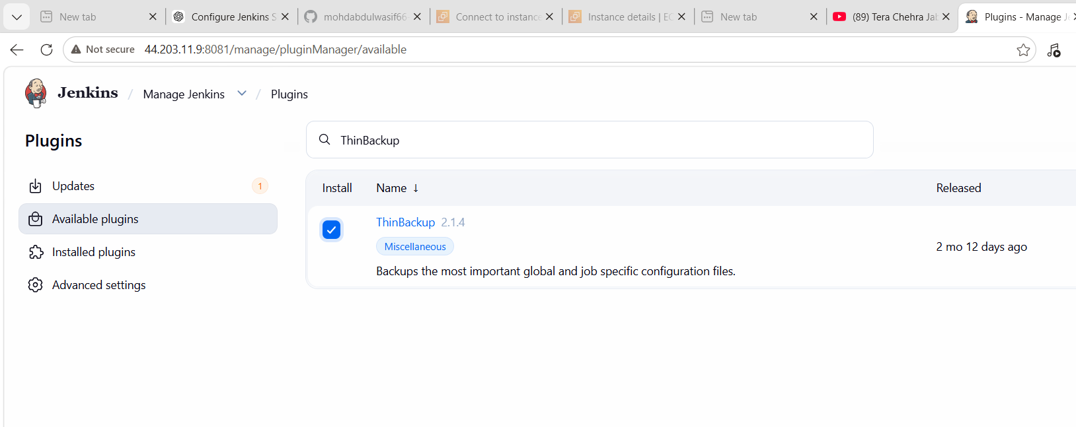
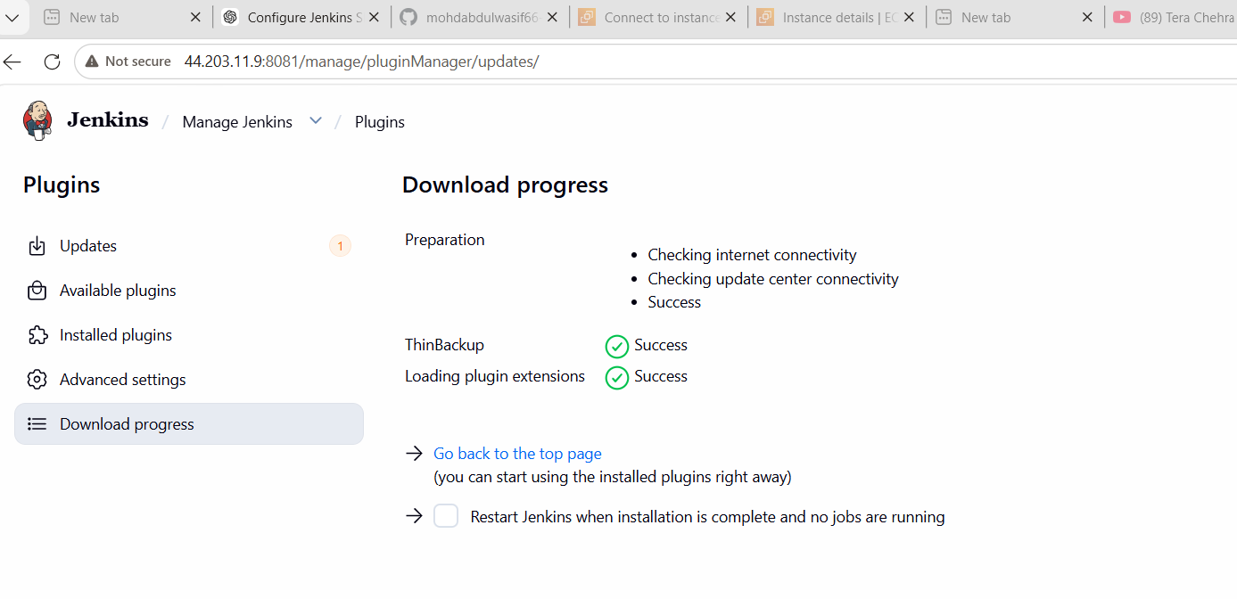
STEP 2: Configure ThinBackup
Go to:
Manage Jenkins → ThinBackup
Click:
Settings
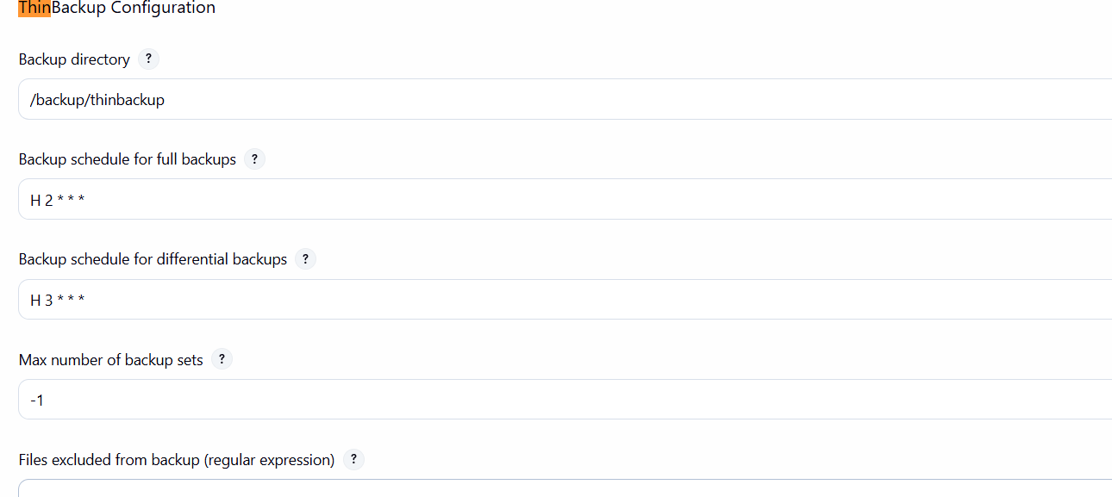
Cause 1
Backup not triggered
✔ Fix → Click “Backup Now”

🔴 Cause 2
Permission issue
✔ Fix:
sudo chown -R jenkins:jenkins /backup/thinbackup

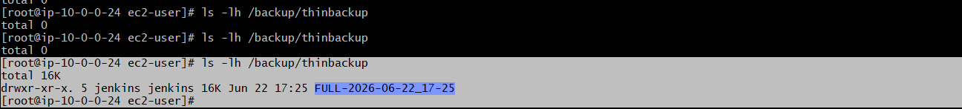
Conclusion
In Task 5, we successfully configured Jenkins ThinBackup plugin to take automated backups. We created a backup directory, executed full backup, and verified that Jenkins data (jobs, plugins, and configurations) was safely stored in the backup location.

📚 What We Learned
- How to install and configure ThinBackup plugin in Jenkins
- How to set and manage backup directory permissions
- How Jenkins backup stores jobs, plugins, and configurations
- Importance of backups for disaster recovery and migration
- How to manually trigger and verify Jenkins backup

Task 6: Set Up a New Jenkins Server and Restore the Backup Taken in Task 4
🎯 Objective
Provision a new Jenkins server and restore the backup created in Task 4 (Bash Script Backup).

✅ Step 1: Launch a New Server
Create a new EC2 instance (Amazon Linux 2023).
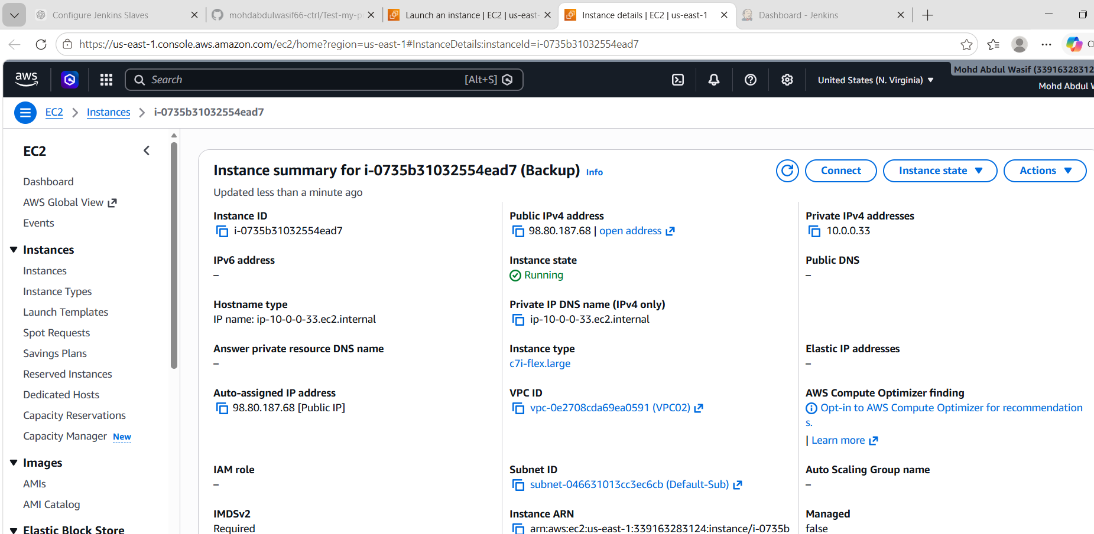
Update packages:
sudo dnf update -y

✅ Step 2: Install Java 21
sudo dnf install java-21-amazon-corretto -y
Verify:
java -version
Expected:
openjdk version "21"
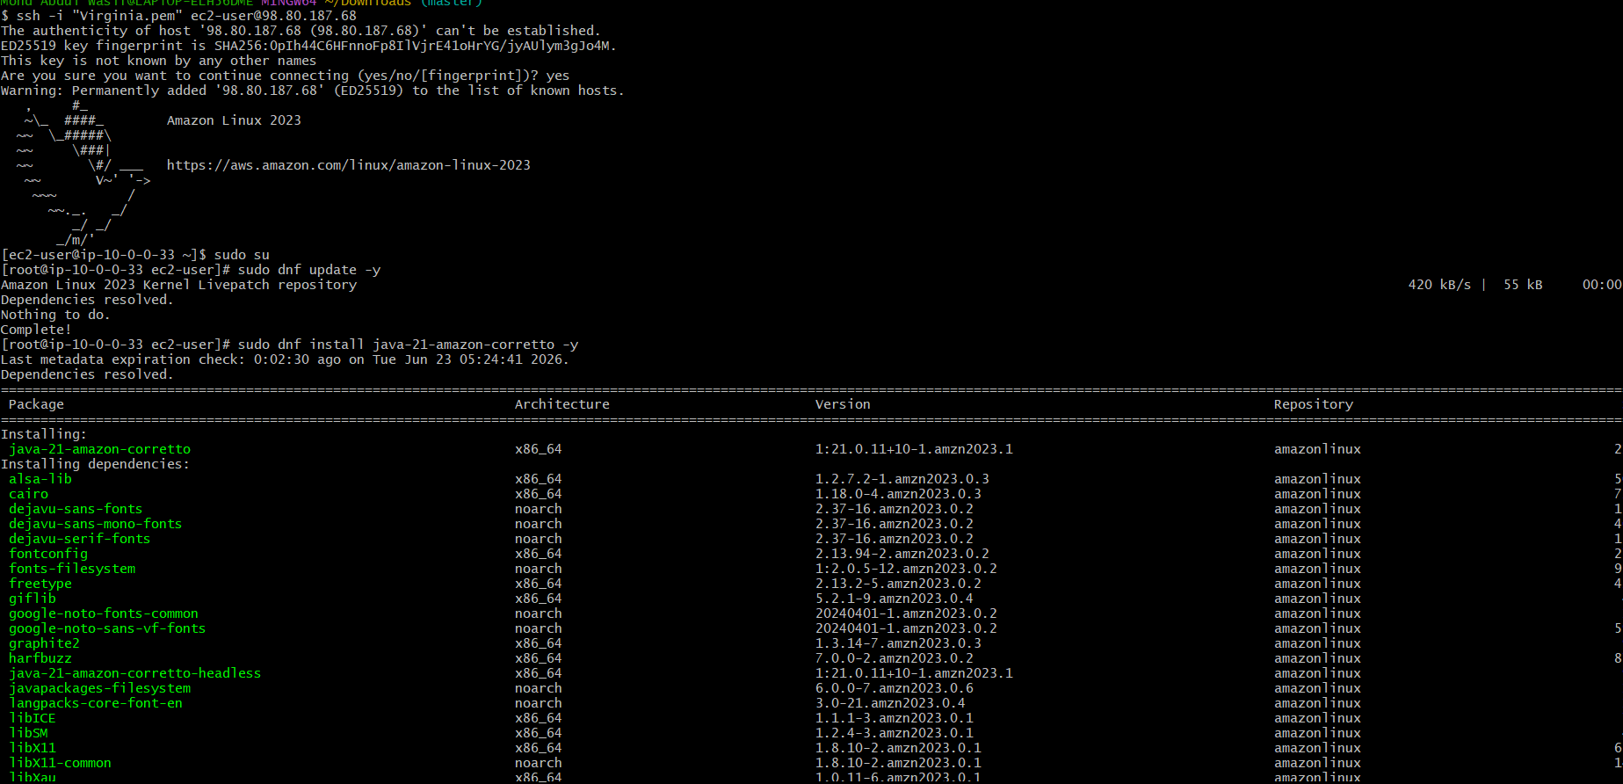

✅ Step 3: Install Jenkins
Import Jenkins key:
sudo rpm --import https://pkg.jenkins.io/redhat-stable/jenkins.io-2023.key
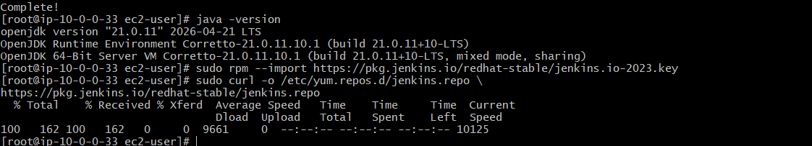
Add Jenkins repository:
sudo curl -o /etc/yum.repos.d/jenkins.repo \
https://pkg.jenkins.io/redhat-stable/jenkins.repo
Install Jenkins:
sudo dnf install jenkins -y
Enable and start Jenkins:
sudo systemctl enable jenkins
sudo systemctl start jenkins
Verify:
sudo systemctl status Jenkins
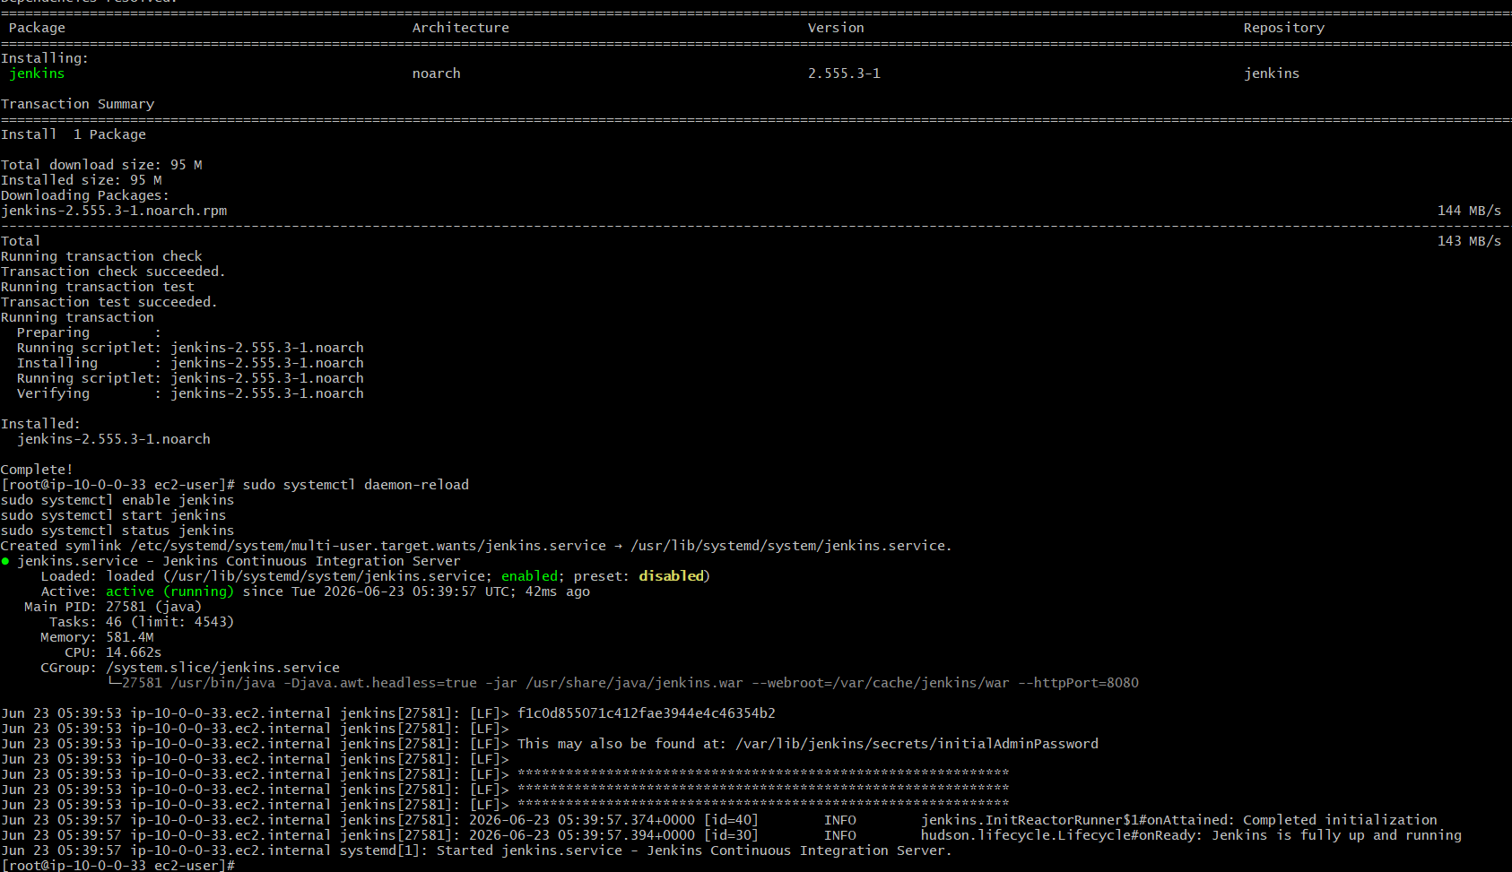

✅ Step 4: Copy Backup File from Old Server
Example backup:
jenkins_backup_2026-06-22-16-07-32.tar.gz
Copy using SCP:
scp -i Virginia.pem \
jenkins_backup_2026-06-22-16-07-32.tar.gz \
ec2-user@<NEW_SERVER_IP>:/tmp/

✅ Step 5: Stop Jenkins on New Server
sudo systemctl stop Jenkins
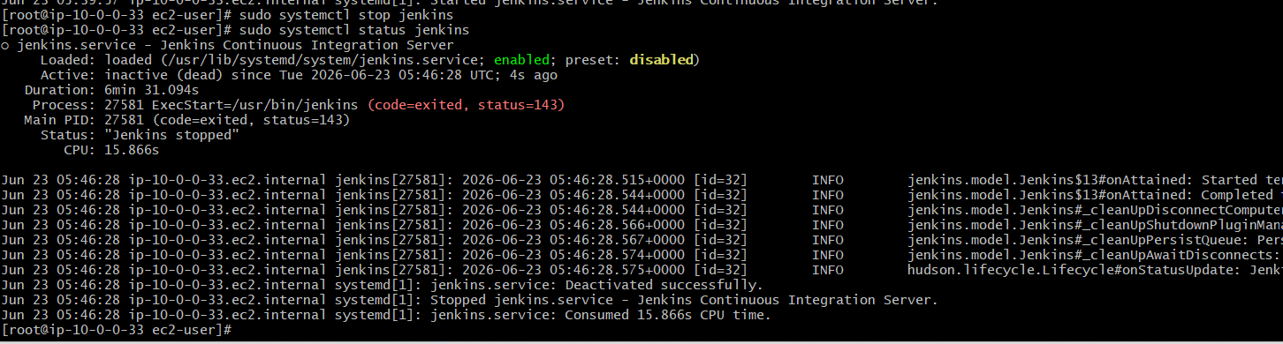

✅ Step 6: Remove Existing Jenkins Data
sudo mv /var/lib/jenkins /var/lib/jenkins_old
Create a fresh directory:
sudo mkdir -p /var/lib/jenkins

✅ Step 7: Restore Backup
Extract backup:
sudo tar -xzvf /tmp/jenkins_backup_2026-06-22-16-07-32.tar.gz -C /
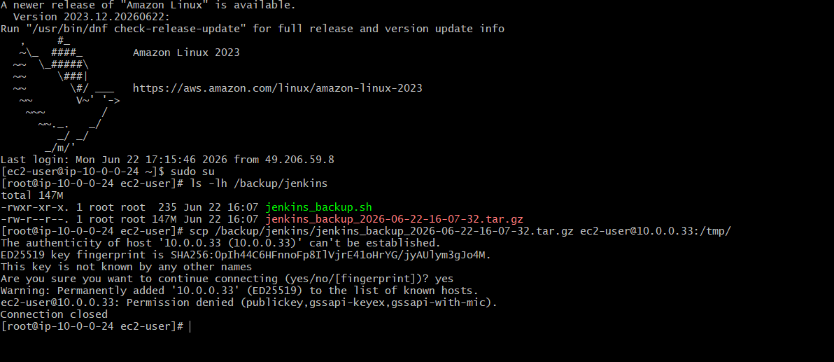
Option 1 (Recommended): Copy using your laptop
Step 1: From your laptop, download the backup from the old server
scp -i Virginia.pem ec2-user@<OLD_PUBLIC_IP>:/backup/jenkins/jenkins_backup_2026-06-22-16-07-32.tar.gz .
Example:
scp -i Virginia.pem ec2-user@100.48.210.224:/backup/jenkins/jenkins_backup_2026-06-22-16-07-32.tar.gz .

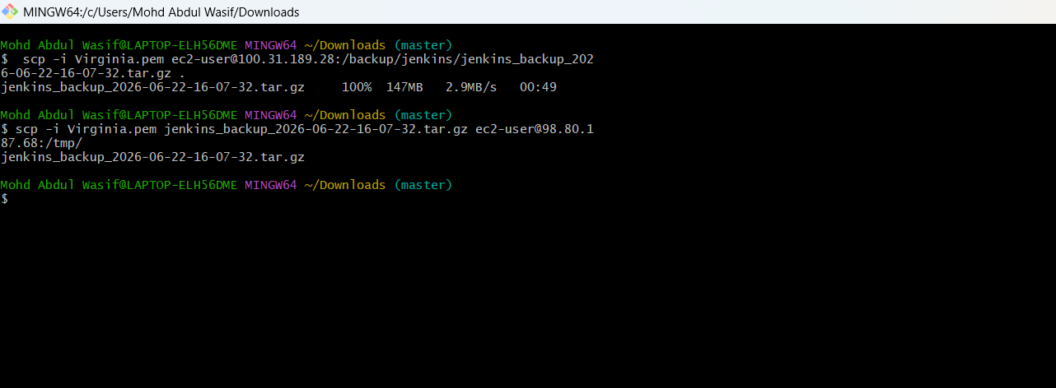
Step 2: Upload to the new server
scp -i Virginia.pem jenkins_backup_2026-06-22-16-07-32.tar.gz ec2-user@98.80.187.68:/tmp/

Step 3: Verify on the new server
SSH into the new server:
ssh -i Virginia.pem ec2-user@98.80.187.68
Check:
ls -lh /tmp

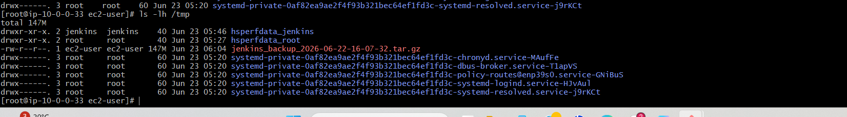

✅ Step 8: Fix Ownership
sudo chown -R jenkins:jenkins /var/lib/jenkins

✅ Step 9: Start Jenkins
sudo systemctl start jenkins
Check:
sudo systemctl status jenkins
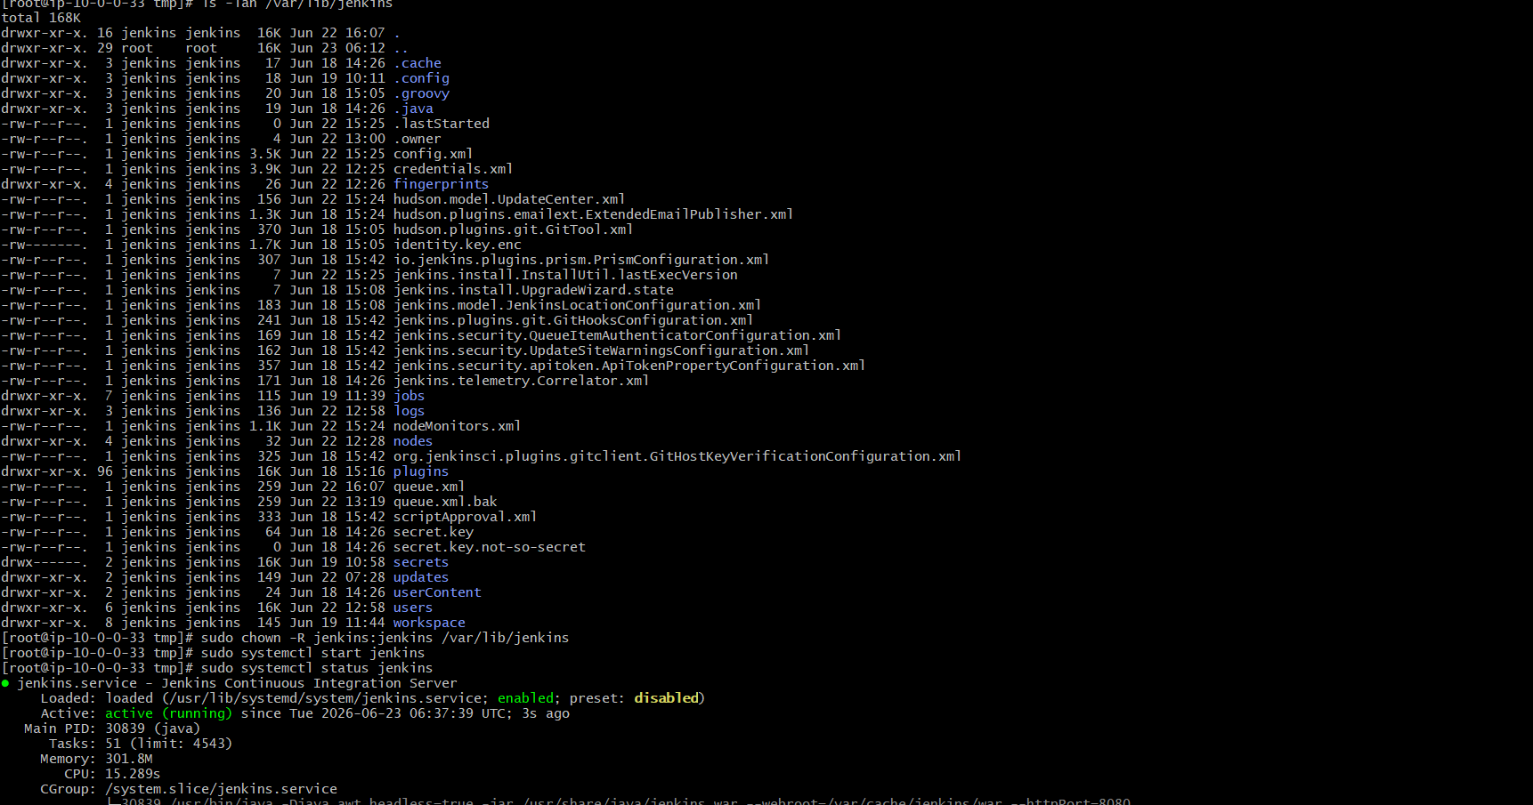

✅ Step 10: Verify Restoration

Open:
http://<NEW_SERVER_PUBLIC_IP>:8080
Verify:
- Jobs restored ✔
- Plugins restored ✔
- Credentials restored ✔
- Nodes configuration restored ✔
- Build history restored ✔
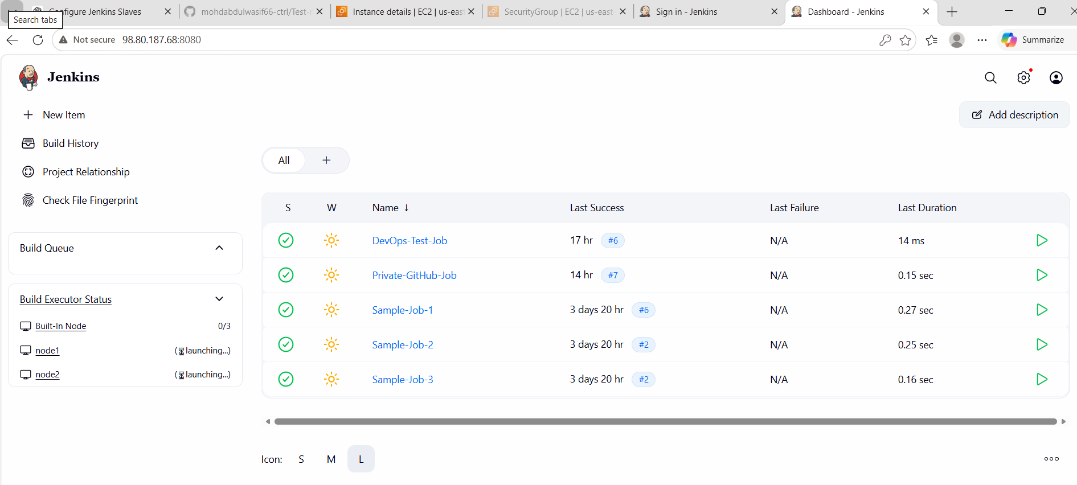
Conclusion
In this Jenkins DevOps task, we successfully performed the full CI/CD setup lifecycle including:
- Configuring Jenkins master and slave nodes using SSH
- Setting up Java 21 and Jenkins agents
- Fixing connectivity issues between master and slave nodes
- Configuring GitHub integration using webhooks and Poll SCM
- Creating and testing Jenkins jobs with a private GitHub repository
- Performing Jenkins backup using script and ThinBackup plugin
- Restoring Jenkins server on a new instance from backup
Finally, Jenkins was successfully restored and is running with all configurations, jobs, and plugins intact after resolving multiple setup and authentication issues.

📚 What We Learned
🔹 1. Jenkins Master-Slave Architecture
- How to connect EC2 slave nodes using SSH
- Importance of key-based authentication
🔹 2. Security Group & Networking
- Opening required ports (22, 8080/8081)
- Troubleshooting ping vs SSH connectivity differences
🔹 3. Jenkins Job Integration
- GitHub integration using:
  - Webhooks
  - Poll SCM
- Triggering builds automatically on code changes
🔹 4. Backup & Restore Process
- Using script-based backup of /var/lib/jenkins
- Using ThinBackup plugin for Jenkins backup automation
- Restoring Jenkins safely using tar extraction
🔹 5. Troubleshooting Skills
- Debugging SSH permission errors
- Fixing Jenkins service failures
- Resolving repository GPG and installation issues
- Fixing Jenkins login/authentication problems

