Terraform-Microservice-Development
Terraform Microservice Deployment on AWS (Docker + ECR + EC2 + ALB)
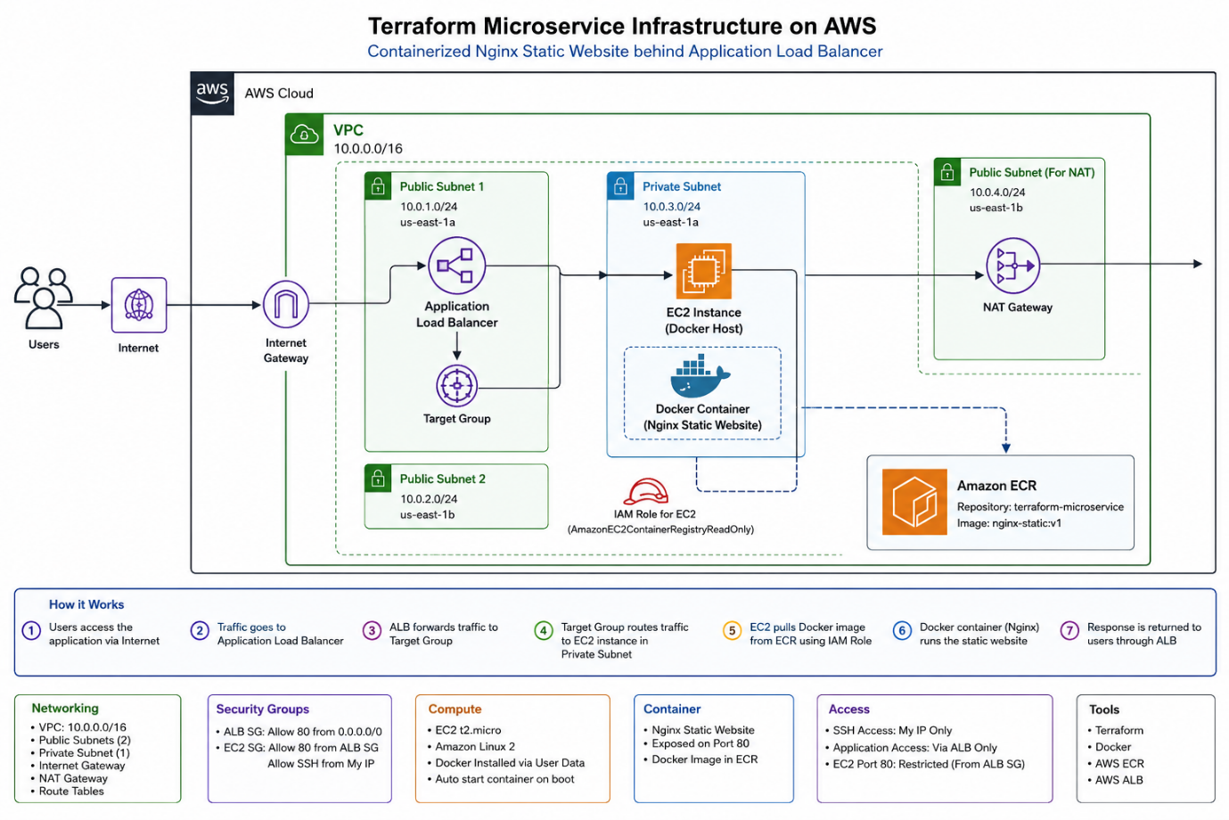

Objective
Deploy a containerized web application on AWS using Terraform by following Infrastructure as Code (IaC) best practices.
The deployment should:
- Create a Docker image using Nginx or Apache
- Push the image to Amazon ECR (Docker Registry)
- Create a custom VPC with networking resources
- Launch an EC2 instance
- Pull the Docker image from ECR
- Run the container on the EC2 instance
- Create an Application Load Balancer (ALB) to access the application
- Block direct public access to the EC2 instance except SSH from allowed IPs
- Manage the complete infrastructure using Terraform

Prerequisites
Software Required
- AWS Account (Free Tier)
- Terraform Installed
- AWS CLI Installed
- Docker Desktop / Docker Engine
- Git
- VS Code
- SSH Key Pair (Local)
- IAM User with AdministratorAccess
- Internet Connection

AWS Services Used
- Amazon ECR
- VPC
- Internet Gateway
- Route Table
- Public & Private Subnets
- Security Groups
- EC2
- Application Load Balancer
- Target Group
- IAM Role
- IAM Instance Profile
- Elastic IP (Optional)
- CloudWatch (Optional)

Project Structure
terraform-microservice/

├── Dockerfile
├── index.html
├── app.sh

├── main.tf
├── provider.tf
├── variables.tf
├── terraform.tfvars
├── outputs.tf
├── locals.tf

├── userdata.sh

├── modules/
│
├── networking/
├── ec2/
├── alb/
├── ecr/

├── scripts/
│ build.sh
│ push.sh

└── README.md
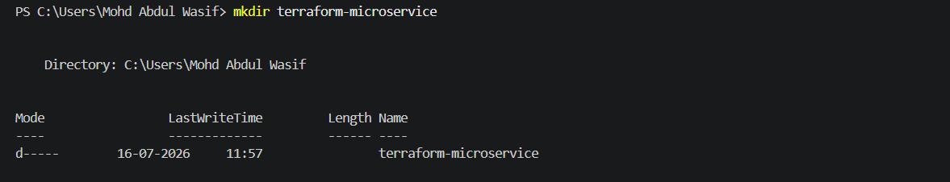
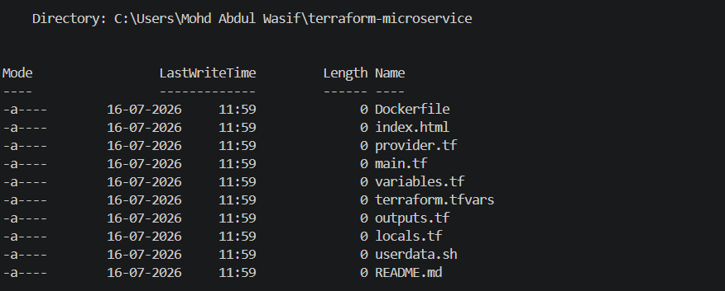
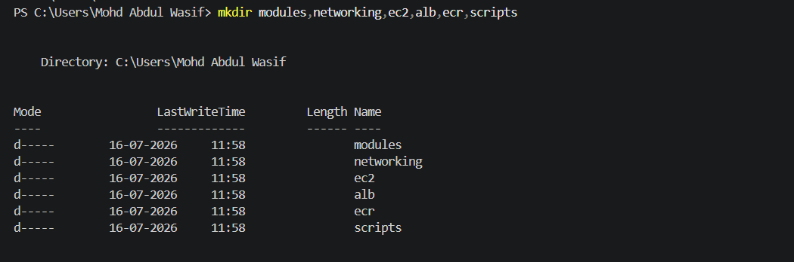

Step 1 - Create Static Web Page
Create
index.html
Simple page
<!DOCTYPE html>
<html lang="en">
<head>
<meta charset="UTF-8">
<meta name="viewport" content="width=device-width, initial-scale=1.0">
<title>Terraform Microservice</title>

<style>
*{
margin:0;
padding:0;
box-sizing:border-box;
font-family:Segoe UI,Tahoma,Geneva,Verdana,sans-serif;
}

body{
height:100vh;
display:flex;
justify-content:center;
align-items:center;
background:url("https://images.unsplash.com/photo-1516321318423-f06f85e504b3?auto=format&fit=crop&w=1950&q=80");
background-size:cover;
background-position:center;
}

.overlay{
position:absolute;
width:100%;
height:100%;
background:rgba(0,0,0,.55);
}

.container{
position:relative;
width:700px;
max-width:90%;
padding:45px;
text-align:center;
color:white;
border-radius:20px;
backdrop-filter:blur(12px);
background:rgba(255,255,255,.12);
border:1px solid rgba(255,255,255,.25);
box-shadow:0 10px 30px rgba(0,0,0,.4);
}

h1{
font-size:50px;
margin-bottom:15px;
color:#00d4ff;
}

h2{
font-size:26px;
margin-bottom:20px;
}

p{
font-size:18px;
line-height:1.7;
margin-bottom:20px;
}

.name{
font-size:24px;
color:#FFD700;
font-weight:bold;
}

.badges{
margin-top:25px;
}

.badges span{
display:inline-block;
margin:8px;
padding:10px 20px;
background:#ffffff22;
border-radius:30px;
font-weight:bold;
font-size:16px;
}

.footer{
margin-top:30px;
font-size:15px;
color:#ddd;
}
</style>

</head>

<body>

<div class="overlay"></div>

<div class="container">

<h1>🚀 Welcome to Terraform Microservice</h1>

<h2>Cloud Infrastructure Deployment</h2>

<p>
This web application is deployed using
<b>Terraform Infrastructure as Code</b>,
containerized with <b>Docker</b>,
stored in <b>Amazon ECR</b>,
running on an <b>AWS EC2 Instance</b>,
and securely accessed through an
<b>Application Load Balancer</b>.
</p>

<div class="name">
👨‍💻 Developed by <br>
Mohd Abdul Wasif
</div>

<div class="badges">
<span>🐳 Docker</span>
<span>☁ AWS</span>
<span>🏗 Terraform</span>
<span>⚡ Nginx</span>
<span>🚀 DevOps</span>
</div>

<div class="footer">
Terraform • Docker • AWS • EC2 • ALB • ECR
</div>

</div>

</body>
</html>
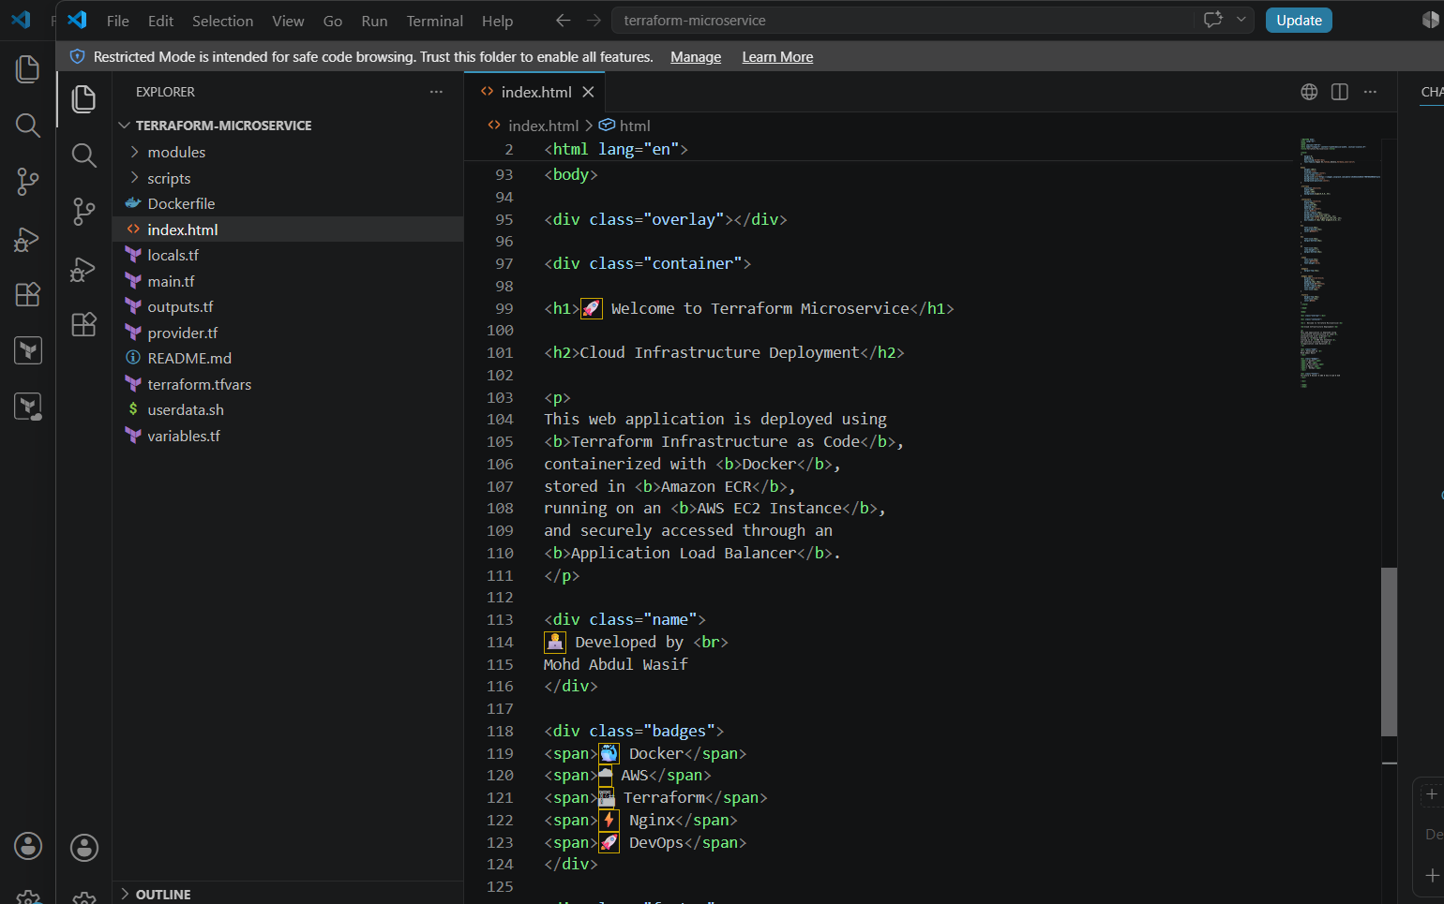

Step 2 - Create Dockerfile
# Use official lightweight Nginx image
FROM nginx:alpine

# Remove default Nginx page
RUN rm -rf /usr/share/nginx/html/*

# Copy our static website
COPY index.html /usr/share/nginx/html/

# Expose port 80
EXPOSE 80

# Start Nginx
CMD ["nginx", "-g", "daemon off;"]
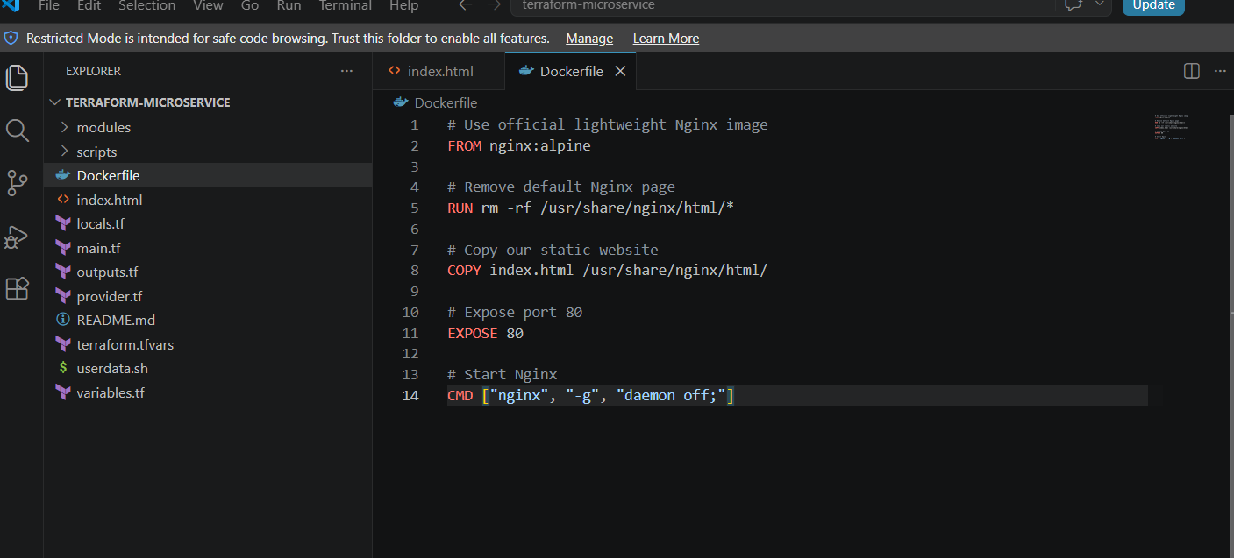

Step 3 - Build Docker Image
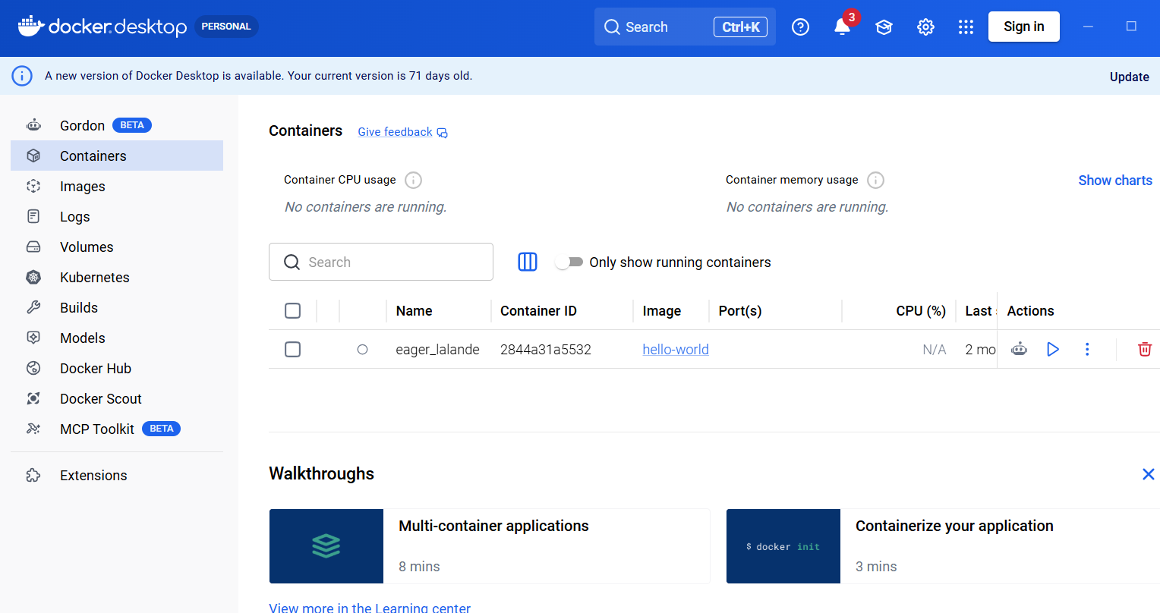
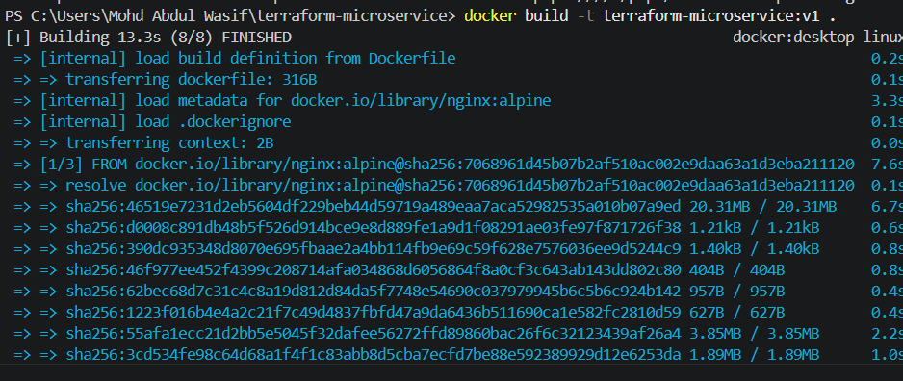
docker build -t terraform-web .
Verify
docker images
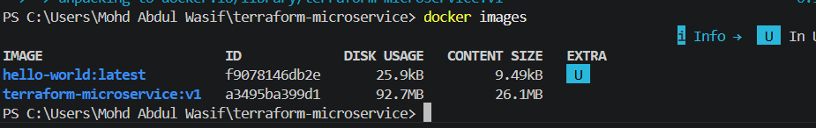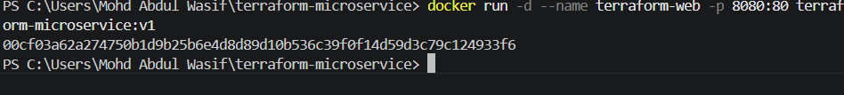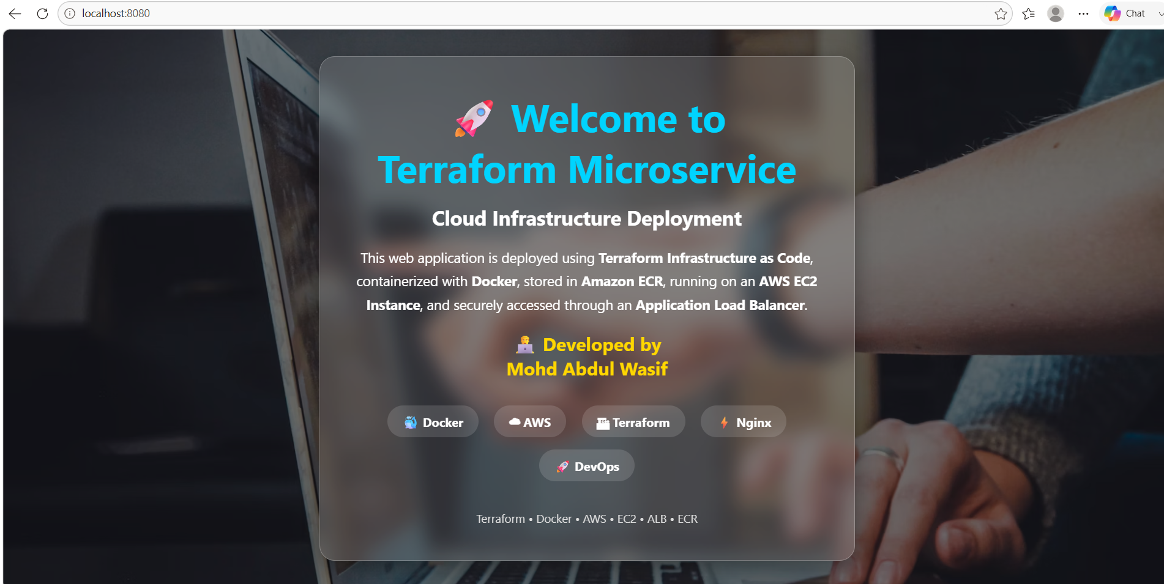

Step 4 - Create SSH Key
Linux
ssh-keygen -t rsa
Windows
ssh-keygen
Files generated
id_rsa
id_rsa.pub

Step 5 - Configure AWS CLI
aws configure
Verify
aws sts get-caller-identity
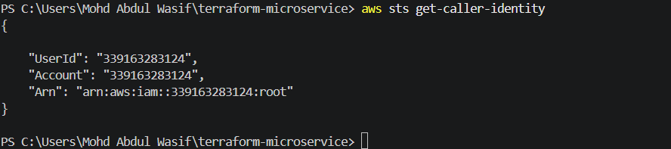

Step 6 - Create Terraform Provider
terraform {
required_version = ">= 1.5.0"

required_providers {
aws = {
source = "hashicorp/aws"
version = "~> 6.0"
}
}
}

provider "aws" {
region = var.aws_region

default_tags {
tags = local.common_tags
}
}
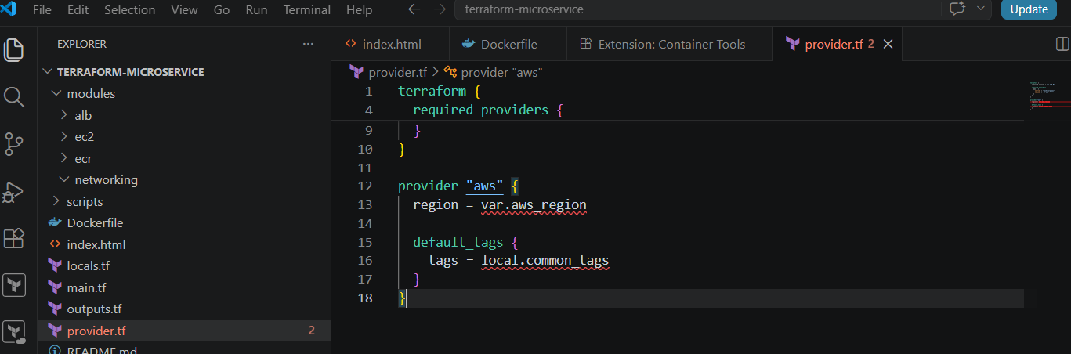
Variable.tf
variable "aws_region" {
description = "AWS region where resources will be created"
type = string
default = "us-east-1"
}

variable "project_name" {
description = "Name used for AWS resources"
type = string
default = "terraform-microservice"
}

variable "image_tag" {
description = "Docker image version"
type = string
default = "v1"
}
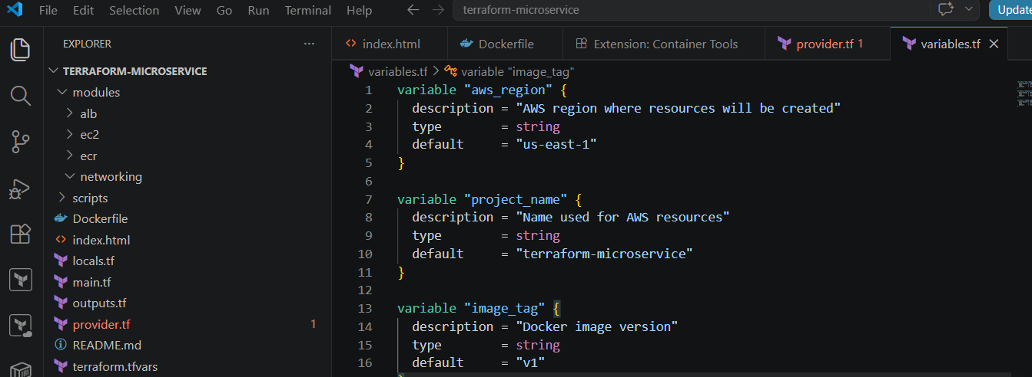
Local,tf
locals {
common_tags = {
Project = var.project_name
ManagedBy = "Terraform"
Developer = "Mohd Abdul Wasif"
}
}
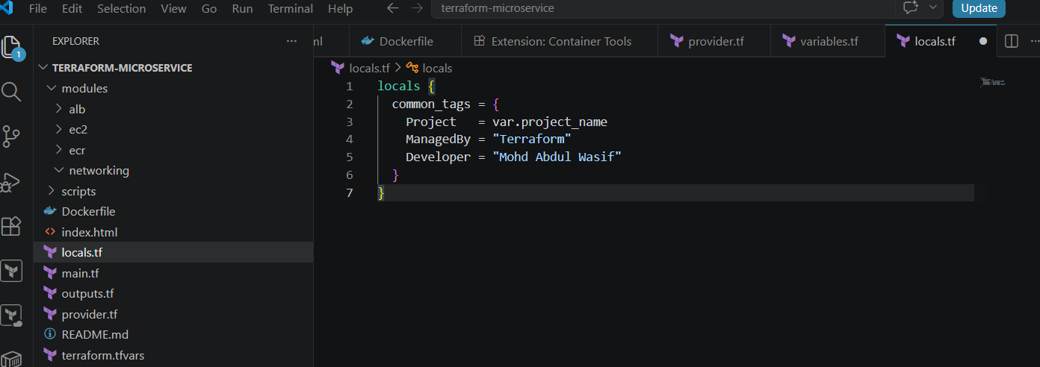
terraform.tfvars
aws_region = "us-east-1"
project_name = "terraform-microservice"
image_tag = "v1"
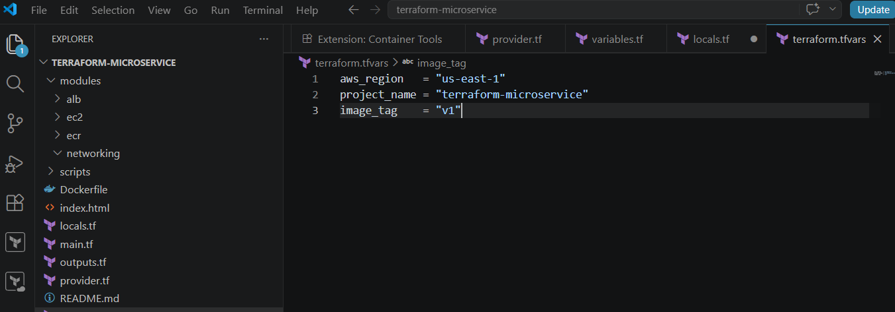

Step 7 - Create Amazon ECR Repository
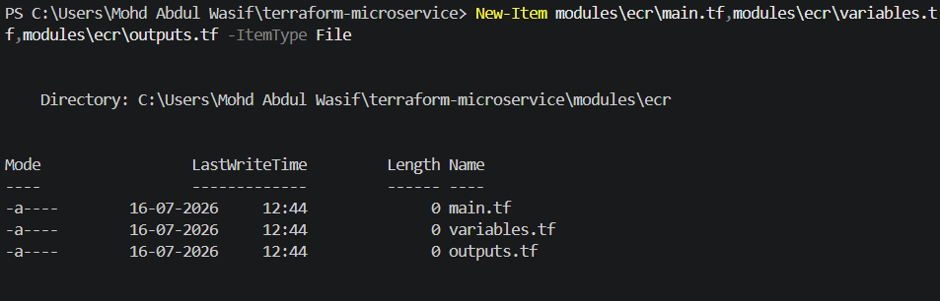
Ecr >Variable
variable "repository_name" {
description = "Name of the ECR repository"
type = string
}

variable "tags" {
description = "Tags for the ECR repository"
type = map(string)
default = {}
}
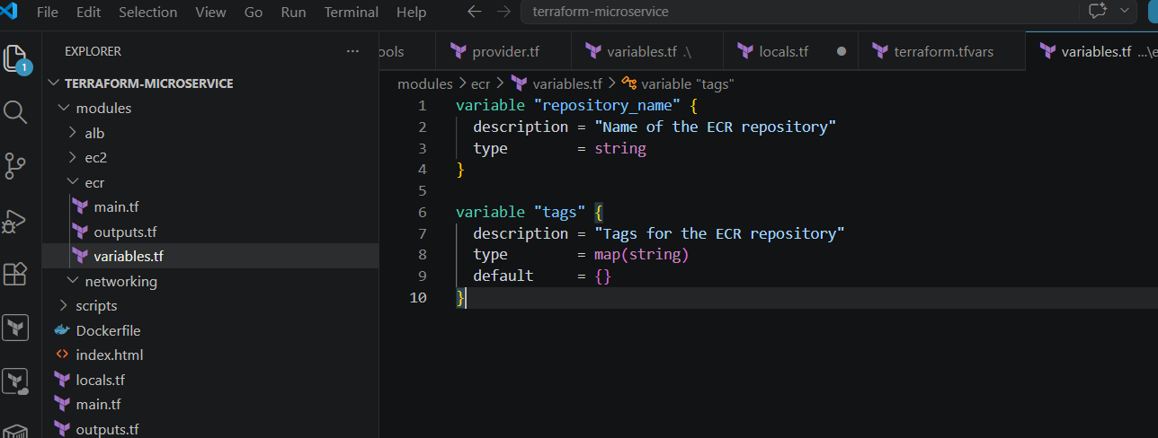
modules/ecr/main.tf
Paste:
resource "aws_ecr_repository" "this" {
name = var.repository_name
image_tag_mutability = "MUTABLE"

image_scanning_configuration {
scan_on_push = true
}

encryption_configuration {
encryption_type = "AES256"
}

tags = var.tags
}
Save the file.
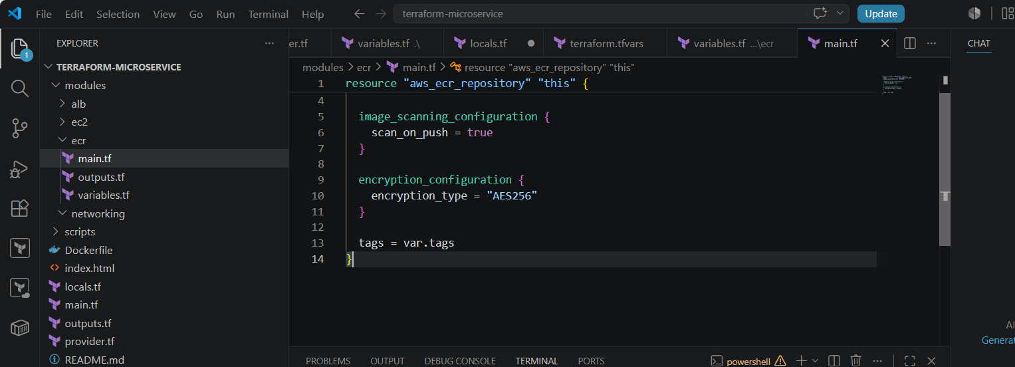
modules/ecr/outputs.tf
Paste:
output "repository_url" {
description = "URL of the ECR repository"
value = aws_ecr_repository.this.repository_url
}

output "repository_name" {
description = "Name of the ECR repository"
value = aws_ecr_repository.this.name
}
Save the file.
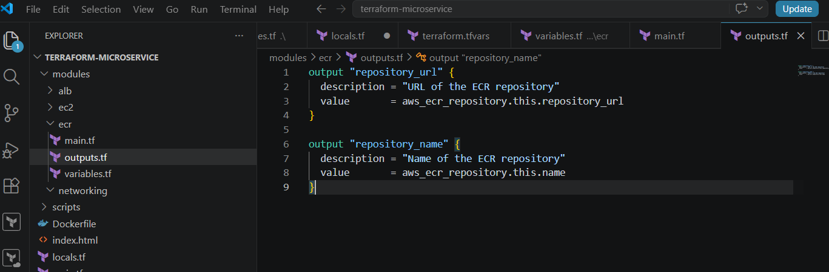
4. Add the ECR module in the root main.tf
Open this file:
C:\Users\Mohd Abdul Wasif\terraform-microservice\main.tf
Paste:
module "ecr" {
source = "./modules/ecr"

repository_name = var.project_name
tags = local.common_tags
}
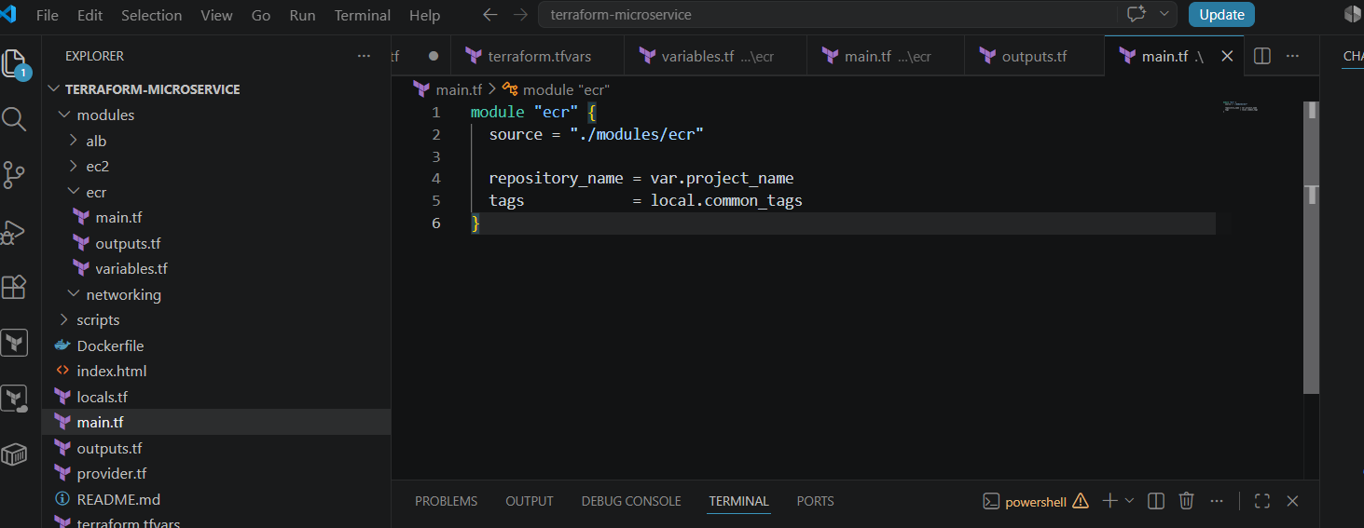
5. Add the output in root outputs.tf
Paste:
output "ecr_repository_url" {
description = "ECR repository URL"
value = module.ecr.repository_url
}
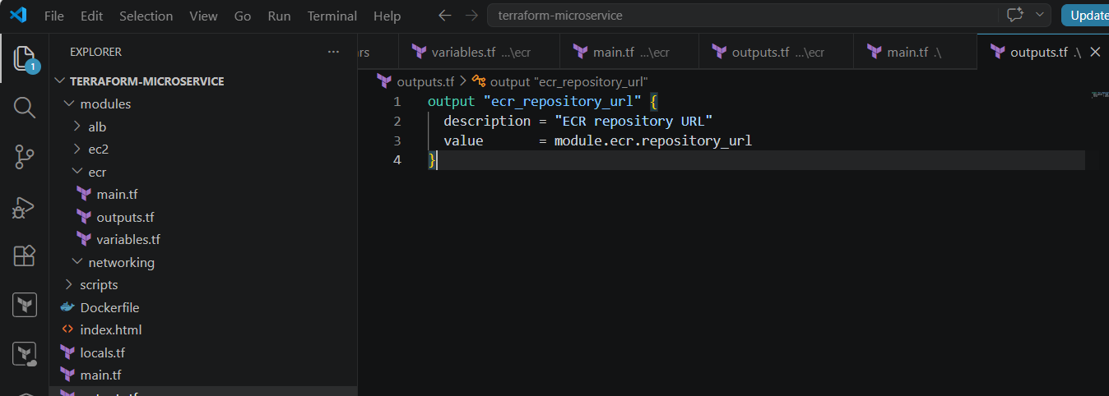
6. Confirm the root files also contain code
Your root variables.tf should contain:
variable "aws_region" {
description = "AWS region"
type = string
default = "us-east-1"
}

variable "project_name" {
description = "Project name"
type = string
default = "terraform-microservice"
}

variable "image_tag" {
description = "Docker image tag"
type = string
default = "v1"
}
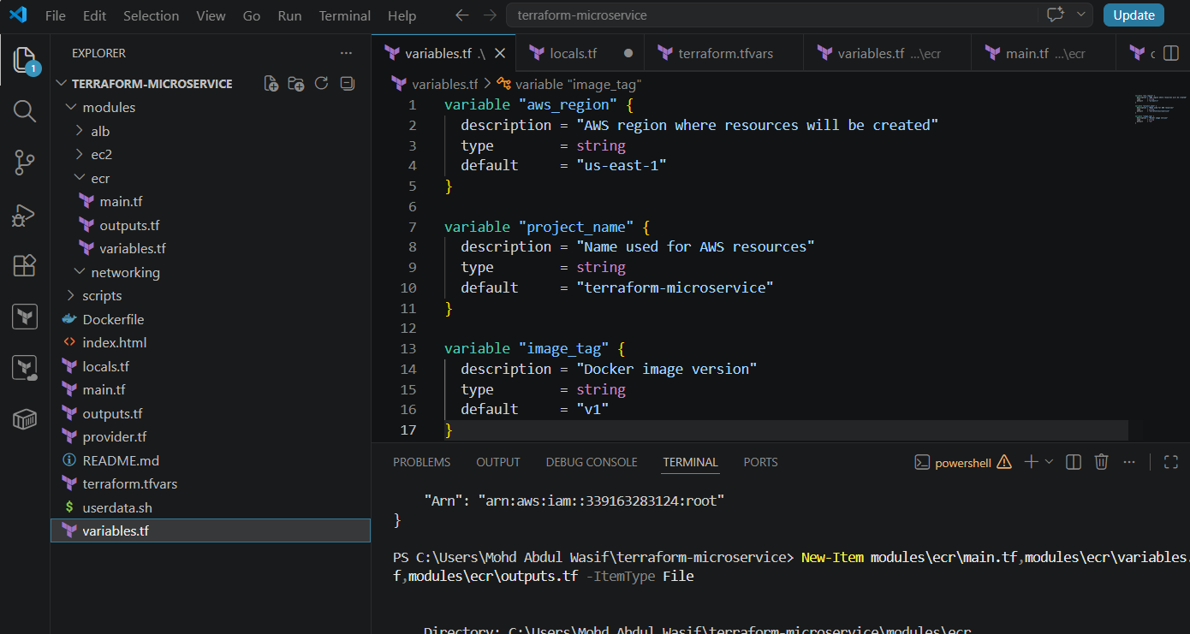
Your root locals.tf should contain:
locals {
common_tags = {
Project = var.project_name
ManagedBy = "Terraform"
Developer = "Mohd Abdul Wasif"
}
}
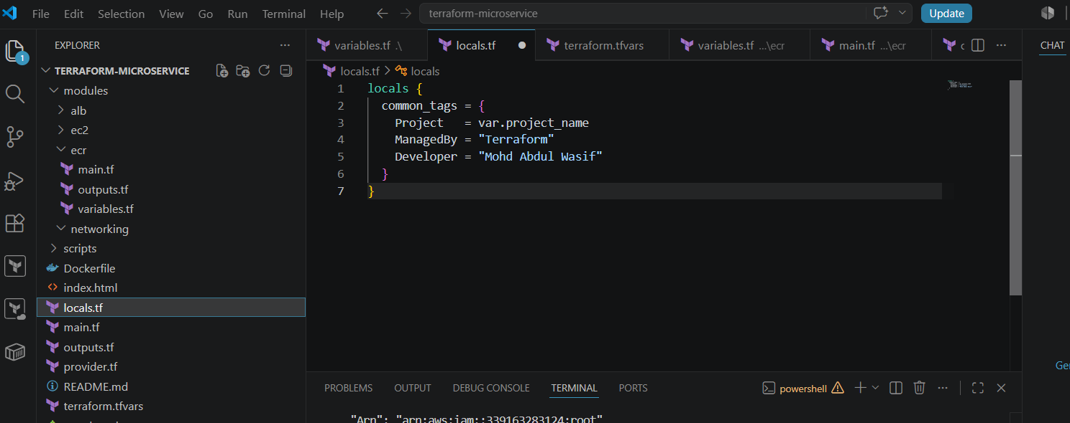
Your root provider.tf should contain:
terraform {
required_version = ">= 1.5.0"

required_providers {
aws = {
source = "hashicorp/aws"
version = "~> 6.0"
}
}
}

provider "aws" {
region = var.aws_region

default_tags {
tags = local.common_tags
}
}
Your terraform.tfvars should contain:
aws_region = "us-east-1"
project_name = "terraform-microservice"
image_tag = "v1"
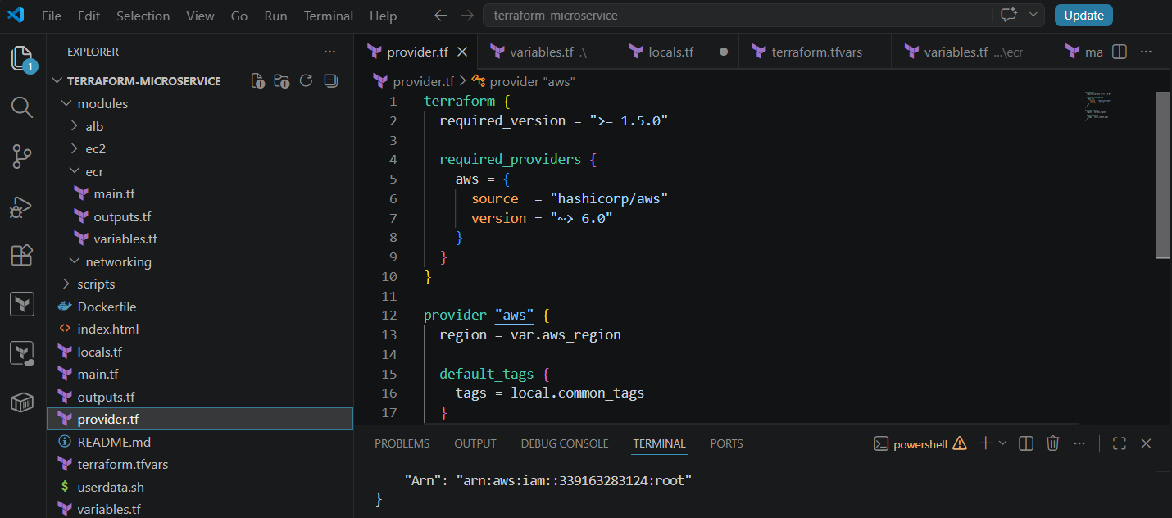
7. Run Terraform commands
From:
PS C:\Users\Mohd Abdul Wasif\terraform-microservice>
run:
terraform init
terraform fmt -recursive
terraform validate
terraform plan
The expected plan should show approximately:
Plan: 1 to add, 0 to change, 0 to destroy
Do not run terraform apply until terraform validate and terraform plan complete successfully.
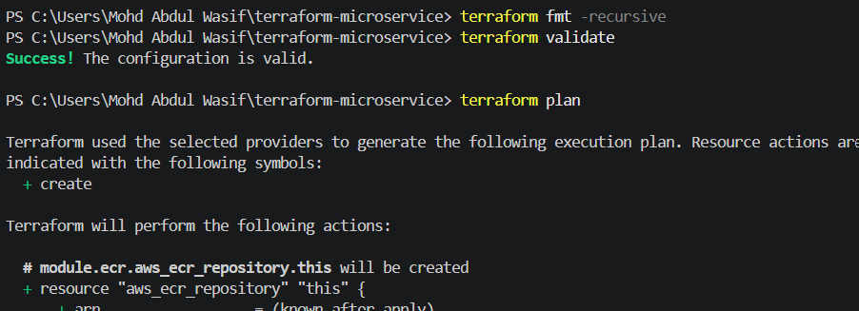
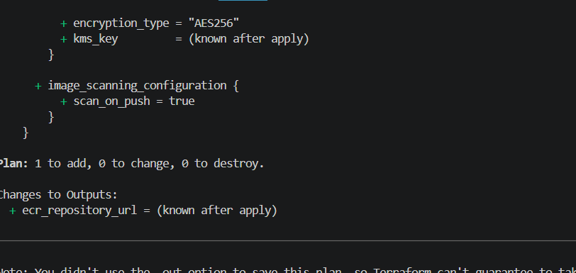
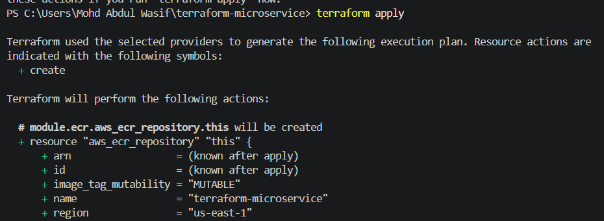
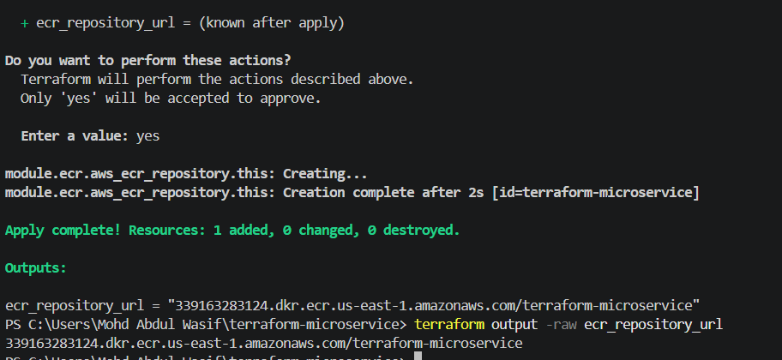
1. Try login through Command Prompt
Run this in PowerShell:
cmd /c "aws ecr get-login-password --region us-east-1 | docker login --username AWS --password-stdin 339163283124.dkr.ecr.us-east-1.amazonaws.com"
AWS documents this exact authentication pattern: generate the password in the repository’s region, use username AWS, and provide only the registry hostname.
Expected:
Login Succeeded
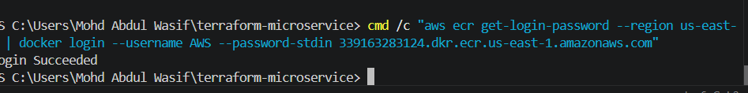

Terraform creates
Amazon ECR Repository
Example
terraform-web
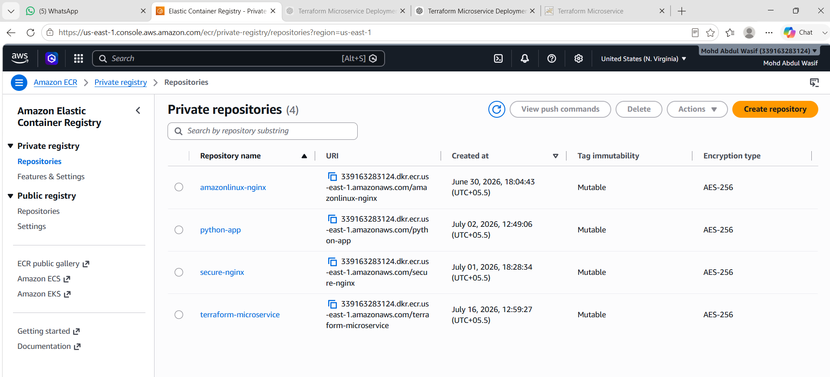
Now tag and push your local image.
docker tag terraform-microservice:v1 339163283124.dkr.ecr.us-east-1.amazonaws.com/terraform-microservice:v1
Verify:
docker images
Then push:
docker push 339163283124.dkr.ecr.us-east-1.amazonaws.com/terraform-microservice:v1
Expected final line:
v1: digest: sha256:...

Step 8 - Push Docker Image to ECR
Terraform creates repository.
Then
Login
aws ecr get-login-password
Tag image
docker tag terraform-web:latest <repository-url>:latest
Push
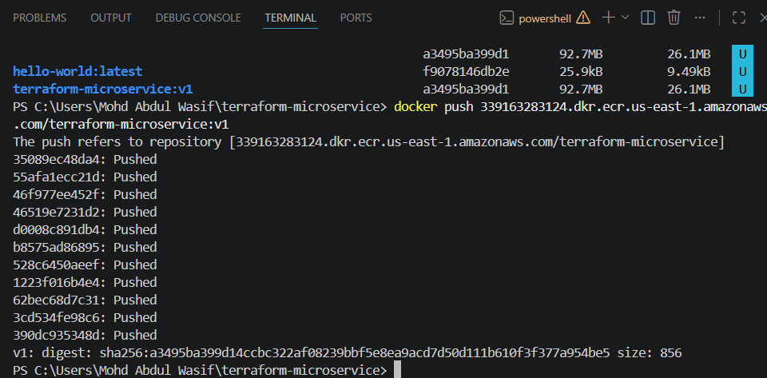
docker push <repository-url>:latest
fter that, verify in:
AWS Console → ECR → Repositories → terraform-microservice
You should see image tag:
v1
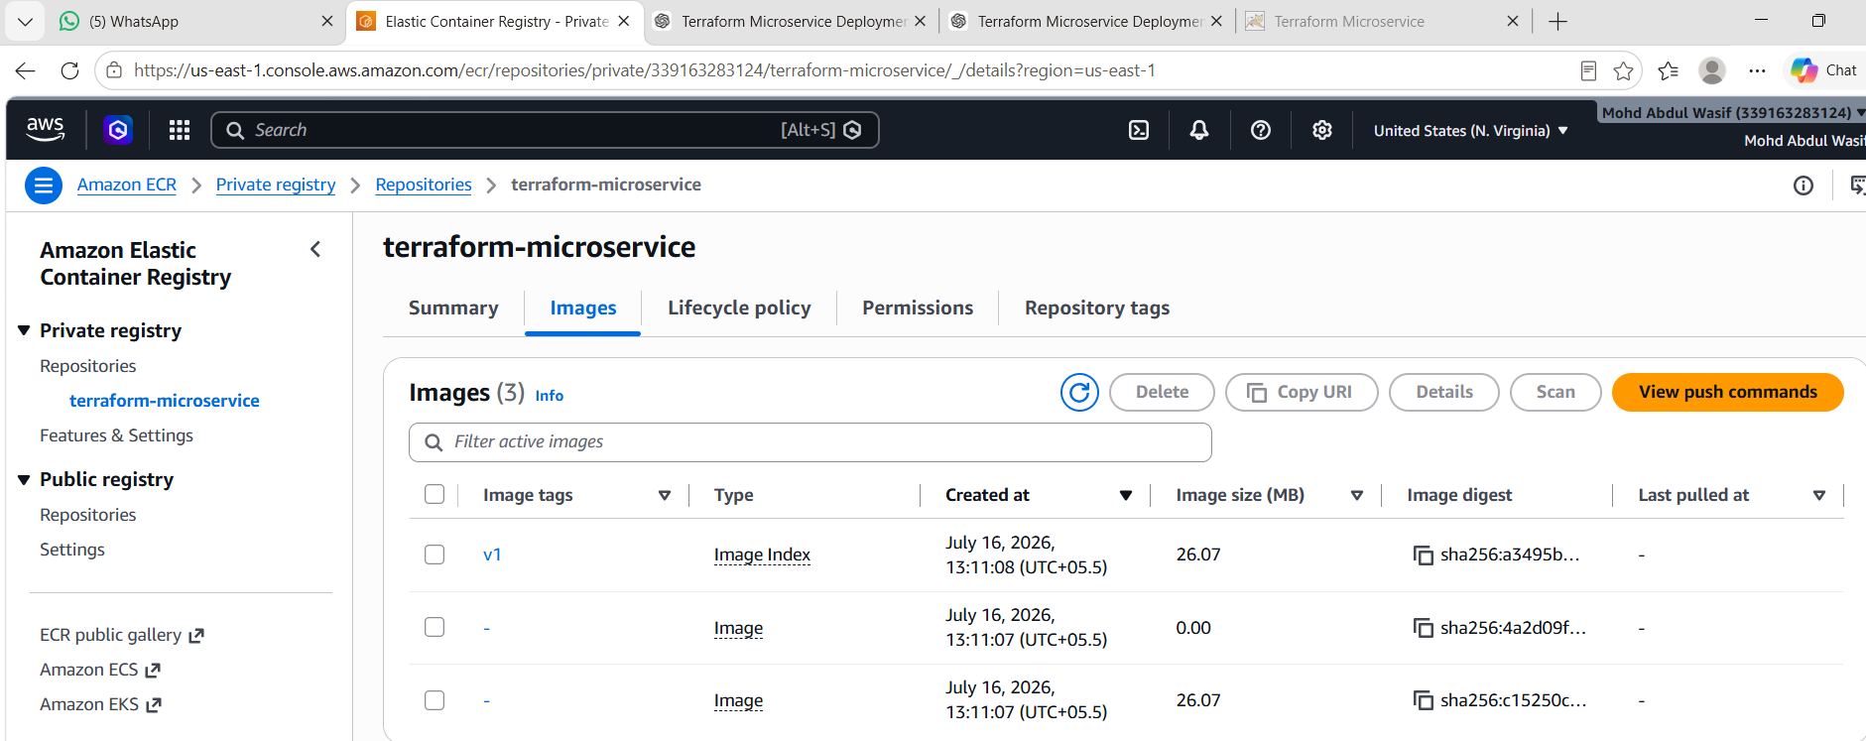
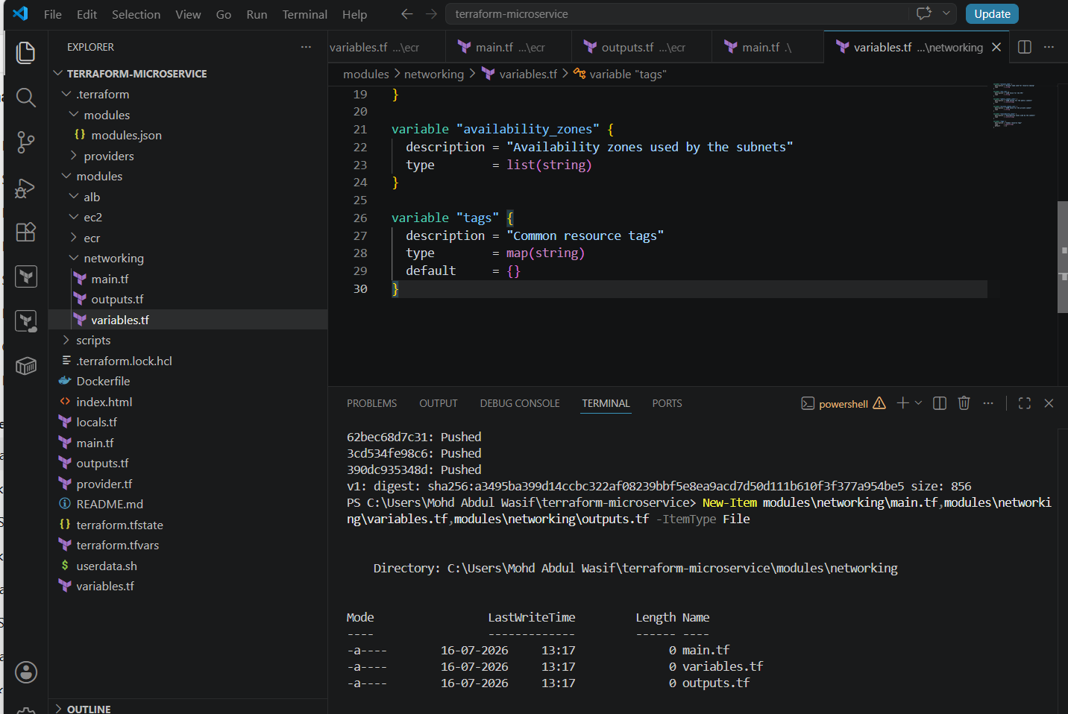
Your project folders are ready:
modules/
├── alb/
├── ec2/
├── ecr/
└── networking/
Now create the three files inside modules/networking.
Run from:
PS C:\Users\Mohd Abdul Wasif\terraform-microservice>
New-Item modules\networking\main.tf,modules\networking\variables.tf,modules\networking\outputs.tf -ItemType File
If PowerShell says the files already exist, that is fine. Open them in VS Code and add the following code.
1. modules/networking/variables.tf
variable "project_name" {
description = "Project name used for resource naming"
type = string
}

variable "vpc_cidr" {
description = "CIDR block for the VPC"
type = string
}

variable "public_subnet_cidrs" {
description = "CIDR blocks for the public subnets"
type = list(string)
}

variable "private_subnet_cidr" {
description = "CIDR block for the private subnet"
type = string
}

variable "availability_zones" {
description = "Availability zones used by the subnets"
type = list(string)
}

variable "tags" {
description = "Common resource tags"
type = map(string)
default = {}
}
2. modules/networking/main.tf
resource "aws_vpc" "this" {
cidr_block = var.vpc_cidr
enable_dns_support = true
enable_dns_hostnames = true

tags = merge(
var.tags,
{
Name = "${var.project_name}-vpc"
}
)
}

resource "aws_internet_gateway" "this" {
vpc_id = aws_vpc.this.id

tags = merge(
var.tags,
{
Name = "${var.project_name}-igw"
}
)
}

resource "aws_subnet" "public" {
count = length(var.public_subnet_cidrs)

vpc_id = aws_vpc.this.id
cidr_block = var.public_subnet_cidrs[count.index]
availability_zone = var.availability_zones[count.index]
map_public_ip_on_launch = true

tags = merge(
var.tags,
{
Name = "${var.project_name}-public-subnet-${count.index + 1}"
Type = "Public"
}
)
}

resource "aws_subnet" "private" {
vpc_id = aws_vpc.this.id
cidr_block = var.private_subnet_cidr
availability_zone = var.availability_zones[0]

tags = merge(
var.tags,
{
Name = "${var.project_name}-private-subnet"
Type = "Private"
}
)
}

resource "aws_route_table" "public" {
vpc_id = aws_vpc.this.id

route {
cidr_block = "0.0.0.0/0"
gateway_id = aws_internet_gateway.this.id
}

tags = merge(
var.tags,
{
Name = "${var.project_name}-public-rt"
}
)
}

resource "aws_route_table_association" "public" {
count = length(aws_subnet.public)

subnet_id = aws_subnet.public[count.index].id
route_table_id = aws_route_table.public.id
}

resource "aws_eip" "nat" {
domain = "vpc"

tags = merge(
var.tags,
{
Name = "${var.project_name}-nat-eip"
}
)
}

resource "aws_nat_gateway" "this" {
allocation_id = aws_eip.nat.id
subnet_id = aws_subnet.public[0].id

depends_on = [aws_internet_gateway.this]

tags = merge(
var.tags,
{
Name = "${var.project_name}-nat-gateway"
}
)
}

resource "aws_route_table" "private" {
vpc_id = aws_vpc.this.id

route {
cidr_block = "0.0.0.0/0"
nat_gateway_id = aws_nat_gateway.this.id
}

tags = merge(
var.tags,
{
Name = "${var.project_name}-private-rt"
}
)
}

resource "aws_route_table_association" "private" {
subnet_id = aws_subnet.private.id
route_table_id = aws_route_table.private.id
}
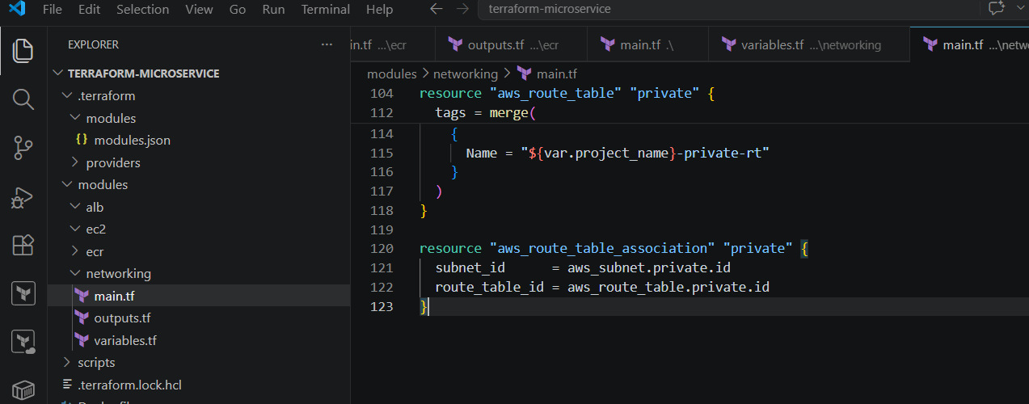
3. modules/networking/outputs.tf
output "vpc_id" {
description = "ID of the created VPC"
value = aws_vpc.this.id
}

output "public_subnet_ids" {
description = "IDs of the public subnets"
value = aws_subnet.public[*].id
}

output "private_subnet_id" {
description = "ID of the private subnet"
value = aws_subnet.private.id
}

output "internet_gateway_id" {
description = "ID of the Internet Gateway"
value = aws_internet_gateway.this.id
}

output "nat_gateway_id" {
description = "ID of the NAT Gateway"
value = aws_nat_gateway.this.id
}
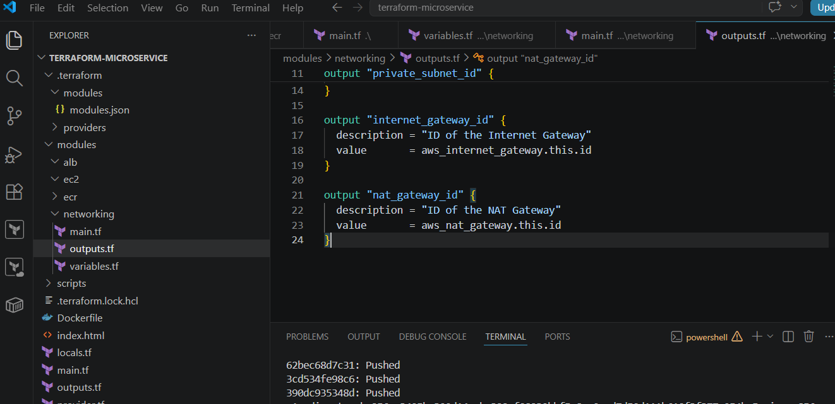
4. Add networking variables to root variables.tf
Add below your existing variables:
variable "vpc_cidr" {
description = "CIDR block for the VPC"
type = string
default = "10.0.0.0/16"
}

variable "public_subnet_cidrs" {
description = "CIDR blocks for public subnets"
type = list(string)
default = [
"10.0.1.0/24",
"10.0.2.0/24"
]
}

variable "private_subnet_cidr" {
description = "CIDR block for private subnet"
type = string
default = "10.0.10.0/24"
}

variable "availability_zones" {
description = "Availability zones used by the deployment"
type = list(string)
default = [
"us-east-1a",
"us-east-1b"
]
}
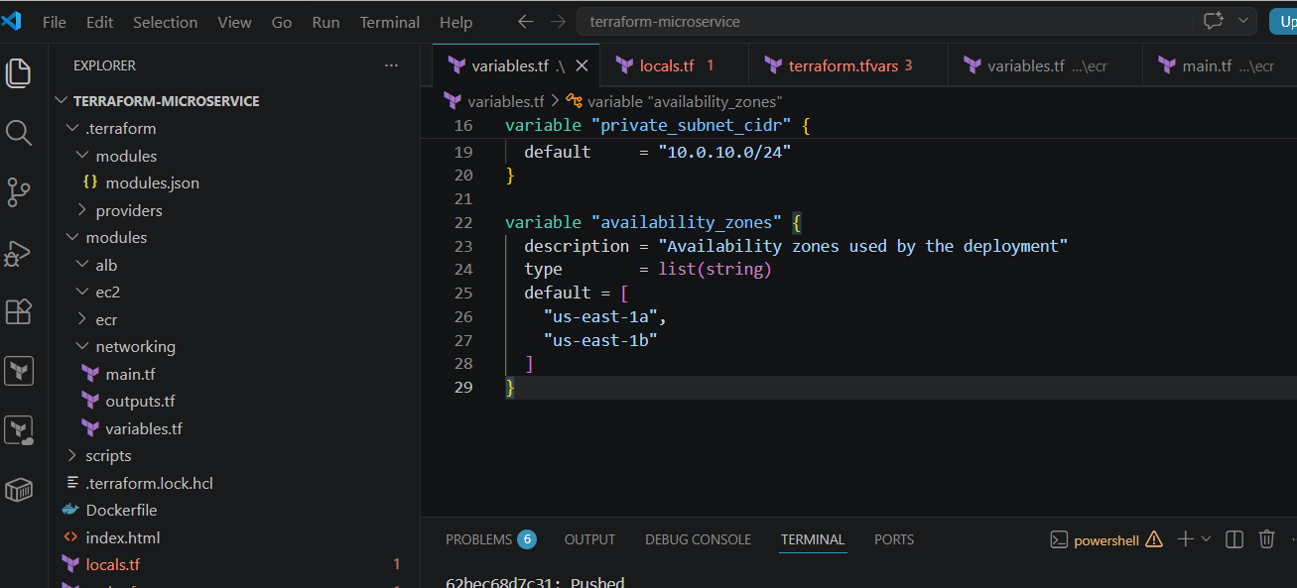
5. Add values to terraform.tfvars
vpc_cidr = "10.0.0.0/16"

public_subnet_cidrs = [
"10.0.1.0/24",
"10.0.2.0/24"
]

private_subnet_cidr = "10.0.10.0/24"

availability_zones = [
"us-east-1a",
"us-east-1b"
]
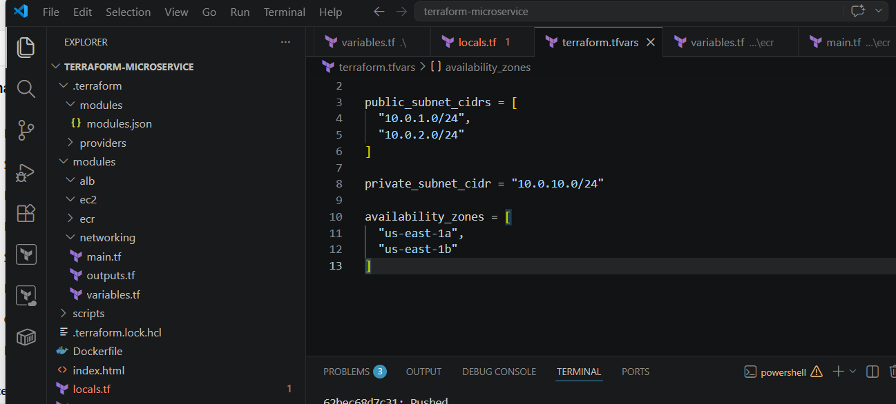
6. Connect the networking module in root main.tf
Keep your existing ECR module and add this below it:
module "networking" {
source = "./modules/networking"

project_name = var.project_name
vpc_cidr = var.vpc_cidr
public_subnet_cidrs = var.public_subnet_cidrs
private_subnet_cidr = var.private_subnet_cidr
availability_zones = var.availability_zones
tags = local.common_tags
}
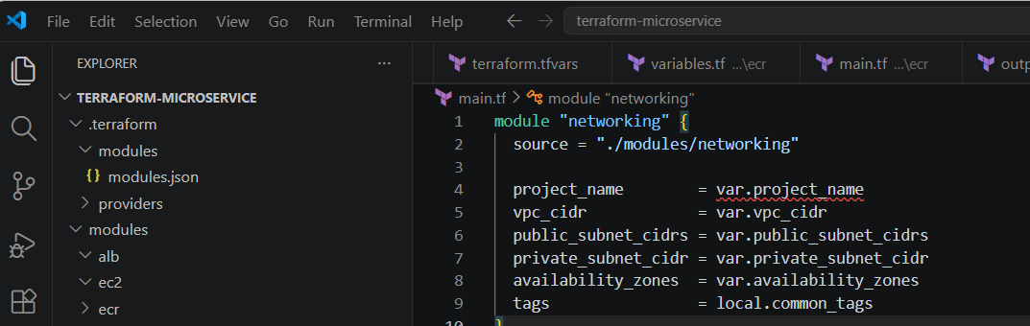
7. Add networking outputs to root outputs.tf
Keep the ECR output and add:
output "vpc_id" {
description = "Created VPC ID"
value = module.networking.vpc_id
}

output "public_subnet_ids" {
description = "Public subnet IDs"
value = module.networking.public_subnet_ids
}

output "private_subnet_id" {
description = "Private subnet ID"
value = module.networking.private_subnet_id
}
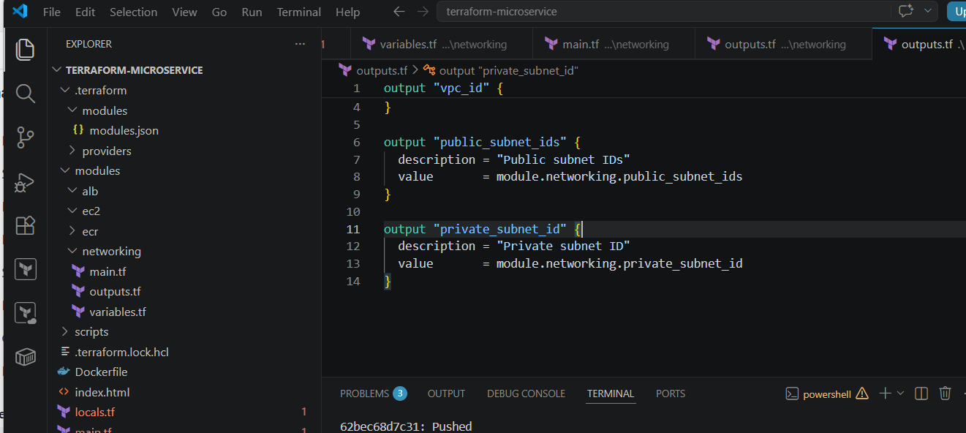
8. Run Terraform checks
terraform init
terraform fmt -recursive
terraform validate
terraform plan
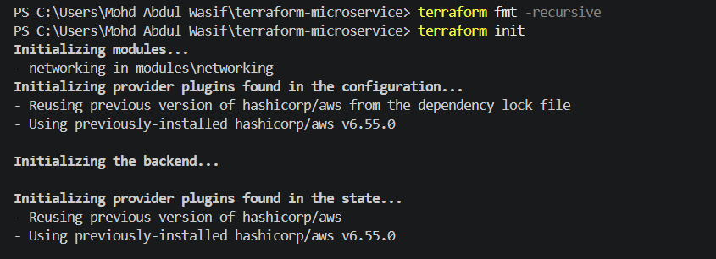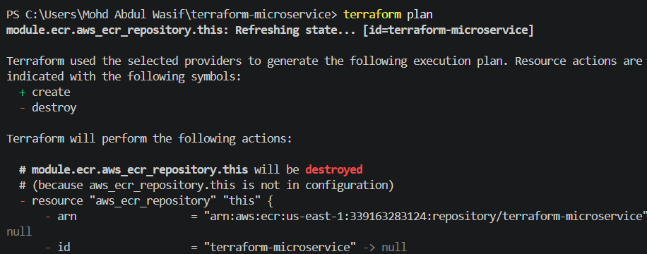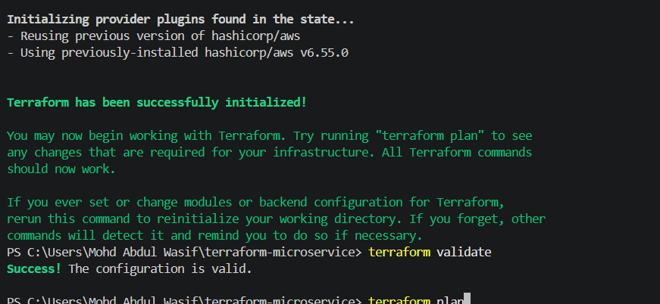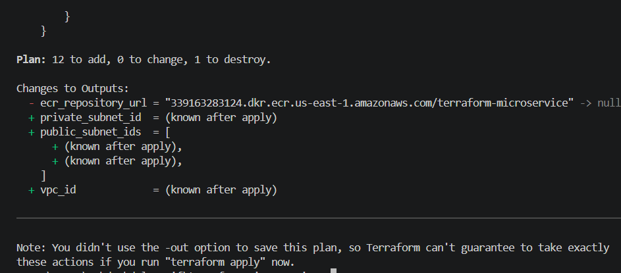

Step 9 - Create VPC
Terraform creates
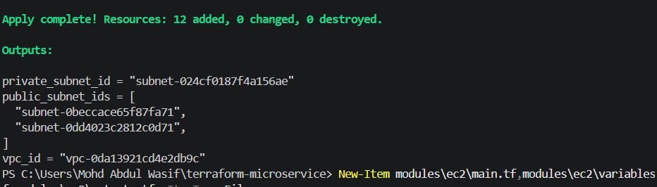
- VPC
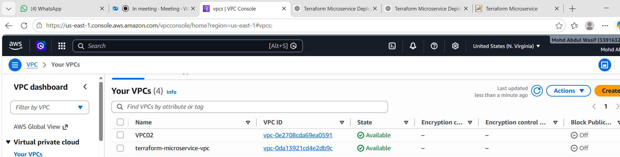
- Internet Gateway
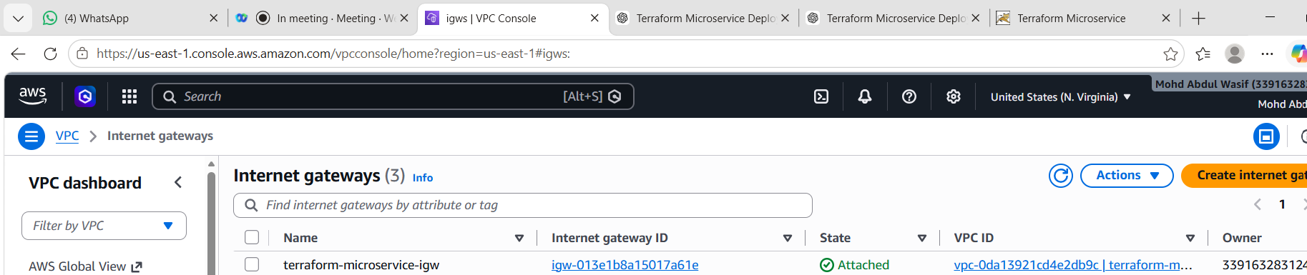
- Route Table
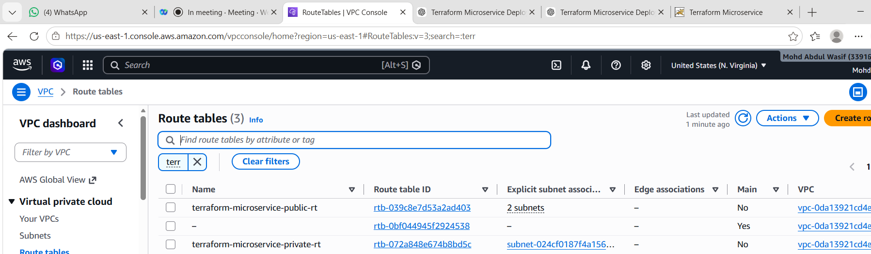
- Public Subnet
- Private Subnet
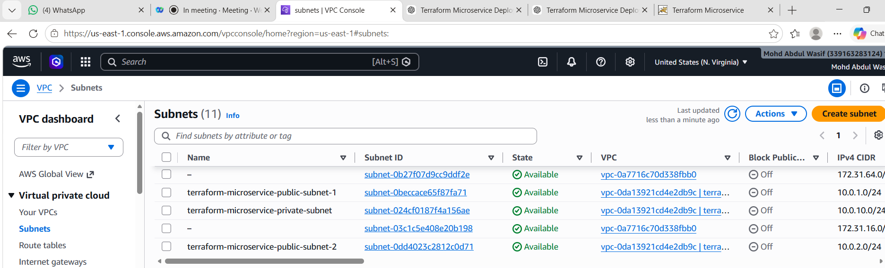
- Route Associations
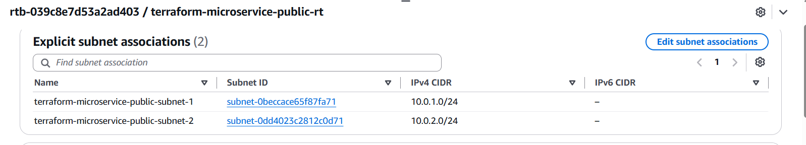
Step 1: Create a local SSH key
- From the project root, run:
- ssh-keygen -t ed25519 -f "$HOME\.ssh\terraform-microservice" -C "terraform-microservice"
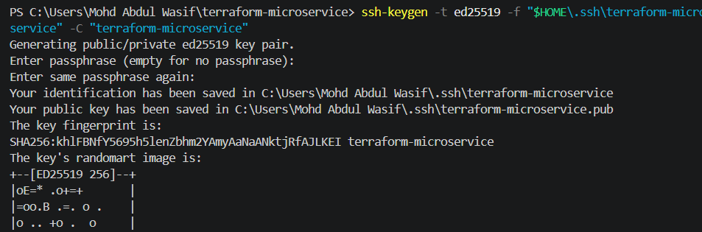
- Press Enter when asked for a passphrase, or set one for better security.
- It creates:
- C:\Users\Mohd Abdul Wasif\.ssh\terraform-microservice
- C:\Users\Mohd Abdul Wasif\.ssh\terraform-microservice.pub
- Do not share the private key:
- terraform-microservice
- Confirm both files:
- Get-ChildItem "$HOME\.ssh\terraform-microservice*"
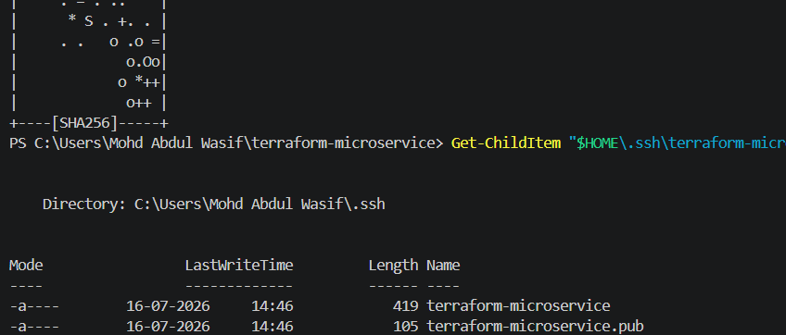

- Step 2: Find your public IP
- Run:
- curl.exe https://checkip.amazonaws.com
- Example:
- 123.45.67.89
- Your SSH CIDR will be:
- 123.45.67.89/32
- Replace the example with your real public IP.

- Step 3: Create EC2 module files
- Your modules/ec2 folder already exists. Create the files:
- New-Item modules\ec2\main.tf,modules\ec2\variables.tf,modules\ec2\outputs.tf -ItemType File
- If PowerShell says they already exist, do not recreate them—just open them in VS Code.

- Step 4: modules/ec2/variables.tf
- Paste:
- variable "project_name" {
- description = "Project name used for resource naming"
- type = string
- }

- variable "vpc_id" {
- description = "VPC ID"
- type = string
- }

- variable "subnet_id" {
- description = "Public subnet ID for the EC2 instance"
- type = string
- }

- variable "instance_type" {
- description = "EC2 instance type"
- type = string
- }

- variable "ssh_allowed_cidr" {
- description = "Public IP CIDR allowed to connect using SSH"
- type = string
- }

- variable "public_key" {
- description = "Local SSH public key content"
- type = string
- }

- variable "user_data" {
- description = "Startup script used to install Docker and run the application"
- type = string
- }

- variable "tags" {
- description = "Common tags"
- type = map(string)
- default = {}
- }
- Save the file.

- Step 5: modules/ec2/main.tf
- Paste:
- # Latest Amazon Linux 2023 x86_64 AMI
- data "aws_ssm_parameter" "amazon_linux_2023" {
- name = "/aws/service/ami-amazon-linux-latest/al2023-ami-kernel-default-x86_64"
- }

- # Register the locally generated public SSH key in AWS
- resource "aws_key_pair" "this" {
- key_name = "${var.project_name}-key"
- public_key = var.public_key

- tags = merge(
- var.tags,
- {
- Name = "${var.project_name}-key"
- }
- )
- }

- # Security group used by the Application Load Balancer
- resource "aws_security_group" "alb" {
- name = "${var.project_name}-alb-sg"
- description = "Allow public HTTP traffic to the load balancer"
- vpc_id = var.vpc_id

- tags = merge(
- var.tags,
- {
- Name = "${var.project_name}-alb-sg"
- }
- )
- }

- resource "aws_vpc_security_group_ingress_rule" "alb_http" {
- security_group_id = aws_security_group.alb.id

- description = "Allow HTTP from the internet"
- cidr_ipv4 = "0.0.0.0/0"
- from_port = 80
- to_port = 80
- ip_protocol = "tcp"
- }

- resource "aws_vpc_security_group_egress_rule" "alb_outbound" {
- security_group_id = aws_security_group.alb.id

- description = "Allow outbound traffic"
- cidr_ipv4 = "0.0.0.0/0"
- ip_protocol = "-1"
- }

- # Security group used by the EC2 instance
- resource "aws_security_group" "ec2" {
- name = "${var.project_name}-ec2-sg"
- description = "Allow application traffic from ALB and SSH from approved IP"
- vpc_id = var.vpc_id

- tags = merge(
- var.tags,
- {
- Name = "${var.project_name}-ec2-sg"
- }
- )
- }

- # SSH only from your public IP
- resource "aws_vpc_security_group_ingress_rule" "ec2_ssh" {
- security_group_id = aws_security_group.ec2.id

- description = "Allow SSH from approved public IP"
- cidr_ipv4 = var.ssh_allowed_cidr
- from_port = 22
- to_port = 22
- ip_protocol = "tcp"
- }

- # HTTP only from the ALB security group
- resource "aws_vpc_security_group_ingress_rule" "ec2_http_from_alb" {
- security_group_id = aws_security_group.ec2.id

- description = "Allow HTTP only from the load balancer"
- referenced_security_group_id = aws_security_group.alb.id
- from_port = 80
- to_port = 80
- ip_protocol = "tcp"
- }

- resource "aws_vpc_security_group_egress_rule" "ec2_outbound" {
- security_group_id = aws_security_group.ec2.id

- description = "Allow outbound traffic"
- cidr_ipv4 = "0.0.0.0/0"
- ip_protocol = "-1"
- }

- # IAM role assumed by EC2
- resource "aws_iam_role" "ec2" {
- name = "${var.project_name}-ec2-role"

- assume_role_policy = jsonencode({
- Version = "2012-10-17"

- Statement = [
- {
- Effect = "Allow"

- Principal = {
- Service = "ec2.amazonaws.com"
- }

- Action = "sts:AssumeRole"
- }
- ]
- })

- tags = var.tags
- }

- # Give EC2 permission to pull images from ECR
- resource "aws_iam_role_policy_attachment" "ecr_pull" {
- role = aws_iam_role.ec2.name
- policy_arn = "arn:aws:iam::aws:policy/AmazonEC2ContainerRegistryPullOnly"
- }

- resource "aws_iam_instance_profile" "ec2" {
- name = "${var.project_name}-instance-profile"
- role = aws_iam_role.ec2.name
- }

- # Application EC2 instance
- resource "aws_instance" "this" {
- ami = data.aws_ssm_parameter.amazon_linux_2023.value
- instance_type = var.instance_type
- subnet_id = var.subnet_id
- associate_public_ip_address = true

- key_name = aws_key_pair.this.key_name
- vpc_security_group_ids = [aws_security_group.ec2.id]
- iam_instance_profile = aws_iam_instance_profile.ec2.name

- user_data = var.user_data
- user_data_replace_on_change = true

- metadata_options {
- http_endpoint = "enabled"
- http_tokens = "required"
- }

- root_block_device {
- volume_type = "gp3"
- volume_size = 8
- encrypted = true
- delete_on_termination = true
- }

- tags = merge(
- var.tags,
- {
- Name = "${var.project_name}-server"
- }
- )

- depends_on = [
- aws_iam_role_policy_attachment.ecr_pull
- ]
- }
- AWS publishes current Amazon Linux 2023 AMI IDs through Systems Manager public parameters, so this avoids hard-coding an AMI that may later become invalid.
- The AmazonEC2ContainerRegistryPullOnly managed policy gives the EC2 role permission to pull images from ECR without storing AWS access keys on the server.

- Step 6: modules/ec2/outputs.tf
- Paste:
- output "instance_id" {
- description = "EC2 instance ID"
- value = aws_instance.this.id
- }

- output "public_ip" {
- description = "EC2 public IP used only for approved SSH access"
- value = aws_instance.this.public_ip
- }

- output "private_ip" {
- description = "EC2 private IP"
- value = aws_instance.this.private_ip
- }

- output "ec2_security_group_id" {
- description = "EC2 security group ID"
- value = aws_security_group.ec2.id
- }

- output "alb_security_group_id" {
- description = "Load Balancer security group ID"
- value = aws_security_group.alb.id
- }

- Step 7: Create scripts/userdata.sh
- Your project already has a scripts folder. Open:
- scripts/userdata.sh
- Paste:
- #!/bin/bash
- set -euxo pipefail

- exec > >(tee /var/log/terraform-microservice-userdata.log | logger -t user-data -s 2>/dev/console) 2>&1

- dnf update -y
- dnf install -y docker awscli

- systemctl enable --now docker

- REGISTRY_HOST="${ecr_registry}"
- IMAGE_URI="${image_uri}"
- AWS_REGION="${aws_region}"

- aws ecr get-login-password --region "$AWS_REGION" |
- docker login \
- --username AWS \
- --password-stdin "$REGISTRY_HOST"

- docker pull "$IMAGE_URI"

- docker rm -f terraform-web || true

- docker run \
- --detach \
- --name terraform-web \
- --restart unless-stopped \
- --publish 80:80 \
- "$IMAGE_URI"

- docker image prune -f
- Save the file.

- Step 8: Add root variables
- Open the root variables.tf and add:
- #############################################
- # AWS Configuration
- #############################################

- variable "aws_region" {
- description = "AWS Region"
- type = string
- default = "us-east-1"
- }

- #############################################
- # Project Configuration
- #############################################

- variable "project_name" {
- description = "Project Name"
- type = string
- default = "terraform-microservice"
- }

- variable "image_tag" {
- description = "Docker Image Tag"
- type = string
- default = "v1"
- }

- #############################################
- # Networking
- #############################################

- variable "vpc_cidr" {
- description = "CIDR block for VPC"
- type = string
- default = "10.0.0.0/16"
- }

- variable "public_subnet_cidrs" {
- description = "Public Subnets"

- type = list(string)

- default = [
- "10.0.1.0/24",
- "10.0.2.0/24"
- ]
- }

- variable "private_subnet_cidr" {
- description = "Private Subnet"

- type = string

- default = "10.0.10.0/24"
- }

- variable "availability_zones" {

- description = "Availability Zones"

- type = list(string)

- default = [
- "us-east-1a",
- "us-east-1b"
- ]
- }

- #############################################
- # EC2 Configuration
- #############################################

- variable "instance_type" {
- description = "EC2 Instance Type"

- type = string

- default = "t3.micro"
- }

- variable "ssh_allowed_cidr" {

- description = "Public IP Allowed for SSH"

- type = string
- }

- variable "ssh_public_key_path" {

- description = "SSH Public Key Path"

- type = string

- default = "~/.ssh/terraform-microservice.pub"
- }
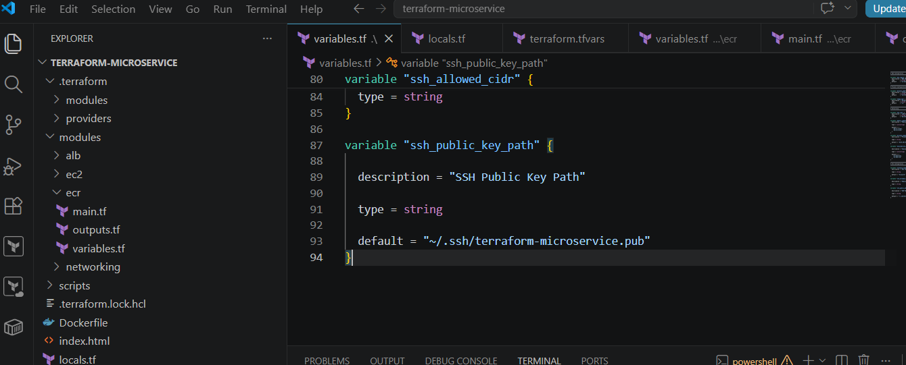
- Step 9: Update terraform.tfvars
- Add:
- #############################################
- # AWS
- #############################################

- aws_region = "us-east-1"

- #############################################
- # Project
- #############################################

- project_name = "terraform-microservice"

- image_tag = "v1"

- #############################################
- # Networking
- #############################################

- vpc_cidr = "10.0.0.0/16"

- public_subnet_cidrs = [
- "10.0.1.0/24",
- "10.0.2.0/24"
- ]

- private_subnet_cidr = "10.0.10.0/24"

- availability_zones = [
- "us-east-1a",
- "us-east-1b"
- ]

- #############################################
- # EC2
- #############################################

- instance_type = "t3.micro"

- ssh_allowed_cidr = "103.203.172.230/32"
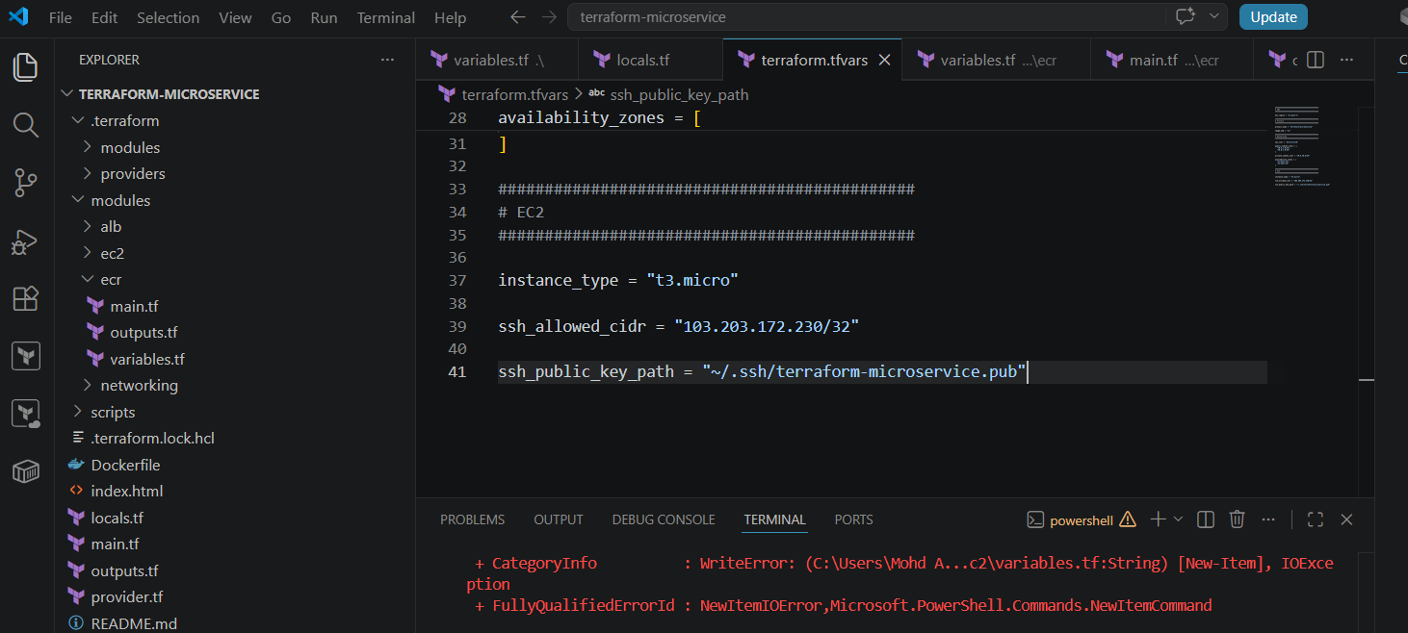

- ssh_public_key_path = "~/.ssh/terraform-microservice.pub"Those are private addresses and will not allow SSH from the internet.

- Step 10: Add EC2 module to root main.tf
- Keep your existing ECR and networking modules. Add this below them:
- locals {
- ecr_registry_host = split("/", module.ecr.repository_url)[0]
- application_image = "${module.ecr.repository_url}:${var.image_tag}"
- }

- module "ec2" {
- source = "./modules/ec2"

- project_name = var.project_name
- vpc_id = module.networking.vpc_id

- # Public subnet permits direct SSH from only the approved CIDR.
- subnet_id = module.networking.public_subnet_ids[0]

- instance_type = var.instance_type
- ssh_allowed_cidr = var.ssh_allowed_cidr
- public_key = file(pathexpand(var.ssh_public_key_path))

- user_data = templatefile("${path.module}/scripts/userdata.sh", {
- aws_region = var.aws_region
- ecr_registry = local.ecr_registry_host
- image_uri = local.application_image
- })

- tags = local.common_tags

- depends_on = [
- module.ecr,
- module.networking
- ]
- }
- Your complete root main.tf should now contain:
- module "ecr" {
- source = "./modules/ecr"

- repository_name = var.project_name
- tags = local.common_tags
- }

- module "networking" {
- source = "./modules/networking"

- project_name = var.project_name
- vpc_cidr = var.vpc_cidr
- public_subnet_cidrs = var.public_subnet_cidrs
- private_subnet_cidr = var.private_subnet_cidr
- availability_zones = var.availability_zones
- tags = local.common_tags
- }

- locals {
- ecr_registry_host = split("/", module.ecr.repository_url)[0]
- application_image = "${module.ecr.repository_url}:${var.image_tag}"
- }

- module "ec2" {
- source = "./modules/ec2"

- project_name = var.project_name
- vpc_id = module.networking.vpc_id
- subnet_id = module.networking.public_subnet_ids[0]

- instance_type = var.instance_type
- ssh_allowed_cidr = var.ssh_allowed_cidr
- public_key = file(pathexpand(var.ssh_public_key_path))

- user_data = templatefile("${path.module}/scripts/userdata.sh", {
- aws_region = var.aws_region
- ecr_registry = local.ecr_registry_host
- image_uri = local.application_image
- })

- tags = local.common_tags

- depends_on = [
- module.ecr,
- module.networking
- ]
- }
- Having more than one locals block is valid, but your existing root locals.tf must still contain common_tags.

- Step 11: Add root outputs
- Add to root outputs.tf:
- output "ec2_instance_id" {
- description = "Application EC2 instance ID"
- value = module.ec2.instance_id
- }

- output "ec2_public_ip" {
- description = "EC2 public IP used for approved SSH access"
- value = module.ec2.public_ip
- }

- output "ec2_private_ip" {
- description = "EC2 private IP used by the load balancer"
- value = module.ec2.private_ip
- }
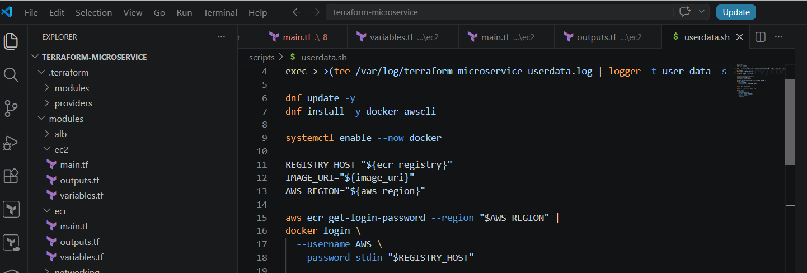

- Step 12: Check before applying
- Run:
- terraform fmt -recursive
- terraform init
- terraform validate
- terraform plan
- Check the final plan carefully. It must show:
- 0 to destroy
- Do not apply if Terraform wants to destroy the ECR repository, VPC, NAT Gateway, or other existing resources.
- After a clean plan:
- terraform apply
- Type:
- yes
- The next phase after successful EC2 creation is the Application Load Balancer module and target group attachment.
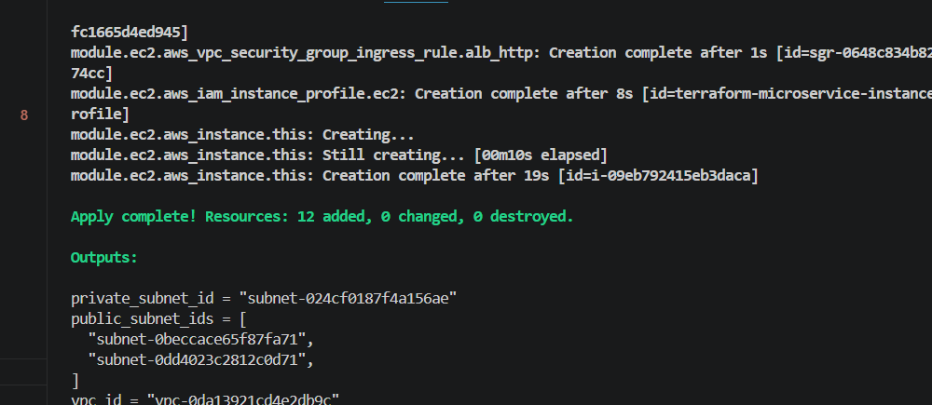

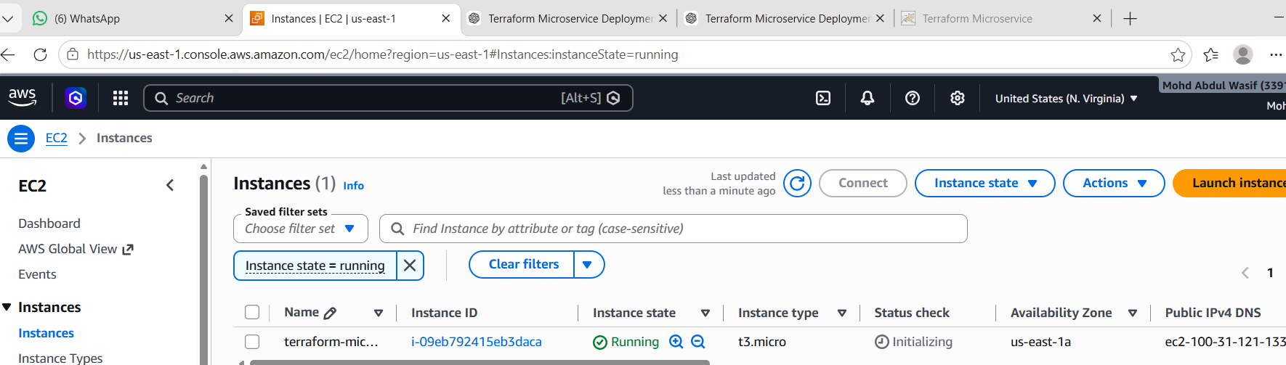

Create ALB files
From the project root:
New-Item modules\alb\main.tf,modules\alb\variables.tf,modules\alb\outputs.tf -ItemType File
If they already exist, just open them.
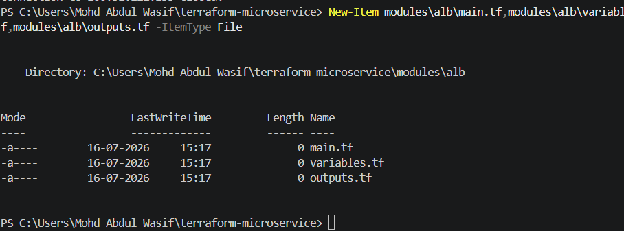
2. modules/alb/variables.tf
variable "project_name" {
description = "Project name used for resource naming"
type = string
}

variable "vpc_id" {
description = "VPC ID"
type = string
}

variable "public_subnet_ids" {
description = "Public subnet IDs for the load balancer"
type = list(string)
}

variable "alb_security_group_id" {
description = "Security group ID for the load balancer"
type = string
}

variable "instance_id" {
description = "EC2 instance ID registered with the target group"
type = string
}

variable "tags" {
description = "Common tags"
type = map(string)
default = {}
}
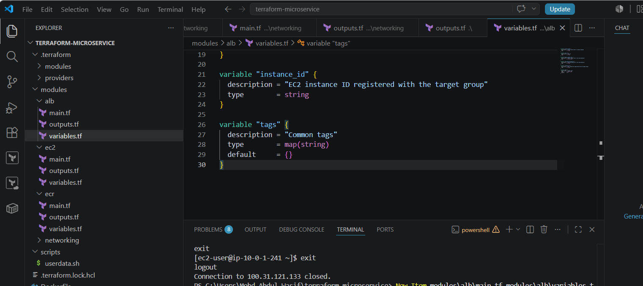
3. modules/alb/main.tf
resource "aws_lb" "this" {
name = "${var.project_name}-alb"
internal = false
load_balancer_type = "application"

security_groups = [
var.alb_security_group_id
]

subnets = var.public_subnet_ids

enable_deletion_protection = false

tags = merge(
var.tags,
{
Name = "${var.project_name}-alb"
}
)
}

resource "aws_lb_target_group" "this" {
name = "${var.project_name}-tg"
port = 80
protocol = "HTTP"
target_type = "instance"
vpc_id = var.vpc_id

health_check {
enabled = true
path = "/"
protocol = "HTTP"
port = "traffic-port"
matcher = "200-399"
interval = 30
timeout = 5
healthy_threshold = 2
unhealthy_threshold = 2
}

tags = merge(
var.tags,
{
Name = "${var.project_name}-tg"
}
)
}

resource "aws_lb_target_group_attachment" "this" {
target_group_arn = aws_lb_target_group.this.arn
target_id = var.instance_id
port = 80
}

resource "aws_lb_listener" "http" {
load_balancer_arn = aws_lb.this.arn
port = 80
protocol = "HTTP"

default_action {
type = "forward"
target_group_arn = aws_lb_target_group.this.arn
}
}
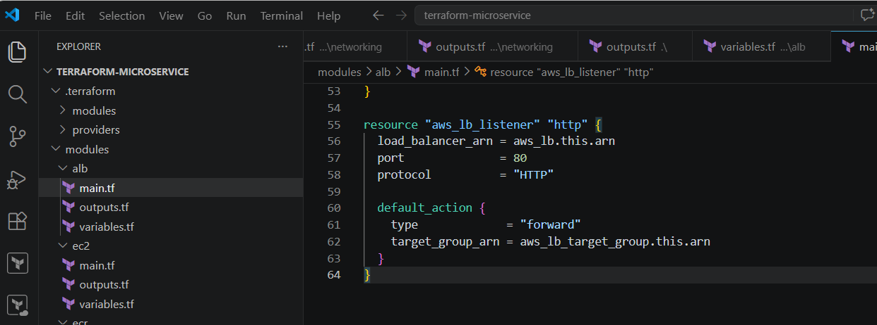
4. modules/alb/outputs.tf
output "load_balancer_dns_name" {
description = "Public DNS name of the Application Load Balancer"
value = aws_lb.this.dns_name
}

output "load_balancer_arn" {
description = "ARN of the Application Load Balancer"
value = aws_lb.this.arn
}

output "target_group_arn" {
description = "ARN of the ALB target group"
value = aws_lb_target_group.this.arn
}
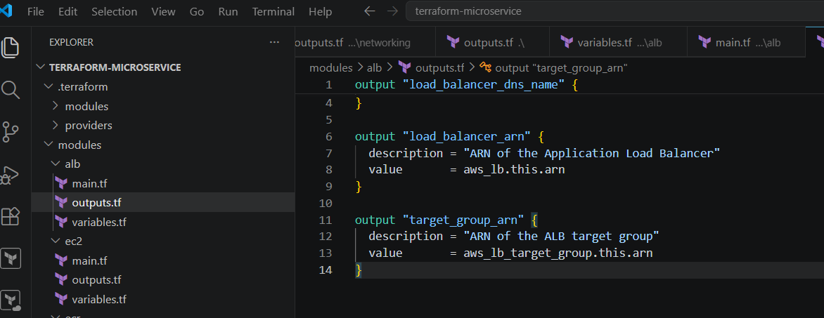
5. Add the ALB module to root main.tf
Add this below the EC2 module:
module "alb" {
source = "./modules/alb"

project_name = var.project_name
vpc_id = module.networking.vpc_id
public_subnet_ids = module.networking.public_subnet_ids
alb_security_group_id = module.ec2.alb_security_group_id
instance_id = module.ec2.instance_id
tags = local.common_tags

depends_on = [
module.ec2
]
}
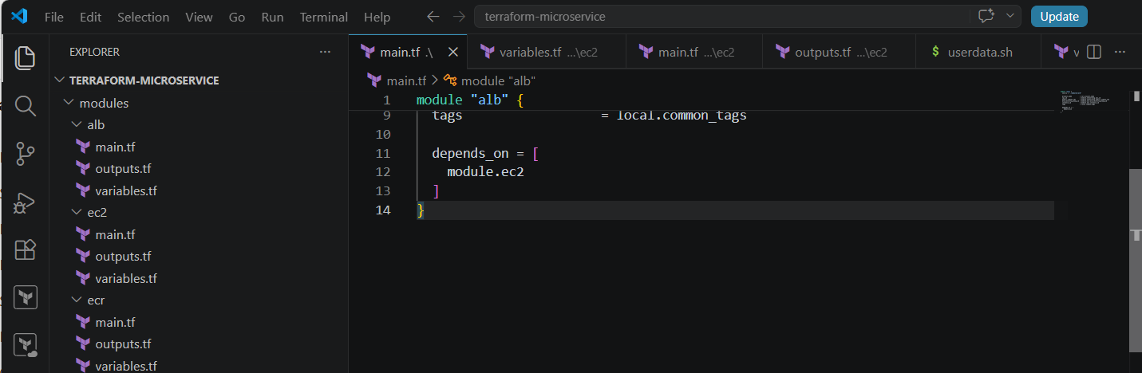
Your root main.tf should now contain four modules:
ECR
Networking
EC2
ALB
6. Add ALB output to root outputs.tf
output "load_balancer_dns_name" {
description = "Public URL of the application load balancer"
value = module.alb.load_balancer_dns_name
}

output "application_url" {
description = "Application URL"
value = "http://${module.alb.load_balancer_dns_name}"
}
7. Run Terraform checks
terraform fmt -recursive
terraform init
terraform validate
terraform plan
The plan should create approximately:
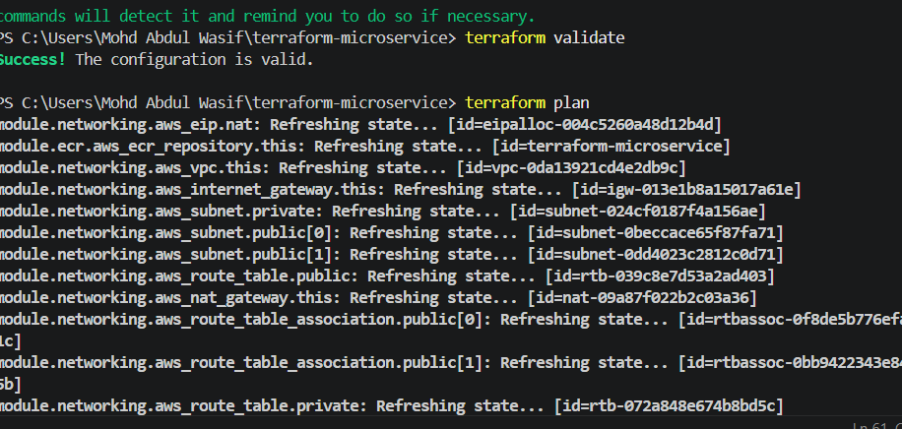
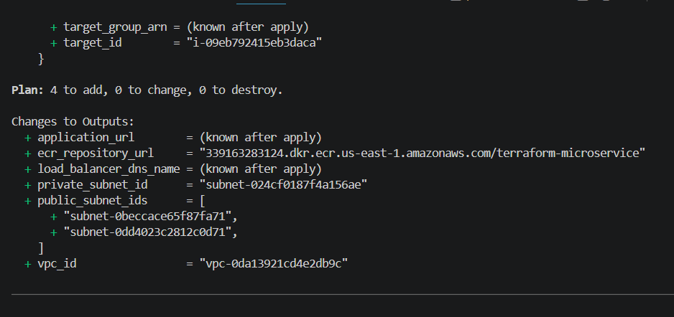
Application Load Balancer
Target Group
Target Group Attachment
Listener
The final line should show:
0 to destroy
Then apply:
terraform apply
Type:
Yes
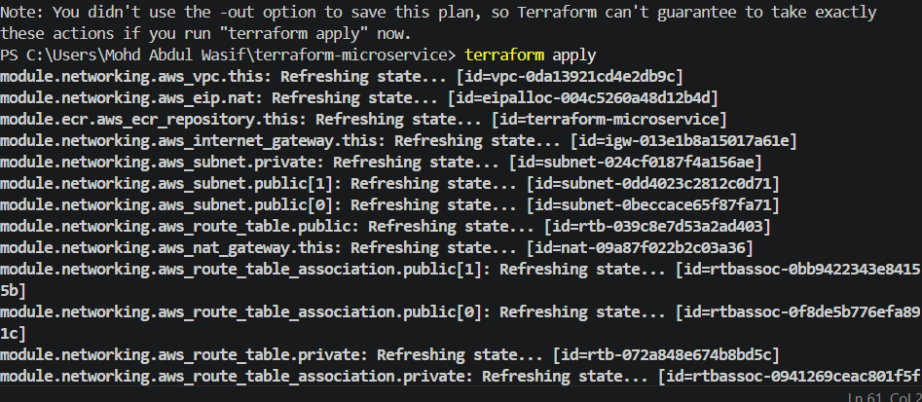
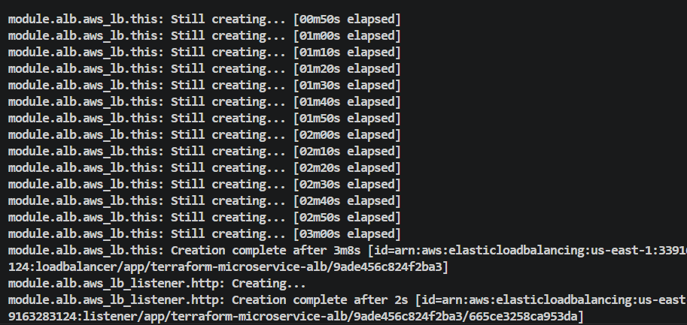
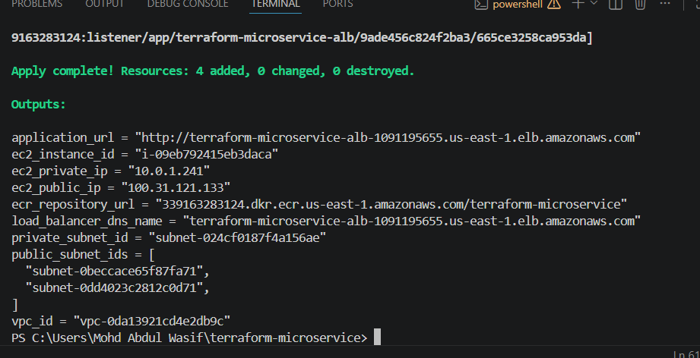
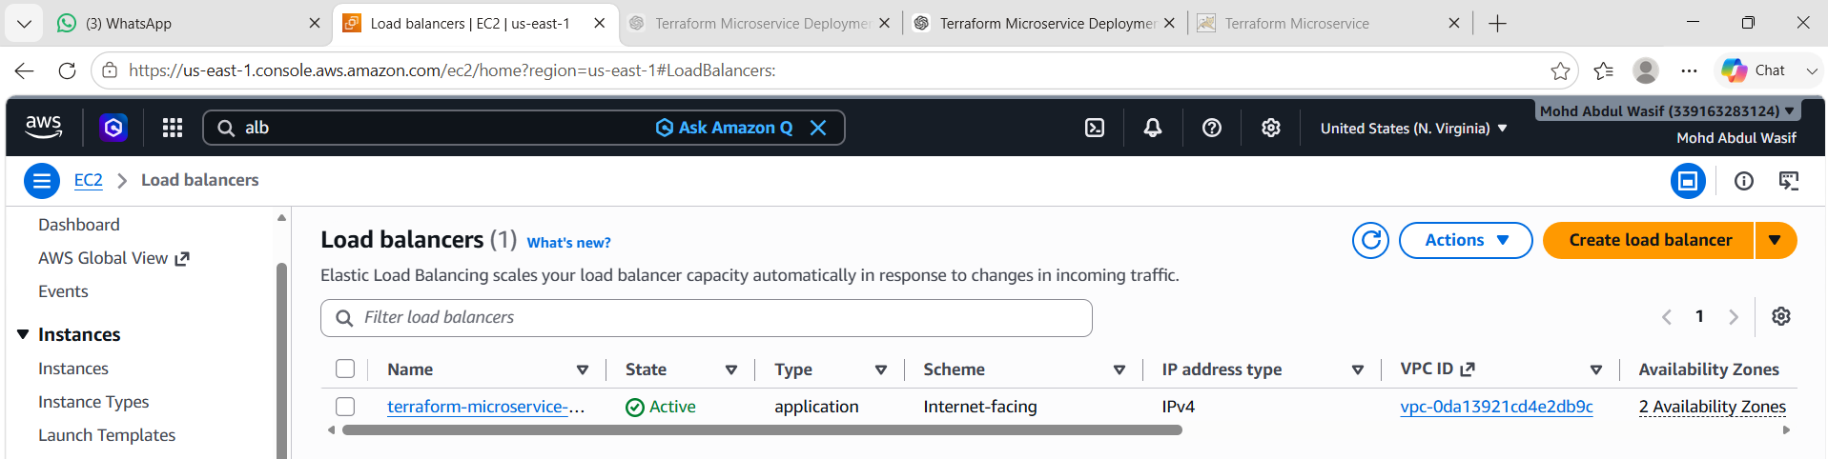
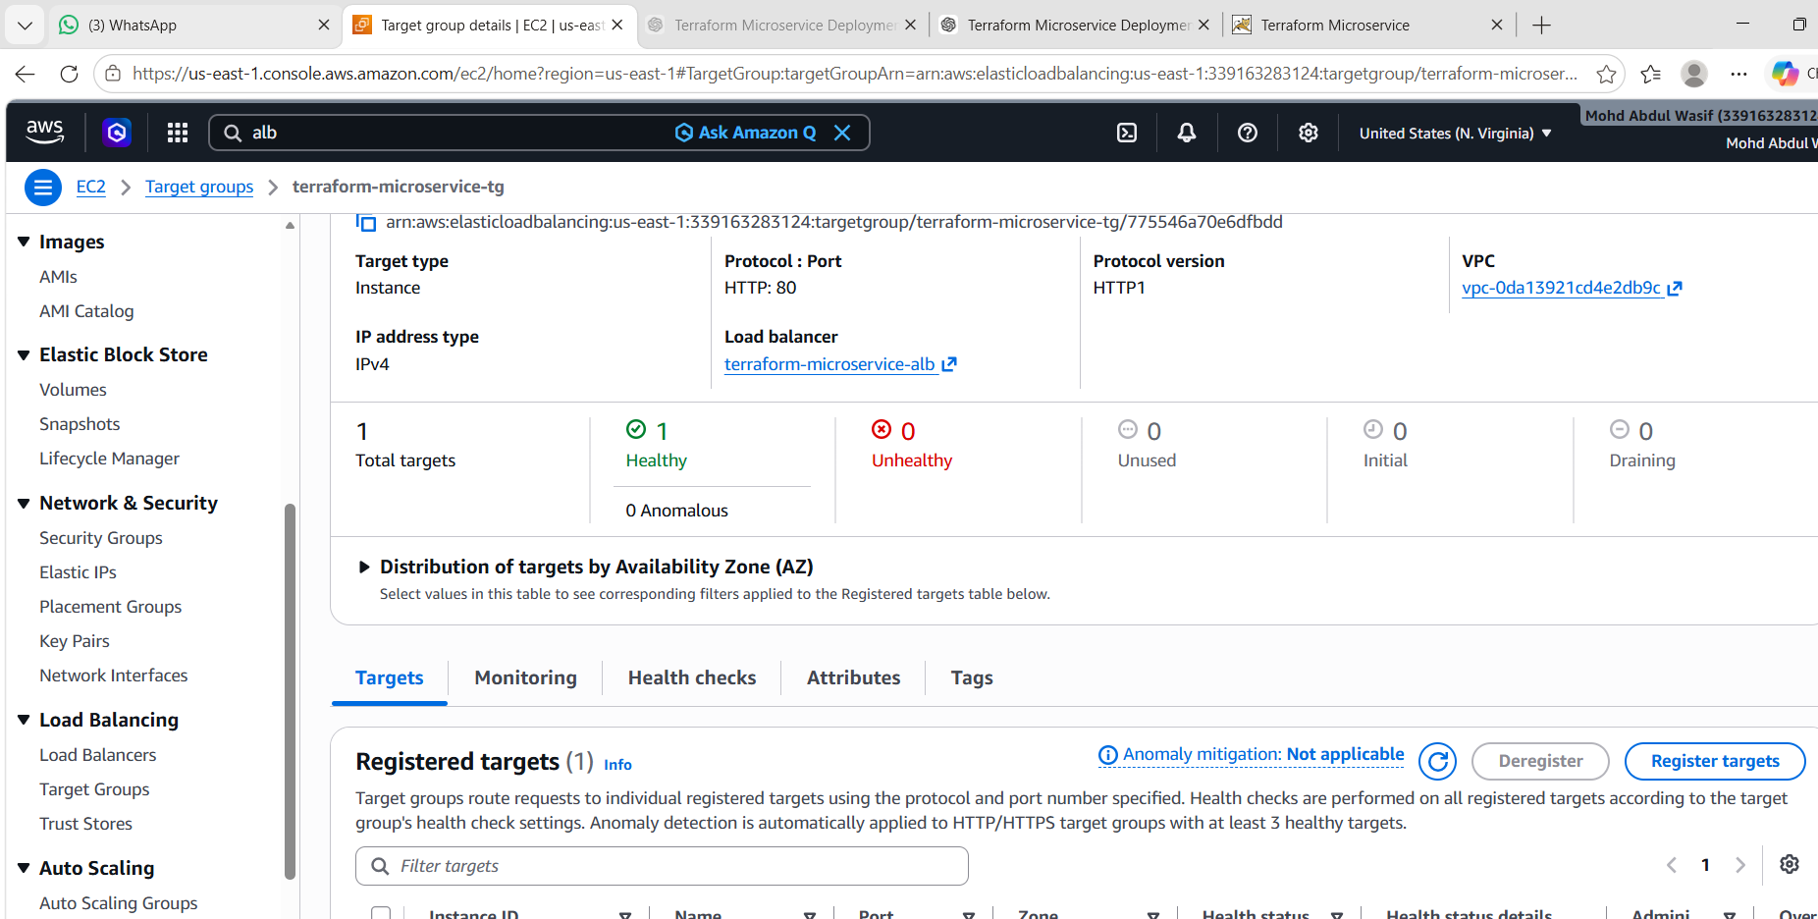
Completed ✅
- ✅ Created a Dockerfile for the application.
- ✅ Created a custom static HTML page.
- ✅ Built the Docker image locally.
- ✅ Tested the container on localhost:8080.
- ✅ Created an Amazon ECR repository with Terraform.
- ✅ Pushed the Docker image to ECR.
- ✅ Created a custom VPC.
- ✅ Created public and private subnets.
- ✅ Created an Internet Gateway.
- ✅ Created a NAT Gateway.
- ✅ Created route tables and associations.
- ✅ Created an EC2 instance.
- ✅ Created an IAM Role and Instance Profile.
- ✅ Registered your SSH key.
- ✅ Created security groups.
- ✅ EC2 successfully pulled the Docker image from ECR.
- ✅ Docker container started automatically via user data.
- ✅ Created an Application Load Balancer.
- ✅ Created a Target Group.
- ✅ Created a Listener.
- ✅ Attached the EC2 instance to the Target Group.
- ✅ Terraform outputs include the ALB DNS name and application URL.

One final verification ⏳
Open the application URL:
http://terraform-microservice-alb-1091195655.us-east-1.elb.amazonaws.com

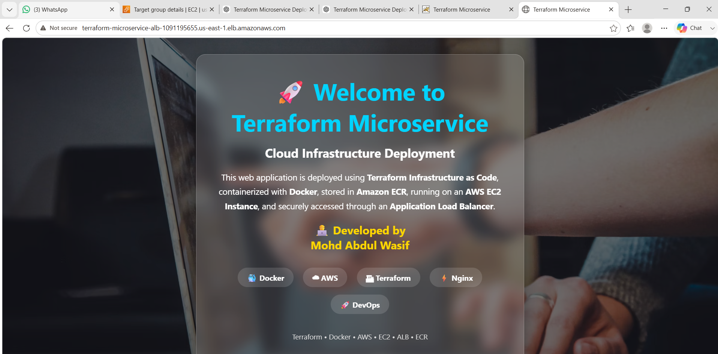
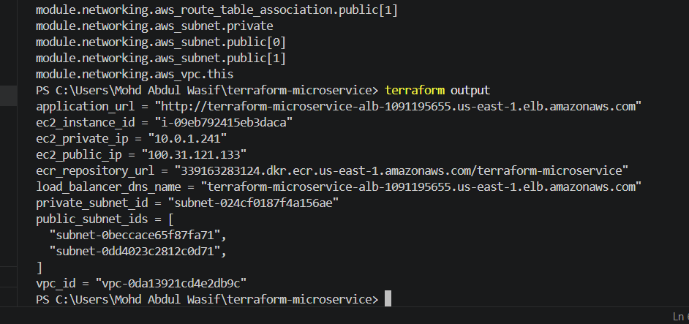
Then destroy the infrastructure
Run:
terraform destroy
Type:
yes
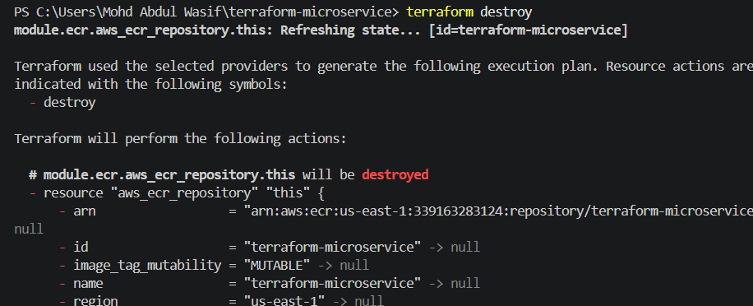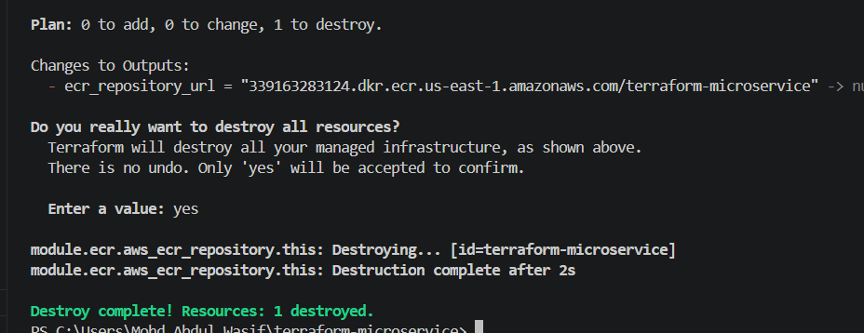

Architecture
Internet
│
│
┌────────────────────┐
│ Application Load │
│ Balancer (ALB) │
└─────────┬──────────┘
│
│
HTTP (Port 80)
│
┌────────────────┐
│ EC2 Instance │
│ Docker Engine │
│ Nginx Container│
└───────┬────────┘
│
Pull Image
│
┌───────────────┐
│ Amazon ECR │
└───────────────┘

SSH → Allowed Public IP only

Terraform Best Practices Used
- Separate modules
- Variables
- Outputs
- Locals
- terraform.tfvars
- Reusable code
- IAM Roles instead of Access Keys
- User Data for automation
- Security Groups with least privilege
- Infrastructure as Code
- Version-controlled configuration

Common Errors & Fixes
Error | Solution
No default VPC | Create a custom VPC in Terraform
Docker image not found | Build and push image before deployment
AccessDenied to ECR | Attach ECR ReadOnly IAM policy
ALB Health Check Failed | Ensure container is running on port 80
SSH Permission Denied | Use correct private key and security group
Terraform Validate Failed | Fix syntax errors in .tf files
Image Pull Failed | Verify ECR login and repository URL
Target Unhealthy | Check Docker container and security groups

What We Learned
- Built a Docker image for a static web application.
- Stored the image securely in Amazon ECR.
- Used Terraform to provision AWS infrastructure automatically.
- Designed a secure VPC with networking and security groups.
- Configured IAM roles so EC2 could access ECR without storing credentials.
- Automated Docker installation and container deployment using EC2 User Data.
- Deployed the application behind an Application Load Balancer for secure access.
- Restricted direct access to the EC2 instance while allowing controlled SSH access.
- Applied Terraform best practices using modules, variables, outputs, and reusable code.
- Managed the full infrastructure lifecycle using terraform init, fmt, validate, plan, apply, and destroy.

Conclusion
This project demonstrated how to deploy a secure, containerized microservice on AWS using Terraform as Infrastructure as Code. The application was packaged with Docker, stored in Amazon ECR, and automatically deployed to an EC2 instance within a custom VPC. An Application Load Balancer provided controlled public access while direct instance access remained restricted. By organizing the code with modules, variables, and reusable components, the infrastructure became easier to manage, scale, and maintain, following industry-standard DevOps and Terraform best practices.

