Kubernetes-Task-02
Kubernetes Pod Practical Tasks
Common prerequisites
Before starting all tasks, confirm:
- Kubernetes cluster is running.
- kubectl is installed and configured.
- Control plane and worker nodes are in Ready status.
- Internet access is available to download container images.
kubectl cluster-info
kubectl get nodes
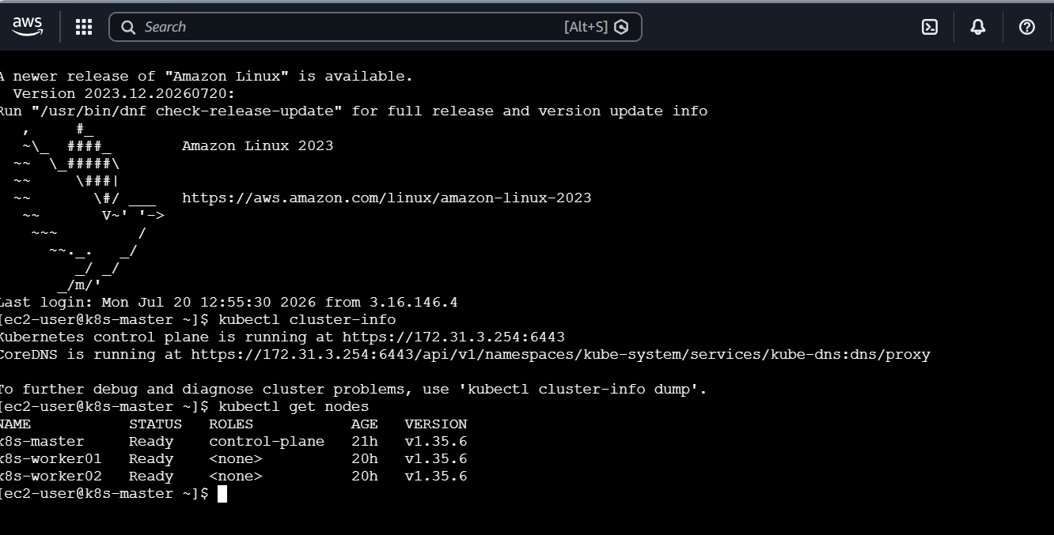
Perform the tasks one by one. Delete or rename old Pods before reusing the same Pod name.

Task 1: Create a Simple Pod Using YAML
Objective
Create a Pod named firstpod containing one Nginx container and verify its status and logs.
Step 1: Create task1-firstpod.yaml
apiVersion: v1
kind: Pod
metadata:
name: firstpod
labels:
app: nginx
spec:
containers:
- name: nginx-container
image: nginx:latest
ports:
- containerPort: 80
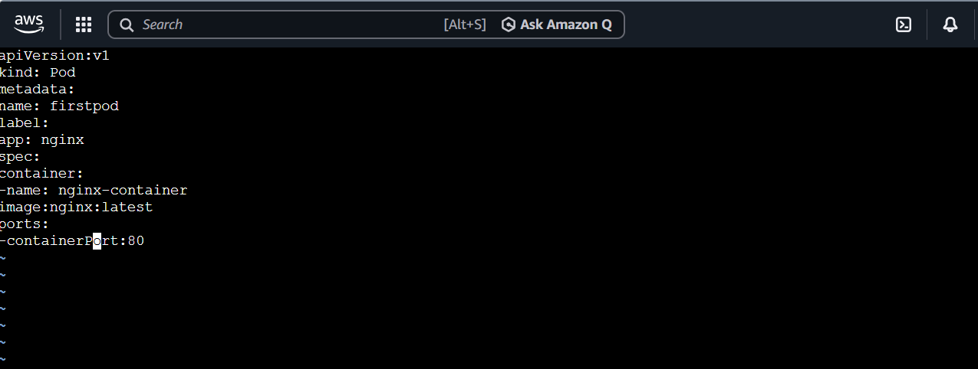
The label will later help a Kubernetes Service locate this Pod.
Step 2: Create the Pod
kubectl apply -f task1-firstpod.yaml
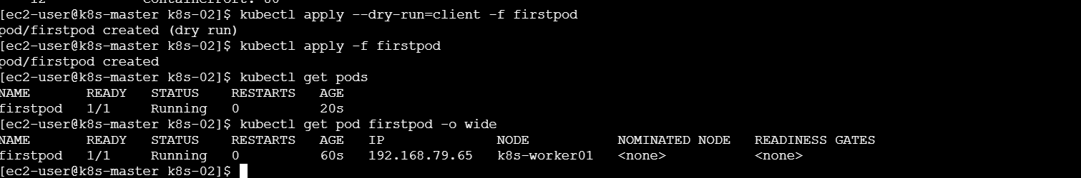
Step 3: Verify the Pod
kubectl get pods
kubectl get pod firstpod -o wide

Wait until its status becomes Running.
Step 4: Check logs
kubectl logs firstpod
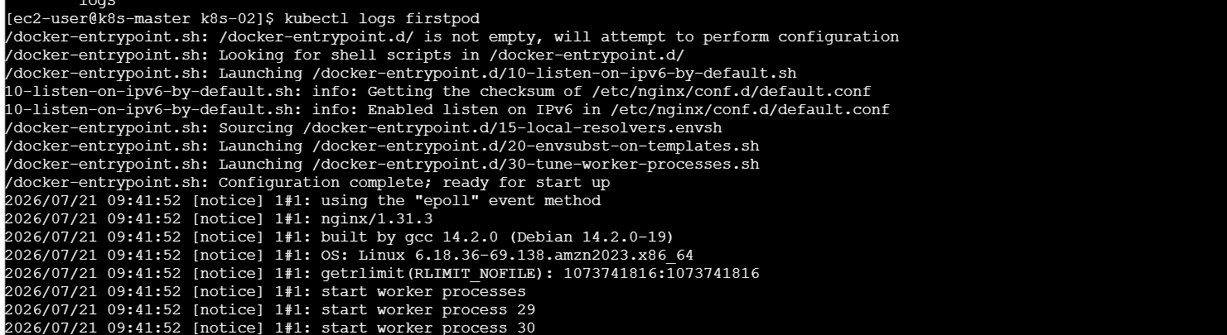
Nginx may show no logs until it receives a request. Generate a request:
kubectl exec firstpod -- curl -s http://localhost
kubectl logs firstpod
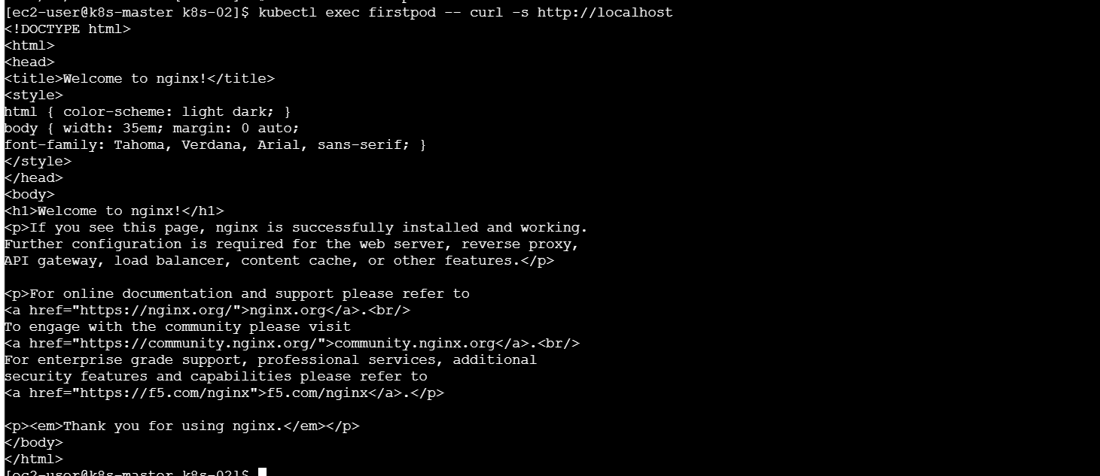
What we learned
We learned how to define a Pod in YAML, deploy it and check its status and container logs.
Conclusion
The firstpod Pod was created successfully with an Nginx container.
Task 2: Set Environment Variables in a Pod
Objective
Pass myname and City environment variables to a container.
Prerequisite
Delete the previous Pod because most Pod configurations cannot be changed after creation:
kubectl delete pod firstpod
Create task2-env.yaml
apiVersion: v1
kind: Pod
metadata:
name: firstpod
labels:
app: nginx
spec:
containers:
- name: nginx-container
image: nginx:latest
env:
- name: myname
value: "sabair"
- name: City
value: "Hyderabad"
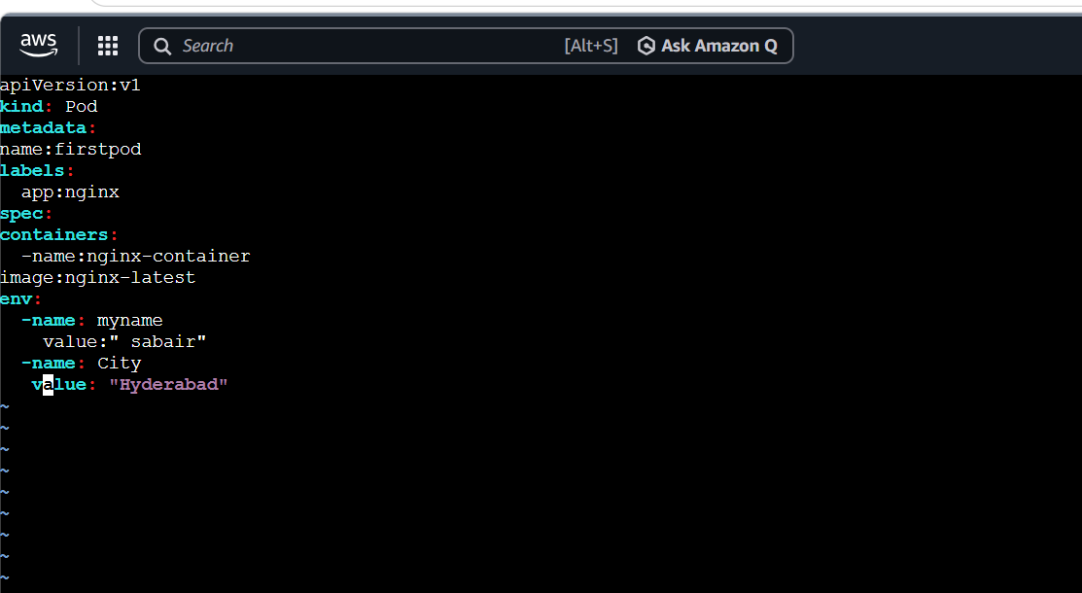
Environment variable names are case-sensitive, so City and CITY are different.
Deploy and verify
kubectl apply -f task2-env.yaml
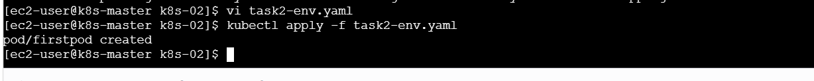
kubectl get pods
kubectl exec firstpod – env
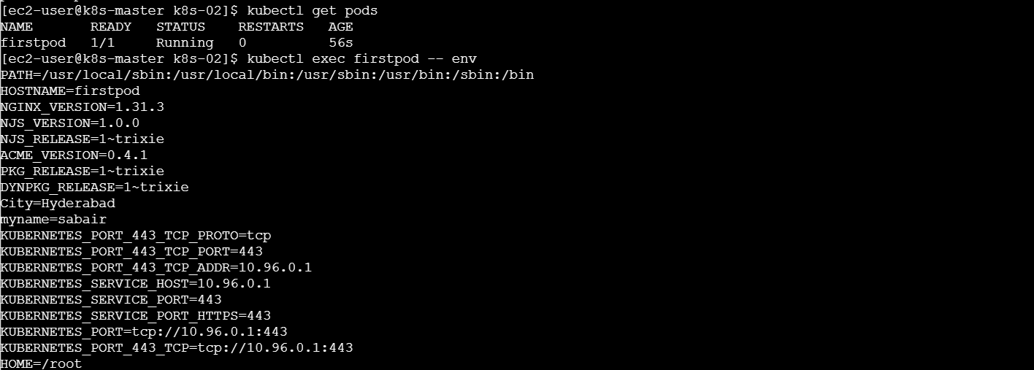
Check only the required variables:
kubectl exec firstpod -- printenv myname City
Expected result:
sabair
Hyderabad
What we learned
We learned how to supply application configuration through Pod environment variables.
Conclusion
The environment variables were successfully passed to the Nginx container.
Task 3: Deploy a Pod with Commands and Args
Objective
Run a container that sleeps for 50 seconds using command and args.
Create task3-args.yaml
apiVersion: v1
kind: Pod
metadata:
name: args-pod
spec:
restartPolicy: Never
containers:
- name: sleep-container
image: nginx:latest
command: ["/bin/sh", "-c"]
args:
- |
echo "Container sleeping for 50 seconds"
sleep 50
echo "Sleep completed"
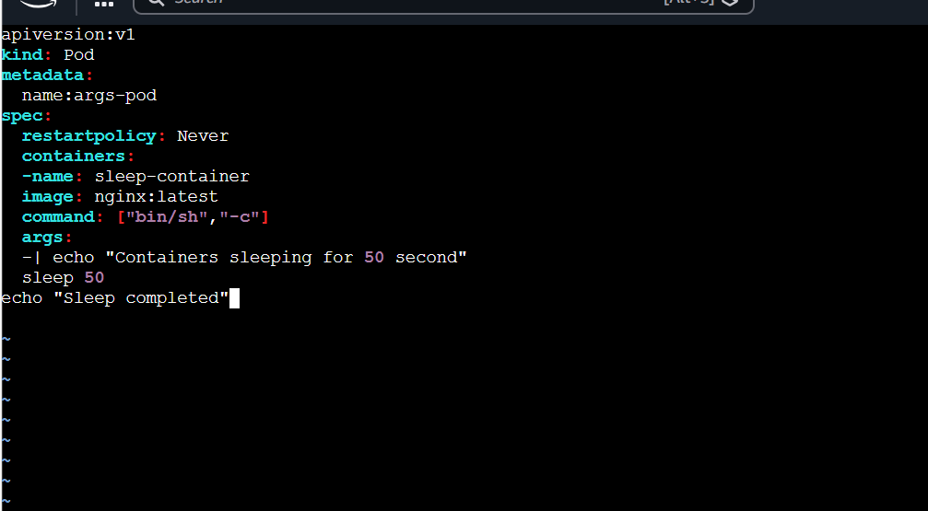
We use command to start the shell and args to provide instructions to it.
Deploy and verify
kubectl apply -f task3-args.yaml
kubectl get pods
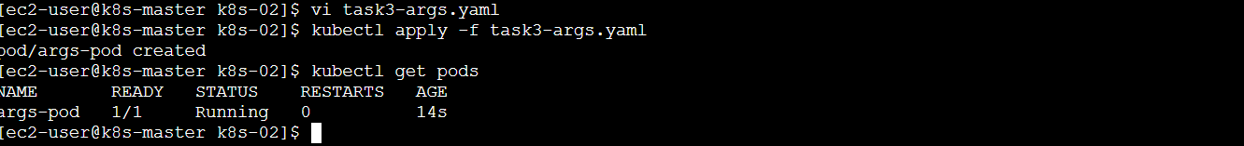
kubectl describe pod args-pod
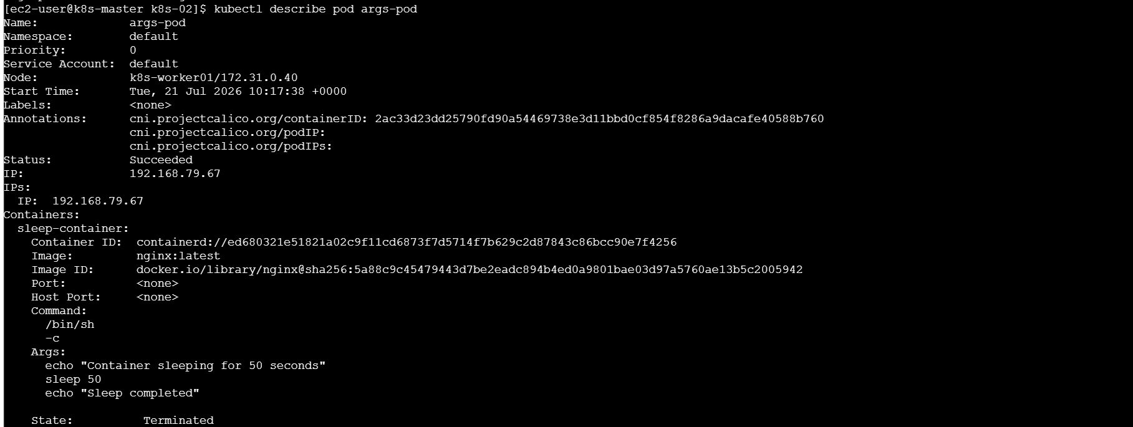
Under Containers, check:
Command:
/bin/sh
-c
Args:
echo ...
sleep 50
Check the logs:
kubectl logs args-pod
After 50 seconds, the Pod should show Completed. This is expected because restartPolicy is Never.
What we learned
We learned how command changes the container’s starting program and args passes instructions to it.
Conclusion
The container successfully executed the sleep command and completed after 50 seconds.

Task 4: Create a Pod with Two Containers
Objective
Run two containers inside one Pod and verify that they share the same network.
Important point
Two Nginx containers cannot both listen on port 80 inside the same Pod because containers share one network. Therefore:
- First Nginx listens on port 80.
- Second Nginx listens on port 8080.
Create task4-two-containers.yaml
apiVersion: v1
kind: Pod
metadata:
name: two-container-pod
spec:
containers:
- name: nginx-one
image: nginx:latest
ports:
- containerPort: 80

- name: nginx-two
image: nginx:latest
command: ["/bin/sh", "-c"]
args:
- |
sed -i 's/listen 80;/listen 8080;/' /etc/nginx/conf.d/default.conf
sed -i 's/listen \[::\]:80;/listen [::]:8080;/' /etc/nginx/conf.d/default.conf
exec nginx -g 'daemon off;'
ports:
- containerPort: 8080
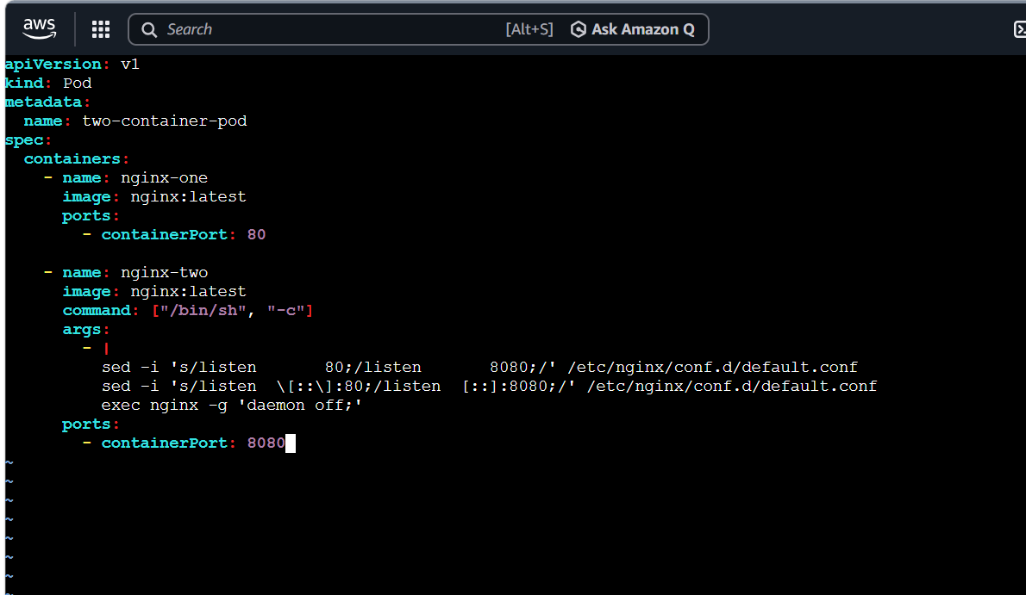
Deploy and verify
kubectl apply -f task4-two-containers.yaml
kubectl get pod two-container-pod
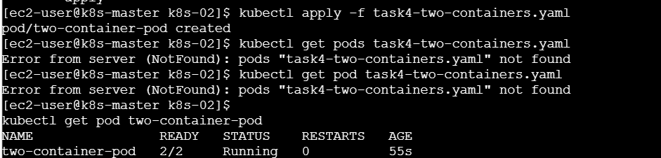
List both containers:
kubectl get pod two-container-pod \
-o jsonpath='{.spec.containers[*].name}'
Access the first container:
kubectl exec -it two-container-pod -c nginx-one -- /bin/sh
Access the second container:
kubectl exec -it two-container-pod -c nginx-two -- /bin/sh
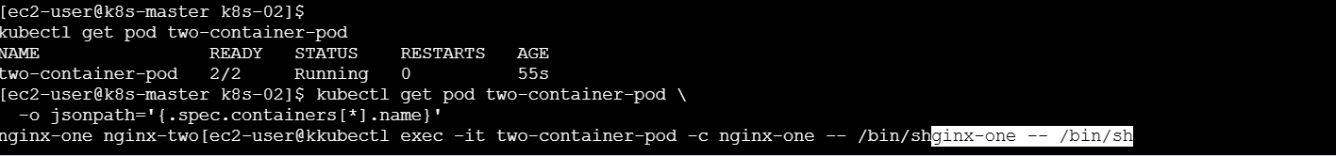
Verify communication through the shared localhost network:
kubectl exec two-container-pod -c nginx-one -- curl -I http://localhost:8080
kubectl exec two-container-pod -c nginx-two -- curl -I http://localhost:80
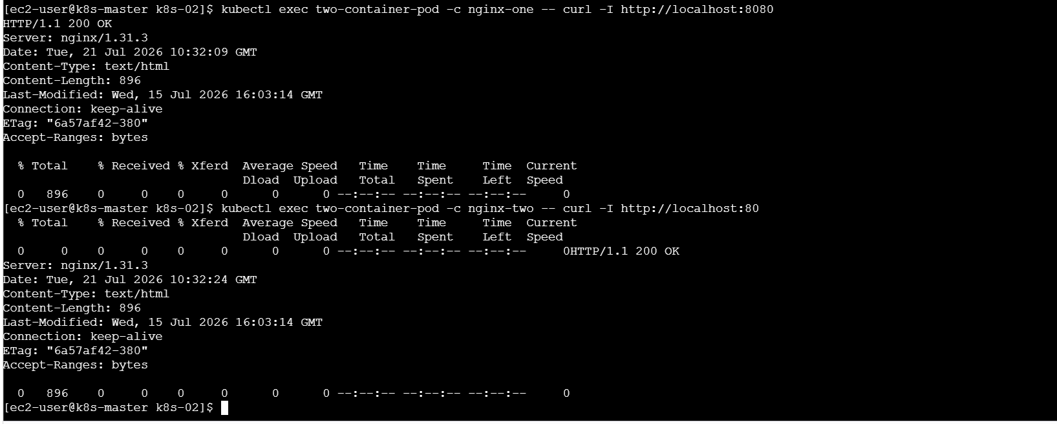
A response such as HTTP/1.1 200 OK confirms connectivity.
What we learned
We learned that containers in the same Pod share the same IP address and communicate using localhost, but they must use different ports.
Conclusion
Both Nginx containers ran successfully and communicated through the Pod’s shared network.

Task 5: Set Up an Init Container
Objective
Run an init container for 30 seconds before starting the main containers.
Create task5-init-container.yaml
apiVersion: v1
kind: Pod
metadata:
name: init-pod
spec:
initContainers:
- name: setup-container
image: busybox:latest
command: ["/bin/sh", "-c"]
args:
- |
echo "Initial setup started"
sleep 30
echo "Initial setup completed"

containers:
- name: nginx-main
image: nginx:latest
ports:
- containerPort: 80
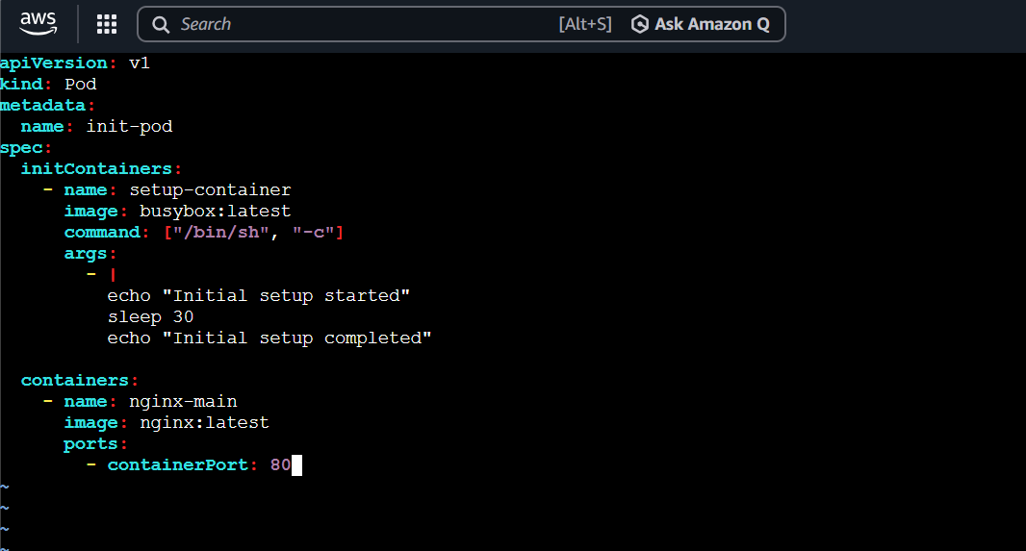
The main Nginx container will not start until the init container completes successfully.
Deploy and observe
kubectl apply -f task5-init-container.yaml
kubectl get pods -w
Initially, you should see:
Init:0/1
After approximately 30 seconds:
Running
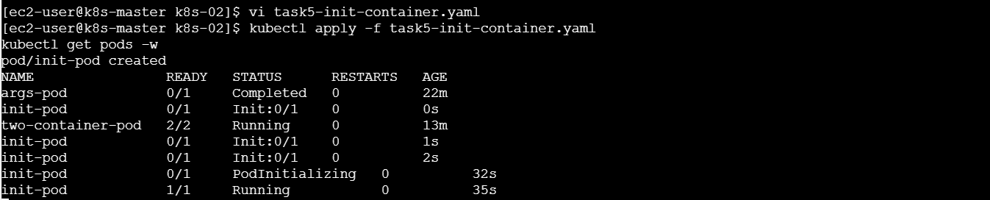
Press Ctrl+C to stop watching. This does not stop the Pod.
Verify the init container
kubectl describe pod init-pod
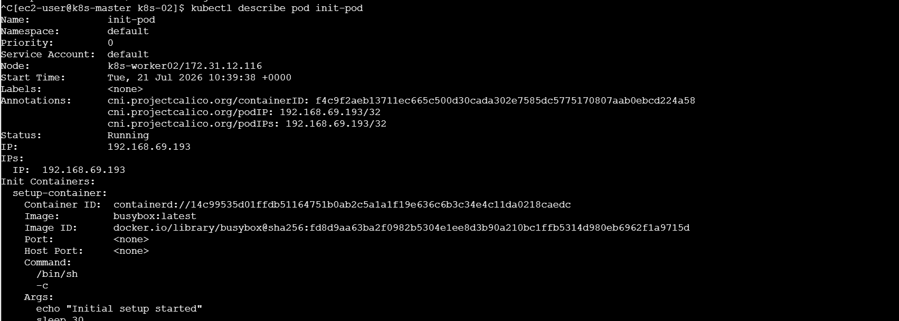
kubectl logs init-pod -c setup-container
Expected logs:
Initial setup started
Initial setup completed
What we learned
We learned that init containers perform setup work and must complete before regular application containers start.
Conclusion
The init container completed its 30-second setup, after which the Nginx container started.

Task 6: Generate YAML Using Dry Run
Objective
Generate a YAML manifest without immediately creating a Pod.
Generate the YAML
kubectl run nginx \
--image=nginx:latest \
--dry-run=client \
-o yaml > task6-dry-run.yaml
--dry-run=client
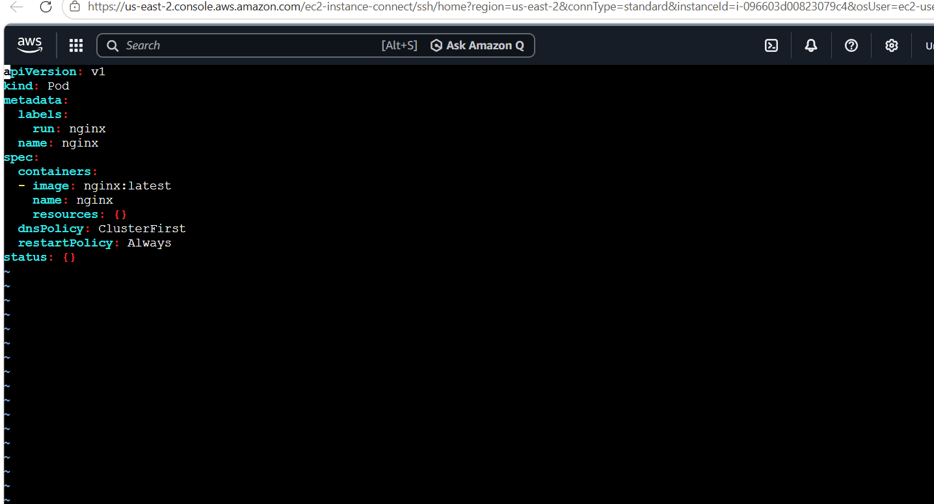
prepares the configuration locally but does not send it to the cluster.
Modify task6-dry-run.yaml
apiVersion: v1
kind: Pod
metadata:
name: nginx
labels:
app: nginx
environment: practice
spec:
containers:
- name: nginx
image: nginx:latest
env:
- name: TRAINING
value: "Kubernetes"
restartPolicy: Always
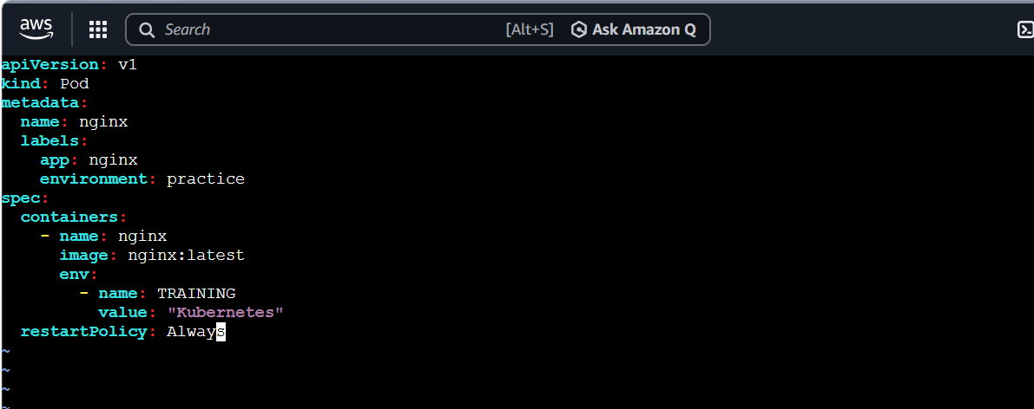
Deploy and verify
kubectl apply -f task6-dry-run.yaml
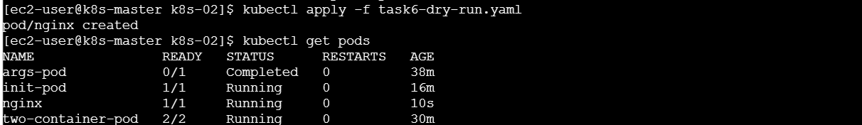
kubectl get pod nginx --show-labels
kubectl exec nginx -- printenv TRAINING
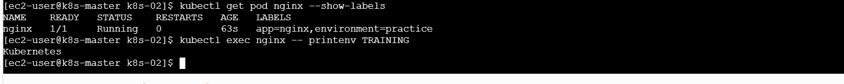
What we learned
We learned how to generate a correct YAML template using an imperative command and customize it before deployment.
Conclusion
The dry-run command generated the manifest without creating a resource, and the modified YAML was later deployed successfully.
Task 7: Use kubectl create vs kubectl apply
Objective
Understand the difference between creating a new resource and applying configuration changes.
Create task7-create-apply.yaml
apiVersion: v1
kind: Pod
metadata:
name: create-apply-pod
spec:
containers:
- name: nginx
image: nginx:1.27
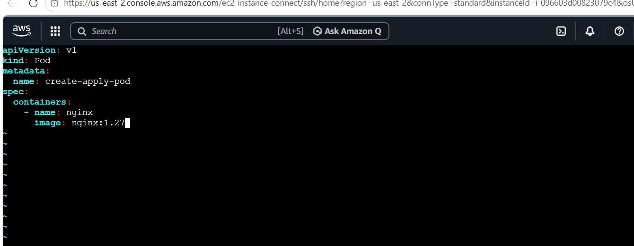
Create the Pod for the first time
kubectl create -f task7-create-apply.yaml
kubectl get pod create-apply-pod
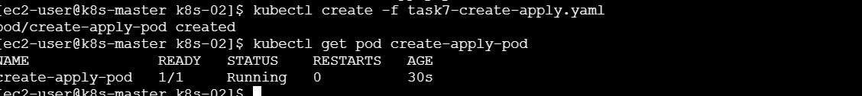
Run the same command again:
kubectl create -f task7-create-apply.yaml
It should fail because the Pod already exists.
Modify the image
Change:
image: nginx:1.27
to:
image: nginx:1.28
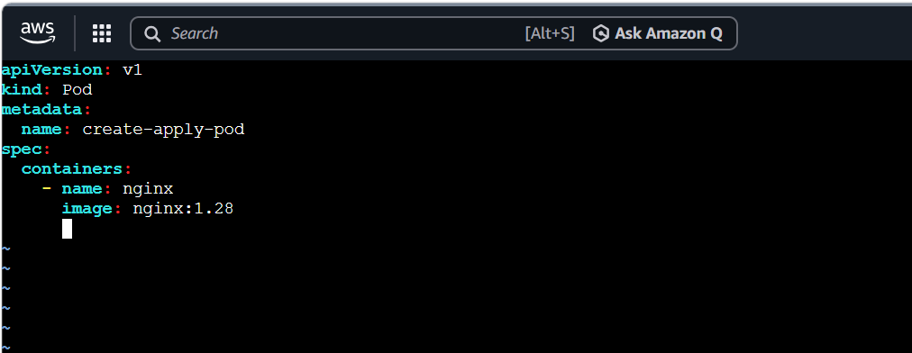
Apply the change:
kubectl apply -f task7-create-apply.yaml
Verify the image:
kubectl get pod create-apply-pod \
-o jsonpath='{.spec.containers[0].image}'
Difference
Command | Behaviour
kubectl create | Creates a resource but fails if it already exists.
kubectl apply | Creates a missing resource or updates an existing resource.
What we learned
We learned that create is mainly for first-time creation, while apply manages both creation and supported updates.
Conclusion
kubectl create created the original Pod, while kubectl apply updated its container image.

Task 8: Edit an Existing Pod
Objective
Modify an allowed field of a running Pod using kubectl edit.
Important limitation
Kubernetes does not allow most Pod fields, including environment variables, to be edited after creation. The container image is one field that can normally be changed.
For production applications, we usually edit a Deployment instead of an individual Pod.
Edit the Pod
kubectl edit pod create-apply-pod
Find:
image: nginx:1.28
Change it to:
image: nginx:alpine
Save and close the editor.
For vi:
Press Esc
Type :wq
Press Enter
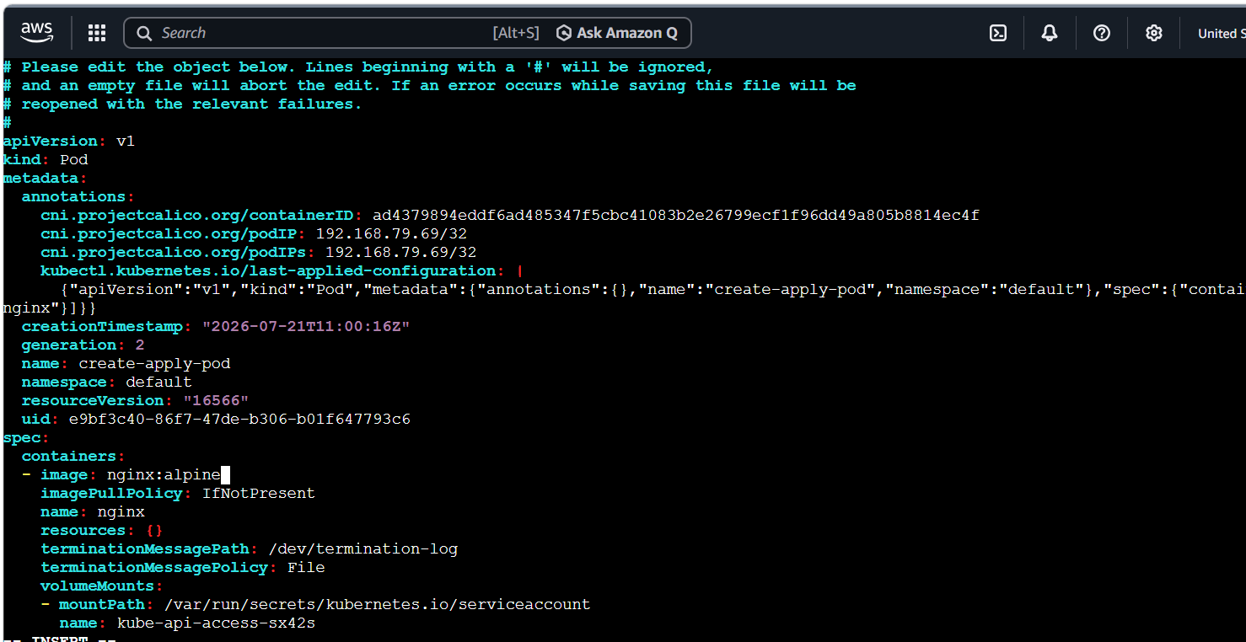
Verify the modification
kubectl get pod create-apply-pod \
-o jsonpath='{.spec.containers[0].image}'
Check additional details:
kubectl describe pod create-apply-pod
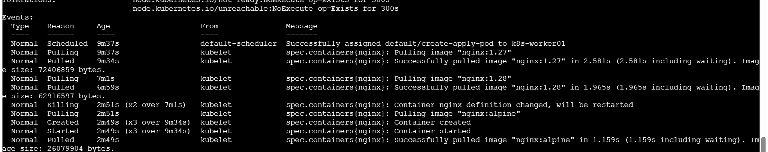
If you try to change an environment variable, Kubernetes may reject it as an immutable Pod update. In that case, update the YAML, delete the Pod and recreate it.
What we learned
We learned how to edit a running resource and that Kubernetes restricts changes to most existing Pod fields.
Conclusion
The running Pod’s image was updated successfully using kubectl edit.
Task 9: Expose a Pod Using ClusterIP Service
Your current Pod list does not show firstpod, so first create it with a unique label. This prevents the Service from selecting your Task 6 nginx Pod.
Objective
Create an Nginx Pod named firstpod and expose it internally through a ClusterIP Service on port 80.
Step 1: Create the YAML file
vi task9-service.yaml
Paste:
apiVersion: v1
kind: Pod
metadata:
name: firstpod
labels:
app: firstpod
spec:
containers:
- name: nginx-container
image: nginx:latest
ports:
- containerPort: 80

---
apiVersion: v1
kind: Service
metadata:
name: firstpod-service
spec:
type: ClusterIP
selector:
app: firstpod
ports:
- name: http
protocol: TCP
port: 80
targetPort: 80
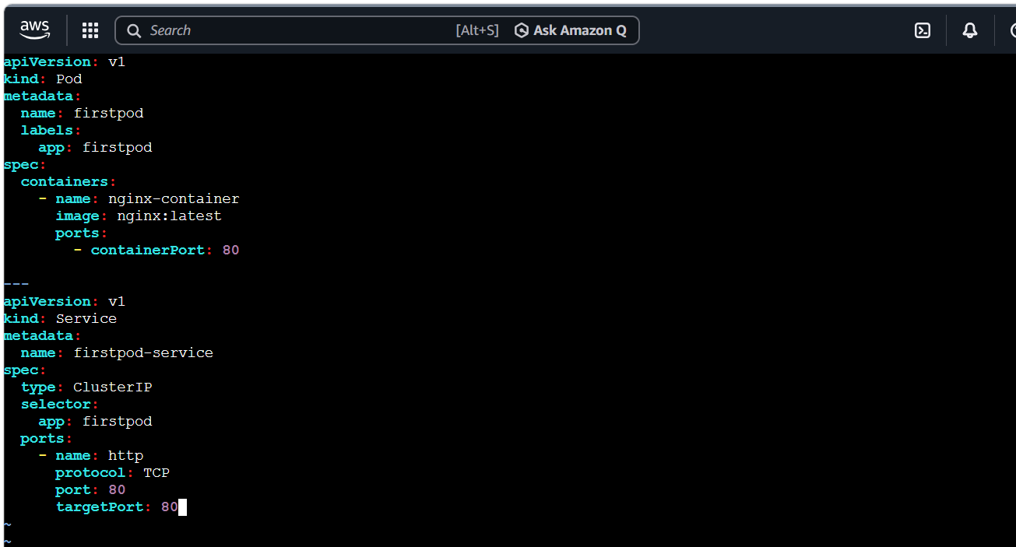
The --- separates the Pod and Service definitions inside the same YAML file.
Save using:
Esc
:wq
Enter
Step 2: Apply the YAML
kubectl apply -f task9-service.yaml
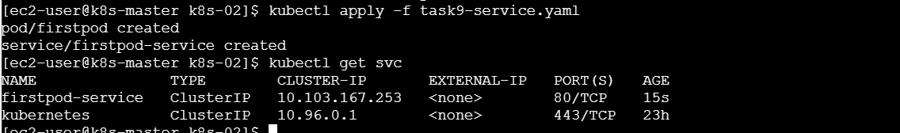
Expected:
pod/firstpod created
service/firstpod-service created
Step 3: Verify the Pod and Service
kubectl get pod firstpod
kubectl get svc firstpod-service

Expected Service output:
NAME TYPE CLUSTER-IP PORT(S)
firstpod-service ClusterIP 10.x.x.x 80/TCP
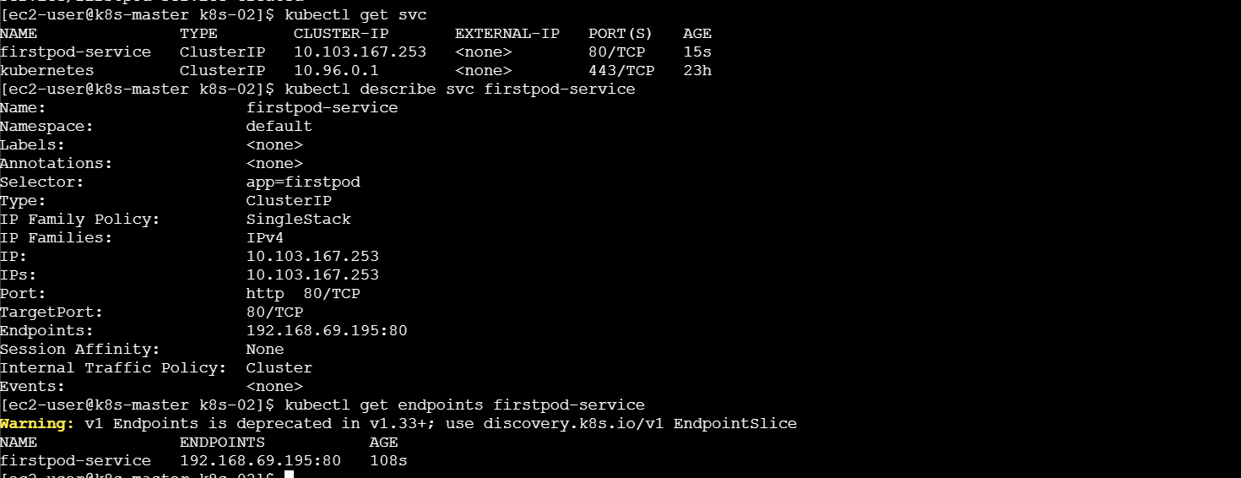
ClusterIP means the application is accessible only from inside the Kubernetes cluster.
Step 4: Confirm the Service selected firstpod
kubectl get endpoints firstpod-service

You should see a Pod IP with port 80:
192.168.x.x:80
For newer Kubernetes versions, you can also use:
kubectl get endpointslice \
-l kubernetes.io/service-name=firstpod-service
Step 5: Test the Service
Run a temporary BusyBox Pod:
kubectl run service-test \
--image=busybox:latest \
--restart=Never \
--rm -it \
-- wget -qO- http://firstpod-service
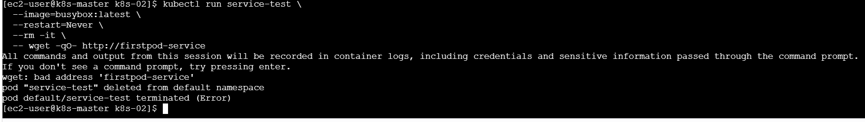
You should receive the Nginx welcome-page HTML. The temporary testing Pod is automatically deleted because of --rm.
You can also test through the Service IP:
kubectl get svc firstpod-service
Copy its ClusterIP and run:
curl http://<CLUSTER-IP>
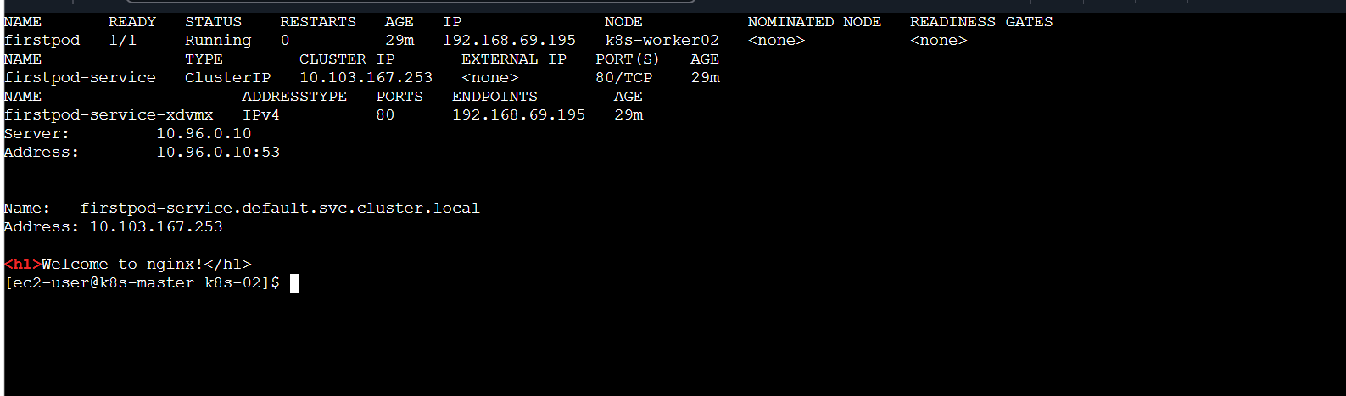
What we learned
We learned that a Service uses labels and selectors to locate Pods and provides a stable IP address and DNS name even if a Pod’s IP changes.
Conclusion
The firstpod Nginx application was successfully exposed internally through the firstpod-service ClusterIP Service on port 80.

Task 10: Pod with Resource Requests and Limits
Objective
Configure CPU and memory requests and limits for two containers.
Understanding resources
- Request: Minimum resource Kubernetes reserves for the container.
- Limit: Maximum resource the container is allowed to use.
Create task10-resources.yaml
apiVersion: v1
kind: Pod
metadata:
name: resource-pod
spec:
containers:
- name: nginx-one
image: nginx:latest
resources:
requests:
cpu: "100m"
memory: "64Mi"
limits:
cpu: "200m"
memory: "128Mi"

- name: helper-container
image: busybox:latest
command: ["/bin/sh", "-c"]
args:
- "while true; do sleep 3600; done"
resources:
requests:
cpu: "50m"
memory: "32Mi"
limits:
cpu: "100m"
memory: "64Mi"
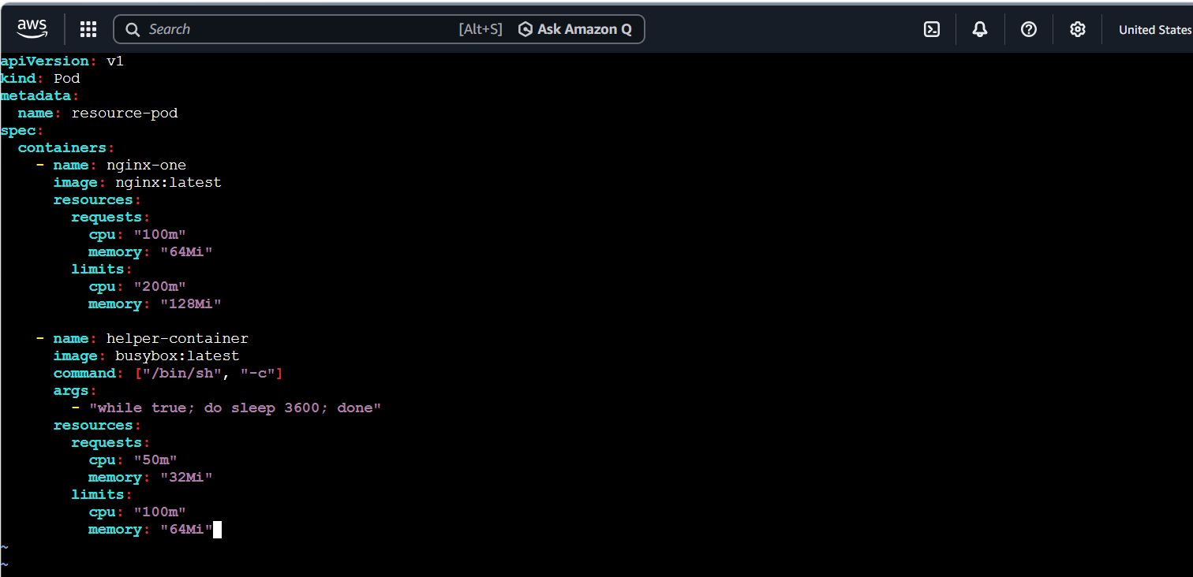
Here, 100m means 100 millicores, which equals 0.1 CPU core.
Deploy and verify
kubectl apply -f task10-resources.yaml
kubectl get pod resource-pod
kubectl describe pod resource-pod
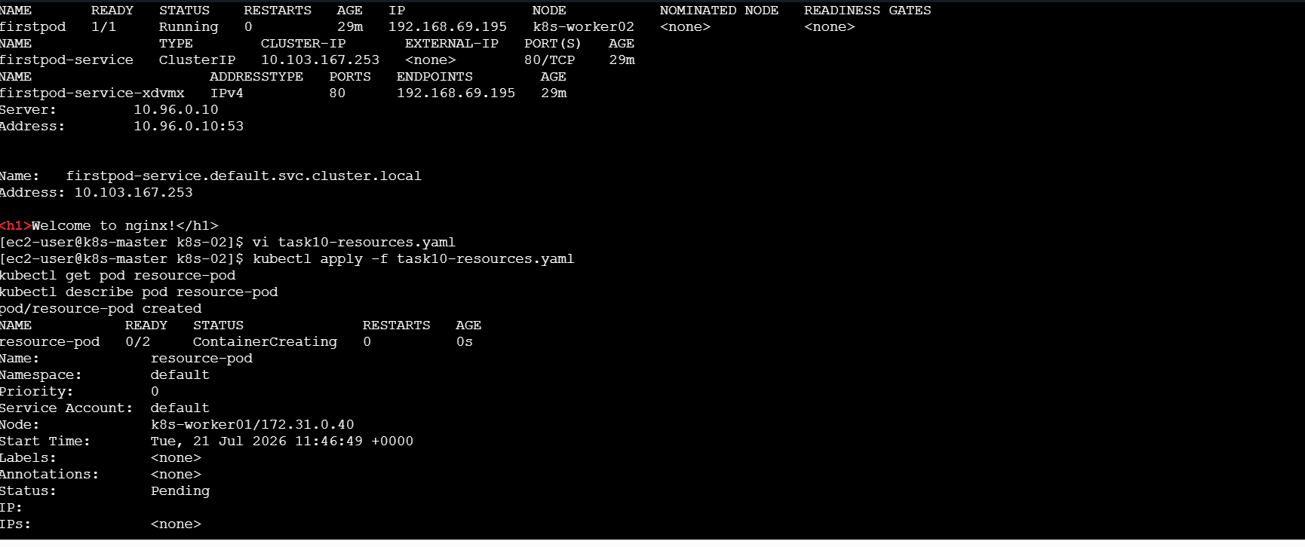
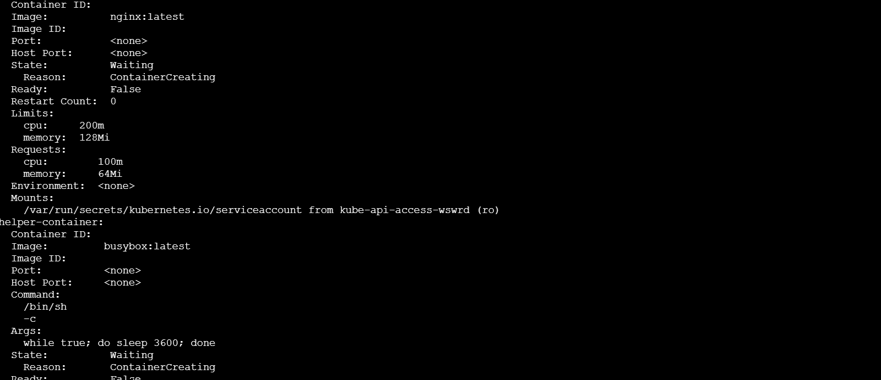
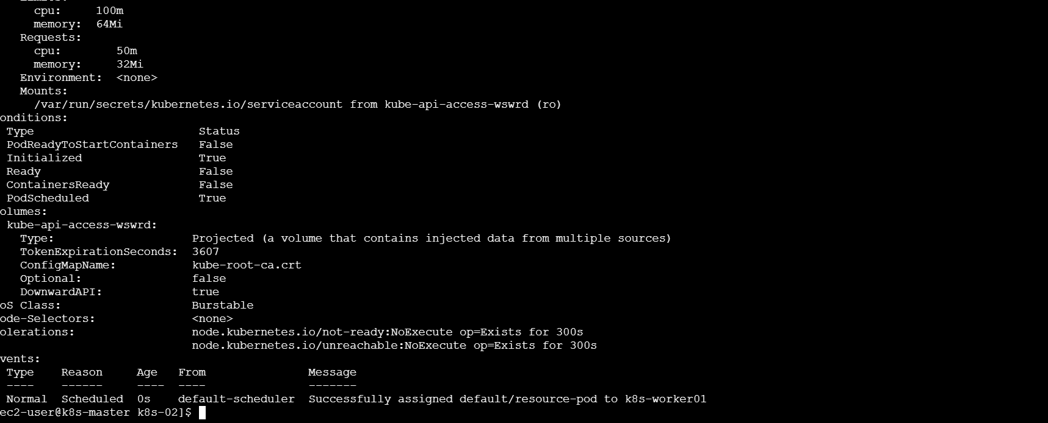
Look under each container for:
Limits:
cpu:
memory:
Requests:
cpu:
memory:
You can also verify using:
kubectl get pod resource-pod \
-o jsonpath='{range .spec.containers[*]}{"\nContainer: "}{.name}{"\nRequests: "}{.resources.requests}{"\nLimits: "}{.resources.limits}{"\n"}{end}'
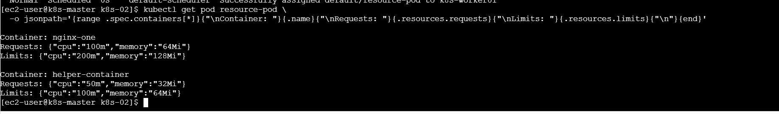

What we learned
We learned how resource requests help Kubernetes schedule Pods and how limits prevent containers from using excessive resources.
Conclusion
CPU and memory requests and limits were successfully configured for both containers.

Overall learning
After completing these tasks, we learned how to:
- Create and manage Pods using YAML.
- Configure environment variables, commands and arguments.
- Run multiple containers inside one Pod.
- Prepare applications using init containers.
- Generate manifests with --dry-run.
- Understand create, apply and edit.
- Expose a Pod through a ClusterIP Service.
- Control container CPU and memory usage.
Overall conclusion
These ten practical tasks cover the main fundamentals of Kubernetes Pod management. We created Pods, configured containers, verified communication, exposed an application through a Service and controlled resource usage using YAML manifests.

