Kubernetes-Task-03
Kubernetes Services, ReplicationController and ReplicaSet Lab
Objective
In this lab, we will:
- Create an Apache Pod and expose it internally using ClusterIP.
- Expose an Nginx Pod externally using NodePort.
- Create and scale an Nginx ReplicationController.
- Manage Pods using advanced ReplicaSet label selectors.
- Test load balancing across multiple Nginx Pods.
- Delete a ReplicationController without deleting its Pods.

Prerequisites
Make sure you have:
- A working Kubernetes cluster with one control plane and worker nodes.
- kubectl installed and configured.
- Worker nodes in Ready status.
- A working CNI plugin such as Calico.
- Internet access on worker nodes to pull Apache, Nginx and BusyBox images.
- If using AWS EC2, allow the required NodePort in the worker-node Security Group.
Check the cluster:
kubectl get nodes
Expected:
NAME STATUS ROLES
k8s-master Ready control-plane
k8s-worker01 Ready <none>
k8s-worker02 Ready <none>
Create a separate namespace for this lab:
kubectl create namespace service-lab
kubectl config set-context --current --namespace=service-lab

Task 1: Create a Cluster IP Service for Apache
A ClusterIP Service is accessible only from inside the Kubernetes cluster.
Step 1: Create the YAML file
vi apache-clusterip.yaml
Add:
apiVersion: v1
kind: Pod
metadata:
name: apache-pod
labels:
app: apache
spec:
containers:
- name: apache-container
image: httpd:2.4
ports:
- containerPort: 80
---
apiVersion: v1
kind: Service
metadata:
name: apache-service
spec:
type: ClusterIP
selector:
app: apache
ports:
- protocol: TCP
port: 80
targetPort: 80
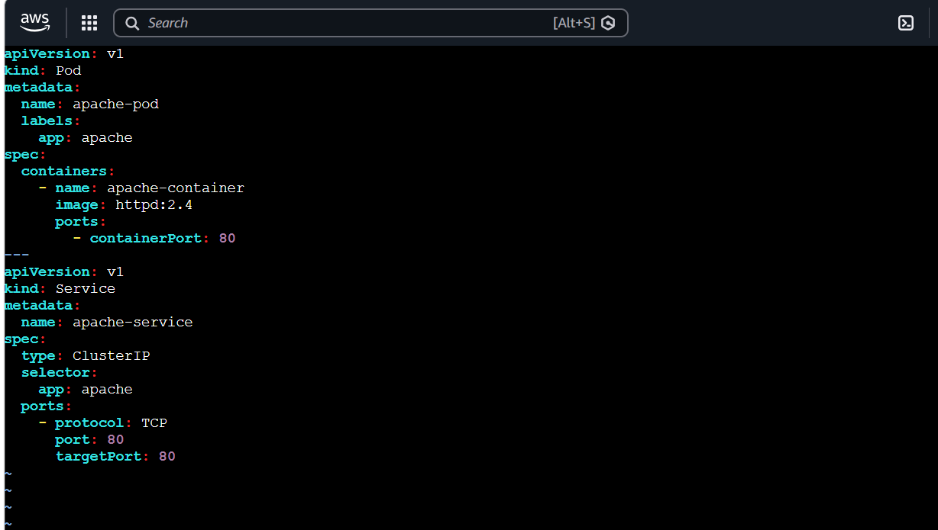
Save the file.
Step 2: Deploy Apache and the Service
kubectl apply -f apache-clusterip.yaml
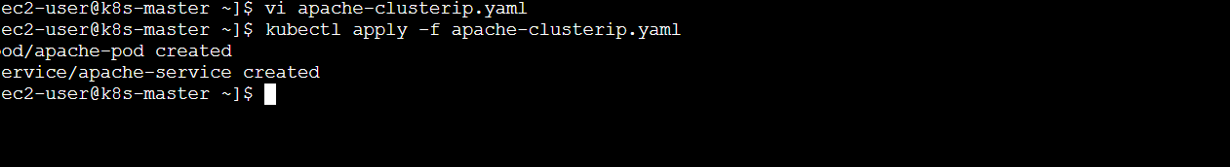
Step 3: Verify
kubectl get pods
kubectl get services
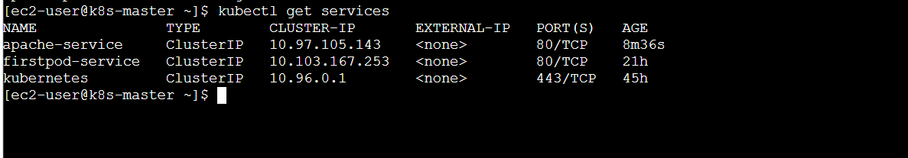
kubectl get endpoints apache-service
Expected service output:
NAME TYPE CLUSTER-IP PORT(S)
apache-service ClusterIP 10.96.x.x 80/TCP
The endpoints should display the Apache Pod IP.
Step 4: Test from inside the cluster
kubectl run apache-test \
--image=busybox:1.36 \
--restart=Never \
--rm -it \
-- wget -qO- http://apache-service
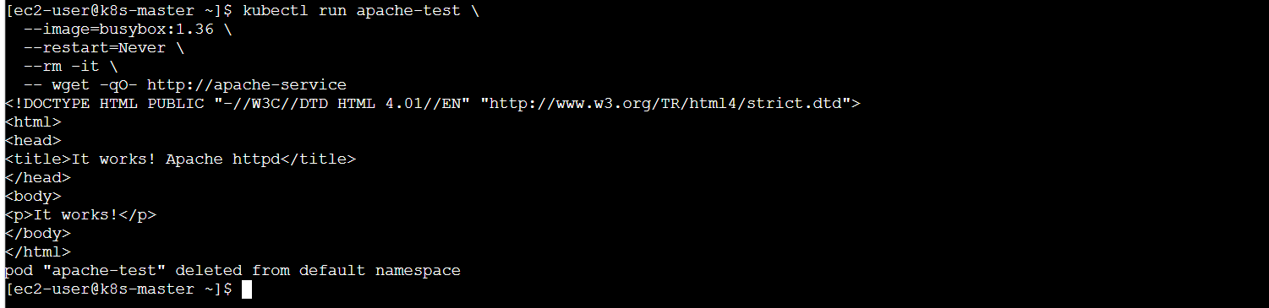
Expected output:
<html><body><h1>It works!</h1></body></html>

Task 2: Expose a Nginx Pod Using NodePort
A NodePort Service allows access using:
Node-IP:NodePort
Step 1: Create the YAML file
vi nginx-nodeport.yaml
Add:
apiVersion: v1
kind: Pod
metadata:
name: nginx-nodeport-pod
labels:
app: nginx-nodeport
spec:
containers:
- name: nginx
image: nginx:1.27
ports:
- containerPort: 80
---
apiVersion: v1
kind: Service
metadata:
name: nginx-nodeport-service
spec:
type: NodePort
selector:
app: nginx-nodeport
ports:
- protocol: TCP
port: 80
targetPort: 80
nodePort: 30080
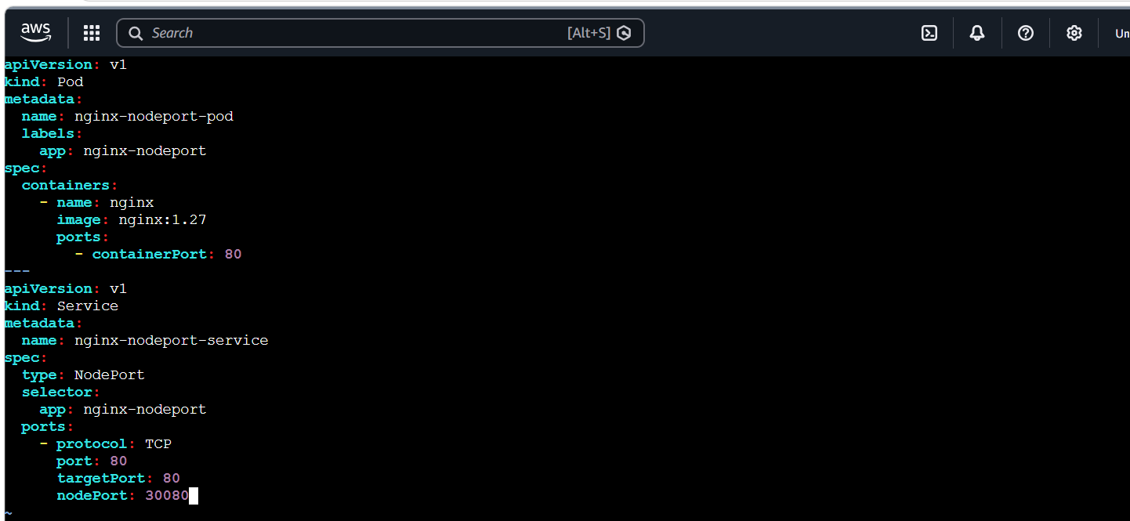
Step 2: Deploy
kubectl apply -f nginx-nodeport.yaml
Step 3: Verify
kubectl get pods -o wide
kubectl get service nginx-nodeport-service
kubectl get endpoints nginx-nodeport-service
Expected:
NAME TYPE PORT(S)
nginx-nodeport-service NodePort 80:30080/TCP
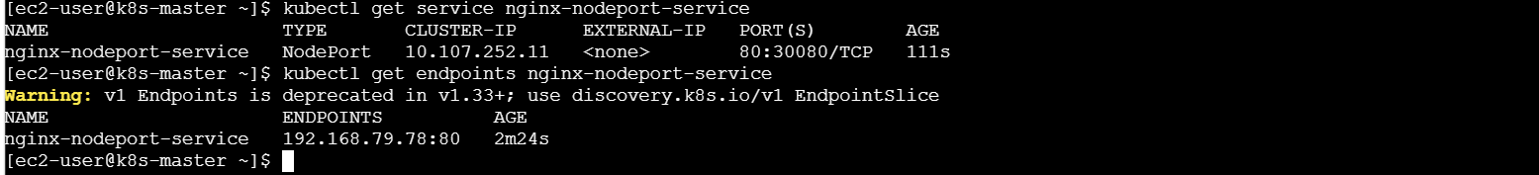
Step 4: Get node IP addresses
kubectl get nodes -o wide
Step 5: Test the NodePort
From the control plane or another machine that can reach the worker:
curl http://<NODE-IP>:30080
Example:
curl http://172.31.10.20:30080
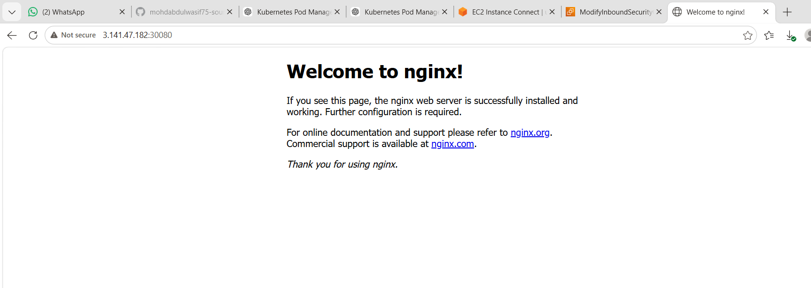
For AWS EC2 browser access:
http://<WORKER-PUBLIC-IP>:30080
Add this rule to the worker-node Security Group if necessary:
Type: Custom TCP
Port: 30080
Source: My IP
Do not expose NodePort to everyone unless required.

Task 3: Deploy a ReplicationController with 3 Nginx Pods
A ReplicationController maintains the requested number of Pods. If one Pod is deleted, it creates another Pod automatically.
ReplicationController is an older Kubernetes controller. Deployments and ReplicaSets are normally preferred for new applications.
Step 1: Create the YAML file
vi nginx-rc.yaml
Add:
apiVersion: v1
kind: ReplicationController
metadata:
name: nginx-rc
spec:
replicas: 3
selector:
app: nginx-rc-app
template:
metadata:
labels:
app: nginx-rc-app
spec:
containers:
- name: nginx
image: nginx:1.27
ports:
- containerPort: 80
lifecycle:
postStart:
exec:
command:
- /bin/sh
- -c
- echo "Response from Pod $(hostname)" > /usr/share/nginx/html/index.html
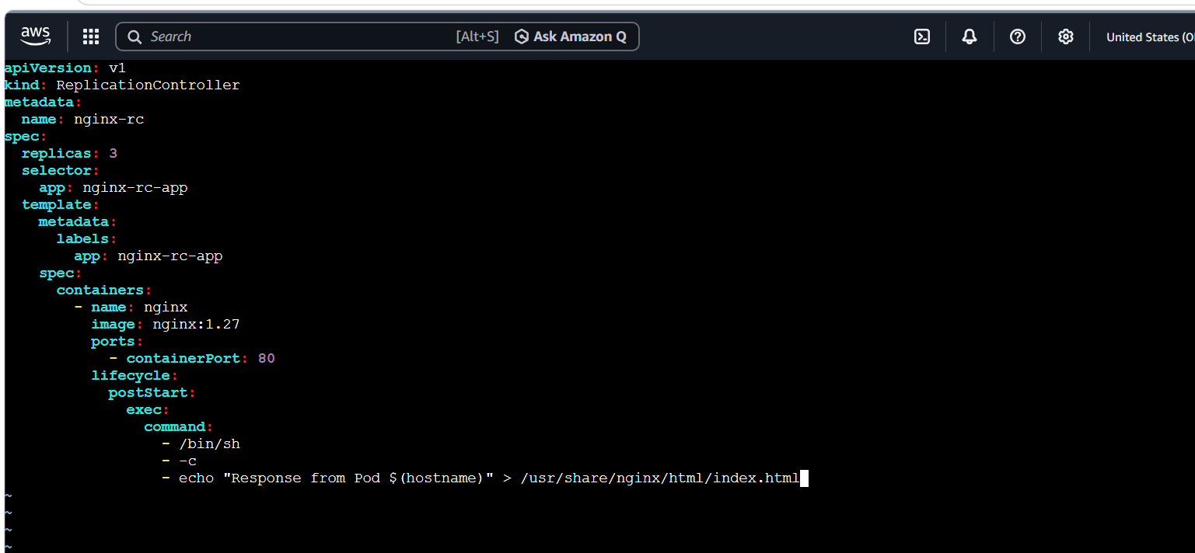
Step 2: Deploy
kubectl apply -f nginx-rc.yaml
Step 3: Verify the ReplicationController
kubectl get rc
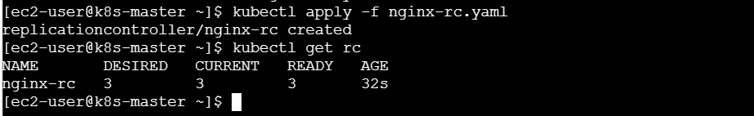
kubectl get pods -l app=nginx-rc-app -o wide
Expected:
NAME DESIRED CURRENT READY
nginx-rc 3 3 3
Step 4: Test automatic Pod replacement
Check the Pod names:
kubectl get pods -l app=nginx-rc-app
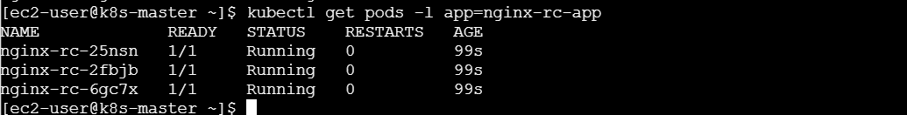
Delete one Pod:
kubectl delete pod <POD-NAME>
Check again:
kubectl get pods -l app=nginx-rc-app
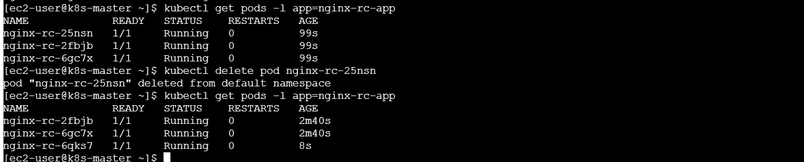
The Replication Controller automatically creates a replacement, Pod.
Task 4: Scale the Replication Controller from 3 to 5
Run:
kubectl scale rc nginx-rc --replicas=5
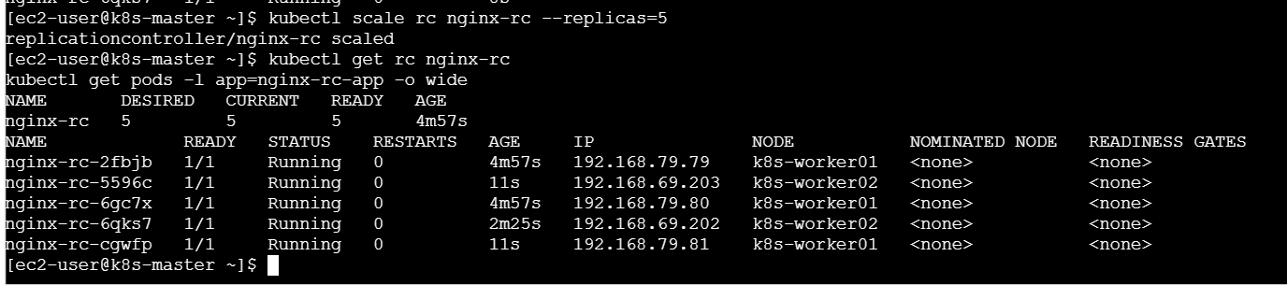
Verify:
kubectl get rc nginx-rc
kubectl get pods -l app=nginx-rc-app -o wide
Expected:
NAME DESIRED CURRENT READY
nginx-rc 5 5 5

You can also permanently change this line in nginx-rc.yaml:
replicas: 5
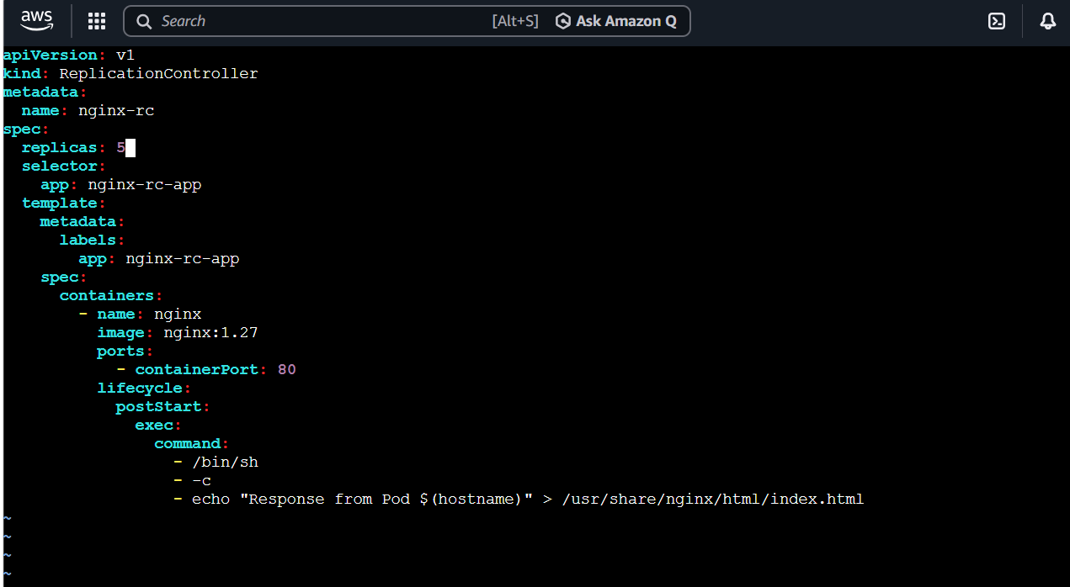
Then run:
kubectl apply -f nginx-rc.yaml
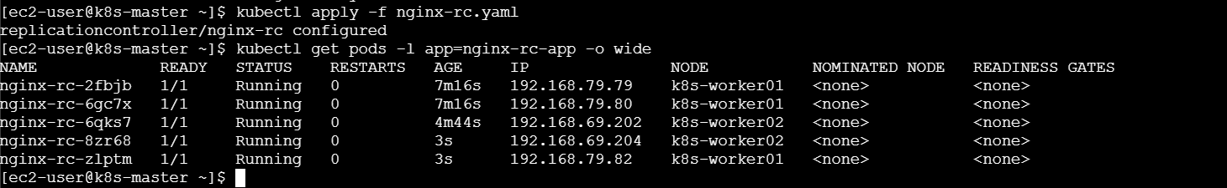

Task 5: Create a ReplicaSet Using Multiple Labels—Prod and Test
This task demonstrates a ReplicaSet selector that accepts:
environment=prod OR environment=test
match Expressions supports operators such as In, NotIn, Exists and Does Not Exist. Kubernetes label selector documentation
Step 1: Create the YAML file
vi multi-label-rs.yaml
Add:
apiVersion: v1
kind: Pod
metadata:
name: manual-test-pod
labels:
app: multi-environment
environment: test
spec:
containers:
- name: nginx
image: nginx:1.27
---
apiVersion: apps/v1
kind: ReplicaSet
metadata:
name: multi-label-rs
spec:
replicas: 3
selector:
matchLabels:
app: multi-environment
matchExpressions:
- key: environment
operator: In
values:
- prod
- test
template:
metadata:
labels:
app: multi-environment
environment: prod
spec:
containers:
- name: nginx
image: nginx:1.27
ports:
- containerPort: 80
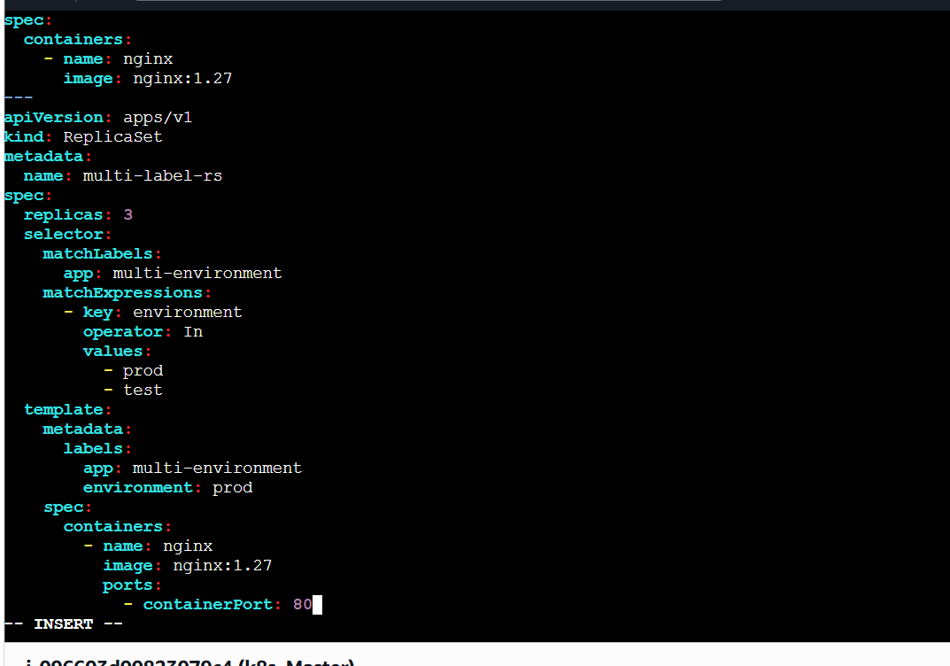
Explanation:
- The manually created Pod has environment: test.
- New ReplicaSet Pods have environment: prod.
- The ReplicaSet selector accepts both prod and test.
- The ReplicaSet can adopt the matching test Pod and create enough prod Pods to maintain three replicas.
Step 2: Deploy
kubectl apply -f multi-label-rs.yaml
Step 3: Verify
kubectl get rs multi-label-rs
kubectl get pods -l app=multi-environment --show-labels
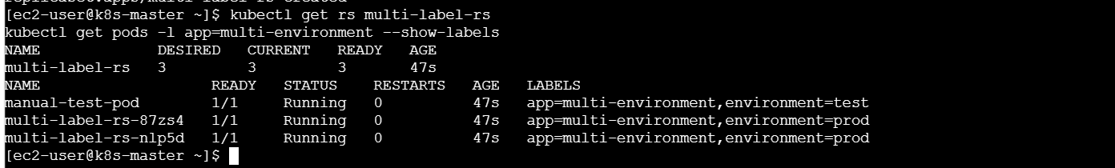
You should see Pods with both labels:
environment=test
environment=prod
Check the Pod owner:
kubectl get pod manual-test-pod \
-o jsonpath='{.metadata.ownerReferences[0].name}{"\n"}'
Expected:
multi-label-rs

Task 6: Create a ReplicaSet That Excludes Backend Pods
We will use the Does Not Exist operator. The ReplicaSet will manage Pods only when the tier label is absent.
Step 1: Create the YAML file
vi exclude-backend-rs.yaml
Add:
apiVersion: v1
kind: Pod
metadata:
name: backend-pod
labels:
app: exclusion-demo
tier: backend
spec:
containers:
- name: nginx
image: nginx:1.27
---
apiVersion: apps/v1
kind: ReplicaSet
metadata:
name: exclude-backend-rs
spec:
replicas: 2
selector:
matchLabels:
app: exclusion-demo
matchExpressions:
- key: tier
operator: DoesNotExist
template:
metadata:
labels:
app: exclusion-demo
spec:
containers:
- name: nginx
image: nginx:1.27
ports:
- containerPort: 80
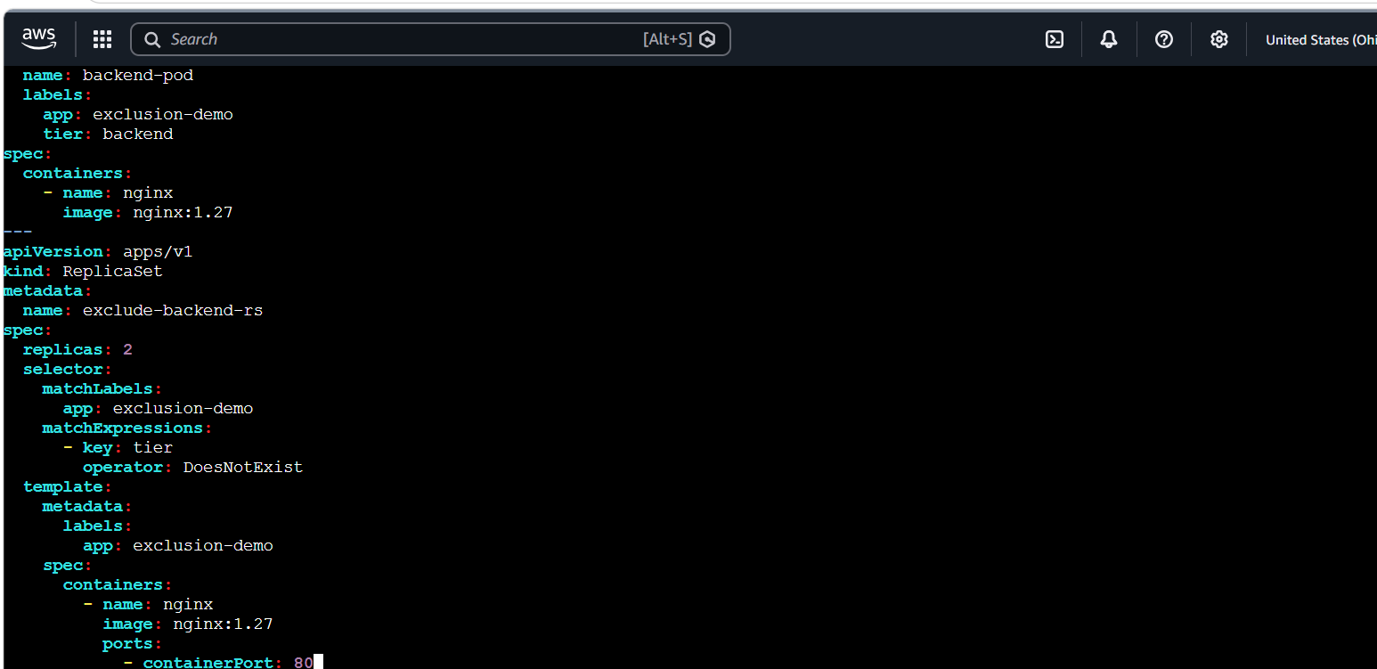
Step 2: Deploy
kubectl apply -f exclude-backend-rs.yaml
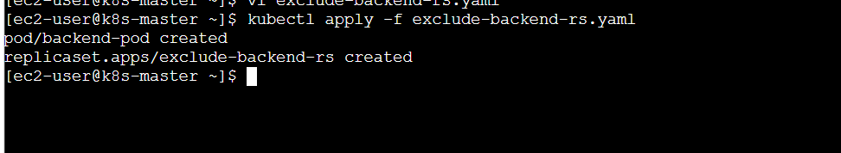
Step 3: Verify all Pods
kubectl get pods -l app=exclusion-demo --show-labels
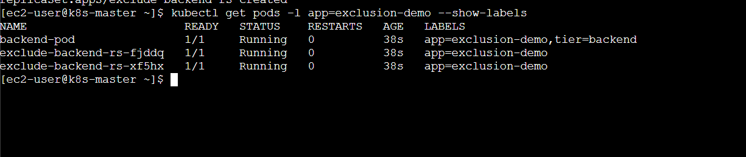
You should have:
- Two Pods without the tier label, managed by the ReplicaSet.
- One backend-pod with tier=backend, not managed by the ReplicaSet.
Step 4: Verify selected Pods
kubectl get pods \
-l 'app=exclusion-demo,!tier' \
--show-labels
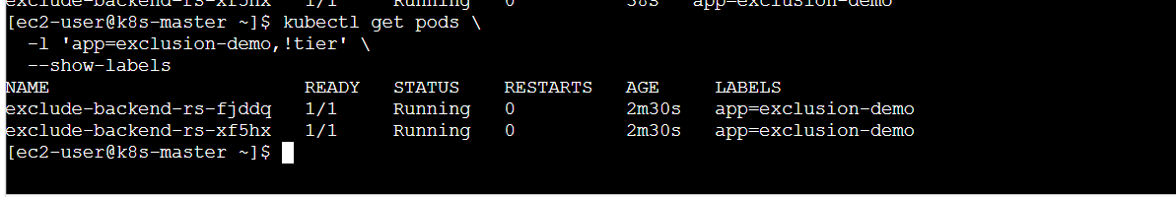
Only the two ReplicaSet Pods should appear.
Check the backend Pod owner:
kubectl get pod backend-pod \
-o jsonpath='{.metadata.ownerReferences}{"\n"}'
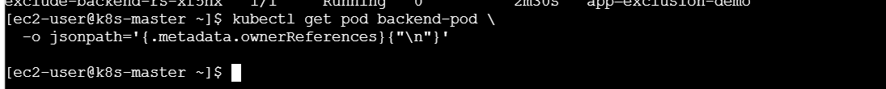
Expected:
[]
This confirms that the backend Pod was excluded.
Task 7: Test Load Balancing Through NodePort
We will expose the five Nginx Pods created by nginx-rc.
Each Pod’s page displays its hostname, so repeated requests show which Pod handled the request.
Step 1: Create the NodePort Service
vi loadbalancer-service.yaml
Add:
apiVersion: v1
kind: Service
metadata:
name: nginx-loadbalancer-service
spec:
type: NodePort
selector:
app: nginx-rc-app
ports:
- protocol: TCP
port: 80
targetPort: 80
nodePort: 30081
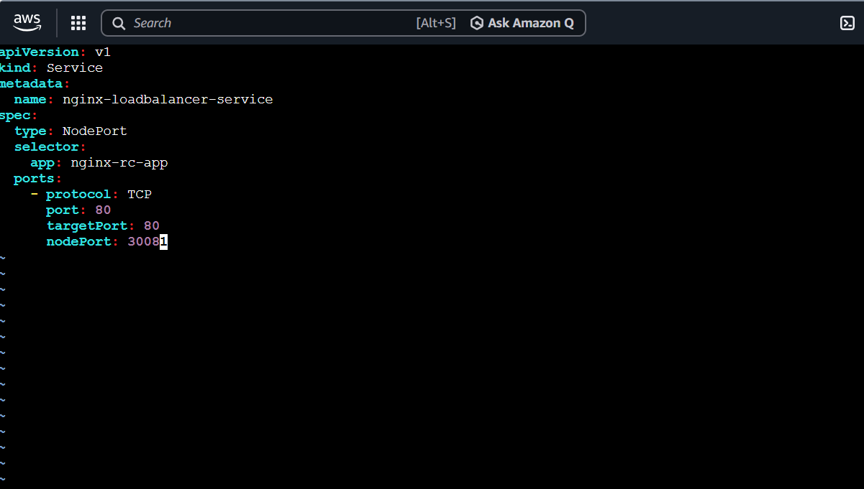
Step 2: Deploy
kubectl apply -f loadbalancer-service.yaml
Step 3: Verify endpoints
kubectl get service nginx-loadbalancer-service
kubectl get endpoints nginx-loadbalancer-service
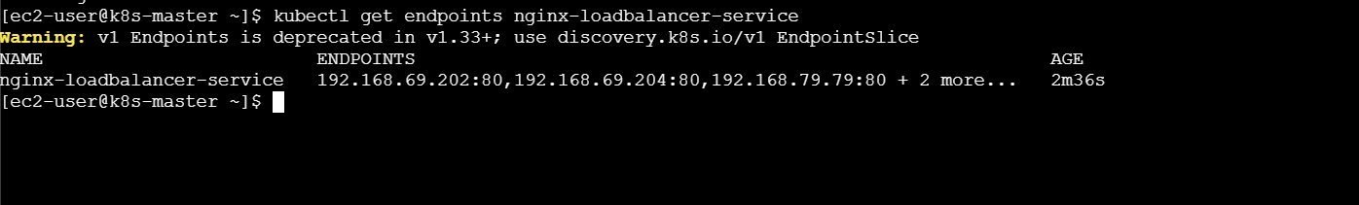
kubectl get pods -l app=nginx-rc-app -o wide
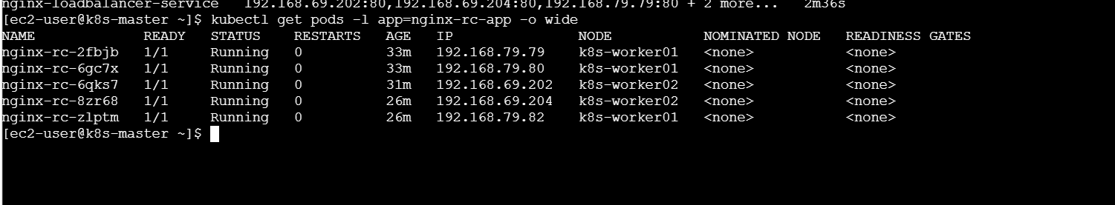
The endpoints should contain the IP addresses of all five Nginx Pods.
Step 4: Send multiple requests
for i in {1..10}; do
curl -s http://<NODE-IP>:30081
echo
done
Example:
for i in {1..10}; do
curl -s http://172.31.10.20:30081
echo
done
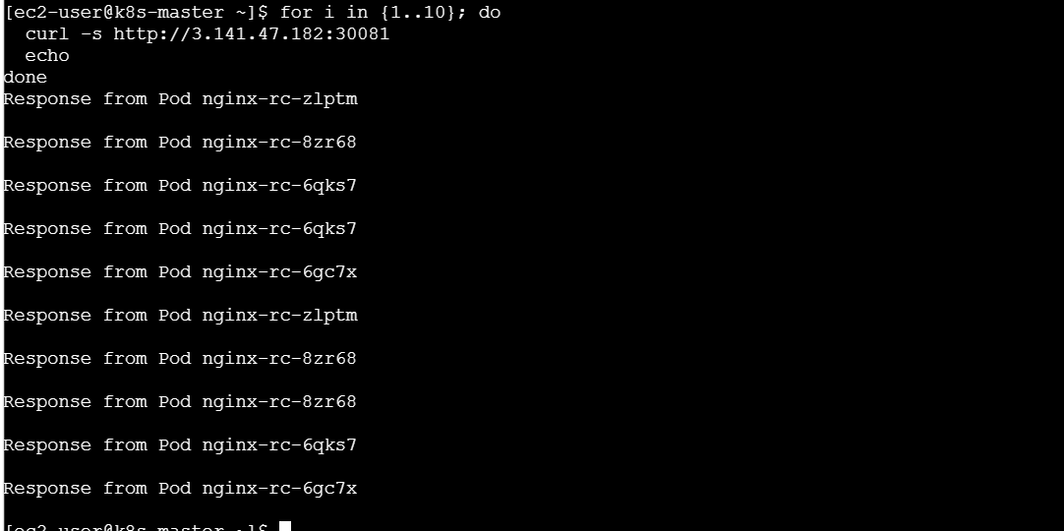
Possible output:
Response from Pod nginx-rc-7pt2d
Response from Pod nginx-rc-k4d8m
Response from Pod nginx-rc-vb9xq
Response from Pod nginx-rc-7pt2d
Response from Pod nginx-rc-f6nws
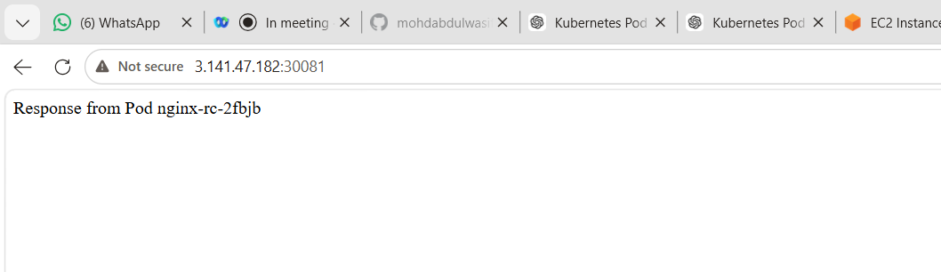
Different Pod names confirm that the Service is distributing requests among multiple Pods.
The exact order is not guaranteed. You may sometimes receive responses from the same Pod more than once.
For AWS browser access, allow TCP port 30081 from your IP in the worker-node Security Group.

Task 8: Delete the ReplicationController Without Deleting Pods
Normally, deleting a ReplicationController also removes the Pods it controls. The --cascade=orphan option deletes only the controller and leaves its Pods running. Kubernetes ReplicationController documentation
Step 1: Check the controller and Pods
kubectl get rc nginx-rc
kubectl get pods -l app=nginx-rc-app
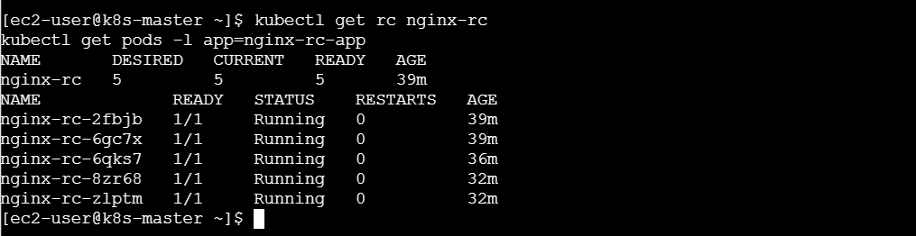
Step 2: Delete only the ReplicationController
kubectl delete rc nginx-rc --cascade=orphan
Expected:
replicationcontroller "nginx-rc" deleted
Step 3: Verify
kubectl get rc nginx-rc
Expected:
Error from server (NotFound)
Check the Pods:
kubectl get pods -l app=nginx-rc-app
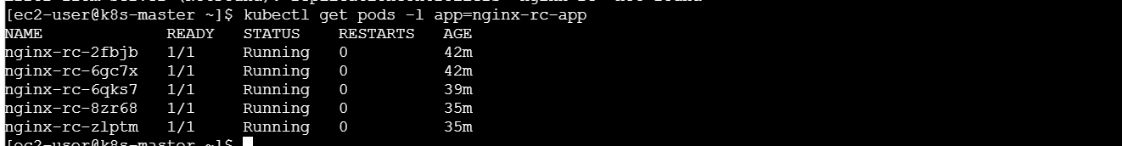
The five Pods should still be running.
Important observation
These Pods are now orphan Pods. If one is deleted, Kubernetes will not recreate it because their ReplicationController no longer exists.
Test it if required:
kubectl delete pod <ONE-POD-NAME>
kubectl get pods -l app=nginx-rc-app
The Pod count decreases and no replacement is created.
The NodePort Service can continue sending traffic to the remaining matching Pods.

Important Verification Commands
kubectl get all
kubectl get pods -o wide
kubectl get services
kubectl get rc
kubectl get rs
kubectl get endpoints
kubectl get pods --show-labels
Detailed information:
kubectl describe service apache-service
kubectl describe service nginx-nodeport-service
kubectl describe rc nginx-rc
kubectl describe rs multi-label-rs
kubectl describe rs exclude-backend-rs

Cleanup
Run these commands after completing and documenting the lab:
kubectl delete -f apache-clusterip.yaml
kubectl delete -f nginx-nodeport.yaml
kubectl delete -f multi-label-rs.yaml
kubectl delete -f exclude-backend-rs.yaml
kubectl delete -f loadbalancer-service.yaml
Because the ReplicationController was deleted with --cascade=orphan, remove its remaining Pods separately:
kubectl delete pods -l app=nginx-rc-app
Finally:
kubectl delete namespace service-lab
Deleting the namespace removes anything still present inside it.

What We Learned
- ClusterIP exposes an application only inside the Kubernetes cluster.
- NodePort exposes an application through NodeIP:NodePort.
- Services use labels and selectors to find their backend Pods.
- A ReplicationController maintains the required number of Pod replicas.
- kubectl scale increases or decreases the replica count.
- ReplicaSets support advanced selectors such as In and DoesNotExist.
- A Service distributes requests across multiple matching Pods.
- --cascade=orphan deletes a controller while keeping its Pods running.
- Orphan Pods continue running, but Kubernetes will not recreate them if they fail.
Conclusion
In this lab, we deployed Apache and Nginx applications and exposed them using ClusterIP and NodePort Services. We created and scaled a ReplicationController, used advanced ReplicaSet label selectors, tested Service load balancing and safely deleted a ReplicationController without removing its running Pods.

