Docker_Challenge_09

Task 1: Create Customized Docker Image Using Dockerfile
Objective
To create a custom Docker image for a Python application using a Dockerfile.
Steps
git clone https://github.com/betawins/Python-app.git
cd Python-app
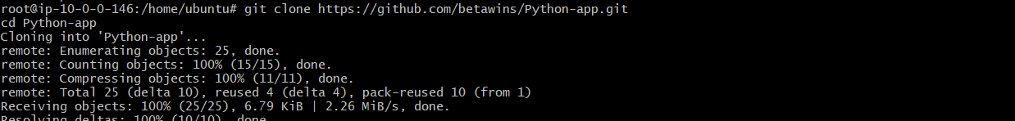
Run this inside /home/ubuntu/Python-app:
cat > Dockerfile <<'EOF'
FROM python:3.11-slim
WORKDIR /app
COPY requirements.txt .
RUN pip install -r requirements.txt
COPY . .
EXPOSE 5000
CMD ["python", "app.py"]
EOF
Now check:
ls -l
cat Dockerfile

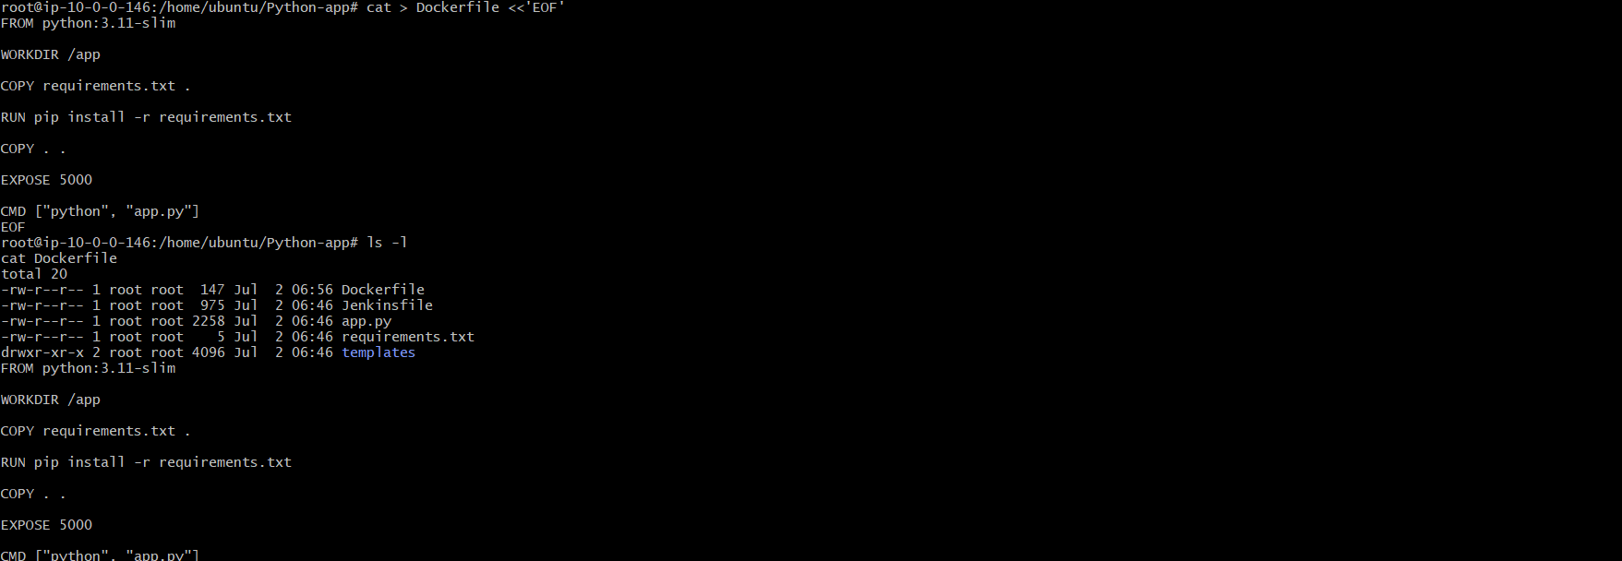
Build image:
docker build -t python-app:v1 .
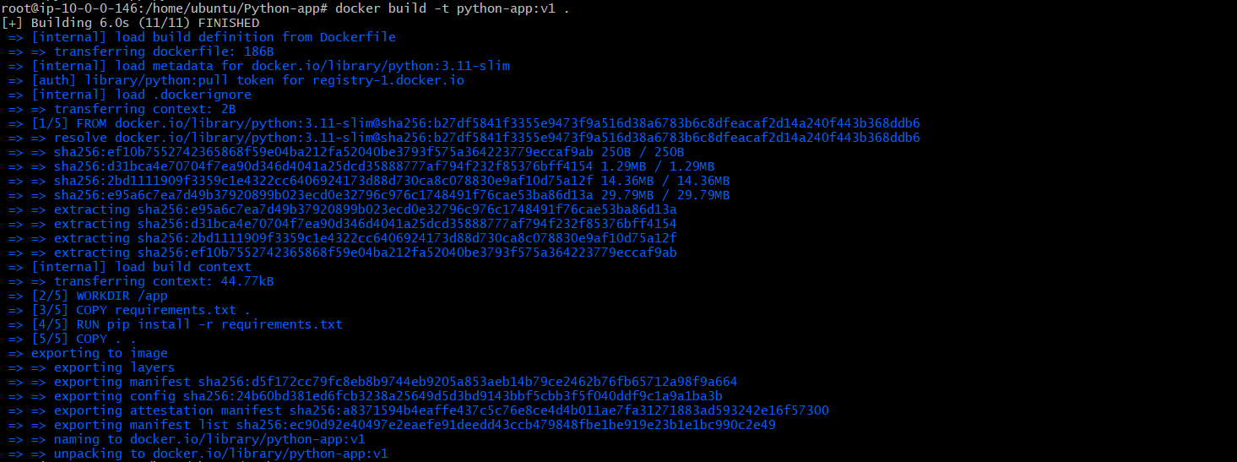
Run container:
docker run -d -p 5000:5000 --name python-app python-app:v1
Check container:
docker ps
Test:
docker run -d -p 5000:8080 --name python-app python-app:v1
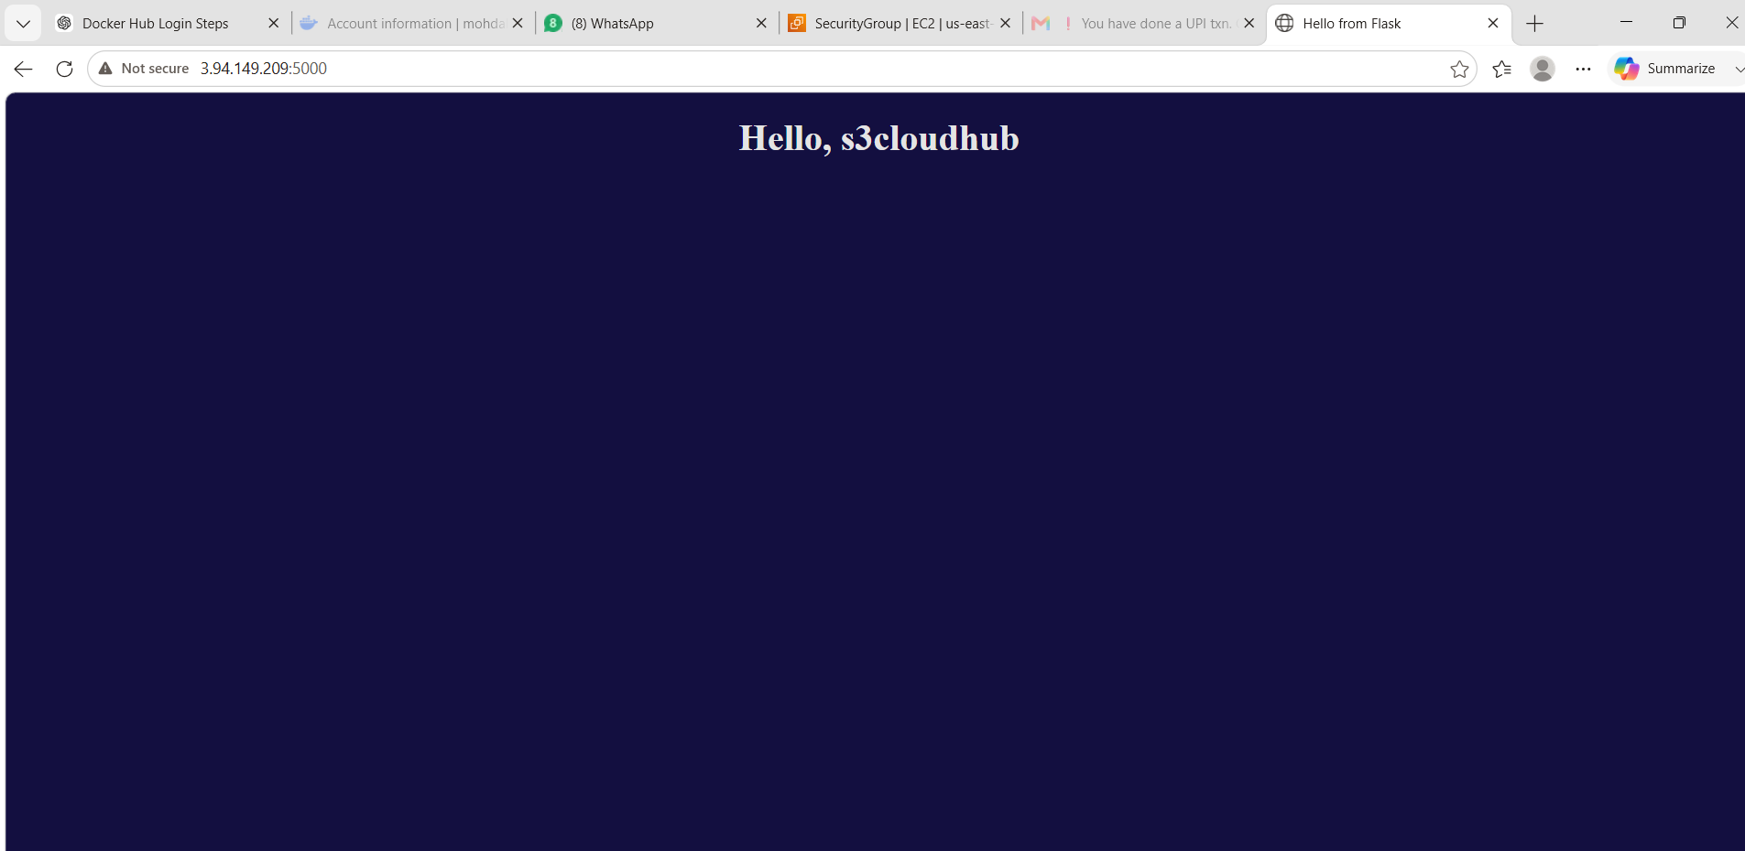
What We Learned
We learned how to write a Dockerfile, build an image, and run a Python application inside a container.
Conclusion
Successfully created and ran a customized Docker image using Dockerfile.
Task 2: Push Docker Image to Docker Hub
Objective
To upload the customized Docker image from the local Docker server to Docker Hub so it can be stored, shared, and pulled from any machine.

Prerequisites
- Docker installed and running.
- Docker Hub account.
- Docker Hub Personal Access Token.
- Docker image already built (python-app:v1).
- Internet connection.

Step 1: Check Docker Image
Verify that the image exists.
docker images
Expected output:
REPOSITORY TAG
python-app v1

Step 2: Login to Docker Hub
docker login
Enter:
Username:
mohdabdulwasif
Password:
<Your Docker Hub Personal Access Token>
Expected output:
Login Succeeded
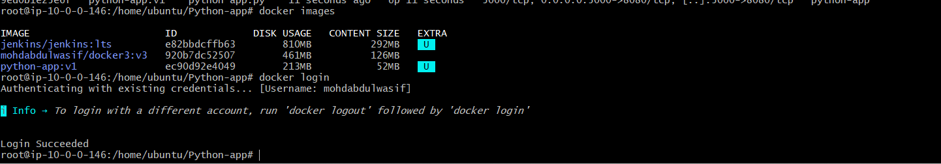

Step 3: Tag the Image
Tag the local image with your Docker Hub repository name.
docker tag python-app:v1 mohdabdulwasif/python-app:v1
Verify:
docker images
Expected:
python-app:v1
mohdabdulwasif/python-app:v1

Step 4: Push the Image
docker push mohdabdulwasif/python-app:v1
Expected output:
The push refers to repository [docker.io/mohdabdulwasif/python-app]
latest: digest:
Pushed successfully
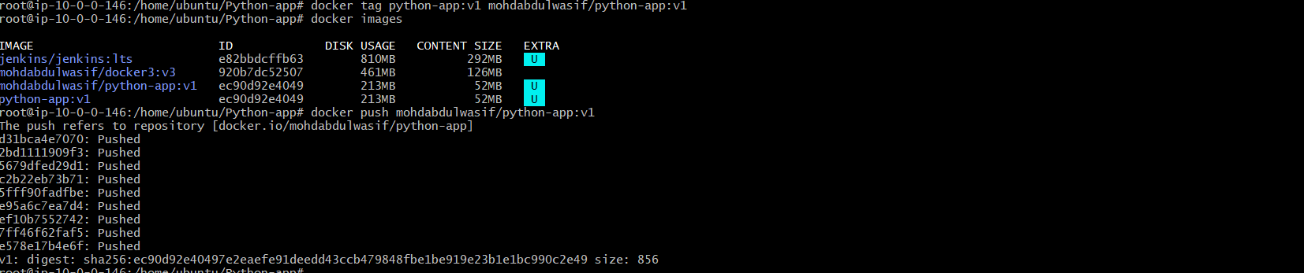

Step 5: Verify on Docker Hub
Login to Docker Hub and open Repositories.
You should see:
python-app
Click the repository and verify that tag v1 is available.
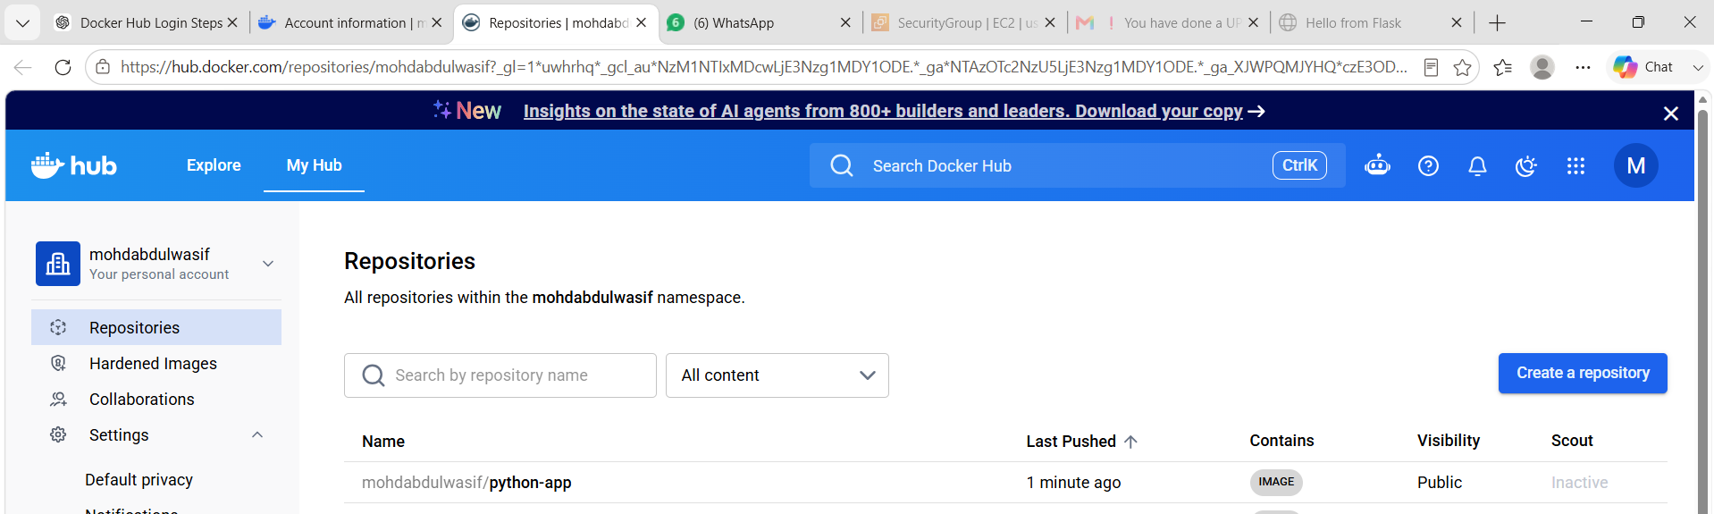
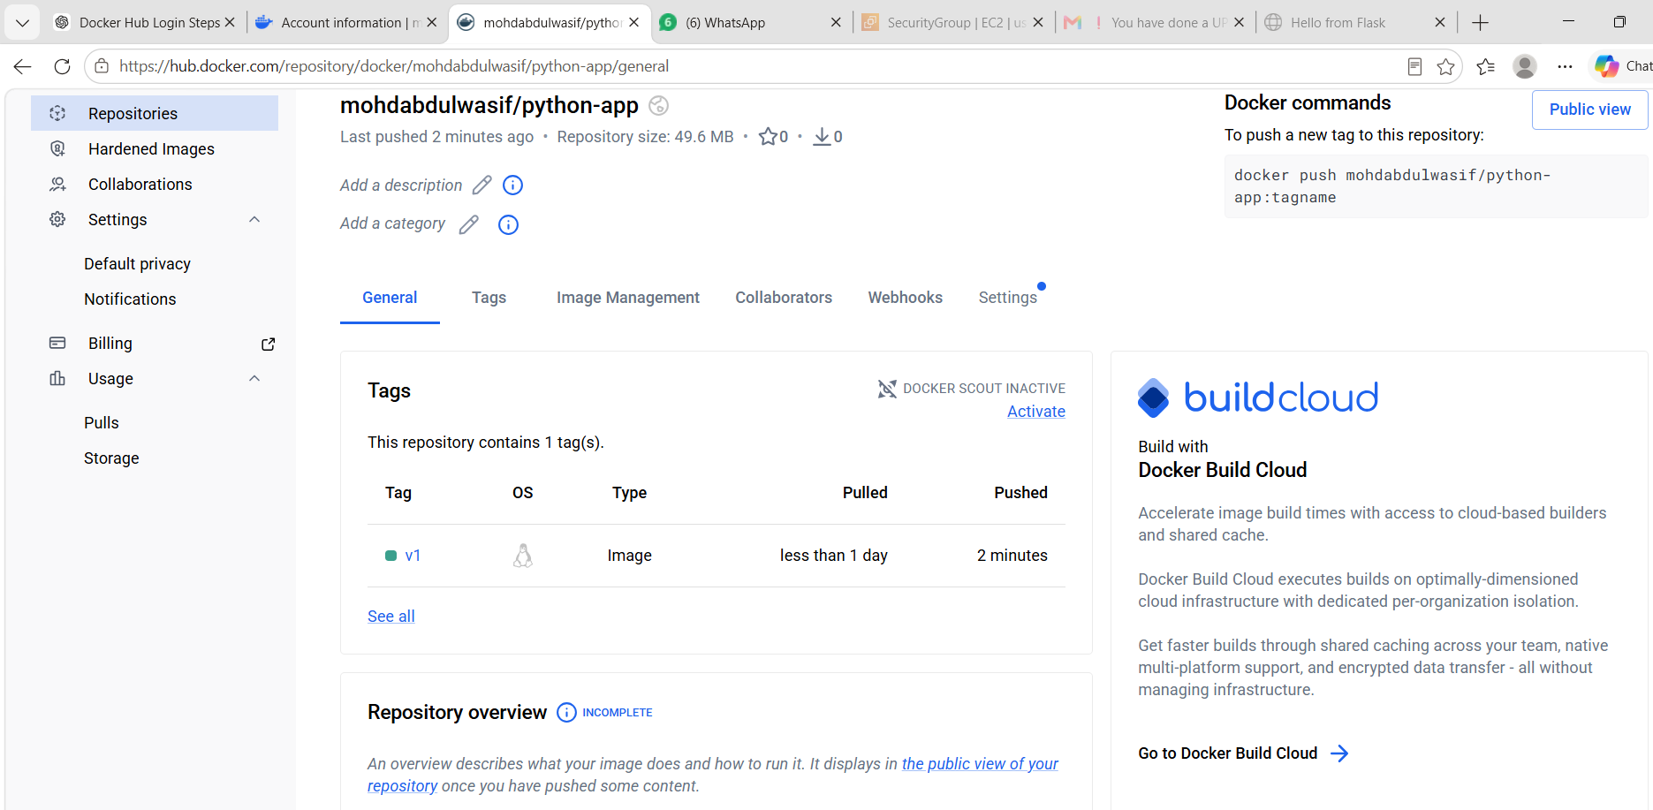

Architecture
Local Docker Image
│
▼
docker tag
│
▼
Docker Hub Repository
│
▼
docker push
│
▼
Docker Hub Cloud

Commands Summary
docker images
docker login
docker tag python-app:v1 mohdabdulwasif/python-app:v1
docker push mohdabdulwasif/python-app:v1

What We Learned
- How to authenticate with Docker Hub.
- How to tag a Docker image for a registry.
- How to upload Docker images to Docker Hub.
- Difference between a local image and a registry image.
- How Docker Hub stores and manages container images.

Conclusion
Successfully tagged and pushed the customized Python Docker image to Docker Hub. The image is now stored in a remote registry and can be pulled and deployed from any Docker-enabled system.
Task 3: Push Same Docker Image to Amazon ECR
Objective
To push the same python-app:v1 Docker image to AWS Elastic Container Registry.
Prerequisites
- AWS CLI configured
- Docker installed
- AWS IAM user/role has ECR permissions
- Existing image: python-app:v1

Step 1: Check AWS Account ID
aws sts get-caller-identity
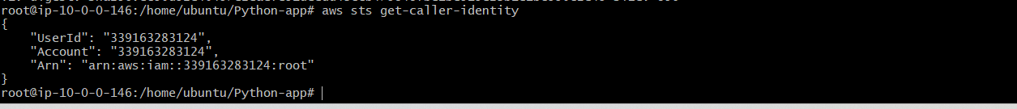
Copy your Account ID.

Step 2: Create ECR Repository
aws ecr create-repository \
--repository-name python-app \
--region us-east-1
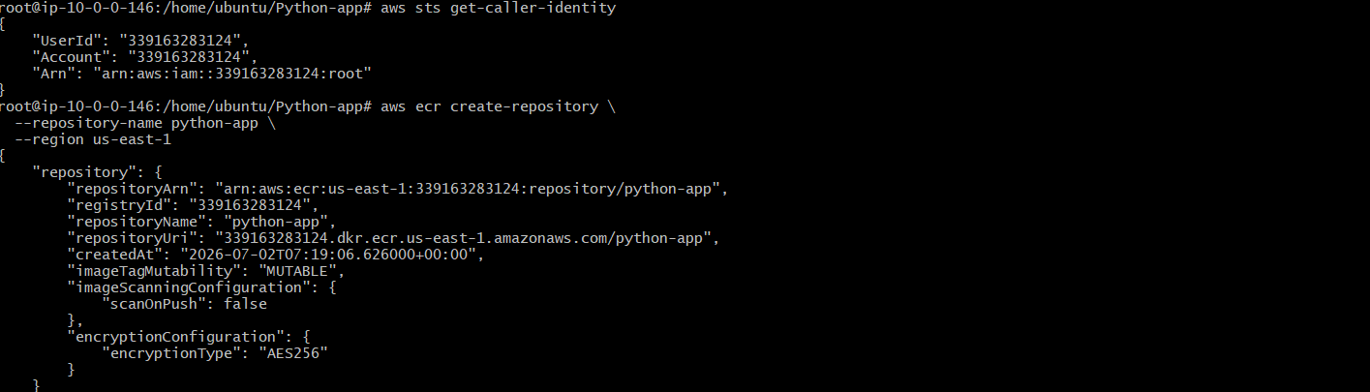

Step 3: Login to ECR
aws ecr get-login-password --region us-east-1 | docker login --username AWS --password-stdin 339163283124.dkr.ecr.us-east-1.amazonaws.com
Login Succeeded

Step 4: Tag Image for ECR
docker tag python-app:v1 <account-id>.dkr.ecr.us-east-1.amazonaws.com/python-app:v1
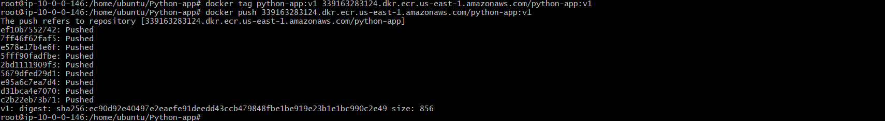

Step 5: Push Image to ECR
docker push <account-id>.dkr.ecr.us-east-1.amazonaws.com/python-app:v1

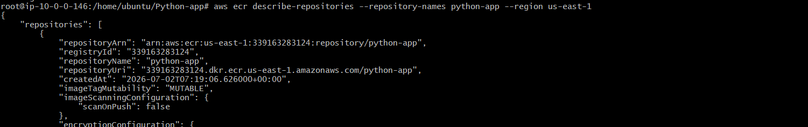

Step 6: Verify in AWS Console
Go to:
AWS Console → ECR → Repositories → python-app → Images
You should see tag:
v1
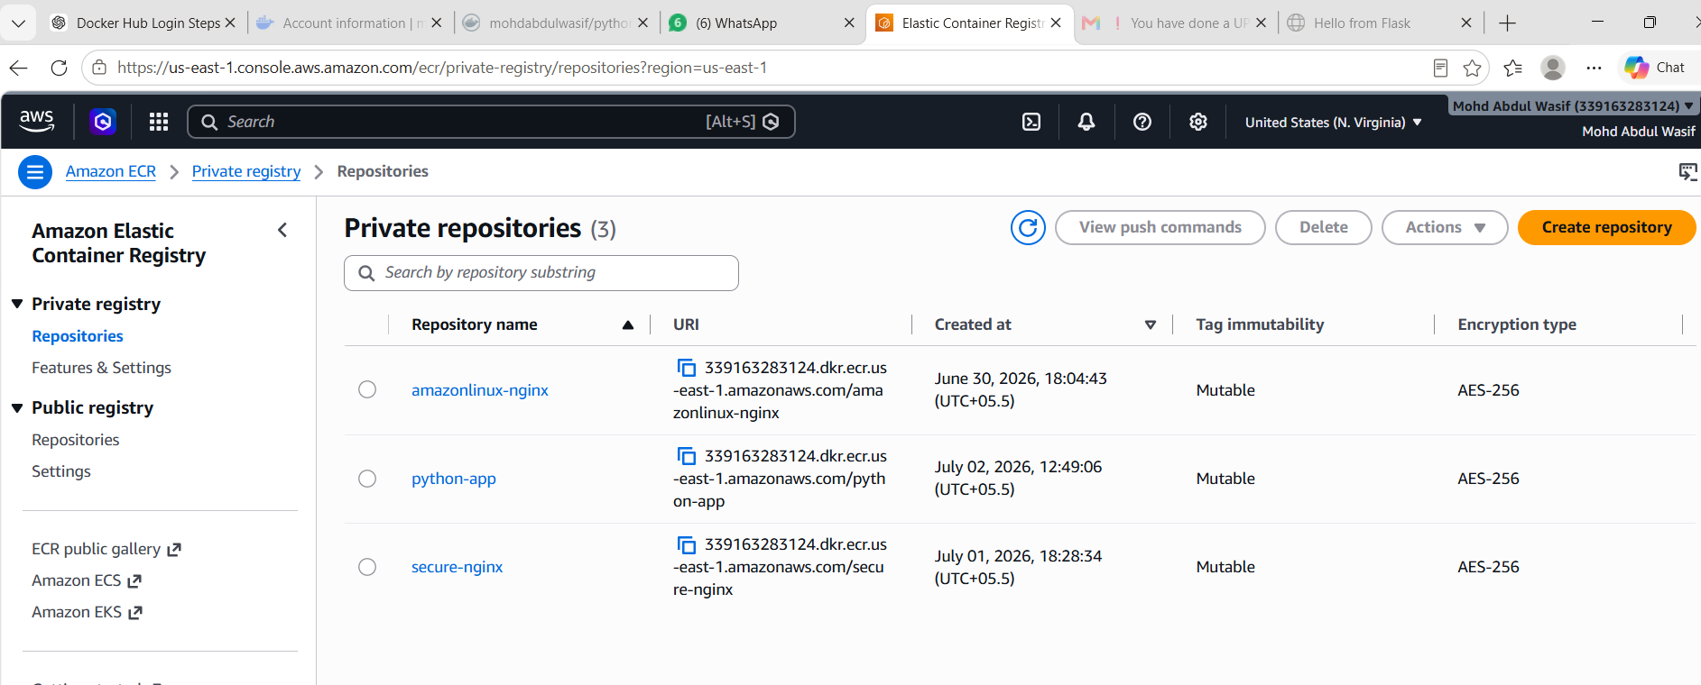

What We Learned
We learned how to create an AWS ECR repository, login to ECR, tag Docker images for AWS, and push Docker images to ECR.
Conclusion
Successfully pushed the same Docker image to Amazon ECR.
Task 4: Provision One EC2 Instance Using Terraform and Install Jenkins
Objective
To provision an AWS EC2 instance using Terraform and automatically configure it as a Jenkins server for CI/CD automation.

Prerequisites
- AWS Account
- AWS CLI installed and configured
- Terraform installed
- Existing AWS Key Pair (Virginia)
- Existing VPC and Subnet
- Ubuntu 24.04 AMI
- Internet connectivity
- IAM user with EC2 permissions

Step-by-Step Procedure
Step 1: Install Terraform
Verify whether Terraform is installed.
terraform -version
If not installed:
sudo apt update
sudo apt install terraform -y
Verify installation again:
terraform -version

Step 2: Create Terraform Project Directory
mkdir terraform-jenkins
cd terraform-jenkins

Step 3: Create Terraform Configuration File
Create the configuration file.
vi main.tf
Add the following resources:
- AWS Provider
- Security Group
- EC2 Instance
- User Data (Jenkins Installation)
- Output Variables
Save the file.
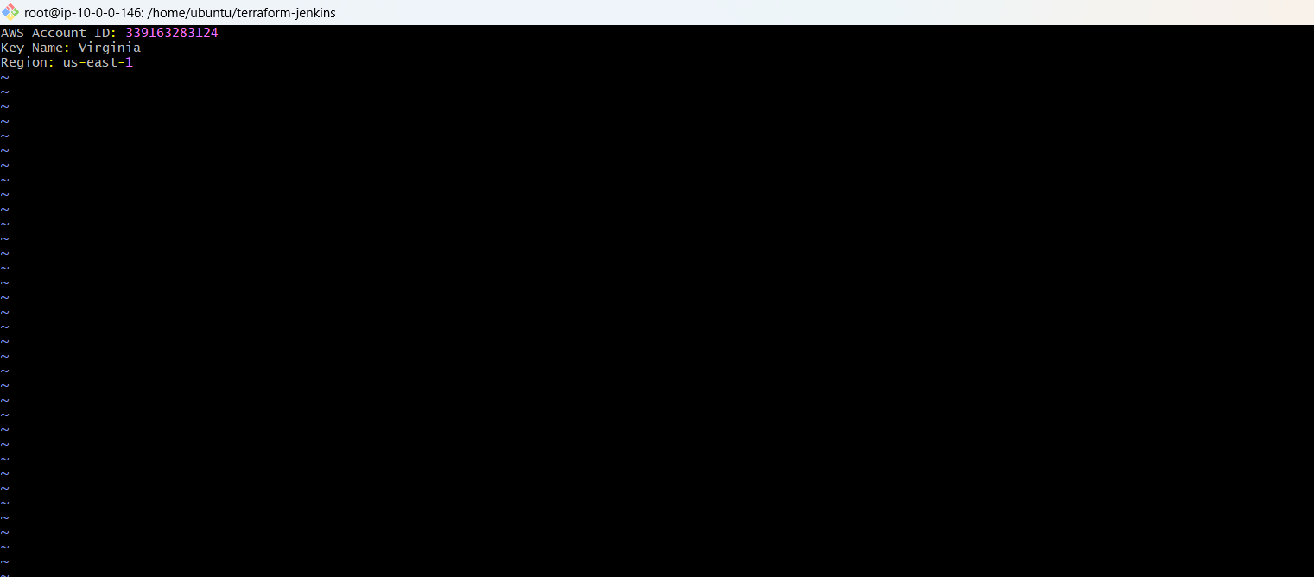

Step 4: Identify AWS Resources
Check Region
aws configure get region
Output:
us-east-1

Check Key Pair
aws ec2 describe-key-pairs --query "KeyPairs[*].KeyName" --output table
Output:
Virginia
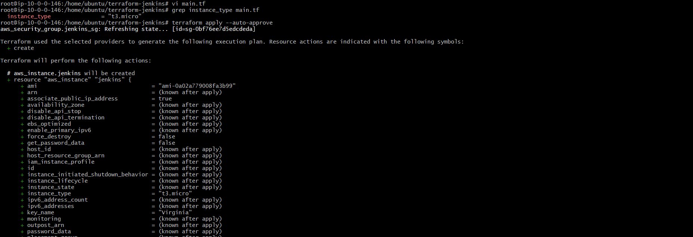

Check VPC
aws ec2 describe-vpcs --query "Vpcs[*].[VpcId,IsDefault]" --output table
Output:
vpc-0e2708cda69ea0591

Check Subnet
aws ec2 describe-subnets --query "Subnets[*].[SubnetId,VpcId]" --output table
Output:
subnet-046631013cc3ec6cb
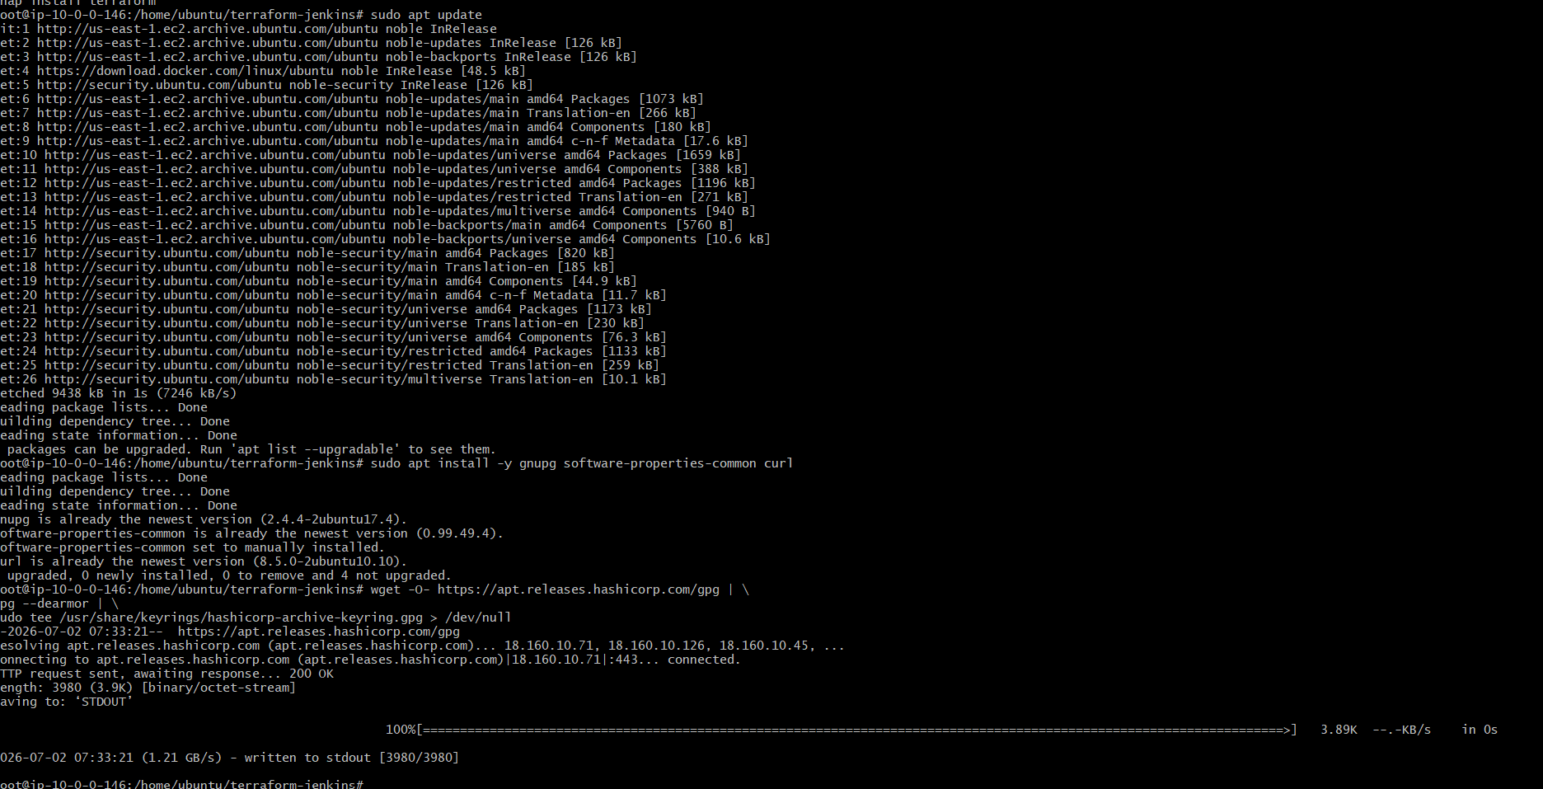
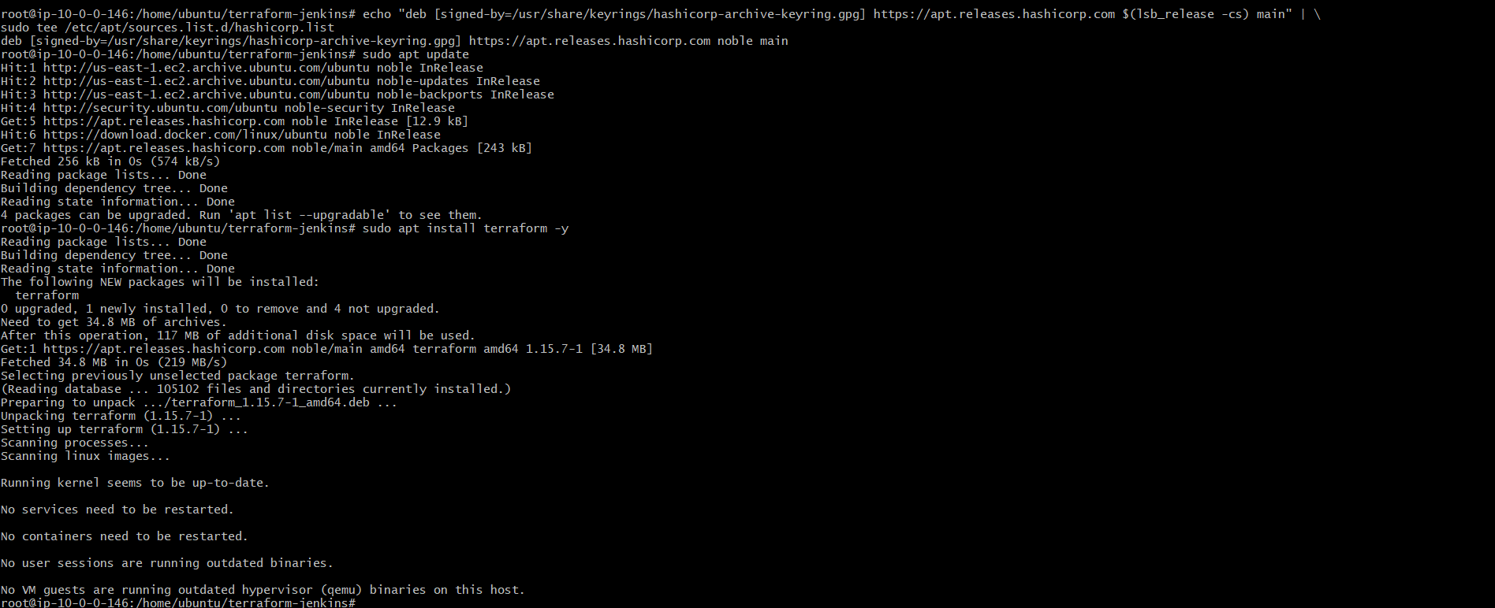
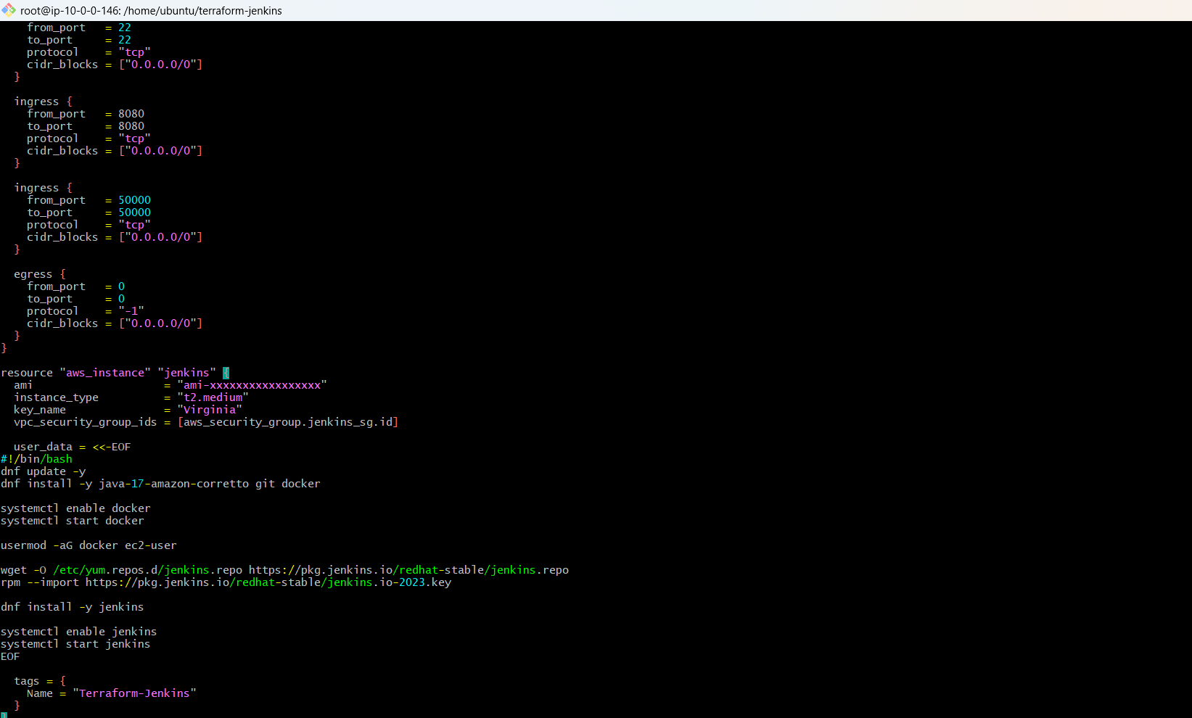

Check Latest Ubuntu AMI
aws ec2 describe-images \
--owners 099720109477 \
--filters "Name=name,Values=ubuntu/images/hvm-ssd-gp3/ubuntu-noble-24.04-amd64-server-*" \
--query "Images | sort_by(@,&CreationDate)[-1].ImageId" \
--output text
Copy the latest AMI ID into main.tf.
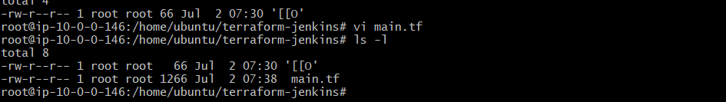

Step 5: Initialize Terraform
terraform init
Terraform downloads the required AWS provider plugins.
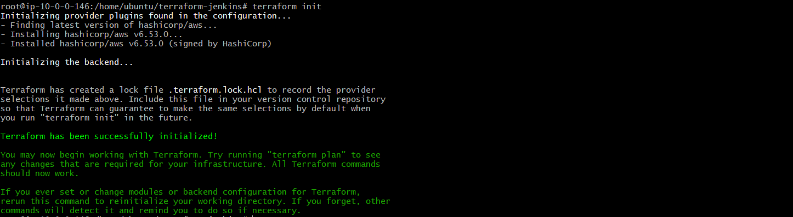

Step 6: Validate the Configuration
terraform plan
Review the execution plan to ensure Terraform will create the required resources.
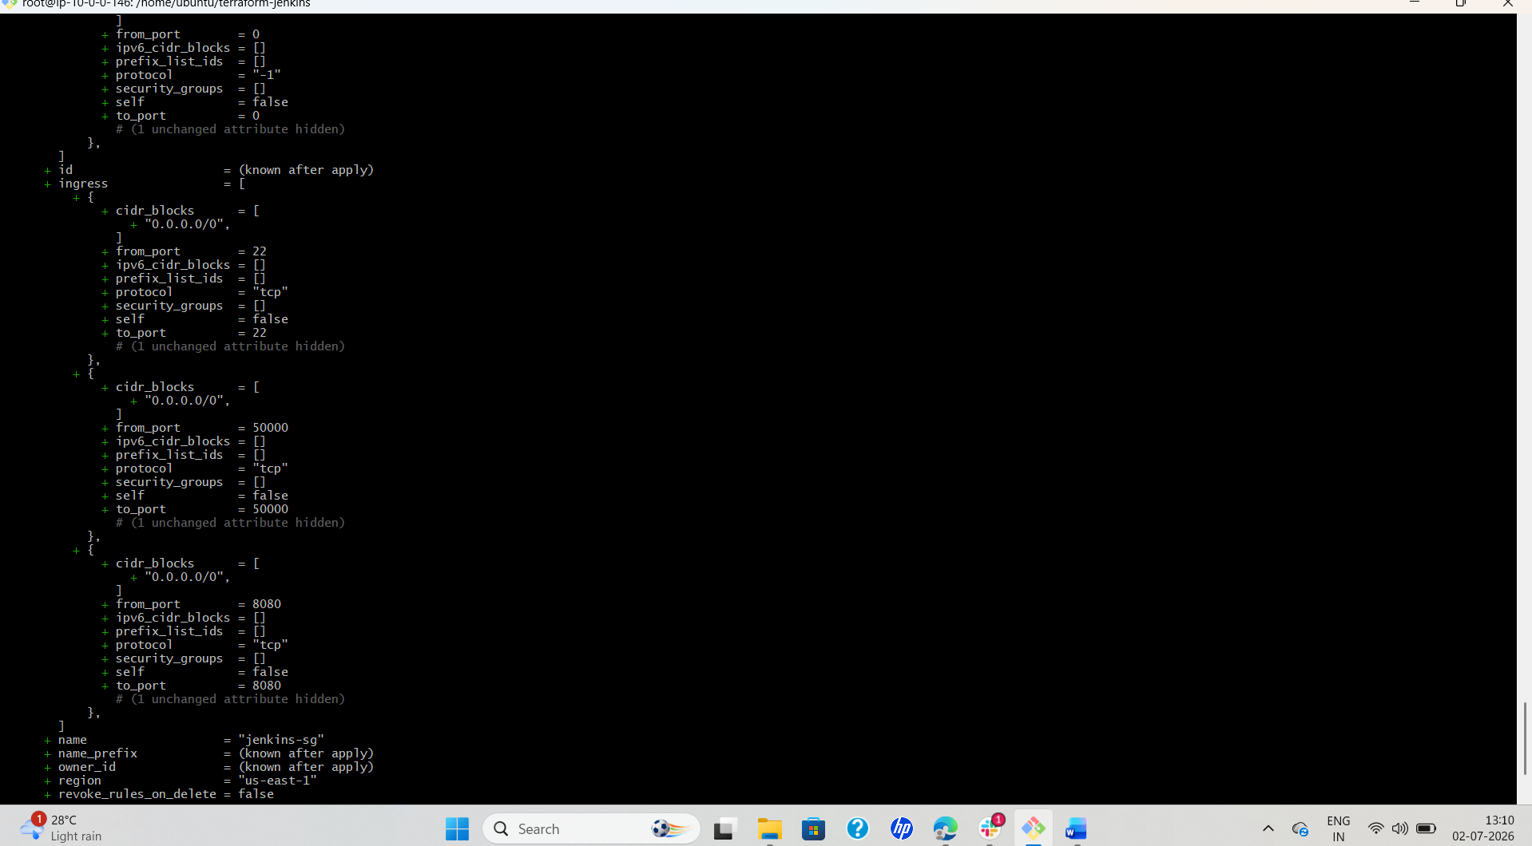
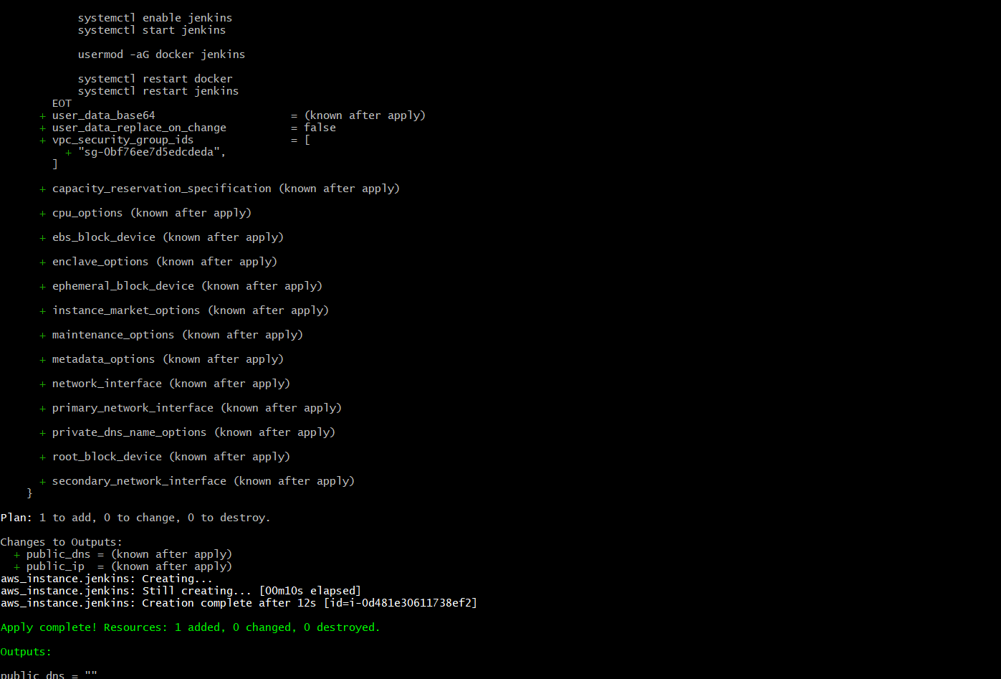

Step 7: Create AWS Infrastructure
terraform apply --auto-approve
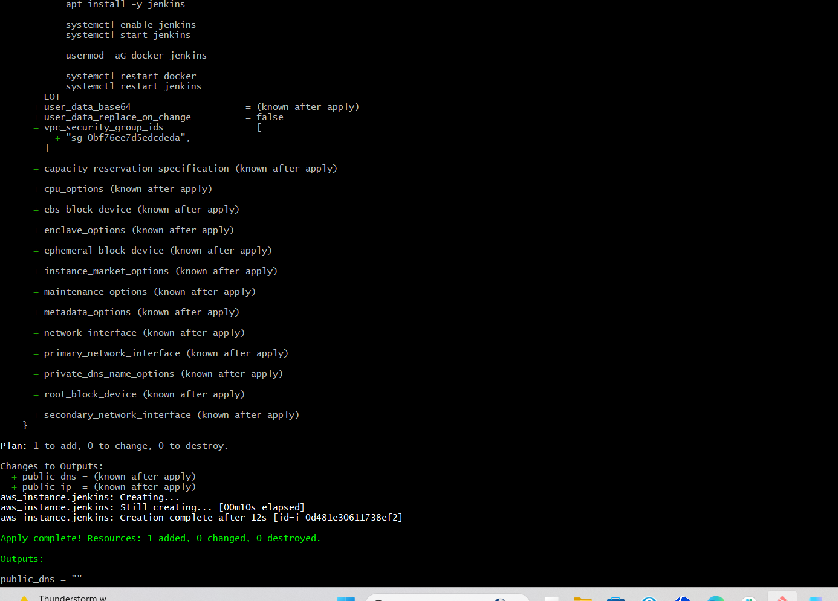
Terraform creates:
- Security Group
- EC2 Instance
- Public IP Address
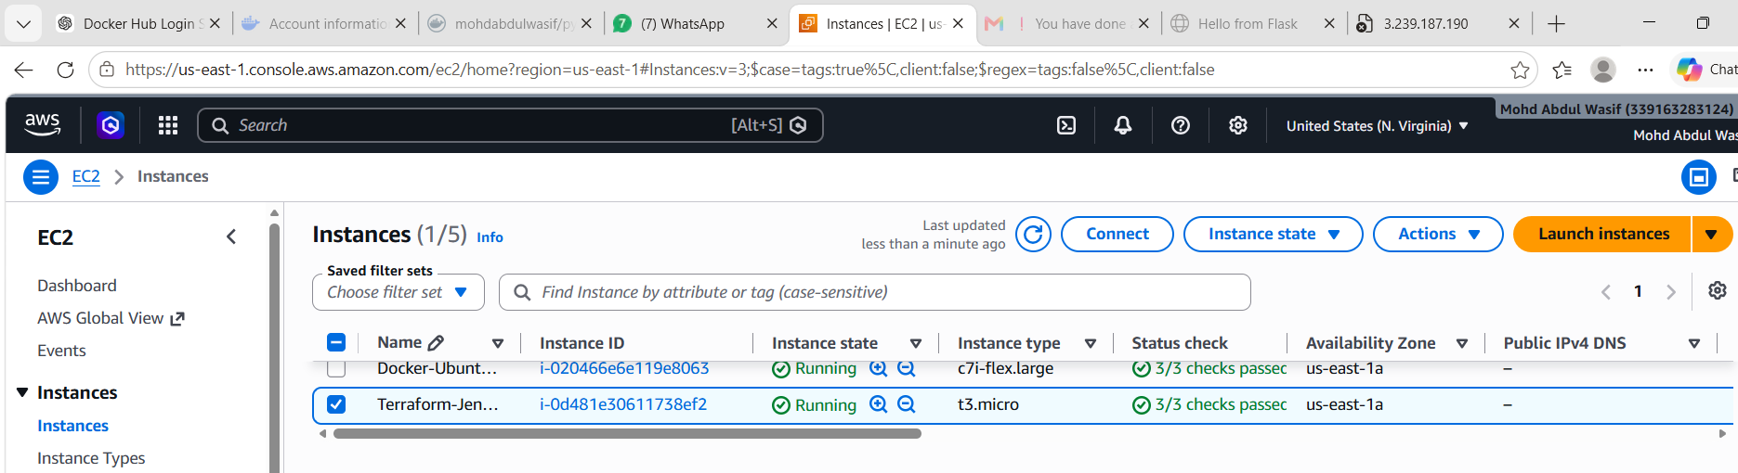

Step 8: Retrieve Public IP
terraform output public_ip
Example:
3.239.187.190

Step 9: Connect to EC2
Connect using either:
- EC2 Instance Connect (AWS Console), or
- SSH using the .pem key.
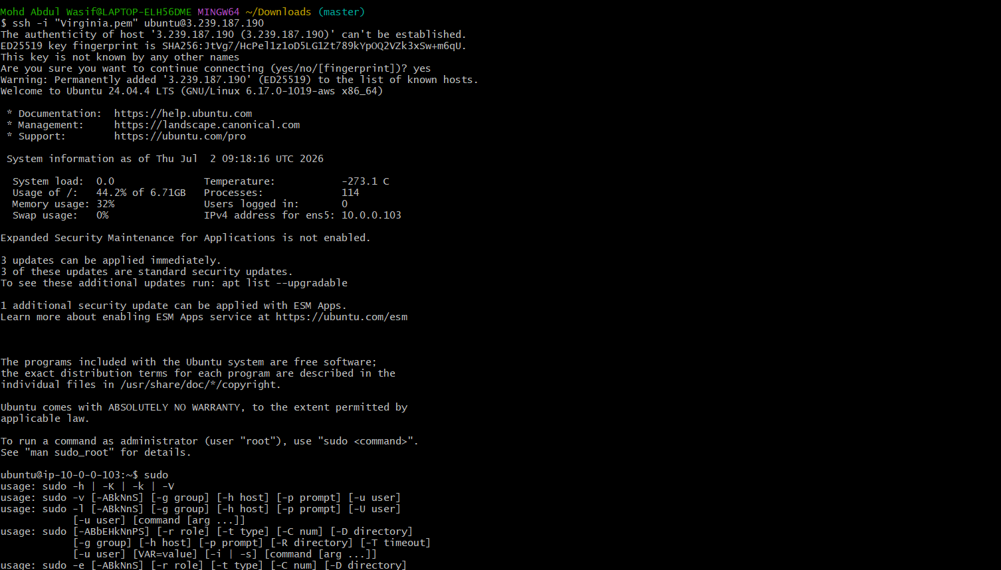

Step 10: Verify Jenkins Installation
Check Jenkins service.
sudo systemctl status jenkins
If Jenkins is not installed:
Install:
sudo apt update
sudo apt install jenkins -y
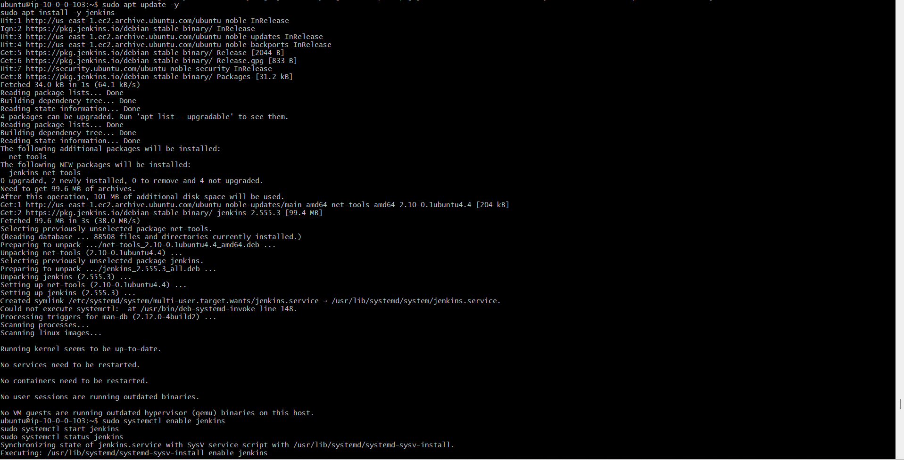

Step 11: Resolve Java Version Issue
Jenkins required Java 21.
Check Java:
java -version
Install Java 21:
sudo apt install openjdk-21-jdk -y
Verify:
java -version
Restart Jenkins:
sudo systemctl restart Jenkins
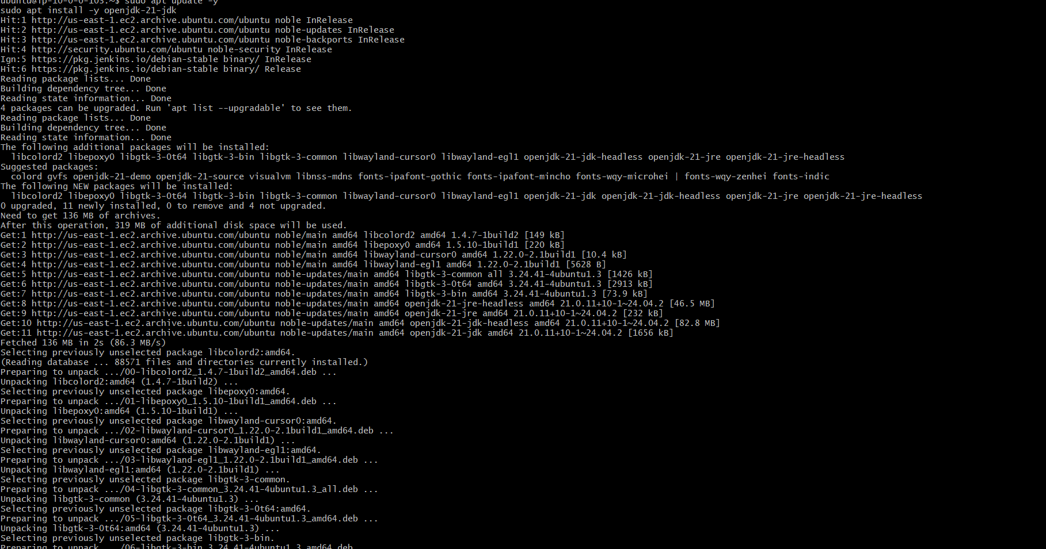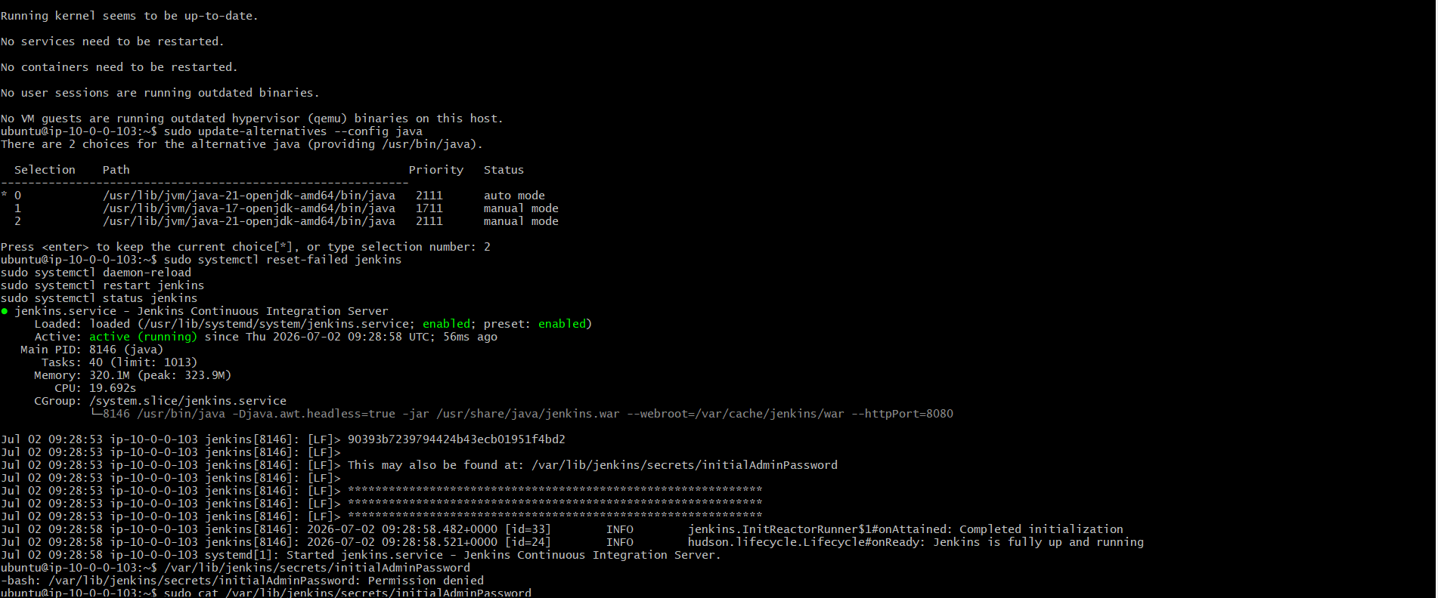

Step 12: Retrieve Initial Jenkins Password
sudo cat /var/lib/jenkins/secrets/initialAdminPassword

Step 13: Access Jenkins
Open:
http://<Public-IP>:8080
Complete the Jenkins setup wizard.
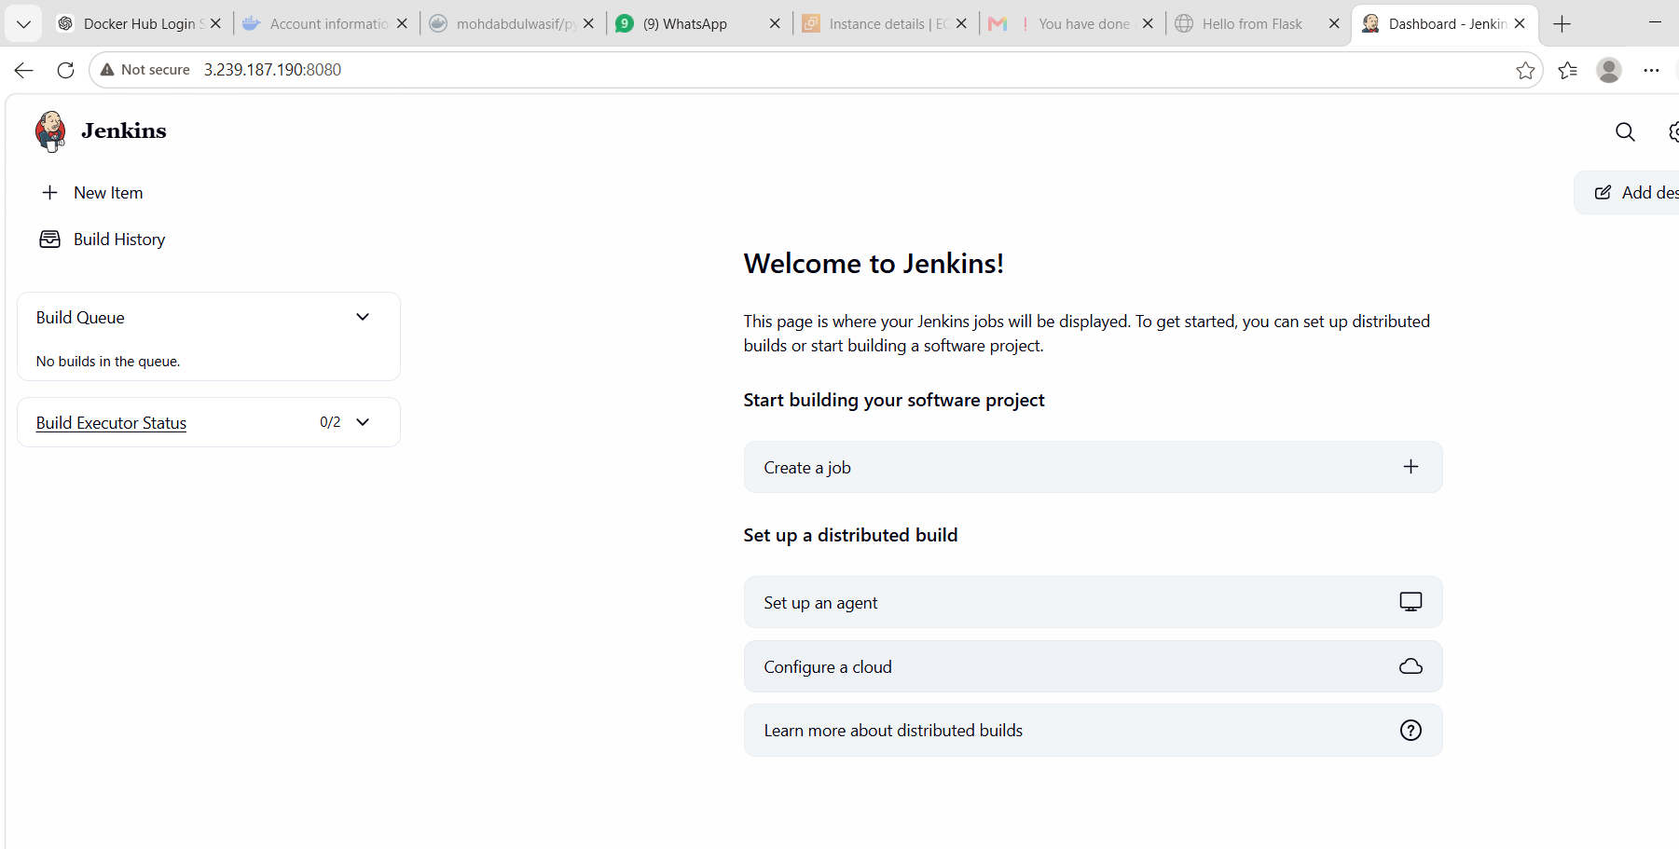

What We Learned
- How to provision AWS infrastructure using Terraform.
- How to create EC2 instances using Infrastructure as Code.
- How to configure VPC, Subnet, Security Group, and Key Pair in Terraform.
- How to troubleshoot Terraform deployment errors.
- How to install and configure Jenkins on Ubuntu.
- How to resolve Jenkins installation issues related to GPG keys and Java versions.
- How to retrieve Terraform outputs and access the Jenkins server.

Conclusion
Successfully provisioned an EC2 instance using Terraform and configured it as a Jenkins server. During the implementation, multiple real-world issues—including missing Terraform configuration, VPC selection, AMI validation, instance type compatibility, Jenkins repository key changes, SSH access, and Java version requirements—were identified and resolved. This task provided practical experience with Infrastructure as Code (Terraform) and automated Jenkins server provisioning on AWS

Task 5: Create a Jenkins Job to Build and Push the Docker Image to Docker Hub
Objective
To automate the Docker image build and push process using Jenkins Pipeline. The pipeline will clone the source code from GitHub, build a Docker image, log in to Docker Hub, and push the image to the Docker Hub repository.

Prerequisites
- Jenkins installed and running
- Docker installed on Jenkins server
- Docker service running
- Jenkins user added to the Docker group
- Docker Hub account
- Docker Hub Personal Access Token
- GitHub repository
- Required Jenkins plugins installed:
  - Git
  - Pipeline
  - Docker Pipeline
  - Credentials Binding

Step-by-Step Procedure
Step 1: Verify Docker Installation
Login to the Jenkins server and verify Docker.
docker --version
Check Docker service:
sudo systemctl status docker
If Docker is not running:
sudo systemctl start docker
sudo systemctl enable docker
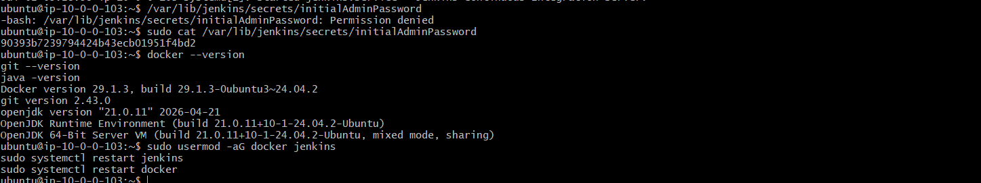

Step 2: Give Docker Permission to Jenkins User
Add Jenkins to the Docker group.
sudo usermod -aG docker jenkins
Restart Jenkins.
sudo systemctl restart jenkins
Restart Docker.
sudo systemctl restart docker


Step 3: Login to Jenkins
Open browser.
http://<Jenkins-Public-IP>:8080
Login using the Jenkins administrator credentials.


Step 4: Install Required Plugins
Navigate to:
Manage Jenkins
↓
Plugins
↓
Available Plugins
Install:
- Git Plugin
- Pipeline Plugin
- Docker Pipeline Plugin
- Credentials Binding Plugin
Restart Jenkins if prompted.
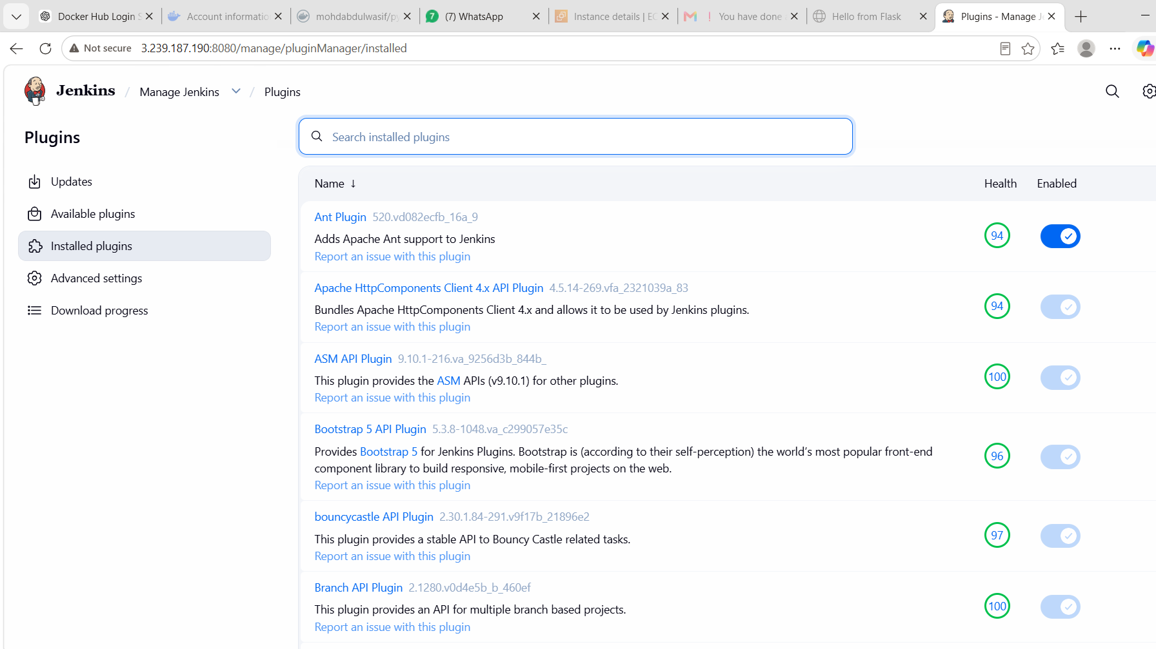

Step 5: Add Docker Hub Credentials
Navigate to:
Manage Jenkins
↓
Credentials
↓
System
↓
Global Credentials
↓
Add Credentials
Enter:
Kind:
Username with password
Username:
mohdabdulwasif
Password:
Docker Hub Personal Access Token
ID:
dockerhub-creds
Description:
Docker Hub Credentials
Click Create.
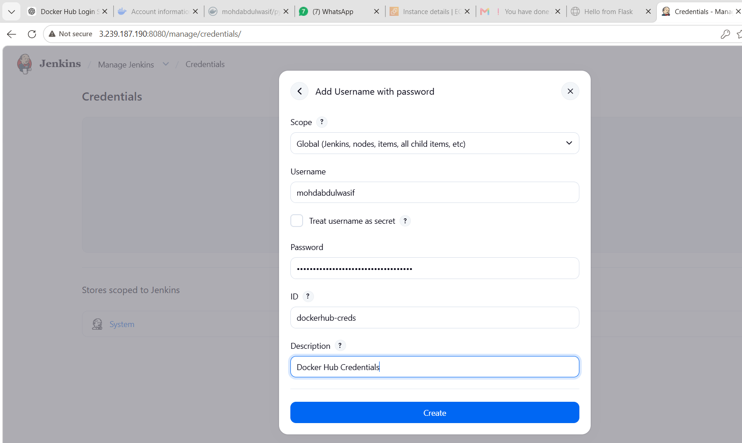

Step 6: Create a New Pipeline Job
Navigate to:
Dashboard
↓
New Item
Enter Job Name:
Python-App-Docker-Pipeline
Select:
Pipeline
Click OK.
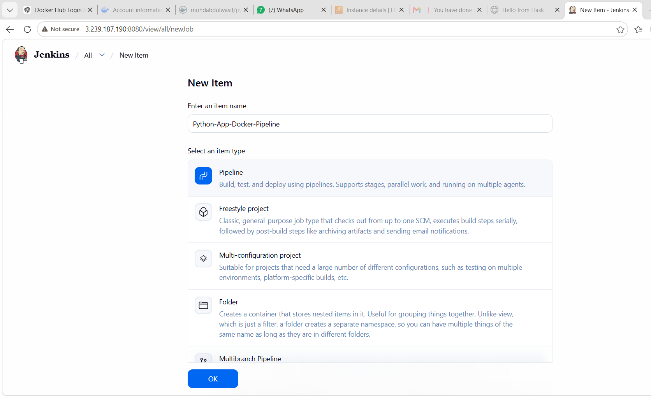

Step 7: Configure the Pipeline
Scroll to the Pipeline section.
Select:
Definition:
Pipeline script
Paste the Jenkins Pipeline script.
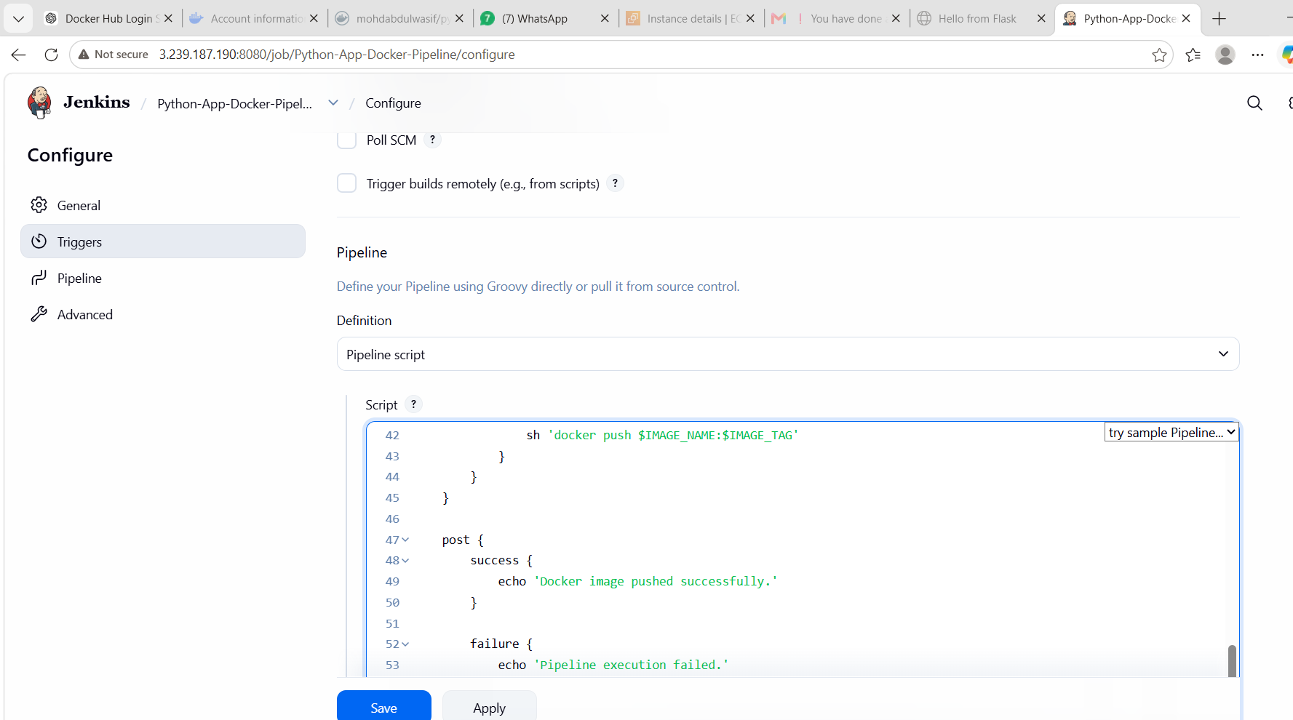

Step 8: Add Pipeline Script
pipeline {
agent any
environment {
IMAGE_NAME = "mohdabdulwasif/python-app"
IMAGE_TAG = "v1"
}
stages {
stage('Git Clone') {
steps {
git branch: 'main',
url: 'https://github.com/betawins/Python-app.git'
}
}
stage('Build Docker Image') {
steps {
sh 'docker build -t $IMAGE_NAME:$IMAGE_TAG .'
}
}
stage('Docker Login') {
steps {
withCredentials([
usernamePassword(
credentialsId: 'dockerhub-creds',
usernameVariable: 'DOCKER_USER',
passwordVariable: 'DOCKER_PASS'
)
]) {
sh '''
echo $DOCKER_PASS | docker login -u $DOCKER_USER --password-stdin
'''
}
}
}
stage('Push Docker Image') {
steps {
sh 'docker push $IMAGE_NAME:$IMAGE_TAG'
}
}
}
post {
success {
echo 'Docker image pushed successfully.'
}
failure {
echo 'Pipeline execution failed.'
}
}
}

Step 9: Save the Pipeline
Click:
Save


Step 10: Build the Pipeline
Click:
Build Now
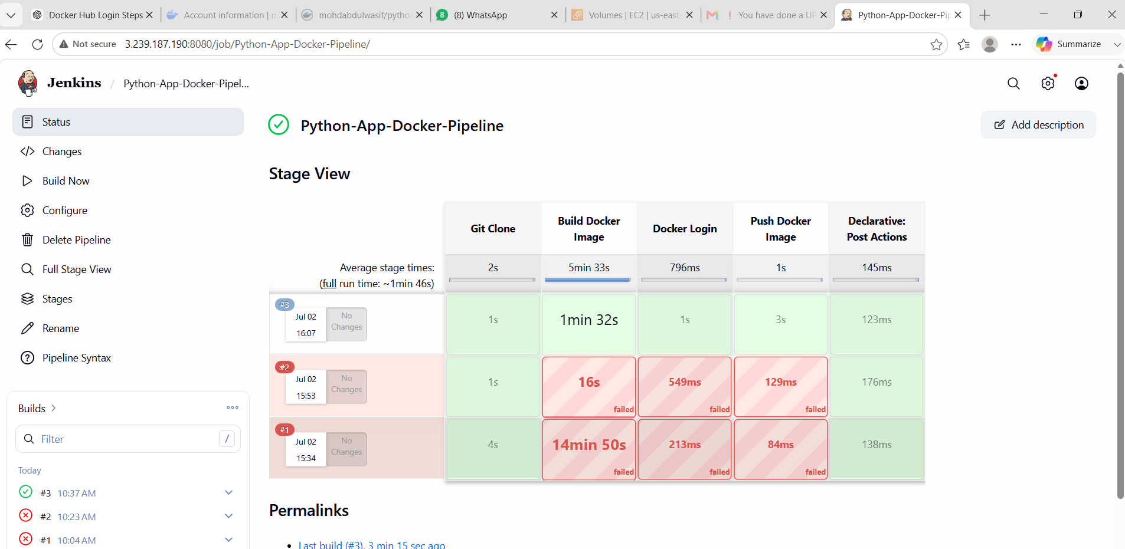

Step 11: Verify Pipeline Execution
Open:
Build History
↓
Latest Build
↓
Console Output
Verify the stages:
✓ Git Clone
✓ Build Docker Image
✓ Docker Login
✓ Push Docker Image
✓ SUCCESS
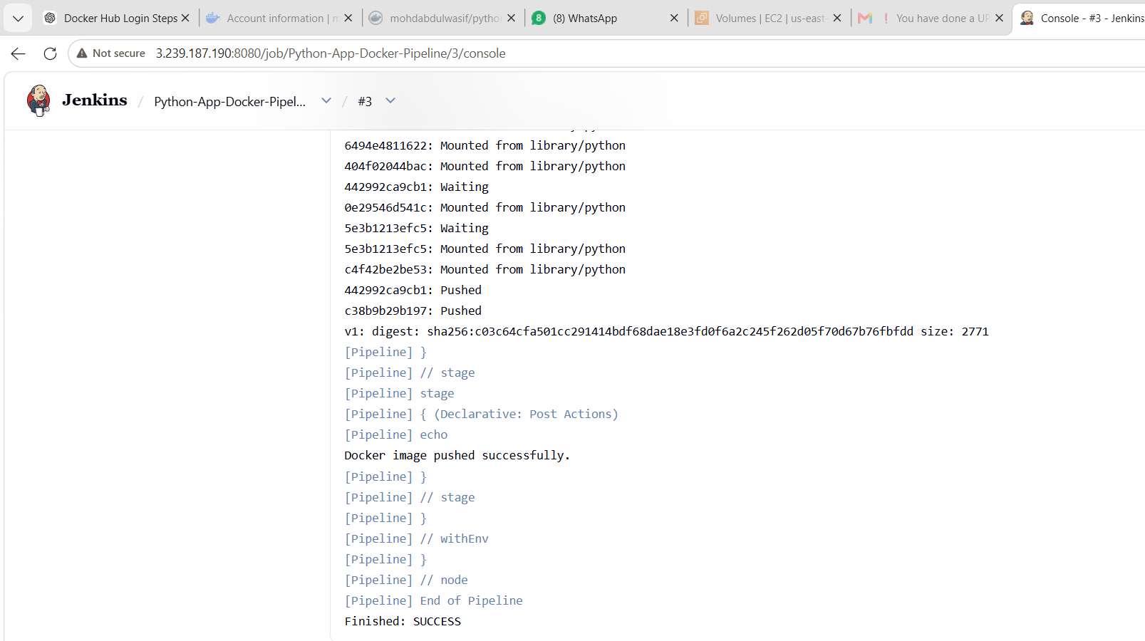

Step 12: Verify Docker Hub
Login to Docker Hub.
Navigate to:
Repositories
↓
python-app
Verify that the image with tag v1 is available.
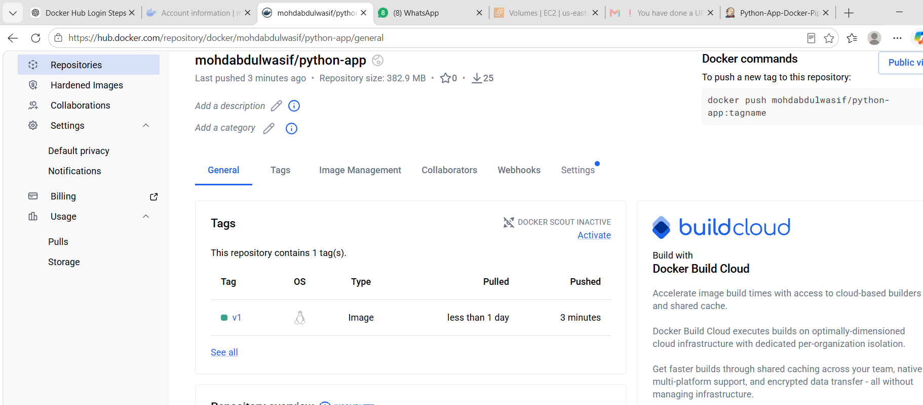

Pipeline Flow
GitHub Repository
│
▼
Jenkins Pipeline
│
▼
Git Clone
│
▼
Docker Build
│
▼
Docker Login
│
▼
Docker Push
│
▼
Docker Hub

What We Learned
- How to create a Jenkins Pipeline job.
- How to integrate GitHub with Jenkins.
- How to build Docker images automatically.
- How to securely store Docker Hub credentials in Jenkins.
- How to push Docker images to Docker Hub using a pipeline.
- How CI/CD automates container image creation and publishing.

Conclusion
Successfully created a Jenkins Pipeline that automated the process of cloning source code from GitHub, building a Docker image, authenticating with Docker Hub using secure credentials, and pushing the Docker image to Docker Hub. This task demonstrated a complete CI/CD workflow for Docker image automation using Jenkins.

