Kubernetes-Task-08
Task 1: Create and Test a Kubernetes Pod with an EmptyDir Volume
Objective
To create a Kubernetes Pod using an EmptyDir volume and verify that the data is shared between containers in the Pod but is deleted when the Pod is removed.
Step 1: Create YAML
apiVersion: v1
kind: Pod
metadata:
name: emptydir-pod
spec:
containers:
- name: nginx
image: nginx
volumeMounts:
- mountPath: /data
name: myvolume
volumes:
- name: myvolume
emptyDir: {}
Save as:
emptydir-pod.yaml
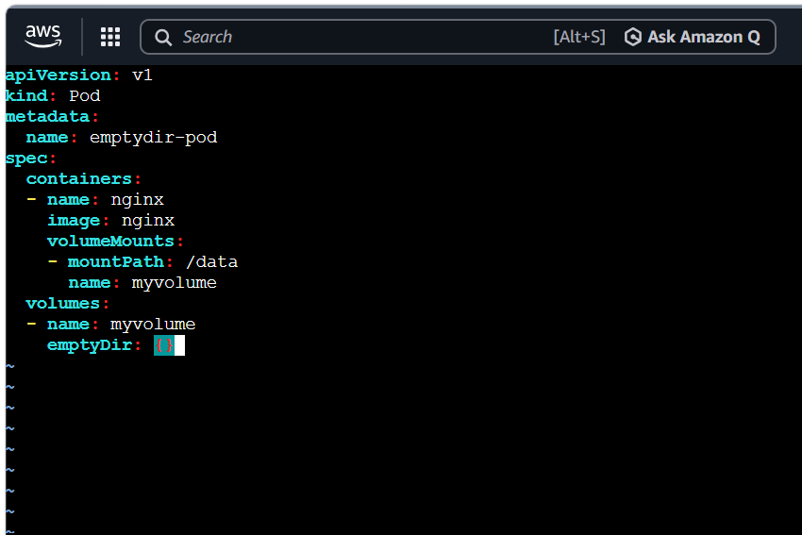

Step 2: Create Pod
kubectl apply -f emptydir-pod.yaml
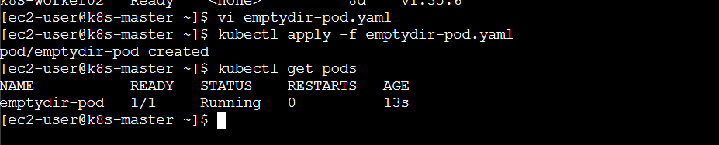

Step 3: Verify Pod
kubectl get pods


Step 4: Login into Pod
kubectl exec -it emptydir-pod -- /bin/bash

Step 5: Create Files
cd /data

touch file1 file2 file3

ls
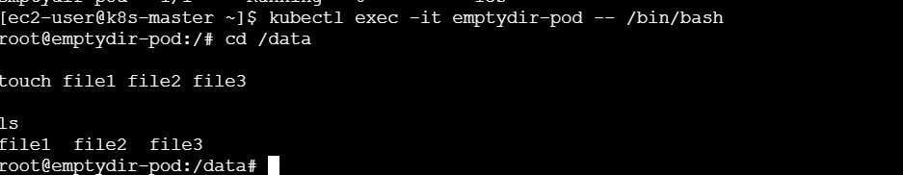

Step 6: Exit
exit

Step 7: Restart Container
Delete Pod
kubectl delete pod emptydir-pod
Recreate
kubectl apply -f emptydir-pod.yaml
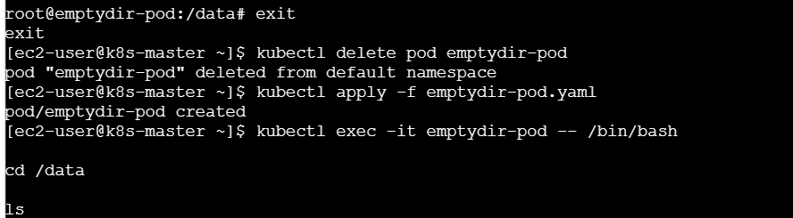

Step 8: Check Data
kubectl exec -it emptydir-pod -- /bin/bash

cd /data

ls

Files will not exist because the Pod was recreated.

What We Learned
- How to create an EmptyDir volume.
- How to mount a volume inside a container.
- How to create and verify files inside the mounted directory.
- EmptyDir data survives container restarts but is lost when the Pod is deleted.
Conclusion
Successfully created a Pod with an EmptyDir volume and verified that the data existed while the Pod was running. After deleting and recreating the Pod, the data was no longer available, confirming that EmptyDir provides temporary storage only for the lifetime of the Pod.

Task 2: Configure a HostPath Volume in Kubernetes and Validate Data Persistence
Objective
To configure a HostPath volume in Kubernetes and verify that data stored on the worker node remains available even after the Pod is recreated.
Step 1: Create YAML
apiVersion: v1
kind: Pod
metadata:
name: hostpath-pod
spec:
containers:
- image: nginx
name: nginx
volumeMounts:
- mountPath: /app
name: host-storage

volumes:
- name: host-storage
hostPath:
path: /data
type: DirectoryOrCreate
Save
hostpath.yaml
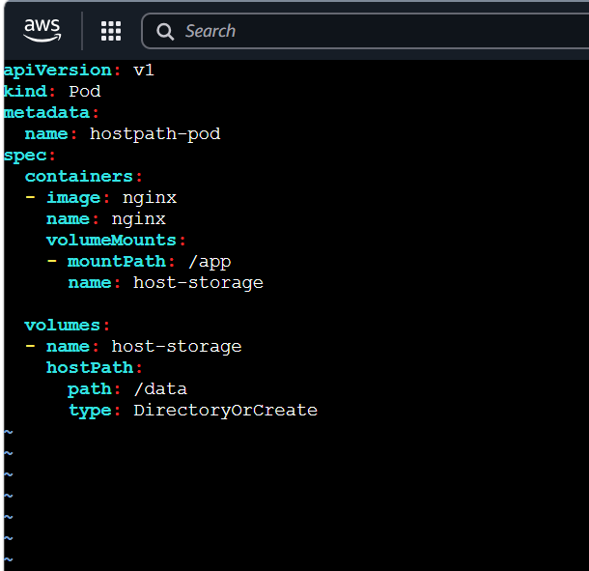

Step 2: Create Pod
kubectl apply -f hostpath.yaml
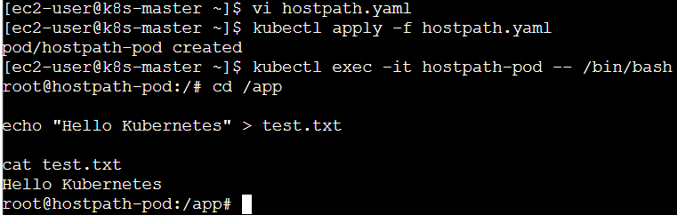

Step 3: Login
kubectl exec -it hostpath-pod -- /bin/bash

Step 4: Create File
cd /app

echo "Hello Kubernetes" > test.txt

cat test.txt


Step 5: Exit
exit

Step 6: Check on Worker Node
SSH into Worker Node
cd /data

ls

cat test.txt
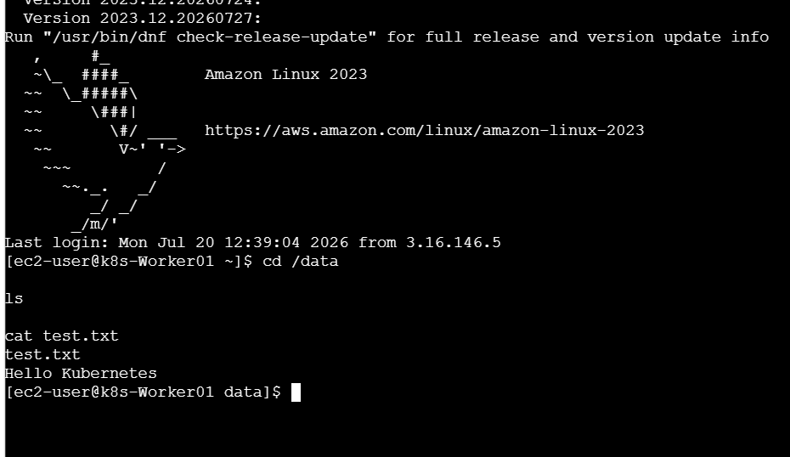

Step 7: Delete Pod
kubectl delete pod hostpath-pod

Step 8: Recreate Pod
kubectl apply -f hostpath.yaml
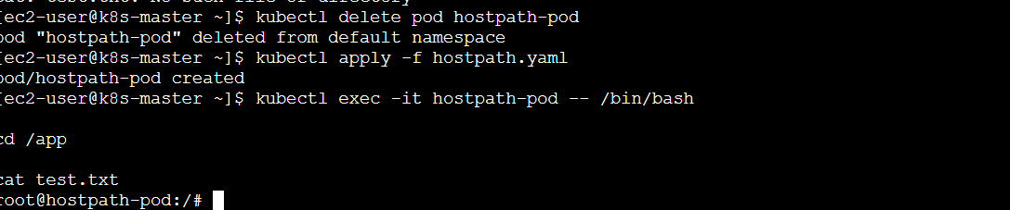

Step 9: Verify
kubectl exec -it hostpath-pod -- /bin/bash


cd /app

cat test.txt
Data should still exist.
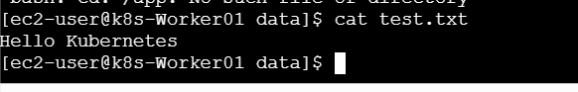

What We Learned
- How to configure a HostPath volume.
- How to mount a host directory inside a Pod.
- How to validate data persistence on the worker node.
- HostPath stores data on the Kubernetes node instead of inside the Pod.
Conclusion
Successfully configured a HostPath volume and verified that data remained available after deleting and recreating the Pod. This demonstrated that HostPath provides persistent storage on a specific node but is suitable only when the Pod runs on the same worker node.

Task 3: Deploy an Amazon EBS Volume Using Persistent Volume and Persistent Volume Claim (PVC)
Objective
To create a Persistent Volume (PV) and Persistent Volume Claim (PVC) using an Amazon EBS volume and attach it to a Kubernetes Pod.
Step 1: Create EBS Volume
AWS Console
EC2

↓

Volumes

↓

Create Volume

Size : 2 GB

AZ : Same as Worker Node
Copy
Volume ID
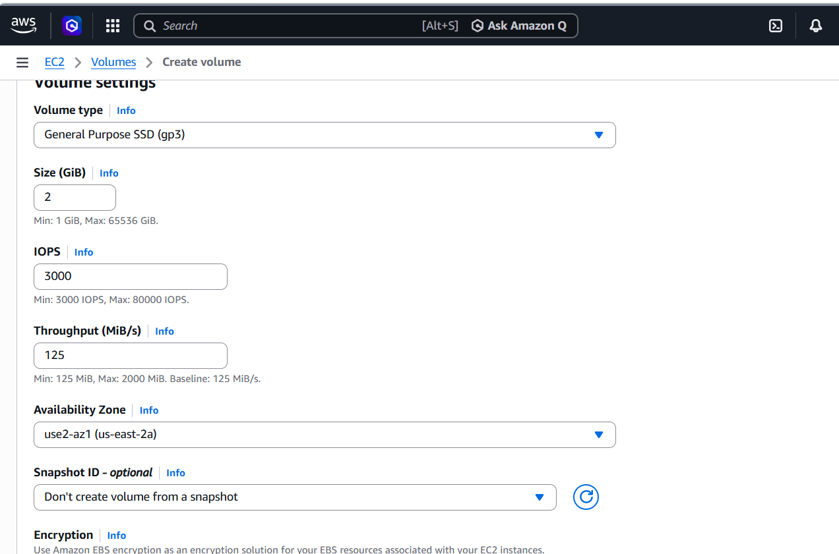

Step 2: Create Persistent Volume
apiVersion: v1
kind: PersistentVolume
metadata:
name: ebs-pv
spec:
capacity:
storage: 2Gi
accessModes:
- ReadWriteOnce
persistentVolumeReclaimPolicy: Retain
awsElasticBlockStore:
volumeID: vol-xxxxxxxx
fsType: ext4
Save
pv.yaml
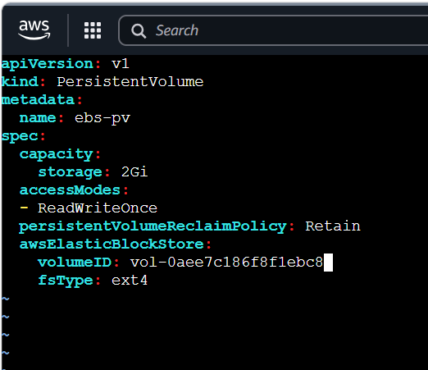

Step 3: Create PV
kubectl apply -f pv.yaml
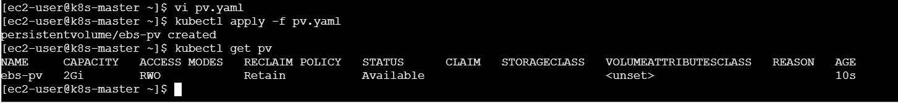

Step 4: Verify
kubectl get pv


Step 5: Create PVC
apiVersion: v1
kind: PersistentVolumeClaim
metadata:
name: ebs-pvc
spec:
accessModes:
- ReadWriteOnce
resources:
requests:
storage: 2Gi
Save
pvc.yaml
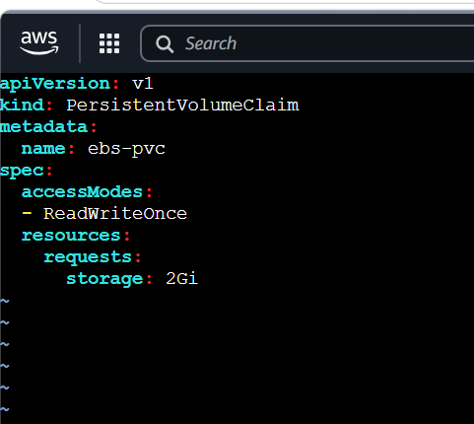

Step 6: Create PVC
kubectl apply -f pvc.yaml
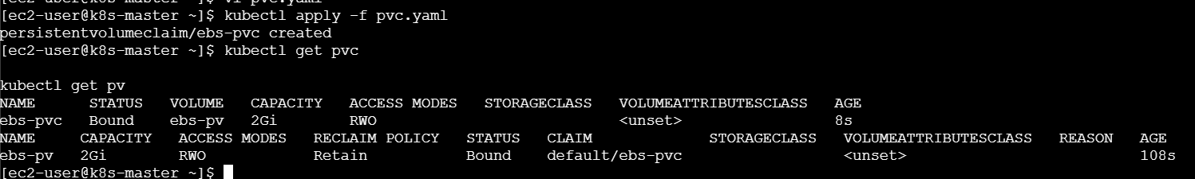

Step 7: Verify
kubectl get pvc

kubectl get pv

Status should be
Bound

Step 8: Create Pod
apiVersion: v1
kind: Pod
metadata:
name: ebs-pod
spec:
containers:
- image: nginx
name: nginx
volumeMounts:
- mountPath: /storage
name: ebs-storage

volumes:
- name: ebs-storage
persistentVolumeClaim:
claimName: ebs-pvc
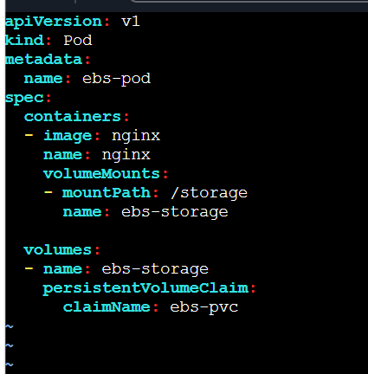

Step 9: Apply
kubectl apply -f ebs-pod.yaml

Step 10: Verify
kubectl exec -it ebs-pod -- /bin/bash

cd /storage

touch demo.txt

ls
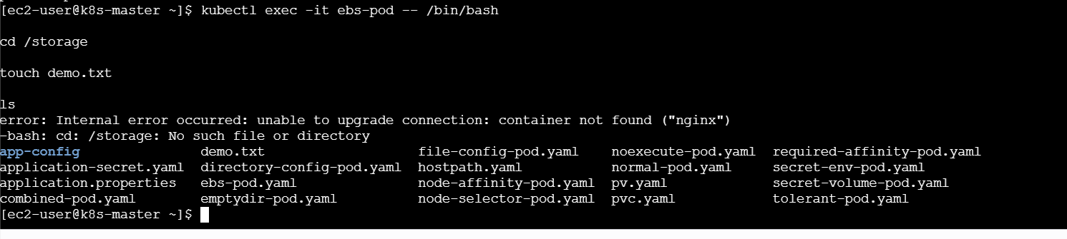

What We Learned
- How to create an Amazon EBS volume.
- How to configure a Persistent Volume (PV).
- How to create and bind a Persistent Volume Claim (PVC).
- How to mount persistent storage inside a Pod.
- How Kubernetes provides persistent storage using PV and PVC.
Conclusion
Successfully deployed an Amazon EBS volume using a Persistent Volume and Persistent Volume Claim. Verified that the PV and PVC were successfully bound and that the Pod could access the persistent storage.

Task 4: Set Up an Amazon EFS Volume and Attach it to Multiple Pods
Objective
To configure an Amazon EFS file system and mount it to multiple Kubernetes Pods using a shared Persistent Volume Claim.
Step 1: Create EFS
AWS Console
EFS

↓

Create File System
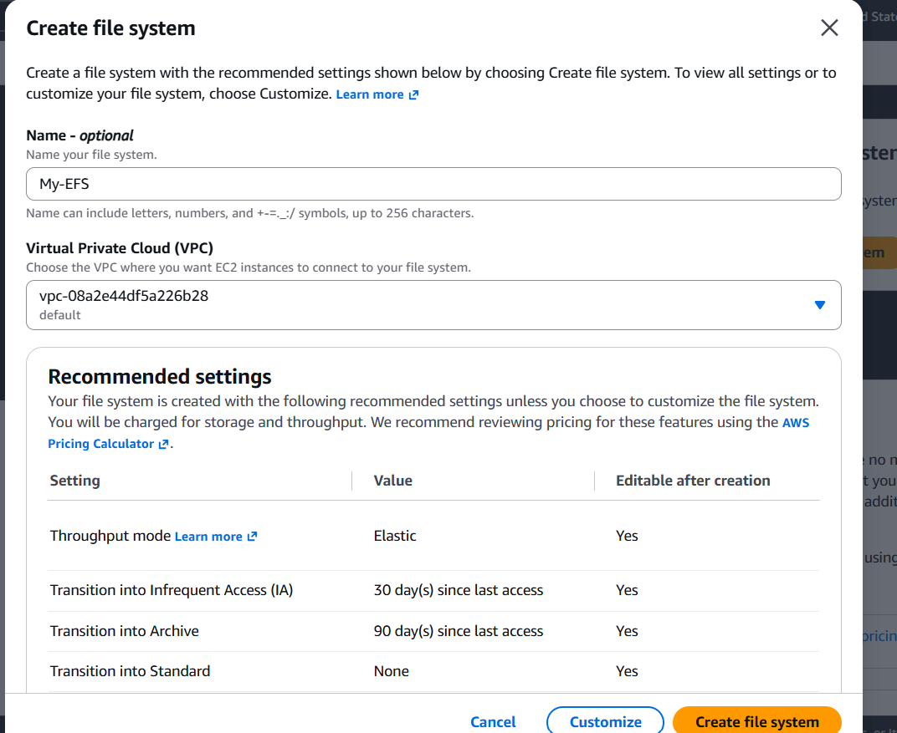
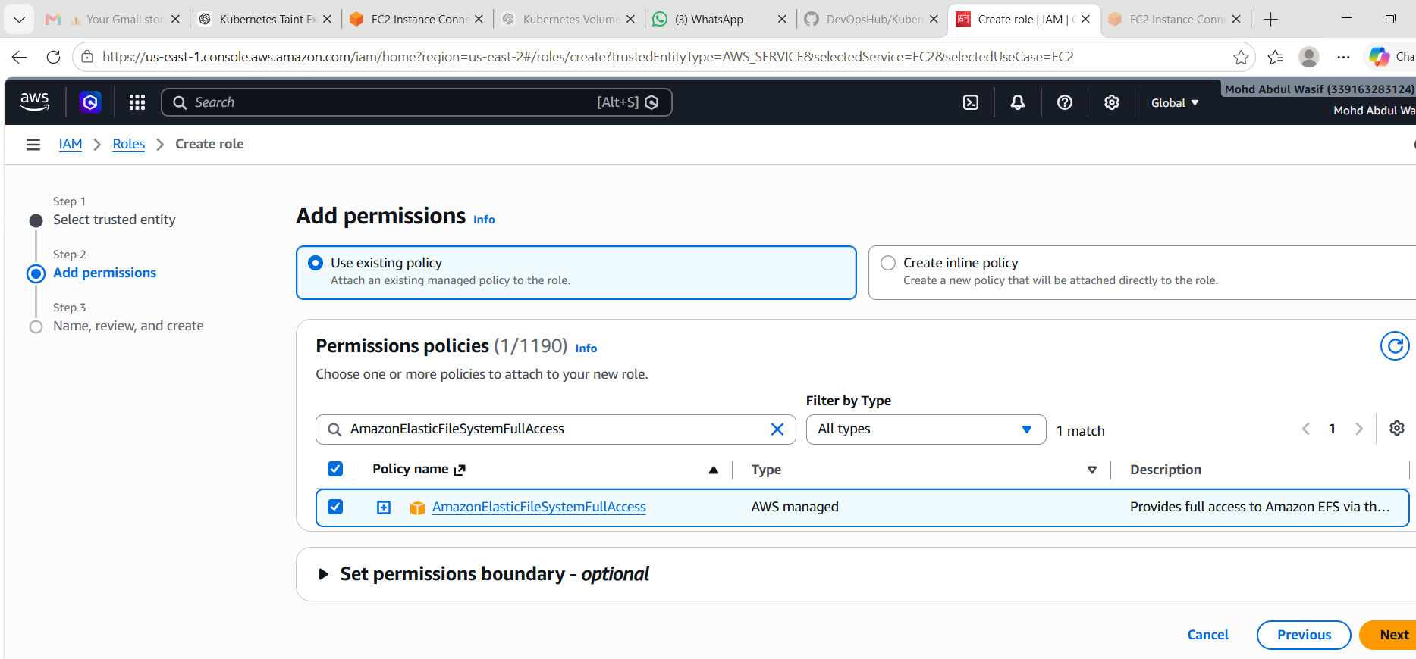
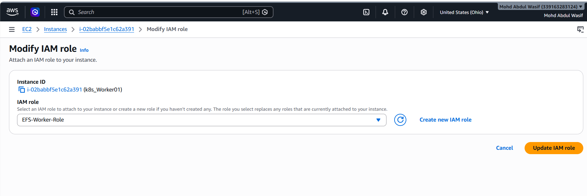

Step 2: Install EFS CSI Driver
First install git
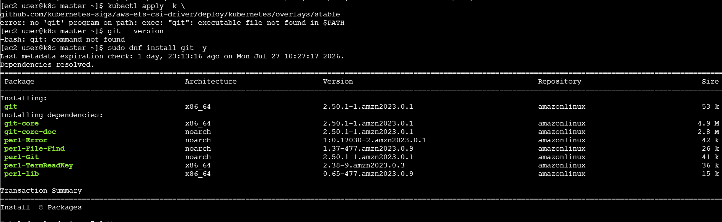
kubectl apply -k \
github.com/kubernetes-sigs/aws-efs-csi-driver/deploy/kubernetes/overlays/stable
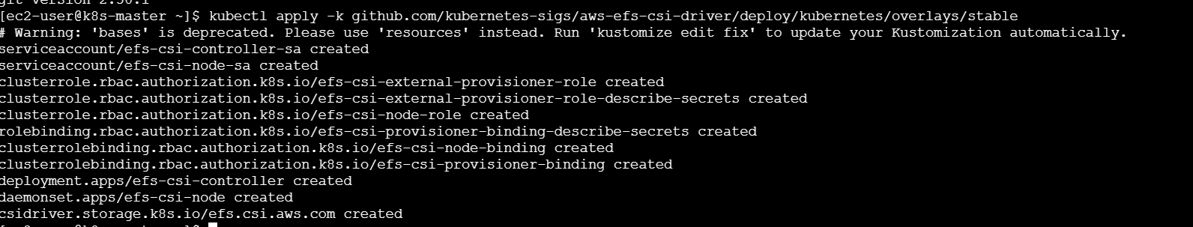

Step 3: Create StorageClass
apiVersion: storage.k8s.io/v1
kind: StorageClass
metadata:
name: efs-sc
provisioner: efs.csi.aws.com
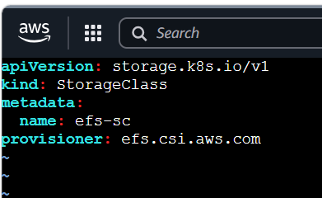
Step 2: Apply the StorageClass
kubectl apply -f efs-storageclass.yaml
Expected output:
storageclass.storage.k8s.io/efs-sc created

Step 3: Verify
kubectl get storageclass
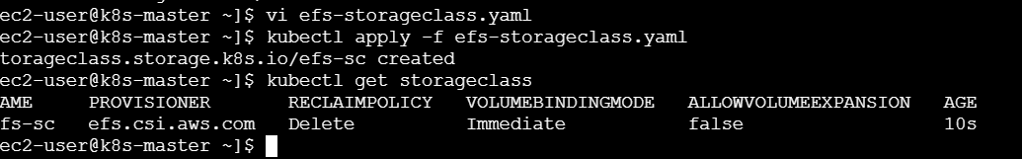

Step 4: Create PVC
apiVersion: v1
kind: PersistentVolumeClaim
metadata:
name: efs-pvc
spec:
accessModes:
- ReadWriteMany
storageClassName: efs-sc
resources:
requests:
storage: 5Gi
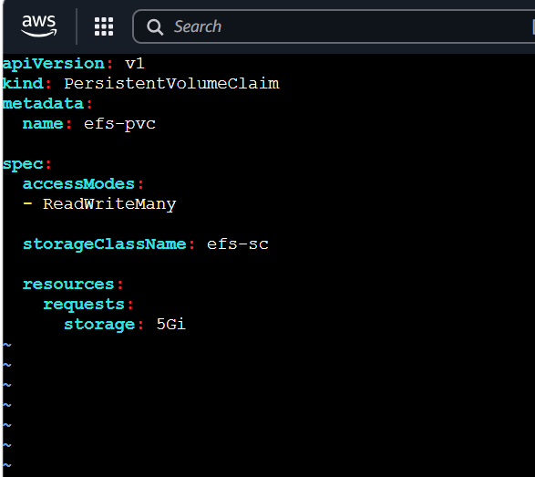
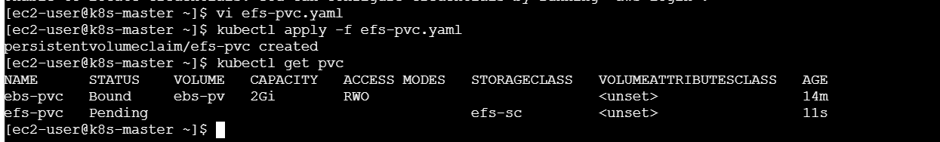

Step 5: Create Pod-1
Mount PVC at
/shared
Create file:
vi efs-pod1.yaml
Add:
apiVersion: v1
kind: Pod

metadata:
name: efs-pod1

spec:
containers:
- name: nginx
image: nginx

volumeMounts:
- name: efs-volume
mountPath: /shared

volumes:
- name: efs-volume
persistentVolumeClaim:
claimName: efs-pvc
Save and exit.

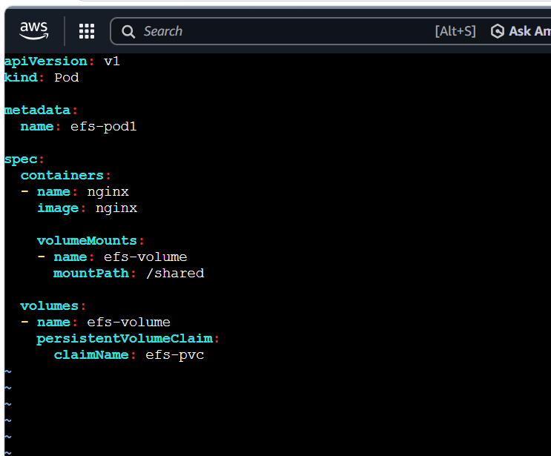
Create Pod-1
kubectl apply -f efs-pod1.yaml
Check:
kubectl get pods
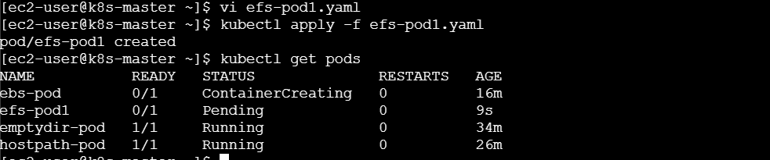
Output:
NAME READY STATUS
efs-pod1 1/1 Running

Step 6: Create Pod-2
Mount same PVC
/shared
Create file:
vi efs-pod2.yaml
Add:
apiVersion: v1
kind: Pod

metadata:
name: efs-pod2

spec:
containers:
- name: nginx
image: nginx

volumeMounts:
- name: efs-volume
mountPath: /shared

volumes:
- name: efs-volume
persistentVolumeClaim:
claimName: efs-pvc
Save and exit.
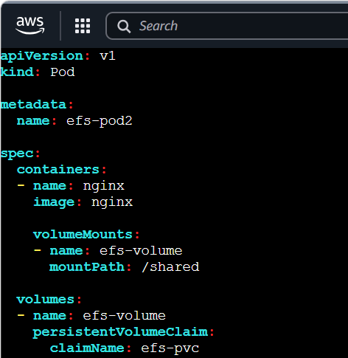

Create Pod-2
kubectl apply -f efs-pod2.yaml
Check:
kubectl get pods
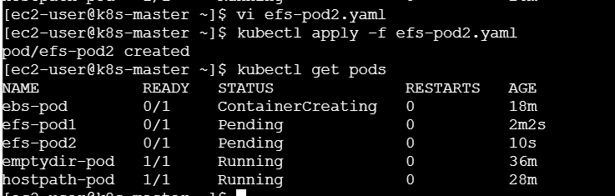
Output:
NAME READY STATUS
efs-pod1 1/1 Running
efs-pod2 1/1 Running

Step 7: Test
Inside Pod-1
echo "Hello EFS" > /shared/test.txt
Inside Pod-2
cat /shared/test.txt
Output
Hello EFS
Inside Pod-1 create file
Enter Pod-1:
kubectl exec -it efs-pod1 -- bash
Create file:
echo "Hello EFS" > /shared/test.txt
Verify:
cat /shared/test.txt
Output:
Hello EFS
Exit:
exit

Inside Pod-2 read file
Enter Pod-2:
kubectl exec -it efs-pod2 -- bash
Run:
cat /shared/test.txt
Output:
Hello EFS
Exit:
exit
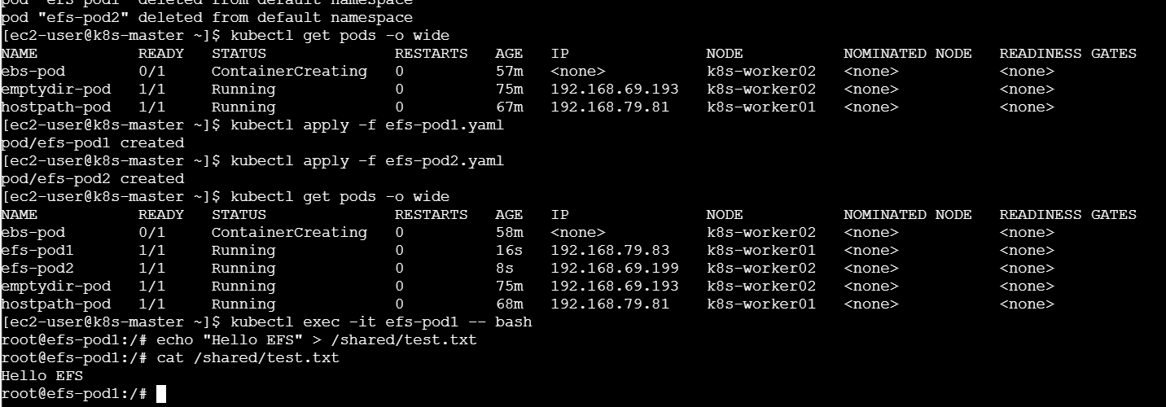

What We Learned
- How to create an Amazon EFS file system.
- How to configure the EFS CSI Driver.
- How to create a StorageClass and PVC for EFS.
- How multiple Pods can simultaneously access the same storage.
- Difference between ReadWriteOnce (EBS) and ReadWriteMany (EFS).
Conclusion
Successfully configured Amazon EFS and mounted the same storage to multiple Pods. Verified that files created in one Pod were immediately accessible from another Pod, demonstrating shared storage functionality.

Task 5: Implement and Test Liveness and Readiness Probes in a Kubernetes Pod
Objective
To configure Liveness and Readiness probes for a Kubernetes Pod and verify how Kubernetes monitors application health.
Step 1: Create YAML
apiVersion: v1
kind: Pod
metadata:
name: probe-pod
spec:
containers:
- name: nginx
image: nginx

livenessProbe:
httpGet:
path: /
port: 80
initialDelaySeconds: 10
periodSeconds: 5

readinessProbe:
httpGet:
path: /
port: 80
initialDelaySeconds: 5
periodSeconds: 5
Save
probe.yaml
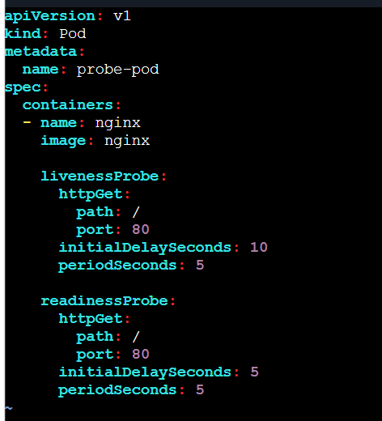

Step 2: Apply
kubectl apply -f probe.yaml

Step 3: Verify
kubectl get pods
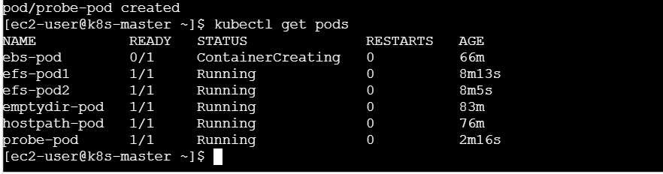

Step 4: Describe Pod
kubectl describe pod probe-pod
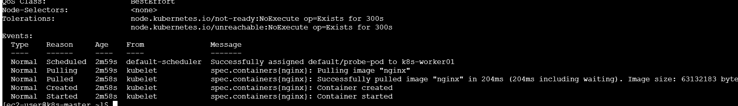
Check
Liveness Probe

Readiness Probe

Step 5: Observe Events
kubectl get events
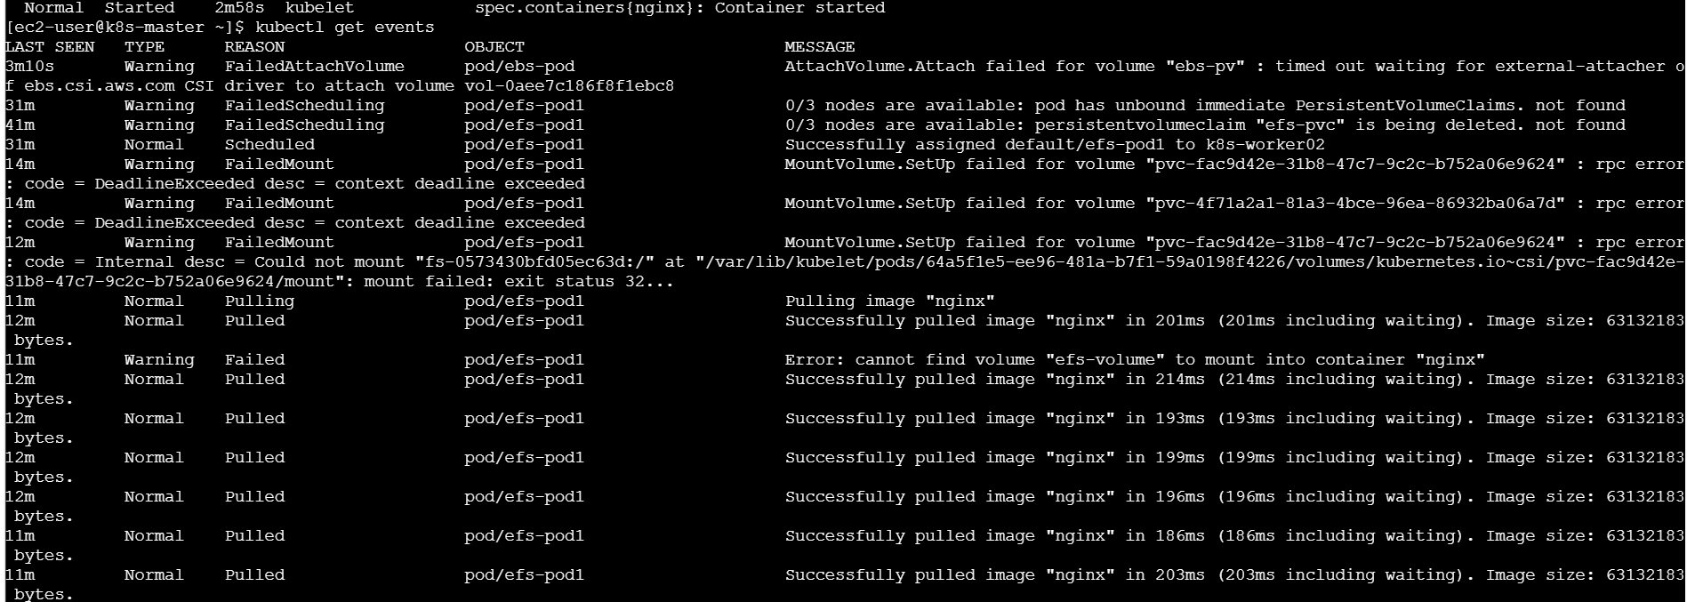

Step 6: Watch Pod
kubectl get pods -w
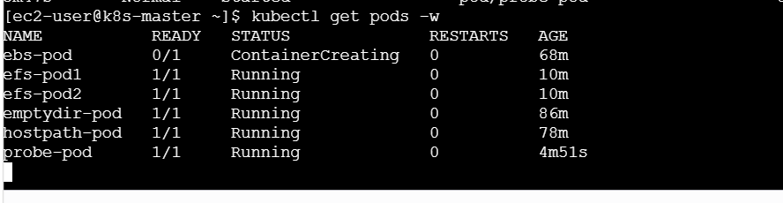
If the liveness probe fails, Kubernetes automatically restarts the container.
1. Write file from Pod-1
kubectl exec -it efs-pod1 -- bash
Inside pod:
echo "Hello EFS" > /shared/test.txt
Verify:
cat /shared/test.txt
Output:
Hello EFS
Exit:
exit

2. Read file from Pod-2
kubectl exec -it efs-pod2 -- bash
Run:
cat /shared/test.txt
Expected output:
Hello EFS
Exit:
exit
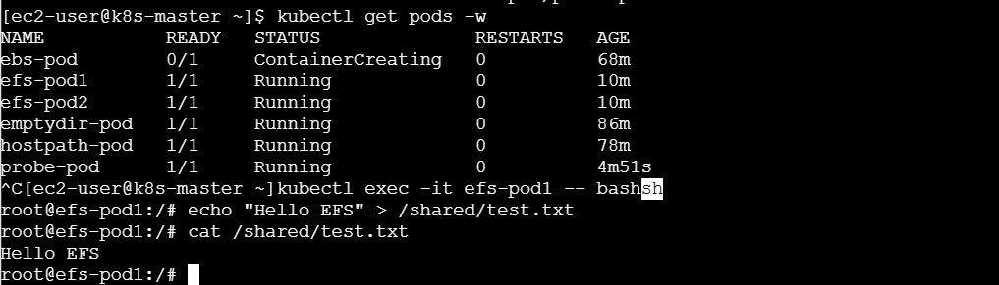

Cleanup
kubectl delete pod emptydir-pod
kubectl delete pod hostpath-pod
kubectl delete pod ebs-pod
kubectl delete pod probe-pod

kubectl delete pvc ebs-pvc
kubectl delete pv ebs-pv

kubectl delete pvc efs-pvc
kubectl delete storageclass efs-sc
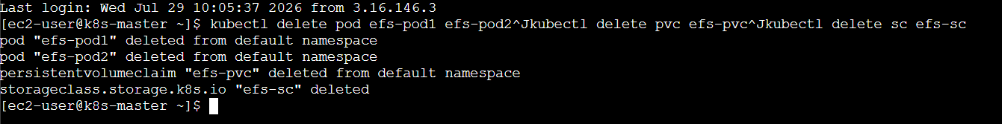

What We Learned
- How to configure Liveness Probes.
- How to configure Readiness Probes.
- Difference between Liveness and Readiness probes.
- How Kubernetes automatically restarts unhealthy containers.
- How Readiness Probes ensure traffic is sent only to healthy Pods.
Conclusion
Successfully implemented Liveness and Readiness probes in a Kubernetes Pod and verified that Kubernetes continuously monitored the application's health. The Pod was marked ready only after passing the readiness check, and unhealthy containers were automatically restarted by the liveness probe.

