Kubernetes-Task-09

Task 1: Configure Kubernetes Ingress
Objective
To understand how to expose Kubernetes applications using Ingress, configure an Ingress Controller, and route external HTTP traffic to Services using a single entry point instead of multiple LoadBalancer services.

Prerequisites
- Kubernetes Cluster or Minikube
- kubectl installed
- NGINX Deployment
- Kubernetes Service
- Ingress Controller

Step 1: Check Cluster
kubectl get nodes
kubectl get pods -A
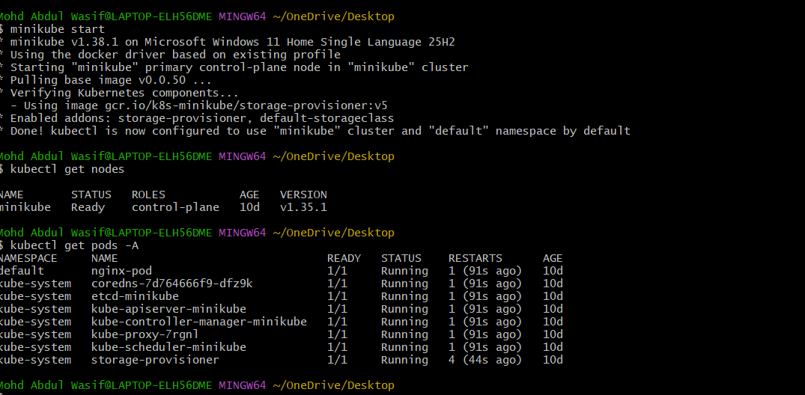
Create folder:
mkdir k8s-practice
Go inside:
cd k8s-practice
Check:
pwd
Expected:
/c/Users/Mohd Abdul Wasif/OneDrive/Desktop/k8s-practice

Step 2: Create deployment.yaml
Create file:
vi deployment.yaml
Press i and paste:
apiVersion: apps/v1
kind: Deployment

metadata:
name: nginx-deployment

spec:
replicas: 3

selector:
matchLabels:
app: nginx

template:
metadata:
labels:
app: nginx

spec:
containers:
- name: nginx
image: nginx
ports:
- containerPort: 80
Save:
Press:
ESC
:wq
ENTER
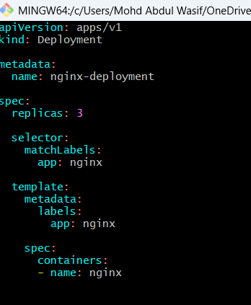

Step 2: Create Deployment
kubectl apply -f deployment.yaml
Verify
kubectl get deployments
kubectl get pods
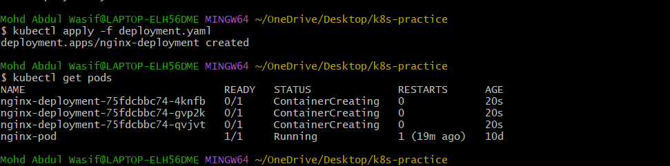

Step 3: Create Service
Create file:
vi service.yaml
Press i and paste:
apiVersion: v1
kind: Service

metadata:
name: nginx-nodeport-service

spec:
type: NodePort

selector:
app: nginx

ports:
- port: 80
targetPort: 80
nodePort: 30080
Save:
ESC
:wq
ENTER
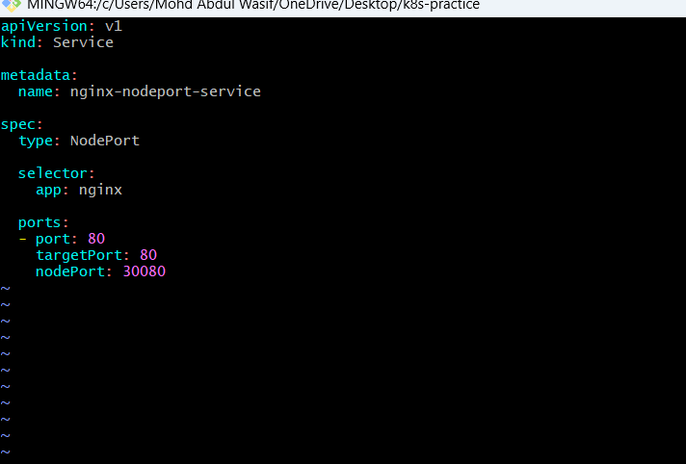
kubectl apply -f service.yaml
Verify
kubectl get svc
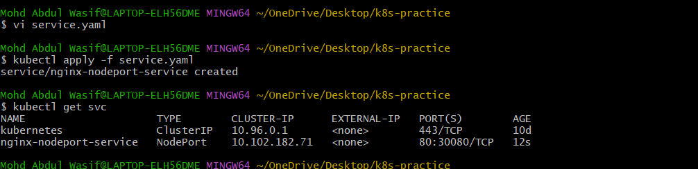
Step 4: Check Pods
kubectl get pods -o wide
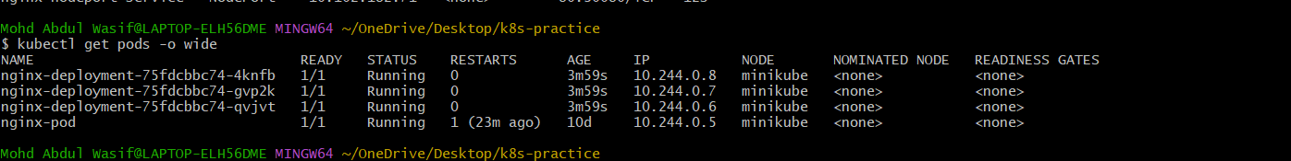

Step 4: Enable Ingress Controller (Minikube)
minikube addons enable ingress
Verify
kubectl get pods -n ingress-nginx
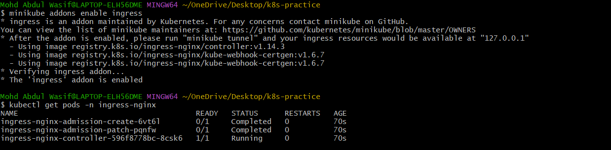
Create file:
vi ingress.yaml
Paste:
apiVersion: networking.k8s.io/v1
kind: Ingress

metadata:
name: myapp-ingress

spec:
ingressClassName: nginx

rules:
- host: myapp.com

http:
paths:
- path: /
pathType: Prefix

backend:
service:
name: nginx-service
port:
number: 80
Save:
ESC
:wq
ENTER
Apply:
kubectl apply -f ingress.yaml
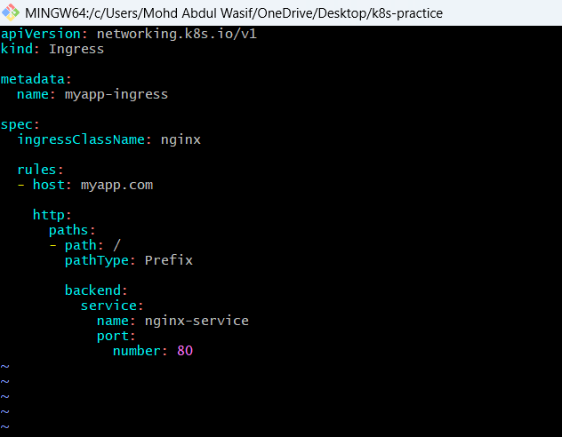

Step 5: Create Ingress Resource
kubectl apply -f ingress.yaml
Verify
kubectl get ingress
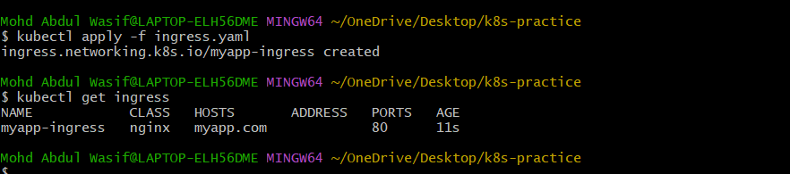

Step 6: Start Tunnel (Minikube)
minikube tunnel
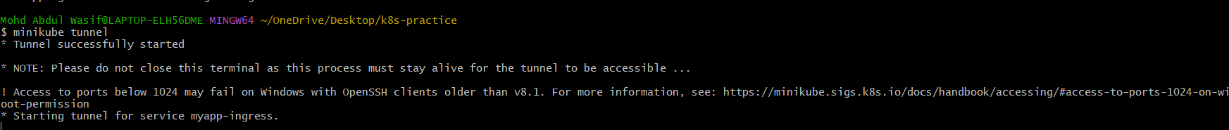

Step 7: Configure Local Hosts File
Example
127.0.0.1 myapp.com
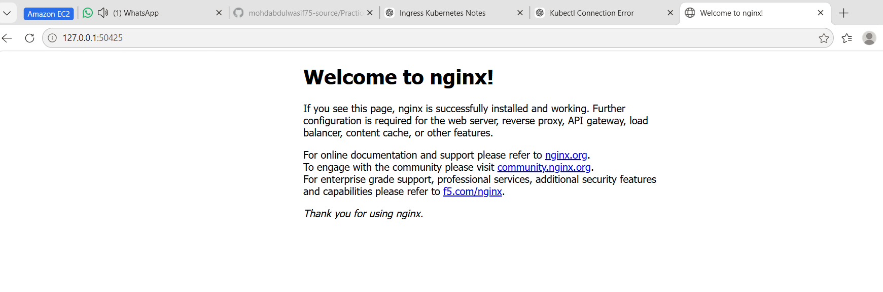

Step 8: Access Application
http:wasif.local
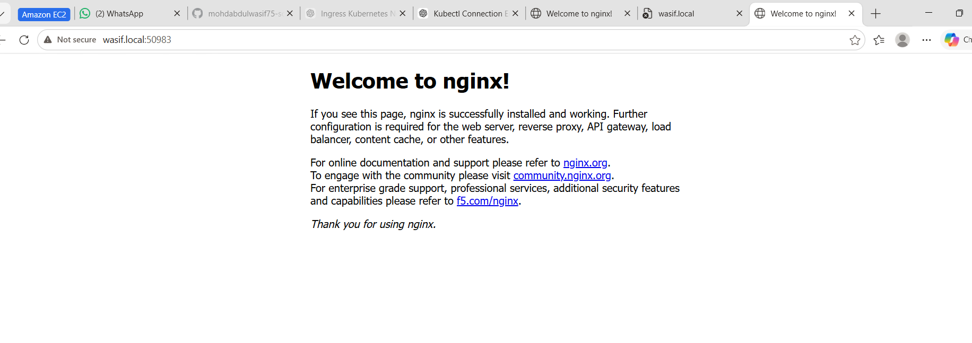

What We Learned
- What is Ingress
- What is Ingress Controller
- Difference between Service and Ingress
- Host-based Routing
- Path-based Routing
- Why Ingress is used
- How to expose applications using one entry point
- How NGINX Ingress Controller works

Conclusion
Successfully configured an NGINX Ingress Controller, created an Ingress Resource, and exposed a Kubernetes application using a domain name through a single entry point. Learned how Ingress reduces cost, supports advanced routing features, and simplifies application exposure.

Task 2: Upgrade Kubernetes Cluster (v1.35 → v1.36)
Objective
To safely upgrade Kubernetes cluster from v1.35.6 to v1.36.x using kubeadm by upgrading the Control Plane first followed by Worker Nodes with minimum downtime.

Prerequisites
Before starting:
- Kubernetes Cluster:
  - 1 Control Plane
  - 2 Worker Nodes
- Ubuntu/Amazon Linux nodes
- sudo access
- Internet connectivity
- Cluster backup recommended
Current Cluster:
Control Plane : k8s-master
Worker Nodes : k8s-worker01
k8s-worker02

Control Plane Upgrade
Login to Master:
ssh ec2-user@k8s-master

Step 1: Check Current Version
Check nodes:
kubectl get nodes
Output:
NAME STATUS VERSION
k8s-master Ready v1.35.6
k8s-worker01 Ready v1.35.6
k8s-worker02 Ready v1.35.6
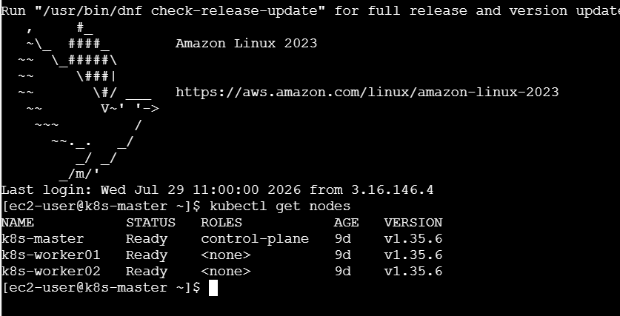
Check kubectl:
kubectl version
Check kubeadm:
kubeadm version
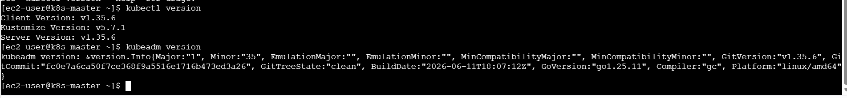

Step 2: Add Kubernetes v1.36 Repository
Remove old repository:
sudo rm -f /etc/yum.repos.d/kubernetes.repo
Create Kubernetes repo:
sudo tee /etc/yum.repos.d/kubernetes.repo <<EOF
[kubernetes]
name=Kubernetes
baseurl=https://pkgs.k8s.io/core:/stable:/v1.36/rpm/
enabled=1
gpgcheck=1
gpgkey=https://pkgs.k8s.io/core:/stable:/v1.36/rpm/repodata/repomd.xml.key
EOF
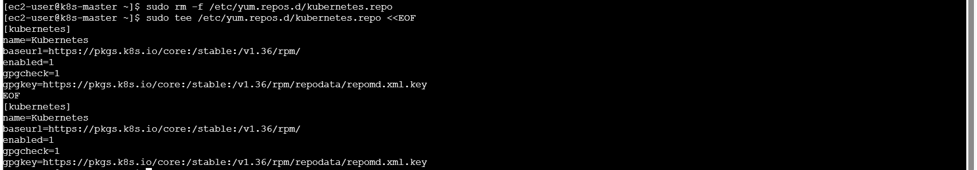
Update packages:
sudo yum clean all
sudo yum makecache
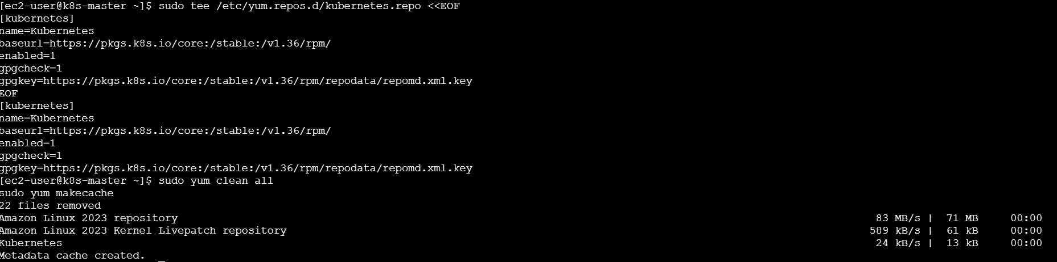

Step 3: Upgrade kubeadm
Check current kubeadm:
kubeadm version
Remove hold:
sudo yum versionlock delete kubeadm
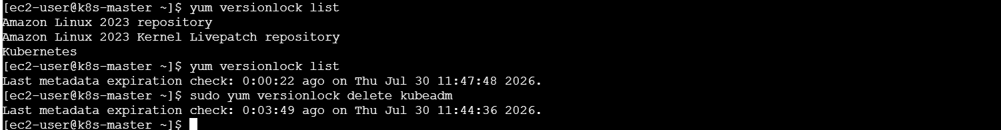
Install kubeadm 1.36:
sudo yum install -y kubeadm-1.36.*
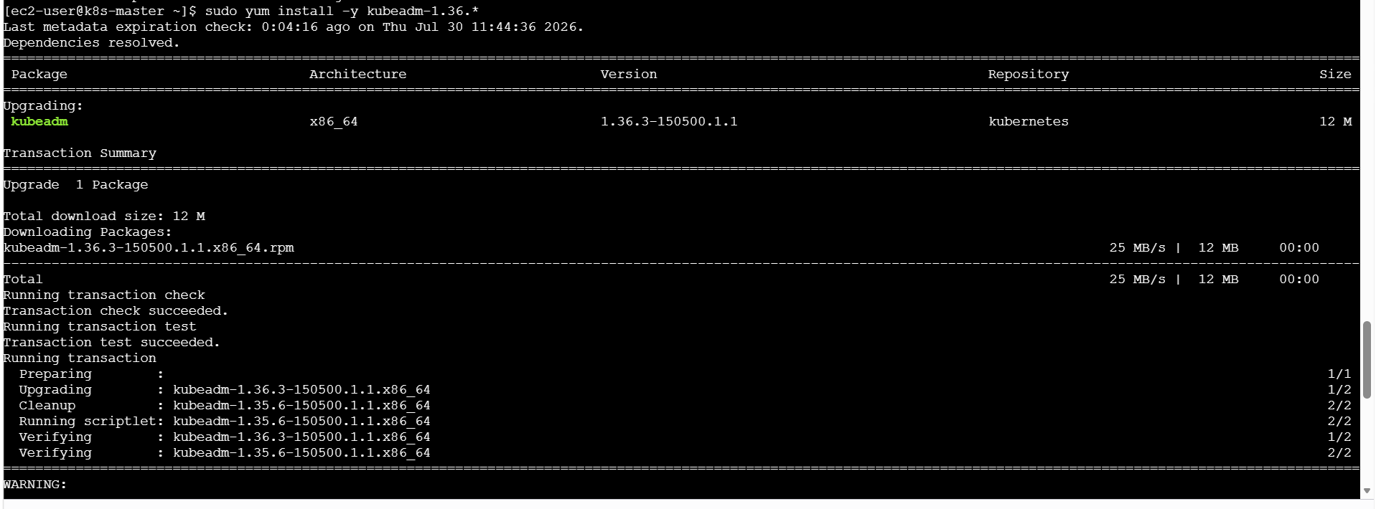
Verify:
kubeadm version
Expected:
kubeadm version: v1.36.x

Step 4: Check Upgrade Plan
Run:
sudo kubeadm upgrade plan
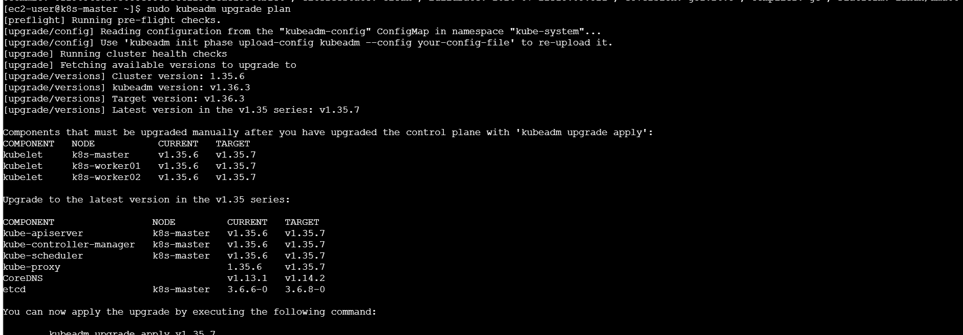
Purpose:
- Checks cluster health
- Shows available upgrade versions
- Validates prerequisites

Step 5: Upgrade Control Plane
Run:
sudo kubeadm upgrade apply v1.36.3
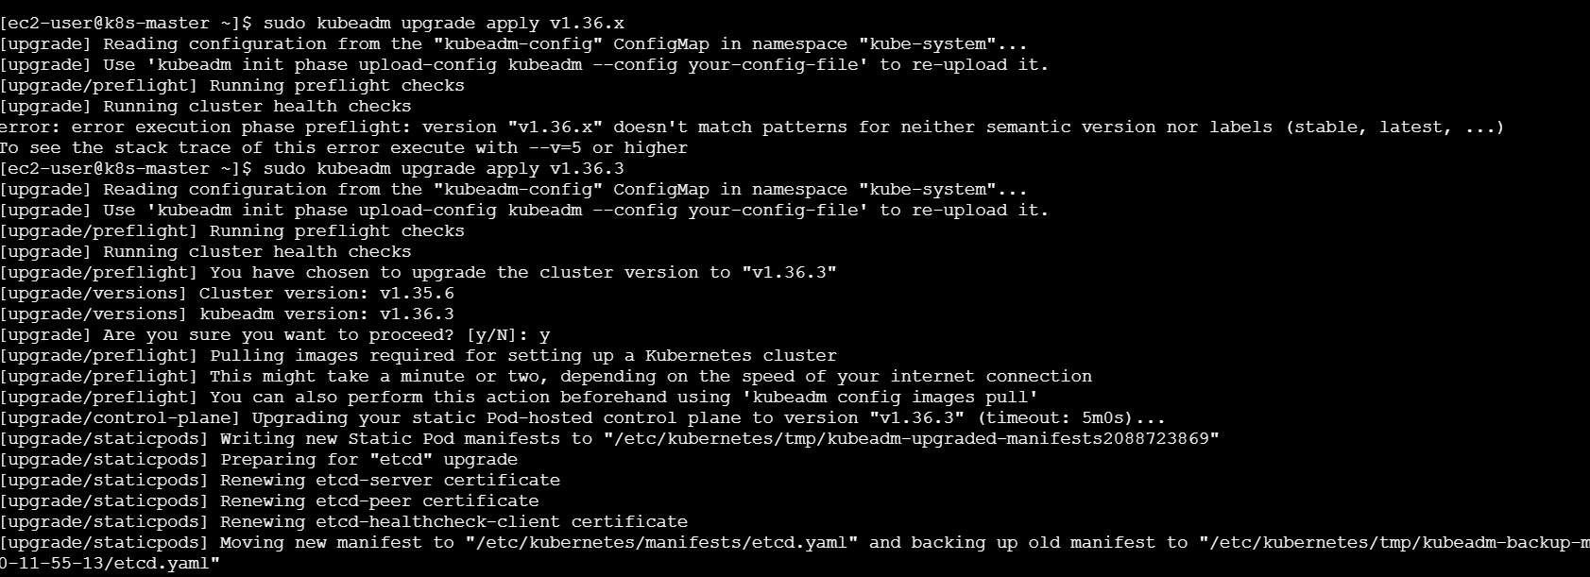
Example:
sudo kubeadm upgrade apply v1.36.0
Wait until completion.

Step 6: Drain Master Node
Find master name:
kubectl get nodes
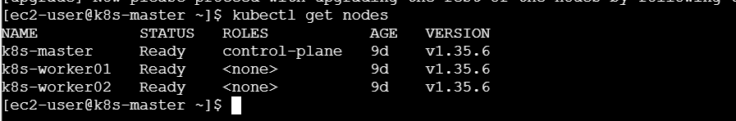
Drain:
kubectl drain k8s-master \
--ignore-daemonsets \
--delete-emptydir-data
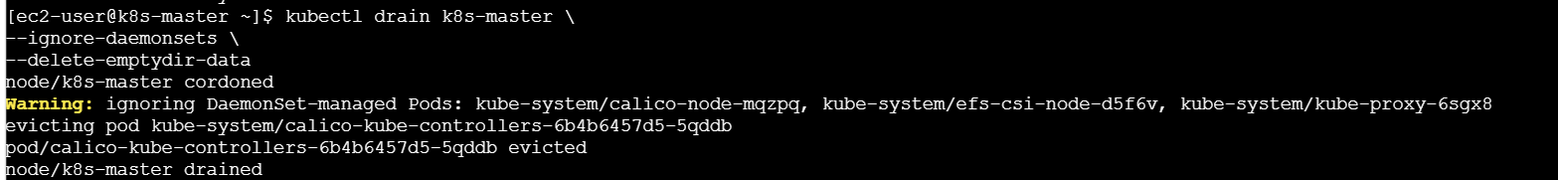
Check:
kubectl get nodes
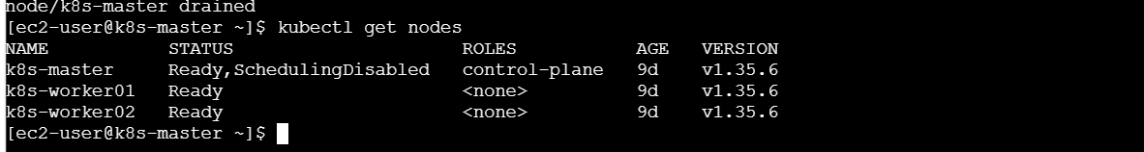
Expected:
k8s-master Ready,SchedulingDisabled

Step 7: Upgrade kubelet and kubectl
Remove version lock:
sudo yum versionlock delete kubelet kubectl
Upgrade:
sudo yum install -y kubelet-1.36.* kubectl-1.36.*
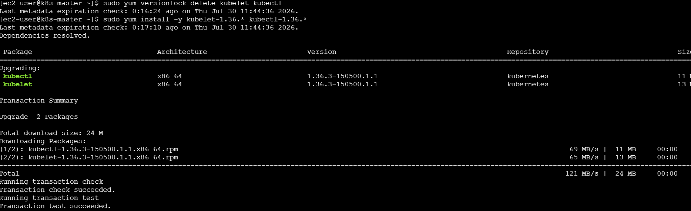
Lock packages:
sudo yum versionlock add kubelet kubectl
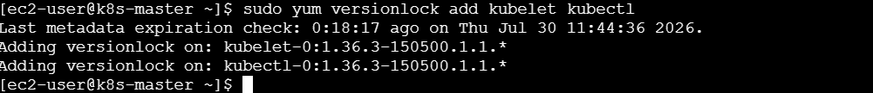

Step 8: Restart kubelet
sudo systemctl daemon-reload

sudo systemctl restart kubelet
Check:
systemctl status kubelet
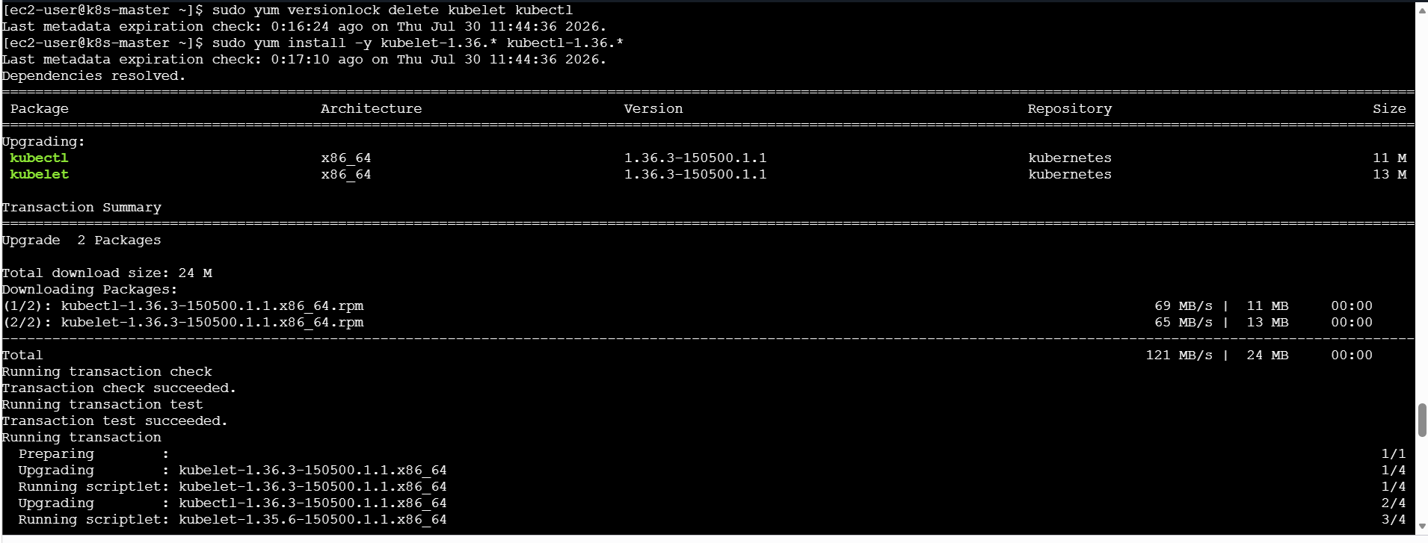

Step 9: Uncordon Master
Enable scheduling:
kubectl uncordon k8s-master
Verify:
kubectl get nodes
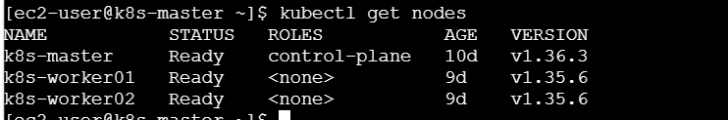
Expected:
k8s-master Ready v1.36.x

Worker Node Upgrade
Repeat for:
k8s-worker01
k8s-worker02

Step 10: Login Worker Node
Example:
ssh ec2-user@k8s-worker01
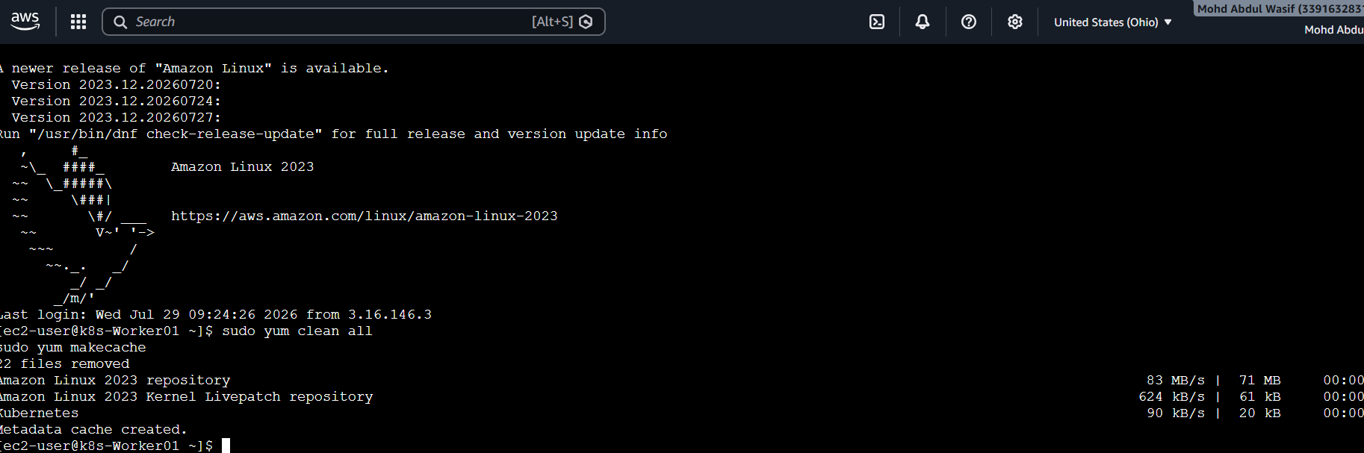
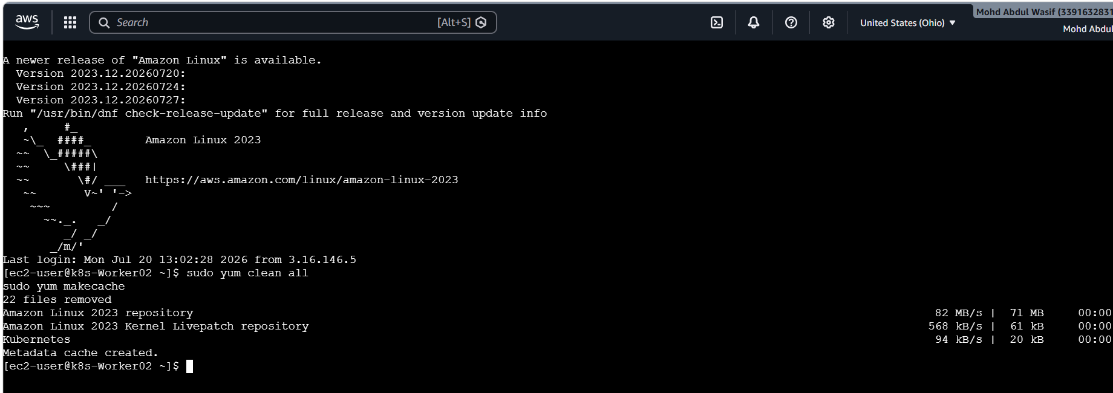

Step 11: Upgrade kubeadm
Update repo:
sudo yum clean all
sudo yum makecache
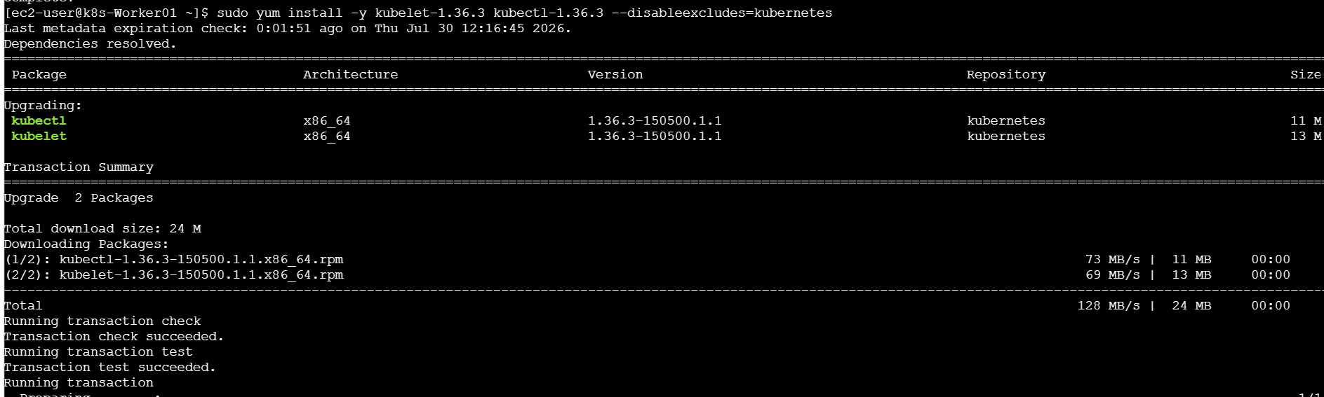
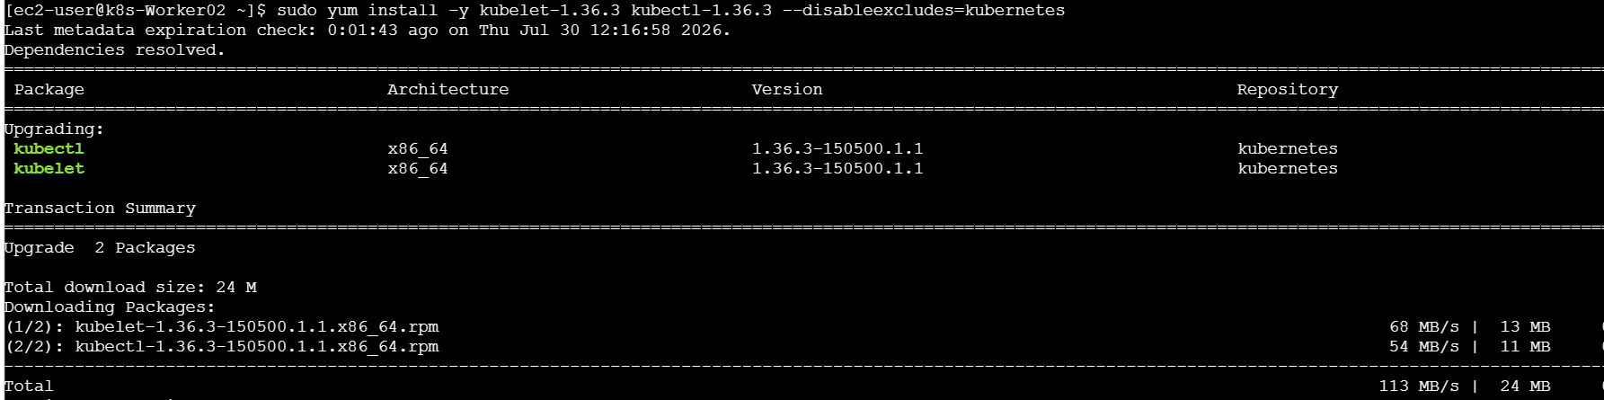
Install:
sudo yum install -y kubeadm-1.36.*
Verify:
kubeadm version

Step 12: Upgrade Worker Configuration
Run:
sudo kubeadm upgrade node

Step 13: Drain Worker Node
Run from Master:
kubectl drain k8s-worker01 \
--ignore-daemonsets \
--delete-emptydir-data
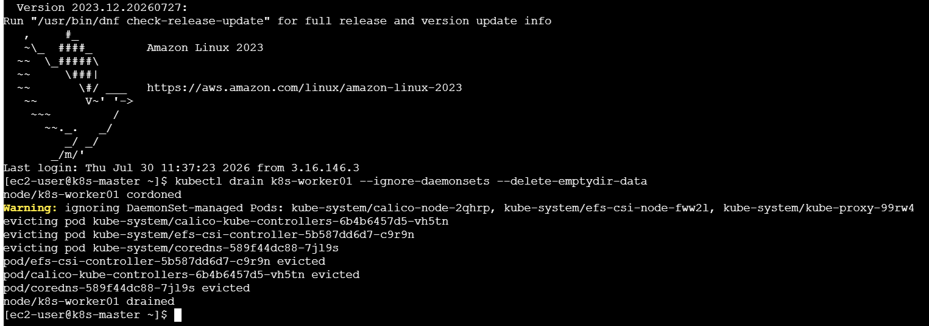
Worker 1 Upgrade
Step 1: Drain the worker (run on the master)
kubectl drain k8s-worker01 --ignore-daemonsets --delete-emptydir-data
Step 2: On k8s-worker01, update the Kubernetes repository to v1.36
sudo vi /etc/yum.repos.d/kubernetes.repo
Use:
[kubernetes]
name=Kubernetes
baseurl=https://pkgs.k8s.io/core:/stable:/v1.36/rpm/
enabled=1
gpgcheck=1
gpgkey=https://pkgs.k8s.io/core:/stable:/v1.36/rpm/repodata/repomd.xml.key
exclude=kubelet kubeadm kubectl cri-tools kubernetes-cni
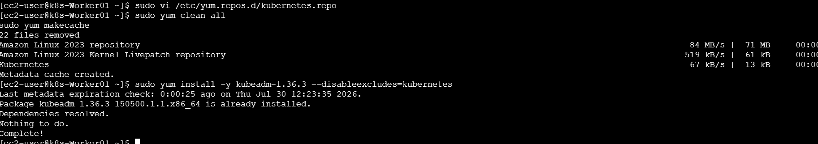
Step 3: Refresh package metadata
sudo yum clean all
sudo yum makecache
Step 4: Upgrade kubeadm
sudo yum install -y kubeadm-1.36.3 --disableexcludes=Kubernetes
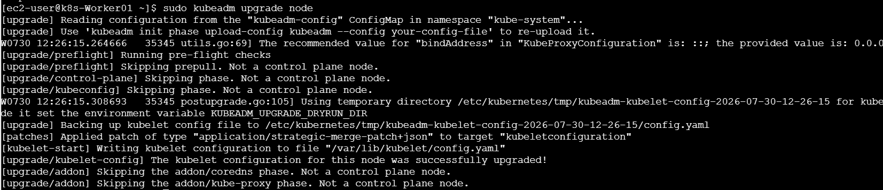
Verify:
kubeadm version
It should show:
v1.36.3
Step 5: Upgrade the node
sudo kubeadm upgrade node
Step 6: Upgrade kubelet and kubectl
sudo yum install -y kubelet-1.36.3 kubectl-1.36.3 --disableexcludes=Kubernetes
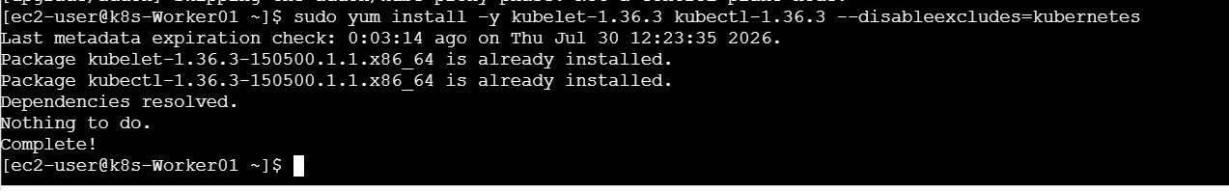
Step 7: Restart kubelet
sudo systemctl daemon-reload
sudo systemctl restart kubelet
Step 8: Mark the node schedulable again (run on the master)
kubectl uncordon k8s-worker01
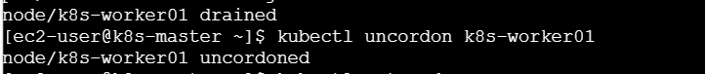

Repeat Same Steps For Worker02
Login:
ssh ec2-user@k8s-worker02
Perform:
Upgrade kubeadm
kubeadm upgrade node
Drain node
Upgrade kubelet
Restart kubelet
Uncordon node

Final Verification
Run on Master:
kubectl get nodes
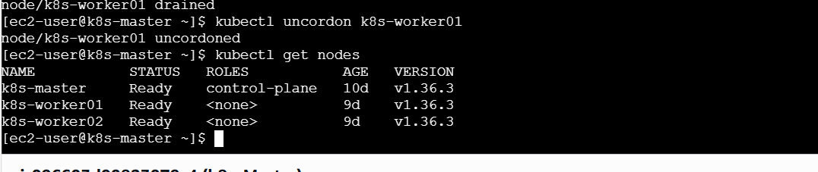
Expected:
NAME STATUS ROLES VERSION

k8s-master Ready control-plane v1.36.x

k8s-worker01 Ready <none> v1.36.x

k8s-worker02 Ready <none> v1.36.x

Important Commands
Command | Purpose
kubectl get nodes | Check node versions
kubeadm version | Check kubeadm version
kubeadm upgrade plan | Check upgrade readiness
kubeadm upgrade apply | Upgrade control plane
kubeadm upgrade node | Upgrade worker configuration
kubectl drain | Safely remove node from scheduling
kubectl uncordon | Enable scheduling
systemctl restart kubelet | Restart Kubernetes agent

What We Learned
- Kubernetes upgrade should follow minor version sequence.
- Control Plane is upgraded before Workers.
- kubeadm manages cluster upgrade process.
- kubelet runs Kubernetes node services.
- kubectl communicates with Kubernetes API.
- Drain protects workloads during maintenance.
- Uncordon brings nodes back into scheduling.
- Version upgrades require careful planning in production.

Conclusion
Successfully upgraded Kubernetes cluster from v1.35.6 to v1.36.x using kubeadm. The Control Plane was upgraded first, followed by Worker Nodes. Nodes were drained before maintenance and uncordoned after completion to ensure workloads continued running with minimum disruption.

