Kubernetes-Task-10
Task 1: Setup EKS Cluster Using eksctl
Objective
To create an Amazon EKS cluster using the eksctl command-line tool and verify that the Kubernetes control plane and worker nodes are working correctly.
Prerequisites
- AWS account
- IAM user/role with required permissions
- AWS CLI installed
- kubectl installed
- eksctl installed
- Internet connectivity
Step 1: Configure AWS CLI
Check AWS CLI:
aws --version
Configure credentials:
aws configure
Enter:
AWS Access Key ID
AWS Secret Access Key
Default region name: us-east-1
Default output format: json
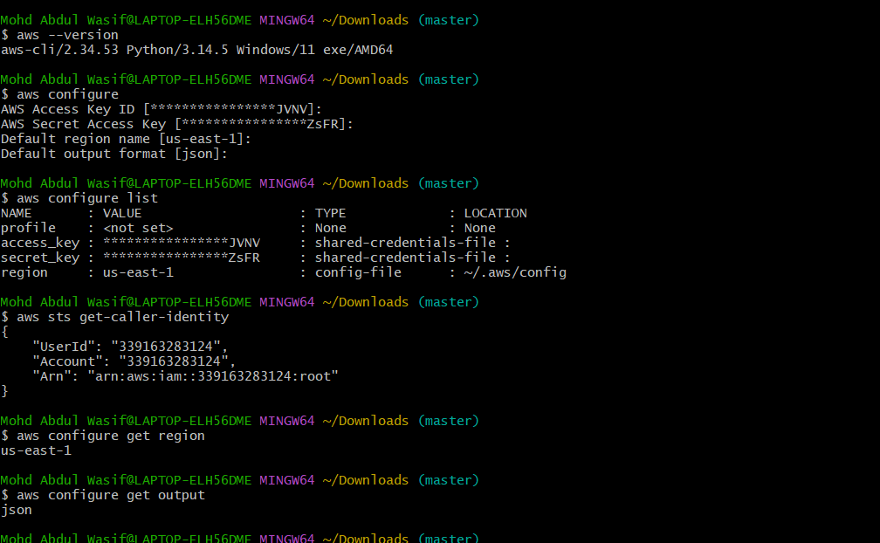
Verify:
aws sts get-caller-identity

Step 2: Check eksctl
Run these commands in PowerShell, one at a time:
Set-ExecutionPolicy Bypass -Scope Process -Force
Then:
[System.Net.ServicePointManager]::SecurityProtocol = [System.Net.ServicePointManager]::SecurityProtocol -bor 3072
Then:
iex ((New-Object System.Net.WebClient).DownloadString('https://community.chocolatey.org/install.ps1'))
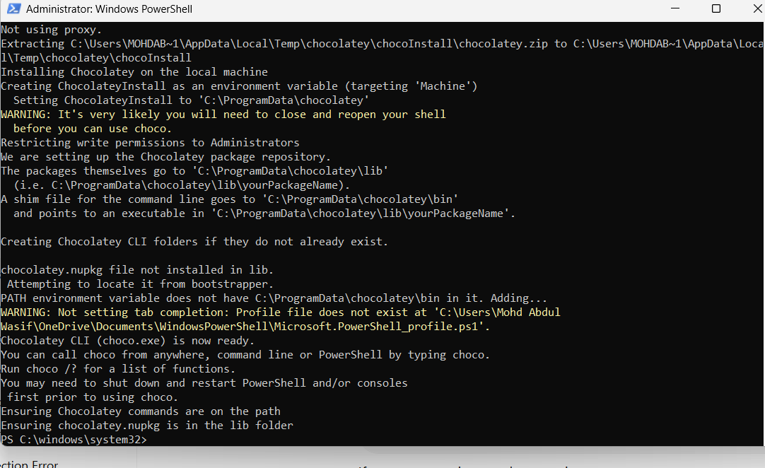
4. After Chocolatey finishes, close PowerShell completely.
Open a new Administrator PowerShell and run:
choco --version
If you get a version number, continue:
choco install -y eksctl
Then:
eksctl version

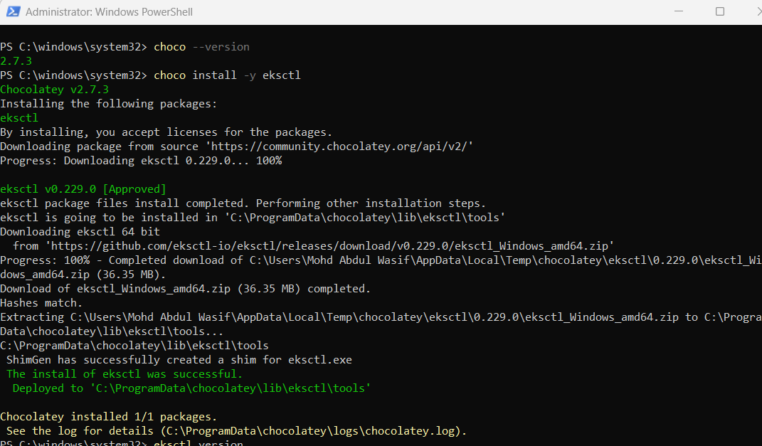
eksctl version
If it is installed correctly, you should see its version.

Step 3: Create EKS Cluster
Example:
eksctl create cluster \
--name my-eks-cluster \
--region us-east-1 \
--nodegroup-name worker-nodes \
--node-type t3.medium \
--nodes 2 \
--nodes-min 1 \
--nodes-max 3 \
--managed
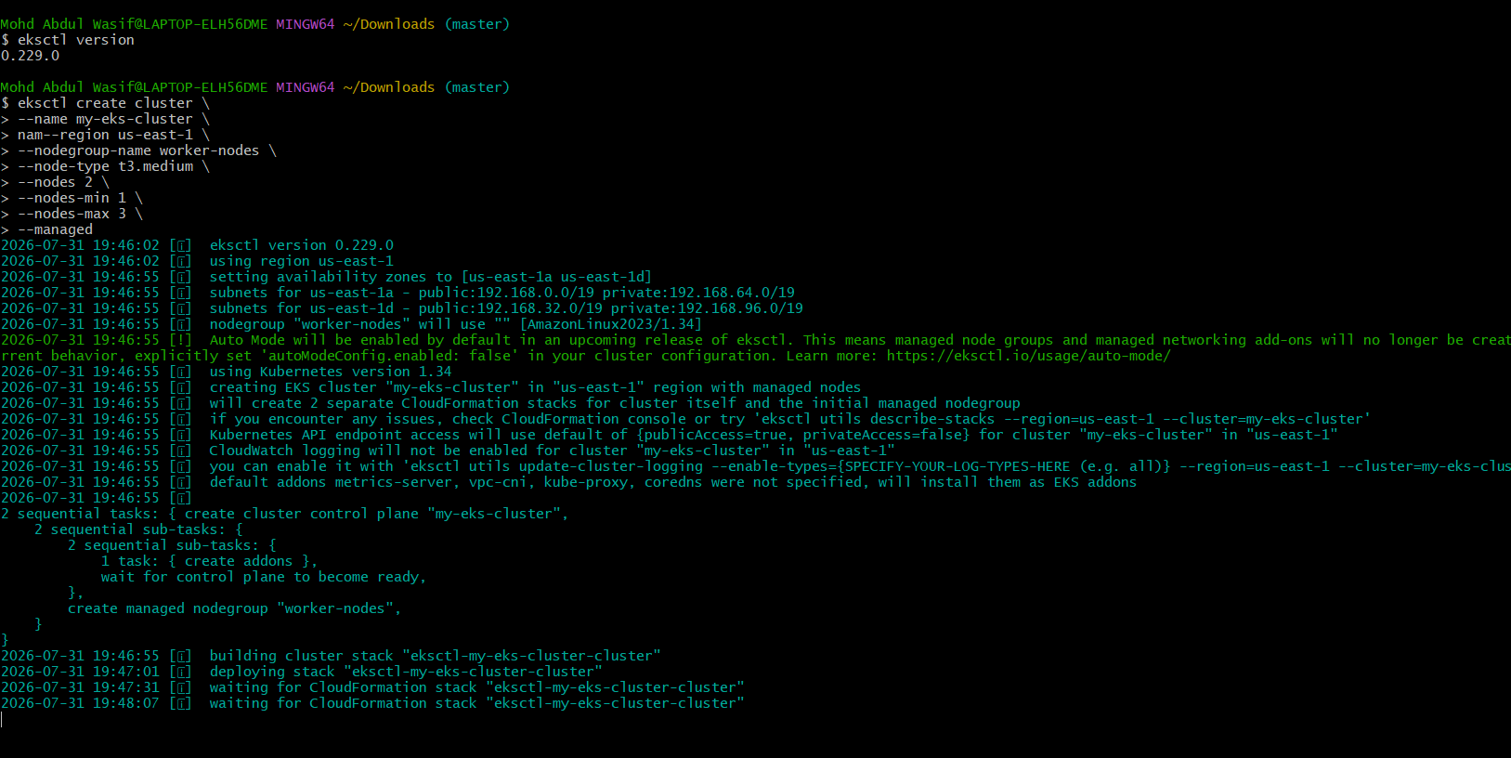
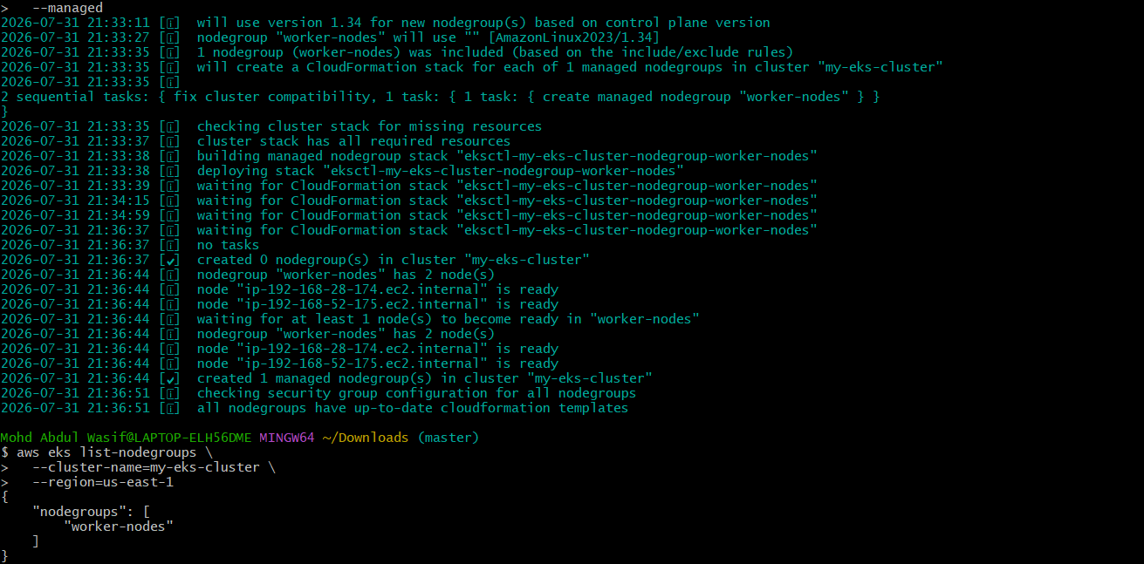
This creates:
- EKS control plane
- VPC/networking
- 2 worker nodes
- Managed node group
- Security groups
- IAM roles
- Required networking configuration
The process can take several minutes.

Step 4: Verify Cluster
kubectl get nodes
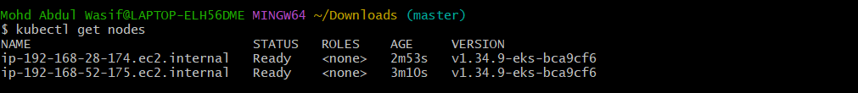
Expected:
NAME STATUS ROLES
ip-xxx-xxx-xxx-xxx Ready <none>
ip-xxx-xxx-xxx-xxx Ready <none>
Check cluster information:
kubectl cluster-info

Step 5: Check Pods
kubectl get pods -A
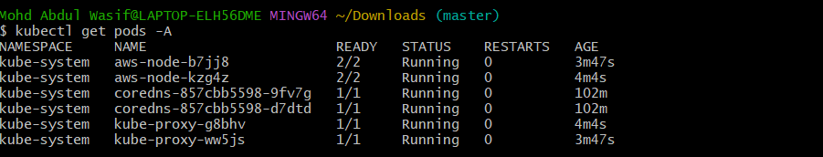
You should see Kubernetes system components such as:
coredns
kube-proxy
aws-node

Step 6: Deploy Test Application
Create:
kubectl create deployment nginx --image=nginx
Check:
kubectl get deployments
kubectl get pods
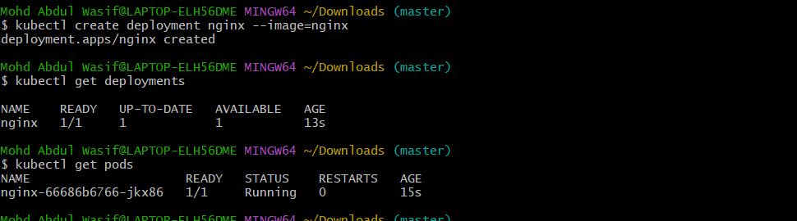
Expose it:
kubectl expose deployment nginx \
--type=LoadBalancer \
--port=80
Check:
kubectl get svc
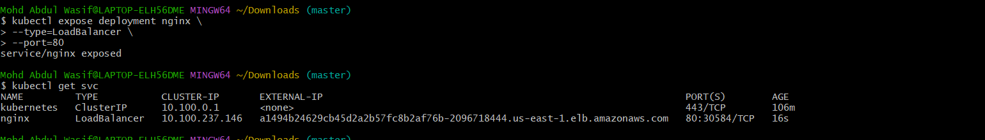

What We Learned
- How to create an EKS cluster using eksctl
- How EKS control plane and worker nodes work
- How to configure AWS CLI
- How to verify EKS nodes and system pods
- How to deploy an application to EKS
Conclusion
We successfully created an EKS cluster using eksctl, verified the worker nodes, and deployed an Nginx application.

Task 2: Setup EKS Cluster Using AWS Console
Objective
To create an Amazon EKS cluster manually using the AWS Management Console and understand the different configuration options.
Step 1: Open EKS Console
Go to the AWS Management Console and open:
Amazon EKS → Clusters → Create cluster

Step 2: Configure Cluster
Select:
Create
Enter:
Cluster name: console-eks-cluster
Kubernetes version: choose the supported version you want to practice
Select/create an IAM role for the EKS cluster.
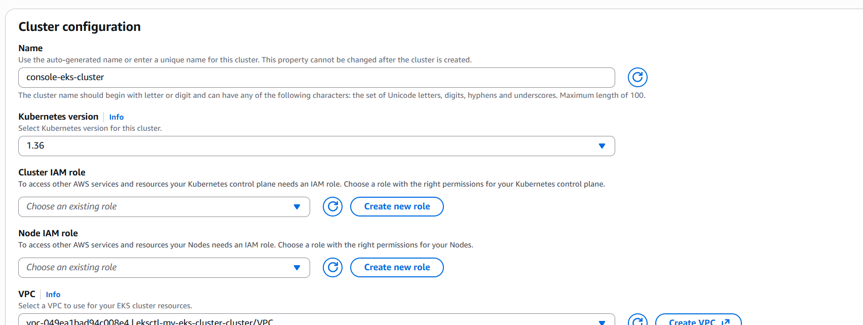
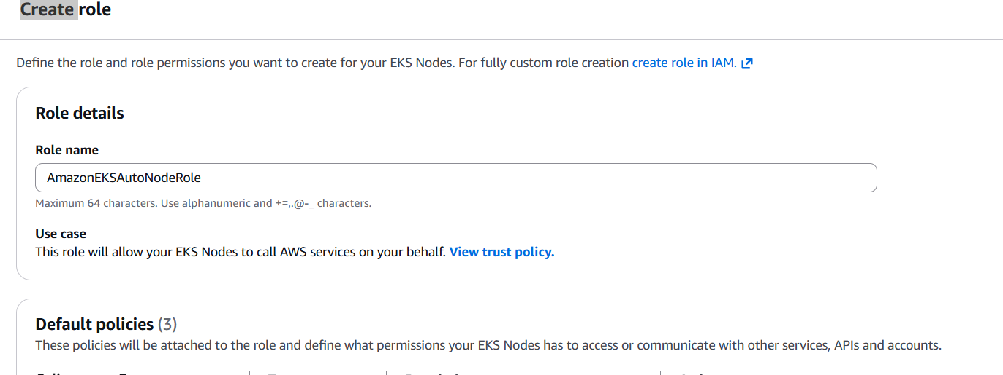
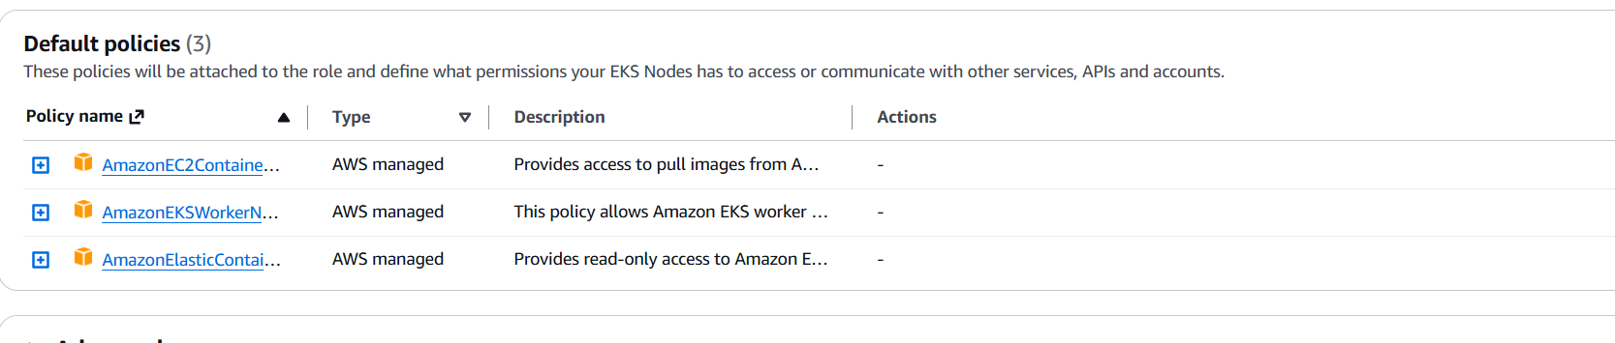
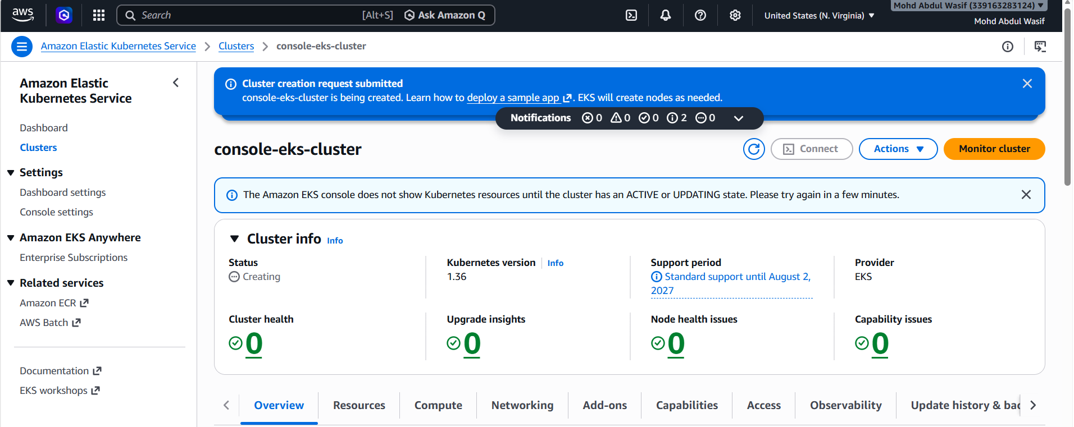

Step 3: Configure Networking
Select:
- VPC
- Subnets
- Security groups
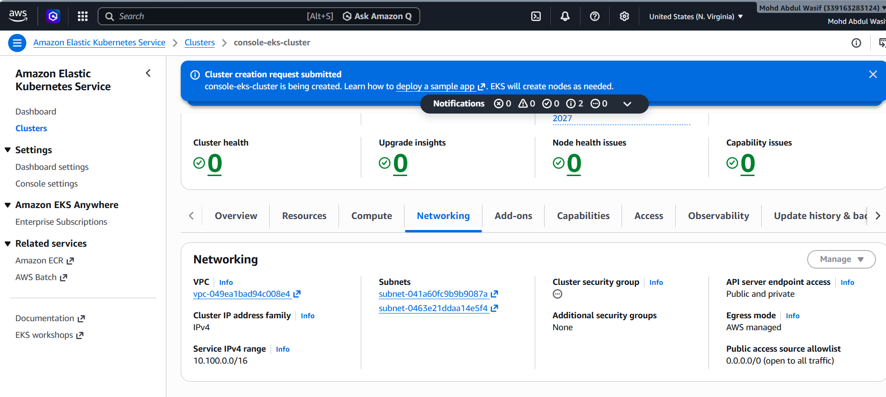
For practice, you can use the VPC created for the cluster or an existing suitable VPC.
Make sure the selected subnets are appropriate for EKS.

Step 4: Configure Add-ons
During cluster creation, AWS may provide options for EKS add-ons.
Common add-ons include:
- Amazon VPC CNI
- CoreDNS
- kube-proxy
Keep the recommended/default configuration for a basic practice cluster.

Step 5: Create Cluster
Click:
Create
Wait until the cluster status becomes:
ACTIVE

Step 6: Create Node Group
Go to:
EKS
→ Clusters
→ console-eks-cluster
→ Compute
→ Add node group
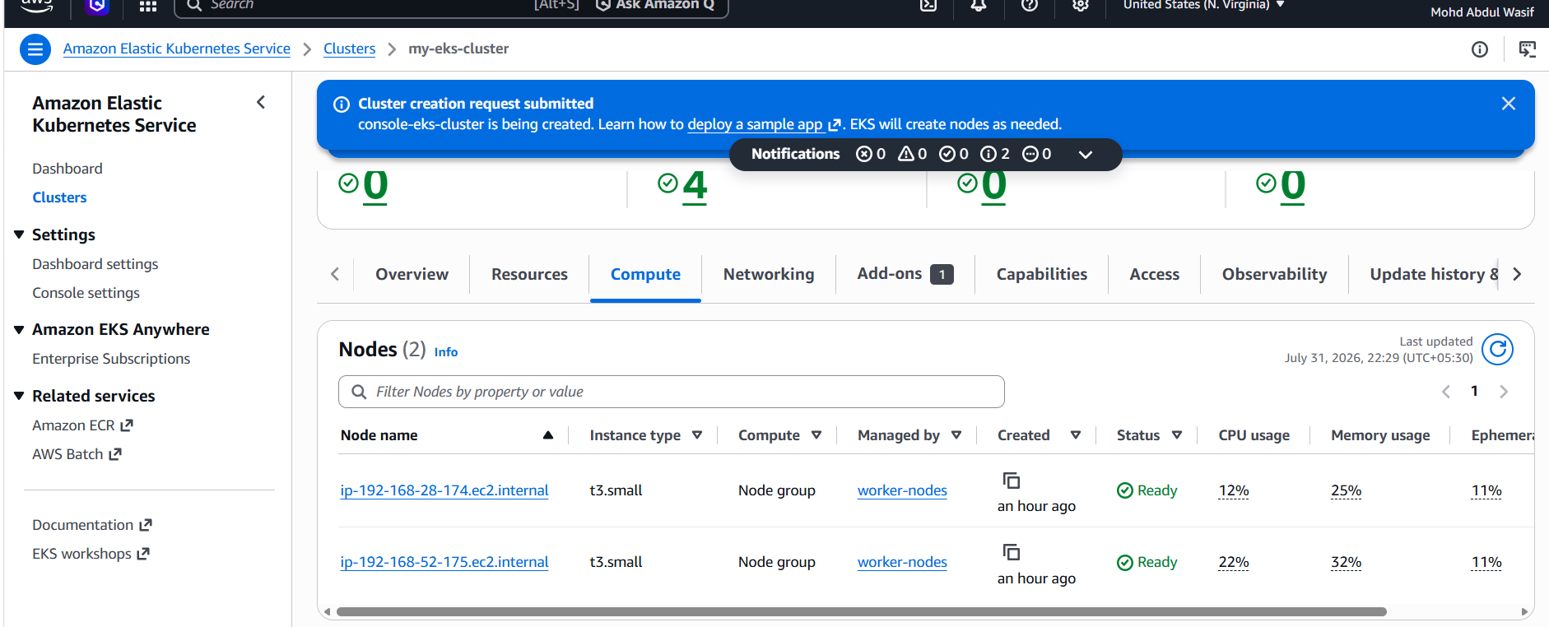
Enter:
Node group name: worker-group
Select/create the required IAM role.
Choose an instance type such as:
t3.medium
Set desired capacity:
Desired: 2
Minimum: 1
Maximum: 3
Create the node group.
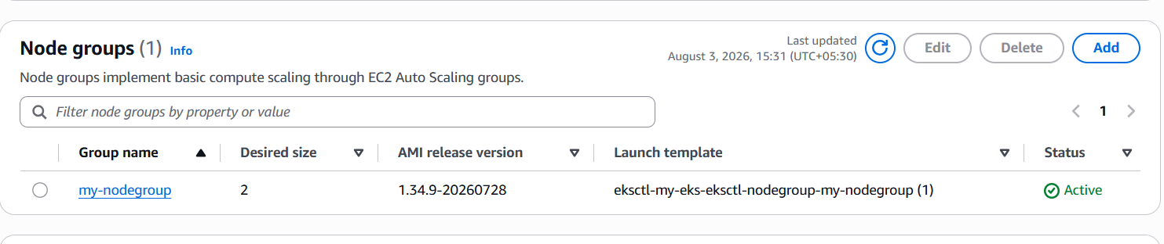
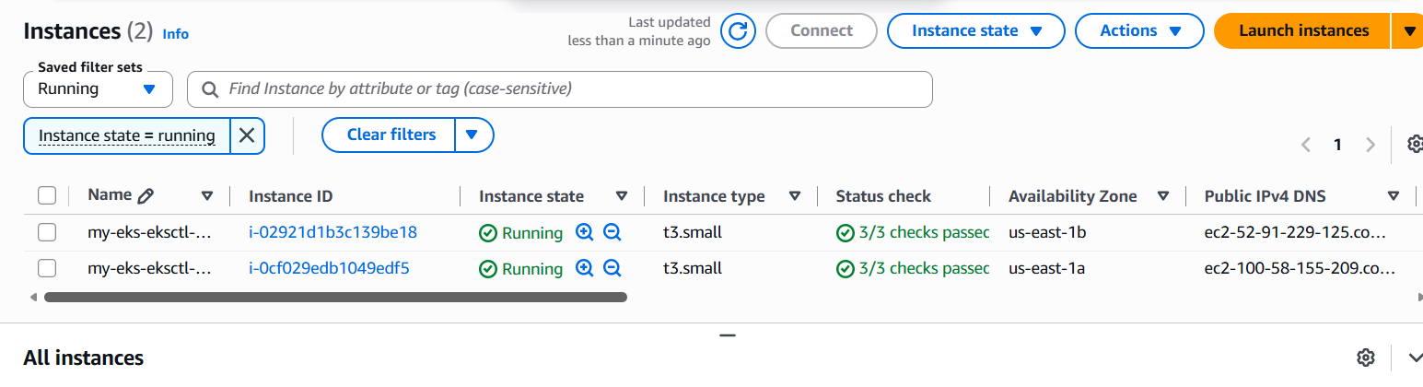

Step 7: Connect kubectl
AWS Console provides the command/instructions to update your kubeconfig.
Typically:
aws eks update-kubeconfig \
--region us-east-1 \
--name console-eks-cluster
Verify:
kubectl get nodes

Step 8: Verify
kubectl get pods -A
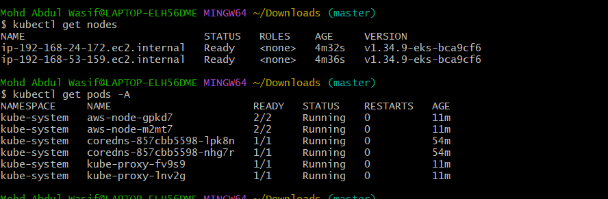
kubectl get svc -A

What We Learned
- How to create EKS using the AWS Console
- How to configure EKS networking
- How to create managed node groups
- How to connect kubectl to EKS
- Difference between CLI-based and console-based EKS creation
Conclusion
We successfully created an EKS cluster through the AWS Console and connected to it using kubectl.

Task 3 — Setup HPA
Now we can use the same EKS cluster.
Objective
Configure a Horizontal Pod Autoscaler so that Kubernetes automatically increases or decreases pod replicas based on CPU utilization.

Step 1: Check Metrics Server
Run:
kubectl get deployment metrics-server -n kube-system
If it doesn't exist, install the EKS Metrics Server add-on/method appropriate for yourcluster version.
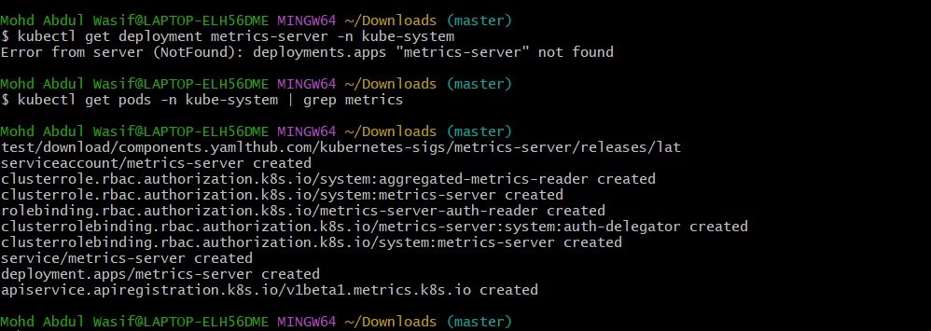
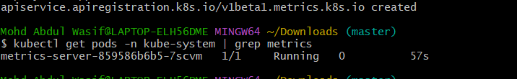
Then verify:
kubectl top nodes
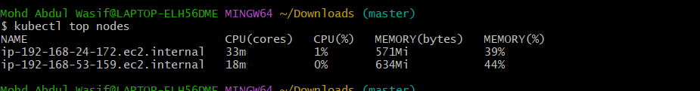
You should get something similar to:
NAME CPU(cores) CPU% MEMORY(bytes) MEMORY%
node-1 120m 6% 800Mi 20%
node-2 100m 5% 750Mi 19%
If kubectl top nodes doesn't work, don't continue with HPA until Metrics Server is working.
--limits=cpu=500m
Step 3 — Create an Application
Create a deployment:
kubectl create deployment hpa-nginx --image=nginx
Check:
kubectl get deployment hpa-nginx
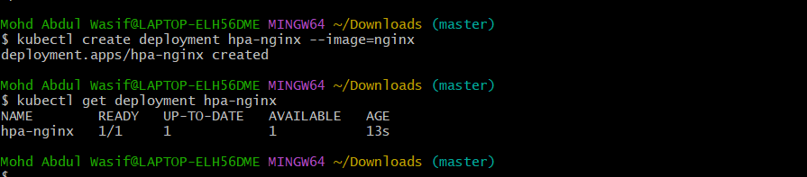
Expected:
NAME READY UP-TO-DATE AVAILABLE
hpa-nginx 1/1 1 1

Step 4 — Set CPU Request
HPA needs a CPU request to calculate utilization.
Run:
kubectl set resources deployment hpa-nginx \
--requests=cpu=100m \
--limits=cpu=200m
Verify:
kubectl describe deployment hpa-nginx
Look for:
Requests:
cpu: 100m

Limits:
cpu: 200m
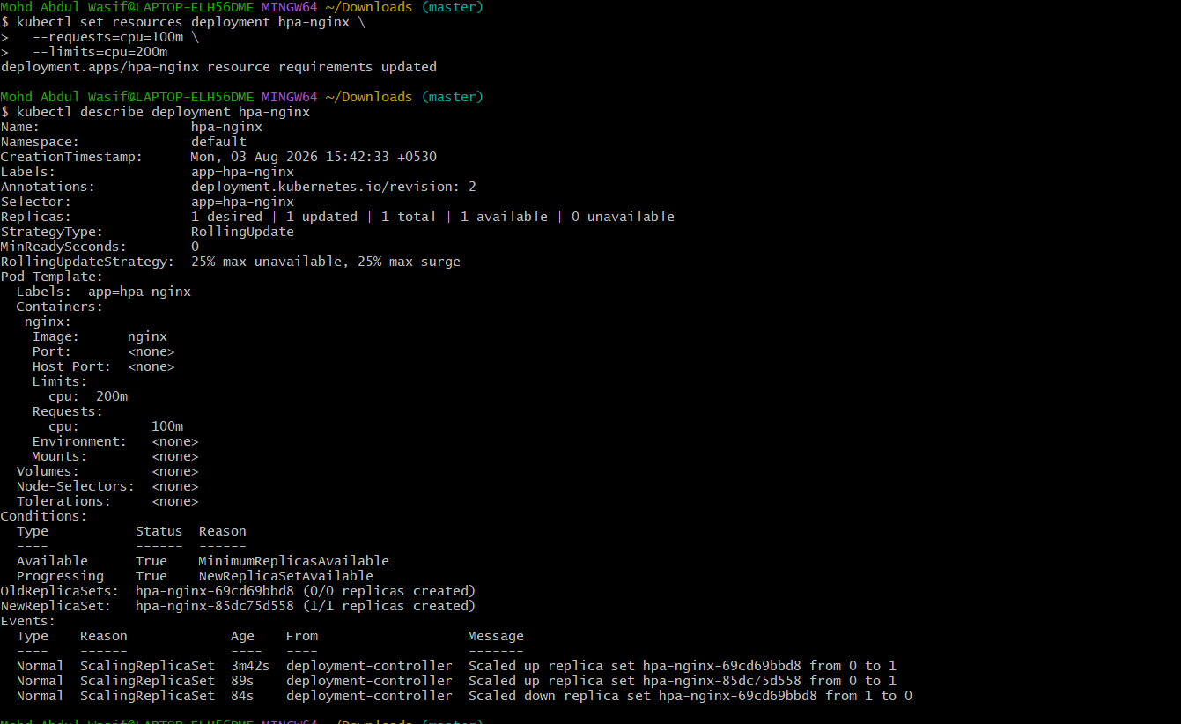

Step 5 — Create HPA
Create an HPA with:
- Minimum replicas = 1
- Maximum replicas = 5
- Target CPU = 50%
Run:
kubectl autoscale deployment hpa-nginx \
--cpu-percent=50 \
--min=1 \
--max=5
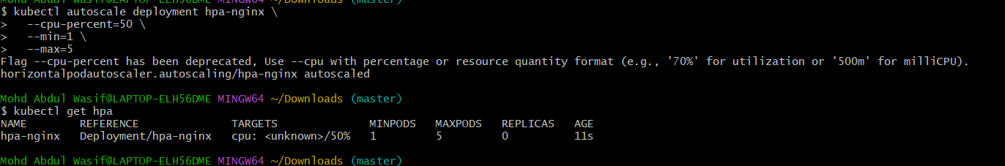
Check:
kubectl get hpa
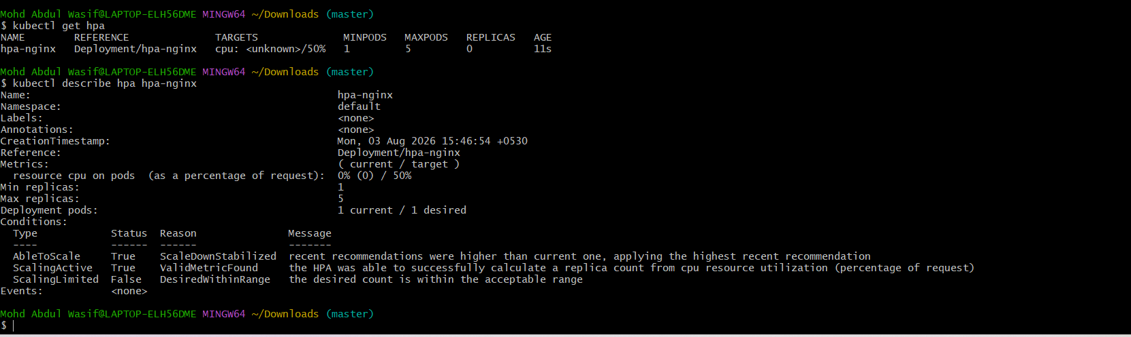
You should see:
NAME REFERENCE TARGETS MINPODS MAXPODS REPLICAS
hpa-nginx Deployment/hpa-nginx .../50% 1 5 1

Step 6 — Detailed HPA check
kubectl describe hpa hpa-nginx
You should see:
Min replicas: 1
Max replicas: 5
Target CPU utilization: 50%

Step 7 — Generate CPU load
Now we need to create CPU load so HPA has a reason to scale.
Create a temporary load generator:
kubectl run load-generator \
--image=busybox \
--restart=Never \
-- /bin/sh -c "while true; do wget -q -O- http://hpa-nginx; done"
But hpa-nginx currently doesn't have a Service, so first create one:
kubectl expose deployment hpa-nginx \
--port=80 \
--target-port=80 \
--name=hpa-nginx
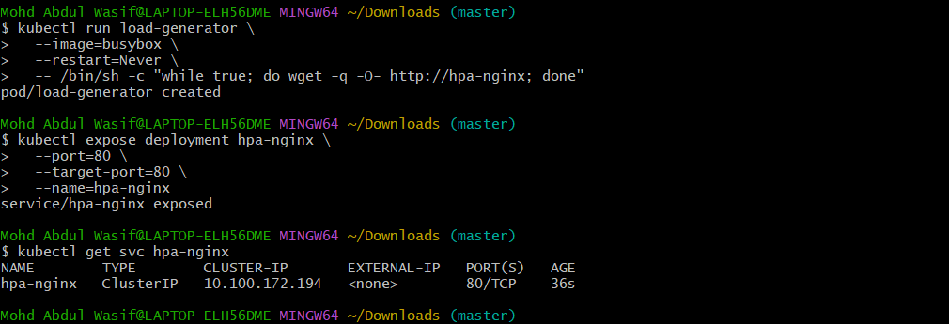
Check:
kubectl get svc hpa-nginx
Then create the load generator:
kubectl run load-generator \
--image=busybox \
--restart=Never \
-- /bin/sh -c "while true; do wget -q -O- http://hpa-nginx; done"
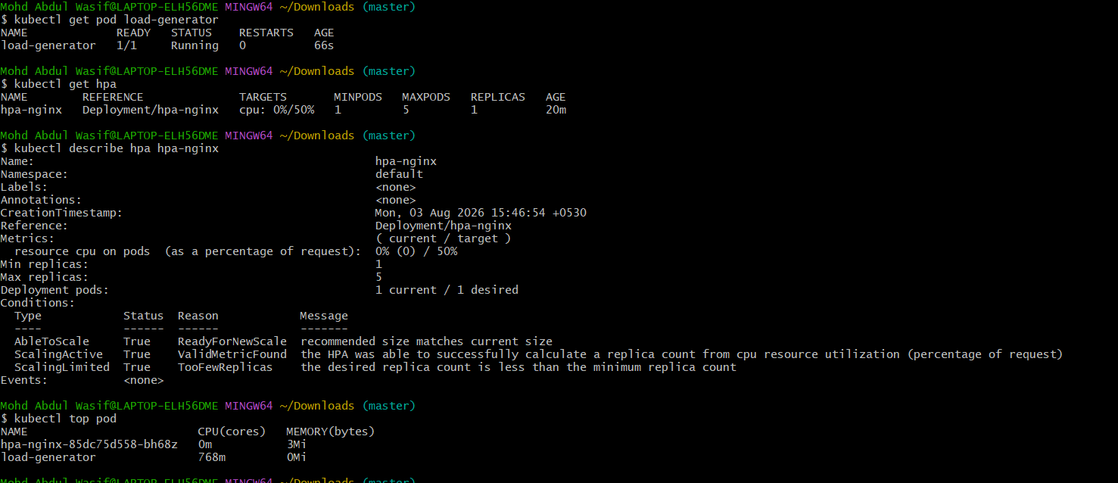

Step 8 — Watch HPA
Run:
kubectl get hpa -w
You may initially see:
REPLICAS
1
After CPU increases, HPA should increase replicas:
1 → 2 → 3 ...
The maximum is:
5
So Kubernetes will not exceed 5 replicas.

Step 9 — Watch Pods
Open another terminal and run:
kubectl get pods -w
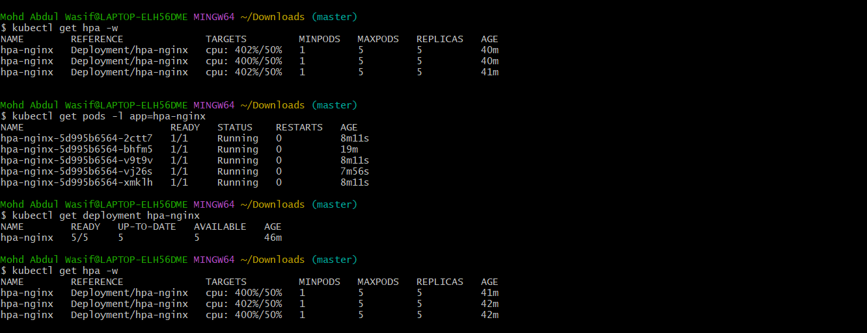
You should eventually see additional pods:
hpa-nginx-xxxxx 1/1 Running
hpa-nginx-yyyyy 1/1 Running
hpa-nginx-zzzzz 1/1 Running

Step 10 — Stop the load
Once you've observed scaling, delete the load generator:
kubectl delete pod load-generator
Then watch:
kubectl get hpa -w

After CPU falls, HPA should eventually scale the deployment back toward:
1 replica

Step 11 — Final verification
Run:
kubectl get deployment hpa-nginx
kubectl get hpa
kubectl get pods
You can also check metrics:
kubectl top pods
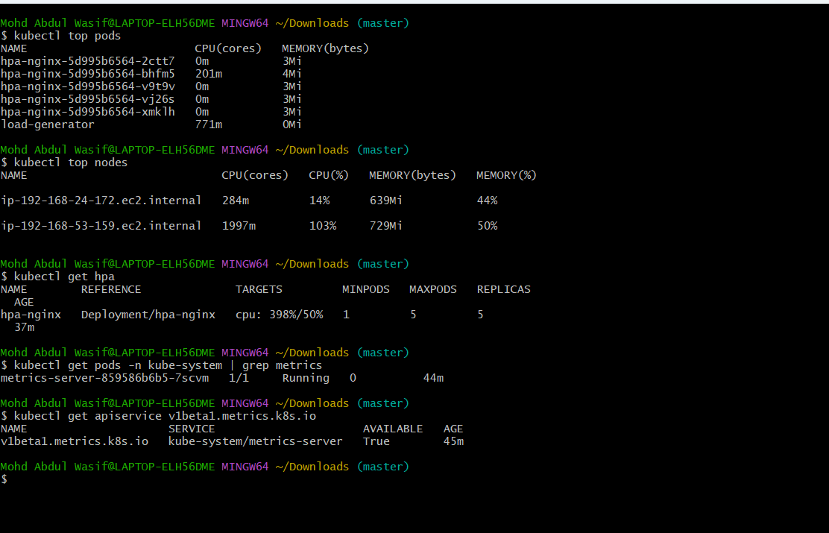

Task 3 Completed When
You have demonstrated:
Deployment
↓
HPA
↓
CPU increases
↓
Pods increase
↓
CPU decreases
↓
Pods decrease
What we learned
HPA (Horizontal Pod Autoscaler) automatically changes the number of pod replicas based on resource utilization such as CPU.
Important distinction:
HPA
↓
More/fewer PODS

Cluster Autoscaler
↓
More/fewer NODES
We'll use that distinction in your next task — Cluster Autoscaler.
Start with Step 1
Run:
kubectl get deployment metrics-server -n kube-system
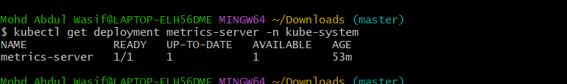

Task 4: Kubernetes Secret and Inject into Pod
Objective
Create a Kubernetes Secret and make the secret value available inside a Pod as an environment variable.
Step 1: Create a Secret
Run:
kubectl create secret generic app-secret \
--from-literal=username=admin \
--from-literal=password=MyPassword123
Verify:
kubectl get secret app-secret
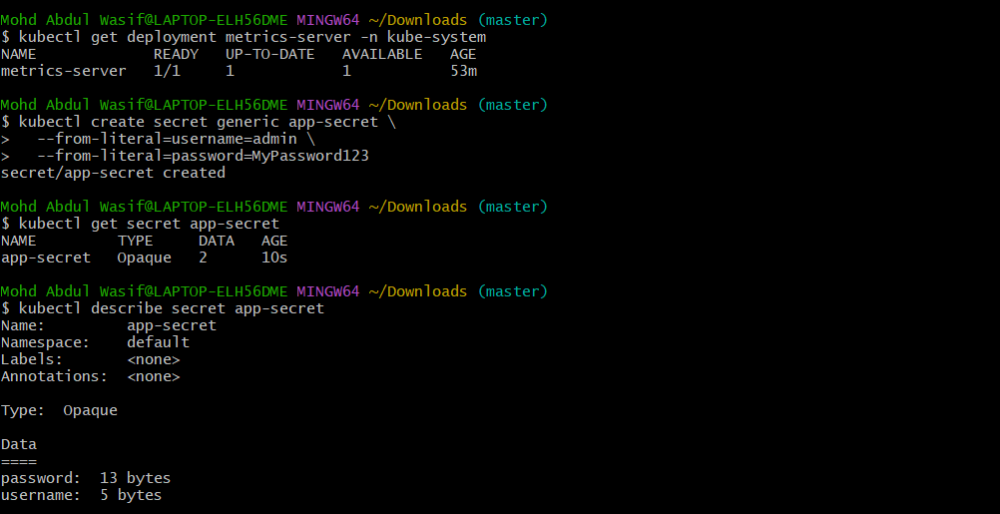
You can also check:
kubectl describe secret app-secret
describe will show the keys, but not reveal the actual values.

Step 2: Create a Pod YAML
Create secret-pod.yaml:
apiVersion: v1
kind: Pod
metadata:
name: secret-pod
spec:
containers:
- name: nginx
image: nginx
env:
- name: APP_USERNAME
valueFrom:
secretKeyRef:
name: app-secret
key: username

- name: APP_PASSWORD
valueFrom:
secretKeyRef:
name: app-secret
key: password
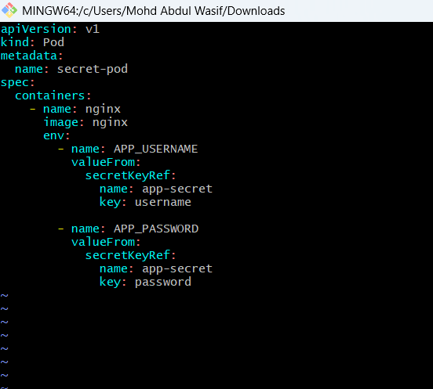
Apply it:
kubectl apply -f secret-pod.yaml

Step 3: Verify the Pod
kubectl get pod secret-pod
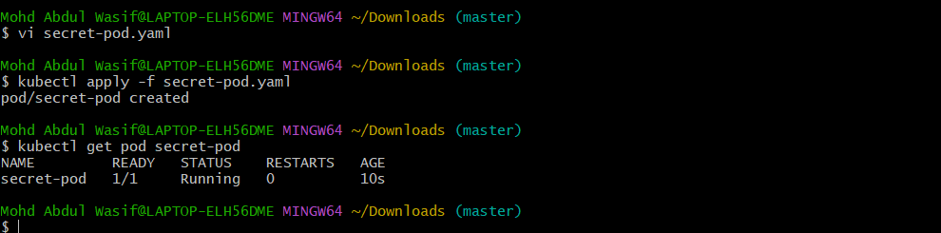
Expected:
NAME READY STATUS RESTARTS AGE
secret-pod 1/1 Running 0 ...

Step 4: Verify the Secret Inside the Pod
Run:
kubectl exec secret-pod -- env | grep APP_
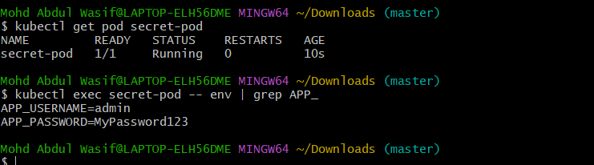
Expected:
APP_USERNAME=admin
APP_PASSWORD=MyPassword123
This confirms that the Kubernetes Secret was successfully injected into the container. ✅

Step 5: Test the Secret
You can also check individually:
kubectl exec secret-pod -- printenv APP_USERNAME
and:
kubectl exec secret-pod -- printenv APP_PASSWORD
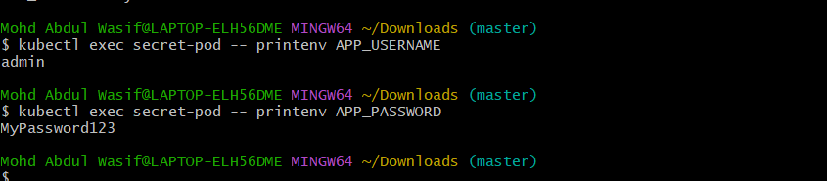

Step 6: Cleanup
After completing the task:
kubectl delete pod secret-pod
kubectl delete secret app-secret
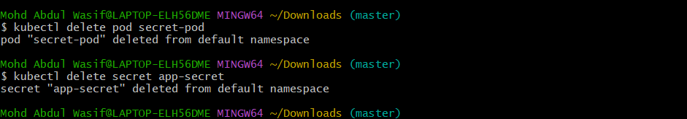
Task 4 status
Activity | Status
Create Secret | ⏳
Verify Secret | ⏳
Create Pod | ⏳
Inject Secret | ⏳
Verify inside Pod | ⏳
Cleanup | ⏳
Task 5: Check EKS Add-ons
Objective
Identify and inspect the add-ons available in your EKS cluster and understand what functionality they provide.
Step 1 — List the EKS add-ons
Run:
aws eks list-addons --cluster-name my-eks-eksctl --region us-east-1
Step 2 — Check the cluster
Run:
aws eks describe-cluster \
--name my-eks-eksctl \
--region us-east-1 \
--query "cluster.version" \
--output text
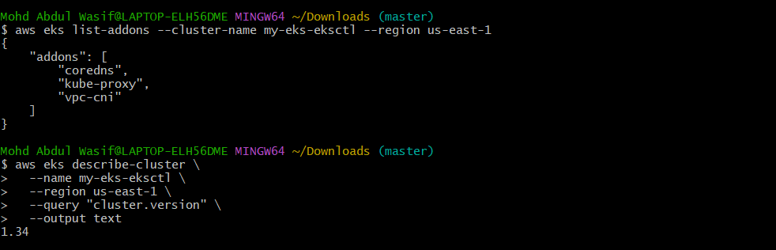
Step 3 — Check Kubernetes system pods
Run:
kubectl get pods -n kube-system
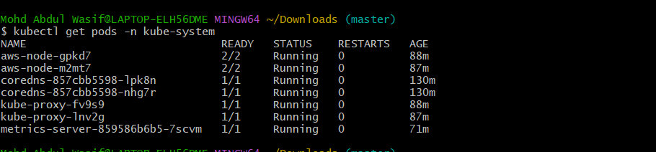
Step 4 — Check add-on details
If Step 1 shows something like:
vpc-cni
coredns
kube-proxy
you can inspect each one:
aws eks describe-addon \
--cluster-name my-eks-eksctl \
--addon-name vpc-cni \
--region us-east-1
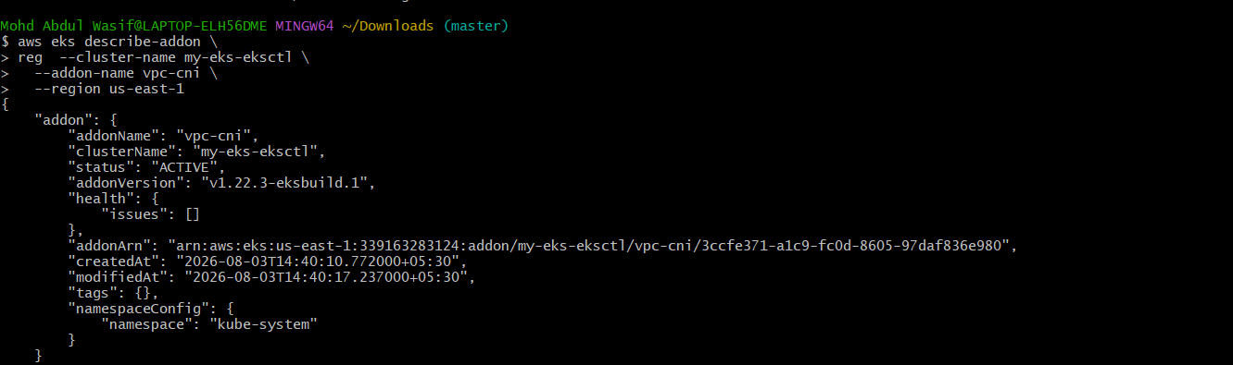
For CoreDNS:
aws eks describe-addon \
--cluster-name my-eks-eksctl \
--addon-name coredns \
--region us-east-1
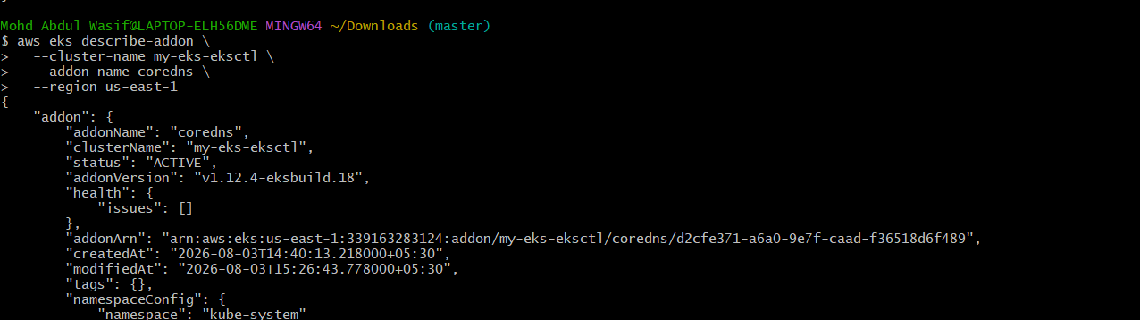
For kube-proxy:
aws eks describe-addon \
--cluster-name my-eks-eksctl \
--addon-name kube-proxy \
--region us-east-1
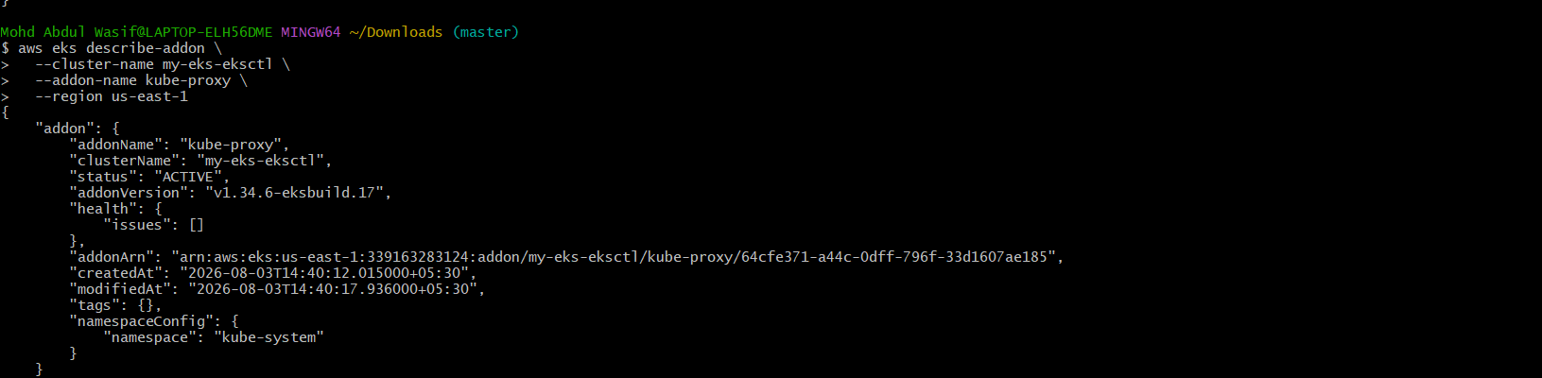
What we learned
Your AWS CLI is correctly configured for:
Region: us-east-1
and the cluster actually available in that region is:
my-eks-eksctl
So from now on, for this EKS cluster, use:
my-eks-eksctl
instead of my-eks-cluster.
Now run only this command:
aws eks list-addons --cluster-name my-eks-eksctl --region us-east-1
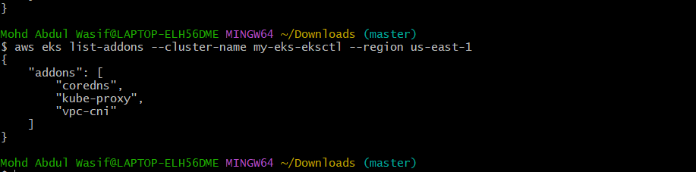

Task 6 — Upgrade EKS Cluster
Step 1: Check available Kubernetes versions
Run:
aws eks describe-addon-versions \
--kubernetes-version 1.35 \
--region us-east-1 \
--query "addons[].addonName" \
--output table
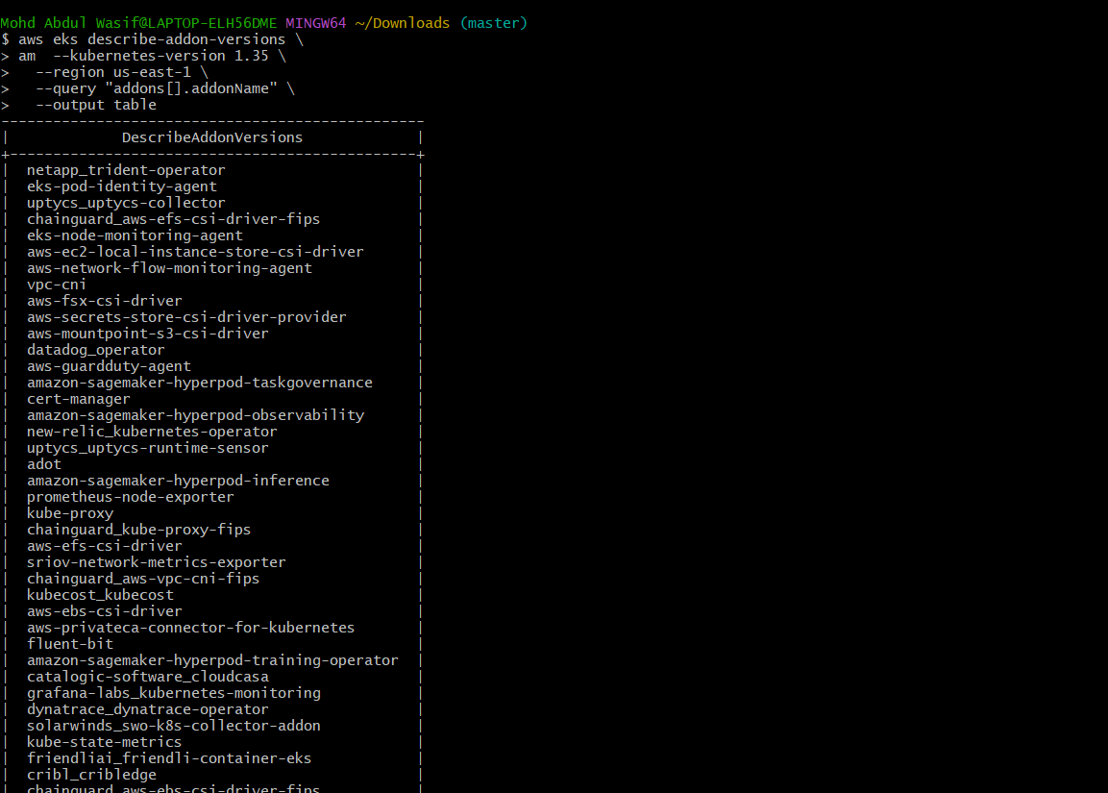
More importantly, check the versions supported by the EKS API:
aws eks describe-cluster \
--name my-eks-eksctl \
--region us-east-1 \
--query "cluster.{Version:version,Status:status,PlatformVersion:platformVersion}" \
--output table
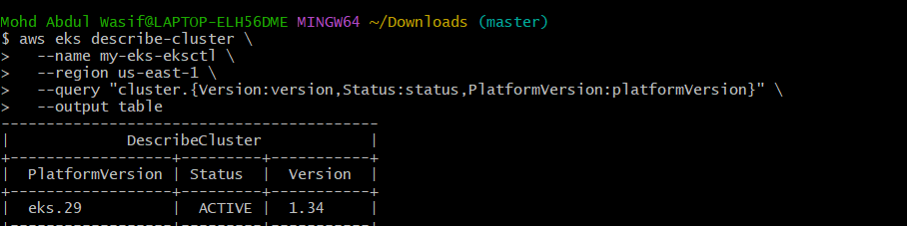
Step 2: Check node group
Because your cluster was created using eksctl, first find the managed node group:
eksctl get nodegroup \
--cluster my-eks-eksctl \
--region us-east-1
You should get something similar to:
CLUSTER NODEGROUP STATUS
my-eks-eksctl <nodegroup> ACTIVE
Step 3: Check cluster health
Run:
kubectl get nodes
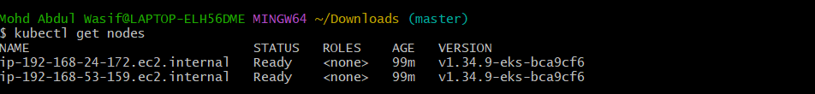
You already have:
2 Ready
which is good. ✅
Also run:
kubectl get pods -A
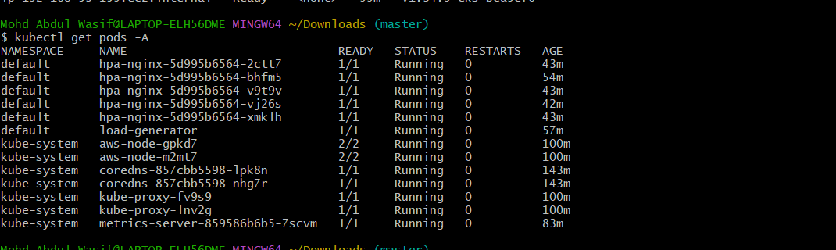
Make sure there aren't important pods stuck in Pending, CrashLoopBackOff, or Error.
⚠️ Important
Your cluster is currently Kubernetes 1.34, and your nodes are v1.34.9.
Don't manually run commands such as:
kubeadm upgrade
or install a different kubectl/kubelet version. EKS managed control planes and managed node groups are upgraded through AWS/EKS, not the kubeadm procedure you used on your separate Kubernetes cluster.
For now, run these 3 commands:
eksctl get nodegroup --cluster my-eks-eksctl --region us-east-1
kubectl get pods -A
aws eks describe-cluster \
--name my-eks-eksctl \
--region us-east-1 \
--query "cluster.{Version:version,Status:status,PlatformVersion:platformVersion}" \
--output table
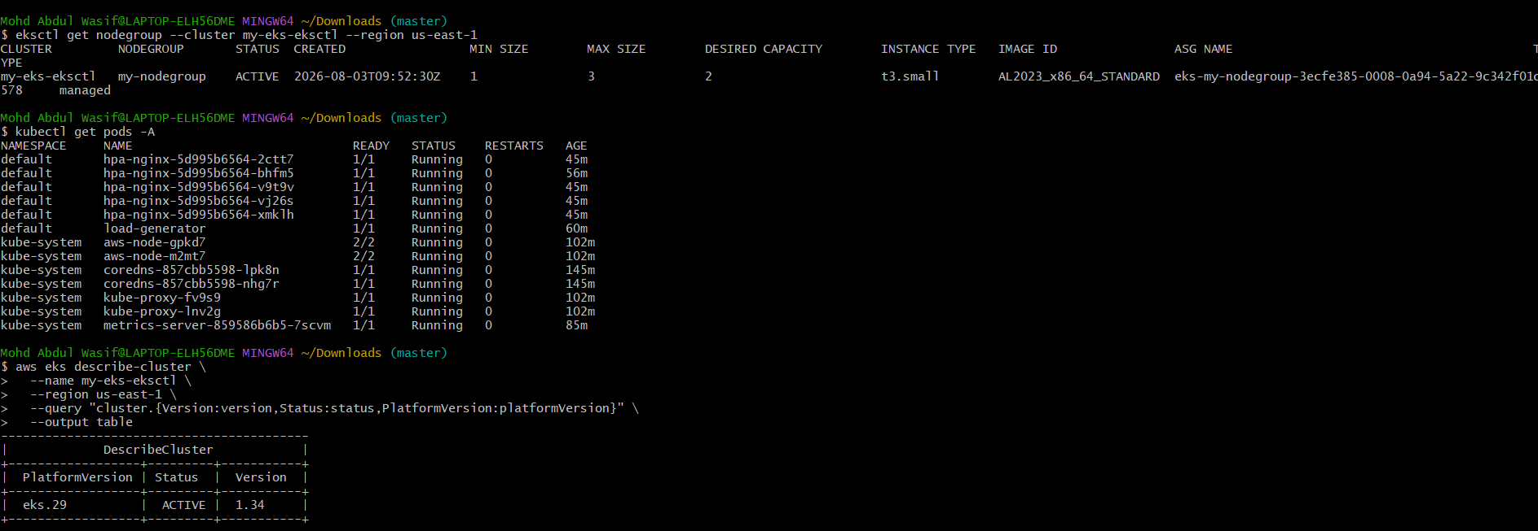
Step 1 — Check available EKS versions
Run:
aws eks describe-cluster-versions \
--region us-east-1 \
--query "clusterVersions[].clusterVersion" \
--output table
You should see versions such as 1.34, 1.35, and potentially 1.36.
AWS currently documents EKS 1.35 and 1.36 as available versions.
Step 2 — Check specifically for 1.35
You can also run:
aws eks describe-cluster-versions \
--region us-east-1 \
--cluster-versions 1.35 \
--query "clusterVersions[].{Version:clusterVersion,Status:versionStatus,Patch:kubernetesPatchVersion}" \
--output table
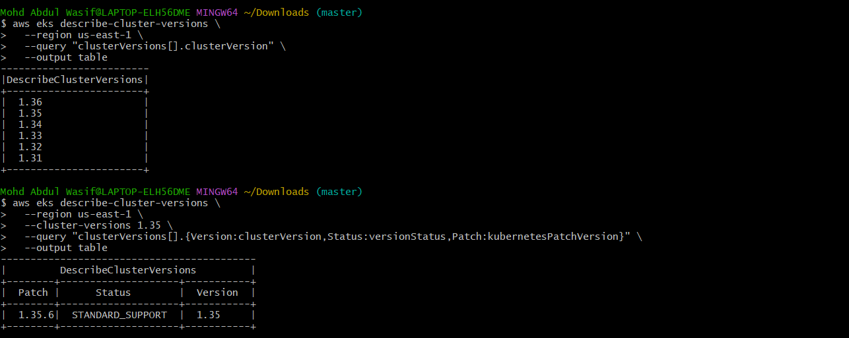
If 1.35 is returned, we'll proceed with:
1.34 control plane
↓
1.35 control plane
↓
1.35 node group
↓
1.35 add-ons
↓
verification
AWS recommends upgrading the EKS control plane one minor version at a time, then upgrading the nodes and EKS add-ons.
Your result:
Current cluster: 1.34
Target version: 1.35
Patch: 1.35.6
Support: STANDARD_SUPPORT
Before we perform the upgrade, let's check the current node group and add-on versions so we have a clean before/after record.
Step 2 — Record current node/add-on versions
Run these three commands:
kubectl get nodes -o wide
aws eks describe-addon \
--cluster-name my-eks-eksctl \
--addon-name vpc-cni \
--region us-east-1 \
--query "addon.{Name:addonName,Version:addonVersion,Status:status}" \
--output table
aws eks describe-addon \
--cluster-name my-eks-eksctl \
--addon-name coredns \
--region us-east-1 \
--query "addon.{Name:addonName,Version:addonVersion,Status:status}" \
--output table
And:
aws eks describe-addon \
--cluster-name my-eks-eksctl \
--addon-name kube-proxy \
--region us-east-1 \
--query "addon.{Name:addonName,Version:addonVersion,Status:status}" \
--output table
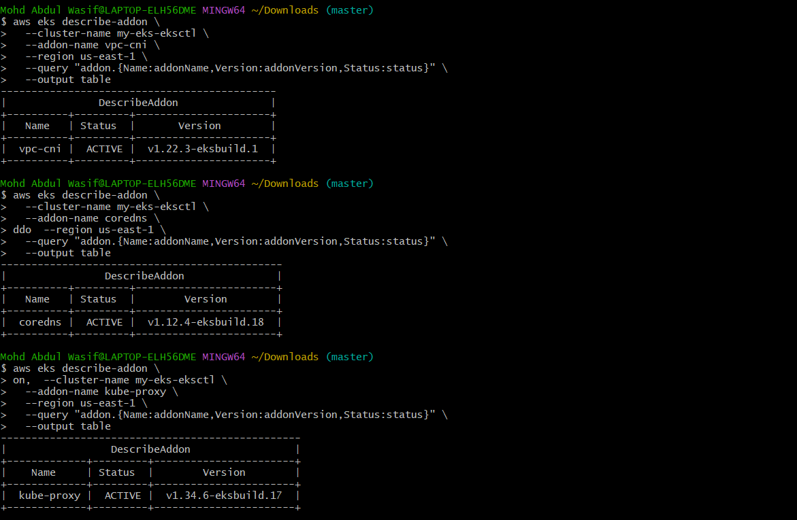
Then we'll upgrade
The sequence will be:
EKS 1.34
│
▼
Control Plane → 1.35
│
▼
Node Group → 1.35
│
▼
CoreDNS / kube-proxy / VPC CNI
│
▼
Final verification
Step 1 — Upgrade the EKS Control Plane
Your cluster is:
my-eks-eksctl
Region: us-east-1
Current version: 1.34
Target version: 1.35
Run:
aws eks update-cluster-version \
--name my-eks-eksctl \
--kubernetes-version 1.35 \
--region us-east-1
You should get an output containing an update ID and:
"status": "InProgress"
Step 2 — Monitor the upgrade
Run:
aws eks describe-update \
--name my-eks-eksctl \
--update-id <UPDATE-ID> \
--region us-east-1 \
--query "update.{Status:status,Errors:errors}" \
--output table
Replace <UPDATE-ID> with the ID returned by Step 1.
Keep checking until:
Status
-------
Successful
Step 3 — Verify the control plane
After the upgrade completes:
aws eks describe-cluster \
--name my-eks-eksctl \
--region us-east-1 \
--query "cluster.{Version:version,Status:status,PlatformVersion:platformVersion}" \
--output table
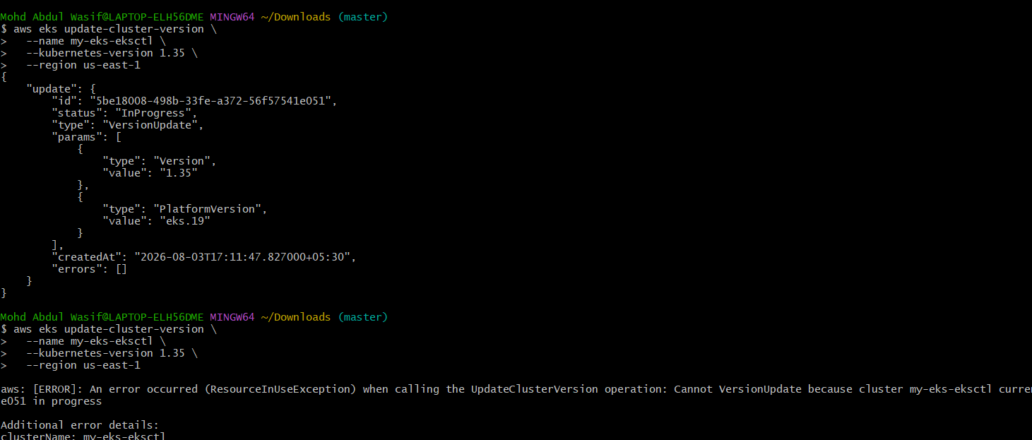
Expected:
Version Status
1.35 ACTIVE
Then:
kubectl get nodes
⚠️ Don't worry if the nodes still show v1.34.x at this point. The control plane and managed node group are upgraded separately.
For now, run only Step 1:
aws eks update-cluster-version \
--name my-eks-eksctl \
--kubernetes-version 1.35 \
--region us-east-1
Step 1 — Monitor the upgrade
Run:
aws eks describe-update \
--name my-eks-eksctl \
--update-id 5be18008-498b-33fe-a372-56f57541e051 \
--region us-east-1 \
--query "update.{Status:status,Errors:errors}" \
--output table
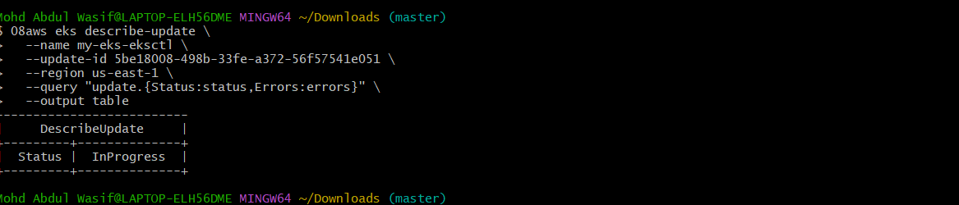
You want to eventually see:
Status
---------
Successful
It may take several minutes.
Then verify:
aws eks describe-cluster \
--name my-eks-eksctl \
--region us-east-1 \
--query "cluster.{Version:version,Status:status,PlatformVersion:platformVersion}" \
--output table
We want:
Version Status
1.35 ACTIVE
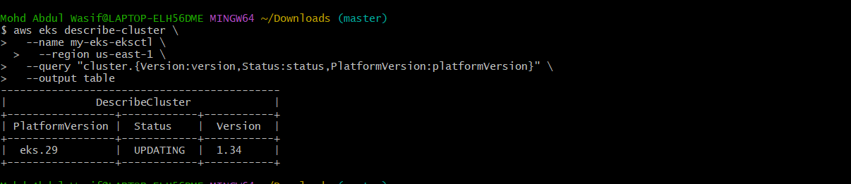
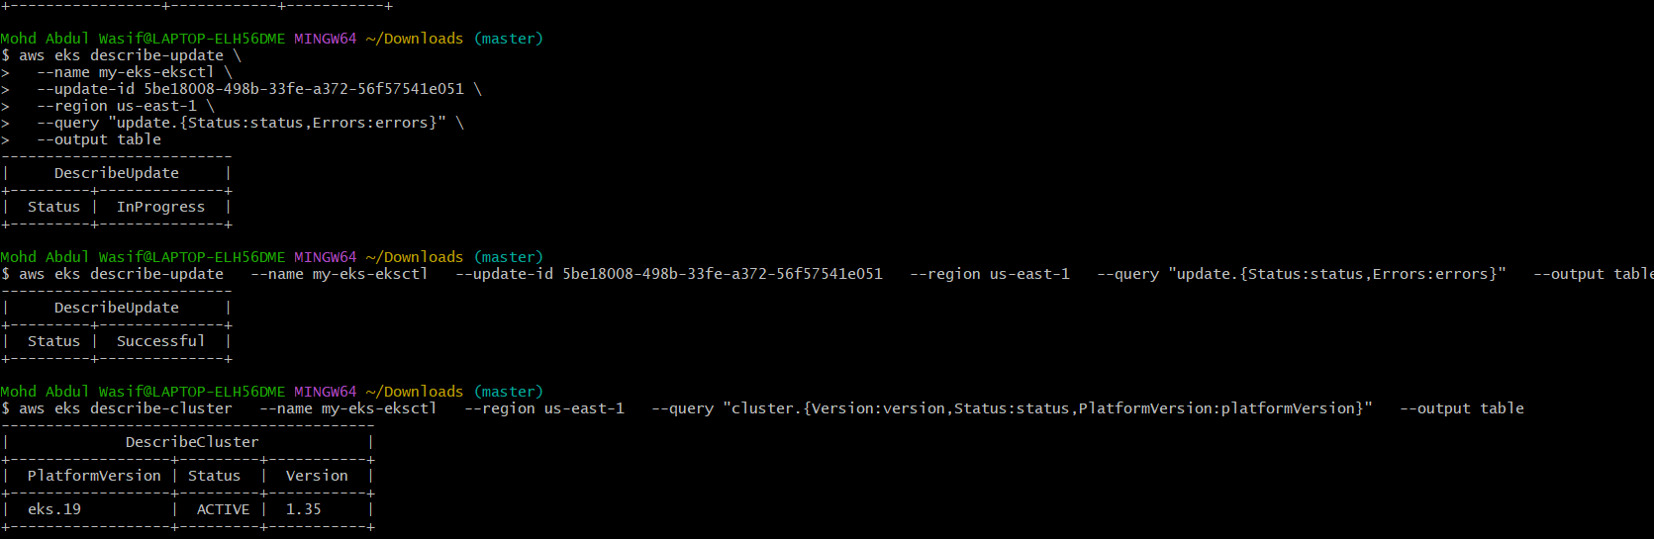
Step 2 — Upgrade my-nodegroup
Now run:
aws eks update-nodegroup-version \
--cluster-name my-eks-eksctl \
--nodegroup-name my-nodegroup \
--kubernetes-version 1.35 \
--region us-east-1
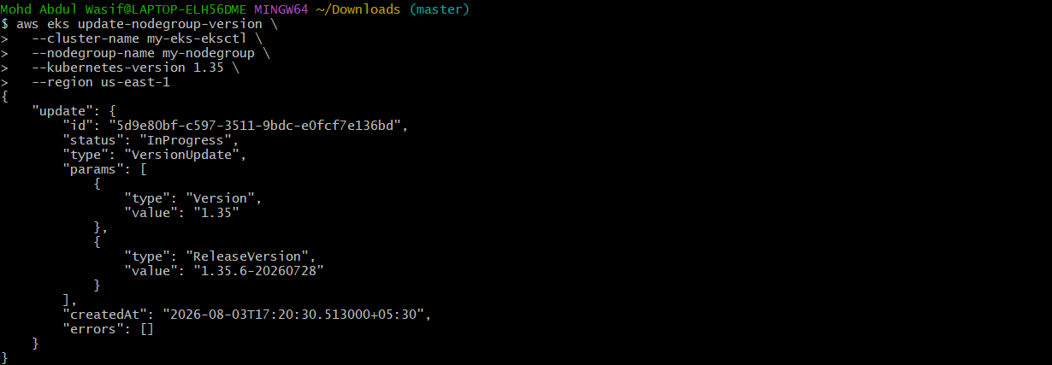
You should get something like:
"status": "InProgress"
and an update ID.
Step 3 — Monitor the node-group upgrade
Use the update ID returned by Step 2:
aws eks describe-update \
--name my-eks-eksctl \
--nodegroup-name my-nodegroup \
--update-id YOUR_UPDATE_ID \
--region us-east-1 \
--query "update.{Status:status,Errors:errors}" \
--output table
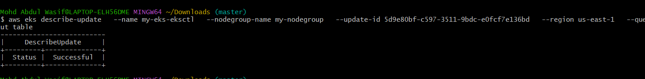
Wait until:
Successful
Step 4 — Verify nodes
After it completes:
kubectl get nodes
You want both nodes to show something similar to:
STATUS VERSION
Ready v1.35.x-eks...
Ready v1.35.x-eks...
Also check:
eksctl get nodegroup \
--cluster my-eks-eksctl \
--region us-east-1
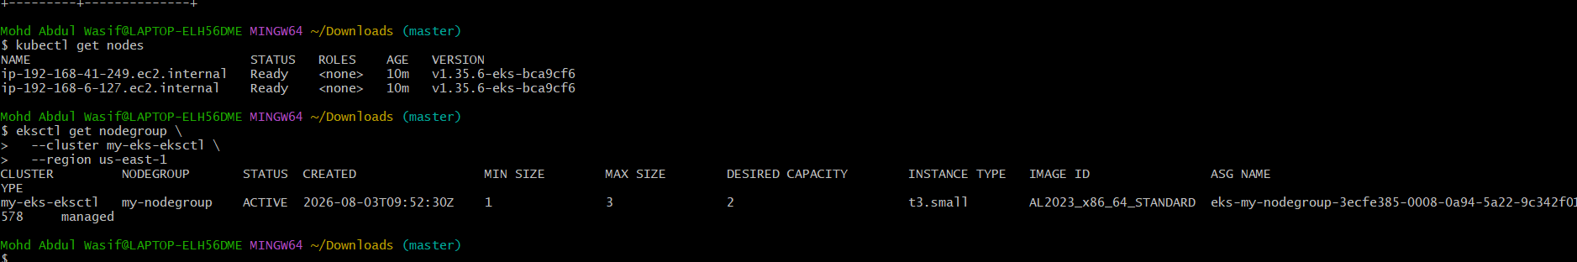
The node group should be:
ACTIVE
Important
Don't upgrade the add-ons yet. First complete:
Control Plane 1.34 → 1.35 ✅
↓
Node Group 1.34 → 1.35 ⏳
↓
Add-ons ⏳
↓
Final testing ⏳

Your results confirm:
Control plane: 1.35 ACTIVE ✅
Node group: my-nodegroup ACTIVE ✅
Nodes: 2 Ready ✅
Node version: v1.35.6 ✅
AWS's recommended EKS upgrade sequence is control plane → nodes → add-ons → final verification.
Next: Update and verify the EKS add-ons
Your add-ons were from Kubernetes 1.34, so we should check the compatible 1.35 versions before updating them. AWS specifically recommends checking add-on compatibility after a Kubernetes upgrade.
Step 1 — Check available CoreDNS version
aws eks describe-addon-versions \
--kubernetes-version 1.35 \
--addon-name coredns \
--region us-east-1 \
--query 'addons[].addonVersions[].{Version:addonVersion,Default:compatibilities[0].defaultVersion}' \
--output table
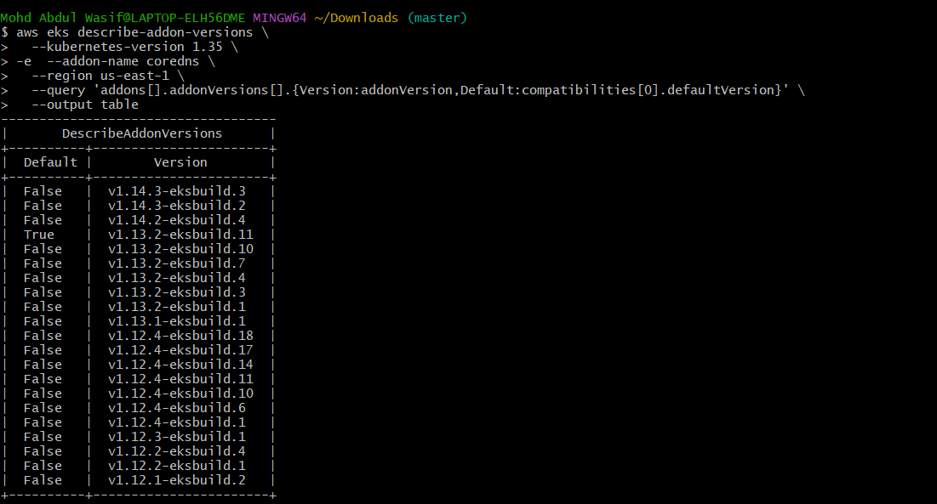
Step 2 — Check kube-proxy
aws eks describe-addon-versions \
--kubernetes-version 1.35 \
--addon-name kube-proxy \
--region us-east-1 \
--query 'addons[].addonVersions[].{Version:addonVersion,Default:compatibilities[0].defaultVersion}' \
--output table
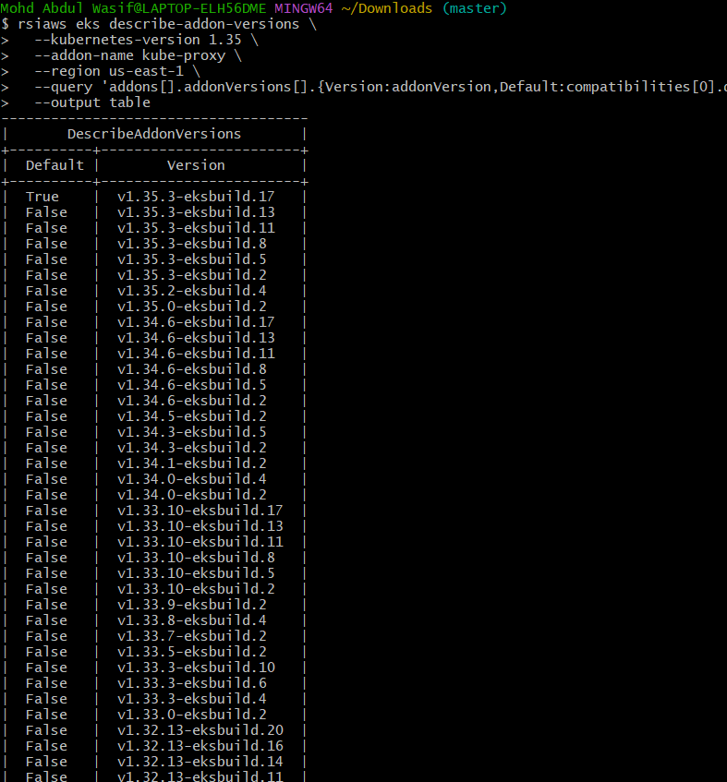
Step 3 — Check VPC CNI
aws eks describe-addon-versions \
--kubernetes-version 1.35 \
--addon-name vpc-cni \
--region us-east-1 \
--query
'addons[].addonVersions[].{Version:addonVersion,Default:compatibilities[0].defaultVersion}' \
--output table
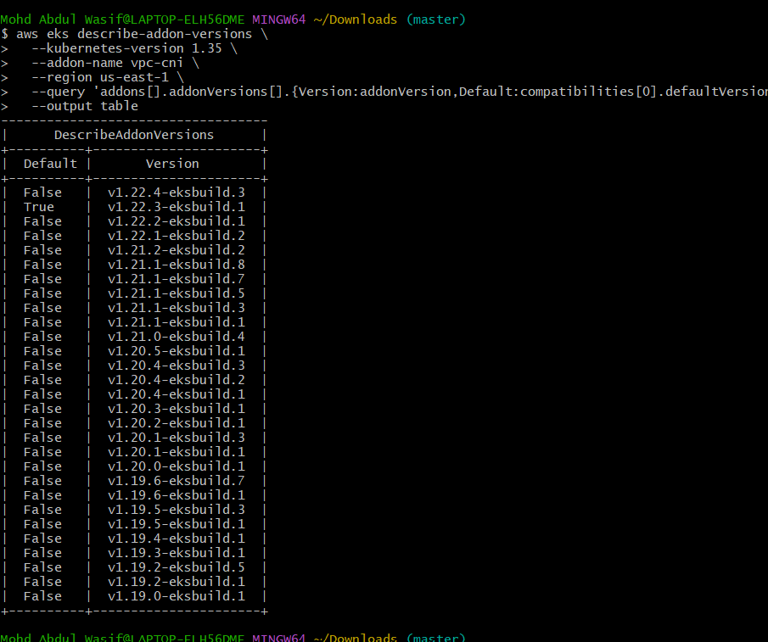
Don't update them yet. Send me the three outputs, and I'll tell you exactly which versions to use.
es. Let's continue with the CoreDNS and kube-proxy checks.
1. Check CoreDNS compatibility
aws eks describe-addon-versions \
--kubernetes-version 1.35 \
--addon-name coredns \
--region us-east-1 \
--query 'addons[].addonVersions[].{Version:addonVersion,Default:compatibilities[0].defaultVersion}' \
--output table
2. Check kube-proxy compatibility
aws eks describe-addon-versions \
--kubernetes-version 1.35 \
--addon-name kube-proxy \
--region us-east-1 \
--query 'addons[].addonVersions[].{Version:addonVersion,Default:compatibilities[0].defaultVersion}' \
--output table
After both checks, we will do the final verification:
Control Plane 1.35 ✅
Node Group 1.35 ✅
VPC CNI ✅
CoreDNS ⏳
kube-proxy ⏳
Final cluster verification ⏳
Next: Update CoreDNS
Run:
aws eks update-addon \
--cluster-name my-eks-eksctl \
--addon-name coredns \
--addon-version v1.13.2-eksbuild.11 \
--region us-east-1 \
--resolve-conflicts OVERWRITE
You'll get an update ID and InProgress.
Then check:
aws eks describe-addon \
--cluster-name my-eks-eksctl \
--addon-name coredns \
--region us-east-1 \
--query "addon.{Version:addonVersion,Status:status}" \
--output table
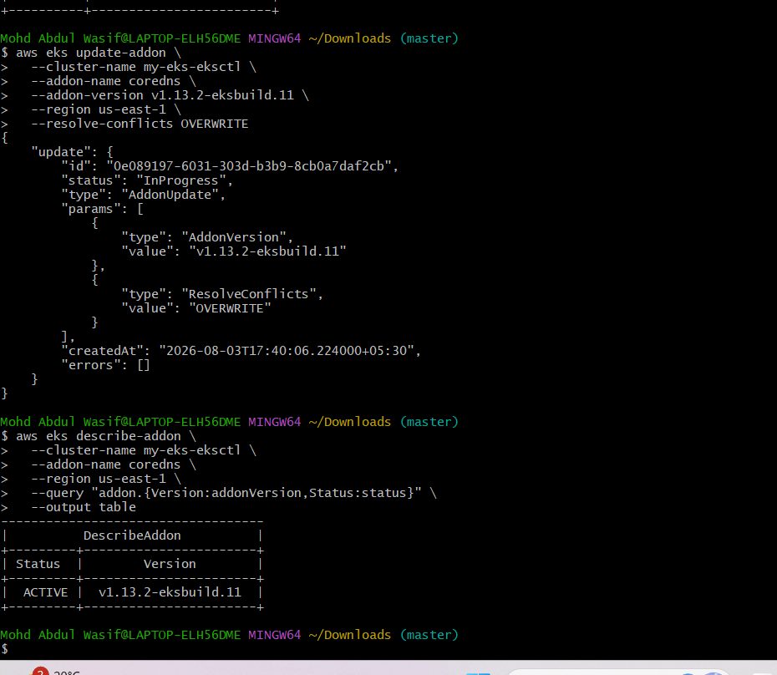
Wait until it shows:
Version Status
v1.13.2-eksbuild.11 ACTIVE
Do CoreDNS first. Don't update kube-proxy yet. Send me the result after CoreDNS becomes ACTIVE.

Step 1 — Update kube-proxy
Run:
aws eks update-addon \
--cluster-name my-eks-eksctl \
--addon-name kube-proxy \
--addon-version v1.35.3-eksbuild.17 \
--region us-east-1 \
--resolve-conflicts OVERWRITE
You should get:
"status": "InProgress"
Step 2 — Check kube-proxy status
aws eks describe-addon \
--cluster-name my-eks-eksctl \
--addon-name kube-proxy \
--region us-east-1 \
--query "addon.{Version:addonVersion,Status:status}" \
--output table
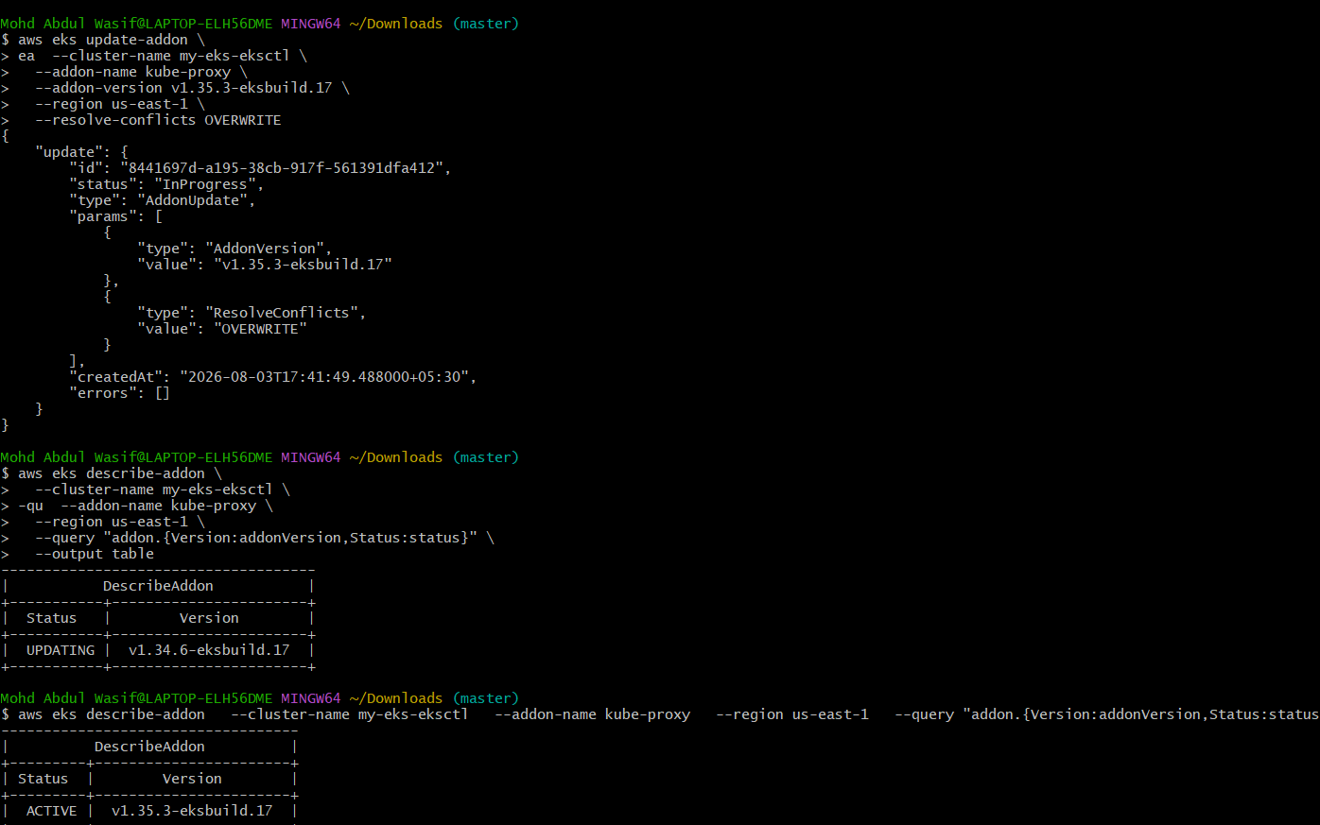
Wait until:
| Status | ACTIVE |
and the version is:
v1.35.3-eksbuild.17
Step 3 — VPC CNI
Your VPC CNI is already:
v1.22.3-eksbuild.1
which is the default compatible version for EKS 1.35, so you don't need to change it.
Once kube-proxy is ACTIVE, run:
kubectl get nodes
kubectl get pods -A
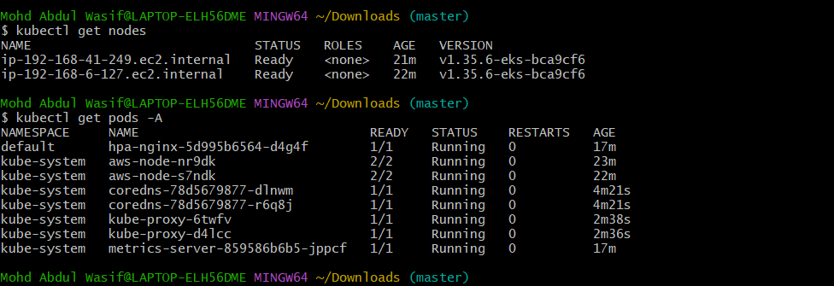
aws eks list-addons \
--cluster-name my-eks-eksctl \
--region us-east-1
Then verify all add-ons:
aws eks describe-addon \
--cluster-name my-eks-eksctl \
--addon-name coredns \
--region us-east-1 \
--query "addon.{Name:addonName,Version:addonVersion,Status:status}" \
--output table
aws eks describe-addon \
--cluster-name my-eks-eksctl \
--addon-name kube-proxy \
--region us-east-1 \
--query "addon.{Name:addonName,Version:addonVersion,Status:status}" \
--output table
aws eks describe-addon \
--cluster-name my-eks-eksctl \
--addon-name vpc-cni \
--region us-east-1 \
--query "addon.{Name:addonName,Version:addonVersion,Status:status}" \
--output table
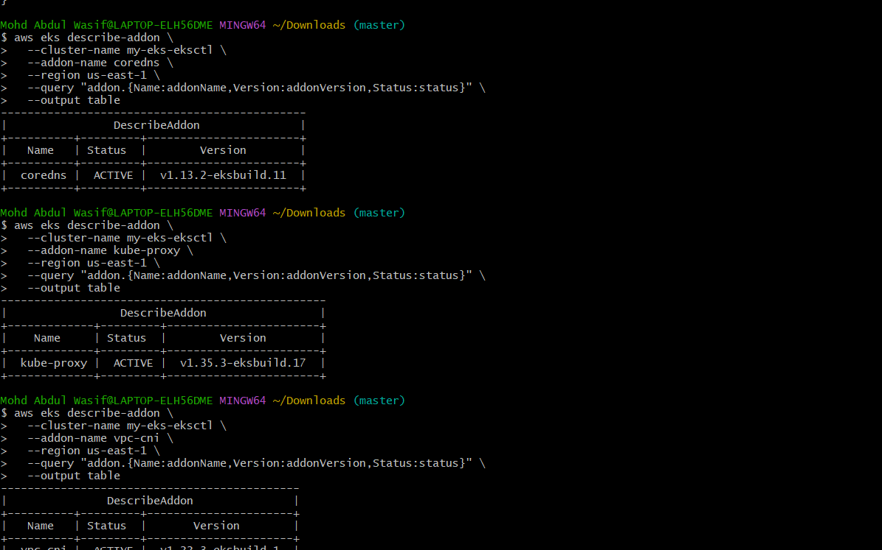
Final status
Component | Before | After | Status
EKS Control Plane | 1.34 | 1.35 | ✅
Managed Node Group | 1.34 | 1.35.6 | ✅
CoreDNS | 1.12.4 | 1.13.2-eksbuild.11 | ✅
kube-proxy | 1.34.6 | 1.35.3-eksbuild.17 | ✅
VPC CNI | 1.22.3 | 1.22.3-eksbuild.1 | ✅
Node 1 | 1.34.9 | 1.35.6 | ✅
Node 2 | 1.34.9 | 1.35.6 | ✅
Your add-ons are all:
ACTIVE
and your cluster upgrade path was:
EKS 1.34
↓
Control Plane → 1.35 ✅
↓
Node Group → 1.35.6 ✅
↓
CoreDNS → 1.13.2 ✅
↓
kube-proxy → 1.35.3 ✅
↓
VPC CNI → 1.22.3 ✅
One final health check
Run these three commands:
kubectl get nodes
kubectl get pods -A
aws eks describe-cluster \
--name my-eks-eksctl \
--region us-east-1 \
--query "cluster.{Version:version,Status:status}" \
--output table
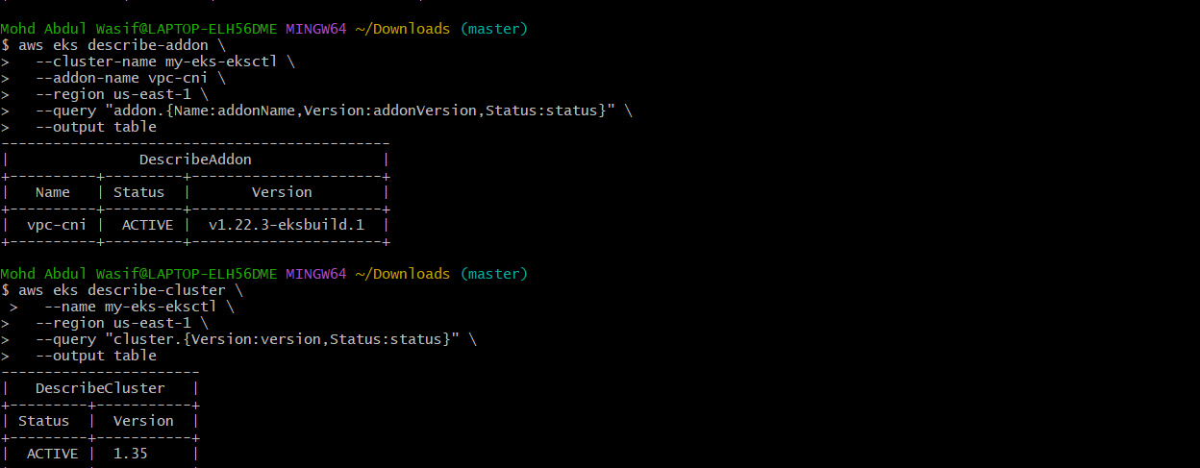
What We Learned
- Learned how to check the current Kubernetes version of an Amazon EKS cluster.
- Learned how to check whether a newer Kubernetes version is available using AWS CLI.
- Learned that EKS should be upgraded one minor version at a time, such as 1.34 → 1.35.
- Learned how to upgrade the EKS control plane using aws eks update-cluster-version.
- Learned how to monitor an EKS update using aws eks describe-update.
- Learned that the managed node group must be upgraded separately after the control plane upgrade.
- Learned how to upgrade a managed node group using aws eks update-nodegroup-version.
- Learned how to verify node versions using kubectl get nodes.
- Learned how to check EKS add-ons such as:
  - CoreDNS – provides DNS and service discovery.
  - kube-proxy – handles Kubernetes Service networking.
  - VPC CNI – provides AWS VPC networking for Pods.
- Learned how to check add-on compatibility with a specific Kubernetes version.
- Learned how to update EKS managed add-ons after a Kubernetes upgrade.
- Learned how to verify that add-ons are in the ACTIVE state.
- Learned that an upgrade should be performed in the correct order:
EKS Control Plane
↓
Managed Node Group
↓
EKS Add-ons
↓
Final Verification
Conclusion
The EKS cluster was successfully upgraded from Kubernetes 1.34 to 1.35. The control plane was upgraded first, followed by the managed node group. Both worker nodes were successfully upgraded to v1.35.6 and remained in the Ready state.
The EKS add-ons were also verified and updated for compatibility with Kubernetes 1.35. CoreDNS, kube-proxy, and VPC CNI were confirmed to be in the ACTIVE state.
This hands-on task provided practical experience with EKS version upgrades, managed node groups, add-on compatibility, upgrade monitoring, and post-upgrade verification, which are important skills for maintaining Kubernetes clusters in AWS.

Task 7 — Configure Cluster Autoscaler
Step 1: Understand what we're doing
You already configured HPA earlier:
High CPU
↓
HPA
↓
More Pods
Now Cluster Autoscaler works at the node level:
Pods cannot be scheduled
↓
Cluster Autoscaler
↓
Increase nodes
↓
Pod gets scheduled
And when nodes become unnecessary:
Low utilization
↓
Cluster Autoscaler
↓
Remove unnecessary node
Your node group already has:
Min = 1
Max = 3
Desired = 2
So Autoscaler can scale between 1 and 3 nodes.
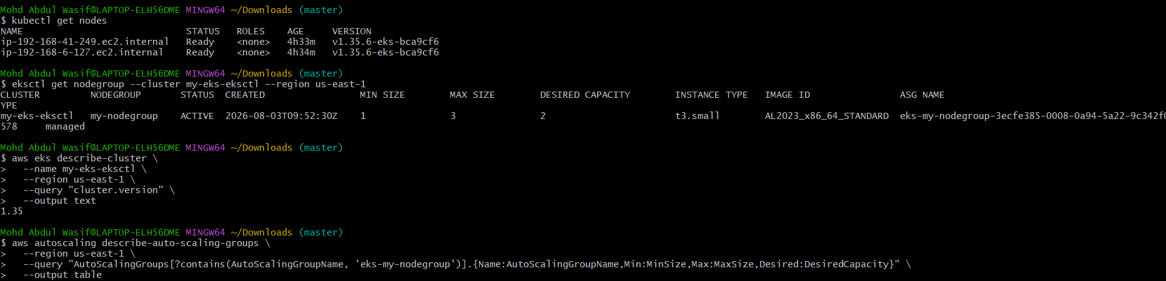

Step 2: Add Autoscaler tags to the node group
Run:
aws autoscaling describe-auto-scaling-groups \
--region us-east-1 \
--query "AutoScalingGroups[?contains(AutoScalingGroupName, 'eks-my-nodegroup')].{Name:AutoScalingGroupName,Min:MinSize,Max:MaxSize,Desired:DesiredCapacity}" \
--output table
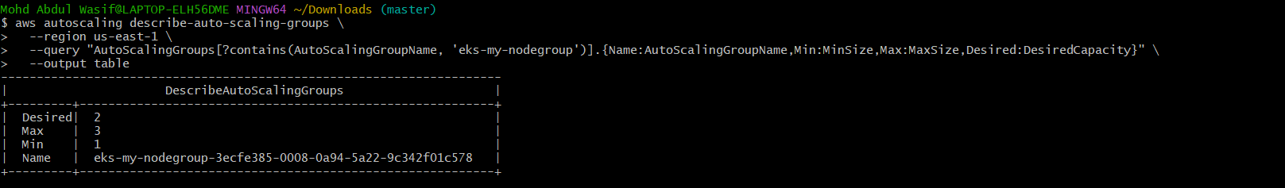
You should see your ASG.
Then we'll add the required tags:
k8s.io/cluster-autoscaler/enabled = true
k8s.io/cluster-autoscaler/my-eks-eksctl = owned
Don't add the tags manually yet.
First run Step 2 command above and send me the output.
Then I'll give you the exact commands for your Auto Scaling Group.
Step 3 — Add Cluster Autoscaler tags
Run these two commands separately.
Tag 1
aws autoscaling create-or-update-tags \
--region us-east-1 \
--tags ResourceId=eks-my-nodegroup-3ecfe385-0008-0a94-5a22-9c342f01c578,ResourceType=auto-scaling-group,Key=k8s.io/cluster-autoscaler/enabled,Value=true,PropagateAtLaunch=true
Tag 2
aws autoscaling create-or-update-tags \
--region us-east-1 \
--tags ResourceId=eks-my-nodegroup-3ecfe385-0008-0a94-5a22-9c342f01c578,ResourceType=auto-scaling-group,Key=k8s.io/cluster-autoscaler/my-eks-eksctl,Value=owned,PropagateAtLaunch=true
Step 4 — Verify the tags
Run:
aws autoscaling describe-auto-scaling-groups \
--region us-east-1 \
--auto-scaling-group-names eks-my-nodegroup-3ecfe385-0008-0a94-5a22-9c342f01c578 \
--query "AutoScalingGroups[0].Tags[?contains(Key, 'cluster-autoscaler')]" \
--output table
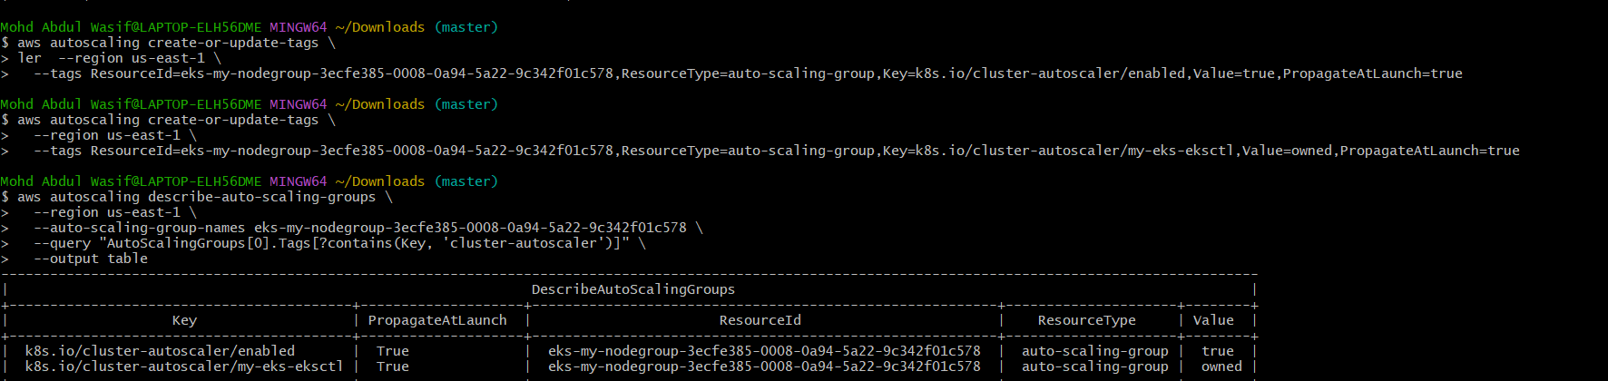
You should see:
k8s.io/cluster-autoscaler/enabled true
k8s.io/cluster-autoscaler/my-eks-eksctl owned
Step 5 — Create IAM permissions
The Cluster Autoscaler needs AWS permissions to change the Auto Scaling Group size.
We'll create an IAM policy and attach it to the node IAM role.
First, find your node IAM role
Run:
aws eks describe-nodegroup \
--cluster-name my-eks-eksctl \
--nodegroup-name my-nodegroup \
--region us-east-1 \
--query "nodegroup.nodeRole" \
--output text
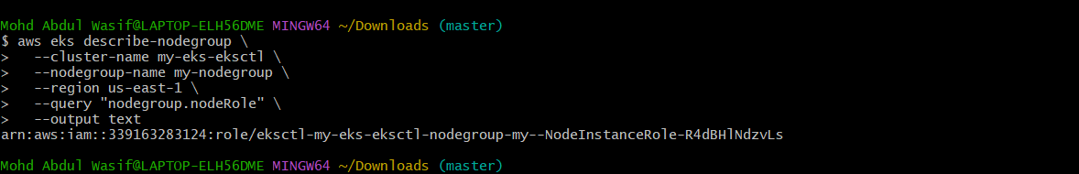
You should get something similar to:
arn:aws:iam::339163283124:role/AmazonEKSNodeRole-Task2
Step 6 — Create the Cluster Autoscaler IAM policy
We'll create a policy with only the permissions needed to read and modify Auto Scaling groups.
Run this in Git Bash:
cat > cluster-autoscaler-policy.json <<'EOF'
{
"Version": "2012-10-17",
"Statement": [
{
"Effect": "Allow",
"Action": [
"autoscaling:DescribeAutoScalingGroups",
"autoscaling:DescribeAutoScalingInstances",
"autoscaling:DescribeLaunchConfigurations",
"autoscaling:DescribeScalingActivities",
"autoscaling:DescribeTags",
"autoscaling:SetDesiredCapacity",
"autoscaling:TerminateInstanceInAutoScalingGroup"
],
"Resource": "*"
}
]
}
EOF
Then create the IAM policy:
aws iam create-policy \
--policy-name AmazonEKSClusterAutoscalerPolicy \
--policy-document file://cluster-autoscaler-policy.json
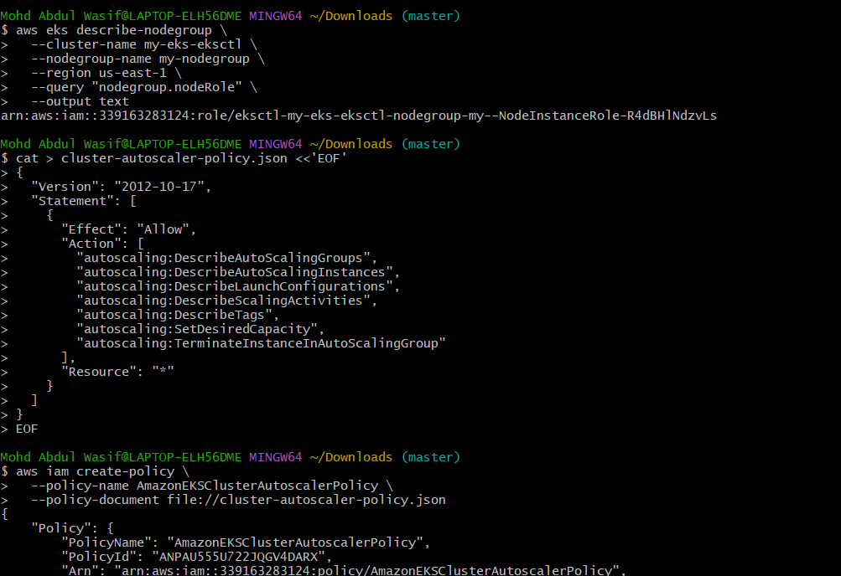
You should receive an ARN similar to:
arn:aws:iam::339163283124:policy/AmazonEKSClusterAutoscalerPolicy
Step 7 — Attach the policy
Your role is:
eksctl-my-eks-eksctl-nodegroup-my--NodeInstanceRole-R4dBHlNdzvLs
Run:
aws iam attach-role-policy \
--role-name eksctl-my-eks-eksctl-nodegroup-my--NodeInstanceRole-R4dBHlNdzvLs \
--policy-arn arn:aws:iam::339163283124:policy/AmazonEKSClusterAutoscalerPolicy
If successful, AWS normally returns no output.
Step 8 — Verify the attachment
Run:
aws iam list-attached-role-policies \
--role-name eksctl-my-eks-eksctl-nodegroup-my--NodeInstanceRole-R4dBHlNdzvLs \
--query "AttachedPolicies[?PolicyName=='AmazonEKSClusterAutoscalerPolicy']" \
--output table
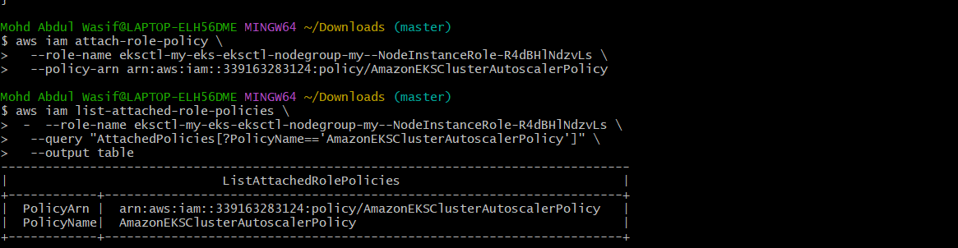
You should see:
PolicyName
------------------------------------
AmazonEKSClusterAutoscalerPolicy
Your setup now has:
EKS Cluster
↓
my-nodegroup
↓
Node IAM Role
↓
AmazonEKSClusterAutoscalerPolicy ✅
↓
Auto Scaling Group
↓
Min: 1 | Desired: 2 | Max: 3
Step 8 — Deploy Cluster Autoscaler
Before deploying it, let's verify the EKS OIDC/IRSA configuration because the recommended EKS setup uses IAM roles for Kubernetes service accounts.
Run:
eksctl utils associate-iam-oidc-provider \
--cluster my-eks-eksctl \
--region us-east-1 \
--approve
If it says something like:
already associated
that's fine. ✅
Then check:
eksctl get iamserviceaccount \
--cluster my-eks-eksctl \
--region us-east-1
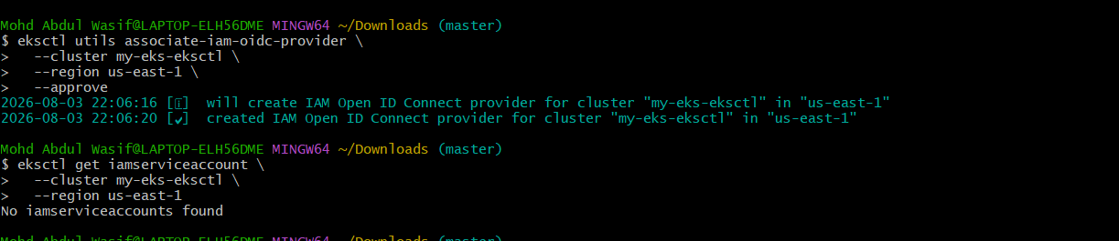
Important
We're going to deploy Cluster Autoscaler with a Kubernetes ServiceAccount and IAM permissions.
Don't deploy the Autoscaler yet.
Step 9 — Create the Cluster Autoscaler IAM Service Account
Run:
eksctl create iamserviceaccount \
--cluster my-eks-eksctl \
--region us-east-1 \
--namespace kube-system \
--name cluster-autoscaler \
--attach-policy-arn arn:aws:iam::339163283124:policy/AmazonEKSClusterAutoscalerPolicy \
--approve \
--override-existing-serviceaccounts
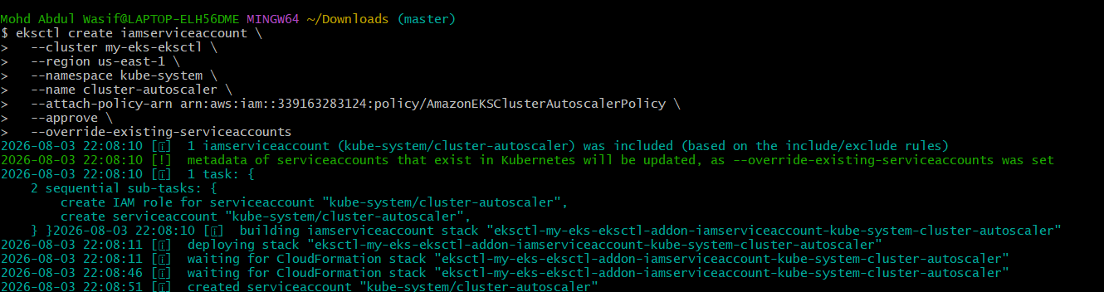
This will create:
Namespace: kube-system
ServiceAccount: cluster-autoscaler
IAM Role: automatically created by eksctl
Policy: AmazonEKSClusterAutoscalerPolicy
Step 10 — Verify it
After the command completes:
eksctl get iamserviceaccount \
--cluster my-eks-eksctl \
--region us-east-1
You should see something similar to:
NAMESPACE NAME ROLE ARN
kube-system cluster-autoscaler arn:aws:iam::...
Then:
kubectl get serviceaccount cluster-autoscaler -n kube-system
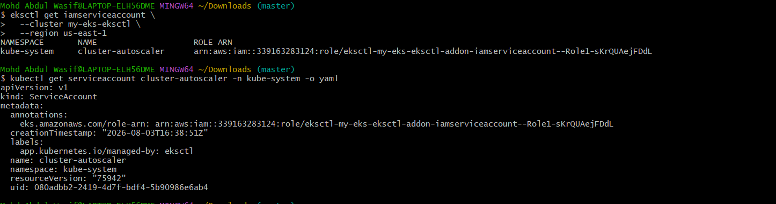
You should get:
NAME
cluster-autoscaler
Step 11 — Check your Cluster Autoscaler version options
Run:
kubectl version --output=json
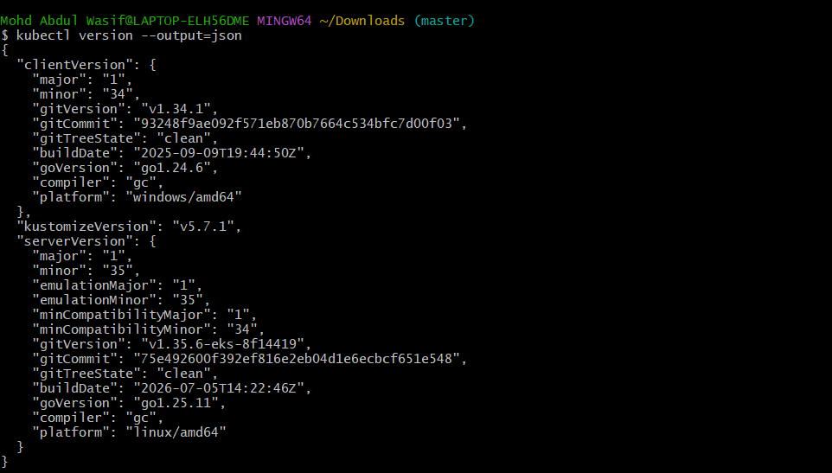
and:
kubectl get serviceaccount cluster-autoscaler -n kube-system
Also check that the IAM role annotation is present:
kubectl get serviceaccount cluster-autoscaler \
-n kube-system \
-o jsonpath='{.metadata.annotations.eks\.amazonaws\.com/role-arn}'
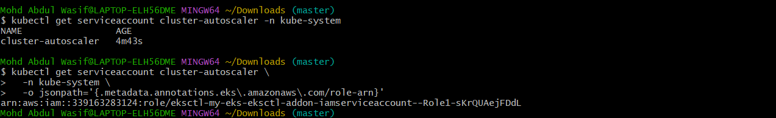
You should get:
arn:aws:iam::339163283124:role/eksctl-my-eks-eksctl-addon-iamserviceaccount--Role1-sKrQUAejFDdL
Once those checks pass, we'll deploy the Kubernetes 1.35-compatible Cluster Autoscaler and then test scaling from your current:
Min = 1
Desired = 2
Max = 3
Step 12 — Check Cluster Autoscaler logs
Run:
kubectl logs -n kube-system deployment/cluster-autoscaler
Look for messages containing:
my-eks-eksctl
and:
minSize=1
maxSize=3
You should not see errors such as:
AccessDenied
Unauthorized
failed to autodiscover
No node groups found
Step 13 — Check the Autoscaler arguments
Run:
kubectl get deployment cluster-autoscaler \
-n kube-system \
-o jsonpath='{.spec.template.spec.containers[0].args}'
You should see arguments similar to:
--cloud-provider=aws
--nodes=1:3:...
--node-group-auto-discovery=asg:tag=...
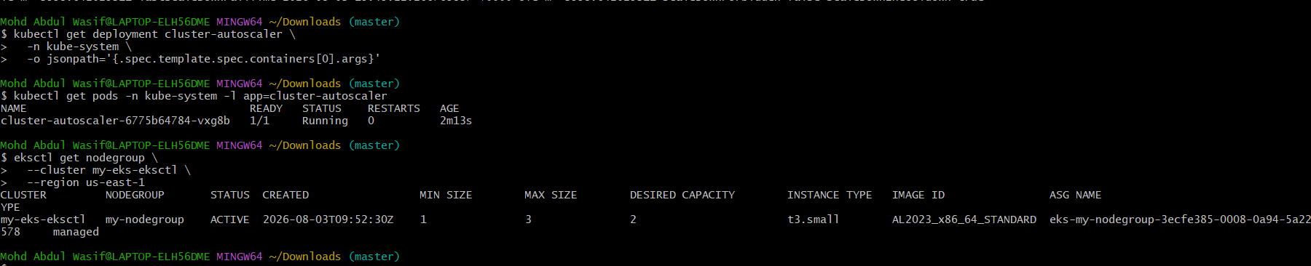
Step 14 — Check the pod
kubectl get pods -n kube-system -l app=cluster-autoscaler

Expected:
cluster-autoscaler-xxxxx 1/1 Running
Step 15 — Check your node group
eksctl get nodegroup \
--cluster my-eks-eksctl \
--region us-east-1

Your current configuration should remain:
MIN SIZE 1
MAX SIZE 3
DESIRED 2
Important
Don't create a large workload yet. First verify that the Autoscaler has successfully discovered your ASG.
Step 16 — Update the Deployment
Instead of kubectl edit, run these commands.
First update the image:
kubectl -n kube-system set image deployment/cluster-autoscaler \
cluster-autoscaler=registry.k8s.io/autoscaling/cluster-autoscaler:v1.35.0
Then replace the placeholder in the argument:
kubectl -n kube-system get deployment cluster-autoscaler -o yaml > ca.yaml
Open it:
notepad ca.yaml
Find:
--node-group-auto-discovery=asg:tag=k8s.io/cluster-autoscaler/enabled,k8s.io/cluster-autoscaler/<YOUR CLUSTER NAME>
Change it to:
--node-group-auto-discovery=asg:tag=k8s.io/cluster-autoscaler/enabled,k8s.io/cluster-autoscaler/my-eks-eksctl
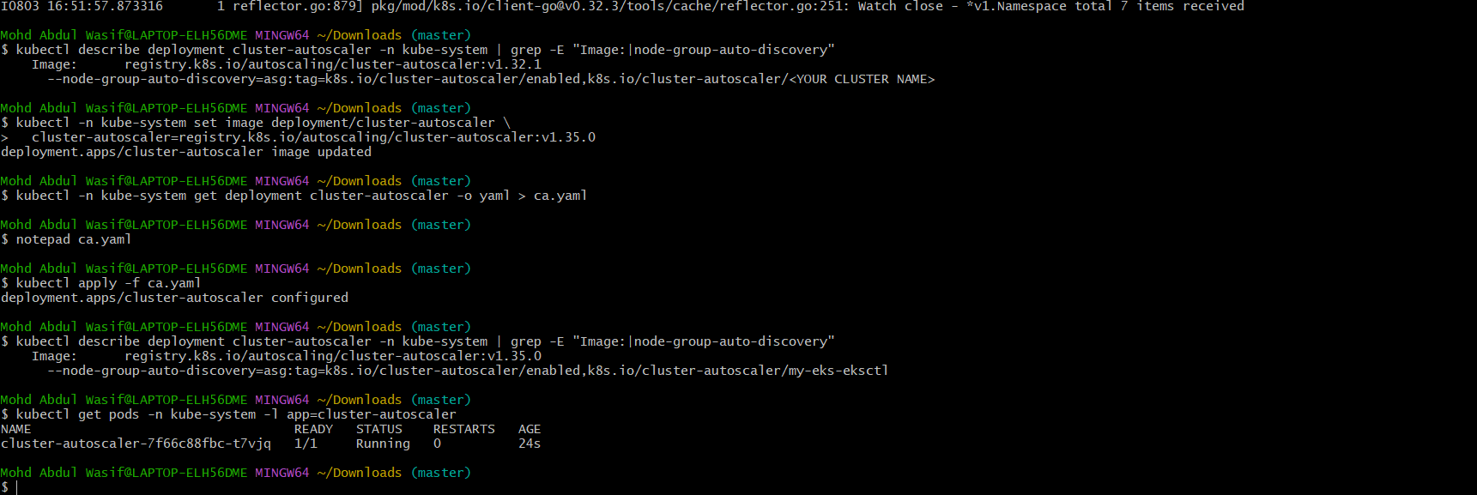
Save the file.
Then apply it:
kubectl apply -f ca.yaml
Step 17 — Verify
Run:
kubectl describe deployment cluster-autoscaler -n kube-system | grep -E "Image:|node-group-auto-discovery"
You should now see:
Image: registry.k8s.io/autoscaling/cluster-autoscaler:v1.35.0

--node-group-auto-discovery=asg:tag=k8s.io/cluster-autoscaler/enabled,k8s.io/cluster-autoscaler/my-eks-eksctl
Then:
kubectl get pods -n kube-system -l app=cluster-autoscaler

Expected:
1/1 Running
Step 20 — Add the required RBAC permissions
Create a file:
cat > cluster-autoscaler-resource-rbac.yaml <<'EOF'
apiVersion: rbac.authorization.k8s.io/v1
kind: ClusterRole
metadata:
name: cluster-autoscaler-resource-reader
rules:
- apiGroups:
- resource.k8s.io
resources:
- resourceslices
- resourceclaims
- deviceclasses
verbs:
- get
- list
- watch
---
apiVersion: rbac.authorization.k8s.io/v1
kind: ClusterRoleBinding
metadata:
name: cluster-autoscaler-resource-reader
roleRef:
apiGroup: rbac.authorization.k8s.io
kind: ClusterRole
name: cluster-autoscaler-resource-reader
subjects:
- kind: ServiceAccount
name: cluster-autoscaler
namespace: kube-system
EOF
Apply it:
kubectl apply -f cluster-autoscaler-resource-rbac.yaml
You should get:
clusterrole.rbac.authorization.k8s.io/cluster-autoscaler-resource-reader created
clusterrolebinding.rbac.authorization.k8s.io/cluster-autoscaler-resource-reader created
Step 21 — Restart Autoscaler
kubectl rollout restart deployment cluster-autoscaler -n kube-system
Wait for it:
kubectl rollout status deployment cluster-autoscaler -n kube-system
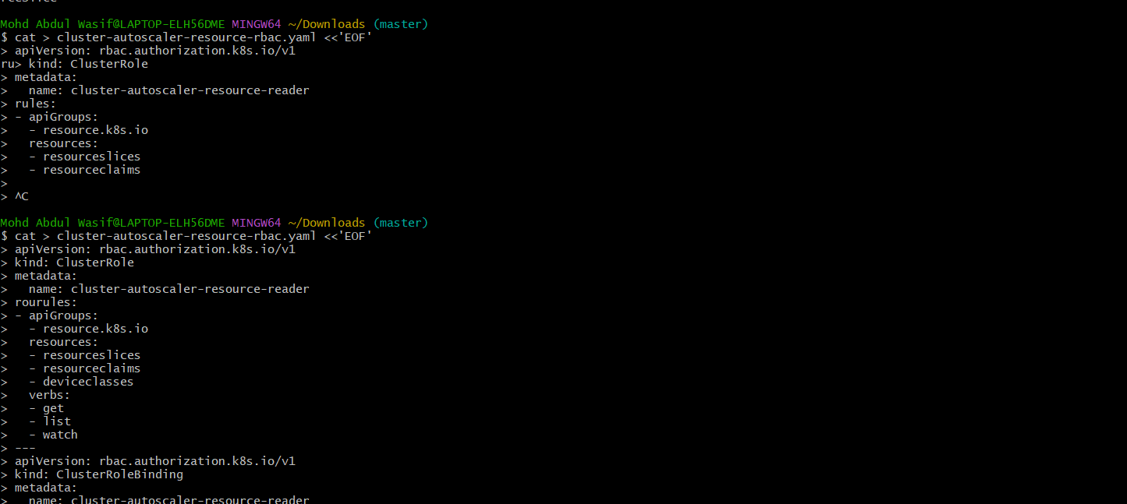
Expected:
deployment "cluster-autoscaler" successfully rolled out
Step 22 — Check logs again
kubectl logs -n kube-system deployment/cluster-autoscaler
Then specifically check for errors:
kubectl logs -n kube-system deployment/cluster-autoscaler | grep -iE "error|forbidden|failed|denied|unauthorized"
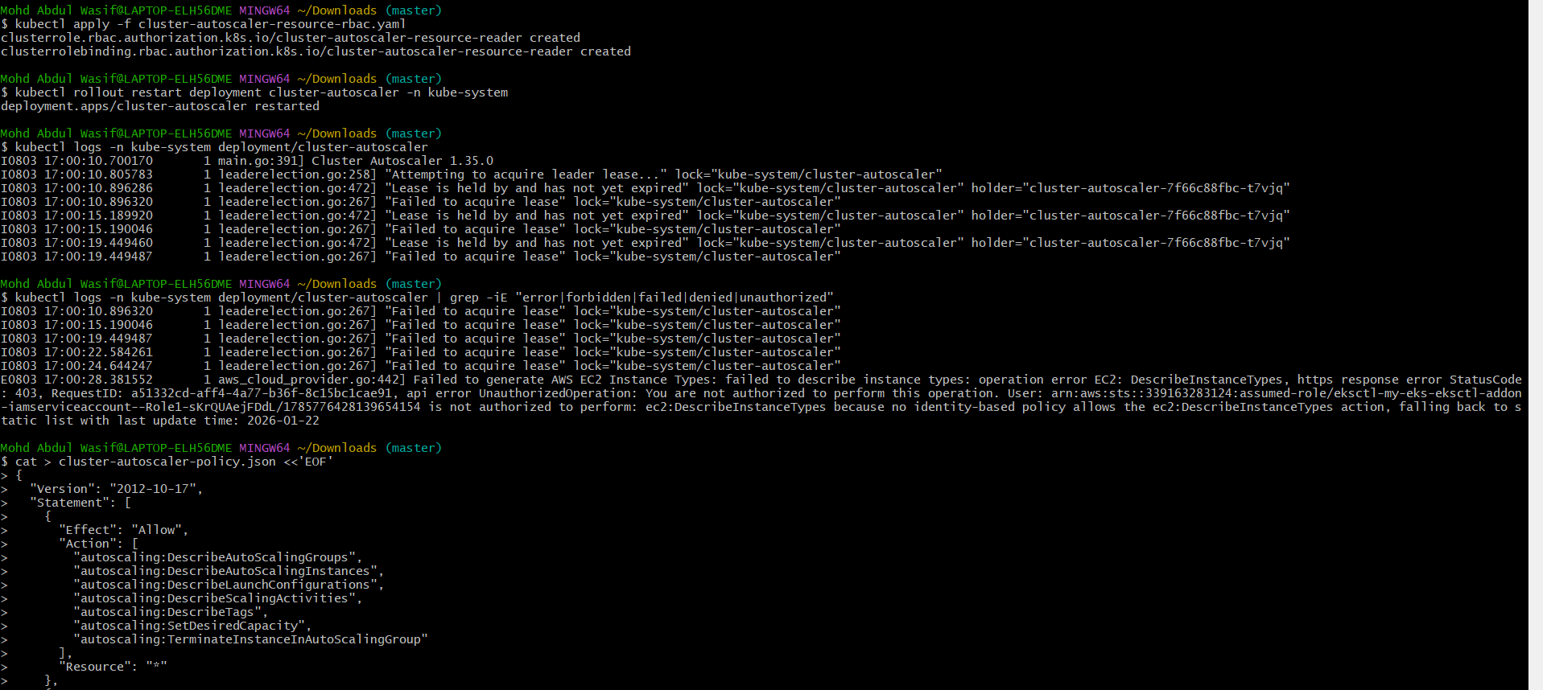
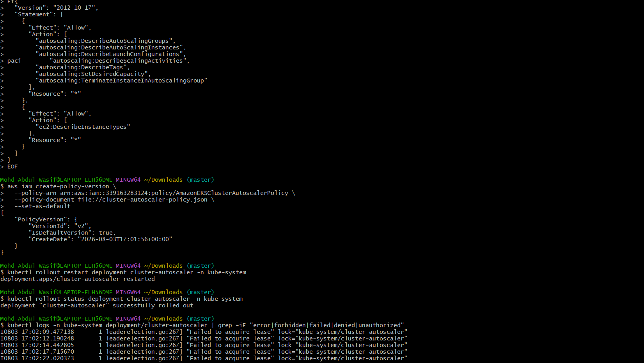
We want the resourceslices, resourceclaims, and deviceclasses forbidden messages to disappear.
Step 1 — Create a workload that cannot fit
Run:
kubectl create deployment ca-test --image=nginx --replicas=10
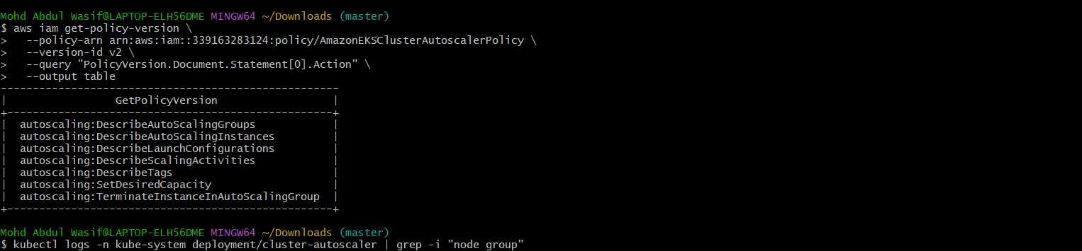
Then:
kubectl get pods -o wide
If some pods become Pending, that's what we want.
Step 2 — Watch the nodes
Open another Git Bash window and run:
kubectl get nodes -w
You should eventually see a third node appear.
Step 3 — Watch the autoscaler
Run:
kubectl logs -n kube-system deployment/cluster-autoscaler --tail=100 -f
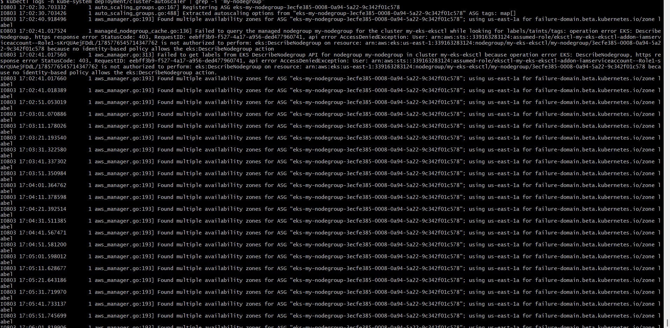
Look for messages related to:
scale up
scale-up
Increasing node group
my-nodegroup
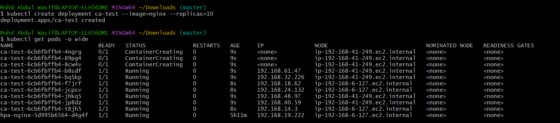
Step 4 — Check AWS ASG
aws autoscaling describe-auto-scaling-groups \
--region us-east-1 \
--auto-scaling-group-names eks-my-nodegroup-3ecfe385-0008-0a94-5a22-9c342f01c578 \
--query "AutoScalingGroups[0].{Min:MinSize,Max:MaxSize,Desired:DesiredCapacity}" \
--output table
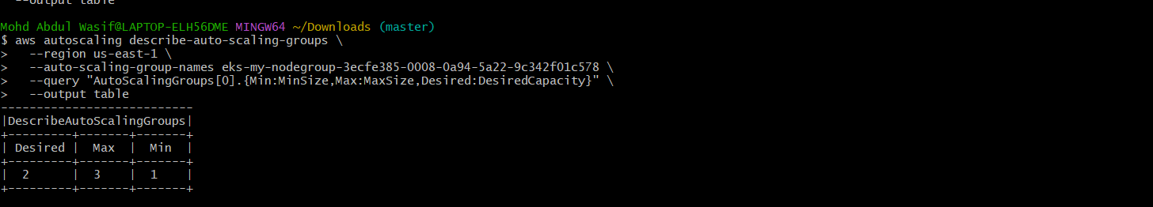
Expected after successful scale-up:
Min 1
Max 3
Desired 3
Step 5 — Clean up
After confirming the third node:
kubectl delete deployment ca-test
Step 1: Create a test deployment
Run:
kubectl create deployment ca-test --image=nginx --replicas=10
Step 2: Check pods
kubectl get pods -o wide
You may see some pods as:
Pending
because your current node capacity is insufficient.
Step 3: Watch nodes
Open another Git Bash window:
kubectl get nodes -w
Wait for a new node to appear.
You currently have:
2 nodes
The expected result is:
3 nodes
Step 4: Check node group
eksctl get nodegroup \
--cluster my-eks-eksctl \
--region us-east-1
The desired capacity should become:
DESIRED CAPACITY = 3
Step 5: Check autoscaler logs
kubectl logs -n kube-system deployment/cluster-autoscaler --tail=100 | grep -iE "scale|increase|expand|unschedulable"
You want to see evidence that the autoscaler detected the pending workload and initiated scale-up.
Step 6: Verify all pods
kubectl get pods -o wide
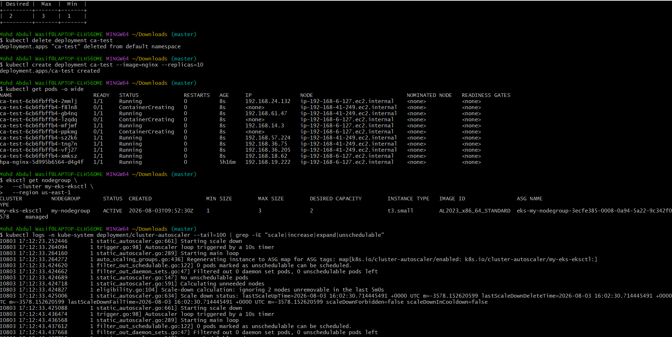
Eventually the ca-test pods should become:
10/10 Running
Step 7: Clean up
After confirming scale-up:
kubectl delete deployment ca-test
Then check:
kubectl get nodes
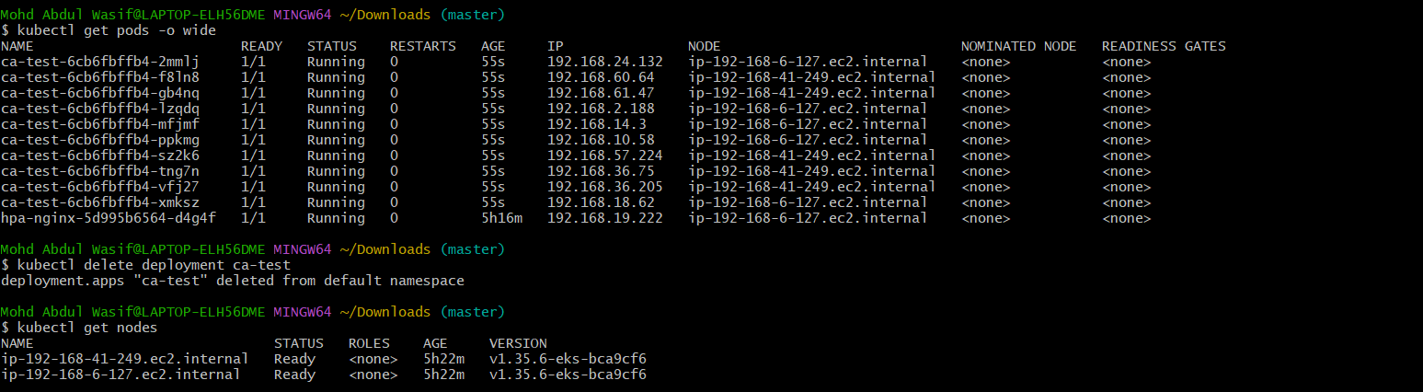
The autoscaler should eventually recognize that the extra node is unnecessary and scale the node group back toward the minimum/needed capacity.
Task 8: Create Kubernetes Job and CronJob
Your next task is Job and CronJob. We'll do it hands-on on your existing EKS cluster my-eks-eksctl.
Objective
Learn how to:
- Create a Kubernetes Job
- Run a task until it successfully completes
- Create a CronJob
- Schedule a task periodically
- Check Job/CronJob status and logs
- Clean up the resources
Step 1: Verify cluster
kubectl get nodes
You should see your two/three EKS worker nodes as Ready.
Step 2: Create a Job
Create the YAML:
cat > job.yaml <<'EOF'
apiVersion: batch/v1
kind: Job
metadata:
name: demo-job
spec:
template:
spec:
containers:
- name: demo
image: busybox:1.36
command: ["sh", "-c", "echo Job started; sleep 10; echo Job completed"]
restartPolicy: Never
backoffLimit: 2
EOF
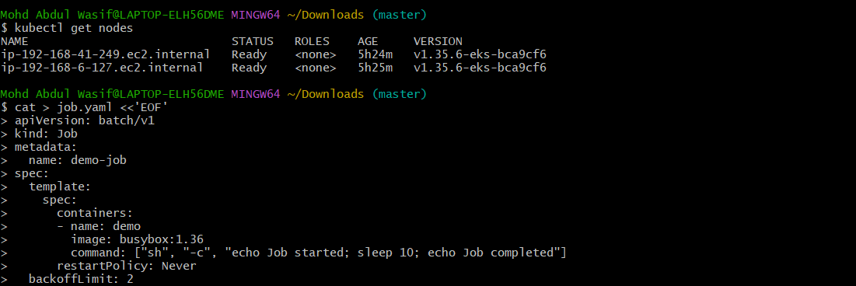
Apply it:
kubectl apply -f job.yaml
Step 3: Check the Job
kubectl get jobs
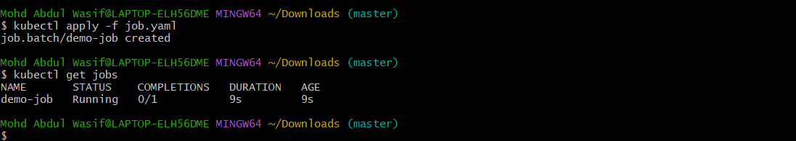
Expected:
NAME COMPLETIONS DURATION AGE
demo-job 1/1 ... ...
Step 4: Check the Pod
kubectl get pods
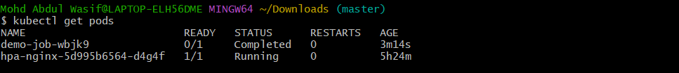
You should see the Job pod with:
STATUS Completed
Step 5: Check Job logs
kubectl logs job/demo-job
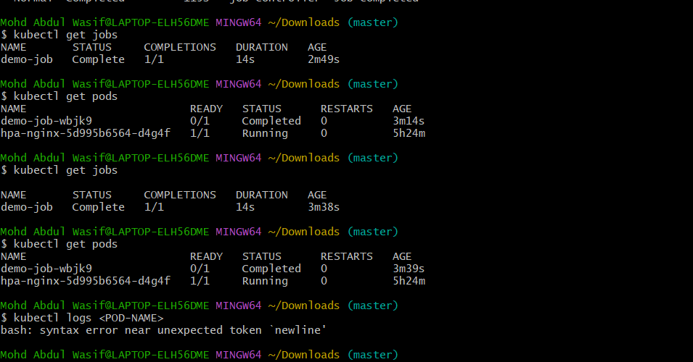
Expected:
Job started
Job completed
Step 6: Create a CronJob
Now create a CronJob that runs every minute:
cat > cronjob.yaml <<'EOF'
apiVersion: batch/v1
kind: CronJob
metadata:
name: demo-cronjob
spec:
schedule: "*/1 * * * *"
jobTemplate:
spec:
template:
spec:
containers:
- name: cron-demo
image: busybox:1.36
command: ["sh", "-c", "date; echo CronJob executed"]
restartPolicy: Never
EOF
Apply:
kubectl apply -f cronjob.yaml
Step 7: Check CronJob
kubectl get cronjobs
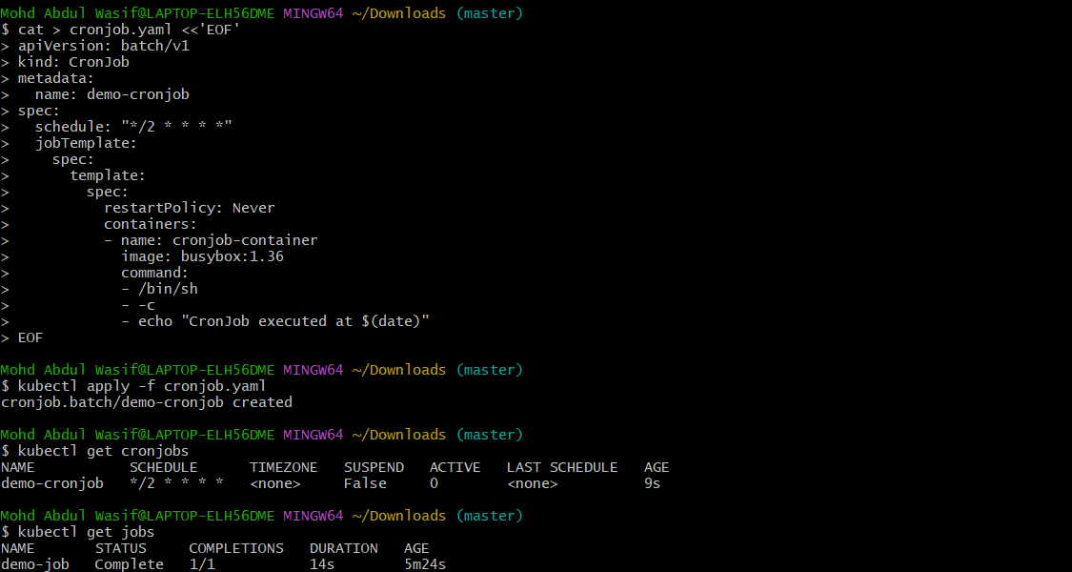
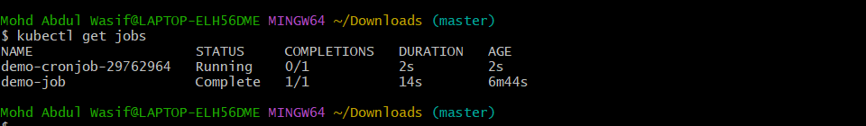
You should see:
NAME SCHEDULE SUSPEND ACTIVE
demo-cronjob */1 * * * * False 0
Step 1: Apply the CronJob
If you already created cronjob.yaml, run:
kubectl apply -f cronjob.yaml
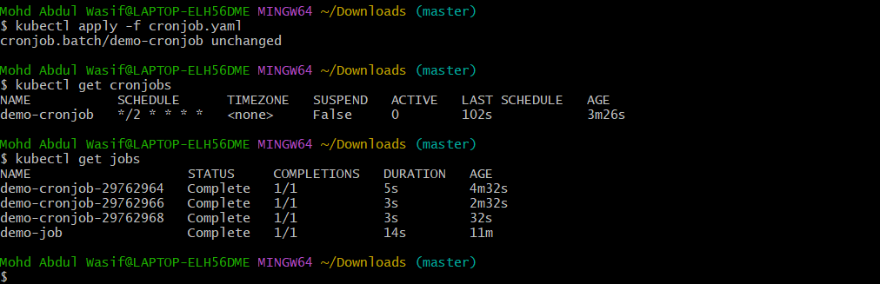
Expected:
cronjob.batch/demo-cronjob created
Step 2: Check CronJob
kubectl get cronjobs
You should see:
NAME SCHEDULE SUSPEND ACTIVE LAST SCHEDULE
demo-cronjob */2 * * * * False 0 ...

Step 3: Wait for the CronJob to create a Job
Because the schedule is every 2 minutes, wait until the next execution and run:
kubectl get jobs

You should see something similar to:
NAME STATUS COMPLETIONS
demo-job Complete 1/1
demo-cronjob-xxxxxxxx Complete 1/1
Step 4: Check the CronJob Pod
kubectl get pods
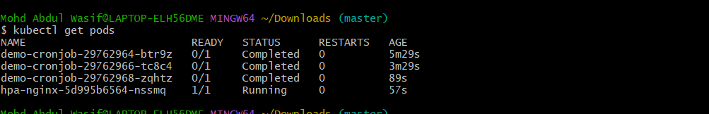
You should see a Pod created by the CronJob with:
STATUS
Completed
Step 5: View the CronJob output
First find the Pod:
kubectl get pods --sort-by=.metadata.creationTimestamp
Then use the actual Pod name:
kubectl logs <actual-pod-name>
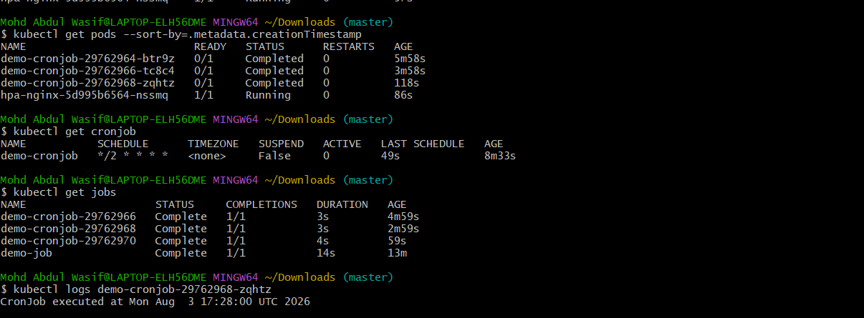
For example:
kubectl logs demo-cronjob-123456789
You should get output similar to:
CronJob executed at Mon Aug 3 ...
Step 6: Describe the CronJob
kubectl describe cronjob demo-cronjob
Look for:
Schedule: */2 * * * *

Last Schedule Time:
Active:
Step 7: Final verification
Run:
kubectl get cronjob
kubectl get jobs
kubectl get pods
If the CronJob has created a completed Job and Pod, the CronJob task is complete.
After this, your next task will be Create Secret and inject it inside a Pod.

Step 8: Wait for it to execute
After about one minute:
kubectl get jobs
You should see a new Job created by the CronJob.
Then:
kubectl get pods
Step 9: Check CronJob logs
First get the CronJob-created pod:
kubectl get pods --sort-by=.metadata.creationTimestamp
Then:
kubectl logs <pod-name>

You should see something similar to:
Mon Aug 3 ...
CronJob executed
Step 10: Check CronJob details
kubectl describe cronjob demo-cronjob
Look for:
Schedule: */1 * * * *
Active Jobs
Last Schedule Time
Step 11: Cleanup
Delete the CronJob:
kubectl delete cronjob demo-cronjob
Delete the Job:
kubectl delete job demo-job
Verify:
kubectl get jobs
kubectl get cronjobs
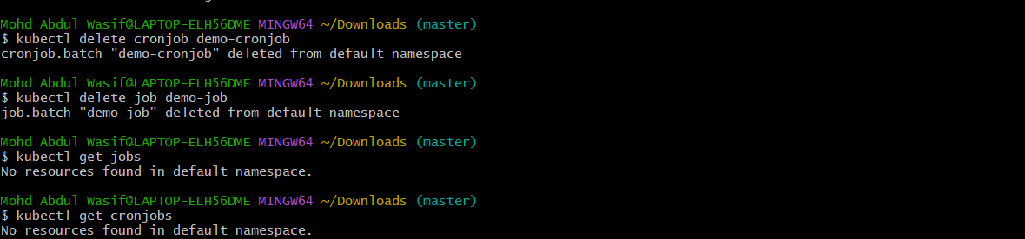
Both should be empty.
What you will learn
Job:
Job
↓
Pod
↓
Task executes
↓
Pod Completed
↓
Job Completed
CronJob:
CronJob
↓
Schedule
↓
Job
↓
Pod
↓
Task executes
CronJob task result
Item | Status
CronJob created | ✅
Schedule working | ✅
Multiple Jobs created | ✅
Pods created automatically | ✅
Pods completed successfully | ✅
CronJob task | ✅ COMPLETED
What we learned
- Job runs a task to completion.
- CronJob automatically creates Jobs according to a schedule.
- */2 * * * * means the CronJob runs every 2 minutes.
- Each execution creates a new Job and Pod.
- Completed Pods can be checked with kubectl get pods.
- Logs can be viewed using kubectl logs.
Continue with the Secret and Secret Injection task.
- Step 1: Create the Secret
- Run:
- kubectl create secret generic app-secret \
- --from-literal=username=admin \
- --from-literal=password=MySecret123
- Expected:
- secret/app-secret created
- Step 2: Verify the Secret
- kubectl get secret app-secret
- Expected:
- NAME TYPE DATA AGE
- app-secret Opaque 2 ...
- Check the details:
- kubectl describe secret app-secret
- Notice that Kubernetes does not display the actual secret values in describe.
- Step 3: Create a Pod that uses the Secret
- Create secret-pod.yaml:
- cat > secret-pod.yaml <<'EOF'
- apiVersion: v1
- kind: Pod
- metadata:
- name: secret-pod
- spec:
- containers:
- - name: nginx
- image: nginx:latest
- env:
- - name: APP_USERNAME
- valueFrom:
- secretKeyRef:
- name: app-secret
- key: username
- - name: APP_PASSWORD
- valueFrom:
- secretKeyRef:
- name: app-secret
- key: password
- EOF
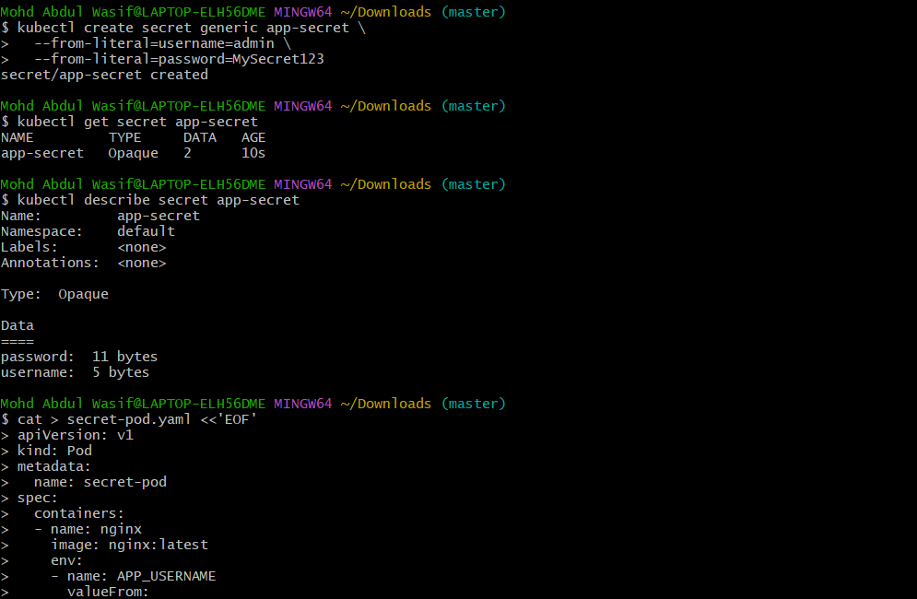
- Step 4: Apply the Pod
- kubectl apply -f secret-pod.yaml
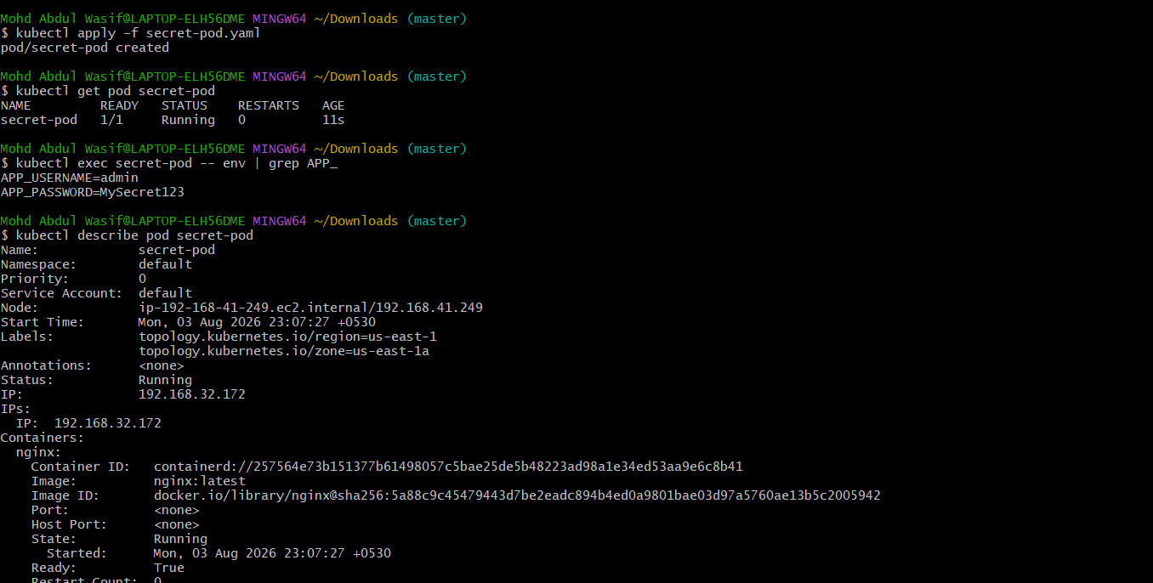
- Expected:
- pod/secret-pod created
- Step 5: Check the Pod
- kubectl get pod secret-pod
- Wait until:
- secret-pod 1/1 Running
- Step 6: Verify the Secret was injected
- Run:
- kubectl exec secret-pod -- env | grep APP_

- You should see:
- APP_USERNAME=admin
- APP_PASSWORD=MySecret123
- This proves the Secret was successfully injected into the container as environment variables.
- Step 7: Verify the Secret reference
- kubectl describe pod secret-pod
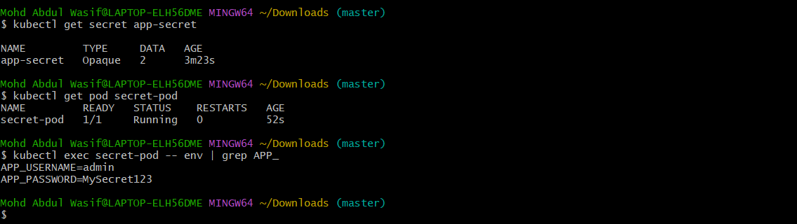
- Under Environment, you should see references to:
- APP_USERNAME
- APP_PASSWORD
- Step 8: Optional — Inject Secret as files
- Kubernetes can also mount Secrets as files. We can practice that after confirming the environment-variable method works.
- Task completion criteria
- Your task is complete when these work:
- kubectl get secret app-secret
- kubectl get pod secret-pod
- kubectl exec secret-pod -- env | grep APP
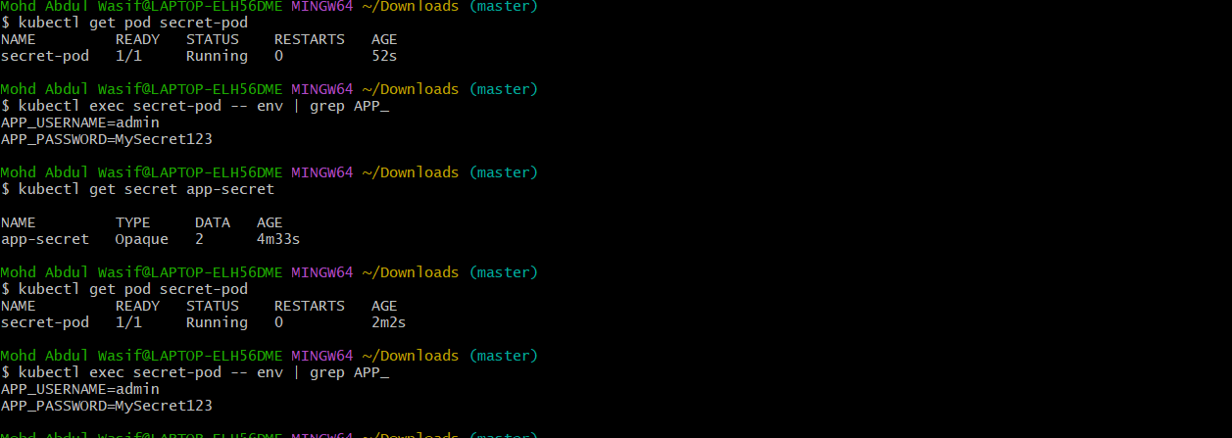 _
- Expected:
- app-secret Opaque 2
- secret-pod 1/1 Running
- APP_USERNAME=admin
- APP_PASSWORD=MySecret123

Step 1: Create a Secret-mounted Pod
cat > secret-volume-pod.yaml <<'EOF'
apiVersion: v1
kind: Pod
metadata:
name: secret-volume-pod
spec:
containers:
- name: nginx
image: nginx:latest
volumeMounts:
- name: secret-volume
mountPath: /etc/app-secret
readOnly: true
volumes:
- name: secret-volume
secret:
secretName: app-secret
EOF
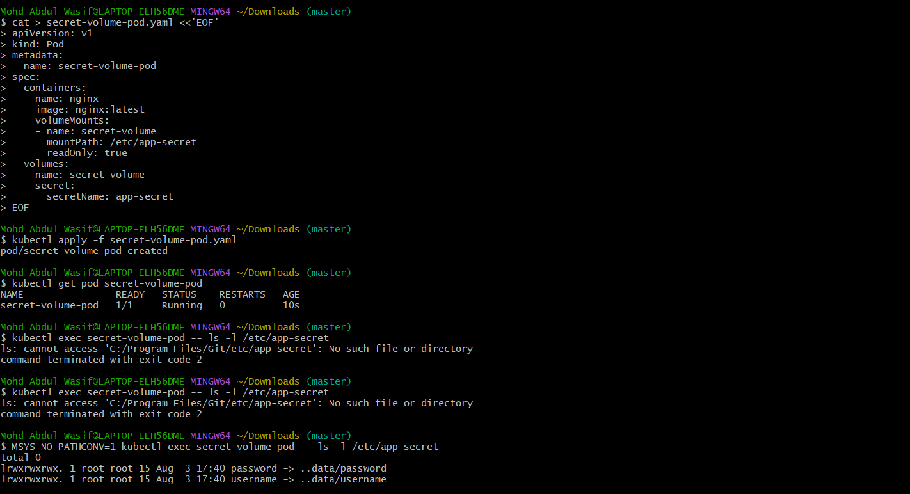
Step 2: Create the Pod
kubectl apply -f secret-volume-pod.yaml
Expected:
pod/secret-volume-pod created
Step 3: Check the Pod
kubectl get pod secret-volume-pod
Wait for:
secret-volume-pod 1/1 Running
Step 4: Check the Secret files
Run:
kubectl exec secret-volume-pod -- ls -l /etc/app-secret

You should see:
username
password
Step 5: Read the Secret from the mounted files
kubectl exec secret-volume-pod -- cat /etc/app-secret/username
Expected:
admin
And:
kubectl exec secret-volume-pod -- cat /etc/app-secret/password
Expected:
MySecret123
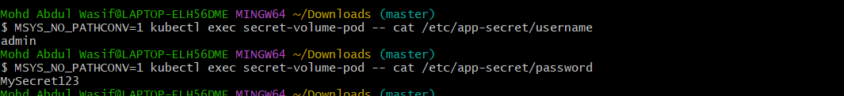
Step 6: Final verification
Run:
kubectl get secret app-secret
kubectl get pods
kubectl exec secret-volume-pod -- ls /etc/app-secret
✅ What you learned
You have now practiced both common Secret injection methods:
- Environment variables
Secret → env → Container
- Volume mount
Secret → Volume → /etc/app-secret/
Task status
Create Secret and Inject Inside Pod → ✅ COMPLETED
What you learned
- Kubernetes Secrets store sensitive configuration.
- Secrets can be injected as environment variables.
- Secrets can also be mounted as files.
- secretKeyRef is used for environment variables.
- secret volumes are used for file-based injection.
- Git Bash may require MSYS_NO_PATHCONV=1 for Linux paths.

