Challenge-8
Challenge-08:-Use the below code and implement our CICD stages.
- Source Code:https://github.com/betawins/hiring-app.git
Repository contains the application code for the hiring app.
- Create one Declarative pipeline job
- Create one Scripted pipeline job
- Create one multi stage pipeline job
- Create one parallel stage pipeline job
Jenkins Official Documentation
Recommended
- Pipeline:https://www.jenkins.io/doc/book/pipeline/
- Environment Variables:https://www.jenkins.io/doc/book/pipeline/jenkinsfile/#using-environment-variables
- Parameters:https://www.jenkins.io/doc/book/pipeline/syntax/#parameters
- Handling credentials in Pipeline:https://www.jenkins.io/doc/book/pipeline/jenkinsfile/#handling-credentials

Jenkins CI/CD Pipeline (Declarative) – Step by Step

PRE-REQUISITES (Must be ready)
Before pipeline:
Jenkins Plugins:
- Git Plugin
- Pipeline Plugin
- SonarQube Scanner Plugin
- Nexus Artifact Uploader Plugin (or HTTP Request)
- Slack Notification Plugin
- Maven Integration Plugin

Tools in Jenkins:
- JDK 17
- Maven
- SonarQube server configured
- Nexus repository configured
- Tomcat running (Docker or VM)
- Slack workspace integration

STEP 1: Create Jenkins Pipeline Job
Go to Jenkins:
New Item → Pipeline → Name: cicd-pipeline
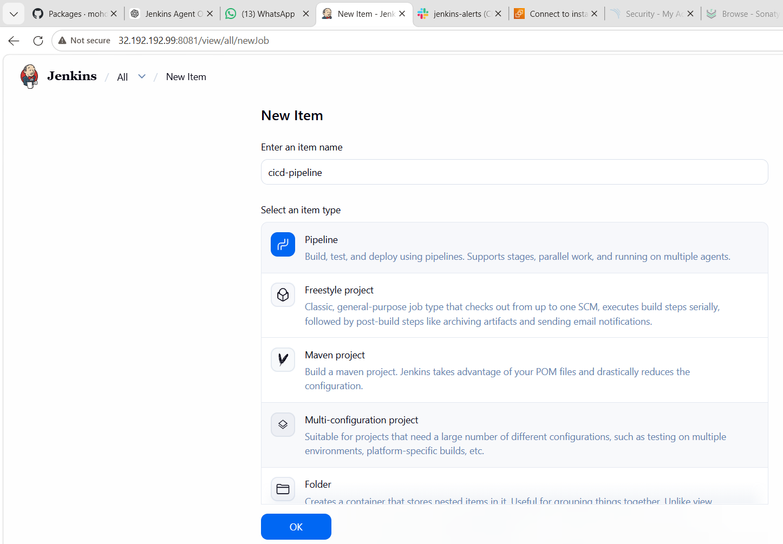

STEP 2: Configure Git Branch
Repo:
https://github.com/betawins/sabear_simplecutomerapp.git
Branch:
feature-1.1

🔧 STEP 3: Declarative Pipeline Script
Paste this in Pipeline Script
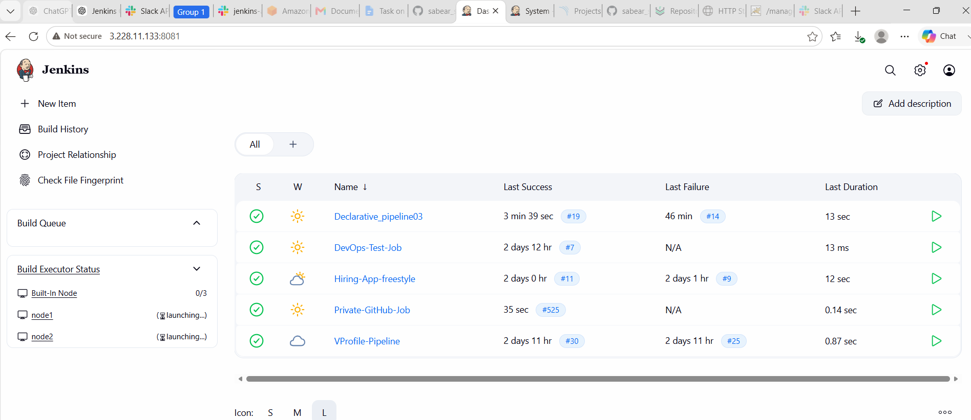

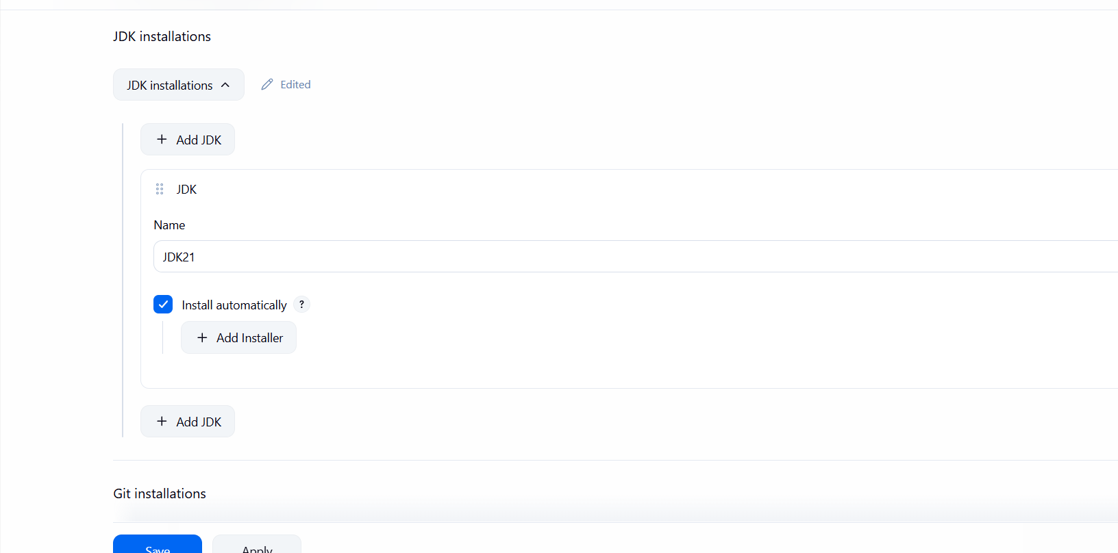
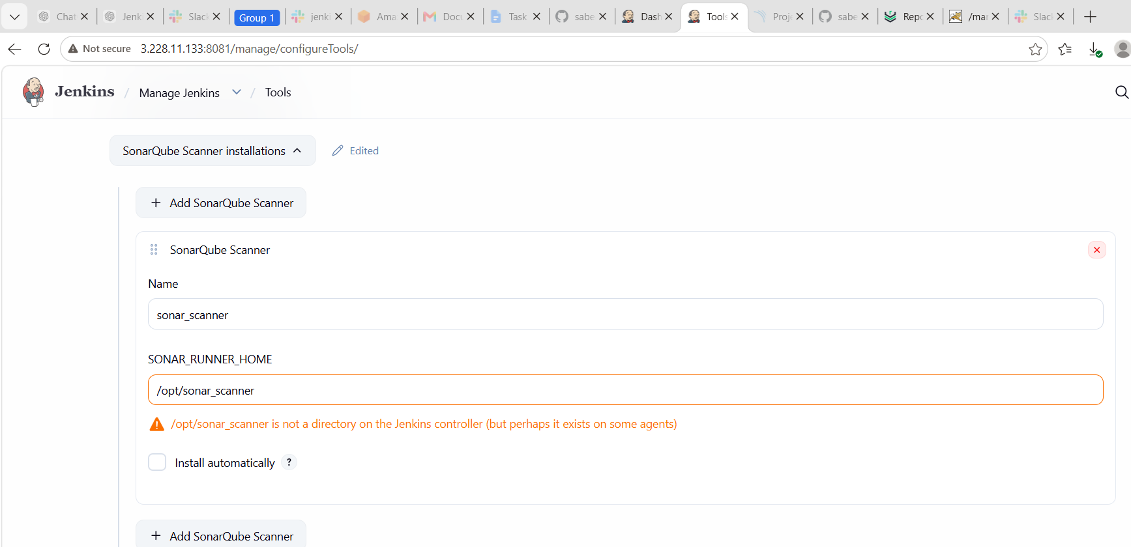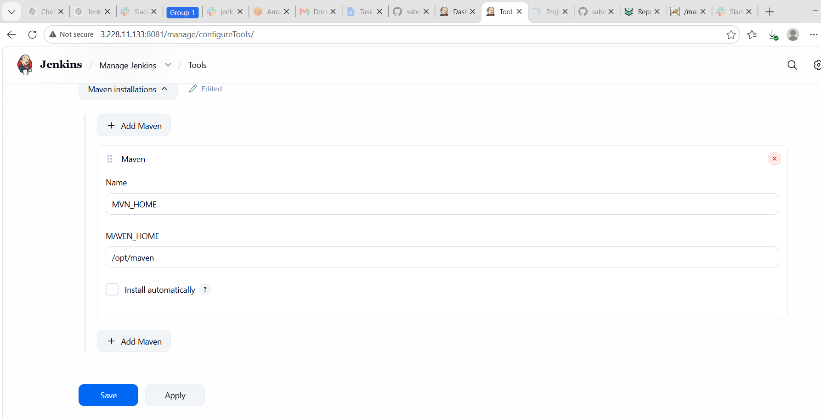

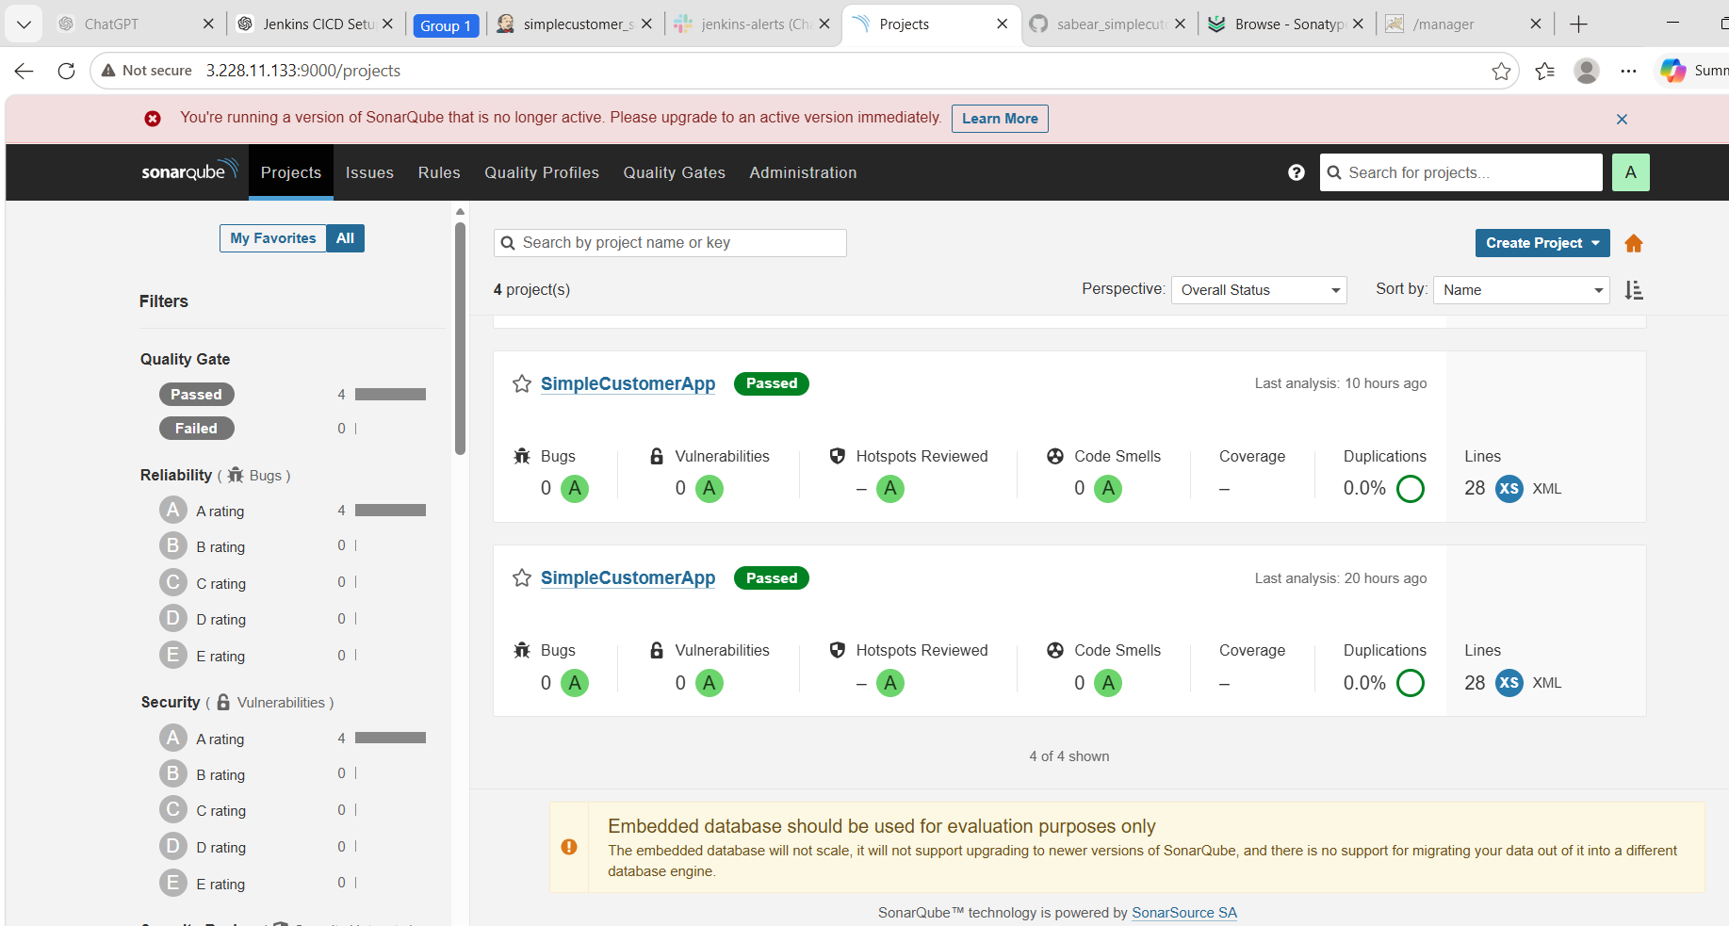

pipeline {
agent any

tools {
jdk 'JDK21'
maven 'MVN_HOME'
}

environment {
APP_NAME = "simple-customer-app"

NEXUS_URL = "3.228.11.133:8082"
NEXUS_REPO = "Maven03"

TOMCAT_URL = "http://3.228.11.133:8080"

SLACK_CHANNEL = "#jenkins-alerts"
}

stages {

stage('Git Clone') {
steps {
git branch: 'feature-1.1',
url: 'https://github.com/betawins/sabear_simplecutomerapp.git'
}
}

stage('Maven Build') {
steps {
sh 'mvn clean package -DskipTests'
}
}

stage('SonarQube Analysis') {
steps {
withSonarQubeEnv('sonarqube_server') {
sh 'mvn sonar:sonar'
}
}
}

stage('Get WAR File') {
steps {
script {
env.WAR_FILE = sh(
script: "ls target/*.war | head -n 1",
returnStdout: true
).trim()

echo "WAR FILE FOUND: ${env.WAR_FILE}"
}
}
}

stage('Upload to Nexus') {
steps {
nexusArtifactUploader(
nexusVersion: 'nexus3',
protocol: 'http',
nexusUrl: "${NEXUS_URL}",
groupId: 'com.javatpoint',
version: "${BUILD_NUMBER}",
repository: "${NEXUS_REPO}",
credentialsId: 'Nexus',
artifacts: [
[
artifactId: 'SimpleCustomerApp',
classifier: '',
file: "${env.WAR_FILE}",
type: 'war'
]
]
)
}
}

stage('Deploy to Tomcat') {
steps {
deploy adapters: [
tomcat9(
credentialsId: 'tomcat_deploy',
url: "${TOMCAT_URL}"
)
],
contextPath: 'SimpleCustomerApp',
war: "${env.WAR_FILE}"
}
}
}

post {
success {
slackSend(
channel: "${SLACK_CHANNEL}",
color: 'good',
message: "✅ SUCCESS: ${env.JOB_NAME} #${env.BUILD_NUMBER} uploaded to Nexus and deployed to Tomcat. URL: ${env.BUILD_URL}"
)
}

failure {
slackSend(
channel: "${SLACK_CHANNEL}",
color: 'danger',
message: "❌ FAILED: ${env.JOB_NAME} #${env.BUILD_NUMBER}. Check Jenkins: ${env.BUILD_URL}"
)
}

always {
cleanWs()
}
}
}
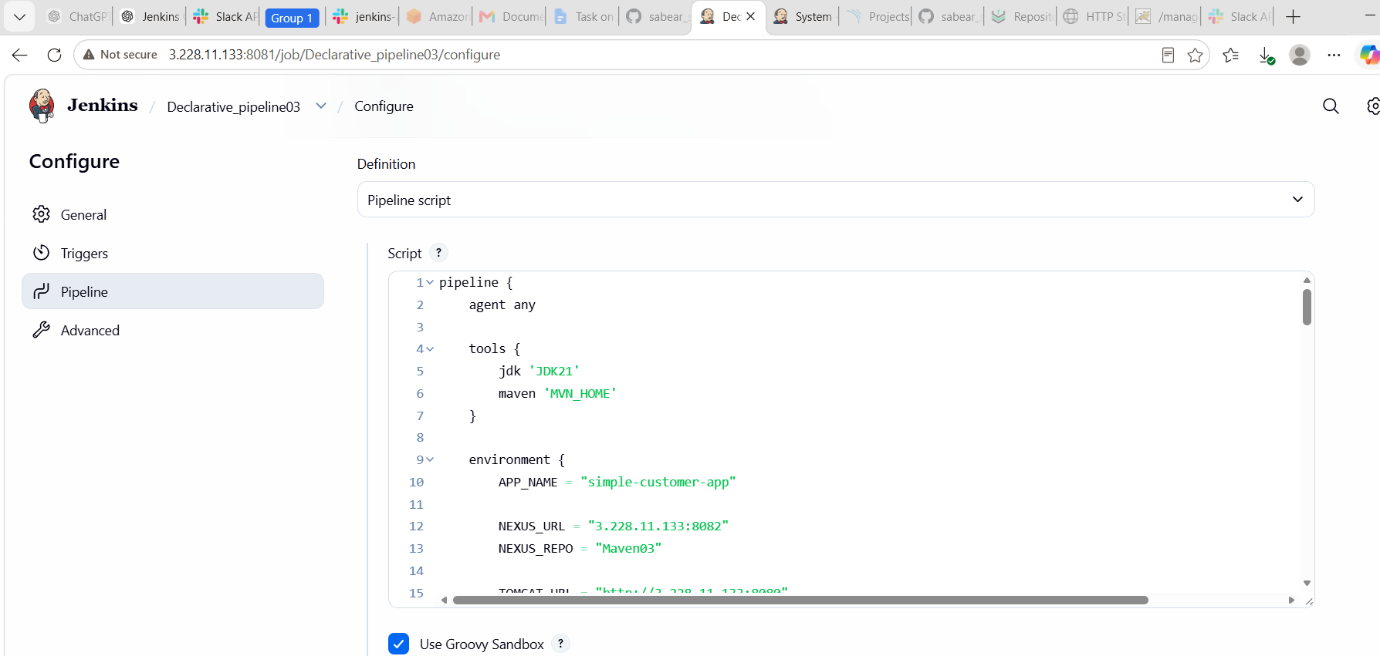

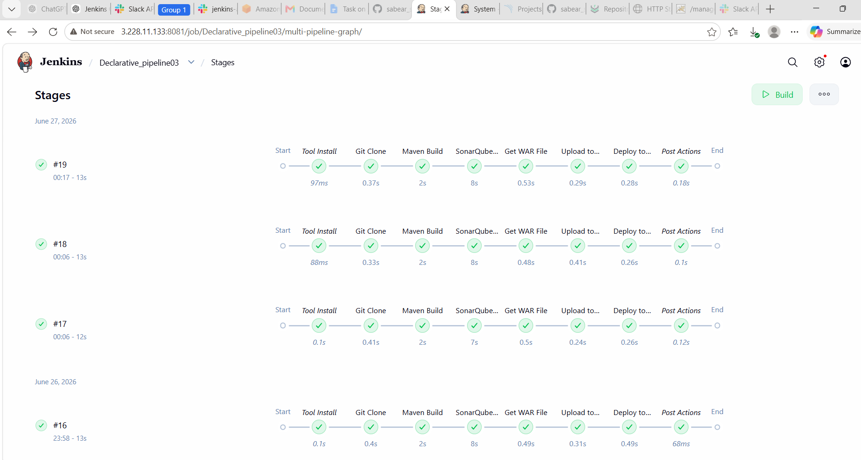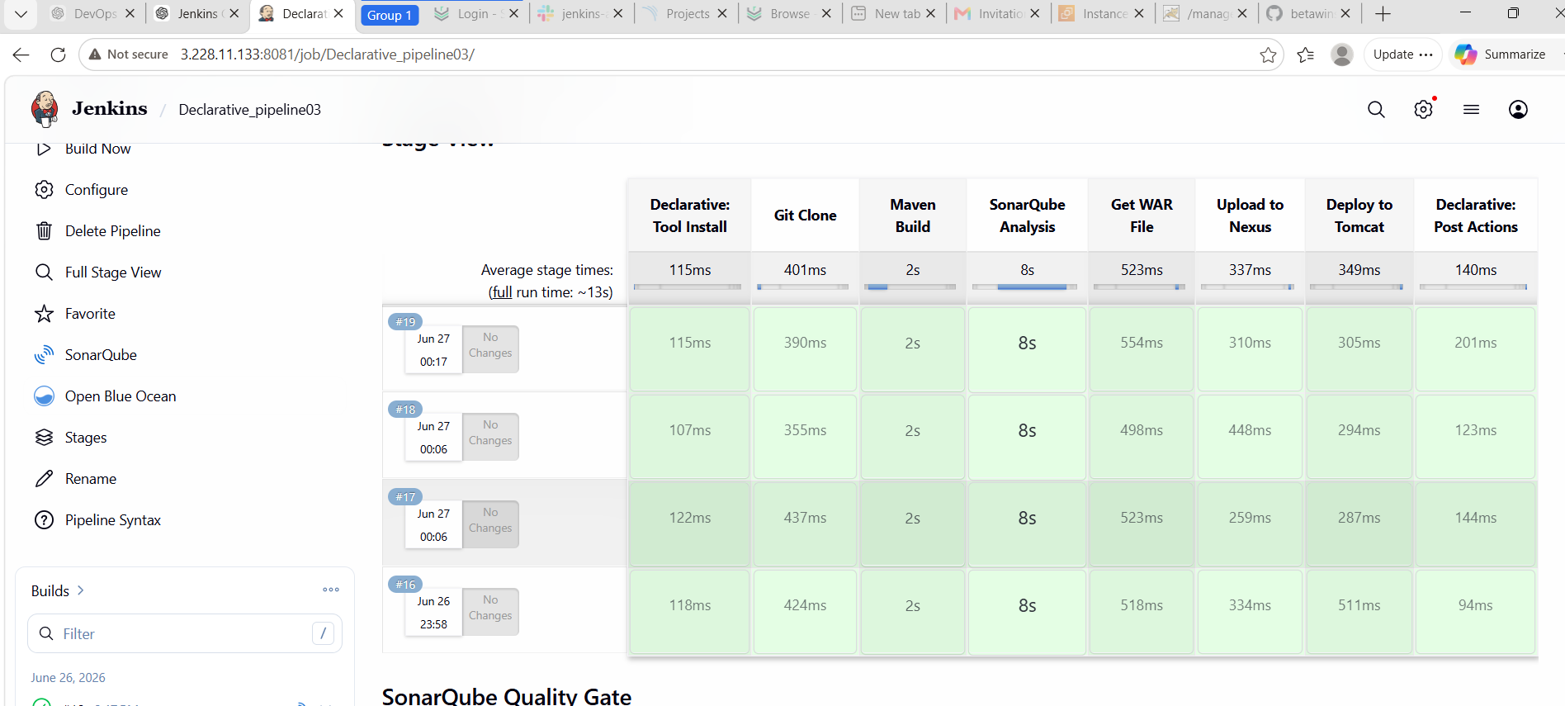
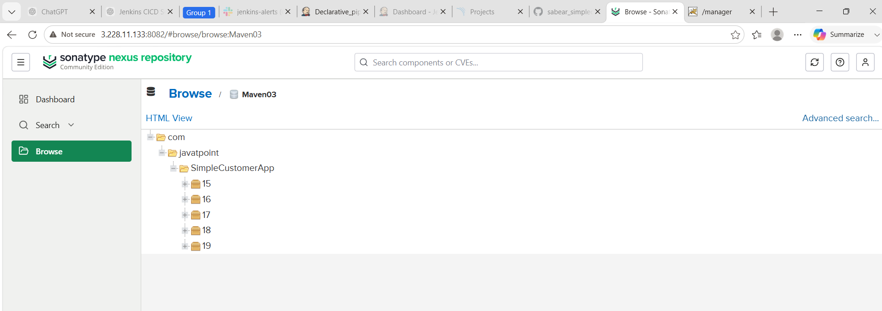

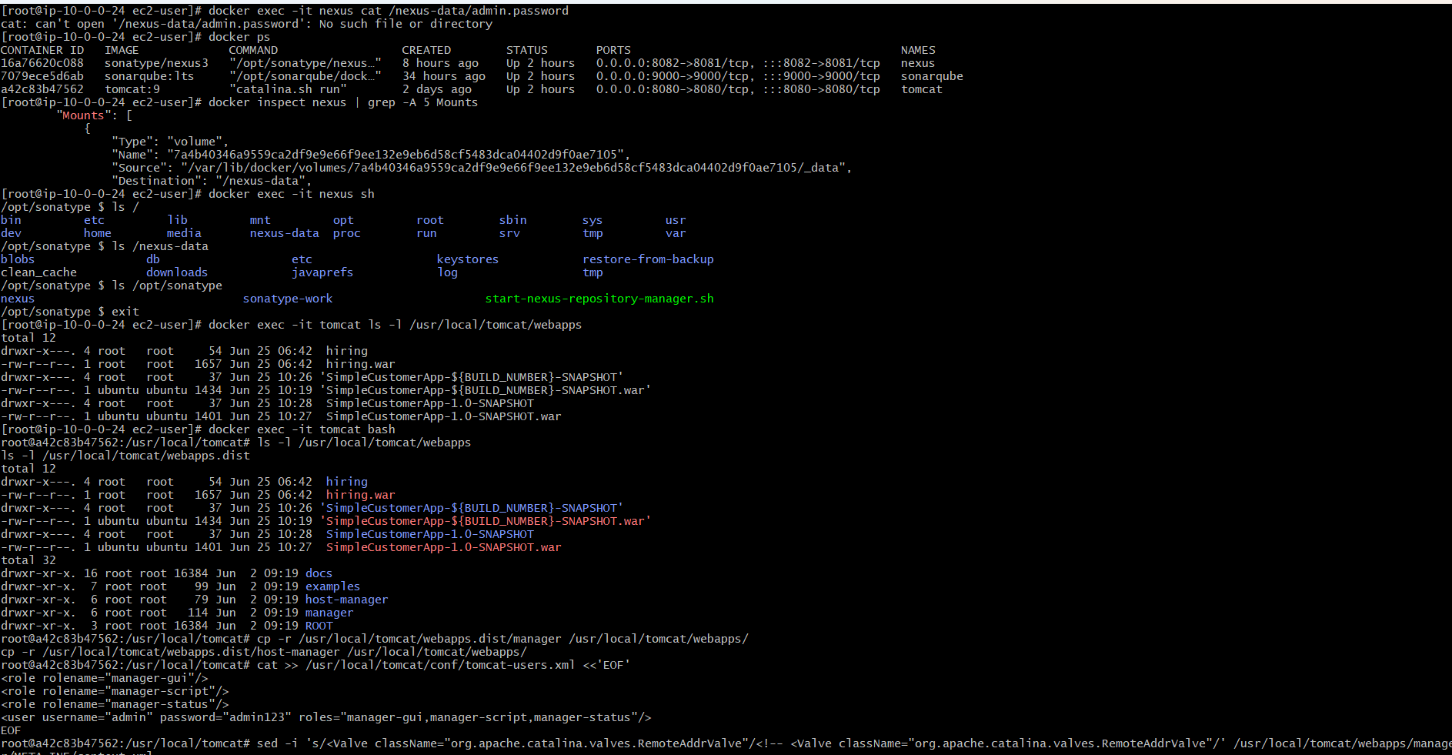
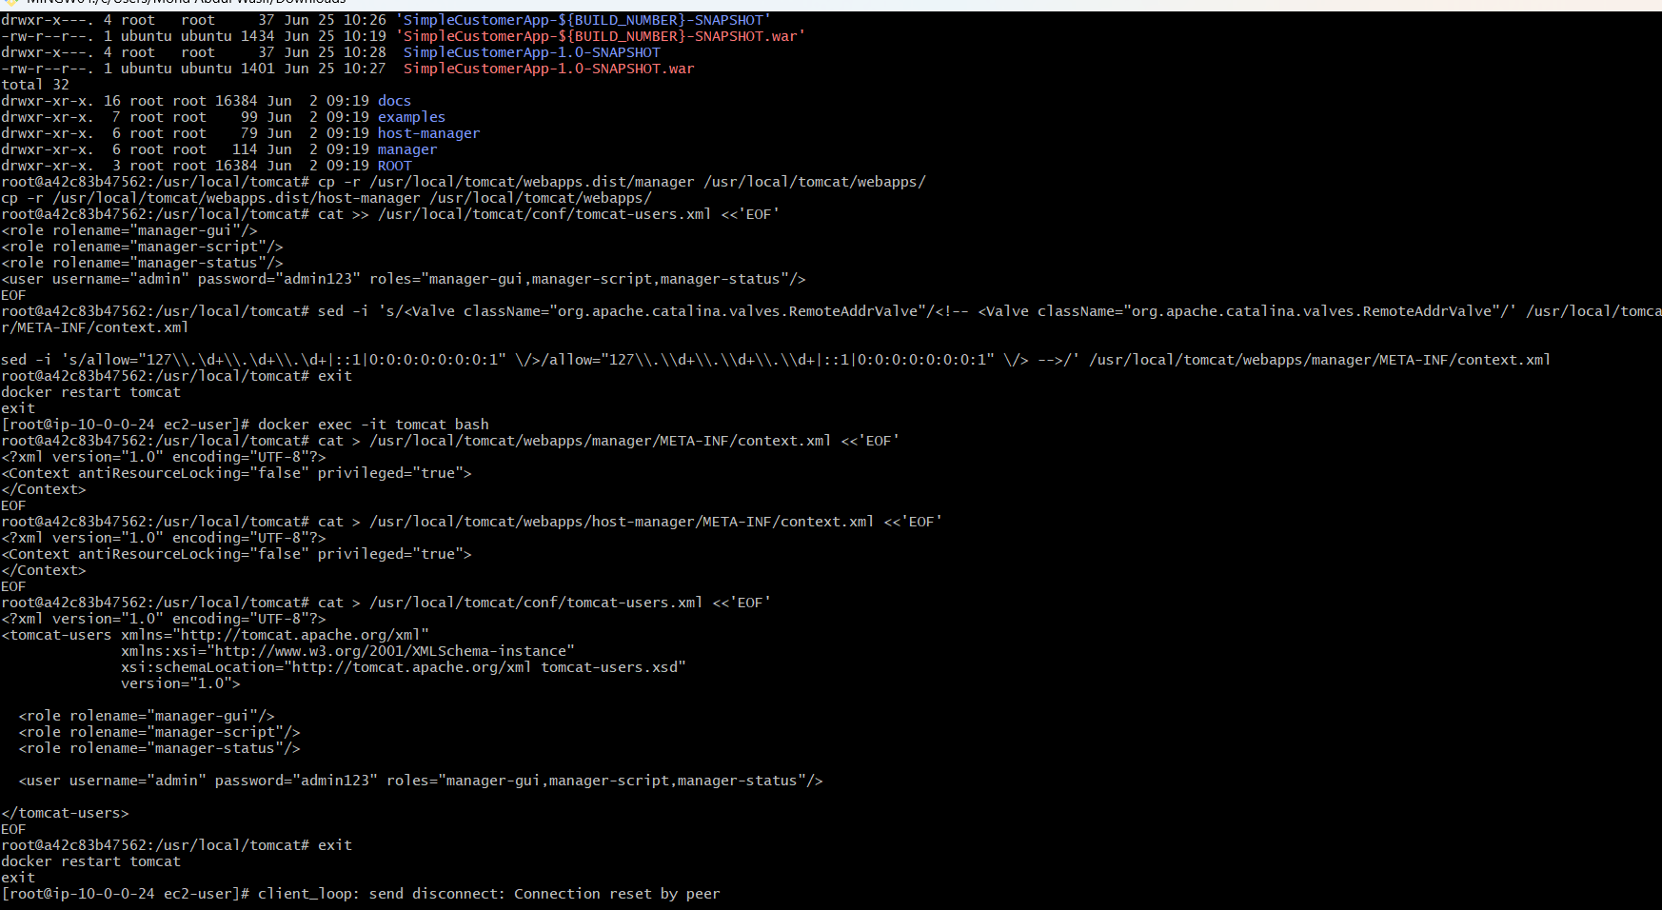
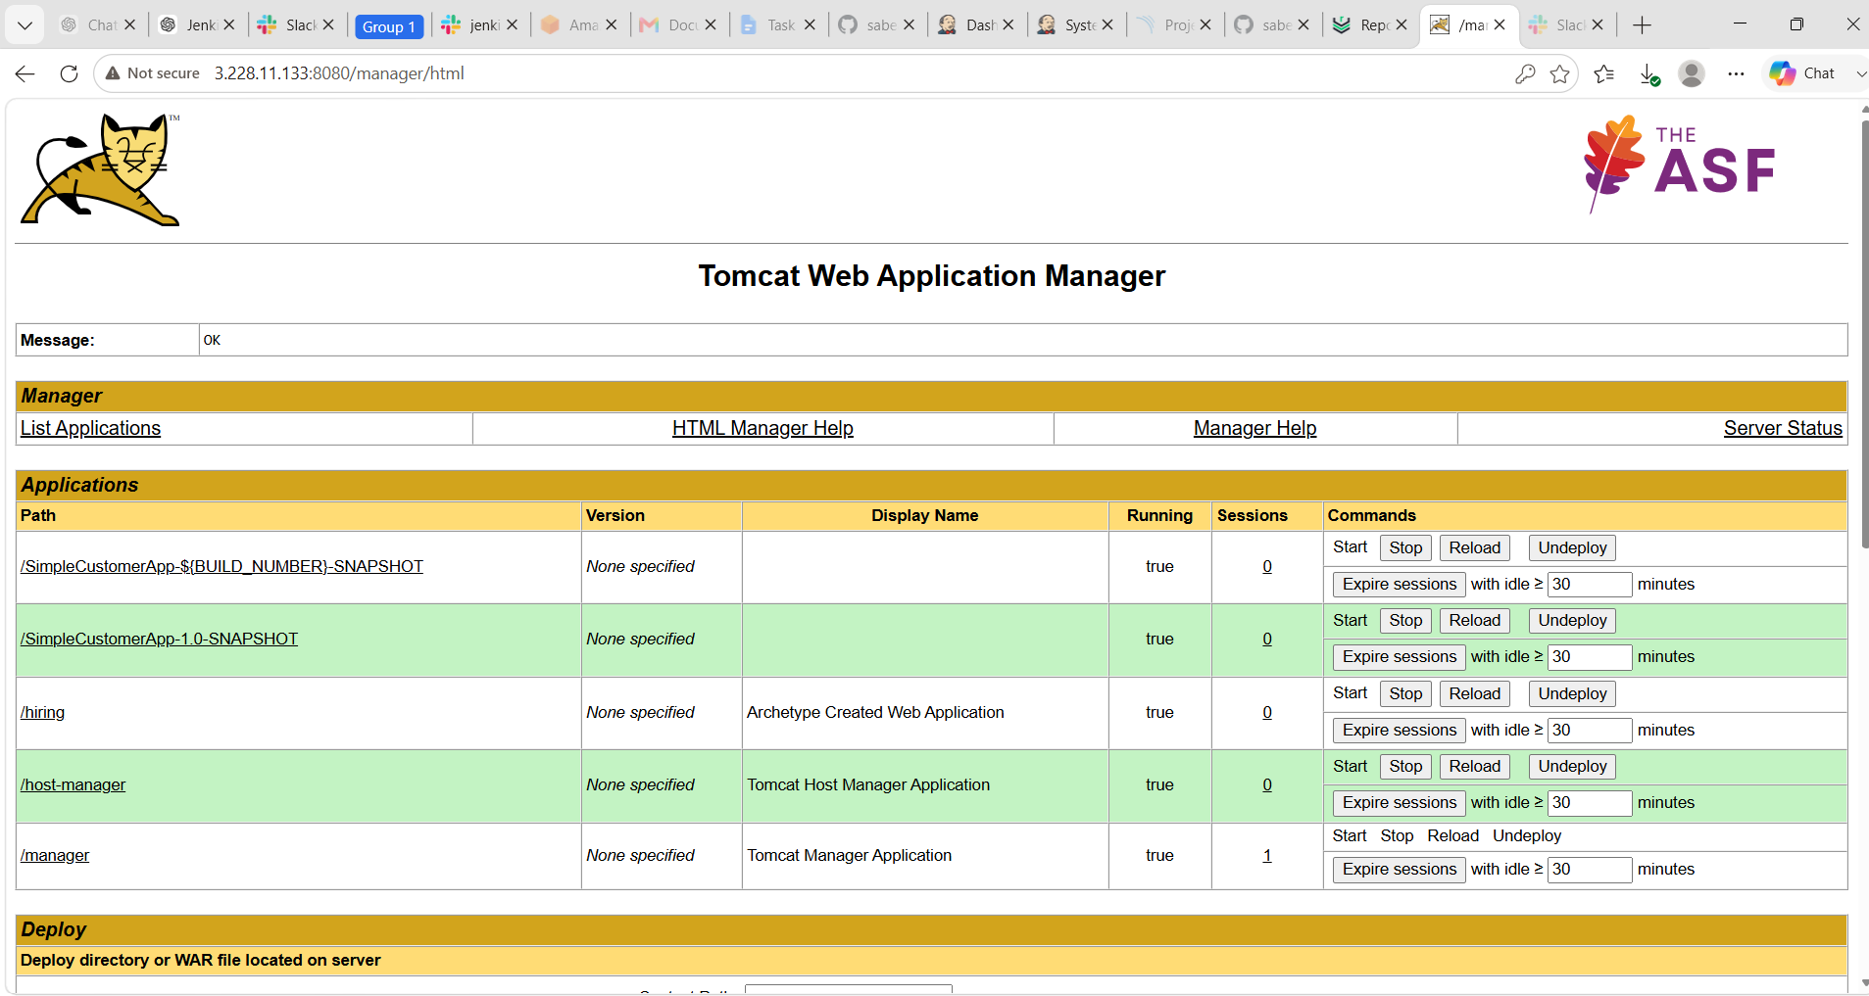
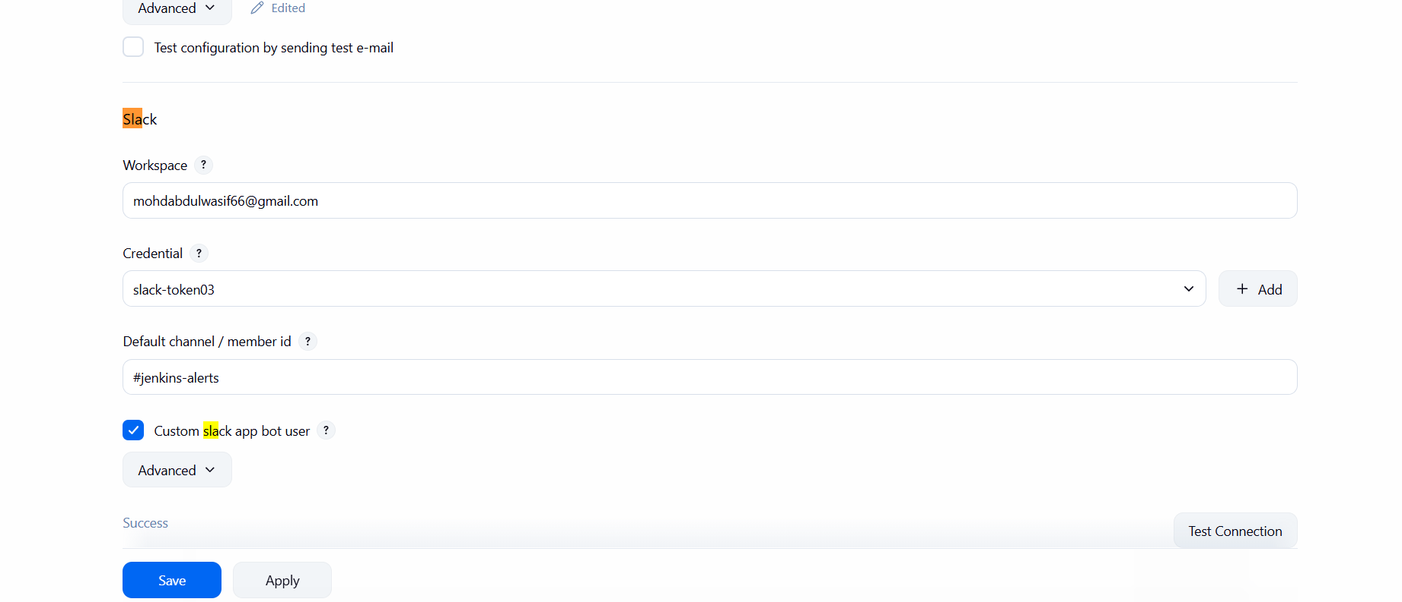

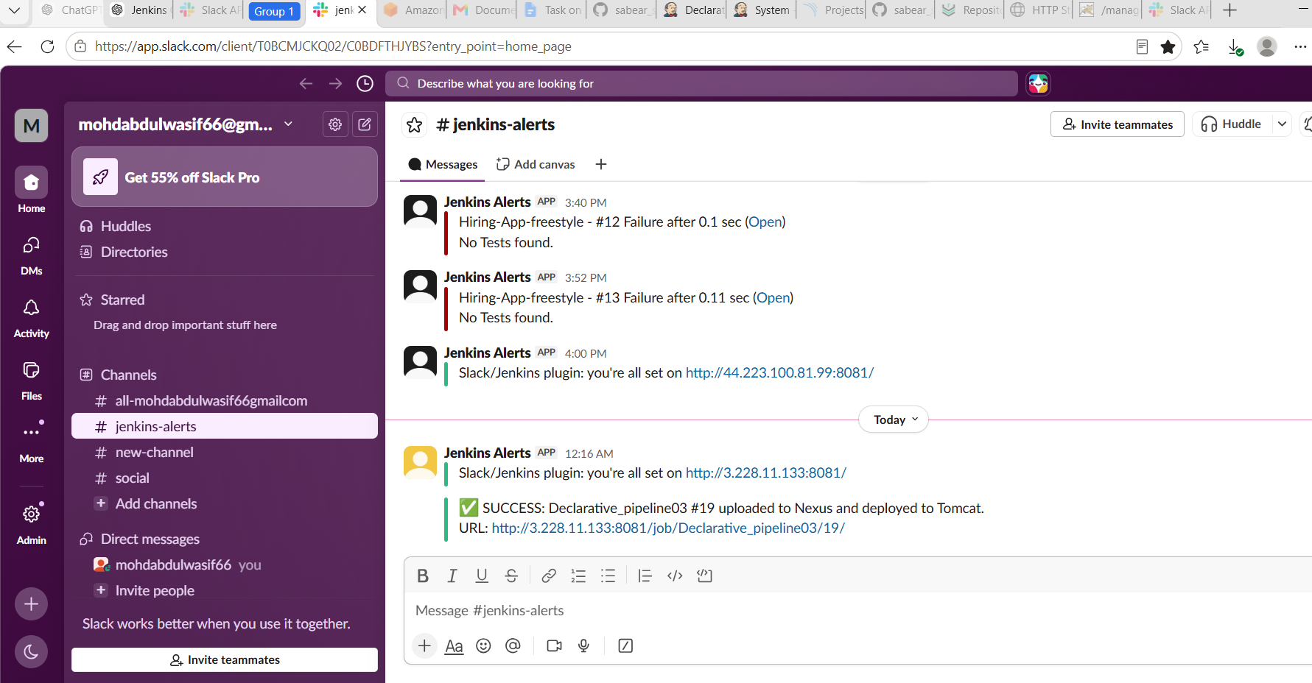

Step-by-Step
Step 1: Create Jenkins Job
- Open Jenkins
- Click New Item
- Name:
simplecustomer_scripted_pipeline
- Select Pipeline
- Click OK

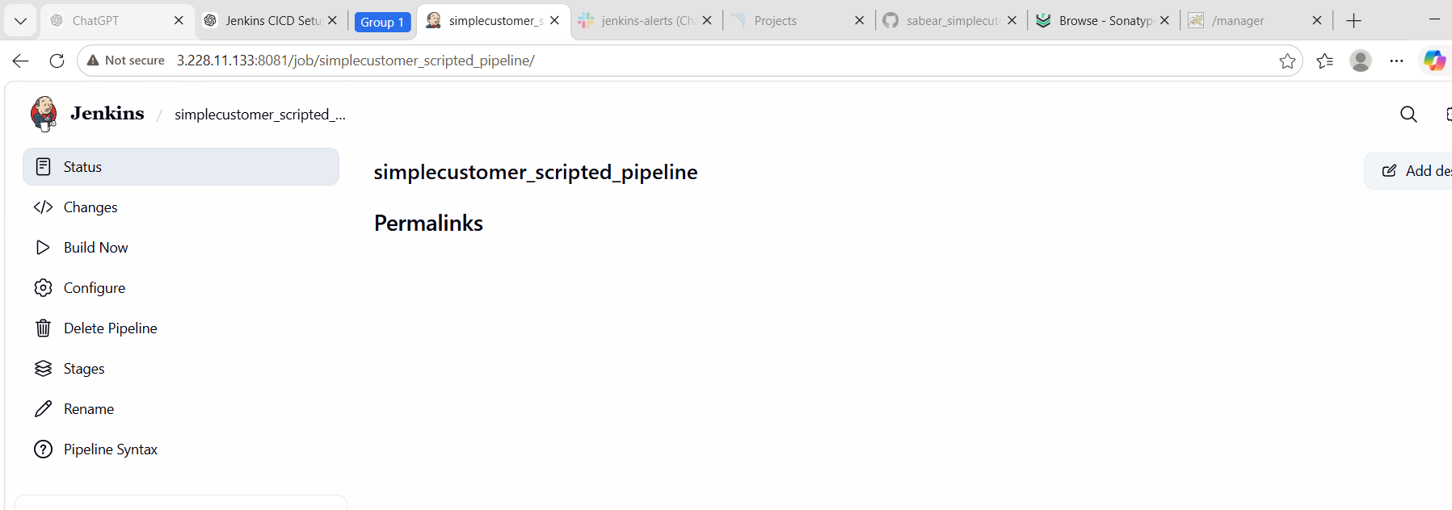
Step 2: Pipeline Configuration
Go to:
Pipeline → Definition → Pipeline script
Paste the below scripted pipeline.
node {

def APP_NAME = "simple-customer-app"
def NEXUS_URL = "3.228.11.133:8082"
def NEXUS_REPO = "Maven03"
def TOMCAT_URL = "http://3.228.11.133:8080"
def SLACK_CHANNEL = "#jenkins-alerts"
def WAR_FILE = ""

try {

stage('Git Clone') {
git branch: 'feature-1.1',
url: 'https://github.com/betawins/sabear_simplecutomerapp.git'
}

stage('Add Test Web Page') {
sh '''
mkdir -p src/main/webapp

cat > src/main/webapp/index.jsp <<'EOF'
<html>
<body>
<h1>SimpleCustomerApp Deployed Successfully</h1>
<h2>Jenkins Scripted CI/CD Pipeline Working</h2>
</body>
</html>
EOF
'''
}

stage('Maven Compilation') {
def mvnHome = tool 'MVN_HOME'
def javaHome = tool 'JDK21'

withEnv([
"JAVA_HOME=${javaHome}",
"PATH=${javaHome}/bin:${mvnHome}/bin:${env.PATH}"
]) {
sh 'mvn clean package -DskipTests'
}
}

stage('SonarQube Integration') {
def mvnHome = tool 'MVN_HOME'
def javaHome = tool 'JDK21'

withEnv([
"JAVA_HOME=${javaHome}",
"PATH=${javaHome}/bin:${mvnHome}/bin:${env.PATH}"
]) {
withSonarQubeEnv('sonarqube_server') {
sh 'mvn sonar:sonar'
}
}
}

stage('Get WAR File') {
WAR_FILE = sh(
script: "ls target/*.war | head -n 1",
returnStdout: true
).trim()

echo "WAR FILE FOUND: ${WAR_FILE}"

sh "jar -tf ${WAR_FILE} | grep index.jsp"
}

stage('Nexus Artifactory') {
nexusArtifactUploader(
nexusVersion: 'nexus3',
protocol: 'http',
nexusUrl: "${NEXUS_URL}",
groupId: 'com.javatpoint',
version: "${BUILD_NUMBER}",
repository: "${NEXUS_REPO}",
credentialsId: 'Nexus',
artifacts: [
[
artifactId: 'SimpleCustomerApp',
classifier: '',
file: "${WAR_FILE}",
type: 'war'
]
]
)
}

stage('Deploy On Tomcat') {
deploy adapters: [
tomcat9(
credentialsId: 'tomcat_deploy',
url: "${TOMCAT_URL}"
)
],
contextPath: '/SimpleCustomerApp',
war: "${WAR_FILE}"
}

stage('Slack Notification') {
slackSend(
channel: "${SLACK_CHANNEL}",
color: 'good',
message: "✅ SUCCESS: ${env.JOB_NAME} #${env.BUILD_NUMBER} uploaded to Nexus and deployed on Tomcat. URL: ${env.BUILD_URL}"
)
}

echo "✅ Pipeline completed successfully for ${APP_NAME}"

} catch (Exception e) {

slackSend(
channel: "${SLACK_CHANNEL}",
color: 'danger',
message: "❌ FAILED: ${env.JOB_NAME} #${env.BUILD_NUMBER}. Check Jenkins: ${env.BUILD_URL}"
)

currentBuild.result = 'FAILURE'
throw e

} finally {
cleanWs()
}
}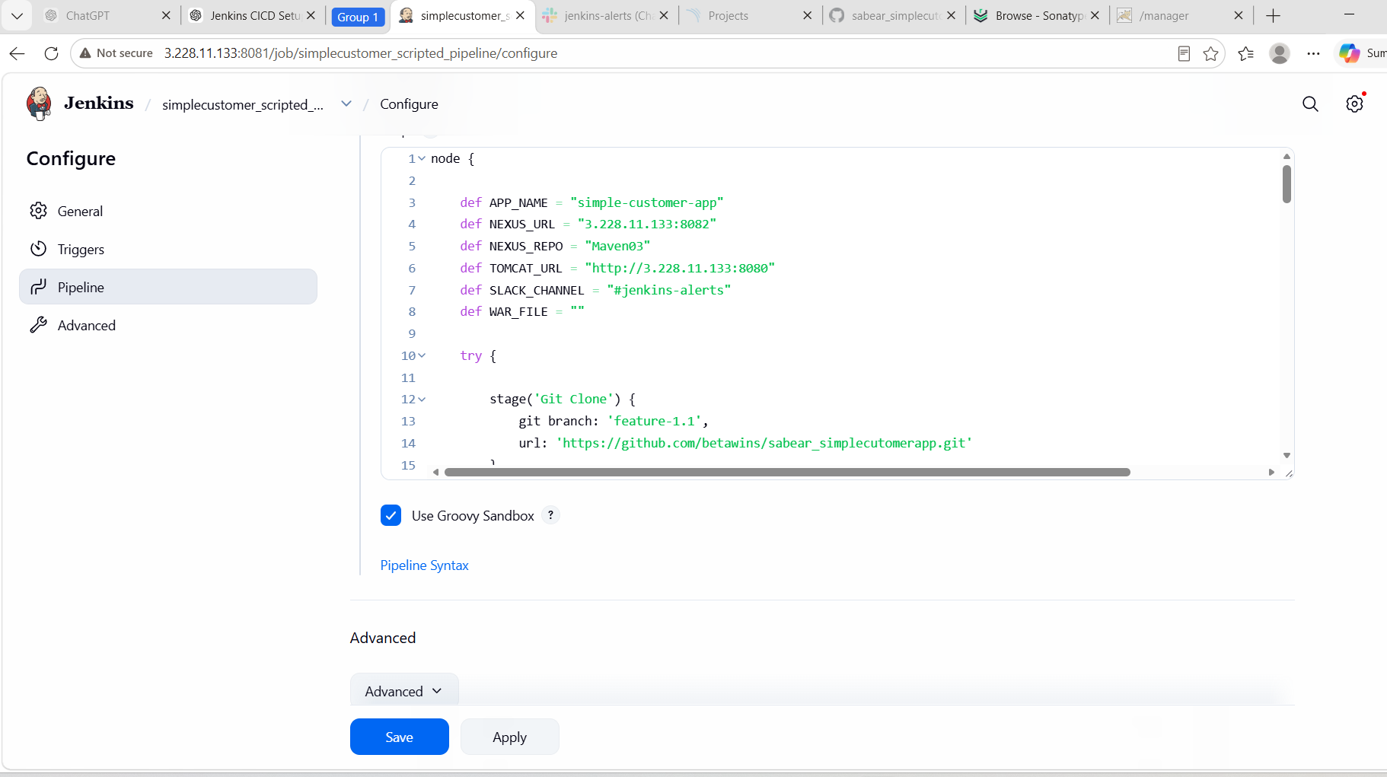
Flow
Git Clone
↓
Maven Compilation
↓
SonarQube Integration
↓
Get WAR File
↓
Nexus Artifactory
↓
Deploy On Tomcat
↓
Slack Notification
Important Notes
Before running, confirm:
JDK tool name: JDK21
Maven tool name: MVN_HOME
SonarQube server name: sonarqube_server
Nexus credential ID: Nexus
Tomcat credential ID: tomcat_deploy
Slack channel: #jenkins-alerts
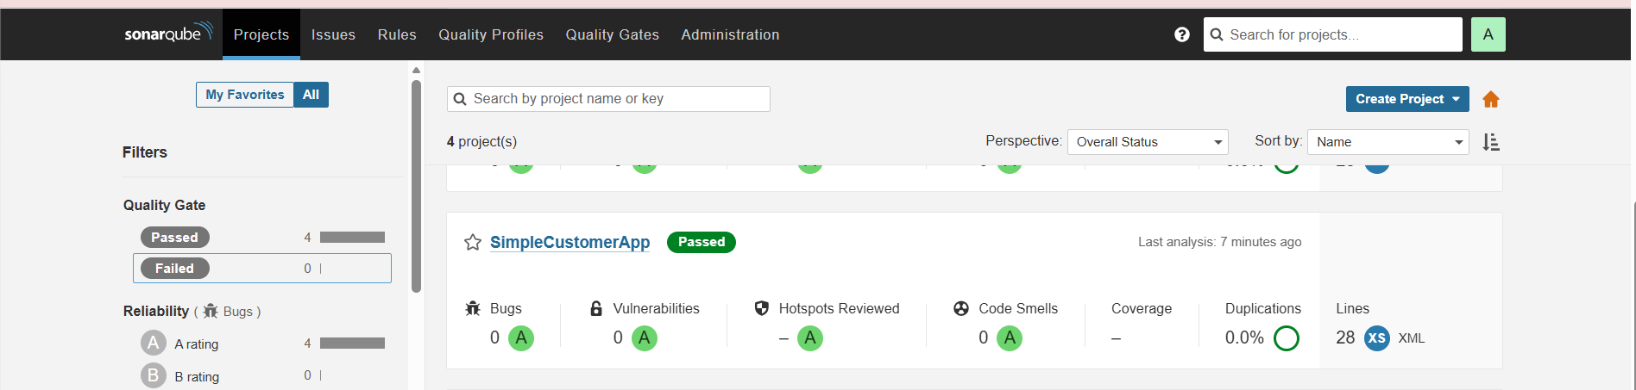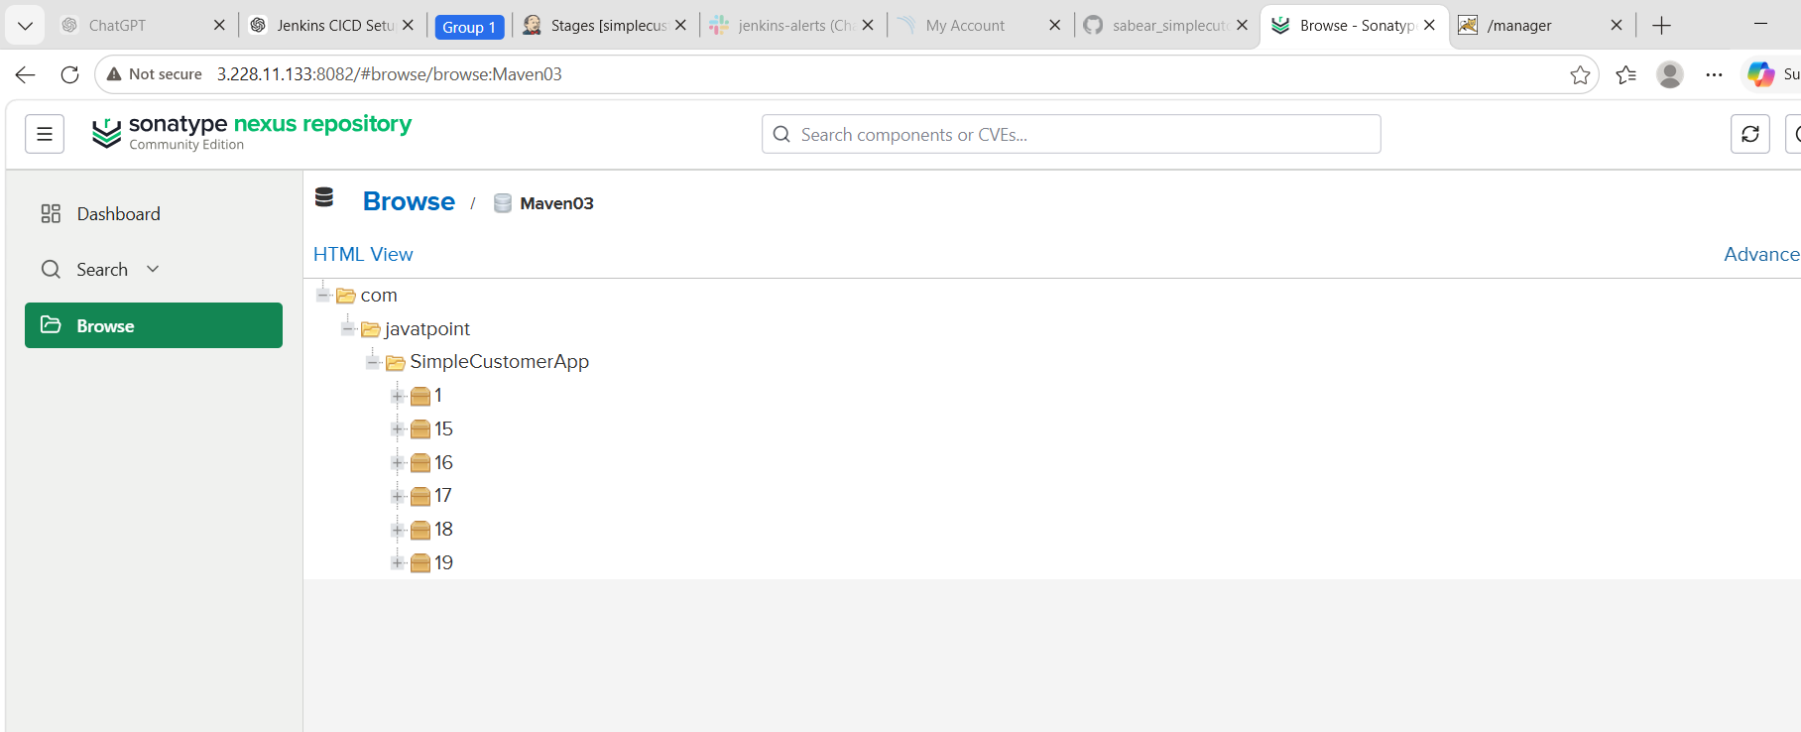
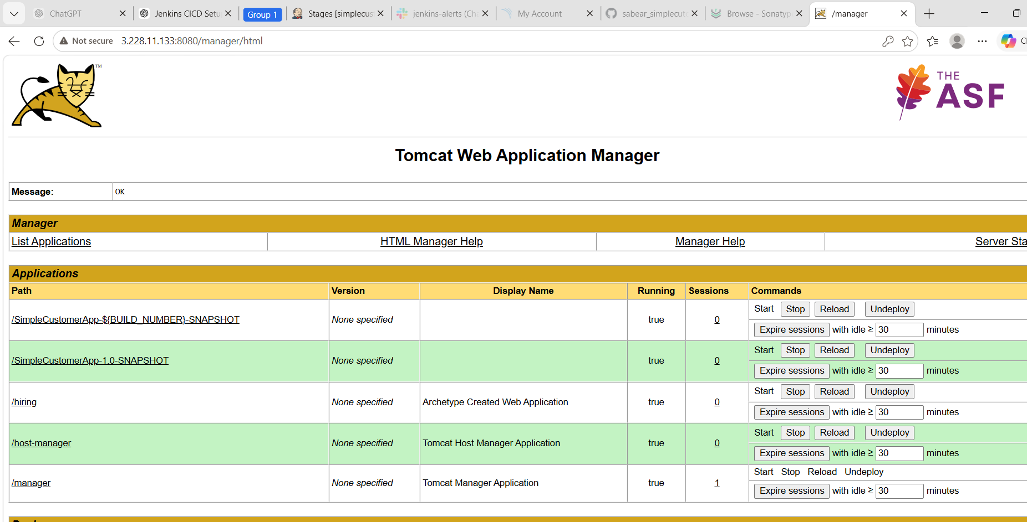
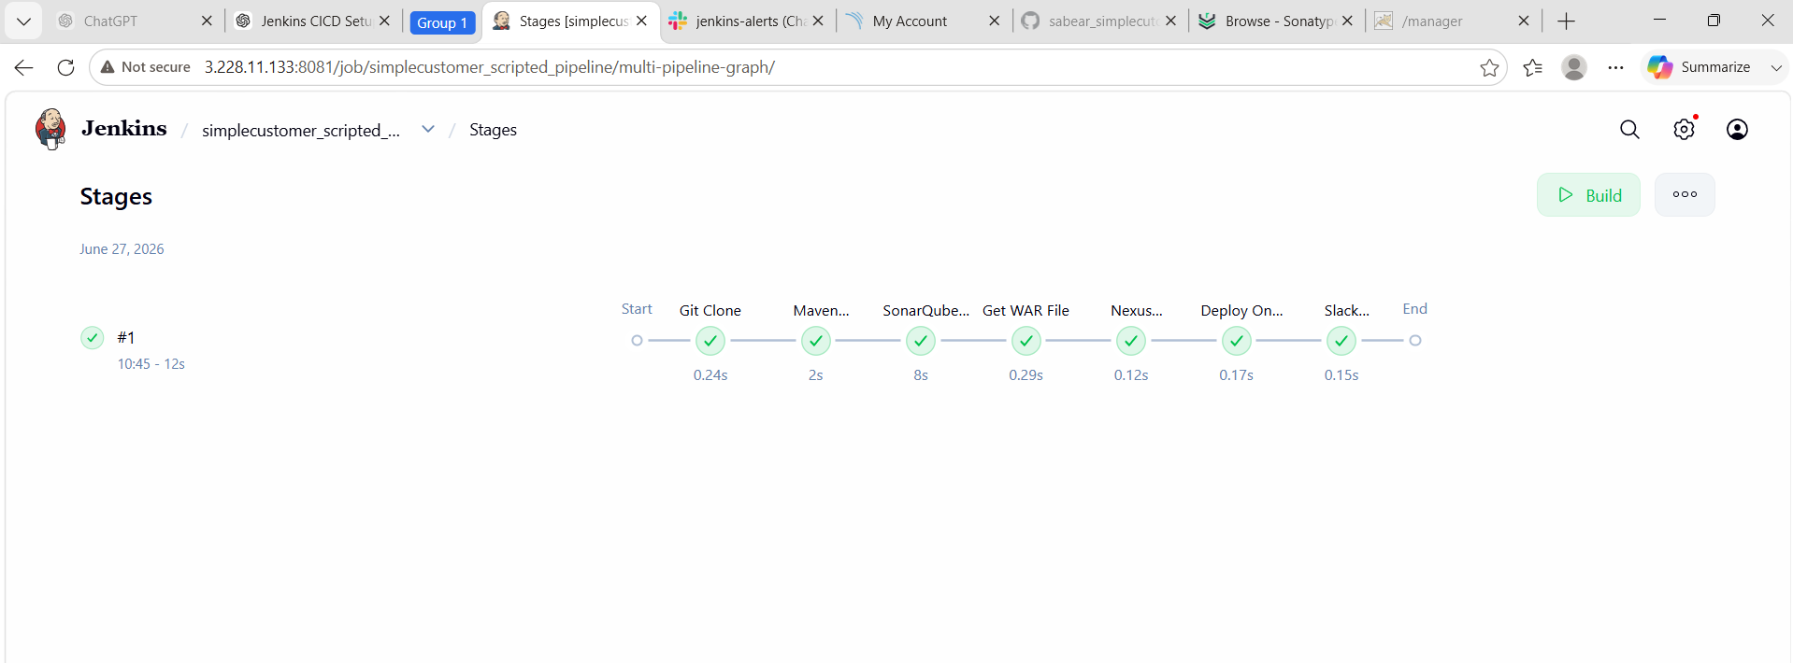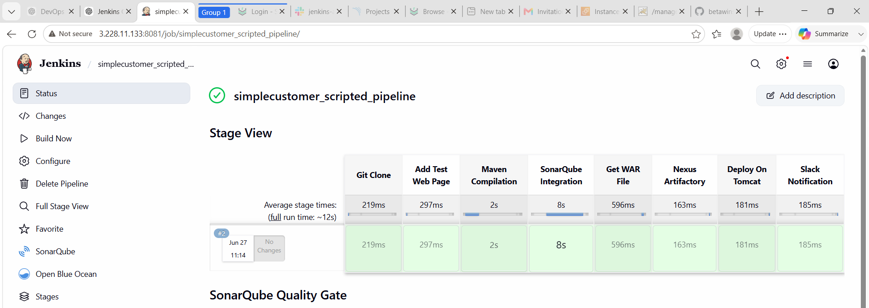

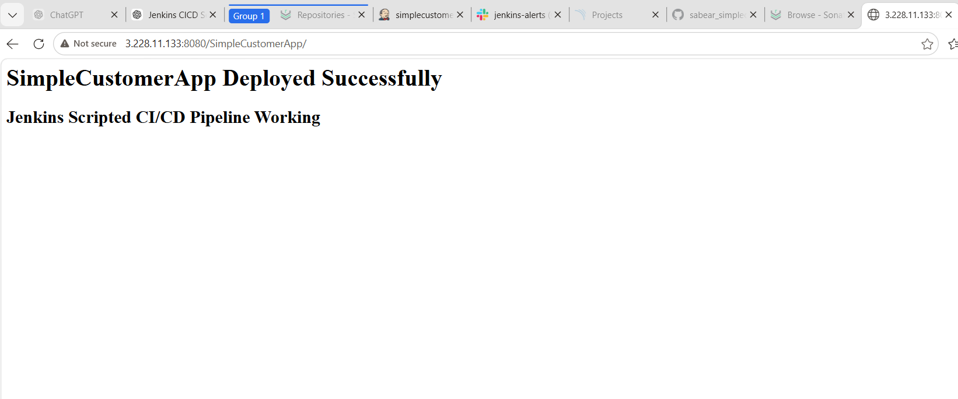

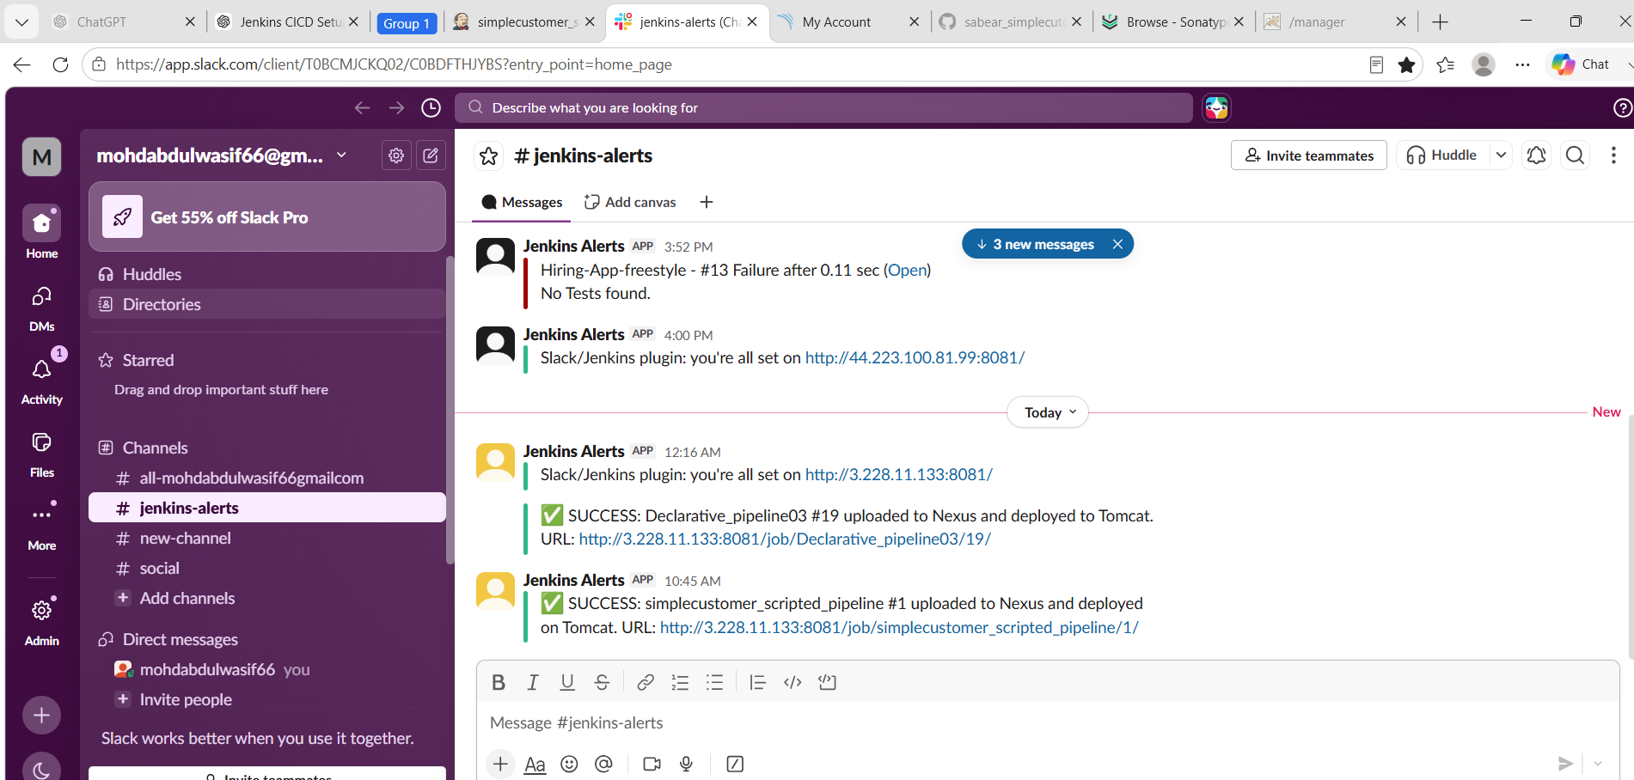
What We Learned
- Learned the difference between Scripted Pipeline and Declarative Pipeline in Jenkins.
- Learned how to create a Scripted Pipeline using Groovy syntax.
- Learned how to clone a specific Git branch (feature-1.1) from GitHub.
- Learned how to build and package a Java web application using Maven.
- Learned how to integrate SonarQube with Jenkins for code quality analysis.
- Learned how to generate and identify the correct WAR file for deployment.
- Learned how to upload build artifacts to Nexus Repository Manager.
- Learned how to configure and deploy a WAR file to Apache Tomcat automatically.
- Learned how to configure Slack notifications for Jenkins build status.
- Learned how to troubleshoot common CI/CD issues related to Git, Maven, SonarQube, Nexus, Tomcat, and Slack integrations.

Conclusion
The Scripted Jenkins CI/CD pipeline was successfully implemented for the SimpleCustomerApp project using the feature-1.1 branch. The pipeline automated the complete software delivery process, including source code checkout, Maven build, SonarQube code quality analysis, Nexus artifact upload, Tomcat deployment, and Slack notification. During the implementation, several real-world issues related to artifact generation, Nexus repository policies, Tomcat deployment, and Slack authentication were identified and resolved. This task provided hands-on experience with Jenkins Scripted Pipelines and strengthened practical knowledge of CI/CD automation using industry-standard DevOps tools.

Step 5: Create Multi-Stage Pipeline Job
Create job:

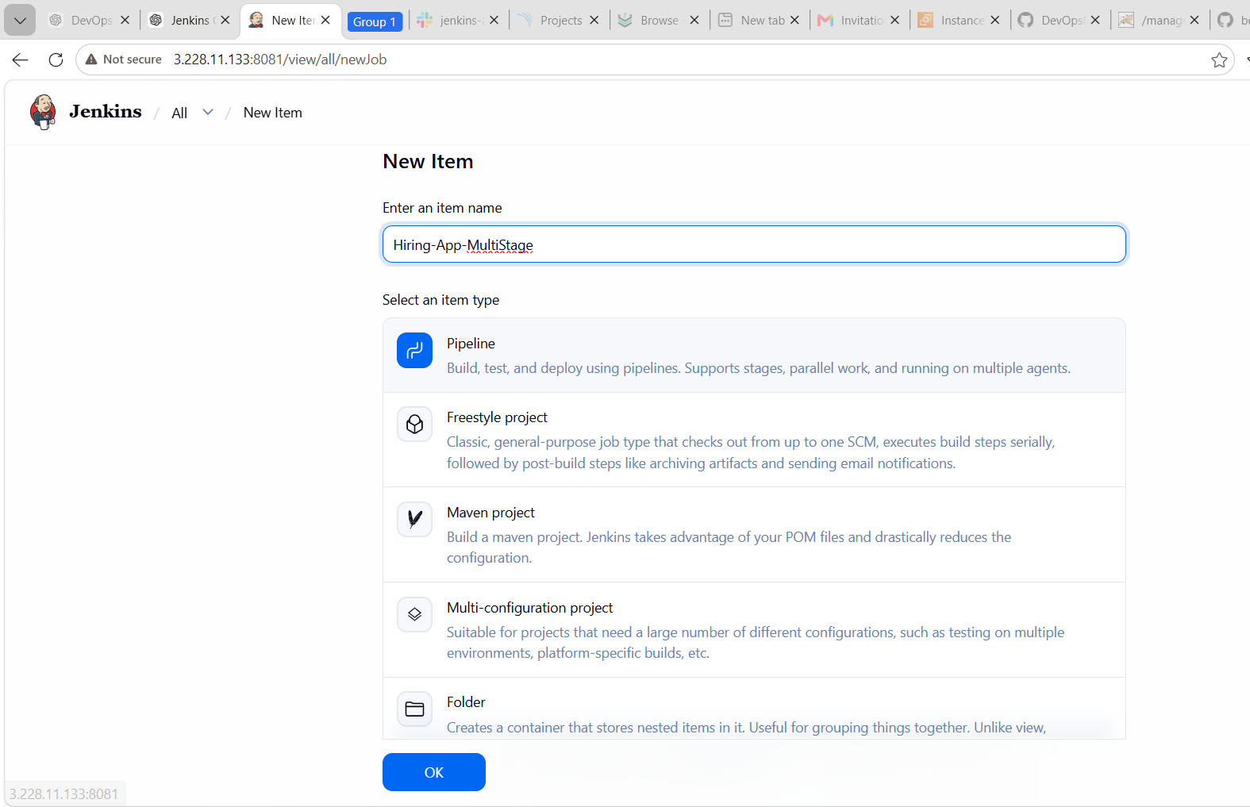
node {

def APP_NAME = "hiring-app"
def NEXUS_URL = "3.228.11.133:8082"
def NEXUS_REPO = "Maven03"
def TOMCAT_URL = "http://3.228.11.133:8080"
def SLACK_CHANNEL = "#jenkins-alerts"
def WAR_FILE = ""

try {

stage('Git Clone') {
git branch: 'main',
url: 'https://github.com/betawins/hiring-app.git'
}

stage('Maven Build') {
def mvnHome = tool 'MVN_HOME'
def javaHome = tool 'JDK21'

withEnv([
"JAVA_HOME=${javaHome}",
"PATH=${javaHome}/bin:${mvnHome}/bin:${env.PATH}"
]) {
sh 'mvn clean package -DskipTests'
}
}

stage('SonarQube Analysis') {
def mvnHome = tool 'MVN_HOME'
def javaHome = tool 'JDK21'

withEnv([
"JAVA_HOME=${javaHome}",
"PATH=${javaHome}/bin:${mvnHome}/bin:${env.PATH}"
]) {
withSonarQubeEnv('sonarqube_server') {
sh 'mvn sonar:sonar'
}
}
}

stage('Get WAR File') {
WAR_FILE = sh(
script: "ls target/*.war | head -n 1",
returnStdout: true
).trim()

echo "WAR FILE FOUND: ${WAR_FILE}"
}

stage('Upload to Nexus') {
nexusArtifactUploader(
nexusVersion: 'nexus3',
protocol: 'http',
nexusUrl: "${NEXUS_URL}",
groupId: 'com.hiringapp',
version: "${BUILD_NUMBER}",
repository: "${NEXUS_REPO}",
credentialsId: 'Nexus',
artifacts: [
[
artifactId: 'HiringApp',
classifier: '',
file: "${WAR_FILE}",
type: 'war'
]
]
)
}

stage('Deploy to Tomcat') {
deploy adapters: [
tomcat9(
credentialsId: 'tomcat_deploy',
url: "${TOMCAT_URL}"
)
],
contextPath: '/hiring',
war: "${WAR_FILE}"
}

stage('Slack Notification') {
slackSend(
channel: "${SLACK_CHANNEL}",
color: 'good',
message: "✅ SUCCESS: ${env.JOB_NAME} #${env.BUILD_NUMBER} Hiring App deployed successfully. URL: ${env.BUILD_URL}"
)
}

echo "✅ Pipeline completed successfully for ${APP_NAME}"

} catch (Exception e) {

slackSend(
channel: "${SLACK_CHANNEL}",
color: 'danger',
message: "❌ FAILED: ${env.JOB_NAME} #${env.BUILD_NUMBER}. Check Jenkins: ${env.BUILD_URL}"
)

currentBuild.result = 'FAILURE'
throw e

} finally {
cleanWs()
}
}
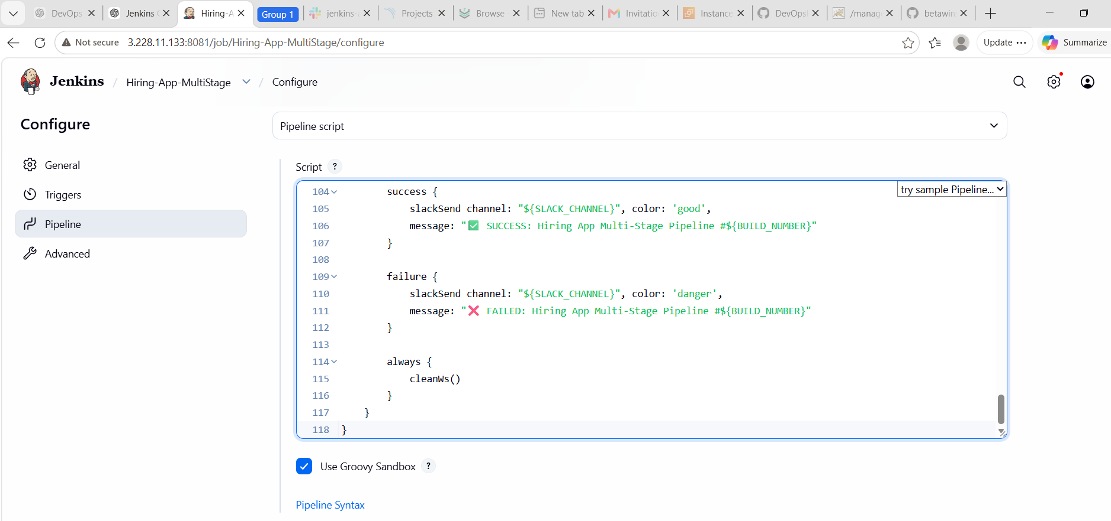

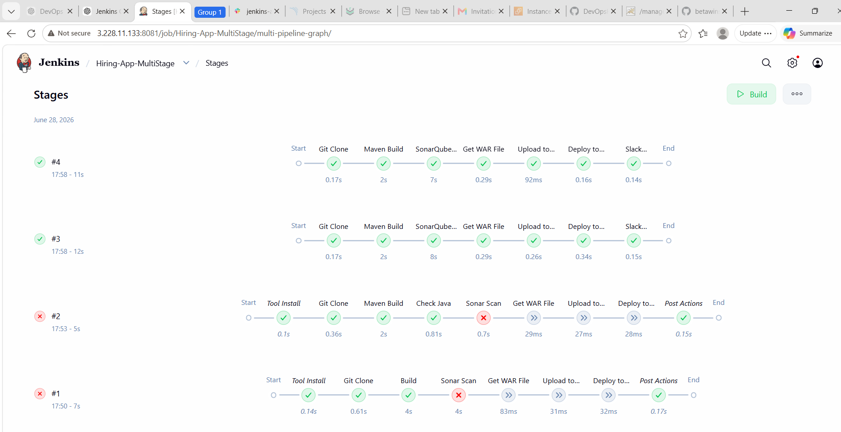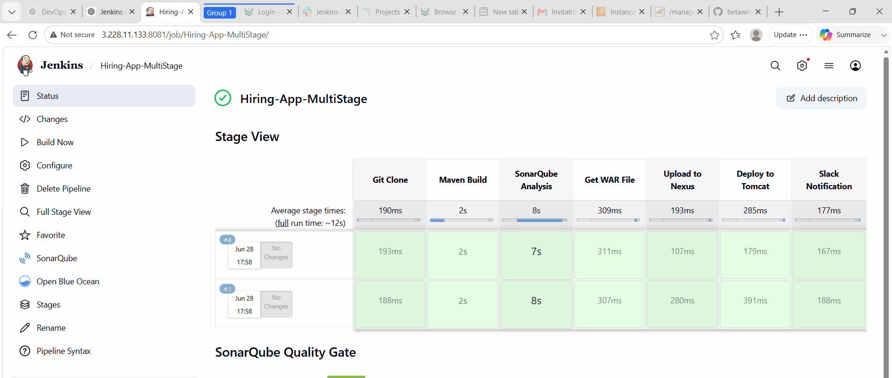

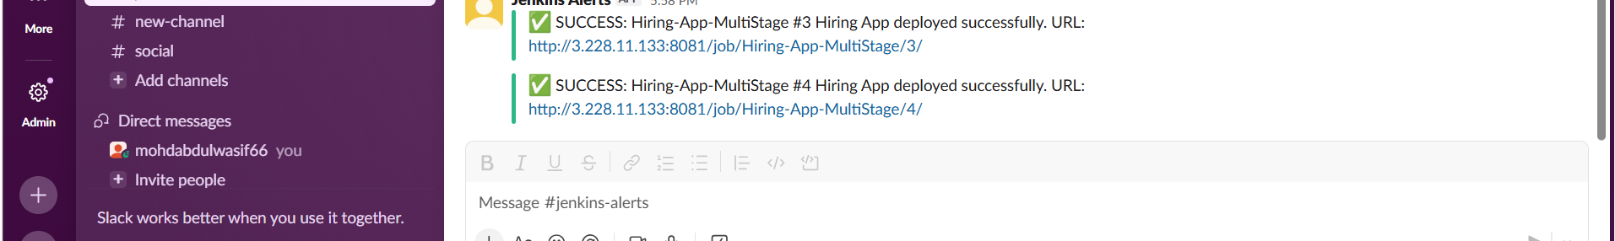

Final Verification
After every successful pipeline, check:
Jenkins Console Output = SUCCESS
SonarQube project visible
Nexus artifact uploaded
Tomcat app running
Slack notification received

Create Parallel Pipeline Job
Step 1: Create Job
- Jenkins Dashboard → New Item
- Name:
Hiring-App-Parallel
- Select Pipeline
- Click OK

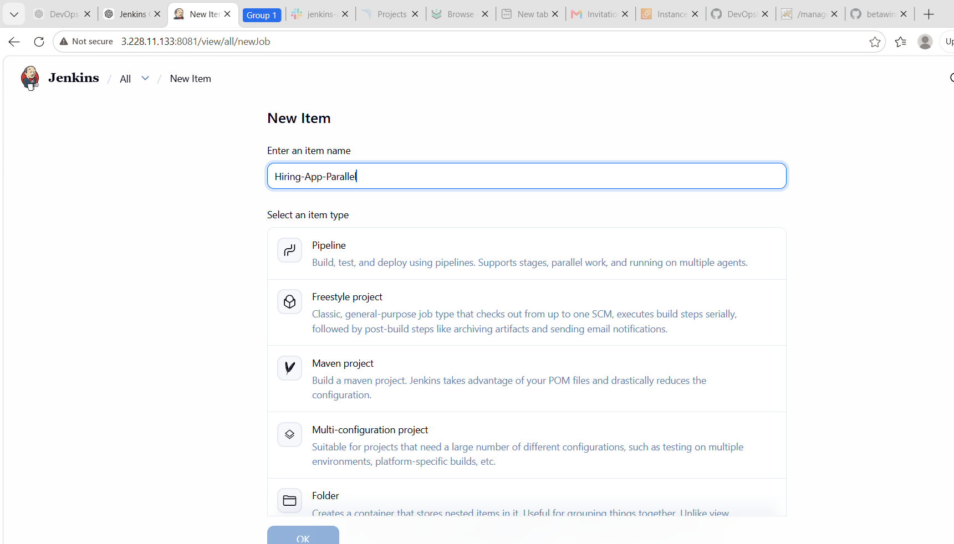

Step 2: Add Pipeline Script
- Scroll to Pipeline
- Definition: Pipeline script
- Paste this:
pipeline {
agent any
tools {
jdk 'JDK21'
maven 'MVN_HOME'
}
environment {
APP_NAME = "hiring-app"
NEXUS_URL = "3.228.11.133:8082"
NEXUS_REPO = "Maven03"
TOMCAT_URL = "http://3.228.11.133:8080"
SLACK_CHANNEL = "#jenkins-alerts"
}
stages {
stage('Git Clone') {
steps {
git branch: 'main',
url: 'https://github.com/betawins/hiring-app.git'
}
}
stage('Parallel Build and Sonar') {
parallel {
stage('Maven Build') {
steps {
sh 'mvn clean package -DskipTests'
}
}
stage('SonarQube Analysis') {
steps {
sh 'mvn clean compile -DskipTests'
withSonarQubeEnv('sonarqube_server') {
sh 'mvn sonar:sonar'
}
}
}
}
}
stage('Get WAR File') {
steps {
script {
env.WAR_FILE = sh(
script: "ls target/*.war | head -n 1",
returnStdout: true
).trim()
echo "WAR FILE FOUND: ${env.WAR_FILE}"
}
}
}
stage('Upload to Nexus') {
steps {
nexusArtifactUploader(
nexusVersion: 'nexus3',
protocol: 'http',
nexusUrl: "${NEXUS_URL}",
groupId: 'com.hiringapp',
version: "${BUILD_NUMBER}",
repository: "${NEXUS_REPO}",
credentialsId: 'Nexus',
artifacts: [
[
artifactId: 'HiringApp',
classifier: '',
file: "${env.WAR_FILE}",
type: 'war'
]
]
)
}
}
stage('Deploy to Tomcat') {
steps {
deploy adapters: [
tomcat9(
credentialsId: 'tomcat_deploy',
url: "${TOMCAT_URL}"
)
],
contextPath: '/hiring',
war: "${env.WAR_FILE}"
}
}
}
post {
success {
slackSend(
channel: "${SLACK_CHANNEL}",
color: 'good',
message: "✅ SUCCESS: Hiring App Parallel Pipeline #${BUILD_NUMBER} completed. URL: ${env.BUILD_URL}"
)
}
failure {
slackSend(
channel: "${SLACK_CHANNEL}",
color: 'danger',
message: "❌ FAILED: Hiring App Parallel Pipeline #${BUILD_NUMBER}. Check Jenkins: ${env.BUILD_URL}"
)
}
always {
cleanWs()
}
}
}
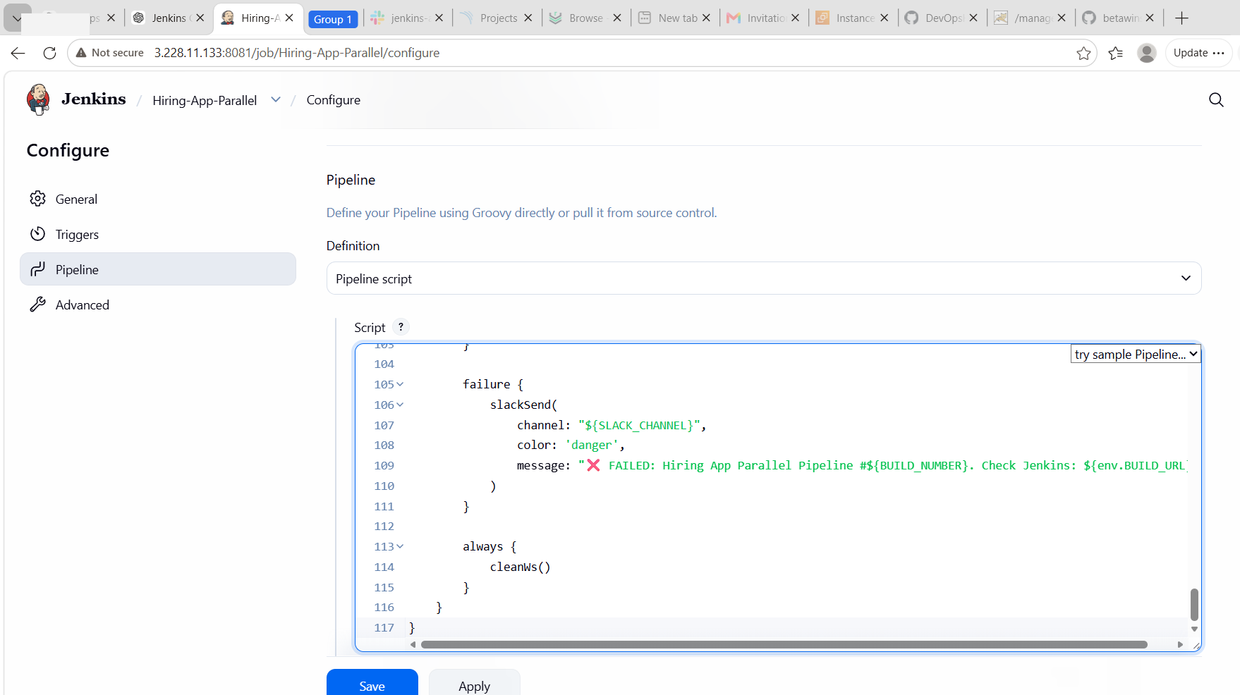
Step 3: Save and Build
Click Save → Build Now
Step 4: Verify
Check:
Git Clone = Success
Parallel Maven Build = Success
Parallel SonarQube Analysis = Success
Nexus Upload = Success
Tomcat Deploy = Success
Slack Notification = Success

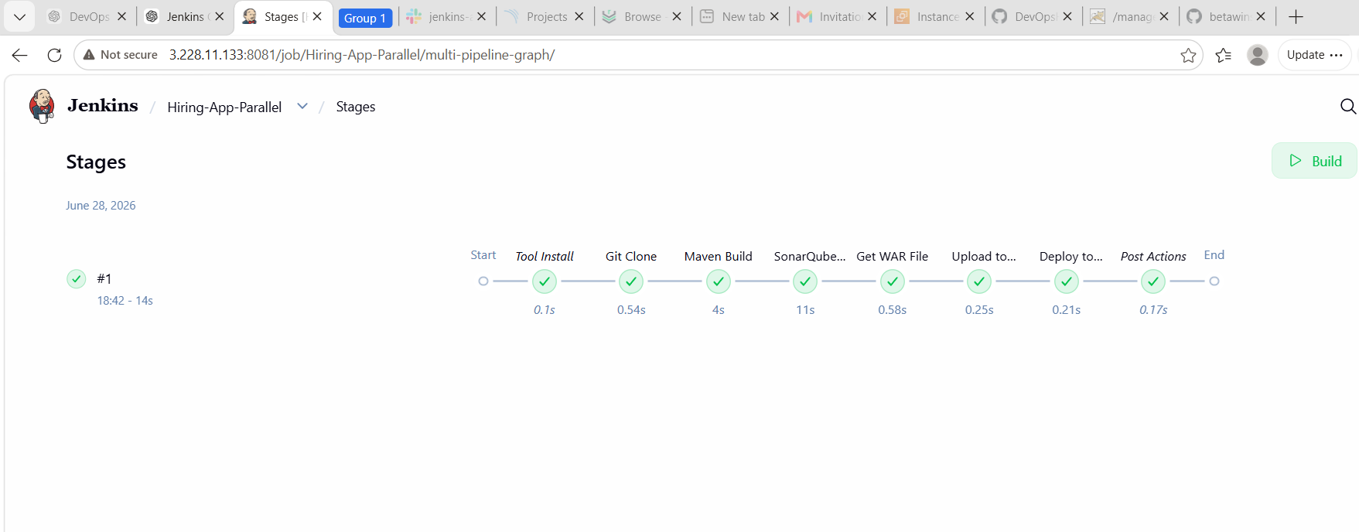
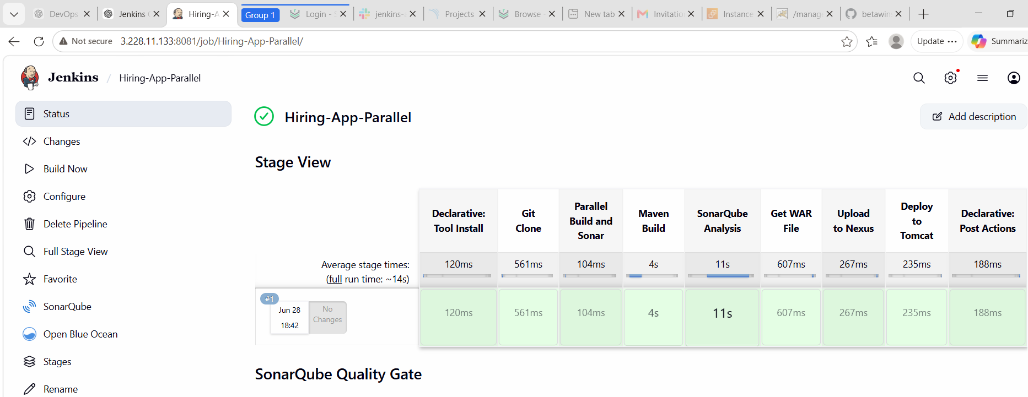
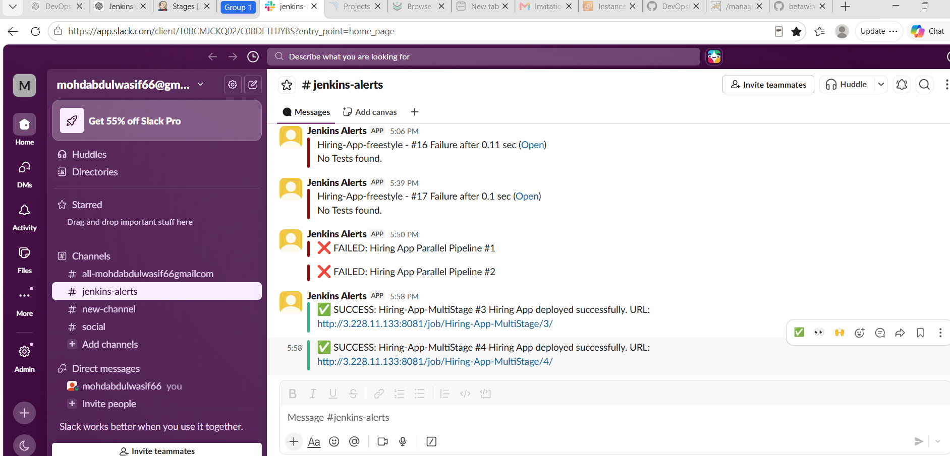
App URL:
http://3.228.11.133:8080/hiring/
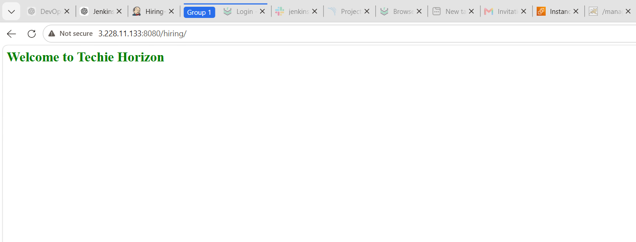

Conclusion
Successfully implemented multiple Jenkins Pipeline types for the Hiring App, including Declarative, Scripted, Multi-Stage, and Parallel pipelines. The CI/CD process automated source code checkout, Maven build, SonarQube code quality analysis, Nexus artifact upload, Tomcat deployment, and Slack notifications. This challenge provided practical experience with Jenkins Pipeline as Code and demonstrated different ways to build scalable, efficient, and maintainable CI/CD workflows.
What We Learned
- Understood the differences between Freestyle, Declarative, Scripted, Multi-Stage, and Parallel pipelines.
- Learned how to automate the complete CI/CD lifecycle using Jenkins.
- Integrated GitHub for source code management and automatic code checkout.
- Used Maven to compile, package, and build Java applications.
- Performed static code analysis using SonarQube.
- Published build artifacts to Nexus Repository Manager.
- Deployed WAR files automatically to Apache Tomcat.
- Configured Slack notifications for build success and failure alerts.
- Learned how to use Jenkins credentials securely for Nexus, Tomcat, and Slack integrations.
- Implemented parallel execution of independent stages to reduce overall pipeline execution time.
- Improved troubleshooting skills by resolving issues related to Maven, SonarQube, Nexus, Tomcat, Slack, and Jenkins Pipeline syntax.
- Gained hands-on experience with Pipeline as Code, making CI/CD pipelines reusable, maintainable, and version-controlled.

